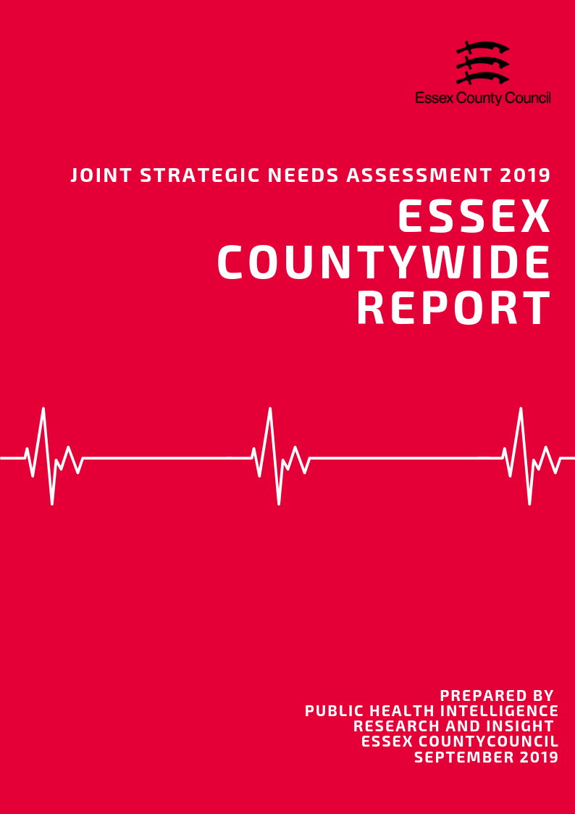

**Introduction**

What is a Joint Strategic Needs Assessment?

The JSNA is statutory process for Health & Wellbeing Boards (HWBB) to identify and improve the current and future health, wellbeing and social care needs of their area. The purpose is to inform strategic decision making, commissioning of services and reduce inequalities for all ages. There is no set format, prescribed content or specific time-period that a JSNA must cover, only that one must be produced in partnership with HWBB member organisations.

For the 2019 JSNA, the Health & Wellbeing Board is using a ‘place-based’ approach for the suite of JSNA products which will look at issues and needs at smaller local geographies. These geographies serve as building blocks to satisfy the need for intelligence at local authority and NHS geographical area and include:

• NHS/LA Locality/Neighbourhood Profiles

• District/Borough Council Profiles

• A Countywide Report

• Specialist Topic Deep Dive Reports (ESCG to develop)

This document presents data from a range of key topics which contribute to the overall the health and wellbeing of residents, in order to highlight areas of inequality and identify opportunities to improve the healthy lives for residents across the Essex County Council Local Authority area, with information also available separately for each of the 12 Districts and Boroughs where relevant.

Key findings from this and the 12 individual Local Authority Profiles will be used to identify issues that the Health and Wellbeing Board may wish to consider when refreshing the Joint Health and Wellbeing Strategy.

*Notes of Terminology:*

This document uses the term Essex to refer to the Essex County Council local authority area which does not include the Southend-on-Sea and Thurrock unitary authority areas.

**Contents**

|  |  |  |
| --- | --- | --- |
| **No.** | **Section** | **Page** |
| **1** | **Key Findings** | **3** |
| **2** | **Population & Demographics** | **10** |
| **3** | **Access to Services** | **23** |
| **4** | **Wider Determinants of Health** | **31** |
| **5** | **Lifestyle, Sexual Health & Substance Misuse** | **51** |
| **6** | **Life Expectancy & Mortality** | **60** |
| **7** | **Birth Rates and Infant Health** | **69** |
| **8** | **ILLNESS & HOSPITAL ADMISSIONS** | **74** |
| **9** | **Mental Health** | **94** |
| **10** | **Potential Areas for Future Focus** | **98** |

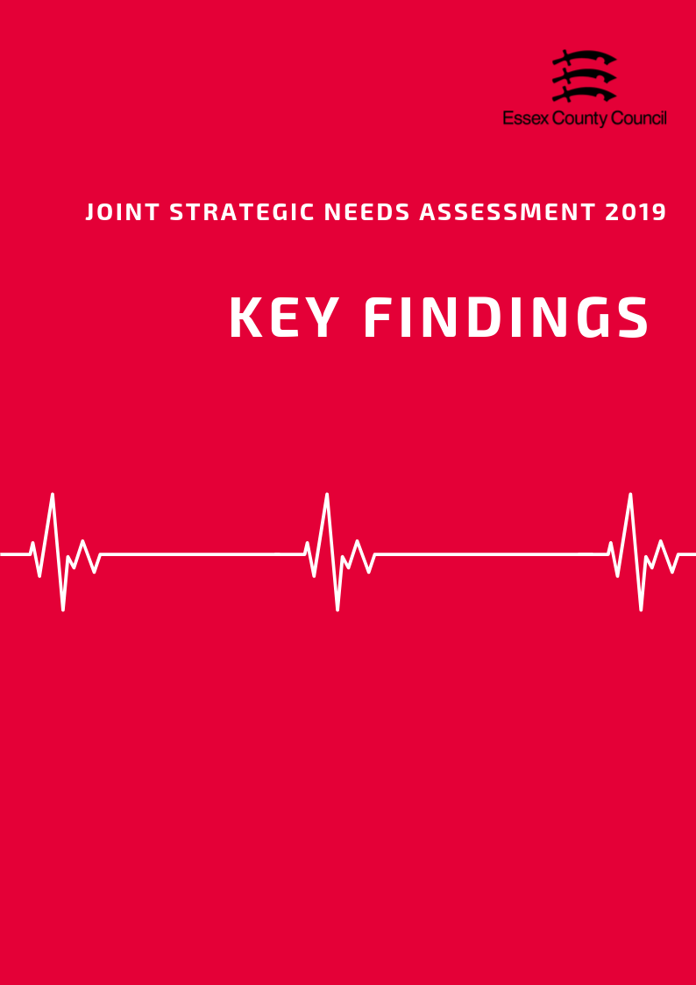

**Population and Demographics**

* Essex has an estimated population of 1.47 million people in 2018, an increase of 1.54% since the 2011 census.
* The proportion of the population classified as “Working Age” is 2% lower than the national average whilst the population aged 65+ is 2% higher.
* The current old age dependency ratio is equivalent to 335.6 people aged 65+ to every 1000 working age people. This is higher than the national average and is predicted to increase to 380.4 per 1000 by 2034.
* At the time of the 2011 census the BAME population of Essex was 9.2% of the total population. More recent statistics are not available****.

**Access to Services**

* The Essex County council administrative area covers approximately 3670 square kilometres and is the third largest upper tier authority in the East of England in terms of area.
* The average travel time to 8 key local services across the county is 19.4 minutes by walking or public transport. Travel times to hospitals have the longest average journey time at 45.4 minutes with three districts having travel times in excess of 60 minutes.
* In 2018 the Essex County Council Social Care was known to have:
  + Looked after 1,461 children and young people
  + Provided long term support to 21,685 adults
  + Facilitated short term care aimed at maximising independence to 6,125 adults
  + Received 24,625 requests for support from new clients
  + Provided support to 4,435 carers
* The Department of Work and Pensions recorded 16,620 people in receipt of Carers Allowance in the county in November 2018



**Wider Determinants of Health**

* The average weekly earnings for full time workers were higher than the national average at £618.6 per week. Average weekly earnings for part time workers were lower than the national average at £182.10.
* The Office of National Statistics estimated that 13,100 households with dependent children across the county were workless in 2017 (i.e. no resident adults classed as economically active being in work).
* 23.9% of residents aged 16+ have no formal qualifications, slightly higher than the averages for England and the East of England. Essex residents also achieve lower levels of NVQ level four qualifications (certificate of higher education) or higher (Batchelors Degree and above) with 22.9% of residents gaining this level of qualification compared to the 27.4% at the England Level.
* 72.1% of children achieved a good level of development at the early years foundation stage in 2018, similar to the average for England.
* Since the introduction of the new GCSE grading system, pupil performance across Essex has generally been just above the national average with 63.3% of pupils achieving grade 9-4 in English and Maths (a good pass) and 40.7% achieving grade 9-5 (a strong pass) in 2018.
* Although the rate of economic activity and employment for the county is generally above the average for England, the number of residents claiming out of work benefits has increased to its highest level in 5 years from 1.4% in April 2015 to 2.1% in April 2019.
* In 2018/19 a total of 21,803 households were on housing waiting lists, equivalent to 3.54% of all households in the Essex County Council Area.
* In 2018 there were 67 rough sleepers recorded across the county equivalent to 1.08 rough sleepers to every 10,000 households in the area. 1,560 households were classed as "homeless" regardless of statutory duty to be housed.
* In the 12 months from the 1st April 2018 to the 31st March 2019 Essex Police recorded a total of 121,202 crimes (excluding fraud) in the Essex County Council area (not including Southend and Thurrock). The overall rate of crime per 1000 residents generally remains lower than average with a rate of 78 crimes per 1000 people in the Essex County Council area in 2018/19 compared to a rate of 87 across the whole Essex Police Force area, 89 for England.
* In 2014 it was estimated that Essex had a fast food density of 69.5 outlets (per 100,000 people) well below the England average of 88.2.

**Lifestyle, Sexual Health & Substance Misuse**

* 21.11% of children in reception year were classified as overweight (including obese) whilst 8.59% were classed as Obese (including severely obese). By year 6 it is estimated that 32% of children are overweight or obese with 17.9% classed as Obese or severely obese.
* In Essex in 2016/17 63.6% of adults were classed as overweight or obese, slightly higher than the England average of 61.3%.
* Across Essex, 66.07% of residents ages over 19 years were classified as physically active in 2017/18. The proportion of residents classified as physically inactive across Essex was 21.78%. Both levels were similar to the average levels for England.
* Across the whole of Essex in 2017, the prevalence of current smokers among residents aged over 18 years was 13.84%. This was similar to the prevalence across England (14.87%).
* The age-standardised mortality rate from drug misuse per 100,000 population across the whole of Essex was 3.63. This was slightly lower than the rate for England (4.33).
* The directly age standardised rate of alcohol-related hospital admissions across Essex as a whole in 2017/18 was 1935.65 per 100,000 population. This is lower than the rate across England (2223.80).
* The proportion of all 15-24 year olds across Essex in 2017 screened for chlamydia services was 15.5% and was lower than the chlamydia screening prevalence for England (19.3%).

**Life Expectancy & Mortality**

* The average life expectancy at birth for a child born in Essex (2015-2017) was 83.3 years for females and 80.2 years for males. This is just above the average for England for both sexes (Females = 83.1 years, Males = 79.6 years).
* Males from birth had a healthy life expectancy of 64.53 years whilst females were slightly lower at 64.18 years.
* From birth females across Essex were expected to life 62.2 years of their life disability free, whilst males were expected to be disability free for slightly longer at 63.9 years.
* The top three biggest causes of premature mortality for both sexes were:
  + cancer (131 per 100,000)
  + cardiovascular diseases (62.6 per 100,000)
  + respiratory diseases (30.8 per 100,000)

*The rates for all three were lower than the England averages.*

* Mortality rates for breast cancer (All persons rate = 11.22; Female only rate: 26.6) were higher than the average for England (10.6; 20.6) with 8 out of 12 District having mortality rates for women above this level.
* Between August 2014 and July 2017, the three-year average rate of Excess Winter Deaths for all ages in Essex was 23.3%, slightly higher than the average for England (21.9%) and the fourth highest level compared to the other upper tier authorities in the East of England. The level of Excess Winter Deaths specifically in the over 85s age group was 31.7%. during the same period, just above the England rate of 29.3% and the fifth highest level in the East of England.

**Birth Rates & Infant Health**

* According to the Office for National Statistics, in Essex in 2017, the Crude Birth Rate (CBR; all births per 1,000 population) was 11.3, similar to the CBR of 11.6 across England.
* The CBR has remained stable overall since 2013, with a CBR also of 11.3 in 2013. In contrast, the CBR across England decreased by 0.7 (2013: 12.3, 2017: 11.6).
* The rate of premature births per 1,000 total live and still births across Essex was 74.69 over the 3-year period of 2014 - 2016. This is lower compared to the premature birth rate across England (79.52).
* The percentage of breastfeeding initiation in the first 48 hours after delivery in 2016/17 was 75.02%; similar to the England level (74.49%).
* The percentage of mothers known to be smokers at the time of delivery out of all maternities was 10.60% in Essex in 2017/18. This was similar to that for England (10.80%).

**Illness & Hospital Admissions**

* Across Essex, the county average for emergency hospital admissions for all causes and all ages for the period of 2013/14 - 2017/18 was lower than the England benchmark at 89.6.
* Emergency Admissions for Chronic Obstructive Pulmonary Disease (COPD) (83.2), Coronary Heart Disease (90.5), Heart Attack (87.5) and Stroke (94.3) were all lower than the England Baseline overall.
* Public Health England estimates that there was a three-year average of 475.2 Accident and Emergency attendances by children under the age of 5 across Essex as a whole compared to an England rate of 551.6.
* The directly age standard admissions rate of hip fractures was estimated to be 611.9 per 100,000 population ages 65 and over. This was higher than the average for England (577.8) and was also higher than average in 9 out of 12 Districts.
* In 2015/16, the proportion of GP registered patients (also known as the QOF prevalence) with a diagnosis of Hypertension across England was 13.9%. All 12 districts had prevalence rates above the England level.
* The QOF prevalence of Coronary Heart Disease (CHD) across England during the same period was 3.1% and was higher than average in 10 out of 12 districts in Essex.
* The proportion of GP registered patients in Essex with Dementia is estimated to be 0.81%, slightly higher than the average for England (0.76%). 8 districts had rates equal to or higher than the England average (Highest: Tendring =1.06%) whilst 4 were below (Lowest: Harlow = 0.59%).
* The incidence ratio for all cancers across Essex was 98.49, similar to the rate for England. Four areas were worse than the incidence ratio for all cancers across England (100).
* The percentage of patients registered with GPs in the County who are recorded as having Diabetes (QOF Prevalence) is 6.6% across the Essex County Council area, similar to the average for England of 6.5%
* The rate of GP registered children who have received both of MMR vaccination injections by age five is 89.4%. This is higher than the England average (87.2%) but is well below the 95% needed to eliminate measles within the population.
* In 2018 the rate of measles per 100,000 people in Essex was 1.5, similar to the England average of 1.7. At a District level Castle point was the only area to be classified as significantly worse than the level for England with an incidence rate of 11.1 per 100,000.

**Mental Health**

* In Essex 47% of adult social care users aged 18+ had as much social contact as they would like, which was similar to the average for England (46%) and East of England (45.9%). For adult social care users aged 65+ this figure reduced slightly to 43.9% but remained similar to the average for England (44%) and East of England (43.5%).
* Only 26.8% of carers aged 18+ in Essex had as much social contact as they would like, lower than average for England (35.5%) and East of England (31.6%) and was the third lowest level out of the upper tier and unitary authorities in the Eastern region. 25.4% Carers aged 65+ said they had as much social contact as they would like compared to the England (38.3%) and East of England (31.6%) averages.
* According to the Essex Residents Survey in 2018, 25.5% of residents aged from 16 to 65 plus years across Essex reported feeling isolated from others.
* The prevalence of depression and anxiety among persons aged over 18 years across Essex was estimated to be 12.49%. This is lower than the prevalence for England (13.74%).
* The prevalence of severe mental health conditions recorded on general practice disease registers across Essex was 0.80. This is lower than the prevalence for severe mental health conditions for England (0.94)
* The rate of emergency hospital admissions for intentional self-harm among persons of all ages across Essex was 156.98 in 2017/18. This is significantly lower than the rate for England (185.48). Women (201.7) in Essex were 1.8 times more likely to be admitted to hospital for intentional self-harm than men (113.5) but had generally had a lower admissions rate than the average for England (235.3)
* The age-standardised mortality rate per 100,000 population from suicide and injury of undetermined intent among persons aged over 10 years across the whole of Essex was 10.88 in 2015/17, higher than the rate for England (9.57). The rate among males across Essex was 16.90 and 5.31 among females, both of which slightly higher than the rate for England (14.69 male; 4.69 female).

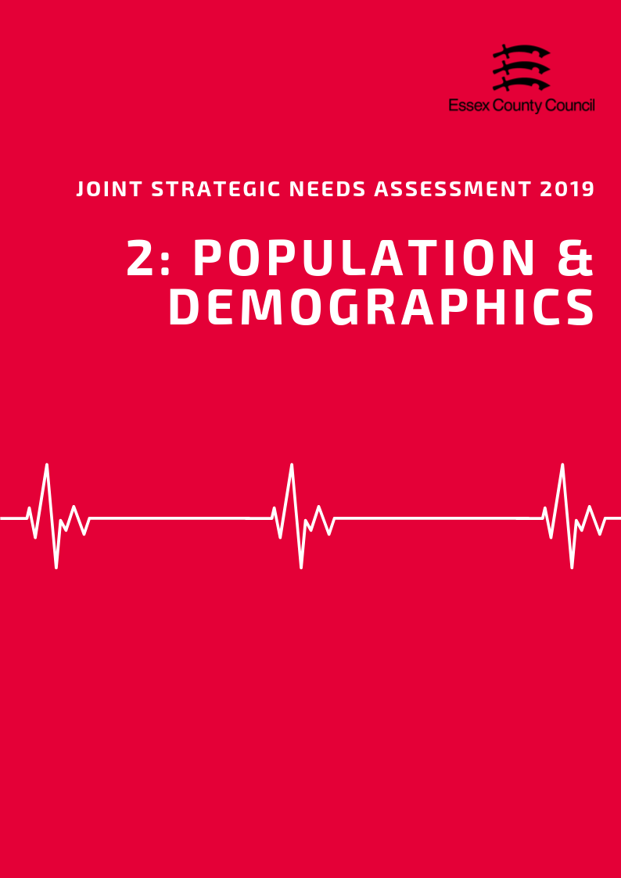

**POPULATION & DEMOGRAPHICS**

***Population Growth***

According to mid-year population estimates for 2018, the total population of the Essex County Council local authority area was an estimated 1,477,764 people. This is the largest local authority by population size in the East of England and makes up 23% of the total population of the region. 51.1% of the population is Female whilst 48.9% are male, meaning there are 33,308 more women living in Essex than men. This is just above/below the average for England (50.6% vs 49.4%).

The population of Essex is estimated to have grown by 22,242 people (a rise of 1.54%) since the 2011 which is well below the growth rate for England (5.95%). The 12 months between 2017 and 2018 saw the largest single year population increase and is estimated to have grown by 9,587, people making up 42% of the growth since 2011. The largest single source of population growth (59%) was attributed to internal (already UK based) inward migration from other local authorities, followed by inward international migration (26%). Births minus deaths contributed to 14% of the population growth of the last 12 months and was the smallest overall component of growth.

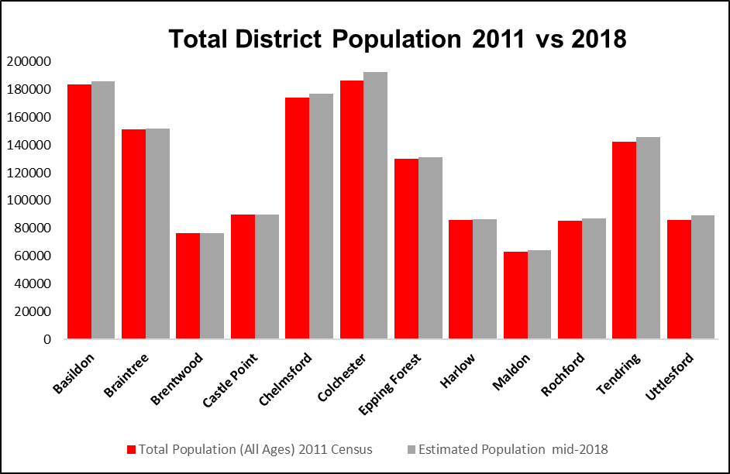

Population growth at District level is varied across the county with areas such as Uttlesford (3.47%), Chelmsford (3.15%) and Tendring (2.25%) seeing the largest levels of growth since 2011 (albeit below the England average) whilst Brentwood (0.21%), Braintree (0.37%), and Castle Point (0.38%) are estimated to have seen the smallest levels.*Between 2017 and 2018* the *Braintree (-116 people) and Brentwood (-25 people) local authority areas were estimated to have had negative population growth overall. During the same period Tendring (-964), Castle Point (-203), Rochford (-146) and Maldon (-101) are all estimated to have had fewer births than deaths during the same period.*

Looking forward, the Office of National Statistics population projections (2016 based) predict that by 2034 the total population will increase by another 195,160 people to a total of 1,650,500, an increase of 13.41% from 2011 estimates.

***Age Split***

It is estimated that 18.9% of the population are aged 0-15 years (Children & Young People), 60.6% of the population are aged 16-64 (working age group) and 20.5% are aged 65 and over. Compared to the average for England, the Working Age group is 2% lower than the national average, whilst the 65+ age group is 2% higher.

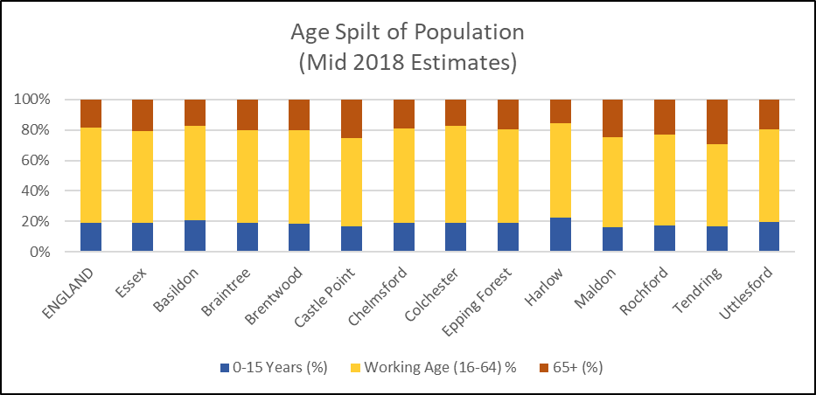

Within the current Working Age group, it is estimated that 183, 549 people are aged between 55 and 64 years and thus may be retiring over the next 10 years. This is equivalent to 12.4% of the total population (or 20.5% of the current working age population). By comparison 174,805 of 6-15-year olds (11.8% of the total population) will be entering the Working Age group classification over the next ten years. Not only is this 4.76% or 8,744 people fewer people entering the Working Age category, many are also likely to stay on in further and higher education many will not become economically active until later.

***Old Age Dependency Ratio***

A useful measure to understand how the balance in the population will change, particularly when planning for the needs of the aging population is the old age dependency ratio (OADR) – the number of people over 65 years old for every 1,000 people aged between 16 and 64 years old.

Compared to England, Essex has a higher OADR than the national average with an estimated rate of 335.6 in 2019 (England 286.8). This is equivalent to 2.98 working age people to every person aged 65 and over. By 2034 this rate is predicted to rise to 380.4 per 1000, remaining well above the England (334.2) average rates. Across the county the OADR varies considerably with Tendring (544 per 1000) having an equivalent of 1.84 working age residents to ever person aged over 65, whilst Harlow (242 per 1000) having an estimated 4.12 per person aged 65+. This dependency ratio will continue to rise with the ONS estimating that by 2034 there will be a rate 1.63 to 1 in Tendring, 1.8 to 1 in Maldon, and 2.13 in Castle Point. This increasing ratio will likely add pressure on future demand for care and social services support across the county but particularly in the areas identified.

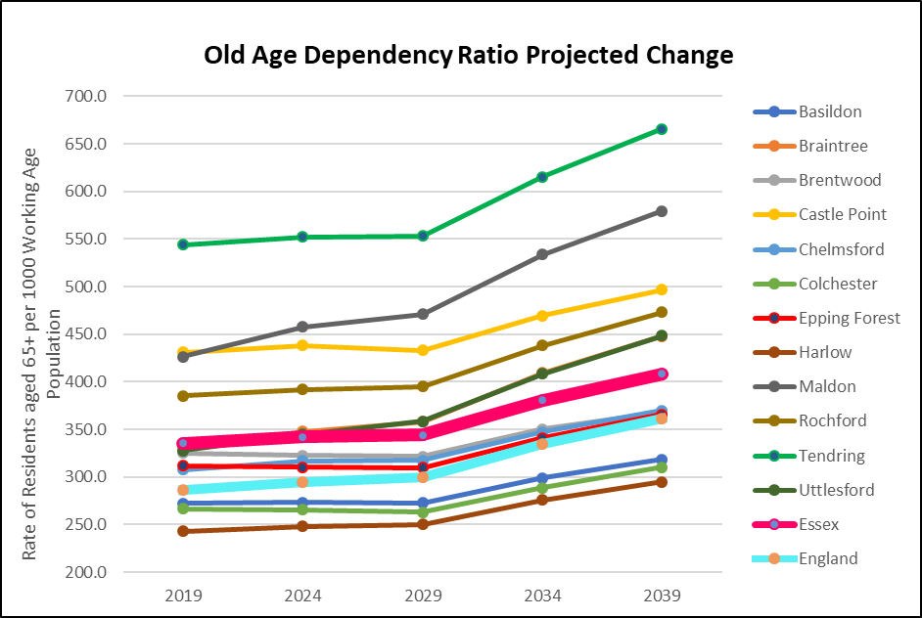

***Ethnicity***

Figures for the ethnicity of the population is currently only available using the data available from the 2011 census as the Office of National Statistics does not produce modelled estimates or prediction for this category.

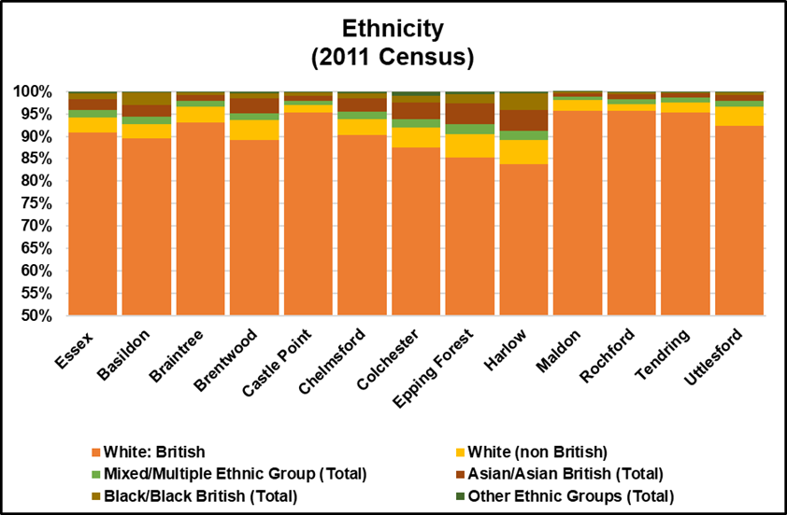

According to the 2011 census 90.8% of Essex’s population identify as White British and 9.2% have a minority ethnic identity including White Non-British. Harlow has the highest percentage of Black and Minority Ethnic Residents (BAME) at 16.15%, the Maldon District has the lowest proportion at 4.25%.

***Household Composition***

At the time of the 2011 Census there were an estimated 132,575 households (22.8%) across Essex which contained dependent children. This was just above the average for England (21.99%) and was similar across most of Essex, with the exception of Uttlesford (27.7%) which was 5.69% higher than England, and Tendring which was lower (16.9%).  
  
Households with married or civil partnership couples made up over a third (36.8%)   
of all households in the area slightly higher than the rate for England (33.2%) followed by single person households (28.4%) which was just below the national average England (30.2%).   
  
The number of lone parent households (9.7%) was slightly below the rate for England (10.6%) (Lowest: Uttlesford & Maldon = 7.4%; Highest: Harlow = 13.1%)  
  
134,998 households (23.7%) were occupied solely by residents aged 65 and over including 76,477 households (13.1%) where a resident aged 65 and over was living alone. This was higher than the average for England (20.7%, 12.4%) in both cases. At a district level Tendring had the highest level in the county for both measures (32.6%, 18.6%), Harlow had the lowest percentage of all over 65 households (19.8%) and Colchester had the lowest rate of over 65s living alone (11.4%).

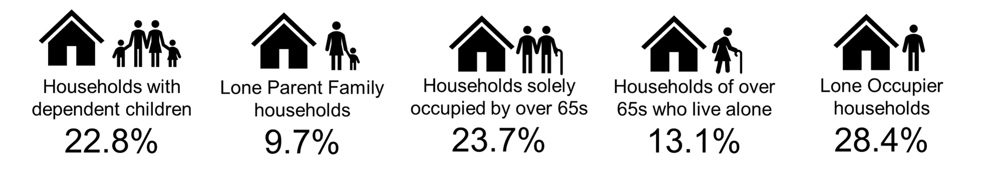

***Learning Disabilities and Special Educational Needs***

In 2018 Essex County Council had recorded a total of 9,356 pre and school age children and young people across the county with some form of special education needs support including 3071 people with Autistic Spectrum Disorder (ASD) and 1088 with severe learning disabilities (SLD). 54% of students with LD or Special Educational needs were of primary school age, with 39% at secondary school.

Adult Social Care data also shows a further 3790 adults with ASD and LD support by Essex County Council across the area with a range of support packages depending on the severity of the condition. Some sources such as POPPI/PANSI suggest the level for adults could be around 27546 people of whom 21059 people are aged 18-64 and 6487 people are aged 65+. This total is equivalent to 2.34% of the age weighted population and is similar to the levels across England (2.36%). Of this number it is estimated that a total of 5667 (*4797 age 18-64; 870 age 65+)* have severe learning disabilities thus may have additional support needs.

***Physical Impairment***

In February 2019 Essex County Council Adult Social Care was known to be supporting 2006 working age adults classed as having a physical impairment (PI) or long-term physical condition across the county. Further analysis showed that 16% live in the top 20% most deprived areas nationally and 45% live the bottom 50% of areas nationally for deprivation around Essex.

Exact figures for the number of people living in an area with a physical impairment are not available however figures from the department for work and pensions in 2018 showed that 20,960 residents in the ECC area were claiming disability related benefits for physical impairments. For the purposes of the JSNA we can also look at a number of proxy measures. For adults aged 18-64 predictions from PANSI (2019) estimate that 48922 people in Essex might currently have some form of impaired mobility, 43,109 have difficulty in performing personal care tasks, and 2817 have health condition caused by a stroke.

For Adults aged 65+ predictions from POPPI (2019) estimate that 57,212 people might be unable to manage one or more mobility task (*such as going out of doors and walking down the road; getting up and down stairs; getting around the house on the level; getting to the toilet; getting in and out of bed),* whilst 66,662 people have their day to day activities limited a lot by their physical health.

***Sensory Impairments***

Essex County Council's sensory register in 2019 recorded 8993 residents with a sensory impairment across the county. This included 31% (2811 people) who were partially sighted and 29.1% (2616 people) who were blind. 19% (1712 people) were classed as "hard of hearing", and 10% were deaf but with speech. As with other forms of physical or learning disabilities other sources estimate that the proportion of residents with sensory impairments is significantly higher than those currently supported by Essex County council, with 5272 people aged 18-64 predicted to have severe hearing loss and a further 25,231 over the age of 65.

POPPI / Predictions estimate that there are 30503 adults with severe hearing loss of which 25231 people are aged 65+. 564 people aged 18-64 were predicted to have serious visual impairments whilst 27181 people aged 65+ had moderate or severe visual impairment.





***Table 3: Old Age Dependency Ratio***

|  |  |  |  |  |  |  |  |  |  |
| --- | --- | --- | --- | --- | --- | --- | --- | --- | --- |
| **Old Age Dependency Ratio**  **(Rate of residents aged 65 years and over per working age population)** | | | | | | | | | |
|  | **2019** | | **2024** | | **2029** | | **2034** | | **2039** |
| **England** | 286.8 | | 295.1 | | 299.7 | | 334.2 | | 361 |
| **Essex** | 335.6 | | 342.0 | | 343.9 | | 380.4 | | 408.6 |
| Basildon | 272.4 | | 273.2 | | 272.6 | | 298.8 | | 318.3 |
| Braintree | 330.0 | | 348.0 | | 358.2 | | 409.2 | | 448.1 |
| Brentwood | 325.1 | | 322.5 | | 321.6 | | 350.6 | | 368.1 |
| Castle Point | 431.1 | | 438.3 | | 432.9 | | 469.6 | | 496.8 |
| Chelmsford | 307.9 | | 316.8 | | 317.7 | | 347.1 | | 369.9 |
| Colchester | 266.4 | | 265.6 | | 263.1 | | 288.7 | | 310.1 |
| Epping Forest | 311.8 | | 310.2 | | 309.9 | | 340.9 | | 365.9 |
| Harlow | 242.8 | | 248.3 | | 250.0 | | 276.1 | | 294.9 |
| Maldon | 426.6 | | 457.5 | | 471.1 | | 533.8 | | 579.2 |
| Rochford | 385.1 | | 392.1 | | 394.9 | | 438.2 | | 473.1 |
| Tendring | 544.0 | | 552.1 | | 553.3 | | 615.3 | | 665.7 |
| Uttlesford | 327.7 | | 344.9 | | 358.6 | | 408.2 | | 448.4 |
| ***Source: Office of National Statistics Population Projections 2016*** | | | | | | | | | |
|  |  |  | |  | |  | |  | |
|  | | | | | | | | | |

**Table 4: Ethnicity**

|  |  |  |  |  |  |  |  |
| --- | --- | --- | --- | --- | --- | --- | --- |
| **Ethnicity** | | | | | | | |
|  | **White British %** | **% White non British** | **% Mixed/ Multiple Ethnic Group** | **% Asian/ Asian British** | **% Black/ Black British** | **% Other Ethnic Groups** | **Total Percentage of BAME (Inc. white non-British)** |
| **England** | 79.75% | 5.7% | 2.3% | 7.8% | 3.5% | 1.0% | 20.25% |
| **Essex** | 90.8% | 3.5% | 1.5% | 2.5% | 1.3% | 0.4% | 9.24% |
| Basildon | 89.5% | 3.1% | 1.7% | 2.7% | 2.7% | 0.3% | 10.48% |
| Braintree | 93.2% | 3.5% | 1.2% | 1.4% | 0.6% | 0.2% | 6.85% |
| Brentwood | 89.2% | 4.3% | 1.6% | 3.2% | 1.2% | 0.4% | 10.75% |
| Castle Point | 95.4% | 1.5% | 1.0% | 1.1% | 0.8% | 0.2% | 4.62% |
| Chelmsford | 90.3% | 3.6% | 1.6% | 2.9% | 1.2% | 0.4% | 9.70% |
| Colchester | 87.5% | 4.5% | 1.8% | 3.7% | 1.5% | 1.0% | 12.49% |
| Epping Forest | 85.2% | 5.3% | 2.1% | 4.8% | 1.9% | 0.7% | 14.78% |
| Harlow | 83.9% | 5.2% | 2.1% | 4.6% | 3.8% | 0.5% | 16.14% |
| Maldon | 95.8% | 2.3% | 0.8% | 0.8% | 0.2% | 0.1% | 4.25% |
| Rochford | 95.6% | 1.6% | 1.1% | 1.1% | 0.5% | 0.2% | 4.39% |
| Tendring | 95.4% | 2.2% | 1.1% | 0.9% | 0.3% | 0.1% | 4.62% |
| Uttlesford | 92.3% | 4.3% | 1.2% | 1.4% | 0.5% | 0.2% | 7.70% |
| ***Source: Office of National Statistics 2011 Census*** | | | | | | | |



**Table 6: Learning Disability Predictions 2019**

|  |  |  |  |  |  |  |
| --- | --- | --- | --- | --- | --- | --- |
|  | **Number of people predicted to have a learning disability in 2019** | | | | | |
| **Age 18-64** | | **Age 65+** | | **Total Age 18+** | |
| **Number** | **%\*** | **Number** | **%\*** | **Number** | **%\*** |
| **England** | **826834** | **2.44%** | **216362** | **2.09%** | **1043196** | **2.36%** |
| **East of England** | **89212** | **2.43%** | **26011** | **2.09%** | **115223** | **2.34%** |
| **Essex** | **21059** | **2.43%** | **6487** | **2.09%** | **27546** | **2.34%** |
| Basildon | 2740 | 2.43% | 683 | 2.09% | 3423 | 2.36% |
| Braintree | 2164 | 2.42% | 659 | 2.09% | 2823 | 2.34% |
| Brentwood | 1110 | 2.42% | 333 | 2.08% | 1443 | 2.33% |
| Castle Point | 1219 | 2.42% | 486 | 2.09% | 1705 | 2.32% |
| Chelmsford | 2561 | 2.43% | 725 | 2.09% | 3286 | 2.35% |
| Colchester | 2947 | 2.45% | 713 | 2.10% | 3660 | 2.37% |
| Epping Forest | 1914 | 2.43% | 546 | 2.09% | 2460 | 2.34% |
| Harlow | 1276 | 2.44% | 282 | 2.07% | 1558 | 2.36% |
| Maldon | 870 | 2.41% | 344 | 2.11% | 1214 | 2.32% |
| Rochford | 1210 | 2.42% | 429 | 2.09% | 1639 | 2.32% |
| Tendring | 1828 | 2.41% | 919 | 2.09% | 2747 | 2.30% |
| Uttlesford | 1237 | 2.42% | 376 | 2.09% | 1613 | 2.33% |
|  | **Number of people predicted to have a moderate or severe learning disability in 2019** | | | | | |
| **Age 18-64** | | **Age 65+** | | **Total Age 18+** | |
| **Number** | **%\*** | **Number** | **%\*** | **Number** | **%\*** |
| **England** | 188444 | 0.56% | 29128 | 0.28% | 217572 | 0.49% |
| **East of England** | 20343 | 0.55% | 3488 | 0.28% | 23831 | 0.48% |
| **Essex** | 4797 | 0.55% | 870 | 0.28% | 5667 | 0.48% |
| Basildon | 625 | 0.56% | 92 | 0.28% | 717 | 0.49% |
| Braintree | 493 | 0.55% | 89 | 0.28% | 582 | 0.48% |
| Brentwood | 253 | 0.55% | 44 | 0.28% | 297 | 0.48% |
| Castle Point | 277 | 0.55% | 65 | 0.28% | 342 | 0.47% |
| Chelmsford | 585 | 0.56% | 97 | 0.28% | 682 | 0.49% |
| Colchester | 672 | 0.56% | 96 | 0.28% | 768 | 0.50% |
| Epping Forest | 437 | 0.55% | 73 | 0.28% | 510 | 0.49% |
| Harlow | 291 | 0.56% | 38 | 0.28% | 329 | 0.50% |
| Maldon | 197 | 0.55% | 47 | 0.29% | 244 | 0.47% |
| Rochford | 276 | 0.55% | 57 | 0.28% | 333 | 0.47% |
| Tendring | 413 | 0.55% | 123 | 0.28% | 536 | 0.45% |
| Uttlesford | 283 | 0.55% | 50 | 0.28% | 333 | 0.48% |
| *Source POPPI/PANSI 2019* | | | | | | |

***Table 7: Learning Disability Projections***

|  |  |  |  |  |  |  |  |  |
| --- | --- | --- | --- | --- | --- | --- | --- | --- |
| **Predicted Numbers of People with a Learning Disability to 2035** | | | | | | | | |
|  | **2025** | | **2030** | | **2035** | | **Predicted Change 2019-2035** | |
| **18-64** | **65+** | **18-64** | **65+** | **18-64** | **65+** | **18-64** | **65+** |
| **England** | **833689** | **240660** | **839192** | **269064** | **842807** | **296050** | **15973** | **79688** |
| **East of England** | **90564** | **28952** | **91550** | **32438** | **92307** | **35875** | **3095** | **9864** |
| **Essex** | **21467** | **7179** | **21763** | **8011** | **22030** | **8855** | **971** | **2368** |
| Basildon | 2816 | 754 | 2880 | 844 | 2953 | 932 | 213 | 249 |
| Braintree | 2167 | 744 | 2166 | 842 | 2149 | 936 | -15 | 277 |
| Brentwood | 1137 | 354 | 1155 | 397 | 1180 | 433 | 70 | 100 |
| Castle Point | 1217 | 520 | 1221 | 566 | 1230 | 614 | 11 | 128 |
| Chelmsford | 2590 | 797 | 2619 | 881 | 2650 | 958 | 89 | 233 |
| Colchester | 3078 | 784 | 3182 | 877 | 3254 | 976 | 307 | 263 |
| Epping Forest | 1961 | 594 | 1993 | 662 | 2034 | 733 | 120 | 187 |
| Harlow | 1292 | 319 | 1315 | 356 | 1341 | 391 | 65 | 109 |
| Maldon | 853 | 392 | 844 | 434 | 835 | 482 | -35 | 138 |
| Rochford | 1213 | 467 | 1219 | 521 | 1218 | 570 | 8 | 141 |
| Tendring | 1856 | 1017 | 1879 | 1139 | 1893 | 1263 | 65 | 344 |
| Uttlesford | 1268 | 437 | 1283 | 506 | 1299 | 572 | 62 | 196 |
| **Predicted Numbers of People with Moderate or Severe Learning Disabilities to 2035** | | | | | | | | |
|  | **2025** | | **2030** | | **2035** | | **Predicted Change 2019-2035** | |
| **18-64** | **65+** | **18-64** | **65+** | **18-64** | **65+** | **18-64** | **65+** |
| **England** | **190642** | **31818** | **192706** | **35452** | **193757** | **38627** | **5313** | **9499** |
| **East of England** | **20718** | **3802** | **21027** | **4244** | **21222** | **4654** | **879** | **1166** |
| **Essex** | **4906** | **942** | **4994** | **1047** | **5064** | **1150** | **267** | **280** |
| Basildon | 645 | 100 | 663 | 112 | 680 | 123 | 55 | 31 |
| Braintree | 495 | 98 | 496 | 110 | 493 | 121 | 0 | 32 |
| Brentwood | 260 | 46 | 266 | 51 | 272 | 56 | 19 | 12 |
| Castle Point | 277 | 68 | 279 | 73 | 282 | 79 | 5 | 14 |
| Chelmsford | 593 | 104 | 603 | 114 | 610 | 123 | 25 | 26 |
| Colchester | 704 | 103 | 731 | 115 | 749 | 127 | 77 | 31 |
| Epping Forest | 449 | 78 | 458 | 87 | 468 | 95 | 31 | 22 |
| Harlow | 296 | 43 | 303 | 48 | 309 | 51 | 18 | 13 |
| Maldon | 194 | 52 | 192 | 57 | 191 | 63 | -6 | 16 |
| Rochford | 277 | 61 | 279 | 68 | 280 | 74 | 4 | 17 |
| Tendring | 420 | 133 | 428 | 149 | 432 | 164 | 19 | 41 |
| Uttlesford | 290 | 57 | 295 | 66 | 299 | 74 | 16 | 24 |
| *Source POPPI/PANSI 2019* | | | | | | | | |

***Table 8: Physical Impairments***

|  |  |  |  |  |  |  |  |  |
| --- | --- | --- | --- | --- | --- | --- | --- | --- |
| **The number of people aged 18-64 predicted to have a physical impairment in 2019** | | | | | | | | |
|  | **Impaired Mobility** | | **Any moderate or severe personal care disability** | | **A longstanding health condition caused by a stroke** | | **Combined Total** | |
| **Number** | **%\*** | **Number** | **%\*** | **Number** | **%\*** | **Number** | **%\*** |
| **Essex** | **48922** | **5.23%** | **43109** | **4.61%** | **2817** | **0.30%** | **94848** | **10.13%** |
| **Basildon** | **6079** | **4.97%** | **5385** | **4.40%** | **345** | **0.28%** | **11809** | **9.66%** |
| Braintree | 5149 | 5.41% | 4540 | 4.77% | 300 | 0.32% | 9989 | 10.49% |
| Brentwood | 2618 | 5.27% | 2307 | 4.65% | 151 | 0.30% | 5076 | 10.23% |
| Castle Point | 2969 | 5.54% | 2604 | 4.86% | 172 | 0.32% | 5745 | 10.73% |
| Chelmsford | 5814 | 5.16% | 5139 | 4.56% | 334 | 0.30% | 11287 | 10.01% |
| Colchester | 5953 | 4.53% | 5328 | 4.06% | 338 | 0.26% | 11619 | 8.85% |
| Epping Forest | 4467 | 5.24% | 3937 | 4.62% | 256 | 0.30% | 8660 | 10.16% |
| Harlow | 2786 | 4.95% | 2461 | 4.38% | 155 | 0.28% | 5402 | 9.61% |
| Maldon | 2282 | 6.02% | 1991 | 5.25% | 135 | 0.36% | 4408 | 11.63% |
| Rochford | 2967 | 5.56% | 2604 | 4.88% | 172 | 0.32% | 5743 | 10.76% |
| Tendring | 4785 | 5.80% | 4142 | 5.02% | 273 | 0.33% | 9200 | 11.16% |
| Uttlesford | 3089 | 5.51% | 2710 | 4.83% | 181 | 0.32% | 5980 | 10.66% |
| *Percentage of the total population aged 18-64 based on 2019 population projections | | | | | | | | |

|  |  |  |  |  |  |  |
| --- | --- | --- | --- | --- | --- | --- |
|  | **The number of Adults aged 65 and over with long term limiting conditions or restricted mobility** | | | | | |
| **Day-to-day activities are limited a little** | | **Day-to-day activities are limited a lot** | | **Unable to manage at least one mobility** activity on their own** | |
| **Number** | **%** | **Number** | **%** | **Number** | **%** |
| Essex | 76314 | 24.6% | 66662 | 21.5% | 57212 | 18.4% |
| Basildon | 8044 | 24.6% | 8043 | 24.6% | 6058 | 18.5% |
| Braintree | 7669 | 24.3% | 6309 | 20.0% | 5676 | 18.0% |
| Brentwood | 3793 | 23.7% | 3020 | 18.9% | 3147 | 19.7% |
| Castle Point | 5593 | 24.1% | 5482 | 23.6% | 4180 | 18.0% |
| Chelmsford | 8433 | 24.3% | 6379 | 18.4% | 6387 | 18.4% |
| Colchester | 8386 | 24.7% | 7079 | 20.8% | 6142 | 18.1% |
| Epping Forest | 6265 | 24.0% | 5398 | 20.7% | 5017 | 19.2% |
| Harlow | 3465 | 25.5% | 3615 | 26.6% | 2625 | 19.3% |
| Maldon | 3909 | 24.0% | 3237 | 19.9% | 2893 | 17.7% |
| Rochford | 5259 | 25.7% | 4198 | 20.5% | 3727 | 18.2% |
| Tendring | 11449 | 26.1% | 10819 | 24.6% | 8078 | 18.4% |
| Uttlesford | 4309 | 23.9% | 3242 | 18.0% | 3358 | 18.7% |
| *\*\*Activities include: going out of doors and walking down the road; getting up and down stairs; getting around the house on the level; getting to the toilet; getting in and out of bed* | | | | | | |
| *Source POPPI/PANSI 2019* | | | | | | |

***Table 9: Sensory Impairments***

|  |  |  |  |  |  |  |
| --- | --- | --- | --- | --- | --- | --- |
|  | **Severe Hearing Loss** | | | **Visual Impairments** | | |
| **Visual Impairments Total** | **Serious Visual Impairments in people age 18-64** | **Moderate or Severe Visual Impairments in People age 65+** |
| **Total 18 and over** | **18-64** | **65+** |
| Essex | 30503 | 5272 | 25231 | 27745 | 564 | 27181 |
| Basildon | 3309 | 659 | 2651 | 2925 | 74 | 2851 |
| Braintree | 3074 | 562 | 2511 | 2775 | 59 | 2716 |
| Brentwood | 1718 | 285 | 1433 | 1475 | 29 | 1446 |
| Castle Point | 2154 | 317 | 1837 | 2059 | 32 | 2027 |
| Chelmsford | 3496 | 632 | 2864 | 3113 | 68 | 3045 |
| Colchester | 3293 | 631 | 2663 | 3022 | 78 | 2944 |
| Epping Forest | 2757 | 487 | 2269 | 2364 | 52 | 2312 |
| Harlow | 1487 | 310 | 1177 | 1238 | 34 | 1204 |
| Maldon | 1471 | 245 | 1227 | 1418 | 23 | 1395 |
| Rochford | 1956 | 310 | 1645 | 1827 | 33 | 1794 |
| Tendring | 4013 | 503 | 3510 | 3916 | 50 | 3866 |
| Uttlesford | 1775 | 331 | 1443 | 1613 | 33 | 1580 |
| *Source POPPI/PANSI 2019* | | | | | | |

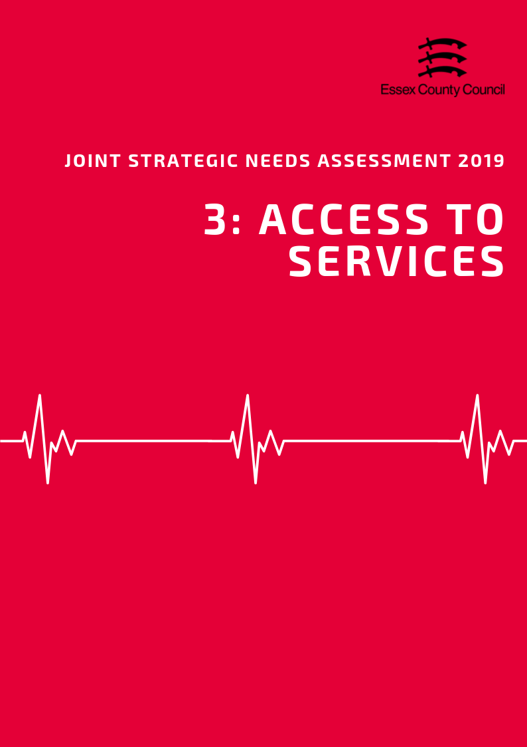

**ACCESS TO SERVICES**

**Area**

Covering an area of approximately 3670 square kilometres, Essex County Council administrative area is the third largest upper tier authority in the East of England in terms of area. The area is classified as predominantly urban with significant rural populations indicating that majority of residents live in or close to urban centres whilst 33.9% live in less densely populated rural settlements. This classification is based on where residents were living at the time of the 2011 census rather than the topography of the area as a whole. As such this does not necessarily reflect the challenges agencies will face when delivering services across an area with large numbers of smaller and possibly geographically disconnected settlements. By comparison to other counties in the East of England, Norfolk (61.9%) and Suffolk (59.9%) had a higher percentage of rural populations whilst Hertfordshire (15.9%) was lower.

***Population Density***

With an estimated 427 residents per square kilometre, the Essex County Council administrative area is roughly in line with the England average (430 per sq. km) and is the second most densely populated upper tier authority at in the East of England excluding unitary authorities). At a district level there is considerable variation with Harlow (2,836 per sq.km), Castle Point (1,998 per sq.km), and Basildon (1,689 per sq. km) being nearly 4 times or more densely populated than the county average; whilst Uttlesford (139 per sq. km), Maldon (180 per sq.km) and Braintree (248 per sq.km) were considerably lower.

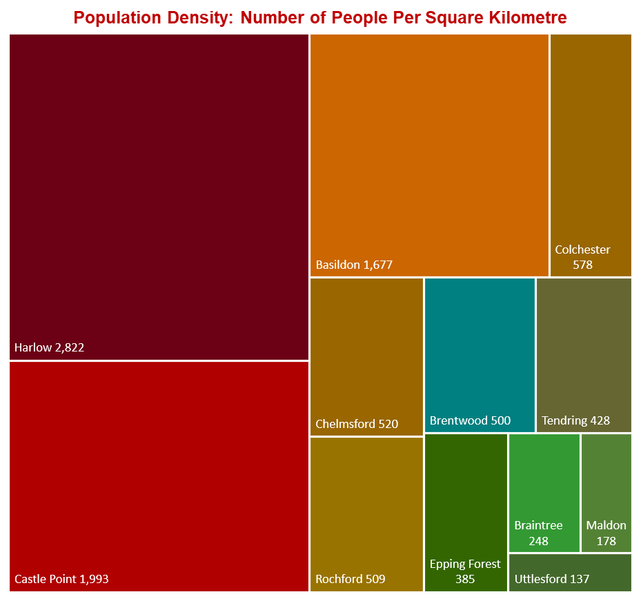

***Travel Time to Key Services***

According to the Department for Transport, the average time for an Essex resident to 8 key local services (including Employment Centres, Education Providers, GP Surgeries and Hospitals) was 19.4 minutes by public transport or walking, this varied considerably across the county with four predominantly rural areas of Braintree (23.7), Maldon (28.5), Tendring (21.5) and Uttlesford (23.7) having travel times in excess of the county average.

Travel time to GP surgeries was an average of 11.6 minutes (Highest: Uttlesford = 15.1; Lowest: Basildon = 8.9) with five areas having times longer than the average based on the nearest possible surgery.

Travel times to hospitals are where we see the largest disparity across the county with an average travel time of 45.4 minutes (Lowest: Harlow = 23.4 minutes; Highest: Maldon = 80.9). 5 areas had travels times higher than the county average with three areas, Maldon (80.9), Tendring (64.3) and Braintree (60) having travel times of one hour or more. It should also be noted that figures are based on average journey time by public transport but do not account for frequency of services at different times of day.

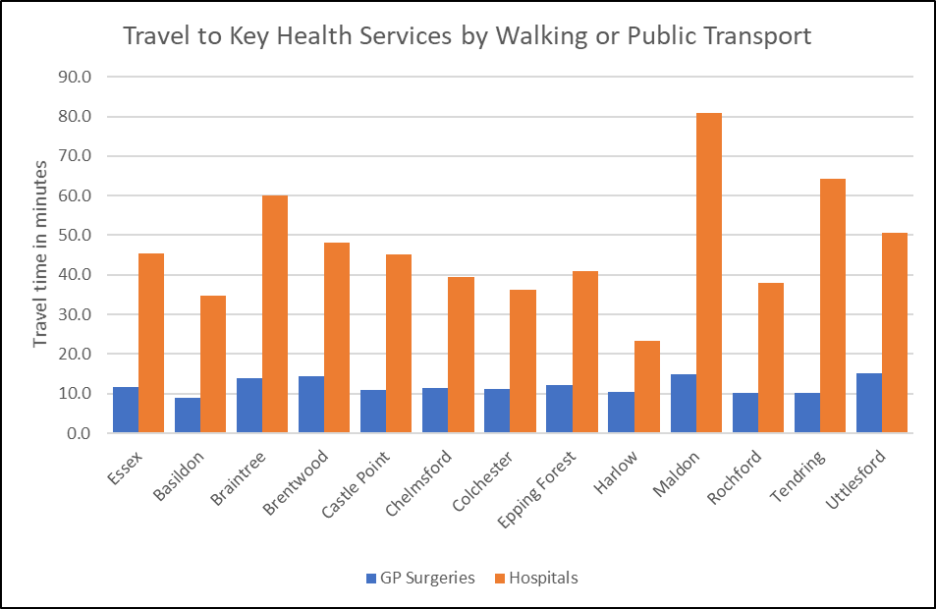

***Satisfaction with Local Services***

Information about satisfaction with GP services from the GP Patient Survey is presented at CCG level and shows that for the 5 CCGs in Essex the percentage of the patients aged 16+ who have had a positive experience of their GP varied slightly across the county with the highest levels in Castle Point and Rochford (82.7%) and the lowest levels in North East Essex (79.1%). Compared to the average for England (83.8%) and the Eastern Region (83.3%) all CCGs in Essex had lower than average levels of positive experiences.

|  |  |  |
| --- | --- | --- |
| **The percentage of patients aged 16+ who have a positive experience of their GP practice** | **Time period** | **%** |
| **England** | **2018** | **83.8** |
| **East NHS region** | **2018** | **83.3** |
| NHS Basildon And Brentwood CCG | 2018 | 80.6 |
| NHS Castle Point and Rochford CCG | 2018 | 82.8 |
| NHS Mid Essex CCG | 2018 | 79.2 |
| NHS North East Essex CCG | 2018 | 79.1 |
| NHS Southend CCG | 2018 | 80.1 |
| NHS Thurrock CCG | 2018 | 76.0 |
| NHS West Essex CCG | 2018 | 80.2 |

*Source: GP Patient Survey 2018*

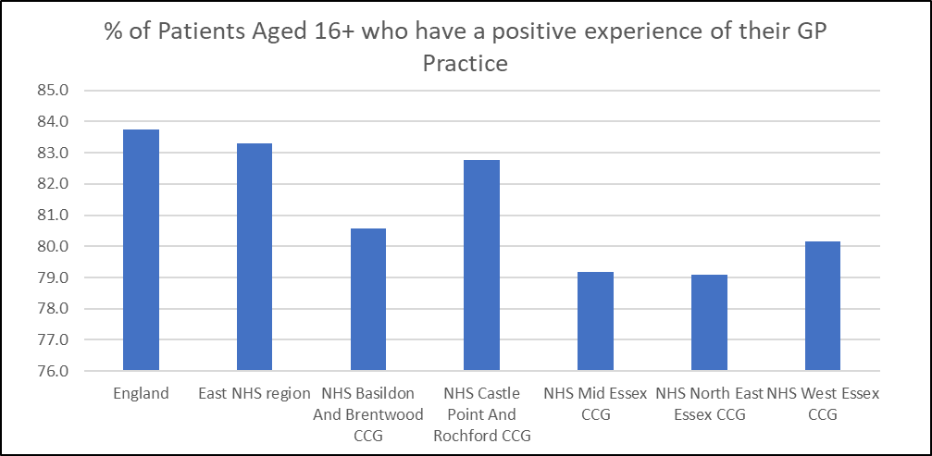

**Social Care Support Services**

***Looked After Children***

In the year ending the 31st March 2018 there were 1,461 children and young people who had been in the care in the care of Essex County Council at some point during this period, with a further 15 children and young people looked after under a series of short term placements. As of the 31st March 2018 there were 1017 currently in the care of the Local authority, equivalent to a rate of 33 children per 10,000 people. The rate of children in care was lower compared to the rate for England (64 per 10,000) and the East of England (49 per 10,000) and was the joint lowest rate of children in care out of the upper tier and unitary authorities in the region.

During same period, 454 children started to be looked after by the Local Authority whilst 457 ceased to be under the care of Essex County Council including 74 children who were adopted. It is estimated that during the same period there were 803 care leavers in Essex aged 17-21 of which 215 people were aged 17-18 and 588 people were aged 19-21. Based on available information it is estimated that 89% of care leavers aged 17-18 were living in suitable accommodation during this period, dropping to 82% for care leavers aged 19-21.

**Table: Looked After Children Numbers 2014-2018**

|  |  |  |  |  |  |  |  |  |  |  |
| --- | --- | --- | --- | --- | --- | --- | --- | --- | --- | --- |
|  | **All children looked after during the year ending 31 March excluding those only looked after under a series of short term placements** | | | | | **Children looked after during the year ending 31 March who were only looked after under a series of short term placements3** | | | | |
|  | 2014 | 2015 | 2016 | 2017 | 2018 | 2014 | 2015 | 2016 | 2017 | 2018 |
| **England** | 98,090 | 99,410 | 100,910 | 102,660 | 104,100 | 3,470 | 2,770 | 2,300 | 1,740 | 1,560 |
| **East of England** | 8,990 | 9,010 | 9,000 | 9,270 | 9,320 | 190 | 130 | 110 | 100 | 90 |
| **Essex** | 1,623 | 1,529 | 1,444 | 1,480 | 1,461 | 53 | 36 | 28 | 19 | 15 |
| **Southend-on-Sea** | 348 | 330 | 358 | 413 | 401 | 0 | 0 | 0 | 0 | 0 |
| **Thurrock** | 386 | 411 | 473 | 528 | 514 | 0 | 0 | 0 | 0 | 0 |

***Adult Social Care Support***

In 2017/18 Essex County Council's Adult Social Care Team provided long term support to 21,685 people aged 18 years and over. Of this cohort 6,610 people (30.5%) were aged 18 to 64 years and 15,075 people (69.5%) were aged 65 years and older. Compared to 2016-17 in the numbers of 18-64 year olds supported fell slightly by 1.7% but was an increase of 3.9% compared 2015-16. Similarly, the numbers of people aged 65+ given long term support reduced by 3.9% compared to 2016-17 but grew by 5.1% compared to 2015-16.

|  |  |  |  |  |  |
| --- | --- | --- | --- | --- | --- |
| **Long Term Support during the year** | | | | | |
|  | **All Persons** | **18 to 64** | **18 to 64 (%)** | **65 and over** | **65+ (%)** |
| England | 857,765 | 292,380 | 34.1% | 565,385 | 65.9% |
| East of England | 92,140 | 30,490 | 33.1% | 61,650 | 66.9% |
| ***Essex*** | ***21,685*** | ***6,610*** | ***30.5%*** | ***15,075*** | ***69.5%*** |
| Southend-on-Sea | 4,235 | 1,595 | 37.7% | 2,640 | 62.3% |
| Thurrock | 2,305 | 1,075 | 46.6% | 1,230 | 53.4% |

The Adult Social Care team also facilitated short-term care aimed at maximising independent living to 6,125 people, of whom 385 (6.3%) were aged 18-64 and 5,740 (93.7%) were aged 65 years and older. Between 2016-17 and 2017-18 the numbers of 18-64 year olds given short-term support increased by 11.6% but was only a 1.3% increase compared to figures from 2015-16. The numbers of people aged 65+ receiving short long term support increased by 15.2% compared to 2016-17 but was 15.8% lower than 2015-16%.

|  |  |  |  |  |  |
| --- | --- | --- | --- | --- | --- |
| **New clients with an episode of ST-Max care and a known sequel** | | | | | |
|  | **All Persons** | **18 to 64** | **18 to 64 (%)** | **65 and over** | **65+ (%)** |
| England | 212,835 | 25,285 | 11.88% | 187,550 | 88.1% |
| East of England | 20,825 | 2,625 | 12.61% | 18,200 | 87.4% |
| ***Essex*** | ***6,125*** | ***385*** | ***6.29%*** | ***5,740*** | ***93.7%*** |
| Southend-on-Sea | 1,320 | 410 | 31.06% | 910 | 68.9% |
| Thurrock | 605 | 225 | 37.19% | 380 | 62.8% |

During 2017-18 the Adult Social Care Team received 24,625 support requests from new clients of which 5,845 (23.7%) were aged 18-64 and 18,780 (76.3%) were aged 65 and over. Compared to the previous year this was a 2.7% reduction in the number of requests for support from all ages and an 8.1% reduction compared to 2015-16. Looking at the different age groups individually the number of requests for support from new clients aged 18-64 grew by 7.35% compared to the previous year, and by 10.3% compared to two years prior. By comparison the number of requests for support from new clients aged 65 and over reduced by 5.5% in one year and reduced by 12.7% over 2 years.

|  |  |  |  |  |  |
| --- | --- | --- | --- | --- | --- |
| **Requests for support received from new clients** | | | | | |
|  | **All Persons** | **18 to 64** | **18-64%** | **65 and over** | **Age 65 + %** |
| England | 1843920 | 523,920 | 28.4% | 1,320,000 | 71.6% |
| East of England | 167215 | 44,380 | 26.5% | 122,835 | 73.5% |
| **Essex** | **24625** | **5,845** | **23.7%** | **18,780** | **76.3%** |
| Southend-on-Sea | 3935 | 1,610 | 40.9% | 2,325 | 59.1% |
| Thurrock | 7630 | 2,155 | 28.2% | 5,475 | 71.8% |

In 2017-18 majority of new Adult Social Care clients aged 18-64 were accessing social care services through community routes (5,145 people / 88%), with a small number (445 people / 7.6%) accessing support on discharge from hospital, and a number of people (205 people / 3.5%) who transitioned into the adult social care system from children’s services.

According to the NHS data Essex County Council adult social care team receives a lower level or requests for support from new clients aged 18-64 compared to other areas. In 2017-18 requests for support were equivalent to 680 requests per 100,000 residents compared to an average of 1,555 requests per 100,000 for England, an average of 1,405 per 100,000 for County Councils, and 1,220 per 100,000 average across the East of England for the same age group. This was also the 4th lowest level in the region. The number of requests for support from adults aged 65+ was considerably higher than younger age groups but was also found to be lower than other areas. In 2017-18 requests from this age group were equivalent to a rate of 6,265 per 100,000 people, which was lower than the rate for England (13,160), the average for county councils nationally (12,110), the East of England (10,220), and is the second lowest rate in the East of England compared to the other upper tier and unitary authorities.

Looking at the number of requests for support made by clients to Adult Social care during 2017-18 period both the 18-64 age group and the 65+ age group was slightly lower than other areas with average of 1 support request per person for both age group. This was slightly lower than the average for England (18-64: 1.32; 65+: 1.39) and the East of England (18-64: 1.09; 65+: 1.15).

***Carers Support***

In 2017-18 Essex County Council provided support to 4,435 carers across the county. Of the carers supported the majority (2,245 people / 50.6%) were aged 65 to 84 years old, followed by carers aged 26-64 (1,395 people / 31.5%), carers aged 85+ (735 people / 16.5%), and carers aged 18-25 (55 people / 1.24%). No carers aged under 18 were recorded as receiving support from ECC during this period. Compared to other areas Essex County Council supported a higher number of carers aged 65-84 and 85+ compared to the average for England (36.7%, 8.9%) and the East of England (41.2%, 10.7%) and lower levels of carers aged 26-64 England = 50.7%; East of England = 45.6%).

Carers support provided by Essex County Council during this period included 3,030 episodes of Advice Guidance and Signposting, 1,140 direct payments supports and 200 respite care and other direct support to the cared for person. Alongside the support given to carers by Essex County Council figures from the Department for Work and Pensions from November 2018 identified 16,620 residents in the Essex County Council area who were in receipt of Carers Allowance including 110 people aged under 18 who are providing some form of unpaid care. As carers allowance when residents begin to receive the state pension only a small number of carers (3 people) are recorded as being in receipt of this benefit over the age of 65 as such these figures do not reflect the number of state pension age carers in the county.

|  |  |  |  |  |  |
| --- | --- | --- | --- | --- | --- |
| **Table: Support provided to carers during the year, by age band, 2017-18** | | | | | |
|  | **England** | **East of England** | **Essex** | **Southend-on-Sea** | **Thurrock** |
| **Under 18** | 4,215 | 65 | **\*** | 30 | * |
| **Under 18 %** | 1.17% | 0.25% | **0.00%** | 1.14% | 0.00% |
| **18 to 25** | 9,340 | 575 | **55** | 45 | 85 |
| **18 to 25%** | 2.59% | 2.23% | **1.24%** | 1.71% | 14.53% |
| **26 to 64** | 182,510 | 11,785 | **1,395** | 1,495 | 285 |
| **26 to 64%** | 50.65% | 45.63% | **31.45%** | 56.95% | 48.72% |
| **65 to 84** | 132,220 | 10,650 | **2,245** | 855 | 45 |
| **65 to 84 %** | 36.70% | 41.20% | **50.60%** | 32.60% | 7.70% |
| **85 and over** | 32,025 | 2,760 | **735** | 205 | 165 |
| **85 and over %** | 8.90% | 10.70% | **16.60%** | 7.80% | 28.20% |
| **Total** | 360,310 | 25,830 | **4,435** | 2,625 | 585 |
| *Source: ASC-FR Collection 2017-18, SALT Collection 2017-18, NHS Digital* | | | | | |

|  |  |  |  |  |  |  |  |  |  |  |  |  |  |
| --- | --- | --- | --- | --- | --- | --- | --- | --- | --- | --- | --- | --- | --- |
|  | **Number of people in receipt of carers allowance by age Group – November 2018** | | | | | | | | | | | | |
| **Total** | | **under 18** | | **18-24** | **25-34** | | **35-44** | | **45-54** | **55-64** | | **65+** |
| **Essex** | **16,620** | | **30** | | **580** | **2,940** | | **4,020** | | **4,410** | **4,410** | | **230** |
| Basildon | 2,690 | | 10 | | 120 | 530 | | 710 | | 670 | 630 | | 30 |
| Braintree | 1,750 | |  | | 40 | 350 | | 430 | | 460 | 430 | | 20 |
| Brentwood | 540 | |  | | 20 | 70 | | 120 | | 160 | 150 | | ~ |
| Castle Point | 1,110 | |  | | 40 | 160 | | 220 | | 310 | 350 | | 20 |
| Chelmsford | 1,500 | |  | | 50 | 260 | | 400 | | 400 | 360 | | 20 |
| Colchester | 1,990 | | 10 | | 80 | 390 | | 500 | | 520 | 450 | | 30 |
| Epping Forest | 1,170 | |  | | 40 | 170 | | 280 | | 320 | 340 | | 20 |
| Harlow | 1,100 | |  | | 40 | 220 | | 300 | | 260 | 260 | | 10 |
| Maldon | 720 | |  | | 10 | 130 | | 170 | | 200 | 210 | | 10 |
| Rochford | 770 | |  | | 20 | 80 | | 190 | | 230 | 250 | | 10 |
| Tendring | 2,800 | |  | | 100 | 490 | | 610 | | 720 | 830 | | 40 |
| Uttlesford | 480 | |  | | 10 | 80 | | 90 | | 140 | 130 | | 10 |
|  | | **Number of people in receipt of carers allowance by Gender –November 2018** | | | | | | | | | | | |
| **All Claimants** | | **Male** | | | | | **Female** | | | | |
|  | | **Number** | | **Number** | | | **%** | | **Number** | | | **%** | |
| **Essex** | | **16,620** | | **3,760** | | | **22.6%** | | **12,860** | | | **77.4%** | |
| Basildon | | 2,690 | | 610 | | | 22.7% | | 2,080 | | | 77.3% | |
| Braintree | | 1,750 | | 390 | | | 22.3% | | 1,360 | | | 77.7% | |
| Brentwood | | 540 | | 100 | | | 18.5% | | 440 | | | 81.5% | |
| Castle Point | | 1,110 | | 230 | | | 20.7% | | 880 | | | 79.3% | |
| Chelmsford | | 1,510 | | 310 | | | 20.5% | | 1,200 | | | 79.5% | |
| Colchester | | 1,990 | | 430 | | | 21.6% | | 1,560 | | | 78.4% | |
| Epping Forest | | 1,170 | | 260 | | | 22.2% | | 910 | | | 77.8% | |
| Harlow | | 1,100 | | 230 | | | 20.9% | | 870 | | | 79.1% | |
| Maldon | | 720 | | 140 | | | 19.4% | | 580 | | | 80.6% | |
| Rochford | | 770 | | 160 | | | 20.8% | | 610 | | | 79.2% | |
| Tendring | | 2,810 | | 800 | | | 28.5% | | 2,010 | | | 71.5% | |
| Uttlesford | | 480 | | 100 | | | 20.8% | | 380 | | | 79.2% | |
| *Source: Department of Work and Pensions 2019* | | | | | | | | | | | | | |

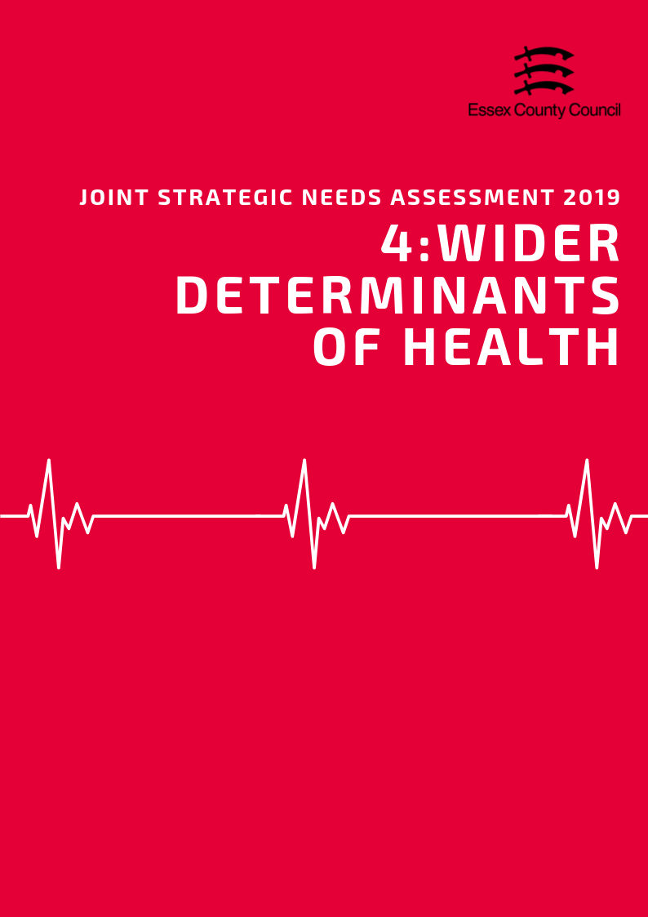

**Wider Determinants of Health**

***“Wider determinants, also known as social determinants, are a diverse range of social, economic and environmental factors which impact on people’s health. Such factors are influenced by the local, national and international distribution of power and resources which shape the conditions of daily life. They determine the extent to which different individuals have the physical, social and personal resources to identify and achieve goals, meet their needs and deal with changes to their circumstances.” Public Health England 2019***

***Income & Average Earnings***

The average weekly income for an Essex resident working full time in 2018 was £618.6 this is was £43.70 (7%) higher than the average for England, and £28.30 (4.6%) higher than the average for the East of England. By comparison part time workers in Essex earned £182.10 per week, £5.20 (-2.9%) less than the average for England, and £5.10 (-2.8%) less than the average for the East of England.

Earnings varied at District level with Brentwood (£754.10 p/w), Rochford (£729.50 p/w) and Epping Forest (£681.90 p/w) earning the most on average, whilst residents in Harlow (£531.10 p/w), Tendring (£543.90% p/w) and Colchester (£570.40 p/w) earning the lowest.

Male residents earned on average £130 (19.5%) more per week than female residents with an average weekly pay of £668.10 for male full time workers compared to £618.60 for females. This gender based income difference varied considerably at District Level with Rochford (7.2%), Tendring (7.4%) and Brentwood (9.9%) having the smallest difference, whilst Castle Point (29.3%), Braintree (26%) and Basildon (23%) had the largest."

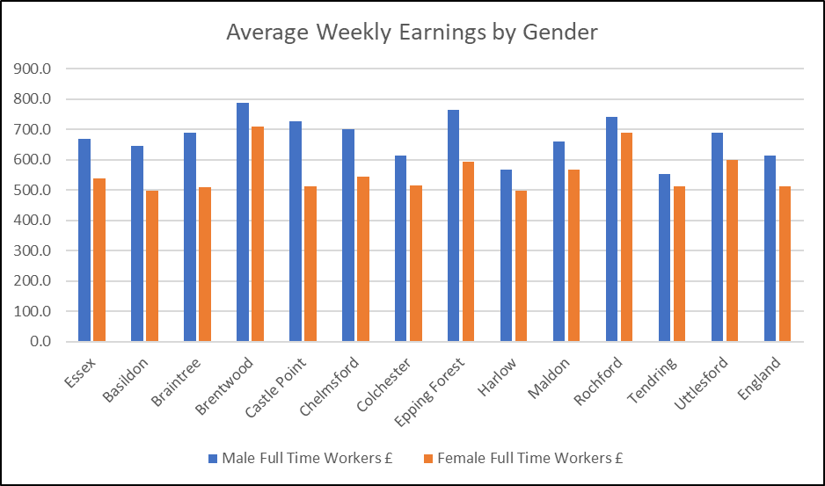

***Deprivation***

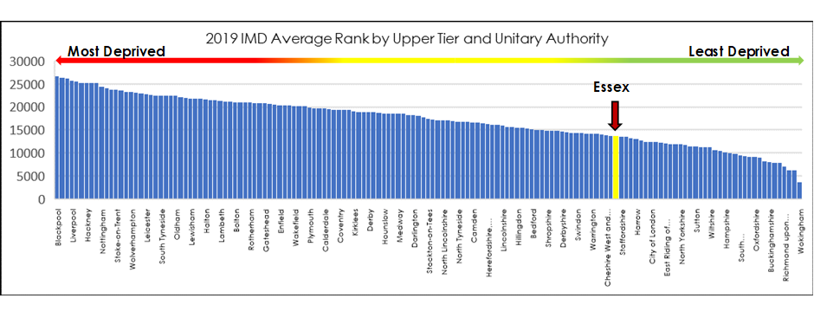The English Indices of Deprivation (2019) suggest that, overall, Essex compares favourably with other local authority areas. It has lower levels of deprivation than 70% of upper tier authority areas. Essex’s overall position has changed very little since 2015, albeit following a sustained increase in deprivation since 2007 and a steep increase since 2010.

Essex compares less well against other counties in the south east of England. The percentage of Essex residents living in the most deprived 20% of areas is amongst the highest in the South East – behind only Kent and East Sussex

|  |  |  |  |  |  |
| --- | --- | --- | --- | --- | --- |
|  | **Decile 1+2** | | **Decile 9+10** | | **Total Population** |
| **Number of Residents** | **% of total population** | **Number of Residents** | **% of total population** |
| **Buckinghamshire** | 1317 | 0.3% | 252381 | 48.0% | 526324 |
| **East Sussex** | 78232 | 14.4% | 85308 | 15.7% | 544685 |
| **Essex** | **123640** | **8.6%** | **370347** | **25.6%** | **1445044** |
| **Hampshire** | 64387 | 4.7% | 590207 | 43.5% | 1356711 |
| **Hertfordshire** | 22527 | 1.9% | 463679 | 39.8% | 1164366 |
| **Kent** | 220479 | 14.5% | 287146 | 18.9% | 1520860 |
| **Oxfordshire** | 28691 | 4.3% | 311445 | 46.3% | 672541 |
| **Surrey** | 6316 | 0.5% | 618584 | 52.8% | 1170766 |
| **West Berkshire** | 1551 | 1.0% | 71947 | 45.7% | 157460 |
| **West Sussex** | 30175 | 3.6% | 267882 | 32.0% | 838034 |
| **Buckinghamshire** | 1317 | 0.3% | 252381 | 48.0% | 526324 |

The most significant structural factors affecting deprivation are incomes and employment, but recent changes in deprivation across Essex stem from small changes in barriers to housing and local services; health outcomes; and levels of crime.

Within Essex there is a large and growing gap between the most and least deprived districts. Castle Point Borough and Tendring District have seen sustained increases in deprivation relative to districts across England. Tendring District in particular is falling further behind the rest of the county.

|  |  |  |  |  |  |  |  |  |
| --- | --- | --- | --- | --- | --- | --- | --- | --- |
|  | **2019** | | **2015** | | **2010** | | **2007** | |
| **Ave. Rank** | **Rank of Ave. Rank** | **Ave. Rank** | **Rank of Ave. Rank** | **Ave. Rank** | **Rank of Ave. Rank** | **Ave. Rank** | **Rank of Ave. Rank** |
| **Tendring** | 22083.12 | 32 | 21026.27 | 49 | 19241.56 | 80 | 18983.26 | 81 |
| **Harlow** | 18582.78 | 100 | 19908.53 | 70 | 19826.46 | 68 | 18606.31 | 92 |
| **Basildon** | 17744.6 | 111 | 17704.19 | 110 | 15842.34 | 136 | 16050.90 | 132 |
| **Colchester** | 13956.03 | 181 | 14032.56 | 184 | 12252.41 | 197 | 12337.15 | 190 |
| **Castle Point** | 13905.85 | 182 | 13918.57 | 186 | 12726.06 | 190 | 11166.14 | 208 |
| **Epping Forest** | 12930.26 | 200 | 13195.47 | 196 | 12370.31 | 194 | 12451.49 | 187 |
| **Braintree** | 12716.15 | 203 | 13452.81 | 194 | 12129.57 | 201 | 11974.84 | 198 |
| **Maldon** | 12389.29 | 211 | 12889.24 | 201 | 10960.06 | 217 | 10736.04 | 214 |
| **Chelmsford** | 10004.42 | 260 | 10252.97 | 253 | 7429.14 | 284 | 7265.32 | 267 |
| **Rochford** | 8121.79 | 286 | 8967.92 | 277 | 7248.37 | 285 | 7250.35 | 268 |
| **Brentwood** | 8058.04 | 287 | 8128.47 | 286 | 7679.132 | 281 | 7326.36 | 265 |
| **Uttlesford** | 7386.46 | 295 | 8096.25 | 289 | 5958.065 | 296 | 4984.24 | 297 |

Looking at the average rank of the LSOAs in each of the districts shows that between 2015 and 2019 10 of the 12 areas saw a decrease in rank indicating relative decrease in overall deprivation. Harlow saw the largest decrease of 1325.75 places followed by Rochford (-846.13 places). Castle Point and Colchester has relatively small decreases in their average ranks, but these changes were not large enough to maintain their rank of average rank* from 2015 and thus these areas decreased slightly in their rank of all LTLAs. Brentwood also saw a relatively small increase in the average rank of the LSOAs in its area however due to the gap between the next closest areas nationally, this area was able to increase its position by one place overall.

Tendring had the largest average rank increase between 2015 and 2019 moving up by 1065.71 places, thus accounting for the drop in its rank of average rank of from 49th place nationally to 32nd and moving the area into the most deprived decile nationally.

There are major concentrations of deprivation at the neighbourhood level in Essex. 75 of neighbourhoods (LSOAs) are among the 20% most deprived nationally. They are home to over 120,000 Essex residents, a figure which has doubled since 2007.

|  |  |  |  |  |  |
| --- | --- | --- | --- | --- | --- |
|  | **Decile 1+2** | | **Decile 9+10** | | **Total Population** |
| **Time Period** | **Number of Residents** | **% of Population** | **Number of Residents** | **% of Population** |
| 2007 | 60380 | 4.5% | 415648 | 30.9% | 1346689 |
| 2010 | 82187 | 5.9% | 429257 | 30.9% | 1387321 |
| 2015 | 124984 | 8.9% | 339618 | 24.2% | 1406094 |
| 2019 | 123640 | 8.6% | 370347 | 25.6% | 1445044 |

*\*(Please note that rank of average rank calculations for previous years have been recalculated solely for Lower Tier Authorities in the 2019 Indices of Deprivation to allow for a standardised comparison over time. As such these may be slightly different compared to the rank of average ranks listed in previous IOD documents).*

*See the Essex 2019 Indices of Deprivation report for a full analysis of the latest English Indices of deprivation data for each district.*

***Fuel Poverty***

52,833 households or 8.64% were estimated to be in fuel poverty in 2016 with 6 areas having percentages higher than average (Highest: Tendring = 10.6%; Lowest: Rochford = 7.6%).



***Child Poverty***

The Office of National Statistics estimated that 13,100 households with dependent children across the county were workless in 2017 (i.e. no resident adults classed as economically active being in work). This was equivalent to approximately 2.8% but was lower than the England average of 3.4%. This varies across districts with 3 areas, Tendring (8.7%); Harlow (8.2%); and Chelmsford (4.2%) having levels higher than the England and County levels.

89,381 pupils or 10.04% were also eligible for free school meals at the time of the 2018 school census (Highest: Tendring = 16.86%; Lowest: Uttlesford = 4.25%). This was lower than the average for England (13.35%) with only one area (Tendring) having higher levels than the national average.

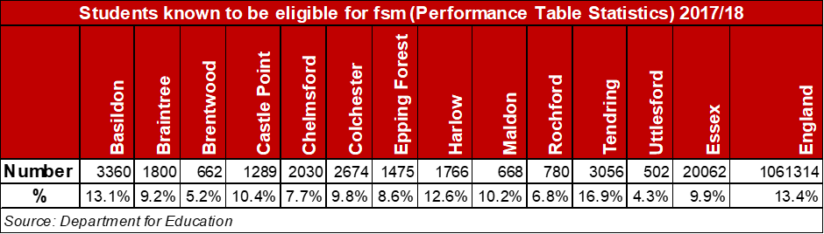

41,365 children and young people (13.0% living in the area) are recorded as being in low income households either in receipt of Child Tax Credits, Income Support or Job Seeker Allowance. This was lower than the rate for England (16.6%) but varied considerable across the county (Highest = Tendring 23%; Lowest = 6.6%) with a 16.4 percentage point different between the highest and lowest areas.

|  |  |  |  |  |  |  |
| --- | --- | --- | --- | --- | --- | --- |
| **Children in families in receipt of CTC (<60% median income) or IS/JSA** | | | | | | |
|  | *Total number of children where the youngest child is aged:* | | | | *Total Number of Children in low income households* | *% of All Children* |
| *0 - 4* | *5 - 10* | *11 - 15* | *16 - 19* |
| ***Basildon*** | 4,075 | 2,240 | 985 | 370 | 7,670 | 18.2% |
| ***Braintree*** | 1,950 | 1,010 | 575 | 215 | 3,750 | 11.7% |
| ***Brentwood*** | 695 | 335 | 205 | 80 | 1,315 | 9.0% |
| ***Castle Point*** | 1,250 | 680 | 380 | 120 | 2,430 | 14.1% |
| ***Chelmsford*** | 1,900 | 1,030 | 565 | 195 | 3,690 | 10.6% |
| ***Colchester*** | 2,985 | 1,510 | 630 | 230 | 5,355 | 14.0% |
| ***Epping Forest*** | 1,595 | 940 | 475 | 205 | 3,215 | 12.0% |
| ***Harlow*** | 2,040 | 995 | 420 | 175 | 3,630 | 16.6% |
| ***Maldon*** | 645 | 380 | 230 | 80 | 1,335 | 11.1% |
| ***Rochford*** | 755 | 455 | 230 | 120 | 1,560 | 9.6% |
| ***Tendring*** | 3,250 | 1,755 | 890 | 360 | 6,255 | 23.0% |
| ***Uttlesford*** | 545 | 345 | 190 | 80 | 1,160 | 6.6% |
| ***Essex Total*** | ***21,685*** | ***11,675*** | ***5,775*** | ***2,230*** | ***41,365*** | ***13.0%*** |
| ***England*** | ***1,016,710*** | ***530,585*** | ***270,235*** | ***111,760*** | ***1,929,290*** | ***16.6%*** |

***Education & Skills***

Across Essex it is estimated that 23.9% of residents aged 16+ have no formal qualifications, slightly higher than the averages for England and the East of England of 22.5% (both).

|  |  |  |  |  |
| --- | --- | --- | --- | --- |
| ***Area*** | ***Number of adult residents with no qualifications*** | ***% of adult residents with no qualifications*** | ***Number of adult residents with Level 4 qualifications and above*** | ***% of adult residents with Level 4 qualifications and above*** |
| **Basildon** | 37084 | 26.64% | 25939 | 18.63% |
| **Braintree** | 26958 | 22.83% | 26212 | 22.20% |
| **Brentwood** | 11651 | 19.38% | 18441 | 30.68% |
| **Castle Point** | 21885 | 29.92% | 10693 | 14.62% |
| **Chelmsford** | 25844 | 18.86% | 39452 | 28.80% |
| **Colchester** | 27440 | 19.40% | 38412 | 27.16% |
| **Epping Forest** | 24360 | 23.95% | 25769 | 25.34% |
| **Harlow** | 16948 | 26.05% | 11468 | 17.63% |
| **Maldon** | 11749 | 23.13% | 12009 | 23.64% |
| **Rochford** | 16134 | 23.63% | 13659 | 20.01% |
| **Tendring** | 39616 | 34.30% | 18340 | 15.88% |
| **Uttlesford** | 11232 | 17.72% | 20251 | 31.94% |
| **Essex** | 270901 | 23.89% | 260645 | 22.99% |
| **England** | 9656810 | 22.46% | 11769361 | 27.38% |
| **East of England** | 1067449 | 22.53% | 1218862 | 25.72% |

Essex residents also achieve lower levels of NVQ level four qualifications (certificate of higher education) or higher (Batchelors Degree and above) with 22.9% of residents gaining this level of qualification compared to the 27.4% at the England Level, and 25.7% across the East of England. At a District Level Tendring (34.3%), Castle Point (29.9%), and Basildon have the highest proportion of residents with no formal qualifications, whilst Castle Point (14.6%), Tendring (15.9%), and Harlow (17.6%) also have the lowest level of NVQ level 4 Qualifications. By comparison Uttlesford (17.7%), Chelmsford (18.9%) and Brentwood (19.4%) have the lowest levels of residents with no formal qualifications and the highest levels of residents with Level 4 qualifications or above.

***Early Years***

At the Essex level the percentage of children achieving a good level of development has generally improved since 2015 with 72.1% of children achieving a good level of development in 2018, an increase of 4.4 percent compared to 2015. The 2018 score is just above the average for England of 71.5% but is a slight reduction (-1.4%) compared to 2017. A similar trend was seen in the percentage of children achieving at least the expected level across all early learning goals. This has increased to 70.7%, up by 4.9% compared to 2015 but down 1.5% on the previous year. This was also just above the average for England of 70.2%.

|  |  |
| --- | --- |
| ***Achieving at least the expected level across all early learning goals***  *Children achieving at least the expected level across all early learning goals (ELGs) are those achieving ‘expected’ or ‘exceeded’ in all 17 ELGs.* | ***Good level of development (GLD)***  *Children achieving a good level of development are those achieving at least the expected level within the following areas of learning: communication and language; physical development; personal, social and emotional development; literacy and mathematics.* |

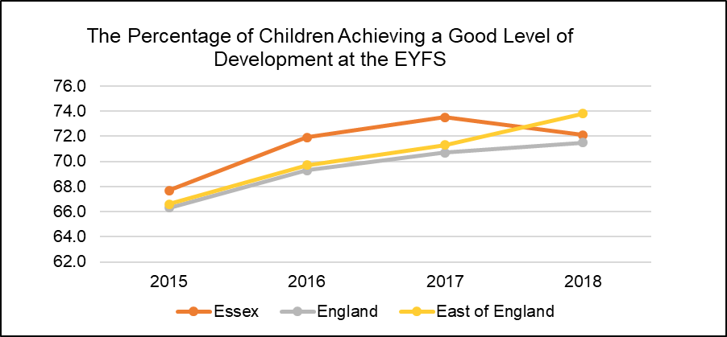

At a district level, most areas have seen improvements in child development at the Early Years Foundation Stage since for both performance measures. Rochford (79%), Brentwood (77%) and Uttlesford (77%) had the highest levels pupils achieving a good level of development as well as at least the expected standard in all ELGs (77%, 76%, 76%). Tendring (70%) and Harlow (72%) had the lowest levels of pupils achieving a good level of development and at least the expected standards (70%, 71%) although levels in Harlow were above higher than the England averages.

|  |  |  |  |  |  |  |  |  |  |  |  |
| --- | --- | --- | --- | --- | --- | --- | --- | --- | --- | --- | --- |
|  | **2015** | | **2016** | | **2017** | | **2018** | |  | **Change 2015-2018** | |
| **Area of Pupil Residence** | ***% of ELG*** | ***% of GLD*** | ***% of ELG*** | ***% of GLD*** | ***% of ELG*** | ***% of GLD*** | ***% of ELG*** | ***% of GLD*** |  | *% of ELG* | *% of GLD* |
| **Basildon** | 65 | 67 | 70 | 71 | 70 | 71 | 72.0 | 73.0 | 2.0 | 6.0 |
| **Braintree** | 63 | 65 | 71 | 72 | 72 | 74 | 72.0 | 73.0 | 9.0 | 8.0 |
| **Brentwood** | 70 | 71 | 73 | 75 | 77 | 78 | 76.0 | 77.0 | 6.0 | 6.0 |
| **Castle Point** | 61 | 65 | 70 | 72 | 70 | 73 | 73.0 | 74.0 | 12.0 | 9.0 |
| **Chelmsford** | 68 | 70 | 73 | 73 | 74 | 75 | 74.0 | 75.0 | 6.0 | 5.0 |
| **Colchester** | 64 | 66 | 68 | 70 | 71 | 72 | 73.0 | 73.0 | 9.0 | 7.0 |
| **Epping Forest** | 67 | 69 | 69 | 70 | 72 | 73 | 73.0 | 73.0 | 6.0 | 4.0 |
| **Harlow** | 65 | 66 | 69 | 71 | 69 | 72 | 71.0 | 72.0 | 6.0 | 6.0 |
| **Maldon** | 70 | 72 | 73 | 74 | 74 | 75 | 75.0 | 76.0 | 5.0 | 4.0 |
| **Rochford** | 70 | 72 | 73 | 74 | 76 | 77 | 77.0 | 79.0 | 7.0 | 7.0 |
| **Tendring** | 64 | 66 | 66 | 67 | 67 | 70 | 70.0 | 70.0 | 6.0 | 4.0 |
| **Uttlesford** | 72 | 73 | 78 | 79 | 76 | 77 | 76.0 | 77.0 | 4.0 | 4.0 |
| **Essex** | 65.8 | 67.7 | 70.5 | 71.9 | 72.1 | 73.5 | 70.7 | 72.1 | 4.9 | 4.4 |
| **England** | 64.1 | 66.3 | 67.3 | 69.3 | 69.0 | 70.7 | 70.2 | 71.5 | 6.1 | 5.2 |
| **East of England** | 64.6 | 66.6 | 67.8 | 69.7 | 69.4 | 71.3 | 73.0 | 73.8 | 8.4 | 7.2 |
| *% of ELG = % of pupils achieving at least the expected standard in all Early Learning Goals* | | | | | | | | | | | |
| *% of GLD = % of pupils achieving a Good Level of Development at the Early Years foundation Stage* | | | | | | | | | | | |

*GCSE Attainment*

From summer 2017 the way GCSEs are graded have changed and are now graded be graded from 9 to 1, with 9 being the highest grade, rather than A*-G. The old and new GCSE grading scales do not directly compare but there are three points where they align:

* The bottom of grade 7 is aligned with the bottom of grade A;
* The bottom of grade 4 is aligned with the bottom of grade C; and
* The bottom of grade 1 is aligned with the bottom of grade G.

Figures will be published detailing the proportion of pupils achieving both grade 4 and above and grade 5 and above. The Department for Education classes grade 4 as a ‘standard pass’; this is the minimum level that pupils need to reach in English and maths (previously a ‘C’). Grade 5 and above is recognised as a ‘strong pass’ – this will be one of the headline measures of school performance.

Since the introduction of the new GCSE grading system, pupil performance across Essex has generally been just above the national average with 63.3% of pupils achieving grade 9-4 in English and Maths (a good pass) and 40.7% achieving grade 9-5 (a strong pass) in 2018. This is higher than the England averages (59.1% and 39.9%) but lower than the average for the East of England (65.2% and 43.7%). Compared to scores for 2017 this is slight reduction in the overall attainment rate (-1.6%, -1.7%) however it is not possible to make a longer-term comparison due to changes in the grading system.

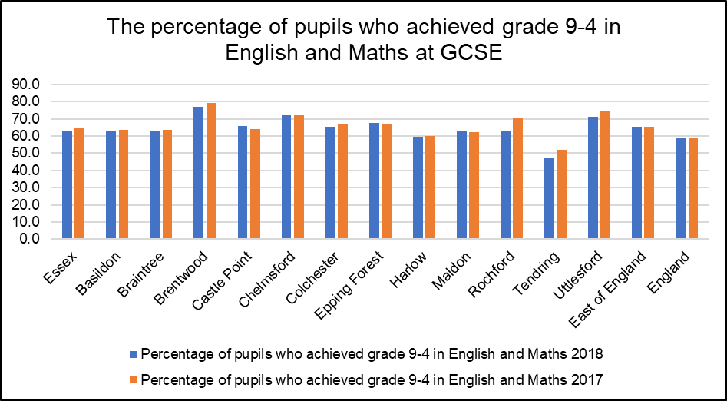

Attainment 8 measures the average achievement of pupils in up to 8 qualifications including English (double weighted if the combined English qualification, or both language and literature are taken), maths (double weighted), three further qualifications that count in the English Baccalaureate (EBacc) and three further qualifications that can be GCSE qualifications (including EBacc subjects) or any other non-GCSE qualifications on the DfE approved list. This measure will become the standard performance measure for areas, replacing the previously used measure of the percentage of students achieving 5 or more grade A* to Cs including English and Maths.

Looking at the pupils' Attainment 8 score provides a slightly longer-term comparison of performance and shows that overall performance has fallen 4.3% down from 50.4% in 2016 to 46.1% in 2018. These figures are higher than the average for England but lower than East of England. The downward trend in performance for Essex matches the trend observed at across England since the introduction of the new GCSE grading system which has seen a 4% reduction in average attainment 8 scores between 2016 and 2018.

At a District level two areas, Tendring (39.9) and Harlow (42.8), had average Attainment 8 scores below the average for both Essex and England. A further three areas, Castle Point (45), Basildon (45.3) and Braintree (45.5), had average scores above the average for England but below the average for Essex. The remaining areas all achieved scores above both county and national average.

|  |  |  |  |  |  |  |  |
| --- | --- | --- | --- | --- | --- | --- | --- |
| **GCSE Attainment 2017 & 2018** | | | | | | | |
| **Area** | 2017 | | | 2018 | | | Average Attainment 8 Score 2017-2018 Change |
| % of pupils who achieved grade 9-5 in English and Maths | % of pupils who achieved grade 9-4 in English and Maths | Average Attainment 8 Score | % of pupils who achieved grade 9-5 in English and Maths | % of pupils who achieved grade 9-4 in English and Maths | Average Attainment 8 Score |
| **Basildon** | 41.4 | 63.4 | 46.4 | 40.7 | 62.6 | 45.3 | -4.0 |
| **Braintree** | 40.4 | 63.6 | 45.2 | 39 | 63 | 45.5 | -4.0 |
| **Brentwood** | 56.5 | 79.3 | 51.0 | 56.2 | 76.8 | 52.6 | -1.5 |
| **Castle Point** | 39.2 | 64.2 | 45.6 | 41.9 | 65.6 | 45 | -4.7 |
| **Chelmsford** | 49.5 | 72.2 | 50.4 | 49.5 | 72 | 50.9 | -3.1 |
| **Colchester** | 46.9 | 66.7 | 47.6 | 43.6 | 65.3 | 48 | -3.6 |
| **Epping Forest** | 43.8 | 66.8 | 47.8 | 45 | 67.8 | 46.9 | -4.3 |
| **Harlow** | 36.5 | 59.8 | 44.1 | 38.3 | 59.6 | 42.8 | -5.4 |
| **Maldon** | 42.4 | 62.4 | 47.0 | 39 | 62.8 | 47 | -5.8 |
| **Rochford** | 47.5 | 70.5 | 47.9 | 41.5 | 63.1 | 46.3 | -4.7 |
| **Tendring** | 31.9 | 52.0 | 41.6 | 26.5 | 47.2 | 39.9 | -5.9 |
| **Uttlesford** | 51.6 | 74.9 | 51.5 | 50.1 | 71.1 | 51.8 | -3.1 |
| **Essex** | 42.4 | 64.9 | 46.7 | 40.7 | 63.3 | 46.1 | -4.3 |
| **East of England** | 43.5 | 65.4 | **46.7** | 43.7 | 65.2 | 47 | -3.4 |
| **England** | 39.1 | 58.5 | 44.6 | 39.9 | 59.1 | 44.5 | -4.0 |

*Destination of School Leavers*

In 2017 95% of pupils in Essex were in sustained Education, Employment or Training at the end of Key stage 4 (Secondary School). This is 1% higher than the average for England and in line with the rest of the Eastern region. Within this group 86% were in education, 5 percent were in apprenticeships, and 4% were in Employment roughly in line with the average for England and the East. At a district level Tendring and Basildon had the lowest rates of school leavers continuing in Education with an average of 82%, 4 percentage points below the county and national average, and the highest levels of young people not sustaining education employment or training (7%). Brentwood (90%) and Chelmsford (89%) had the highest levels of young people continuing in education, whilst Castle Point (8%) and Rochford (7%) had the highest proportions of young people entering apprenticeships.

|  |  |  |  |  |  |  |
| --- | --- | --- | --- | --- | --- | --- |
| ***Percentage of pupils with destinations sustained for at least two terms post KS4 in 2016/17:*** | | | | | | |
| **Area** | Any sustained education or employment | Any sustained education destination | Sustained apprenticeships | Sustained employment destination | Destination not sustained | Activity not captured in the data |
| **ENGLAND\*** | **94** | **86** | **5** | **3** | **5** | **1** |
| **EAST** | **95** | **87** | **4** | **3** | **5** | **1** |
| **Essex** | **95** | **86** | **5** | **4** | **5** | **1** |
| Basildon | 93 | 82 | 5 | 5 | 7 | 1 |
| Braintree | 94 | 85 | 5 | 5 | 5 | 1 |
| Brentwood | 96 | 90 | 3 | 2 | 3 | 2 |
| Castle Point | 94 | 83 | 8 | 3 | 5 | 1 |
| Chelmsford | 96 | 89 | 4 | 3 | 4 | 0 |
| Colchester | 95 | 87 | 4 | 4 | 5 | 1 |
| Epping Forest | 95 | 88 | 5 | 2 | 4 | x |
| Harlow | 95 | 88 | 4 | 3 | 3 | 2 |
| Maldon | 96 | 85 | 6 | 5 | 3 | x |
| Rochford | 95 | 86 | 7 | 3 | 4 | 2 |
| Tendring | 92 | 82 | 5 | 6 | 7 | 1 |
| Uttlesford | 94 | 87 | 5 | 3 | 5 | 0 |
| ***Percentage of pupils with destinations sustained for at least two terms post KS5 in 2016/17:*** | | | | | | |
| **Area** | Any sustained education destination | Higher education (level 4 and above) | Sustained apprenticeships | Sustained employment destination | Destination not sustained | Activity not captured in the data |
| **ENGLAND\*** | **61** | **50** | **6** | **22** | **8** | **4** |
| **EAST** | **58** | **49** | **7** | **25** | **7** | **3** |
| **Essex** | **56** | **46** | **8** | **26** | **7** | **3** |
| Basildon | 50 | 40 | 11 | 28 | 9 | 3 |
| Braintree | 53 | 42 | 7 | 30 | 6 | 4 |
| Brentwood | 58 | 52 | 10 | 21 | 8 | 3 |
| Castle Point | 45 | 32 | 10 | 32 | 9 | 4 |
| Chelmsford | 60 | 54 | 7 | 25 | 5 | 2 |
| Colchester | 62 | 48 | 4 | 24 | 7 | 3 |
| Epping Forest | 59 | 47 | 8 | 22 | 8 | 4 |
| Harlow | 52 | 39 | 7 | 32 | 9 | 1 |
| Maldon | 50 | 41 | 9 | 32 | 5 | 3 |
| Rochford | 47 | 39 | 12 | 30 | 9 | 3 |
| Tendring | 51 | 41 | 8 | 28 | 9 | 4 |
| Uttlesford | 61 | 52 | 5 | 26 | 6 | 2 |
| * State-funded schools (mainstream and special)  x Data not available  *NB: England figures may not add to 100% due to rounding* | | | | | | |

After Key Stage 5 (Further Education) the number of young people in sustained education employment or training was estimated to have reduced to 89%. Of this cohort, the majority (56%) were believed to be in Education including 46% attending University or a Higher Education provider. This was 4 percentage points below the national average (50%) and 3 percentage points below the average for the East of England (49%). The next largest destination was sustained employment accounting for approximately 26% of the cohort, 4% more than the England average (22%) and 1% more than the East of England (25%). 8% were in apprenticeships, 2% more than the rate for England (6%). 7% were not in any form of sustained education, training or employment, 1 percentage point less than the national average.

At a district level, residents in Castle Point (32%), Harlow (39%) and Rochford (39%) were least likely to enter higher education, whilst Chelmsford (54%), Brentwood (52%) and Uttlesford (52%) had the highest rates. In five areas (Basildon, Castle Point, Harlow, Rochford, and Tendring) 9% of the cohort were not working or studying.

***Employment and Economic Activity***

80.8% of residents (720,400 people) aged 16-64 in Essex are economically active. This is just above the England average of 78.7%. This rate varies across the county with seven Districts above both the Essex and England average and 5 below. The Braintree District has the highest rate of Economic activity at 87.1%, whilst Brentwood had the lowest level of 71.9%. Within the same age group, it is estimated that 78.1% of the total population (including both economically active and inactive residents) are in Employment, 2.7% higher than the England Average of 75.4%; with 6 districts having an employment rate above the county average, and 6 below. Rochford had the highest rate of employment at 85.8% whilst Brentwood had the lowest at 71.9%, 6.3% lower than combined rate for Essex.

|  |  |  |  |  |  |  |  |  |  |  |
| --- | --- | --- | --- | --- | --- | --- | --- | --- | --- | --- |
| **Residents Age 16-64 Claiming Key Out of Work Benefits** | | | | | | | | | | |
| **Area** | **April 2015** | | **April 2016** | | **April 2017** | | **April 2018** | | **April 2019** | |
| **Claimant Count** | **%** | **Claimant Count** | **%** | **Claimant Count** | **%** | **Claimant Count** | **%** | **Claimant Count** | **%** |
| Basildon | 2,155 | 1.9 | 2,110 | 1.8 | 2,140 | 1.9 | 2,605 | 2.3 | 3,330 | 2.9 |
| Braintree | 1,155 | 1.2 | 1,090 | 1.2 | 1,030 | 1.1 | 1,315 | 1.4 | 1,720 | 1.9 |
| Brentwood | 355 | 0.8 | 295 | 0.6 | 415 | 0.9 | 555 | 1.2 | 720 | 1.5 |
| Castle Point | 685 | 1.3 | 740 | 1.4 | 675 | 1.3 | 555 | 1.1 | 920 | 1.8 |
| Chelmsford | 1,430 | 1.3 | 1,250 | 1.2 | 1,255 | 1.1 | 1,225 | 1.1 | 1,590 | 1.5 |
| Colchester | 1,395 | 1.2 | 1,540 | 1.3 | 1,425 | 1.2 | 1,435 | 1.2 | 2,240 | 1.8 |
| Epping Forest | 1,050 | 1.3 | 925 | 1.1 | 980 | 1.2 | 1,010 | 1.3 | 1,230 | 1.5 |
| Harlow | 1,195 | 2.2 | 1,000 | 1.8 | 1,050 | 1.9 | 1,535 | 2.8 | 1,865 | 3.5 |
| Maldon | 400 | 1.1 | 360 | 1.0 | 385 | 1.0 | 380 | 1.0 | 405 | 1.1 |
| Rochford | 500 | 1.0 | 455 | 0.9 | 470 | 0.9 | 465 | 0.9 | 700 | 1.4 |
| Tendring | 2,015 | 2.6 | 2,200 | 2.8 | 2,225 | 2.8 | 2,170 | 2.8 | 3,150 | 4.0 |
| Uttlesford | 300 | 0.6 | 240 | 0.5 | 255 | 0.5 | 370 | 0.7 | 500 | 0.9 |
| **England** | **660,415** | **1.9** | **630,975** | **1.8** | **662,795** | **1.9** | **751,250** | **2.1** | **922,235** | **2.6** |
| **East** | **51,805** | **1.4** | **48,255** | **1.3** | **51,225** | **1.4** | **60,080** | **1.6** | **75,315** | **2.0** |
| **Essex** | **12,625** | **1.4** | **12,200** | **1.4** | **12,305** | **1.4** | **13,615** | **1.5** | **18,370** | **2.1** |

Although the rate of economic activity and employment for the county is generally above the average for England, the number of residents claiming out of work benefits has increased to its highest level in 5 years from 1.4% in April 2015 to 2.1% in April 2019, equivalent to an increase of 5745 claimants. This is lower than the England average of 2.6% but just above the average for the Region of 2%. At a local level all Districts were found to have increased levels of claimants, with three areas, Tendring (4%), Harlow (3.5%), and Basildon (2.9%) all having unemployment rates above both the county and national averages. It should be noted however that some of the increases in claimant rates may be affected by introduction of universal credit and changes in the way in which certain claimants are logged as "out of work”.

171,200 people or 19.2% of residents aged 16-64 are thought to be economically inactive (not in employment who have not been seeking work within the last 4 weeks and/or are unable to start work within the next 2 weeks). The Essex average is just below than the England average of 21.3% however 5 Districts have inactivity rates above both the county and national level. Brentwood has the highest level at 28.1% whilst Braintree has the lowest level at 12.9%.

Across the county the most common reason for working age people to be economically inactive was either Looking after the home or family (30.8%), being a student (20.8%) or long-term sickness (19.4%). A further 25,000 residents (14.6% of the working age population) were retired before the age of 65, slightly higher than the England average of 12.9%.

***Occupations***

According to the Annual Population Survey June 2019, Essex residents are most likely to work in Professional Occupations (18.3%), Associate Professional & Technical Occupations (15.1%) as Directors and Senior Officials (13.3). The smallest occupation groups were people working in Process, Plant and Machine Operative roles (5.6%), Sales and Customer Service jobs (6.1%), and Caring, Leisure and other Service Occupations (9.5%). This is similar to the distribution at the national level.

|  |  |  |  |  |  |  |  |  |  |
| --- | --- | --- | --- | --- | --- | --- | --- | --- | --- |
| **Percentage of Residents by Employment Occupation Group**  *(Annual Population Survey: 12 months to June 2019)* | | | | | | | | | |
|  | **1: managers, directors and senior officials** | **2: professional occupations** | **3: associate prof & tech occupations** | **4: administrative & secretarial occupations** | **5: skilled trades occupations** | **6: caring, leisure and other service occupations** | **7: sales and customer service occupations** | **8: process, plant and machine operatives** | **9: elementary occupations** |
| **England** | **11.4** | **21.2** | **15.0** | **9.9** | **9.8** | **8.9** | **7.1** | **6.2** | **10.2** |
| **East** | **12.2** | **20.0** | **14.4** | **10.5** | **10.3** | **9.1** | **6.8** | **6.3** | **10.3** |
| **Essex** | **13.3** | **18.3** | **15.1** | **10.6** | **11.5** | **9.5** | **6.1** | **5.6** | **10.0** |

At a district level, areas showed considerable variation in the main occupational groups with higher levels of Managers, Directors and Senior Officials in areas such as Brentwood (24.1%) compared to significantly lower levels in areas such as Castle Point (7.8%), Harlow (7.9%) and Rochford (8%).

***Housing***

In 2018/19 a total of 21,803 households on housing waiting lists across Essex, equivalent to 3.54% of all households in the area. During the same period, it is estimated that 2,100 homes were let directly or through nominations from the local authority, equivalent to 9.6% of households on the waiting lists across Essex. Out of the total number of households on waiting lists it was recorded that:

* 11,885 households (54. %) were classed as being in a "reasonable preference category" (Highest: Rochford=100%/638 Households. Lowest: Maldon 10.1%/95 Households)
* 1,560 (7.2%) of households were classes as "homeless" regardless of statutory duty to be housed (Highest: Castle Point=21.2%/114 Households. Lowest: Epping Forest and Maldon= 0 Households)
* 3,473 (15.9%) of households were classed as being overcrowded or unsatisfactory conditions (Highest: Tendring = 43.3%/589 Households. Lowest: Epping Forest = 0 Households)
* 3,262 (14.9%) of households need to move due to welfare, medical or disability grounds (Highest: Rochford = 60.8%/388 Households. Lowest: Chelmsford = 4.39%/173 Households)

|  |  |  |  |  |  |  |  |  |  |
| --- | --- | --- | --- | --- | --- | --- | --- | --- | --- |
|  | ***Total households on the housing waiting list*** | ***Total households on the housing waiting list in a reasonable preference category*** | | ***Percentage People who are homeless within the meaning given in Part VII of the Act, regardless of whether there is a statutory duty to house them*** | | ***People occupying insanitary or overcrowded housing or otherwise living in unsatisfactory housing conditions*** | | ***People who need to move on medical or welfare grounds, including grounds relating to a disability*** | |
| ***Count*** | ***Count*** | ***%*** | ***Count*** | ***%*** | ***Count*** | ***%*** | ***Count*** | ***%*** |
| Essex | **21,803** | **11,885** | **54.5%** | 1560 | **7.2%** | 3473 | **15.9%** | 3262 | **15.0%** |
| Basildon | 1,169 | 576 | **49.3%** | 5 | **0.4%** | 441 | **37.7%** | 57 | **4.9%** |
| Braintree | 2,749 | 1,070 | **38.9%** | 47 | **1.7%** | 773 | **28.1%** | 276 | **10.0%** |
| Brentwood | 626 | 389 | **62.1%** | 57 | **9.1%** | 8 | **1.3%** | 267 | **42.7%** |
| Castle Point | 539 | 509 | **94.4%** | 114 | **21.2%** | 183 | **34.0%** | 197 | **36.5%** |
| Chelmsford | 3,939 | 3,269 | **83.0%** | 494 | **12.5%** | 429 | **10.9%** | 173 | **4.4%** |
| Colchester | 4,392 | 1,983 | **45.2%** | 111 | **2.5%** | 299 | **6.8%** | 533 | **12.1%** |
| Epping Forest | 1,376 | 299 | **21.7%** | 0 | **0.0%** | 0 | **0.0%** | 299 | **21.7%** |
| Harlow | 2,965 | 1,403 | **47.3%** | 537 | **18.1%** | 522 | **17.6%** | 298 | **10.1%** |
| Maldon | 936 | 95 | **10.1%** | 0 | **0.0%** | 28 | **3.0%** | 54 | **5.8%** |
| Rochford | 638 | 638 | **100.0%** | 79 | **12.4%** | 62 | **9.7%** | 388 | **60.8%** |
| Tendring | 1,362 | 1,275 | **93.6%** | 19 | **1.4%** | 589 | **43.2%** | 563 | **41.3%** |
| Uttlesford | 1,112 | 379 | **34.1%** | 97 | **8.7%** | 139 | **12.5%** | 157 | **14.1%** |
| Source: LA Housing Returns 2018-19; Regulator of Social Housing Statistical returns 2017/18 | | | | | | | | | |

Across the Districts in Essex the number of households waiting for social housing will generally vary with the size of the district/borough although not in a consistent manner. Colchester had the highest number of households on their housing waiting list with 4,392 households with 45% classed in a "reasonable preference category", whilst Castle Point had the lowest number at 539 households but 94% classed as "reasonable preference".

|  |  |  |  |  |  |
| --- | --- | --- | --- | --- | --- |
|  | ***Local Authority Owned (including those owned by other Local Authorities)*** | ***General Needs Social Housing Stock (owned by RSLs)*** | ***Sum of Supported Accommodation Housing Stock (owned by RSLs)*** | ***Sum of Social Housing for Older People (owned by RSLs)*** | ***Total*** |
| **Essex** | **42,569** | **40102** | **2100** | **4844** | **89,928** |
| **Basildon** | 10,954 | 5293 | 220 | 351 | 16,890 |
| **Braintree** | 4 | 9499 | 305 | 713 | 10,622 |
| **Brentwood** | 2,441 | 759 | 114 | 169 | 3,483 |
| **Castle Point** | 1,517 | 460 | 54 | 73 | 2,104 |
| **Chelmsford** | 56 | 9458 | 294 | 286 | 10,140 |
| **Colchester** | 5,945 | 3988 | 524 | 355 | 10,835 |
| **Epping Forest** | 6,453 | 1403 | 58 | 228 | 8,213 |
| **Harlow** | 9,279 | 1468 | 197 | 292 | 11,236 |
| **Maldon** | 0 | 2178 | 22 | 812 | 3,012 |
| **Rochford** | 0 | 2133 | 45 | 697 | 2,875 |
| **Tendring** | 3,134 | 1935 | 198 | 681 | 5,948 |
| **Uttlesford** | 2,786 | 1528 | 69 | 187 | 4,570 |
| RSL = Register Social Landlord (including Housings Associations) | | | | | |
| Source: LA Housing Returns 2018-19; Regulator of Social Housing Statistical returns 2017/18 | | | | | |

***Homelessness & Rough Sleeping***

According to Public Health England, homeless people experience the most significant health inequalities and that the mean life expectancy of somebody who is homeless is just 44 years for men and 42 years for women. Since 2010 the number of rough sleepers across the Essex County Council area has gradually risen peaking at an estimated 107 individuals in 2017, before reducing to 67 people in 2018.

Compared to the average rates of rough sleeping across the rest of the country the Essex area had an estimated 1.08 rough sleepers to every 10,000 households in the area. This rate is lower than the average for England (2.01 per 10,000) and the East of England (1.88) however one area (Harlow = 2.5 per 10,000) is higher than the England average, whilst Chelmsford (1.9 per 10,000) was above the rate for the East of England.

|  |  |  |  |  |  |  |  |  |
| --- | --- | --- | --- | --- | --- | --- | --- | --- |
|  | ***Under 18*** | | ***18 - 25*** | | ***26 or over*** | | ***Age not known*** | |
| ***Count*** | ***%*** | ***Count*** | ***%*** | ***Count*** | ***%*** | ***Count*** | ***%*** |
| **England** | **1** | **0.02%** | **295** | **6.3%** | **3744** | **80.1%** | **637** | **13.6%** |
| **East of England** | **0** | **0.00%** | **28** | **5.8%** | **395** | **81.6%** | **61** | **12.6%** |
| **Essex** | **0** | **0.00%** | **1** | **1.5%** | **47** | **70.1%** | **19** | **28.4%** |
| Basildon | 0 | 0.00% | 1 | 8.3% | 11 | 91.7% | 0 | 0.0% |
| Braintree | 0 | 0.00% | 0 | 0 | 5 | 100.0% | 0 | 0.0% |
| Brentwood | 0 | 0.00% | 0 | 0 | 2 | 100.0% | 0 | 0.0% |
| Castle Point | 0 | 0.00% | 0 | 0 | 0 | 0.0% | 0 | 0.0% |
| Chelmsford | 0 | 0.00% | 0 | 0 | 6 | 42.9% | 8 | 57.1% |
| Colchester | 0 | 0.00% | 0 | 0 | 9 | 69.2% | 4 | 30.8% |
| Epping Forest | 0 | 0.00% | 0 | 0 | 0 | 0.0% | 3 | 100.0% |
| Harlow | 0 | 0.00% | 0 | 0 | 9 | 100.0% | 0 | 0.0% |
| Maldon | 0 | 0.00% | 0 | 0 | 0 | 0.0% | 0 | 0.0% |
| Rochford | 0 | 0.00% | 0 | 0 | 0 | 0.0% | 3 | 100.0% |
| Tendring | 0 | 0.00% | 0 | 0 | 5 | 83.3% | 1 | 16.7% |
| Uttlesford | 0 | 0.00% | 0 | 0 | 0 | 0.0% | 0 | 0.0% |

The largest numbers of rough sleepers are concentrated in more urban districts such as Chelmsford (14), Colchester (13), Basildon (12) and Harlow (9). In November 2018 Basildon, Colchester and Harlow (as well as Southend-on-Sea) were selected out of 83 areas nationally to receive additional funding to tackle rough sleeping in their areas. These areas have all seen the largest overall reductions in the number of rough sleepers identified in the last count. Three areas (Castle Point, Maldon, and Uttlesford) did not identify any rough sleepers during their last count.

Across the area the majority of rough sleepers identified were aged 26 years or older (70.2%), one person was aged 18-25, whilst the remainder (28.4%) were age unknown. Compared to other areas, the proportion of rough sleepers aged 25 (1.49%) was lower the England (6.95%) and East of England average (5.79), however the percentage of rough sleepers of unknown ages (28.4%) was more than double the average for England (13.6%) or the East (12.6%).

Overall 79.1% (53 people) of the rough sleepers in the Essex County Council area were identified as male, whilst 10.5% (7 people) were female and a further 10.5% (7 people) were of unknown gender. The percentage of male rough sleepers is slightly lower than the average for England (84.2%) and East of England (82.2%) whilst the rate of female rough sleepers is also lower (England = 13.7%, East of England= 15.3%).

***Crime and Community Safety***

Nationally and locally the number of crimes recorded by the police force in England and Wales is on the increase. In the 12 months from the 1st April 2018 to the 31st March 2019 Essex Police recorded a total of 121,202 crimes (excluding fraud) in the Essex County Council area (not including Southend and Thurrock). This in an increase of 16.7% or 17,306 crimes during the same period in 2017/18, and 43.8% or 36,894 compared to 2015/16. This is the highest 4 year increase in the East of England and is just above the total increase for the whole of the Essex Police Force area (42.7%). By comparison Southend-on-Sea (39.8%) and Thurrock (38.7%) saw total increases below this level.

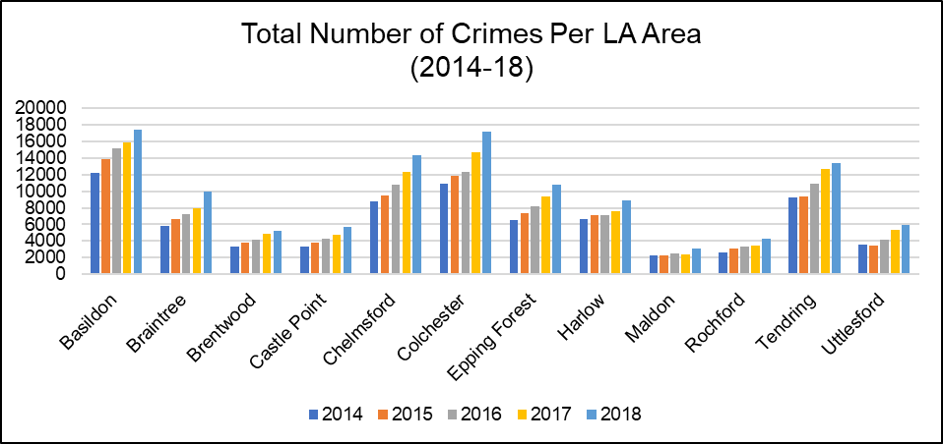

Despite this increase in the number of recorded crimes in recent years, the overall rate of crime per 1000 residents generally remains lower than average with a rate of 78 crimes per 1000 people in the Essex County Council area in 2018/19 compared to a rate of 87 across the whole Essex Police Force area, 89 for England, and 110 in Southend-on-Sea and 101 in Thurrock. Like the increase in the total number of recorded crimes, the rate of crimes per 1000 has also increased over the last 4 years from 59 per 1000 residents in 2015/16 to 78 in 2018/19. This increase is largely in line with the trends observed nationally and is in line with the average rates for the East of England Region. At a District level the rate of crimes per 1000 people varies considerably with four areas (Harlow = 108, Basildon = 99, Tendring = 97, Colchester = 94) having a rate of crimes per 1000 above the average for England; whilst a further two areas (Chelmsford = 86, Epping Forest = 83) have a rate above the average for the Essex County Council area.

***Violent Crime***

One of the changes in the levels of crime being experienced is an increase in the levels of Violent Crime. The biggest driver in the increase in violent crime in Essex has come from the increase in the number of crimes recorded as stalking or harassment. Nationally the Crown Prosecution Service (CPS) reports that there was a 69% increase in prosecutions started for stalking offences from 2016–17 to 2017–18 because of improvements in awareness following a police and CPS inspection and the implementation of Violence Against Women Strategies. This development is reflected locally with 8,312 crimes recorded as stalking or harassment in 2017/18 rising to 16,411 in 2018/19; an increase of 97%. For both the Essex County Council area and the whole Essex Police Force area, violent crime represents the largest major category of crime type (36.4%, 35.2%) followed by theft offences (35%, 35.3%) and Criminal Damage and Arson (10.1%. 10.2%). This is roughly in line with the trends regionally and nationally.

For Crimes Against Society (for which there is no direct victim) public order offences made up the largest number and contributed just 8.4% of all crimes in the ECC area and 8.5% for Essex Police overall. The only exception to this pattern at a District level is in Uttlesford which saw 692 offences for possession of weapons recorded in the last year (equivalent to 11.4% of all crimes in the area); this difference compared to other districts can largely be attributed to offences occurring at Stansted Airport (where people are found to be bringing in weapons which might otherwise be legal in the country of departure) rather than crimes in the community.

***Domestic Abuse***

Figures from the 12 months from April 2017 to March 2018 estimate that 13 percent of all recorded crimes taking place in the Essex Force area (including Southend and Thurrock) were Domestic Abuse related offences with a total of 17,763 crimes recorded during that period. Of these offences, 14,047 (79%) involved violence against the person and made up an estimated 34% of all violent offences recorded. During the same time period the Essex Police Force area (including Southend-on-Sea and Thurrock) had a rate of 10 domestic offences per 1000 people. Although this was in-line with average for England and Wales (10 per 1000) it was the highest rate of Domestic Abuse related offences in the East of England and higher than the combined average for the London region.

Like other crimes the number of recorded incidents of Domestic Abuse has seen an increase in recent year both nationally and locally. The total number of Domestic abuse related offences has increased by 4,983 or 39% since 2016, just below the increases seen at a national (England & Wales = 42.3%) and regional level (East of England = 44%). The rate of domestic abuse incidents per 1000 people has similarly increased from 7 per 1000 in 2016 to 10 in 2018 but has remained in-line with the national average.

The Crime Survey for England and Wales notes that *"Domestic abuse is often a hidden crime that is not reported to the police. Therefore, data held by the police can only provide a partial picture of the actual level of domestic abuse experienced",* and that *"Increases in the volume of domestic abuse cases entering the criminal justice system can be attributed to many factors. These include police forces improving their identification and recording of domestic abuse incidents as crimes and an increased willingness by victims to come forward and report these crimes."*

*This dataset is currently only available at Police Force Level so is not able to be segmented further for the purposes of this JSNA.*

***Hate Crime***

Over the past 5 years the number of offences recorded by Essex Police as a Hate Crime has more than doubled from a total of 1052 incidents in 2013/14 to 2237 incidents in 2017/18. Racially motivated hate crimes make up the largest percentage of incidents recorded in 2017/18 (68.7%) with 1537 incidents recording race as a motivating factor, an increase of 82.5% or 695 incidents in 5 years.

Disablist (10.9%) and Homophobic (10.7%) represent the next most common motivational factors and have more than doubled in the same period (279%, 105.1%).

Religiously motivated hate crimes recorded 140 (6.3%) incidents and had the largest percentage increase (636.8%) from 19 incidents in 2013/14. Transphobic hate crimes recorded 77 incidents (3.4%) and had seen a similar increase over the last five years, up from 27 incidents (185.2%).

**Environmental Health & Licencing**

The Marmot Review (2008) identified different health outcomes could be associated with the prevalence of certain built environment factors in the area such as the rate of noise complaints, the number of alcohol licences in an area, to the density of fast food outlets in a neighbourhood.

***Excess Noise***

Excessive noise can have a range of impacts on our health from directly affecting our auditory system and hearing, to impacting our physical and mental health and quality of life; especially through long term exposure. Modelled estimates from based on data collected by the Chartered Institute of Environmental Health (CIEH) give an estimate for the rate of complaints per 1000 people about excessive noise from neighbours, their neighbourhood or the environment. Public Health England estimates that in 2016 there was an average of 4.8 noise complaints per 1000 residents across the Essex County Council area, just below the England average of 6.3. At a District level three areas (Epping Forest = 9.8, Harlow = 7.6, Colchester = 7.2) had rates above the England average whilst a further two (Brentwood = 5.1, Basildon = 5) also had rates just above the county average.

***Alcohol Licences***

Number of premises licences and club premises certificates permitted to sell or supply alcohol on trade and/or off trade is another measure used to look at the impact of the physical environment on health, particularly when considering alcohol harm and illness. Local Alcohol Profiles for England estimate that in 2016/17 there were an average of 1.4 licenced premises per square kilometre in England, although data is not available for a countywide average. At a District Level four areas (Harlow = 5.4, Castle Point = 3.7, Basildon = 2.8, Colchester 1.9) had rates significantly higher than the national average whilst another three areas (Chelmsford = 1.3, Epping Forest = 1.4, Tendring =1.5) had rates approaching or just over.

***Density of Fast Food Outlets***

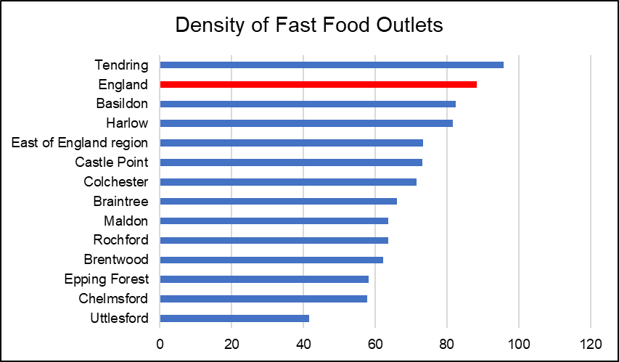The availability of fast food is an issue which is associated with a range of negative health outcomes for our communities such as obesity. This indicator calculates the number of fast food outlets per 100,000 population at an area level as a proxy for the density of these businesses within a particular local authority area. In 2014 it was estimated that Essex had a fast food density of 69.5 outlets (per 100,000 people) well below the England average of 88.2. This rate is not consistent at District Level with one area (Tendring = 95.8) having a rate above the England average, and four others (Basildon = 82.5, Harlow = 81.6, Castle Point = 73.1, Colchester = 71.5) above the average for Essex.

***Air Quality***

Poor air quality is a significant public health issue with clear evidence that particulate matter (human made air pollution) having a significant contributory role in a range of poor health outcomes including respiratory disorders and cardiopulmonary mortality. The Indicator for fine particulate matter looks at the mean annual concentration in micrograms per cubic metre (weighted for population exposure) and showed that in 2016 the Essex mean average was 9.6 micrograms per cubic metre and was just above the England average of 9.3 per cubic metre. At a district level only three areas (Tendring, Maldon, Uttlesford) had average air pollution levels below the England Levels (at 9.2 per cubic metre), whilst one area, Epping Forest (10.1) had average pollution levels above 10.

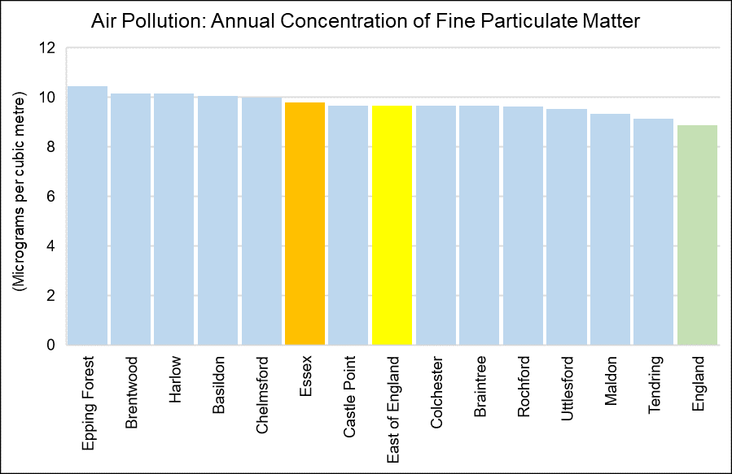

|  |  |
| --- | --- |
| Air pollution: fine particulate matter (2017) | |
| Area Name | micrograms per cubic metre |
| **England** | 8.904 |
| **East of England** | 9.6851 |
| **Essex** | 9.8132 |
| **Basildon** | 10.0819 |
| **Braintree** | 9.6742 |
| **Brentwood** | 10.1725 |
| **Castle Point** | 9.6913 |
| **Chelmsford** | 10.002 |
| **Colchester** | 9.6771 |
| **Epping Forest** | 10.4769 |
| **Harlow** | 10.1565 |
| **Maldon** | 9.3362 |
| **Rochford** | 9.6448 |
| **Tendring** | 9.1363 |
| **Uttlesford** | 9.5392 |
| *Annual concentration of human-made fine particulate matter at an area level, adjusted to account for population exposure. Fine particulate matter is also known as PM2.5 and has a metric of micrograms per cubic metre (µg/m3).* | |

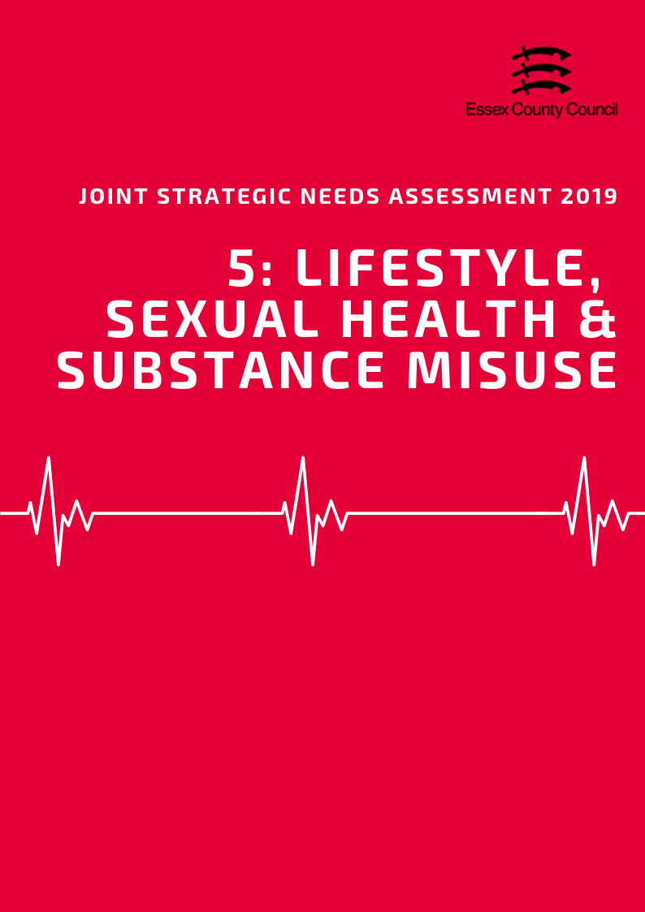

**LIFESTYLE, Sexual Health & Substance misuse**

This Section brings together datasets looking at a range of lifestyle and behavioural factors which can impact on long term health outcomes and increase or decrease the likelihood of developing a range of conditions or require more serious treatments going forward. This section includes:

* Obesity, Physical Activity and Healthy Eating
* Substance Misuse
* Sexual Health

**Obesity, Physical Activity and Healthy Eating**

***Childhood Obesity***

In Essex in 2017/18, 0.8% of children in Reception (aged 4 – 5 years) were classified as underweight. This was lower than the prevalence of underweight across England (0.98%) with variations at district level (highest: Harlow 1.46%; lowest: Braintree 0.47%). Three areas, Brentwood (0.99%), Epping Forest (1.32%) and Harlow, had levels above the national average whilst figures for Castle Point, Maldon and Rochford were suppressed for disclosure control.

An Estimated 21.11% of children in reception year were classified as overweight (including obese) (Highest: Maldon = 28%; Lowest: Epping Forest = 17.3%) whilst 8.59% were classed as Obese (including severely obese) (Highest: Harlow = 10.97: Lowest: Uttlesford = 6.74). Both county levels were lower than the average for England (22.38% and 9.53%)

|  |  |  |  |  |  |  |  |  |
| --- | --- | --- | --- | --- | --- | --- | --- | --- |
|  | **Prevalence of weight categories among children in Reception by District, 2017/18** | | | | | | | |
| **Healthy weight** | | **Underweight** | | **Overweight (Inc. obese)** | | **Obese (Inc. severe obesity)** | |
| **Value (%)** | **Rank** | **Value (%)** | **Rank** | **Value (%)** | **Rank** | **Value (%)** | **Rank** |
| **Basildon** | 79.10 | 4 | 0.70 | 7 | 20.20 | 7 | 8.82 | 5 |
| **Braintree** | 75.49 | 8 | 0.47 | 9 | 24.04 | 3 | 8.78 | 6 |
| **Brentwood** | 80.54 | 2 | 0.99 | 3 | 18.47 | 10 | 7.27 | 11 |
| **Castle Point** | * | - | * | - | 19.17 | 8 | 8.98 | 4 |
| **Chelmsford** | 78.61 | 5 | 0.76 | 6 | 20.64 | 6 | 7.40 | 9 |
| **Colchester** | 77.91 | 6 | 0.93 | 4 | 21.16 | 5 | 8.15 | 7 |
| **Epping Forest** | 81.39 | 1 | 1.32 | 2 | 17.29 | 12 | 7.33 | 10 |
| **Harlow** | 75.75 | 7 | 1.46 | 1 | 22.79 | 4 | 10.97 | 1 |
| **Maldon** | * | - | * | - | 28.07 | 1 | 10.63 | 2 |
| **Rochford** | * | - | * | - | 18.46 | 11 | 7.84 | 8 |
| **Tendring** | 74.65 | 9 | 0.56 | 8 | 24.79 | 2 | 10.52 | 3 |
| **Uttlesford** | 80.32 | 3 | 0.86 | 5 | 18.82 | 9 | 6.74 | 12 |
| **Essex** | 78.08 | - | 0.80 | - | 21.11 | - | 8.59 | - |
| **England** | 76.64 | - | 0.98 | - | 22.38 | - | 9.53 | - |

* supressed for disclosure control

By year 6 it is estimated that 32% of children in this age group were overweight or obese (highest: Harlow 37.45%; lowest: Uttlesford 25.84%) with three areas, Harlow; Tendring (36.3%); and Maldon (34.6%) having rates above the national average of 34.2%. In the same year group, it is estimated that 17.9% of all children across Essex are classed as Obese or severely obese (highest: Tendring 22.56%; lowest: Uttlesford 13.91%) with 2 areas, Tendring, and Harlow (22.07%) being above the England average of 20.14%.

|  |  |  |  |  |  |  |  |  |
| --- | --- | --- | --- | --- | --- | --- | --- | --- |
|  | **Prevalence of weight categories among children in Year 6 by District, 2017/18** | | | | | | | |
| **Healthy weight** | | **Underweight** | | **Overweight (Inc. obese)** | | **Obese (Inc. severe obesity)** | |
| **Value (%)** | **Rank** | **Value (%)** | **Rank** | **Value (%)** | **Rank** | **Value (%)** | **Rank** |
| **Basildon** | 64.67 | 8 | 1.40 | 5 | 33.92 | 4 | 19.66 | 3 |
| **Braintree** | 66.47 | 5 | 1.03 | 9 | 32.51 | 7 | 17.70 | 6 |
| **Brentwood** | * | - | * | - | 26.29 | 11 | 14.80 | 11 |
| **Castle Point** | 65.03 | 7 | 1.17 | 8 | 33.80 | 5 | 19.42 | 4 |
| **Chelmsford** | 68.75 | 2 | 1.59 | 2 | 29.66 | 10 | 15.40 | 10 |
| **Colchester** | 68.62 | 3 | 1.54 | 3 | 29.84 | 9 | 15.53 | 9 |
| **Epping Forest** | 65.08 | 6 | 1.51 | 4 | 33.41 | 6 | 19.05 | 5 |
| **Harlow** | 61.34 | 10 | 1.22 | 7 | 37.45 | 1 | 22.07 | 2 |
| **Maldon** | * | - | * | - | 34.59 | 3 | 17.12 | 7 |
| **Rochford** | 66.63 | 4 | 2.42 | 1 | 30.95 | 8 | 16.19 | 8 |
| **Tendring** | 62.79 | 9 | 0.93 | 10 | 36.28 | 2 | 22.56 | 1 |
| **Uttlesford** | 72.91 | 1 | 1.26 | 6 | 25.84 | 12 | 13.91 | 12 |
| **Essex** | 66.49 | - | 1.34 | - | 32.17 | - | 17.93 | - |
| **England** | 64.29 | - | 1.39 | - | 34.32 | - | 20.14 | - |

*supressed for disclosure control

***Adult Obesity & Healthy Eating***

In Essex in 2016/17 63.6% of adults were classed as overweight or obese, slightly higher than the England average of 61.3%. 7 of the 12 district areas also had obesity rates above the national average (Highest: Basildon = 70.4%; Lowest: Uttlesford = 55.3%).

The proportion of adults aged over 16 years in the county meeting the recommended fruit and vegetable intake of 5 portions on a ‘usual day’ was 55.96% in 2016/17, lower than the England average of 57.44%. (highest: Braintree 62.92%; lowest: Harlow 46.23%). Only 6 of the 12 district boroughs were equal to or higher than the national average.

|  |  |  |  |  |  |  |  |  |
| --- | --- | --- | --- | --- | --- | --- | --- | --- |
|  | **Percentage eating the recommended “5 a day”** | |  | **Percentage of Adults who are overweight or obese** | |  | **Percentage who take part in Organised sport** | |
| **Value** | **Rank** |  | **Value** | **Rank** |  | **Value** | **Value** |
| **Basildon** | 50.2% | 11 |  | 70.5% | 1 |  | 29.5% | 10 |
| **Braintree** | 62.9% | 1 |  | 60.8% | 8 |  | 33.7% | 9 |
| **Brentwood** | 62.1% | 3 |  | 58.5% | 10 |  | 43.0% | 2 |
| **Castle Point** | 58.2% | 5 |  | 65.1% | 4 |  | 35.1% | 6 |
| **Chelmsford** | 53.7% | 10 |  | 63.3% | 6 |  | 38.2% | 5 |
| **Colchester** | 54.6% | 9 |  | 64.4% | 5 |  | 35.1% | 7 |
| **Epping Forest** | 56.7% | 6 |  | 58.8% | 9 |  | 46.9% | 1 |
| **Harlow** | 46.2% | 12 |  | 66.9% | 3 |  | 25.8% | 11 |
| **Maldon** | 59.7% | 4 |  | 57.9% | 11 |  | 34.6% | 8 |
| **Rochford** | 55.3% | 7 |  | 61.4% | 7 |  | 41.0% | 4 |
| **Tendring** | 54.7% | 8 |  | 67.5% | 2 |  | 22.1% | 12 |
| **Uttlesford** | 62.7% | 2 |  | 55.3% | 12 |  | 42.6% | 3 |
| **Essex** | 55.9% | - |  | 63.6% | - |  | 35% | - |
| **England** | 57.4% | - |  | 61.3% | - |  | - | - |

***Physical Activity***

Across Essex, 66.07% of residents ages over 19 years were classified as physically active in 2017/18 (highest: Uttlesford 70.72%; lowest: Basildon 61.87%). This is similar to the physical activity prevalence across England (66.26%). Similarly, the proportion of residents classified as physically inactive across Essex of 21.78% was also similar to the proportion inactive across England of 22.23% (highest: Harlow = 27.30%; lowest: Colchester = 18.45%).

|  |  |  |  |  |  |  |  |  |
| --- | --- | --- | --- | --- | --- | --- | --- | --- |
|  | Percentage of Adults who are physically active or inactive | | | | | | | |
| 2015/16 | | 2016/17 | | *2017/18* | | 3 year change | |
| % active | % inactive | % active | % inactive | *% active* | *% inactive* | % active | % inactive |
| Basildon | 65.46 | 24.00 | 60.98 | 26.28 | ***61.87*** | ***25.30*** | -3.59 | 1.31 |
| Braintree | 57.80 | 23.20 | 66.45 | 23.22 | ***67.55*** | ***19.17*** | 9.75 | -4.04 |
| Brentwood | 68.63 | 18.31 | 70.10 | 21.77 | ***65.79*** | ***22.51*** | -2.84 | 4.20 |
| Castle Point | 69.86 | 22.14 | 61.27 | 25.05 | ***68.43*** | ***21.43*** | -1.43 | -0.71 |
| Chelmsford | 67.26 | 22.16 | 67.88 | 22.09 | ***62.73*** | ***23.74*** | -4.53 | 1.58 |
| Colchester | 74.33 | 16.63 | 67.21 | 21.64 | ***67.74*** | ***18.45*** | -6.59 | 1.82 |
| England | 66.13 | 22.33 | 66.01 | 22.24 | ***66.26*** | ***22.23*** | 0.13 | -0.10 |
| Epping Forest | 68.72 | 18.05 | 67.65 | 18.97 | ***69.78*** | ***18.48*** | 1.06 | 0.44 |
| Essex | 66.06 | 22.10 | 65.95 | 22.64 | ***66.07*** | ***21.78*** | 0.01 | -0.32 |
| Harlow | 60.80 | 29.28 | 62.78 | 23.30 | ***63.31*** | ***25.36*** | 2.50 | -3.92 |
| Maldon | 68.56 | 19.42 | 67.44 | 19.11 | ***68.39*** | ***19.09*** | -0.17 | -0.34 |
| Rochford | 64.23 | 20.83 | 70.05 | 19.21 | ***69.75*** | ***22.37*** | 5.52 | 1.54 |
| Tendring | 58.01 | 31.44 | 62.61 | 27.30 | ***62.55*** | ***25.09*** | 4.54 | -6.35 |
| Uttlesford | 68.99 | 18.39 | 71.38 | 18.42 | ***70.72*** | ***19.21*** | 1.73 | 0.83 |

Between 2015/16 and 2017/18 levels of physical activity in adults have reduced in 6 of the 12 Districts with 5 areas seeing levels increase to varying degrees (Highest: Braintree = +9.75%; Lowest: Colchester= -6.59%). This trend is not reflected at the national level with physical activity levels remaining relatively constant at 66.13% to 66.26% during the same period.

**Substance Misuse**

***Smoking***

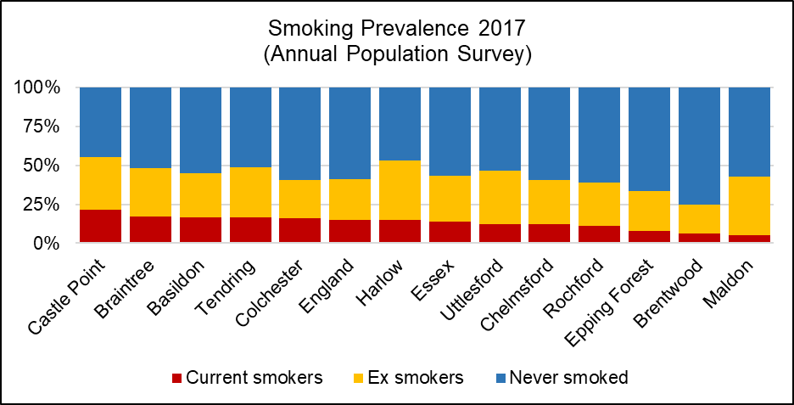Across the whole of Essex in 2017, the prevalence of current smokers among residents aged over 18 years was 13.84%. This was similar to the prevalence across England (14.87%).

Ex-smokers among persons aged over 18 years across the whole of Essex was 29.51%, whilst people who claimed to have never smoked was 56.65%. The prevalence of ex-smokers is slightly higher than the prevalence across England (26.17%), and the prevalence of never-smoked relatively similar to that across England (58.96%).

|  |  |  |  |  |  |  |
| --- | --- | --- | --- | --- | --- | --- |
|  | **Smoking prevalence in adults by current and previous status (Annual Population Survey, 2017)** | | | | | |
| **Current smoker** | | **Ex-smoker** | | **Never-smoked** | |
| **%** | **Rank** | **%** | **Rank** | **%** | **Rank** |
| **Basildon** | 16.72 | 3 | 28.18 | 8 | 55.10 | 7 |
| **Braintree** | 17.15 | 2 | 31.19 | 6 | 51.65 | 9 |
| **Brentwood** | 6.48 | 11 | 18.37 | 12 | 75.15 | 1 |
| **Castle Point** | 21.48 | 1 | 33.89 | 4 | 44.62 | 12 |
| **Chelmsford** | 12.02 | 8 | 28.75 | 7 | 59.23 | 4 |
| **Colchester** | 15.99 | 5 | 24.80 | 11 | 59.20 | 5 |
| **Epping Forest** | 7.84 | 10 | 25.72 | 10 | 66.44 | 2 |
| **Harlow** | 14.81 | 6 | 38.19 | 1 | 47.01 | 11 |
| **Maldon** | 5.33 | 12 | 37.50 | 2 | 57.17 | 6 |
| **Rochford** | 10.98 | 9 | 28.02 | 9 | 61.00 | 3 |
| **Tendring** | 16.72 | 4 | 32.03 | 5 | 51.25 | 10 |
| **Uttlesford** | 12.33 | 7 | 34.38 | 3 | 53.29 | 8 |
| **Essex** | 13.84 | - | 29.51 | - | 56.65 | - |
| **England** | 14.87 | - | 26.17 | - | 58.96 | - |

Smoking attributable mortality over the three year period of 2012 - 2014 across the whole of Essex was estimated to be 258.24. This was significantly better than the smoking attributable mortality across England (274.76). The prevalence of smoking attributable mortality due to heart disease was 26.21 across Essex, also significantly better than that for England (29.68). Overall, it was estimated that 1194.708 potential years of life were lost across the whole of Essex due to smoking.

***Alcohol***

Alcohol-related hospital admissions are defined as admissions where the primary and any secondary diagnoses are an alcohol-attributable code. According to Public Health England, the directly age standardised rate of alcohol-related hospital admissions across Essex as a whole in 2017/18 was 1935.65 per 100,000 population. This is lower than the rate across England (2223.80).

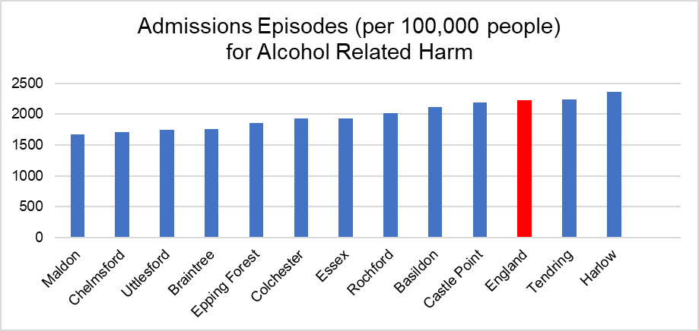

The directly age standardised rate per 100,000 population of alcohol-related mortality was estimated to be 41.90 across Essex as a whole in 2017, lower than that for England (46.15).

Across Essex as a whole, there were 1474 persons aged over 18 years that were receiving specialist treatment for alcohol abuse in 2016/17. 80,454 people were receiving such treatment across England as a whole.

***Drug Use***

According to the Office for National Statistics, the age-standardised mortality rate from drug misuse per 100,000 population across the whole of Essex was 3.63 over the period of 2015 - 2017. This was slightly lower than the rate for England (4.33). The rate was unable to be calculated for the Districts of Basildon, Brentwood, Castle Point, Epping Forest, Maldon, Rochford and Uttlesford as the number of cases was too small.

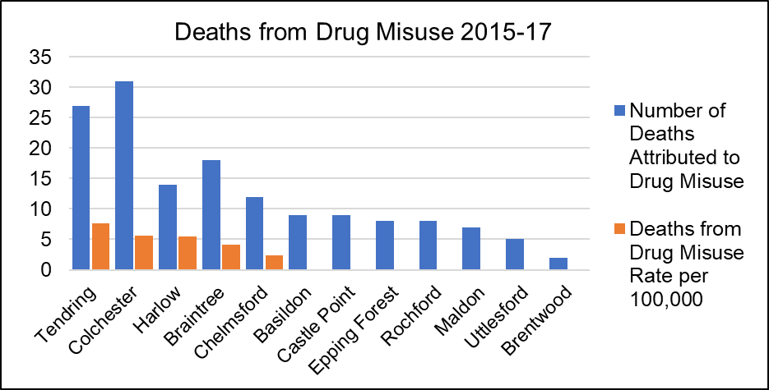

3530 persons aged over 18 years across Essex were in treatment at specialist drug misuse services in 2014/15, with a rate of 3.12 per 1000 population. This is slightly lower than the rate across England (4.82).

|  |  |  |  |  |  |  |
| --- | --- | --- | --- | --- | --- | --- |
|  | **Alcohol and Drugs** | | | | | |
| **Alcohol-related hospital admission rate per 100K** | | **Alcohol mortality** | | **Deaths from drug misuse** | |
| Value | Rank | Value | Rank | Count | Rate Per 100K |
| **Basildon** | 2111.07 | 4 | 46.31 | 2 | 9 | * |
| **Braintree** | 1761.831 | 8 | 41.66 | 4 | 18 | 4.19 |
| **Brentwood** | 1576.501 | 12 | 39.80 | 6 | 2 | * |
| **Castle Point** | 2194.25 | 3 | 39.46 | 7 | 9 | * |
| **Chelmsford** | 1713.9 | 10 | 38.26 | 8 | 12 | 2.33 |
| **Colchester** | 1934.702 | 6 | 40.12 | 5 | 31 | 5.59 |
| **Epping Forest** | 1856.899 | 7 | 35.50 | 10 | 8 | * |
| **Harlow** | 2360.043 | 1 | 44.38 | 3 | 14 | 5.51 |
| **Maldon** | 1675.22 | 11 | 37.67 | 9 | 7 | * |
| **Rochford** | 2022.617 | 5 | 32.49 | 12 | 8 | * |
| **Tendring** | 2237.576 | 2 | 61.49 | 1 | 27 | 7.60 |
| **Uttlesford** | 1749.756 | 9 | 33.78 | 11 | 5 | * |
| **Essex** | 1935.651 | - | 41.90 | - | 150 | 3.63 |
| **England** | 2223.806 | - | 46.15 | - | 6996 | 4.33 |

*value cannot be calculated as number of cases too small

**Sexual Health**

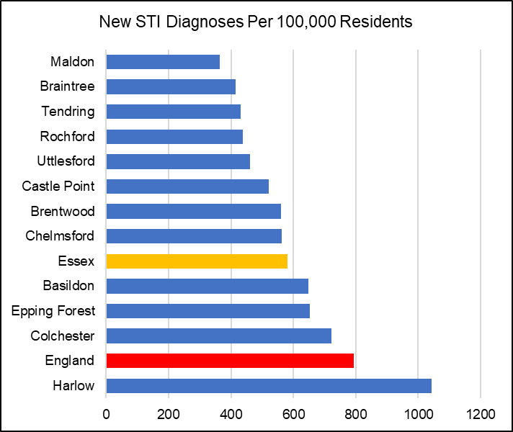According to Public Health England in 2017, the rate of new Sexually Transmitted Infections (STI) diagnoses among persons across Essex was 580.81 per 100,000 population aged between 15 - 64 years. This was significantly lower than the rate of that across England (793.85). STI diagnoses excluded chlamydia in under 25 year olds and was among persons attending specialist (level 3) and non-specialist (level 1 and 2) sexual health services.

The proportion of all 15 - 24 year olds across Essex in 2017 screened for chlamydia with asymptomatic screens and symptomatic tests at sexual health services was 15.5. This was slightly lower than the chlamydia screening prevalence for England (19.3).

In Essex, the rate of all chlamydia diagnoses among 15 to 24 year olds attending sexual health services was 1449.1 per 100,000 population aged 15 to 24. This was lower than the detection rate of that across England (1881.9).

|  |  |  |  |  |  |  |  |  |  |  |
| --- | --- | --- | --- | --- | --- | --- | --- | --- | --- | --- |
|  | | **New STI diagnoses (excluding chlamydia aged <25) / 100,000** | | | | | **Chlamydia proportion aged 15-24 screened** | | | |
| **Value** | | | **Rank** | | **%** | | **Rank** | |
| **Basildon** | | 647.54 | | | 4 | | 14.5 | | 5 | |
| **Braintree** | | 414.14 | | | 11 | | 12.5 | | 11 | |
| **Brentwood** | | 560.57 | | | 6 | | 13.2 | | 8 | |
| **Castle Point** | | 520.65 | | | 7 | | 12.4 | | 12 | |
| **Chelmsford** | | 561.50 | | | 5 | | 15.3 | | 4 | |
| **Colchester** | | 721.10 | | | 2 | | 18.2 | | 2 | |
| **Epping Forest** | | 653.27 | | | 3 | | 15.5 | | 3 | |
| **Harlow** | | 1042.41 | | | 1 | | 29.5 | | 1 | |
| **Maldon** | | 364.71 | | | 12 | | 13.1 | | 9 | |
| **Rochford** | | 438.23 | | | 9 | | 13.7 | | 6 | |
| **Tendring** | | 430.44 | | | 10 | | 13.1 | | 10 | |
| **Uttlesford** | | 459.94 | | | 8 | | 13.7 | | 7 | |
| **Essex** | | 580.81 | | |  | | 15.5 | |  | |
| **England** | | 793.85 | | |  | | 19.3 | |  | |
| **Chlamydia detection rate / 100,000 aged 15-24** | | **Persons** | | | **Male** | | | | **Female** | | | |
| **Value** | | **Rank** | **Value** | | **Rank** | | **Value** | | **Rank** | |
| **Basildon** | | 1484.2 | | 3 | 1000.3 | | 4 | | 1972.9 | | 3 | |
| **Braintree** | | 1199.6 | | 8 | 750.5 | | 9 | | 1689.1 | | 7 | |
| **Brentwood** | | 1016 | | 11 | 820.3 | | 8 | | 1192.8 | | 12 | |
| **Castle Point** | | 1081.3 | | 9 | 635.3 | | 11 | | 1564.5 | | 8 | |
| **Chelmsford** | | 1266.8 | | 6 | 836.3 | | 7 | | 1720.8 | | 5 | |
| **Colchester** | | 2094.9 | | 2 | 1564.1 | | 2 | | 2679.4 | | 1 | |
| **Epping Forest** | | 1295.8 | | 5 | 873.7 | | 6 | | 1711.8 | | 6 | |
| **Harlow** | | 2444.9 | | 1 | 2266 | | 1 | | 2641.3 | | 2 | |
| **Maldon** | | 933.3 | | 12 | 621.1 | | 12 | | 1279.5 | | 11 | |
| **Rochford** | | 1262.2 | | 7 | 1088.1 | | 3 | | 1444.2 | | 9 | |
| **Tendring** | | 1320.6 | | 4 | 897.4 | | 5 | | 1777.2 | | 4 | |
| **Uttlesford** | | 1035 | | 10 | 749.5 | | 10 | | 1351 | | 10 | |
| **Essex** | | 1449.1 | |  | 1049.8 | |  | | 1872.1 | |  | |

***HIV***

Among people aged 15 to 59 years across Essex, the rate of those living with a diagnosed HIV infection and seen at HIV service was 1.26 per 1,000 population, relatively similar to the rate across England (2.32).

The rate of all new HIV diagnoses among adults aged over 15 years accessing HIV care in Essex was 5.63 per 100,000 population. This was lower than the rate for the whole of England (8.66).

According to Public Health England, HIV late diagnosis is a CD4 cell count of less than 350 cells per mm3 among all new diagnoses with a CD4 cell count available within 91 days of diagnosis. In Essex, the percentage of adults aged over 15 years with a HIV late diagnosis accessing HIV care was 44.52 over the three year period of 2015 - 2017. This was relatively similar to the prevalence of HIV late diagnosis across England (41.12). Values for Castle Point and Maldon were not disclosed.

***Other key STIs include genital warts, genital herpes, gonorrhoea and syphilis.***

Among people of all ages accessing sexual health services in 2017 across Essex, the rate of diagnosis of the first episode of genital warts was 98.43. This was slightly lower than the rate across England (103.86). The diagnosis rate of genital herpes was also lower than that across England (56.69), with a rate of 50.00. Similarly, the diagnosis rate of gonorrhoea across Essex (37.38) was nearly half the rate across England (78.79). The syphilis diagnosis rate was 3.64, also significantly than the rate for England (12.48).

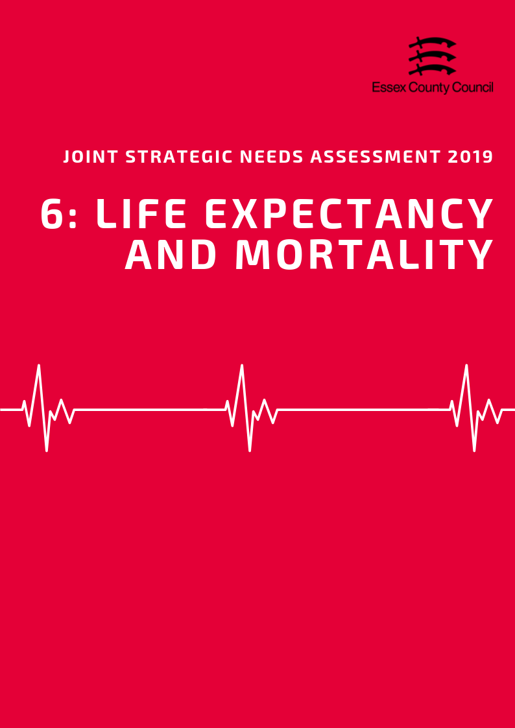

**LIFE EXPECTANCY & MORTALITY**

***Life Expectancy***

*Life Expectancy at Birth*

The average life expectancy at birth for a child born in Essex (2015-2017) was 83.3 years for females and 80.2 years for males. This is just above the average for England for both sexes (Females = 83.1 years, Males = 79.6 years), however there is considerable variance across the county at more local levels. Overall the office of national statistics estimates that the inequality in life expectancy at birth between most and least deprived areas is an average of 6 years for females and 7.7 years for males.

At a district level life expectancy at birth was lower than the England average in four areas for females (Tendring = 81.5, Basildon and Braintree = 82.7, Castle Point = 83) and two areas for males (Tendring = 77.8, Harlow = 78.5). The highest average life expectancy at birth for Females was estimated to be 84.8 years (Rochford) and 82.1 (Uttlesford)

During the same period, life expectancy at age 65 (the number of additional years a person could expect to live) was 21.2 years for females and 18.9 years for males; similar to the England average for both sexes (Females = 21.1 years, Males = 18.8 years). Like life expectancy at birth, life expectancy at age 65 can vary considerably between the most and least deprived areas with an estimated 3.2 years for females and 4.2 years for males.

At district level life expectancy at age 65 was highest was highest in Uttlesford for both females (22 years) and males (20 years), whilst three areas (Braintree and Tendring = 20.6 years, Castle Point = 20.8) were lower than the England average for females, and five areas (Tendring = 18.2, Harlow = 18.3, Castle Point = 18.4, Braintree = 18.6, Basildon 18.7) were lower for males.

*Healthy Life Expectancy*

In the period 2015 to 2017, males from birth had a healthy life expectancy of 64.53 years whilst females were slightly lower at 64.18 years. This means that a male born during this period would expect to spend 15.6 years (19.5% of their life expectancy) in "Not Good Health" compared females with 19.12 years (23% of their life expectancy). For males this is slightly better than the England average (16.17 years/20.3%) but worse than average for females (21.14 years/25.4%). For people aged 65 during the same period, healthy life expectancy was 9.93 years for females and 8.26 years for males both better than the average for England (10.9, 10.4).

*Disability Free Life Expectancy*

From birth females across Essex were expected to live 62.2 years of their life disability free, whilst males were expected to be disability free for slightly longer at 63.9 years. The rate of disability free life expectancy for females was equivalent to spending 21.1 years or 25.4% of their life with a disability or long term life limiting condition, slightly higher than the average for England. By comparison males of the same age were expected to spend on average 16.2 years or 20.2% of their life in the same state, however this was just below the national average. This pattern is the same at age 65 with female residents expected to spend longer with a disability (11.2 years) compared to male counterparts (8.8 years), both just under the England baseline (11.3, 8.9).

The difference between the two sexes reflects the trend nationally where healthy and disability free life expectancy increases for females has not kept pace with males.

***Table: Life Expectancy at Birth***

|  |  |  |  |  |  |
| --- | --- | --- | --- | --- | --- |
|  |  |  | **EAST** | **ENGLAND** | **ESSEX** |
| At age 65 | Female | Life Expectancy | 21.45 | 21.09 | 21.17 |
| Disability Free Life Expectancy | 10.05 | 9.82 | 10.00 |
| Years with disability | 11.40 | 11.27 | 11.17 |
| Proportion of life expectancy | 53.1% | 53.4% | 52.8% |
| Healthy Life Expectancy | 11.27 | 10.91 | 11.24 |
| Years in 'Not good' health | 10.18 | 10.18 | 9.93 |
| Proportion of life expectancy | 47.5% | 48.3% | 46.9% |
| Male | Life Expectancy | 19.17 | 18.76 | 18.89 |
| Disability Free Life Expectancy | 10.15 | 9.89 | 10.53 |
| Years with disability | 9.02 | 8.87 | 8.35 |
| Proportion of life expectancy | 47.1% | 47.3% | 44.2% |
| Healthy Life Expectancy | 10.71 | 10.44 | 10.63 |
| Years in 'Not good' health | 8.45 | 8.32 | 8.26 |
| Proportion of life expectancy | 44.1% | 44.4% | 43.7% |

***Table: Life Expectancy at Age 65***

|  |  |  |  |  |  |
| --- | --- | --- | --- | --- | --- |
|  |  |  | **EAST** | **ENGLAND** | **ESSEX** |
| At Birth | Female | Life Expectancy | 83.68 | 83.13 | 83.30 |
| Disability Free Life Expectancy | 62.89 | 62.15 | 62.16 |
| Years with disability | 20.79 | 20.97 | 21.14 |
| Proportion of life expectancy | 24.8% | 25.2% | 25.4% |
| Healthy Life Expectancy | 64.57 | 63.77 | 64.18 |
| Years in 'Not good' health | 19.11 | 19.35 | 19.12 |
| Proportion of life expectancy | 22.8% | 23.3% | 23.0% |
| Male | Life Expectancy | 80.36 | 79.55 | 80.16 |
| Disability Free Life Expectancy | 64.02 | 63.08 | 63.94 |
| Years with disability | 16.34 | 16.47 | 16.23 |
| Proportion of life expectancy | 20.3% | 20.7% | 20.2% |
| Healthy Life Expectancy | 64.15 | 63.38 | 64.53 |
| Years in 'Not good' health | 16.21 | 16.17 | 15.64 |
| Proportion of life expectancy | 20.2% | 20.3% | 19.5% |

***Mortality***

In 2017 the Essex County Council area had an all ages mortality rate of 953.2 deaths per 100,000 residents, based on 14,655 deaths recorded during that time period. This overall mortality rate was similar than the England average of 958.7 (per 100K) and had increased slightly compared the previous year (944.6 per 100K). Looking at mortality rates across the different age groups in Essex, 43% of all deaths during this period were from residents aged 85 years and over with an age standardised mortality rate of 16031.7 per 100K (based 6339 actual deaths); higher than the England rate (15280.8) and a pattern repeated across 8 of the 12 Districts and Boroughs in the County. All other age groups had mortality rates below the national average.

At a district level 6 of the 12 local authority areas had an all age mortality rate that was higher than the England average (Highest: Tendring = 1068.9; Lowest: Uttlesford = 809.2), with three of these areas (Basildon, Harlow, Tendring) also having higher than average mortality rates for the under 75 age groups. in 2015-17 there were 12,4256 deaths under the age of 75 were recorded equivalent to a rate of 307 deaths per 100,000 residents. This is lower than the average for England (332), however three areas at district level were found to be higher (Basildon, Harlow, and Tendring).

Looking at the different causes of mortality, the top three biggest causes for both sexes were cancer (131 per 100,000) cardiovascular diseases (62.6 per 100,000) and respiratory diseases (30.8 per 100,000) however the rates for all three were lower than the England averages.

Only mortality rates for breast cancer (All persons rate = 11.22; Female only rate: 26.6) were actually higher than the average for England (10.6; 20.6) with 8 out of 12 District having mortality rates for women which were higher than average.

*Premature Deaths from Cancer*

From 2015-17 Public Health England recorded 5314 deaths from cancer under the age of 75, equal to a premature mortality rate of 131 deaths per 100,000 people. Whilst this is lower than the average for England (135) for both sexes, whilst three areas at District level (Basildon, Castle Point and Tendring) have mortality were observed to have rates above both the county and England averages. Public health England estimates that in 2017 that just 53.3% of cancer cases were diagnosed at early (either stage 1 or 2) in Essex. This is slightly above the England baseline (52.2%) but is at its lowest level since 2012.

*Breast Cancer*

An issue specifically affecting female residents in Essex is the rate of deaths from breast cancer in the under 75 age group with 447 premature deaths recorded in the last period. This was equivalent to a rate of 21.5 deaths per 100,000 compared to the England average of 20.6 and was also higher than average in 8 out of the 12 districts and boroughs in the county.

***The percentage of eligible women in the Essex County Council area who were screened adequately for breast cancer within the previous three years (from 31st March 2018) has reached its lowest level since 2010, with a rate of just 73.5% in 2018 compared to 79.6% in 2010. This is worse than the average for England in 2018 (74.9%) with seven out of the 12 districts and boroughs also having screening rates falling below the England level (Highest: Uttlesford = 78.7%; Lowest: Maldon = 57.3%).*** Six of the 12 districts also recorded reductions in the level of breast cancer screening in the last year, with the Maldon District showing the biggest reduction from 79% in 2017 down to 57.3% in 2018.

Public Health England recommends that improvements in coverage would mean more breast cancers are detected at earlier more treatable stages.

*Bowel Cancer*

Colorectal (Bowel) cancer was another common cause of premature deaths with 457 deaths recorded during the same period for both men and women, equivalent to a rate pf 11.3 per 100,000 residents, just under the rate for England (12 per 100,000). Mortality rates for females under 75 was also higher than average in 7 out of 12 districts across the county (Highest: Maldon = 14.23; Lowest = Epping Forest: 6.03) whilst male rates were above baseline in 3 areas (Highest: Tendring = 20.24; Lowest: Colchester = 9.0).

***Preventable Mortality***

*According to Public Health England, "preventable mortality is that deaths are considered preventable if, in the light of the understanding of the determinants of health at the time of death, all or most deaths from the underlying cause (subject to age limits if appropriate) could potentially be avoided by public health interventions in the broadest sense".*

In the period of 2015-2017 it is estimated that 7,185 deaths for all age groups or 18.9% of all deaths that occurred in the County were preventable. This was equivalent to a rate of 161.9 per 100,000 people, lower than the rate (181.5) and percentage (18.9%) for England but an increase on the previous year. Males were 36.5% more likely to die from a preventable cause (SMR= 200.1 per 100K) compared to females (SMR= 127.1 per 100K), which the largest difference of 51.3% in Harlow and the smallest difference in Maldon at 24%.

For the under 75 age group Cancer was the largest cause of preventable mortality with a rate of 74.2 preventable deaths per 100,000 overall, with was similar in rate for both males (66.5 per 100K) and females (63.5), all of which were below the England baseline. Cardiovascular disease was the next largest preventable cause with a combined rate of 38.8 per 100,000 for both sexes, however the rate of preventable deaths for males (59.8 per 100K) was significantly higher than females (19.3 per 100K).

At a district level Harlow (272.9) and Tendring (274.9) both had preventable mortality rates above the England average for Males of all ages (and all persons), whilst Maldon (147.6) and Tendring (166) had higher than average rates for females. In the under 75 age group, four areas (Basildon, Braintree, Castle Point, and Tendring) all had above average rates of preventable mortality from Cancer, with five areas (Basildon, Braintree, Castle Point, Maldon and Tendring) higher than average rates specifically for females.

***Killed and Seriously Injured in Road Traffic Accidents***

Deaths caused by road traffic accidents in Essex are generally higher than the rate for England with 51.3 deaths per 100,000 between 2015-17 across the county compared to an average of 40.8 for the country. At a district level 3 areas, Rochford (36.2) Harlow (36.5) and Basildon (39.7) have rates just below but close to the England average, whilst the remaining 9 all had rates which higher (Lowest: Rochford = 36.2; Highest: Epping Forest = 78.8).

The rate of children killed on seriously injured on roads in Essex was also higher than average at 18.8 per 100,000 compared to 17.4 nationally during the same period. Breakdowns at district level are not currently available.

During the period of 2014-16 data showed that 33.4 road traffic accidents in every 1000 were alcohol related in Essex. This rate is higher than the England average of 26.4 and was above the national average in 8 of the 12 districts (Lowest: Brentwood = 23.3; Highest: Braintree 42.7).

|  |  |  |  |  |  |  |  |  |
| --- | --- | --- | --- | --- | --- | --- | --- | --- |
|  | **Killed and seriously injured (KSI) casualties on England's roads** | | | | |  | **20111-13 VS 2015-17 Change** | |
| 2011 - 13 | 2012 - 14 | 2013 - 15 | 2014 - 16 | 2015 - 17 | Rate (per 100K) | % |
| Epping Forest | 66.93 | 70.35 | 67.73 | 75.81 | 78.76 | 11.83 | 17.7% |
| Uttlesford | 56.24 | 50.80 | 48.37 | 55.16 | 64.51 | 8.27 | 14.7% |
| Maldon | 42.51 | 42.86 | 43.52 | 57.83 | 59.92 | 17.41 | 41.0% |
| Tendring | 43.35 | 39.80 | 40.60 | 45.84 | 57.43 | 14.08 | 32.5% |
| Braintree | 39.09 | 40.45 | 43.09 | 51.37 | 55.76 | 16.67 | 42.7% |
| Brentwood | 47.66 | 47.28 | 45.23 | 54.10 | 54.28 | 6.62 | 13.9% |
| **ESSEX** | **42.74** | **42.21** | **42.47** | **48.18** | **51.28** | **8.55** | **20.0%** |
| Chelmsford | 48.61 | 43.25 | 44.49 | 45.74 | 47.65 | -0.96 | -2.0% |
| Colchester | 45.41 | 42.89 | 44.02 | 46.51 | 46.54 | 1.14 | 2.5% |
| Castle Point | 26.83 | 28.97 | 32.99 | 39.24 | 41.97 | 15.14 | 56.4% |
| **ENGLAND** | **39.71** | **39.26** | **38.50** | **39.70** | **40.80** | **1.09** | **2.7%** |
| Basildon | 32.48 | 36.98 | 35.79 | 39.02 | 39.72 | 7.25 | 22.3% |
| Harlow | 26.97 | 21.97 | 24.03 | 31.25 | 36.49 | 9.52 | 35.3% |
| Rochford | 30.99 | 34.94 | 32.23 | 39.52 | 36.17 | 5.18 | 16.7% |
| Number of people reported killed or seriously injured (KSI) on the roads, all ages, per 100,000 resident population | | | | | | | | |

***Excess Winter Deaths***

Excess Winter Deaths Index (EWD Index) is the excess winter deaths measured as the ratio of extra deaths from all causes that occur in the winter months compared with the expected number of deaths, based on the average of the number of non-winter deaths. The Excess Winter Deaths Index is calculated as the number of excess winter deaths divided by the average non-winter deaths expressed as a percentage.

Between August 2014 and July 2017, the three year average rate of Excess Winter Deaths for all ages in Essex was 23.3%, slightly higher than the average for England (21.9%) and the fourth highest level compared to the other upper tier authorities in the East of England region (Highest: Bedford = 27.7%; Lowest: Luton = 17.3%). At a district level 3 areas (Brentwood = 9.3%; Maldon =17.4%; Basildon 19.4%) had levels below the rate for England, whilst 6 areas also had levels above the average for Essex, with the highest percentage of Excess Winter Deaths for all ages in Uttlesford (30.1%), Castle Point (27.2%) and Tendring (26.1%) and Braintree (26.1%).

Looking at the level of Excess Winter Deaths specifically in the over 85s age group shows an even higher level with a rate of 31.7% Excess Winter Deaths across Essex during the same period, just above the England rate of 29.3% and the fifth highest level in the East of England compared to the other upper tier authorities (Highest: Bedford = 39.5%; Lowest: Thurrock = 20.5%). At a district level in Essex only two areas (Brentwood = 14.5%; Chelmsford = 22.2%) had levels below the national average and 9 areas had rates above the county average, with the areas with the highest 3 year average percentage of excess winter deaths being Maldon (39.5%), Uttlesford (38.5%) and Castle Point (37.7%). All breakdown of the levels of Excess Winter Deaths for each district can be found in the table at the end of this section.

|  |  |  |  |  |
| --- | --- | --- | --- | --- |
| ***Row Labels*** | ***Excess winter deaths index (3 years, age 85+) Percentage*** | ***Essex rank (lowest to Highest)*** | ***Excess winter deaths index (3 years, all ages) Percentage*** | ***Essex rank (lowest to Highest)*** |
| ***England*** | 29.3 |  | 21.1 |  |
| ***Essex*** | 31.7 |  | 23.3 |  |
| ***Basildon*** | 34.5 | 7 | 19.4 | 3 |
| ***Braintree*** | 30.9 | 3 | 26.1 | 9 |
| ***Brentwood*** | 14.5 | 1 | 9.3 | 1 |
| ***Castle Point*** | 37.7 | 10 | 27.2 | 11 |
| ***Chelmsford*** | 22.2 | 2 | 22.2 | 6 |
| ***Colchester*** | 36.8 | 9 | 25.4 | 7 |
| ***Epping Forest*** | 31.8 | 4 | 25.5 | 8 |
| ***Harlow*** | 35.2 | 8 | 22.1 | 5 |
| ***Maldon*** | 39.5 | 12 | 17.4 | 2 |
| ***Rochford*** | 32.2 | 5 | 21.5 | 4 |
| ***Tendring*** | 32.7 | 6 | 26.1 | 10 |
| ***Uttlesford*** | 38.5 | 11 | 30.1 | 12 |

|  |  |  |  |  |  |  |  |  |  |  |
| --- | --- | --- | --- | --- | --- | --- | --- | --- | --- | --- |
|  | **Mortality Rates for All Persons** | | | | | | | | | |
|  | **Under 75 mortality from colorectal cancer** | **Under 75 mortality rate from all cardiovascular diseases** | **Under 75 mortality rate from all causes** | **Under 75 Mortality rate from breast cancer** | **Under 75 mortality rate from cancer** | **Under 75 mortality rate from heart disease** | **Under 75 mortality rate from injuries** | **Under 75 mortality rate from liver disease** | **Under 75 mortality rate from respiratory disease** | **Under 75 mortality rate from stroke** |
| Basildon | 13.82 | 70.92 | 336.39 | 9.81 | 157.15 | 35.80 | 7.39 | 15.06 | 33.14 | 13.42 |
| Braintree | 9.61 | 65.40 | 310.64 | 14.10 | 132.10 | 34.11 | 11.18 | 13.98 | 27.49 | 13.47 |
| Brentwood | 11.37 | 48.51 | 265.73 | 8.77 | 119.54 | 24.19 | 7.54 | 13.63 | 26.70 | 7.89 |
| Castle Point | 11.75 | 66.34 | 313.33 | 14.03 | 141.84 | 32.15 | 8.67 | 14.13 | 32.70 | 13.16 |
| Chelmsford | 10.17 | 54.03 | 272.91 | 11.22 | 119.76 | 28.45 | 9.85 | 11.26 | 24.02 | 10.46 |
| Colchester | 8.66 | 56.64 | 298.36 | 8.88 | 122.23 | 29.44 | 12.54 | 15.99 | 34.37 | 10.51 |
| England | 11.97 | 72.50 | 331.95 | 10.60 | 134.59 | 38.72 | 12.78 | 18.51 | 34.26 | 13.08 |
| Epping Forest | 8.76 | 52.34 | 276.80 | 12.69 | 121.43 | 25.31 | 9.88 | 13.81 | 28.24 | 10.55 |
| Essex | 11.32 | 62.56 | 307.35 | 11.22 | 131.18 | 31.57 | 10.20 | 14.68 | 30.76 | 11.73 |
| Harlow | 8.36 | 91.62 | 356.97 | 10.82 | 127.68 | 48.42 | 12.35 | 13.82 | 40.82 | 17.71 |
| Maldon | 16.10 | 61.97 | 297.26 | 13.50 | 126.61 | 31.51 | 17.62 | 14.29 | 23.06 | 11.74 |
| Rochford | 10.33 | 49.03 | 263.54 | 10.20 | 120.80 | 20.34 |  | 9.21 | 21.59 | 6.15 |
| Tendring | 15.21 | 79.58 | 400.31 | 11.80 | 149.39 | 37.51 | 17.86 | 25.26 | 45.35 | 15.68 |
| Uttlesford | 10.45 | 52.83 | 252.76 | 9.45 | 113.08 | 30.85 | 5.47 | 13.50 | 23.93 | 8.65 |

|  |  |  |  |  |  |  |  |  |  |  |  |  |  |  |  |  |  |  |  |
| --- | --- | --- | --- | --- | --- | --- | --- | --- | --- | --- | --- | --- | --- | --- | --- | --- | --- | --- | --- |
|  | **Mortality Rates for Female Residents** | | | | | | | | | | | | | | | | | | |
| **Under 75 mortality from colorectal cancer** | | **Under 75 mortality rate from all cardiovascular diseases** | | **Under 75 mortality rate from all causes** | | **Under 75 Mortality rate from breast cancer** | | **Under 75 mortality rate from cancer** | | **Under 75 mortality rate from heart disease** | | **Under 75 mortality rate from injuries** | | **Under 75 mortality rate from liver disease** | | **Under 75 mortality rate from respiratory disease** | | **Under 75 mortality rate from stroke** |
| Basildon | 10.31 | | 44.80 | | 280.68 | | 18.43 | | 143.66 | | 17.14 | |  | | 15.78 | | 29.86 | | 11.47 |
| Braintree | 6.45 | | 41.03 | | 259.69 | | 27.49 | | 125.03 | | 15.85 | | 6.64 | | 9.85 | | 23.61 | | 12.05 |
| Brentwood | 12.08 | | 28.51 | | 217.07 | | 17.08 | | 106.45 | |  | |  | | 14.93 | | 22.74 | |  |
| Castle Point | 11.60 | | 37.02 | | 255.09 | | 27.15 | | 135.91 | | 12.14 | |  | | 12.61 | | 25.47 | | 8.02 |
| Chelmsford | 9.30 | | 32.79 | | 220.20 | | 21.76 | | 112.36 | | 12.28 | | 5.47 | | 5.98 | | 20.98 | | 7.20 |
| Colchester | 8.27 | | 33.63 | | 231.45 | | 16.34 | | 100.83 | | 13.04 | | 10.20 | | 10.54 | | 25.83 | | 10.54 |
| England | 9.36 | | 45.22 | | 264.13 | | 20.59 | | 120.68 | | 18.46 | | 7.08 | | 12.97 | | 28.98 | | 11.33 |
| Epping Forest | 6.03 | | 31.76 | | 230.83 | | 24.42 | | 106.93 | | 11.46 | | 8.94 | | 9.38 | | 25.44 | | 8.78 |
| Essex | 9.54 | | 37.62 | | 250.12 | | 21.53 | | 120.61 | | 14.03 | | 6.34 | | 11.49 | | 25.44 | | 9.69 |
| Harlow |  | | 48.16 | | 256.41 | | 20.81 | | 108.86 | | 21.88 | |  | | 12.50 | | 30.63 | | 14.90 |
| Maldon | 14.24 | | 33.27 | | 254.87 | | 26.60 | | 133.30 | | 13.33 | | 13.36 | |  | | 19.54 | |  |
| Rochford | 10.67 | | 26.76 | | 213.16 | | 19.72 | | 113.43 | | 9.14 | |  | | 7.50 | | 13.51 | |  |
| Tendring | 10.64 | | 50.97 | | 320.64 | | 22.03 | | 133.00 | | 17.01 | | 7.67 | | 20.63 | | 37.80 | | 15.13 |
| Uttlesford | 14.23 | | 34.52 | | 221.05 | | 18.54 | | 124.54 | | 14.97 | |  | | 11.93 | | 17.59 | |  |
|  | | **Mortality Rates for Male Residents** | | | | | | | | | | | | | | | | | |
| **Under 75 mortality from colorectal cancer** | | **Under 75 mortality rate from all cardiovascular diseases** | | **Under 75 mortality rate from all causes** | | **Under 75 Mortality rate from breast cancer** | | **Under 75 mortality rate from cancer** | | **Under 75 mortality rate from heart disease** | | **Under 75 mortality rate from injuries** | | **Under 75 mortality rate from liver disease** | | **Under 75 mortality rate from respiratory disease** | **Under 75 mortality rate from stroke** |
| Basildon | | 17.81 | | 99.62 | | 397.73 | |  | | 172.39 | | 56.22 | | 11.82 | | 14.36 | | 36.87 | 15.54 |
| Braintree | | 13.02 | | 91.43 | | 364.90 | |  | | 139.74 | | 53.66 | | 15.89 | | 18.39 | | 31.54 | 14.99 |
| Brentwood | | 10.55 | | 69.95 | | 317.48 | |  | | 133.43 | | 43.71 | |  | | 12.22 | | 30.95 |  |
| Castle Point | | 12.06 | | 98.06 | | 377.12 | |  | | 149.35 | | 53.77 | | 13.49 | | 15.71 | | 40.68 | 18.99 |
| Chelmsford | | 11.13 | | 77.03 | | 329.61 | |  | | 128.28 | | 45.96 | | 14.34 | | 16.89 | | 27.24 | 14.00 |
| Colchester | | 9.00 | | 81.61 | | 371.09 | |  | | 145.81 | | 47.24 | | 15.05 | | 21.98 | | 43.84 | 10.44 |
| England | | 14.74 | | 101.25 | | 403.22 | | 0.16 | | 149.57 | | 60.09 | | 18.56 | | 24.30 | | 39.90 | 14.93 |
| Epping Forest | | 11.70 | | 74.50 | | 326.33 | |  | | 137.14 | | 40.29 | | 10.87 | | 18.58 | | 31.31 | 12.39 |
| Essex | | 13.24 | | 89.42 | | 368.93 | |  | | 142.83 | | 50.47 | | 14.20 | | 18.10 | | 36.54 | 13.93 |
| Harlow | | 12.24 | | 139.51 | | 468.88 | |  | | 149.33 | | 78.10 | | 20.15 | | 15.19 | | 52.91 | 20.54 |
| Maldon | | 17.94 | | 91.25 | | 341.00 | |  | | 119.81 | | 50.07 | | 21.78 | | 21.79 | | 26.56 | 17.01 |
| Rochford | | 10.07 | | 73.13 | | 317.49 | |  | | 128.69 | | 32.39 | |  | | 11.08 | | 30.51 | 10.28 |
| Tendring | | 20.24 | | 111.07 | | 488.75 | |  | | 167.63 | | 60.01 | | 28.97 | | 30.42 | | 53.80 | 16.34 |
| Uttlesford | |  | | 71.35 | | 284.31 | |  | | 101.11 | | 46.90 | |  | | 15.01 | | 30.38 | 9.84 |

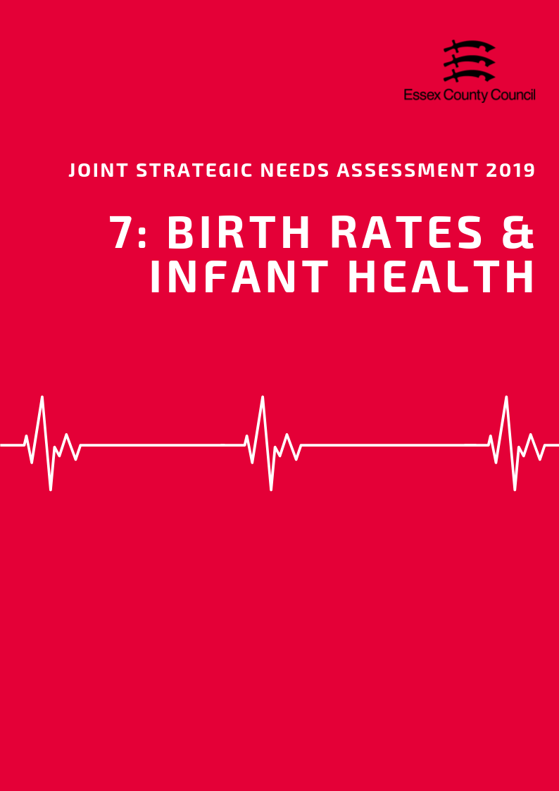

**Birth Rates & Infant Health**

***Birth Rates***

According to the Office for National Statistics, in Essex in 2017, the Crude Birth Rate (CBR; all births per 1,000 population) was 11.3, similar to the CBR of 11.6 across England.

The CBR has remained stable overall since 2013, with a CBR also of 11.3 in 2013. In contrast, the CBR across England decreased by 0.7 (2013: 12.3, 2017: 11.6). The largest rate increase was seen in 2013 - 2014 and largest decrease in 2014 - 2015.

The table below provides the ranked CBR in each district in Essex for years 2013 – 2017, and Table 2. the ranked birth rates per 1,000 by age group.

**Table 1. Ranked Crude Birth Rate per 1,000 population in the Essex Districts, 2013 – 2017**

|  |  |  |  |  |  |  |  |  |  |  |
| --- | --- | --- | --- | --- | --- | --- | --- | --- | --- | --- |
| District | Year | | | | | | | | | |
| 2013 | | 2014 | | 2015 | | 2016 | | 2017 | |
| CBR | Rank | CBR | Rank | CBR | Rank | CBR | Rank | CBR | Rank |
| Basildon | 13.6 | 2 | 13.4 | 2 | 13.5 | 2 | 13.6 | 2 | 13.5 | 2 |
| Braintree | 11.1 | 5 | 11.0 | 7 | 10.7 | 7 | 11.4 | 6 | 11.2 | 5 |
| Brentwood | 11.1 | 6 | 11.6 | 4 | 11.7 | 5 | 11.1 | 7 | 10.9 | 7 |
| Castle Point | 9.0 | 10 | 9.7 | 10 | 9.5 | 9 | 9.6 | 9 | 9.7 | 9 |
| Chelmsford | 10.9 | 7 | 11.4 | 6 | 10.9 | 6 | 11.7 | 5 | 11.2 | 6 |
| Colchester | 12.4 | 3 | 12.4 | 3 | 12.2 | 4 | 11.8 | 4 | 11.7 | 4 |
| Epping Forest | 12.2 | 4 | 11.5 | 5 | 12.5 | 3 | 12.2 | 3 | 12.4 | 3 |
| Harlow | 14.6 | 1 | 16.1 | 1 | 14.3 | 1 | 15.2 | 1 | 14.2 | 1 |
| Maldon | 8.8 | 11 | 8.5 | 12 | 9.2 | 11 | 8.4 | 12 | 9.2 | 12 |
| Rochford | 8.4 | 12 | 9.4 | 11 | 8.8 | 12 | 8.8 | 11 | 9.7 | 10 |
| Tendring | 9.7 | 9 | 9.8 | 9 | 9.5 | 10 | 9.0 | 10 | 9.4 | 11 |
| Uttlesford | 9.9 | 8 | 10.9 | 8 | 10.5 | 8 | 10.7 | 8 | 9.8 | 8 |
| Essex | 11.3 | - | 11.5 | - | 11.3 | - | 11.4 | - | 11.3 | - |
| England | 12.3 | - | 12.2 | - | 12.1 | - | 12.0 | - | 11.6 | - |

***Age of Mother***

The rate of births per 1,000 females aged 25 – 29 years was 109.2 in 2016, higher than the rate across England (98.5). Across Essex, the rate among females aged 30 – 34 years (123.9) was also higher than the rate across England (112.4). Rate of births in all other age groups were relatively similar to the national comparator.

|  |  |  |  |  |  |  |  |  |
| --- | --- | --- | --- | --- | --- | --- | --- | --- |
|  | **Birth Rates (per 1000) by Age of Mother** | | | | | | | |
| **Under 18s** | **Under 20** | **20-24 years** | **25-29 years** | **30-34 years** | **35-39 years** | **40-44 years** | **45+ years** |
| **Essex** | **5.6** | **11.9** | **57.3** | **109.2** | **123.9** | **66.7** | **12.4** | **1** |
| **England** | **4.6** | **13.5** | **55.6** | **98.5** | **112.4** | **67.5** | **14.9** | **1.1** |
| Basildon | 4.1 | 17 | 73.9 | 117.9 | 122.5 | 66.3 | 13 | - |
| Braintree | 7.2 | 12.7 | 70.3 | 120.8 | 115.1 | 61 | 12.8 | 0.7 |
| Brentwood | 3.0 | 7.5 | 36 | 90.7 | 145.4 | 77.4 | 14 | 1 |
| Castle Point | 3.8 | 10.1 | 51.2 | 110.4 | 126.5 | 62.1 | 7.7 | 1.2 |
| Chelmsford | 3.1 | 10.4 | 43.3 | 105.1 | 124.8 | 73 | 14.6 | 1.1 |
| Colchester | 3.4 | 11.4 | 52.1 | 93 | 111.4 | 61.9 | 11.7 | 1.7 |
| Epping Forest | 4.2 | 8.6 | 45 | 98.8 | 145.5 | 77.8 | 14.5 | 1 |
| Harlow | 8.5 | 16.2 | 72.4 | 137.5 | 116.8 | 69.3 | 15.4 | 2.7 |
| Maldon | 2.8 | 8.3 | 61.9 | 100.8 | 122.4 | 60.8 | 6.3 | - |
| Rochford | 5.3 | 7.9 | 32.4 | 105.3 | 128.2 | 53.5 | 12.3 | - |
| Tendring | 8.1 | 18.8 | 88.4 | 132.6 | 101.7 | 46.8 | 9.4 | - |
| Uttlesford | 1.9 | 6.2 | 47.1 | 93.7 | 151.1 | 85.9 | 13.2 | 1.4 |

***Under 18 Conceptions Rate***

The rate of conceptions per 1,000 females aged under 18 years across Essex was 16.7, and the rate of live births was 4.64. The conception rate is similar to that across England (18.8), but the birth rate lower (5.55). The rate of under 18 conceptions in 2018 was found to be highest in Tendring and lowest in Uttlesford.

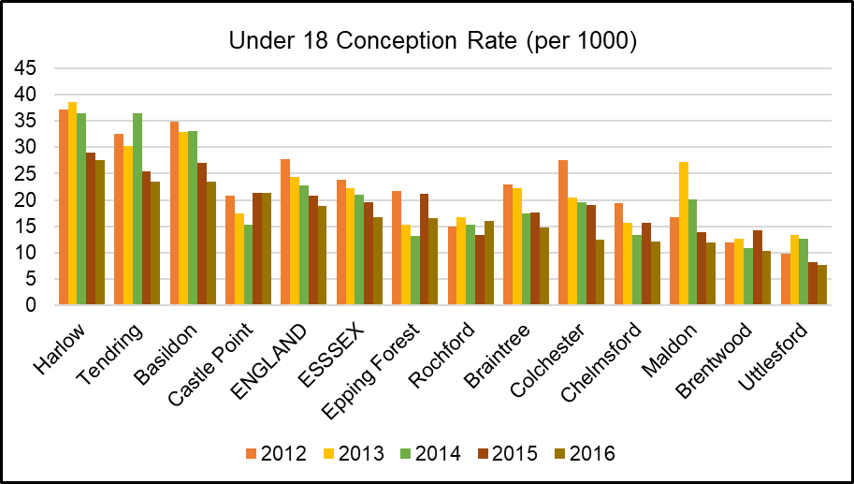

Note: rate is per 1,000 population of that age group, not total population (e.g. per 1,000 aged under 20 years).

***Premature Births***

Premature births are live or still births at a gestational age of less than 37 weeks. The rate of premature births per 1,000 total live and still births across Essex was 74.69 over the 3 year period of 2014 - 2016. This is lower compared to the premature birth rate across England (79.52).

***Low Birth Weight***

Low birth weight is defined as a live birth with a recorded weight under 2500g and gestational age of at least 37 weeks. Across Essex in 2016, the percentage of low birth weight out of all live births with a recorded weight (and gestational age >=37 weeks) was 2.11%. This is lower than the prevalence of low birth weight across England (2.79%).

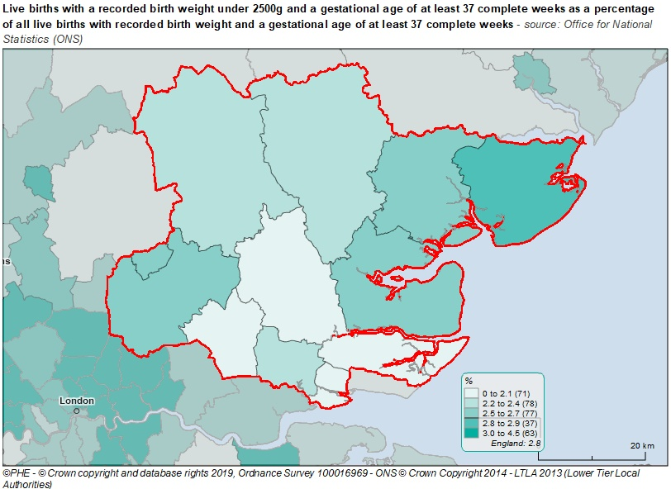

***Infant Mortality***

According to Public Health England, the rate of infant mortality aged under 1 years old was 3.10 per 1,000 live births in Essex over the period 2015 - 2017. This was lower than that for England (3.92). Two areas (Tendring = 5.5, Colchester = 4.2) had infant mortality rate above the England average but were not class as statistically significantly different.

***Breastfeeding***

Breastfeeding initiation is mothers giving their babies breast milk in the first 48 hours after delivery. The percentage of breastfeeding initiation of the total number of maternities in Essex in 2016/17 was 75.02%, similar to that across England (74.49%). Four districts (Basildon = 68%, Tendring = 68.4%, Braintree = 70.8%, and Harlow 71.2%) had rates below the England level. Data was not available for Epping Forest and Maldon.

***Smoking at The Time of Delivery***

The percentage of mothers known to be smokers at the time of delivery out of all maternities was 10.60% in Essex in 2017/18. This was similar to that for England (10.80%). Two CCG areas (North East Essex = 14.7%, and Basildon & Brentwood CCG = 11.8%) had levels of smoking at delivery above the national average.

*All of the infant health datasets mentioned in this section is set out in table below:*

|  |  |  |  |  |  |
| --- | --- | --- | --- | --- | --- |
|  | **Premature births (less than 37 weeks gestation) Per 1000** | **Low birth weight of term babies (%)** | **Infant mortality (per 1000)** | **Breast Feeding Initiation (%)** | **Smoking status at time of delivery (%)** |
| **England** | 79.52 | 2.79 | 3.92 | 74.49 | 10.80 |
| **Essex** | 74.69 | 2.11 | 3.10 | 75.02 | 10.6 |
| Basildon | 79.05 | 2.52 | 2.83 | 68.02 | 11.82 |
| Braintree | 73.88 | 2.32 | 3.19 | 70.82 | 7.76 |
| Brentwood | 62.79 | 2.03 | 1.56 | 76.56 | 11.82 |
| Castle Point | 91.76 | 1.92 | 1.94 | 75.70 | 6.25 |
| Chelmsford | 65.68 | 1.67 | 3.06 | 77.55 | 7.76 |
| Colchester | 77.37 | 2.50 | 4.20 | 82.02 | 14.70 |
| Epping Forest | 74.35 | 2.07 | 1.24 | ! | 9.98 |
| Harlow | 84.90 | 2.61 | 3.20 | 71.18 | 9.98 |
| Maldon | 59.39 | 1.18 | 2.95 | ! | 7.76 |
| Rochford | 62.91 | 1.13 | 3.42 | 83.35 | 6.25 |
| Tendring | 81.90 | 2.03 | 5.52 | 68.38 | 14.70 |
| Uttlesford | 67.35 | 1.82 | 2.99 | 80.28 | 9.98 |
| Time Period | 2014-16 | 2016 | 2015-17 | 2016/17 | 2017/18 |
| ! Data not available | | | | | |

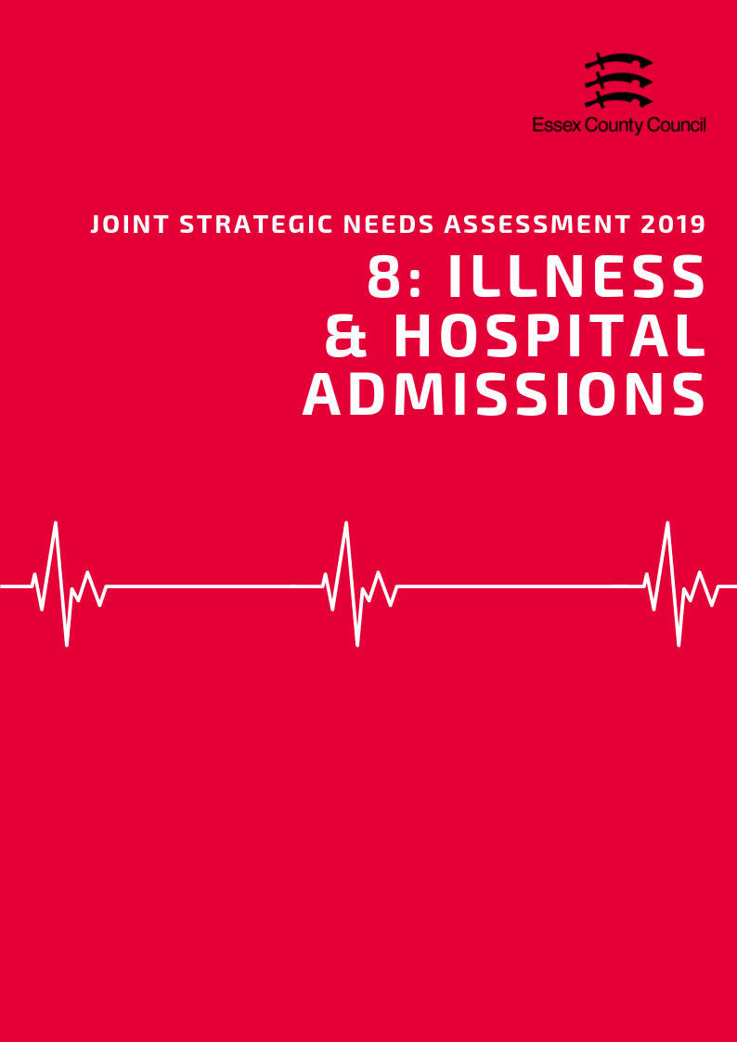

**Illness & Hospital Admissions**

***Emergency Hospital Admissions***

Emergency (unplanned) hospital admissions are both costly to the Health Service and can be a proxy indicator for wider health inequalities within local communities. In order to accurately compare admissions rates between areas of different sizes and compositions statistics are presented using Standardised Admission Ratio is defined as the ratio of the observed number of admissions in an area to the number expected if the area had the same age specific rates as England (Always set at 100).

Across Essex, the county average for emergency hospital admissions for all causes and all ages for the period of 2013/14 - 2017/18 was lower than the England benchmark at 89.6. At a district level 10 of the 12 districts in the ECC area also had levels below the England baseline (Lowest: Uttlesford = 73.1; Highest: Harlow = 110.9) with Tendring in-line with England level (100.3) and Harlow being higher (110.9).

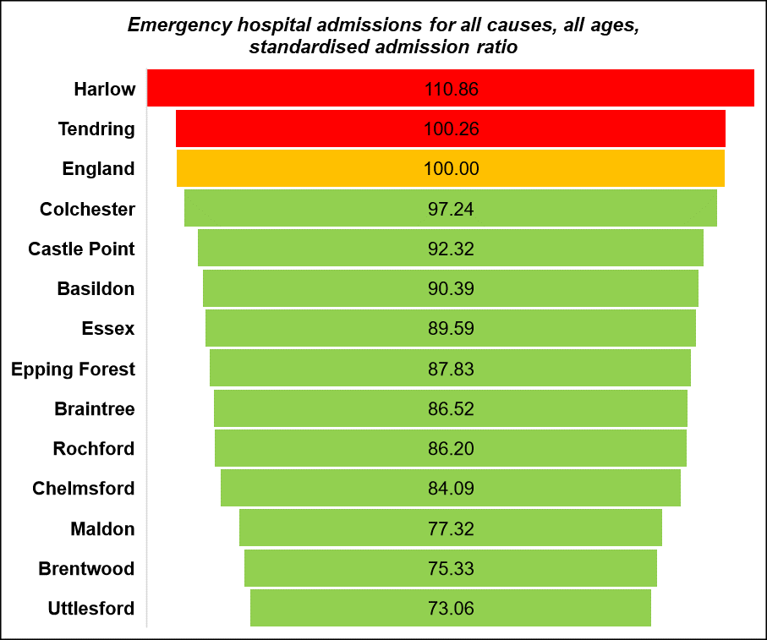

Emergency Admissions ratios for different 5 major condition types present a more mixed picture about the causes of demand on A&E services. Emergency Admissions for Chronic Obstructive Pulmonary Disease (COPD) (83.2), Coronary Heart Disease (90.5), Heart Attack (87.5) and Stroke (94.3) were all lower than the England Baseline overall. At a District level Basildon was above or in-line with the England level for all four condition types (see table below), Harlow was higher than average for 3 conditions (excluding stroke SAR = 96.8). Tendring was similar to England for COPD and Stroke, and higher for CHD. Castle Point was higher than average for COPD and Stroke, whilst Rochford was also higher for Stroke.

|  |  |  |  |  |  |  |
| --- | --- | --- | --- | --- | --- | --- |
|  | Emergency hospital admissions (standardised admission ratio) | | | | | |
|  | All causes  & All ages | Chronic Obstructive Pulmonary Disease (COPD) | Coronary Heart Disease, (CHD) | Hip fracture in persons 65 years and over | Myocardial Infarction (heart attack) | Stroke |
| Basildon | 90.4 | 116.5 | 100.4 | 103.5 | 104.0 | 113.8 |
| Braintree | 86.5 | 75.5 | 83.5 | 116.1 | 85.2 | 88.8 |
| Brentwood | 75.3 | 61.3 | 81.1 | 104.4 | 81.6 | 89.8 |
| Castle Point | 92.3 | 102.0 | 84.7 | 104.5 | 77.5 | 102.0 |
| Chelmsford | 84.1 | 61.2 | 77.2 | 107.9 | 75.4 | 89.3 |
| Colchester | 97.2 | 71.7 | 92.4 | 108.3 | 81.2 | 86.5 |
| England | 100.0 | 100.0 | 100.0 | 100.0 | 100.0 | 100.0 |
| Epping Forest | 87.8 | 78.4 | 88.3 | 99.7 | 91.9 | 89.8 |
| Essex | 89.6 | 83.2 | 90.5 | 106.2 | 87.5 | 94.3 |
| Harlow | 110.9 | 129.8 | 128.8 | 99.3 | 125.8 | 96.8 |
| Maldon | 77.3 | 52.2 | 80.8 | 105.8 | 83.9 | 80.2 |
| Rochford | 86.2 | 81.6 | 90.5 | 101.9 | 77.0 | 105.7 |
| Tendring | 100.3 | 100.3 | 105.7 | 108.4 | 93.7 | 100.1 |
| Uttlesford | 73.1 | 51.9 | 67.6 | 106.1 | 74.4 | 76.0 |

***Admissions for Children and Young People***

Admissions episodes for children are presented in slightly different way in that they are calculated using a three-year average rate per 1,000 residents, not against an England baseline of 100. Data from Public Health England estimates that there was a three-year average of 475.2 Accident and Emergency attendances by children under the age of 5 across Essex as a whole compared to an England rate of 551.6. Two areas, Basildon (633) and Harlow (721.8) had rates above the England level, whilst all other areas were below. The rate of children under 5 years old given an emergency admission during the same period was lower overall at 116.6 across Essex but higher than England in Colchester (230.8) and Tendring (195.2).

***Emergency Readmissions***

Based on Hospital Episode Statistics, 11.8% of emergency admissions to any hospital in England occurred within 30 days of discharge from previous admissions. Aggregated figures are not available for the County as a whole however looking at each district individually we can see that 10 of the 12 districts had readmissions rates below the England level (Lowest: Basildon = 9.8%) with two areas. Harlow (12.7%) and Epping Forest (12.11) having rates above the England level. Note that readmissions coded under obstetrics, or those with a cancer diagnosis (not benign or in situ) or chemotherapy for cancer during the readmittance spell were excluded.

***Violence Related Admissions***

Across Essex the (age standardised) rate per 100,000 population of emergency hospital admissions for violence was 28.83 over the period of 2015/16 - 2017/18. This was below the average for England (43.36) with only one district exceeding the England Level during this time (highest: Tendring 50.75; lowest: Uttlesford 12.80).

***Injuries and Harm***

Hospital admissions due to alcohol-related unintentional injuries is defined as admissions where the secondary diagnoses are an alcohol-attributable ICD-10 unintentional injuries code. This is displayed as a standardised rate per 100,000 population. Essex had a lower rate of hospital admissions due to alcohol-related unintentional injuries among persons in 2017/18, with a rate of 135.29 compared to England (144.30). Basildon was the only district with a rate higher than England; all other districts were similar or lower (163.08).

Standardised Admissions Ratios for Hospital stays for Alcohol Related Harm (86.1) was lower compared to England but was higher in two Districts, Harlow (111) and Tendring (105.2). The SAR for Hospital Stays for Self-Harm (81.6) was again lower across Essex as a whole compared to England but higher in Tendring (151.5) and Colchester (130.6).

|  |  |  |  |  |  |
| --- | --- | --- | --- | --- | --- |
|  | **Unintentional and deliberate injuries (per 10,000)** | | **Hospital admissions for violence (Incl. sexual violence) *Directly Age Standardised Per 100K*** | **Hospital Stays (Standardised Admissions Ratios)** | |
| **Children (aged 0-14 years)** | **Young People (aged 15-24)** | **For alcohol-related harm** | **For self-harm** |
| **England** | **96.44** | **132.67** | **43.36** | **100.0** | **100.0** |
| **Essex** | **88.22** | **125.93** | **28.83** | **86.1** | **81.6** |
| Basildon | 56.04 | 188.13 | 34.50 | 85.9 | 57.5 |
| Braintree | 96.73 | 135.54 | 18.06 | 77.7 | 78.4 |
| Brentwood | 65.56 | 112.42 | 20.47 | 67.9 | 40.1 |
| Castle Point | 70.35 | 107.87 | 28.24 | 89.1 | 62.0 |
| Chelmsford | 99.08 | 136.21 | 26.99 | 75.4 | 76.9 |
| Colchester | 120.74 | 124.52 | 34.90 | 93.0 | 130.6 |
| Epping Forest | 88.23 | 89.35 | 29.05 | 87.4 | 47.7 |
| Harlow | 85.02 | 105.57 | 34.25 | 111.0 | 87.7 |
| Maldon | 95.84 | 114.00 | 23.93 | 72.6 | 61.9 |
| Rochford | 73.12 | 93.17 | 17.86 | 81.2 | 59.8 |
| Tendring | 112.74 | 114.68 | 50.75 | 105.2 | 151.5 |

***Falls and Hip Fractures***

Falls are the largest cause of emergency hospital admissions for older people, and significantly impact on long term outcomes, e.g. being a major precipitant of people moving from their own home to long-term nursing or residential care.

Emergency hospital admissions for falls in people aged 65 + across Essex (2059.5) was lower than the England average (2170.4) but was higher than average in four districts, Basildon (2677.1), Braintree (2122.3) Castle Point (2362.1) and Rochford (2258.5). All other areas were below the England level.

Emergency admissions for hip fractures in persons in aged 65 and over is a key issue across the county where emergency admissions ratios exceed the England Level (100) for both the county average (106.2) and 10 of the 12 districts (Highest: Braintree = 116.1). Two areas, Harlow (99.3) and Epping Forest (99.7) were just below.

The directly age standard admissions rate of hip fractures was estimated to be 611.9 per 100,000 population ages 65 and over. This was higher than the average for England (577.8) and was also higher than average in 9 out of 12 Districts (Lowest: Uttlesford = 532.2; Highest: Braintree = 716.4) with three areas (Chelmsford, Epping Forest, and Uttlesford) having rates below.

|  |  |  |  |  |  |  |
| --- | --- | --- | --- | --- | --- | --- |
|  | **Emergency hospital admissions due to falls** | | | **Hip fractures** | | |
| **All Persons Aged 65 and over** | **Age 65-79** | **Age 80+** | **All persons aged 65 and over** | **Age 65-79** | **Age 80+** |
| England | 2170.43 | 1032.87 | 5469.37 | 577.76 | 246.32 | 1539 |
| Essex | 2059.46 | 940.94 | 5303.19 | 611.9 | 259.41 | 1634 |
| Basildon | 2677.1 | 1345.86 | 6537.69 | 617.96 | 300.99 | 1537 |
| Braintree | 2122.3 | 950.99 | 5519.13 | 716.43 | 269.9 | 2011 |
| Brentwood | 2071.46 | 1067.65 | 4982.49 | 623.82 | 337.66 | 1454 |
| Castle Point | 2362.11 | 912.43 | 6566.18 | 588.79 | 207.44 | 1695 |
| Chelmsford | 1929.67 | 883.43 | 4963.76 | 565.04 | 214.47 | 1582 |
| Colchester | 1945.47 | 921.23 | 4915.78 | 626.55 | 261.02 | 1687 |
| Epping Forest | 1772.09 | 774.38 | 4665.45 | 542.61 | 239.76 | 1421 |
| Harlow | 1742.48 | 830.26 | 4387.93 | 615.28 | 291.71 | 1554 |
| Maldon | 1877.77 | 876.69 | 4780.91 | 604.99 | 264.76 | 1592 |
| Rochford | 2258.51 | 850.92 | 6340.51 | 607.61 | 219.16 | 1734 |
| Tendring | 1955.95 | 902.11 | 5012.1 | 660.87 | 292.17 | 1730 |
| Uttlesford | 1871.26 | 822.68 | 4912.14 | 532.18 | 215.53 | 1450 |

**ILLNESS AND LONG TERM CONDITIONS**

As part of the Quality Outcomes Framework (QOF) each GP surgery records the percentage of registered patients who have been diagnosed with a range of different medical conditions. This rate is known as QOF prevalence which along with records from of practices can be combined to give a prevalence level at different geographies.

***Hypertension & Stroke***

High blood pressure (hypertension) puts extra strain on your heart and blood vessels and can cause them to become weaker or damaged leading to increased risk of heart attack, kidney disease and a range of other conditions. In 2015/16, the proportion of GP registered patients (also known as the QOF prevalence) with a diagnosis of Hypertension across Essex was 15.1% compared to the England level of 13.9%. 10 districts had prevalence rates above this level, whilst 2 had rates similar to or just lower than England (Lowest: Colchester = 13.3%; Highest: Tendring = 19.6%). The prevalence of undiagnosed hypertension among persons aged over 16 years, similar to or above the England rate of 12.2% in 9 out of 12 districts (highest: Tendring 14.04; lowest: Colchester = 11.61).

The percentage of patients across Essex who had experienced a stroke or transient ischemic attack was 1.76% in 2017/18 across England, with seven districts in Essex having rates equal to or higher than this level (Lowest: Colchester = 1.42%; Highest: Tendring = 2.5%).

***Coronary Heart Disease***

Coronary heart disease is the term that describes what happens when your heart's blood supply is blocked or interrupted by a build-up of fatty substances in the coronary arteries. This increases the risk of problems such as heart attacks. The QOF prevalence of Coronary Heart Disease (CHD) in 2015/16 across Essex was 3.2% which was similar to the rate for England of 3.1%. Two CCGs in Essex had prevalence levels above the England average (Castle Point & Rochford = 3.6, North East Essex = 3.5).

***Chronic Obstructive Pulmonary Disease (COPD)***

Chronic Obstructive Pulmonary Disease (COPD) refers to serious lung conditions, including chronic bronchitis and emphysema. According to data from the Hospital Episode Statistics, the age standardised rate of emergency hospital admissions for COPD in adults aged over 35 years was 350.3 per 100,000 across Essex lower than the rate for England of 417.3. 4 areas, Basildon (490.5); Harlow (481.3); Castle Point (453.7); and Tendring (428.4), had rates above the England level, whilst the remaining 8 areas all had rates below both England and Essex (lowest: Uttlesford= 215.50).

***Epilepsy***

Epilepsy is a common condition that affects the brain and causes frequent seizures along with a wide range of other symptoms. Epilepsy can start at any age, but usually starts either in childhood or in people over 60 and is often a lifelong condition.

In 2017/18, the estimated proportion of GP registered patients across England was 0.8%, above the rates observed in 6 out of the 12 districts in Essex (Lowest: Epping Forest = 0.59; Highest: Tendring = 1.05). Braintree (0.89), Harlow (0.81), Maldon (0.82) and Tendring (1.05) all had rates higher than the England average.

***Dementia***

The proportion of GP registered patients in Essex with Dementia is estimated to be 0.81%, slightly higher than the average for England (0.76%). 8 districts had rates equal to or higher than the England average (Highest: Tendring =1.06%) whilst 4 were below (Lowest: Harlow = 0.59%).

Over the last three years the estimated Dementia diagnosis rate in people aged 65 and over in Essex is estimated to have risen from 60.5% in 2017 to 64.5% in 2019. Despite this increase, diagnosis rates remain lower than the England average of 68.7% with only 2 districts, Epping Forest (81.7%) and Rochford (81.7%), having diagnosis rates over the England level (Lowest: Maldon = 57.6%).

|  |  |  |  |  |  |
| --- | --- | --- | --- | --- | --- |
|  | **QOF Prevalence (% of GP Registered Patients)** | | | | |
|  | **Asthma**  **(all ages)** | **Dementia**  **(all ages)** | **Epilepsy (18+)** | **Hypertension (all ages)** | **Stroke (all ages)** |
| **England** | **5.93** | **0.76** | **0.80** | **13.94** | **1.77** |
| Basildon | 6.09 | 0.69 | 0.78 | 14.96 | 1.82 |
| Braintree | 6.29 | 0.80 | 0.89 | 13.70 | 1.77 |
| Brentwood | 5.29 | 0.90 | 0.73 | 14.67 | 1.89 |
| Castle Point | 5.87 | 0.77 | 0.80 | 18.07 | 1.87 |
| Chelmsford | 6.08 | 0.72 | 0.75 | 13.76 | 1.55 |
| Colchester | 5.81 | 0.67 | 0.80 | 13.32 | 1.43 |
| Epping Forest | 5.10 | 1.06 | 0.59 | 13.95 | 1.61 |
| Harlow | 5.83 | 0.59 | 0.81 | 13.40 | 1.48 |
| Maldon | 6.40 | 0.78 | 0.82 | 16.19 | 1.92 |
| Rochford | 5.94 | 1.04 | 0.70 | 16.13 | 1.89 |
| Tendring | 6.90 | 1.07 | 1.05 | 19.58 | 2.47 |
| Uttlesford | 6.55 | 0.79 | 0.64 | 14.41 | 1.58 |

POPPI (Projecting Older People's Population Information) projections using health and census data estimate that in 2019 there are likely to be 21,972 people across Essex over the age of 65 with dementia and that this figure is could increase by 33% by 2030 to 29,437 people. Tendring current has the highest number of estimated people with dementia (3,104) whilst Harlow has the lowest (1,018).

Projected dementia numbers of people with dementia for individual districts are set out in the table below (Source: POPPI 2019)

|  |  |  |  |  |  |
| --- | --- | --- | --- | --- | --- |
| **Projected number of people age 65+ with Dementia** | **2019** | **2020** | **2025** | **2030** | **2035** |
| **Essex** | 21,972 | 22,478 | 25,510 | 29,437 | 33,729 |
| Basildon | 2,284 | 2,316 | 2,595 | 2,926 | 3,349 |
| Braintree | 2,174 | 2,225 | 2,595 | 3,114 | 3,633 |
| Brentwood | 1,264 | 1,276 | 1,403 | 1,576 | 1,744 |
| Castle Point | 1,566 | 1,619 | 1,840 | 2,129 | 2,338 |
| Chelmsford | 2,452 | 2,503 | 2,908 | 3,330 | 3,799 |
| Colchester | 2,323 | 2,396 | 2,689 | 3,180 | 3,639 |
| Epping Forest | 1,967 | 1,994 | 2,233 | 2,541 | 2,858 |
| Harlow | 1,018 | 1,024 | 1,111 | 1,229 | 1,370 |
| Maldon | 1,053 | 1,103 | 1,319 | 1,597 | 1,835 |
| Rochford | 1,417 | 1,444 | 1,661 | 1,880 | 2,133 |
| Tendring | 3,104 | 3,183 | 3,576 | 4,112 | 4,684 |
| Uttlesford | 1,309 | 1,349 | 1,625 | 1,944 | 2,275 |

***Cancer***

The NHS estimates that more than 1 in 3 people will develop some form of cancer during their lifetime with the 4 most common types of cancer being:

* lung cancer
* breast cancer
* prostate cancer
* bowel cancer

The following incidence ratio of all cancers and the major cancer sub-types are the standardised incidence ratio, the number of observed new cases as a percentage of number expected new cases, calculated relative to England (100) during the period of 2012-2016.

The incidence ratio for all cancers across Essex was 98.49, similar to the rate for England. Four areas were worse than the incidence ratio for all cancers across England (100), including; Harlow (105.2), Basildon (104.8), Tendring (104.7) and Epping Forest (104.6). The lowest incidence ratios for all cancers were recorded in Rochford (91.6).

Lung cancer had an incidence ratio of 90.5 across Essex (highest: Harlow 123.62; lowest: Uttlesford 67.11), with four areas Basildon (108.6), Castle Point (101.6), Harlow, and Tendring (106.2)) behind above the England level, however only two of these areas (Basildon and Harlow) were classified as being significantly worse than.

The incidence ratio for Breast Cancer across Essex (100.97) was classed not significantly different to England (100) as were all district level all 12 areas (highest: Uttlesford 108.04; lowest: Castle Point 92.74).

The incidence ratio for colorectal/bowel cancer across Essex was just below England at 97.6 but was not classed as significantly different. Epping Forest (103.8), Basildon (102.1) and Tendring (101.4) all had incidence ratio above the England level, however ALL districts with the exception of Brentwood (88.81) were not considered to be significantly different (highest: Epping Forest = 103.80; lowest: Brentwood = 88.81).

Prostate cancer had an incidence ratio 104.1 across Essex, just above the England level (highest: Epping Forest = 132.98; lowest: Basildon = 92.01). 6 of the 12 districts also had rates above the England level with Epping Forest, Colchester (112.3) and Tendring (109.8) classed as significantly worse.

|  |  |  |  |  |  |
| --- | --- | --- | --- | --- | --- |
|  | Incidence Rates of Cancers | | | | |
| Breast Cancer | Colorectal Cancer | Lung Cancer | Prostate Cancer | All Cancers |
| **England** | **100.00** | **100.00** | **100.00** | **100.00** | **100.00** |
| **Essex** | **100.97** | **97.58** | **90.53** | **104.12** | **98.49** |
| Basildon | 106.58 | 102.13 | 108.63 | 92.01 | 104.75 |
| Braintree | 98.81 | 88.86 | 84.42 | 104.95 | 95.66 |
| Brentwood | 99.53 | 88.81 | 68.29 | 101.00 | 93.95 |
| Castle Point | 92.74 | 92.87 | 101.61 | 93.50 | 96.58 |
| Chelmsford | 104.20 | 99.87 | 70.10 | 99.10 | 92.40 |
| Colchester | 98.63 | 98.14 | 84.95 | 112.32 | 97.99 |
| Epping Forest | 103.04 | 103.80 | 96.50 | 132.98 | 104.62 |
| Harlow | 100.36 | 98.95 | 123.62 | 95.24 | 105.18 |
| Maldon | 105.22 | 93.31 | 83.34 | 95.07 | 93.35 |
| Rochford | 96.24 | 98.32 | 80.73 | 97.19 | 91.62 |
| Tendring | 97.98 | 101.04 | 106.26 | 109.79 | 104.66 |
| Uttlesford | 108.04 | 96.62 | 67.11 | 102.20 | 94.02 |

***Musculoskeletal (MSK) Conditions***

Musculoskeletal (MSK) conditions affect the joints, bones and muscles, and also include rarer autoimmune diseases and back pain. MSK conditions are the leading cause of pain and disability in England and account for one of the highest causes of sickness absence and productivity loss.

Across Essex 5 of 12 districts higher than average rates of residents reporting a long term MSK problem compared to the England average of 33.5% (Highest: Tendring = 29.8%; Lowest: 29.8%).

Four areas had higher than average levels of residents reporting a long-term back problem compared to the England average of 9.4% (Highest: Tendring = 13.1%; Lowest: Chelmsford = 7.5%). Five areas also higher than average rates of arthritis or joint problems (Highest: Tendring = 17.6%; Lowest: Uttlesford = 9.8%)

|  |  |  |  |
| --- | --- | --- | --- |
|  | **% reporting a long term MSK problem** | **% reporting a long-term back problem** | **% reporting arthritis or long-term joint problem** |
| Basildon | 33.5 | 9.4 | 11.5 |
| Braintree | 33.4 | 8.7 | 12.8 |
| Brentwood | 35.7 | 10.5 | 13.0 |
| Castle Point | 39.3 | 9.4 | 15.3 |
| Chelmsford | 30.8 | 7.5 | 11.3 |
| Colchester | 32.0 | 8.2 | 10.6 |
| England | 33.5 | 9.4 | 12.2 |
| Epping Forest | 32.0 | 8.7 | 11.7 |
| Essex | 34.9 | 9.3 | 12.6 |
| Harlow | 33.4 | 10.5 | 11.9 |
| Maldon | 36.6 | 11.3 | 13.3 |
| Rochford | 36.8 | 8.0 | 13.4 |
| Tendring | 47.7 | 13.1 | 17.6 |
| Uttlesford | 29.8 | 8.2 | 9.8 |

***Diabetes***

Diabetes is a lifelong condition that causes a person's blood sugar level to become too high.

There are 2 main types of diabetes:

* type 1 diabetes – where the body's immune system attacks and destroys the cells that produce insulin
* type 2 diabetes – where the body does not produce enough insulin, or the body's cells do not react to insulin

Type 2 diabetes is far more common than type 1. In the UK, around 90% of all adults with diabetes have type 2.

The percentage of patients registered with GPs in the County who are recorded as having Diabetes (QOF Prevalence) is 6.6% across the Essex County Council area, similar to the average for England of 6.5%. Information on this measure is only currently available at CCG level which showed four out of the five CCG areas were similar to the England average apart from Castle Point and Rochford CCG (7.2%) which was slightly higher. Public Health England estimates that the total rate of diabetes (both diagnosed and undiagnosed) is likely to be higher at 8.5% across England. The rate for Essex is estimated to be in-line with the England average apart from in the North East Essex CCG (9.0%) where it is expected to be slightly higher.

|  |  |  |  |  |
| --- | --- | --- | --- | --- |
|  | Diabetes: QOF prevalence (17+) | Estimated prevalence of diabetes (undiagnosed and diagnosed) | People with type 1 diabetes who have received an annual foot check | People with type 2 diabetes who have received an annual foot check |
| England | 6.5% | 8.5% | 70.1% | 79.4% |
| Essex | 6.6% | 8.5% |  |  |
| NHS Basildon And Brentwood CCG | 6.4% | 8.2% | 61.8% | 65.9% |
| NHS Castle Point and Rochford CCG | 7.2% | 8.6% | 54.4% | 61.8% |
| NHS Mid Essex CCG | 6.4% | 8.1% | 58.3% | 65.7% |
| NHS North East Essex CCG | 6.8% | 9.0% | 81.8% | 85.5% |
| NHS West Essex CCG | 6.2% | 8.1% | 64.0% | 72.4% |

Diabetes can reduce the blood supply to feet and cause a loss of feeling known as peripheral neuropathy. This can mean foot injuries don't heal well and you may not notice if your foot is sore or injured. Annual foot checks for people with diabetes are therefore an essential part of care monitoring procedures. Across Essex four out of five CCG areas have fewer patients receiving an annual foot check for both type 1 and 2 diabetes than the England average.

**Vaccinations**

Vaccinations are one of the most important interventions in place to prevent the spread of avoidable diseases amongst the population. In the UK the majority of vaccinations are given childhood, with a number of boosters and additional vaccinations also given to people of different ages who might be at higher risk from certain diseases.

Across the UK vaccination rates are declining with fewer people completing full courses of vaccinations compared to recent years leading to increased potential for outbreaks of diseases within an area. According to the NHS "If 95% of children receive the MMR vaccine, it's possible to get rid of measles. However, measles, mumps and rubella can quickly spread again if fewer than 90% of people are vaccinated."

***Childhood Vaccinations***

Data on Childhood Vaccinations is largely presented as the average for the CCG area, using data amalgamated up from individual GP practices. These averages can be positively skewed by figures higher performing practices in the area and mask coverage issues at a more local level. As such we have also analysed vaccination coverage levels within relevant age groups against two additional criteria recorded by NHS England;

* The number and percentage of GP practices meeting the minimum of 90% of patients vaccinated
* The number and percentage of GP practices meeting the target of 95% or more patients vaccinated

*Tables at the end of this chapter provide a full breakdown of current childhood vaccination coverage levels by CCG area.*

***Measles, Mumps and Rubella (MMR)***

By age 5 it is estimated that 96.5% of the GP registered children in Essex have received one of the two MMR vaccination injections required to achieve full vaccination coverage. This is higher than the average for England of 94.9%, with 139 out of 178 GP practices (78.1%) in the area achieving at least 95% coverage or Higher. At CCG level across the 5 areas in the county all areas achieved 95% coverage or higher for the first part of the MMR vaccination (Highest: Castle Point and Rochford CCG = 97.1%; Lowest: West Essex CCG = 95.5%).

By comparison the rate of GP registered children who have received both of MMR vaccination injections by age five drops to 89.4%, which although higher than the England average (87.2%), is well below the 95% needed to eliminate measles within the population. NHS England Child Vaccination coverage statistics identified 81 out of 178 GP practices (45.5%) across Essex with less than 90% vaccination coverage of the eligible population, and only 22 practices (12.4%) which were achieving coverage of 95% or higher. The level practices achieving less than 90% coverage varied considerably across the county (Lowest: Mid Essex CCG = 22.8%; Highest: West Essex CCG = 60.6%), similarly for those areas achieving 95% coverage or higher (Highest: Mid Essex CCG = 22.2%; Lowest: West Essex CCG = 0%). Compared to other vaccines on the regular NHS schedule (excluding boosters), the MMR overall has the lowest number of GP practices achieving 95% coverage or higher in the county.

***Diphtheria, Tetanus, Pertussis (Whooping Cough), Polio, Haemophilus Influenzae Type B (hib): DTaP/IPV/Hib***

97.1% of GP registered children in Essex had received the full course of DTaP/IPV/Hib injections by Age 5. This is higher than the average for England (95.6%) with only one out of the 5 CCG areas in Essex achieving less than the England Average (Highest: Castle Point & Rochford CCG = 98.3%; Lowest: West Essex CCG = 94.6%). At induvial GP practice level, the NHS vaccination coverage statistics identified 36 practices which had coverage levels below 90% (20.2%) and 68 (38.2%) which were achieving coverage levels of 95% or higher.

***Rotavirus***

An estimated 92.4% of GP registered children Essex had received their vaccinations against Rotavirus by 12 months; higher than the average for England (90.1%). Looking at coverage levels across individual GP practices, NHS England statistics identified 40 practices (22.5%) which had coverage levels below 90% and 63 practices (35.4%) achieving coverage of 95% or higher. At individual CCG Level one area (North East Essex CCG = 88.5%) achieved less than 90% coverage (Highest: Castle Point and Rochford CCG = 95.8%).

**Pneumococcal Vaccine (PCV)**

The pneumococcal vaccine protects against serious and potentially fatal pneumococcal infections such as pneumonia, septicaemia (a kind of blood poisoning) and meningitis and is given to infants over three separate doses at 8 weeks, 16 weeks and 1 year. By 24 months 92.8% of the GP registered children in Essex have received their PCV vaccinations, higher than the England (91%) average coverage levels. Out of 5 CCG areas 4 had coverage rates above 90% (Highest: Castle Point and Rochford CCG = 96.2%; Lowest: North East Essex CCG = 89.9%) with 40 out of 178 GP practices (22.5%) achieving coverage levels of less than 90% and 74 practices (41.6%) achieving coverage levels of 95% or higher.

***Meningitis***

According to the NHS Meningitis can be caused by a number of different infections, as such a number of different vaccinations are used to offer protection against this including the MMR, DTaP/IPV/Hib, and Pneumococcal Vaccine already mentioned in this report. In addition, the NHS also includes separate vaccinations against Meningitis C (and Hib) at one year old and also Meningitis B which takes place at 8 weeks, 16 weeks and booster at 1 year.

Coverage levels of the Hib & Meningitis C vaccination across Essex is 94.8% of eligible GP registered children by age 5, higher than the rate for England of 92.4% but just below the target 95% coverage level. All 5 of the 5 CCGs in Essex achieved coverage levels above 90% with 3 areas achieving 95% coverage or higher (Highest: Castle Point and Rochford CCG = 96.5%; lowest: North East Essex CCG= 93.8%), with 18 practices achieving less than 90% coverage (10.5%) and 105 practices achieving 95% or higher (59%).

Coverage levels of the new Meningitis B vaccination across Essex is 94.2% of eligible GP registered children at 12 months, just above to the rate for England of 92.5%. Out of the 5 CCGs in Essex (Highest: Castle Point and Rochford CCG = 95.8%; Lowest: North East Essex CCG= 92.4%) all areas have coverage levels above 90% and 2 had coverage levels above 95%. At GP practice level 30 out of 178 GP practices (16.9%) had coverage levels below 90% and 82 practices (46.1%) achieving 95% coverage or higher.

***Children in Care Immunisations***

According to figures from the Department for Education in 2018, 77.6% of children in care are up to date with the vaccinations in the NHS routine list across the whole of Essex. This is lower than the average for England (85.3%) and the East of England (85.1%) and is the 4th lowest rate out of 11 upper tier and unitary authorities in the eastern region (Highest: Norfolk = 96.3%; Lowest: Thurrock = 65.4%).

***Flu Vaccinations***

Vaccination against the Flu is offered on an annual basis to both children and adults likely to be at risk of flu and associated complications including:

* Children between 6 months and 2 years in a high risk group
* Children aged 2-17 in an eligible group
* Adults aged 18-64 who are pregnant or have a long term health condition that places them at increased risk
* People aged 65 and over

Across Essex in 2017/2018 it is estimated that 38.4% of children aged 2-3 years old received the flu vaccination compared to 43.5% across England and 43.3% in the East of England and lower than the minimum coverage target of 40% (Highest: Central Bedfordshire = 50.4%; Lowest: Southend-on-Sea = 26.8%).

The percentage of at risk people aged 6 months to 64 years in receipt of a flu vaccination was 45.3%, lower than the England (48.9%) and East of England (47.7%) averages and lower than the minimum target of 55% coverage. The Essex coverage level was the third lowest out of 11 upper tier and unitary authorities in the Eastern Region, although no areas achieved the recommended minimum 55% coverage levels (Highest: Central Bedfordshire = 50.4%; Lowest: Southend-on-Sea = 41.3%).

Annual flu vaccinations for residents aged 65+ were given to 70% of the population in 2017/18. This was slightly lower than the average for England (72.6%) and the East of England (72%), and under the minimum target level of 75%. Out of 11 upper tier and unitary authorities in the Eastern Region, the vaccination coverage levels for Essex were the fourth lowest level overall (Highest: Cambridgeshire = 74.4%; Lowest: Southend-on-Sea = 65.0%).

***PPV - Pneumococcal Vaccination for Adults age 65+***

The pneumococcal polysaccharide vaccine (PPV) protects against 23 types of Streptococcus pneumoniae bacterium and has expanded to include immunisation to all those aged 65 years and over in England. Across Essex 64.9% of the population had received the PPV in 2017/18 Lower than the average for England (69.5%) and the East of England (69.2%), and just under the minimum target level of 65%. Out of 11 upper tier and unitary authorities in the Eastern Region, the vaccination coverage levels for Essex were the third lowest level overall (Highest: Cambridgeshire = 75.4%; Lowest: Southend-on-Sea = 56.7%) with the lowest coverage levels in the region occurring across the three authority areas in the greater Essex area.

***Human papillomavirus (HPV)***

The Human papillomavirus (HPV) is the name of a very common group of viruses which can be contracted through sexual interactions. According to the NHS England the majority of people with HPV do not experience any problems however for some people with specific types of HPV it can cause genital warts or increase the risk of certain cancers. The national HPV immunisation programme was introduced in 2008 for secondary school year 8 females (12 to 13 years of age) to protect them against the main causes of cervical cancer using a two dose vaccination schedule. The first dose is given in year 8 (age 12-13) and the second in year 9.

In 2017/18 in Essex 81.4% of eligible girls in year 9 had received both doses of the HPV vaccination, slightly lower than the England (83.8%) and East of England (83.2%) and just above the 80% minimum target. This is the fourth lowest coverage level out of 11 upper tier and unitary authorities in the East of England (Highest: Bedford = 92.9%; Lowest: Luton 78.8%).

From September 2019 the HPV vaccine will also be offered to boys as well as girls aged 12-13 nationally.

*Vaccination Coverage Levels at county/unitary level (Percentages)*

|  |  |  |  |  |  |  |  |  |
| --- | --- | --- | --- | --- | --- | --- | --- | --- |
|  | Children in care immunisations | Population vaccination coverage - Flu (2-3 years old) - current method | Population vaccination coverage - Flu (aged 65+) | Population vaccination coverage - Flu (at risk individuals) | Population vaccination coverage - HPV vaccination coverage for one dose (females 12-13 years old) | Population vaccination coverage - HPV vaccination coverage for two doses (females 13-14 years old) | Population vaccination coverage - PPV | Population vaccination coverage - Shingles vaccination coverage (70 years old) |
| East of England | 85.1 | 43.3 | 72.0 | 47.7 | 87.6 | 83.2 | 69.2 | 85.9 |
| England | 85.3 | 43.5 | 72.6 | 48.9 | 86.9 | 83.8 | 69.5 | 88.9 |
| Essex | 77.6 | 38.4 | 70.0 | 45.3 | 89.9 | 81.4 | 64.9 | 75.7 |
| Southend-on-Sea | 67.9 | 26.8 | 65.0 | 41.3 | 89.3 | 81.2 | 56.7 | 64.2 |
| Thurrock | 65.4 | 30.1 | 66.8 | 43.2 | 91.0 | 82.7 | 60.8 | 83.5 |

***Vaccine Preventable Conditions***

Variation in incidence rates for certain conditions which are considered vaccine preventable may reflect differences in underlying population including the uptake of vaccination. Public Health England suggests that high prevalence of the following conditions "should prompt a review of routine immunisation uptake and vaccination of high risk groups".

***Measles***

In 2018 the rate of measles per 100,000 people in Essex was 1.5, similar to the England average of 1.7. At a District level Castle point was the only area to be classified as significantly worse than the level for England with an incidence rate of 11.1 per 100,000. Two other areas, Epping Forest (3.8%) and Harlow (3.5%) also had rates which were higher than the county average, whilst five areas had recorded no incidents of measles in 2018. The incidence rate of Measles in Castle Point is also the highest level of any district or unitary authority area in the East of England.

***Mumps***

Across Essex the incidence rate of Mumps in 2017 was 1.1 per 100,000 and was significantly better than the rate for England (3.2). At a district level, only the Rochford District (3.5 per 100,000) had an incidence rate of mumps above the rate for England, whilst two areas (Harlow=2.3 and Colchester=2.1) had rates above the Essex average. Three areas (Maldon, Brentwood, and Braintree) had no recorded incidents during this period.

*Pertussis (Whooping Cough)*

The incidence rate of pertussis in 2017 across Essex was 5.4 per 100,000 people and was significantly better than the rate for England of 7.8 during the same period. At a district level, Uttlesford (14.8) and Colchester (14.2) had rates which were significantly worse than the England baseline, whilst the Braintree District (9.9) also had a higher rate than the England Baseline but not to the level where it was classed as "significantly worse".

***Typhoid and Paratyphoid***

In 2018 Essex had a Typhoid and Paratyphoid rate of 0.2 per 100,000 people. This was below the England baseline of 0.61, with only three areas recording incidents across the county (Harlow = 1.16; Uttlesford = 1.14; and Basildon = 0.54). All three area were classed as being similar to the England baseline level, whilst all other area had no recorded incidents.

|  |  |  |  |  |  |
| --- | --- | --- | --- | --- | --- |
|  | **Mumps 5-year incidence rate/100,000** | **Mumps incidence rate/100,000** | **Pertussis incidence rate/100,000** | **Measles 5-year incidence rate/100,000** | **Measles incidence rate/100,000** |
| Basildon | 1.33 | 0.55 | 0.54 | 0.00 | 0.54 |
| Braintree | 2.27 | 0.00 | 9.89 | 0.27 | 0.66 |
| Brentwood | 2.39 | 0.00 | 3.92 | 0.80 | 0.00 |
| Castle Point | 1.80 | 1.11 | 4.45 | 1.57 | 11.13 |
| Chelmsford | 3.26 | 1.15 | 0.57 | 0.12 | 0.00 |
| Colchester | 3.10 | 2.14 | 14.20 | 0.11 | 0.00 |
| England | 3.60 | 3.25 | 7.80 | 1.49 | 1.74 |
| Epping Forest | 2.49 | 0.77 | 1.53 | 1.09 | 3.83 |
| Essex | 2.07 | 1.10 | 5.45 | 0.38 | 1.50 |
| Harlow | 2.13 | 2.33 | 3.48 | 0.00 | 3.48 |
| Maldon | 0.32 | 0.00 | 1.56 | 0.00 | 0.00 |
| Rochford | 2.36 | 3.50 | 1.16 | 0.24 | 1.16 |
| Tendring | 1.43 | 0.70 | 6.22 | 0.29 | 0.69 |
| Uttlesford | 0.00 | 1.16 | 14.83 | 0.72 | 0.00 |

|  |  |  |  |  |  |  |  |
| --- | --- | --- | --- | --- | --- | --- | --- |
|  | ENGLAND | ESSEX | BASILDON AND BRENTWOOD CCG | CASTLE POINT AND ROCHFORD CCG | MID ESSEX CCG | NORTH EAST ESSEX CCG | WEST ESSEX CCG |
| Total no. GPs | | 178 | 39 | 24 | 45 | 37 | 33 |
| MMR 1 injection coverage at age 5 (% of eligible population) | 94.9 | 96.5 | 96.2 | 97.1 | 97.0 | 96.5 | 95.5 |
| No. GP Practices meeting the minimum 90% vaccination coverage level for MMR1at 5y |  | 173 | 38.0 | 23.0 | 44.0 | 37.0 | 31.0 |
| % GP Practices meeting the minimum 90% vaccination coverage level for MMR1 at 5y |  | 97.2% | 97.4% | 95.8% | 97.8% | 100.0% | 93.9% |
| No. GP Practices meeting the target 95% vaccination coverage level for MMR1 at 5y |  | 139 | 29.0 | 19.0 | 38.0 | 31.0 | 22.0 |
| % GP Practices meeting the target 95% vaccination coverage level for MMR1 at 5y |  | 78.1% | 74.4% | 79.2% | 84.4% | 83.8% | 66.7% |
|  |  |  |  |  |  |  |  |
| MMR 2 Injections coverage at age 5 (% of eligible population) | 87.2 | 89.4 | 90.1 | 91.5 | 91.9 | 86.6 | 87.8 |
| No. GP Practices meeting the minimum 90% vaccination coverage level for MMR2 at 5y |  | 97 | 22 | 12 | 35 | 15 | 13 |
| % GP Practices meeting the minimum 90% vaccination coverage level for MMR2 at 5y |  | 54.5% | 56.4% | 50.0% | 77.8% | 40.5% | 39.4% |
| No. GP Practices meeting the target 95% vaccination coverage level for MMR2 at 5y |  | 22 | 6 | 4 | 10 | 2 | 0 |
| % GP Practices meeting the target 95% vaccination coverage level for MMR2 at 5y |  | 12.4% | 15.4% | 16.7% | 22.2% | 5.4% | 0.0% |

|  |  |  |  |  |  |  |  |
| --- | --- | --- | --- | --- | --- | --- | --- |
|  | ENGLAND | ESSEX | BASILDON AND BRENTWOOD CCG | CASTLE POINT AND ROCHFORD CCG | MID ESSEX CCG | NORTH EAST ESSEX CCG | WEST ESSEX CCG |
| Total no. GPs | | 178 | 39 | 24 | 45 | 37 | 33 |
| PCV coverage at 24 months (% of eligible population) | 91 | 92.8 | 93.0 | 96.2 | 94.3 | 89.9 | 92.0 |
| No. GP Practices meeting the minimum 90% vaccination coverage level for PCV Booster at 24m |  | 138 | 30.0 | 21 | 41.0 | 23.0 | 23.0 |
| % GP Practices meeting the minimum 90% vaccination coverage level for PCV Booster at 24m |  | 77.5% | 76.9% | 87.5% | 91.1% | 62.2% | 69.7% |
| No. GP Practices meeting the target 95% vaccination coverage level for PCV Booster at 24m |  | 74 | 19.0 | 17 | 22.0 | 7.0 | 9.0 |
| % GP Practices meeting the target 95% vaccination coverage level for PCV Booster at 24m |  | 41.6% | 48.7% | 70.8% | 48.9% | 18.9% | 27.3% |
|  |  |  |  |  |  |  |  |
| Rotavirus vaccinations at 12 months (% of eligible population) | 90.1 | 92.4 | 92.6 | 94.9 | 95.1 | 88.5 | 90.1 |
| No. GP Practices meeting the minimum 90% vaccination coverage level for Rotavirus at 12m |  | 138 | 34 | 23 | 41 | 19 | 21 |
| % GP Practices meeting the minimum 90% vaccination coverage level for Rotavirus at 12m |  | 77.5% | 87.2% | 95.8% | 91.1% | 51.4% | 63.6% |
| No. GP Practices meeting the target 95% vaccination coverage level for Rotavirus at 12m |  | 63 | 9.0 | 15 | 27.0 | 5.0 | 7.0 |
| % GP Practices meeting the target 95% vaccination coverage level for Rotavirus at 12m |  | 35.4% | 23.1% | 62.5% | 60.0% | 13.5% | 21.2% |

|  |  |  |  |  |  |  |  |
| --- | --- | --- | --- | --- | --- | --- | --- |
|  | ENGLAND | ESSEX | BASILDON AND BRENTWOOD CCG | CASTLE POINT AND ROCHFORD CCG | MID ESSEX CCG | NORTH EAST ESSEX CCG | WEST ESSEX CCG |
| Total no. GPs | | 178 | 39 | 24 | 45 | 37 | 33 |
| Hib & MenC vaccinations at 24 months (% of eligible population) | 91.2 | 92.7 | 93.1 | 96.1 | 94.6 | 89.8 | 91.8 |
| No GP Practices meeting the minimum 90% vaccination coverage level for Hib & Men C at 5y |  | 142 | 31 | 21 | 42 | 24 | 24 |
| % GP Practices meeting the minimum 90% vaccination coverage level for Hib & Men C at 5y |  | 79.8% | 79.5% | 87.5% | 93.3% | 64.9% | 72.7% |
| No. GP Practices meeting the target 95% vaccination coverage level for Hib & Men C at 5y |  | 68 | 17 | 15 | 22 | 7 | 7 |
| % GP Practices meeting the target 95% vaccination coverage level for Hib & Men C at 5y |  | 38.2% | 43.6% | 62.5% | 48.9% | 18.9% | 21.2% |
|  |  |  |  |  |  |  |  |
| Hib & MenC vaccinations at 5 years (% of eligible population) | 92.4 | 94.8 | 95.2 | 96.5 | 95.6 | 93.8 | 93.9 |
| No GP Practices meeting the minimum 90% vaccination coverage level for Hib & Men C at 5y |  | 160 | 35 | 22 | 43 | 32 | 28 |
| % GP Practices meeting the minimum 90% vaccination coverage level for Hib & Men C at 5y |  | 89.9% | 89.7% | 91.7% | 95.6% | 86.5% | 84.8% |
| No. GP Practices meeting the target 95% vaccination coverage level for Hib & Men C at 5y |  | 105 | 25 | 17 | 30 | 18 | 15 |
| % GP Practices meeting the target 95% vaccination coverage level for Hib & Men C at 5y |  | 59.0% | 64.1% | 70.8% | 66.7% | 48.6% | 45.5% |

|  |  |  |  |  |  |  |  |
| --- | --- | --- | --- | --- | --- | --- | --- |
|  | ENGLAND | ESSEX | BASILDON AND BRENTWOOD CCG | CASTLE POINT AND ROCHFORD CCG | MID ESSEX CCG | NORTH EAST ESSEX CCG | WEST ESSEX CCG |
| Total no. GPs | | 178 | 39 | 24 | 45 | 37 | 33 |
| DTaP/IPV/Hib Vaccinations at 5 years (% of Eligible Population) | 95.6 | 97.1 | 97.0 | 98.3 | 98.0 | 96.2 | 94.6 |
| No GP Practices meeting the minimum 90% vaccination coverage level for DTaP/IPV/Hib at 5y |  | 173 | 37.0 | 24.0 | 45.0 | 37.0 | 30.0 |
| % GP Practices meeting the minimum 90% vaccination coverage level for DTaP/IPV/Hib at 5y |  | 97% | 95% | 100% | 100% | 100% | 91% |
| No. GP Practices meeting the target 95% vaccination coverage level for DTaP/IPV/Hib at 5y |  | 149 | 32.0 | 21.0 | 44.0 | 30.0 | 22.0 |
| % GP Practices meeting the target 95% vaccination coverage level for DTaP/IPV/Hib at 5y |  | 83.7% | 82.1% | 87.5% | 97.8% | 81.1% | 66.7% |
|  |  |  |  |  |  |  |  |
| MenB vaccinations at 12 months (% of eligible population) | 92.5 | 94.2 | 93.2 | 95.8 | 95.6 | 92.4 | 92.8 |
| No GP Practices meeting the minimum 90% vaccination coverage level for Men B at 12m |  | 148 | 32 | 22 | 41 | 28 | 25 |
| % GP Practices meeting the minimum 90% vaccination coverage level for Men B at 12m |  | 83.1% | 82.1% | 91.7% | 91.1% | 75.7% | 75.8% |
| No. GP Practices meeting the target 95% vaccination coverage level for Men B at 12m |  | 82 | 19 | 17 | 22 | 14 | 10 |
| % GP Practices meeting the target 95% vaccination coverage level for Men B at 12m |  | 46.1% | 48.7% | 70.8% | 48.9% | 37.8% | 30.3% |

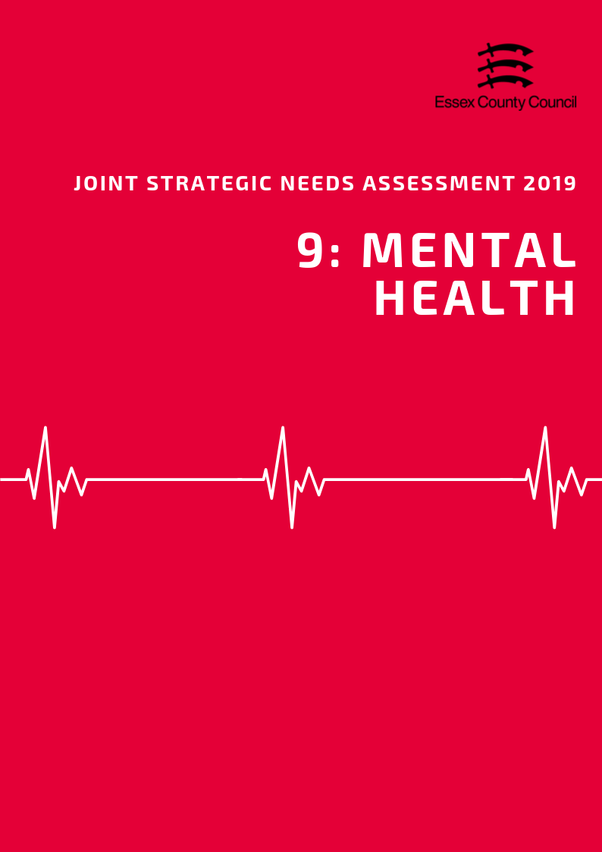

**Mental Health**

***Social Isolation***

Loneliness is linked with poorer mental and physical health. According to the Adult Social Care Survey 2017/18, in Essex 47% of adult social care users aged 18+ had as much social contact as they would like, which was similar to the average for England (46%) and East of England (45.9%). For adult social care users aged 65+ this figure reduced slightly to 43.9% but remained similar to the average for England (44%) and East of England (43.5%)

People providing unpaid care to friends and family may often feel isolated or not have enough social contact with other people outside of their role as a Carer. Personal Social Services Survey of Adult Carers in England (2016/17) found that only 26.8% of carers aged 18+ in Essex had as much social contact as they would like, lower than average for England (35.5%) and East of England (31.6%) and was the third lowest level out of the upper tier and unitary authorities in the Eastern region. Carers aged 65+ also had less social contact than they would like with only 25.4% saying they had as much social contact as they would like compared to the England (38.3%) and East of England (31.6%) averages. This was also the third lowest level in the eastern region.

According to the Essex Residents Survey in 2018, 25.5% of residents aged from 16 to 65 plus years across Essex reported feeling isolated from others.

***Mental Health***

According to the General Practice Patient Survey (GPPS; NHS England) in 2016/17, the prevalence of depression and anxiety among persons aged over 18 years across Essex was estimated to be 12.49%*. This is lower than the prevalence for England (13.74&). Common mental health conditions are only recorded at CCG such it is not possible to give individual estimates for each District. CCG level data suggests that Colchester and Tendring (North East Essex CCG) have the highest levels of common mental health conditions in Essex (14.3%) whilst Braintree, Maldon and Chelmsford (Mid Essex CCG) have the lowest.

Severe mental health conditions include schizophrenia, bipolar affective disorder and other psychoses. In 2017/18, the prevalence of these as recorded on general practise disease registers across Essex was 0.80. This is lower than the prevalence for severe mental health conditions for England (0.94). At a District Level only Tendring (1%) was estimated as having a rate of severe mental conditions, whilst Uttlesford had the lowest (0.63%)

The prevalence of reporting a long-term mental health condition among persons aged over 18 years across Essex, according to the GPPS, was 8.23% in 2017/18. This was slightly lower than the prevalence across England (9.06%). The prevalence of any mental health disorder among children aged between 5 to 16 years across Essex was 8.71 in 2015, slightly lower than the prevalence for England (9.23). This again was highest in the Tendring District (9.76%), just above the national average, whilst Uttlesford had the lowest levels (7.67%)

***Self-Harm***

According to estimates produced by Public Health England the rate of emergency hospital admissions for intentional self-harm among persons of all ages across Essex was 156.98 in 2017/18. This is significantly lower than the rate for England (185.48). Women (201.7) in Essex were 1.8 times more likely to be admitted to hospital for intentional self-harm than men (113.5) but had generally had a lower admissions rate than the average for England (235.3). This varied considerable across the county with women in the Tendring District having the highest admission rate at 326.8 per 100,000 people, whilst the lowest rate was in Epping Forest 92.5, a 71% difference.

***Suicide***

The age-standardised mortality rate per 100,000 population from suicide and injury of undetermined intent among persons aged over 10 years across the whole of Essex was 10.88 in 2015/17, higher than the rate for England (9.57). The rate among males across Essex was 16.90 and 5.31 among females, both of which slightly higher than the rate for England (14.69 male; 4.69 female).

This rate was highest in Maldon at 23.6 per 100,000 people whilst the lowest rate was in Epping Forest at 7.26. It should be noted however that although Maldon had the highest rate, a number of areas are likely to have higher actual numbers of suicides due to the relatively small population of the Maldon District as a whole.

|  |  |  |  |  |  |  |
| --- | --- | --- | --- | --- | --- | --- |
| **District** | **Depression and Anxiety prevalence (GP Patient Survey): % of respondents aged 18+** | **Rank** | **Prevalence of Severe Mental Health Conditions** | **Rank** | **Estimated prevalence of mental health disorders in children and young people:**  **% population aged 5-16** | **Rank** |
| Basildon | 13.28 | 3 | 0.92 | 3 | 9.29 | 3 |
| Braintree | 11.23 | 11 | 0.75 | 7 | 8.80 | 5 |
| Brentwood | 13.28 | 4 | 0.66 | 10 | 7.82 | 11 |
| Castle Point | 12.48 | 6 | 0.68 | 9 | 8.89 | 4 |
| Chelmsford | 11.23 | 10 | 0.72 | 8 | 8.24 | 8 |
| Colchester | 14.30 | 1 | 0.93 | 2 | 8.75 | 6 |
| Epping | 11.31 | 7 | 0.78 | 5 | 8.22 | 10 |
| Harlow | 11.31 | 8 | 0.81 | 4 | 9.65 | 2 |
| Maldon | 11.23 | 12 | 0.76 | 6 | 8.38 | 7 |
| Rochford | 12.48 | 5 | 0.63 | 11 | 8.24 | 9 |
| Tendring | 14.30 | 2 | 1.00 | 1 | 9.76 | 1 |
| Uttlesford | 11.31 | 9 | 0.63 | 12 | 7.67 | 12 |
| **Essex** | 12.49 | N/A | 0.80 | N/A | 8.71 | N/A |
| **England** | 13.74 | N/A | 0.94 | N/A | 9.23 | N/A |

|  |  |  |  |  |  |  |
| --- | --- | --- | --- | --- | --- | --- |
| **Rate of Emergency Hospital Admissions for Intentional Self-Harm in Essex Districts, 2017/18** | | | | | | |
| **District** | **Persons** | | **Male** | | **Female** | |
| Rate | Rank | Rate | Rank | Rate | Rank |
| Basildon | 200.48 | 3 | 153.78 | 2 | 248.32 | 3 |
| Braintree | 145.48 | 5 | 101.13 | 6 | 191.72 | 6 |
| Brentwood | 96.74 | 11 | 64.56 | 10 | 129.53 | 11 |
| Castle Point | 155.06 | 4 | 116.04 | 4 | 192.8 | 5 |
| Chelmsford | 134.88 | 7 | 75.57 | 8 | 194.97 | 4 |
| Colchester | 207.63 | 2 | 145.51 | 3 | 273.85 | 2 |
| Epping Forest | 71.73 | 12 | 52.41 | 11 | 92.48 | 12 |
| Harlow | 123.59 | 8 | 99.53 | 7 | 148.17 | 10 |
| Maldon | 112.78 | 9 | 75.47 | 9 | 149.1 | 9 |
| Rochford | 100.88 | 10 | 51.55 | 12 | 150.42 | 8 |
| Tendring | 289.2 | 1 | 252.69 | 1 | 326.81 | 1 |
| Uttlesford | 142.57 | 6 | 102.45 | 5 | 184.84 | 6 |
| **Essex** | 156.98 | N/A | 113.48 | N/A | 201.70 | N/A |
| **England** | 185.48 | N/A | 137.73 | N/A | 235.28 | N/A |

|  |  |  |  |  |  |  |
| --- | --- | --- | --- | --- | --- | --- |
| **Suicide Rate across Essex Districts among persons, males and females in 2015 / 17** | | | | | | |
| **District** | **Persons** | | **Male** | | **Female** | |
| Rate | Rank | Rate | Rank | Rate | Rank |
| Basildon | 9.69 | 7 | 16.94 | 7 | - | - |
| Braintree | 11.12 | 6 | 17.61 | 6 | 5.86 | 3 |
| Brentwood | 7.78 | 10 | 12.03 | 11 | - | - |
| Castle Point | 8.34 | 8 | 13.91 | 9 | - | - |
| Chelmsford | 11.78 | 5 | 17.97 | 5 | 5.72 | 4 |
| Colchester | 13.08 | 4 | 19.6 | 4 | 6.97 | 2 |
| Epping Forest | 5.24 | 12 | 7.26 | 12 | - | - |
| Harlow | 14.9 | 2 | 23.34 | 3 | - | - |
| Maldon | 14.52 | 3 | 23.64 | 1 | - | - |
| Rochford | 8.02 | 9 | 12.36 | 10 | - | - |
| Tendring | 15.96 | 1 | 23.39 | 2 | 8.89 | 1 |
| Uttlesford | 7.74 | 11 | 13.94 | 8 | - | - |
| **Essex** | 10.88 | N/A | 16.90 | N/A | 5.31 | N/A |
| **England** | 9.57 | N/A | 14.69 | N/A | 4.69 | N/A |

**Data Sources and Further Information**

*There are several caveats to the estimates of prevalence of depression and anxiety, severe mental health conditions, and prevalence of reporting long-term health conditions in the Districts across Essex. The prevalence of depression and anxiety, and the reporting of long-term health conditions among residents were produced by aggregating data available from CCG level upwards to the District which the CCG is located. The prevalence of severe mental health conditions at District level was estimated through aggregating data of General Practitioner (GP) surgeries located in that District. The district level estimates were then aggregated together to provide Essex level estimates for these three indicators.

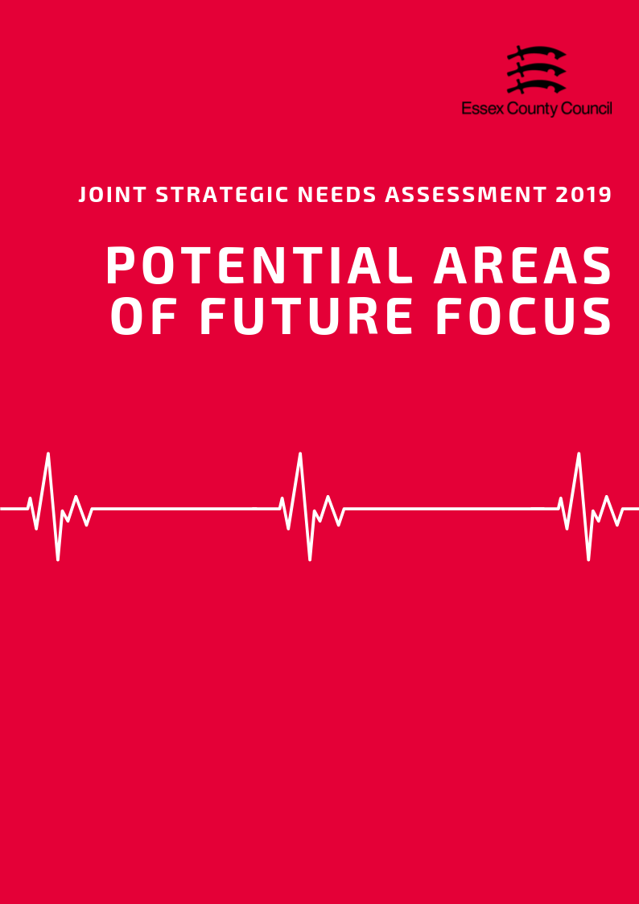

|  |  |
| --- | --- |
| LIFESTYLE, SEXUAL HEALTH & SUBSTANCE MISUSE | 1. Work to reduce excess weight and obesity across all age groups, particularly in school age children 2. Increase the rate of physical activity in adults 3. Increase screening rates for Chlamydia in 18-24-year olds |
| Life Expectancy & Mortality | 1. **Reduce the rate of premature mortality from a range of cancers, and Investigate the reasons behind the higher than average rates of Breast Cancer mortality** 2. **Close the gap in life expectancy between the highest and lowest performing areas of the county** 3. **Reduce the number of KSI in road traffic accidents on the county’s roads** |
| Birth Rates and Infant Health | 1. **Reduce the rate of mothers who smoke at the time of delivery** 2. **Increase the rate of breastfeeding** |
| ILLNESS & HOSPITAL ADMISSIONS | 1. **Reduce the rate of emergency admissions for a range of chronic conditions particularly in Basildon and Harlow** 2. **Reduce the rate of Hip Fractures in the over 65s age group** 3. **Increase vaccination coverage levels** |
| Mental Health | 1. **Reduce levels of self-harm for women generally across the county and across both men and women in the following areas; Basildon, Colchester, Tendring** 2. **Reduce levels of suicide amongst men generally and investigate possible drivers of suicide amongst cases in the Maldon, Tendring and Harlow** |

