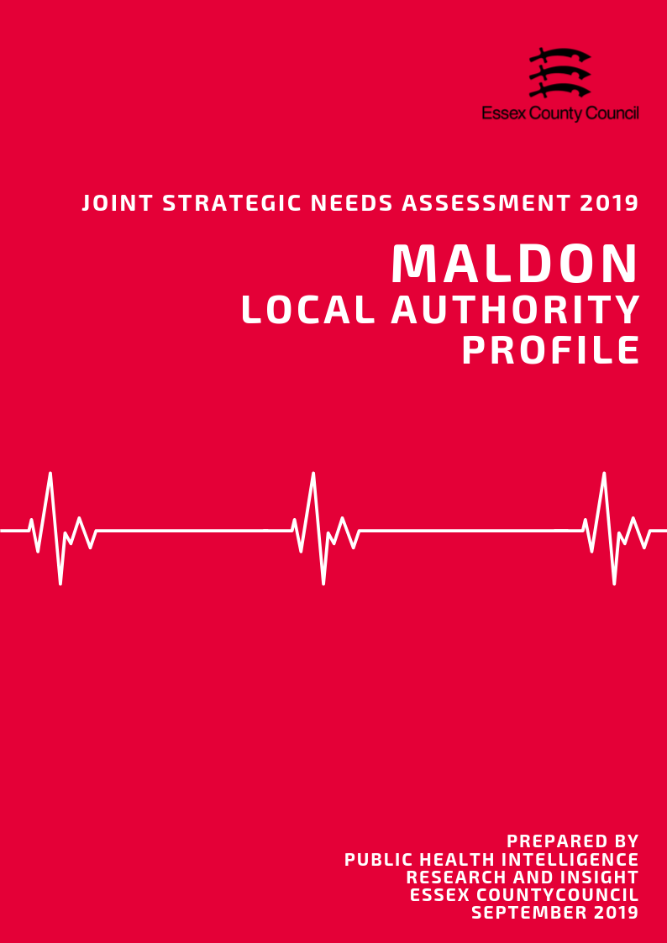

**Introduction**

What is a Joint Strategic Needs Assessment?

The JSNA is statutory process for Health & Wellbeing Boards (HWBB) to identify and improve the current and future health, wellbeing and social care needs of their area. The purpose is to inform strategic decision making, commissioning of services and reduce inequalities for all ages. There is no set format, prescribed content or specific time-period that a JSNA must cover, only that one must be produced in partnership with HWBB member organisations.

For the 2019 JSNA, the Health & Wellbeing Board is using a ‘place-based’ approach for the suite of JSNA products which will look at issues and needs at smaller local geographies. These geographies serve as building blocks to satisfy the need for intelligence at local authority and NHS geographical area and include:

• NHS/LA Locality/Neighbourhood Profiles

• District/Borough Council Profiles

• A Countywide Report

• Specialist Topic Deep Dive Reports (ESCG to develop)

This document presents data from a range of key topics which contribute to the overall the health and wellbeing of residents, in order to highlight areas of inequality and identify opportunities to improve the healthy lives for residents across the Essex County Council Local Authority area, with information also available separately for each of the 12 Districts and Boroughs where relevant.

Key findings from this and the 12 individual Local Authority Profiles will be used to identify issues that the Health and Wellbeing Board may wish to consider when refreshing the Joint Health and Wellbeing Strategy.

*Notes of Terminology:*

This document uses the term Essex to refer to the Essex County Council local authority area which does not include the Southend-on-Sea and Thurrock unitary authority areas. The term Maldon is used to refer to the whole local authority area.

**Contents**

|  |  |  |
| --- | --- | --- |
| **No.** | **Section** | **Page** |
| **1** | **Key Findings** | **3** |
| **2** | **Population & Demographics** | **7** |
| **3** | **Access to Services** | **20** |
| **4** | **Wider Determinants of Health** | **25** |
| **5** | **Lifestyle, Sexual Health & Substance Misuse** | **40** |
| **6** | **Life Expectancy & Mortality** | **50** |
| **7** | **Birth Rates and Infant Health** | **58** |
| **8** | **ILLNESS & HOSPITAL ADMISSIONS** | **63** |
| **9** | **Mental Health** | **80** |
|  |  |  |

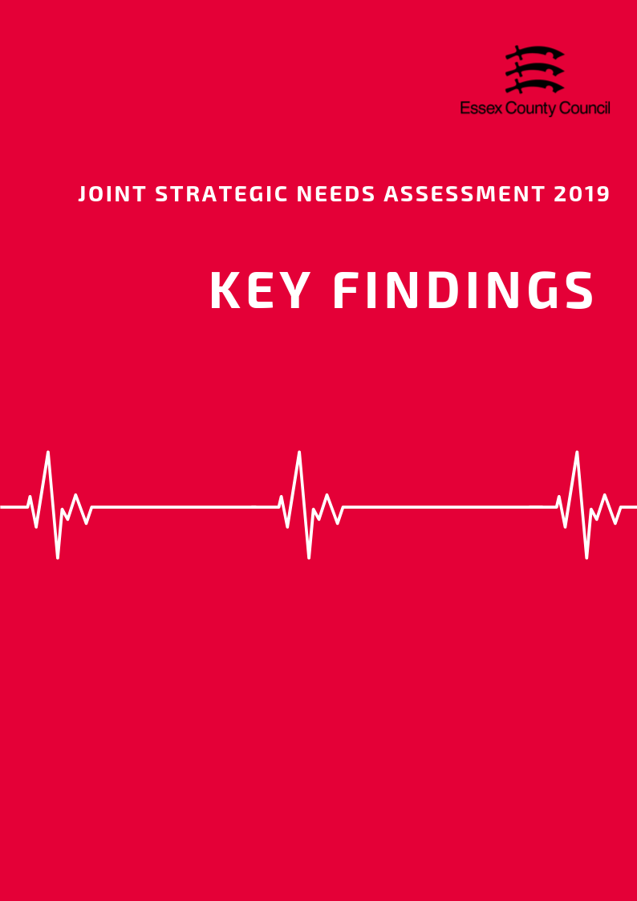

**The Top three things to know about…**

**Population and Demographics**

* According to the Office of National Statistics in 2018, the total population of the Maldon District was an estimated 64,425 people making it the smallest local authority area in Essex in terms of population size. This is an estimated increase of 1,075 people since the 2011 census (a rise of 1.7%).
* The Maldon District overall has the lowest proportion of Children and Young People aged 0-15 (16.4%) in Essex and a lower percentage of 16 to 64 years olds (58.6%) than the Essex average (18.9%, and 60.6%). By comparison the percentage of older people (24.9%) is higher than the Essex average (20.4%) and is the third second highest proportion of older people compared to the other District’s and Boroughs.
* The Maldon District had an estimated Old Age Dependency Ratio of 426 people aged 65+ to every 1000 working age. This is equivalent to 2.3 working age people to every person aged 65 and over, and is the third highest dependency rate in Essex, significantly above than the average for Essex (335.6) and England (286.8).

**Access to Services**

* Covering an area of approximately 259 square kilometres, the Maldon District is the seventh largest local authority in Essex in terms of area.
* With an estimated 178 residents per square kilometre, the Maldon District is the second (out of 12) least densely populated area in Essex
* Maldon District residents have the highest travel times to local services compared to the Essex average (19.4 minutes), with an average of 28.5 minutes by walking or public transport to 8 key services. Looking at times to health services, average times to GP surgeries were estimated at 14.9 minutes, above the Essex average (11.6 minutes); whilst time to hospitals was 81 minutes, 34 minutes higher than the Essex average (45.4 minutes) and the longest travel time in the county.

**Wider Determinants of Health**

* The average weekly income for a Maldon resident working full time in 2018 was £622.80, £4.20 (0.7%) above than the average for Essex and £47.90 (7.7%) more than the average for England. This was the seventh highest average income out of 12 Districts.
* In 2018, 62.8% of pupils achieved grade 9-4 in English and Maths (a good pass) and 39% achieved grade 9-5 (a strong pass) at GCSE. This is just above the England average for good passes (59.1%), just below for strong passes (39.9%), and just below the averages for the Essex (63.3% and 40.7%).
* The amount of residents claiming out of work benefits is lower than average and has generally remained consistent over the last 5 years from 1.1% in April 2015 to 1.1% in April 2019. This is 1% lower than the averages for Essex (2.1%), 1.5% lower than England (2.6%), is the second lowest claimant rate in Essex overall.

**Lifestyle, Sexual Health & Substance Misuse**

* In 2017/18 that 28.1% of pupils in Reception year were classed as overweight or obese. This was higher than England and Essex and the highest level in Essex. The sample of pupils in Year 6 showed that 34.6% of pupils in this year group were classed as overweight or obese, similar to England and but higher than the Essex average.
* 57.88% residents in Maldon aged over 18 years were classified as overweight or obese in 2016/17. This is lower than the prevalence of adult overweight or obesity across the whole of England (61.29%) and Essex (63.56%) and was ranked as being the second lowest prevalence across the Essex Districts.

In the Maldon District in 2017, the prevalence of current smokers among persons aged over 18 years was 5.33. This was the lowest compared across the other Districts in Essex. This was also significantly lower than the prevalence across the whole of Essex (13.84) and England (14.87).

**Life Expectancy & Mortality**

* The average life expectancy at birth for a child born in Maldon (2015-2017) was 83.4 years for females and 80.2 years for males; higher than the average for England for both sexes (Females = 83.1 years, Males = 79.6 years).
* During the same period, life expectancy at age 65 (the number of additional years a person could expect to live) was 21.7 years for females and 19.0 years for males, slightly higher than average when compared to England (Females = 21.1 years, Males = 18.8).
* In the Maldon District 27 deaths of women under the age of 75 were recorded between 2015 and 2017, equivalent to a rate of 26.6 deaths per 100,000 people. This is the 3rd highest rate in Essex; higher than the average for Essex (21.5) or England (20.6).

**Birth Rates & Infant Health** 

* The Maldon District has been consistently ranked as having one of the lowest Crude Birth Rates (CBR) in each year since 2013. However, the CBR has increased overall, with, for example, a CBR of 8.8 in 2013. This is also the 3rd highest increase relative to the rate increase of the other Districts in Essex.
* The rate of conceptions in women aged under 18 years per 1,000 females aged 15 to 17 years in the Maldon District was 12.0 in 2016. This was the third lowest rate compared to that of the other Essex Districts, and lower than that for Essex as a whole (16.7) and England (18.8).
* The percentage of mothers known to be smokers at the time of delivery out of all maternities was 7.76 in the Mid Essex CCG 2017/18. This was the joint second (with Braintree and Chelmsford) compared across the other Districts in Essex, and lower than that for Essex as a whole (10.60) and England (10.80).

**Illness & Hospital Admissions**

* The admissions ratio for emergency admissions for all causes among persons of all ages was 77.32 in Maldon, which was ranked as being the third lowest admission ratio across the Essex Districts.
* In Maldon in 2017/18, the age standardised rate of emergency hospital admissions due to hip fractures among persons aged over 65 years was 604.99 per 100,000 population. This was lower than the rate across Essex as a whole (611.91) but higher than England (577.76).
* In 2015/16, the estimated proportion of all those registered at General Practitioner surgeries in the Maldon District with a diagnosis of Hypertension was 16.19%. This was higher than the prevalence across Essex as a whole (15.11%) and England (13.94%) and was ranked as being the third highest QOF prevalence compared across the Essex Districts (highest: Tendring 19.58%; lowest: Colchester 13.32%).

**Mental Health**

* The prevalence of reporting a long-term mental health condition among persons aged over 18 years in the NHS Mid Essex CCG of Essex, according to the GPPS, was 8.39% in 2017/18. This was ranked as being the second highest prevalence compared across the CCGs of Essex (highest: NHS North East Essex CCG 9.63%; lowest: NHS West Essex CCG 7.19%) but was similar to that across Essex (8.23%) and England (9.06%).
* The age-standardised mortality rate per 100,000 population from suicide and injury of undetermined intent among persons aged over 10 years in Maldon was 14.52 in 2015/17, which was ranked as being the third highest rate across the Districts in Essex. This was significantly higher than the rate across Essex as a whole (10.88) and England (9.57).
* Maldon was ranked as having the highest suicide rate among males compared to that across the other Essex Districts, with a rate of 23.64. This is 61% higher than the rate for England (14.69) and significantly above Essex as a whole (16.90).

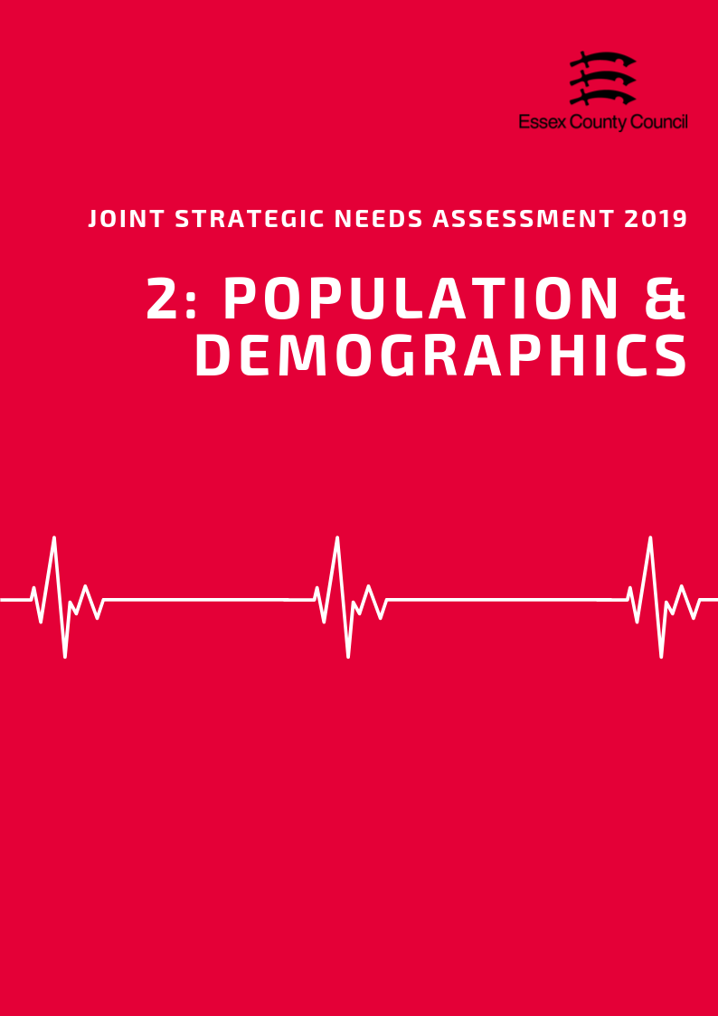

**POPULATION & DEMOGRAPHICS**

***Population Growth***

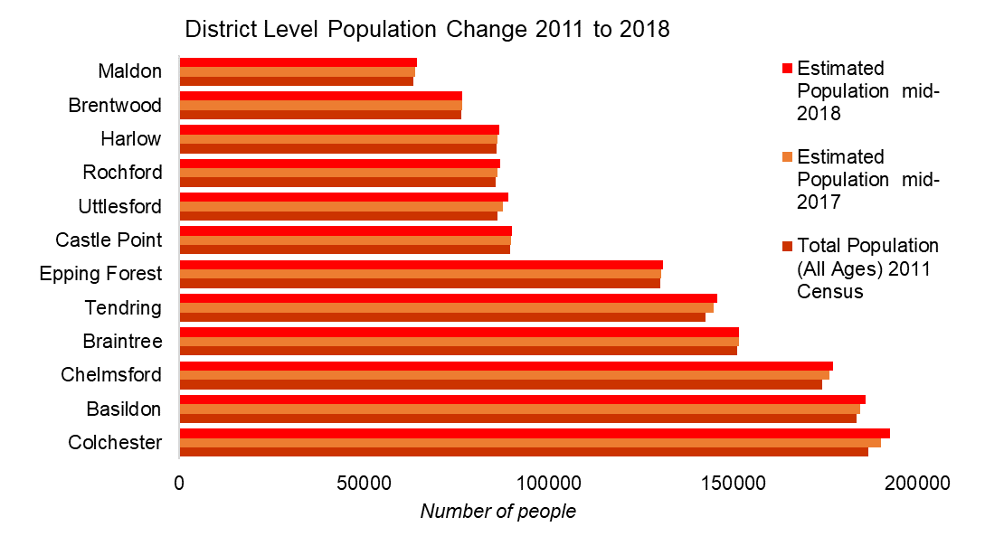According to the Office of National Statistics in 2018, the total population of the Maldon District was an estimated 64,425 people making it the smallest local authority area in Essex in terms of population size. This is an estimated increase of 1,075 people since the 2011 census (a rise of 1.7%) which is lower than had previously been predicted by the Office of National Statistics in earlier mid-year estimates. This is lower than the growth rate for England (5.59%) but higher than the average for Essex (1.54%).

Looking forward, the Office of National Statistics population projections (2016 based) predict that by 2034 the total population will increase by another 5325 people to a total of 69, 300.

***Age Split***

The Maldon District overall has the lowest proportion of Children and Young People aged 0-15 (16.4%) in Essex and a lower percentage of 16 to 64 years olds (58.6%) than the Essex average (18.9%, and 60.6%). By comparison the percentage of older people (24.9%) is higher than the Essex average (20.4%) and is the third second highest proportion of older people compared to the other District’s and Boroughs.

Over the next 15 years the percentage of older people in the Maldon District will increase (to 29.4%), higher than the predicted average for Essex (22.6%) by 2034. Over the same period, percentage of young people (15.5%) and residents aged 18 to 64 (55.12%) will continue to decrease below the county average (17.9% and 59.4%). This will be the second lowest percentage of 18 to 64 year olds across Essex.

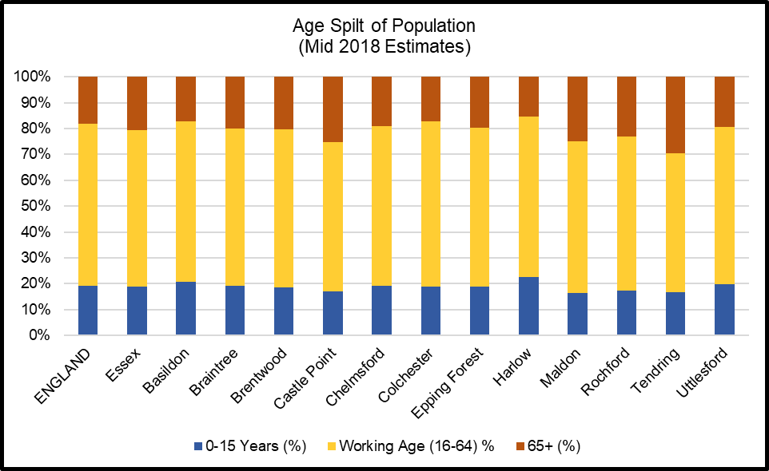

|  |  |  |  |  |  |
| --- | --- | --- | --- | --- | --- |
|  | | **Essex** | | **Maldon** | |
| **2024** | **Total Population** | 1549200 |  | 66000 |  |
| **Under 18** | 292989 | 18.9% | 10738 | 16.3% |
| **18-64** | 936049 | 60.4% | 37914 | 57.4% |
| **65+** | 320162 | 20.7% | 17347 | 26.3% |
| **2029** | **Total Population** | 1602700 |  | 67700 |  |
| **Under 18** | 295387 | 18.4% | 10729 | 15.8% |
| **18-64** | 972743 | 60.7% | 38727 | 57.2% |
| **65+** | 334570 | 20.9% | 18244 | 26.9% |
| **2034** | **Total Population** | 1650800 |  | 69200 |  |
| **Under 18** | 296076 | 17.9% | 10693 | 15.5% |
| **18-64** | 981362 | 59.4% | 38146 | 55.1% |
| **65+** | 373362 | 22.6% | 20361 | 29.4% |

***Old Age Dependency Ratio***

A useful measure to understand how the balance in the population will change, particularly when planning for the needs of the aging population is the old age dependency ratio (OADR) – the number of people over 65 years old for every 1,000 people aged between 16 and 64 years old.

Compared to other areas in Essex, the Maldon District has a much larger OADR than most other areas with an estimated rate of 426.6 in 2019. This is equivalent to 2.3 working age people to every person aged 65 and over, and is the third highest dependency rate in Essex, significantly above than the average for Essex (335.6) and England (286.8). By 2034 this rate is predicted to rise to 533.8 per 1000, well above the rates for Essex (380.4) and England (334.2), overtaking Castle Point as the area with the second largest OADR in Essex.

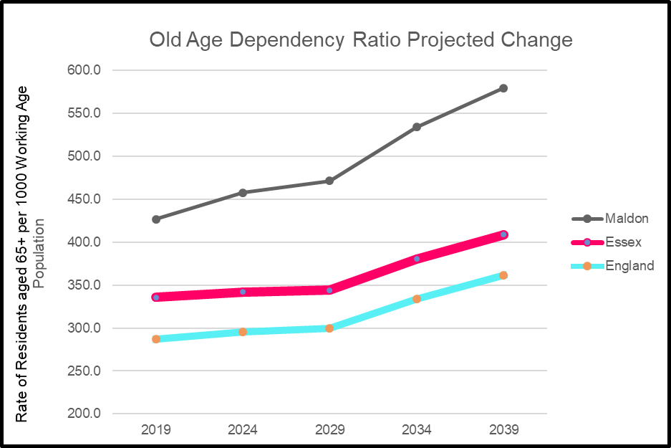

***Ethnicity***

At the time of the 2011 census the population of the Maldon District was majority White British (95.8%) with the remainder (4.2%) of residents coming from Black and Minority Ethnic (BAME) ethnic groups including white non-British residents. The percentage of BAME residents was significantly lower than the averages for both Essex (9.2%) and England (20.3%) and was the lowest percentage in the county in 2011.

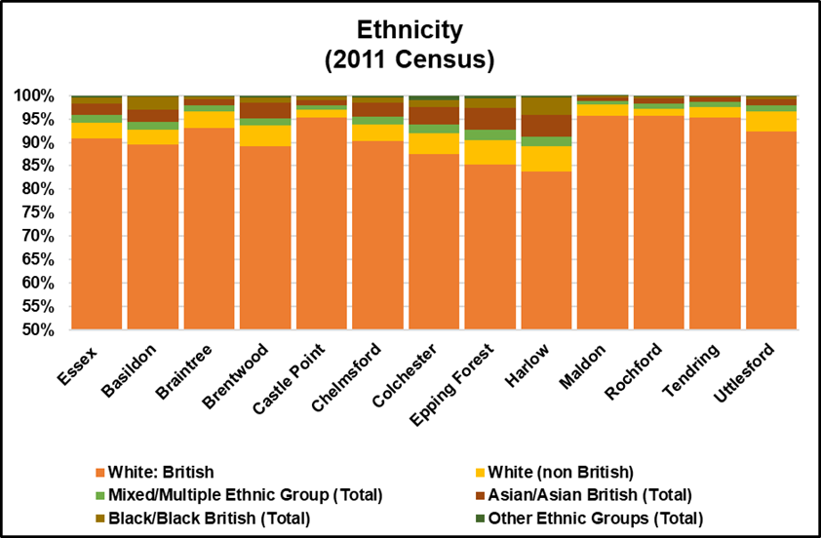

*Researchers note: The Office of National Statistics does not produce modelled estimates or projected figures by ethnic group; as such the only comprehensively available figures are taken from the 2011 Census. Given the age of this data caution is advised when generalising to the current population.*

***Household Composition***

At the time of the 2011 Census there were an estimated 25,817 households in the Maldon District of which 23.1% contained dependent children. This was just above the average for Essex (22.8%) and England (21.99%).

There was a higher percentage of households with married or civil partnership couples (40.6%) and fewer single person households (26.8%) than the Essex (36.8%, 28.4%) and England (33.2%, 30.2%) averages.

The number of lone parent households (7.4%) was lower the average for Essex (9.7%) and England (10.6%) and was the (joint) lowest rate in Essex.

6,378 households (24.7%) were occupied solely by residents aged 65 and over including 3,451 households (13.4%) where a resident aged 65 and over was living alone. This was higher than the average for Essex (23.2%, 13.1%) and for England (20.7%, 12.4%).

***Learning Disabilities and Special Educational Needs***

Exact figures for the number of residents with Learning Disabilities are not available however modelled predictions from POPPI/PANSI suggest the level could be around 1214 people of whom 870 people are aged 18-64 and 344 people are aged 65+. This total is equivalent to 2.32% of the age weighted population and is similar to the levels across England (2.36%) and Essex (2.34%). Of this number it is estimated that a total of 244 (*197 age 18-64; 47 age 65+)* have severe learning disabilities thus may have additional support needs.

By 2035 it is predicted that the number of people with Learning disabilities will increase to 853 people in the 18-64 age group (a reduction of 35 people), and to 482 (an increase of 138) for those aged 65+. In the severe learning disabilities category this is predicted to increase to 191 and 63 respectively.

***Impaired Mobility***

Exact figures for the number of people living in an area with a physical impairment are not available, as such for the purposes of the JSNA we will look at a number of proxy measures. For adults aged 18-64 predictions from PANSI (2019) estimate that 2282 people in the area might currently have some form of impaired mobility, 1991 have difficulty in performing personal care tasks, and 135 have health condition caused by a stroke.

For Adults aged 65+ predictions from POPPI (2019) estimate that 2893 people might be unable to manage one or more mobility task (*such as going out of doors and walking down the road; getting up and down stairs; getting around the house on the level; getting to the toilet; getting in and out of bed),* whilst 3237 people have their day to day activities limited a lot by their physical health.

***Sensory Impairments***

POPPI / Predictions estimate that there are 1471 people with severe hearing loss of which 1227 people are aged 65+. 23 people aged 18-64 were predicted to have serious visual impairments whilst 1395 people aged 65+ had moderate or severe visual impairment.





***Table 3: Old Age Dependency Ratio***

|  |  |  |  |  |  |  |  |  |  |
| --- | --- | --- | --- | --- | --- | --- | --- | --- | --- |
| **Old Age Dependency Ratio**  **(Rate of residents aged 65 years and over per working age population)** | | | | | | | | | |
|  | **2019** | | **2024** | | **2029** | | **2034** | | **2039** |
| **England** | 286.8 | | 295.1 | | 299.7 | | 334.2 | | 361 |
| **Essex** | 335.6 | | 342.0 | | 343.9 | | 380.4 | | 408.6 |
| Basildon | 272.4 | | 273.2 | | 272.6 | | 298.8 | | 318.3 |
| Braintree | 330.0 | | 348.0 | | 358.2 | | 409.2 | | 448.1 |
| Brentwood | 325.1 | | 322.5 | | 321.6 | | 350.6 | | 368.1 |
| Castle Point | 431.1 | | 438.3 | | 432.9 | | 469.6 | | 496.8 |
| Chelmsford | 307.9 | | 316.8 | | 317.7 | | 347.1 | | 369.9 |
| Colchester | 266.4 | | 265.6 | | 263.1 | | 288.7 | | 310.1 |
| Epping Forest | 311.8 | | 310.2 | | 309.9 | | 340.9 | | 365.9 |
| Harlow | 242.8 | | 248.3 | | 250.0 | | 276.1 | | 294.9 |
| Maldon | 426.6 | | 457.5 | | 471.1 | | 533.8 | | 579.2 |
| Rochford | 385.1 | | 392.1 | | 394.9 | | 438.2 | | 473.1 |
| Tendring | 544.0 | | 552.1 | | 553.3 | | 615.3 | | 665.7 |
| Uttlesford | 327.7 | | 344.9 | | 358.6 | | 408.2 | | 448.4 |
| ***Source: Office of National Statistics Population Projections 2016*** | | | | | | | | | |
|  |  |  | |  | |  | |  | |
|  | | | | | | | | | |

**Table 4: Ethnicity**

|  |  |  |  |  |  |  |  |
| --- | --- | --- | --- | --- | --- | --- | --- |
| **Ethnicity** | | | | | | | |
|  | **White British %** | **% White non British** | **% Mixed/ Multiple Ethnic Group** | **% Asian/ Asian British** | **% Black/ Black British** | **% Other Ethnic Groups** | **Total Percentage of BAME (Inc. white non-British)** |
| **England** | 79.75% | 5.7% | 2.3% | 7.8% | 3.5% | 1.0% | 20.25% |
| **Essex** | 90.8% | 3.5% | 1.5% | 2.5% | 1.3% | 0.4% | 9.24% |
| Basildon | 89.5% | 3.1% | 1.7% | 2.7% | 2.7% | 0.3% | 10.48% |
| Braintree | 93.2% | 3.5% | 1.2% | 1.4% | 0.6% | 0.2% | 6.85% |
| Brentwood | 89.2% | 4.3% | 1.6% | 3.2% | 1.2% | 0.4% | 10.75% |
| Castle Point | 95.4% | 1.5% | 1.0% | 1.1% | 0.8% | 0.2% | 4.62% |
| Chelmsford | 90.3% | 3.6% | 1.6% | 2.9% | 1.2% | 0.4% | 9.70% |
| Colchester | 87.5% | 4.5% | 1.8% | 3.7% | 1.5% | 1.0% | 12.49% |
| Epping Forest | 85.2% | 5.3% | 2.1% | 4.8% | 1.9% | 0.7% | 14.78% |
| Harlow | 83.9% | 5.2% | 2.1% | 4.6% | 3.8% | 0.5% | 16.14% |
| Maldon | 95.8% | 2.3% | 0.8% | 0.8% | 0.2% | 0.1% | 4.25% |
| Rochford | 95.6% | 1.6% | 1.1% | 1.1% | 0.5% | 0.2% | 4.39% |
| Tendring | 95.4% | 2.2% | 1.1% | 0.9% | 0.3% | 0.1% | 4.62% |
| Uttlesford | 92.3% | 4.3% | 1.2% | 1.4% | 0.5% | 0.2% | 7.70% |
| ***Source: Office of National Statistics 2011 Census*** | | | | | | | |

**Table 5: Household Composition**

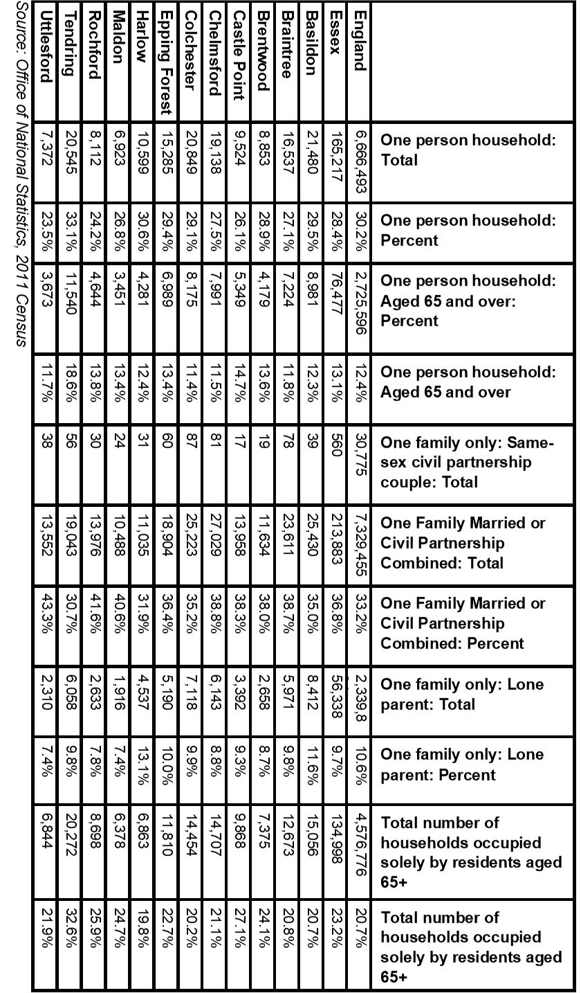

**Table 6: Learning Disability Predictions 2019**

|  |  |  |  |  |  |  |
| --- | --- | --- | --- | --- | --- | --- |
|  | **Number of people predicted to have a learning disability in 2019** | | | | | |
| **Age 18-64** | | **Age 65+** | | **Total Age 18+** | |
| **Number** | **%\*** | **Number** | **%\*** | **Number** | **%\*** |
| **England** | **826834** | **2.44%** | **216362** | **2.09%** | **1043196** | **2.36%** |
| **East of England** | **89212** | **2.43%** | **26011** | **2.09%** | **115223** | **2.34%** |
| **Essex** | **21059** | **2.43%** | **6487** | **2.09%** | **27546** | **2.34%** |
| Basildon | 2740 | 2.43% | 683 | 2.09% | 3423 | 2.36% |
| Braintree | 2164 | 2.42% | 659 | 2.09% | 2823 | 2.34% |
| Brentwood | 1110 | 2.42% | 333 | 2.08% | 1443 | 2.33% |
| Castle Point | 1219 | 2.42% | 486 | 2.09% | 1705 | 2.32% |
| Chelmsford | 2561 | 2.43% | 725 | 2.09% | 3286 | 2.35% |
| Colchester | 2947 | 2.45% | 713 | 2.10% | 3660 | 2.37% |
| Epping Forest | 1914 | 2.43% | 546 | 2.09% | 2460 | 2.34% |
| Harlow | 1276 | 2.44% | 282 | 2.07% | 1558 | 2.36% |
| Maldon | 870 | 2.41% | 344 | 2.11% | 1214 | 2.32% |
| Rochford | 1210 | 2.42% | 429 | 2.09% | 1639 | 2.32% |
| Tendring | 1828 | 2.41% | 919 | 2.09% | 2747 | 2.30% |
| Uttlesford | 1237 | 2.42% | 376 | 2.09% | 1613 | 2.33% |
|  | **Number of people predicted to have a moderate or severe learning disability in 2019** | | | | | |
| **Age 18-64** | | **Age 65+** | | **Total Age 18+** | |
| **Number** | **%\*** | **Number** | **%\*** | **Number** | **%\*** |
| **England** | 188444 | 0.56% | 29128 | 0.28% | 217572 | 0.49% |
| **East of England** | 20343 | 0.55% | 3488 | 0.28% | 23831 | 0.48% |
| **Essex** | 4797 | 0.55% | 870 | 0.28% | 5667 | 0.48% |
| Basildon | 625 | 0.56% | 92 | 0.28% | 717 | 0.49% |
| Braintree | 493 | 0.55% | 89 | 0.28% | 582 | 0.48% |
| Brentwood | 253 | 0.55% | 44 | 0.28% | 297 | 0.48% |
| Castle Point | 277 | 0.55% | 65 | 0.28% | 342 | 0.47% |
| Chelmsford | 585 | 0.56% | 97 | 0.28% | 682 | 0.49% |
| Colchester | 672 | 0.56% | 96 | 0.28% | 768 | 0.50% |
| Epping Forest | 437 | 0.55% | 73 | 0.28% | 510 | 0.49% |
| Harlow | 291 | 0.56% | 38 | 0.28% | 329 | 0.50% |
| Maldon | 197 | 0.55% | 47 | 0.29% | 244 | 0.47% |
| Rochford | 276 | 0.55% | 57 | 0.28% | 333 | 0.47% |
| Tendring | 413 | 0.55% | 123 | 0.28% | 536 | 0.45% |
| Uttlesford | 283 | 0.55% | 50 | 0.28% | 333 | 0.48% |
| *Source POPPI/PANSI 2019* | | | | | | |

***Table 7: Learning Disability Projections***

|  |  |  |  |  |  |  |  |  |
| --- | --- | --- | --- | --- | --- | --- | --- | --- |
| **Predicted Numbers of People with a Learning Disability to 2035** | | | | | | | | |
|  | **2025** | | **2030** | | **2035** | | **Predicted Change 2019-2035** | |
| **18-64** | **65+** | **18-64** | **65+** | **18-64** | **65+** | **18-64** | **65+** |
| **England** | **833689** | **240660** | **839192** | **269064** | **842807** | **296050** | **15973** | **79688** |
| **East of England** | **90564** | **28952** | **91550** | **32438** | **92307** | **35875** | **3095** | **9864** |
| **Essex** | **21467** | **7179** | **21763** | **8011** | **22030** | **8855** | **971** | **2368** |
| Basildon | 2816 | 754 | 2880 | 844 | 2953 | 932 | 213 | 249 |
| Braintree | 2167 | 744 | 2166 | 842 | 2149 | 936 | -15 | 277 |
| Brentwood | 1137 | 354 | 1155 | 397 | 1180 | 433 | 70 | 100 |
| Castle Point | 1217 | 520 | 1221 | 566 | 1230 | 614 | 11 | 128 |
| Chelmsford | 2590 | 797 | 2619 | 881 | 2650 | 958 | 89 | 233 |
| Colchester | 3078 | 784 | 3182 | 877 | 3254 | 976 | 307 | 263 |
| Epping Forest | 1961 | 594 | 1993 | 662 | 2034 | 733 | 120 | 187 |
| Harlow | 1292 | 319 | 1315 | 356 | 1341 | 391 | 65 | 109 |
| Maldon | 853 | 392 | 844 | 434 | 835 | 482 | -35 | 138 |
| Rochford | 1213 | 467 | 1219 | 521 | 1218 | 570 | 8 | 141 |
| Tendring | 1856 | 1017 | 1879 | 1139 | 1893 | 1263 | 65 | 344 |
| Uttlesford | 1268 | 437 | 1283 | 506 | 1299 | 572 | 62 | 196 |
| **Predicted Numbers of People with Moderate or Severe Learning Disabilities to 2035** | | | | | | | | |
|  | **2025** | | **2030** | | **2035** | | **Predicted Change 2019-2035** | |
| **18-64** | **65+** | **18-64** | **65+** | **18-64** | **65+** | **18-64** | **65+** |
| **England** | **190642** | **31818** | **192706** | **35452** | **193757** | **38627** | **5313** | **9499** |
| **East of England** | **20718** | **3802** | **21027** | **4244** | **21222** | **4654** | **879** | **1166** |
| **Essex** | **4906** | **942** | **4994** | **1047** | **5064** | **1150** | **267** | **280** |
| Basildon | 645 | 100 | 663 | 112 | 680 | 123 | 55 | 31 |
| Braintree | 495 | 98 | 496 | 110 | 493 | 121 | 0 | 32 |
| Brentwood | 260 | 46 | 266 | 51 | 272 | 56 | 19 | 12 |
| Castle Point | 277 | 68 | 279 | 73 | 282 | 79 | 5 | 14 |
| Chelmsford | 593 | 104 | 603 | 114 | 610 | 123 | 25 | 26 |
| Colchester | 704 | 103 | 731 | 115 | 749 | 127 | 77 | 31 |
| Epping Forest | 449 | 78 | 458 | 87 | 468 | 95 | 31 | 22 |
| Harlow | 296 | 43 | 303 | 48 | 309 | 51 | 18 | 13 |
| Maldon | 194 | 52 | 192 | 57 | 191 | 63 | -6 | 16 |
| Rochford | 277 | 61 | 279 | 68 | 280 | 74 | 4 | 17 |
| Tendring | 420 | 133 | 428 | 149 | 432 | 164 | 19 | 41 |
| Uttlesford | 290 | 57 | 295 | 66 | 299 | 74 | 16 | 24 |
| *Source POPPI/PANSI 2019* | | | | | | | | |

***Table 8: Physical Impairments***

|  |  |  |  |  |  |  |  |  |
| --- | --- | --- | --- | --- | --- | --- | --- | --- |
| **The number of people aged 18-64 predicted to have a physical impairment in 2019** | | | | | | | | |
|  | **Impaired Mobility** | | **Any moderate or severe personal care disability** | | **A longstanding health condition caused by a stroke** | | **Combined Total** | |
| **Number** | **%\*** | **Number** | **%\*** | **Number** | **%\*** | **Number** | **%\*** |
| **Essex** | **48922** | **5.23%** | **43109** | **4.61%** | **2817** | **0.30%** | **94848** | **10.13%** |
| **Basildon** | **6079** | **4.97%** | **5385** | **4.40%** | **345** | **0.28%** | **11809** | **9.66%** |
| Braintree | 5149 | 5.41% | 4540 | 4.77% | 300 | 0.32% | 9989 | 10.49% |
| Brentwood | 2618 | 5.27% | 2307 | 4.65% | 151 | 0.30% | 5076 | 10.23% |
| Castle Point | 2969 | 5.54% | 2604 | 4.86% | 172 | 0.32% | 5745 | 10.73% |
| Chelmsford | 5814 | 5.16% | 5139 | 4.56% | 334 | 0.30% | 11287 | 10.01% |
| Colchester | 5953 | 4.53% | 5328 | 4.06% | 338 | 0.26% | 11619 | 8.85% |
| Epping Forest | 4467 | 5.24% | 3937 | 4.62% | 256 | 0.30% | 8660 | 10.16% |
| Harlow | 2786 | 4.95% | 2461 | 4.38% | 155 | 0.28% | 5402 | 9.61% |
| Maldon | 2282 | 6.02% | 1991 | 5.25% | 135 | 0.36% | 4408 | 11.63% |
| Rochford | 2967 | 5.56% | 2604 | 4.88% | 172 | 0.32% | 5743 | 10.76% |
| Tendring | 4785 | 5.80% | 4142 | 5.02% | 273 | 0.33% | 9200 | 11.16% |
| Uttlesford | 3089 | 5.51% | 2710 | 4.83% | 181 | 0.32% | 5980 | 10.66% |
| *Percentage of the total population aged 18-64 based on 2019 population projections | | | | | | | | |

|  |  |  |  |  |  |  |
| --- | --- | --- | --- | --- | --- | --- |
|  | **The number of Adults aged 65 and over with long term limiting conditions or restricted mobility** | | | | | |
| **Day-to-day activities are limited a little** | | **Day-to-day activities are limited a lot** | | **Unable to manage at least one mobility** activity on their own** | |
| **Number** | **%** | **Number** | **%** | **Number** | **%** |
| Essex | 76314 | 24.6% | 66662 | 21.5% | 57212 | 18.4% |
| Basildon | 8044 | 24.6% | 8043 | 24.6% | 6058 | 18.5% |
| Braintree | 7669 | 24.3% | 6309 | 20.0% | 5676 | 18.0% |
| Brentwood | 3793 | 23.7% | 3020 | 18.9% | 3147 | 19.7% |
| Castle Point | 5593 | 24.1% | 5482 | 23.6% | 4180 | 18.0% |
| Chelmsford | 8433 | 24.3% | 6379 | 18.4% | 6387 | 18.4% |
| Colchester | 8386 | 24.7% | 7079 | 20.8% | 6142 | 18.1% |
| Epping Forest | 6265 | 24.0% | 5398 | 20.7% | 5017 | 19.2% |
| Harlow | 3465 | 25.5% | 3615 | 26.6% | 2625 | 19.3% |
| Maldon | 3909 | 24.0% | 3237 | 19.9% | 2893 | 17.7% |
| Rochford | 5259 | 25.7% | 4198 | 20.5% | 3727 | 18.2% |
| Tendring | 11449 | 26.1% | 10819 | 24.6% | 8078 | 18.4% |
| Uttlesford | 4309 | 23.9% | 3242 | 18.0% | 3358 | 18.7% |
| *\*\*Activities include: going out of doors and walking down the road; getting up and down stairs; getting around the house on the level; getting to the toilet; getting in and out of bed* | | | | | | |
| *Source POPPI/PANSI 2019* | | | | | | |

***Table 9: Sensory Impairments***

|  |  |  |  |  |  |  |
| --- | --- | --- | --- | --- | --- | --- |
|  | **Severe Hearing Loss** | | | **Visual Impairments** | | |
| **Visual Impairments Total** | **Serious Visual Impairments in people age 18-64** | **Moderate or Severe Visual Impairments in People age 65+** |
| **Total 18 and over** | **18-64** | **65+** |
| Essex | 30503 | 5272 | 25231 | 27745 | 564 | 27181 |
| Basildon | 3309 | 659 | 2651 | 2925 | 74 | 2851 |
| Braintree | 3074 | 562 | 2511 | 2775 | 59 | 2716 |
| Brentwood | 1718 | 285 | 1433 | 1475 | 29 | 1446 |
| Castle Point | 2154 | 317 | 1837 | 2059 | 32 | 2027 |
| Chelmsford | 3496 | 632 | 2864 | 3113 | 68 | 3045 |
| Colchester | 3293 | 631 | 2663 | 3022 | 78 | 2944 |
| Epping Forest | 2757 | 487 | 2269 | 2364 | 52 | 2312 |
| Harlow | 1487 | 310 | 1177 | 1238 | 34 | 1204 |
| Maldon | 1471 | 245 | 1227 | 1418 | 23 | 1395 |
| Rochford | 1956 | 310 | 1645 | 1827 | 33 | 1794 |
| Tendring | 4013 | 503 | 3510 | 3916 | 50 | 3866 |
| Uttlesford | 1775 | 331 | 1443 | 1613 | 33 | 1580 |
| *Source POPPI/PANSI 2019* | | | | | | |

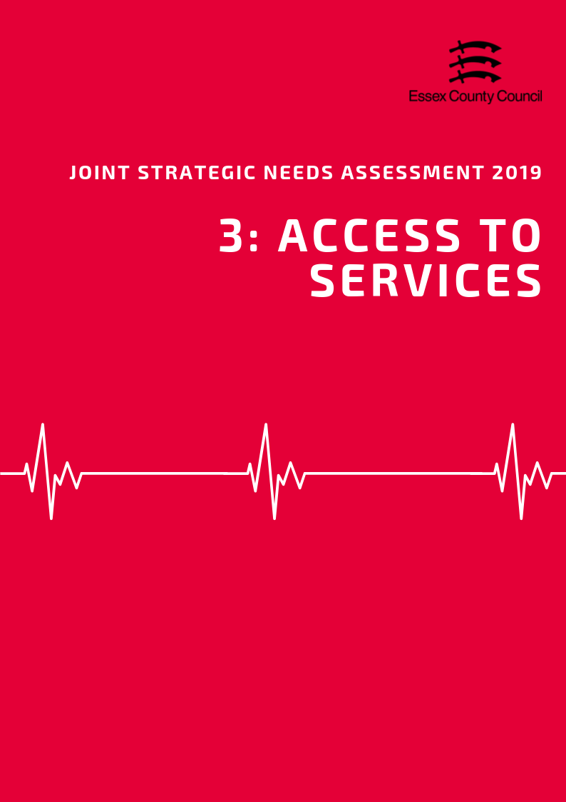

**ACCESS TO SERVICES**

**Area**

Covering an area of approximately 259 square kilometres, the Maldon District is the seventh largest local authority in Essex in terms of area. It is classed statistically as predominantly rural with the majority of residents living in rural settlements or hub towns including the largest settlements of Maldon and Burnham-on-Crouch.

***Population Density***

With an estimated 178 residents per square kilometre, the Maldon District is the second (out of 12) least densely populated area in Essex, well below the county average (424 people per sq. km).

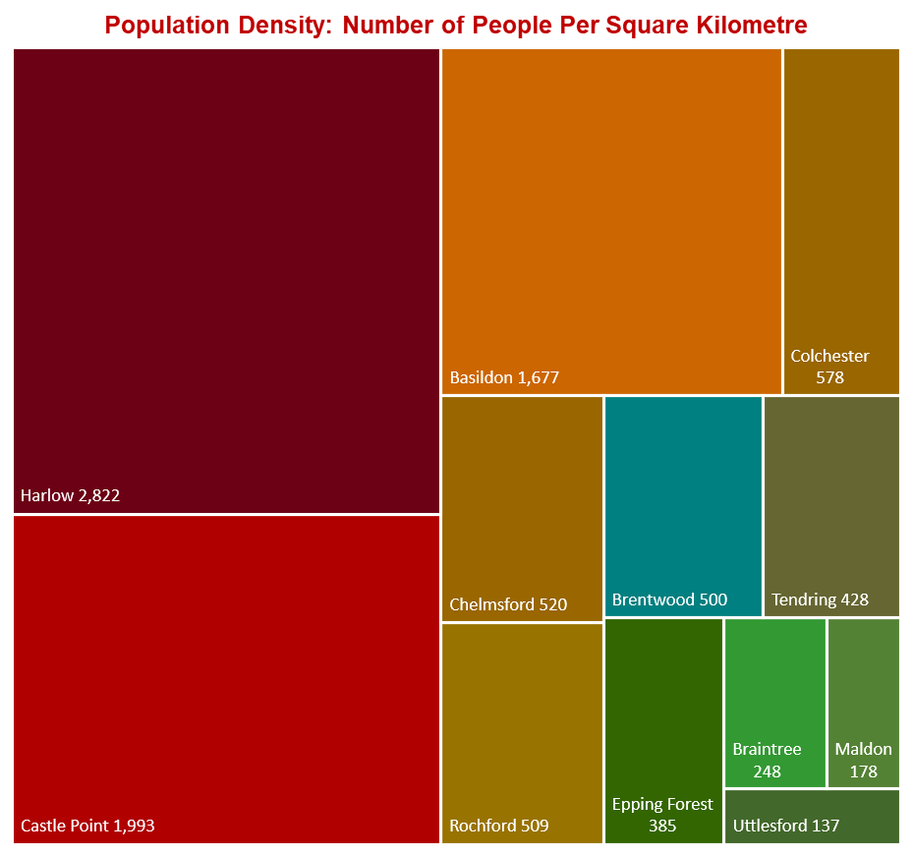

***Travel Time to Key Services***

According to the Department for Transport, Maldon District residents have the highest travel times to local services compared to the Essex average (19.4 minutes), with an average of 28.5 minutes by walking or public transport to 8 key services. Looking at times to health services, average times to GP surgeries were estimated at 14.9 minutes, above the Essex average (11.6 minutes); whilst time to hospitals was 81 minutes, 34 minutes higher than the Essex average (45.4 minutes) and the longest travel time in the county. Access to a car reduced these travel times significantly to 8.7 minutes for GP surgeries and 38.3 minutes to hospitals, although times to hospitals remained the highest in the county and were 15.3 minutes higher than Essex average (23 minutes).

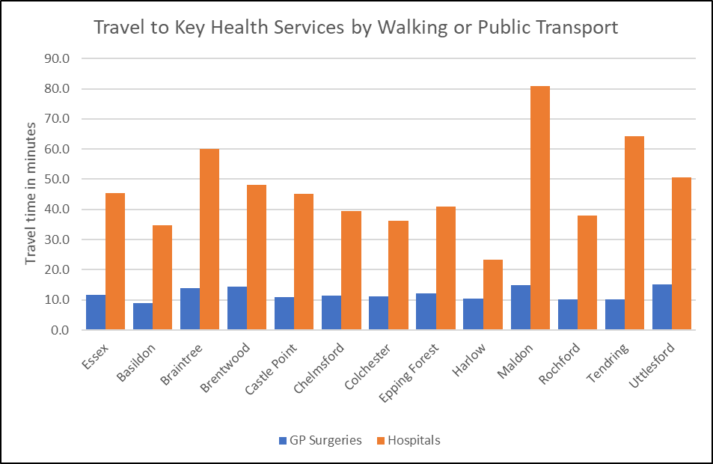

***Source: Department for Transport***

*See table at the end of this chapter for average travel times to all service types.*

***Satisfaction with GP Services***

Information about satisfaction with GP services from the GP Patient Survey are only available at CCG level so it is not possible to present views of Maldon residents in isolation. According to data from the 2018 survey, 79.2% of patients in the Mid Essex CCG reported a positive experience of their GP practice. This lower than the average for both England (83.75%) and the NHS Eastern Region (83.3%) but is in line with the combined average for all CCGs in Essex (80.35%).

|  |  |  |
| --- | --- | --- |
| **The percentage of patients aged 16+ who have a positive experience of their GP practice** | **Time period** | **%** |
| **England** | **2018** | **83.8** |
| **East NHS region** | **2018** | **83.3** |
| NHS Basildon And Brentwood CCG | 2018 | 80.6 |
| NHS Castle Point and Rochford CCG | 2018 | 82.8 |
| NHS Mid Essex CCG | 2018 | 79.2 |
| NHS North East Essex CCG | 2018 | 79.1 |
| NHS Southend CCG | 2018 | 80.1 |
| NHS Thurrock CCG | 2018 | 76.0 |
| NHS West Essex CCG | 2018 | 80.2 |

*Source: GP Patient Survey 2018*

***Carers***

The exact number of residents providing informal or unpaid care to friends or family members is not known, however figures from the Department for Work and Pensions identified 720 residents who had been in receipt of Carers Allowance benefits in November 2018.The largest numbers of claimants were in 55-64 age group. Women were more than four times more likely to be in receipt of carers allowance (580 / 80.6%) compared to Men however this rate was close to the levels across Essex as a whole (77.4%).

|  |  |  |  |  |  |  |  |  |  |  |  |  |  |
| --- | --- | --- | --- | --- | --- | --- | --- | --- | --- | --- | --- | --- | --- |
|  | **Number of people in receipt of carers allowance by age Group – November 2018** | | | | | | | | | | | | |
| **Total** | | **under 18** | | **18-24** | **25-34** | | **35-44** | | **45-54** | **55-64** | | **65+** |
| **Essex** | **16,620** | | **30** | | **580** | **2,940** | | **4,020** | | **4,410** | **4,410** | | **230** |
| Basildon | 2,690 | | 10 | | 120 | 530 | | 710 | | 670 | 630 | | 30 |
| Braintree | 1,750 | |  | | 40 | 350 | | 430 | | 460 | 430 | | 20 |
| Brentwood | 540 | |  | | 20 | 70 | | 120 | | 160 | 150 | | ~ |
| Castle Point | 1,110 | |  | | 40 | 160 | | 220 | | 310 | 350 | | 20 |
| Chelmsford | 1,500 | |  | | 50 | 260 | | 400 | | 400 | 360 | | 20 |
| Colchester | 1,990 | | 10 | | 80 | 390 | | 500 | | 520 | 450 | | 30 |
| Epping Forest | 1,170 | |  | | 40 | 170 | | 280 | | 320 | 340 | | 20 |
| Harlow | 1,100 | |  | | 40 | 220 | | 300 | | 260 | 260 | | 10 |
| Maldon | 720 | |  | | 10 | 130 | | 170 | | 200 | 210 | | 10 |
| Rochford | 770 | |  | | 20 | 80 | | 190 | | 230 | 250 | | 10 |
| Tendring | 2,800 | |  | | 100 | 490 | | 610 | | 720 | 830 | | 40 |
| Uttlesford | 480 | |  | | 10 | 80 | | 90 | | 140 | 130 | | 10 |
|  | | **Number of people in receipt of carers allowance by Gender –November 2018** | | | | | | | | | | | |
| **All Claimants** | | **Male** | | | | | **Female** | | | | |
|  | | **Number** | | **Number** | | | **%** | | **Number** | | | **%** | |
| **Essex** | | **16,620** | | **3,760** | | | **22.6%** | | **12,860** | | | **77.4%** | |
| Basildon | | 2,690 | | 610 | | | 22.7% | | 2,080 | | | 77.3% | |
| Braintree | | 1,750 | | 390 | | | 22.3% | | 1,360 | | | 77.7% | |
| Brentwood | | 540 | | 100 | | | 18.5% | | 440 | | | 81.5% | |
| Castle Point | | 1,110 | | 230 | | | 20.7% | | 880 | | | 79.3% | |
| Chelmsford | | 1,510 | | 310 | | | 20.5% | | 1,200 | | | 79.5% | |
| Colchester | | 1,990 | | 430 | | | 21.6% | | 1,560 | | | 78.4% | |
| Epping Forest | | 1,170 | | 260 | | | 22.2% | | 910 | | | 77.8% | |
| Harlow | | 1,100 | | 230 | | | 20.9% | | 870 | | | 79.1% | |
| Maldon | | 720 | | 140 | | | 19.4% | | 580 | | | 80.6% | |
| Rochford | | 770 | | 160 | | | 20.8% | | 610 | | | 79.2% | |
| Tendring | | 2,810 | | 800 | | | 28.5% | | 2,010 | | | 71.5% | |
| Uttlesford | | 480 | | 100 | | | 20.8% | | 380 | | | 79.2% | |
| *Source: Department of Work and Pensions 2019* | | | | | | | | | | | | | |

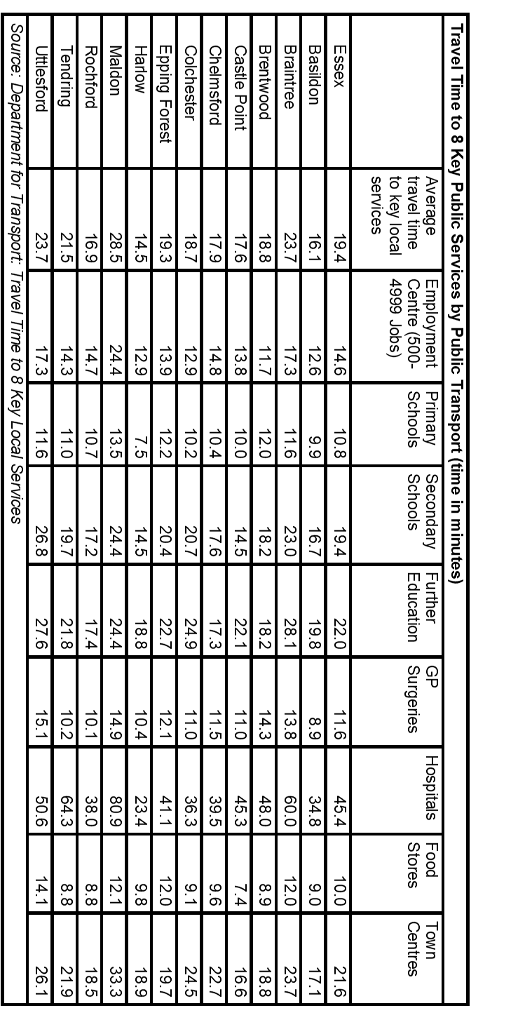

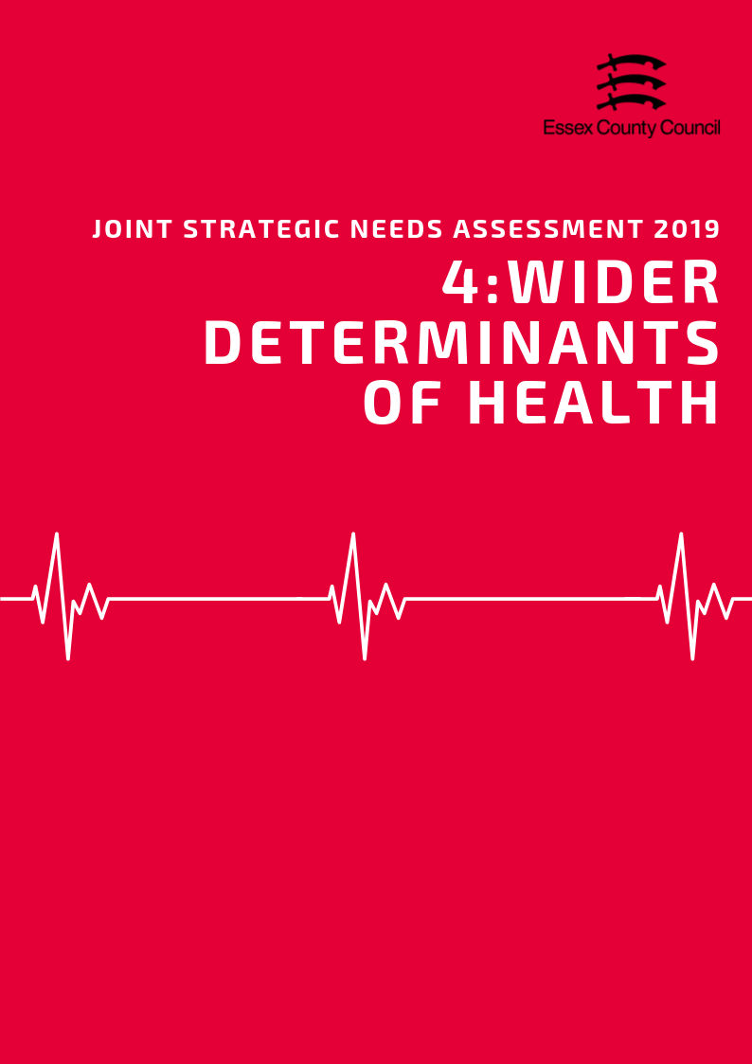

**Wider Determinants of Health**

***“Wider determinants, also known as social determinants, are a diverse range of social, economic and environmental factors which impact on people’s health. Such factors are influenced by the local, national and international distribution of power and resources which shape the conditions of daily life. They determine the extent to which different individuals have the physical, social and personal resources to identify and achieve goals, meet their needs and deal with changes to their circumstances.” Public Health England 2019***

***Income & Average Earnings***

The average weekly income for a Maldon resident working full time in 2018 was £622.80, £4.20 (0.7%) above than the average for Essex and £47.90 (7.7%) more than the average for England. This was the seventh highest average income out of 12 Districts. Part time workers earned an average of £203.10 per week, 10.34% more than the Essex average, 7.8% higher than the average for England, and was the second highest average income in the county.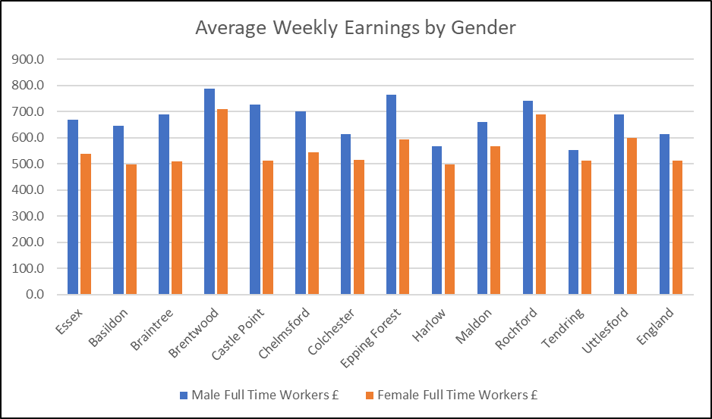

Male residents generally earned £92.5 (14%) more per week than females with an average weekly pay of £659 for male full time workers compared to £566.50 for females. This was below the average income difference for England (16.7%) and was sixth lowest average difference in percentage.

***Deprivation***

In the Indices of Multiple Deprivation 2019 the Maldon Local Authority area was ranked 211 out of 317 lower tier authorities in England based on the average rank of the LSOAs in this area (where 1= most deprived). This places Maldon in the upper 40% of least deprived Lower Tier Local Authorities (LTLAs) nationally. Compared to the other local authority areas in Essex, Maldon is ranked as 8th out of 12 in the county for overall deprivation and is one of three areas in Essex which fall into the 7th decile nationally.

*See the Essex 2019 Indices of Deprivation report for a full analysis of the latest English Indices of deprivation data for each district.*

***Fuel Poverty***

Figures from 2016 estimate that 2,432 households the Maldon area were classed as fuel poor. This is equivalent to 9% of the total number of households in the area which was higher than the average for Essex (8.6%) but lower than England (11.1%).



***Child Poverty***

1355 children and young people (11.1% living in the area) are recorded as being in low income households either in receipt of Child Tax Credits, Income Support or Job Seeker Allowance. This is the 5th lowest rate in Essex and lower than the rate for England (16.6%). It is also estimated that 668 pupils (10.2%) were eligible for free-school meals at the time of the last school census, this is above the average for Essex (9.87%) but below the rate for England (13.4%).

|  |  |  |  |  |  |  |
| --- | --- | --- | --- | --- | --- | --- |
| **Children in families in receipt of CTC (<60% median income) or IS/JSA** | | | | | | |
|  | *Total number of children where the youngest child is aged:* | | | | *Total Number of Children in low income households* | *% of All Children* |
| *0 - 4* | *5 - 10* | *11 - 15* | *16 - 19* |
| ***Basildon*** | 4,075 | 2,240 | 985 | 370 | 7,670 | 18.2% |
| ***Braintree*** | 1,950 | 1,010 | 575 | 215 | 3,750 | 11.7% |
| ***Brentwood*** | 695 | 335 | 205 | 80 | 1,315 | 9.0% |
| ***Castle Point*** | 1,250 | 680 | 380 | 120 | 2,430 | 14.1% |
| ***Chelmsford*** | 1,900 | 1,030 | 565 | 195 | 3,690 | 10.6% |
| ***Colchester*** | 2,985 | 1,510 | 630 | 230 | 5,355 | 14.0% |
| ***Epping Forest*** | 1,595 | 940 | 475 | 205 | 3,215 | 12.0% |
| ***Harlow*** | 2,040 | 995 | 420 | 175 | 3,630 | 16.6% |
| ***Maldon*** | 645 | 380 | 230 | 80 | 1,335 | 11.1% |
| ***Rochford*** | 755 | 455 | 230 | 120 | 1,560 | 9.6% |
| ***Tendring*** | 3,250 | 1,755 | 890 | 360 | 6,255 | 23.0% |
| ***Uttlesford*** | 545 | 345 | 190 | 80 | 1,160 | 6.6% |
| ***Essex Total*** | ***21,685*** | ***11,675*** | ***5,775*** | ***2,230*** | ***41,365*** | ***13.0%*** |
| ***England*** | ***1,016,710*** | ***530,585*** | ***270,235*** | ***111,760*** | ***1,929,290*** | ***16.6%*** |

Department for Education performance tables estimate that in 2017/18 there were 668 pupils (10.2%) who were eligible for free school meals in the area. This was higher than the average for Essex (9.9%) but lower than England (13.9%).



***Education & Skills***

*Adult Qualifications*

23.1% of Maldon residents aged 16+ had no formal qualifications at the time of the 2011 Census, 0.8% lower than the average for Essex (23.9%) and 0.7% higher than the average for England (22.5%). Maldon residents also achieved lower than the national average of NVQ level four qualifications (certificate of higher education) or higher (Batchelors Degree and above) with 23.6% of residents gaining this level of qualification compared to an average of 23% for the whole of Essex and 27.4% at the England level. These are the seventh and sixth highest levels in Essex respectively.

*Levels for all districts in the Essex County Council area along with averages for the county, East of England and England are set out in the table below.*

|  |  |  |  |  |
| --- | --- | --- | --- | --- |
| ***Area*** | ***Number of adult residents with no qualifications*** | ***% of adult residents with no qualifications*** | ***Number of adult residents with Level 4 qualifications and above*** | ***% of adult residents with Level 4 qualifications and above*** |
| **Basildon** | 37084 | 26.64% | 25939 | 18.63% |
| **Braintree** | 26958 | 22.83% | 26212 | 22.20% |
| **Brentwood** | 11651 | 19.38% | 18441 | 30.68% |
| **Castle Point** | 21885 | 29.92% | 10693 | 14.62% |
| **Chelmsford** | 25844 | 18.86% | 39452 | 28.80% |
| **Colchester** | 27440 | 19.40% | 38412 | 27.16% |
| **Epping Forest** | 24360 | 23.95% | 25769 | 25.34% |
| **Harlow** | 16948 | 26.05% | 11468 | 17.63% |
| **Maldon** | 11749 | 23.13% | 12009 | 23.64% |
| **Rochford** | 16134 | 23.63% | 13659 | 20.01% |
| **Tendring** | 39616 | 34.30% | 18340 | 15.88% |
| **Uttlesford** | 11232 | 17.72% | 20251 | 31.94% |
| **Essex** | 270901 | 23.89% | 260645 | 22.99% |
| **England** | 9656810 | 22.46% | 11769361 | 27.38% |
| **East of England** | 1067449 | 22.53% | 1218862 | 25.72% |

*Early Years*

***Achieving at least the expected level across all early learning goals***

*Children achieving at least the expected level across all early learning goals (ELGs) are those achieving ‘expected’ or ‘exceeded’ in all 17 ELGs.*

In Maldon the percentage of children achieving a good level of development has generally improved since 2015 with 76% of children achieving a good level of development in 2018, an increase of 4% compared to 2015. The 2018 score was higher than the average for Essex (72.1) and England (71.5%), and a 1% increase compared to 2017.

***Good level of development (GLD)***

*Children achieving a good level of development are those achieving at least the expected level within the following areas of learning: communication and language; physical development; personal, social and emotional development; literacy and mathematics.*

A similar trend was seen in the percentage of children achieving at least the expected level across all early learning goals. This has also increased to 75% in 2018, up by 5% compared to 2015 but was no change on the previous year. This was higher than the averages for Essex (70.7%) and England (70.2%).

*Levels for all districts in the Essex County Council area along with averages for the county, East of England and England are set out in the table below.*

|  |  |  |  |  |  |  |  |  |  |  |  |
| --- | --- | --- | --- | --- | --- | --- | --- | --- | --- | --- | --- |
|  | **2015** | | **2016** | | **2017** | | **2018** | |  | **Change 2015-2018** | |
| **Area of Pupil Residence** | ***% of ELG*** | ***% of GLD*** | ***% of ELG*** | ***% of GLD*** | ***% of ELG*** | ***% of GLD*** | ***% of ELG*** | ***% of GLD*** |  | *% of ELG* | *% of GLD* |
| **Basildon** | 65 | 67 | 70 | 71 | 70 | 71 | 72.0 | 73.0 | 2.0 | 6.0 |
| **Braintree** | 63 | 65 | 71 | 72 | 72 | 74 | 72.0 | 73.0 | 9.0 | 8.0 |
| **Brentwood** | 70 | 71 | 73 | 75 | 77 | 78 | 76.0 | 77.0 | 6.0 | 6.0 |
| **Castle Point** | 61 | 65 | 70 | 72 | 70 | 73 | 73.0 | 74.0 | 12.0 | 9.0 |
| **Chelmsford** | 68 | 70 | 73 | 73 | 74 | 75 | 74.0 | 75.0 | 6.0 | 5.0 |
| **Colchester** | 64 | 66 | 68 | 70 | 71 | 72 | 73.0 | 73.0 | 9.0 | 7.0 |
| **Epping Forest** | 67 | 69 | 69 | 70 | 72 | 73 | 73.0 | 73.0 | 6.0 | 4.0 |
| **Harlow** | 65 | 66 | 69 | 71 | 69 | 72 | 71.0 | 72.0 | 6.0 | 6.0 |
| **Maldon** | 70 | 72 | 73 | 74 | 74 | 75 | 75.0 | 76.0 | 5.0 | 4.0 |
| **Rochford** | 70 | 72 | 73 | 74 | 76 | 77 | 77.0 | 79.0 | 7.0 | 7.0 |
| **Tendring** | 64 | 66 | 66 | 67 | 67 | 70 | 70.0 | 70.0 | 6.0 | 4.0 |
| **Uttlesford** | 72 | 73 | 78 | 79 | 76 | 77 | 76.0 | 77.0 | 4.0 | 4.0 |
| **Essex** | 65.8 | 67.7 | 70.5 | 71.9 | 72.1 | 73.5 | 70.7 | 72.1 | 4.9 | 4.4 |
| **England** | 64.1 | 66.3 | 67.3 | 69.3 | 69.0 | 70.7 | 70.2 | 71.5 | 6.1 | 5.2 |
| **East of England** | 64.6 | 66.6 | 67.8 | 69.7 | 69.4 | 71.3 | 73.0 | 73.8 | 8.4 | 7.2 |
| *% of ELG = % of pupils achieving at least the expected standard in all Early Learning Goals* | | | | | | | | | | | |
| *% of GLD = % of pupils achieving a Good Level of Development at the Early Years foundation Stage* | | | | | | | | | | | |

*GCSE Attainment*

***Attainment 8***

*Attainment 8 measures a student's average grade across eight subjects across the following three groups:*

***English and maths:*** *(double-weighted)*

***English Baccalaureate (Ebacc):*** *the highest scores from the sciences, computer science, geography, history and languages.*

***Open group:*** *Any remaining GCSEs and other approved academic, arts or vocational qualifications.*

Since the introduction of the new GCSE grading system, pupil performance in Maldon has seen slight changes with 62.8% of pupils achieving grade 9-4 in English and Maths (a good pass) and 39% achieving grade 9-5 (a strong pass) in 2018. This is just above the England average for good passes (59.1%), just below for strong passes (39.9%), and just below the averages for the Essex (63.3% and 40.7%). Compared to scores for 2017 this is slight increase in the percentages of pupils achieving a good pass (+0.4%), but a larger decrease in the perecentage of students achieving strong passes (-3.4%). Longer term comparisons are not possible due to changes in the grading system. Looking at the pupils' Attainment 8 score provides a slightly longer term comparison of performance and shows that overall performance has fallen 5.8% down from 52.8% in 2016 to 47% in 2018. These figures are higher than the average for England (48.5, 44.5) and Essex (50.4, 46.1), and were the fifth highest scores in the county in 2018. The downward trend in performance for Maldon is slightly steeper than the trend observed at across England since the introduction of the new GCSE grading system which has seen a 4% reduction in average attainment 8 scores between 2016 and 2018.

|  |  |  |  |  |  |  |  |
| --- | --- | --- | --- | --- | --- | --- | --- |
| **Area** | 2017 | | | 2018 | | | Average Attainment 8 Score 2017-2018 Change |
| % of pupils who achieved grade 9-5 in English and Maths | % of pupils who achieved grade 9-4 in English and Maths | Average Attainment 8 Score | % of pupils who achieved grade 9-5 in English and Maths | % of pupils who achieved grade 9-4 in English and Maths | Average Attainment 8 Score |
| **Basildon** | 41.4 | 63.4 | 46.4 | 40.7 | 62.6 | 45.3 | -4.0 |
| **Braintree** | 40.4 | 63.6 | 45.2 | 39 | 63 | 45.5 | -4.0 |
| **Brentwood** | 56.5 | 79.3 | 51.0 | 56.2 | 76.8 | 52.6 | -1.5 |
| **Castle Point** | 39.2 | 64.2 | 45.6 | 41.9 | 65.6 | 45 | -4.7 |
| **Chelmsford** | 49.5 | 72.2 | 50.4 | 49.5 | 72 | 50.9 | -3.1 |
| **Colchester** | 46.9 | 66.7 | 47.6 | 43.6 | 65.3 | 48 | -3.6 |
| **Epping Forest** | 43.8 | 66.8 | 47.8 | 45 | 67.8 | 46.9 | -4.3 |
| **Harlow** | 36.5 | 59.8 | 44.1 | 38.3 | 59.6 | 42.8 | -5.4 |
| **Maldon** | 42.4 | 62.4 | 47.0 | 39 | 62.8 | 47 | -5.8 |
| **Rochford** | 47.5 | 70.5 | 47.9 | 41.5 | 63.1 | 46.3 | -4.7 |
| **Tendring** | 31.9 | 52.0 | 41.6 | 26.5 | 47.2 | 39.9 | -5.9 |
| **Uttlesford** | 51.6 | 74.9 | 51.5 | 50.1 | 71.1 | 51.8 | -3.1 |
| **Essex** | 42.4 | 64.9 | 46.7 | 40.7 | 63.3 | 46.1 | -4.3 |
| **East of England** | 43.5 | 65.4 | **46.7** | 43.7 | 65.2 | 47 | -3.4 |
| **England** | 39.1 | 58.5 | 44.6 | 39.9 | 59.1 | 44.5 | -4.0 |

*Destinations of School Leavers*

In 2017 96% of pupils in Maldon were in sustained Education, Employment or Training at the end of Key stage 4 (Secondary School), just above the average for England (94%) and Essex (95%). Within this group 85% were in education, lower than the county and England averages (86%). A further 6% were in apprenticeships, whilst another 5% were in employment. At this stage 3% of young people were not in any form of sustained education, employment or training, just below to the national and county average (5%).

|  |  |  |  |  |  |  |
| --- | --- | --- | --- | --- | --- | --- |
| ***Percentage of pupils with destinations sustained for at least two terms post KS4 in 2016/17:*** | | | | | | |
| **Area** | Any sustained education or employment | Any sustained education destination | Sustained apprenticeships | Sustained employment destination | Destination not sustained | Activity not captured in the data |
| **ENGLAND\*** | **94** | **86** | **5** | **3** | **5** | **1** |
| **EAST** | **95** | **87** | **4** | **3** | **5** | **1** |
| **Essex** | **95** | **86** | **5** | **4** | **5** | **1** |
| Basildon | 93 | 82 | 5 | 5 | 7 | 1 |
| Braintree | 94 | 85 | 5 | 5 | 5 | 1 |
| Brentwood | 96 | 90 | 3 | 2 | 3 | 2 |
| Castle Point | 94 | 83 | 8 | 3 | 5 | 1 |
| Chelmsford | 96 | 89 | 4 | 3 | 4 | 0 |
| Colchester | 95 | 87 | 4 | 4 | 5 | 1 |
| Epping Forest | 95 | 88 | 5 | 2 | 4 | x |
| Harlow | 95 | 88 | 4 | 3 | 3 | 2 |
| Maldon | 96 | 85 | 6 | 5 | 3 | x |
| Rochford | 95 | 86 | 7 | 3 | 4 | 2 |
| Tendring | 92 | 82 | 5 | 6 | 7 | 1 |
| Uttlesford | 94 | 87 | 5 | 3 | 5 | 0 |
| * State-funded schools (mainstream and special)  x Data not available  *NB: England figures may not add to 100% due to rounding* | | | | | | |

After Key Stage 5 (Further Education) the number of young people in sustained education employment or training reduced to 92%. Of this cohort, 50% were believed to be in Education including 41% in Higher Education, the (joint) third lowest rate in the county. The rate of young people attending university was 9% lower than the national average (50%) and 5% below the average for Essex (46%). The next largest destination was sustained employment accounting for approximately 32% of the cohort, higher than the England (22%) and Essex (26%) averages, and the (joint) highest rate in the county. 9% were in apprenticeships, just above the average for Essex (8%), whilst 5% were not in any form of sustained education, training or employment, lower than the rate for Essex (7%).

|  |  |  |  |  |  |  |
| --- | --- | --- | --- | --- | --- | --- |
| ***Percentage of pupils with destinations sustained for at least two terms post KS5 in 2016/17:*** | | | | | | |
| **Area** | Any sustained education destination | Higher education (level 4 and above) | Sustained apprenticeships | Sustained employment destination | Destination not sustained | Activity not captured in the data |
| **ENGLAND\*** | **61** | **50** | **6** | **22** | **8** | **4** |
| **EAST** | **58** | **49** | **7** | **25** | **7** | **3** |
| **Essex** | **56** | **46** | **8** | **26** | **7** | **3** |
| Basildon | 50 | 40 | 11 | 28 | 9 | 3 |
| Braintree | 53 | 42 | 7 | 30 | 6 | 4 |
| Brentwood | 58 | 52 | 10 | 21 | 8 | 3 |
| Castle Point | 45 | 32 | 10 | 32 | 9 | 4 |
| Chelmsford | 60 | 54 | 7 | 25 | 5 | 2 |
| Colchester | 62 | 48 | 4 | 24 | 7 | 3 |
| Epping Forest | 59 | 47 | 8 | 22 | 8 | 4 |
| Harlow | 52 | 39 | 7 | 32 | 9 | 1 |
| Maldon | 50 | 41 | 9 | 32 | 5 | 3 |
| Rochford | 47 | 39 | 12 | 30 | 9 | 3 |
| Tendring | 51 | 41 | 8 | 28 | 9 | 4 |
| Uttlesford | 61 | 52 | 5 | 26 | 6 | 2 |
| * State-funded schools (mainstream and special)  x Data not available  *NB: England figures may not add to 100% due to rounding* | | | | | | |

***Employment and Economic Activity***

Economic Activity

77.7% of residents (28,100 people) aged 16-64 in Maldon are economically active, i3.1% lower than the average for Essex (80.8%) and 1% lower than England (78.7%). This is the eighth highest rate of economic activity in the county (Highest = Braintree (87.1%), Lowest = Brentwood (71.9%)). Within the same age group (including both economically active and inactive people) it is estimated that the 73.9% are in Employment, 4.2% lower than the Essex Average (78.1%) and 1.5% lower than the rate for England (75.4%).

The amount of residents claiming out of work benefits is lower than average and has generally remained consistent over the last 5 years from 1.1% in April 2015 to 1.1% in April 2019. This is 1% lower than the averages for Essex (2.1%), 1.5% lower than England (2.6%), is the second lowest claimant rate in Essex overall.

to being students are not available for 2018 due to sample sizes being too low to provide an accurate estimate.

|  |  |  |  |  |  |  |  |  |  |  |
| --- | --- | --- | --- | --- | --- | --- | --- | --- | --- | --- |
| **Residents Age 16-64 Claiming Key Out of Work Benefits** | | | | | | | | | | |
| **Area** | **April 2015** | | **April 2016** | | **April 2017** | | **April 2018** | | **April 2019** | |
| **Claimant Count** | **%** | **Claimant Count** | **%** | **Claimant Count** | **%** | **Claimant Count** | **%** | **Claimant Count** | **%** |
| Basildon | 2,155 | 1.9 | 2,110 | 1.8 | 2,140 | 1.9 | 2,605 | 2.3 | 3,330 | 2.9 |
| Braintree | 1,155 | 1.2 | 1,090 | 1.2 | 1,030 | 1.1 | 1,315 | 1.4 | 1,720 | 1.9 |
| Brentwood | 355 | 0.8 | 295 | 0.6 | 415 | 0.9 | 555 | 1.2 | 720 | 1.5 |
| Castle Point | 685 | 1.3 | 740 | 1.4 | 675 | 1.3 | 555 | 1.1 | 920 | 1.8 |
| Chelmsford | 1,430 | 1.3 | 1,250 | 1.2 | 1,255 | 1.1 | 1,225 | 1.1 | 1,590 | 1.5 |
| Colchester | 1,395 | 1.2 | 1,540 | 1.3 | 1,425 | 1.2 | 1,435 | 1.2 | 2,240 | 1.8 |
| Epping Forest | 1,050 | 1.3 | 925 | 1.1 | 980 | 1.2 | 1,010 | 1.3 | 1,230 | 1.5 |
| Harlow | 1,195 | 2.2 | 1,000 | 1.8 | 1,050 | 1.9 | 1,535 | 2.8 | 1,865 | 3.5 |
| Maldon | 400 | 1.1 | 360 | 1.0 | 385 | 1.0 | 380 | 1.0 | 405 | 1.1 |
| Rochford | 500 | 1.0 | 455 | 0.9 | 470 | 0.9 | 465 | 0.9 | 700 | 1.4 |
| Tendring | 2,015 | 2.6 | 2,200 | 2.8 | 2,225 | 2.8 | 2,170 | 2.8 | 3,150 | 4.0 |
| Uttlesford | 300 | 0.6 | 240 | 0.5 | 255 | 0.5 | 370 | 0.7 | 500 | 0.9 |
| **England** | **660,415** | **1.9** | **630,975** | **1.8** | **662,795** | **1.9** | **751,250** | **2.1** | **922,235** | **2.6** |
| **East** | **51,805** | **1.4** | **48,255** | **1.3** | **51,225** | **1.4** | **60,080** | **1.6** | **75,315** | **2.0** |
| **Essex** | **12,625** | **1.4** | **12,200** | **1.4** | **12,305** | **1.4** | **13,615** | **1.5** | **18,370** | **2.1** |

8,100 people or 22.3% of residents aged 16-64 are thought to be economically inactive (not in employment who have not been seeking work within the last 4 weeks and/or are unable to start work within the next 2 weeks). The Maldon rate is higher than the average for Essex (19.2%) and England (21.3%) and is the fifth highest rate of economic inactivity in the county (Highest = Brentwood (28.1%), lowest = Braintree (12.9%)).

The most common reason for working age people to be economically inactive was either looking after the home or family (30.8%), Other reasons (24.2%), or long term sickness (18.3%). Compared to the rest of Essex, Maldon had the fifth lowest rate of people retiring before age 65 (15.2%), just above the Essex Average (14.6%). Estimates for the number of people economically inactive due

***Occupations***

Maldon residents are most likely to work as Managers, Directors and Senior Officials (19%), Associate Professional and Technical Occupations (12.8%), or Caring, Leisure and other service occupations (12.5%). The smallest occupation groups were Plant and Machine Operative Roles (7.3%). Compared to the rest of Essex, Maldon has the second highest proportion of people working in caring, leisure and other service roles.

|  |  |  |  |  |  |  |  |  |  |
| --- | --- | --- | --- | --- | --- | --- | --- | --- | --- |
| **Percentage of Residents by Employment Occupation Group**  *(Annual Population Survey: 12 months to June 2019)* | | | | | | | | | |
|  | **1: managers, directors and senior officials** | **2: professional occupations** | **3: associate prof & tech occupations** | **4: administrative & secretarial occupations** | **5: skilled trades occupations** | **6: caring, leisure and other service occupations** | **7: sales and customer service occupations** | **8: process, plant and machine operatives** | **9: elementary occupations** |
| Basildon | 7.3 | 18.2 | 17.3 | 11.2 | 8.9 | 11.1 | 9.4 | 4.9 | 11.7 |
| Braintree | 14.4 | 18.7 | 15.4 | 8.8 | 12.0 | 8.6 | 5.9 | 2.9 | 12.9 |
| Brentwood | 20.0 | 24.1 | 18.0 | 5.4 | 13.5 | 8.5 | ! | ! | 6.0 |
| Castle Point | 7.8 | 14.2 | 9.7 | 13.2 | 17.6 | 10.2 | ! | 7.8 | 17.8 |
| Chelmsford | 13.1 | 22.2 | 16.5 | 9.2 | 9.1 | 10.6 | 5.9 | 3.5 | 10.0 |
| Colchester | 11.5 | 18.6 | 12.3 | 9.6 | 10.2 | 13.3 | 5.4 | 9.1 | 9.9 |
| Epping Forest | 19.2 | 22.3 | 12.0 | 11.7 | 12.4 | 6.5 | 3.3 | 5.7 | 6.9 |
| Harlow | 7.9 | 14.8 | 19.0 | 9.9 | 9.8 | 8.0 | 7.1 | 15.0 | 8.5 |
| Maldon | 19.0 | 8.2 | 12.8 | 9.3 | 12.0 | 12.5 | 8.7 | 7.3 | 10.2 |
| Rochford | 8.0 | 22.0 | 20.0 | 15.4 | 14.5 | 4.5 | 4.2 | 6.0 | 5.5 |
| Tendring | 16.6 | 14.1 | 13.0 | 10.2 | 16.3 | 9.8 | 8.9 | 1.7 | 9.3 |
| Uttlesford | 20.2 | 16.0 | 17.7 | 14.4 | 4.4 | 5.9 | 9.9 | 4.0 | 7.5 |
| **England** | **11.4** | **21.2** | **15.0** | **9.9** | **9.8** | **8.9** | **7.1** | **6.2** | **10.2** |
| **East** | **12.2** | **20.0** | **14.4** | **10.5** | **10.3** | **9.1** | **6.8** | **6.3** | **10.3** |
| **Essex** | **13.3** | **18.3** | **15.1** | **10.6** | **11.5** | **9.5** | **6.1** | **5.6** | **10.0** |

***Housing***

According to the most recent statistics there are an estimated 3,012 social housing units in the Maldon area, all of which are owned by housing associations and other social landlords. This is the third lowest number of social housing units of any district or borough in the Essex County Council area (Highest: Basildon = 16,890, Lowest: Castle Point = 2,104 units).

Across both the Social and Private rented housing sector in 2018-19 in 2018-19 five properties were inspected and found to have one or more "category 1 hazard". i.e. it poses a serious and immediate risk to a person's health and safety (Highest: Epping Forest = 614, Lowest: Brentwood = 0). All properties with these hazards were found to be the private rented sector.

|  |  |  |  |  |  |
| --- | --- | --- | --- | --- | --- |
|  | ***Local Authority Owned (including those owned by other Local Authorities)*** | ***General Needs Social Housing Stock (owned by RSLs)*** | ***Sum of Supported Accommodation Housing Stock (owned by RSLs)*** | ***Sum of Social Housing for Older People (owned by RSLs)*** | ***Total*** |
| **Essex** | **42,569** | **40102** | **2100** | **4844** | **89,928** |
| **Basildon** | 10,954 | 5293 | 220 | 351 | 16,890 |
| **Braintree** | 4 | 9499 | 305 | 713 | 10,622 |
| **Brentwood** | 2,441 | 759 | 114 | 169 | 3,483 |
| **Castle Point** | 1,517 | 460 | 54 | 73 | 2,104 |
| **Chelmsford** | 56 | 9458 | 294 | 286 | 10,140 |
| **Colchester** | 5,945 | 3988 | 524 | 355 | 10,835 |
| **Epping Forest** | 6,453 | 1403 | 58 | 228 | 8,213 |
| **Harlow** | 9,279 | 1468 | 197 | 292 | 11,236 |
| **Maldon** | 0 | 2178 | 22 | 812 | 3,012 |
| **Rochford** | 0 | 2133 | 45 | 697 | 2,875 |
| **Tendring** | 3,134 | 1935 | 198 | 681 | 5,948 |
| **Uttlesford** | 2,786 | 1528 | 69 | 187 | 4,570 |
| RSL = Register Social Landlord (including Housings Associations) | | | | | |
| Source: LA Housing Returns 2018-19; Regulator of Social Housing Statistical returns 2017/18 | | | | | |

In 2018/19 there were a total of 936 households on the housing waiting list in Maldon, equivalent to 3.4% of all households in the area. During the same period, it is estimated that 32 homes were let directly or through nominations from the local authority, equivalent to 3.4% of households on the waiting list. Out of the total number of households on waiting list it was recorded that:

* 95 households (47%) were classed as being in a "reasonable preference category" (Highest: Rochford=100%/638 Households. Lowest: Maldon 10.1%/95 Households)
* 0 households were classed as "homeless" regardless of statutory duty to be housed (Highest: Castle Point=21.2%/114 Households. Lowest: Epping Forest and Maldon= 0 Households)
* 28 households (3%) were classed as being overcrowded or in unsatisfactory conditions (Highest: Tendring = 43.3%/589 Households. Lowest: Epping Forest = 0 Households)
* 54 households (5.7%) need to move due to welfare, medical or disability grounds (Highest: Rochford = 60.8%/388 Households. Lowest: Chelmsford = 4.4%/173 Households)

Compared to other areas Maldon has the lowest percentage of applicants in a reasonable preference category (Essex average = 54.5%) and the second lowest percentage of households which are overcrowded or unsanitary (Essex average 15.9%).

|  |  |  |  |  |  |  |  |  |  |
| --- | --- | --- | --- | --- | --- | --- | --- | --- | --- |
|  | ***Total households on the housing waiting list*** | ***Total households on the housing waiting list in a reasonable preference category*** | | ***Percentage People who are homeless within the meaning given in Part VII of the Act, regardless of whether there is a statutory duty to house them*** | | ***People occupying insanitary or overcrowded housing or otherwise living in unsatisfactory housing conditions*** | | ***People who need to move on medical or welfare grounds, including grounds relating to a disability*** | |
| ***Count*** | ***Count*** | ***%*** | ***Count*** | ***%*** | ***Count*** | ***%*** | ***Count*** | ***%*** |
| Essex | **21,803** | **11,885** | **54.5%** | 1560 | **7.2%** | 3473 | **15.9%** | 3262 | **15.0%** |
| Basildon | 1,169 | 576 | **49.3%** | 5 | **0.4%** | 441 | **37.7%** | 57 | **4.9%** |
| Braintree | 2,749 | 1,070 | **38.9%** | 47 | **1.7%** | 773 | **28.1%** | 276 | **10.0%** |
| Brentwood | 626 | 389 | **62.1%** | 57 | **9.1%** | 8 | **1.3%** | 267 | **42.7%** |
| Castle Point | 539 | 509 | **94.4%** | 114 | **21.2%** | 183 | **34.0%** | 197 | **36.5%** |
| Chelmsford | 3,939 | 3,269 | **83.0%** | 494 | **12.5%** | 429 | **10.9%** | 173 | **4.4%** |
| Colchester | 4,392 | 1,983 | **45.2%** | 111 | **2.5%** | 299 | **6.8%** | 533 | **12.1%** |
| Epping Forest | 1,376 | 299 | **21.7%** | 0 | **0.0%** | 0 | **0.0%** | 299 | **21.7%** |
| Harlow | 2,965 | 1,403 | **47.3%** | 537 | **18.1%** | 522 | **17.6%** | 298 | **10.1%** |
| Maldon | 936 | 95 | **10.1%** | 0 | **0.0%** | 28 | **3.0%** | 54 | **5.8%** |
| Rochford | 638 | 638 | **100.0%** | 79 | **12.4%** | 62 | **9.7%** | 388 | **60.8%** |
| Tendring | 1,362 | 1,275 | **93.6%** | 19 | **1.4%** | 589 | **43.2%** | 563 | **41.3%** |
| Uttlesford | 1,112 | 379 | **34.1%** | 97 | **8.7%** | 139 | **12.5%** | 157 | **14.1%** |
| Source: LA Housing Returns 2018-19; Regulator of Social Housing Statistical returns 2017/18 | | | | | | | | | |

*Homelessness & Rough Sleeping*

According to Public Health England, homeless people experience the most significant health inequalities and that the mean life expectancy of somebody who is homeless is just 44 years for men and 42 years for women. The number of rough sleepers across the Maldon District has generally remained low with no rough sleepers identified during the 2018 annual count. Maldon, along with Castle Point and Uttlesford, is one of three local authorities which did not record any rough sleepers in 2018, whilst larger more urban centres such as Chelmsford (14), Colchester (13), Basildon (12), and Harlow (9) were found to have the highest numbers during the same period.

|  |  |  |  |  |  |  |  |  |
| --- | --- | --- | --- | --- | --- | --- | --- | --- |
|  | ***Under 18*** | | ***18 - 25*** | | ***26 or over*** | | ***Age not known*** | |
| ***Count*** | ***%*** | ***Count*** | ***%*** | ***Count*** | ***%*** | ***Count*** | ***%*** |
| **England** | **1** | **0.02%** | **295** | **6.3%** | **3744** | **80.1%** | **637** | **13.6%** |
| **East of England** | **0** | **0.00%** | **28** | **5.8%** | **395** | **81.6%** | **61** | **12.6%** |
| **Essex** | **0** | **0.00%** | **1** | **1.5%** | **47** | **70.1%** | **19** | **28.4%** |
| Basildon | 0 | 0.00% | 1 | 8.3% | 11 | 91.7% | 0 | 0.0% |
| Braintree | 0 | 0.00% | 0 | 0 | 5 | 100.0% | 0 | 0.0% |
| Brentwood | 0 | 0.00% | 0 | 0 | 2 | 100.0% | 0 | 0.0% |
| Castle Point | 0 | 0.00% | 0 | 0 | 0 | 0.0% | 0 | 0.0% |
| Chelmsford | 0 | 0.00% | 0 | 0 | 6 | 42.9% | 8 | 57.1% |
| Colchester | 0 | 0.00% | 0 | 0 | 9 | 69.2% | 4 | 30.8% |
| Epping Forest | 0 | 0.00% | 0 | 0 | 0 | 0.0% | 3 | 100.0% |
| Harlow | 0 | 0.00% | 0 | 0 | 9 | 100.0% | 0 | 0.0% |
| Maldon | 0 | 0.00% | 0 | 0 | 0 | 0.0% | 0 | 0.0% |
| Rochford | 0 | 0.00% | 0 | 0 | 0 | 0.0% | 3 | 100.0% |
| Tendring | 0 | 0.00% | 0 | 0 | 5 | 83.3% | 1 | 16.7% |
| Uttlesford | 0 | 0.00% | 0 | 0 | 0 | 0.0% | 0 | 0.0% |

***Crime and Community Safety***

Nationally and locally the number of crimes recorded by the police force in England and Wales is on the increase. Over a four year period the number of crimes recorded in the Maldon area has risen by 42.1% from 2,341 crimes or 37 per 1000 residents in 2015/16 to 3,327 crimes or 52 per 1000 in 2018/19. Despite this increase, the overall crime rate for Maldon is significantly lower than the average for England (89 per 1000) and the whole Essex Police area (87 per 1000) and is the 2nd (out of 14) lowest local authority in Essex (including Southend and Thurrock).

The largest category of crime in the area in the last year was Violent Crime which accounted for 1,354 offences (40.7%) or a rate of 21 crimes per 1000; lower than the average rate for Essex police (32 per 1000) or for England (28 per 1000) and the third lowest rate in Essex overall. Theft makes up the second largest category with 1,000 crimes (30.1%) or a rate of 16 per 1000; much lower than the Essex Police (32 per 1000) or England (28 per 1000) averages. The proportion of Violent Crime is just above the average for Essex Police whilst theft is slightly lower (Violent Crime = 36.2%, Theft = 35.3%).

The most significant four year change in the number of crimes recorded in the Maldon area is the increase in the levels of Violent Crime, which has seen an additional 657 offences in 2018/19 (an increase of 94%) compared to the same period in 2015/16. The increase in the rate of violent Crime locally reflects a national trend which includes an increase in the number of crimes recorded as stalking or harassment. Nationally the Crown Prosecution Service (CPS) reports that there was a 69% increase in prosecutions started for stalking offences from 2016–17 to 2017–18 because of improvements in awareness following a police and CPS inspection and the implementation of Violence Against Women Strategies. This development is reflected locally with 521 crimes recorded as stalking or harassment in 2018/19 up from 235 in 2017/18.

**Environmental Health and Licencing**

The Marmot Review (2008) identified different health outcomes could be associated with the prevalence of certain build environment factors in their area such as the rate of noise complaints, the number of alcohol licences in an area, to the density of fast food outlets in a neighbourhood.

***Noise***

Excessive noise can have a range of impacts on our health from directly affecting our auditory system and hearing, to impacting our physical and mental health and quality of life; especially through long term exposure. Modelled estimates from based on data collected by the Chartered Institute of Environmental Health (CIEH) give an estimate for the rate of complaints per 1000 people about excessive noise from neighbours, their neighbourhood or the environment. Public Health England estimates that in 2016 there was an average of 3.3 noise complaints per 1000 residents in the Maldon area; lower than the average rates for Essex (4.8) or England (6.3). Compared to other areas this was the 7th highest estimated rate in the Essex County Council area (Highest: Epping Forest = 9.8, Lowest: Castle Point = 1.6).

***Alcohol Licences***

Number of premises permitted to sell or supply alcohol on trade and/or off trade is another measure used to look at the impact of the physical environment on health, particularly when considering alcohol related harm and illness. Local Alcohol Profiles for England estimate that in 2016/17 there were an average of 0.7 licenced premises per square kilometre in Maldon, below the England average of 1.4 (data is not available for an Essex countywide average). Compared to other districts in Essex this is the (joint) 2nd lowest rate per square kilometre in the county* (Highest: Harlow = 5.4, Lowest: Uttlesford = 0.5).

***Density of Fast Food Outlets***

The availability of fast food is an issue which is associated with a range of negative health outcomes for our communities such as obesity. This indicator calculates the number of fast food outlets per 100,000 population at an area level as a proxy for the density of these businesses within a particular local authority area. In 2014 it was estimated that Maldon had a density of 63.7 per 100,000, lower than the Essex (69.5) and England (88.2) average densities. Compared to other districts, this is the 7th highest density in Essex (Highest: Tendring = 95.8, Lowest: Uttlesford = 41.6).

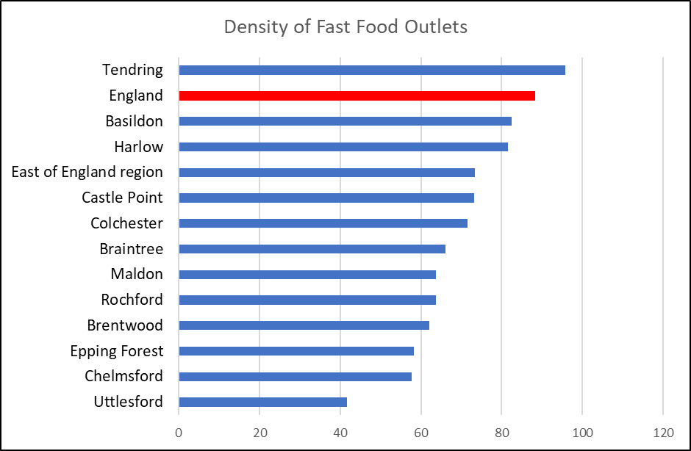

***Air Quality***

Poor air quality is a significant public health issue with clear evidence that particulate matter (human made air pollution) having a significant contributory role in a range of poor health outcomes including respiratory disorders and cardiopulmonary mortality. The Indicator for fine particulate matter looks at the average annual concentration in micrograms per cubic metre (weighted for population exposure) and showed that in 2016 the air pollution levels were 9.2 micrograms per cubic metre, lower than the average levels for England (9.3) and Essex (9.6). Compared to other areas Maldon had the second lowest air pollution levels in the county (Highest: Epping Forest = 10.1 per cubic metre).

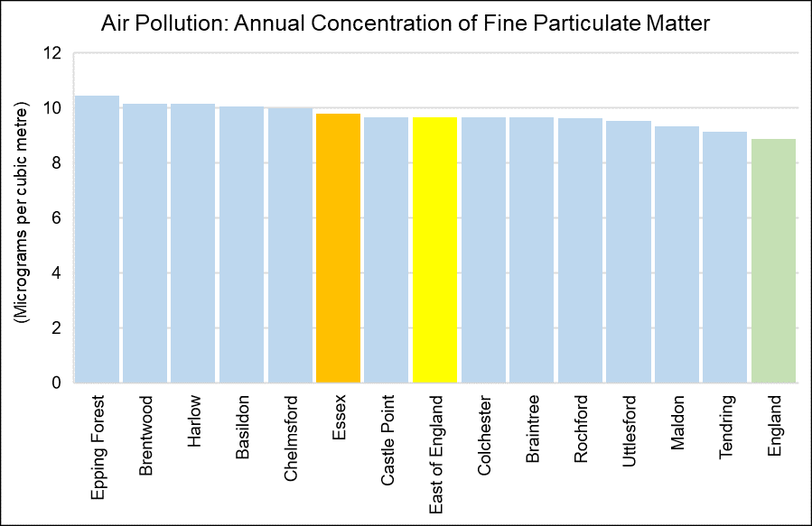

|  |  |
| --- | --- |
| Air pollution: fine particulate matter (2017) | |
| Area Name | micrograms per cubic metre |
| **England** | 8.904 |
| **East of England** | 9.6851 |
| **Essex** | 9.8132 |
| **Basildon** | 10.0819 |
| **Braintree** | 9.6742 |
| **Brentwood** | 10.1725 |
| **Castle Point** | 9.6913 |
| **Chelmsford** | 10.002 |
| **Colchester** | 9.6771 |
| **Epping Forest** | 10.4769 |
| **Harlow** | 10.1565 |
| **Maldon** | 9.3362 |
| **Rochford** | 9.6448 |
| **Tendring** | 9.1363 |
| **Uttlesford** | 9.5392 |
| *Annual concentration of human-made fine particulate matter at an area level, adjusted to account for population exposure. Fine particulate matter is also known as PM2.5 and has a metric of micrograms per cubic metre (µg/m3).* | |

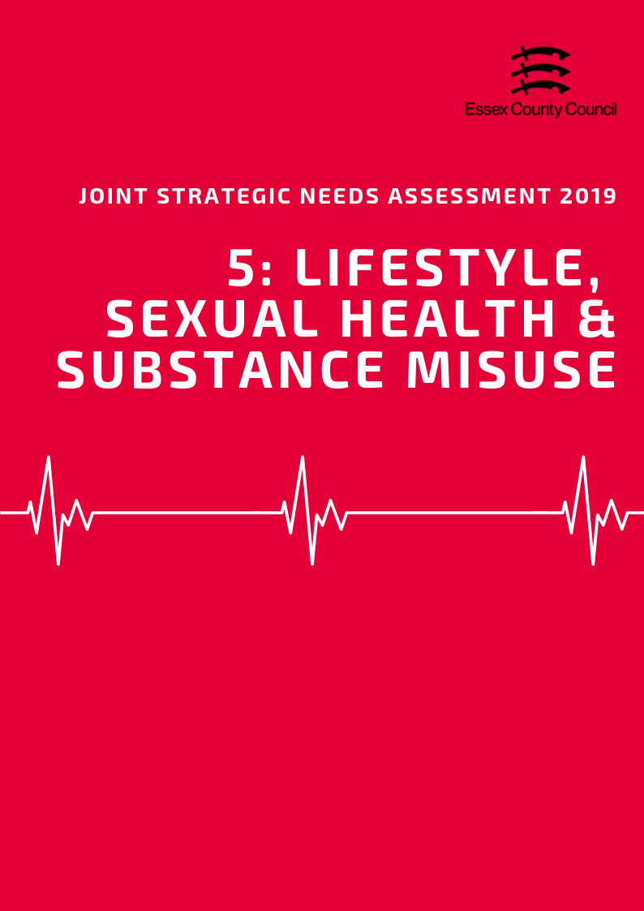

**LIFESTYLE, Sexual Health & Substance misuse**

This Section brings together datasets looking at a range of lifestyle and behavioural factors which can impact on long term health outcomes and increase or decrease the likelihood of developing a range of conditions or require more serious treatments going forward. This section includes:

* Children’s Weight
* Adult Healthy Eating, Obesity and Physical Activity
* Sexual Health
* Substance Misuse

**Children’s Weight**

***Reception Class***

In 2017/18 the National Child Measurement Programme (NCMP) estimated that 28.1% of pupils in Reception class (R in the table below) in Maldon were classed as overweight or obese. This was higher than the average for England (22.4%) and Essex (21.1%) and was the highest rate in the county. Of this group 10.63% were classed as obese, with a further 1.99% also classed as severely obese.

|  |  |  |  |  |  |  |  |  |  |  |  |
| --- | --- | --- | --- | --- | --- | --- | --- | --- | --- | --- | --- |
| **National Child Measurement Programme**  2017/18 | Prevalence of all overweight (including overweight, obesity and severe obesity) | | | |  | Prevalence of overweight  (%) | | Prevalence of obesity including severe obesity  (%) | | Prevalence of severe obesity  (%) | |
| Reception (R) | | Year 6  (Y6) | |
| % | Rank | % | Rank | R | Y6 | R | Y6 | R | Y6 |
| Basildon | 20.2 | 7 | 33.9 | 4 | 11.38 | 14.27 | 8.82 | 19.66 | 2.31 | 4.30 |
| Braintree | 24.0 | 3 | 32.5 | 7 | 15.25 | 14.80 | 8.78 | 17.70 | 1.60 | 3.44 |
| Brentwood | 18.5 | 10 | 26.3 | 11 | 11.21 | 11.49 | 7.27 | 14.80 | 1.48 | 2.11 |
| Castle Point | 19.2 | 8 | 33.8 | 5 | 10.19 | 14.39 | 8.98 | 19.42 | 2.08 | 4.80 |
| Chelmsford | 20.6 | 6 | 29.7 | 10 | 13.24 | 14.26 | 7.40 | 15.40 | 1.46 | 2.67 |
| Colchester | 21.2 | 5 | 29.8 | 9 | 13.00 | 14.30 | 8.15 | 15.53 | 1.54 | 2.93 |
| Epping Forest | 17.3 | 12 | 33.4 | 6 | 9.96 | 14.37 | 7.33 | 19.05 | 1.39 | 3.17 |
| Harlow | 22.8 | 4 | 37.4 | 1 | 11.82 | 15.38 | 10.97 | 22.07 | 2.92 | 5.39 |
| Maldon | 28.1 | 1 | 34.6 | 3 | 17.44 | 17.47 | 10.63 | 17.12 | 1.99 | 2.57 |
| Rochford | 18.5 | 11 | 30.9 | 8 | 10.62 | 14.76 | 7.84 | 16.19 | 0.72 | 2.64 |
| Tendring | 24.8 | 2 | 36.3 | 2 | 14.27 | 13.72 | 10.52 | 22.56 | 2.90 | 4.81 |
| Uttlesford | 18.8 | 9 | 25.8 | 12 | 12.09 | 11.92 | 6.74 | 13.91 | 0.96 | 2.09 |
| Essex | 21.1 |  | 32.2 |  | **12.52** | **14.24** | **8.59** | **17.93** | **1.84** | **3.51** |
| England | 22.4 |  | 34.3 |  | **12.84** | **14.18** | **9.53** | **20.14** | **2.40** | **4.24** |

Compared to the rest of Essex the overall level of obesity in Reception Year was above the average for Essex (8.6%) and England (9.53%) and were the third highest levels in the county. The levels of severe obesity for this age group were just above the level for Essex (1.84%) but below England (2.4%) and were fifth highest in the county. Prevalence levels for overweight but not obese children (17.44%) were highest out of the 12 districts and were above both England (12.84%) and Essex levels (12.52%)

***Year 6***

The sample of pupils in Year 6 in the 2017/18 NCMP showed that 34.6% of pupils in this year group were classed as overweight or obese in Maldon, 6.5 percentage points higher than their Reception class counterparts. This was similar to England levels (34.3%) but higher than the Essex (32.2%) average and was the third highest level in the county. Within this year group it estimated that 17.12% of pupils were classed as obese (6.49% higher than Reception Class), of whom 2.57% were classed as severely obese. Combined obesity levels were the 8th highest level in the county with levels for obesity and severe obesity both and were lower than the county and national averages.

***Change Over Time***

Over the last 10 years the prevalence levels of overweight and obese children in both Reception class and Year 6 has fluctuated around similar levels but not shown definitive upward or downward trends in most areas. Unlike other areas however the Maldon District has seen continual year on year increases for Reception age children since 2013/14 (20.8%) increasing by 7.3 percentage points to the highest level in 10 years by 2017/18 (28.1%). Prevalence levels for Year 6 pupils are less consistent with the 10 year low recorded in 2008/9 (25.7%) and the 10 year high recorded in 2010/11 (34.7%). Since 2010/11 levels for year six pupils have fluctuated but returned close to the 10 year high in 2017/18 (34.6%).

|  |  |
| --- | --- |
|  |  |

**Healthy & underweight children**

The level of children who are underweight or healthy weight in the Maldon District was suppressed by the NCMP in 2017/18 due to disclosure control however it can be estimated that the combined prevalence of healthy weight and underweight children will be 71.9% in reception year and 65.4%.

|  |  |  |  |  |
| --- | --- | --- | --- | --- |
| **Time Period: 2017/18** | **Prevalence of underweight (%)** | | **Prevalence of healthy weight (%)** | |
| **R** | **Y6** | **R** | **Y6** |
| Basildon | 0.70 | 1.40 | 79.10 | 64.67 |
| Braintree | 0.47 | 1.03 | 75.49 | 66.47 |
| Brentwood | 0.99 | ! | 80.54 | ! |
| Castle Point | ! | 1.17 | ! | 65.03 |
| Chelmsford | 0.76 | 1.59 | 78.61 | 68.75 |
| Colchester | 0.93 | 1.54 | 77.91 | 68.62 |
| Epping Forest | 1.32 | 1.51 | 81.39 | 65.08 |
| Harlow | 1.46 | 1.22 | 75.75 | 61.34 |
| Maldon | ! | ! | ! | ! |
| Rochford | ! | 2.42 | ! | 66.63 |
| Tendring | 0.56 | 0.93 | 74.65 | 62.79 |
| Uttlesford | 0.86 | 1.26 | 80.32 | 72.91 |
| Essex | 0.80 | 1.34 | 78.08 | 66.49 |
| England | 0.98 | 1.39 | 76.64 | 64.29 |

***Adult Obesity, Healthy Eating, and Physical Activity***

57.88% residents in Maldon aged over 18 years were classified as overweight or obese in 2016/17. This is lower than the prevalence of adult overweight or obesity across the whole of England (61.29%) and Essex (63.56%) and was ranked as being the second lowest prevalence across the Essex Districts (highest: Basildon 70.47%; lowest: Uttlesford 55.32%).

The proportion of adults aged over 16 years meeting the recommended fruit and vegetable intake of 5 portions on a ‘usual day’ was 59.7% in 2016/17. This was higher than the proportion meeting this recommendation across Essex (55.96%) and England (57.44%) and was ranked as being the 4th highest proportion across the Districts in Essex (highest: Braintree 62.92%; lowest: Harlow 46.23%).

|  |  |  |  |  |  |  |  |  |
| --- | --- | --- | --- | --- | --- | --- | --- | --- |
|  | **Percentage eating the recommended “5 a day”** | |  | **Percentage of Adults who are overweight or obese** | |  | **Percentage who take part in Organised sport** | |
| **Value** | **Rank** |  | **Value** | **Rank** |  | **Value** | **Value** |
| **Basildon** | 50.2% | 11 |  | 70.5% | 1 |  | 29.5% | 10 |
| **Braintree** | 62.9% | 1 |  | 60.8% | 8 |  | 33.7% | 9 |
| **Brentwood** | 62.1% | 3 |  | 58.5% | 10 |  | 43.0% | 2 |
| **Castle Point** | 58.2% | 5 |  | 65.1% | 4 |  | 35.1% | 6 |
| **Chelmsford** | 53.7% | 10 |  | 63.3% | 6 |  | 38.2% | 5 |
| **Colchester** | 54.6% | 9 |  | 64.4% | 5 |  | 35.1% | 7 |
| **Epping Forest** | 56.7% | 6 |  | 58.8% | 9 |  | 46.9% | 1 |
| **Harlow** | 46.2% | 12 |  | 66.9% | 3 |  | 25.8% | 11 |
| **Maldon** | 59.7% | 4 |  | 57.9% | 11 |  | 34.6% | 8 |
| **Rochford** | 55.3% | 7 |  | 61.4% | 7 |  | 41.0% | 4 |
| **Tendring** | 54.7% | 8 |  | 67.5% | 2 |  | 22.1% | 12 |
| **Uttlesford** | 62.7% | 2 |  | 55.3% | 12 |  | 42.6% | 3 |
| **Essex** | 55.9% | - |  | 63.6% | - |  | 35% | - |
| **England** | 57.4% | - |  | 61.3% | - |  | - | - |

Physical inactivity is classified as doing less than 30 minutes of moderate intensity activity per week. Of adults aged over 19 years, 19.9%% were classified as being physically inactive in 2017/18. This is lower than the proportion of adults physically inactive across Essex (21.78%) and England (22.23%), and a similar level compared to the previous period.

The proportion of adult residents classified as physically active (doing more than 150 minutes of moderate intensity activity per week) was 68.39% (highest: Uttlesford 70.72%; Lowest: Basildon 61.87%). This was higher than the proportion of adults physically active across Essex as a whole (66.07%) and England (66.26%) and a slight increase compared to 2016/17 levels (67.44%).

In 2016/17 Maldon was also ranked as having the 8th highest percentage of residents involved in organised sports across the Essex Districts, with 34.6%. This was similar to the percentage across the whole of Essex (35%).

|  |  |  |  |  |  |  |  |  |
| --- | --- | --- | --- | --- | --- | --- | --- | --- |
|  | Percentage of Adults who are physically active or inactive | | | | | | | |
| 2015/16 | | 2016/17 | | *2017/18* | | 3 year change | |
| % active | % inactive | % active | % inactive | *% active* | *% inactive* | % active | % inactive |
| England | 66.13 | 22.33 | 66.01 | 22.24 | ***66.26*** | ***22.23*** | 0.13 | -0.10 |
| Essex | 66.06 | 22.10 | 65.95 | 22.64 | ***66.07*** | ***21.78*** | 0.01 | -0.32 |
| Basildon | 65.46 | 24.00 | 60.98 | 26.28 | ***61.87*** | ***25.30*** | -3.59 | 1.31 |
| Braintree | 57.80 | 23.20 | 66.45 | 23.22 | ***67.55*** | ***19.17*** | 9.75 | -4.04 |
| Brentwood | 68.63 | 18.31 | 70.10 | 21.77 | ***65.79*** | ***22.51*** | -2.84 | 4.20 |
| Castle Point | 69.86 | 22.14 | 61.27 | 25.05 | ***68.43*** | ***21.43*** | -1.43 | -0.71 |
| Chelmsford | 67.26 | 22.16 | 67.88 | 22.09 | ***62.73*** | ***23.74*** | -4.53 | 1.58 |
| Colchester | 74.33 | 16.63 | 67.21 | 21.64 | ***67.74*** | ***18.45*** | -6.59 | 1.82 |
| Epping Forest | 68.72 | 18.05 | 67.65 | 18.97 | ***69.78*** | ***18.48*** | 1.06 | 0.44 |
| Harlow | 60.80 | 29.28 | 62.78 | 23.30 | ***63.31*** | ***25.36*** | 2.50 | -3.92 |
| Maldon | 68.56 | 19.42 | 67.44 | 19.11 | ***68.39*** | ***19.09*** | -0.17 | -0.34 |
| Rochford | 64.23 | 20.83 | 70.05 | 19.21 | ***69.75*** | ***22.37*** | 5.52 | 1.54 |
| Tendring | 58.01 | 31.44 | 62.61 | 27.30 | ***62.55*** | ***25.09*** | 4.54 | -6.35 |
| Uttlesford | 68.99 | 18.39 | 71.38 | 18.42 | ***70.72*** | ***19.21*** | 1.73 | 0.83 |

**Sexual Health**

***New STI Diagnosis***

According to Public Health England in 2017, the rate of new STI diagnoses among persons in the Maldon District was 364.71 per 100,000 population aged between 15 - 64 years. This was the lowest rate compared across the other Districts in Essex, and significantly lower than that for Essex as a whole (580.81) and England (793.85). STI diagnoses excluded chlamydia in under 25 year olds and was among persons attending specialist (level 3) and non-specialist (level 1 and 2) sexual health services.

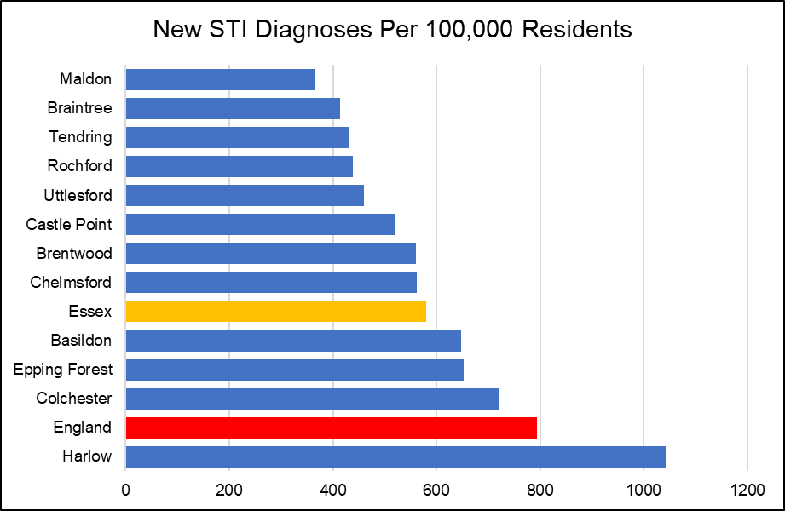

***Chlamydia***

The proportion of all 15 - 24 year olds in Maldon in 2017 screened for chlamydia at sexual health services was 13.1%. This was the 9th lowest proportion compared to that of the other Districts in Essex, and lower than the Essex (15.5) and England (19.3) averages.

|  |  |  |  |  |
| --- | --- | --- | --- | --- |
|  | **New STI diagnoses (excluding chlamydia aged <25) / 100,000** | | **Chlamydia proportion aged 15-24 screened** | |
| **Value** | **Rank** | **%** | **Rank** |
| Basildon | 647.54 | 4 | 14.5 | 5 |
| Braintree | 414.14 | 11 | 12.5 | 11 |
| Brentwood | 560.57 | 6 | 13.2 | 8 |
| Castle Point | 520.65 | 7 | 12.4 | 12 |
| Chelmsford | 561.50 | 5 | 15.3 | 4 |
| Colchester | 721.10 | 2 | 18.2 | 2 |
| Epping Forest | 653.27 | 3 | 15.5 | 3 |
| Harlow | 1042.41 | 1 | 29.5 | 1 |
| Maldon | 364.71 | 12 | 13.1 | 9 |
| Rochford | 438.23 | 9 | 13.7 | 6 |
| Tendring | 430.44 | 10 | 13.1 | 10 |
| Uttlesford | 459.94 | 8 | 13.7 | 7 |
| **Essex** | **580.81** |  | **15.5** |  |
| **England** | **793.85** |  | **19.3** |  |

In Maldon, the rate of all chlamydia diagnoses among 15 to 24 year olds attending sexual health services was 933.3 per 100,000 population aged 15 to 24. This was the lowest detection rate compared to the other Districts in Essex, and lower than that for the whole of Essex (1449.1) and England (1881.9).

|  |  |  |  |  |  |  |
| --- | --- | --- | --- | --- | --- | --- |
| **Chlamydia detection rate / 100,000 aged 15-24** | **Persons** | | **Male** | | **Female** | |
| **Value** | **Rank** | **Value** | **Rank** | **Value** | **Rank** |
| **Basildon** | 1484.2 | 3 | 1000.3 | 4 | 1972.9 | 3 |
| **Braintree** | 1199.6 | 8 | 750.5 | 9 | 1689.1 | 7 |
| **Brentwood** | 1016 | 11 | 820.3 | 8 | 1192.8 | 12 |
| **Castle Point** | 1081.3 | 9 | 635.3 | 11 | 1564.5 | 8 |
| **Chelmsford** | 1266.8 | 6 | 836.3 | 7 | 1720.8 | 5 |
| **Colchester** | 2094.9 | 2 | 1564.1 | 2 | 2679.4 | 1 |
| **Epping Forest** | 1295.8 | 5 | 873.7 | 6 | 1711.8 | 6 |
| **Harlow** | 2444.9 | 1 | 2266 | 1 | 2641.3 | 2 |
| **Maldon** | 933.3 | 12 | 621.1 | 12 | 1279.5 | 11 |
| **Rochford** | 1262.2 | 7 | 1088.1 | 3 | 1444.2 | 9 |
| **Tendring** | 1320.6 | 4 | 897.4 | 5 | 1777.2 | 4 |
| **Uttlesford** | 1035 | 10 | 749.5 | 10 | 1351 | 10 |
| **Essex** | 1449.1 |  | 1049.8 |  | 1872.1 |  |

***HIV***

Among people aged 15 to 59 years in the Maldon District, the rate of those living with a diagnosed HIV infection and seen at HIV service was 0.50 per 1,000 population. This was the lowest rate compared across that of the other Districts in Essex, and lower than that for Essex as a whole (1.26) and England (2.32).

The rate of all new HIV diagnoses among adults aged over 15 years accessing HIV care in Maldon was 1.85 per 100,000 population. This was the third lowest rate compared across the Essex Districts, and lower than the rate for the whole of Essex (5.63) and England (8.66).

***Other STIs***

The rate of all diagnoses of the first episode of genital warts among people accessing sexual health services was 81.99 in the Maldon District. This was the second lowest rate compared to the other Essex Districts, and lower than the rate across Essex as a whole (98.43), but similar to that for England (103.86).

Maldon also had the lowest diagnosis rate of the first episode of genital herpes among, with a rate of 26.80 per 100,000 population. This was also lower than the rate for the whole of Essex (50.00) and England (56.66).

The diagnosis rate of gonorrhoea was also the lowest in Maldon, with a rate of 12.62 per 100,000 population. This was also lower than the rate across Essex as a whole (37.38) and for England (78.79).

**Substance Misuse**

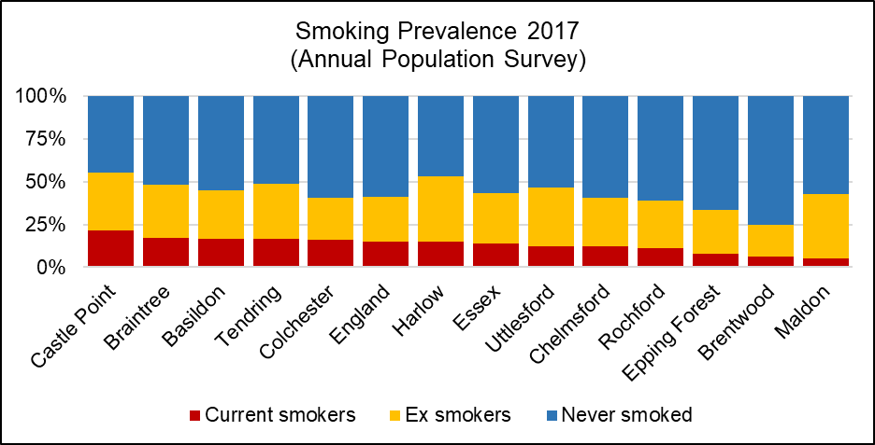

***Smoking***

In the Maldon District in 2017, the prevalence of current smokers among persons aged over 18 years was 5.33. This was the lowest compared across the other Districts in Essex. This was also significantly lower than the prevalence across the whole of Essex (13.84) and England (14.87).

Smoking attributable mortality in Maldon over the three year period of 2012 - 14 was estimated to be 225.48, of which 24.56 was due to heart disease. Smoking attributable mortality was the third lowest in Maldon compared across the other Essex Districts, and lower than that across Essex (258.24) and England (274.76). Overall, it was estimated that 768.42 potential years of life were lost due to smoking in Maldon.

Maldon had the second highest prevalence of ex-smokers among persons aged over 18 years out of the Essex Districts in 2017, with a prevalence of 37.50, similar to that across Essex (29.51) and England (26.17).

*See table below for the ranked prevalence of current and previous smoking status across the Districts in Essex in 2017/18.*

|  |  |  |  |  |  |  |
| --- | --- | --- | --- | --- | --- | --- |
|  | **Smoking prevalence in adults by current and previous status (Annual Population Survey, 2017)** | | | | | |
| **Current smoker** | | **Ex-smoker** | | **Never-smoked** | |
| **%** | **Rank** | **%** | **Rank** | **%** | **Rank** |
| **Basildon** | 16.72 | 3 | 28.18 | 8 | 55.10 | 7 |
| **Braintree** | 17.15 | 2 | 31.19 | 6 | 51.65 | 9 |
| **Brentwood** | 6.48 | 11 | 18.37 | 12 | 75.15 | 1 |
| **Castle Point** | 21.48 | 1 | 33.89 | 4 | 44.62 | 12 |
| **Chelmsford** | 12.02 | 8 | 28.75 | 7 | 59.23 | 4 |
| **Colchester** | 15.99 | 5 | 24.80 | 11 | 59.20 | 5 |
| **Epping Forest** | 7.84 | 10 | 25.72 | 10 | 66.44 | 2 |
| **Harlow** | 14.81 | 6 | 38.19 | 1 | 47.01 | 11 |
| **Maldon** | 5.33 | 12 | 37.50 | 2 | 57.17 | 6 |
| **Rochford** | 10.98 | 9 | 28.02 | 9 | 61.00 | 3 |
| **Tendring** | 16.72 | 4 | 32.03 | 5 | 51.25 | 10 |
| **Uttlesford** | 12.33 | 7 | 34.38 | 3 | 53.29 | 8 |
| **Essex** | 13.84 | - | 29.51 | - | 56.65 | - |
| **England** | 14.87 | - | 26.17 | - | 58.96 | - |

***Alcohol***

Alcohol-related hospital admissions are defined as admissions where the primary and any secondary diagnoses are an alcohol-attributable code. According to Public Health England, the directly age standardised rate of alcohol-related hospital admissions in the Maldon District in 2017/18 was 1675.22 per 100,000 population. This was the second lowest rate compared across the other Districts in Essex, and also lower than the rate across the whole of Essex (1935.65) and England (2223.81). The directly age standardised rate per 100,000 population of alcohol-related mortality was estimated to be 37.67 in Maldon in 2017, the 9th highest rate compared across the other Districts in Essex.

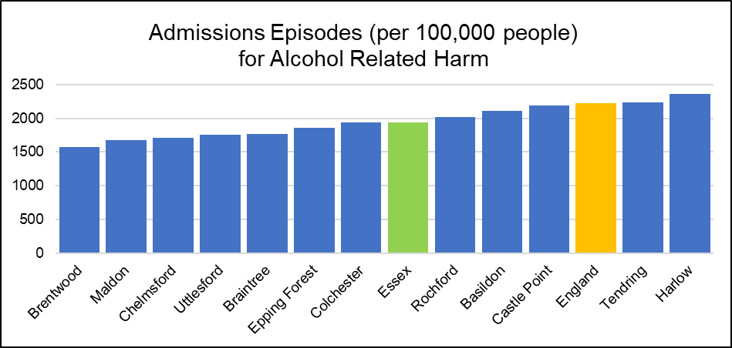

***Drug Use***

Over the period of 2015 – 2017 a total of 7 deaths were recorded which were attributable to drug use in the Maldon District. According to the Office for National Statistics, the age-standardised mortality rate from drug misuse per 100,000 population could not be calculated due to the sample size being too small. The rate was also unable to be calculated for the Districts of Basildon, Brentwood, Castle Point, Epping Forest, Rochford and Uttlesford.

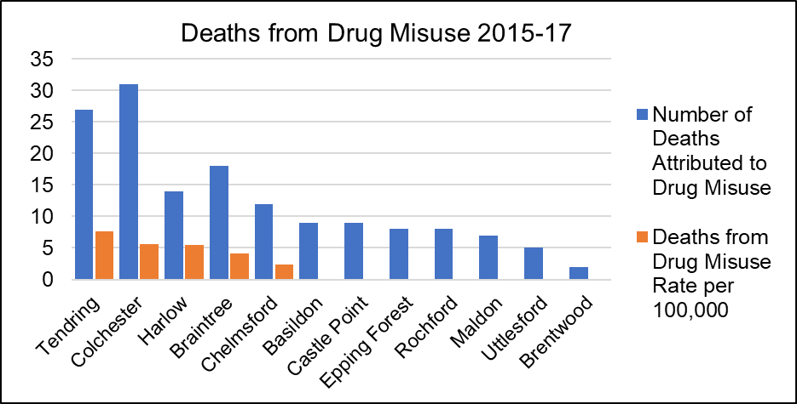

|  |  |  |  |  |  |  |
| --- | --- | --- | --- | --- | --- | --- |
|  | **Alcohol and Drugs** | | | | | |
| **Alcohol-related hospital admission rate per 100K** | | **Alcohol mortality** | | **Deaths from drug misuse** | |
| Value | Rank | Value | Rank | Count | Rate Per 100K |
| **Basildon** | 2111.07 | 4 | 46.31 | 2 | 9 | * |
| **Braintree** | 1761.831 | 8 | 41.66 | 4 | 18 | 4.19 |
| **Brentwood** | 1576.501 | 12 | 39.80 | 6 | 2 | * |
| **Castle Point** | 2194.25 | 3 | 39.46 | 7 | 9 | * |
| **Chelmsford** | 1713.9 | 10 | 38.26 | 8 | 12 | 2.33 |
| **Colchester** | 1934.702 | 6 | 40.12 | 5 | 31 | 5.59 |
| **Epping Forest** | 1856.899 | 7 | 35.50 | 10 | 8 | * |
| **Harlow** | 2360.043 | 1 | 44.38 | 3 | 14 | 5.51 |
| **Maldon** | 1675.22 | 11 | 37.67 | 9 | 7 | * |
| **Rochford** | 2022.617 | 5 | 32.49 | 12 | 8 | * |
| **Tendring** | 2237.576 | 2 | 61.49 | 1 | 27 | 7.60 |
| **Uttlesford** | 1749.756 | 9 | 33.78 | 11 | 5 | * |
| **Essex** | 1935.651 | - | 41.90 | - | 150 | 3.63 |
| **England** | 2223.806 | - | 46.15 | - | 6996 | 4.33 |

*value cannot be calculated as number of cases too small

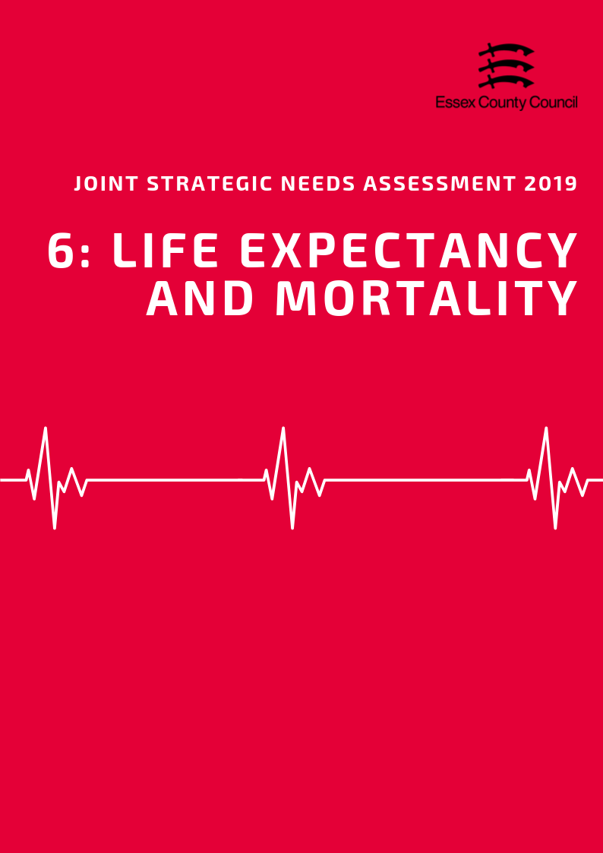

**LIFE EXPECTANCY & MORTALITY**

***Life Expectancy***

*Life Expectancy at Birth*

The average life expectancy at birth for a child born in Maldon (2015-2017) was 83.4 years for females and 80.2 years for males; higher than the average for England for both sexes (Females = 83.1 years, Males = 79.6 years). In this area, it estimated that the difference (inequality) in life expectancy at birth between most and least deprived areas is 2.3 years of life for females and 3.9 years for males. This lower than the average number of years inequality for Essex (6 and 7.7) and England (7.4, 9.4).

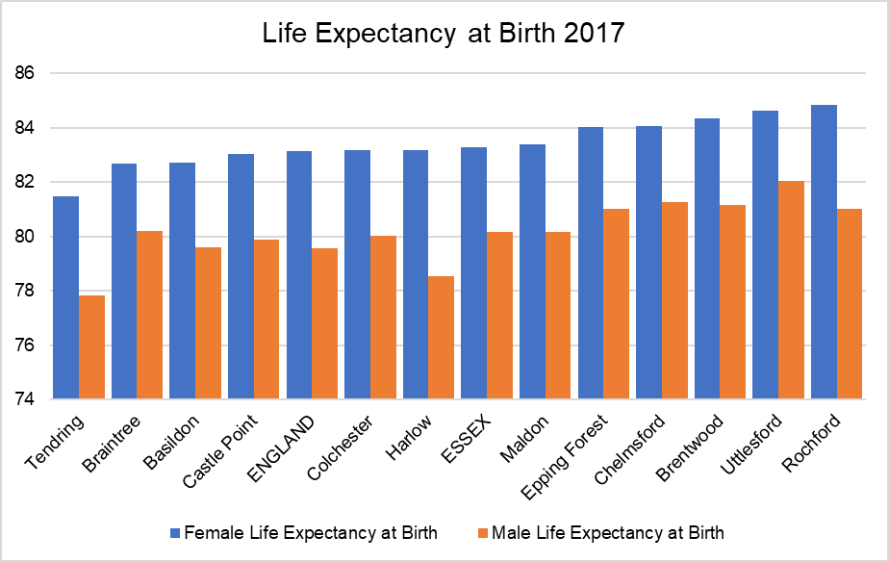

*Life Expectancy at 65*

During the same period, life expectancy at age 65 (the number of additional years a person could expect to live) was 21.7 years for females and 19.0 years for males, slightly higher than average when compared to England (Females = 21.1 years, Males = 18.8). Like life expectancy at birth, life expectancy at age 65 varies between the most and least deprived areas with an estimated gap of 1.9 years for both sexes in Maldon. This is lower than the England average for (Females =4.5, Males =4.9) and is the second lowest (females) and lowest (males) inequality in life expectancy at 65 in Essex.

*Life Expectancy estimates for each lower tier local authority area at birth and at age 65 are set out in the table below:*

|  |  |  |  |  |  |  |  |  |  |
| --- | --- | --- | --- | --- | --- | --- | --- | --- | --- |
|  | **Female Life Expectancy** | | | |  | **Male Life Expectancy** | | | |
| **At 65** | **At birth** | **Inequality in LE** | |  | **At 65** | **At birth** | **Inequality in LE** | |
| **At 65** | **At Birth** |  | **At 65** | **At Birth** |
| **England** | **21.1** | **83.1** | **4.5** | **7.4** |  | **18.8** | **79.6** | **4.9** | **9.4** |
| **Essex** | **21.2** | **83.3** | **3.2** | **6** |  | **18.9** | **80.2** | **4.2** | **7.7** |
| Basildon | 21.1 | 82.7 | 4 | 7.5 |  | 18.6 | 79.6 | 5.1 | 9.6 |
| Braintree | 20.6 | 82.7 | 2.1 | 5 |  | 18.7 | 80.2 | 2.4 | 5.5 |
| Brentwood | 21.6 | 84.3 | 5.1 | 7 |  | 19.4 | 81.2 | 5.9 | 9.9 |
| Castle Point | 20.8 | 83.0 | 2.6 | 4.3 |  | 18.4 | 79.9 | 3.6 | 6 |
| Chelmsford | 21.6 | 84.0 | 2.7 | 4.5 |  | 19.8 | 81.3 | 3.3 | 6 |
| Colchester | 21.1 | 83.2 | 4.7 | 7.8 |  | 18.8 | 80.0 | 4.7 | 7.5 |
| Epping Forest | 21.1 | 84.0 | 3.3 | 5.6 |  | 19.1 | 81.0 | 4.1 | 6.6 |
| Harlow | 21.3 | 83.2 | 2.6 | 5.1 |  | 18.3 | 78.5 | 5.3 | 7.8 |
| Maldon | 21.7 | 83.4 | 1.9 | 2.3 |  | 19.0 | 80.2 | 1.9 | 3.9 |
| Rochford | 21.9 | 84.8 | 2.6 | 4.4 |  | 19.1 | 81.0 | 2.8 | 3.2 |
| Tendring | 20.6 | 81.5 | 4 | 7 |  | 18.2 | 77.8 | 4.5 | 10.8 |
| Uttlesford | 22.0 | 84.6 | 0.6 | -0.3 |  | 20.0 | 82.1 | 1.9 | 2.2 |

***Mortality***

In 2017 the Maldon area had an all ages mortality rate of 876.0 deaths per 100,000 residents, based on 646 deaths recorded during that time period. This overall mortality rate was lower than the England average of 958.7 (per 100K) and was a slight decrease compared the previous year (927.1 per 100K). Looking at mortality rates across the different age groups, 40% of all deaths during this period were from residents aged 85 years and over with an age standardised mortality rate of 15040.4 per 100K (based 261 actual deaths). This was lower than the England average (40.4%, 15280.8 per 100K) and Essex rate (43.3%, 16031.7 per 100K), with mortality rates for all other age groups also below the national average.

*Premature Mortality*

The Maldon District has the sixth lowest rate of all premature mortalities in Essex with a rate of 297 deaths per 100,000 residents under the age of 75. This is 11.7% lower than to the average for England, 3.4% lower than the average for the county, but 15% higher than the best performing area (Uttlesford). Despite this relatively good performance compared to county and national levels, there remain some health inequalities for residents living in some neighbourhoods.

There is also a significant difference in the under 75 mortality rates between males (341 per 100,000) and females (255 per 100,000) a difference of 25%, significantly smaller than the average difference across England (34%).

*Premature Deaths from Cancer*

269 deaths from cancer under the age of 75 were recorded in the Maldon District between 2015-17, equivalent to a rate of 126.6 deaths per 100,000 residents. This is slightly lower than the average for Essex (131) and England (135). Experimental statistics for early stage cancer diagnosis indicate that 53.8% of cases were diagnosed at either stage 1 or 2 in 2017. This is lower than the Essex (53.3%) and England (52.2%) averages and is similar to estimates from the previous year.

Breast cancer is a serious cause of premature mortality for women nationally. In the Maldon District 27 deaths of women under the age of 75 were recorded between 2015 and 2017, equivalent to a rate of 26.6 deaths per 100,000 people. This is the 3rd highest rate in Essex; higher than the average for Essex (21.5) or England (20.6). The percentage of eligible women in Maldon who were screened adequately for breast cancer in (the previous three years from 31st March) 2018 was 57.3%; a significant reduction compared to 79% in 2017. This was the lowest screening rate in Essex and was significantly less than the average for Essex (73.5%) and England (74.9%). Public Health England recommends that improvements in coverage would mean more breast cancers are detected at earlier more treatable stages.

Colorectal cancer was the other most common cause of premature deaths by cancer for both sexes with 35 deaths also recorded in 2015/17. This is equivalent to a rate of 16.1 deaths per 100,000 residents, was higher than the average rates for Essex (11.3) and England (11.9) and was the highest rate in the county overall (lowest: Harlow = 8.3 per 100,000).

***Preventable Mortality***

*According to Public Health England, "preventable mortality is that deaths are considered preventable if, in the light of the understanding of the determinants of health at the time of death, all or most deaths from the underlying cause (subject to age limits if appropriate) could potentially be avoided by public health interventions in the broadest sense".*

In the period of 2015-2017 it is estimated that 379 deaths for all age groups or 19.2% of all deaths that occurred in the Maldon area were preventable. This is equivalent to a rate of 170.3 per 100,000 people, lower than the rate (181.5) but higher than the overall percentage (18.9%). Males were 24% more likely to die from a preventable cause (SMR= 194.3 per 100K) compared to females (SMR= 147.6 per 100K) during the same period.

For the under 75 age group Cancer was the largest cause of preventable mortality with a rate of 77.3 preventable deaths per 100,000 for all persons, lower than the England baseline (82.8) and the rate for Essex (74.2). For each sex the rate of preventable deaths for males (SMR = 68.9) was lower than average (England Males = 89.9), whilst of the rate for females in Braintree (SMR 77.4) was significantly higher than the rate for England (72.3) and was the highest rate in the county. This gender based difference may be related to the higher rate of Breast Cancer mortality (mentioned earlier int his section) observed in this area, however further investigation would be needed to confirm this.

Cardiovascular disease was the next largest preventable cause with a combined rate of 29.6 per 100,000 for both sexes, however the rate for all persons and the rate for each sex were all below the national average for the latest time period.

|  |  |  |  |  |  |  |  |  |  |  |
| --- | --- | --- | --- | --- | --- | --- | --- | --- | --- | --- |
|  | **Mortality Rates for All Persons** | | | | | | | | | |
|  | **Under 75 mortality from colorectal cancer** | **Under 75 mortality rate from all cardiovascular diseases** | **Under 75 mortality rate from all causes** | **Under 75 Mortality rate from breast cancer** | **Under 75 mortality rate from cancer** | **Under 75 mortality rate from heart disease** | **Under 75 mortality rate from injuries** | **Under 75 mortality rate from liver disease** | **Under 75 mortality rate from respiratory disease** | **Under 75 mortality rate from stroke** |
| **England** | **11.97** | **72.50** | **331.95** | **10.60** | **134.59** | **38.72** | **12.78** | **18.51** | **34.26** | **13.08** |
| **Essex** | **11.32** | **62.56** | **307.35** | **11.22** | **131.18** | **31.57** | **10.20** | **14.68** | **30.76** | **11.73** |
| Basildon | 13.82 | 70.92 | 336.39 | 9.81 | 157.15 | 35.80 | 7.39 | 15.06 | 33.14 | 13.42 |
| Braintree | 9.61 | 65.40 | 310.64 | 14.10 | 132.10 | 34.11 | 11.18 | 13.98 | 27.49 | 13.47 |
| Brentwood | 11.37 | 48.51 | 265.73 | 8.77 | 119.54 | 24.19 | 7.54 | 13.63 | 26.70 | 7.89 |
| Castle Point | 11.75 | 66.34 | 313.33 | 14.03 | 141.84 | 32.15 | 8.67 | 14.13 | 32.70 | 13.16 |
| Chelmsford | 10.17 | 54.03 | 272.91 | 11.22 | 119.76 | 28.45 | 9.85 | 11.26 | 24.02 | 10.46 |
| Colchester | 8.66 | 56.64 | 298.36 | 8.88 | 122.23 | 29.44 | 12.54 | 15.99 | 34.37 | 10.51 |
| Epping Forest | 8.76 | 52.34 | 276.80 | 12.69 | 121.43 | 25.31 | 9.88 | 13.81 | 28.24 | 10.55 |
| Harlow | 8.36 | 91.62 | 356.97 | 10.82 | 127.68 | 48.42 | 12.35 | 13.82 | 40.82 | 17.71 |
| Maldon | 16.10 | 61.97 | 297.26 | 13.50 | 126.61 | 31.51 | 17.62 | 14.29 | 23.06 | 11.74 |
| Rochford | 10.33 | 49.03 | 263.54 | 10.20 | 120.80 | 20.34 |  | 9.21 | 21.59 | 6.15 |
| Tendring | 15.21 | 79.58 | 400.31 | 11.80 | 149.39 | 37.51 | 17.86 | 25.26 | 45.35 | 15.68 |
| Uttlesford | 10.45 | 52.83 | 252.76 | 9.45 | 113.08 | 30.85 | 5.47 | 13.50 | 23.93 | 8.65 |

|  |  |  |  |  |  |  |  |  |  |  |
| --- | --- | --- | --- | --- | --- | --- | --- | --- | --- | --- |
|  | **Mortality Rates for Female Residents** | | | | | | | | | |
| **Under 75 mortality from colorectal cancer** | **Under 75 mortality rate from all cardiovascular diseases** | **Under 75 mortality rate from all causes** | **Under 75 Mortality rate from breast cancer** | **Under 75 mortality rate from cancer** | **Under 75 mortality rate from heart disease** | **Under 75 mortality rate from injuries** | **Under 75 mortality rate from liver disease** | **Under 75 mortality rate from respiratory disease** | **Under 75 mortality rate from stroke** |
| **England** | **9.36** | **45.22** | **264.13** | **20.59** | **120.68** | **18.46** | **7.08** | **12.97** | **28.98** | **11.33** |
| **Essex** | **9.54** | **37.62** | **250.12** | **21.53** | **120.61** | **14.03** | **6.34** | **11.49** | **25.44** | **9.69** |
| Basildon | 10.31 | 44.80 | 280.68 | 18.43 | 143.66 | 17.14 |  | 15.78 | 29.86 | 11.47 |
| Braintree | 6.45 | 41.03 | 259.69 | 27.49 | 125.03 | 15.85 | 6.64 | 9.85 | 23.61 | 12.05 |
| Brentwood | 12.08 | 28.51 | 217.07 | 17.08 | 106.45 |  |  | 14.93 | 22.74 |  |
| Castle Point | 11.60 | 37.02 | 255.09 | 27.15 | 135.91 | 12.14 |  | 12.61 | 25.47 | 8.02 |
| Chelmsford | 9.30 | 32.79 | 220.20 | 21.76 | 112.36 | 12.28 | 5.47 | 5.98 | 20.98 | 7.20 |
| Colchester | 8.27 | 33.63 | 231.45 | 16.34 | 100.83 | 13.04 | 10.20 | 10.54 | 25.83 | 10.54 |
| Epping Forest | 6.03 | 31.76 | 230.83 | 24.42 | 106.93 | 11.46 | 8.94 | 9.38 | 25.44 | 8.78 |
| Harlow |  | 48.16 | 256.41 | 20.81 | 108.86 | 21.88 |  | 12.50 | 30.63 | 14.90 |
| Maldon | 14.24 | 33.27 | 254.87 | 26.60 | 133.30 | 13.33 | 13.36 |  | 19.54 |  |
| Rochford | 10.67 | 26.76 | 213.16 | 19.72 | 113.43 | 9.14 |  | 7.50 | 13.51 |  |
| Tendring | 10.64 | 50.97 | 320.64 | 22.03 | 133.00 | 17.01 | 7.67 | 20.63 | 37.80 | 15.13 |
| Uttlesford | 14.23 | 34.52 | 221.05 | 18.54 | 124.54 | 14.97 |  | 11.93 | 17.59 |  |

|  |  |  |  |  |  |  |  |  |  |  |
| --- | --- | --- | --- | --- | --- | --- | --- | --- | --- | --- |
|  | **Mortality Rates for Male Residents** | | | | | | | | | |
| **Under 75 mortality from colorectal cancer** | **Under 75 mortality rate from all cardiovascular diseases** | **Under 75 mortality rate from all causes** | **Under 75 Mortality rate from breast cancer** | **Under 75 mortality rate from cancer** | **Under 75 mortality rate from heart disease** | **Under 75 mortality rate from injuries** | **Under 75 mortality rate from liver disease** | **Under 75 mortality rate from respiratory disease** | **Under 75 mortality rate from stroke** |
| **England** | **14.74** | **101.25** | **403.22** | **0.16** | **149.57** | **60.09** | **18.56** | **24.30** | **39.90** | **14.93** |
| **Essex** | **13.24** | **89.42** | **368.93** |  | **142.83** | **50.47** | **14.20** | **18.10** | **36.54** | **13.93** |
| Basildon | 17.81 | 99.62 | 397.73 |  | 172.39 | 56.22 | 11.82 | 14.36 | 36.87 | 15.54 |
| Braintree | 13.02 | 91.43 | 364.90 |  | 139.74 | 53.66 | 15.89 | 18.39 | 31.54 | 14.99 |
| Brentwood | 10.55 | 69.95 | 317.48 |  | 133.43 | 43.71 |  | 12.22 | 30.95 |  |
| Castle Point | 12.06 | 98.06 | 377.12 |  | 149.35 | 53.77 | 13.49 | 15.71 | 40.68 | 18.99 |
| Chelmsford | 11.13 | 77.03 | 329.61 |  | 128.28 | 45.96 | 14.34 | 16.89 | 27.24 | 14.00 |
| Colchester | 9.00 | 81.61 | 371.09 |  | 145.81 | 47.24 | 15.05 | 21.98 | 43.84 | 10.44 |
| Epping Forest | 11.70 | 74.50 | 326.33 |  | 137.14 | 40.29 | 10.87 | 18.58 | 31.31 | 12.39 |
| Essex | 13.24 | 89.42 | 368.93 |  | 142.83 | 50.47 | 14.20 | 18.10 | 36.54 | 13.93 |
| Harlow | 12.24 | 139.51 | 468.88 |  | 149.33 | 78.10 | 20.15 | 15.19 | 52.91 | 20.54 |
| Maldon | 17.94 | 91.25 | 341.00 |  | 119.81 | 50.07 | 21.78 | 21.79 | 26.56 | 17.01 |
| Rochford | 10.07 | 73.13 | 317.49 |  | 128.69 | 32.39 |  | 11.08 | 30.51 | 10.28 |
| Tendring | 20.24 | 111.07 | 488.75 |  | 167.63 | 60.01 | 28.97 | 30.42 | 53.80 | 16.34 |
| Uttlesford |  | 71.35 | 284.31 |  | 101.11 | 46.90 |  | 15.01 | 30.38 | 9.84 |

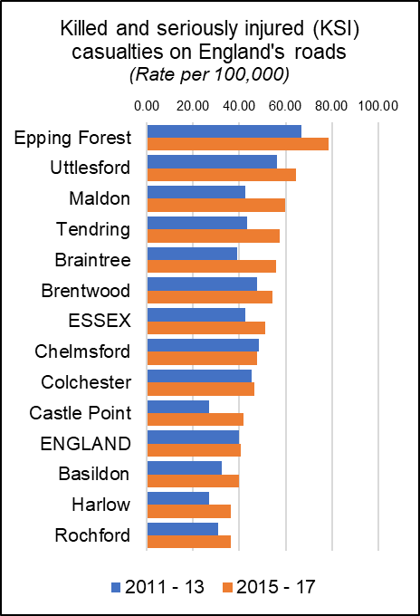***Killed and Seriously Injured in Road Traffic Accidents***

The rate of people killed or seriously injured on England’s roads has risen is recorded as a rate per 100,000 population (all ages) over a three year period. During the last recorded period (2015-17) the average rate for Essex (51.28) was higher than the average for England (40.8) with nine out of 12 Districts having rates above the national average.

Maldon had a rate of 59.92 which was the above the England and Essex averages and was the 3rd highest level in the county. Rates in Maldon have decreased by 17.41 per 100K or 41% compared to 2011-13 with the largest increase observed 2014-16.

*KSI rates for all areas & over time are set out in the table below.*

|  |  |  |  |  |  |  |  |  |
| --- | --- | --- | --- | --- | --- | --- | --- | --- |
|  | **Killed and seriously injured (KSI) casualties on England's roads** | | | | |  | **5 Year Change** | |
| 2011 - 13 | 2012 - 14 | 2013 - 15 | 2014 - 16 | 2015 - 17 | Rate (per 100K) | % |
| Epping Forest | 66.93 | 70.35 | 67.73 | 75.81 | 78.76 | 11.83 | 17.7% |
| Uttlesford | 56.24 | 50.80 | 48.37 | 55.16 | 64.51 | 8.27 | 14.7% |
| Maldon | 42.51 | 42.86 | 43.52 | 57.83 | 59.92 | 17.41 | 41.0% |
| Tendring | 43.35 | 39.80 | 40.60 | 45.84 | 57.43 | 14.08 | 32.5% |
| Braintree | 39.09 | 40.45 | 43.09 | 51.37 | 55.76 | 16.67 | 42.7% |
| Brentwood | 47.66 | 47.28 | 45.23 | 54.10 | 54.28 | 6.62 | 13.9% |
| **ESSEX** | **42.74** | **42.21** | **42.47** | **48.18** | **51.28** | **8.55** | **20.0%** |
| Chelmsford | 48.61 | 43.25 | 44.49 | 45.74 | 47.65 | -0.96 | -2.0% |
| Colchester | 45.41 | 42.89 | 44.02 | 46.51 | 46.54 | 1.14 | 2.5% |
| Castle Point | 26.83 | 28.97 | 32.99 | 39.24 | 41.97 | 15.14 | 56.4% |
| **ENGLAND** | **39.71** | **39.26** | **38.50** | **39.70** | **40.80** | **1.09** | **2.7%** |
| Basildon | 32.48 | 36.98 | 35.79 | 39.02 | 39.72 | 7.25 | 22.3% |
| Harlow | 26.97 | 21.97 | 24.03 | 31.25 | 36.49 | 9.52 | 35.3% |
| Rochford | 30.99 | 34.94 | 32.23 | 39.52 | 36.17 | 5.18 | 16.7% |
| Number of people reported killed or seriously injured (KSI) on the roads, all ages, per 100,000 resident population | | | | | | | | |

***Excess Winter Deaths***

Excess Winter Deaths Index (EWD Index) is the excess winter deaths measured as the ratio of extra deaths from all causes that occur in the winter months compared with the expected number of deaths, based on the average of the number of non-winter deaths. The Excess Winter Deaths Index is calculated as the number of excess winter deaths divided by the average non-winter deaths expressed as a percentage.

**According to the Office of National Statistics…**

*“Colder than average temperatures for the winter months of 2017 to 2018 may partially explain the increase in winter deaths. However, previous years demonstrate a weak relationship between temperature and EWD. Increased EWD are not always coupled with unusually cold winters and conversely winters with decreased EWD are not always coupled with milder winter temperatures, indicating factors other than temperature, such as influenza, are also relevant in explaining trends in excess winter mortality (EWM).”\**

Between August 2014 and July 2017, the three year average rate of Excess Deaths for all ages was 22.1%, just below than the average for England (21.9%) and lower than Essex (23.3%). This was the 5th highest level compared to the other Districts in the county (Highest: Uttlesford = 30.1%; Lowest: Brentwood = 9.3%). Looking at the level of Excess Winter Deaths specifically in the over 85s age group shows a level of 39.5% Excess Winter Deaths for this age group during the same period. This is higher than the England rate of 29.3% and the county average of 31.7% and is the highest level in the county. (Highest: Maldon = 39.5%; Lowest: Brentwood 14.5%). A breakdown of the levels of Excess Winter Deaths for each district can be found in the table below.

|  |  |  |  |  |
| --- | --- | --- | --- | --- |
|  | ***Excess winter deaths index (3 years, age 85+) Percentage*** | ***Essex rank (lowest to Highest)*** | ***Excess winter deaths index (3 years, all ages) Percentage*** | ***Essex rank (lowest to Highest)*** |
| **England** | **29.3** |  | **21.1** |  |
| **Essex** | **31.7** |  | **23.3** |  |
| Basildon | 34.5 | 7 | 19.4 | 3 |
| Braintree | 30.9 | 3 | 26.1 | 9 |
| Brentwood | 14.5 | 1 | 9.3 | 1 |
| Castle Point | 37.7 | 10 | 27.2 | 11 |
| Chelmsford | 22.2 | 2 | 22.2 | 6 |
| Colchester | 36.8 | 9 | 25.4 | 7 |
| Epping Forest | 31.8 | 4 | 25.5 | 8 |
| Harlow | 35.2 | 8 | 22.1 | 5 |
| Maldon | 39.5 | 12 | 17.4 | 2 |
| Rochford | 32.2 | 5 | 21.5 | 4 |
| Tendring | 32.7 | 6 | 26.1 | 10 |
| Uttlesford | 38.5 | 11 | 30.1 | 12 |

*[*https://www.ons.gov.uk/peoplepopulationandcommunity/birthsdeathsandmarriages/deaths/bulletins/excesswintermortalityinenglandandwales/2017to2018provisionaland2016to2017final*](https://www.ons.gov.uk/peoplepopulationandcommunity/birthsdeathsandmarriages/deaths/bulletins/excesswintermortalityinenglandandwales/2017to2018provisionaland2016to2017final)

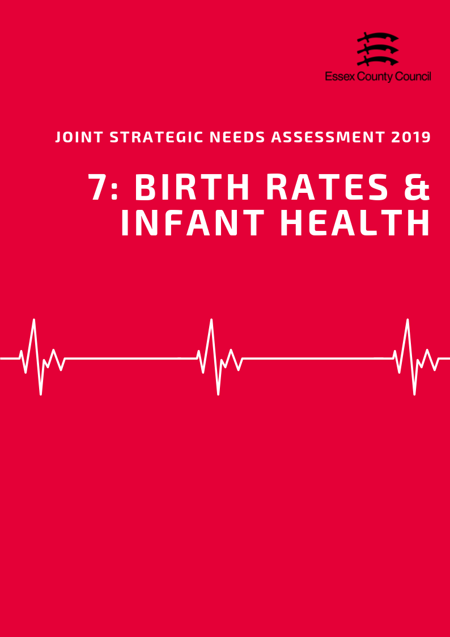

**Birth Rates & Infant Health**

***Birth Rates***

According to the Office for National Statistics the Crude Birth Rate (CBR; all births per 1,000 population) in the Maldon District was 9.19. This was the lowest rate compared to the other Districts in Essex, and lower than the rate for Essex as a whole (11.4) and for England (12.0). 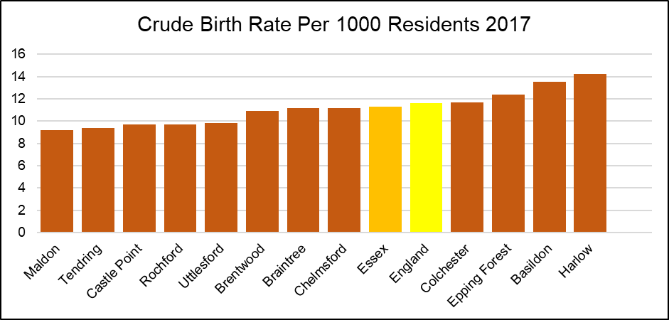Maldon has been consistently ranked as having one of the lowest CBR in each year since 2013. However, the CBR has increased overall, with, for example, a CBR of 8.8 in 2013. This is also the 3rd highest increase relative to the rate increase of the other Districts in Essex. In contrast, the CBR remained stable across Essex (2013 and 2017: 11.3) and decreased across England by 0.7 (2013: 12.3; 2017: 11.6). *The Table below provides the ranked CBR in each district in each year from 2013 to 2017*

|  |  |  |  |  |  |  |  |  |  |  |
| --- | --- | --- | --- | --- | --- | --- | --- | --- | --- | --- |
|  | **Year** | | | | | | | | | |
| **2013** | | **2014** | | **2015** | | **2016** | | **2017** | |
| **CBR** | **Rank** | **CBR** | **Rank** | **CBR** | **Rank** | **CBR** | **Rank** | **CBR** | **Rank** |
| **England** | **12.3** | **-** | **12.2** | **-** | **12.1** | **-** | **12.0** | **-** | **11.6** | **-** |
| **Essex** | **11.3** | **-** | **11.5** | **-** | **11.3** | **-** | **11.4** | **-** | **11.3** | **-** |
| Basildon | 13.6 | 2 | 13.4 | 2 | 13.5 | 2 | 13.6 | 2 | 13.5 | 2 |
| Braintree | 11.1 | 5 | 11.0 | 7 | 10.7 | 7 | 11.4 | 6 | 11.2 | 5 |
| Brentwood | 11.1 | 6 | 11.6 | 4 | 11.7 | 5 | 11.1 | 7 | 10.9 | 7 |
| Castle Point | 9.0 | 10 | 9.7 | 10 | 9.5 | 9 | 9.6 | 9 | 9.7 | 9 |
| Chelmsford | 10.9 | 7 | 11.4 | 6 | 10.9 | 6 | 11.7 | 5 | 11.2 | 6 |
| Colchester | 12.4 | 3 | 12.4 | 3 | 12.2 | 4 | 11.8 | 4 | 11.7 | 4 |
| Epping Forest | 12.2 | 4 | 11.5 | 5 | 12.5 | 3 | 12.2 | 3 | 12.4 | 3 |
| Harlow | 14.6 | 1 | 16.1 | 1 | 14.3 | 1 | 15.2 | 1 | 14.2 | 1 |
| Maldon | 8.8 | 11 | 8.5 | 12 | 9.2 | 11 | 8.4 | 12 | 9.2 | 12 |
| Rochford | 8.4 | 12 | 9.4 | 11 | 8.8 | 12 | 8.8 | 11 | 9.7 | 10 |
| Tendring | 9.7 | 9 | 9.8 | 9 | 9.5 | 10 | 9.0 | 10 | 9.4 | 11 |
| Uttlesford | 9.9 | 8 | 10.9 | 8 | 10.5 | 8 | 10.7 | 8 | 9.8 | 8 |

***Birth rates by age of mother***

The rate of births per 1,000 population among females aged 40 -44 years (6.3) in Maldon was the lowest level compared to the other Districts in Essex in 2016, and lower than that for Essex as a whole (12.4) and England (14.9).

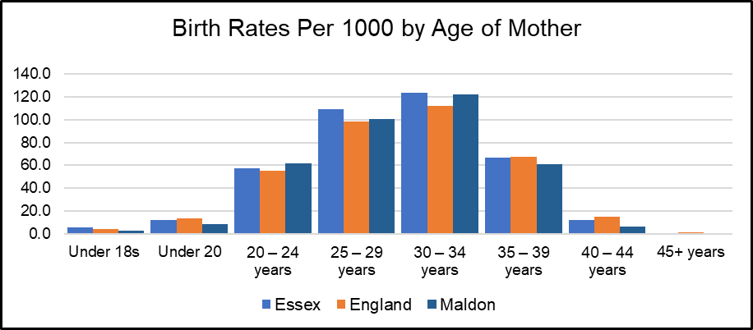

*See Table 2 for birth rates by age of mother for each Essex District*

***Under 18 Conceptions and Births***

The rate of conceptions in women aged under 18 years per 1,000 females aged 15 to 17 years in the Maldon District was 12.0 in 2016. This was the third lowest rate compared to that of the other Essex Districts, and lower than that for Essex as a whole (16.7) and England (18.8).

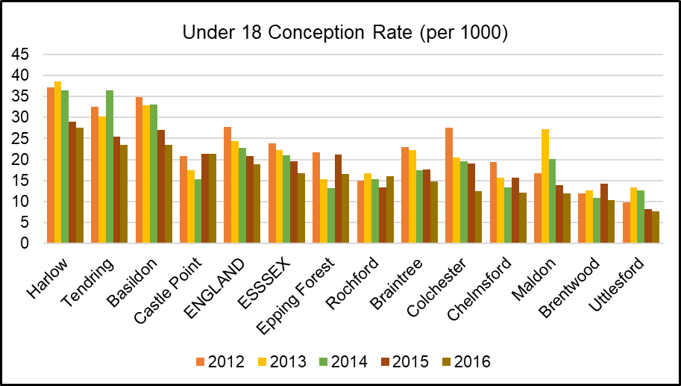

The rate of live births in women aged under 18 per 1,000 females aged 15 to 17 years was 2.77 in Maldon in 2016. This was the second lowest rate compared to the other Districts in Essex, and lower than that for Essex as a whole (4.64) and England (5.55).

|  |  |  |  |  |  |  |  |  |
| --- | --- | --- | --- | --- | --- | --- | --- | --- |
|  | **Birth Rates (per 1000) by Age of Mother** | | | | | | | |
| **Under 18s** | **Under 20** | **20-24 years** | **25-29 years** | **30-34 years** | **35-39 years** | **40-44 years** | **45+ years** |
| **Essex** | **5.6** | **11.9** | **57.3** | **109.2** | **123.9** | **66.7** | **12.4** | **1** |
| **England** | **4.6** | **13.5** | **55.6** | **98.5** | **112.4** | **67.5** | **14.9** | **1.1** |
| Basildon | 4.1 | 17 | 73.9 | 117.9 | 122.5 | 66.3 | 13 | - |
| Braintree | 7.2 | 12.7 | 70.3 | 120.8 | 115.1 | 61 | 12.8 | 0.7 |
| Brentwood | 3.0 | 7.5 | 36 | 90.7 | 145.4 | 77.4 | 14 | 1 |
| Castle Point | 3.8 | 10.1 | 51.2 | 110.4 | 126.5 | 62.1 | 7.7 | 1.2 |
| Chelmsford | 3.1 | 10.4 | 43.3 | 105.1 | 124.8 | 73 | 14.6 | 1.1 |
| Colchester | 3.4 | 11.4 | 52.1 | 93 | 111.4 | 61.9 | 11.7 | 1.7 |
| Epping Forest | 4.2 | 8.6 | 45 | 98.8 | 145.5 | 77.8 | 14.5 | 1 |
| Harlow | 8.5 | 16.2 | 72.4 | 137.5 | 116.8 | 69.3 | 15.4 | 2.7 |
| Maldon | 2.8 | 8.3 | 61.9 | 100.8 | 122.4 | 60.8 | 6.3 | - |
| Rochford | 5.3 | 7.9 | 32.4 | 105.3 | 128.2 | 53.5 | 12.3 | - |
| Tendring | 8.1 | 18.8 | 88.4 | 132.6 | 101.7 | 46.8 | 9.4 | - |
| Uttlesford | 1.9 | 6.2 | 47.1 | 93.7 | 151.1 | 85.9 | 13.2 | 1.4 |

**INFANT HEALTH**

***Premature Births***

Premature births are live or still births at a gestational age of less than 37 weeks. The rate of premature births per 1,000 total live and still births in the Maldon District was 59.39 over the 3 year period of 2014 - 2016. This was the lowest rate compared to the other Districts in Essex, and significantly lower than that for Essex as a whole (74.69) and England (79.52).

***Low Birth Weight***

Low birth weight is defined as a live birth with a recorded weight under 2500g and gestational age of at least 37 weeks. In the Maldon District in 2016, the percentage of low birth weight out of all live births with a recorded weight (and gestational age >=37 weeks) was 1.18. This was the second lowest out of the other Districts in Essex, and lower to that for Essex as a whole (2.11) and England (2.79).

***Infant Mortality***

According to Public Health England, the rate of infant mortality aged under 1 years old was 2.95 per 1,000 live births in the Maldon District over the period 2015 - 2017. This was the 8th highest compared to the other districts of Essex, and slightly lower than that for the whole of Essex (3.10) and England (3.92).

***Breastfeeding Initiation***

The breastfeeding initiation rate for the Maldon District was not disclosed.

***Smoking at The Time of Delivery***

The percentage of mothers known to be smokers at the time of delivery out of all maternities was 7.76 in the Mid Essex CCG 2017/18. This was the joint second (with Braintree and Chelmsford) compared across the other Districts in Essex, and lower than that for Essex as a whole (10.60) and England (10.80).

*All of the infant health datasets mentioned in this section is set out in table below:*

|  |  |  |  |  |  |
| --- | --- | --- | --- | --- | --- |
|  | **Premature births (less than 37 weeks gestation) Per 1000** | **Low birth weight of term babies (%)** | **Infant mortality (per 1000)** | **Breast Feeding Initiation (%)** | **Smoking status at time of delivery (%)** |
| **England** | 79.52 | 2.79 | 3.92 | 74.49 | 10.80 |
| **Essex** | 74.69 | 2.11 | 3.10 | 75.02 | 10.6 |
| Basildon | 79.05 | 2.52 | 2.83 | 68.02 | 11.82 |
| Braintree | 73.88 | 2.32 | 3.19 | 70.82 | 7.76 |
| Brentwood | 62.79 | 2.03 | 1.56 | 76.56 | 11.82 |
| Castle Point | 91.76 | 1.92 | 1.94 | 75.70 | 6.25 |
| Chelmsford | 65.68 | 1.67 | 3.06 | 77.55 | 7.76 |
| Colchester | 77.37 | 2.50 | 4.20 | 82.02 | 14.70 |
| Epping Forest | 74.35 | 2.07 | 1.24 | ! | 9.98 |
| Harlow | 84.90 | 2.61 | 3.20 | 71.18 | 9.98 |
| Maldon | 59.39 | 1.18 | 2.95 | ! | 7.76 |
| Rochford | 62.91 | 1.13 | 3.42 | 83.35 | 6.25 |
| Tendring | 81.90 | 2.03 | 5.52 | 68.38 | 14.70 |
| Uttlesford | 67.35 | 1.82 | 2.99 | 80.28 | 9.98 |
| Time Period | 2014-16 | 2016 | 2015-17 | 2016/17 | 2017/18 |
| ! Data not available | | | | | |

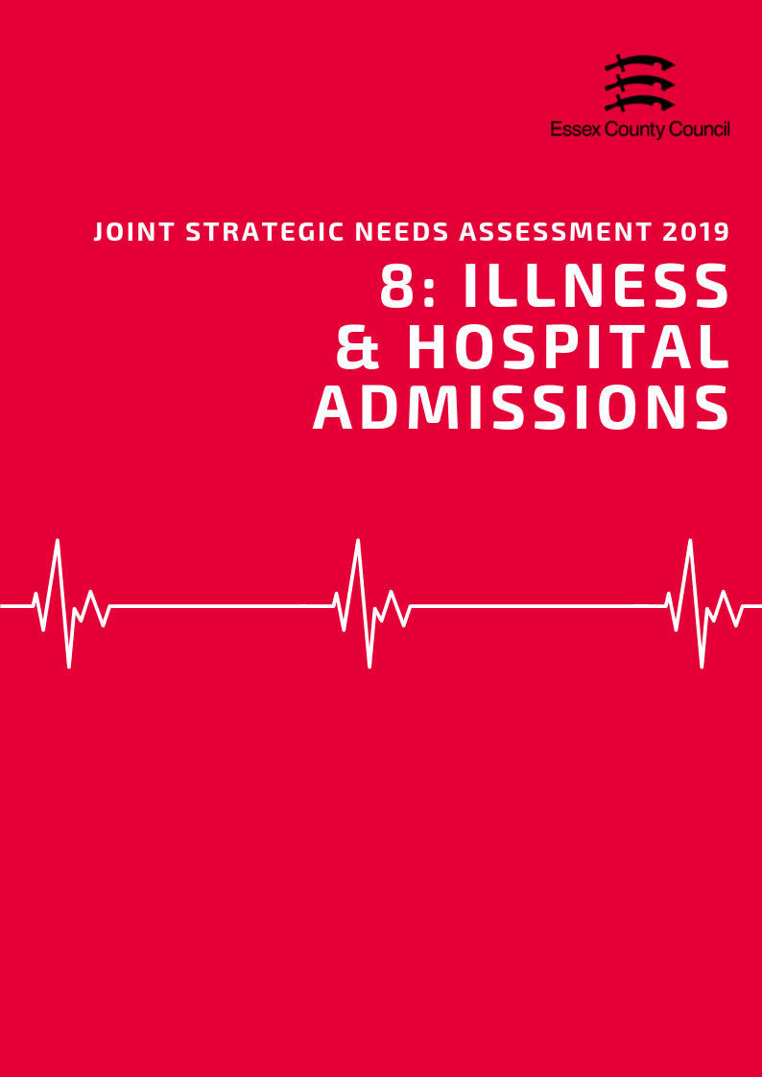

**Illness & Hospital Admissions**

***Emergency Hospital Admissions***

Emergency (unplanned) hospital admissions are both costly to the Health Service and can be a proxy indicator for wider health inequalities within local communities. In order to accurately compare admissions rates between areas of different sizes and compositions statistics are presented using Standardised Admission Ratio is defined as the ratio of the observed number of admissions in an area to the number expected if the area had the same age specific rates as England (Always set at 100).

***Emergency Admissions; all causes and all ages***

The admissions ratio for emergency admissions for all causes among persons of all ages was 77.32 in Maldon, which was ranked as being the third lowest admission ratio across the Essex Districts. This was also significantly better than the emergency admission ratio for all causes across England (100). However, Harlow was the only Essex District with a significantly worse admission ratio compared to England, with all Districts significantly better or similar (Tendring).

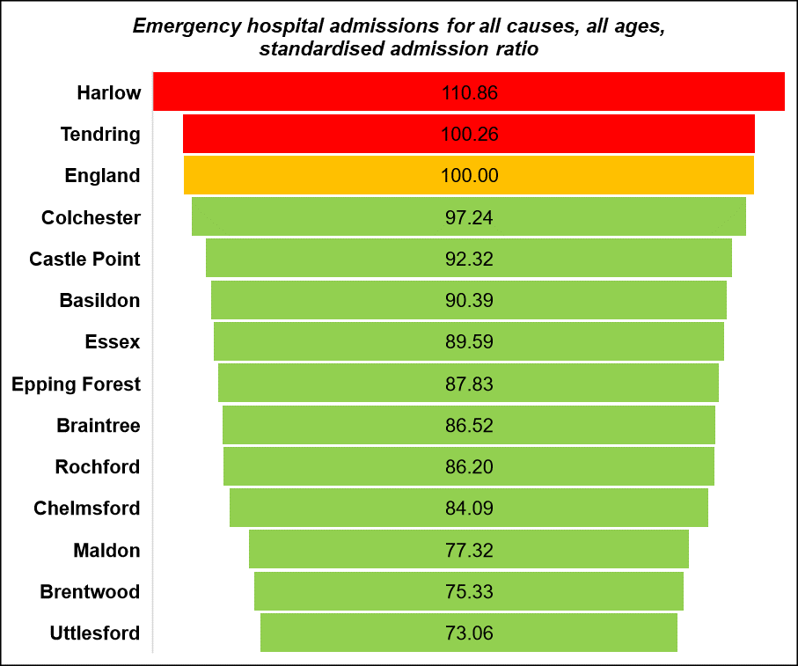

***Emergency Admissions for under 18s***

The emergency hospital admission rate per 1,000 population among those aged 18 years or younger was 5.01 in Maldon. This was ranked as being the 5th highest rate compared across the rates of the Essex Districts (highest: Colchester 10.09; lowest: Castle Point 3.57). Note that this data is an estimate produced by aggregating GP level data. This data is available from Public Health England Fingertips.

|  |  |  |  |  |  |  |
| --- | --- | --- | --- | --- | --- | --- |
|  | Emergency hospital admissions (standardised admission ratio) | | | | | |
|  | All causes  & All ages | Chronic Obstructive Pulmonary Disease (COPD) | Coronary Heart Disease, (CHD) | Hip fracture in persons 65 years and over | Myocardial Infarction (heart attack) | Stroke |
| Basildon | 90.4 | 116.5 | 100.4 | 103.5 | 104.0 | 113.8 |
| Braintree | 86.5 | 75.5 | 83.5 | 116.1 | 85.2 | 88.8 |
| Brentwood | 75.3 | 61.3 | 81.1 | 104.4 | 81.6 | 89.8 |
| Castle Point | 92.3 | 102.0 | 84.7 | 104.5 | 77.5 | 102.0 |
| Chelmsford | 84.1 | 61.2 | 77.2 | 107.9 | 75.4 | 89.3 |
| Colchester | 97.2 | 71.7 | 92.4 | 108.3 | 81.2 | 86.5 |
| England | 100.0 | 100.0 | 100.0 | 100.0 | 100.0 | 100.0 |
| Epping Forest | 87.8 | 78.4 | 88.3 | 99.7 | 91.9 | 89.8 |
| Essex | 89.6 | 83.2 | 90.5 | 106.2 | 87.5 | 94.3 |
| Harlow | 110.9 | 129.8 | 128.8 | 99.3 | 125.8 | 96.8 |
| Maldon | 77.3 | 52.2 | 80.8 | 105.8 | 83.9 | 80.2 |
| Rochford | 86.2 | 81.6 | 90.5 | 101.9 | 77.0 | 105.7 |
| Tendring | 100.3 | 100.3 | 105.7 | 108.4 | 93.7 | 100.1 |
| Uttlesford | 73.1 | 51.9 | 67.6 | 106.1 | 74.4 | 76.0 |

***Heart Attack***

Over the period of 2013/14 - 2017/18, the admissions ratio for emergency admissions for Myocardial Infarction (heart attack) was 83.92 in Maldon. This was ranked as being the 6th highest admissions ratio across the Essex Districts. Every District of Essex had a significantly better admissions ratio for Myocardial Infarction than England, with exception for Basildon and Harlow.

***Coronary Heart Disease***

The admission ratio for emergency admissions due to Coronary Heart Disease (CHD) was 80.77 in Maldon, which was ranked as the third lowest admission ratio across the Essex Districts. This was also significantly better than the admission ratio across England (100).

***Stroke***

The emergency admission ratio for Stroke in Maldon was 80.16, which was the second lowest admission ratio compared across the Essex Districts. This was also significantly better than the admission ratio for Stroke across England (100). All Districts in Essex had an admission ratio similar to (Harlow, Rochford, Tendring) or significantly better than that of England, with exception of significantly worse in Basildon.

***Chronic Obstructive Pulmonary Disease (COPD)***

Chronic Obstructive Pulmonary Disease (COPD) refers to serious lung conditions, including chronic bronchitis and emphysema. According to data from the Hospital Episode Statistics, the age standardised rate of emergency hospital admissions for COPD in adults aged over 35 years was 241.97 per 100,000 in Maldon in 2017/18. This is lower than the rate across Essex (350.33) and England (417.28) and was ranked as the third lowest rate across the Essex Districts (lowest: Uttlesford 215.50; highest: Basildon 490.48).

**Violence and Injuries**

***Violence Related Admissions***

In the Maldon District the directly age standardised rate per 100,000 population of emergency hospital admissions for violence was 23.93 over the period of 2015/16 - 2017/18. This was lower than the emergency hospital admission rate for Essex as a whole (28.83) and significantly better than the rate for England (43.36).

***Injuries***

Maldon had a lower than average rate of hospital stays due to alcohol related harm with a SAR of 72.6 and for intentional self-harm at 61.9.

|  |  |  |  |  |  |
| --- | --- | --- | --- | --- | --- |
|  | **Unintentional and deliberate injuries (per 10,000)** | | **Hospital admissions for violence (Incl. sexual violence) *Directly Age Standardised Per 100K*** | **Hospital Stays (Standardised Admissions Ratios)** | |
| **Children (aged 0-14 years)** | **Young People (aged 15-24)** | **For alcohol-related harm** | **For self-harm** |
| **England** | **96.44** | **132.67** | **43.36** | **100.0** | **100.0** |
| **Essex** | **88.22** | **125.93** | **28.83** | **86.1** | **81.6** |
| Basildon | 56.04 | 188.13 | 34.50 | 85.9 | 57.5 |
| Braintree | 96.73 | 135.54 | 18.06 | 77.7 | 78.4 |
| Brentwood | 65.56 | 112.42 | 20.47 | 67.9 | 40.1 |
| Castle Point | 70.35 | 107.87 | 28.24 | 89.1 | 62.0 |
| Chelmsford | 99.08 | 136.21 | 26.99 | 75.4 | 76.9 |
| Colchester | 120.74 | 124.52 | 34.90 | 93.0 | 130.6 |
| Epping Forest | 88.23 | 89.35 | 29.05 | 87.4 | 47.7 |
| Harlow | 85.02 | 105.57 | 34.25 | 111.0 | 87.7 |
| Maldon | 95.84 | 114.00 | 23.93 | 72.6 | 61.9 |
| Rochford | 73.12 | 93.17 | 17.86 | 81.2 | 59.8 |
| Tendring | 112.74 | 114.68 | 50.75 | 105.2 | 151.5 |
| Uttlesford | 69.12 | 118.85 | 12.80 | 75.8 | 68.4 |

***Injuries to Children & Young People***

The rate of hospital admissions caused by unintentional and deliberate injuries in children aged under 15 years per 10,000 resident population aged under 15 was 95.84 in Maldon in 2017/18. This was higher than the rate across Essex (88.22) and just below the level for England (96.44). Similarly, among young people aged between 15 - 24 years, the rate of hospital admissions due to unintentional or deliberate injuries was 114 per 10,000 population aged 15-24 in Chelmsford in 2017/18and was ranked lower than both the rate across Essex (125.93) and England (132.67).

**Falls and Hip Fractures**

According to data from the Hospital Episode Statistics, the age standardised rate of emergency hospital admissions due to falls in persons aged over 65 years was 1877.77 per 100,000 in 2017/18. This was lower than the rate across Essex (2059.46) and England (2170.43). Basildon, Castle Point and Rochford were the only Districts in Essex with a higher rate than England.

|  |  |  |  |  |  |  |
| --- | --- | --- | --- | --- | --- | --- |
|  | **Emergency hospital admissions due to falls** | | | **Hip fractures** | | |
| **All Persons Aged 65 and over** | **Age 65-79** | **Age 80+** | **All persons aged 65 and over** | **Age 65-79** | **Age 80+** |
| England | 2170.43 | 1032.87 | 5469.37 | 577.76 | 246.32 | 1539 |
| Essex | 2059.46 | 940.94 | 5303.19 | 611.9 | 259.41 | 1634 |
| Basildon | 2677.1 | 1345.86 | 6537.69 | 617.96 | 300.99 | 1537 |
| Braintree | 2122.3 | 950.99 | 5519.13 | 716.43 | 269.9 | 2011 |
| Brentwood | 2071.46 | 1067.65 | 4982.49 | 623.82 | 337.66 | 1454 |
| Castle Point | 2362.11 | 912.43 | 6566.18 | 588.79 | 207.44 | 1695 |
| Chelmsford | 1929.67 | 883.43 | 4963.76 | 565.04 | 214.47 | 1582 |
| Colchester | 1945.47 | 921.23 | 4915.78 | 626.55 | 261.02 | 1687 |
| Epping Forest | 1772.09 | 774.38 | 4665.45 | 542.61 | 239.76 | 1421 |
| Harlow | 1742.48 | 830.26 | 4387.93 | 615.28 | 291.71 | 1554 |
| Maldon | 1877.77 | 876.69 | 4780.91 | 604.99 | 264.76 | 1592 |
| Rochford | 2258.51 | 850.92 | 6340.51 | 607.61 | 219.16 | 1734 |
| Tendring | 1955.95 | 902.11 | 5012.1 | 660.87 | 292.17 | 1730 |
| Uttlesford | 1871.26 | 822.68 | 4912.14 | 532.18 | 215.53 | 1450 |

In Maldon in 2017/18, the age standardised rate of emergency hospital admissions due to hip fractures among persons aged over 65 years was 604.99 per 100,000 population. This was lower than the rate across Essex as a whole (611.91) but higher than England (577.76).

**ILLNESS AND LONG TERM CONDITIONS**

As part of the Quality Outcomes Framework (QOF) each GP surgery records the percentage of registered patients who have been diagnosed with a range of different medical conditions. This rate is known as QOF prevalence which along with records from of practices can be combined to give a prevalence level at different geographies.

***Hypertension & Stroke***

In 2015/16, the estimated proportion of all those registered at General Practitioner surgeries in the Maldon District with a diagnosis of Hypertension was 16.19%. This was higher than the prevalence across Essex as a whole (15.11%) and England (13.94%) and was ranked as being the third highest QOF prevalence compared across the Essex Districts (highest: Tendring 19.58%; lowest: Colchester 13.32%).

Rochford, Castle Point, Maldon and Tendring were the only Districts across Essex with a Hypertension QOF prevalence higher than both England (13.94) and Essex (15.11).

In the Maldon District in 2015, the prevalence of diagnosed hypertension among persons aged over 16 years was estimated to be 22.70. This was slightly higher than the prevalence across England (20.78) and was ranked as being the third highest prevalence across the Essex Districts (highest: Tendring 27.44; lowest: Colchester 19.01). Maldon was also ranked as having the second highest prevalence of undiagnosed hypertension among persons aged over 16, with an estimate of 13.27 (highest: Tendring 14.04; lowest: Colchester 11.61). This was also higher than the estimated prevalence across England (12.15).

The percentage of patients in the Maldon District with a stroke or transient ischemic attack, as registered on the disease practice register, was 1.92% in 2017/18. This was higher than that across Essex (1.76%) and England (1.77%) and ranked as being the 2nd highest across the Essex Districts.

***Coronary Heart Disease***

The QOF prevalence, the proportion of patients registered at GP surgeries with a diagnosis, of Coronary Heart Disease (CHD) in the Maldon District was 3.45% in 2017/18. This was ranked as the 4th highest estimated prevalence across the Essex Districts.

Among persons aged between 55 - 79 years in Maldon, the estimated prevalence of CHD was 7.56 in 2015. This was ranked as being the 9th highest estimated prevalence across the Essex Districts, and lower than the prevalence across England (7.94).

***Asthma***

The proportion of all those registered at General Practitioner surgeries in the Maldon District with a diagnosis of Asthma, also known as QOF prevalence, was estimated to be 6.40%. This was ranked as being the third highest prevalence compared across the other Districts in Essex and was higher than that across England (5.93%). Note that this estimate is produced by aggregating from GP level data.

***Epilepsy***

In 2017/18, the estimated proportion of all those registered at General Practitioner surgeries in the Maldon District with a diagnosis of Epilepsy, was 0.82%. This was ranked as being the 3rd highest QOF prevalence compared across the Essex Districts, but was similar to the prevalence across England (0.80).

***Dementia***

The proportion of patients of all ages registered at General Practitioner surgeries in Maldon with a diagnosis of Dementia was to be 0.78%. This was ranked as being the 7th highest prevalence compared across the other Districts in Essex. Among persons aged over 65 years in the Maldon District in 2018, the estimated Dementia diagnosis rate was 52.1. This was lower than the diagnosis rate across Essex as a whole (61.1) and England (67.5) and was ranked as being the lowest rate compared across the Essex Districts (highest: Epping Forest 80.9).

In 2019 information from Projecting Older People’s Population Information (POPPI) estimated that in the Maldon area there were 1053 people with dementia which would rise to 1835 by 2035. Projected dementia numbers of people with dementia for individual districts are set out in the table below (Source: POPPI 2019)

***Table: QOF Prevalence of Long -Term Conditions***

|  |  |  |  |  |  |
| --- | --- | --- | --- | --- | --- |
|  | **QOF Prevalence (% of GP Registered Patients)** | | | | |
|  | **Asthma**  **(all ages)** | **Dementia**  **(all ages)** | **Epilepsy (18+)** | **Hypertension (all ages)** | **Stroke (all ages)** |
| **England** | **5.93** | **0.76** | **0.80** | **13.94** | **1.77** |
| Basildon | 6.09 | 0.69 | 0.78 | 14.96 | 1.82 |
| Braintree | 6.29 | 0.80 | 0.89 | 13.70 | 1.77 |
| Brentwood | 5.29 | 0.90 | 0.73 | 14.67 | 1.89 |
| Castle Point | 5.87 | 0.77 | 0.80 | 18.07 | 1.87 |
| Chelmsford | 6.08 | 0.72 | 0.75 | 13.76 | 1.55 |
| Colchester | 5.81 | 0.67 | 0.80 | 13.32 | 1.43 |
| Epping Forest | 5.10 | 1.06 | 0.59 | 13.95 | 1.61 |
| Harlow | 5.83 | 0.59 | 0.81 | 13.40 | 1.48 |
| Maldon | 6.40 | 0.78 | 0.82 | 16.19 | 1.92 |
| Rochford | 5.94 | 1.04 | 0.70 | 16.13 | 1.89 |
| Tendring | 6.90 | 1.07 | 1.05 | 19.58 | 2.47 |
| Uttlesford | 6.55 | 0.79 | 0.64 | 14.41 | 1.58 |

|  |  |  |  |  |  |
| --- | --- | --- | --- | --- | --- |
| **Projected number of people age 65+ with Dementia** | **2019** | **2020** | **2025** | **2030** | **2035** |
| **Essex** | 21,972 | 22,478 | 25,510 | 29,437 | 33,729 |
| Basildon | 2,284 | 2,316 | 2,595 | 2,926 | 3,349 |
| Braintree | 2,174 | 2,225 | 2,595 | 3,114 | 3,633 |
| Brentwood | 1,264 | 1,276 | 1,403 | 1,576 | 1,744 |
| Castle Point | 1,566 | 1,619 | 1,840 | 2,129 | 2,338 |
| Chelmsford | 2,452 | 2,503 | 2,908 | 3,330 | 3,799 |
| Colchester | 2,323 | 2,396 | 2,689 | 3,180 | 3,639 |
| Epping Forest | 1,967 | 1,994 | 2,233 | 2,541 | 2,858 |
| Harlow | 1,018 | 1,024 | 1,111 | 1,229 | 1,370 |
| Maldon | 1,053 | 1,103 | 1,319 | 1,597 | 1,835 |
| Rochford | 1,417 | 1,444 | 1,661 | 1,880 | 2,133 |
| Tendring | 3,104 | 3,183 | 3,576 | 4,112 | 4,684 |
| Uttlesford | 1,309 | 1,349 | 1,625 | 1,944 | 2,275 |

***Cancer***

The NHS estimates that more than 1 in 3 people will develop some form of cancer during their lifetime with the 4 most common types of cancer being:

* lung cancer
* breast cancer
* prostate cancer
* bowel cancer

The following incidence ratio of all cancers and the major cancer sub-types are the standardised incidence ratio, the number of observed new cases as a percentage of number expected new cases, calculated relative to England (100) during the period of 2012-2016.

|  |  |  |  |  |  |
| --- | --- | --- | --- | --- | --- |
|  | Incidence Rates of Cancers | | | | |
| Breast Cancer | Colorectal Cancer | Lung Cancer | Prostate Cancer | All Cancers |
| **England** | **100.00** | **100.00** | **100.00** | **100.00** | **100.00** |
| **Essex** | **100.97** | **97.58** | **90.53** | **104.12** | **98.49** |
| Basildon | 106.58 | 102.13 | 108.63 | 92.01 | 104.75 |
| Braintree | 98.81 | 88.86 | 84.42 | 104.95 | 95.66 |
| Brentwood | 99.53 | 88.81 | 68.29 | 101.00 | 93.95 |
| Castle Point | 92.74 | 92.87 | 101.61 | 93.50 | 96.58 |
| Chelmsford | 104.20 | 99.87 | 70.10 | 99.10 | 92.40 |
| Colchester | 98.63 | 98.14 | 84.95 | 112.32 | 97.99 |
| Epping Forest | 103.04 | 103.80 | 96.50 | 132.98 | 104.62 |
| Harlow | 100.36 | 98.95 | 123.62 | 95.24 | 105.18 |
| Maldon | 105.22 | 93.31 | 83.34 | 95.07 | 93.35 |
| Rochford | 96.24 | 98.32 | 80.73 | 97.19 | 91.62 |
| Tendring | 97.98 | 101.04 | 106.26 | 109.79 | 104.66 |
| Uttlesford | 108.04 | 96.62 | 67.11 | 102.20 | 94.02 |

***All Cancers***

The incidence ratio for all cancers over the period of 2012 - 2016 in the Maldon District was 93.35. This was significantly better than the incidence ratio for all cancers across England (100) and was ranked as being the 3rd lowest across the Essex Districts (highest: Harlow: 105.18; lowest: Rochford 91.62).

***Lung Cancer***

In Maldon, the incidence ratio for lung cancer was 83.34. This was significantly better than the incidence ratio relative to England (100) and was ranked as being the 8th highest across Essex Districts (highest: Harlow 123.62; lowest: Uttlesford 67.11).

***Breast Cancer***

The incidence ratio for Breast Cancer was 105.22 in Maldon, which was ranked as being the 3rd highest incidence ratio compared across the Districts of Essex (highest: Uttlesford 108.04; lowest: Castle Point 92.74). However, the incidence ratio of all Districts in Essex for breast cancer was not significantly different to England (100).

***Colorectal Cancer***

The incidence ratio for colorectal cancer was 93.31, which was ranked as being the 9th highest incidence ratio across the Essex Districts (highest: Epping Forest 103.80; lowest: Braintree 88.86). However, with exception of Braintree, the incidence ratios for colorectal cancer of all Essex Districts were similar relative to England (100).

**Prostate Cancer**

The incidence ratio of prostate cancer was 95.07, which was ranked as being the third lowest incidence ratio across the Essex Districts (highest: Epping Forest 132.98; lowest Basildon 92.01). However, this was similar relative to the incidence of prostate cancer across England (100).

***Musculoskeletal (MSK) Conditions***

An estimated 36.6% of residents were recorded as reporting a long term musculoskeletal (MSK) problem. This was higher than the Essex average (34.9%) and the average for England (33.5%)

The percentage of residents reporting a long term back problem (11.3%) was also higher than the average for England (9.4%) and Essex (9.3%), as was the percentage of residents reporting arthritis or a long term joint problem (13.3%)

The QOF prevalence of patients aged 50+ recorded with a diagnosis of Osteoporosis (0.33%) was lower than the national average (0.62%) and the average for Essex (0.39%).

|  |  |  |  |  |
| --- | --- | --- | --- | --- |
|  | **% reporting a long term MSK problem** | **% reporting a long-term back problem** | **% reporting arthritis or long-term joint problem** | **Osteoporosis: QOF prevalence (50+)** |
| Basildon | 33.5 | 9.4 | 11.5 | 0.35 |
| Braintree | 33.4 | 8.7 | 12.8 | 0.45 |
| Brentwood | 35.7 | 10.5 | 13.0 | 0.42 |
| Castle Point | 39.3 | 9.4 | 15.3 | 0.26 |
| Chelmsford | 30.8 | 7.5 | 11.3 | 0.4 |
| Colchester | 32.0 | 8.2 | 10.6 | 0.56 |
| England | 33.5 | 9.4 | 12.2 | 0.62 |
| Epping Forest | 32.0 | 8.7 | 11.7 | 0.42 |
| Essex | 34.9 | 9.3 | 12.6 | 0.39 |
| Harlow | 33.4 | 10.5 | 11.9 | 0.27 |
| Maldon | 36.6 | 11.3 | 13.3 | 0.33 |
| Rochford | 36.8 | 8.0 | 13.4 | 0.29 |
| Tendring | 47.7 | 13.1 | 17.6 | 0.41 |
| Uttlesford | 29.8 | 8.2 | 9.8 | 0.36 |

***Diabetes***

Diabetes is a lifelong condition that causes a person's blood sugar level to become too high.

There are 2 main types of diabetes:

* type 1 diabetes – where the body's immune system attacks and destroys the cells that produce insulin
* type 2 diabetes – where the body does not produce enough insulin, or the body's cells do not react to insulin

Type 2 diabetes is far more common than type 1. In the UK, around 90% of all adults with diabetes have type 2.

The recorded QOF prevalence of Diabetes for people aged 17+ in the Mid Essex CCG area was 6.4%. This is similar to the average for England (6.5%) and Essex (6.6%) was the joint second lowest prevalence rate out of the 5 CCGs in Essex. Public health England estimates that around 8.1% of residents in the CCG area are likely to have diabetes suggesting that around 1.7% of people are undiagnosed.

Diabetes can reduce the blood supply to feet and cause a loss of feeling known as peripheral neuropathy. This can mean foot injuries don't heal well and you may not notice if your foot is sore or injured. Annual foot checks for people with diabetes are therefore an essential part of care monitoring procedures. In the Mid Essex CCG area, an estimated 58.3% of people with Type 1 diabetes and 65.7% of people with type 2 diabetes have received an annual foot check. This is significantly lower than the average for England with all but one CCG area in Essex (North East Essex) have rates well below the national average, and none reaching 100 coverage.

|  |  |  |  |  |
| --- | --- | --- | --- | --- |
|  | Diabetes: QOF prevalence (17+) | Estimated prevalence of diabetes (undiagnosed and diagnosed) | People with type 1 diabetes who have received an annual foot check | People with type 2 diabetes who have received an annual foot check |
| England | 6.5% | 8.5% | 70.1% | 79.4% |
| Essex | 6.6% | 8.5% |  |  |
| NHS Basildon And Brentwood CCG | 6.4% | 8.2% | 61.8% | 65.9% |
| NHS Castle Point and Rochford CCG | 7.2% | 8.6% | 54.4% | 61.8% |
| NHS Mid Essex CCG | 6.4% | 8.1% | 58.3% | 65.7% |
| NHS North East Essex CCG | 6.8% | 9.0% | 81.8% | 85.5% |
| NHS West Essex CCG | 6.2% | 8.1% | 64.0% | 72.4% |

**Vaccinations**

Vaccinations are one of the most important interventions in place to prevent the spread of avoidable diseases amongst the population. In the UK the majority of vaccinations are given childhood, with a number of boosters and additional vaccinations also given to people of different ages who might be at higher risk from certain diseases.

Across the UK vaccination rates are declining with fewer people completing full courses of vaccinations compared to recent years leading to increased potential for outbreaks of diseases within an area. According to the NHS "If 95% of children receive the MMR vaccine, it's possible to get rid of measles. However, measles, mumps and rubella can quickly spread again if fewer than 90% of people are vaccinated."

***Vaccine Preventable Conditions***

Variation in incidence rates for certain conditions which are considered vaccine preventable may reflect differences in underlying population including the uptake of vaccination. Public Health England suggests that high prevalence of the following conditions "should prompt a review of routine immunisation uptake and vaccination of high risk groups".

|  |  |  |  |  |  |
| --- | --- | --- | --- | --- | --- |
|  | **Mumps 5-year incidence rate/100,000** | **Mumps incidence rate/100,000** | **Pertussis incidence rate/100,000** | **Measles 5-year incidence rate/100,000** | **Measles incidence rate/100,000** |
| Basildon | 1.33 | 0.55 | 0.54 | 0.00 | 0.54 |
| Braintree | 2.27 | 0.00 | 9.89 | 0.27 | 0.66 |
| Brentwood | 2.39 | 0.00 | 3.92 | 0.80 | 0.00 |
| Castle Point | 1.80 | 1.11 | 4.45 | 1.57 | 11.13 |
| Chelmsford | 3.26 | 1.15 | 0.57 | 0.12 | 0.00 |
| Colchester | 3.10 | 2.14 | 14.20 | 0.11 | 0.00 |
| England | 3.60 | 3.25 | 7.80 | 1.49 | 1.74 |
| Epping Forest | 2.49 | 0.77 | 1.53 | 1.09 | 3.83 |
| Essex | 2.07 | 1.10 | 5.45 | 0.38 | 1.50 |
| Harlow | 2.13 | 2.33 | 3.48 | 0.00 | 3.48 |
| Maldon | 0.32 | 0.00 | 1.56 | 0.00 | 0.00 |
| Rochford | 2.36 | 3.50 | 1.16 | 0.24 | 1.16 |
| Tendring | 1.43 | 0.70 | 6.22 | 0.29 | 0.69 |
| Uttlesford | 0.00 | 1.16 | 14.83 | 0.72 | 0.00 |

***Measles***

In 2018 the rate of measles per 100,000 people in Maldon was 0 and was classed as similar to the England average of 1.7. Only one area in Essex (Castle Point) was classified as significantly worse than the level for England whilst two other areas, Epping Forest (3.8%) and Harlow (3.5%) also had rates which were higher than the county and England average.

***Mumps***

The incidence rate of Mumps in 2017 was 0 per 100,000 and was significantly classed as lower the rate for England (3.2) and Essex (1.1).

***Pertussis (Whooping Cough)***

The incidence rate of pertussis in 2017 was 1.56 per 100,000 people and was lower than the average for Essex (5.4 per 100,000) and England (7.8 per 100,000).

***Childhood Vaccination Coverage***

Data on Childhood Vaccinations is largely presented as the average for the CCG area, using data amalgamated up from individual GP practices. These averages can be positively skewed by figures higher performing practices in the area and mask coverage issues at a more local level. As such we have also analysed vaccination coverage levels within relevant age groups against two additional criteria recorded by NHS England;

* The number and percentage of GP practices meeting the minimum of 90% of patients vaccinated
* The number and percentage of GP practices meeting the target of 95% or more patients vaccinated

*Tables at the end of this chapter provide a full breakdown of current childhood vaccination coverage levels by CCG area.*

***Measles, Mumps and Rubella (MMR)***

By age 5 it is estimated that 97% of the GP registered children in the Mid Essex CCG have received one of the two MMR vaccination injections required to achieve full vaccination coverage. This is higher than the average for England of 94.9% and similar to the Essex average of 96.5%, with 38 out of 45 GP practices (84.4%) in the area achieving at least 95% coverage or Higher.

By comparison the rate of GP registered children who have received both of MMR vaccination injections by age five drops to 91.9%, which although higher than the England (87.2%) and Essex (89.4%) averages is still lower than the NHS target of 95% to eliminate measles within the population. NHS England Child Vaccination coverage statistics identified 10 GP practices (22.2%) in the CCG area with less than 90% vaccination coverage of the eligible population, and 10 (22.2%) which were achieving coverage of 95% or higher. The level practices achieving less than 90% coverage is lower than the whole Essex average (45.5%) and was the best performing CCG in Essex (Highest: West Essex CCG = 60.6%).

***Diphtheria, Tetanus, Pertussis (Whooping Cough), Polio, Haemophilus Influenzae Type B (hib): DTaP/IPV/Hib***

98% of GP registered children in the Mid Essex CCG area had received the full course of DTaP/IPV/Hib injections by Age 5. This is similar to the Essex average of 97.1%, was higher than the average for England (95.6%) and is the second highest vaccination coverage level out of the 5 CCG areas in Essex (Highest: Castle Point & Rochford CCG = 98.3%; Lowest: West Essex CCG = 94.6%). At practice level the NHS vaccination coverage statistics identified only no practices which had coverage levels below 90% and 44 out of 45 (97.8%) which were achieving coverage levels of 95% or higher; better than the averages for Essex (3%, 83.7%).

***Rotavirus***

An estimated 95.1% of GP registered children in the Mid Essex CCG area had received their vaccinations against Rotavirus by 12 months, higher the average for Essex (92.4%) and England (90.1%). Compared to the other CCG areas in Essex this is the highest coverage level out of five areas (Lowest: North East Essex CCG = 88.5%). Looking at coverage levels across individual GP practices, NHS England statistics identified 4 practices (8.9%) which had coverage levels below 90% and 27 practices (60%) achieving coverage of 95% or higher. This is better than the Essex average for both measures (22.5%, 35.4%) and has the second highest percentage of GP practices achieving 95% coverage or higher in the county (Highest: Castle Point and Rochford CCG = 62.5%; Lowest: North East Essex CCG =13.5%).

***Pneumococcal Vaccine (PCV)***

The pneumococcal vaccine protects against serious and potentially fatal pneumococcal infections such as pneumonia, septicaemia (a kind of blood poisoning) and meningitis and is given to infants over three separate doses at 8 weeks, 16 weeks and 1 year. By 24 months old 94.3% of the GP registered children in the Mid Essex CCG area have received their PCV vaccinations, higher the Essex (92.8%) and England (91%) averages. This is second highest coverage level out of 5 CCG areas (Highest: Castle Point and Rochford CCG = 96.2%; Lowest: North East Essex CCG = 89.9%) with 4 out of 45 GP practices (8.9%) achieving coverage levels of less than 90% and 22 practices (48.9%) achieving coverage levels of 95% or higher. These coverage levels are better than the Essex average for both measures (77.5%, 41.6%) and is the second highest level of GP practices achieving 95% or higher in the County (Highest: Castle Point and Rochford CCG = 70.8%); Lowest: North East Essex CCG = 18.9%).

***Meningitis***

According to the NHS Meningitis can be caused by a number of different infections, as such a number of different vaccinations are used to offer protection against this including the MMR, DTaP/IPV/Hib, and Pneumococcal Vaccine already mentioned in this report. In addition, the NHS also includes separate vaccinations against Meningitis C (and Hib) at one year old and also Meningitis B which takes place at 8 weeks, 16 weeks and booster at 1 year.

Coverage levels of the Hib & Meningitis C vaccination across the Mid Essex CCG area is 95.6% of eligible GP registered children by age 5, just above the Essex (94.8%) and the England (92.4%) averages and is the second highest coverage level out of the 5 CCGs in Essex (Highest: Castle Point and Rochford CCG = 96.5%; Lowest: North East Essex CCG = 93.8%). NHS England statistics identified 2 out of 45 GP practices (4.4%) with coverage levels below 90% and 30 practices (66.7%) achieving 95% coverage or higher. This is similar to the Essex average for those with less than 90% coverage (10.1%) and slightly better for those achieving 95% or higher (59%).

Coverage levels of the new Meningitis B vaccination across the Mid Essex CCG area is 95.6% of eligible GP registered children at 12 months, just above the Essex average of 94.2% and the rate for England of 92.5%. This is the second highest coverage level out of the 5 CCGs in Essex (Highest: Castle Point and Rochford CCG = 95.8%; Lowest: North East Essex CCG = 92.4%) with 4 out of 45 GP practices (8.9%) with coverage levels below 90% and 22 practices (48.9%) achieving 95% coverage or higher. This is better than the Essex average for both measures (16.9%, 46.1%) but is lower than the CCG area with the highest percentage of GP practices achieving 95% coverage (Highest: Castle Point and Rochford CCG = 70.8%; Lowest: West Essex CCG = 30.3%).

***Children in Care Immunisations***

According to figures from the Department for Education in 2018, 77.6% of children in care are up to date with the vaccinations in the NHS routine list across the whole of Essex. This is lower than the average for England (85.3%) and the East of England (85.1%) and is the 4th lowest rate out of 11 upper tier and unitary authorities in the eastern region (Highest: Norfolk = 96.3%; Lowest: Thurrock = 65.4%).

|  |  |  |  |  |  |  |  |
| --- | --- | --- | --- | --- | --- | --- | --- |
|  | ENGLAND | ESSEX | BASILDON AND BRENTWOOD CCG | CASTLE POINT AND ROCHFORD CCG | MID ESSEX CCG | NORTH EAST ESSEX CCG | WEST ESSEX CCG |
| Total no. GPs | | 178 | 39 | 24 | 45 | 37 | 33 |
| MMR 1 injection coverage at age 5 (% of eligible population) | 94.9 | 96.5 | 96.2 | 97.1 | 97.0 | 96.5 | 95.5 |
| No. GP Practices meeting the minimum 90% vaccination coverage level for MMR1at 5y |  | 173 | 38.0 | 23.0 | 44.0 | 37.0 | 31.0 |
| % GP Practices meeting the minimum 90% vaccination coverage level for MMR1 at 5y |  | 97.2% | 97.4% | 95.8% | 97.8% | 100.0% | 93.9% |
| No. GP Practices meeting the target 95% vaccination coverage level for MMR1 at 5y |  | 139 | 29.0 | 19.0 | 38.0 | 31.0 | 22.0 |
| % GP Practices meeting the target 95% vaccination coverage level for MMR1 at 5y |  | 78.1% | 74.4% | 79.2% | 84.4% | 83.8% | 66.7% |
|  |  |  |  |  |  |  |  |
| MMR 2 Injections coverage at age 5 (% of eligible population) | 87.2 | 89.4 | 90.1 | 91.5 | 91.9 | 86.6 | 87.8 |
| No. GP Practices meeting the minimum 90% vaccination coverage level for MMR2 at 5y |  | 97 | 22 | 12 | 35 | 15 | 13 |
| % GP Practices meeting the minimum 90% vaccination coverage level for MMR2 at 5y |  | 54.5% | 56.4% | 50.0% | 77.8% | 40.5% | 39.4% |
| No. GP Practices meeting the target 95% vaccination coverage level for MMR2 at 5y |  | 22 | 6 | 4 | 10 | 2 | 0 |
| % GP Practices meeting the target 95% vaccination coverage level for MMR2 at 5y |  | 12.4% | 15.4% | 16.7% | 22.2% | 5.4% | 0.0% |

|  |  |  |  |  |  |  |  |
| --- | --- | --- | --- | --- | --- | --- | --- |
|  | ENGLAND | ESSEX | BASILDON AND BRENTWOOD CCG | CASTLE POINT AND ROCHFORD CCG | MID ESSEX CCG | NORTH EAST ESSEX CCG | WEST ESSEX CCG |
| Total no. GPs | | 178 | 39 | 24 | 45 | 37 | 33 |
| PCV coverage at 24 months (% of eligible population) | 91 | 92.8 | 93.0 | 96.2 | 94.3 | 89.9 | 92.0 |
| No. GP Practices meeting the minimum 90% vaccination coverage level for PCV Booster at 24m |  | 138 | 30.0 | 21 | 41.0 | 23.0 | 23.0 |
| % GP Practices meeting the minimum 90% vaccination coverage level for PCV Booster at 24m |  | 77.5% | 76.9% | 87.5% | 91.1% | 62.2% | 69.7% |
| No. GP Practices meeting the target 95% vaccination coverage level for PCV Booster at 24m |  | 74 | 19.0 | 17 | 22.0 | 7.0 | 9.0 |
| % GP Practices meeting the target 95% vaccination coverage level for PCV Booster at 24m |  | 41.6% | 48.7% | 70.8% | 48.9% | 18.9% | 27.3% |
|  |  |  |  |  |  |  |  |
| Rotavirus vaccinations at 12 months (% of eligible population) | 90.1 | 92.4 | 92.6 | 94.9 | 95.1 | 88.5 | 90.1 |
| No. GP Practices meeting the minimum 90% vaccination coverage level for Rotavirus at 12m |  | 138 | 34 | 23 | 41 | 19 | 21 |
| % GP Practices meeting the minimum 90% vaccination coverage level for Rotavirus at 12m |  | 77.5% | 87.2% | 95.8% | 91.1% | 51.4% | 63.6% |
| No. GP Practices meeting the target 95% vaccination coverage level for Rotavirus at 12m |  | 63 | 9.0 | 15 | 27.0 | 5.0 | 7.0 |
| % GP Practices meeting the target 95% vaccination coverage level for Rotavirus at 12m |  | 35.4% | 23.1% | 62.5% | 60.0% | 13.5% | 21.2% |

|  |  |  |  |  |  |  |  |
| --- | --- | --- | --- | --- | --- | --- | --- |
|  | ENGLAND | ESSEX | BASILDON AND BRENTWOOD CCG | CASTLE POINT AND ROCHFORD CCG | MID ESSEX CCG | NORTH EAST ESSEX CCG | WEST ESSEX CCG |
| Total no. GPs | | 178 | 39 | 24 | 45 | 37 | 33 |
| Hib & MenC vaccinations at 24 months (% of eligible population) | 91.2 | 92.7 | 93.1 | 96.1 | 94.6 | 89.8 | 91.8 |
| No GP Practices meeting the minimum 90% vaccination coverage level for Hib & Men C at 5y |  | 142 | 31 | 21 | 42 | 24 | 24 |
| % GP Practices meeting the minimum 90% vaccination coverage level for Hib & Men C at 5y |  | 79.8% | 79.5% | 87.5% | 93.3% | 64.9% | 72.7% |
| No. GP Practices meeting the target 95% vaccination coverage level for Hib & Men C at 5y |  | 68 | 17 | 15 | 22 | 7 | 7 |
| % GP Practices meeting the target 95% vaccination coverage level for Hib & Men C at 5y |  | 38.2% | 43.6% | 62.5% | 48.9% | 18.9% | 21.2% |
|  |  |  |  |  |  |  |  |
| Hib & MenC vaccinations at 5 years (% of eligible population) | 92.4 | 94.8 | 95.2 | 96.5 | 95.6 | 93.8 | 93.9 |
| No GP Practices meeting the minimum 90% vaccination coverage level for Hib & Men C at 5y |  | 160 | 35 | 22 | 43 | 32 | 28 |
| % GP Practices meeting the minimum 90% vaccination coverage level for Hib & Men C at 5y |  | 89.9% | 89.7% | 91.7% | 95.6% | 86.5% | 84.8% |
| No. GP Practices meeting the target 95% vaccination coverage level for Hib & Men C at 5y |  | 105 | 25 | 17 | 30 | 18 | 15 |
| % GP Practices meeting the target 95% vaccination coverage level for Hib & Men C at 5y |  | 59.0% | 64.1% | 70.8% | 66.7% | 48.6% | 45.5% |

|  |  |  |  |  |  |  |  |
| --- | --- | --- | --- | --- | --- | --- | --- |
|  | ENGLAND | ESSEX | BASILDON AND BRENTWOOD CCG | CASTLE POINT AND ROCHFORD CCG | MID ESSEX CCG | NORTH EAST ESSEX CCG | WEST ESSEX CCG |
| Total no. GPs | | 178 | 39 | 24 | 45 | 37 | 33 |
| DTaP/IPV/Hib Vaccinations at 5 years (% of Eligible Population) | 95.6 | 97.1 | 97.0 | 98.3 | 98.0 | 96.2 | 94.6 |
| No GP Practices meeting the minimum 90% vaccination coverage level for DTaP/IPV/Hib at 5y |  | 173 | 37.0 | 24.0 | 45.0 | 37.0 | 30.0 |
| % GP Practices meeting the minimum 90% vaccination coverage level for DTaP/IPV/Hib at 5y |  | 97% | 95% | 100% | 100% | 100% | 91% |
| No. GP Practices meeting the target 95% vaccination coverage level for DTaP/IPV/Hib at 5y |  | 149 | 32.0 | 21.0 | 44.0 | 30.0 | 22.0 |
| % GP Practices meeting the target 95% vaccination coverage level for DTaP/IPV/Hib at 5y |  | 83.7% | 82.1% | 87.5% | 97.8% | 81.1% | 66.7% |
|  |  |  |  |  |  |  |  |
| MenB vaccinations at 12 months (% of eligible population) | 92.5 | 94.2 | 93.2 | 95.8 | 95.6 | 92.4 | 92.8 |
| No GP Practices meeting the minimum 90% vaccination coverage level for Men B at 12m |  | 148 | 32 | 22 | 41 | 28 | 25 |
| % GP Practices meeting the minimum 90% vaccination coverage level for Men B at 12m |  | 83.1% | 82.1% | 91.7% | 91.1% | 75.7% | 75.8% |
| No. GP Practices meeting the target 95% vaccination coverage level for Men B at 12m |  | 82 | 19 | 17 | 22 | 14 | 10 |
| % GP Practices meeting the target 95% vaccination coverage level for Men B at 12m |  | 46.1% | 48.7% | 70.8% | 48.9% | 37.8% | 30.3% |

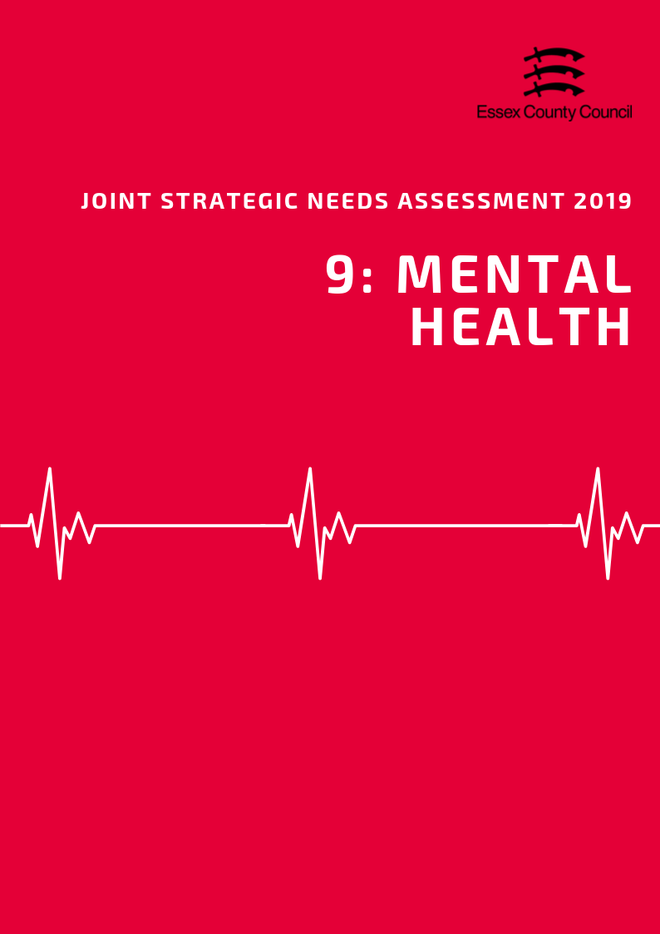

**Mental Health**

***Common Mental Health Conditions***

According to the General Practice Patient Survey (GPPS; NHS England) in 2016/17, the prevalence of depression and anxiety among persons aged over 18 years in NHS Mid Essex CCG in Essex was 11.23%. This was lower than the prevalence across Essex (12.49%) and across England (13.74%) and was ranked as being the lowest prevalence compared across that of the other CCGs in Essex (highest: NHS North East Essex 14.30%).

***Severe Mental Health Conditions***

Severe mental health conditions include schizophrenia, bipolar affective disorder and other psychoses. The prevalence of these as recorded on general practise disease registers in the Maldon District in 2017/18 was 0.76. This was the 6th highest prevalence compared across the other Districts in Essex.

***Long Term Mental Health Conditions***

The prevalence of reporting a long-term mental health condition among persons aged over 18 years in the NHS Mid Essex CCG of Essex, according to the GPPS, was 8.39% in 2017/18. This was ranked as being the second highest prevalence compared across the CCGs of Essex (highest: NHS North East Essex CCG 9.63%; lowest: NHS West Essex CCG 7.19%) but was similar to that across Essex (8.23%) and England (9.06%).

***Children & Young People’s Mental Health***

The Maldon District had the 7th highest estimated prevalence of any mental health disorder among children aged between 5 to 16 years across the Districts of Essex in 2015, with a prevalence of was 8.38. This was lower than the estimated prevalence across the whole of Essex (8.71) and England (9.23). This estimate was based on the prevalence’s previously given in the Office for National Statistics survey Mental Health of Children and Young People in Great Britain (2004).

|  |  |  |  |
| --- | --- | --- | --- |
|  | **Depression and Anxiety prevalence (GP Patient Survey): % of respondents aged 18+** | **Prevalence of Severe Mental Health Conditions** | **Estimated prevalence of mental health disorders in children and young people:**  **% population aged 5-16** |
| **Essex** | **12.49** | **0.80** | **8.71** |
| **England** | **13.74** | **0.94** | **9.23** |
| Basildon | 13.28 | 0.92 | 9.29 |
| Braintree | 11.23 | 0.75 | 8.80 |
| Brentwood | 13.28 | 0.66 | 7.82 |
| Castle Point | 12.48 | 0.68 | 8.89 |
| Chelmsford | 11.23 | 0.72 | 8.24 |
| Colchester | 14.30 | 0.93 | 8.75 |
| Epping | 11.31 | 0.78 | 8.22 |
| Harlow | 11.31 | 0.81 | 9.65 |
| Maldon | 11.23 | 0.76 | 8.38 |
| Rochford | 12.48 | 0.63 | 8.24 |
| Tendring | 14.30 | 1.00 | 9.76 |
| Uttlesford | 11.31 | 0.63 | 7.67 |

***Self-Harm***

According to estimates produced by Public Health England, the Maldon District in 2017/18 had the 9th highest rate of emergency hospital admissions for intentional self-harm among persons of all ages, with a rate of 112.78. This is significantly lower than the rate across Essex as a whole (156.98) and England (185.48). Women in Maldon had the 9th highest admissions rate in the county (149.1) and were twice as likely to be admitted to hospital for intentional self-harm than men (75.5) This is however lower than the rates for women across the rest of Essex (201.7) or England (235.3).

This data is also shown by gender breakdown in the table below:

|  |  |  |  |  |  |  |
| --- | --- | --- | --- | --- | --- | --- |
| **Rate of Emergency Hospital Admissions for Intentional Self-Harm in Essex Districts, 2017/18** | | | | | | |
|  | **All Persons** | | **Male** | | **Female** | |
| **Rate** | **Rank** | **Rate** | **Rank** | **Rate** | **Rank** |
| **England** | **185.48** | **N/A** | **137.73** | **N/A** | **235.28** | **N/A** |
| **Essex** | **156.98** | **N/A** | **113.48** | **N/A** | **201.70** | **N/A** |
| Basildon | 200.48 | 3 | 153.78 | 2 | 248.32 | 3 |
| Braintree | 145.48 | 5 | 101.13 | 6 | 191.72 | 6 |
| Brentwood | 96.74 | 11 | 64.56 | 10 | 129.53 | 11 |
| Castle Point | 155.06 | 4 | 116.04 | 4 | 192.8 | 5 |
| Chelmsford | 134.88 | 7 | 75.57 | 8 | 194.97 | 4 |
| Colchester | 207.63 | 2 | 145.51 | 3 | 273.85 | 2 |
| Epping Forest | 71.73 | 12 | 52.41 | 11 | 92.48 | 12 |
| Harlow | 123.59 | 8 | 99.53 | 7 | 148.17 | 10 |
| Maldon | 112.78 | 9 | 75.47 | 9 | 149.1 | 9 |
| Rochford | 100.88 | 10 | 51.55 | 12 | 150.42 | 8 |
| Tendring | 289.2 | 1 | 252.69 | 1 | 326.81 | 1 |
| Uttlesford | 142.57 | 6 | 102.45 | 5 | 184.84 | 6 |

***Suicide***

The age-standardised mortality rate per 100,000 population from suicide and injury of undetermined intent among persons aged over 10 years in Maldon was 14.52 in 2015/17, which was ranked as being the third highest rate across the Districts in Essex. This was significantly higher than the rate across Essex as a whole (10.88) and England (9.57).

Maldon was ranked as having the highest suicide rate among males compared to that across the other Essex Districts, with a rate of 23.64. This is 61% higher than the rate for England (14.69) and significantly above Essex as a whole (16.90).

The suicide rate among females in Maldon was not disclosed.

|  |  |  |  |  |  |  |
| --- | --- | --- | --- | --- | --- | --- |
|  | **Suicide Rate across Essex Districts among persons, males and females in 2015 / 17** | | | | | |
| **Persons** | | **Male** | | **Female** | |
| **Rate** | **Rank** | **Rate** | **Rank** | **Rate** | **Rank** |
| **England** | 9.57 | N/A | 14.69 | N/A | 4.69 | N/A |
| **Essex** | 10.88 | N/A | 16.90 | N/A | 5.31 | N/A |
| Basildon | 9.69 | 7 | 16.94 | 7 | - | - |
| Braintree | 11.12 | 6 | 17.61 | 6 | 5.86 | 3 |
| Brentwood | 7.78 | 10 | 12.03 | 11 | - | - |
| Castle Point | 8.34 | 8 | 13.91 | 9 | - | - |
| Chelmsford | 11.78 | 5 | 17.97 | 5 | 5.72 | 4 |
| Colchester | 13.08 | 4 | 19.6 | 4 | 6.97 | 2 |
| Epping Forest | 5.24 | 12 | 7.26 | 12 | - | - |
| Harlow | 14.9 | 2 | 23.34 | 3 | - | - |
| Maldon | 14.52 | 3 | 23.64 | 1 | - | - |
| Rochford | 8.02 | 9 | 12.36 | 10 | - | - |
| Tendring | 15.96 | 1 | 23.39 | 2 | 8.89 | 1 |
| Uttlesford | 7.74 | 11 | 13.94 | 8 | - | - |

**Data Sources and Further Information**

*There are several caveats to the estimates of prevalence of depression and anxiety, severe mental health conditions, and prevalence of reporting long-term health conditions in the Districts across Essex. The prevalence of depression and anxiety, and the reporting of long-term health conditions among residents were produced by aggregating data available from CCG level upwards to the District which the CCG is located. The prevalence of severe mental health conditions at District level was estimated through aggregating data of General Practitioner (GP) surgeries located in that District. The district level estimates were then aggregated together to provide Essex level estimates for these three indicators.

