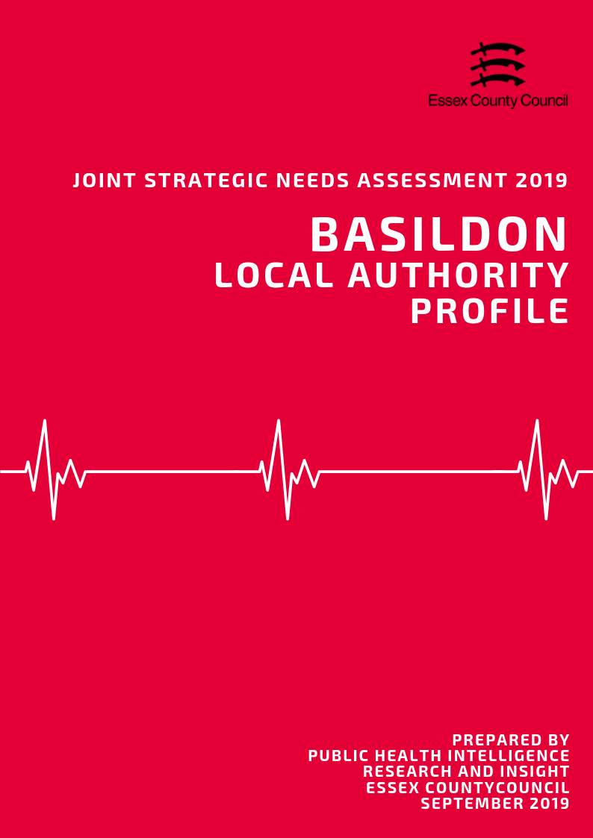

**Introduction**

What is a Joint Strategic Needs Assessment?

The JSNA is statutory process for Health & Wellbeing Boards (HWBB) to identify and improve the current and future health, wellbeing and social care needs of their area. The purpose is to inform strategic decision making, commissioning of services and reduce inequalities for all ages. There is no set format, prescribed content or specific time-period that a JSNA must cover, only that one must be produced in partnership with HWBB member organisations.

For the 2019 JSNA, the Health & Wellbeing Board is using a ‘place-based’ approach for the suite of JSNA products which will look at issues and needs at smaller local geographies. These geographies serve as building blocks to satisfy the need for intelligence at local authority and NHS geographical area and include:

• NHS/LA Locality/Neighbourhood Profiles

• District/Borough Council Profiles

• A Countywide Report

• Specialist Topic Deep Dive Reports (ESCG to develop)

This document presents data from a range of key topics which contribute to the overall the health and wellbeing of residents, in order to highlight areas of inequality and identify opportunities to improve the healthy lives for residents across the Essex County Council Local Authority area, with information also available separately for each of the 12 Districts and Boroughs where relevant.

Key findings from this and the 12 individual Local Authority Profiles will be used to identify issues that the Health and Wellbeing Board may wish to consider when refreshing the Joint Health and Wellbeing Strategy.

*Notes of Terminology:*

This document uses the term Essex to refer to the Essex County Council local authority area which does not include the Southend-on-Sea and Thurrock unitary authority areas. The term Basildon is used to refer to the whole local authority area.

**Contents**

|  |  |  |
| --- | --- | --- |
| **No.** | **Section** | **Page** |
| **1** | **Key Findings** | **3** |
| **2** | **Population & Demographics** | **7** |
| **3** | **Access to Services** | **20** |
| **4** | **Wider Determinants of Health** | **25** |
| **5** | **Lifestyle, Sexual Health & Substance Misuse** | **41** |
| **6** | **Life Expectancy & Mortality** | **51** |
| **7** | **Birth Rates and Infant Health** | **59** |
| **8** | **ILLNESS & HOSPITAL ADMISSIONS** | **64** |
| **9** | **Mental Health** | **82** |
|  |  |  |

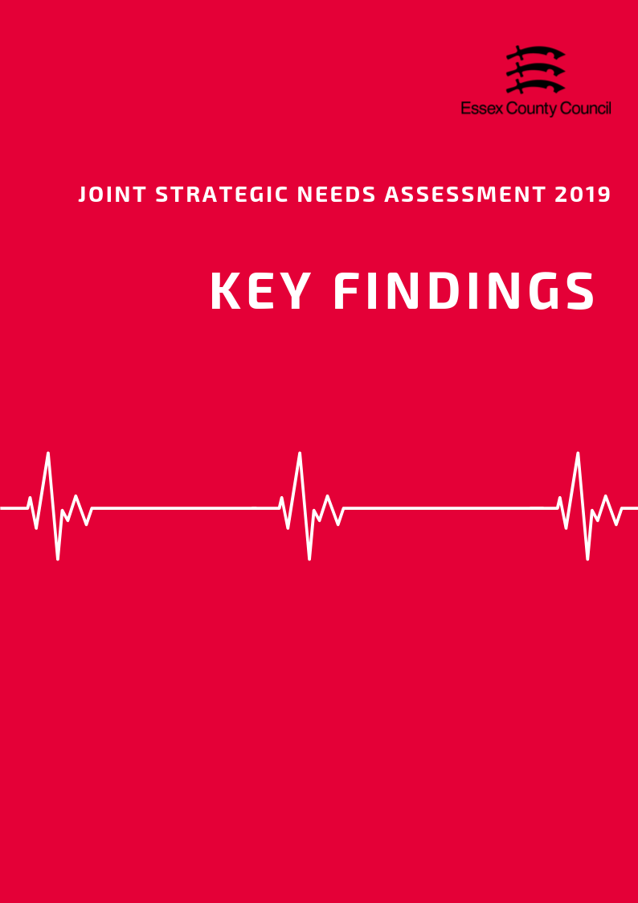

**The Top three things to know about…**

**Population and Demographics**

* In 2018, the total population of Basildon was an estimated 185,862 people making it the second largest local authority area in Essex in terms of population size.
* The Basildon District has a slightly higher proportion of 0-15 year olds (20.8%) and 16 to 64 years olds (62%) than the Essex average (18.9%, and 60.6%).
* Basildon District has a lower OADR than most other areas with an estimated rate of 272.4 people per 1000 working age in 2019. This is lower than the average for Essex as a whole (335.6) the average for England (286.8).



**Access to Services**

* Covering an area of approximately 110 square kilometres, the Basildon District is the third smallest local authority in Essex in terms of area.
* With an estimated 1677 residents per square kilometre, the Basildon District is the third most densely populated local authority in Essex.
* Basildon residents have shorter travel times to local services compared to the Essex average (19.4 minutes), with an average of 16.1 minutes by walking or public transport to 8 key services. Average times to GP surgeries were estimated at just under 9 minutes, whilst hospitals were just under 35 minutes.



**Wider Determinants of Health**

* The average weekly income for a Basildon resident working full time in 2018 was £595, £23.60 (-3.97%) lower than the average for Essex but £20.10 (3.38%) higher than the average for England.
* Since the introduction of the new GCSE grading system, pupil performance in Basildon gradually fallen with 62.6% of pupils achieving grade 9-4 in English and Maths (a good pass) and 40.7% achieving grade 9-5 (a strong pass) in 2018. Compared to scores for 2017 this is slight reduction in the overall attainment rate (-0.8%, -0.7%)
* The amount of residents claiming out of work benefits has increased to its highest level in 5 years from 1.9% in April 2015 to 2.9% in April 2019, equivalent to an increase of 1175 claimants. This is higher than the averages for Essex (2.1%) and England average (2.6%) and is the third highest claimant rate overall.

**Lifestyle, Sexual Health & Substance Misuse**

* In 2017/18 the National Child Measurement Programme (NCMP) estimated that 20.2% of pupils in Reception class (R in the table below) in Basildon were classed as overweight or obese. The sample of pupils in Year 6 showed that 33.7% of pupils in this year group were classed as overweight or obese.
* Of residents in Basildon aged over 18 years, 70.47% were classified as overweight or obese in 2016/17. This is higher than the prevalence of adult overweight or obesity across the whole of Essex (63.56%) and England (61.29%). Basildon was also ranked as having the lowest proportion of adult residents classified as physically active across the Essex Districts, with a proportion of 60.98%
* The percentage of current smokers aged over 18 years was 16.7%, higher than Essex as a whole (13.84) and England (14.87).

**Life Expectancy & Mortality**

* The average life expectancy at birth for a child born in Basildon (2015-2017) was 82.7 years for females and 79.6 years for males. This is lower than the average for England for females (83.1 years) and the same for males (79.6 years) and is the second lowest life expectancy for females and fourth lowest for males in Essex.
* Life expectancy at age 65 (the number of additional years a person could expect to live) was 21.1 years for females and 18.6 years for males; this is similar to the England average for females (21.1 years), but just below for males (18.8 years).
* In 2017 the Basildon area had an all ages mortality rate of 966.9 deaths per 100,000 residents, based on 1589 deaths recorded during that time period. This overall mortality rate was higher than the England average of 958.7 (per 100K) but was a slight decrease compared the previous year (980.2 per 100K).

**Birth Rates & Infant Health**

* The rate of conceptions in women aged under 18 years per 1,000 females aged 15 to 17 years in the Basildon area was 23.4 in 2016. This was the 3rd highest compared to the other Districts in Essex, and significantly higher than that for Essex as a whole (16.7) and for England (18.8).
* Breast feeding initiation was 68.02% and was the lowest level compared across the Essex Districts with data available, and significantly lower than that for the whole of Essex (75.02) and England (74.49).
* The percentage of mothers known to be smokers at the time of delivery was 11.82% in the Basildon and Brentwood CCG area in 2017/18. This was the joint second highest (with Brentwood).

**Illness & Hospital Admissions**

* Emergency Admissions for Chronic Obstructive Pulmonary Disease (COPD) (116.5), Heart Attack (104) and Stroke (113.8) were all higher than the England Baseline overall.
* The directly age standard admissions rate of hip fractures was estimated to be 617.96 per 100,000 population ages 65 and over. This was higher than the average for England (577.8).
* In 2015/16, the proportion of GP registered patients (also known as the QOF prevalence) with a diagnosis of Hypertension across England was 14.96%. higher than the England level.



**Mental Health**

* The Basildon area had the third highest estimated prevalence of any mental health disorder among children aged between 5 to 16 years across the Districts of Essex in 2015, with a prevalence of was 9.29. This was higher than the estimated prevalence across the whole of Essex (8.71).
* The Basildon area in 2017/18 had the third highest rate of emergency hospital admissions for intentional self-harm among persons of all ages, with a rate of 200.48. This is significantly higher than the rate across Essex as a whole (156.98) and England (185.48). Women in Basildon also had the third highest admissions rate in the county (248.3), well above the rates for Essex (201.7) or England (235.3)
* The rate of suicide amongst men in Basildon (16.94 per 100,000) was 15.3% higher than the England average (14.69) but was similar to the rate across Essex as a whole (16.90). This was the 7th highest suicide rate among males compared to the other Districts in Essex.

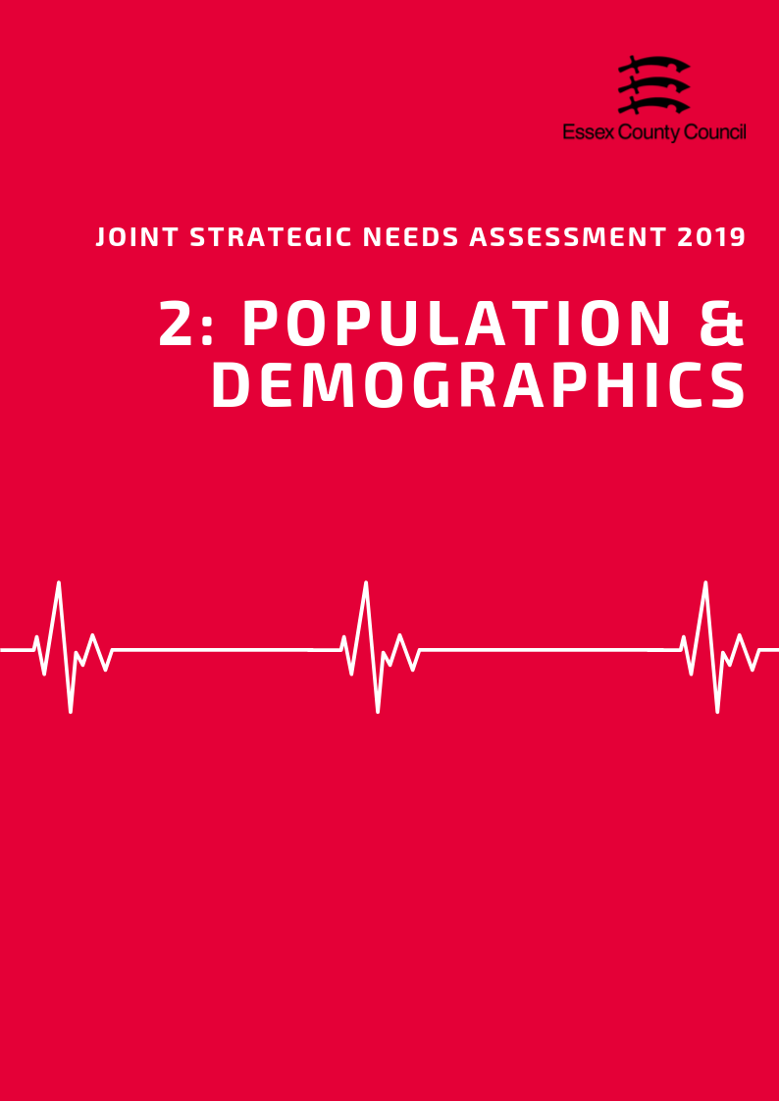

**POPULATION & DEMOGRAPHICS**

***Population Growth***

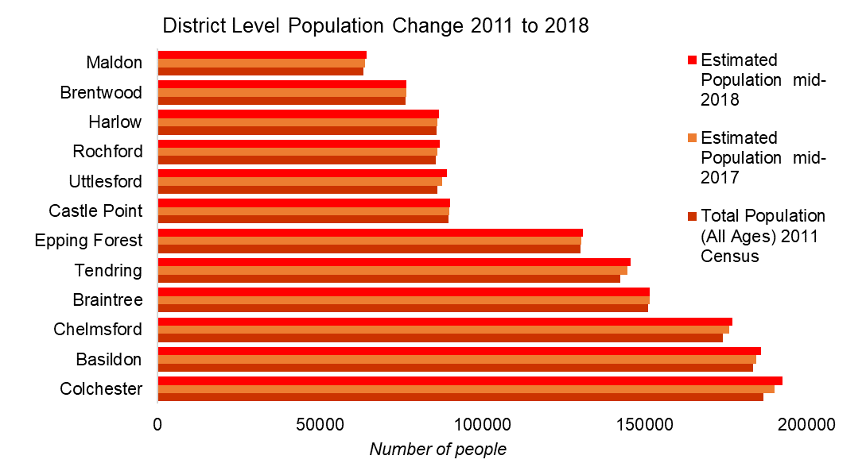According to the Office of National Statistics in 2018, the total population of Basildon was an estimated 185,862 people making it the second largest local authority area in Essex in terms of population size. This is an estimated increase of 2484 people since the 2011 census (a rise of 1.35%) which is lower than had previously been predicted by the Office of National Statistics in earlier mid-year estimates. This is in line with the growth rate for England (5.59%) and just below the average for Essex (1.54%)

Looking forward, the Office of National Statistics population projections (2016 based) predict that by 2034 the total population will increase by another 27321 people to a total of 211,800, an increase of 14.8% from 2017 estimates.

|  |  |  |  |  |  |
| --- | --- | --- | --- | --- | --- |
|  | | **Essex** | | **Basildon** | |
| **2024** | **Total Population** | 1549200 |  | 197200 |  |
| **Under 18** | 292989 | 18.9% | 41509 | 21.0% |
| **18-64** | 936049 | 60.4% | 122282 | 62.0% |
| **65+** | 320162 | 20.7% | 33408 | 16.9% |
| **2029** | **Total Population** | 1602700 |  | 204700 |  |
| **Under 18** | 295387 | 18.4% | 42197 | 20.6% |
| **18-64** | 972743 | 60.7% | 127691 | 62.4% |
| **65+** | 334570 | 20.9% | 34812 | 17.0% |
| **2034** | **Total Population** | 1650800 |  | 211900 |  |
| **Under 18** | 296076 | 17.9% | 42648 | 20.1% |
| **18-64** | 981362 | 59.4% | 130310 | 61.5% |
| **65+** | 373362 | 22.6% | 38942 | 18.4% |

Across Basildon, the proportion of the population aged 65 and over will increase slightly over the next 15 years but is projected to remain 3.8% below the average for Essex. By comparison the proportion of younger people (under 18s) and 18-64 year olds will remain slightly above average.

***Age Split***

The Basildon District has a slightly higher proportion of 0-15 year olds (20.8%) and 16 to 64 years olds (62%) than the Essex average (18.9%, and 60.6%). By comparison the percentage of people aged 65+ (17.2%) is lower than the Essex average (20.5%) and has the second lowest proportion of older people overall.

Over the next 15 years the age spilt of the population will change slightly with a small increase in the proportion of Older People (rising to 18.4%) and a small decrease in the percentage of young people (20.1%) and residents aged 18 to 64 (61.5%). Despite these small shifts, the Basildon District will retain a lower percentage of older people compared to the predicted average for Essex (22.6%) in 2034.

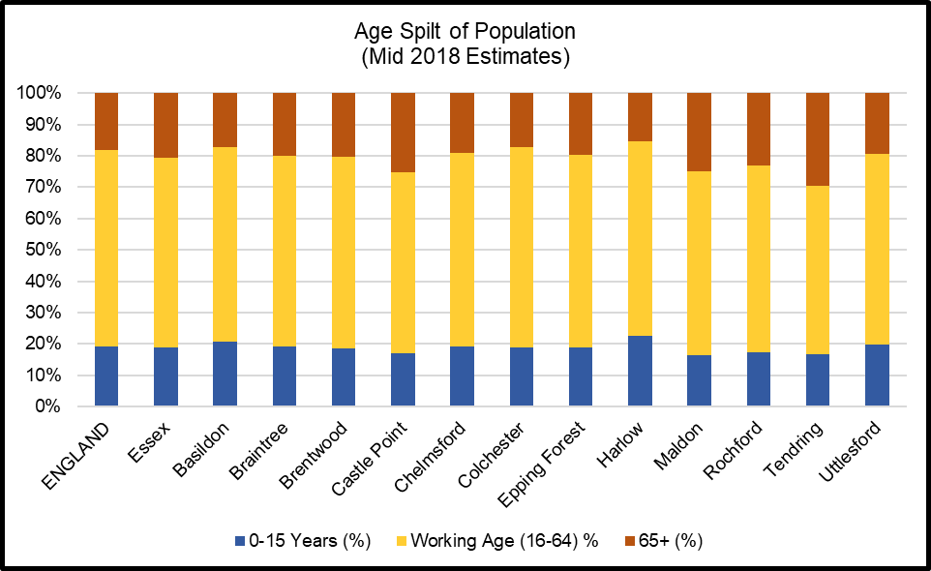

***Old Age Dependency Ratio***

A useful measure to understand how the balance in the population will change, particularly when planning for the needs of the aging population is the old age dependency ratio (OADR) – the number of people over 65 years old for every 1,000 people aged between 16 and 64 years old.

Compared to other areas in Essex, the Basildon District has a lower OADR than most other areas with an estimated rate of 272.4 in 2019. This is the third lowest rate in Essex, significantly lower than the average for Essex as a whole (335.6) and lower than the average for England (286.8) and is equivalent to 3.7 working age people to every person aged 65 and over. By 2034 this rate is predicted to rise to 298.8 per 1000, remaining well below the Essex (380.4) and England (334.2) average rates.

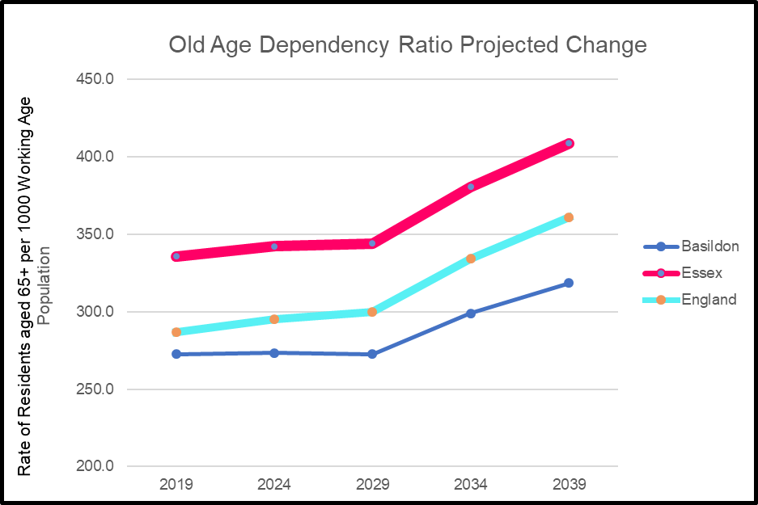

***Ethnicity***

At the time of the 2011 census the population of Basildon was majority White British (89.5%) with the remainder (10.5%) of residents coming from Black and Minority Ethnic (BAME) ethnic groups including white non-British residents. The percentage of BAME residents was slightly higher than the average for Essex in 2011 (9.2%) but was lower than the average for England (20.3%).

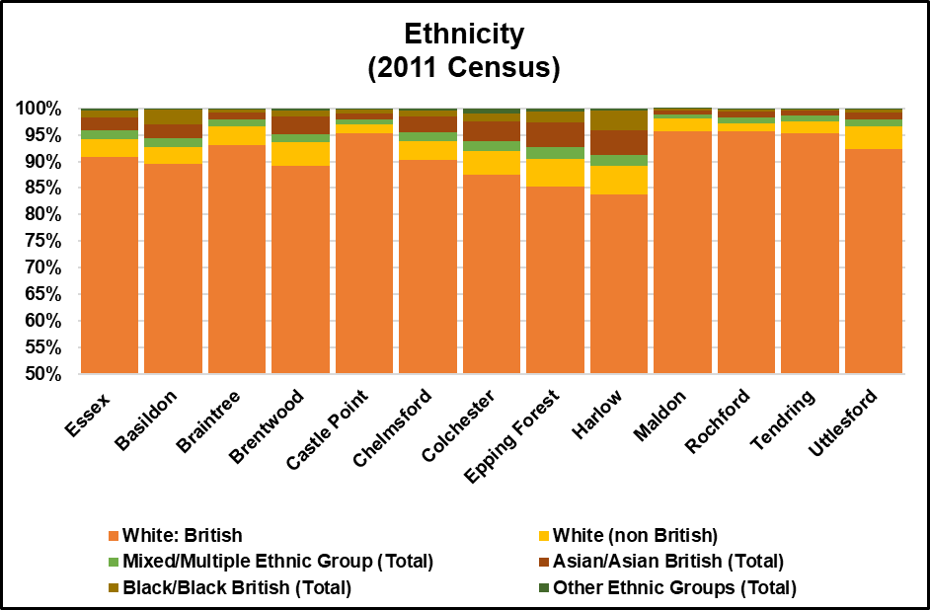

Researchers note: The Office of National Statistics does not produce modelled estimates or projected figures by ethnic group; as such the only comprehensively available figures are taken from the 2011 Census. Given the age of this data caution is advised when generalising to the current population.

***Household Composition***

At the time of the 2011 Census there were an estimated 72,746 households in the Basildon Borough of which 23.2% contained dependent children. This was just above the average for Essex (22.8%) and England (21.99%).

Households with married or civil partnership couples made up over a third (35%)

of all households in the area followed by single person households (29.5%). This was similar to the Essex (36.8%, 28.4%) and England (33.2%, 30.2%).

The number of lone parent households (11.6%) are slightly above the average for Essex (9.7%) and England (10.6%).

15,056 households (20.7%) were occupied solely by residents aged 65 and over including 8,981 households (12.3%) where a resident aged 65 and over was living alone. This was lower than the average for Essex (23.2%, 13.1%) and similar to the average for England (20.7%, 12.4%).

***Learning Disabilities and Special Educational Needs***

Exact figures for the number of residents with Learning Disabilities are not available however modelled predictions from POPPI/PANSI suggest the level could be around 3423 people of whom 2740 people are aged 18-64 and 683 people are aged 65+. This total is equivalent to 2.34% of the age weighted population and is similar to the levels across England (2.36%) and Essex (2.34%). Of this number it is estimated that a total of 717 (*625 age 18-64; 92 age 65+)* have severe learning disabilities thus may have additional support needs.

By 2035 it is predicted that the number of people with Learning disabilities will increase to 2953 people in the 18-64 age group, and to 932 for those aged 65+. In the severe learning disabilities category this is predicted to increase to 680 and 123 respectively.

***Impaired Mobility***

Exact figures for the number of people living in an area with a physical impairment are not available, as such for the purposes of the JSNA we will look at a number of proxy measures. For adults aged 18-64 predictions from PANSI (2019) estimate that 6079 people in the Basildon area might currently have some form of impaired mobility, 5345 have difficulty in performing personal care tasks, and 345 have a health condition caused by a stroke.

For Adults aged 65+ predictions from POPPI (2019) estimate that 6058 people in Basildon might be unable to manage one or more mobility task (*such as going out of doors and walking down the road; getting up and down stairs; getting around the house on the level; getting to the toilet; getting in and out of bed),* whilst 8043 people have their day to day activities limited a lot by their physical health.

***Sensory Impairments***

POPPI / Predictions estimate that there are 3309 people in the Basildon area with severe hearing loss of which 2651 people are aged 65+. 74 people aged 18-64 were predicted to have serious visual impairments whilst 2851 people aged 65+ had moderate or severe visual impairment.





***Table 3: Old Age Dependency Ratio***

|  |  |  |  |  |  |  |  |  |  |
| --- | --- | --- | --- | --- | --- | --- | --- | --- | --- |
| **Old Age Dependency Ratio**  **(Rate of residents aged 65 years and over per working age population)** | | | | | | | | | |
|  | **2019** | | **2024** | | **2029** | | **2034** | | **2039** |
| **England** | 286.8 | | 295.1 | | 299.7 | | 334.2 | | 361 |
| **Essex** | 335.6 | | 342.0 | | 343.9 | | 380.4 | | 408.6 |
| Basildon | 272.4 | | 273.2 | | 272.6 | | 298.8 | | 318.3 |
| Braintree | 330.0 | | 348.0 | | 358.2 | | 409.2 | | 448.1 |
| Brentwood | 325.1 | | 322.5 | | 321.6 | | 350.6 | | 368.1 |
| Castle Point | 431.1 | | 438.3 | | 432.9 | | 469.6 | | 496.8 |
| Chelmsford | 307.9 | | 316.8 | | 317.7 | | 347.1 | | 369.9 |
| Colchester | 266.4 | | 265.6 | | 263.1 | | 288.7 | | 310.1 |
| Epping Forest | 311.8 | | 310.2 | | 309.9 | | 340.9 | | 365.9 |
| Harlow | 242.8 | | 248.3 | | 250.0 | | 276.1 | | 294.9 |
| Maldon | 426.6 | | 457.5 | | 471.1 | | 533.8 | | 579.2 |
| Rochford | 385.1 | | 392.1 | | 394.9 | | 438.2 | | 473.1 |
| Tendring | 544.0 | | 552.1 | | 553.3 | | 615.3 | | 665.7 |
| Uttlesford | 327.7 | | 344.9 | | 358.6 | | 408.2 | | 448.4 |
| ***Source: Office of National Statistics Population Projections 2016*** | | | | | | | | | |
|  |  |  | |  | |  | |  | |
|  | | | | | | | | | |

**Table 4: Ethnicity**

|  |  |  |  |  |  |  |  |
| --- | --- | --- | --- | --- | --- | --- | --- |
| **Ethnicity** | | | | | | | |
|  | **White British %** | **% White non British** | **% Mixed/ Multiple Ethnic Group** | **% Asian/ Asian British** | **% Black/ Black British** | **% Other Ethnic Groups** | **Total Percentage of BAME (Inc. white non-British)** |
| **England** | 79.75% | 5.7% | 2.3% | 7.8% | 3.5% | 1.0% | 20.25% |
| **Essex** | 90.8% | 3.5% | 1.5% | 2.5% | 1.3% | 0.4% | 9.24% |
| Basildon | 89.5% | 3.1% | 1.7% | 2.7% | 2.7% | 0.3% | 10.48% |
| Braintree | 93.2% | 3.5% | 1.2% | 1.4% | 0.6% | 0.2% | 6.85% |
| Brentwood | 89.2% | 4.3% | 1.6% | 3.2% | 1.2% | 0.4% | 10.75% |
| Castle Point | 95.4% | 1.5% | 1.0% | 1.1% | 0.8% | 0.2% | 4.62% |
| Chelmsford | 90.3% | 3.6% | 1.6% | 2.9% | 1.2% | 0.4% | 9.70% |
| Colchester | 87.5% | 4.5% | 1.8% | 3.7% | 1.5% | 1.0% | 12.49% |
| Epping Forest | 85.2% | 5.3% | 2.1% | 4.8% | 1.9% | 0.7% | 14.78% |
| Harlow | 83.9% | 5.2% | 2.1% | 4.6% | 3.8% | 0.5% | 16.14% |
| Maldon | 95.8% | 2.3% | 0.8% | 0.8% | 0.2% | 0.1% | 4.25% |
| Rochford | 95.6% | 1.6% | 1.1% | 1.1% | 0.5% | 0.2% | 4.39% |
| Tendring | 95.4% | 2.2% | 1.1% | 0.9% | 0.3% | 0.1% | 4.62% |
| Uttlesford | 92.3% | 4.3% | 1.2% | 1.4% | 0.5% | 0.2% | 7.70% |
| ***Source: Office of National Statistics 2011 Census*** | | | | | | | |

**Table 5: Household Composition**

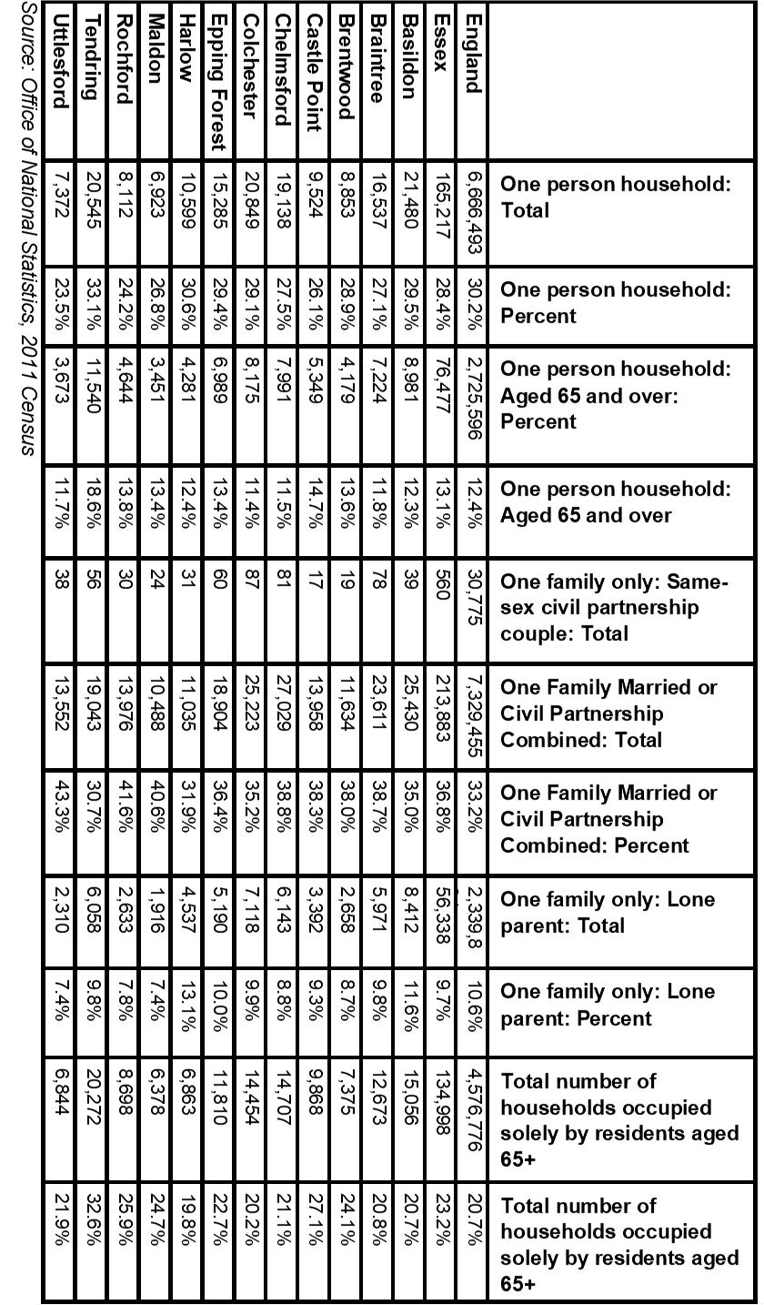

**Table 6: Learning Disability Predictions 2019**

|  |  |  |  |  |  |  |
| --- | --- | --- | --- | --- | --- | --- |
|  | **Number of people predicted to have a learning disability in 2019** | | | | | |
| **Age 18-64** | | **Age 65+** | | **Total Age 18+** | |
| **Number** | **%\*** | **Number** | **%\*** | **Number** | **%\*** |
| **England** | **826834** | **2.44%** | **216362** | **2.09%** | **1043196** | **2.36%** |
| **East of England** | **89212** | **2.43%** | **26011** | **2.09%** | **115223** | **2.34%** |
| **Essex** | **21059** | **2.43%** | **6487** | **2.09%** | **27546** | **2.34%** |
| Basildon | 2740 | 2.43% | 683 | 2.09% | 3423 | 2.36% |
| Braintree | 2164 | 2.42% | 659 | 2.09% | 2823 | 2.34% |
| Brentwood | 1110 | 2.42% | 333 | 2.08% | 1443 | 2.33% |
| Castle Point | 1219 | 2.42% | 486 | 2.09% | 1705 | 2.32% |
| Chelmsford | 2561 | 2.43% | 725 | 2.09% | 3286 | 2.35% |
| Colchester | 2947 | 2.45% | 713 | 2.10% | 3660 | 2.37% |
| Epping Forest | 1914 | 2.43% | 546 | 2.09% | 2460 | 2.34% |
| Harlow | 1276 | 2.44% | 282 | 2.07% | 1558 | 2.36% |
| Maldon | 870 | 2.41% | 344 | 2.11% | 1214 | 2.32% |
| Rochford | 1210 | 2.42% | 429 | 2.09% | 1639 | 2.32% |
| Tendring | 1828 | 2.41% | 919 | 2.09% | 2747 | 2.30% |
| Uttlesford | 1237 | 2.42% | 376 | 2.09% | 1613 | 2.33% |
|  | **Number of people predicted to have a moderate or severe learning disability in 2019** | | | | | |
| **Age 18-64** | | **Age 65+** | | **Total Age 18+** | |
| **Number** | **%\*** | **Number** | **%\*** | **Number** | **%\*** |
| **England** | 188444 | 0.56% | 29128 | 0.28% | 217572 | 0.49% |
| **East of England** | 20343 | 0.55% | 3488 | 0.28% | 23831 | 0.48% |
| **Essex** | 4797 | 0.55% | 870 | 0.28% | 5667 | 0.48% |
| Basildon | 625 | 0.56% | 92 | 0.28% | 717 | 0.49% |
| Braintree | 493 | 0.55% | 89 | 0.28% | 582 | 0.48% |
| Brentwood | 253 | 0.55% | 44 | 0.28% | 297 | 0.48% |
| Castle Point | 277 | 0.55% | 65 | 0.28% | 342 | 0.47% |
| Chelmsford | 585 | 0.56% | 97 | 0.28% | 682 | 0.49% |
| Colchester | 672 | 0.56% | 96 | 0.28% | 768 | 0.50% |
| Epping Forest | 437 | 0.55% | 73 | 0.28% | 510 | 0.49% |
| Harlow | 291 | 0.56% | 38 | 0.28% | 329 | 0.50% |
| Maldon | 197 | 0.55% | 47 | 0.29% | 244 | 0.47% |
| Rochford | 276 | 0.55% | 57 | 0.28% | 333 | 0.47% |
| Tendring | 413 | 0.55% | 123 | 0.28% | 536 | 0.45% |
| Uttlesford | 283 | 0.55% | 50 | 0.28% | 333 | 0.48% |
| *Source POPPI/PANSI 2019* | | | | | | |

***Table 7: Learning Disability Projections***

|  |  |  |  |  |  |  |  |  |
| --- | --- | --- | --- | --- | --- | --- | --- | --- |
| **Predicted Numbers of People with a Learning Disability to 2035** | | | | | | | | |
|  | **2025** | | **2030** | | **2035** | | **Predicted Change 2019-2035** | |
| **18-64** | **65+** | **18-64** | **65+** | **18-64** | **65+** | **18-64** | **65+** |
| **England** | **833689** | **240660** | **839192** | **269064** | **842807** | **296050** | **15973** | **79688** |
| **East of England** | **90564** | **28952** | **91550** | **32438** | **92307** | **35875** | **3095** | **9864** |
| **Essex** | **21467** | **7179** | **21763** | **8011** | **22030** | **8855** | **971** | **2368** |
| Basildon | 2816 | 754 | 2880 | 844 | 2953 | 932 | 213 | 249 |
| Braintree | 2167 | 744 | 2166 | 842 | 2149 | 936 | -15 | 277 |
| Brentwood | 1137 | 354 | 1155 | 397 | 1180 | 433 | 70 | 100 |
| Castle Point | 1217 | 520 | 1221 | 566 | 1230 | 614 | 11 | 128 |
| Chelmsford | 2590 | 797 | 2619 | 881 | 2650 | 958 | 89 | 233 |
| Colchester | 3078 | 784 | 3182 | 877 | 3254 | 976 | 307 | 263 |
| Epping Forest | 1961 | 594 | 1993 | 662 | 2034 | 733 | 120 | 187 |
| Harlow | 1292 | 319 | 1315 | 356 | 1341 | 391 | 65 | 109 |
| Maldon | 853 | 392 | 844 | 434 | 835 | 482 | -35 | 138 |
| Rochford | 1213 | 467 | 1219 | 521 | 1218 | 570 | 8 | 141 |
| Tendring | 1856 | 1017 | 1879 | 1139 | 1893 | 1263 | 65 | 344 |
| Uttlesford | 1268 | 437 | 1283 | 506 | 1299 | 572 | 62 | 196 |
| **Predicted Numbers of People with Moderate or Severe Learning Disabilities to 2035** | | | | | | | | |
|  | **2025** | | **2030** | | **2035** | | **Predicted Change 2019-2035** | |
| **18-64** | **65+** | **18-64** | **65+** | **18-64** | **65+** | **18-64** | **65+** |
| **England** | **190642** | **31818** | **192706** | **35452** | **193757** | **38627** | **5313** | **9499** |
| **East of England** | **20718** | **3802** | **21027** | **4244** | **21222** | **4654** | **879** | **1166** |
| **Essex** | **4906** | **942** | **4994** | **1047** | **5064** | **1150** | **267** | **280** |
| Basildon | 645 | 100 | 663 | 112 | 680 | 123 | 55 | 31 |
| Braintree | 495 | 98 | 496 | 110 | 493 | 121 | 0 | 32 |
| Brentwood | 260 | 46 | 266 | 51 | 272 | 56 | 19 | 12 |
| Castle Point | 277 | 68 | 279 | 73 | 282 | 79 | 5 | 14 |
| Chelmsford | 593 | 104 | 603 | 114 | 610 | 123 | 25 | 26 |
| Colchester | 704 | 103 | 731 | 115 | 749 | 127 | 77 | 31 |
| Epping Forest | 449 | 78 | 458 | 87 | 468 | 95 | 31 | 22 |
| Harlow | 296 | 43 | 303 | 48 | 309 | 51 | 18 | 13 |
| Maldon | 194 | 52 | 192 | 57 | 191 | 63 | -6 | 16 |
| Rochford | 277 | 61 | 279 | 68 | 280 | 74 | 4 | 17 |
| Tendring | 420 | 133 | 428 | 149 | 432 | 164 | 19 | 41 |
| Uttlesford | 290 | 57 | 295 | 66 | 299 | 74 | 16 | 24 |
| *Source POPPI/PANSI 2019* | | | | | | | | |

***Table 8: Physical Impairments***

|  |  |  |  |  |  |  |  |  |
| --- | --- | --- | --- | --- | --- | --- | --- | --- |
| **The number of people aged 18-64 predicted to have a physical impairment in 2019** | | | | | | | | |
|  | **Impaired Mobility** | | **Any moderate or severe personal care disability** | | **A longstanding health condition caused by a stroke** | | **Combined Total** | |
| **Number** | **%\*** | **Number** | **%\*** | **Number** | **%\*** | **Number** | **%\*** |
| **Essex** | **48922** | **5.23%** | **43109** | **4.61%** | **2817** | **0.30%** | **94848** | **10.13%** |
| **Basildon** | **6079** | **4.97%** | **5385** | **4.40%** | **345** | **0.28%** | **11809** | **9.66%** |
| Braintree | 5149 | 5.41% | 4540 | 4.77% | 300 | 0.32% | 9989 | 10.49% |
| Brentwood | 2618 | 5.27% | 2307 | 4.65% | 151 | 0.30% | 5076 | 10.23% |
| Castle Point | 2969 | 5.54% | 2604 | 4.86% | 172 | 0.32% | 5745 | 10.73% |
| Chelmsford | 5814 | 5.16% | 5139 | 4.56% | 334 | 0.30% | 11287 | 10.01% |
| Colchester | 5953 | 4.53% | 5328 | 4.06% | 338 | 0.26% | 11619 | 8.85% |
| Epping Forest | 4467 | 5.24% | 3937 | 4.62% | 256 | 0.30% | 8660 | 10.16% |
| Harlow | 2786 | 4.95% | 2461 | 4.38% | 155 | 0.28% | 5402 | 9.61% |
| Maldon | 2282 | 6.02% | 1991 | 5.25% | 135 | 0.36% | 4408 | 11.63% |
| Rochford | 2967 | 5.56% | 2604 | 4.88% | 172 | 0.32% | 5743 | 10.76% |
| Tendring | 4785 | 5.80% | 4142 | 5.02% | 273 | 0.33% | 9200 | 11.16% |
| Uttlesford | 3089 | 5.51% | 2710 | 4.83% | 181 | 0.32% | 5980 | 10.66% |
| *Percentage of the total population aged 18-64 based on 2019 population projections | | | | | | | | |

|  |  |  |  |  |  |  |
| --- | --- | --- | --- | --- | --- | --- |
|  | **The number of Adults aged 65 and over with long term limiting conditions or restricted mobility** | | | | | |
| **Day-to-day activities are limited a little** | | **Day-to-day activities are limited a lot** | | **Unable to manage at least one mobility** activity on their own** | |
| **Number** | **%** | **Number** | **%** | **Number** | **%** |
| Essex | 76314 | 24.6% | 66662 | 21.5% | 57212 | 18.4% |
| Basildon | 8044 | 24.6% | 8043 | 24.6% | 6058 | 18.5% |
| Braintree | 7669 | 24.3% | 6309 | 20.0% | 5676 | 18.0% |
| Brentwood | 3793 | 23.7% | 3020 | 18.9% | 3147 | 19.7% |
| Castle Point | 5593 | 24.1% | 5482 | 23.6% | 4180 | 18.0% |
| Chelmsford | 8433 | 24.3% | 6379 | 18.4% | 6387 | 18.4% |
| Colchester | 8386 | 24.7% | 7079 | 20.8% | 6142 | 18.1% |
| Epping Forest | 6265 | 24.0% | 5398 | 20.7% | 5017 | 19.2% |
| Harlow | 3465 | 25.5% | 3615 | 26.6% | 2625 | 19.3% |
| Maldon | 3909 | 24.0% | 3237 | 19.9% | 2893 | 17.7% |
| Rochford | 5259 | 25.7% | 4198 | 20.5% | 3727 | 18.2% |
| Tendring | 11449 | 26.1% | 10819 | 24.6% | 8078 | 18.4% |
| Uttlesford | 4309 | 23.9% | 3242 | 18.0% | 3358 | 18.7% |
| *\*\*Activities include: going out of doors and walking down the road; getting up and down stairs; getting around the house on the level; getting to the toilet; getting in and out of bed* | | | | | | |
| *Source POPPI/PANSI 2019* | | | | | | |

***Table 9: Sensory Impairments***

|  |  |  |  |  |  |  |
| --- | --- | --- | --- | --- | --- | --- |
|  | **Severe Hearing Loss** | | | **Visual Impairments** | | |
| **Visual Impairments Total** | **Serious Visual Impairments in people age 18-64** | **Moderate or Severe Visual Impairments in People age 65+** |
| **Total 18 and over** | **18-64** | **65+** |
| Essex | 30503 | 5272 | 25231 | 27745 | 564 | 27181 |
| Basildon | 3309 | 659 | 2651 | 2925 | 74 | 2851 |
| Braintree | 3074 | 562 | 2511 | 2775 | 59 | 2716 |
| Brentwood | 1718 | 285 | 1433 | 1475 | 29 | 1446 |
| Castle Point | 2154 | 317 | 1837 | 2059 | 32 | 2027 |
| Chelmsford | 3496 | 632 | 2864 | 3113 | 68 | 3045 |
| Colchester | 3293 | 631 | 2663 | 3022 | 78 | 2944 |
| Epping Forest | 2757 | 487 | 2269 | 2364 | 52 | 2312 |
| Harlow | 1487 | 310 | 1177 | 1238 | 34 | 1204 |
| Maldon | 1471 | 245 | 1227 | 1418 | 23 | 1395 |
| Rochford | 1956 | 310 | 1645 | 1827 | 33 | 1794 |
| Tendring | 4013 | 503 | 3510 | 3916 | 50 | 3866 |
| Uttlesford | 1775 | 331 | 1443 | 1613 | 33 | 1580 |
| *Source POPPI/PANSI 2019* | | | | | | |

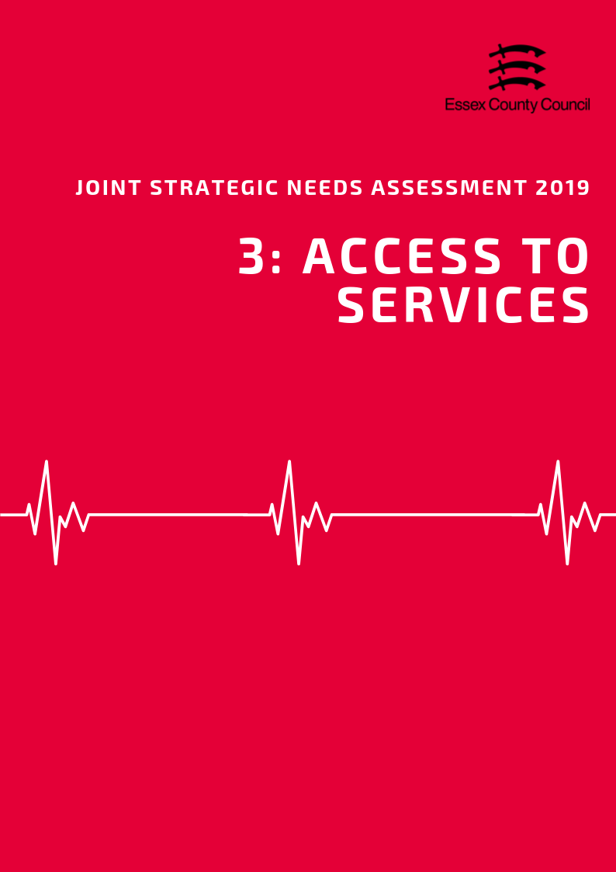

**ACCESS TO SERVICES**

**Area**

Covering an area of approximately 110 square kilometres, the Basildon District is the third smallest local authority in Essex in terms of area. It is classed statistically as predominantly urban with the majority of residents living in or on the fringe of the main urban settlement of Basildon or other main settlements including Wickford and Billericay.

***Population Density***

With an estimated 1677 residents per square kilometre, the Basildon District is the third most densely populated local authority in Essex.

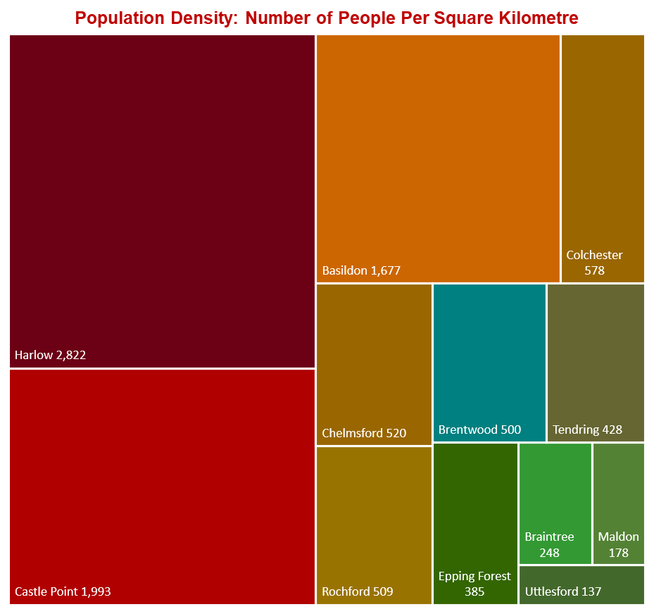

***Travel Time to Key Services***

According to the Department for Transport, Basildon residents have shorter travel times to local services compared to the Essex average (19.4 minutes), with an average of 16.1 minutes by walking or public transport to 8 key services. Average times to GP surgeries were estimated at just under 9 minutes, whilst hospitals were just under 35 minutes. These travel times were the shortest and second shortest in Essex compared to the other areas with travel times by car even shorter with an average of 7.5 minutes for GP surgeries and 16.7 minutes to hospitals.

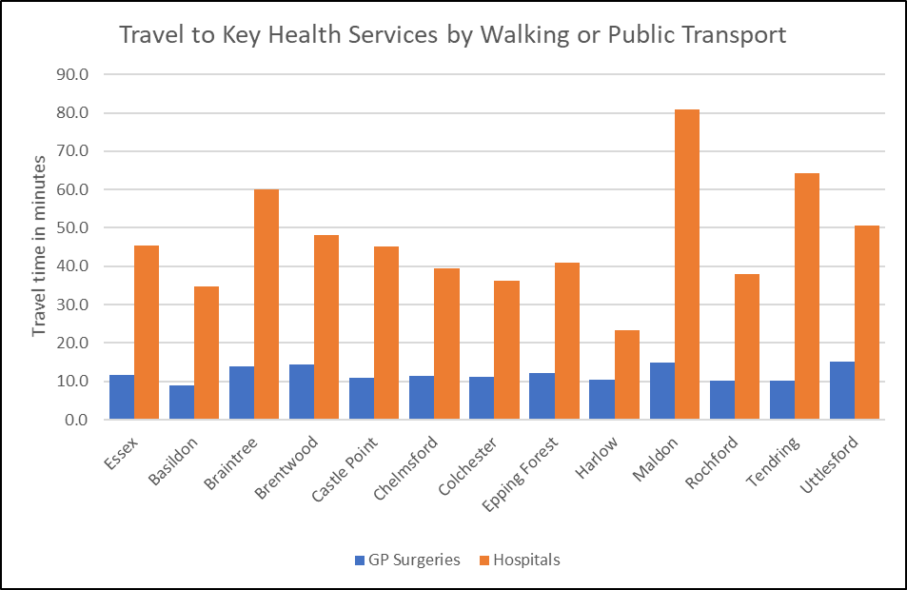

***Source: Department for Transport***

*See table at the end of this chapter for average travel times to all service types.*

***Satisfaction with GP Services***

Information about satisfaction with GP services from the GP Patient Survey are only available at CCG level so it is not possible to present views of Basildon residents in isolation. According to data from the 2018 survey, 80.5% of patients in the Basildon & Brentwood CCG reported a positive experience of their GP practice. This lower than the average for both England (83.75%) and the NHS Eastern Region (83.3%) but is in line with the combined average for all CCGs in Essex (80.35%).

|  |  |  |
| --- | --- | --- |
| **The percentage of patients aged 16+ who have a positive experience of their GP practice** | **Time period** | **%** |
| **England** | **2018** | **83.8** |
| **East NHS region** | **2018** | **83.3** |
| NHS Basildon And Brentwood CCG | 2018 | 80.6 |
| NHS Castle Point and Rochford CCG | 2018 | 82.8 |
| NHS Mid Essex CCG | 2018 | 79.2 |
| NHS North East Essex CCG | 2018 | 79.1 |
| NHS Southend CCG | 2018 | 80.1 |
| NHS Thurrock CCG | 2018 | 76.0 |
| NHS West Essex CCG | 2018 | 80.2 |

*Source: GP Patient Survey 2018*

***Carers***

The exact number of residents providing informal or unpaid care to friends or family members is not known, however figures from the Department for Work and Pensions identified 2690 residents in the Basildon area who had been in receipt of Carers Allowance benefits in November 2018.The largest numbers of claimants in Basildon were in the 35-44 age group, whilst the area also had the highest number of claimants aged 18-24 (120). Women in Basildon were more than three times more likely to be in receipt of carers allowance (2,080 / 77.3%) compared to Men however this rate was similar to the levels across Essex as a whole (77.4%).

|  |  |  |  |  |  |  |  |  |  |  |  |  |  |
| --- | --- | --- | --- | --- | --- | --- | --- | --- | --- | --- | --- | --- | --- |
|  | **Number of people in receipt of carers allowance by age Group – November 2018** | | | | | | | | | | | | |
| **Total** | | **under 18** | | **18-24** | **25-34** | | **35-44** | | **45-54** | **55-64** | | **65+** |
| **Essex** | **16,620** | | **30** | | **580** | **2,940** | | **4,020** | | **4,410** | **4,410** | | **230** |
| Basildon | 2,690 | | 10 | | 120 | 530 | | 710 | | 670 | 630 | | 30 |
| Braintree | 1,750 | |  | | 40 | 350 | | 430 | | 460 | 430 | | 20 |
| Brentwood | 540 | |  | | 20 | 70 | | 120 | | 160 | 150 | | ~ |
| Castle Point | 1,110 | |  | | 40 | 160 | | 220 | | 310 | 350 | | 20 |
| Chelmsford | 1,500 | |  | | 50 | 260 | | 400 | | 400 | 360 | | 20 |
| Colchester | 1,990 | | 10 | | 80 | 390 | | 500 | | 520 | 450 | | 30 |
| Epping Forest | 1,170 | |  | | 40 | 170 | | 280 | | 320 | 340 | | 20 |
| Harlow | 1,100 | |  | | 40 | 220 | | 300 | | 260 | 260 | | 10 |
| Maldon | 720 | |  | | 10 | 130 | | 170 | | 200 | 210 | | 10 |
| Rochford | 770 | |  | | 20 | 80 | | 190 | | 230 | 250 | | 10 |
| Tendring | 2,800 | |  | | 100 | 490 | | 610 | | 720 | 830 | | 40 |
| Uttlesford | 480 | |  | | 10 | 80 | | 90 | | 140 | 130 | | 10 |
|  | | **Number of people in receipt of carers allowance by Gender –November 2018** | | | | | | | | | | | |
| **All Claimants** | | **Male** | | | | | **Female** | | | | |
|  | | **Number** | | **Number** | | | **%** | | **Number** | | | **%** | |
| **Essex** | | **16,620** | | **3,760** | | | **22.6%** | | **12,860** | | | **77.4%** | |
| Basildon | | 2,690 | | 610 | | | 22.7% | | 2,080 | | | 77.3% | |
| Braintree | | 1,750 | | 390 | | | 22.3% | | 1,360 | | | 77.7% | |
| Brentwood | | 540 | | 100 | | | 18.5% | | 440 | | | 81.5% | |
| Castle Point | | 1,110 | | 230 | | | 20.7% | | 880 | | | 79.3% | |
| Chelmsford | | 1,510 | | 310 | | | 20.5% | | 1,200 | | | 79.5% | |
| Colchester | | 1,990 | | 430 | | | 21.6% | | 1,560 | | | 78.4% | |
| Epping Forest | | 1,170 | | 260 | | | 22.2% | | 910 | | | 77.8% | |
| Harlow | | 1,100 | | 230 | | | 20.9% | | 870 | | | 79.1% | |
| Maldon | | 720 | | 140 | | | 19.4% | | 580 | | | 80.6% | |
| Rochford | | 770 | | 160 | | | 20.8% | | 610 | | | 79.2% | |
| Tendring | | 2,810 | | 800 | | | 28.5% | | 2,010 | | | 71.5% | |
| Uttlesford | | 480 | | 100 | | | 20.8% | | 380 | | | 79.2% | |
| *Source: Department of Work and Pensions 2019* | | | | | | | | | | | | | |

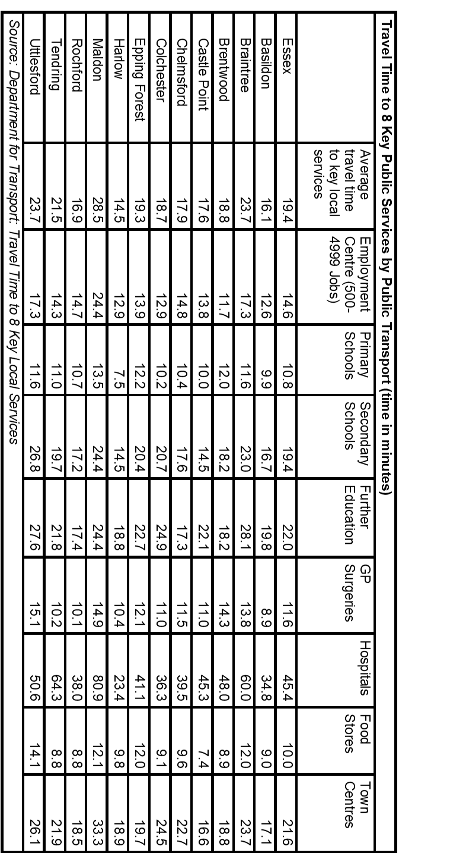

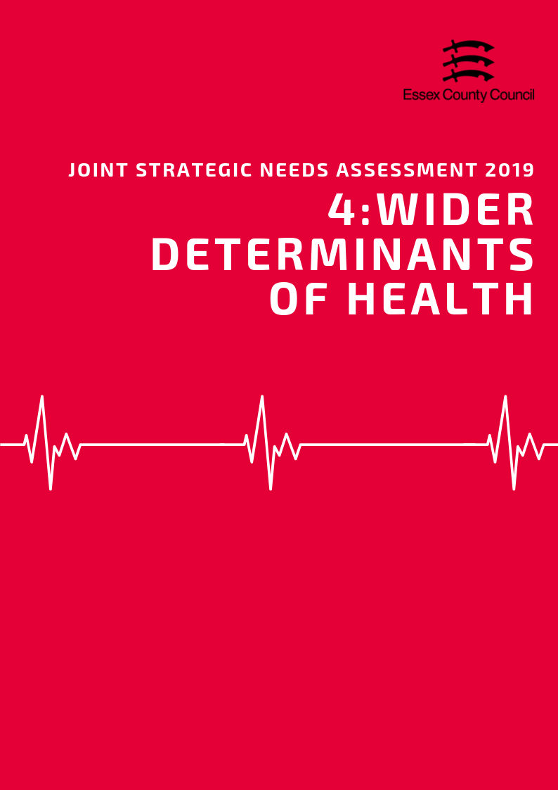

**Wider Determinants of Health**

***“Wider determinants, also known as social determinants, are a diverse range of social, economic and environmental factors which impact on people’s health. Such factors are influenced by the local, national and international distribution of power and resources which shape the conditions of daily life. They determine the extent to which different individuals have the physical, social and personal resources to identify and achieve goals, meet their needs and deal with changes to their circumstances.” Public Health England 2019***

***Income & Average Earnings***

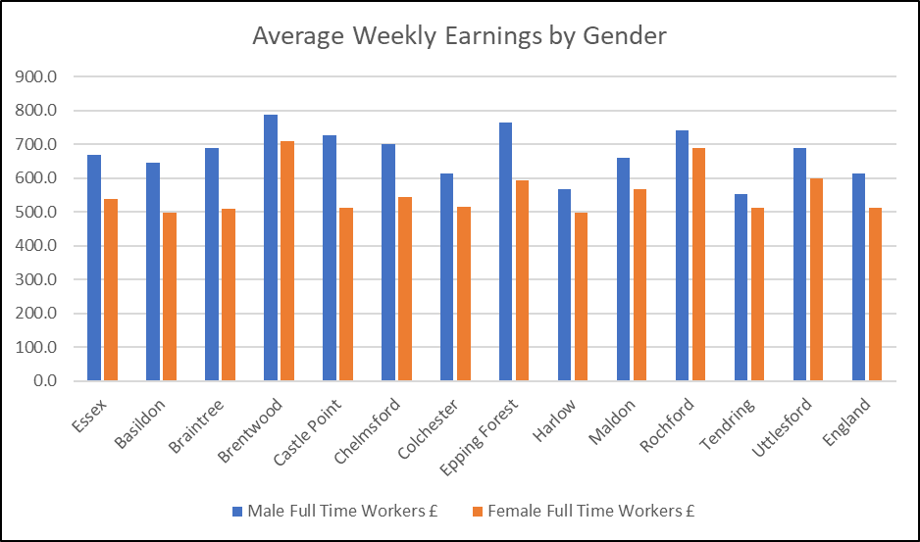The average weekly income for a Basildon resident working full time in 2018 was £595, £23.60 (-3.97%) lower than the average for Essex but £20.10 (3.38%) higher than the average for England. This was the fourth lowest average income out of 12 Districts. Part time workers in Basildon earned £181.20 per week, £0.90 (-0.5%) less than the average for Essex, and £6.10 (-3.37%) less than the average for England. This was the sixth highest weekly income for part time workers in Essex.

Male residents generally earned £149 (23%) more per week than females with an average weekly pay of £646.50 for male full time workers compared to £497.50 for females. This was the third highest difference in the percentage of income and the fifth highest in actual money.

***Deprivation***

In the Indices of Multiple Deprivation 2019 the Basildon Local Authority area was ranked 111 out of 317 lower tier authorities in England based on the average rank of the LSOAs in this area (where 1= most deprived). This places Basildon in the bottom 40% of most deprived Lower Tier Local Authorities (LTLAs) nationally. Compared to the other local authority areas in Essex, Basildon is ranked as third out of 12 in the county for overall deprivation. Basildon is one of three areas in Essex which fall into the lower 50% of most deprived areas nationally.

*See the Essex 2019 Indices of Deprivation report for a full analysis of the latest English Indices of Deprivation data for each district.*

***Fuel Poverty***

Figures from 2016 estimate that 5923 households the Basildon area were classed as fuel poor. This is equivalent to 7.8% of the total number of households in the area which was lower than the average for Essex (8.6%) or England (11.1%) and was the second lowest level in the county.



***Child Poverty***

7,270 children and young people (18.2% living in the area) are recorded as being in low income households either in receipt of Child Tax Credits, Income Support or Job Seeker Allowance. This is the second highest rate in Essex and is higher than the rate for England (16.6%). It is also estimated that 3360 pupils (13.1%) were eligible for free-school meals at the time of the last school census, this is higher than the average for Essex (9.87%) but below the average for England (13.4%)

|  |  |  |  |  |  |  |
| --- | --- | --- | --- | --- | --- | --- |
| **Children in families in receipt of CTC (<60% median income) or IS/JSA** | | | | | | |
|  | *Total number of children where the youngest child is aged:* | | | | *Total Number of Children in low income households* | *% of All Children* |
| *0 - 4* | *5 - 10* | *11 - 15* | *16 - 19* |
| ***Basildon*** | 4,075 | 2,240 | 985 | 370 | 7,670 | 18.2% |
| ***Braintree*** | 1,950 | 1,010 | 575 | 215 | 3,750 | 11.7% |
| ***Brentwood*** | 695 | 335 | 205 | 80 | 1,315 | 9.0% |
| ***Castle Point*** | 1,250 | 680 | 380 | 120 | 2,430 | 14.1% |
| ***Chelmsford*** | 1,900 | 1,030 | 565 | 195 | 3,690 | 10.6% |
| ***Colchester*** | 2,985 | 1,510 | 630 | 230 | 5,355 | 14.0% |
| ***Epping Forest*** | 1,595 | 940 | 475 | 205 | 3,215 | 12.0% |
| ***Harlow*** | 2,040 | 995 | 420 | 175 | 3,630 | 16.6% |
| ***Maldon*** | 645 | 380 | 230 | 80 | 1,335 | 11.1% |
| ***Rochford*** | 755 | 455 | 230 | 120 | 1,560 | 9.6% |
| ***Tendring*** | 3,250 | 1,755 | 890 | 360 | 6,255 | 23.0% |
| ***Uttlesford*** | 545 | 345 | 190 | 80 | 1,160 | 6.6% |
| ***Essex Total*** | ***21,685*** | ***11,675*** | ***5,775*** | ***2,230*** | ***41,365*** | ***13.0%*** |
| ***England*** | ***1,016,710*** | ***530,585*** | ***270,235*** | ***111,760*** | ***1,929,290*** | ***16.6%*** |

Department for Education performance tables estimate that in 2017/18 there were 3360 pupils (13.1%) who were eligible for free school meals in the area. This was higher than the average for Essex (9.9%) but below England (13.4%) and was the second highest level in the county.

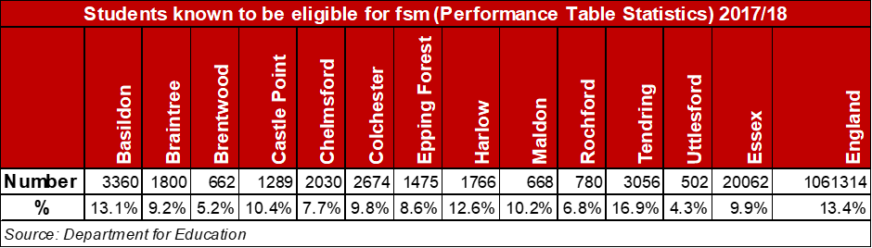

***Education & Skills***

*Adult Qualifications*

26.6% of Basildon residents aged 16+ had no formal qualifications at the time of the 2011 Census, 2.7% higher than the average for Essex (23.9%) and 4.2% higher than the average for England (22.5%). Basildon residents also achieve lower levels of NVQ level four qualifications (certificate of higher education) or higher (Batchelors Degree and above) with 18.6% of residents gaining this level of qualification compared to an average of 23% for the whole of Essex and 27.4% at the England level. These are the third highest and fourth lowest levels respectively.

*Levels for all districts in the Essex County Council area along with averages for the county, East of England and England are set out in the table below.*

|  |  |  |  |  |
| --- | --- | --- | --- | --- |
| ***Area*** | ***Number of adult residents with no qualifications*** | ***% of adult residents with no qualifications*** | ***Number of adult residents with Level 4 qualifications and above*** | ***% of adult residents with Level 4 qualifications and above*** |
| **Basildon** | 37084 | 26.64% | 25939 | 18.63% |
| **Braintree** | 26958 | 22.83% | 26212 | 22.20% |
| **Brentwood** | 11651 | 19.38% | 18441 | 30.68% |
| **Castle Point** | 21885 | 29.92% | 10693 | 14.62% |
| **Chelmsford** | 25844 | 18.86% | 39452 | 28.80% |
| **Colchester** | 27440 | 19.40% | 38412 | 27.16% |
| **Epping Forest** | 24360 | 23.95% | 25769 | 25.34% |
| **Harlow** | 16948 | 26.05% | 11468 | 17.63% |
| **Maldon** | 11749 | 23.13% | 12009 | 23.64% |
| **Rochford** | 16134 | 23.63% | 13659 | 20.01% |
| **Tendring** | 39616 | 34.30% | 18340 | 15.88% |
| **Uttlesford** | 11232 | 17.72% | 20251 | 31.94% |
| **Essex** | 270901 | 23.89% | 260645 | 22.99% |
| **England** | 9656810 | 22.46% | 11769361 | 27.38% |
| **East of England** | 1067449 | 22.53% | 1218862 | 25.72% |

*Early Years*

***Achieving at least the expected level across all early learning goals***

*Children achieving at least the expected level across all early learning goals (ELGs) are those achieving ‘expected’ or ‘exceeded’ in all 17 ELGs.*

The percentage of children in Basildon achieving a good level of development has generally improved since 2015 with 73% of children achieving a good level of development in 2018, an increase of 6% compared to 2015. The 2018 score is just above the averages for Essex (72.1) and England (71.5%) and is a slight increase (2%) compared to 2017.

***Good level of development (GLD)***

*Children achieving a good level of development are those achieving at least the expected level within the following areas of learning: communication and language; physical development; personal, social and emotional development; literacy and mathematics.*

A similar trend was seen in the percentage of children achieving at least the expected level across all early learning goals. This has increased to 72%, up by 7% compared to 2015 and a 2% on the previous year. This was also just above the averages for Essex (70.7%) and England (70.2%).

*Levels for all districts in the Essex County Council area along with averages for the county, East of England and England are set out in the table below.*

|  |  |  |  |  |  |  |  |  |  |  |  |
| --- | --- | --- | --- | --- | --- | --- | --- | --- | --- | --- | --- |
|  | **2015** | | **2016** | | **2017** | | **2018** | |  | **Change 2015-2018** | |
| **Area of Pupil Residence** | ***% of ELG*** | ***% of GLD*** | ***% of ELG*** | ***% of GLD*** | ***% of ELG*** | ***% of GLD*** | ***% of ELG*** | ***% of GLD*** |  | *% of ELG* | *% of GLD* |
| **Basildon** | 65 | 67 | 70 | 71 | 70 | 71 | 72.0 | 73.0 | 2.0 | 6.0 |
| **Braintree** | 63 | 65 | 71 | 72 | 72 | 74 | 72.0 | 73.0 | 9.0 | 8.0 |
| **Brentwood** | 70 | 71 | 73 | 75 | 77 | 78 | 76.0 | 77.0 | 6.0 | 6.0 |
| **Castle Point** | 61 | 65 | 70 | 72 | 70 | 73 | 73.0 | 74.0 | 12.0 | 9.0 |
| **Chelmsford** | 68 | 70 | 73 | 73 | 74 | 75 | 74.0 | 75.0 | 6.0 | 5.0 |
| **Colchester** | 64 | 66 | 68 | 70 | 71 | 72 | 73.0 | 73.0 | 9.0 | 7.0 |
| **Epping Forest** | 67 | 69 | 69 | 70 | 72 | 73 | 73.0 | 73.0 | 6.0 | 4.0 |
| **Harlow** | 65 | 66 | 69 | 71 | 69 | 72 | 71.0 | 72.0 | 6.0 | 6.0 |
| **Maldon** | 70 | 72 | 73 | 74 | 74 | 75 | 75.0 | 76.0 | 5.0 | 4.0 |
| **Rochford** | 70 | 72 | 73 | 74 | 76 | 77 | 77.0 | 79.0 | 7.0 | 7.0 |
| **Tendring** | 64 | 66 | 66 | 67 | 67 | 70 | 70.0 | 70.0 | 6.0 | 4.0 |
| **Uttlesford** | 72 | 73 | 78 | 79 | 76 | 77 | 76.0 | 77.0 | 4.0 | 4.0 |
| **Essex** | 65.8 | 67.7 | 70.5 | 71.9 | 72.1 | 73.5 | 70.7 | 72.1 | 4.9 | 4.4 |
| **England** | 64.1 | 66.3 | 67.3 | 69.3 | 69.0 | 70.7 | 70.2 | 71.5 | 6.1 | 5.2 |
| **East of England** | 64.6 | 66.6 | 67.8 | 69.7 | 69.4 | 71.3 | 73.0 | 73.8 | 8.4 | 7.2 |
| *% of ELG = % of pupils achieving at least the expected standard in all Early Learning Goals* | | | | | | | | | | | |
| *% of GLD = % of pupils achieving a Good Level of Development at the Early Years foundation Stage* | | | | | | | | | | | |

*GCSE Attainment*

Since the introduction of the new GCSE grading system, pupil performance in Basildon gradually fallen with 62.6% of pupils achieving grade 9-4 in English and Maths (a good pass) and 40.7% achieving grade 9-5 (a strong pass) in 2018. This is higher than the England averages (59.1% and 39.9%) but lower or in-line with the average for the Essex (63.3% and 40.7%). Compared to scores for 2017 this is slight reduction in the overall attainment rate (-0.8%, -0.7%) however it is not possible to make a longer term comparison due to changes in the grading system.

***Attainment 8***

*Attainment 8 measures a student's average grade across eight subjects across the following three groups:*

***English and maths:*** *(double-weighted)*

***English Baccalaureate (Ebacc):*** *the highest scores from the sciences, computer science, geography, history and languages.*

***Open group:*** *Any remaining GCSEs and other approved academic, arts or vocational qualifications.*

Looking at the pupils' Attainment 8 score provides a slightly longer term comparison of performance and shows that overall performance has fallen 4.0% down from 49.3% in 2016 to 45.3% in 2018. These figures are higher than the average for England (48.5, 44.5) but lower than Essex (50.4, 46.1) and were the fourth lowest scores in the county in 2018. The downward trend in performance for Basildon matches the trend observed at across England since the introduction of the new GCSE grading system which has seen a 4% reduction in average attainment 8 scores between 2016 and 2018.

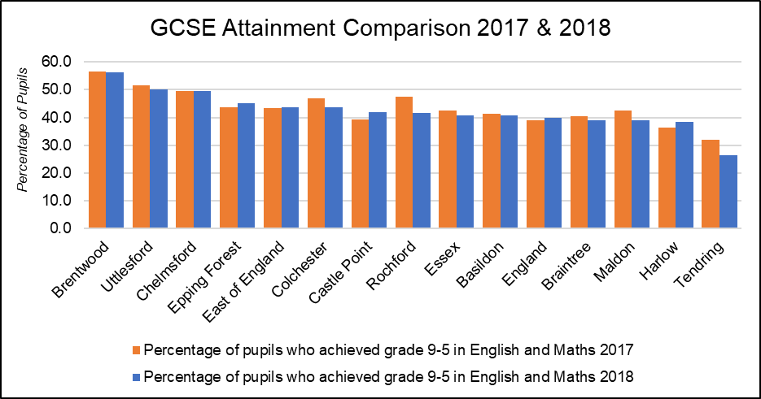

|  |  |  |  |  |  |  |  |
| --- | --- | --- | --- | --- | --- | --- | --- |
| **Area** | 2017 | | | 2018 | | | Average Attainment 8 Score 2017-2018 Change |
| % of pupils who achieved grade 9-5 in English and Maths | % of pupils who achieved grade 9-4 in English and Maths | Average Attainment 8 Score | % of pupils who achieved grade 9-5 in English and Maths | % of pupils who achieved grade 9-4 in English and Maths | Average Attainment 8 Score |
| **Basildon** | 41.4 | 63.4 | 46.4 | 40.7 | 62.6 | 45.3 | -4.0 |
| **Braintree** | 40.4 | 63.6 | 45.2 | 39 | 63 | 45.5 | -4.0 |
| **Brentwood** | 56.5 | 79.3 | 51.0 | 56.2 | 76.8 | 52.6 | -1.5 |
| **Castle Point** | 39.2 | 64.2 | 45.6 | 41.9 | 65.6 | 45 | -4.7 |
| **Chelmsford** | 49.5 | 72.2 | 50.4 | 49.5 | 72 | 50.9 | -3.1 |
| **Colchester** | 46.9 | 66.7 | 47.6 | 43.6 | 65.3 | 48 | -3.6 |
| **Epping Forest** | 43.8 | 66.8 | 47.8 | 45 | 67.8 | 46.9 | -4.3 |
| **Harlow** | 36.5 | 59.8 | 44.1 | 38.3 | 59.6 | 42.8 | -5.4 |
| **Maldon** | 42.4 | 62.4 | 47.0 | 39 | 62.8 | 47 | -5.8 |
| **Rochford** | 47.5 | 70.5 | 47.9 | 41.5 | 63.1 | 46.3 | -4.7 |
| **Tendring** | 31.9 | 52.0 | 41.6 | 26.5 | 47.2 | 39.9 | -5.9 |
| **Uttlesford** | 51.6 | 74.9 | 51.5 | 50.1 | 71.1 | 51.8 | -3.1 |
| **Essex** | 42.4 | 64.9 | 46.7 | 40.7 | 63.3 | 46.1 | -4.3 |
| **East of England** | 43.5 | 65.4 | **46.7** | 43.7 | 65.2 | 47 | -3.4 |
| **England** | 39.1 | 58.5 | 44.6 | 39.9 | 59.1 | 44.5 | -4.0 |

*Destinations of School Leavers*

In 2017 93% of pupils in Basildon were in sustained Education, Employment or Training at the end of Key stage 4 (Secondary School). This is lower than the averages for England (-1%) and Essex (-2%). Within this group 82% were in education, below the county and England averages (86%) and the (joint) lowest level in Essex. 5% were in apprenticeships whilst another 5% were in employment. At this stage Basildon also had the (joint) highest levels of young people not sustaining education employment or training (7%), 2 percentage point higher than the national and county average (5%).

After Key Stage 5 (Further Education) the number of young people in sustained education employment or training was estimated to have reduced to 90%. Of this cohort, 53% were believed to be in Education including 40% in Higher Education. The rate of young people attending university was 10% below the national average (50%) and 6% below the average for the Essex (46%). The next largest destination was sustained employment accounting for approximately 28% of the cohort, 6% more than the England average (22%) and 2% more than Essex (26%). 11% were in apprenticeships, the second highest level in Essex. 9% were not in any form of sustained education, training or employment, 2% more the Essex average.

|  |  |  |  |  |  |  |
| --- | --- | --- | --- | --- | --- | --- |
| ***Percentage of pupils with destinations sustained for at least two terms post KS4 in 2016/17:*** | | | | | | |
| **Area** | Any sustained education or employment | Any sustained education destination | Sustained apprenticeships | Sustained employment destination | Destination not sustained | Activity not captured in the data |
| **ENGLAND\*** | **94** | **86** | **5** | **3** | **5** | **1** |
| **EAST** | **95** | **87** | **4** | **3** | **5** | **1** |
| **Essex** | **95** | **86** | **5** | **4** | **5** | **1** |
| Basildon | 93 | 82 | 5 | 5 | 7 | 1 |
| Braintree | 94 | 85 | 5 | 5 | 5 | 1 |
| Brentwood | 96 | 90 | 3 | 2 | 3 | 2 |
| Castle Point | 94 | 83 | 8 | 3 | 5 | 1 |
| Chelmsford | 96 | 89 | 4 | 3 | 4 | 0 |
| Colchester | 95 | 87 | 4 | 4 | 5 | 1 |
| Epping Forest | 95 | 88 | 5 | 2 | 4 | x |
| Harlow | 95 | 88 | 4 | 3 | 3 | 2 |
| Maldon | 96 | 85 | 6 | 5 | 3 | x |
| Rochford | 95 | 86 | 7 | 3 | 4 | 2 |
| Tendring | 92 | 82 | 5 | 6 | 7 | 1 |
| Uttlesford | 94 | 87 | 5 | 3 | 5 | 0 |
| ***Percentage of pupils with destinations sustained for at least two terms post KS5 in 2016/17:*** | | | | | | |
| **Area** | Any sustained education destination | Higher education (level 4 and above) | Sustained apprenticeships | Sustained employment destination | Destination not sustained | Activity not captured in the data |
| **ENGLAND\*** | **61** | **50** | **6** | **22** | **8** | **4** |
| **EAST** | **58** | **49** | **7** | **25** | **7** | **3** |
| **Essex** | **56** | **46** | **8** | **26** | **7** | **3** |
| Basildon | 50 | 40 | 11 | 28 | 9 | 3 |
| Braintree | 53 | 42 | 7 | 30 | 6 | 4 |
| Brentwood | 58 | 52 | 10 | 21 | 8 | 3 |
| Castle Point | 45 | 32 | 10 | 32 | 9 | 4 |
| Chelmsford | 60 | 54 | 7 | 25 | 5 | 2 |
| Colchester | 62 | 48 | 4 | 24 | 7 | 3 |
| Epping Forest | 59 | 47 | 8 | 22 | 8 | 4 |
| Harlow | 52 | 39 | 7 | 32 | 9 | 1 |
| Maldon | 50 | 41 | 9 | 32 | 5 | 3 |
| Rochford | 47 | 39 | 12 | 30 | 9 | 3 |
| Tendring | 51 | 41 | 8 | 28 | 9 | 4 |
| Uttlesford | 61 | 52 | 5 | 26 | 6 | 2 |
| * State-funded schools (mainstream and special)  x Data not available  *NB: England figures may not add to 100% due to rounding* | | | | | | |

***Employment and Economic Activity***

Economic Activity

74.1% of residents (113,400 people) aged 16-64 in Basildon are economically active, 4.6% lower than the England average (78.7%) and 6.7% lower than the average for Essex (80.8%). This is the second lowest rate of economic activity in the county (Highest = Braintree (87.1%), Lowest = Brentwood (71.9%)). Within the same age group, it is estimated that 72.6% of residents (including both economically active and inactive) are in Employment, 5.5% lower than the Essex Average (78.1%) and 2.7% lower than England (75.4%).

29,400 people or 25.9% of residents aged 16-64 are thought to be economically inactive (not in employment who have not been seeking work within the last 4 weeks and/or are unable to start work within the next 2 weeks). The Basildon average is higher than the rate for Essex (19.2%) and England (21.3%) and is the second highest rate of economic inactivity in the county (Highest = Brentwood (28.1%), lowest = Braintree (12.9%)).

The most common reason for working age people to be economically inactive was either long term sickness (28.6%), Looking after the home or family (27.8%), or being a student (24.3%). Compared to the rest of Essex, Basildon the proportion of residents classed as long term sick is 9.2% higher than the county average (19.4%) and is the highest level of all districts. It is not known what proportion of the population were retired before the age of 65, as data has been supressed due the sample size being too small to give accurate estimates.

|  |  |  |  |  |  |  |  |  |  |  |
| --- | --- | --- | --- | --- | --- | --- | --- | --- | --- | --- |
| **Residents Age 16-64 Claiming Key Out of Work Benefits** | | | | | | | | | | |
| **Area** | **April 2015** | | **April 2016** | | **April 2017** | | **April 2018** | | **April 2019** | |
| **Claimant Count** | **%** | **Claimant Count** | **%** | **Claimant Count** | **%** | **Claimant Count** | **%** | **Claimant Count** | **%** |
| Basildon | 2,155 | 1.9 | 2,110 | 1.8 | 2,140 | 1.9 | 2,605 | 2.3 | 3,330 | 2.9 |
| Braintree | 1,155 | 1.2 | 1,090 | 1.2 | 1,030 | 1.1 | 1,315 | 1.4 | 1,720 | 1.9 |
| Brentwood | 355 | 0.8 | 295 | 0.6 | 415 | 0.9 | 555 | 1.2 | 720 | 1.5 |
| Castle Point | 685 | 1.3 | 740 | 1.4 | 675 | 1.3 | 555 | 1.1 | 920 | 1.8 |
| Chelmsford | 1,430 | 1.3 | 1,250 | 1.2 | 1,255 | 1.1 | 1,225 | 1.1 | 1,590 | 1.5 |
| Colchester | 1,395 | 1.2 | 1,540 | 1.3 | 1,425 | 1.2 | 1,435 | 1.2 | 2,240 | 1.8 |
| Epping Forest | 1,050 | 1.3 | 925 | 1.1 | 980 | 1.2 | 1,010 | 1.3 | 1,230 | 1.5 |
| Harlow | 1,195 | 2.2 | 1,000 | 1.8 | 1,050 | 1.9 | 1,535 | 2.8 | 1,865 | 3.5 |
| Maldon | 400 | 1.1 | 360 | 1.0 | 385 | 1.0 | 380 | 1.0 | 405 | 1.1 |
| Rochford | 500 | 1.0 | 455 | 0.9 | 470 | 0.9 | 465 | 0.9 | 700 | 1.4 |
| Tendring | 2,015 | 2.6 | 2,200 | 2.8 | 2,225 | 2.8 | 2,170 | 2.8 | 3,150 | 4.0 |
| Uttlesford | 300 | 0.6 | 240 | 0.5 | 255 | 0.5 | 370 | 0.7 | 500 | 0.9 |
| **England** | **660,415** | **1.9** | **630,975** | **1.8** | **662,795** | **1.9** | **751,250** | **2.1** | **922,235** | **2.6** |
| **East** | **51,805** | **1.4** | **48,255** | **1.3** | **51,225** | **1.4** | **60,080** | **1.6** | **75,315** | **2.0** |
| **Essex** | **12,625** | **1.4** | **12,200** | **1.4** | **12,305** | **1.4** | **13,615** | **1.5** | **18,370** | **2.1** |

The amount of residents claiming out of work benefits has increased to its highest level in 5 years from 1.9% in April 2015 to 2.9% in April 2019, equivalent to an increase of 1175 claimants. This is higher than the averages for Essex (2.1%) and England average (2.6%) and is the third highest claimant rate overall. It should be noted however that some of the increases in claimant rates may be affected by the introduction of universal credit and changes in the way in which certain claimants are logged as "out of work", with all districts and boroughs showings increases. As such these figures may not actually reflect real term increases.

***Occupations***

Basildon residents are most likely to work in Professional Occupations (18.2%), Associate Professional & Technical Occupations (17.3%) or in Elementary Occupations (11.7%). The smallest occupation groups were people working in Process, Plant and Machine Operative roles (4.9%). Compared to the Essex average Basildon has the second lowest level of residents working as Managers, Directors and Senior Officials (7.3%) and the third highest level of people working elementary occupations.

|  |  |  |  |  |  |  |  |  |  |
| --- | --- | --- | --- | --- | --- | --- | --- | --- | --- |
| **Percentage of Residents by Employment Occupation Group**  *(Annual Population Survey: 12 months to June 2019)* | | | | | | | | | |
|  | **1: managers, directors and senior officials** | **2: professional occupations** | **3: associate prof & tech occupations** | **4: administrative & secretarial occupations** | **5: skilled trades occupations** | **6: caring, leisure and other service occupations** | **7: sales and customer service occupations** | **8: process, plant and machine operatives** | **9: elementary occupations** |
| Basildon | 7.3 | 18.2 | 17.3 | 11.2 | 8.9 | 11.1 | 9.4 | 4.9 | 11.7 |
| Braintree | 14.4 | 18.7 | 15.4 | 8.8 | 12.0 | 8.6 | 5.9 | 2.9 | 12.9 |
| Brentwood | 20.0 | 24.1 | 18.0 | 5.4 | 13.5 | 8.5 | ! | ! | 6.0 |
| Castle Point | 7.8 | 14.2 | 9.7 | 13.2 | 17.6 | 10.2 | ! | 7.8 | 17.8 |
| Chelmsford | 13.1 | 22.2 | 16.5 | 9.2 | 9.1 | 10.6 | 5.9 | 3.5 | 10.0 |
| Colchester | 11.5 | 18.6 | 12.3 | 9.6 | 10.2 | 13.3 | 5.4 | 9.1 | 9.9 |
| Epping Forest | 19.2 | 22.3 | 12.0 | 11.7 | 12.4 | 6.5 | 3.3 | 5.7 | 6.9 |
| Harlow | 7.9 | 14.8 | 19.0 | 9.9 | 9.8 | 8.0 | 7.1 | 15.0 | 8.5 |
| Maldon | 19.0 | 8.2 | 12.8 | 9.3 | 12.0 | 12.5 | 8.7 | 7.3 | 10.2 |
| Rochford | 8.0 | 22.0 | 20.0 | 15.4 | 14.5 | 4.5 | 4.2 | 6.0 | 5.5 |
| Tendring | 16.6 | 14.1 | 13.0 | 10.2 | 16.3 | 9.8 | 8.9 | 1.7 | 9.3 |
| Uttlesford | 20.2 | 16.0 | 17.7 | 14.4 | 4.4 | 5.9 | 9.9 | 4.0 | 7.5 |
| **England** | **11.4** | **21.2** | **15.0** | **9.9** | **9.8** | **8.9** | **7.1** | **6.2** | **10.2** |
| **East** | **12.2** | **20.0** | **14.4** | **10.5** | **10.3** | **9.1** | **6.8** | **6.3** | **10.3** |
| **Essex** | **13.3** | **18.3** | **15.1** | **10.6** | **11.5** | **9.5** | **6.1** | **5.6** | **10.0** |

*Housing*

According to the most recent statistics there are an estimated 16,890 social housing units in the Basildon area including 10,954 owned by the Local Authority. This is the highest number of social housing units of any district or borough in the Essex County Council area (Lowest: Castle Point = 2,104 units).

Across both the Social and Private rented housing sector in 2018-19 a total of 142 properties were inspected and found to have one or more "category 1 hazard". i.e. it poses a serious and immediate risk to a person's health and safety (Highest: Epping Forest = 614, Lowest: Brentwood = 0). All properties with these hazards were found to be in the private rented sector and was the second highest number of unsafe properties in the county.

|  |  |  |  |  |  |
| --- | --- | --- | --- | --- | --- |
|  | ***Local Authority Owned (including those owned by other Local Authorities)*** | ***General Needs Social Housing Stock (owned by RSLs)*** | ***Sum of Supported Accommodation Housing Stock (owned by RSLs)*** | ***Sum of Social Housing for Older People (owned by RSLs)*** | ***Total*** |
| **Essex** | **42,569** | **40102** | **2100** | **4844** | **89,928** |
| **Basildon** | 10,954 | 5293 | 220 | 351 | 16,890 |
| **Braintree** | 4 | 9499 | 305 | 713 | 10,622 |
| **Brentwood** | 2,441 | 759 | 114 | 169 | 3,483 |
| **Castle Point** | 1,517 | 460 | 54 | 73 | 2,104 |
| **Chelmsford** | 56 | 9458 | 294 | 286 | 10,140 |
| **Colchester** | 5,945 | 3988 | 524 | 355 | 10,835 |
| **Epping Forest** | 6,453 | 1403 | 58 | 228 | 8,213 |
| **Harlow** | 9,279 | 1468 | 197 | 292 | 11,236 |
| **Maldon** | 0 | 2178 | 22 | 812 | 3,012 |
| **Rochford** | 0 | 2133 | 45 | 697 | 2,875 |
| **Tendring** | 3,134 | 1935 | 198 | 681 | 5,948 |
| **Uttlesford** | 2,786 | 1528 | 69 | 187 | 4,570 |
| RSL = Register Social Landlord (including Housings Associations) | | | | | |
| Source: LA Housing Returns 2018-19; Regulator of Social Housing Statistical returns 2017/18 | | | | | |

In 2018/19 there were a total of 1,169 households on the housing waiting list in Basildon, equivalent to 1.5% of all households in the area. During the same period, it is estimated that 221 homes were let directly or through nominations from the local authority, equivalent to 18.9% of households on the waiting list. Out of the total number of households on waiting list it was recorded that:

* 576 households (49.3%) were classed as being in a "reasonable preference category" (Highest: Rochford=100%/638 Households. Lowest: Maldon 10.1%/95 Households)
* 5 households (0.4%) were classes as "homeless" regardless of statutory duty to be housed (Highest: Castle Point=21.2%/114 Households. Lowest: Epping Forest and Maldon= 0 Households)
* 441households (37.7%) were classed as being overcrowded or unsatisfactory conditions (Highest: Tendring = 43.3%/589 Households. Lowest: Epping Forest = 0 Households)
* 57 households (4.9%) need to move due to welfare, medical or disability grounds (Highest: Rochford = 60.8%/388 Households. Lowest: Chelmsford = 4.39%/173 Households)

Despite being the second largest local authority in terms of population size, Basildon had only the 7th largest housing waiting list in the county with an above average number of applicants seeking housing due to overcrowding or insanitary conditions (Essex average = 15.9%), but the second lowest level of people seeking housing due to medical, welfare or disability reasons (Essex average 14.96%).

|  |  |  |  |  |  |  |  |  |  |
| --- | --- | --- | --- | --- | --- | --- | --- | --- | --- |
|  | ***Total households on the housing waiting list*** | ***Total households on the housing waiting list in a reasonable preference category*** | | ***Percentage People who are homeless within the meaning given in Part VII of the Act, regardless of whether there is a statutory duty to house them*** | | ***People occupying insanitary or overcrowded housing or otherwise living in unsatisfactory housing conditions*** | | ***People who need to move on medical or welfare grounds, including grounds relating to a disability*** | |
| ***Count*** | ***Count*** | ***%*** | ***Count*** | ***%*** | ***Count*** | ***%*** | ***Count*** | ***%*** |
| Essex | **21,803** | **11,885** | **54.5%** | 1560 | **7.2%** | 3473 | **15.9%** | 3262 | **15.0%** |
| Basildon | 1,169 | 576 | **49.3%** | 5 | **0.4%** | 441 | **37.7%** | 57 | **4.9%** |
| Braintree | 2,749 | 1,070 | **38.9%** | 47 | **1.7%** | 773 | **28.1%** | 276 | **10.0%** |
| Brentwood | 626 | 389 | **62.1%** | 57 | **9.1%** | 8 | **1.3%** | 267 | **42.7%** |
| Castle Point | 539 | 509 | **94.4%** | 114 | **21.2%** | 183 | **34.0%** | 197 | **36.5%** |
| Chelmsford | 3,939 | 3,269 | **83.0%** | 494 | **12.5%** | 429 | **10.9%** | 173 | **4.4%** |
| Colchester | 4,392 | 1,983 | **45.2%** | 111 | **2.5%** | 299 | **6.8%** | 533 | **12.1%** |
| Epping Forest | 1,376 | 299 | **21.7%** | 0 | **0.0%** | 0 | **0.0%** | 299 | **21.7%** |
| Harlow | 2,965 | 1,403 | **47.3%** | 537 | **18.1%** | 522 | **17.6%** | 298 | **10.1%** |
| Maldon | 936 | 95 | **10.1%** | 0 | **0.0%** | 28 | **3.0%** | 54 | **5.8%** |
| Rochford | 638 | 638 | **100.0%** | 79 | **12.4%** | 62 | **9.7%** | 388 | **60.8%** |
| Tendring | 1,362 | 1,275 | **93.6%** | 19 | **1.4%** | 589 | **43.2%** | 563 | **41.3%** |
| Uttlesford | 1,112 | 379 | **34.1%** | 97 | **8.7%** | 139 | **12.5%** | 157 | **14.1%** |
| Source: LA Housing Returns 2018-19; Regulator of Social Housing Statistical returns 2017/18 | | | | | | | | | |

*Homelessness & Rough Sleeping*

According to Public Health England, homeless people experience the most significant health inequalities and that the mean life expectancy of somebody who is homeless is just 44 years for men and 42 years for women. Since 2010 the number of rough sleepers across the Basildon area has gradually risen peaking at an estimated 24 individuals in 2017, before reducing to 12 people in 2018. Compared to the average rates of rough sleeping in other areas, Basildon had estimated 1.56 rough sleepers to every 10,000 households in the area. This is lower than the average for England (2.01 per 10,000) but higher than the average for the rest of the Essex County council area (1.09) and is the fourth highest rate compared to the other districts and boroughs (Highest: Harlow = 2.51, Lowest: Castle Point, Maldon, Uttlesford = 0).

In 2018 Basildon (as well as Colchester, Harlow and Southend-on-Sea) was selected as one 83 areas nationally to receive additional funding to tackle rough sleeping in their areas, at the same time these areas have all seen the largest overall reductions in the number of rough sleepers identified in the last count (see table below).

In 2018 the majority of rough sleepers identified in this area were aged 26 years or older (92%), whilst one person was aged 18-25. 9 people (75%) were identified as male, with 3 people (25%) identified as female.

|  |  |  |  |  |  |  |  |  |
| --- | --- | --- | --- | --- | --- | --- | --- | --- |
|  | ***Under 18*** | | ***18 - 25*** | | ***26 or over*** | | ***Age not known*** | |
| ***Count*** | ***%*** | ***Count*** | ***%*** | ***Count*** | ***%*** | ***Count*** | ***%*** |
| **England** | **1** | **0.02%** | **295** | **6.3%** | **3744** | **80.1%** | **637** | **13.6%** |
| **East of England** | **0** | **0.00%** | **28** | **5.8%** | **395** | **81.6%** | **61** | **12.6%** |
| **Essex** | **0** | **0.00%** | **1** | **1.5%** | **47** | **70.1%** | **19** | **28.4%** |
| Basildon | 0 | 0.00% | 1 | 8.3% | 11 | 91.7% | 0 | 0.0% |
| Braintree | 0 | 0.00% | 0 | 0 | 5 | 100.0% | 0 | 0.0% |
| Brentwood | 0 | 0.00% | 0 | 0 | 2 | 100.0% | 0 | 0.0% |
| Castle Point | 0 | 0.00% | 0 | 0 | 0 | 0.0% | 0 | 0.0% |
| Chelmsford | 0 | 0.00% | 0 | 0 | 6 | 42.9% | 8 | 57.1% |
| Colchester | 0 | 0.00% | 0 | 0 | 9 | 69.2% | 4 | 30.8% |
| Epping Forest | 0 | 0.00% | 0 | 0 | 0 | 0.0% | 3 | 100.0% |
| Harlow | 0 | 0.00% | 0 | 0 | 9 | 100.0% | 0 | 0.0% |
| Maldon | 0 | 0.00% | 0 | 0 | 0 | 0.0% | 0 | 0.0% |
| Rochford | 0 | 0.00% | 0 | 0 | 0 | 0.0% | 3 | 100.0% |
| Tendring | 0 | 0.00% | 0 | 0 | 5 | 83.3% | 1 | 16.7% |
| Uttlesford | 0 | 0.00% | 0 | 0 | 0 | 0.0% | 0 | 0.0% |

*Crime and Community Safety*

Nationally and locally the number of crimes recorded by the police force in England and Wales is on the increase. Over a four year period the number of crimes recorded in the Basildon area has risen by 27% from 14,314 or from 79 crimes per 1000 residents in 2015/16 to 18,228 crimes or 99 crimes per 1000 in 2018/19. This percentage increase is lower than rates seen across the rest of the Essex Police Force area (42.7%) however the overall crime rate for Basildon is the fourth highest area covered by Essex Police (87 per 1000), and is 11% higher than the average for England (89 per 1000).

The largest categories of crime in the area for the last year was Theft which accounted for 6,682 (36.7%) offences or a rate of 36.2 crimes per 1000; and Violent Crime with 6439 (35.3%) offences or 34.9 crimes per 1000. The proportion of these crime types is similar to the averages for the Essex Police Force area (Theft = 35.3%, Violent Crime = 36.2%) although the rates per 1000 people are higher than both the Essex Police average (Theft = 30.7 per 1000, Violent Crime = 31.5 per 1000) and the rate for England (Theft = 34.3 per 1000, Violent Crime = 28.2 per 1000).

The most significant four year change in the number of crimes recorded in the Basildon area is the increase in the levels of Violent Crime, which has seen an additional 2938 offences in 2018/19 (an increase of 83.9%) compared to the same period in 2015/16. The increase in the rate of violent Crime locally reflects a national trend which includes an increase in the number of crimes recorded as stalking or harassment. Nationally the Crown Prosecution Service (CPS) reports that there was a 69% increase in prosecutions started for stalking offences from 2016–17 to 2017–18 because of improvements in awareness following a police and CPS inspection and the implementation of Violence Against Women Strategies. This development is reflected locally with 2,418 crimes recorded as stalking or harassment in 2018/19 up from 1,194 in 2017/18.

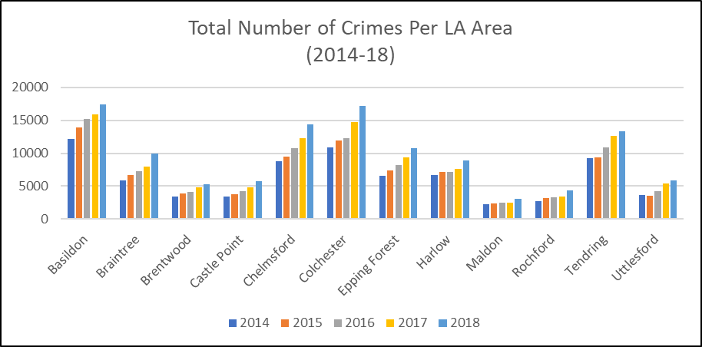

***Environmental Health and Licencing***

The Marmot Review (2008) identified different health outcomes could be associated with the prevalence of certain built environment factors in the area such as the rate of noise complaints, the number of alcohol licences in an area, to the density of fast food outlets in a neighbourhood.

The Marmot Review (2008) identified different health outcomes could be associated with the prevalence of certain build environment factors in the area such as the rate of noise complaints, the number of alcohol licences in an area, to the density of fast food outlets in a neighbourhood.   
  
***Noise***  
Excessive noise can have a range of impacts on our health from directly affecting our auditory system and hearing, to impacting our physical and mental health and quality of life; especially through long term exposure. Modelled estimates from based on data collected by the Chartered Institute of Environmental Health (CIEH) give an estimate for the rate of complaints per 1000 people about excessive noise from neighbours, their neighbourhood or the environment.

Public Health England estimates that in 2016 there was an average of 5.0 noise complaints per 1000 residents across the Basildon area, just above the Essex average of 4.8 but below the England average of 6.3. Compared to other areas, this was the 4th highest estimated rate in the Essex County Council area (Highest: Epping Forest = 9.8, Lowest: Castle Point = 1.6).  
 ***Alcohol Licences***Number of premises licences and club premises certificates permitted to sell or supply alcohol on-trade and/or off-trade is another measure used to look at the impact of the physical environment on health, particularly when considering alcohol harm and illness. Local Alcohol Profiles for England estimate that in 2016/17 there were an average of 2.8 licenced premises per square kilometre in the Basildon area, higher than the England average of 1.4 (data is not available for an Essex countywide average). Compared to other districts in Essex this is the 3rd highest (out of 11*) area (Highest: Harlow = 5.4, Lowest: Uttlesford = 0.5).  
***Density of Fast Food Outlets***  
The availability of fast food is an issue which is associated with a range of negative health outcomes for our communities such as obesity. This indicator calculates the number of fast food outlets per 100,000 population at an area level as a proxy for the density of these businesses within a particular local authority area. In 2014 it was estimated that Basildon had a density of 82.5 per 100,000, higher than the Essex average of 69.5 but just below the England rate of 88.2. Compared to other districts, this is the 2nd (out of 12) highest density in Essex (Highest: Tendring = 95.8, Lowest: Uttlesford = 41.6).

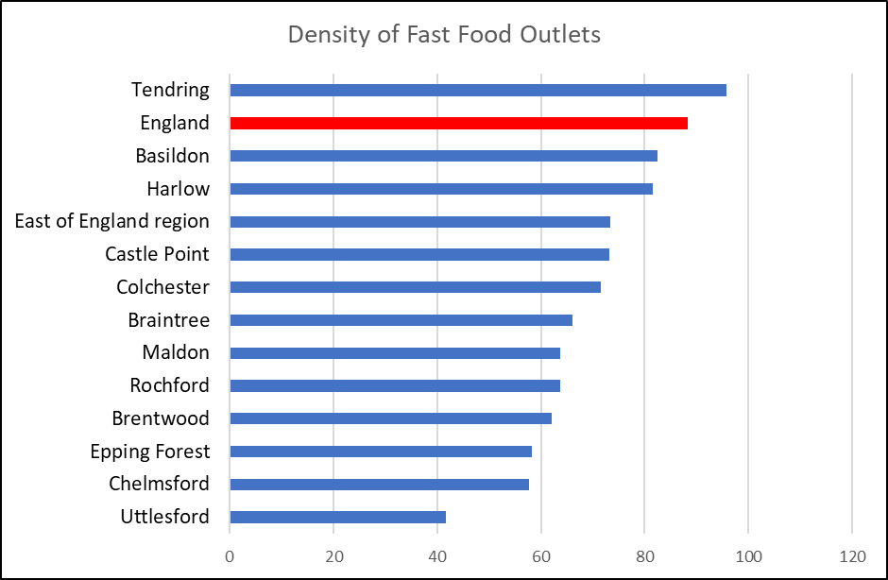

*Air Quality*

Poor air quality is a significant public health issue with clear evidence that particulate matter (human made air pollution) having a significant contributory role in a range of poor health outcomes including respiratory disorders and cardiopulmonary mortality. The Indicator for fine particulate matter looks at the average annual concentration in micrograms per cubic metre (weighted for population exposure) and showed that in 2016 the air pollution levels were 9.9 micrograms per cubic metre, higher than the average levels for Essex (9.6) and England (9.3). Compared to other areas Basildon had the second highest air pollution levels in the county (Highest: Epping Forest = 10.1 per cubic metre, Lowest: Maldon/Tendring/Uttlesford = 9.2).

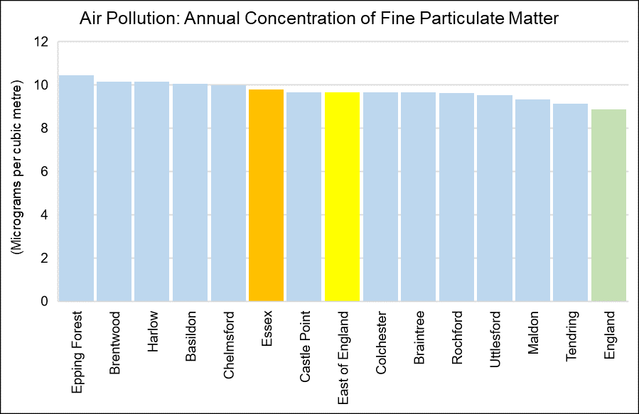

|  |  |
| --- | --- |
| Air pollution: fine particulate matter (2017) | |
| Area Name | micrograms per cubic metre |
| **England** | 8.904 |
| **East of England** | 9.6851 |
| **Essex** | 9.8132 |
| **Basildon** | 10.0819 |
| **Braintree** | 9.6742 |
| **Brentwood** | 10.1725 |
| **Castle Point** | 9.6913 |
| **Chelmsford** | 10.002 |
| **Colchester** | 9.6771 |
| **Epping Forest** | 10.4769 |
| **Harlow** | 10.1565 |
| **Maldon** | 9.3362 |
| **Rochford** | 9.6448 |
| **Tendring** | 9.1363 |
| **Uttlesford** | 9.5392 |
| *Annual concentration of human-made fine particulate matter at an area level, adjusted to account for population exposure. Fine particulate matter is also known as PM2.5 and has a metric of micrograms per cubic metre (µg/m3).* | |

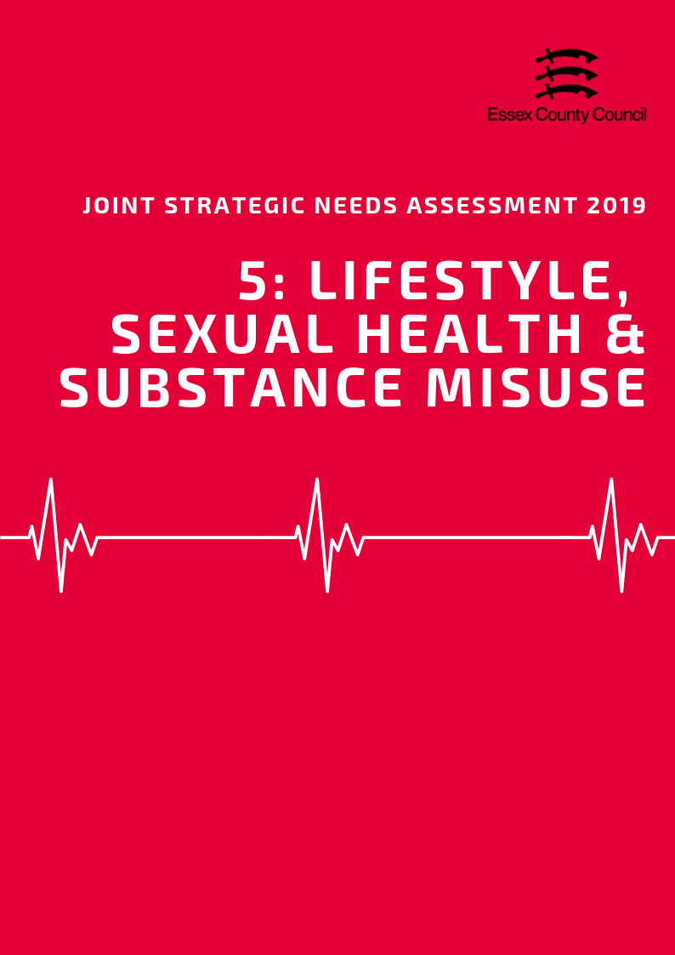

**LIFESTYLE, Sexual Health & Substance misuse**

This Section brings together datasets looking at a range of lifestyle and behavioural factors which can impact on long term health outcomes and increase or decrease the likelihood of developing a range of conditions or require more serious treatments going forward. This section includes:

* Children’s Weight
* Adult Healthy Eating, Obesity and Physical Activity
* Sexual Health
* Substance Misuse

**Children’s Weight**

***Reception Class***

In 2017/18 the National Child Measurement Programme (NCMP) estimated that 20.2% of pupils in Reception class (R in the table below) in Basildon were classed as overweight or obese. This was lower than the average for England (22.4%) and Essex (21.1%) and was the 7th highest rate in Essex.

Of this group 8.8% were classed as obese, with just over a quarter of this number (2.3%) also classed as severely obese. Compared to the rest of Essex this was 5th highest level of obesity for children in this year group.

|  |  |  |  |  |  |  |  |  |  |  |  |
| --- | --- | --- | --- | --- | --- | --- | --- | --- | --- | --- | --- |
| **National Child Measurement Programme**  2017/18 | Prevalence of all overweight (including overweight, obesity and severe obesity) | | | |  | Prevalence of overweight  (%) | | Prevalence of obesity including severe obesity  (%) | | Prevalence of severe obesity  (%) | |
| Reception (R) | | Year 6  (Y6) | |
| % | Rank | % | Rank | R | Y6 | R | Y6 | R | Y6 |
| Basildon | 20.2 | 7 | 33.9 | 4 | 11.38 | 14.27 | 8.82 | 19.66 | 2.31 | 4.30 |
| Braintree | 24.0 | 3 | 32.5 | 7 | 15.25 | 14.80 | 8.78 | 17.70 | 1.60 | 3.44 |
| Brentwood | 18.5 | 10 | 26.3 | 11 | 11.21 | 11.49 | 7.27 | 14.80 | 1.48 | 2.11 |
| Castle Point | 19.2 | 8 | 33.8 | 5 | 10.19 | 14.39 | 8.98 | 19.42 | 2.08 | 4.80 |
| Chelmsford | 20.6 | 6 | 29.7 | 10 | 13.24 | 14.26 | 7.40 | 15.40 | 1.46 | 2.67 |
| Colchester | 21.2 | 5 | 29.8 | 9 | 13.00 | 14.30 | 8.15 | 15.53 | 1.54 | 2.93 |
| Epping Forest | 17.3 | 12 | 33.4 | 6 | 9.96 | 14.37 | 7.33 | 19.05 | 1.39 | 3.17 |
| Harlow | 22.8 | 4 | 37.4 | 1 | 11.82 | 15.38 | 10.97 | 22.07 | 2.92 | 5.39 |
| Maldon | 28.1 | 1 | 34.6 | 3 | 17.44 | 17.47 | 10.63 | 17.12 | 1.99 | 2.57 |
| Rochford | 18.5 | 11 | 30.9 | 8 | 10.62 | 14.76 | 7.84 | 16.19 | 0.72 | 2.64 |
| Tendring | 24.8 | 2 | 36.3 | 2 | 14.27 | 13.72 | 10.52 | 22.56 | 2.90 | 4.81 |
| Uttlesford | 18.8 | 9 | 25.8 | 12 | 12.09 | 11.92 | 6.74 | 13.91 | 0.96 | 2.09 |
| Essex | 21.1 |  | 32.2 |  | **12.52** | **14.24** | **8.59** | **17.93** | **1.84** | **3.51** |
| England | 22.4 |  | 34.3 |  | **12.84** | **14.18** | **9.53** | **20.14** | **2.40** | **4.24** |

***Year 6***

The sample of pupils in Year 6 in the 2017/18 NCMP showed that 33.7% of pupils in this year group were classed as overweight or obese in Basildon, 13.7 percentage points higher than their Reception class counterparts. This just below the England average (34.3%) but higher than the average for Essex (32.2%) and was the 4th highest level out of any district or borough in Essex and the 4th largest difference between the two groups.

Within this year group it estimated that 19.7% of pupils were classed as obese (10.8% higher than Reception Class), of whom 4.3% were classed as severely obese. This level of obesity was the 3rd highest level in the county, dropping two rank places between the year groups.

***Change Over Time***

Over the last 10 years the prevalence levels of overweight and obese children in both Reception class and Year 6 has fluctuated but not shown definitive upward or downward trends. In Basildon the lowest recorded prevalence in the last 10 years was in 2016/17 (19.9%) for Reception class but was in 2008/9 (28.7%) for Year 6 pupils. By comparison the 10 year high was recorded in 2015/16 (22.3%) for Reception class but 2011/12 (34.6%) for Year 6 pupils.

|  |  |
| --- | --- |
|  |  |

**Healthy & underweight children**

Across reception year in Basildon 0.7% of children were recorded as being underweight in 2017/18, slightly less than the England (0.98%) and Essex (0.8%) averages and was the third lowest prevalence compared to the other Essex Districts (where data was available). For pupils in year 6 during the same time period the prevalence of underweight children (1.4%) was double the level observed in reception and was a similar level to England (1.39%) and Essex (1.34%).

In Reception class in 2017/18 the prevalence of healthy weight children was slightly higher than the England and Essex levels. In Year 6 the levels had fallen below the Essex average and but remained similar to the England average. The difference between the prevalence of healthy weight children in Reception class and Year was a drop 14.93 percentage points from 79.1% to 64.67% and is the second largest downward change compared to the other districts and boroughs. Although a small amount of the observed difference can be attributed to the small increase in levels of underweight children in Year 6, the majority of the change is due to increases in the prevalence of Overweight and Obesity between the year groups.

|  |  |  |  |  |
| --- | --- | --- | --- | --- |
| **Time Period: 2017/18** | **Prevalence of underweight (%)** | | **Prevalence of healthy weight (%)** | |
| **R** | **Y6** | **R** | **Y6** |
| Basildon | 0.70 | 1.40 | 79.10 | 64.67 |
| Braintree | 0.47 | 1.03 | 75.49 | 66.47 |
| Brentwood | 0.99 | ! | 80.54 | ! |
| Castle Point | ! | 1.17 | ! | 65.03 |
| Chelmsford | 0.76 | 1.59 | 78.61 | 68.75 |
| Colchester | 0.93 | 1.54 | 77.91 | 68.62 |
| Epping Forest | 1.32 | 1.51 | 81.39 | 65.08 |
| Harlow | 1.46 | 1.22 | 75.75 | 61.34 |
| Maldon | ! | ! | ! | ! |
| Rochford | ! | 2.42 | ! | 66.63 |
| Tendring | 0.56 | 0.93 | 74.65 | 62.79 |
| Uttlesford | 0.86 | 1.26 | 80.32 | 72.91 |
| Essex | 0.80 | 1.34 | 78.08 | 66.49 |
| England | 0.98 | 1.39 | 76.64 | 64.29 |

***Adult Obesity, Healthy Eating, and Physical Activity***

Of residents in Basildon aged over 18 years, 70.47% were classified as overweight or obese in 2016/17. This is higher than the prevalence of adult overweight or obesity across the whole of Essex (63.56%) and England (61.29%) and was ranked as being the highest prevalence across the Essex Districts (lowest: Uttlesford 55.32%).

The proportion of adults aged over 16 years in the Basildon area meeting the recommended fruit and vegetable intake of 5 portions on a ‘usual day’ was 50.18% in 2016/17. This was lower than the proportion meeting this recommendation across Essex (55.96%) and England (57.44%) and was ranked as being the 2nd lowest proportion across the Districts in Essex (highest: Braintree 62.92%; lowest: Harlow 46.23%).

|  |  |  |  |  |  |  |  |  |
| --- | --- | --- | --- | --- | --- | --- | --- | --- |
|  | **Percentage eating the recommended “5 a day”** | |  | **Percentage of Adults who are overweight or obese** | |  | **Percentage who take part in Organised sport** | |
| **Value** | **Rank** |  | **Value** | **Rank** |  | **Value** | **Value** |
| **Basildon** | 50.2% | 11 |  | 70.5% | 1 |  | 29.5% | 10 |
| **Braintree** | 62.9% | 1 |  | 60.8% | 8 |  | 33.7% | 9 |
| **Brentwood** | 62.1% | 3 |  | 58.5% | 10 |  | 43.0% | 2 |
| **Castle Point** | 58.2% | 5 |  | 65.1% | 4 |  | 35.1% | 6 |
| **Chelmsford** | 53.7% | 10 |  | 63.3% | 6 |  | 38.2% | 5 |
| **Colchester** | 54.6% | 9 |  | 64.4% | 5 |  | 35.1% | 7 |
| **Epping Forest** | 56.7% | 6 |  | 58.8% | 9 |  | 46.9% | 1 |
| **Harlow** | 46.2% | 12 |  | 66.9% | 3 |  | 25.8% | 11 |
| **Maldon** | 59.7% | 4 |  | 57.9% | 11 |  | 34.6% | 8 |
| **Rochford** | 55.3% | 7 |  | 61.4% | 7 |  | 41.0% | 4 |
| **Tendring** | 54.7% | 8 |  | 67.5% | 2 |  | 22.1% | 12 |
| **Uttlesford** | 62.7% | 2 |  | 55.3% | 12 |  | 42.6% | 3 |
| **Essex** | 55.9% | - |  | 63.6% | - |  | 35% | - |
| **England** | 57.4% | - |  | 61.3% | - |  | - | - |

Physical inactivity is classified as doing less than 30 minutes of moderate intensity activity per week. Of adults aged over 19 years in Basildon, 26.28% were classified as being physically inactive in 2016/17. This is higher than the proportion of adults physically inactive across Essex (22.64%) and England (22.24%) and was ranked as being the 2nd highest proportion across the Essex Districts (highest: Tendring 27.30%; lowest: Uttlesford 18.42%).

Basildon was also ranked as having the lowest proportion of adult residents classified as physically active across the Essex Districts, with a proportion of 60.98% (highest: Uttlesford 71.38%). This was also lower than the proportion of adults physically active across Essex as a whole (65.95%) and England (66.01%). Physical activity here is defined as doing more than 150 minutes of moderate intensity activity per week.

Basildon also had only 29.5% of residents aged over 16 years involved with organised sport in 2016/17, which was ranked as being the third lowest percentage across the Essex Districts. This was also lower than the percentage of residents across the whole of Essex (35%).

|  |  |  |  |  |  |  |  |  |
| --- | --- | --- | --- | --- | --- | --- | --- | --- |
|  | Percentage of Adults who are physically active or inactive | | | | | | | |
| 2015/16 | | 2016/17 | | *2017/18* | | 3 year change | |
| % active | % inactive | % active | % inactive | *% active* | *% inactive* | % active | % inactive |
| Basildon | 65.46 | 24.00 | 60.98 | 26.28 | ***61.87*** | ***25.30*** | -3.59 | 1.31 |
| Braintree | 57.80 | 23.20 | 66.45 | 23.22 | ***67.55*** | ***19.17*** | 9.75 | -4.04 |
| Brentwood | 68.63 | 18.31 | 70.10 | 21.77 | ***65.79*** | ***22.51*** | -2.84 | 4.20 |
| Castle Point | 69.86 | 22.14 | 61.27 | 25.05 | ***68.43*** | ***21.43*** | -1.43 | -0.71 |
| Chelmsford | 67.26 | 22.16 | 67.88 | 22.09 | ***62.73*** | ***23.74*** | -4.53 | 1.58 |
| Colchester | 74.33 | 16.63 | 67.21 | 21.64 | ***67.74*** | ***18.45*** | -6.59 | 1.82 |
| England | 66.13 | 22.33 | 66.01 | 22.24 | ***66.26*** | ***22.23*** | 0.13 | -0.10 |
| Epping Forest | 68.72 | 18.05 | 67.65 | 18.97 | ***69.78*** | ***18.48*** | 1.06 | 0.44 |
| Essex | 66.06 | 22.10 | 65.95 | 22.64 | ***66.07*** | ***21.78*** | 0.01 | -0.32 |
| Harlow | 60.80 | 29.28 | 62.78 | 23.30 | ***63.31*** | ***25.36*** | 2.50 | -3.92 |
| Maldon | 68.56 | 19.42 | 67.44 | 19.11 | ***68.39*** | ***19.09*** | -0.17 | -0.34 |
| Rochford | 64.23 | 20.83 | 70.05 | 19.21 | ***69.75*** | ***22.37*** | 5.52 | 1.54 |
| Tendring | 58.01 | 31.44 | 62.61 | 27.30 | ***62.55*** | ***25.09*** | 4.54 | -6.35 |
| Uttlesford | 68.99 | 18.39 | 71.38 | 18.42 | ***70.72*** | ***19.21*** | 1.73 | 0.83 |

**Sexual Health**

***New STI Diagnosis***

According to Public Health England in 2017, the rate of new STI diagnoses among persons in the Basildon area was 647.54 per 100,000 population aged between 15 - 64 years. This was the 4th highest rate compared across the other Districts in Essex. STI diagnoses excluded chlamydia among under 25 year olds and was among persons attending specialist (level 3) and non-specialist (level 1 and 2) sexual health services.

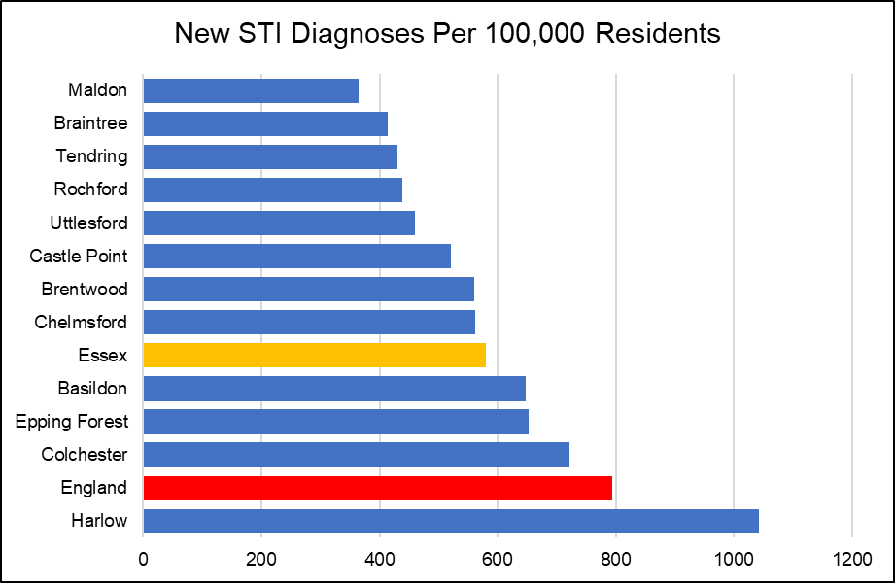

Chlamydia screening rates across Essex were lower than the national average (19.3%) in every area apart from in the Harlow (29.5%) local authority area which also had the highest proportion of new STI diagnoses in the county.

|  |  |  |  |  |
| --- | --- | --- | --- | --- |
|  | **New STI diagnoses (excluding chlamydia aged <25) / 100,000** | | **Chlamydia proportion aged 15-24 screened** | |
| **Value** | **Rank** | **%** | **Rank** |
| **Basildon** | 647.54 | 4 | 14.5 | 5 |
| **Braintree** | 414.14 | 11 | 12.5 | 11 |
| **Brentwood** | 560.57 | 6 | 13.2 | 8 |
| **Castle Point** | 520.65 | 7 | 12.4 | 12 |
| **Chelmsford** | 561.50 | 5 | 15.3 | 4 |
| **Colchester** | 721.10 | 2 | 18.2 | 2 |
| **Epping Forest** | 653.27 | 3 | 15.5 | 3 |
| **Harlow** | 1042.41 | 1 | 29.5 | 1 |
| **Maldon** | 364.71 | 12 | 13.1 | 9 |
| **Rochford** | 438.23 | 9 | 13.7 | 6 |
| **Tendring** | 430.44 | 10 | 13.1 | 10 |
| **Uttlesford** | 459.94 | 8 | 13.7 | 7 |
| **Essex** | 580.81 |  | 15.5 |  |
| **England** | 793.85 |  | 19.3 |  |

***Chlamydia***

In Basildon the rate of all chlamydia diagnoses among 15 to 24 year olds attending sexual health services was 1484.2 per 100,000 population aged 15 to 24. This was the third highest detection rate compared to the other Districts in Essex, but similar to that for the whole of Essex (1449.1) and lower than that for England (1881.9). This data is available by gender breakdown in the table below.

|  |  |  |  |  |  |  |
| --- | --- | --- | --- | --- | --- | --- |
| **Chlamydia detection rate / 100,000 aged 15-24** | **Persons** | | **Male** | | **Female** | |
| **Value** | **Rank** | **Value** | **Rank** | **Value** | **Rank** |
| **Basildon** | 1484.2 | 3 | 1000.3 | 4 | 1972.9 | 3 |
| **Braintree** | 1199.6 | 8 | 750.5 | 9 | 1689.1 | 7 |
| **Brentwood** | 1016 | 11 | 820.3 | 8 | 1192.8 | 12 |
| **Castle Point** | 1081.3 | 9 | 635.3 | 11 | 1564.5 | 8 |
| **Chelmsford** | 1266.8 | 6 | 836.3 | 7 | 1720.8 | 5 |
| **Colchester** | 2094.9 | 2 | 1564.1 | 2 | 2679.4 | 1 |
| **Epping Forest** | 1295.8 | 5 | 873.7 | 6 | 1711.8 | 6 |
| **Harlow** | 2444.9 | 1 | 2266 | 1 | 2641.3 | 2 |
| **Maldon** | 933.3 | 12 | 621.1 | 12 | 1279.5 | 11 |
| **Rochford** | 1262.2 | 7 | 1088.1 | 3 | 1444.2 | 9 |
| **Tendring** | 1320.6 | 4 | 897.4 | 5 | 1777.2 | 4 |
| **Uttlesford** | 1035 | 10 | 749.5 | 10 | 1351 | 10 |
| **Essex** | 1449.1 |  | 1049.8 |  | 1872.1 |  |

***HIV***

Among people aged 15 to 59 years in the Basildon District, the rate of those living with a diagnosed HIV infection and seen at HIV services was 1.67 per 1,000 population. This was the second highest rate compared across that of the other Districts in Essex, but similar to that for Essex as a whole (1.26) and England (2.32).

According to Public Health England, HIV late diagnosis is a CD4 cell count of less than 350 cells per mm3 among all new diagnoses with a CD4 cell count available within 91 days of diagnosis. In the Basildon area, the percentage of adults aged over 15 years with a HIV late diagnosis accessing HIV care was 30.44 over the three year period of 2015 - 2017. This was the second lowest compared across the other Districts in Essex with data available, and lower than that for the whole of Essex (44.52) and England (41.12). Values for Castle Point and Maldon were not disclosed.

***Other STIs***

The diagnoses rate of the first episode of gonorrhoea among people accessing sexual health services was 54.96 per 100,000 population in the Basildon District. This was the second highest rate compared to the other Essex Districts and higher than the rate across Essex as a whole (37.38), but lower than that for England (78.79).

**Substance Misuse**

***Smoking***

In the Basildon area in 2017, the prevalence of current smokers among persons aged over 18 years was 16.72. This was the third highest prevalence out of districts in Essex, and higher than that for Essex as a whole (13.84) and England (14.87).

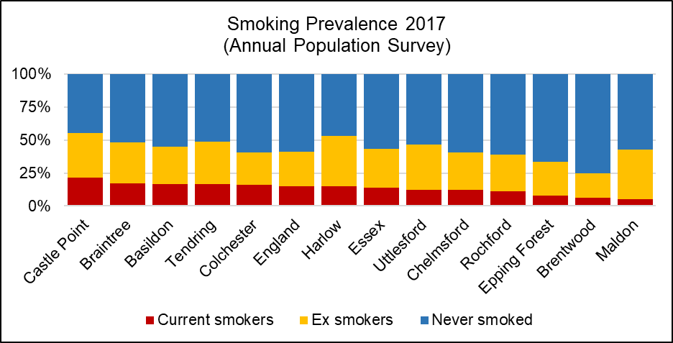Smoking attributable mortality in Basildon over the three year period of 2012 - 14 was estimated to be 315.07, of which 29.81 was due to heart disease. These were ranked as being the second and third highest, respectively, compared to the other Essex Districts. The smoking attributable mortality was also higher in Basildon than for that of Essex as a whole (258.24) and England (274.76).

Overall, it was estimated that 1331.95 potential years of life were lost due to smoking in Basildon in 2013 - 2015 alone.

*See table below for the ranked prevalence of current and previous smoking status across the Districts in Essex in 2017/18.*

|  |  |  |  |  |  |  |
| --- | --- | --- | --- | --- | --- | --- |
|  | **Smoking prevalence in adults by current and previous status (Annual Population Survey, 2017)** | | | | | |
| **Current smoker** | | **Ex-smoker** | | **Never-smoked** | |
| **%** | **Rank** | **%** | **Rank** | **%** | **Rank** |
| **Basildon** | 16.72 | 3 | 28.18 | 8 | 55.10 | 7 |
| **Braintree** | 17.15 | 2 | 31.19 | 6 | 51.65 | 9 |
| **Brentwood** | 6.48 | 11 | 18.37 | 12 | 75.15 | 1 |
| **Castle Point** | 21.48 | 1 | 33.89 | 4 | 44.62 | 12 |
| **Chelmsford** | 12.02 | 8 | 28.75 | 7 | 59.23 | 4 |
| **Colchester** | 15.99 | 5 | 24.80 | 11 | 59.20 | 5 |
| **Epping Forest** | 7.84 | 10 | 25.72 | 10 | 66.44 | 2 |
| **Harlow** | 14.81 | 6 | 38.19 | 1 | 47.01 | 11 |
| **Maldon** | 5.33 | 12 | 37.50 | 2 | 57.17 | 6 |
| **Rochford** | 10.98 | 9 | 28.02 | 9 | 61.00 | 3 |
| **Tendring** | 16.72 | 4 | 32.03 | 5 | 51.25 | 10 |
| **Uttlesford** | 12.33 | 7 | 34.38 | 3 | 53.29 | 8 |
| **Essex** | 13.84 | - | 29.51 | - | 56.65 | - |
| **England** | 14.87 | - | 26.17 | - | 58.96 | - |

***Alcohol***

Alcohol-related hospital admissions are defined as admissions where the primary and any secondary diagnoses are an alcohol-attributable code. According to Public Health England, the directly age standardised rate of alcohol-related hospital admissions in the Basildon area in 2017/18 was 2111.07 per 100,000 population, the 4th highest rate compared across the other Districts in Essex.

The directly age standardised rate per 100,000 population of alcohol-related mortality was estimated to be 46.31 in Basildon in 2017. This was the second highest rate compared to the other districts in Essex, but similar to that of Essex as a whole (41.90) and England (46.15).

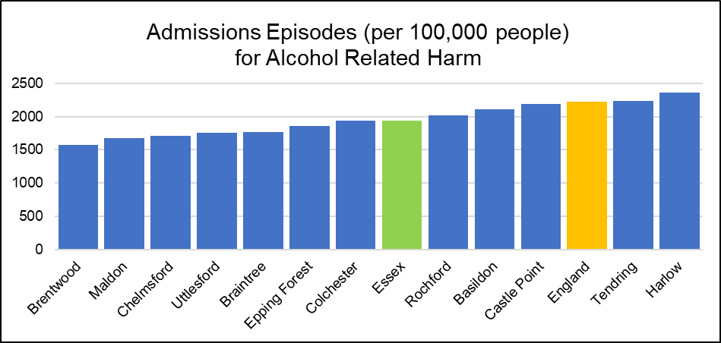

***Drug Use***

In Basildon from 2015-17 there were 9 recorded deaths attributed directly to drug misuse, the joint third lowest number in Essex out of a total of 150 for the whole area. The sample size needed to calculate the standardised mortality rate for deaths from drugs misuse per 100,000 population was too small for this area *(plus 5 others)*, thus was lower than the average rate for England (4.33 per 100,000) or Essex (3.63 per 100,000).

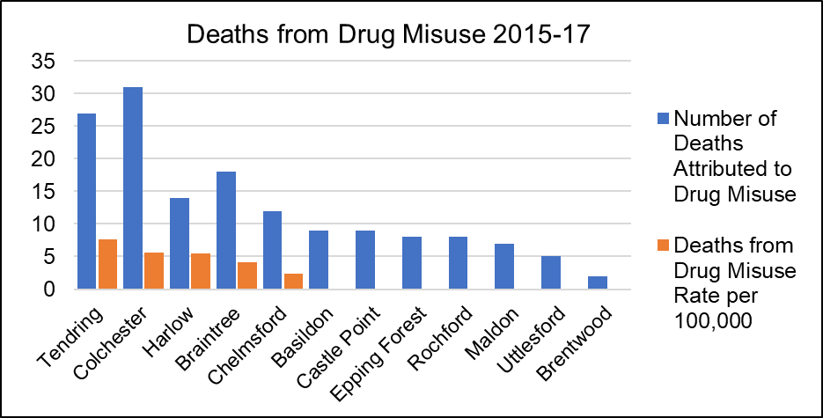

|  |  |  |  |  |  |  |
| --- | --- | --- | --- | --- | --- | --- |
|  | **Alcohol and Drugs** | | | | | |
| **Alcohol-related hospital admission rate per 100K** | | **Alcohol mortality** | | **Deaths from drug misuse** | |
| Value | Rank | Value | Rank | Count | Rate Per 100K |
| **Basildon** | 2111.07 | 4 | 46.31 | 2 | 9 | * |
| **Braintree** | 1761.831 | 8 | 41.66 | 4 | 18 | 4.19 |
| **Brentwood** | 1576.501 | 12 | 39.80 | 6 | 2 | * |
| **Castle Point** | 2194.25 | 3 | 39.46 | 7 | 9 | * |
| **Chelmsford** | 1713.9 | 10 | 38.26 | 8 | 12 | 2.33 |
| **Colchester** | 1934.702 | 6 | 40.12 | 5 | 31 | 5.59 |
| **Epping Forest** | 1856.899 | 7 | 35.50 | 10 | 8 | * |
| **Harlow** | 2360.043 | 1 | 44.38 | 3 | 14 | 5.51 |
| **Maldon** | 1675.22 | 11 | 37.67 | 9 | 7 | * |
| **Rochford** | 2022.617 | 5 | 32.49 | 12 | 8 | * |
| **Tendring** | 2237.576 | 2 | 61.49 | 1 | 27 | 7.60 |
| **Uttlesford** | 1749.756 | 9 | 33.78 | 11 | 5 | * |
| **Essex** | 1935.651 | - | 41.90 | - | 150 | 3.63 |
| **England** | 2223.806 | - | 46.15 | - | 6996 | 4.33 |

*value cannot be calculated as number of cases too small

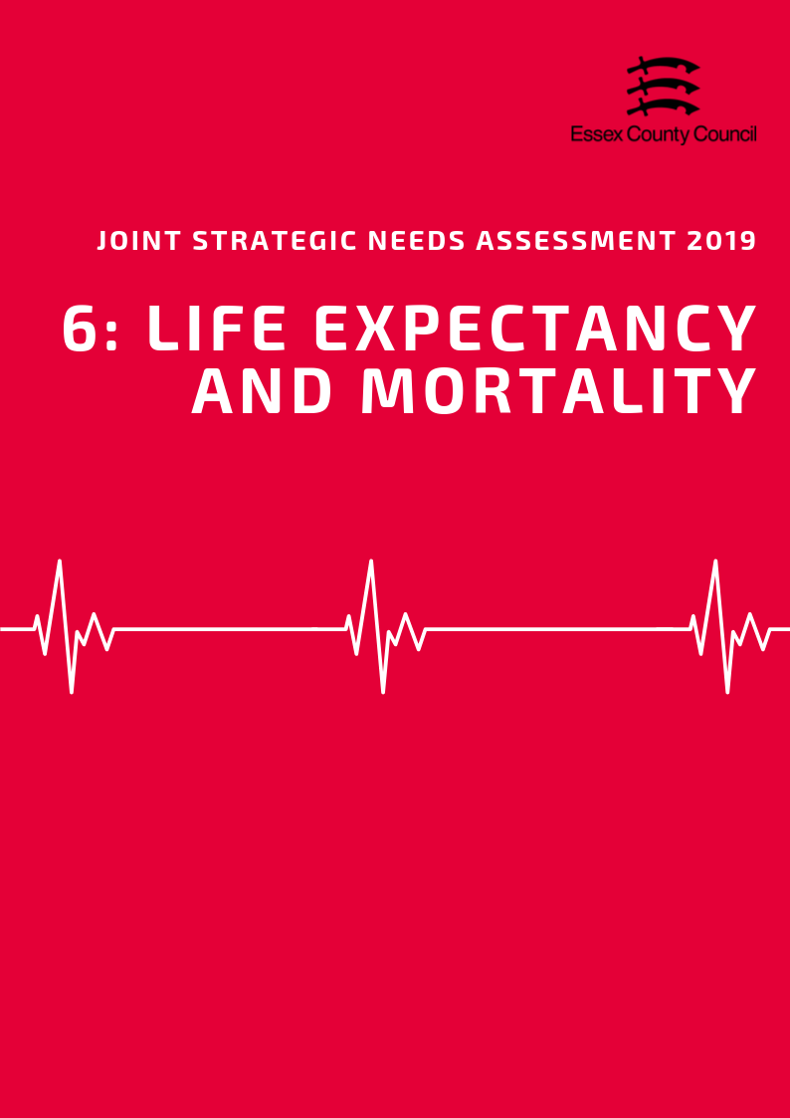

**LIFE EXPECTANCY & MORTALITY**

***Life Expectancy***

*Life Expectancy at Birth*

The average life expectancy at birth for a child born in Basildon (2015-2017) was 82.7 years for females and 79.6 years for males. This is lower than the average for England for females (83.1 years) and the same for males (79.6 years) and is the second lowest life expectancy for females and fourth lowest for males in Essex. In this area, it estimated that the inequality in life expectancy at birth between most and least deprived areas is an average of 7.5 years for females and 9.6 years for males, higher than the average number of years for Essex (6 and 7.7) and England (7.4, 9.4).

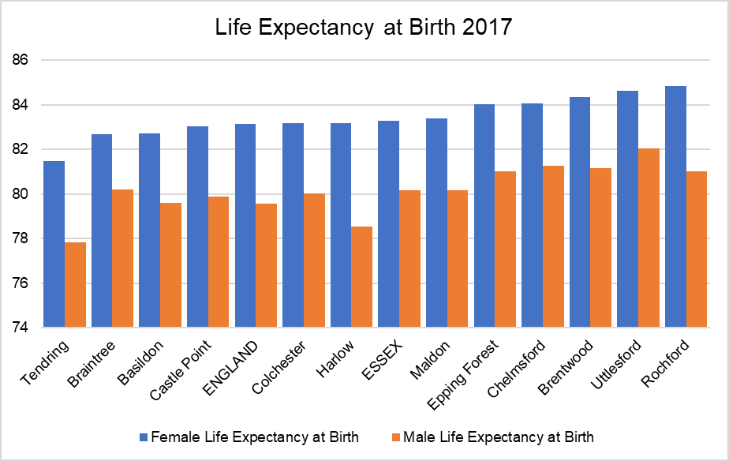

*Life Expectancy at 65*

During the same period, life expectancy at age 65 (the number of additional years a person could expect to live) was 21.1 years for females and 18.6 years for males; this is similar to the England average for females (21.1 years), but just below for males (18.8 years). Like life expectancy at birth, life expectancy at age 65 can vary considerably between the most and least deprived areas with an estimated gap of 4 years for females and 5.1 years for males.

*Life Expectancy estimates for each lower tier local authority area at birth and at age 65 are set out in the table below:*

|  |  |  |  |  |  |  |  |  |  |
| --- | --- | --- | --- | --- | --- | --- | --- | --- | --- |
|  | **Female Life Expectancy** | | | |  | **Male Life Expectancy** | | | |
| **At 65** | **At birth** | **Inequality in LE** | |  | **At 65** | **At birth** | **Inequality in LE** | |
| **At 65** | **At Birth** |  | **At 65** | **At Birth** |
| **England** | **21.1** | **83.1** | **4.5** | **7.4** |  | **18.8** | **79.6** | **4.9** | **9.4** |
| **Essex** | **21.2** | **83.3** | **3.2** | **6** |  | **18.9** | **80.2** | **4.2** | **7.7** |
| Basildon | 21.1 | 82.7 | 4 | 7.5 |  | 18.6 | 79.6 | 5.1 | 9.6 |
| Braintree | 20.6 | 82.7 | 2.1 | 5 |  | 18.7 | 80.2 | 2.4 | 5.5 |
| Brentwood | 21.6 | 84.3 | 5.1 | 7 |  | 19.4 | 81.2 | 5.9 | 9.9 |
| Castle Point | 20.8 | 83.0 | 2.6 | 4.3 |  | 18.4 | 79.9 | 3.6 | 6 |
| Chelmsford | 21.6 | 84.0 | 2.7 | 4.5 |  | 19.8 | 81.3 | 3.3 | 6 |
| Colchester | 21.1 | 83.2 | 4.7 | 7.8 |  | 18.8 | 80.0 | 4.7 | 7.5 |
| Epping Forest | 21.1 | 84.0 | 3.3 | 5.6 |  | 19.1 | 81.0 | 4.1 | 6.6 |
| Harlow | 21.3 | 83.2 | 2.6 | 5.1 |  | 18.3 | 78.5 | 5.3 | 7.8 |
| Maldon | 21.7 | 83.4 | 1.9 | 2.3 |  | 19.0 | 80.2 | 1.9 | 3.9 |
| Rochford | 21.9 | 84.8 | 2.6 | 4.4 |  | 19.1 | 81.0 | 2.8 | 3.2 |
| Tendring | 20.6 | 81.5 | 4 | 7 |  | 18.2 | 77.8 | 4.5 | 10.8 |
| Uttlesford | 22.0 | 84.6 | 0.6 | -0.3 |  | 20.0 | 82.1 | 1.9 | 2.2 |

***Mortality***

In 2017 the Basildon area had an all ages mortality rate of 966.9 deaths per 100,000 residents, based on 1589 deaths recorded during that time period. This overall mortality rate was higher than the England average of 958.7 (per 100K) but was a slight decrease compared the previous year (980.2 per 100K). Looking at mortality rates across the different age groups, 37.6% of all deaths during this period were from residents aged 85 years and over with an age standardised mortality rate of 14674.5 per 100K (based 598 actual deaths). This was lower than the England (40.4%, 15280.8 per 100K) and the Essex average (43.3%, 16031.7 per 100K), whereas all younger age groups had mortality rates which were higher the national average.

*Premature Mortality*

Basildon has the third highest rate of all premature mortalities in Essex with a rate of 336 deaths per 100,000 residents under the age of 75. This is similar to the average for England (332), 8.63% higher than the average for the county, and 24.86% higher than the best performing area (Uttlesford). Although the rate of under 75 mortality for all causes is only slightly above the national average, Female residents in Basildon have a worst under rate of under 75 mortality (281 per 100,000) compared to the national average (264 per 100,000) whilst male residents have a slightly lower rate (398 vs 403 per 100,000).

The top three biggest causes of premature Mortality in the Basildon District in 2015-17 were cancer (157 per 100,000) cardiovascular diseases (70.9 per 100,000) and respiratory diseases (33.1 per 100,000) however only mortality rates for cancer (for both male and female residents were actually higher than the average for England (136 per 100,000).

*Premature Deaths from Cancer*

Premature rates of mortality from all cancers in Basildon (157 per 100,000) is significantly higher than the average for Essex (131) and England (135) for both female and male residents under the age of 75. This is the highest rate of all premature mortality from cancer of all 12 Local Authority areas in Essex. Public health England estimates that in 2017 that just 50.8% of cancer cases were diagnosed at early (either stage 1 or 2) in this area, lower than the England (52.2%) and Essex (53.3%) and were the lowest levels in the county compared to the other districts and boroughs.

Colorectal cancer was one of the most common cause of premature deaths by cancer with 61 deaths recorded in 2015/17, equivalent to a rate pf 13.8 per 100,000 residents, slightly above the rate for England (12 per 100,000). An issue specifically affecting female residents in Essex is the rate of deaths from breast cancer in the under 75 age group with 44 premature deaths for women recorded. This was equivalent to a rate of 18.4 per 100,000 people compared to the England baseline of 20.6 and was also higher than average in 8 out of the 12 districts and boroughs in the county (See table below). The percentage of eligible women in the Basildon area who were screened adequately for breast cancer within the previous three years (from 31st March 2018) has reached its lowest level since 2010, with a rate of just 69.3% in 2018 compared to 73.6% in 2010. This is worse than the average for England in 2018 (74.9%) and was the second lowest level of screening in Essex (Highest: Uttlesford = 78.7%; Lowest: Maldon = 57.3%).

***Preventable Mortality***

*According to Public Health England, "preventable mortality is that deaths are considered preventable if, in the light of the understanding of the determinants of health at the time of death, all or most deaths from the underlying cause (subject to age limits if appropriate)*

In the period of 2015-2017 it is estimated that 881 deaths for all age groups or 18.6% of all deaths that occurred in the Basildon area were preventable. This is equivalent to a rate of 177 per 100,000 people, lower than the rate (181.5) and percentage (18.9%) for England but a slight increase on the previous year. Males were 39% more likely to die from a preventable cause (SMR= 224.2 per 100K) compared to females (SMR= 136.2 per 100K) during the same period.

For the under 75 age group Cancer was the largest cause of preventable mortality with a rate of 82.8 preventable deaths per 100,000 for all persons. This was higher than the England baseline (82.8) and the rate for Essex (74.2) and was higher than average for both males (90.4) and females (75.9) individually. Cardiovascular disease was the next largest preventable cause with a combined rate of 41.9 per 100,000 for both sexes, however the rate for all persons and the rate for each sex individually were all below the national average for the latest time period.

Females in the Basildon area also had a higher than average rate for preventable deaths from liver disease an estimated 14.5 deaths per 100,000. This female-only rate was higher than both the average for females nationally (11.1) and the rate for males (12.9) in the same area.

|  |  |  |  |  |  |  |  |  |  |  |
| --- | --- | --- | --- | --- | --- | --- | --- | --- | --- | --- |
|  | **Mortality Rates for All Persons** | | | | | | | | | |
|  | **Under 75 mortality from colorectal cancer** | **Under 75 mortality rate from all cardiovascular diseases** | **Under 75 mortality rate from all causes** | **Under 75 Mortality rate from breast cancer** | **Under 75 mortality rates from cancer** | **Under 75 mortality rates from heart disease** | **Under 75 mortality rates from injuries** | **Under 75 mortality rates from liver disease** | **Under 75 mortality rates from respiratory disease** | **Under 75 mortality rates from stroke** |
| **England** | **11.97** | **72.50** | **331.95** | **10.60** | **134.59** | **38.72** | **12.78** | **18.51** | **34.26** | **13.08** |
| **Essex** | **11.32** | **62.56** | **307.35** | **11.22** | **131.18** | **31.57** | **10.20** | **14.68** | **30.76** | **11.73** |
| Basildon | 13.82 | 70.92 | 336.39 | 9.81 | 157.15 | 35.80 | 7.39 | 15.06 | 33.14 | 13.42 |
| Braintree | 9.61 | 65.40 | 310.64 | 14.10 | 132.10 | 34.11 | 11.18 | 13.98 | 27.49 | 13.47 |
| Brentwood | 11.37 | 48.51 | 265.73 | 8.77 | 119.54 | 24.19 | 7.54 | 13.63 | 26.70 | 7.89 |
| Castle Point | 11.75 | 66.34 | 313.33 | 14.03 | 141.84 | 32.15 | 8.67 | 14.13 | 32.70 | 13.16 |
| Chelmsford | 10.17 | 54.03 | 272.91 | 11.22 | 119.76 | 28.45 | 9.85 | 11.26 | 24.02 | 10.46 |
| Colchester | 8.66 | 56.64 | 298.36 | 8.88 | 122.23 | 29.44 | 12.54 | 15.99 | 34.37 | 10.51 |
| Epping Forest | 8.76 | 52.34 | 276.80 | 12.69 | 121.43 | 25.31 | 9.88 | 13.81 | 28.24 | 10.55 |
| Harlow | 8.36 | 91.62 | 356.97 | 10.82 | 127.68 | 48.42 | 12.35 | 13.82 | 40.82 | 17.71 |
| Maldon | 16.10 | 61.97 | 297.26 | 13.50 | 126.61 | 31.51 | 17.62 | 14.29 | 23.06 | 11.74 |
| Rochford | 10.33 | 49.03 | 263.54 | 10.20 | 120.80 | 20.34 |  | 9.21 | 21.59 | 6.15 |
| Tendring | 15.21 | 79.58 | 400.31 | 11.80 | 149.39 | 37.51 | 17.86 | 25.26 | 45.35 | 15.68 |
| Uttlesford | 10.45 | 52.83 | 252.76 | 9.45 | 113.08 | 30.85 | 5.47 | 13.50 | 23.93 | 8.65 |

|  |  |  |  |  |  |  |  |  |  |  |
| --- | --- | --- | --- | --- | --- | --- | --- | --- | --- | --- |
|  | **Mortality Rates for Female Residents** | | | | | | | | | |
| **Under 75 mortality from colorectal cancer** | **Under 75 mortality rates from all cardiovascular diseases** | **Under 75 mortality rates from all causes** | **Under 75 Mortality rates from breast cancer** | **Under 75 mortality rates from cancer** | **Under 75 mortality rates from heart disease** | **Under 75 mortality rates from injuries** | **Under 75 mortality rates from liver disease** | **Under 75 mortality rates from respiratory disease** | **Under 75 mortality rates from stroke** |
| **England** | **9.36** | **45.22** | **264.13** | **20.59** | **120.68** | **18.46** | **7.08** | **12.97** | **28.98** | **11.33** |
| **Essex** | **9.54** | **37.62** | **250.12** | **21.53** | **120.61** | **14.03** | **6.34** | **11.49** | **25.44** | **9.69** |
| Basildon | 10.31 | 44.80 | 280.68 | 18.43 | 143.66 | 17.14 |  | 15.78 | 29.86 | 11.47 |
| Braintree | 6.45 | 41.03 | 259.69 | 27.49 | 125.03 | 15.85 | 6.64 | 9.85 | 23.61 | 12.05 |
| Brentwood | 12.08 | 28.51 | 217.07 | 17.08 | 106.45 |  |  | 14.93 | 22.74 |  |
| Castle Point | 11.60 | 37.02 | 255.09 | 27.15 | 135.91 | 12.14 |  | 12.61 | 25.47 | 8.02 |
| Chelmsford | 9.30 | 32.79 | 220.20 | 21.76 | 112.36 | 12.28 | 5.47 | 5.98 | 20.98 | 7.20 |
| Colchester | 8.27 | 33.63 | 231.45 | 16.34 | 100.83 | 13.04 | 10.20 | 10.54 | 25.83 | 10.54 |
| Epping Forest | 6.03 | 31.76 | 230.83 | 24.42 | 106.93 | 11.46 | 8.94 | 9.38 | 25.44 | 8.78 |
| Harlow |  | 48.16 | 256.41 | 20.81 | 108.86 | 21.88 |  | 12.50 | 30.63 | 14.90 |
| Maldon | 14.24 | 33.27 | 254.87 | 26.60 | 133.30 | 13.33 | 13.36 |  | 19.54 |  |
| Rochford | 10.67 | 26.76 | 213.16 | 19.72 | 113.43 | 9.14 |  | 7.50 | 13.51 |  |
| Tendring | 10.64 | 50.97 | 320.64 | 22.03 | 133.00 | 17.01 | 7.67 | 20.63 | 37.80 | 15.13 |
| Uttlesford | 14.23 | 34.52 | 221.05 | 18.54 | 124.54 | 14.97 |  | 11.93 | 17.59 |  |

|  |  |  |  |  |  |  |  |  |  |  |
| --- | --- | --- | --- | --- | --- | --- | --- | --- | --- | --- |
|  | **Mortality Rates for Male Residents** | | | | | | | | | |
| **Under 75 mortality from colorectal cancer** | **Under 75 mortality rates from all cardiovascular diseases** | **Under 75 mortality rates from all causes** | **Under 75 Mortality rates from breast cancer** | **Under 75 mortality rates from cancer** | **Under 75 mortality rates from heart disease** | **Under 75 mortality rates from injuries** | **Under 75 mortality rates from liver disease** | **Under 75 mortality rates from respiratory disease** | **Under 75 mortality rates from stroke** |
| **England** | **14.74** | **101.25** | **403.22** | **0.16** | **149.57** | **60.09** | **18.56** | **24.30** | **39.90** | **14.93** |
| **Essex** | **13.24** | **89.42** | **368.93** |  | **142.83** | **50.47** | **14.20** | **18.10** | **36.54** | **13.93** |
| Basildon | 17.81 | 99.62 | 397.73 |  | 172.39 | 56.22 | 11.82 | 14.36 | 36.87 | 15.54 |
| Braintree | 13.02 | 91.43 | 364.90 |  | 139.74 | 53.66 | 15.89 | 18.39 | 31.54 | 14.99 |
| Brentwood | 10.55 | 69.95 | 317.48 |  | 133.43 | 43.71 |  | 12.22 | 30.95 |  |
| Castle Point | 12.06 | 98.06 | 377.12 |  | 149.35 | 53.77 | 13.49 | 15.71 | 40.68 | 18.99 |
| Chelmsford | 11.13 | 77.03 | 329.61 |  | 128.28 | 45.96 | 14.34 | 16.89 | 27.24 | 14.00 |
| Colchester | 9.00 | 81.61 | 371.09 |  | 145.81 | 47.24 | 15.05 | 21.98 | 43.84 | 10.44 |
| Epping Forest | 11.70 | 74.50 | 326.33 |  | 137.14 | 40.29 | 10.87 | 18.58 | 31.31 | 12.39 |
| Essex | 13.24 | 89.42 | 368.93 |  | 142.83 | 50.47 | 14.20 | 18.10 | 36.54 | 13.93 |
| Harlow | 12.24 | 139.51 | 468.88 |  | 149.33 | 78.10 | 20.15 | 15.19 | 52.91 | 20.54 |
| Maldon | 17.94 | 91.25 | 341.00 |  | 119.81 | 50.07 | 21.78 | 21.79 | 26.56 | 17.01 |
| Rochford | 10.07 | 73.13 | 317.49 |  | 128.69 | 32.39 |  | 11.08 | 30.51 | 10.28 |
| Tendring | 20.24 | 111.07 | 488.75 |  | 167.63 | 60.01 | 28.97 | 30.42 | 53.80 | 16.34 |
| Uttlesford |  | 71.35 | 284.31 |  | 101.11 | 46.90 |  | 15.01 | 30.38 | 9.84 |

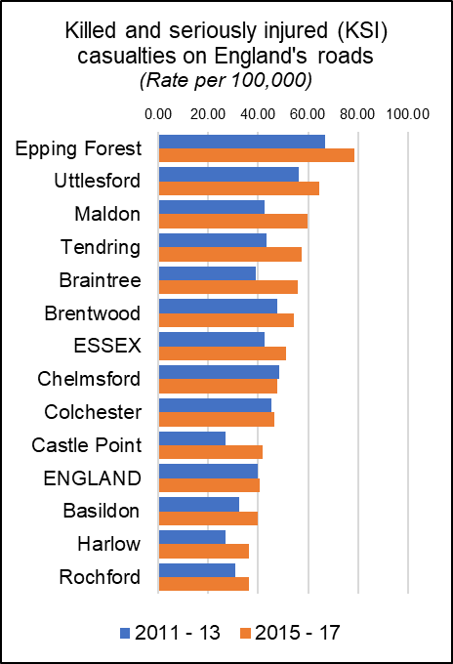***Killed and Seriously Injured in Road Traffic Accidents***

The rate of people killed or seriously injured on England’s roads has risen is recorded as a rate per 100,000 population (all ages) over a three year period. During the last recorded period (2015-17) the average rate for Essex (51.28) was higher than the average for England (40.8) with nine out of 12 Districts having rates above the national average.

Basildon along with 3 other areas, (Rochford (36.2) and Harlow (36.5)) had a rate below he England and county average in 2015-17 and has also been consistently below the national and county average for the last five periods. Despite this lower than average rate of KSIs, levels in Basildon have increased by 7.25 per 100K or 22.3% since 2011-13. This increase is slightly higher than the average increase for Essex as a whole (20%) and more than increase observed at the England level (2.7%).

*KSI rates for all areas & over time are set out in the table below.*

|  |  |  |  |  |  |  |  |  |
| --- | --- | --- | --- | --- | --- | --- | --- | --- |
|  | **Killed and seriously injured (KSI) casualties on England's roads** | | | | |  | **20111 Change** | |
| 2011 - 13 | 2012 - 14 | 2013 - 15 | 2014 - 16 | 2015 - 17 | Rate (per 100K) | % |
| Epping Forest | 66.93 | 70.35 | 67.73 | 75.81 | 78.76 | 11.83 | 17.7% |
| Uttlesford | 56.24 | 50.80 | 48.37 | 55.16 | 64.51 | 8.27 | 14.7% |
| Maldon | 42.51 | 42.86 | 43.52 | 57.83 | 59.92 | 17.41 | 41.0% |
| Tendring | 43.35 | 39.80 | 40.60 | 45.84 | 57.43 | 14.08 | 32.5% |
| Braintree | 39.09 | 40.45 | 43.09 | 51.37 | 55.76 | 16.67 | 42.7% |
| Brentwood | 47.66 | 47.28 | 45.23 | 54.10 | 54.28 | 6.62 | 13.9% |
| **ESSEX** | **42.74** | **42.21** | **42.47** | **48.18** | **51.28** | **8.55** | **20.0%** |
| Chelmsford | 48.61 | 43.25 | 44.49 | 45.74 | 47.65 | -0.96 | -2.0% |
| Colchester | 45.41 | 42.89 | 44.02 | 46.51 | 46.54 | 1.14 | 2.5% |
| Castle Point | 26.83 | 28.97 | 32.99 | 39.24 | 41.97 | 15.14 | 56.4% |
| **ENGLAND** | **39.71** | **39.26** | **38.50** | **39.70** | **40.80** | **1.09** | **2.7%** |
| Basildon | 32.48 | 36.98 | 35.79 | 39.02 | 39.72 | 7.25 | 22.3% |
| Harlow | 26.97 | 21.97 | 24.03 | 31.25 | 36.49 | 9.52 | 35.3% |
| Rochford | 30.99 | 34.94 | 32.23 | 39.52 | 36.17 | 5.18 | 16.7% |
| Number of people reported killed or seriously injured (KSI) on the roads, all ages, per 100,000 resident population | | | | | | | | |

***Excess Winter Deaths***

Excess Winter Deaths Index (EWD Index) is the excess winter deaths measured as the ratio of extra deaths from all causes that occur in the winter months compared with the expected number of deaths, based on the average of the number of non-winter deaths. The Excess Winter Deaths Index is calculated as the number of excess winter deaths divided by the average non-winter deaths expressed as a percentage.

**According to the Office of National Statistics…**

*“Colder than average temperatures for the winter months of 2017 to 2018 may partially explain the increase in winter deaths. However, previous years demonstrate a weak relationship between temperature and EWD. Increased EWD are not always coupled with unusually cold winters and conversely winters with decreased EWD are not always coupled with milder winter temperatures, indicating factors other than temperature, such as influenza, are also relevant in explaining trends in excess winter mortality (EWM).”\**

Between August 2014 and July 2017, the three year average rate of Excess Deaths for all ages in Basildon was 19.4%, slightly lower than the average for England (21.9%) and the average for Essex (23.3%) and the third lowest level compared to the other Districts in the county (Highest: Uttlesford = 30.1%; Lowest: Brentwood = 9.3%).

Looking at the level of Excess Winter Deaths specifically in the over 85s age group shows a higher level with a rate of 34.5% Excess Winter Deaths for this age group during the same period. This is higher than the England rate of 29.3% and the county average of 31.7% and is the 7th lowest level in Essex (Highest: Maldon = 39.5%; Lowest: Brentwood 14.5%). A breakdown of the levels of Excess Winter Deaths for each district can be found in the table below.

|  |  |  |  |  |
| --- | --- | --- | --- | --- |
|  | ***Excess winter deaths index (3 years, age 85+) Percentage*** | ***Essex rank (lowest to Highest)*** | ***Excess winter deaths index (3 years, all ages) Percentage*** | ***Essex rank (lowest to Highest)*** |
| **England** | **29.3** |  | **21.1** |  |
| **Essex** | **31.7** |  | **23.3** |  |
| Basildon | 34.5 | 7 | 19.4 | 3 |
| Braintree | 30.9 | 3 | 26.1 | 9 |
| Brentwood | 14.5 | 1 | 9.3 | 1 |
| Castle Point | 37.7 | 10 | 27.2 | 11 |
| Chelmsford | 22.2 | 2 | 22.2 | 6 |
| Colchester | 36.8 | 9 | 25.4 | 7 |
| Epping Forest | 31.8 | 4 | 25.5 | 8 |
| Harlow | 35.2 | 8 | 22.1 | 5 |
| Maldon | 39.5 | 12 | 17.4 | 2 |
| Rochford | 32.2 | 5 | 21.5 | 4 |
| Tendring | 32.7 | 6 | 26.1 | 10 |
| Uttlesford | 38.5 | 11 | 30.1 | 12 |

*[*https://www.ons.gov.uk/peoplepopulationandcommunity/birthsdeathsandmarriages/deaths/bulletins/excesswintermortalityinenglandandwales/2017to2018provisionaland2016to2017final*](https://www.ons.gov.uk/peoplepopulationandcommunity/birthsdeathsandmarriages/deaths/bulletins/excesswintermortalityinenglandandwales/2017to2018provisionaland2016to2017final)

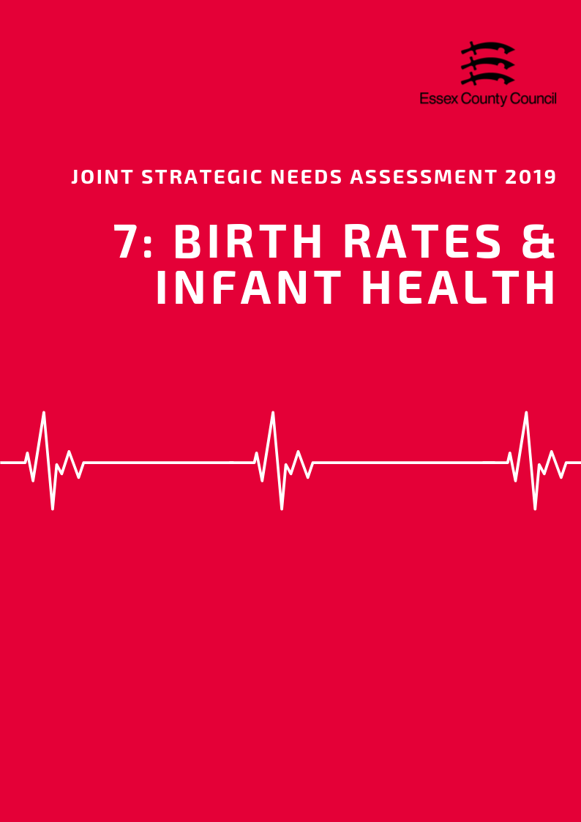

**Birth Rates & Infant Health**

***Birth Rates***

According to the Office for National Statistics, the Crude Birth Rate (CBR; all births per 1,000 population) was 13.50 in Basildon in 2017. This was the second highest CBR compared to the other Districts in Essex and was is higher than the CBR for Essex as a whole (11.4) and for England (12.0).

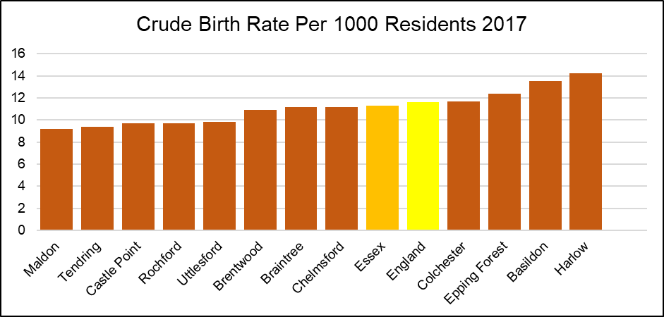

Over 2013 to 2017, the CBR fluctuated but has overall remained similar with a CBR of 13.6 in 2013 and 13.5 in 2017. *The Table below provides the ranked CBR in each district in each year from 2013 to 2017*

|  |  |  |  |  |  |  |  |  |  |  |
| --- | --- | --- | --- | --- | --- | --- | --- | --- | --- | --- |
|  | **Year** | | | | | | | | | |
| **2013** | | **2014** | | **2015** | | **2016** | | **2017** | |
| **CBR** | **Rank** | **CBR** | **Rank** | **CBR** | **Rank** | **CBR** | **Rank** | **CBR** | **Rank** |
| **England** | **12.3** | **-** | **12.2** | **-** | **12.1** | **-** | **12.0** | **-** | **11.6** | **-** |
| **Essex** | **11.3** | **-** | **11.5** | **-** | **11.3** | **-** | **11.4** | **-** | **11.3** | **-** |
| Basildon | 13.6 | 2 | 13.4 | 2 | 13.5 | 2 | 13.6 | 2 | 13.5 | 2 |
| Braintree | 11.1 | 5 | 11.0 | 7 | 10.7 | 7 | 11.4 | 6 | 11.2 | 5 |
| Brentwood | 11.1 | 6 | 11.6 | 4 | 11.7 | 5 | 11.1 | 7 | 10.9 | 7 |
| Castle Point | 9.0 | 10 | 9.7 | 10 | 9.5 | 9 | 9.6 | 9 | 9.7 | 9 |
| Chelmsford | 10.9 | 7 | 11.4 | 6 | 10.9 | 6 | 11.7 | 5 | 11.2 | 6 |
| Colchester | 12.4 | 3 | 12.4 | 3 | 12.2 | 4 | 11.8 | 4 | 11.7 | 4 |
| Epping Forest | 12.2 | 4 | 11.5 | 5 | 12.5 | 3 | 12.2 | 3 | 12.4 | 3 |
| Harlow | 14.6 | 1 | 16.1 | 1 | 14.3 | 1 | 15.2 | 1 | 14.2 | 1 |
| Maldon | 8.8 | 11 | 8.5 | 12 | 9.2 | 11 | 8.4 | 12 | 9.2 | 12 |
| Rochford | 8.4 | 12 | 9.4 | 11 | 8.8 | 12 | 8.8 | 11 | 9.7 | 10 |
| Tendring | 9.7 | 9 | 9.8 | 9 | 9.5 | 10 | 9.0 | 10 | 9.4 | 11 |
| Uttlesford | 9.9 | 8 | 10.9 | 8 | 10.5 | 8 | 10.7 | 8 | 9.8 | 8 |

***Birth rates by age of mother***

The rate of births per 1,000 population among females aged under 20 years was the second highest in Basildon compared to the other Districts in Essex in 2016, and higher than that for Essex as a whole (11.9) and England (13.5).

The rate of births per 1,000 population among females aged 20 - 24 years was the second highest in Basildon compared to the other Districts in Essex in 2016, and higher than that for Essex as a whole (57.3) and for England (55.6).

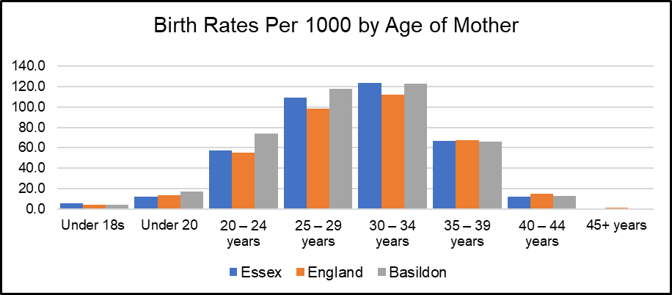

*See Table 2 for birth rates by age of mother for each Essex District*

***Under 18 Conceptions and Births***

The rate of conceptions in women aged under 18 years per 1,000 females aged 15 to 17 years in the Basildon area was 23.4 in 2016. This was the 3rd highest compared to the other Districts in Essex, and significantly higher than that for Essex as a whole (16.7) and for England (18.8).

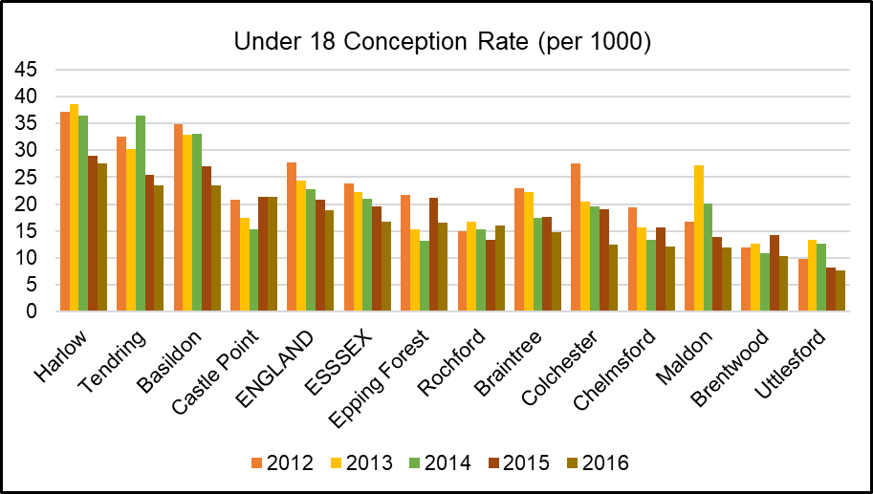

The rate of live births in women aged under 18 per 1,000 females aged 15 to 17 years was 4.11 in Basildon in 2016, the 6th highest compared across the other Districts in Essex.

|  |  |  |  |  |  |  |  |  |
| --- | --- | --- | --- | --- | --- | --- | --- | --- |
|  | **Birth Rates (per 1000) by Age of Mother** | | | | | | | |
| **Under 18s** | **Under 20** | **20-24 years** | **25-29 years** | **30-34 years** | **35-39 years** | **40-44 years** | **45+ years** |
| **Essex** | **5.6** | **11.9** | **57.3** | **109.2** | **123.9** | **66.7** | **12.4** | **1** |
| **England** | **4.6** | **13.5** | **55.6** | **98.5** | **112.4** | **67.5** | **14.9** | **1.1** |
| Basildon | 4.1 | 17 | 73.9 | 117.9 | 122.5 | 66.3 | 13 | - |
| Braintree | 7.2 | 12.7 | 70.3 | 120.8 | 115.1 | 61 | 12.8 | 0.7 |
| Brentwood | 3.0 | 7.5 | 36 | 90.7 | 145.4 | 77.4 | 14 | 1 |
| Castle Point | 3.8 | 10.1 | 51.2 | 110.4 | 126.5 | 62.1 | 7.7 | 1.2 |
| Chelmsford | 3.1 | 10.4 | 43.3 | 105.1 | 124.8 | 73 | 14.6 | 1.1 |
| Colchester | 3.4 | 11.4 | 52.1 | 93 | 111.4 | 61.9 | 11.7 | 1.7 |
| Epping Forest | 4.2 | 8.6 | 45 | 98.8 | 145.5 | 77.8 | 14.5 | 1 |
| Harlow | 8.5 | 16.2 | 72.4 | 137.5 | 116.8 | 69.3 | 15.4 | 2.7 |
| Maldon | 2.8 | 8.3 | 61.9 | 100.8 | 122.4 | 60.8 | 6.3 | - |
| Rochford | 5.3 | 7.9 | 32.4 | 105.3 | 128.2 | 53.5 | 12.3 | - |
| Tendring | 8.1 | 18.8 | 88.4 | 132.6 | 101.7 | 46.8 | 9.4 | - |
| Uttlesford | 1.9 | 6.2 | 47.1 | 93.7 | 151.1 | 85.9 | 13.2 | 1.4 |

**INFANT HEALTH**

***Premature Births***

Premature births are live or still births at a gestational age of less than 37 weeks. The rate of premature births per 1,000 total live and still births in the Basildon area was 79.05 over the 3 year period of 2014 - 2016. This was the 4th highest rate compared to the other Districts in Essex and slightly higher than that for Essex as a whole (74.69), but similar to that for England (79.52).

***Low Birth Weight***

Low birth weight is defined as a live birth with a recorded weight under 2500g and gestational age of at least 37 weeks. In the Basildon area in 2016, the percentage of low birth weight out of all live births with a recorded weight (and gestational age >=37 weeks) was 2.52. This was the second highest out of the other Districts in Essex, but similar to that for Essex as a whole (2.11) and England (2.79).

***Infant Mortality***

According to Public Health England, the rate of infant mortality aged under 1 years old was 2.83 per 1,000 live births in the Basildon area over the period 2015 - 2017. This was the 9th highest compared to the other districts of Essex, and lower than that for the whole of Essex (3.10) and England (3.92).

***Breastfeeding Initiation***

Breastfeeding initiation is mothers giving their babies breast milk in the first 48 hours after delivery. The percentage of breastfeeding initiation of the total number of maternities in the Basildon area in 2016/17 was 68.02%. This was the lowest level compared across the Essex Districts with data available, and significantly lower than that for the whole of Essex (75.02) and England (74.49).

***Smoking at The Time of Delivery***

The percentage of mothers known to be smokers at the time of delivery was 11.82% in the Basildon area in 2017/18. This was the joint second highest (with Brentwood) compared across the other Districts in Essex, and slightly higher than that for Essex as a whole (10.60) and England (10.80).

*All of the infant health datasets mentioned in this section is set out in table below:*

|  |  |  |  |  |  |
| --- | --- | --- | --- | --- | --- |
|  | **Premature births (less than 37 weeks gestation) Per 1000** | **Low birth weight of term babies (%)** | **Infant mortality (per 1000)** | **Breast Feeding Initiation (%)** | **Smoking status at time of delivery (%)** |
| **England** | 79.52 | 2.79 | 3.92 | 74.49 | 10.80 |
| **Essex** | 74.69 | 2.11 | 3.10 | 75.02 | 10.6 |
| Basildon | 79.05 | 2.52 | 2.83 | 68.02 | 11.82 |
| Braintree | 73.88 | 2.32 | 3.19 | 70.82 | 7.76 |
| Brentwood | 62.79 | 2.03 | 1.56 | 76.56 | 11.82 |
| Castle Point | 91.76 | 1.92 | 1.94 | 75.70 | 6.25 |
| Chelmsford | 65.68 | 1.67 | 3.06 | 77.55 | 7.76 |
| Colchester | 77.37 | 2.50 | 4.20 | 82.02 | 14.70 |
| Epping Forest | 74.35 | 2.07 | 1.24 | ! | 9.98 |
| Harlow | 84.90 | 2.61 | 3.20 | 71.18 | 9.98 |
| Maldon | 59.39 | 1.18 | 2.95 | ! | 7.76 |
| Rochford | 62.91 | 1.13 | 3.42 | 83.35 | 6.25 |
| Tendring | 81.90 | 2.03 | 5.52 | 68.38 | 14.70 |
| Uttlesford | 67.35 | 1.82 | 2.99 | 80.28 | 9.98 |
| Time Period | 2014-16 | 2016 | 2015-17 | 2016/17 | 2017/18 |
| ! Data not available | | | | | |

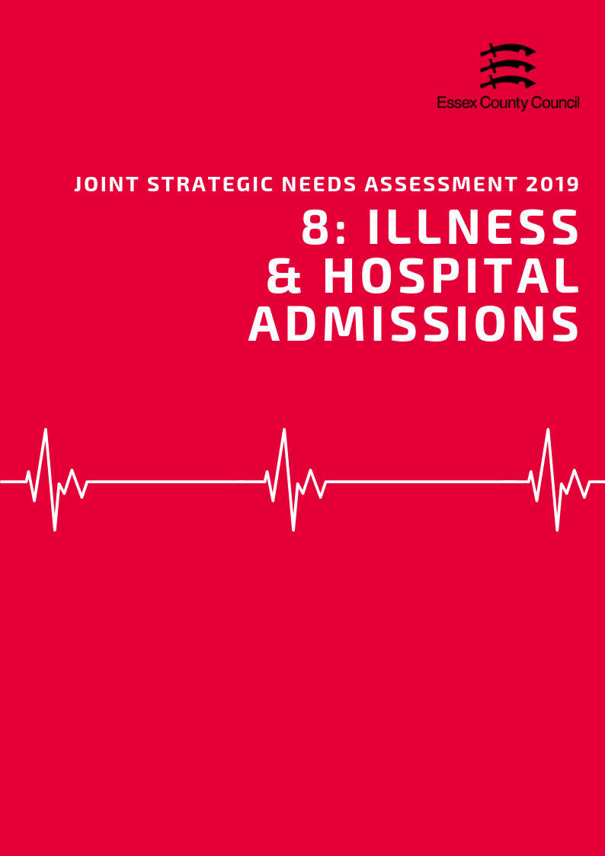

**Illness & Hospital Admissions**

***Emergency Hospital Admissions***

Emergency (unplanned) hospital admissions are both costly to the Health Service and can be a proxy indicator for wider health inequalities within local communities. In order to accurately compare admissions rates between areas of different sizes and compositions statistics are presented using Standardised Admission Ratio is defined as the ratio of the observed number of admissions in an area to the number expected if the area had the same age specific rates as England (Always set at 100).

***Emergency Admissions; all causes and all ages***

The admissions ratio for emergency admissions for all causes among persons of all ages was 90.39 in Basildon, which was ranked as being the 5th highest admission ratio across the Essex Districts.

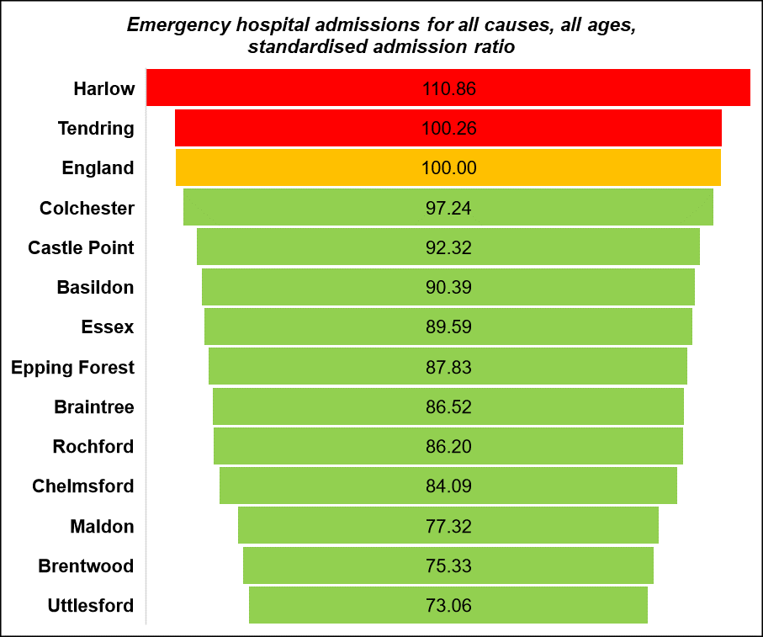

***Emergency Admissions for under 18s***

The emergency hospital admission rate per 1,000 population among those aged 18 years or younger was 3.80 in Basildon. This was ranked as being the third lowest compared across the rates of the Essex Districts (highest: Colchester 10.09; lowest: Castle Point 3.57). Note that this data is an estimate produced by aggregating GP level data. This data is available from Public Health England Fingertips.

|  |  |  |  |  |  |  |
| --- | --- | --- | --- | --- | --- | --- |
|  | Emergency hospital admissions (standardised admission ratio) | | | | | |
|  | All causes  & All ages | Chronic Obstructive Pulmonary Disease (COPD) | Coronary Heart Disease, (CHD) | Hip fracture in persons 65 years and over | Myocardial Infarction (heart attack) | Stroke |
| Basildon | 90.4 | 116.5 | 100.4 | 103.5 | 104.0 | 113.8 |
| Braintree | 86.5 | 75.5 | 83.5 | 116.1 | 85.2 | 88.8 |
| Brentwood | 75.3 | 61.3 | 81.1 | 104.4 | 81.6 | 89.8 |
| Castle Point | 92.3 | 102.0 | 84.7 | 104.5 | 77.5 | 102.0 |
| Chelmsford | 84.1 | 61.2 | 77.2 | 107.9 | 75.4 | 89.3 |
| Colchester | 97.2 | 71.7 | 92.4 | 108.3 | 81.2 | 86.5 |
| England | 100.0 | 100.0 | 100.0 | 100.0 | 100.0 | 100.0 |
| Epping Forest | 87.8 | 78.4 | 88.3 | 99.7 | 91.9 | 89.8 |
| Essex | 89.6 | 83.2 | 90.5 | 106.2 | 87.5 | 94.3 |
| Harlow | 110.9 | 129.8 | 128.8 | 99.3 | 125.8 | 96.8 |
| Maldon | 77.3 | 52.2 | 80.8 | 105.8 | 83.9 | 80.2 |
| Rochford | 86.2 | 81.6 | 90.5 | 101.9 | 77.0 | 105.7 |
| Tendring | 100.3 | 100.3 | 105.7 | 108.4 | 93.7 | 100.1 |
| Uttlesford | 73.1 | 51.9 | 67.6 | 106.1 | 74.4 | 76.0 |

***Heart Attack***

Over the period of 2013/14 - 2017/18, the admissions ratio for emergency admissions for Myocardial Infarction (heart attack) was 104.02 in Basildon. This was ranked as being the 2nd highest admissions ratio across the Essex Districts and higher than the admissions ratio for Essex (87.49), but similar to that across England (100). Every District of Essex had a significantly better admissions ratio for Myocardial Infarction than England, with exception for Basildon and Harlow.

***Coronary Heart Disease***

The admission ratio for emergency admissions due to Coronary Heart Disease (CHD) was 100.38 in Basildon, which was ranked as the 3rd highest admission ratio across the Essex Districts. However, this was not significantly different to the admission ratio across England (100). Harlow and Tendring were the only two Districts of Essex with an admissions ratio for CHD that was significantly worse than that across England.

***Stroke***

The emergency admission ratio for Stroke in Basildon was 113.75, which was the highest admission ratio compared across the Essex Districts. This was also significantly higher than the admission ratio across England (100). Basildon was the only District of Essex with an emergency admission ratio for Stroke significantly worse than England. All other Districts in Essex had an admission ratio similar to (Harlow, Rochford, Tendring) or significantly better than that of England.

***Chronic Obstructive Pulmonary Disease (COPD)***

Chronic Obstructive Pulmonary Disease (COPD) refers to serious lung conditions, including chronic bronchitis and emphysema. According to data from the Hospital Episode Statistics, the age standardised rate of emergency hospital admissions for COPD in adults aged over 35 years was 490.48 per 100,000 in Basildon in 2017/18. This is higher than the rate across Essex (350.33) and England (417.28) and was ranked as the highest rate across the Essex Districts (lowest: Uttlesford 215.50).

**Violence and Injuries**

***Violence Related Admissions***

In the Basildon area, the (age standardised) rate per 100,000 population of emergency hospital admissions for violence was 34.50 over the period of 2015/16 - 2017/18. This was ranked as being the 3rd highest rate compared across the Essex Districts (highest: Tendring 50.75; lowest: Uttlesford 12.80) and higher than the emergency hospital admission rate for Essex as a whole (28.83). However, this was significantly better than the rate across England (43.36).

***Injuries***

Hospital admissions due to alcohol-related unintentional injuries is defined as admissions where the secondary diagnoses are an alcohol-attributable ICD-10 unintentional injuries code. This is displayed as a standardised rate per 100,000 population. The Basildon area was ranked as having the highest rate of hospital admissions due to alcohol-related unintentional injuries among persons in 2017/18, with a rate of 163.08. This was also higher than the rate across the whole of Essex (135.29) and England (144.30). Basildon was the only district with a rate higher than England; all other districts were similar or lower. Standardised admissions ratios for alcohol related harm was however lower than Essex (86.1) and England (100) at 85.9, whilst the SAR for self-harm (57.5) was also significantly lower.

|  |  |  |  |  |  |
| --- | --- | --- | --- | --- | --- |
|  | **Unintentional and deliberate injuries (per 10,000)** | | **Hospital admissions for violence (Incl. sexual violence) *Directly Age Standardised Per 100K*** | **Hospital Stays (Standardised Admissions Ratios)** | |
| **Children (aged 0-14 years)** | **Young People (aged 15-24)** | **For alcohol-related harm** | **For self-harm** |
| **England** | **96.44** | **132.67** | **43.36** | **100.0** | **100.0** |
| **Essex** | **88.22** | **125.93** | **28.83** | **86.1** | **81.6** |
| Basildon | 56.04 | 188.13 | 34.50 | 85.9 | 57.5 |
| Braintree | 96.73 | 135.54 | 18.06 | 77.7 | 78.4 |
| Brentwood | 65.56 | 112.42 | 20.47 | 67.9 | 40.1 |
| Castle Point | 70.35 | 107.87 | 28.24 | 89.1 | 62.0 |
| Chelmsford | 99.08 | 136.21 | 26.99 | 75.4 | 76.9 |
| Colchester | 120.74 | 124.52 | 34.90 | 93.0 | 130.6 |
| Epping Forest | 88.23 | 89.35 | 29.05 | 87.4 | 47.7 |
| Harlow | 85.02 | 105.57 | 34.25 | 111.0 | 87.7 |
| Maldon | 95.84 | 114.00 | 23.93 | 72.6 | 61.9 |
| Rochford | 73.12 | 93.17 | 17.86 | 81.2 | 59.8 |
| Tendring | 112.74 | 114.68 | 50.75 | 105.2 | 151.5 |
| Uttlesford | 69.12 | 118.85 | 12.80 | 75.8 | 68.4 |

***Injuries to Children & Young People***

The rate of hospital admissions caused by unintentional and deliberate injuries in children aged under 15 years per 10,000 resident population aged under 15 was 56.04 in Basildon in 2017/18. This was the lowest rate compared across the Districts in Essex, and lower than the rate across Essex (88.22) and England (96.44). Basildon also had the lowest rate among males aged under 15 years compared across the Districts in Essex in 2017/18, with a rate of 65.89. This was also lower than the Essex (101.91) and England (106.79) rates. The rate among females was 45.64 in Basildon. This was again the lowest rate of the Essex Districts, and lower than the rate across Essex (73.74) and England (85.56).

In contrast, among young people aged between 15 - 24 years, the rate of hospital admissions due to unintentional or deliberate injuries was 188.13 per 10,000 population aged 15-24 in Basildon in 2017/18. This was ranked as being the highest compared across the rates of the other Essex Districts, and higher than the rate across Essex (125.93) and England (132.67).

**Falls and Hip Fractures**

According to data from the Hospital Episode Statistics, the age standardised rate of emergency hospital admissions due to falls in persons aged over 65 years was 2677.10 per 100,000 in Basildon in 2017/18. This was higher than the rate across Essex (2059.46) and England (2170.43) and was ranked as being the highest rate across the Essex Districts (lowest: Harlow 1742.48). Basildon, Castle Point and Rochford were the only Districts in Essex with a higher rate than England.

|  |  |  |  |  |  |  |
| --- | --- | --- | --- | --- | --- | --- |
|  | **Emergency hospital admissions due to falls** | | | **Hip fractures** | | |
| **All Persons Aged 65 and over** | **Age 65-79** | **Age 80+** | **All persons aged 65 and over** | **Age 65-79** | **Age 80+** |
| England | 2170.43 | 1032.87 | 5469.37 | 577.76 | 246.32 | 1539 |
| Essex | 2059.46 | 940.94 | 5303.19 | 611.9 | 259.41 | 1634 |
| Basildon | 2677.1 | 1345.86 | 6537.69 | 617.96 | 300.99 | 1537 |
| Braintree | 2122.3 | 950.99 | 5519.13 | 716.43 | 269.9 | 2011 |
| Brentwood | 2071.46 | 1067.65 | 4982.49 | 623.82 | 337.66 | 1454 |
| Castle Point | 2362.11 | 912.43 | 6566.18 | 588.79 | 207.44 | 1695 |
| Chelmsford | 1929.67 | 883.43 | 4963.76 | 565.04 | 214.47 | 1582 |
| Colchester | 1945.47 | 921.23 | 4915.78 | 626.55 | 261.02 | 1687 |
| Epping Forest | 1772.09 | 774.38 | 4665.45 | 542.61 | 239.76 | 1421 |
| Harlow | 1742.48 | 830.26 | 4387.93 | 615.28 | 291.71 | 1554 |
| Maldon | 1877.77 | 876.69 | 4780.91 | 604.99 | 264.76 | 1592 |
| Rochford | 2258.51 | 850.92 | 6340.51 | 607.61 | 219.16 | 1734 |
| Tendring | 1955.95 | 902.11 | 5012.1 | 660.87 | 292.17 | 1730 |
| Uttlesford | 1871.26 | 822.68 | 4912.14 | 532.18 | 215.53 | 1450 |

The rate of hip fractures in the over 65 population was 617.96 per 100,000, just above the average for Essex (611.9 per 100K), but significantly worse than the rate for England (577.76 per 100K). This was the 5th highest rate of any district in Essex (Highest: Braintree = 716.43; Lowest: Uttlesford = 532.18)

**ILLNESS AND LONG TERM CONDITIONS**

As part of the Quality Outcomes Framework (QOF) each GP surgery records the percentage of registered patients who have been diagnosed with a range of different medical conditions. This rate is known as QOF prevalence which along with records from of practices can be combined to give a prevalence level at different geographies.

***Hypertension & Stroke***

In 2015/16, the estimated proportion of Hypertension in the Basildon area was 14.96%. This was ranked as being the 5th highest QOF prevalence compared across the Essex Districts (highest: Tendring 19.58%; lowest: Colchester 13.32%).

In the Basildon area in 2015, the prevalence of diagnosed hypertension among persons aged over 16 years was estimated to be 21.13. This was slightly higher than the prevalence across England (20.78) and ranked as being the 6th highest prevalence across the Essex Districts (highest: Tendring 27.44; lowest: Colchester 19.01). Basildon was also ranked as 7th highest in Essex for the level of undiagnosed hypertension among persons aged over 16 years, with an estimate of 12.27 (highest: Tendring 14.04; lowest: Colchester 11.61). However, the prevalence in Basildon was similar to that across England (12.15).

The percentage of patients in the Basildon area who had previously had a stroke or transient ischemic attack was 1.82% in 2017/18. This was similar to that across Essex (1.76%) and England (1.77%) and ranked as being the 6th highest across the Essex Districts.

***Coronary Heart Disease***

The QOF prevalence, the proportion of patients registered at GP surgeries with a diagnosis, of Coronary Heart Disease (CHD) in the Basildon District was 3.24% in 2017/18. This was ranked as the 6th highest estimated prevalence across the Essex Districts. Among persons aged between 55 - 79 years in Basildon, the estimated prevalence of CHD was 8.13 in 2015. This was ranked as being the 3rd highest estimated prevalence across the Essex Districts, and higher than the prevalence across England (7.94).

***Asthma***

In Basildon the QOF prevalence of Asthma was to be 6.08%. This was ranked as being the 5th highest prevalence compared across the other Districts in Essex. *Note that this estimate is not directly available at District level so has been produced by aggregating from individual GP level data.*

***Epilepsy***

In 2017/18, the estimated proportion of all those registered at General Practitioner surgeries in the Basildon area with a diagnosis of Epilepsy, also known as the QOF prevalence, was 0.78%. This was ranked as being the 7th highest QOF prevalence compared across the Essex Districts.

***Table: QOF Prevalence of Long -Term Conditions***

|  |  |  |  |  |  |
| --- | --- | --- | --- | --- | --- |
|  | **QOF Prevalence (% of GP Registered Patients)** | | | | |
|  | **Asthma**  **(all ages)** | **Dementia**  **(all ages)** | **Epilepsy (18+)** | **Hypertension (all ages)** | **Stroke (all ages)** |
| **England** | **5.93** | **0.76** | **0.80** | **13.94** | **1.77** |
| Basildon | 6.09 | 0.69 | 0.78 | 14.96 | 1.82 |
| Braintree | 6.29 | 0.80 | 0.89 | 13.70 | 1.77 |
| Brentwood | 5.29 | 0.90 | 0.73 | 14.67 | 1.89 |
| Castle Point | 5.87 | 0.77 | 0.80 | 18.07 | 1.87 |
| Chelmsford | 6.08 | 0.72 | 0.75 | 13.76 | 1.55 |
| Colchester | 5.81 | 0.67 | 0.80 | 13.32 | 1.43 |
| Epping Forest | 5.10 | 1.06 | 0.59 | 13.95 | 1.61 |
| Harlow | 5.83 | 0.59 | 0.81 | 13.40 | 1.48 |
| Maldon | 6.40 | 0.78 | 0.82 | 16.19 | 1.92 |
| Rochford | 5.94 | 1.04 | 0.70 | 16.13 | 1.89 |
| Tendring | 6.90 | 1.07 | 1.05 | 19.58 | 2.47 |
| Uttlesford | 6.55 | 0.79 | 0.64 | 14.41 | 1.58 |

***Dementia***

The proportion of patients of all ages in Basildon with a diagnosis of Dementia was 0.69%. This was the third lowest prevalence compared across the other Districts in Essex and was slightly lower than the prevalence across Essex (0.81%) and England (0.77%). Among persons aged over 65 years in the Basildon area in 2018, the estimated Dementia diagnosis rate was 60.8%. This was ranked as being the 6th highest rate compared across the Districts.

In 2019 information from Projecting Older People’s Population Information (POPPI) estimated that in the Basildon area there were 2,284 people in 2019 and would rise to 3,349 by 2035. Projected dementia numbers of people with dementia for individual districts are set out in the table below (Source: POPPI 2019)

|  |  |  |  |  |  |
| --- | --- | --- | --- | --- | --- |
| **Projected number of people age 65+ with Dementia** | **2019** | **2020** | **2025** | **2030** | **2035** |
| **Essex** | 21,972 | 22,478 | 25,510 | 29,437 | 33,729 |
| Basildon | 2,284 | 2,316 | 2,595 | 2,926 | 3,349 |
| Braintree | 2,174 | 2,225 | 2,595 | 3,114 | 3,633 |
| Brentwood | 1,264 | 1,276 | 1,403 | 1,576 | 1,744 |
| Castle Point | 1,566 | 1,619 | 1,840 | 2,129 | 2,338 |
| Chelmsford | 2,452 | 2,503 | 2,908 | 3,330 | 3,799 |
| Colchester | 2,323 | 2,396 | 2,689 | 3,180 | 3,639 |
| Epping Forest | 1,967 | 1,994 | 2,233 | 2,541 | 2,858 |
| Harlow | 1,018 | 1,024 | 1,111 | 1,229 | 1,370 |
| Maldon | 1,053 | 1,103 | 1,319 | 1,597 | 1,835 |
| Rochford | 1,417 | 1,444 | 1,661 | 1,880 | 2,133 |
| Tendring | 3,104 | 3,183 | 3,576 | 4,112 | 4,684 |
| Uttlesford | 1,309 | 1,349 | 1,625 | 1,944 | 2,275 |

***Cancer***

The NHS estimates that more than 1 in 3 people will develop some form of cancer during their lifetime with the 4 most common types of cancer being:

* lung cancer
* breast cancer
* prostate cancer
* bowel cancer

The following incidence ratio of all cancers and the major cancer sub-types are the standardised incidence ratio, the number of observed new cases as a percentage of number expected new cases, calculated relative to England (100) during the period of 2012-2016.

|  |  |  |  |  |  |
| --- | --- | --- | --- | --- | --- |
|  | Incidence Rates of Cancers | | | | |
| Breast Cancer | Colorectal Cancer | Lung Cancer | Prostate Cancer | All Cancers |
| **England** | **100.00** | **100.00** | **100.00** | **100.00** | **100.00** |
| **Essex** | **100.97** | **97.58** | **90.53** | **104.12** | **98.49** |
| Basildon | 106.58 | 102.13 | 108.63 | 92.01 | 104.75 |
| Braintree | 98.81 | 88.86 | 84.42 | 104.95 | 95.66 |
| Brentwood | 99.53 | 88.81 | 68.29 | 101.00 | 93.95 |
| Castle Point | 92.74 | 92.87 | 101.61 | 93.50 | 96.58 |
| Chelmsford | 104.20 | 99.87 | 70.10 | 99.10 | 92.40 |
| Colchester | 98.63 | 98.14 | 84.95 | 112.32 | 97.99 |
| Epping Forest | 103.04 | 103.80 | 96.50 | 132.98 | 104.62 |
| Harlow | 100.36 | 98.95 | 123.62 | 95.24 | 105.18 |
| Maldon | 105.22 | 93.31 | 83.34 | 95.07 | 93.35 |
| Rochford | 96.24 | 98.32 | 80.73 | 97.19 | 91.62 |
| Tendring | 97.98 | 101.04 | 106.26 | 109.79 | 104.66 |
| Uttlesford | 108.04 | 96.62 | 67.11 | 102.20 | 94.02 |

***All Cancers***

The incidence ratio for all cancers over the period of 2012 - 2016 in Basildon was 104.75. This was significantly worse than the incidence ratio for all cancers across England (100) and was ranked as being the 2nd highest across the Essex Districts (highest: Harlow: 105.18; lowest: Rochford 91.62). Basildon, Epping Forest, Harlow and Tendring were the only Essex Districts with an incidence ratio of all cancers significantly worse than England.

***Lung Cancer***

In Basildon, the incidence ratio for lung cancer was 108.63. This was significantly worse than the incidence ratio relative to England (100) and was ranked as being the 2nd highest across Essex Districts (highest: Harlow 123.62; lowest: Uttlesford 67.11). Basildon and Harlow were the only two Districts in Essex significantly worse than England in terms of lung cancer incidence ratios.

***Breast Cancer***

The incidence ratio for Breast Cancer was 106.58 in Basildon, which was also ranked as being the 2nd highest incidence ratio compared across the Districts of Essex (highest: Uttlesford 108.04; lowest: Castle Point 92.74). However, the incidence ratio of all Districts in Essex for breast cancer was not significantly different to England (100).

***Colorectal Cancer***

The incidence ratio for colorectal cancer was 102.12, which was also ranked as being the 2nd highest incidence ratio across the Essex Districts (highest: Epping Forest 103.80; lowest: Braintree 88.86). However, with exception of Braintree, the incidence ratios for colorectal cancer of all Essex Districts were similar relative to England (100).

**Prostate Cancer**

The incidence ratio of prostate cancer was 92.01, which was ranked as being the lowest incidence ratio across the Essex Districts (highest: Epping Forest 132.98). This was also significantly better relative to the prostate cancer incidence ratio across England (100) and was the only Essex District to be so.

***Musculoskeletal (MSK) Conditions***

In Basildon an estimated 33.5% of residents were recorded as reporting a long term musculoskeletal (MSK) problem. This was lower than the Essex average (34.9%) and in-line with the average for England.

The percentage of residents reporting a long term back problem (9.4%) was also in line with the average for England (9.4%) and similar to Essex (9.3%) whilst the percentage of residents reporting arthritis or a long term joint problem (11.5%) was slightly lower than England (12.2%) and Essex (12.6%).

The QOF prevalence of patients aged 50+ recorded with a diagnosis of Osteoporosis in Basildon (0.35%) was also significantly lower than the national average (0.62%) and slightly under the average for Essex (0.39%).

|  |  |  |  |  |
| --- | --- | --- | --- | --- |
|  | **% reporting a long term MSK problem** | **% reporting a long-term back problem** | **% reporting arthritis or long-term joint problem** | **Osteoporosis: QOF prevalence (50+)** |
| Basildon | 33.5 | 9.4 | 11.5 | 0.35 |
| Braintree | 33.4 | 8.7 | 12.8 | 0.45 |
| Brentwood | 35.7 | 10.5 | 13.0 | 0.42 |
| Castle Point | 39.3 | 9.4 | 15.3 | 0.26 |
| Chelmsford | 30.8 | 7.5 | 11.3 | 0.4 |
| Colchester | 32.0 | 8.2 | 10.6 | 0.56 |
| England | 33.5 | 9.4 | 12.2 | 0.62 |
| Epping Forest | 32.0 | 8.7 | 11.7 | 0.42 |
| Essex | 34.9 | 9.3 | 12.6 | 0.39 |
| Harlow | 33.4 | 10.5 | 11.9 | 0.27 |
| Maldon | 36.6 | 11.3 | 13.3 | 0.33 |
| Rochford | 36.8 | 8.0 | 13.4 | 0.29 |
| Tendring | 47.7 | 13.1 | 17.6 | 0.41 |
| Uttlesford | 29.8 | 8.2 | 9.8 | 0.36 |

***Diabetes***

Diabetes is a lifelong condition that causes a person's blood sugar level to become too high.

There are 2 main types of diabetes:

* type 1 diabetes – where the body's immune system attacks and destroys the cells that produce insulin
* type 2 diabetes – where the body does not produce enough insulin, or the body's cells do not react to insulin

Type 2 diabetes is far more common than type 1. In the UK, around 90% of all adults with diabetes have type 2.

The recorded QOF prevalence of Diabetes for people aged 17+ in the Basildon and Brentwood CCG area was 6.4% across the whole of the CCG area. This is similar to the average for England (6.5%) and Essex (6.6%) was the joint second lowest prevalence rate out of the 5 CCGs in Essex. Public health England estimates that around 8.2% of residents in the Basildon & Brentwood CCG area are likely to have diabetes suggesting that around 1.8% of people are undiagnosed.

Diabetes can reduce the blood supply to feet and cause a loss of feeling known as peripheral neuropathy. This can mean foot injuries don't heal well and you may not notice if your foot is sore or injured. Annual foot checks for people with diabetes are therefore an essential part of care monitoring procedures. In the Basildon and Brentwood CCG area an estimated 61.8% of people with Type 1 diabetes and 65.9% of people with type 2 diabetes have received an annual foot check. This is significantly lower than the average for England with all but one CCG area in Essex (North East Essex) have rates well below the national average, and none reaching 100 coverage.

|  |  |  |  |  |
| --- | --- | --- | --- | --- |
|  | Diabetes: QOF prevalence (17+) | Estimated prevalence of diabetes (undiagnosed and diagnosed) | People with type 1 diabetes who have received an annual foot check | People with type 2 diabetes who have received an annual foot check |
| England | 6.5% | 8.5% | 70.1% | 79.4% |
| Essex | 6.6% | 8.5% |  |  |
| NHS Basildon And Brentwood CCG | 6.4% | 8.2% | 61.8% | 65.9% |
| NHS Castle Point and Rochford CCG | 7.2% | 8.6% | 54.4% | 61.8% |
| NHS Mid Essex CCG | 6.4% | 8.1% | 58.3% | 65.7% |
| NHS North East Essex CCG | 6.8% | 9.0% | 81.8% | 85.5% |
| NHS West Essex CCG | 6.2% | 8.1% | 64.0% | 72.4% |

**Vaccinations**

Vaccinations are one of the most important interventions in place to prevent the spread of avoidable diseases amongst the population. In the UK the majority of vaccinations are given childhood, with a number of boosters and additional vaccinations also given to people of different ages who might be at higher risk from certain diseases.

Across the UK vaccination rates are declining with fewer people completing full courses of vaccinations compared to recent years leading to increased potential for outbreaks of diseases within an area. According to the NHS "If 95% of children receive the MMR vaccine, it's possible to get rid of measles. However, measles, mumps and rubella can quickly spread again if fewer than 90% of people are vaccinated."

***Vaccine Preventable Conditions***

Variation in incidence rates for certain conditions which are considered vaccine preventable may reflect differences in underlying population including the uptake of vaccination. Public Health England suggests that high prevalence of the following conditions "should prompt a review of routine immunisation uptake and vaccination of high risk groups".

|  |  |  |  |  |  |
| --- | --- | --- | --- | --- | --- |
|  | **Mumps 5-year incidence rate/100,000** | **Mumps incidence rate/100,000** | **Pertussis incidence rate/100,000** | **Measles 5-year incidence rate/100,000** | **Measles incidence rate/100,000** |
| Basildon | 1.33 | 0.55 | 0.54 | 0.00 | 0.54 |
| Braintree | 2.27 | 0.00 | 9.89 | 0.27 | 0.66 |
| Brentwood | 2.39 | 0.00 | 3.92 | 0.80 | 0.00 |
| Castle Point | 1.80 | 1.11 | 4.45 | 1.57 | 11.13 |
| Chelmsford | 3.26 | 1.15 | 0.57 | 0.12 | 0.00 |
| Colchester | 3.10 | 2.14 | 14.20 | 0.11 | 0.00 |
| England | 3.60 | 3.25 | 7.80 | 1.49 | 1.74 |
| Epping Forest | 2.49 | 0.77 | 1.53 | 1.09 | 3.83 |
| Essex | 2.07 | 1.10 | 5.45 | 0.38 | 1.50 |
| Harlow | 2.13 | 2.33 | 3.48 | 0.00 | 3.48 |
| Maldon | 0.32 | 0.00 | 1.56 | 0.00 | 0.00 |
| Rochford | 2.36 | 3.50 | 1.16 | 0.24 | 1.16 |
| Tendring | 1.43 | 0.70 | 6.22 | 0.29 | 0.69 |
| Uttlesford | 0.00 | 1.16 | 14.83 | 0.72 | 0.00 |

***Measles***

In 2018 the rate of measles per 100,000 people in Basildon was 0.54 and was classed as not significantly different to the England average of 1.7. Only one area in Essex (Castle Point) was classified as significantly worse than the level for England whilst two other areas, Epping Forest (3.8%) and Harlow (3.5%) also had rates which were higher than the county and England average. Compared to the five year average rate of zero incidents, this is however a slight increase.

***Mumps***

Across Basildon the incidence rate of Mumps in 2017 was 0.55 per 100,000 and was significantly better than the rate for England (3.2) and Essex (1.1). Compared to other areas this is second lowest level with three areas (Maldon, Brentwood, and Braintree) having no recorded incidents during this period.

Pertussis (Whooping Cough)

The incidence rate of pertussis in 2017 across Basildon was 0.54 per 100,000 people and was significantly lower than the average for Essex (5.4 per 100,000) and England (7.8 per 100,000) during the same period. Compared to other districts this was the lowest rate in the county.

***Childhood Vaccination Coverage***

Data on Childhood Vaccinations is largely presented as the average for the CCG area, using data amalgamated up from individual GP practices. These averages can be positively skewed by figures higher performing practices in the area and mask coverage issues at a more local level. As such we have also analysed vaccination coverage levels within relevant age groups against two additional criteria recorded by NHS England;

* The number and percentage of GP practices meeting the minimum of 90% of patients vaccinated
* The number and percentage of GP practices meeting the target of 95% or more patients vaccinated

*Tables at the end of this chapter provide a full breakdown of current childhood vaccination coverage levels by CCG area.*

***Measles, Mumps and Rubella (MMR)***

By age 5 it is estimated that 96.2% of the GP registered children in the Basildon and Brentwood CCG have received one of the two MMR vaccination injections required to achieve full vaccination coverage. This is higher than the average for England of 94.9% and similar to the Essex average of 96.5%, with 29 GP practices (74.4%) in the area achieving at least 95% coverage or Higher.

By comparison the rate of GP registered children who have received both of MMR vaccination injections by age five drops to 90.1%, which although higher than the England (87.2%) and Essex (89.4%) averages is still lower than the NHS target of 95% to eliminate measles within the population. NHS England Child Vaccination coverage statistics identified 17 GP practices (43.6%) in the CCG area with less than 90% vaccination coverage of the eligible population, 6 practices (15.4%) which were achieving coverage of 95% or higher.

The level practices achieving less than 90% coverage is just below the whole Essex average (45.5%) but is significantly higher than the best performing CCG in Essex (Lowest: Mid Essex CCG = 22.8%; Highest: West Essex CCG = 60.6%).

***Diphtheria, Tetanus, Pertussis (Whooping Cough), Polio, Haemophilus Influenzae Type B (hib): DTaP/IPV/Hib***

97% of GP registered children in the Basildon and Brentwood CCG area had recieved the full course of DTaP/IPV/Hib injections by Age 5. This is similar to the Essex average of 97.1% and just above the average for England (95.6%) and is the third highest vaccination coverage level out of the 5 CCG areas in Essex (Highest: Castle Point & Rochford CCG = 98.3%; Lowest: West Essex CCG = 94.6%). At practice level the NHS vaccination coverage statistics identified only 2 practices (5%) which had coverage levels below 90% and 32 (82.1%) which were achieving coverage levels of 95% or higher; similar to the averages for Essex (3%, 83.7%).

***Rotavirus***

An estimated 92.6% of GP registered children in the Basildon and Brentwood CCG area had received their vaccinations against Rotavirus by 12 months. This is similar to the average for Essex (92.4%) and just above the level for England (90.1%). Compared to the other CCG areas in Essex this is the third highest coverage level out of five areas (Highest: Mid Essex CCG = 95.1%; Lowest: North East Essex CCG = 88.5%). Looking at coverage levels across individual GP practices, NHS England statistics identified 5 practices (12.8%) which had coverage levels below 90% and 9 practices (23.1%) achieving coverage of 95% or higher. This is better than the Essex average for those achieving less than 90% coverage (22.5%) but lower than the average for those achieving 95% or higher (35.4%) and is significantly lower than the highest performing area (Highest: Castle Point and Rochford CCG = 62.5%; Lowest: North East Essex CCG =13.5%).

***Pneumococcal Vaccine (PCV)***

The pneumococcal vaccine protects against serious and potentially fatal pneumococcal infections such as pneumonia, septicaemia (a kind of blood poisoning) and meningitis and is given to infants over three separate doses at 8 weeks, 16 weeks and 1 year.

By 24 months 93% of the GP registered children in the Basildon and Brentwood CCG area have recived their PCV vaccinations, similar to the Essex average of 92.8% and just above the England average of 91%. This is third highest coverage level out of 5 CCG areas (Highest: Castle Point and Rochford CCG = 96.2%; Lowest: North East Essex CCG = 89.9%) with an 9 out of 39 GP practices (13.1%) achieving coverage levels of less than 90% and 19 practices (48.7%) achieving coverage levels of 95% or higher. These coverage levels are similar to the Essex average for those achieving less than 90% coverage (77.5%) and higher than average for those achieving 95% or higher (41.6%), although the proportion achieving 95% or higher is significantly lower than the best performing CCG in the County (Highest: Castle Point and Rochford CCG = 70.8%); Lowest: North East Essex CCG = 18.9%).

***Meningitis***

According to the NHS Meningitis can be caused by a number of different infections, as such a number of different vaccinations are used to offer protection against this including the MMR, DTaP/IPV/Hib, and Pneumococcal Vaccine already mentioned in this report. In addition, the NHS also includes separate vaccinations against Meningitis C (and Hib) at one year old and also Meningitis B which takes place at 8 weeks, 16 weeks and booster at 1 year.

Coverage levels of the Hib & Meningitis C vaccination across the Basildon and Brentwood CCG area is 95.2% of eligible GP registered children by age 5, similar to the Essex average of 94.8% and higher than the rate for England of 92.4% and is the third highest coverage level out of the 5 CCGs in Essex (Highest: Castle Point and Rochford CCG = 96.5%; Lowest: North East Essex CCG = 93.8%). NHS England statistics identified 4 out of 39 GP practices (10.3%) with coverage levels below 90% and 25 practices (64.1%) achieving 95% coverage or higher. This is similar to the Essex average for those with less than 90% coverage (10.1%) and slightly better for those achieving 95% or higher (59%).

Coverage levels of the new Meningitis B vaccination across the Basildon and Brentwood CCG area is 93.2% of eligible GP registered children at 12 months, just below the Essex average of 94.2% and just above the rate for England of 92.5%. This is the third highest coverage level out of the 5 CCGs in Essex (Highest: Castle Point and Rochford CCG = 95.8%; Lowest: North East Essex CCG = 92.4%) with 7 out of 39 GP practices (17.9%) with coverage levels below 90% and 19 practices (48.7%) achieving 95% coverage or higher. This is similar to the Essex average for both measures (16.9%, 46.1%) but is lower than the CCG area with the highest percentage of GP practices achieving 95% coverage (Highest: Castle Point and Rochford CCG = 70.8%; Lowest: West Essex CCG = 30.3%).

***Children in Care Immunisations***

According to figures from the Department for Education in 2018, 77.6% of children in care are up to date with the vaccinations in the NHS routine list across the whole of Essex. This is lower than the average for England (85.3%) and the East of England (85.1%) and is the 4th lowest rate out of 11 upper tier and unitary authorities in the eastern region (Highest: Norfolk = 96.3%; Lowest: Thurrock = 65.4%).

|  |  |  |  |  |  |  |  |
| --- | --- | --- | --- | --- | --- | --- | --- |
|  | ENGLAND | ESSEX | BASILDON AND BRENTWOOD CCG | CASTLE POINT AND ROCHFORD CCG | MID ESSEX CCG | NORTH EAST ESSEX CCG | WEST ESSEX CCG |
| Total no. GPs | | 178 | 39 | 24 | 45 | 37 | 33 |
| MMR 1 injection coverage at age 5 (% of eligible population) | 94.9 | 96.5 | 96.2 | 97.1 | 97.0 | 96.5 | 95.5 |
| No. GP Practices meeting the minimum 90% vaccination coverage level for MMR1at 5y |  | 173 | 38.0 | 23.0 | 44.0 | 37.0 | 31.0 |
| % GP Practices meeting the minimum 90% vaccination coverage level for MMR1 at 5y |  | 97.2% | 97.4% | 95.8% | 97.8% | 100.0% | 93.9% |
| No. GP Practices meeting the target 95% vaccination coverage level for MMR1 at 5y |  | 139 | 29.0 | 19.0 | 38.0 | 31.0 | 22.0 |
| % GP Practices meeting the target 95% vaccination coverage level for MMR1 at 5y |  | 78.1% | 74.4% | 79.2% | 84.4% | 83.8% | 66.7% |
|  |  |  |  |  |  |  |  |
| MMR 2 Injections coverage at age 5 (% of eligible population) | 87.2 | 89.4 | 90.1 | 91.5 | 91.9 | 86.6 | 87.8 |
| No. GP Practices meeting the minimum 90% vaccination coverage level for MMR2 at 5y |  | 97 | 22 | 12 | 35 | 15 | 13 |
| % GP Practices meeting the minimum 90% vaccination coverage level for MMR2 at 5y |  | 54.5% | 56.4% | 50.0% | 77.8% | 40.5% | 39.4% |
| No. GP Practices meeting the target 95% vaccination coverage level for MMR2 at 5y |  | 22 | 6 | 4 | 10 | 2 | 0 |
| % GP Practices meeting the target 95% vaccination coverage level for MMR2 at 5y |  | 12.4% | 15.4% | 16.7% | 22.2% | 5.4% | 0.0% |

|  |  |  |  |  |  |  |  |
| --- | --- | --- | --- | --- | --- | --- | --- |
|  | ENGLAND | ESSEX | BASILDON AND BRENTWOOD CCG | CASTLE POINT AND ROCHFORD CCG | MID ESSEX CCG | NORTH EAST ESSEX CCG | WEST ESSEX CCG |
| Total no. GPs | | 178 | 39 | 24 | 45 | 37 | 33 |
| PCV coverage at 24 months (% of eligible population) | 91 | 92.8 | 93.0 | 96.2 | 94.3 | 89.9 | 92.0 |
| No. GP Practices meeting the minimum 90% vaccination coverage level for PCV Booster at 24m |  | 138 | 30.0 | 21 | 41.0 | 23.0 | 23.0 |
| % GP Practices meeting the minimum 90% vaccination coverage level for PCV Booster at 24m |  | 77.5% | 76.9% | 87.5% | 91.1% | 62.2% | 69.7% |
| No. GP Practices meeting the target 95% vaccination coverage level for PCV Booster at 24m |  | 74 | 19.0 | 17 | 22.0 | 7.0 | 9.0 |
| % GP Practices meeting the target 95% vaccination coverage level for PCV Booster at 24m |  | 41.6% | 48.7% | 70.8% | 48.9% | 18.9% | 27.3% |
|  |  |  |  |  |  |  |  |
| Rotavirus vaccinations at 12 months (% of eligible population) | 90.1 | 92.4 | 92.6 | 94.9 | 95.1 | 88.5 | 90.1 |
| No. GP Practices meeting the minimum 90% vaccination coverage level for Rotavirus at 12m |  | 138 | 34 | 23 | 41 | 19 | 21 |
| % GP Practices meeting the minimum 90% vaccination coverage level for Rotavirus at 12m |  | 77.5% | 87.2% | 95.8% | 91.1% | 51.4% | 63.6% |
| No. GP Practices meeting the target 95% vaccination coverage level for Rotavirus at 12m |  | 63 | 9.0 | 15 | 27.0 | 5.0 | 7.0 |
| % GP Practices meeting the target 95% vaccination coverage level for Rotavirus at 12m |  | 35.4% | 23.1% | 62.5% | 60.0% | 13.5% | 21.2% |

|  |  |  |  |  |  |  |  |
| --- | --- | --- | --- | --- | --- | --- | --- |
|  | ENGLAND | ESSEX | BASILDON AND BRENTWOOD CCG | CASTLE POINT AND ROCHFORD CCG | MID ESSEX CCG | NORTH EAST ESSEX CCG | WEST ESSEX CCG |
| Total no. GPs | | 178 | 39 | 24 | 45 | 37 | 33 |
| Hib & MenC vaccinations at 24 months (% of eligible population) | 91.2 | 92.7 | 93.1 | 96.1 | 94.6 | 89.8 | 91.8 |
| No GP Practices meeting the minimum 90% vaccination coverage level for Hib & Men C at 5y |  | 142 | 31 | 21 | 42 | 24 | 24 |
| % GP Practices meeting the minimum 90% vaccination coverage level for Hib & Men C at 5y |  | 79.8% | 79.5% | 87.5% | 93.3% | 64.9% | 72.7% |
| No. GP Practices meeting the target 95% vaccination coverage level for Hib & Men C at 5y |  | 68 | 17 | 15 | 22 | 7 | 7 |
| % GP Practices meeting the target 95% vaccination coverage level for Hib & Men C at 5y |  | 38.2% | 43.6% | 62.5% | 48.9% | 18.9% | 21.2% |
|  |  |  |  |  |  |  |  |
| Hib & MenC vaccinations at 5 years (% of eligible population) | 92.4 | 94.8 | 95.2 | 96.5 | 95.6 | 93.8 | 93.9 |
| No GP Practices meeting the minimum 90% vaccination coverage level for Hib & Men C at 5y |  | 160 | 35 | 22 | 43 | 32 | 28 |
| % GP Practices meeting the minimum 90% vaccination coverage level for Hib & Men C at 5y |  | 89.9% | 89.7% | 91.7% | 95.6% | 86.5% | 84.8% |
| No. GP Practices meeting the target 95% vaccination coverage level for Hib & Men C at 5y |  | 105 | 25 | 17 | 30 | 18 | 15 |
| % GP Practices meeting the target 95% vaccination coverage level for Hib & Men C at 5y |  | 59.0% | 64.1% | 70.8% | 66.7% | 48.6% | 45.5% |

|  |  |  |  |  |  |  |  |
| --- | --- | --- | --- | --- | --- | --- | --- |
|  | ENGLAND | ESSEX | BASILDON AND BRENTWOOD CCG | CASTLE POINT AND ROCHFORD CCG | MID ESSEX CCG | NORTH EAST ESSEX CCG | WEST ESSEX CCG |
| Total no. GPs | | 178 | 39 | 24 | 45 | 37 | 33 |
| DTaP/IPV/Hib Vaccinations at 5 years (% of Eligible Population) | 95.6 | 97.1 | 97.0 | 98.3 | 98.0 | 96.2 | 94.6 |
| No GP Practices meeting the minimum 90% vaccination coverage level for DTaP/IPV/Hib at 5y |  | 173 | 37.0 | 24.0 | 45.0 | 37.0 | 30.0 |
| % GP Practices meeting the minimum 90% vaccination coverage level for DTaP/IPV/Hib at 5y |  | 97% | 95% | 100% | 100% | 100% | 91% |
| No. GP Practices meeting the target 95% vaccination coverage level for DTaP/IPV/Hib at 5y |  | 149 | 32.0 | 21.0 | 44.0 | 30.0 | 22.0 |
| % GP Practices meeting the target 95% vaccination coverage level for DTaP/IPV/Hib at 5y |  | 83.7% | 82.1% | 87.5% | 97.8% | 81.1% | 66.7% |
|  |  |  |  |  |  |  |  |
| MenB vaccinations at 12 months (% of eligible population) | 92.5 | 94.2 | 93.2 | 95.8 | 95.6 | 92.4 | 92.8 |
| No GP Practices meeting the minimum 90% vaccination coverage level for Men B at 12m |  | 148 | 32 | 22 | 41 | 28 | 25 |
| % GP Practices meeting the minimum 90% vaccination coverage level for Men B at 12m |  | 83.1% | 82.1% | 91.7% | 91.1% | 75.7% | 75.8% |
| No. GP Practices meeting the target 95% vaccination coverage level for Men B at 12m |  | 82 | 19 | 17 | 22 | 14 | 10 |
| % GP Practices meeting the target 95% vaccination coverage level for Men B at 12m |  | 46.1% | 48.7% | 70.8% | 48.9% | 37.8% | 30.3% |

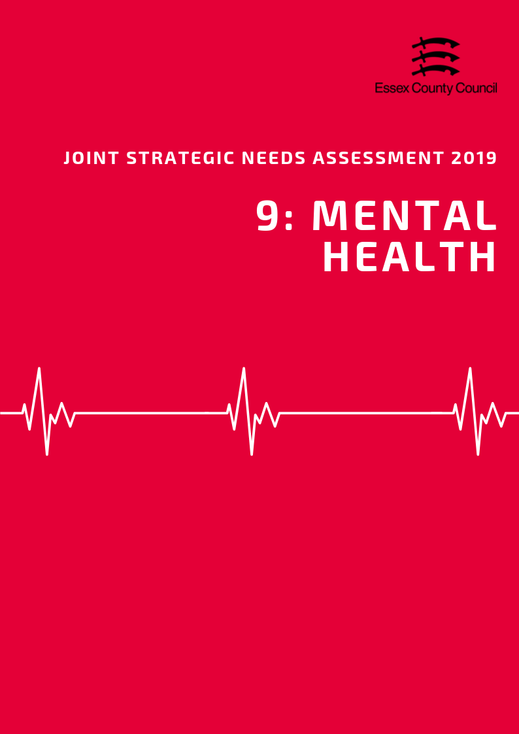

**Mental Health**

**Common Mental Health Conditions**

According to the General Practice Patient Survey (GPPS; NHS England) in 2016/17, the prevalence of depression and anxiety among persons aged over 18 years in NHS Basildon and Brentwood CCG in Essex was 13.28%. This was similar to the prevalence across England (13.74%) but higher than that across the whole of Essex (12.49%) and was ranked as being the second highest prevalence compared across that of the other CCGs in Essex (highest: NHS North East Essex 14.30%; lowest: NHS Mid Essex 11.23%).

**Severe Mental Health Conditions**

Severe mental health conditions include schizophrenia, bipolar affective disorder and other psychoses. The prevalence of these as recorded on general practise disease registers in the Basildon area in 2017/18 was 0.92. This was ranked as being the third highest prevalence compared across the other Districts in Essex, and higher than the prevalence across Essex as a whole (0.80).

**Long Term Mental Health Conditions**

The prevalence of reporting a long-term mental health condition among persons aged over 18 years in the NHS Basildon and Brentwood CCG of Essex, according to the GPPS, was 7.48% in 2017/18. This was lower than the prevalence across the whole of Essex (8.23%) and England (9.06%) and was ranked as being the second lowest prevalence compared across the CCGs of Essex (highest: NHS North East Essex CCG 9.63%; lowest: NHS West Essex CCG 7.19%).

**Mental Health Among Young People**

The Basildon area had the third highest estimated prevalence of any mental health disorder among children aged between 5 to 16 years across the Districts of Essex in 2015, with a prevalence of was 9.29. This was higher than the estimated prevalence across the whole of Essex (8.71). This estimate was based on the prevalence’s previously given in the Office for National Statistics survey Mental Health of Children and Young People in Great Britain (2004).

|  |  |  |  |
| --- | --- | --- | --- |
|  | **Depression and Anxiety prevalence (GP Patient Survey): % of respondents aged 18+** | **Prevalence of Severe Mental Health Conditions** | **Estimated prevalence of mental health disorders in children and young people:**  **% population aged 5-16** |
| **Essex** | **12.49** | **0.80** | **8.71** |
| **England** | **13.74** | **0.94** | **9.23** |
| Basildon | 13.28 | 0.92 | 9.29 |
| Braintree | 11.23 | 0.75 | 8.80 |
| Brentwood | 13.28 | 0.66 | 7.82 |
| Castle Point | 12.48 | 0.68 | 8.89 |
| Chelmsford | 11.23 | 0.72 | 8.24 |
| Colchester | 14.30 | 0.93 | 8.75 |
| Epping | 11.31 | 0.78 | 8.22 |
| Harlow | 11.31 | 0.81 | 9.65 |
| Maldon | 11.23 | 0.76 | 8.38 |
| Rochford | 12.48 | 0.63 | 8.24 |
| Tendring | 14.30 | 1.00 | 9.76 |
| Uttlesford | 11.31 | 0.63 | 7.67 |

***Self-Harm***

According to estimates produced by Public Health England, The Basildon area in 2017/18 had the third highest rate of emergency hospital admissions for intentional self-harm among persons of all ages, with a rate of 200.48. This is significantly higher than the rate across Essex as a whole (156.98) and England (185.48). Women in Basildon also had the third highest admissions rate in the county (248.3), well above the rates for Essex (201.7) or England (235.3) and were 1.6 times more likely to be admitted to hospital for intentional self-harm than men (153.8 per 100,000).

This data is also shown by gender breakdown in the table below:

|  |  |  |  |  |  |  |
| --- | --- | --- | --- | --- | --- | --- |
| **Rate of Emergency Hospital Admissions for Intentional Self-Harm in Essex Districts, 2017/18** | | | | | | |
|  | **All Persons** | | **Male** | | **Female** | |
| **Rate** | **Rank** | **Rate** | **Rank** | **Rate** | **Rank** |
| **England** | **185.48** | **N/A** | **137.73** | **N/A** | **235.28** | **N/A** |
| **Essex** | **156.98** | **N/A** | **113.48** | **N/A** | **201.70** | **N/A** |
| Basildon | 200.48 | 3 | 153.78 | 2 | 248.32 | 3 |
| Braintree | 145.48 | 5 | 101.13 | 6 | 191.72 | 6 |
| Brentwood | 96.74 | 11 | 64.56 | 10 | 129.53 | 11 |
| Castle Point | 155.06 | 4 | 116.04 | 4 | 192.8 | 5 |
| Chelmsford | 134.88 | 7 | 75.57 | 8 | 194.97 | 4 |
| Colchester | 207.63 | 2 | 145.51 | 3 | 273.85 | 2 |
| Epping Forest | 71.73 | 12 | 52.41 | 11 | 92.48 | 12 |
| Harlow | 123.59 | 8 | 99.53 | 7 | 148.17 | 10 |
| Maldon | 112.78 | 9 | 75.47 | 9 | 149.1 | 9 |
| Rochford | 100.88 | 10 | 51.55 | 12 | 150.42 | 8 |
| Tendring | 289.2 | 1 | 252.69 | 1 | 326.81 | 1 |
| Uttlesford | 142.57 | 6 | 102.45 | 5 | 184.84 | 6 |

***Suicide***

The age-standardised mortality rate per 100,000 population from suicide and injury of undetermined intent among persons aged over 10 years in Basildon was 9.69 in 2015/17, which was ranked as being the 7th highest rate across the Districts in Essex. Table 5 provides the ranked suicide rate among persons and by gender breakdown in each District in Essex in 2015/17.

The rate of suicide amongst men in Basildon (16.94 per 100,000) was 15.3% higher than the England average (14.69) but was similar to the rate across Essex as a whole (16.90). This was the 7th highest suicide rate among males compared to the other Districts in Essex.

The suicide rate among females in Basildon was not disclosed.

|  |  |  |  |  |  |  |
| --- | --- | --- | --- | --- | --- | --- |
|  | **Suicide Rate across Essex Districts among persons, males and females in 2015 / 17** | | | | | |
| **Persons** | | **Male** | | **Female** | |
| **Rate** | **Rank** | **Rate** | **Rank** | **Rate** | **Rank** |
| **England** | 9.57 | N/A | 14.69 | N/A | 4.69 | N/A |
| **Essex** | 10.88 | N/A | 16.90 | N/A | 5.31 | N/A |
| Basildon | 9.69 | 7 | 16.94 | 7 | - | - |
| Braintree | 11.12 | 6 | 17.61 | 6 | 5.86 | 3 |
| Brentwood | 7.78 | 10 | 12.03 | 11 | - | - |
| Castle Point | 8.34 | 8 | 13.91 | 9 | - | - |
| Chelmsford | 11.78 | 5 | 17.97 | 5 | 5.72 | 4 |
| Colchester | 13.08 | 4 | 19.6 | 4 | 6.97 | 2 |
| Epping Forest | 5.24 | 12 | 7.26 | 12 | - | - |
| Harlow | 14.9 | 2 | 23.34 | 3 | - | - |
| Maldon | 14.52 | 3 | 23.64 | 1 | - | - |
| Rochford | 8.02 | 9 | 12.36 | 10 | - | - |
| Tendring | 15.96 | 1 | 23.39 | 2 | 8.89 | 1 |
| Uttlesford | 7.74 | 11 | 13.94 | 8 | - | - |

**Data Sources and Further Information**

*There are several caveats to the estimates of prevalence of depression and anxiety, severe mental health conditions, and prevalence of reporting long-term health conditions in the Districts across Essex. The prevalence of depression and anxiety, and the reporting of long-term health conditions among residents were produced by aggregating data available from CCG level upwards to the District which the CCG is located. The prevalence of severe mental health conditions at District level was estimated through aggregating data of General Practitioner (GP) surgeries located in that District. The district level estimates were then aggregated together to provide Essex level estimates for these three indicators.

