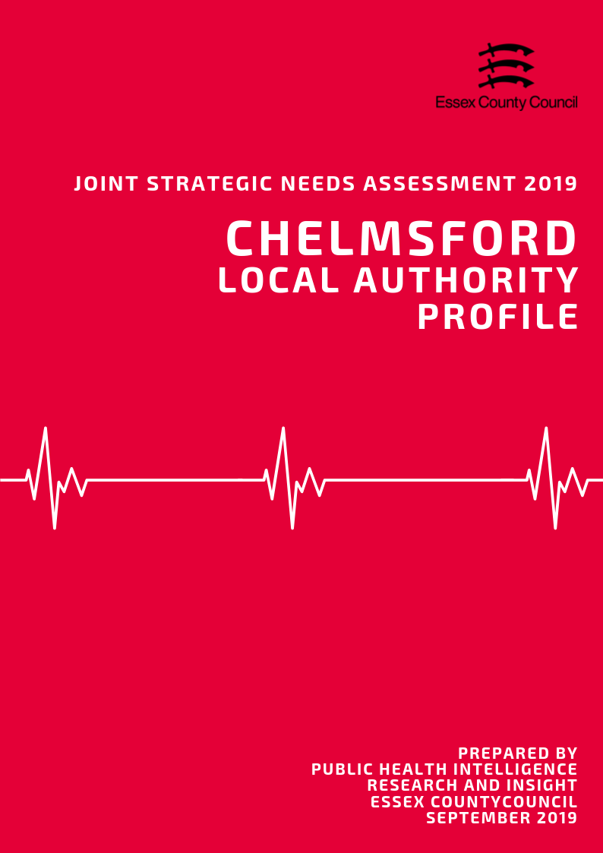

**Introduction**

What is a Joint Strategic Needs Assessment?

The JSNA is statutory process for Health & Wellbeing Boards (HWBB) to identify and improve the current and future health, wellbeing and social care needs of their area. The purpose is to inform strategic decision making, commissioning of services and reduce inequalities for all ages. There is no set format, prescribed content or specific time-period that a JSNA must cover, only that one must be produced in partnership with HWBB member organisations.

For the 2019 JSNA, the Health & Wellbeing Board is using a ‘place-based’ approach for the suite of JSNA products which will look at issues and needs at smaller local geographies. These geographies serve as building blocks to satisfy the need for intelligence at local authority and NHS geographical area and include:

• NHS/LA Locality/Neighbourhood Profiles

• District/Borough Council Profiles

• A Countywide Report

• Specialist Topic Deep Dive Reports (ESCG to develop)

This document presents data from a range of key topics which contribute to the overall the health and wellbeing of residents, in order to highlight areas of inequality and identify opportunities to improve the healthy lives for residents across the Essex County Council Local Authority area, with information also available separately for each of the 12 Districts and Boroughs where relevant.

Key findings from this and the 12 individual Local Authority Profiles will be used to identify issues that the Health and Wellbeing Board may wish to consider when refreshing the Joint Health and Wellbeing Strategy.

*Notes of Terminology:*

This document uses the term Essex to refer to the Essex County Council local authority area which does not include the Southend-on-Sea and Thurrock unitary authority areas. The term Chelmsford is used to refer to the whole local authority area.

**Contents**

|  |  |  |
| --- | --- | --- |
| **No.** | **Section** | **Page** |
| **1** | **Key Findings** | **3** |
| **2** | **Population & Demographics** | **9** |
| **3** | **Access to Services** | **20** |
| **4** | **Wider Determinants of Health** | **25** |
| **5** | **Lifestyle, Sexual Health & Substance Misuse** | **40** |
| **6** | **Life Expectancy & Mortality** | **50** |
| **7** | **Birth Rates and Infant Health** | **59** |
| **8** | **ILLNESS & HOSPITAL ADMISSIONS** | **64** |
| **9** | **Mental Health** | **82** |
|  |  |  |

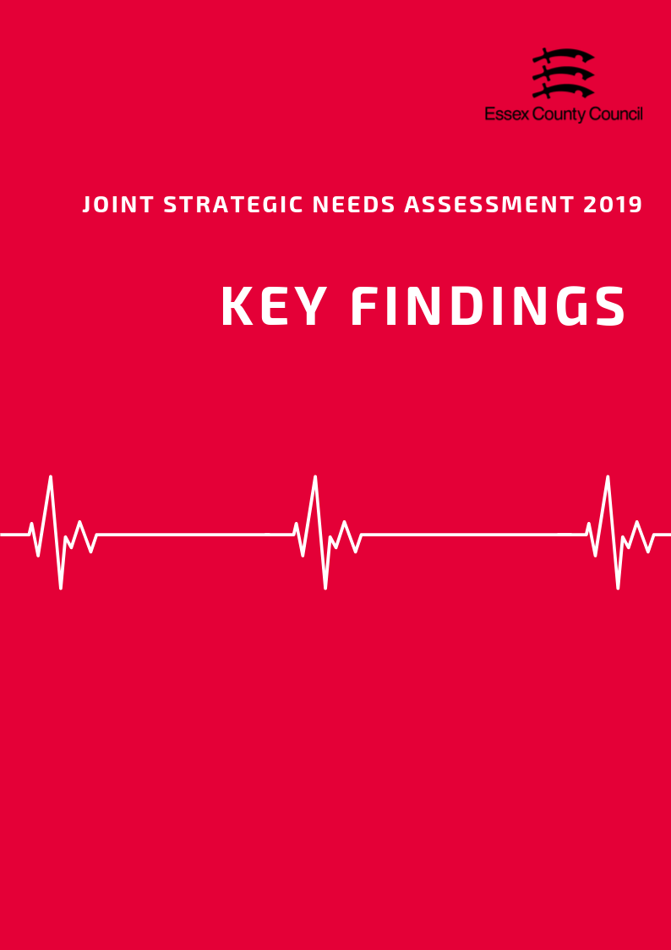

**The Top three things to know about…**

**Population and Demographics**

* In 2018, the total population of the Chelmsford local authority area was an estimated 177,079 people making it the third largest local authority area in Essex in terms of population size. This is an estimated increase of 2990 people since the 2011 census (a rise of 1.72%)
* Chelmsford is similar the county average for children aged 0-15 (19.1%), with a slightly higher percentage of 16 to 64 years olds (61.8%) and a smaller percentage people aged 65+ (19.1%) compared to the average for Essex as a whole (18.9%, 60.6% and 20.5%).
* Chelmsford has an Old Age Dependency Ratio of 307.9 people age 65+ to every 1000 working age. This is equivalent to 3.25 working age people to every one person aged 65 and over and is below the average for Essex as a whole (335.6), but higher than the average for England (286.8).

**Access to Services**

Covering an area of approximately 339 square kilometres, the Chelmsford City local authority is the fourth largest in Essex in terms of area.

* With an estimated 520 residents per square kilometre, Chelmsford City is just above the Essex average (424 people per sq. km) and the fifth highest district in terms of population density overall
* Chelmsford City residents have slightly shorter travel times to local services compared to the Essex average (19.4 minutes), with an average of 17.9 minutes by walking or public transport to 8 key services. Looking at times to health services, average times to GP surgeries were estimated at 11.5 minutes in-line with the Essex average (11.6 minutes), whilst time to hospitals were 39.5 minutes, 5 minutes lower than the county average.

**Wider Determinants of Health**

* The average weekly income for a Chelmsford resident working full time in 2018 was £630.20, £11.60 (1.8%) higher than the average for Essex and £55.30 (8.77%) higher than the average for England. This was the sixth highest average income out of 12 Districts.
* In 2018, 72% of pupils achieved grade 9-4 in English and Maths (a good pass) and 49.5% achieved grade 9-5 (a strong pass) at GCSE. This is higher than the England average (59.1%, 39.9%) and Essex (63.3% and 40.7%).
* The amount of residents claiming out of work benefits is lower than average but has increased to its highest level in 5 years from 1.3% in April 2015 to 1.5% in April 2019. This is lower than the averages for Essex (2.1%) and England (2.6%) is the (joint) seventh highest claimant rate in Essex overall.

**Lifestyle, Sexual Health & Substance Misuse**

* In 2017/18 that 20.6% of pupils in Reception year were classed as overweight or obese. This lower than the level for England or Essex. The sample of pupils in Year 6 showed that 29.7% of pupils in this year group were classed as overweight or obese, again lower than England.
* Of residents aged over 18 years, 63.32% were classified as overweight or obese in 2016/17. This is relatively similar to the prevalence of adult overweight or obesity across the whole of Essex (63.56%), but lower than that for England (61.29%)
* The rate of all new HIV diagnoses among adults aged over 15 years in Chelmsford was 8.99 per 100,000 population. This was the second highest rate compared across the Essex Districts and higher than the rate for the whole of Essex (5.63), but similar to that for England (8.66).

**Life Expectancy & Mortality**

* The average life expectancy at birth for a child born in Chelmsford (2015-2017) was 84 years for females and 81.3 years for males. This higher than the average for England for both sexes (Females = 83.1, Males = 79.6), and is the third highest male life expectancy in Essex.
* Life expectancy at age 65 (the number of additional years a person could expect to live) was 21.6 years for females and 19.8 years for males, higher than the England average for both sexes (Females = 21.1, Males 18.8) and is the second highest male LE in Essex.
* Chelmsford had a rate of 46.75 people per 100,000 killed or seriously injured on the roads in 2015-17. This was the above the England average but below Essex and was the 7th highest level in the county.

**Birth Rates & Infant Health**

* The rate of conceptions in women aged under 18 years per 1,000 females aged 15 to 17 years in the Chelmsford are was 12.2 in 2016, the 9th highest rate compared across the other Essex Districts.
* The percentage of breastfeeding initiation of the total number of maternities in the Chelmsford area in 2016/17 was 77.55%. This was the 4th highest compared across the Essex Districts with data available, and higher than that for the whole of Essex (75.02) and England (74.49).
* The percentage of mothers known to be smokers at the time of delivery out of all maternities was 7.76% in the Mid Essex CCG in 2017/18. This was the second lowest (compared across the other CCGs in Essex, and lower than that for Essex as a whole (10.60) and England (10.80).

**Illness & Hospital Admissions**

* The admissions ratio for emergency admissions for all causes among persons of all ages was 84.09 in Chelmsford, which was ranked as being the 9th highest admission ratio across the Essex Districts.
* The rate of hospital admissions caused by unintentional and deliberate injuries in children aged under 15 years per 10,000 resident population aged under 15 was 99.08 in Chelmsford in 2017/18. This was the third highest rate compared across the Districts in Essex and higher than the rate across Essex (88.22) and England (96.44).
* The age standardised rate of emergency hospital admissions due to hip fractures among persons aged over 65 years was 565.04 per 100,000 population. This was lower than the rate across Essex as a whole (611.91) and England (577.76), and was ranked as being the third lowest rate across the Districts in Essex

**Mental Health**

* Chelmsford had the 8th highest estimated prevalence of any mental health disorder among children aged between 5 to 16 years across the Districts of Essex in 2015, with a prevalence of was 8.24%. This was slightly lower than the estimated prevalence across the whole of Essex (8.71%) and England (9.23%).
* Women in Chelmsford had the 4th highest admissions rate in the county (194.97) for self-harm and were 2.6 times more likely to be admitted to hospital for intentional self-harm than men (75.5).
* Chelmsford was ranked as having the 5th highest suicide rate among males compared to that across the other Essex Districts, with a rate of 17.97. This is 23.1% higher than the rate across England (14.69) and above the rate of Essex as a whole (16.90).

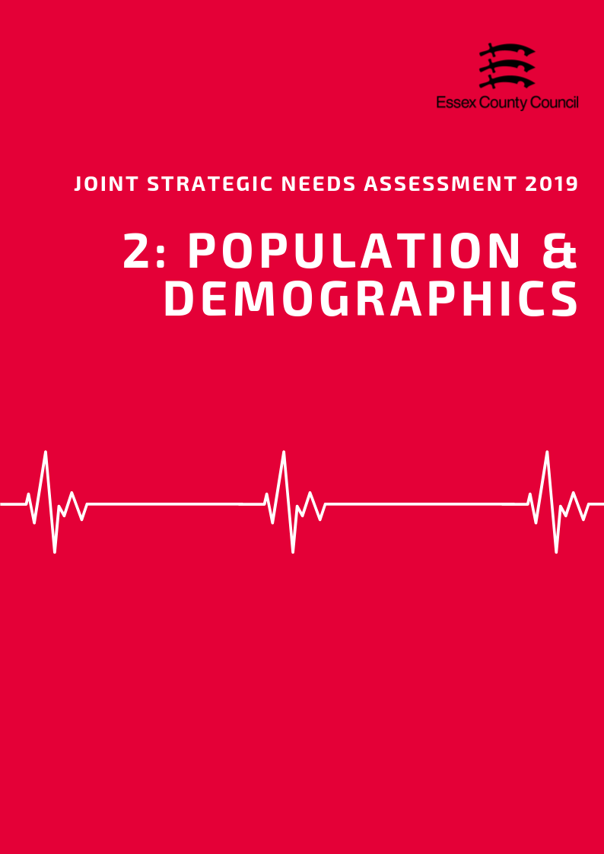

**POPULATION & DEMOGRAPHICS**

***Population Growth***

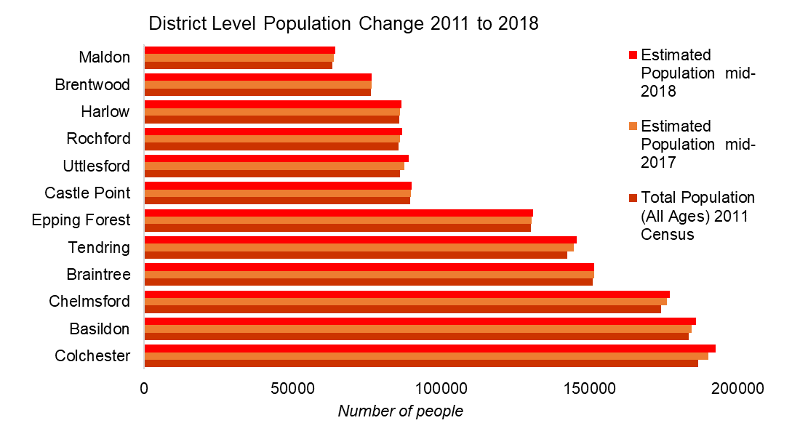According to the Office of National Statistics in 2018, the total population of the Chelmsford local authority area was an estimated 177,079 people making it the third largest local authority area in Essex in terms of population size. This is an estimated increase of 2990 people since the 2011 census (a rise of 1.72%) which is lower than had previously been predicted by the Office of National Statistics in earlier mid-year estimates. This is lower than the growth rate for England (5.59%) which nationally has seen the lowest rate of growth since 2004 but just above Essex.

Looking forward, the Office of National Statistics population projections (2016 based) predict that by 2034 the total population will increase by another 16,206 people to a total of 192,400.

|  |  |  |  |  |  |
| --- | --- | --- | --- | --- | --- |
|  | | **Essex** | | **Chelmsford** | |
| **2024** | **Total Population** | 1549200 |  | 183200 |  |
| **Under 18** | 292989 | 18.9% | 34692 | 18.9% |
| **18-64** | 936049 | 60.4% | 112782 | 61.6% |
| **65+** | 320162 | 20.7% | 35725 | 19.5% |
| **2029** | **Total Population** | 1602700 |  | 188000 |  |
| **Under 18** | 295387 | 18.4% | 34560 | 18.4% |
| **18-64** | 972743 | 60.7% | 116447 | 61.9% |
| **65+** | 334570 | 20.9% | 36993 | 19.7% |
| **2034** | **Total Population** | 1650800 |  | 192500 |  |
| **Under 18** | 296076 | 17.9% | 34573 | 18.0% |
| **18-64** | 981362 | 59.4% | 117234 | 60.9% |
| **65+** | 373362 | 22.6% | 40693 | 21.1% |

***Age Split***

Chelmsford is similar the county average for children aged 0-15 (19.1%), with a slightly higher percentage of 16 to 64 years olds (61.8%) and a smaller percentage people aged 65+ (19.1%) compared to the average for Essex as a whole (18.9%, 60.6% and 20.5%).

Over the next 15 years the age spilt of the population will change slightly with a small increase in the proportion of Older People (rising to 21%), and a small decrease in the percentage of young people aged 0-17 (18%) and residents aged 18 to 64 (61%). Despite this small shift, the Chelmsford City local authority area will have a lower percentage of older people compared to the predicted average for Essex (22.6%) in 2034.

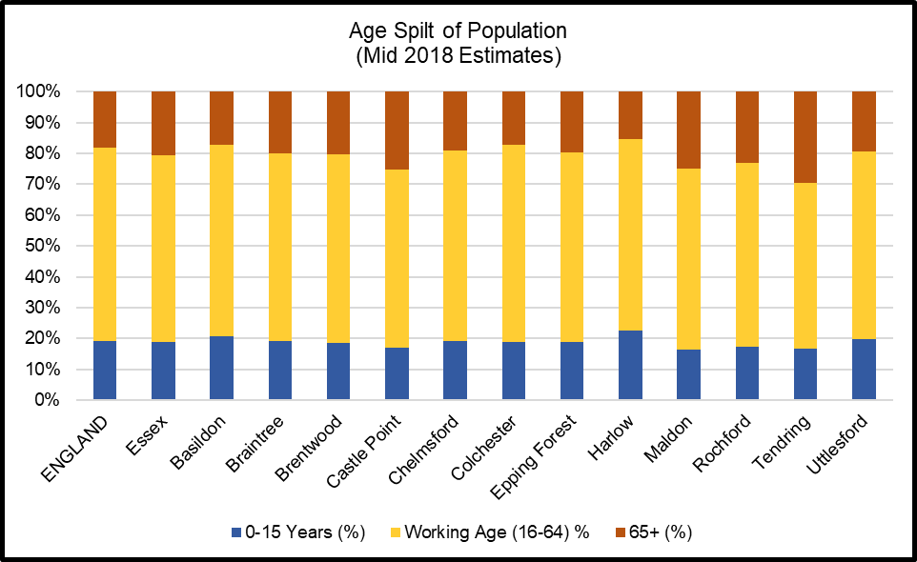

***Old Age Dependency Ratio***

A useful measure to understand how the balance in the population will change, particularly when planning for the needs of the aging population is the old age dependency ratio (OADR) – the number of people over 65 years old for every 1,000 people aged between 16 and 64 years old.

Chelmsford had an estimated OADR of 307.9 in 2019. This is equivalent to 3.25 working age people to every one person aged 65 and over and is below the average for Essex as a whole (335.6), but higher than the average for England (286.8). By 2034 this rate is predicted to rise to 347.1 per 1000, below the total rate for Essex (380.4) but higher than the rate for England (334.2).

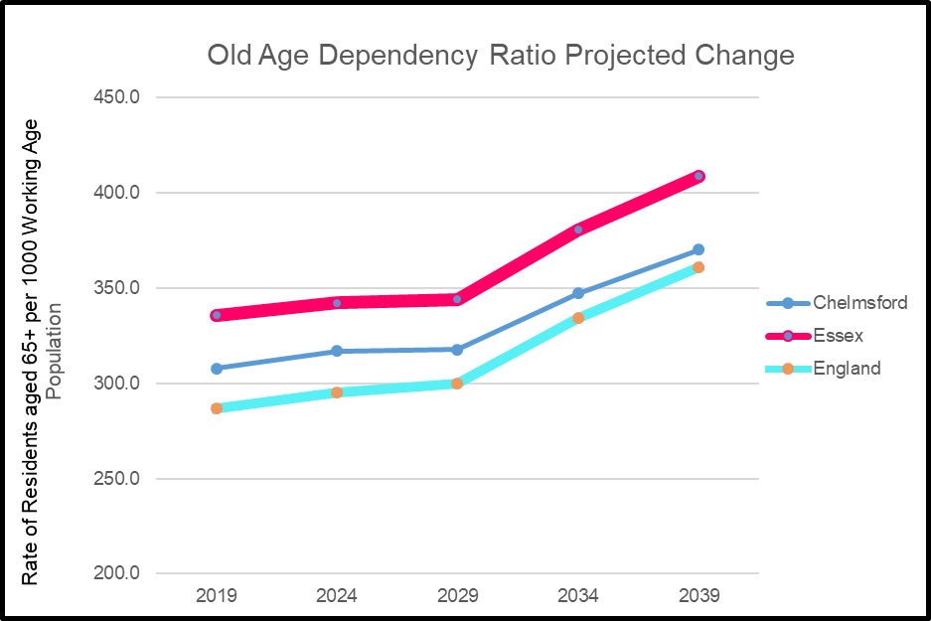

***Ethnicity***

At the time of the 2011 census the population of the Chelmsford City local authority area was majority White British (90.3%) with the remainder (9.7%) of residents coming from Black and Minority Ethnic (BAME) ethnic groups including white non-British residents. The percentage of BAME residents was similar to the average for Essex in 2011 (9.2%) but was significantly lower than the average for England (20.3%).

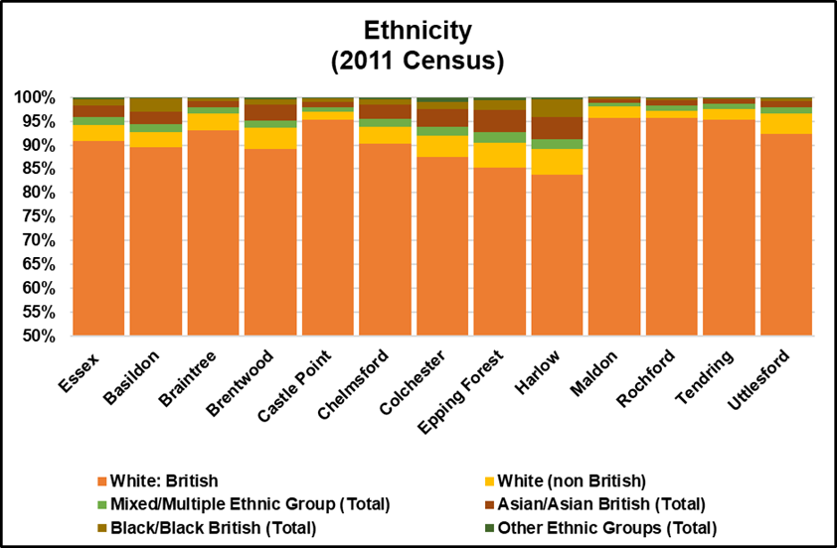

*Researchers note: The Office of National Statistics does not produce modelled estimates or projected figures by ethnic group; as such the only comprehensively available figures are taken from the 2011 Census. Given the age of this data caution is advised when generalising to the current population.*

***Household Composition***

At the time of the 2011 Census there were an estimated 69,667 households in the Chelmsford City area of which 23.7% contained dependent children. This was just above the average for Essex (22.8%) and England (21.9%).

Households with married or civil partnership couples (38.8%) made up over a third of all households higher than the averages for Essex (36.8%) or England (33.2%)

Single person households (27.5%) and lone parent households (8.8%) were below the averages for Essex (28.4%, 9.7) and England (30.2%, 10.6%).

14,707 households (21.1%) were occupied solely by residents aged 65 and over including 7,991 households (11.5%) where a resident aged 65 and over was living alone. This is slightly lower than the average for Essex (23.2%, 13.1%) and similar to the average for England (20.7%, 12.4%).

***Learning Disabilities and Special Educational Needs***

Exact figures for the number of residents with Learning Disabilities are not available however modelled predictions from POPPI/PANSI suggest the level could be around 3286 people of whom 2561 people are aged 18-64 and 725 people are aged 65+. This total is equivalent to 2.35% of the age weighted population and is similar to the levels across England (2.36%) and Essex (2.34%). Of this number it is estimated that a total of 682 (*585 age 18-64; 97 age 65+)* have severe learning disabilities thus may have additional support needs.

By 2035 it is predicted that the number of people with Learning disabilities will increase to 2650 people in the 18-64 age group, and to 958 for those aged 65+. In the severe learning disabilities category this is predicted to increase to 610 and 123 respectively.

***Impaired Mobility***

Exact figures for the number of people living in an area with a physical impairment are not available, as such for the purposes of the JSNA we will look at a number of proxy measures. For adults aged 18-64 predictions from PANSI (2019) estimate that 5814 people might currently have some form of impaired mobility, 5139 have difficulty in performing personal care tasks, and 334 have a health condition caused by a stroke.

For Adults aged 65+ predictions from POPPI (2019) estimate that 6387 people might be unable to manage one or more mobility task (*such as going out of doors and walking down the road; getting up and down stairs; getting around the house on the level; getting to the toilet; getting in and out of bed),* whilst 6379 people have their day to day activities limited a lot by their physical health.

***Sensory Impairments***

POPPI / Predictions estimate that there are 3496 people with severe hearing loss of which 2864 people are aged 65+. 68 people aged 18-64 were predicted to have serious visual impairments whilst 3045 people aged 65+ had moderate or severe visual impairment.





***Table 3: Old Age Dependency Ratio***

|  |  |  |  |  |  |  |  |  |  |
| --- | --- | --- | --- | --- | --- | --- | --- | --- | --- |
| **Old Age Dependency Ratio**  **(Rate of residents aged 65 years and over per working age population)** | | | | | | | | | |
|  | **2019** | | **2024** | | **2029** | | **2034** | | **2039** |
| **England** | 286.8 | | 295.1 | | 299.7 | | 334.2 | | 361 |
| **Essex** | 335.6 | | 342.0 | | 343.9 | | 380.4 | | 408.6 |
| Basildon | 272.4 | | 273.2 | | 272.6 | | 298.8 | | 318.3 |
| Braintree | 330.0 | | 348.0 | | 358.2 | | 409.2 | | 448.1 |
| Brentwood | 325.1 | | 322.5 | | 321.6 | | 350.6 | | 368.1 |
| Castle Point | 431.1 | | 438.3 | | 432.9 | | 469.6 | | 496.8 |
| Chelmsford | 307.9 | | 316.8 | | 317.7 | | 347.1 | | 369.9 |
| Colchester | 266.4 | | 265.6 | | 263.1 | | 288.7 | | 310.1 |
| Epping Forest | 311.8 | | 310.2 | | 309.9 | | 340.9 | | 365.9 |
| Harlow | 242.8 | | 248.3 | | 250.0 | | 276.1 | | 294.9 |
| Maldon | 426.6 | | 457.5 | | 471.1 | | 533.8 | | 579.2 |
| Rochford | 385.1 | | 392.1 | | 394.9 | | 438.2 | | 473.1 |
| Tendring | 544.0 | | 552.1 | | 553.3 | | 615.3 | | 665.7 |
| Uttlesford | 327.7 | | 344.9 | | 358.6 | | 408.2 | | 448.4 |
| ***Source: Office of National Statistics Population Projections 2016*** | | | | | | | | | |
|  |  |  | |  | |  | |  | |
|  | | | | | | | | | |

**Table 4: Ethnicity**

|  |  |  |  |  |  |  |  |
| --- | --- | --- | --- | --- | --- | --- | --- |
| **Ethnicity** | | | | | | | |
|  | **White British %** | **% White non British** | **% Mixed/ Multiple Ethnic Group** | **% Asian/ Asian British** | **% Black/ Black British** | **% Other Ethnic Groups** | **Total Percentage of BAME (Inc. white non-British)** |
| **England** | 79.75% | 5.7% | 2.3% | 7.8% | 3.5% | 1.0% | 20.25% |
| **Essex** | 90.8% | 3.5% | 1.5% | 2.5% | 1.3% | 0.4% | 9.24% |
| Basildon | 89.5% | 3.1% | 1.7% | 2.7% | 2.7% | 0.3% | 10.48% |
| Braintree | 93.2% | 3.5% | 1.2% | 1.4% | 0.6% | 0.2% | 6.85% |
| Brentwood | 89.2% | 4.3% | 1.6% | 3.2% | 1.2% | 0.4% | 10.75% |
| Castle Point | 95.4% | 1.5% | 1.0% | 1.1% | 0.8% | 0.2% | 4.62% |
| Chelmsford | 90.3% | 3.6% | 1.6% | 2.9% | 1.2% | 0.4% | 9.70% |
| Colchester | 87.5% | 4.5% | 1.8% | 3.7% | 1.5% | 1.0% | 12.49% |
| Epping Forest | 85.2% | 5.3% | 2.1% | 4.8% | 1.9% | 0.7% | 14.78% |
| Harlow | 83.9% | 5.2% | 2.1% | 4.6% | 3.8% | 0.5% | 16.14% |
| Maldon | 95.8% | 2.3% | 0.8% | 0.8% | 0.2% | 0.1% | 4.25% |
| Rochford | 95.6% | 1.6% | 1.1% | 1.1% | 0.5% | 0.2% | 4.39% |
| Tendring | 95.4% | 2.2% | 1.1% | 0.9% | 0.3% | 0.1% | 4.62% |
| Uttlesford | 92.3% | 4.3% | 1.2% | 1.4% | 0.5% | 0.2% | 7.70% |
| ***Source: Office of National Statistics 2011 Census*** | | | | | | | |

**Table 5: Household Composition**

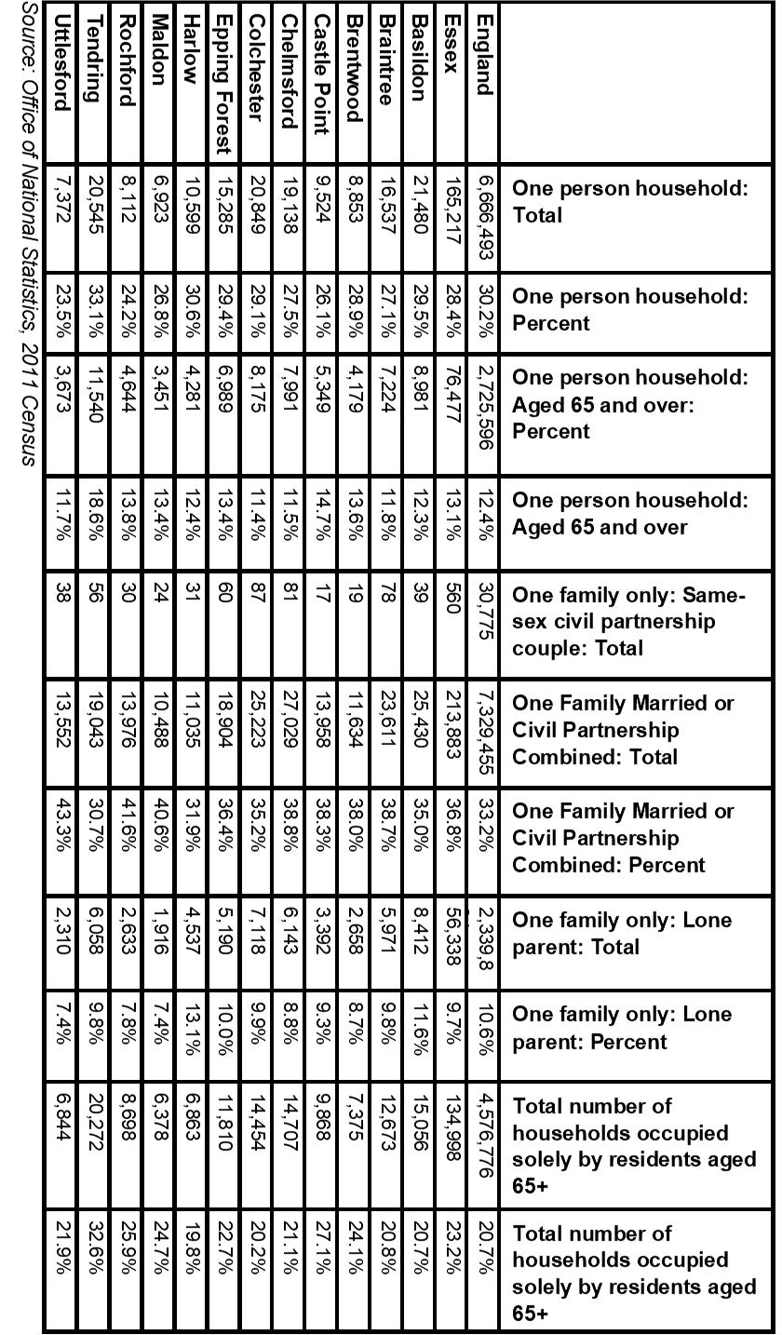

**Table 6: Learning Disability Predictions 2019**

|  |  |  |  |  |  |  |
| --- | --- | --- | --- | --- | --- | --- |
|  | **Number of people predicted to have a learning disability in 2019** | | | | | |
| **Age 18-64** | | **Age 65+** | | **Total Age 18+** | |
| **Number** | **%\*** | **Number** | **%\*** | **Number** | **%\*** |
| **England** | **826834** | **2.44%** | **216362** | **2.09%** | **1043196** | **2.36%** |
| **East of England** | **89212** | **2.43%** | **26011** | **2.09%** | **115223** | **2.34%** |
| **Essex** | **21059** | **2.43%** | **6487** | **2.09%** | **27546** | **2.34%** |
| Basildon | 2740 | 2.43% | 683 | 2.09% | 3423 | 2.36% |
| Braintree | 2164 | 2.42% | 659 | 2.09% | 2823 | 2.34% |
| Brentwood | 1110 | 2.42% | 333 | 2.08% | 1443 | 2.33% |
| Castle Point | 1219 | 2.42% | 486 | 2.09% | 1705 | 2.32% |
| Chelmsford | 2561 | 2.43% | 725 | 2.09% | 3286 | 2.35% |
| Colchester | 2947 | 2.45% | 713 | 2.10% | 3660 | 2.37% |
| Epping Forest | 1914 | 2.43% | 546 | 2.09% | 2460 | 2.34% |
| Harlow | 1276 | 2.44% | 282 | 2.07% | 1558 | 2.36% |
| Maldon | 870 | 2.41% | 344 | 2.11% | 1214 | 2.32% |
| Rochford | 1210 | 2.42% | 429 | 2.09% | 1639 | 2.32% |
| Tendring | 1828 | 2.41% | 919 | 2.09% | 2747 | 2.30% |
| Uttlesford | 1237 | 2.42% | 376 | 2.09% | 1613 | 2.33% |
|  | **Number of people predicted to have a moderate or severe learning disability in 2019** | | | | | |
| **Age 18-64** | | **Age 65+** | | **Total Age 18+** | |
| **Number** | **%\*** | **Number** | **%\*** | **Number** | **%\*** |
| **England** | 188444 | 0.56% | 29128 | 0.28% | 217572 | 0.49% |
| **East of England** | 20343 | 0.55% | 3488 | 0.28% | 23831 | 0.48% |
| **Essex** | 4797 | 0.55% | 870 | 0.28% | 5667 | 0.48% |
| Basildon | 625 | 0.56% | 92 | 0.28% | 717 | 0.49% |
| Braintree | 493 | 0.55% | 89 | 0.28% | 582 | 0.48% |
| Brentwood | 253 | 0.55% | 44 | 0.28% | 297 | 0.48% |
| Castle Point | 277 | 0.55% | 65 | 0.28% | 342 | 0.47% |
| Chelmsford | 585 | 0.56% | 97 | 0.28% | 682 | 0.49% |
| Colchester | 672 | 0.56% | 96 | 0.28% | 768 | 0.50% |
| Epping Forest | 437 | 0.55% | 73 | 0.28% | 510 | 0.49% |
| Harlow | 291 | 0.56% | 38 | 0.28% | 329 | 0.50% |
| Maldon | 197 | 0.55% | 47 | 0.29% | 244 | 0.47% |
| Rochford | 276 | 0.55% | 57 | 0.28% | 333 | 0.47% |
| Tendring | 413 | 0.55% | 123 | 0.28% | 536 | 0.45% |
| Uttlesford | 283 | 0.55% | 50 | 0.28% | 333 | 0.48% |
| *Source POPPI/PANSI 2019* | | | | | | |

***Table 7: Learning Disability Projections***

|  |  |  |  |  |  |  |  |  |
| --- | --- | --- | --- | --- | --- | --- | --- | --- |
| **Predicted Numbers of People with a Learning Disability to 2035** | | | | | | | | |
|  | **2025** | | **2030** | | **2035** | | **Predicted Change 2019-2035** | |
| **18-64** | **65+** | **18-64** | **65+** | **18-64** | **65+** | **18-64** | **65+** |
| **England** | **833689** | **240660** | **839192** | **269064** | **842807** | **296050** | **15973** | **79688** |
| **East of England** | **90564** | **28952** | **91550** | **32438** | **92307** | **35875** | **3095** | **9864** |
| **Essex** | **21467** | **7179** | **21763** | **8011** | **22030** | **8855** | **971** | **2368** |
| Basildon | 2816 | 754 | 2880 | 844 | 2953 | 932 | 213 | 249 |
| Braintree | 2167 | 744 | 2166 | 842 | 2149 | 936 | -15 | 277 |
| Brentwood | 1137 | 354 | 1155 | 397 | 1180 | 433 | 70 | 100 |
| Castle Point | 1217 | 520 | 1221 | 566 | 1230 | 614 | 11 | 128 |
| Chelmsford | 2590 | 797 | 2619 | 881 | 2650 | 958 | 89 | 233 |
| Colchester | 3078 | 784 | 3182 | 877 | 3254 | 976 | 307 | 263 |
| Epping Forest | 1961 | 594 | 1993 | 662 | 2034 | 733 | 120 | 187 |
| Harlow | 1292 | 319 | 1315 | 356 | 1341 | 391 | 65 | 109 |
| Maldon | 853 | 392 | 844 | 434 | 835 | 482 | -35 | 138 |
| Rochford | 1213 | 467 | 1219 | 521 | 1218 | 570 | 8 | 141 |
| Tendring | 1856 | 1017 | 1879 | 1139 | 1893 | 1263 | 65 | 344 |
| Uttlesford | 1268 | 437 | 1283 | 506 | 1299 | 572 | 62 | 196 |
| **Predicted Numbers of People with Moderate or Severe Learning Disabilities to 2035** | | | | | | | | |
|  | **2025** | | **2030** | | **2035** | | **Predicted Change 2019-2035** | |
| **18-64** | **65+** | **18-64** | **65+** | **18-64** | **65+** | **18-64** | **65+** |
| **England** | **190642** | **31818** | **192706** | **35452** | **193757** | **38627** | **5313** | **9499** |
| **East of England** | **20718** | **3802** | **21027** | **4244** | **21222** | **4654** | **879** | **1166** |
| **Essex** | **4906** | **942** | **4994** | **1047** | **5064** | **1150** | **267** | **280** |
| Basildon | 645 | 100 | 663 | 112 | 680 | 123 | 55 | 31 |
| Braintree | 495 | 98 | 496 | 110 | 493 | 121 | 0 | 32 |
| Brentwood | 260 | 46 | 266 | 51 | 272 | 56 | 19 | 12 |
| Castle Point | 277 | 68 | 279 | 73 | 282 | 79 | 5 | 14 |
| Chelmsford | 593 | 104 | 603 | 114 | 610 | 123 | 25 | 26 |
| Colchester | 704 | 103 | 731 | 115 | 749 | 127 | 77 | 31 |
| Epping Forest | 449 | 78 | 458 | 87 | 468 | 95 | 31 | 22 |
| Harlow | 296 | 43 | 303 | 48 | 309 | 51 | 18 | 13 |
| Maldon | 194 | 52 | 192 | 57 | 191 | 63 | -6 | 16 |
| Rochford | 277 | 61 | 279 | 68 | 280 | 74 | 4 | 17 |
| Tendring | 420 | 133 | 428 | 149 | 432 | 164 | 19 | 41 |
| Uttlesford | 290 | 57 | 295 | 66 | 299 | 74 | 16 | 24 |
| *Source POPPI/PANSI 2019* | | | | | | | | |

***Table 8: Physical Impairments***

|  |  |  |  |  |  |  |  |  |
| --- | --- | --- | --- | --- | --- | --- | --- | --- |
| **The number of people aged 18-64 predicted to have a physical impairment in 2019** | | | | | | | | |
|  | **Impaired Mobility** | | **Any moderate or severe personal care disability** | | **A longstanding health condition caused by a stroke** | | **Combined Total** | |
| **Number** | **%\*** | **Number** | **%\*** | **Number** | **%\*** | **Number** | **%\*** |
| **Essex** | **48922** | **5.23%** | **43109** | **4.61%** | **2817** | **0.30%** | **94848** | **10.13%** |
| **Basildon** | **6079** | **4.97%** | **5385** | **4.40%** | **345** | **0.28%** | **11809** | **9.66%** |
| Braintree | 5149 | 5.41% | 4540 | 4.77% | 300 | 0.32% | 9989 | 10.49% |
| Brentwood | 2618 | 5.27% | 2307 | 4.65% | 151 | 0.30% | 5076 | 10.23% |
| Castle Point | 2969 | 5.54% | 2604 | 4.86% | 172 | 0.32% | 5745 | 10.73% |
| Chelmsford | 5814 | 5.16% | 5139 | 4.56% | 334 | 0.30% | 11287 | 10.01% |
| Colchester | 5953 | 4.53% | 5328 | 4.06% | 338 | 0.26% | 11619 | 8.85% |
| Epping Forest | 4467 | 5.24% | 3937 | 4.62% | 256 | 0.30% | 8660 | 10.16% |
| Harlow | 2786 | 4.95% | 2461 | 4.38% | 155 | 0.28% | 5402 | 9.61% |
| Maldon | 2282 | 6.02% | 1991 | 5.25% | 135 | 0.36% | 4408 | 11.63% |
| Rochford | 2967 | 5.56% | 2604 | 4.88% | 172 | 0.32% | 5743 | 10.76% |
| Tendring | 4785 | 5.80% | 4142 | 5.02% | 273 | 0.33% | 9200 | 11.16% |
| Uttlesford | 3089 | 5.51% | 2710 | 4.83% | 181 | 0.32% | 5980 | 10.66% |
| *Percentage of the total population aged 18-64 based on 2019 population projections | | | | | | | | |

|  |  |  |  |  |  |  |
| --- | --- | --- | --- | --- | --- | --- |
|  | **The number of Adults aged 65 and over with long term limiting conditions or restricted mobility** | | | | | |
| **Day-to-day activities are limited a little** | | **Day-to-day activities are limited a lot** | | **Unable to manage at least one mobility** activity on their own** | |
| **Number** | **%** | **Number** | **%** | **Number** | **%** |
| Essex | 76314 | 24.6% | 66662 | 21.5% | 57212 | 18.4% |
| Basildon | 8044 | 24.6% | 8043 | 24.6% | 6058 | 18.5% |
| Braintree | 7669 | 24.3% | 6309 | 20.0% | 5676 | 18.0% |
| Brentwood | 3793 | 23.7% | 3020 | 18.9% | 3147 | 19.7% |
| Castle Point | 5593 | 24.1% | 5482 | 23.6% | 4180 | 18.0% |
| Chelmsford | 8433 | 24.3% | 6379 | 18.4% | 6387 | 18.4% |
| Colchester | 8386 | 24.7% | 7079 | 20.8% | 6142 | 18.1% |
| Epping Forest | 6265 | 24.0% | 5398 | 20.7% | 5017 | 19.2% |
| Harlow | 3465 | 25.5% | 3615 | 26.6% | 2625 | 19.3% |
| Maldon | 3909 | 24.0% | 3237 | 19.9% | 2893 | 17.7% |
| Rochford | 5259 | 25.7% | 4198 | 20.5% | 3727 | 18.2% |
| Tendring | 11449 | 26.1% | 10819 | 24.6% | 8078 | 18.4% |
| Uttlesford | 4309 | 23.9% | 3242 | 18.0% | 3358 | 18.7% |
| *\*\*Activities include: going out of doors and walking down the road; getting up and down stairs; getting around the house on the level; getting to the toilet; getting in and out of bed* | | | | | | |
| *Source POPPI/PANSI 2019* | | | | | | |

***Table 9: Sensory Impairments***

|  |  |  |  |  |  |  |
| --- | --- | --- | --- | --- | --- | --- |
|  | **Severe Hearing Loss** | | | **Visual Impairments** | | |
| **Visual Impairments Total** | **Serious Visual Impairments in people age 18-64** | **Moderate or Severe Visual Impairments in People age 65+** |
| **Total 18 and over** | **18-64** | **65+** |
| Essex | 30503 | 5272 | 25231 | 27745 | 564 | 27181 |
| Basildon | 3309 | 659 | 2651 | 2925 | 74 | 2851 |
| Braintree | 3074 | 562 | 2511 | 2775 | 59 | 2716 |
| Brentwood | 1718 | 285 | 1433 | 1475 | 29 | 1446 |
| Castle Point | 2154 | 317 | 1837 | 2059 | 32 | 2027 |
| Chelmsford | 3496 | 632 | 2864 | 3113 | 68 | 3045 |
| Colchester | 3293 | 631 | 2663 | 3022 | 78 | 2944 |
| Epping Forest | 2757 | 487 | 2269 | 2364 | 52 | 2312 |
| Harlow | 1487 | 310 | 1177 | 1238 | 34 | 1204 |
| Maldon | 1471 | 245 | 1227 | 1418 | 23 | 1395 |
| Rochford | 1956 | 310 | 1645 | 1827 | 33 | 1794 |
| Tendring | 4013 | 503 | 3510 | 3916 | 50 | 3866 |
| Uttlesford | 1775 | 331 | 1443 | 1613 | 33 | 1580 |
| *Source POPPI/PANSI 2019* | | | | | | |

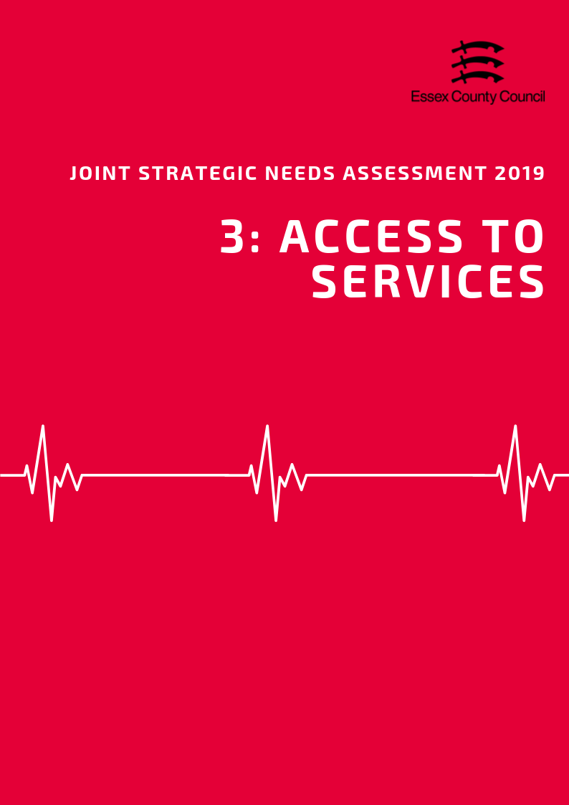

**ACCESS TO SERVICES**

**Area**

Covering an area of approximately 339 square kilometres, the Chelmsford City local authority is the fourth largest in Essex in terms of area. It is classed statistically as predominantly urban the majority of residents living in or on the fringe of urban areas such as Chelmsford, but also includes a number of smaller more rural settlements.

***Population Density***

With an estimated 520 residents per square kilometre, Chelmsford City is just above the Essex average (424 people per sq. km) and the fifth highest district in terms of population density overall.

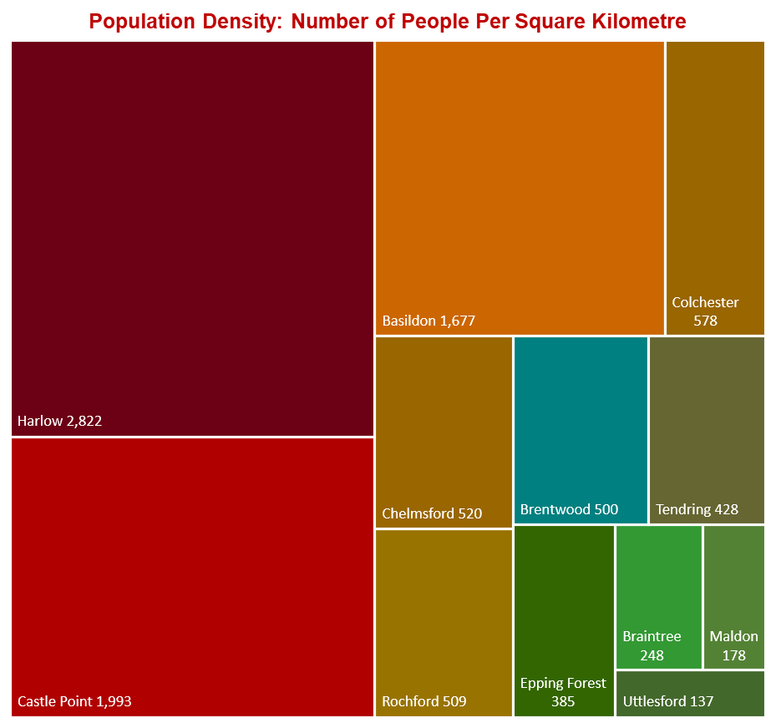

***Travel Time to Key Services***

According to the Department for Transport, Chelmsford City residents have slightly shorter travel times to local services compared to the Essex average (19.4 minutes), with an average of 17.9 minutes by walking or public transport to 8 key services. Looking at times to health services, average times to GP surgeries were estimated at 11.5 minutes in-line with the Essex average (11.6 minutes), whilst time to hospitals were 39.5 minutes, 5 minutes lower than the county average. Access to a car reduced these travel times significantly to 8.1 minutes for GP surgeries and 21.6 minutes to hospitals.

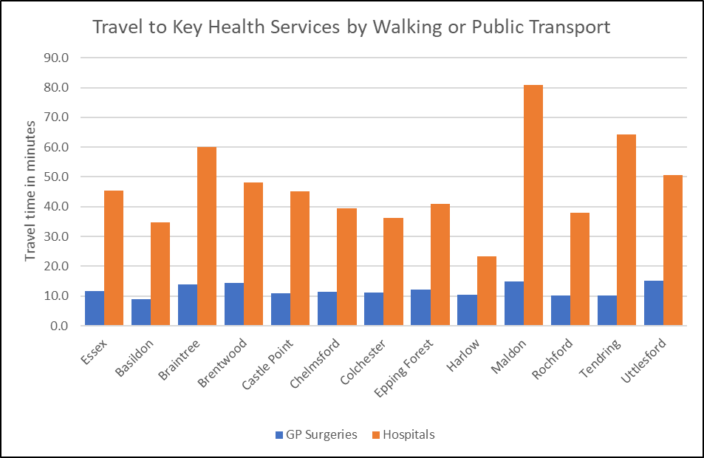

***Source: Department for Transport***

*See table at the end of this chapter for average travel times to all service types.*

***Satisfaction with GP Services***

Information about satisfaction with GP services from the GP Patient Survey are only available at CCG level so it is not possible to present views of Chelmsford residents in isolation. According to data from the 2018 survey, 79.2% of patients in the Mid Essex CCG reported a positive experience of their GP practice. This lower than the average for both England (83.75%) and the NHS Eastern Region (83.3%) but is in line with the combined average for all CCGs in Essex (80.35%).

|  |  |  |
| --- | --- | --- |
| **The percentage of patients aged 16+ who have a positive experience of their GP practice** | **Time period** | **%** |
| **England** | **2018** | **83.8** |
| **East NHS region** | **2018** | **83.3** |
| NHS Basildon And Brentwood CCG | 2018 | 80.6 |
| NHS Castle Point and Rochford CCG | 2018 | 82.8 |
| NHS Mid Essex CCG | 2018 | 79.2 |
| NHS North East Essex CCG | 2018 | 79.1 |
| NHS Southend CCG | 2018 | 80.1 |
| NHS Thurrock CCG | 2018 | 76.0 |
| NHS West Essex CCG | 2018 | 80.2 |

*Source: GP Patient Survey 2018*

***Carers***

The exact number of residents providing informal or unpaid care to friends or family members is not known, however figures from the Department for Work and Pensions identified 1500 residents who had been in receipt of Carers Allowance benefits in November 2018.The largest numbers of claimants were in the 35-44 and 45-54 age groups. Women were more than three times more likely to be in receipt of carers allowance (1200 / 79.5%) compared to Men however this rate was similar to the levels across Essex as a whole (77.4%).

|  |  |  |  |  |  |  |  |  |  |  |  |  |  |
| --- | --- | --- | --- | --- | --- | --- | --- | --- | --- | --- | --- | --- | --- |
|  | **Number of people in receipt of carers allowance by age Group – November 2018** | | | | | | | | | | | | |
| **Total** | | **under 18** | | **18-24** | **25-34** | | **35-44** | | **45-54** | **55-64** | | **65+** |
| **Essex** | **16,620** | | **30** | | **580** | **2,940** | | **4,020** | | **4,410** | **4,410** | | **230** |
| Basildon | 2,690 | | 10 | | 120 | 530 | | 710 | | 670 | 630 | | 30 |
| Braintree | 1,750 | |  | | 40 | 350 | | 430 | | 460 | 430 | | 20 |
| Brentwood | 540 | |  | | 20 | 70 | | 120 | | 160 | 150 | | ~ |
| Castle Point | 1,110 | |  | | 40 | 160 | | 220 | | 310 | 350 | | 20 |
| Chelmsford | 1,500 | |  | | 50 | 260 | | 400 | | 400 | 360 | | 20 |
| Colchester | 1,990 | | 10 | | 80 | 390 | | 500 | | 520 | 450 | | 30 |
| Epping Forest | 1,170 | |  | | 40 | 170 | | 280 | | 320 | 340 | | 20 |
| Harlow | 1,100 | |  | | 40 | 220 | | 300 | | 260 | 260 | | 10 |
| Maldon | 720 | |  | | 10 | 130 | | 170 | | 200 | 210 | | 10 |
| Rochford | 770 | |  | | 20 | 80 | | 190 | | 230 | 250 | | 10 |
| Tendring | 2,800 | |  | | 100 | 490 | | 610 | | 720 | 830 | | 40 |
| Uttlesford | 480 | |  | | 10 | 80 | | 90 | | 140 | 130 | | 10 |
|  | | **Number of people in receipt of carers allowance by Gender –November 2018** | | | | | | | | | | | |
| **All Claimants** | | **Male** | | | | | **Female** | | | | |
|  | | **Number** | | **Number** | | | **%** | | **Number** | | | **%** | |
| **Essex** | | **16,620** | | **3,760** | | | **22.6%** | | **12,860** | | | **77.4%** | |
| Basildon | | 2,690 | | 610 | | | 22.7% | | 2,080 | | | 77.3% | |
| Braintree | | 1,750 | | 390 | | | 22.3% | | 1,360 | | | 77.7% | |
| Brentwood | | 540 | | 100 | | | 18.5% | | 440 | | | 81.5% | |
| Castle Point | | 1,110 | | 230 | | | 20.7% | | 880 | | | 79.3% | |
| Chelmsford | | 1,510 | | 310 | | | 20.5% | | 1,200 | | | 79.5% | |
| Colchester | | 1,990 | | 430 | | | 21.6% | | 1,560 | | | 78.4% | |
| Epping Forest | | 1,170 | | 260 | | | 22.2% | | 910 | | | 77.8% | |
| Harlow | | 1,100 | | 230 | | | 20.9% | | 870 | | | 79.1% | |
| Maldon | | 720 | | 140 | | | 19.4% | | 580 | | | 80.6% | |
| Rochford | | 770 | | 160 | | | 20.8% | | 610 | | | 79.2% | |
| Tendring | | 2,810 | | 800 | | | 28.5% | | 2,010 | | | 71.5% | |
| Uttlesford | | 480 | | 100 | | | 20.8% | | 380 | | | 79.2% | |
| *Source: Department of Work and Pensions 2019* | | | | | | | | | | | | | |

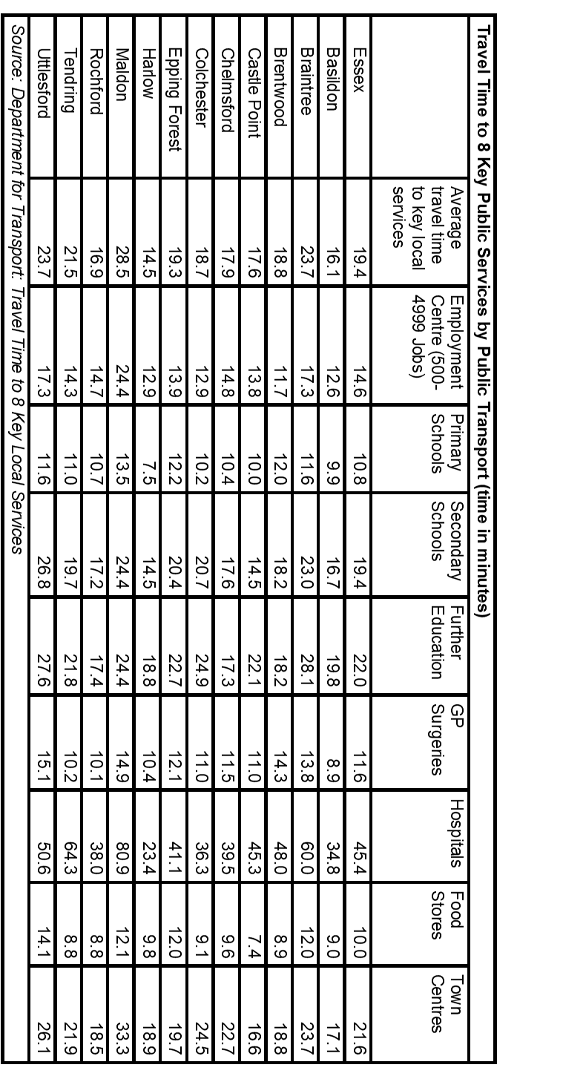

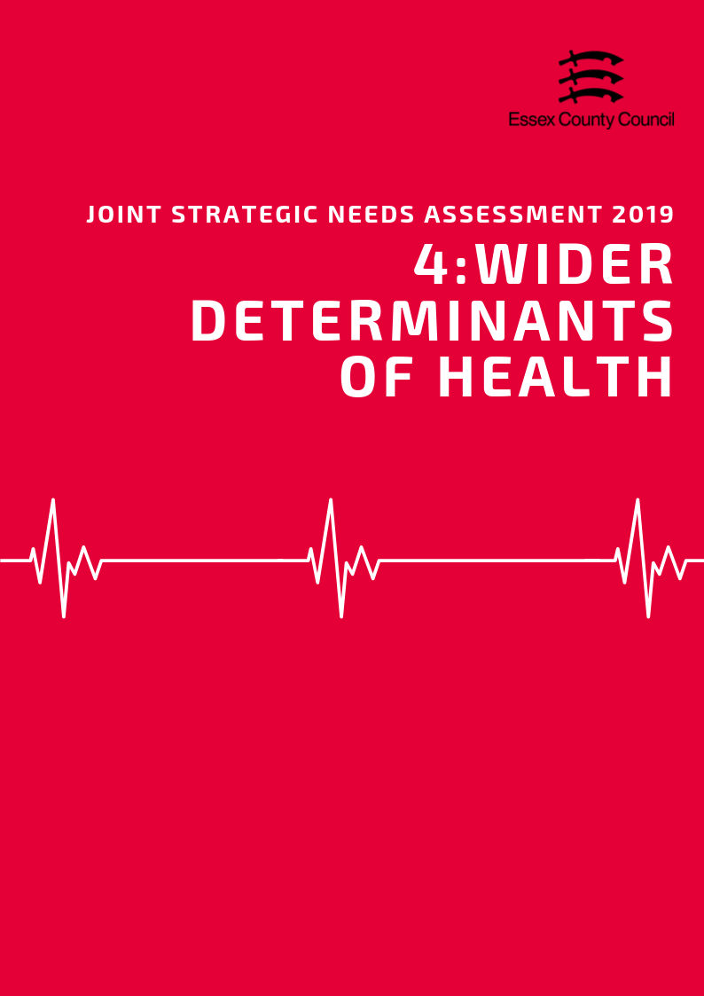

**Wider Determinants of Health**

***“Wider determinants, also known as social determinants, are a diverse range of social, economic and environmental factors which impact on people’s health. Such factors are influenced by the local, national and international distribution of power and resources which shape the conditions of daily life. They determine the extent to which different individuals have the physical, social and personal resources to identify and achieve goals, meet their needs and deal with changes to their circumstances.” Public Health England 2019***

***Income & Average Earnings***

The average weekly income for a Chelmsford resident working full time in 2018 was £630.20, £11.60 (1.8%) higher than the average for Essex and £55.30 (8.77%) higher than the average for England. This was the sixth highest average income out of 12 Districts. Part time workers earned an average of £188.50 per week, 3.4% above than the Essex average, 0.6% above the average for England, and was the fourth highest average income in the county.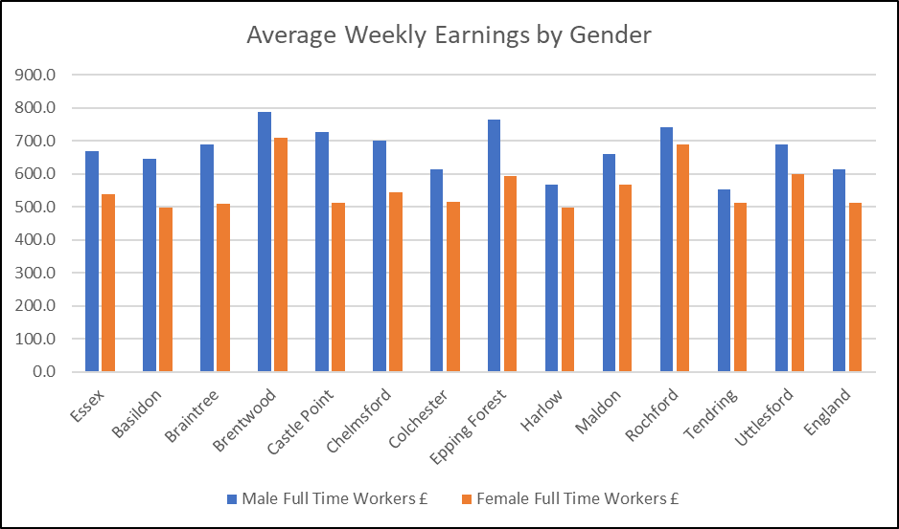

Male residents generally earned £157.6 (22.50%) more per week than females with an average weekly pay of £700.60 for male full time workers compared to £543 for females. This was fifth highest average difference in percentage and the fourth highest in terms of actual income.

***Deprivation***

In the Indices of Multiple Deprivation 2019 the Chelmsford Local Authority area was ranked 260 out of 317 lower tier authorities in England based on the average rank of the LSOAs in this area (where 1= most deprived). This places Chelmsford in the top 20% of least deprived Lower Tier Local Authorities (LTLAs) nationally. Compared to the other local authority areas in Essex, Chelmsford is ranked as 9th out of 12 in the county for overall deprivation and is the only area in Essex which falls into the 9th decile nationally.

*See the Essex 2019 Indices of Deprivation report for a full analysis of the latest English Indices of deprivation data for each district.*

***Fuel Poverty***

Figures from 2016 estimate that 5,771 households the Chelmsford area were classed as fuel poor. This is equivalent to 7.9% of the total number of households in the area which was lower than the average for Essex (8.6%) or England (11.1%).



***Child Poverty***

3690 children and young people (10.6% living in the area) are recorded as being in low income households either in receipt of Child Tax Credits, Income Support or Job Seeker Allowance. This is the 4th lowest rate in Essex and is lower than the rate for England (16.6%). It is also estimated that 2030 pupils (7.7%) were eligible for free-school meals at the time of the last school census, this is below the average for Essex (9.87%) and England (13.4%).

|  |  |  |  |  |  |  |
| --- | --- | --- | --- | --- | --- | --- |
| **Children in families in receipt of CTC (<60% median income) or IS/JSA** | | | | | | |
|  | *Total number of children where the youngest child is aged:* | | | | *Total Number of Children in low income households* | *% of All Children* |
| *0 - 4* | *5 - 10* | *11 - 15* | *16 - 19* |
| ***Basildon*** | 4,075 | 2,240 | 985 | 370 | 7,670 | 18.2% |
| ***Braintree*** | 1,950 | 1,010 | 575 | 215 | 3,750 | 11.7% |
| ***Brentwood*** | 695 | 335 | 205 | 80 | 1,315 | 9.0% |
| ***Castle Point*** | 1,250 | 680 | 380 | 120 | 2,430 | 14.1% |
| ***Chelmsford*** | 1,900 | 1,030 | 565 | 195 | 3,690 | 10.6% |
| ***Colchester*** | 2,985 | 1,510 | 630 | 230 | 5,355 | 14.0% |
| ***Epping Forest*** | 1,595 | 940 | 475 | 205 | 3,215 | 12.0% |
| ***Harlow*** | 2,040 | 995 | 420 | 175 | 3,630 | 16.6% |
| ***Maldon*** | 645 | 380 | 230 | 80 | 1,335 | 11.1% |
| ***Rochford*** | 755 | 455 | 230 | 120 | 1,560 | 9.6% |
| ***Tendring*** | 3,250 | 1,755 | 890 | 360 | 6,255 | 23.0% |
| ***Uttlesford*** | 545 | 345 | 190 | 80 | 1,160 | 6.6% |
| ***Essex Total*** | ***21,685*** | ***11,675*** | ***5,775*** | ***2,230*** | ***41,365*** | ***13.0%*** |
| ***England*** | ***1,016,710*** | ***530,585*** | ***270,235*** | ***111,760*** | ***1,929,290*** | ***16.6%*** |

Department for Education performance tables estimate that in 2017/18 there were 2030 pupils (7.7%) who were eligible for free school meals in the area. This was lower than the average for Essex (9.9%) or England (13.9%).



***Education & Skills***

*Adult Qualifications*

18.9% of Chelmsford residents aged 16+ had no formal qualifications at the time of the 2011 Census, 5% lower than the average for Essex (23.9%) and 3.6% lower than the average for England (22.5%). Chelmsford residents also achieved higher than average levels of NVQ level four qualifications (certificate of higher education) or higher (Batchelors Degree and above) with 28.8% of residents gaining this level of qualification compared to an average of 23% for the whole of Essex and 27.4% at the England level. These are the second lowest and third highest levels in Essex respectively.

*Levels for all districts in the Essex County Council area along with averages for the county, East of England and England are set out in the table below.*

|  |  |  |  |  |
| --- | --- | --- | --- | --- |
| ***Area*** | ***Number of adult residents with no qualifications*** | ***% of adult residents with no qualifications*** | ***Number of adult residents with Level 4 qualifications and above*** | ***% of adult residents with Level 4 qualifications and above*** |
| **Basildon** | 37084 | 26.64% | 25939 | 18.63% |
| **Braintree** | 26958 | 22.83% | 26212 | 22.20% |
| **Brentwood** | 11651 | 19.38% | 18441 | 30.68% |
| **Castle Point** | 21885 | 29.92% | 10693 | 14.62% |
| **Chelmsford** | 25844 | 18.86% | 39452 | 28.80% |
| **Colchester** | 27440 | 19.40% | 38412 | 27.16% |
| **Epping Forest** | 24360 | 23.95% | 25769 | 25.34% |
| **Harlow** | 16948 | 26.05% | 11468 | 17.63% |
| **Maldon** | 11749 | 23.13% | 12009 | 23.64% |
| **Rochford** | 16134 | 23.63% | 13659 | 20.01% |
| **Tendring** | 39616 | 34.30% | 18340 | 15.88% |
| **Uttlesford** | 11232 | 17.72% | 20251 | 31.94% |
| **Essex** | 270901 | 23.89% | 260645 | 22.99% |
| **England** | 9656810 | 22.46% | 11769361 | 27.38% |
| **East of England** | 1067449 | 22.53% | 1218862 | 25.72% |

*Early Years*

***Achieving at least the expected level across all early learning goals***

*Children achieving at least the expected level across all early learning goals (ELGs) are those achieving ‘expected’ or ‘exceeded’ in all 17 ELGs.*

In Chelmsford the percentage of children achieving a good level of development has generally improved since 2015 with 75% of children achieving a good level of development in 2018, an increase of 5% compared to 2015. The 2018 score higher than the averages for Essex (72.1) and England (71.5%) and was no change compared to 2017. A similar trend was seen in the percentage of children achieving at least the expected level across all early learning goals. This has increased to 75% in 2018, up by 6% compared to 2015 and again no change on the previous year. This was higher than the averages for Essex (70.7%) and England (70.2%).

***Good level of development (GLD)***

*Children achieving a good level of development are those achieving at least the expected level within the following areas of learning: communication and language; physical development; personal, social and emotional development; literacy and mathematics.*

*Levels for all districts in the Essex County Council area along with averages for the county, East of England and England are set out in the table below.*

|  |  |  |  |  |  |  |  |  |  |  |  |
| --- | --- | --- | --- | --- | --- | --- | --- | --- | --- | --- | --- |
|  | **2015** | | **2016** | | **2017** | | **2018** | |  | **Change 2015-2018** | |
| **Area of Pupil Residence** | ***% of ELG*** | ***% of GLD*** | ***% of ELG*** | ***% of GLD*** | ***% of ELG*** | ***% of GLD*** | ***% of ELG*** | ***% of GLD*** |  | *% of ELG* | *% of GLD* |
| **Basildon** | 65 | 67 | 70 | 71 | 70 | 71 | 72.0 | 73.0 | 2.0 | 6.0 |
| **Braintree** | 63 | 65 | 71 | 72 | 72 | 74 | 72.0 | 73.0 | 9.0 | 8.0 |
| **Brentwood** | 70 | 71 | 73 | 75 | 77 | 78 | 76.0 | 77.0 | 6.0 | 6.0 |
| **Castle Point** | 61 | 65 | 70 | 72 | 70 | 73 | 73.0 | 74.0 | 12.0 | 9.0 |
| **Chelmsford** | 68 | 70 | 73 | 73 | 74 | 75 | 74.0 | 75.0 | 6.0 | 5.0 |
| **Colchester** | 64 | 66 | 68 | 70 | 71 | 72 | 73.0 | 73.0 | 9.0 | 7.0 |
| **Epping Forest** | 67 | 69 | 69 | 70 | 72 | 73 | 73.0 | 73.0 | 6.0 | 4.0 |
| **Harlow** | 65 | 66 | 69 | 71 | 69 | 72 | 71.0 | 72.0 | 6.0 | 6.0 |
| **Maldon** | 70 | 72 | 73 | 74 | 74 | 75 | 75.0 | 76.0 | 5.0 | 4.0 |
| **Rochford** | 70 | 72 | 73 | 74 | 76 | 77 | 77.0 | 79.0 | 7.0 | 7.0 |
| **Tendring** | 64 | 66 | 66 | 67 | 67 | 70 | 70.0 | 70.0 | 6.0 | 4.0 |
| **Uttlesford** | 72 | 73 | 78 | 79 | 76 | 77 | 76.0 | 77.0 | 4.0 | 4.0 |
| **Essex** | 65.8 | 67.7 | 70.5 | 71.9 | 72.1 | 73.5 | 70.7 | 72.1 | 4.9 | 4.4 |
| **England** | 64.1 | 66.3 | 67.3 | 69.3 | 69.0 | 70.7 | 70.2 | 71.5 | 6.1 | 5.2 |
| **East of England** | 64.6 | 66.6 | 67.8 | 69.7 | 69.4 | 71.3 | 73.0 | 73.8 | 8.4 | 7.2 |
| *% of ELG = % of pupils achieving at least the expected standard in all Early Learning Goals* | | | | | | | | | | | |
| *% of GLD = % of pupils achieving a Good Level of Development at the Early Years foundation Stage* | | | | | | | | | | | |

*GCSE Attainment*

Since the introduction of the new GCSE grading system, pupil performance in Chelmsford has remained consistent with 72% of pupils achieving grade 9-4 in English and Maths (a good pass) and 49.5% achieving grade 9-5 (a strong pass) in 2018. This is higher than the England average (59.1%, 39.9%) and Essex (63.3% and 40.7%). Compared to scores for 2017 this only a mimimal change in the overall attainment rate (-0.2%, 0%) however it is not possible to make a longer term comparison due to changes in the grading system.

***Attainment 8***

*Attainment 8 measures a student's average grade across eight subjects across the following three groups:*

***English and maths:*** *(double-weighted)*

***English Baccalaureate (Ebacc):*** *the highest scores from the sciences, computer science, geography, history and languages.*

***Open group:*** *Any remaining GCSEs and other approved academic, arts or vocational qualifications.*

Looking at the pupils' Attainment 8 score provides a slightly longer term comparison of performance and shows that overall performance has fallen 3.1% down from 54% in 2016 to 50.9% in 2018. These figures are higher than the average for England (48.5, 44.5) and Essex (50.4, 46.1), and were the third highest scores in the county in 2018. The downward trend in performance for Chelmsford is similar to the trend observed at across England since the introduction of the new GCSE grading system which has seen a 4% reduction in average attainment 8 scores between 2016 and 2018.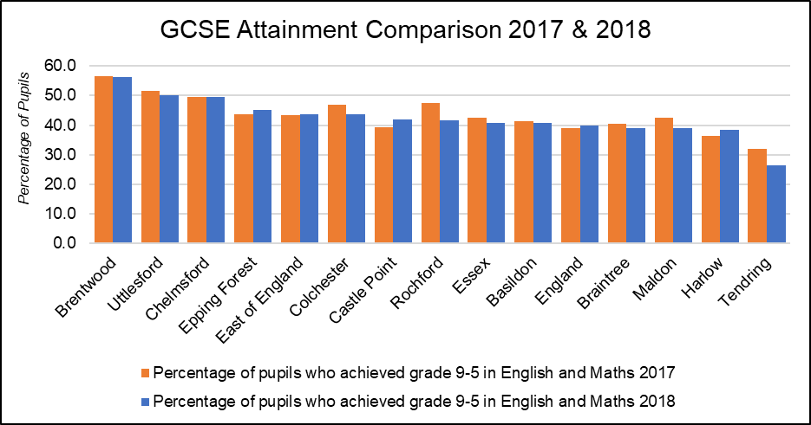

|  |  |  |  |  |  |  |  |
| --- | --- | --- | --- | --- | --- | --- | --- |
| **Area** | 2017 | | | 2018 | | | Average Attainment 8 Score 2017-2018 Change |
| % of pupils who achieved grade 9-5 in English and Maths | % of pupils who achieved grade 9-4 in English and Maths | Average Attainment 8 Score | % of pupils who achieved grade 9-5 in English and Maths | % of pupils who achieved grade 9-4 in English and Maths | Average Attainment 8 Score |
| **Basildon** | 41.4 | 63.4 | 46.4 | 40.7 | 62.6 | 45.3 | -4.0 |
| **Braintree** | 40.4 | 63.6 | 45.2 | 39 | 63 | 45.5 | -4.0 |
| **Brentwood** | 56.5 | 79.3 | 51.0 | 56.2 | 76.8 | 52.6 | -1.5 |
| **Castle Point** | 39.2 | 64.2 | 45.6 | 41.9 | 65.6 | 45 | -4.7 |
| **Chelmsford** | 49.5 | 72.2 | 50.4 | 49.5 | 72 | 50.9 | -3.1 |
| **Colchester** | 46.9 | 66.7 | 47.6 | 43.6 | 65.3 | 48 | -3.6 |
| **Epping Forest** | 43.8 | 66.8 | 47.8 | 45 | 67.8 | 46.9 | -4.3 |
| **Harlow** | 36.5 | 59.8 | 44.1 | 38.3 | 59.6 | 42.8 | -5.4 |
| **Maldon** | 42.4 | 62.4 | 47.0 | 39 | 62.8 | 47 | -5.8 |
| **Rochford** | 47.5 | 70.5 | 47.9 | 41.5 | 63.1 | 46.3 | -4.7 |
| **Tendring** | 31.9 | 52.0 | 41.6 | 26.5 | 47.2 | 39.9 | -5.9 |
| **Uttlesford** | 51.6 | 74.9 | 51.5 | 50.1 | 71.1 | 51.8 | -3.1 |
| **Essex** | 42.4 | 64.9 | 46.7 | 40.7 | 63.3 | 46.1 | -4.3 |
| **East of England** | 43.5 | 65.4 | **46.7** | 43.7 | 65.2 | 47 | -3.4 |
| **England** | 39.1 | 58.5 | 44.6 | 39.9 | 59.1 | 44.5 | -4.0 |

*Destinations of School Leavers*

In 2017 96% of pupils in Chelmsford were in sustained Education, Employment or Training at the end of Key stage 4 (Secondary School), just above the average for England (94%) and Essex (95%). Within this group 89% were in education, higher again than the county and England averages (86%) and the second highest rate in Essex. A further 4% were in apprenticeships, whilst another 3% were in employment. At this stage 4% of young people were not in any form of sustained education, employment or training, just below to the national and county average (5%).

After Key Stage 5 (Further Education) the number of young people in sustained education employment or training reduced to 92%. Of this cohort, 60% were believed to be in Education including 54% in Higher Education, the highest rate in Essex. The rate of young people attending university was 4% higher the national average (50%) and 8% above the average for Essex (46%). The next largest destination was sustained employment accounting for approximately 25% of the cohort, 3% higher than the England average (22%) and 1% less than Essex (26%). 7% were in apprenticeships whilst 5% were not in any form of sustained education, training or employment, just below the average for Essex for both measures (8%, 7%).

|  |  |  |  |  |  |  |
| --- | --- | --- | --- | --- | --- | --- |
| ***Percentage of pupils with destinations sustained for at least two terms post KS4 in 2016/17:*** | | | | | | |
| **Area** | Any sustained education or employment | Any sustained education destination | Sustained apprenticeships | Sustained employment destination | Destination not sustained | Activity not captured in the data |
| **ENGLAND\*** | **94** | **86** | **5** | **3** | **5** | **1** |
| **EAST** | **95** | **87** | **4** | **3** | **5** | **1** |
| **Essex** | **95** | **86** | **5** | **4** | **5** | **1** |
| Basildon | 93 | 82 | 5 | 5 | 7 | 1 |
| Braintree | 94 | 85 | 5 | 5 | 5 | 1 |
| Brentwood | 96 | 90 | 3 | 2 | 3 | 2 |
| Castle Point | 94 | 83 | 8 | 3 | 5 | 1 |
| Chelmsford | 96 | 89 | 4 | 3 | 4 | 0 |
| Colchester | 95 | 87 | 4 | 4 | 5 | 1 |
| Epping Forest | 95 | 88 | 5 | 2 | 4 | x |
| Harlow | 95 | 88 | 4 | 3 | 3 | 2 |
| Maldon | 96 | 85 | 6 | 5 | 3 | x |
| Rochford | 95 | 86 | 7 | 3 | 4 | 2 |
| Tendring | 92 | 82 | 5 | 6 | 7 | 1 |
| Uttlesford | 94 | 87 | 5 | 3 | 5 | 0 |
| ***Percentage of pupils with destinations sustained for at least two terms post KS5 in 2016/17:*** | | | | | | |
| **Area** | Any sustained education destination | Higher education (level 4 and above) | Sustained apprenticeships | Sustained employment destination | Destination not sustained | Activity not captured in the data |
| **ENGLAND\*** | **61** | **50** | **6** | **22** | **8** | **4** |
| **EAST** | **58** | **49** | **7** | **25** | **7** | **3** |
| **Essex** | **56** | **46** | **8** | **26** | **7** | **3** |
| Basildon | 50 | 40 | 11 | 28 | 9 | 3 |
| Braintree | 53 | 42 | 7 | 30 | 6 | 4 |
| Brentwood | 58 | 52 | 10 | 21 | 8 | 3 |
| Castle Point | 45 | 32 | 10 | 32 | 9 | 4 |
| Chelmsford | 60 | 54 | 7 | 25 | 5 | 2 |
| Colchester | 62 | 48 | 4 | 24 | 7 | 3 |
| Epping Forest | 59 | 47 | 8 | 22 | 8 | 4 |
| Harlow | 52 | 39 | 7 | 32 | 9 | 1 |
| Maldon | 50 | 41 | 9 | 32 | 5 | 3 |
| Rochford | 47 | 39 | 12 | 30 | 9 | 3 |
| Tendring | 51 | 41 | 8 | 28 | 9 | 4 |
| Uttlesford | 61 | 52 | 5 | 26 | 6 | 2 |
| * State-funded schools (mainstream and special)  x Data not available  *NB: England figures may not add to 100% due to rounding* | | | | | | |

***Employment and Economic Activity***

Economic Activity

83.4% of residents (91,600 people) aged 16-64 in Chelmsford are economically active, 2.6% higher than the average for Essex (80.8%) and 4.7% higher than England (78.7%). This is the fifth highest rate of economic activity in the county (Highest = Braintree (87.1%), Lowest = Brentwood (71.9%)). Within the same age group (including both economically active and inactive people) it is estimated that the 78.6% are in Employment, 0.5% higher than the Essex Average (78.1%) and 3.2% higher than England (75.4%).

The amount of residents claiming out of work benefits is lower than average but has increased to its highest level in 5 years from 1.3% in April 2015 to 1.5% in April 2019. This is lower than the averages for Essex (2.1%) and England (2.6%) is the (joint) seventh highest claimant rate in Essex overall, and is equivalent to an increase of 160 claimants. It should be noted however that some of the increases in claimant rates may be affected by the introduction of universal credit and changes in the way in which certain claimants are logged as "out of work", with all districts and boroughs showings increases. As such these figures may not actually reflect real term increases.

|  |  |  |  |  |  |  |  |  |  |  |
| --- | --- | --- | --- | --- | --- | --- | --- | --- | --- | --- |
| **Residents Age 16-64 Claiming Key Out of Work Benefits** | | | | | | | | | | |
| **Area** | **April 2015** | | **April 2016** | | **April 2017** | | **April 2018** | | **April 2019** | |
| **Claimant Count** | **%** | **Claimant Count** | **%** | **Claimant Count** | **%** | **Claimant Count** | **%** | **Claimant Count** | **%** |
| Basildon | 2,155 | 1.9 | 2,110 | 1.8 | 2,140 | 1.9 | 2,605 | 2.3 | 3,330 | 2.9 |
| Braintree | 1,155 | 1.2 | 1,090 | 1.2 | 1,030 | 1.1 | 1,315 | 1.4 | 1,720 | 1.9 |
| Brentwood | 355 | 0.8 | 295 | 0.6 | 415 | 0.9 | 555 | 1.2 | 720 | 1.5 |
| Castle Point | 685 | 1.3 | 740 | 1.4 | 675 | 1.3 | 555 | 1.1 | 920 | 1.8 |
| Chelmsford | 1,430 | 1.3 | 1,250 | 1.2 | 1,255 | 1.1 | 1,225 | 1.1 | 1,590 | 1.5 |
| Colchester | 1,395 | 1.2 | 1,540 | 1.3 | 1,425 | 1.2 | 1,435 | 1.2 | 2,240 | 1.8 |
| Epping Forest | 1,050 | 1.3 | 925 | 1.1 | 980 | 1.2 | 1,010 | 1.3 | 1,230 | 1.5 |
| Harlow | 1,195 | 2.2 | 1,000 | 1.8 | 1,050 | 1.9 | 1,535 | 2.8 | 1,865 | 3.5 |
| Maldon | 400 | 1.1 | 360 | 1.0 | 385 | 1.0 | 380 | 1.0 | 405 | 1.1 |
| Rochford | 500 | 1.0 | 455 | 0.9 | 470 | 0.9 | 465 | 0.9 | 700 | 1.4 |
| Tendring | 2,015 | 2.6 | 2,200 | 2.8 | 2,225 | 2.8 | 2,170 | 2.8 | 3,150 | 4.0 |
| Uttlesford | 300 | 0.6 | 240 | 0.5 | 255 | 0.5 | 370 | 0.7 | 500 | 0.9 |
| **England** | **660,415** | **1.9** | **630,975** | **1.8** | **662,795** | **1.9** | **751,250** | **2.1** | **922,235** | **2.6** |
| **East** | **51,805** | **1.4** | **48,255** | **1.3** | **51,225** | **1.4** | **60,080** | **1.6** | **75,315** | **2.0** |
| **Essex** | **12,625** | **1.4** | **12,200** | **1.4** | **12,305** | **1.4** | **13,615** | **1.5** | **18,370** | **2.1** |

18,300 people or 16.6% of residents aged 16-64 are thought to be economically inactive (not in employment who have not been seeking work within the last 4 weeks and/or are unable to start work within the next 2 weeks). The Chelmsford rate is lower than the rate for Essex (19.2%) and England (21.3%) and is the fifth lowest rate of economic inactivity in the county (Highest = Brentwood (28.1%), lowest = Braintree (12.9%)). The most common reason for working age people to be economically inactive was either Long term sickness (24.1%), looking after the home or family (23.1%) or being a student (21.1%). Compared to the rest of Essex, Chelmsford had the lowest proportion of residents looking after their home or family, 7.7% lower than the county average (30.8%) and however this is similar to the rate for England (24.4%). A further 3,500 (18.9% of economically inactive residents) are retired before the age of 65, 4.3% above the Essex average.

***Occupations***

Chelmsford residents are most likely to work in Professional Occupations (22.2%), Associate Professional & Technical Occupations (16.5%), or as Managers, Directors and Senior Officials (13.1%). The smallest occupation groups were people working as plant or machine operatives (3.5%) and Sales and Other customer Service Occupations (5.9%). Compared to the rest of Essex, Chelmsford has the lower levels of people working as plant and machine operatives (third lowest level) and higher levels of Professionals (third highest level).

|  |  |  |  |  |  |  |  |  |  |
| --- | --- | --- | --- | --- | --- | --- | --- | --- | --- |
| **Percentage of Residents by Employment Occupation Group**  *(Annual Population Survey: 12 months to June 2019)* | | | | | | | | | |
|  | **1: managers, directors and senior officials** | **2: professional occupations** | **3: associate prof & tech occupations** | **4: administrative & secretarial occupations** | **5: skilled trades occupations** | **6: caring, leisure and other service occupations** | **7: sales and customer service occupations** | **8: process, plant and machine operatives** | **9: elementary occupations** |
| Basildon | 7.3 | 18.2 | 17.3 | 11.2 | 8.9 | 11.1 | 9.4 | 4.9 | 11.7 |
| Braintree | 14.4 | 18.7 | 15.4 | 8.8 | 12.0 | 8.6 | 5.9 | 2.9 | 12.9 |
| Brentwood | 20.0 | 24.1 | 18.0 | 5.4 | 13.5 | 8.5 | ! | ! | 6.0 |
| Castle Point | 7.8 | 14.2 | 9.7 | 13.2 | 17.6 | 10.2 | ! | 7.8 | 17.8 |
| Chelmsford | 13.1 | 22.2 | 16.5 | 9.2 | 9.1 | 10.6 | 5.9 | 3.5 | 10.0 |
| Colchester | 11.5 | 18.6 | 12.3 | 9.6 | 10.2 | 13.3 | 5.4 | 9.1 | 9.9 |
| Epping Forest | 19.2 | 22.3 | 12.0 | 11.7 | 12.4 | 6.5 | 3.3 | 5.7 | 6.9 |
| Harlow | 7.9 | 14.8 | 19.0 | 9.9 | 9.8 | 8.0 | 7.1 | 15.0 | 8.5 |
| Maldon | 19.0 | 8.2 | 12.8 | 9.3 | 12.0 | 12.5 | 8.7 | 7.3 | 10.2 |
| Rochford | 8.0 | 22.0 | 20.0 | 15.4 | 14.5 | 4.5 | 4.2 | 6.0 | 5.5 |
| Tendring | 16.6 | 14.1 | 13.0 | 10.2 | 16.3 | 9.8 | 8.9 | 1.7 | 9.3 |
| Uttlesford | 20.2 | 16.0 | 17.7 | 14.4 | 4.4 | 5.9 | 9.9 | 4.0 | 7.5 |
| **England** | **11.4** | **21.2** | **15.0** | **9.9** | **9.8** | **8.9** | **7.1** | **6.2** | **10.2** |
| **East** | **12.2** | **20.0** | **14.4** | **10.5** | **10.3** | **9.1** | **6.8** | **6.3** | **10.3** |
| **Essex** | **13.3** | **18.3** | **15.1** | **10.6** | **11.5** | **9.5** | **6.1** | **5.6** | **10.0** |

*Housing*

According to the most recent statistics there are an estimated 10,140 social housing units in the Chelmsford area the majority of which (10,038) are owned housing associations and other social housing providers. This is the fifth highest number of social housing units of any district or borough in the Essex County Council area (Highest: Basildon = 16,890, Lowest: Castle Point = 2,104 units).

Across both the Social and Private rented housing sector in 2018-19 a total of 29 properties were inspected and found to have one or more "category 1 hazard". i.e. it poses a serious and immediate risk to a person's health and safety (Highest: Epping Forest = 614, Lowest: Brentwood = 0). All properties with these hazards were found to be in the private rented sector.

|  |  |  |  |  |  |
| --- | --- | --- | --- | --- | --- |
|  | ***Local Authority Owned (including those owned by other Local Authorities)*** | ***General Needs Social Housing Stock (owned by RSLs)*** | ***Sum of Supported Accommodation Housing Stock (owned by RSLs)*** | ***Sum of Social Housing for Older People (owned by RSLs)*** | ***Total*** |
| **Essex** | **42,569** | **40102** | **2100** | **4844** | **89,928** |
| **Basildon** | 10,954 | 5293 | 220 | 351 | 16,890 |
| **Braintree** | 4 | 9499 | 305 | 713 | 10,622 |
| **Brentwood** | 2,441 | 759 | 114 | 169 | 3,483 |
| **Castle Point** | 1,517 | 460 | 54 | 73 | 2,104 |
| **Chelmsford** | 56 | 9458 | 294 | 286 | 10,140 |
| **Colchester** | 5,945 | 3988 | 524 | 355 | 10,835 |
| **Epping Forest** | 6,453 | 1403 | 58 | 228 | 8,213 |
| **Harlow** | 9,279 | 1468 | 197 | 292 | 11,236 |
| **Maldon** | 0 | 2178 | 22 | 812 | 3,012 |
| **Rochford** | 0 | 2133 | 45 | 697 | 2,875 |
| **Tendring** | 3,134 | 1935 | 198 | 681 | 5,948 |
| **Uttlesford** | 2,786 | 1528 | 69 | 187 | 4,570 |
| RSL = Register Social Landlord (including Housings Associations) | | | | | |
| Source: LA Housing Returns 2018-19; Regulator of Social Housing Statistical returns 2017/18 | | | | | |

In 2018/19 there were a total of 3,939 households on the housing waiting list in Chelmsford, equivalent to 5.4% of all households in the area. During the same period, it is estimated that 299 homes were let directly or through nominations from the local authority, equivalent to 7.6% of households on the waiting list. Out of the total number of households on waiting list it was recorded that:

* 3,269 households (83%) were classed as being in a "reasonable preference category" (Highest: Rochford=100%/638 Households. Lowest: Maldon 10.1%/95 Households)
* 494 households (12.5%) were classed as "homeless" regardless of statutory duty to be housed (Highest: Castle Point=21.2%/114 Households. Lowest: Epping Forest and Maldon= 0 Households)
* 429 households (10.9%) were classed as being overcrowded or in unsatisfactory conditions (Highest: Tendring = 43.3%/589 Households. Lowest: Epping Forest = 0 Households)
* 173 households (4.4%) need to move due to welfare, medical or disability grounds (Highest: Rochford = 60.8%/388 Households. Lowest: Chelmsford = 4.4%/173 Households)

Compared to other areas Chelmsford has the second largest housing waiting list in the county with the second highest percentage of applicants classed as homeless (Essex average = 7.2%), and the lowest percentage of people seeking housing welfare reasons (Essex average 14.96%).

|  |  |  |  |  |  |  |  |  |  |
| --- | --- | --- | --- | --- | --- | --- | --- | --- | --- |
|  | ***Total households on the housing waiting list*** | ***Total households on the housing waiting list in a reasonable preference category*** | | ***Percentage People who are homeless within the meaning given in Part VII of the Act, regardless of whether there is a statutory duty to house them*** | | ***People occupying insanitary or overcrowded housing or otherwise living in unsatisfactory housing conditions*** | | ***People who need to move on medical or welfare grounds, including grounds relating to a disability*** | |
| ***Count*** | ***Count*** | ***%*** | ***Count*** | ***%*** | ***Count*** | ***%*** | ***Count*** | ***%*** |
| Essex | **21,803** | **11,885** | **54.5%** | 1560 | **7.2%** | 3473 | **15.9%** | 3262 | **15.0%** |
| Basildon | 1,169 | 576 | **49.3%** | 5 | **0.4%** | 441 | **37.7%** | 57 | **4.9%** |
| Braintree | 2,749 | 1,070 | **38.9%** | 47 | **1.7%** | 773 | **28.1%** | 276 | **10.0%** |
| Brentwood | 626 | 389 | **62.1%** | 57 | **9.1%** | 8 | **1.3%** | 267 | **42.7%** |
| Castle Point | 539 | 509 | **94.4%** | 114 | **21.2%** | 183 | **34.0%** | 197 | **36.5%** |
| Chelmsford | 3,939 | 3,269 | **83.0%** | 494 | **12.5%** | 429 | **10.9%** | 173 | **4.4%** |
| Colchester | 4,392 | 1,983 | **45.2%** | 111 | **2.5%** | 299 | **6.8%** | 533 | **12.1%** |
| Epping Forest | 1,376 | 299 | **21.7%** | 0 | **0.0%** | 0 | **0.0%** | 299 | **21.7%** |
| Harlow | 2,965 | 1,403 | **47.3%** | 537 | **18.1%** | 522 | **17.6%** | 298 | **10.1%** |
| Maldon | 936 | 95 | **10.1%** | 0 | **0.0%** | 28 | **3.0%** | 54 | **5.8%** |
| Rochford | 638 | 638 | **100.0%** | 79 | **12.4%** | 62 | **9.7%** | 388 | **60.8%** |
| Tendring | 1,362 | 1,275 | **93.6%** | 19 | **1.4%** | 589 | **43.2%** | 563 | **41.3%** |
| Uttlesford | 1,112 | 379 | **34.1%** | 97 | **8.7%** | 139 | **12.5%** | 157 | **14.1%** |
| Source: LA Housing Returns 2018-19; Regulator of Social Housing Statistical returns 2017/18 | | | | | | | | | |

*Homelessness & Rough Sleeping*

According to Public Health England, homeless people experience the most significant health inequalities and that the mean life expectancy of somebody who is homeless is just 44 years for men and 42 years for women. Chelmsford generally has a higher number of rough sleepers than other areas, with 14 individuals identified in 2018, the highest number out of all the Districts and Boroughs. In 2017 Chelmsford had third highest number of rough sleepers in the county (17 people) behind Basildon and Harlow (24), and Colchester (20), however these areas saw large reductions in the number of rough sleepers by in 2018, making the new highest area. In November 2018 Basildon, Colchester and Harlow (as well as Southend-on-Sea) were selected out of 83 areas nationally to receive additional funding to tackle rough sleeping in their areas.

Compared to the average rates of rough sleeping in other areas, Chelmsford had estimated 1.9 rough sleepers to every 10,000 households in the area. This is lower than the average for England (2.01 per 10,000) but higher than the average for the rest of the Essex County council area (1.09) and is the second highest rate compared to the other districts and boroughs (Highest: Harlow = 2.51, Lowest: Castle Point, Maldon, Uttlesford = 0). In this area, 42.9% of rough sleepers (6 people) were aged 26 years or older and 8 people were age unknown (57.1%). 8 people were identified as male (57.1%), 3 people were female (21.4%) and 3 people's gender was not identified (21.4%).

|  |  |  |  |  |  |  |  |  |
| --- | --- | --- | --- | --- | --- | --- | --- | --- |
|  | ***Under 18*** | | ***18 - 25*** | | ***26 or over*** | | ***Age not known*** | |
| ***Count*** | ***%*** | ***Count*** | ***%*** | ***Count*** | ***%*** | ***Count*** | ***%*** |
| **England** | **1** | **0.02%** | **295** | **6.3%** | **3744** | **80.1%** | **637** | **13.6%** |
| **East of England** | **0** | **0.00%** | **28** | **5.8%** | **395** | **81.6%** | **61** | **12.6%** |
| **Essex** | **0** | **0.00%** | **1** | **1.5%** | **47** | **70.1%** | **19** | **28.4%** |
| Basildon | 0 | 0.00% | 1 | 8.3% | 11 | 91.7% | 0 | 0.0% |
| Braintree | 0 | 0.00% | 0 | 0 | 5 | 100.0% | 0 | 0.0% |
| Brentwood | 0 | 0.00% | 0 | 0 | 2 | 100.0% | 0 | 0.0% |
| Castle Point | 0 | 0.00% | 0 | 0 | 0 | 0.0% | 0 | 0.0% |
| Chelmsford | 0 | 0.00% | 0 | 0 | 6 | 42.9% | 8 | 57.1% |
| Colchester | 0 | 0.00% | 0 | 0 | 9 | 69.2% | 4 | 30.8% |
| Epping Forest | 0 | 0.00% | 0 | 0 | 0 | 0.0% | 3 | 100.0% |
| Harlow | 0 | 0.00% | 0 | 0 | 9 | 100.0% | 0 | 0.0% |
| Maldon | 0 | 0.00% | 0 | 0 | 0 | 0.0% | 0 | 0.0% |
| Rochford | 0 | 0.00% | 0 | 0 | 0 | 0.0% | 3 | 100.0% |
| Tendring | 0 | 0.00% | 0 | 0 | 5 | 83.3% | 1 | 16.7% |
| Uttlesford | 0 | 0.00% | 0 | 0 | 0 | 0.0% | 0 | 0.0% |

***Crime and Community Safety***

Nationally and locally the number of crimes recorded by the police force in England and Wales is on the increase. Over a four year period the number of crimes recorded in the Chelmsford area has risen by 57.2% from 9,683 incidents or 56 crimes per 1000 residents in 2015/16 to 15,218 crimes or 86 crimes per 1000 in 2018/19. This percentage increase is higher than the average change rate for the whole Essex Police Force area (42.7%) however the overall crime rate for Chelmsford is just below (-3%) the average for England (89 per 1000), similar to the Essex Police Force area (87 per 1000) and is the 7th (out of 14) highest local authority in Essex (including Southend and Thurrock).

The largest category of crime in the area for the last year was Theft which accounted for 5387 (35.4%) offences or a rate of 31 crimes per 1000; in line with the average rate of theft for Essex police (31 per 1000) and just below the average for England (34 per 1000). Violent Crime makes up the second largest category with 34.5% of crimes or a rate of 30 per 1000; lower than the Essex Police (32 per 1000) average but just above England (28 per 1000). The proportion of these offences are generally in line with the distribution across the rest of the Essex Police Force area (Theft = 35.3%, Violent Crime = 36.2%).

The most significant four year change in the number of crimes recorded in the Chelmsford area is the increase in the levels of Violent Crime, which has seen an additional 2600 offences in 2018/19 (an increase of 98%) compared to the same period in 2015/16. The increase in the rate of violent Crime locally reflects a national trend which includes an increase in the number of crimes recorded as stalking or harassment. Nationally the Crown Prosecution Service (CPS) reports that there was a 69% increase in prosecutions started for stalking offences from 2016–17 to 2017–18 because of improvements in awareness following a police and CPS inspection and the implementation of Violence Against Women Strategies. This development is reflected locally with 1884 crimes recorded as stalking or harassment in 2018/19 up from 989 in 2017/18.

***Environmental Health and Licencing***

The Marmot Review (2008) identified different health outcomes could be associated with the prevalence of certain build environment factors in their area such as the rate of noise complaints, the number of alcohol licences in an area, to the density of fast food outlets in a neighbourhood.

***Noise***

Excessive noise can have a range of impacts on our health from directly affecting our auditory system and hearing, to impacting our physical and mental health and quality of life; especially through long term exposure. Modelled estimates from based on data collected by the Chartered Institute of Environmental Health (CIEH) give an estimate for the rate of complaints per 1000 people about excessive noise from neighbours, their neighbourhood or the environment. Public Health England estimates that in 2016 there was an average of 4.5 noise complaints per 1000 residents across the Chelmsford area, lower than the average rates for Essex (4.8) or England (6.3). Compared to other areas, this was the 6th highest estimated rate in the Essex County Council area (Highest: Epping Forest = 9.8, Lowest: Castle Point = 1.6).

***Alcohol Licences***

Number of premises licences and club premises certificates permitted to sell or supply alcohol on trade and/or off trade is another measure used to look at the impact of the physical environment on health, particularly when considering alcohol harm and illness. Local Alcohol Profiles for England estimate that in 2016/17 there were an average of 1.3 licenced premises per square kilometre in the Chelmsford area, similar to the England average of 1.4 (data is not available for an Essex countywide average). Compared to other districts in Essex this is the 7th highest area* (Highest: Harlow = 5.4, Lowest: Uttlesford = 0.5).

***Density of Fast Food Outlets***

The availability of fast food is an issue which is associated with a range of negative health outcomes for our communities such as obesity. This indicator calculates the number of fast food outlets per 100,000 population at an area level as a proxy for the density of these businesses within a particular local authority area. In 2014 it was estimated that Chelmsford had a density of 57.7 per 100,000, lower than the Essex (69.5) and England (88.2) average densities. Compared to other districts, this is the 2nd lowest density in Essex (Highest: Tendring = 95.8, Lowest: Uttlesford = 41.6).

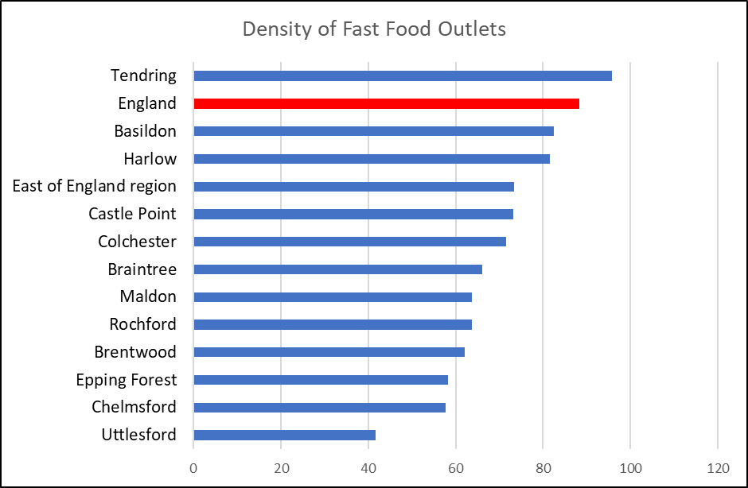

***Air Quality***

Poor air quality is a significant public health issue with clear evidence that particulate matter (human made air pollution) having a significant contributory role in a range of poor health outcomes including respiratory disorders and cardiopulmonary mortality. The Indicator for fine particulate matter looks at the average annual concentration in micrograms per cubic metre (weighted for population exposure) and showed that in 2016 the air pollution levels were 9.8 micrograms per cubic metre, higher than the average levels for England (9.3) and Essex (9.6). Compared to other areas Chelmsford had the joint 3rd highest air pollution levels in the county (Highest: Epping Forest = 10.1 per cubic metre, Lowest: Maldon/Tendring/Uttlesford = 9.2).

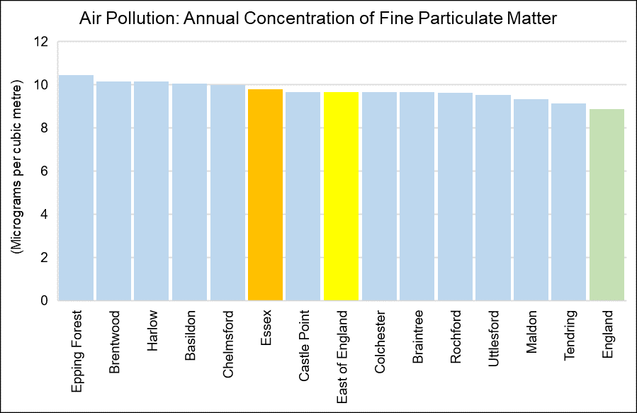

|  |  |
| --- | --- |
| Air pollution: fine particulate matter (2017) | |
| Area Name | micrograms per cubic metre |
| **England** | 8.904 |
| **East of England** | 9.6851 |
| **Essex** | 9.8132 |
| **Basildon** | 10.0819 |
| **Braintree** | 9.6742 |
| **Brentwood** | 10.1725 |
| **Castle Point** | 9.6913 |
| **Chelmsford** | 10.002 |
| **Colchester** | 9.6771 |
| **Epping Forest** | 10.4769 |
| **Harlow** | 10.1565 |
| **Maldon** | 9.3362 |
| **Rochford** | 9.6448 |
| **Tendring** | 9.1363 |
| **Uttlesford** | 9.5392 |
| *Annual concentration of human-made fine particulate matter at an area level, adjusted to account for population exposure. Fine particulate matter is also known as PM2.5 and has a metric of micrograms per cubic metre (µg/m3).* | |

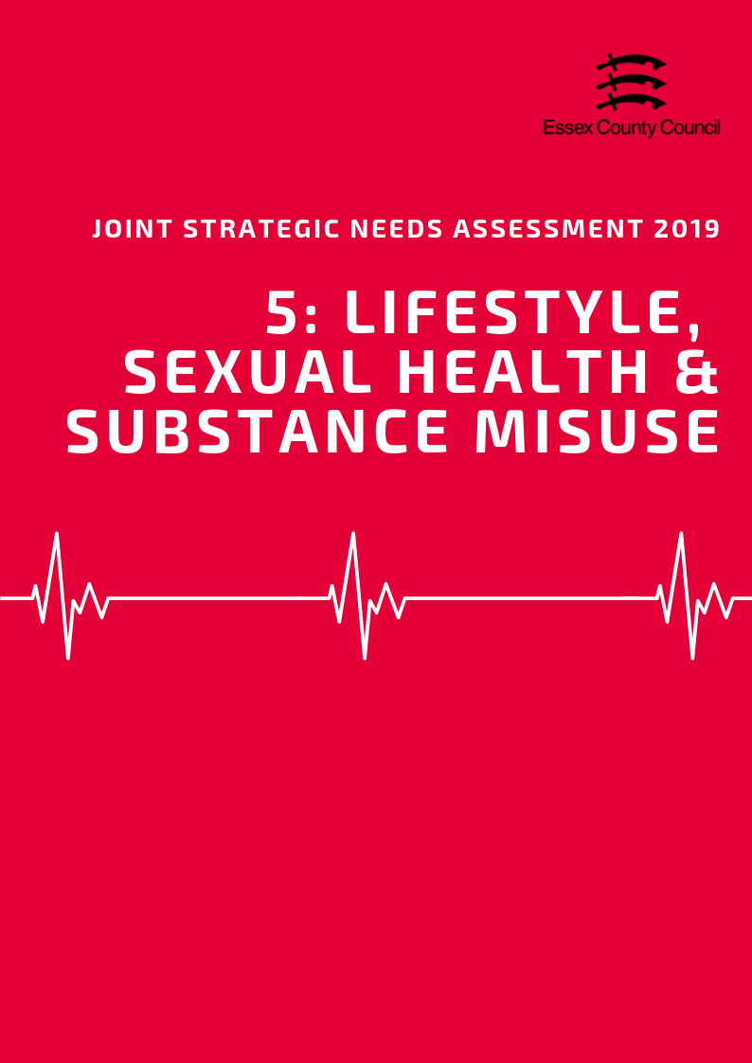

**LIFESTYLE, Sexual Health & Substance misuse**

This Section brings together datasets looking at a range of lifestyle and behavioural factors which can impact on long term health outcomes and increase or decrease the likelihood of developing a range of conditions or require more serious treatments going forward. This section includes:

* Children’s Weight
* Adult Healthy Eating, Obesity and Physical Activity
* Sexual Health
* Substance Misuse

**Children’s Weight**

***Reception Class***

In 2017/18 the National Child Measurement Programme (NCMP) estimated that 20.6% of pupils in Reception class (R in the table below) in Chelmsford were classed as overweight or obese. This was lower than the average for England (22.4%) and Essex (21.1%) and was the 6th highest rate in Essex. Of this group 7.4% were classed as obese, with a further 1.6% also classed as severely obese. Compared to the rest of Essex the overall level of obesity lower than the averages for Essex (8.6%) and England (9.53%) as were the levels of severe obesity for this age group.

|  |  |  |  |  |  |  |  |  |  |  |  |
| --- | --- | --- | --- | --- | --- | --- | --- | --- | --- | --- | --- |
| **National Child Measurement Programme**  2017/18 | Prevalence of all overweight (including overweight, obesity and severe obesity) | | | |  | Prevalence of overweight  (%) | | Prevalence of obesity including severe obesity  (%) | | Prevalence of severe obesity  (%) | |
| Reception (R) | | Year 6  (Y6) | |
| % | Rank | % | Rank | R | Y6 | R | Y6 | R | Y6 |
| Basildon | 20.2 | 7 | 33.9 | 4 | 11.38 | 14.27 | 8.82 | 19.66 | 2.31 | 4.30 |
| Braintree | 24.0 | 3 | 32.5 | 7 | 15.25 | 14.80 | 8.78 | 17.70 | 1.60 | 3.44 |
| Brentwood | 18.5 | 10 | 26.3 | 11 | 11.21 | 11.49 | 7.27 | 14.80 | 1.48 | 2.11 |
| Castle Point | 19.2 | 8 | 33.8 | 5 | 10.19 | 14.39 | 8.98 | 19.42 | 2.08 | 4.80 |
| Chelmsford | 20.6 | 6 | 29.7 | 10 | 13.24 | 14.26 | 7.40 | 15.40 | 1.46 | 2.67 |
| Colchester | 21.2 | 5 | 29.8 | 9 | 13.00 | 14.30 | 8.15 | 15.53 | 1.54 | 2.93 |
| Epping Forest | 17.3 | 12 | 33.4 | 6 | 9.96 | 14.37 | 7.33 | 19.05 | 1.39 | 3.17 |
| Harlow | 22.8 | 4 | 37.4 | 1 | 11.82 | 15.38 | 10.97 | 22.07 | 2.92 | 5.39 |
| Maldon | 28.1 | 1 | 34.6 | 3 | 17.44 | 17.47 | 10.63 | 17.12 | 1.99 | 2.57 |
| Rochford | 18.5 | 11 | 30.9 | 8 | 10.62 | 14.76 | 7.84 | 16.19 | 0.72 | 2.64 |
| Tendring | 24.8 | 2 | 36.3 | 2 | 14.27 | 13.72 | 10.52 | 22.56 | 2.90 | 4.81 |
| Uttlesford | 18.8 | 9 | 25.8 | 12 | 12.09 | 11.92 | 6.74 | 13.91 | 0.96 | 2.09 |
| Essex | 21.1 |  | 32.2 |  | **12.52** | **14.24** | **8.59** | **17.93** | **1.84** | **3.51** |
| England | 22.4 |  | 34.3 |  | **12.84** | **14.18** | **9.53** | **20.14** | **2.40** | **4.24** |

***Year 6***

The sample of pupils in Year 6 in the 2017/18 NCMP showed that 29.7% of pupils in this year group were classed as overweight or obese in Chelmsford, 9.1 percentage points higher than their Reception class counterparts. This was lower than the England (34.3%) Essex (32.2%) average and was the 10th highest level out of any district or borough in Essex. Within this year group it estimated that 15.4% of pupils were classed as obese (8% higher than Reception Class), of whom 2.67% were classed as severely obese. Combined obesity levels were also the 10th highest level in the county and were below the county and national averages, as were the levels of severe obesity.

***Change Over Time***

Over the last 10 years the prevalence levels of overweight and obese children in both Reception class and Year 6 has fluctuated around similar levels but not shown definitive upward or downward trends in most areas. In Chelmsford the lowest recorded prevalence in the last 10 years was in 2008/09 for both Reception class (15%) and for Year 6 pupils (27.7%). The 10 year high was recorded in 2010/11 for both Reception class (24.4%) and Year 6 pupils (31.7%).

|  |  |
| --- | --- |
|  |  |

**Healthy & underweight children**

The level of Reception aged children classed as underweight in Chelmsford in 2017/18, was 0.76% and was lower than the averages for England (0.98%) and Essex (0.8%). By Year 6 the recorded prevalence had risen to 1.59% which was higher than the recorded levels for both England (1.39%) and Essex (1.34%) and the second highest recorded level of underweight children in Essex compared to the other districts (where data is available).The prevalence of healthy weight children in Reception class (78.6%) was similar to the Essex average (78.08%) and just above the level for England (76.64%). In Year 6 the levels (68.75%) had dropped by 9.9% but remained above Essex average but just above and England level. Although a small amount of the observed difference can be attributed to the small increase in levels of underweight children in Year 6, the majority of the change is due to increases in the prevalence of Overweight and Obesity between the year groups.

|  |  |  |  |  |
| --- | --- | --- | --- | --- |
| **Time Period: 2017/18** | **Prevalence of underweight (%)** | | **Prevalence of healthy weight (%)** | |
| **R** | **Y6** | **R** | **Y6** |
| Basildon | 0.70 | 1.40 | 79.10 | 64.67 |
| Braintree | 0.47 | 1.03 | 75.49 | 66.47 |
| Brentwood | 0.99 | ! | 80.54 | ! |
| Castle Point | ! | 1.17 | ! | 65.03 |
| Chelmsford | 0.76 | 1.59 | 78.61 | 68.75 |
| Colchester | 0.93 | 1.54 | 77.91 | 68.62 |
| Epping Forest | 1.32 | 1.51 | 81.39 | 65.08 |
| Harlow | 1.46 | 1.22 | 75.75 | 61.34 |
| Maldon | ! | ! | ! | ! |
| Rochford | ! | 2.42 | ! | 66.63 |
| Tendring | 0.56 | 0.93 | 74.65 | 62.79 |
| Uttlesford | 0.86 | 1.26 | 80.32 | 72.91 |
| Essex | 0.80 | 1.34 | 78.08 | 66.49 |
| England | 0.98 | 1.39 | 76.64 | 64.29 |

***Adult Obesity, Healthy Eating, and Physical Activity***

Of residents in Chelmsford aged over 18 years, 63.32% were classified as overweight or obese in 2016/17. This is relatively similar to the prevalence of adult overweight or obesity across the whole of Essex (63.56%), but lower than that for England (61.29%) and was ranked as being the 6th highest prevalence across the Essex Districts (highest: Basildon 70.47%; lowest: Uttlesford 55.32%).

The proportion of adults aged over 16 years in the Chelmsford area meeting the recommended fruit and vegetable intake of 5 portions on a ‘usual day’ was 53.70% in 2016/17. This was lower than the proportion meeting this recommendation across Essex (55.96%) and England (57.44%) and was ranked as being the 3rd lowest proportion across the Districts in Essex (highest: Braintree 62.92%; lowest: Harlow 46.23%).

|  |  |  |  |  |  |  |  |  |
| --- | --- | --- | --- | --- | --- | --- | --- | --- |
|  | **Percentage eating the recommended “5 a day”** | |  | **Percentage of Adults who are overweight or obese** | |  | **Percentage who take part in Organised sport** | |
| **Value** | **Rank** |  | **Value** | **Rank** |  | **Value** | **Value** |
| **Basildon** | 50.2% | 11 |  | 70.5% | 1 |  | 29.5% | 10 |
| **Braintree** | 62.9% | 1 |  | 60.8% | 8 |  | 33.7% | 9 |
| **Brentwood** | 62.1% | 3 |  | 58.5% | 10 |  | 43.0% | 2 |
| **Castle Point** | 58.2% | 5 |  | 65.1% | 4 |  | 35.1% | 6 |
| **Chelmsford** | 53.7% | 10 |  | 63.3% | 6 |  | 38.2% | 5 |
| **Colchester** | 54.6% | 9 |  | 64.4% | 5 |  | 35.1% | 7 |
| **Epping Forest** | 56.7% | 6 |  | 58.8% | 9 |  | 46.9% | 1 |
| **Harlow** | 46.2% | 12 |  | 66.9% | 3 |  | 25.8% | 11 |
| **Maldon** | 59.7% | 4 |  | 57.9% | 11 |  | 34.6% | 8 |
| **Rochford** | 55.3% | 7 |  | 61.4% | 7 |  | 41.0% | 4 |
| **Tendring** | 54.7% | 8 |  | 67.5% | 2 |  | 22.1% | 12 |
| **Uttlesford** | 62.7% | 2 |  | 55.3% | 12 |  | 42.6% | 3 |
| **Essex** | 55.9% | - |  | 63.6% | - |  | 35% | - |
| **England** | 57.4% | - |  | 61.3% | - |  | - | - |

Physical inactivity is classified as doing less than 30 minutes of moderate intensity activity per week. Of adults aged over 19 years, 23.74% were classified as being physically inactive in 2017/18. This is higher than the proportion of adults physically inactive across Essex (21.78%) and England (22.23%), and an increase compared to the previous period.

The proportion of adult residents classified as physically active (doing more than 150 minutes of moderate intensity activity per week) was 62.73% (highest: Uttlesford 70.72%; Lowest: Basildon 61.87%). This was lower than the proportion of adults physically active across Essex as a whole (66.07%) and England (66.26%) and a reduction compared to 2016/17 levels (67.88%).

In 2016/17 Chelmsford was also ranked as having the 5th highest percentage of residents involved in organised sports across the Essex Districts, with 38.2% in 2016/17. This was higher than the percentage across the whole of Essex (35%).

|  |  |  |  |  |  |  |  |  |
| --- | --- | --- | --- | --- | --- | --- | --- | --- |
|  | Percentage of Adults who are physically active or inactive | | | | | | | |
| 2015/16 | | 2016/17 | | *2017/18* | | 3 year change | |
| % active | % inactive | % active | % inactive | *% active* | *% inactive* | % active | % inactive |
| England | 66.13 | 22.33 | 66.01 | 22.24 | ***66.26*** | ***22.23*** | 0.13 | -0.10 |
| Essex | 66.06 | 22.10 | 65.95 | 22.64 | ***66.07*** | ***21.78*** | 0.01 | -0.32 |
| Basildon | 65.46 | 24.00 | 60.98 | 26.28 | ***61.87*** | ***25.30*** | -3.59 | 1.31 |
| Braintree | 57.80 | 23.20 | 66.45 | 23.22 | ***67.55*** | ***19.17*** | 9.75 | -4.04 |
| Brentwood | 68.63 | 18.31 | 70.10 | 21.77 | ***65.79*** | ***22.51*** | -2.84 | 4.20 |
| Castle Point | 69.86 | 22.14 | 61.27 | 25.05 | ***68.43*** | ***21.43*** | -1.43 | -0.71 |
| Chelmsford | 67.26 | 22.16 | 67.88 | 22.09 | ***62.73*** | ***23.74*** | -4.53 | 1.58 |
| Colchester | 74.33 | 16.63 | 67.21 | 21.64 | ***67.74*** | ***18.45*** | -6.59 | 1.82 |
| Epping Forest | 68.72 | 18.05 | 67.65 | 18.97 | ***69.78*** | ***18.48*** | 1.06 | 0.44 |
| Harlow | 60.80 | 29.28 | 62.78 | 23.30 | ***63.31*** | ***25.36*** | 2.50 | -3.92 |
| Maldon | 68.56 | 19.42 | 67.44 | 19.11 | ***68.39*** | ***19.09*** | -0.17 | -0.34 |
| Rochford | 64.23 | 20.83 | 70.05 | 19.21 | ***69.75*** | ***22.37*** | 5.52 | 1.54 |
| Tendring | 58.01 | 31.44 | 62.61 | 27.30 | ***62.55*** | ***25.09*** | 4.54 | -6.35 |
| Uttlesford | 68.99 | 18.39 | 71.38 | 18.42 | ***70.72*** | ***19.21*** | 1.73 | 0.83 |

**Sexual Health**

***New STI Diagnosis***

According to Public Health England in 2017, the rate of new STI diagnoses among persons in the Chelmsford area was 561.50 per 100,000 population aged between 15 - 64 years. This was the 5th highest rate compared across the other Districts in Essex. STI diagnoses excluded chlamydia in under 25 year olds and was among persons attending specialist (level 3) and non-specialist (level 1 and 2) sexual health services.

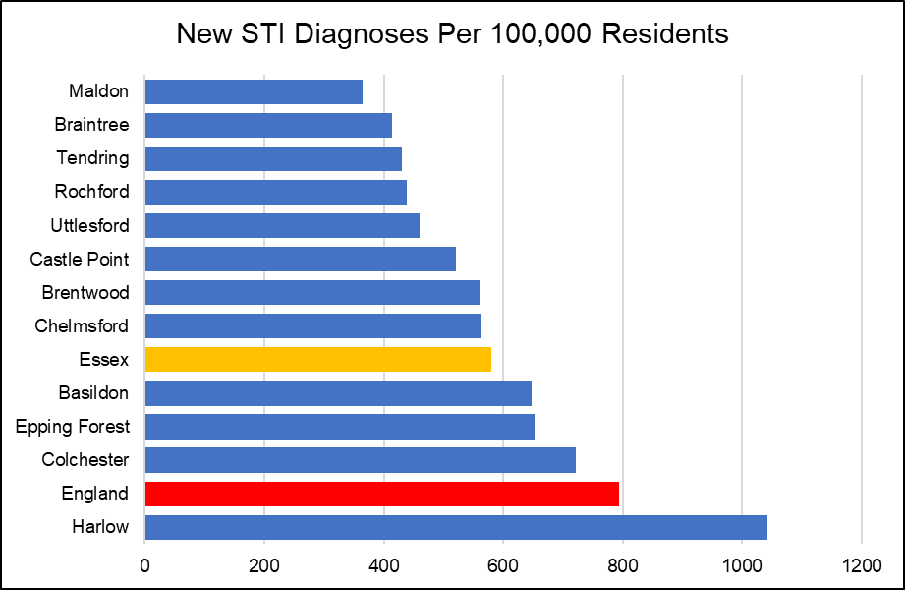

***Chlamydia***

The proportion of all 15 - 24 year olds in Chelmsford in 2017 screened for chlamydia with asymptomatic screens and symptomatic tests at sexual health services was 15.3 This was the 4th lowest proportion compared to that of the other Districts in Essex, and lower than that across the whole of Essex (15.5) and England (19.3).

|  |  |  |  |  |
| --- | --- | --- | --- | --- |
|  | **New STI diagnoses (excluding chlamydia aged <25) / 100,000** | | **Chlamydia proportion aged 15-24 screened** | |
| **Value** | **Rank** | **%** | **Rank** |
| Basildon | 647.54 | 4 | 14.5 | 5 |
| Braintree | 414.14 | 11 | 12.5 | 11 |
| Brentwood | 560.57 | 6 | 13.2 | 8 |
| Castle Point | 520.65 | 7 | 12.4 | 12 |
| Chelmsford | 561.50 | 5 | 15.3 | 4 |
| Colchester | 721.10 | 2 | 18.2 | 2 |
| Epping Forest | 653.27 | 3 | 15.5 | 3 |
| Harlow | 1042.41 | 1 | 29.5 | 1 |
| Maldon | 364.71 | 12 | 13.1 | 9 |
| Rochford | 438.23 | 9 | 13.7 | 6 |
| Tendring | 430.44 | 10 | 13.1 | 10 |
| Uttlesford | 459.94 | 8 | 13.7 | 7 |
| **Essex** | **580.81** |  | **15.5** |  |
| **England** | **793.85** |  | **19.3** |  |

The rate of all chlamydia diagnoses among 15 to 24 year olds attending sexual health services was 1266.8 per 100,000 population aged 15 to 24. This was the 6th highest detection rate compared to the other Districts in Essex.

|  |  |  |  |  |  |  |
| --- | --- | --- | --- | --- | --- | --- |
| **Chlamydia detection rate / 100,000 aged 15-24** | **Persons** | | **Male** | | **Female** | |
| **Value** | **Rank** | **Value** | **Rank** | **Value** | **Rank** |
| **Basildon** | 1484.2 | 3 | 1000.3 | 4 | 1972.9 | 3 |
| **Braintree** | 1199.6 | 8 | 750.5 | 9 | 1689.1 | 7 |
| **Brentwood** | 1016 | 11 | 820.3 | 8 | 1192.8 | 12 |
| **Castle Point** | 1081.3 | 9 | 635.3 | 11 | 1564.5 | 8 |
| **Chelmsford** | 1266.8 | 6 | 836.3 | 7 | 1720.8 | 5 |
| **Colchester** | 2094.9 | 2 | 1564.1 | 2 | 2679.4 | 1 |
| **Epping Forest** | 1295.8 | 5 | 873.7 | 6 | 1711.8 | 6 |
| **Harlow** | 2444.9 | 1 | 2266 | 1 | 2641.3 | 2 |
| **Maldon** | 933.3 | 12 | 621.1 | 12 | 1279.5 | 11 |
| **Rochford** | 1262.2 | 7 | 1088.1 | 3 | 1444.2 | 9 |
| **Tendring** | 1320.6 | 4 | 897.4 | 5 | 1777.2 | 4 |
| **Uttlesford** | 1035 | 10 | 749.5 | 10 | 1351 | 10 |
| **Essex** | 1449.1 |  | 1049.8 |  | 1872.1 |  |

***HIV***

The rate of all new HIV diagnoses among adults aged over 15 years accessing HIV care in Chelmsford was 8.99 per 100,000 population. This was the second highest rate compared across the Essex Districts and higher than the rate for the whole of Essex (5.63), but similar to that for England (8.66).

***Other STIs***

The rate of all diagnoses of the first episode of genital warts among people accessing sexual health services was 109.65 in the Chelmsford area. This was the second highest rate compared to the other Essex Districts, and slightly higher than the rate across Essex as a whole (98.43) and England (103.86).

The diagnosis rate of the first episode of genital herpes services was 29.76 per 100,000 population. This was the third lowest rate compared across the other Districts in Essex, and lower than that for the whole of Essex (50.00) and England (56.66).

Chelmsford also had the second lowest diagnosis rate of syphilis, with a rate of 1.72 per 100,000 population. This was also lower than the rate across Essex as a whole (3.64) and for England (12.48).

**Substance Misuse**

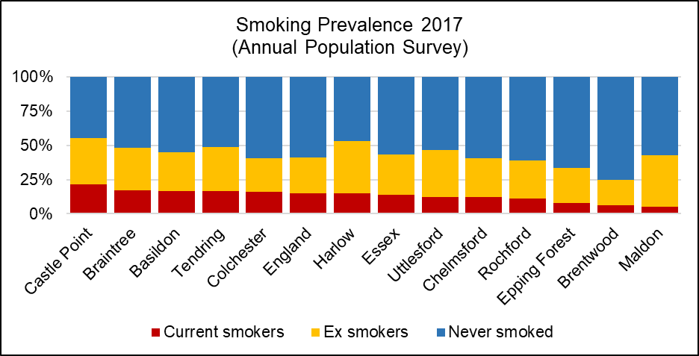

***Smoking***

In Chelmsford in 2017, the prevalence of current smokers among persons aged over 18 years was 12.02%. This was the 8th highest prevalence across Districts in Essex, similar to that for Essex as a whole (13.84%) and England (14.87%).

Smoking attributable mortality over the three year period of 2012 - 14 was estimated to be 211.22, of which 22.69 was due to heart disease.

Compared to other Districts in Essex the smoking attributable mortality was the second lowest in Chelmsford, and also lower than that across the whole of both Essex (258.24) and England (274.76). Overall, it was estimated that 1020.13 potential years of life were lost due to smoking in Chelmsford.

*See table below for the ranked prevalence of current and previous smoking status across the Districts in Essex in 2017/18.*

|  |  |  |  |  |  |  |
| --- | --- | --- | --- | --- | --- | --- |
|  | **Smoking prevalence in adults by current and previous status (Annual Population Survey, 2017)** | | | | | |
| **Current smoker** | | **Ex-smoker** | | **Never-smoked** | |
| **%** | **Rank** | **%** | **Rank** | **%** | **Rank** |
| **Basildon** | 16.72 | 3 | 28.18 | 8 | 55.10 | 7 |
| **Braintree** | 17.15 | 2 | 31.19 | 6 | 51.65 | 9 |
| **Brentwood** | 6.48 | 11 | 18.37 | 12 | 75.15 | 1 |
| **Castle Point** | 21.48 | 1 | 33.89 | 4 | 44.62 | 12 |
| **Chelmsford** | 12.02 | 8 | 28.75 | 7 | 59.23 | 4 |
| **Colchester** | 15.99 | 5 | 24.80 | 11 | 59.20 | 5 |
| **Epping Forest** | 7.84 | 10 | 25.72 | 10 | 66.44 | 2 |
| **Harlow** | 14.81 | 6 | 38.19 | 1 | 47.01 | 11 |
| **Maldon** | 5.33 | 12 | 37.50 | 2 | 57.17 | 6 |
| **Rochford** | 10.98 | 9 | 28.02 | 9 | 61.00 | 3 |
| **Tendring** | 16.72 | 4 | 32.03 | 5 | 51.25 | 10 |
| **Uttlesford** | 12.33 | 7 | 34.38 | 3 | 53.29 | 8 |
| **Essex** | 13.84 | - | 29.51 | - | 56.65 | - |
| **England** | 14.87 | - | 26.17 | - | 58.96 | - |

***Alcohol***

Alcohol-related hospital admissions are defined as admissions where the primary and any secondary diagnoses are an alcohol-attributable code. According to Public Health England, the directly age standardised rate of alcohol-related hospital admissions in the Chelmsford area in 2017/18 was 1713.90 per 100,000 population, the third lowest rate compared across the other Districts in Essex. This is also lower than the rate across Essex as a whole (1935.65) and England (2223.80). The directly age standardised rate per 100,000 population of alcohol-related mortality was estimated to be 38.26 in Chelmsford in 2017, the 8th highest rate compared across the other Districts in Essex.

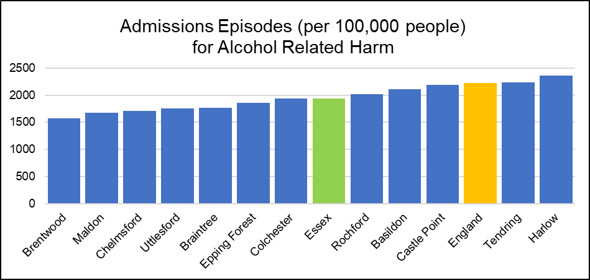

***Drug Use***

According to the Office for National Statistics, the age-standardised mortality rate from drug misuse per 100,000 population in the Chelmsford District was 2.33 over the period of 2015 - 2017. This was the lowest rate compared across that of the other Districts in Essex with data available, and lower than the rate across the whole of Essex (3.63) and England (4.33). The rate was unable to be calculated for the Districts of Basildon, Brentwood, Castle Point, Epping Forest, Maldon, Rochford and Uttlesford as the number of cases was too small.

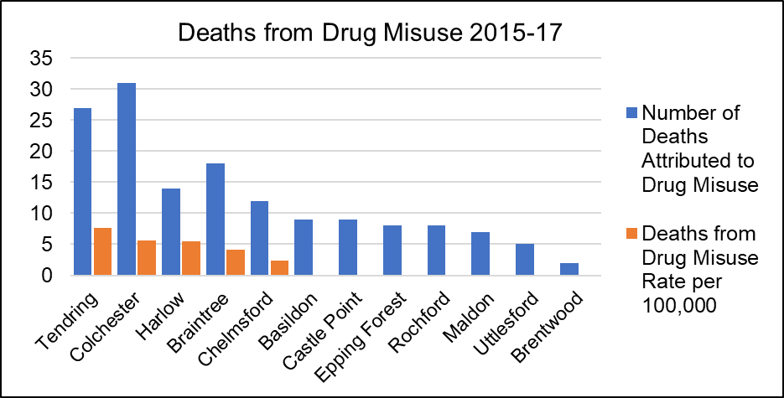

|  |  |  |  |  |  |  |
| --- | --- | --- | --- | --- | --- | --- |
|  | **Alcohol and Drugs** | | | | | |
| **Alcohol-related hospital admission rate per 100K** | | **Alcohol mortality** | | **Deaths from drug misuse** | |
| Value | Rank | Value | Rank | Count | Rate Per 100K |
| **Basildon** | 2111.07 | 4 | 46.31 | 2 | 9 | * |
| **Braintree** | 1761.831 | 8 | 41.66 | 4 | 18 | 4.19 |
| **Brentwood** | 1576.501 | 12 | 39.80 | 6 | 2 | * |
| **Castle Point** | 2194.25 | 3 | 39.46 | 7 | 9 | * |
| **Chelmsford** | 1713.9 | 10 | 38.26 | 8 | 12 | 2.33 |
| **Colchester** | 1934.702 | 6 | 40.12 | 5 | 31 | 5.59 |
| **Epping Forest** | 1856.899 | 7 | 35.50 | 10 | 8 | * |
| **Harlow** | 2360.043 | 1 | 44.38 | 3 | 14 | 5.51 |
| **Maldon** | 1675.22 | 11 | 37.67 | 9 | 7 | * |
| **Rochford** | 2022.617 | 5 | 32.49 | 12 | 8 | * |
| **Tendring** | 2237.576 | 2 | 61.49 | 1 | 27 | 7.60 |
| **Uttlesford** | 1749.756 | 9 | 33.78 | 11 | 5 | * |
| **Essex** | 1935.651 | - | 41.90 | - | 150 | 3.63 |
| **England** | 2223.806 | - | 46.15 | - | 6996 | 4.33 |

*value cannot be calculated as number of cases too small

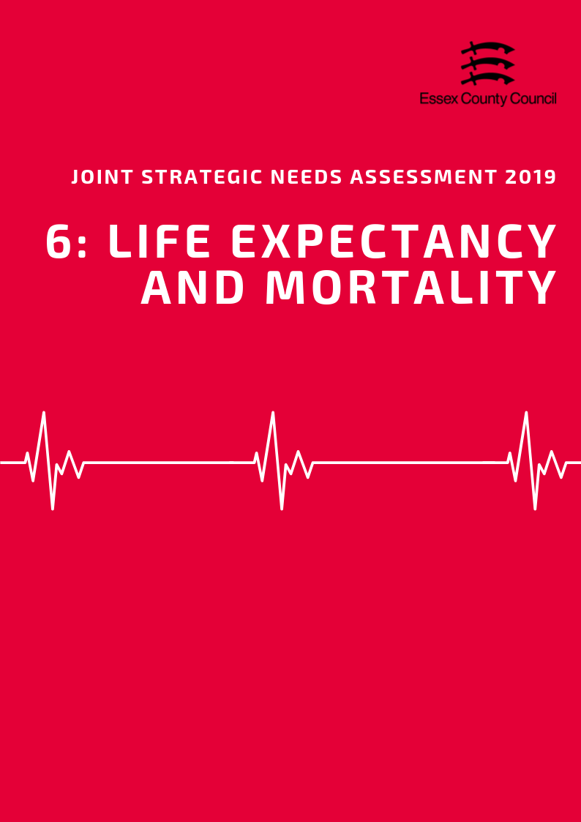

**LIFE EXPECTANCY & MORTALITY**

***Life Expectancy***

*Life Expectancy at Birth*

The average life expectancy at birth for a child born in Chelmsford (2015-2017) was 84 years for females and 81.3 years for males. This higher than the average for England for both sexes (Females = 83.1, Males = 79.6), and is the third highest male life expectancy in Essex. In this area, it estimated that the difference (inequality) in life expectancy at birth between most and least deprived areas is an average of 4.5 years for females and 6 years for males, lower than the average number of years difference for both sexes at in Essex (6, 7.7) and England (7.4, 9.4).

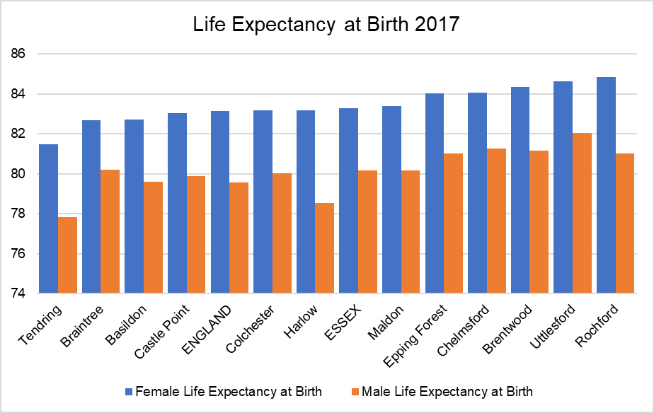

*Life Expectancy at 65*

During the same period, life expectancy at age 65 (the number of additional years a person could expect to live) was 21.6 years for females and 19.8 years for males, higher than the England average for both sexes (Females = 21.1, Males 18.8) and is the second highest male LE in Essex. Like life expectancy at birth, life expectancy at age 65 can vary considerably between the most and least deprived areas with an estimated gap of 2.7 years for females and 3.3 years for males in Chelmsford. This is lower than the county (Females = 3.2, Males = 4.2) and England (Females = 4.5, Males= 4.9) averages for both sexes.

*Life Expectancy estimates for each lower tier local authority area at birth and at age 65 are set out in the table below:*

|  |  |  |  |  |  |  |  |  |  |
| --- | --- | --- | --- | --- | --- | --- | --- | --- | --- |
|  | **Female Life Expectancy** | | | |  | **Male Life Expectancy** | | | |
| **At 65** | **At birth** | **Inequality in LE** | |  | **At 65** | **At birth** | **Inequality in LE** | |
| **At 65** | **At Birth** |  | **At 65** | **At Birth** |
| **England** | **21.1** | **83.1** | **4.5** | **7.4** |  | **18.8** | **79.6** | **4.9** | **9.4** |
| **Essex** | **21.2** | **83.3** | **3.2** | **6** |  | **18.9** | **80.2** | **4.2** | **7.7** |
| Basildon | 21.1 | 82.7 | 4 | 7.5 |  | 18.6 | 79.6 | 5.1 | 9.6 |
| Braintree | 20.6 | 82.7 | 2.1 | 5 |  | 18.7 | 80.2 | 2.4 | 5.5 |
| Brentwood | 21.6 | 84.3 | 5.1 | 7 |  | 19.4 | 81.2 | 5.9 | 9.9 |
| Castle Point | 20.8 | 83.0 | 2.6 | 4.3 |  | 18.4 | 79.9 | 3.6 | 6 |
| Chelmsford | 21.6 | 84.0 | 2.7 | 4.5 |  | 19.8 | 81.3 | 3.3 | 6 |
| Colchester | 21.1 | 83.2 | 4.7 | 7.8 |  | 18.8 | 80.0 | 4.7 | 7.5 |
| Epping Forest | 21.1 | 84.0 | 3.3 | 5.6 |  | 19.1 | 81.0 | 4.1 | 6.6 |
| Harlow | 21.3 | 83.2 | 2.6 | 5.1 |  | 18.3 | 78.5 | 5.3 | 7.8 |
| Maldon | 21.7 | 83.4 | 1.9 | 2.3 |  | 19.0 | 80.2 | 1.9 | 3.9 |
| Rochford | 21.9 | 84.8 | 2.6 | 4.4 |  | 19.1 | 81.0 | 2.8 | 3.2 |
| Tendring | 20.6 | 81.5 | 4 | 7 |  | 18.2 | 77.8 | 4.5 | 10.8 |
| Uttlesford | 22.0 | 84.6 | 0.6 | -0.3 |  | 20.0 | 82.1 | 1.9 | 2.2 |

***Mortality***

In 2017 the Chelmsford area had an all ages mortality rate of 879.6 deaths per 100,000 residents, based on 1522 deaths recorded during that time period. This overall mortality rate was lower than the England average of 958.7 (per 100K), but was a slight decrease compared the previous year (863.4 per 100K). Looking at mortality rates across the different age groups, 43% of all deaths during this period were from residents aged 85 years and over with an age standardised mortality rate of 14883.8 per 100K (based 656 actual deaths). This was lower than the England average (40.4%, 15280.8 per 100K) and Essex rate (43.3%, 16031.7 per 100K), with mortality rates for all other age groups also below the national average.

*Premature Mortality*

The Chelmsford City area has the fourth lowest rate of all premature mortalities in Essex with a rate of 273 deaths per 100,000 residents under the age of 75. This is 21.6% lower than the average for England, 12.6% lower than the average for the county, but higher 7.4% higher than the best performing area (Uttlesford). Despite this relatively good performance compared to county and national levels, there likely remain inequalities for residents living in some neighbourhoods.

There is also a significant difference in the under 75 mortality rates between females (330 per 100,000) and males (220 per 100,000) a difference of 33%; slightly smaller than the average difference across England (34%).

*Premature Deaths from Cancer*

553 deaths from cancer under the age of 75 were recorded in the Chelmsford City area between 2015-17, equivalent to a rate of 119.8 deaths per 100,000 residents. This is significantly lower than the average for Essex (131) and England (135), and the 3rd lowest rate in Essex. Experimental statistics for early stage cancer diagnosis indicate that 56.2% of cases were diagnosed at either stage 1 or 2 in 2017. This is higher than the Essex (53.3%) and England (52.2%) averages and but is down compared to 57.2% in 2016.

Breast cancer serious cause of cause of premature mortality for women across the county. In Chelmsford 52 deaths for women under the age of 75 were recorded between 2015 and 2017, equivalent to a rate of 21.8 deaths per 100,000 people and higher than the average for Essex (21.5) or England (20.6). The percentage of eligible women in the Chelmsford City area who were screened adequately for breast cancer in (the previous three years from 31st March) 2018 was 71.9%. This was lower than the average for Essex (73.5%) or England (74.9%) and was the fourth lowest level of screening in the county. Public Health England recommends that improvements in coverage would mean more breast cancers are detected at earlier more treatable stages.

Colorectal cancer was the second most common cause of premature deaths by cancer with 47 deaths recorded in 2015/17. This is equivalent to a rate of 10.2 per 100,000 residents (the 5th lowest mortality rate for all districts) and is slightly lower than the rate for Essex (11.3) and England (12).

***Preventable Mortality***

*According to Public Health England, "preventable mortality is that deaths are considered preventable if, in the light of the understanding of the determinants of health at the time of death, all or most deaths from the underlying cause (subject to age limits if appropriate) could potentially be avoided by public health interventions in the broadest sense".*

In the period of 2015-2017 it is estimated that 722 deaths for all age groups or 16.2% of all deaths that occurred in the Chelmsford area were preventable. This is equivalent to a rate of 142.1 per 100,000 people, lower than the rate (181.5) and percentage (18.9%) for England. Males were 36% more likely to die from a preventable cause (SMR= 174.9 per 100K) compared to females (SMR= 111.3 per 100K) during the same period.

For the under 75 age group Cancer was the largest cause of preventable mortality with a rate of 65.8 preventable deaths per 100,000 for all persons. This was lower than the England baseline (82.8) and the rate for Essex (74.2) and was also lower than average for both males (SMR = 57.3) and females (SMR = 67.8) individually.

Cardiovascular disease was the next largest preventable cause with a combined rate of 33.8 per 100,000 for both sexes, however the rate for all persons and the rate for each sex were all below the national average for the latest time period.

|  |  |  |  |  |  |  |  |  |  |  |
| --- | --- | --- | --- | --- | --- | --- | --- | --- | --- | --- |
|  | **Mortality Rates for All Persons** | | | | | | | | | |
|  | **Under 75 mortality from colorectal cancer** | **Under 75 mortality rate from all cardiovascular diseases** | **Under 75 mortality rate from all causes** | **Under 75 Mortality rate from breast cancer** | **Under 75 mortality rate from cancer** | **Under 75 mortality rate from heart disease** | **Under 75 mortality rate from injuries** | **Under 75 mortality rate from liver disease** | **Under 75 mortality rate from respiratory disease** | **Under 75 mortality rate from stroke** |
| **England** | **11.97** | **72.50** | **331.95** | **10.60** | **134.59** | **38.72** | **12.78** | **18.51** | **34.26** | **13.08** |
| **Essex** | **11.32** | **62.56** | **307.35** | **11.22** | **131.18** | **31.57** | **10.20** | **14.68** | **30.76** | **11.73** |
| Basildon | 13.82 | 70.92 | 336.39 | 9.81 | 157.15 | 35.80 | 7.39 | 15.06 | 33.14 | 13.42 |
| Braintree | 9.61 | 65.40 | 310.64 | 14.10 | 132.10 | 34.11 | 11.18 | 13.98 | 27.49 | 13.47 |
| Brentwood | 11.37 | 48.51 | 265.73 | 8.77 | 119.54 | 24.19 | 7.54 | 13.63 | 26.70 | 7.89 |
| Castle Point | 11.75 | 66.34 | 313.33 | 14.03 | 141.84 | 32.15 | 8.67 | 14.13 | 32.70 | 13.16 |
| Chelmsford | 10.17 | 54.03 | 272.91 | 11.22 | 119.76 | 28.45 | 9.85 | 11.26 | 24.02 | 10.46 |
| Colchester | 8.66 | 56.64 | 298.36 | 8.88 | 122.23 | 29.44 | 12.54 | 15.99 | 34.37 | 10.51 |
| Epping Forest | 8.76 | 52.34 | 276.80 | 12.69 | 121.43 | 25.31 | 9.88 | 13.81 | 28.24 | 10.55 |
| Harlow | 8.36 | 91.62 | 356.97 | 10.82 | 127.68 | 48.42 | 12.35 | 13.82 | 40.82 | 17.71 |
| Maldon | 16.10 | 61.97 | 297.26 | 13.50 | 126.61 | 31.51 | 17.62 | 14.29 | 23.06 | 11.74 |
| Rochford | 10.33 | 49.03 | 263.54 | 10.20 | 120.80 | 20.34 |  | 9.21 | 21.59 | 6.15 |
| Tendring | 15.21 | 79.58 | 400.31 | 11.80 | 149.39 | 37.51 | 17.86 | 25.26 | 45.35 | 15.68 |
| Uttlesford | 10.45 | 52.83 | 252.76 | 9.45 | 113.08 | 30.85 | 5.47 | 13.50 | 23.93 | 8.65 |

|  |  |  |  |  |  |  |  |  |  |  |
| --- | --- | --- | --- | --- | --- | --- | --- | --- | --- | --- |
|  | **Mortality Rates for Female Residents** | | | | | | | | | |
| **Under 75 mortality from colorectal cancer** | **Under 75 mortality rate from all cardiovascular diseases** | **Under 75 mortality rate from all causes** | **Under 75 Mortality rate from breast cancer** | **Under 75 mortality rate from cancer** | **Under 75 mortality rate from heart disease** | **Under 75 mortality rate from injuries** | **Under 75 mortality rate from liver disease** | **Under 75 mortality rate from respiratory disease** | **Under 75 mortality rate from stroke** |
| **England** | **9.36** | **45.22** | **264.13** | **20.59** | **120.68** | **18.46** | **7.08** | **12.97** | **28.98** | **11.33** |
| **Essex** | **9.54** | **37.62** | **250.12** | **21.53** | **120.61** | **14.03** | **6.34** | **11.49** | **25.44** | **9.69** |
| Basildon | 10.31 | 44.80 | 280.68 | 18.43 | 143.66 | 17.14 |  | 15.78 | 29.86 | 11.47 |
| Braintree | 6.45 | 41.03 | 259.69 | 27.49 | 125.03 | 15.85 | 6.64 | 9.85 | 23.61 | 12.05 |
| Brentwood | 12.08 | 28.51 | 217.07 | 17.08 | 106.45 |  |  | 14.93 | 22.74 |  |
| Castle Point | 11.60 | 37.02 | 255.09 | 27.15 | 135.91 | 12.14 |  | 12.61 | 25.47 | 8.02 |
| Chelmsford | 9.30 | 32.79 | 220.20 | 21.76 | 112.36 | 12.28 | 5.47 | 5.98 | 20.98 | 7.20 |
| Colchester | 8.27 | 33.63 | 231.45 | 16.34 | 100.83 | 13.04 | 10.20 | 10.54 | 25.83 | 10.54 |
| Epping Forest | 6.03 | 31.76 | 230.83 | 24.42 | 106.93 | 11.46 | 8.94 | 9.38 | 25.44 | 8.78 |
| Harlow |  | 48.16 | 256.41 | 20.81 | 108.86 | 21.88 |  | 12.50 | 30.63 | 14.90 |
| Maldon | 14.24 | 33.27 | 254.87 | 26.60 | 133.30 | 13.33 | 13.36 |  | 19.54 |  |
| Rochford | 10.67 | 26.76 | 213.16 | 19.72 | 113.43 | 9.14 |  | 7.50 | 13.51 |  |
| Tendring | 10.64 | 50.97 | 320.64 | 22.03 | 133.00 | 17.01 | 7.67 | 20.63 | 37.80 | 15.13 |
| Uttlesford | 14.23 | 34.52 | 221.05 | 18.54 | 124.54 | 14.97 |  | 11.93 | 17.59 |  |

|  |  |  |  |  |  |  |  |  |  |  |
| --- | --- | --- | --- | --- | --- | --- | --- | --- | --- | --- |
|  | **Mortality Rates for Male Residents** | | | | | | | | | |
| **Under 75 mortality from colorectal cancer** | **Under 75 mortality rate from all cardiovascular diseases** | **Under 75 mortality rate from all causes** | **Under 75 Mortality rate from breast cancer** | **Under 75 mortality rate from cancer** | **Under 75 mortality rate from heart disease** | **Under 75 mortality rate from injuries** | **Under 75 mortality rate from liver disease** | **Under 75 mortality rate from respiratory disease** | **Under 75 mortality rate from stroke** |
| **England** | **14.74** | **101.25** | **403.22** | **0.16** | **149.57** | **60.09** | **18.56** | **24.30** | **39.90** | **14.93** |
| **Essex** | **13.24** | **89.42** | **368.93** |  | **142.83** | **50.47** | **14.20** | **18.10** | **36.54** | **13.93** |
| Basildon | 17.81 | 99.62 | 397.73 |  | 172.39 | 56.22 | 11.82 | 14.36 | 36.87 | 15.54 |
| Braintree | 13.02 | 91.43 | 364.90 |  | 139.74 | 53.66 | 15.89 | 18.39 | 31.54 | 14.99 |
| Brentwood | 10.55 | 69.95 | 317.48 |  | 133.43 | 43.71 |  | 12.22 | 30.95 |  |
| Castle Point | 12.06 | 98.06 | 377.12 |  | 149.35 | 53.77 | 13.49 | 15.71 | 40.68 | 18.99 |
| Chelmsford | 11.13 | 77.03 | 329.61 |  | 128.28 | 45.96 | 14.34 | 16.89 | 27.24 | 14.00 |
| Colchester | 9.00 | 81.61 | 371.09 |  | 145.81 | 47.24 | 15.05 | 21.98 | 43.84 | 10.44 |
| Epping Forest | 11.70 | 74.50 | 326.33 |  | 137.14 | 40.29 | 10.87 | 18.58 | 31.31 | 12.39 |
| Essex | 13.24 | 89.42 | 368.93 |  | 142.83 | 50.47 | 14.20 | 18.10 | 36.54 | 13.93 |
| Harlow | 12.24 | 139.51 | 468.88 |  | 149.33 | 78.10 | 20.15 | 15.19 | 52.91 | 20.54 |
| Maldon | 17.94 | 91.25 | 341.00 |  | 119.81 | 50.07 | 21.78 | 21.79 | 26.56 | 17.01 |
| Rochford | 10.07 | 73.13 | 317.49 |  | 128.69 | 32.39 |  | 11.08 | 30.51 | 10.28 |
| Tendring | 20.24 | 111.07 | 488.75 |  | 167.63 | 60.01 | 28.97 | 30.42 | 53.80 | 16.34 |
| Uttlesford |  | 71.35 | 284.31 |  | 101.11 | 46.90 |  | 15.01 | 30.38 | 9.84 |

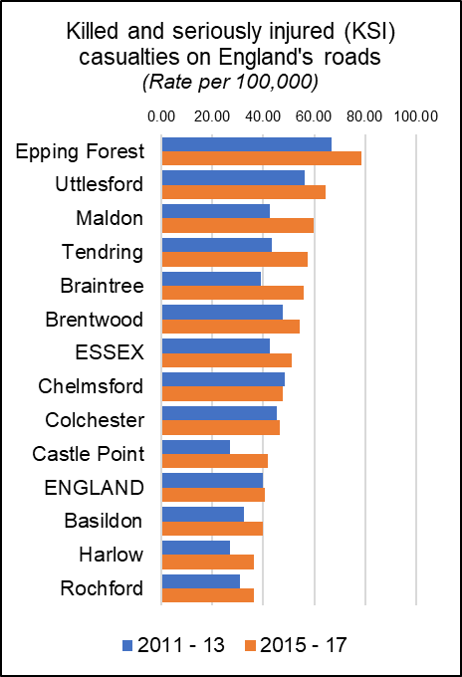***Killed and Seriously Injured in Road Traffic Accidents***

The rate of people killed or seriously injured on England’s roads has risen is recorded as a rate per 100,000 population (all ages) over a three year period. During the last recorded period (2015-17) the average rate for Essex (51.28) was higher than the average for England (40.8) with nine out of 12 Districts having rates above the national average.

Chelmsford had a rate of 46.75 which was the above the England average but below Essex in 2015-17 and was the 7th highest level in the county. Rates in Chelmsford have decreased by 0.96 per 100K or 2% compared to 2011-13 but an increase compared to the previous year.

*KSI rates for all areas & over time are set out in the table below.*

|  |  |  |  |  |  |  |  |  |
| --- | --- | --- | --- | --- | --- | --- | --- | --- |
|  | **Killed and seriously injured (KSI) casualties on England's roads** | | | | |  | **5 Year Change** | |
| 2011 - 13 | 2012 - 14 | 2013 - 15 | 2014 - 16 | 2015 - 17 | Rate (per 100K) | % |
| Epping Forest | 66.93 | 70.35 | 67.73 | 75.81 | 78.76 | 11.83 | 17.7% |
| Uttlesford | 56.24 | 50.80 | 48.37 | 55.16 | 64.51 | 8.27 | 14.7% |
| Maldon | 42.51 | 42.86 | 43.52 | 57.83 | 59.92 | 17.41 | 41.0% |
| Tendring | 43.35 | 39.80 | 40.60 | 45.84 | 57.43 | 14.08 | 32.5% |
| Braintree | 39.09 | 40.45 | 43.09 | 51.37 | 55.76 | 16.67 | 42.7% |
| Brentwood | 47.66 | 47.28 | 45.23 | 54.10 | 54.28 | 6.62 | 13.9% |
| **ESSEX** | **42.74** | **42.21** | **42.47** | **48.18** | **51.28** | **8.55** | **20.0%** |
| Chelmsford | 48.61 | 43.25 | 44.49 | 45.74 | 47.65 | -0.96 | -2.0% |
| Colchester | 45.41 | 42.89 | 44.02 | 46.51 | 46.54 | 1.14 | 2.5% |
| Castle Point | 26.83 | 28.97 | 32.99 | 39.24 | 41.97 | 15.14 | 56.4% |
| **ENGLAND** | **39.71** | **39.26** | **38.50** | **39.70** | **40.80** | **1.09** | **2.7%** |
| Basildon | 32.48 | 36.98 | 35.79 | 39.02 | 39.72 | 7.25 | 22.3% |
| Harlow | 26.97 | 21.97 | 24.03 | 31.25 | 36.49 | 9.52 | 35.3% |
| Rochford | 30.99 | 34.94 | 32.23 | 39.52 | 36.17 | 5.18 | 16.7% |
| Number of people reported killed or seriously injured (KSI) on the roads, all ages, per 100,000 resident population | | | | | | | | |

***Excess Winter Deaths***

Excess Winter Deaths Index (EWD Index) is the excess winter deaths measured as the ratio of extra deaths from all causes that occur in the winter months compared with the expected number of deaths, based on the average of the number of non-winter deaths. The Excess Winter Deaths Index is calculated as the number of excess winter deaths divided by the average non-winter deaths expressed as a percentage.

**According to the Office of National Statistics…**

*“Colder than average temperatures for the winter months of 2017 to 2018 may partially explain the increase in winter deaths. However, previous years demonstrate a weak relationship between temperature and EWD. Increased EWD are not always coupled with unusually cold winters and conversely winters with decreased EWD are not always coupled with milder winter temperatures, indicating factors other than temperature, such as influenza, are also relevant in explaining trends in excess winter mortality (EWM).”\**

Between August 2014 and July 2017, the three year average rate of Excess Deaths for all ages was 22.2%, higher than the average for England (21.9%) and lower than Essex (23.3%). This was the 6th highest level compared to the other Districts in the county (Highest: Uttlesford = 30.1%; Lowest: Brentwood = 9.3%). Looking at the level of Excess Winter Deaths specifically in the over 85s age group shows the same rate of 22.2% Excess Winter Deaths for this age group during the same period. This is lower than the England rate of 29.3% and the county average of 31.7% and is the second lowest level in Essex (Highest: Maldon = 39.5%; Lowest: Brentwood 14.5%). A breakdown of the levels of Excess Winter Deaths for each district can be found in the table below.

|  |  |  |  |  |
| --- | --- | --- | --- | --- |
|  | ***Excess winter deaths index (3 years, age 85+) Percentage*** | ***Essex rank (lowest to Highest)*** | ***Excess winter deaths index (3 years, all ages) Percentage*** | ***Essex rank (lowest to Highest)*** |
| **England** | **29.3** |  | **21.1** |  |
| **Essex** | **31.7** |  | **23.3** |  |
| Basildon | 34.5 | 7 | 19.4 | 3 |
| Braintree | 30.9 | 3 | 26.1 | 9 |
| Brentwood | 14.5 | 1 | 9.3 | 1 |
| Castle Point | 37.7 | 10 | 27.2 | 11 |
| Chelmsford | 22.2 | 2 | 22.2 | 6 |
| Colchester | 36.8 | 9 | 25.4 | 7 |
| Epping Forest | 31.8 | 4 | 25.5 | 8 |
| Harlow | 35.2 | 8 | 22.1 | 5 |
| Maldon | 39.5 | 12 | 17.4 | 2 |
| Rochford | 32.2 | 5 | 21.5 | 4 |
| Tendring | 32.7 | 6 | 26.1 | 10 |
| Uttlesford | 38.5 | 11 | 30.1 | 12 |

*[*https://www.ons.gov.uk/peoplepopulationandcommunity/birthsdeathsandmarriages/deaths/bulletins/excesswintermortalityinenglandandwales/2017to2018provisionaland2016to2017final*](https://www.ons.gov.uk/peoplepopulationandcommunity/birthsdeathsandmarriages/deaths/bulletins/excesswintermortalityinenglandandwales/2017to2018provisionaland2016to2017final)

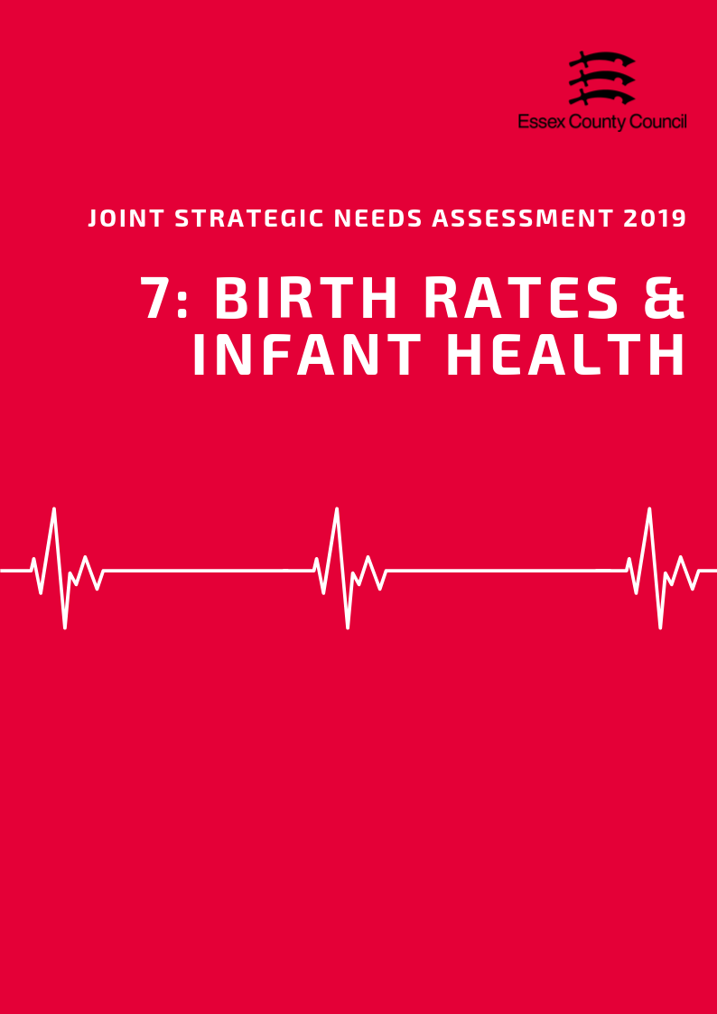

**Birth Rates & Infant Health**

***Birth Rates***

According to the Office for National Statistics the Crude Birth Rate (CBR; all births per 1,000 population) was 11.2 in the Chelmsford area in 2017. This was the 6th highest CBR compared to the other Districts in Essex.

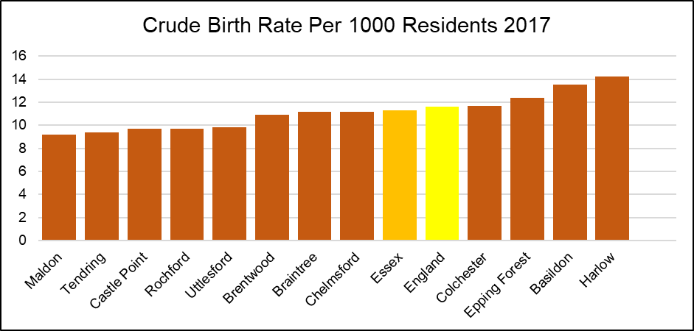

Over the period of 2013 to 2017, the CBR in Chelmsford has fluctuated but shown an overall increase, with, for example, a CBR of 10.9 in 2013. This was the fourth largest increase in CBR of the Districts in Essex. In contrast, the CBR remained stable across Essex (2013 and 2017: 11.3) and decreased across England by 0.7 (2013: 12.3; 2017: 11.6).

*The Table below provides the ranked CBR in each district in each year from 2013 to 2017*

|  |  |  |  |  |  |  |  |  |  |  |
| --- | --- | --- | --- | --- | --- | --- | --- | --- | --- | --- |
|  | **Year** | | | | | | | | | |
| **2013** | | **2014** | | **2015** | | **2016** | | **2017** | |
| **CBR** | **Rank** | **CBR** | **Rank** | **CBR** | **Rank** | **CBR** | **Rank** | **CBR** | **Rank** |
| **England** | **12.3** | **-** | **12.2** | **-** | **12.1** | **-** | **12.0** | **-** | **11.6** | **-** |
| **Essex** | **11.3** | **-** | **11.5** | **-** | **11.3** | **-** | **11.4** | **-** | **11.3** | **-** |
| Basildon | 13.6 | 2 | 13.4 | 2 | 13.5 | 2 | 13.6 | 2 | 13.5 | 2 |
| Braintree | 11.1 | 5 | 11.0 | 7 | 10.7 | 7 | 11.4 | 6 | 11.2 | 5 |
| Brentwood | 11.1 | 6 | 11.6 | 4 | 11.7 | 5 | 11.1 | 7 | 10.9 | 7 |
| Castle Point | 9.0 | 10 | 9.7 | 10 | 9.5 | 9 | 9.6 | 9 | 9.7 | 9 |
| Chelmsford | 10.9 | 7 | 11.4 | 6 | 10.9 | 6 | 11.7 | 5 | 11.2 | 6 |
| Colchester | 12.4 | 3 | 12.4 | 3 | 12.2 | 4 | 11.8 | 4 | 11.7 | 4 |
| Epping Forest | 12.2 | 4 | 11.5 | 5 | 12.5 | 3 | 12.2 | 3 | 12.4 | 3 |
| Harlow | 14.6 | 1 | 16.1 | 1 | 14.3 | 1 | 15.2 | 1 | 14.2 | 1 |
| Maldon | 8.8 | 11 | 8.5 | 12 | 9.2 | 11 | 8.4 | 12 | 9.2 | 12 |
| Rochford | 8.4 | 12 | 9.4 | 11 | 8.8 | 12 | 8.8 | 11 | 9.7 | 10 |
| Tendring | 9.7 | 9 | 9.8 | 9 | 9.5 | 10 | 9.0 | 10 | 9.4 | 11 |
| Uttlesford | 9.9 | 8 | 10.9 | 8 | 10.5 | 8 | 10.7 | 8 | 9.8 | 8 |

***Birth rates by age of mother***

The rate of births among females aged 40 -44 years was 14.6 per 1,000, the second highest compared to the other Districts in Essex in 2016. This was also higher than that for Essex as a whole (12.4), but similar to the rate across England (14.9).

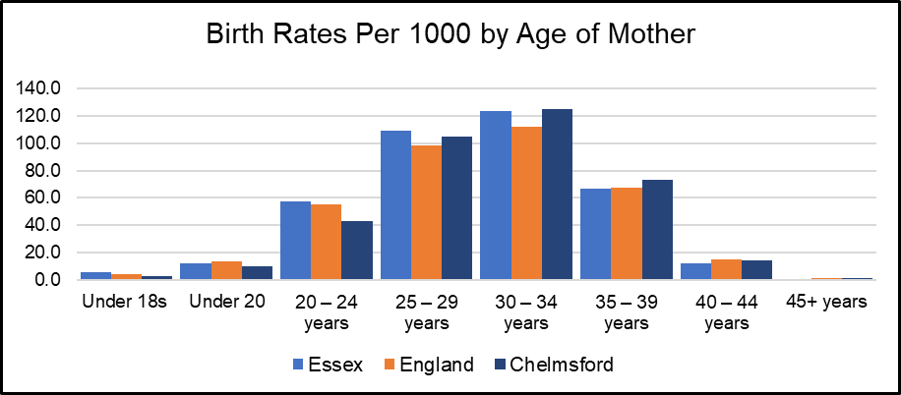

*See Table 2 for birth rates by age of mother for each Essex District*

***Under 18 Conceptions and Births***

The rate of conceptions in women aged under 18 years per 1,000 females aged 15 to 17 years in the Chelmsford area was 12.2 in 2016, the 9th highest rate compared across the other Essex Districts.

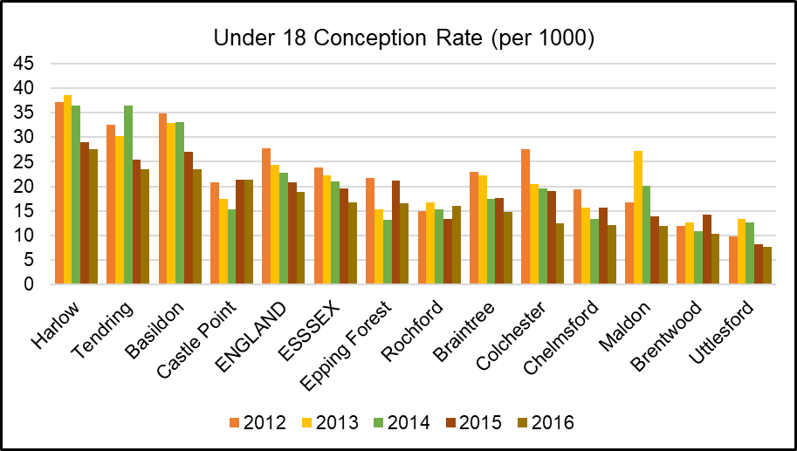

The rate of live births in women aged under 18 per 1,000 females aged 15 to 17 years was 3.13 in Chelmsford in 2016, the 9th highest rate compared to the other Districts in Essex.

|  |  |  |  |  |  |  |  |  |
| --- | --- | --- | --- | --- | --- | --- | --- | --- |
|  | **Birth Rates (per 1000) by Age of Mother** | | | | | | | |
| **Under 18s** | **Under 20** | **20-24 years** | **25-29 years** | **30-34 years** | **35-39 years** | **40-44 years** | **45+ years** |
| **Essex** | **5.6** | **11.9** | **57.3** | **109.2** | **123.9** | **66.7** | **12.4** | **1** |
| **England** | **4.6** | **13.5** | **55.6** | **98.5** | **112.4** | **67.5** | **14.9** | **1.1** |
| Basildon | 4.1 | 17 | 73.9 | 117.9 | 122.5 | 66.3 | 13 | - |
| Braintree | 7.2 | 12.7 | 70.3 | 120.8 | 115.1 | 61 | 12.8 | 0.7 |
| Brentwood | 3.0 | 7.5 | 36 | 90.7 | 145.4 | 77.4 | 14 | 1 |
| Castle Point | 3.8 | 10.1 | 51.2 | 110.4 | 126.5 | 62.1 | 7.7 | 1.2 |
| Chelmsford | 3.1 | 10.4 | 43.3 | 105.1 | 124.8 | 73 | 14.6 | 1.1 |
| Colchester | 3.4 | 11.4 | 52.1 | 93 | 111.4 | 61.9 | 11.7 | 1.7 |
| Epping Forest | 4.2 | 8.6 | 45 | 98.8 | 145.5 | 77.8 | 14.5 | 1 |
| Harlow | 8.5 | 16.2 | 72.4 | 137.5 | 116.8 | 69.3 | 15.4 | 2.7 |
| Maldon | 2.8 | 8.3 | 61.9 | 100.8 | 122.4 | 60.8 | 6.3 | - |
| Rochford | 5.3 | 7.9 | 32.4 | 105.3 | 128.2 | 53.5 | 12.3 | - |
| Tendring | 8.1 | 18.8 | 88.4 | 132.6 | 101.7 | 46.8 | 9.4 | - |
| Uttlesford | 1.9 | 6.2 | 47.1 | 93.7 | 151.1 | 85.9 | 13.2 | 1.4 |

**INFANT HEALTH**

***Premature Births***

Premature births are live or still births at a gestational age of less than 37 weeks. The rate of premature births per 1,000 total live and still births in the Chelmsford area was 65.68 over the 3 year period of 2014 - 2016. This was the 9th highest rate compared to the other Districts in Essex, and significantly lower than that for Essex as a whole (74.69) and England (79.52).

***Low Birth Weight***

Low birth weight is defined as a live birth with a recorded weight under 2500g and gestational age of at least 37 weeks. In the Chelmsford area in 2016, the percentage of low birth weight out of all live births with a recorded weight (and gestational age >=37 weeks) was 1.67. This was the third lowest out of the other Districts in Essex, and slightly lower to that for Essex as a whole (2.11) and England (2.79).

***Infant Mortality***

According to Public Health England, the rate of infant mortality aged under 1 years old was 3.06 per 1,000 live births in the Chelmsford area over the period 2015 - 2017. This was the 6th highest compared to the other districts of Essex and similar to that for the whole of Essex (3.10), but lower than that for England (3.92).

***Breastfeeding Initiation***

Breastfeeding initiation is mothers giving their babies breast milk in the first 48 hours after delivery. The percentage of breastfeeding initiation of the total number of maternities in the Chelmsford area in 2016/17 was 77.55%. This was the 4th highest compared across the Essex Districts with data available, and higher than that for the whole of Essex (75.02) and England (74.49).

***Smoking at The Time of Delivery***

The percentage of mothers known to be smokers at the time of delivery out of all maternities was 7.76% in the Mid Essex CCG in 2017/18. This was the second lowest (compared across the other CCGs in Essex, and lower than that for Essex as a whole (10.60) and England (10.80).

*All of the infant health datasets mentioned in this section is set out in table below:*

|  |  |  |  |  |  |
| --- | --- | --- | --- | --- | --- |
|  | **Premature births (less than 37 weeks gestation) Per 1000** | **Low birth weight of term babies (%)** | **Infant mortality (per 1000)** | **Breast Feeding Initiation (%)** | **Smoking status at time of delivery (%)** |
| **England** | 79.52 | 2.79 | 3.92 | 74.49 | 10.80 |
| **Essex** | 74.69 | 2.11 | 3.10 | 75.02 | 10.6 |
| Basildon | 79.05 | 2.52 | 2.83 | 68.02 | 11.82 |
| Braintree | 73.88 | 2.32 | 3.19 | 70.82 | 7.76 |
| Brentwood | 62.79 | 2.03 | 1.56 | 76.56 | 11.82 |
| Castle Point | 91.76 | 1.92 | 1.94 | 75.70 | 6.25 |
| Chelmsford | 65.68 | 1.67 | 3.06 | 77.55 | 7.76 |
| Colchester | 77.37 | 2.50 | 4.20 | 82.02 | 14.70 |
| Epping Forest | 74.35 | 2.07 | 1.24 | ! | 9.98 |
| Harlow | 84.90 | 2.61 | 3.20 | 71.18 | 9.98 |
| Maldon | 59.39 | 1.18 | 2.95 | ! | 7.76 |
| Rochford | 62.91 | 1.13 | 3.42 | 83.35 | 6.25 |
| Tendring | 81.90 | 2.03 | 5.52 | 68.38 | 14.70 |
| Uttlesford | 67.35 | 1.82 | 2.99 | 80.28 | 9.98 |
| Time Period | 2014-16 | 2016 | 2015-17 | 2016/17 | 2017/18 |
| ! Data not available | | | | | |

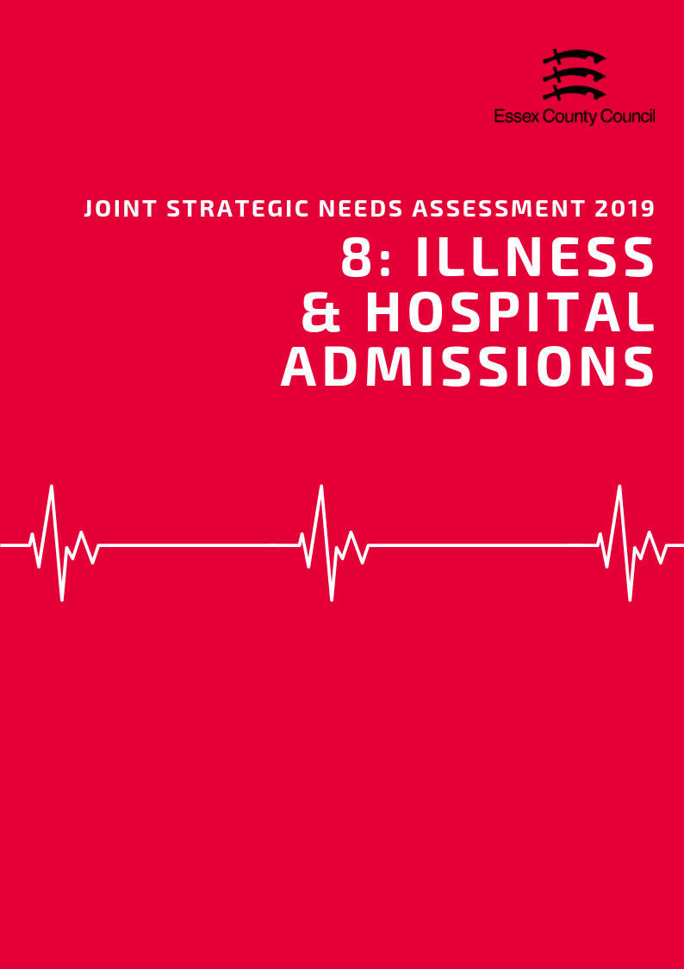

**Illness & Hospital Admissions**

***Emergency Hospital Admissions***

Emergency (unplanned) hospital admissions are both costly to the Health Service and can be a proxy indicator for wider health inequalities within local communities. In order to accurately compare admissions rates between areas of different sizes and compositions statistics are presented using Standardised Admission Ratio is defined as the ratio of the observed number of admissions in an area to the number expected if the area had the same age specific rates as England (Always set at 100).

***Emergency Admissions; all causes and all ages***

The admissions ratio for emergency admissions for all causes among persons of all ages was 84.09 in Chelmsford, which was ranked as being the 9th highest admission ratio across the Essex Districts.

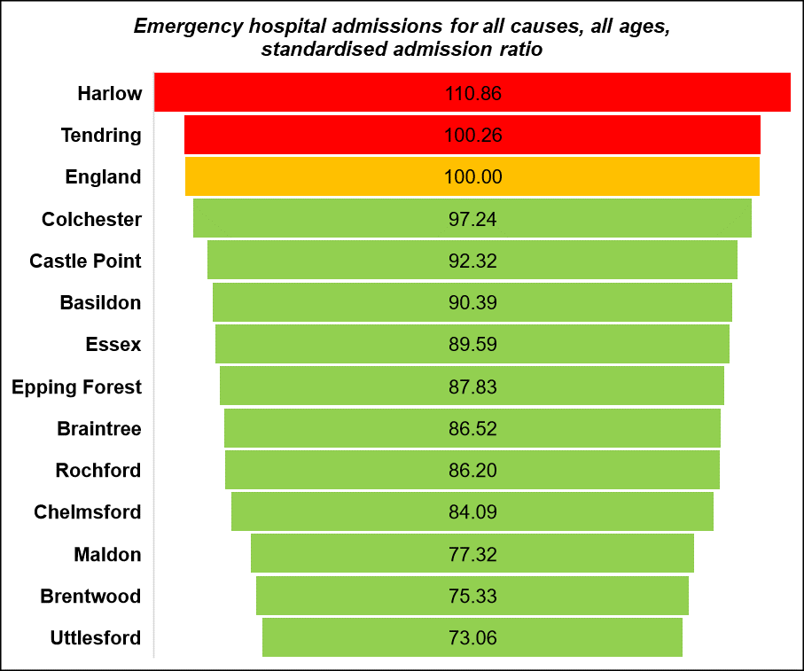

***Emergency Admissions for under 18s***

The emergency hospital admission rate per 1,000 population among those aged 18 years or younger was 5.80 in Chelmsford. This was ranked as being the third highest rate compared across the rates of the Essex Districts (highest: Colchester 10.09; lowest: Castle Point 3.57). Note that this data is an estimate produced by aggregating GP level data. This data is available from Public Health England Fingertips.

|  |  |  |  |  |  |  |
| --- | --- | --- | --- | --- | --- | --- |
|  | Emergency hospital admissions (standardised admission ratio) | | | | | |
|  | All causes  & All ages | Chronic Obstructive Pulmonary Disease (COPD) | Coronary Heart Disease, (CHD) | Hip fracture in persons 65 years and over | Myocardial Infarction (heart attack) | Stroke |
| Basildon | 90.4 | 116.5 | 100.4 | 103.5 | 104.0 | 113.8 |
| Braintree | 86.5 | 75.5 | 83.5 | 116.1 | 85.2 | 88.8 |
| Brentwood | 75.3 | 61.3 | 81.1 | 104.4 | 81.6 | 89.8 |
| Castle Point | 92.3 | 102.0 | 84.7 | 104.5 | 77.5 | 102.0 |
| Chelmsford | 84.1 | 61.2 | 77.2 | 107.9 | 75.4 | 89.3 |
| Colchester | 97.2 | 71.7 | 92.4 | 108.3 | 81.2 | 86.5 |
| England | 100.0 | 100.0 | 100.0 | 100.0 | 100.0 | 100.0 |
| Epping Forest | 87.8 | 78.4 | 88.3 | 99.7 | 91.9 | 89.8 |
| Essex | 89.6 | 83.2 | 90.5 | 106.2 | 87.5 | 94.3 |
| Harlow | 110.9 | 129.8 | 128.8 | 99.3 | 125.8 | 96.8 |
| Maldon | 77.3 | 52.2 | 80.8 | 105.8 | 83.9 | 80.2 |
| Rochford | 86.2 | 81.6 | 90.5 | 101.9 | 77.0 | 105.7 |
| Tendring | 100.3 | 100.3 | 105.7 | 108.4 | 93.7 | 100.1 |
| Uttlesford | 73.1 | 51.9 | 67.6 | 106.1 | 74.4 | 76.0 |

***Heart Attack***

Over the period of 2013/14 - 2017/18, the admissions ratio for emergency admissions for Myocardial Infarction (heart attack) was 75.41 in Chelmsford. This was ranked as being the third lowest admissions ratio across the Essex Districts, and better than the admissions ratio across Essex (87.49) and England (100). Every District of Essex had a significantly better admissions ratio for Myocardial Infarction than England, with exception for Basildon and Harlow.

***Coronary Heart Disease***

The admission ratio for emergency admissions due to Coronary Heart Disease (CHD) was 77.22 in Chelmsford, which was ranked as the second lowest admission ratio across the Essex Districts. This was also significantly better than the admission ratio across England (100).

***Stroke***

The emergency admission ratio for Stroke in Chelmsford was 89.34, which was the 8th highest admission ratio compared across the Essex Districts. All Districts in Essex had an admission ratio similar to (Harlow, Rochford, Tendring) or significantly better than that of England, with exception of significantly worse in Basildon.

***Chronic Obstructive Pulmonary Disease (COPD)***

Chronic Obstructive Pulmonary Disease (COPD) refers to serious lung conditions, including chronic bronchitis and emphysema. According to data from the Hospital Episode Statistics, the age standardised rate of emergency hospital admissions for COPD in adults aged over 35 years was 245.12 per 100,000 in Chelmsford in 2017/18. This was ranked as the 9th highest rate across the Essex Districts (lowest: Uttlesford 215.50; highest: Basildon 490.48).

**Violence and Injuries**

***Violence Related Admissions***

In the Braintree District of Essex, the directly age standardised rate per 100,000 population of emergency hospital admissions for violence was 26.99 over the period of 2015/16 - 2017/18. This was lower r than the emergency hospital admission rate for Essex as a whole (28.83) and significantly better than the rate for England (43.36).

***Injuries***

Chelmsford had a lower than average rate of hospital stays due to alcohol related harm with a SAR of 75.4 and for intentional self-harm at 76.9.

|  |  |  |  |  |  |
| --- | --- | --- | --- | --- | --- |
|  | **Unintentional and deliberate injuries (per 10,000)** | | **Hospital admissions for violence (Incl. sexual violence) *Directly Age Standardised Per 100K*** | **Hospital Stays (Standardised Admissions Ratios)** | |
| **Children (aged 0-14 years)** | **Young People (aged 15-24)** | **For alcohol-related harm** | **For self-harm** |
| **England** | **96.44** | **132.67** | **43.36** | **100.0** | **100.0** |
| **Essex** | **88.22** | **125.93** | **28.83** | **86.1** | **81.6** |
| Basildon | 56.04 | 188.13 | 34.50 | 85.9 | 57.5 |
| Braintree | 96.73 | 135.54 | 18.06 | 77.7 | 78.4 |
| Brentwood | 65.56 | 112.42 | 20.47 | 67.9 | 40.1 |
| Castle Point | 70.35 | 107.87 | 28.24 | 89.1 | 62.0 |
| Chelmsford | 99.08 | 136.21 | 26.99 | 75.4 | 76.9 |
| Colchester | 120.74 | 124.52 | 34.90 | 93.0 | 130.6 |
| Epping Forest | 88.23 | 89.35 | 29.05 | 87.4 | 47.7 |
| Harlow | 85.02 | 105.57 | 34.25 | 111.0 | 87.7 |
| Maldon | 95.84 | 114.00 | 23.93 | 72.6 | 61.9 |
| Rochford | 73.12 | 93.17 | 17.86 | 81.2 | 59.8 |
| Tendring | 112.74 | 114.68 | 50.75 | 105.2 | 151.5 |
| Uttlesford | 69.12 | 118.85 | 12.80 | 75.8 | 68.4 |

***Injuries to Children & Young People***

The rate of hospital admissions caused by unintentional and deliberate injuries in children aged under 15 years per 10,000 resident population aged under 15 was 99.08 in Chelmsford in 2017/18. This was the third highest rate compared across the Districts in Essex and higher than the rate across Essex (88.22) and England (96.44). Colchester, Tendring and Chelmsford were the only Districts with rates higher than Essex and England. Chelmsford also had the third highest rate among males aged under 15 years compared across the Districts in Essex in 2017/18, with a rate of 125.54. This was also higher than the Essex (101.91) and England (106.79) rates. Similarly, among young people aged between 15 - 24 years, the rate of hospital admissions due to unintentional or deliberate injuries was 136.21 per 10,000 population aged 15-24 in Chelmsford in 2017/18. This was ranked as being the second highest compared across the rates of the other Essex Districts and higher than the average rate across Essex (125.93), but relatively similar to that across England (132.67). Basildon was the only district with a rate higher than England.

**Falls and Hip Fractures**

According to data from the Hospital Episode Statistics, the age standardised rate of emergency hospital admissions due to falls in persons aged over 65 years was 1929.67 per 100,000 in 2017/18. This was higher than the rate across Essex (2059.46) but lower than England (2170.43). Basildon, Castle Point and Rochford were the only Districts in Essex with a higher rate than England.

|  |  |  |  |  |  |  |
| --- | --- | --- | --- | --- | --- | --- |
|  | **Emergency hospital admissions due to falls** | | | **Hip fractures** | | |
| **All Persons Aged 65 and over** | **Age 65-79** | **Age 80+** | **All persons aged 65 and over** | **Age 65-79** | **Age 80+** |
| England | 2170.43 | 1032.87 | 5469.37 | 577.76 | 246.32 | 1539 |
| Essex | 2059.46 | 940.94 | 5303.19 | 611.9 | 259.41 | 1634 |
| Basildon | 2677.1 | 1345.86 | 6537.69 | 617.96 | 300.99 | 1537 |
| Braintree | 2122.3 | 950.99 | 5519.13 | 716.43 | 269.9 | 2011 |
| Brentwood | 2071.46 | 1067.65 | 4982.49 | 623.82 | 337.66 | 1454 |
| Castle Point | 2362.11 | 912.43 | 6566.18 | 588.79 | 207.44 | 1695 |
| Chelmsford | 1929.67 | 883.43 | 4963.76 | 565.04 | 214.47 | 1582 |
| Colchester | 1945.47 | 921.23 | 4915.78 | 626.55 | 261.02 | 1687 |
| Epping Forest | 1772.09 | 774.38 | 4665.45 | 542.61 | 239.76 | 1421 |
| Harlow | 1742.48 | 830.26 | 4387.93 | 615.28 | 291.71 | 1554 |
| Maldon | 1877.77 | 876.69 | 4780.91 | 604.99 | 264.76 | 1592 |
| Rochford | 2258.51 | 850.92 | 6340.51 | 607.61 | 219.16 | 1734 |
| Tendring | 1955.95 | 902.11 | 5012.1 | 660.87 | 292.17 | 1730 |
| Uttlesford | 1871.26 | 822.68 | 4912.14 | 532.18 | 215.53 | 1450 |

In Chelmsford in 2017/18, the age standardised rate of emergency hospital admissions due to hip fractures among persons aged over 65 years was 565.04 per 100,000 population. This was lower than the rate across Essex as a whole (611.91) and England (577.76) and was ranked as being the third lowest rate across the Districts in Essex (highest: Braintree 716.43; lowest: Uttlesford 532.18).

**ILLNESS AND LONG TERM CONDITIONS**

As part of the Quality Outcomes Framework (QOF) each GP surgery records the percentage of registered patients who have been diagnosed with a range of different medical conditions. This rate is known as QOF prevalence which along with records from of practices can be combined to give a prevalence level at different geographies.

***Hypertension & Stroke***

In 2015/16, the estimated proportion of all those registered at General Practitioner surgeries in the Chelmsford area with a diagnosis of Hypertension was 13.76%. This was ranked as being the 9th highest QOF prevalence compared across the Essex Districts (highest: Tendring 19.58%; lowest: Colchester 13.32%).

In 2015, the prevalence of diagnosed hypertension among persons aged over 16 years was estimated to be 19.48. This was slightly lower than the prevalence across England (20.78) and was ranked as being the third lowest prevalence across the Essex Districts (highest: Tendring 27.44; lowest: Colchester 19.01). Chelmsford was also ranked as having the third lowest prevalence of undiagnosed hypertension among persons aged over 16, with an estimate of 11.95 (highest: Tendring 14.04; lowest: Colchester 11.61). This was also slightly lower than the estimated prevalence across England (12.15).

The percentage of patients with a stroke or transient ischemic attack, as registered on the disease practice register, was 1.55% in 2017/18. This was lower than that across Essex (1.76%) and England (1.77%) and ranked as being the third lowest across the Essex Districts.

***Coronary Heart Disease***

The QOF prevalence, the proportion of patients registered at GP surgeries with a diagnosis, of Coronary Heart Disease (CHD) in the Chelmsford District was 3.14% in 2017/18. This was ranked as the 9th highest estimated prevalence across the Essex Districts. Among persons aged between 55 - 79 years in Chelmsford, the estimated prevalence of CHD was 7.42 in 2015. This was ranked as being the 3rd lowest estimated prevalence across the Essex Districts, and lower than the prevalence across England (7.94).

***Asthma***

The proportion of patients with a diagnosis of Asthma was estimated to be 6.08%. This was ranked as being the 6th highest prevalence compared across the other Districts in Essex. Note that this estimate is produced by aggregating from GP level data.

***Epilepsy***

In 2017/18, the estimated proportion of all those registered at General Practitioner surgeries in Chelmsford with a diagnosis of Epilepsy was 0.75%. This was ranked as being the 8th highest QOF prevalence compared across the Essex Districts.).

***Table: QOF Prevalence of Long -Term Conditions***

|  |  |  |  |  |  |
| --- | --- | --- | --- | --- | --- |
|  | **QOF Prevalence (% of GP Registered Patients)** | | | | |
|  | **Asthma**  **(all ages)** | **Dementia**  **(all ages)** | **Epilepsy (18+)** | **Hypertension (all ages)** | **Stroke (all ages)** |
| **England** | **5.93** | **0.76** | **0.80** | **13.94** | **1.77** |
| Basildon | 6.09 | 0.69 | 0.78 | 14.96 | 1.82 |
| Braintree | 6.29 | 0.80 | 0.89 | 13.70 | 1.77 |
| Brentwood | 5.29 | 0.90 | 0.73 | 14.67 | 1.89 |
| Castle Point | 5.87 | 0.77 | 0.80 | 18.07 | 1.87 |
| Chelmsford | 6.08 | 0.72 | 0.75 | 13.76 | 1.55 |
| Colchester | 5.81 | 0.67 | 0.80 | 13.32 | 1.43 |
| Epping Forest | 5.10 | 1.06 | 0.59 | 13.95 | 1.61 |
| Harlow | 5.83 | 0.59 | 0.81 | 13.40 | 1.48 |
| Maldon | 6.40 | 0.78 | 0.82 | 16.19 | 1.92 |
| Rochford | 5.94 | 1.04 | 0.70 | 16.13 | 1.89 |
| Tendring | 6.90 | 1.07 | 1.05 | 19.58 | 2.47 |
| Uttlesford | 6.55 | 0.79 | 0.64 | 14.41 | 1.58 |

***Dementia***

The QOF prevalence of Dementia was estimated to be was estimated to be 0.72%. This was ranked as being the 9th highest prevalence compared across the other Districts in Essex.

Among persons aged over 65 years in Chelmsford in 2018, the estimated Dementia diagnosis rate was 60.4. This was ranked as being the 7th highest rate compared across the Districts.

In 2019 information from Projecting Older People’s Population Information (POPPI) estimated that in the Chelmsford area there were 2452 people with dementia which would rise to 3799 by 2035. Projected dementia numbers of people with dementia for individual districts are set out in the table below (Source: POPPI 2019)

|  |  |  |  |  |  |
| --- | --- | --- | --- | --- | --- |
| **Projected number of people age 65+ with Dementia** | **2019** | **2020** | **2025** | **2030** | **2035** |
| **Essex** | 21,972 | 22,478 | 25,510 | 29,437 | 33,729 |
| Basildon | 2,284 | 2,316 | 2,595 | 2,926 | 3,349 |
| Braintree | 2,174 | 2,225 | 2,595 | 3,114 | 3,633 |
| Brentwood | 1,264 | 1,276 | 1,403 | 1,576 | 1,744 |
| Castle Point | 1,566 | 1,619 | 1,840 | 2,129 | 2,338 |
| Chelmsford | 2,452 | 2,503 | 2,908 | 3,330 | 3,799 |
| Colchester | 2,323 | 2,396 | 2,689 | 3,180 | 3,639 |
| Epping Forest | 1,967 | 1,994 | 2,233 | 2,541 | 2,858 |
| Harlow | 1,018 | 1,024 | 1,111 | 1,229 | 1,370 |
| Maldon | 1,053 | 1,103 | 1,319 | 1,597 | 1,835 |
| Rochford | 1,417 | 1,444 | 1,661 | 1,880 | 2,133 |
| Tendring | 3,104 | 3,183 | 3,576 | 4,112 | 4,684 |
| Uttlesford | 1,309 | 1,349 | 1,625 | 1,944 | 2,275 |

***Cancer***

The NHS estimates that more than 1 in 3 people will develop some form of cancer during their lifetime with the 4 most common types of cancer being:

* lung cancer
* breast cancer
* prostate cancer
* bowel cancer

The following incidence ratio of all cancers and the major cancer sub-types are the standardised incidence ratio, the number of observed new cases as a percentage of number expected new cases, calculated relative to England (100) during the period of 2012-2016.

|  |  |  |  |  |  |
| --- | --- | --- | --- | --- | --- |
|  | Incidence Rates of Cancers | | | | |
| Breast Cancer | Colorectal Cancer | Lung Cancer | Prostate Cancer | All Cancers |
| **England** | **100.00** | **100.00** | **100.00** | **100.00** | **100.00** |
| **Essex** | **100.97** | **97.58** | **90.53** | **104.12** | **98.49** |
| Basildon | 106.58 | 102.13 | 108.63 | 92.01 | 104.75 |
| Braintree | 98.81 | 88.86 | 84.42 | 104.95 | 95.66 |
| Brentwood | 99.53 | 88.81 | 68.29 | 101.00 | 93.95 |
| Castle Point | 92.74 | 92.87 | 101.61 | 93.50 | 96.58 |
| Chelmsford | 104.20 | 99.87 | 70.10 | 99.10 | 92.40 |
| Colchester | 98.63 | 98.14 | 84.95 | 112.32 | 97.99 |
| Epping Forest | 103.04 | 103.80 | 96.50 | 132.98 | 104.62 |
| Harlow | 100.36 | 98.95 | 123.62 | 95.24 | 105.18 |
| Maldon | 105.22 | 93.31 | 83.34 | 95.07 | 93.35 |
| Rochford | 96.24 | 98.32 | 80.73 | 97.19 | 91.62 |
| Tendring | 97.98 | 101.04 | 106.26 | 109.79 | 104.66 |
| Uttlesford | 108.04 | 96.62 | 67.11 | 102.20 | 94.02 |

***All Cancers***

The incidence ratio for all cancers over the period of 2012 - 2016 in the Chelmsford area was 92.40. This was significantly better than the incidence ratio for all cancers across England (100) and was ranked as being the 2nd lowest across the Essex Districts (highest: Harlow: 105.18; lowest: Rochford 91.62).

***Lung Cancer***

In Chelmsford, the incidence ratio for lung cancer was 70.10. This was significantly better than the incidence ratio relative to England (100) and was ranked as being the third lowest across Essex Districts (highest: Harlow 123.62; lowest: Uttlesford 67.11).

***Breast Cancer***

The incidence ratio for Breast Cancer was 104.20 in Chelmsford, which was ranked as being the 4th highest incidence ratio compared across the Districts of Essex (highest: Uttlesford 108.04; lowest: Castle Point 92.74). However, the incidence ratio of all Districts in Essex for breast cancer was not significantly different to England (100).

***Colorectal Cancer***

The incidence ratio for colorectal cancer was 99.87, which was ranked as being the 4th highest incidence ratio across the Essex Districts (highest: Epping Forest 103.80; lowest: Braintree 88.86). However, with exception of Braintree, the incidence ratios for colorectal cancer of all Essex Districts were similar relative to England (100).

**Prostate Cancer**

The incidence ratio of prostate cancer was 99.10, which was ranked as being the 7th highest incidence ratio across the Essex Districts (highest: Epping Forest 132.98; lowest Basildon 92.01).

***Musculoskeletal (MSK) Conditions***

An estimated 30.8% of residents were recorded as reporting a long term musculoskeletal (MSK) problem. This was lower than the Essex average (34.9%) and the average for England (33.5%)

The percentage of residents reporting a long term back problem (7.5%) was also lower than the average for England (9.4%) and Essex (9.3%), whilst the percentage of residents reporting arthritis or a long term joint problem (11.3%) was also just below the county and national averages.

The QOF prevalence of patients aged 50+ recorded with a diagnosis of Osteoporosis (0.4%) was lower than the national average (0.62%) but slightly above the average for Essex (0.39%).

|  |  |  |  |  |
| --- | --- | --- | --- | --- |
|  | **% reporting a long term MSK problem** | **% reporting a long-term back problem** | **% reporting arthritis or long-term joint problem** | **Osteoporosis: QOF prevalence (50+)** |
| Basildon | 33.5 | 9.4 | 11.5 | 0.35 |
| Braintree | 33.4 | 8.7 | 12.8 | 0.45 |
| Brentwood | 35.7 | 10.5 | 13.0 | 0.42 |
| Castle Point | 39.3 | 9.4 | 15.3 | 0.26 |
| Chelmsford | 30.8 | 7.5 | 11.3 | 0.4 |
| Colchester | 32.0 | 8.2 | 10.6 | 0.56 |
| England | 33.5 | 9.4 | 12.2 | 0.62 |
| Epping Forest | 32.0 | 8.7 | 11.7 | 0.42 |
| Essex | 34.9 | 9.3 | 12.6 | 0.39 |
| Harlow | 33.4 | 10.5 | 11.9 | 0.27 |
| Maldon | 36.6 | 11.3 | 13.3 | 0.33 |
| Rochford | 36.8 | 8.0 | 13.4 | 0.29 |
| Tendring | 47.7 | 13.1 | 17.6 | 0.41 |
| Uttlesford | 29.8 | 8.2 | 9.8 | 0.36 |

***Diabetes***

Diabetes is a lifelong condition that causes a person's blood sugar level to become too high.

There are 2 main types of diabetes:

* type 1 diabetes – where the body's immune system attacks and destroys the cells that produce insulin
* type 2 diabetes – where the body does not produce enough insulin, or the body's cells do not react to insulin

Type 2 diabetes is far more common than type 1. In the UK, around 90% of all adults with diabetes have type 2.

The recorded QOF prevalence of Diabetes for people aged 17+ in the Mid Essex CCG area was 6.4%. This is similar to the average for England (6.5%) and Essex (6.6%) was the joint second lowest prevalence rate out of the 5 CCGs in Essex. Public health England estimates that around 8.1% of residents in the CCG area are likely to have diabetes suggesting that around 1.7% of people are undiagnosed.

Diabetes can reduce the blood supply to feet and cause a loss of feeling known as peripheral neuropathy. This can mean foot injuries don't heal well and you may not notice if your foot is sore or injured. Annual foot checks for people with diabetes are therefore an essential part of care monitoring procedures. In the Mid Essex CCG area, an estimated 58.3% of people with Type 1 diabetes and 65.7% of people with type 2 diabetes have received an annual foot check. This is significantly lower than the average for England with all but one CCG area in Essex (North East Essex) have rates well below the national average, and none reaching 100 coverage.

|  |  |  |  |  |
| --- | --- | --- | --- | --- |
|  | Diabetes: QOF prevalence (17+) | Estimated prevalence of diabetes (undiagnosed and diagnosed) | People with type 1 diabetes who have received an annual foot check | People with type 2 diabetes who have received an annual foot check |
| England | 6.5% | 8.5% | 70.1% | 79.4% |
| Essex | 6.6% | 8.5% |  |  |
| NHS Basildon And Brentwood CCG | 6.4% | 8.2% | 61.8% | 65.9% |
| NHS Castle Point and Rochford CCG | 7.2% | 8.6% | 54.4% | 61.8% |
| NHS Mid Essex CCG | 6.4% | 8.1% | 58.3% | 65.7% |
| NHS North East Essex CCG | 6.8% | 9.0% | 81.8% | 85.5% |
| NHS West Essex CCG | 6.2% | 8.1% | 64.0% | 72.4% |

**Vaccinations**

Vaccinations are one of the most important interventions in place to prevent the spread of avoidable diseases amongst the population. In the UK the majority of vaccinations are given childhood, with a number of boosters and additional vaccinations also given to people of different ages who might be at higher risk from certain diseases.

Across the UK vaccination rates are declining with fewer people completing full courses of vaccinations compared to recent years leading to increased potential for outbreaks of diseases within an area. According to the NHS "If 95% of children receive the MMR vaccine, it's possible to get rid of measles. However, measles, mumps and rubella can quickly spread again if fewer than 90% of people are vaccinated."

***Vaccine Preventable Conditions***

Variation in incidence rates for certain conditions which are considered vaccine preventable may reflect differences in underlying population including the uptake of vaccination. Public Health England suggests that high prevalence of the following conditions "should prompt a review of routine immunisation uptake and vaccination of high risk groups".

|  |  |  |  |  |  |
| --- | --- | --- | --- | --- | --- |
|  | **Mumps 5-year incidence rate/100,000** | **Mumps incidence rate/100,000** | **Pertussis incidence rate/100,000** | **Measles 5-year incidence rate/100,000** | **Measles incidence rate/100,000** |
| Basildon | 1.33 | 0.55 | 0.54 | 0.00 | 0.54 |
| Braintree | 2.27 | 0.00 | 9.89 | 0.27 | 0.66 |
| Brentwood | 2.39 | 0.00 | 3.92 | 0.80 | 0.00 |
| Castle Point | 1.80 | 1.11 | 4.45 | 1.57 | 11.13 |
| Chelmsford | 3.26 | 1.15 | 0.57 | 0.12 | 0.00 |
| Colchester | 3.10 | 2.14 | 14.20 | 0.11 | 0.00 |
| England | 3.60 | 3.25 | 7.80 | 1.49 | 1.74 |
| Epping Forest | 2.49 | 0.77 | 1.53 | 1.09 | 3.83 |
| Essex | 2.07 | 1.10 | 5.45 | 0.38 | 1.50 |
| Harlow | 2.13 | 2.33 | 3.48 | 0.00 | 3.48 |
| Maldon | 0.32 | 0.00 | 1.56 | 0.00 | 0.00 |
| Rochford | 2.36 | 3.50 | 1.16 | 0.24 | 1.16 |
| Tendring | 1.43 | 0.70 | 6.22 | 0.29 | 0.69 |
| Uttlesford | 0.00 | 1.16 | 14.83 | 0.72 | 0.00 |

***Measles***

In 2018 the rate of measles per 100,000 people in Chelmsford was 0 and was classed as similar to the England average of 1.7. Only one area in Essex (Castle Point) was classified as significantly worse than the level for England whilst two other areas, Epping Forest (3.8%) and Harlow (3.5%) also had rates which were higher than the county and England average.

***Mumps***

The incidence rate of Mumps in 2017 was 1.15 per 100,000 and was classed as similar to the rate for England (3.2) and Essex (1.1).

***Pertussis (Whooping Cough)***

The incidence rate of pertussis in 2017 was 0.57 per 100,000 people and was better than the average for Essex (5.4 per 100,000) and England (7.8 per 100,000).

***Childhood Vaccination Coverage***

Data on Childhood Vaccinations is largely presented as the average for the CCG area, using data amalgamated up from individual GP practices. These averages can be positively skewed by figures higher performing practices in the area and mask coverage issues at a more local level. As such we have also analysed vaccination coverage levels within relevant age groups against two additional criteria recorded by NHS England;

* The number and percentage of GP practices meeting the minimum of 90% of patients vaccinated
* The number and percentage of GP practices meeting the target of 95% or more patients vaccinated

*Tables at the end of this chapter provide a full breakdown of current childhood vaccination coverage levels by CCG area.*

***Measles, Mumps and Rubella (MMR)***

By age 5 it is estimated that 97% of the GP registered children in the Mid Essex CCG have received one of the two MMR vaccination injections required to achieve full vaccination coverage. This is higher than the average for England of 94.9% and similar to the Essex average of 96.5%, with 38 out of 45 GP practices (84.4%) in the area achieving at least 95% coverage or Higher.

By comparison the rate of GP registered children who have received both of MMR vaccination injections by age five drops to 91.9%, which although higher than the England (87.2%) and Essex (89.4%) averages is still lower than the NHS target of 95% to eliminate measles within the population. NHS England Child Vaccination coverage statistics identified 10 GP practices (22.2%) in the CCG area with less than 90% vaccination coverage of the eligible population, and 10 (22.2%) which were achieving coverage of 95% or higher. The level practices achieving less than 90% coverage is lower than the whole Essex average (45.5%) and was the best performing CCG in Essex (Highest: West Essex CCG = 60.6%).

***Diphtheria, Tetanus, Pertussis (Whooping Cough), Polio, Haemophilus Influenzae Type B (hib): DTaP/IPV/Hib***

98% of GP registered children in the Mid Essex CCG area had received the full course of DTaP/IPV/Hib injections by Age 5. This is similar to the Essex average of 97.1%, was higher than the average for England (95.6%) and is the second highest vaccination coverage level out of the 5 CCG areas in Essex (Highest: Castle Point & Rochford CCG = 98.3%; Lowest: West Essex CCG = 94.6%). At practice level the NHS vaccination coverage statistics identified only no practices which had coverage levels below 90% and 44 out of 45 (97.8%) which were achieving coverage levels of 95% or higher; better than the averages for Essex (3%, 83.7%).

***Rotavirus***

An estimated 95.1% of GP registered children in the Mid Essex CCG area had received their vaccinations against Rotavirus by 12 months, higher the average for Essex (92.4%) and England (90.1%). Compared to the other CCG areas in Essex this is the highest coverage level out of five areas (Lowest: North East Essex CCG = 88.5%). Looking at coverage levels across individual GP practices, NHS England statistics identified 4 practices (8.9%) which had coverage levels below 90% and 27 practices (60%) achieving coverage of 95% or higher. This is better than the Essex average for both measures (22.5%, 35.4%) and has the second highest percentage of GP practices achieving 95% coverage or higher in the county (Highest: Castle Point and Rochford CCG = 62.5%; Lowest: North East Essex CCG =13.5%).

***Pneumococcal Vaccine (PCV)***

The pneumococcal vaccine protects against serious and potentially fatal pneumococcal infections such as pneumonia, septicaemia (a kind of blood poisoning) and meningitis and is given to infants over three separate doses at 8 weeks, 16 weeks and 1 year. By 24 months old 94.3% of the GP registered children in the Mid Essex CCG area have received their PCV vaccinations, higher the Essex (92.8%) and England (91%) averages. This is second highest coverage level out of 5 CCG areas (Highest: Castle Point and Rochford CCG = 96.2%; Lowest: North East Essex CCG = 89.9%) with 4 out of 45 GP practices (8.9%) achieving coverage levels of less than 90% and 22 practices (48.9%) achieving coverage levels of 95% or higher. These coverage levels are better than the Essex average for both measures (77.5%, 41.6%) and is the second highest level of GP practices achieving 95% or higher in the County (Highest: Castle Point and Rochford CCG = 70.8%); Lowest: North East Essex CCG = 18.9%).

***Meningitis***

According to the NHS Meningitis can be caused by a number of different infections, as such a number of different vaccinations are used to offer protection against this including the MMR, DTaP/IPV/Hib, and Pneumococcal Vaccine already mentioned in this report. In addition, the NHS also includes separate vaccinations against Meningitis C (and Hib) at one year old and also Meningitis B which takes place at 8 weeks, 16 weeks and booster at 1 year.

Coverage levels of the Hib & Meningitis C vaccination across the Mid Essex CCG area is 95.6% of eligible GP registered children by age 5, just above the Essex (94.8%) and the England (92.4%) averages and is the second highest coverage level out of the 5 CCGs in Essex (Highest: Castle Point and Rochford CCG = 96.5%; Lowest: North East Essex CCG = 93.8%). NHS England statistics identified 2 out of 45 GP practices (4.4%) with coverage levels below 90% and 30 practices (66.7%) achieving 95% coverage or higher. This is similar to the Essex average for those with less than 90% coverage (10.1%) and slightly better for those achieving 95% or higher (59%).

Coverage levels of the new Meningitis B vaccination across the Mid Essex CCG area is 95.6% of eligible GP registered children at 12 months, just above the Essex average of 94.2% and the rate for England of 92.5%. This is the second highest coverage level out of the 5 CCGs in Essex (Highest: Castle Point and Rochford CCG = 95.8%; Lowest: North East Essex CCG = 92.4%) with 4 out of 45 GP practices (8.9%) with coverage levels below 90% and 22 practices (48.9%) achieving 95% coverage or higher. This is better than the Essex average for both measures (16.9%, 46.1%) but is lower than the CCG area with the highest percentage of GP practices achieving 95% coverage (Highest: Castle Point and Rochford CCG = 70.8%; Lowest: West Essex CCG = 30.3%).

***Children in Care Immunisations***

According to figures from the Department for Education in 2018, 77.6% of children in care are up to date with the vaccinations in the NHS routine list across the whole of Essex. This is lower than the average for England (85.3%) and the East of England (85.1%) and is the 4th lowest rate out of 11 upper tier and unitary authorities in the eastern region (Highest: Norfolk = 96.3%; Lowest: Thurrock = 65.4%).

|  |  |  |  |  |  |  |  |
| --- | --- | --- | --- | --- | --- | --- | --- |
|  | ENGLAND | ESSEX | BASILDON AND BRENTWOOD CCG | CASTLE POINT AND ROCHFORD CCG | MID ESSEX CCG | NORTH EAST ESSEX CCG | WEST ESSEX CCG |
| Total no. GPs | | 178 | 39 | 24 | 45 | 37 | 33 |
| MMR 1 injection coverage at age 5 (% of eligible population) | 94.9 | 96.5 | 96.2 | 97.1 | 97.0 | 96.5 | 95.5 |
| No. GP Practices meeting the minimum 90% vaccination coverage level for MMR1at 5y |  | 173 | 38.0 | 23.0 | 44.0 | 37.0 | 31.0 |
| % GP Practices meeting the minimum 90% vaccination coverage level for MMR1 at 5y |  | 97.2% | 97.4% | 95.8% | 97.8% | 100.0% | 93.9% |
| No. GP Practices meeting the target 95% vaccination coverage level for MMR1 at 5y |  | 139 | 29.0 | 19.0 | 38.0 | 31.0 | 22.0 |
| % GP Practices meeting the target 95% vaccination coverage level for MMR1 at 5y |  | 78.1% | 74.4% | 79.2% | 84.4% | 83.8% | 66.7% |
|  |  |  |  |  |  |  |  |
| MMR 2 Injections coverage at age 5 (% of eligible population) | 87.2 | 89.4 | 90.1 | 91.5 | 91.9 | 86.6 | 87.8 |
| No. GP Practices meeting the minimum 90% vaccination coverage level for MMR2 at 5y |  | 97 | 22 | 12 | 35 | 15 | 13 |
| % GP Practices meeting the minimum 90% vaccination coverage level for MMR2 at 5y |  | 54.5% | 56.4% | 50.0% | 77.8% | 40.5% | 39.4% |
| No. GP Practices meeting the target 95% vaccination coverage level for MMR2 at 5y |  | 22 | 6 | 4 | 10 | 2 | 0 |
| % GP Practices meeting the target 95% vaccination coverage level for MMR2 at 5y |  | 12.4% | 15.4% | 16.7% | 22.2% | 5.4% | 0.0% |

|  |  |  |  |  |  |  |  |
| --- | --- | --- | --- | --- | --- | --- | --- |
|  | ENGLAND | ESSEX | BASILDON AND BRENTWOOD CCG | CASTLE POINT AND ROCHFORD CCG | MID ESSEX CCG | NORTH EAST ESSEX CCG | WEST ESSEX CCG |
| Total no. GPs | | 178 | 39 | 24 | 45 | 37 | 33 |
| PCV coverage at 24 months (% of eligible population) | 91 | 92.8 | 93.0 | 96.2 | 94.3 | 89.9 | 92.0 |
| No. GP Practices meeting the minimum 90% vaccination coverage level for PCV Booster at 24m |  | 138 | 30.0 | 21 | 41.0 | 23.0 | 23.0 |
| % GP Practices meeting the minimum 90% vaccination coverage level for PCV Booster at 24m |  | 77.5% | 76.9% | 87.5% | 91.1% | 62.2% | 69.7% |
| No. GP Practices meeting the target 95% vaccination coverage level for PCV Booster at 24m |  | 74 | 19.0 | 17 | 22.0 | 7.0 | 9.0 |
| % GP Practices meeting the target 95% vaccination coverage level for PCV Booster at 24m |  | 41.6% | 48.7% | 70.8% | 48.9% | 18.9% | 27.3% |
|  |  |  |  |  |  |  |  |
| Rotavirus vaccinations at 12 months (% of eligible population) | 90.1 | 92.4 | 92.6 | 94.9 | 95.1 | 88.5 | 90.1 |
| No. GP Practices meeting the minimum 90% vaccination coverage level for Rotavirus at 12m |  | 138 | 34 | 23 | 41 | 19 | 21 |
| % GP Practices meeting the minimum 90% vaccination coverage level for Rotavirus at 12m |  | 77.5% | 87.2% | 95.8% | 91.1% | 51.4% | 63.6% |
| No. GP Practices meeting the target 95% vaccination coverage level for Rotavirus at 12m |  | 63 | 9.0 | 15 | 27.0 | 5.0 | 7.0 |
| % GP Practices meeting the target 95% vaccination coverage level for Rotavirus at 12m |  | 35.4% | 23.1% | 62.5% | 60.0% | 13.5% | 21.2% |

|  |  |  |  |  |  |  |  |
| --- | --- | --- | --- | --- | --- | --- | --- |
|  | ENGLAND | ESSEX | BASILDON AND BRENTWOOD CCG | CASTLE POINT AND ROCHFORD CCG | MID ESSEX CCG | NORTH EAST ESSEX CCG | WEST ESSEX CCG |
| Total no. GPs | | 178 | 39 | 24 | 45 | 37 | 33 |
| Hib & MenC vaccinations at 24 months (% of eligible population) | 91.2 | 92.7 | 93.1 | 96.1 | 94.6 | 89.8 | 91.8 |
| No GP Practices meeting the minimum 90% vaccination coverage level for Hib & Men C at 5y |  | 142 | 31 | 21 | 42 | 24 | 24 |
| % GP Practices meeting the minimum 90% vaccination coverage level for Hib & Men C at 5y |  | 79.8% | 79.5% | 87.5% | 93.3% | 64.9% | 72.7% |
| No. GP Practices meeting the target 95% vaccination coverage level for Hib & Men C at 5y |  | 68 | 17 | 15 | 22 | 7 | 7 |
| % GP Practices meeting the target 95% vaccination coverage level for Hib & Men C at 5y |  | 38.2% | 43.6% | 62.5% | 48.9% | 18.9% | 21.2% |
|  |  |  |  |  |  |  |  |
| Hib & MenC vaccinations at 5 years (% of eligible population) | 92.4 | 94.8 | 95.2 | 96.5 | 95.6 | 93.8 | 93.9 |
| No GP Practices meeting the minimum 90% vaccination coverage level for Hib & Men C at 5y |  | 160 | 35 | 22 | 43 | 32 | 28 |
| % GP Practices meeting the minimum 90% vaccination coverage level for Hib & Men C at 5y |  | 89.9% | 89.7% | 91.7% | 95.6% | 86.5% | 84.8% |
| No. GP Practices meeting the target 95% vaccination coverage level for Hib & Men C at 5y |  | 105 | 25 | 17 | 30 | 18 | 15 |
| % GP Practices meeting the target 95% vaccination coverage level for Hib & Men C at 5y |  | 59.0% | 64.1% | 70.8% | 66.7% | 48.6% | 45.5% |

|  |  |  |  |  |  |  |  |
| --- | --- | --- | --- | --- | --- | --- | --- |
|  | ENGLAND | ESSEX | BASILDON AND BRENTWOOD CCG | CASTLE POINT AND ROCHFORD CCG | MID ESSEX CCG | NORTH EAST ESSEX CCG | WEST ESSEX CCG |
| Total no. GPs | | 178 | 39 | 24 | 45 | 37 | 33 |
| DTaP/IPV/Hib Vaccinations at 5 years (% of Eligible Population) | 95.6 | 97.1 | 97.0 | 98.3 | 98.0 | 96.2 | 94.6 |
| No GP Practices meeting the minimum 90% vaccination coverage level for DTaP/IPV/Hib at 5y |  | 173 | 37.0 | 24.0 | 45.0 | 37.0 | 30.0 |
| % GP Practices meeting the minimum 90% vaccination coverage level for DTaP/IPV/Hib at 5y |  | 97% | 95% | 100% | 100% | 100% | 91% |
| No. GP Practices meeting the target 95% vaccination coverage level for DTaP/IPV/Hib at 5y |  | 149 | 32.0 | 21.0 | 44.0 | 30.0 | 22.0 |
| % GP Practices meeting the target 95% vaccination coverage level for DTaP/IPV/Hib at 5y |  | 83.7% | 82.1% | 87.5% | 97.8% | 81.1% | 66.7% |
|  |  |  |  |  |  |  |  |
| MenB vaccinations at 12 months (% of eligible population) | 92.5 | 94.2 | 93.2 | 95.8 | 95.6 | 92.4 | 92.8 |
| No GP Practices meeting the minimum 90% vaccination coverage level for Men B at 12m |  | 148 | 32 | 22 | 41 | 28 | 25 |
| % GP Practices meeting the minimum 90% vaccination coverage level for Men B at 12m |  | 83.1% | 82.1% | 91.7% | 91.1% | 75.7% | 75.8% |
| No. GP Practices meeting the target 95% vaccination coverage level for Men B at 12m |  | 82 | 19 | 17 | 22 | 14 | 10 |
| % GP Practices meeting the target 95% vaccination coverage level for Men B at 12m |  | 46.1% | 48.7% | 70.8% | 48.9% | 37.8% | 30.3% |

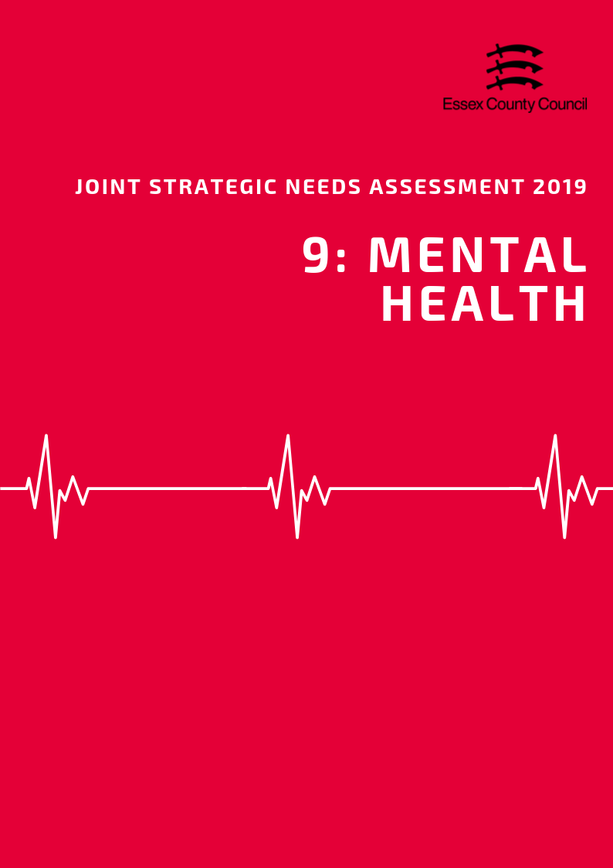

**Mental Health**

***Common Mental Health Conditions***

According to the General Practice Patient Survey (GPPS; NHS England) in 2016/17, the prevalence of depression and anxiety among persons aged over 18 years in NHS Mid Essex CCG in Essex was 11.23%. This was lower than the prevalence across Essex (12.49%) and across England (13.74%) and was ranked as being the lowest prevalence compared across that of the other CCGs in Essex (highest: NHS North East Essex 14.30%).

***Severe Mental Health Conditions***

Severe mental health conditions include schizophrenia, bipolar affective disorder and other psychoses. The prevalence of these as recorded on general practise disease registers in the Chelmsford area in 2017/18 was 0.72. This was the 8th highest prevalence compared across the other Districts in Essex.

***Long Term Mental Health Conditions***

The prevalence of reporting a long-term mental health condition among persons aged over 18 years in the NHS Mid Essex CCG of Essex, according to the GPPS, was 8.39% in 2017/18. This was ranked as being the second highest prevalence compared across the CCGs of Essex (highest: NHS North East Essex CCG 9.63%; lowest: NHS West Essex CCG 7.19%) but was similar to that across Essex (8.23%) and England (9.06%).

***Children & Young People’s Mental Health***

Chelmsford had the 8th highest estimated prevalence of any mental health disorder among children aged between 5 to 16 years across the Districts of Essex in 2015, with a prevalence of was 8.24. This was slightly lower than the estimated prevalence across the whole of Essex (8.71) and England (9.23).

This estimate was based on the prevalence’s previously given in the Office for National Statistics survey Mental Health of Children and Young People in Great Britain (2004).

|  |  |  |  |
| --- | --- | --- | --- |
|  | **Depression and Anxiety prevalence (GP Patient Survey): % of respondents aged 18+** | **Prevalence of Severe Mental Health Conditions** | **Estimated prevalence of mental health disorders in children and young people:**  **% population aged 5-16** |
| **Essex** | **12.49** | **0.80** | **8.71** |
| **England** | **13.74** | **0.94** | **9.23** |
| Basildon | 13.28 | 0.92 | 9.29 |
| Braintree | 11.23 | 0.75 | 8.80 |
| Brentwood | 13.28 | 0.66 | 7.82 |
| Castle Point | 12.48 | 0.68 | 8.89 |
| Chelmsford | 11.23 | 0.72 | 8.24 |
| Colchester | 14.30 | 0.93 | 8.75 |
| Epping | 11.31 | 0.78 | 8.22 |
| Harlow | 11.31 | 0.81 | 9.65 |
| Maldon | 11.23 | 0.76 | 8.38 |
| Rochford | 12.48 | 0.63 | 8.24 |
| Tendring | 14.30 | 1.00 | 9.76 |
| Uttlesford | 11.31 | 0.63 | 7.67 |

***Self-Harm***

According to estimates produced by Public Health England, the Chelmsford area in 2017/18 had the 7th highest rate of emergency hospital admissions for intentional self-harm among persons of all ages, with a rate of 134.88. This is significantly lower than the rate across Essex as a whole (156.98) and England (185.48). Women in Chelmsford had the 4th highest admissions rate in the county (194.97) and were 2.6 times more likely to be admitted to hospital for intentional self-harm than men (75.5) This is however lower than the rates for women across the rest of Essex (201.7) or England (235.3).

This data is also shown by gender breakdown in the table below:

|  |  |  |  |  |  |  |
| --- | --- | --- | --- | --- | --- | --- |
| **Rate of Emergency Hospital Admissions for Intentional Self-Harm in Essex Districts, 2017/18** | | | | | | |
|  | **All Persons** | | **Male** | | **Female** | |
| **Rate** | **Rank** | **Rate** | **Rank** | **Rate** | **Rank** |
| **England** | **185.48** | **N/A** | **137.73** | **N/A** | **235.28** | **N/A** |
| **Essex** | **156.98** | **N/A** | **113.48** | **N/A** | **201.70** | **N/A** |
| Basildon | 200.48 | 3 | 153.78 | 2 | 248.32 | 3 |
| Braintree | 145.48 | 5 | 101.13 | 6 | 191.72 | 6 |
| Brentwood | 96.74 | 11 | 64.56 | 10 | 129.53 | 11 |
| Castle Point | 155.06 | 4 | 116.04 | 4 | 192.8 | 5 |
| Chelmsford | 134.88 | 7 | 75.57 | 8 | 194.97 | 4 |
| Colchester | 207.63 | 2 | 145.51 | 3 | 273.85 | 2 |
| Epping Forest | 71.73 | 12 | 52.41 | 11 | 92.48 | 12 |
| Harlow | 123.59 | 8 | 99.53 | 7 | 148.17 | 10 |
| Maldon | 112.78 | 9 | 75.47 | 9 | 149.1 | 9 |
| Rochford | 100.88 | 10 | 51.55 | 12 | 150.42 | 8 |
| Tendring | 289.2 | 1 | 252.69 | 1 | 326.81 | 1 |
| Uttlesford | 142.57 | 6 | 102.45 | 5 | 184.84 | 6 |

***Suicide***

The age-standardised mortality rate per 100,000 population from suicide and injury of undetermined intent among persons aged over 10 years in Chelmsford was 11.78 in 2015/17, which was ranked as being the 5th highest rate across the Districts in Essex. This was higher than the rate across Essex as a whole (10.88) and England (9.57).

Chelmsford was ranked as having the 5th highest suicide rate among males compared to that across the other Essex Districts, with a rate of 17.97. This is 23.1% higher than the rate across England (14.69) and above the rate of Essex as a whole (16.90).

The suicide rate among females in Chelmsford was 5.72. This was ranked as the lowest compared across the rates of that in Districts with data available, but slightly higher than the rate across Essex as a whole (5.31) and England (4.69).

|  |  |  |  |  |  |  |
| --- | --- | --- | --- | --- | --- | --- |
|  | **Suicide Rate across Essex Districts among persons, males and females in 2015 / 17** | | | | | |
| **Persons** | | **Male** | | **Female** | |
| **Rate** | **Rank** | **Rate** | **Rank** | **Rate** | **Rank** |
| **England** | 9.57 | N/A | 14.69 | N/A | 4.69 | N/A |
| **Essex** | 10.88 | N/A | 16.90 | N/A | 5.31 | N/A |
| Basildon | 9.69 | 7 | 16.94 | 7 | - | - |
| Braintree | 11.12 | 6 | 17.61 | 6 | 5.86 | 3 |
| Brentwood | 7.78 | 10 | 12.03 | 11 | - | - |
| Castle Point | 8.34 | 8 | 13.91 | 9 | - | - |
| Chelmsford | 11.78 | 5 | 17.97 | 5 | 5.72 | 4 |
| Colchester | 13.08 | 4 | 19.6 | 4 | 6.97 | 2 |
| Epping Forest | 5.24 | 12 | 7.26 | 12 | - | - |
| Harlow | 14.9 | 2 | 23.34 | 3 | - | - |
| Maldon | 14.52 | 3 | 23.64 | 1 | - | - |
| Rochford | 8.02 | 9 | 12.36 | 10 | - | - |
| Tendring | 15.96 | 1 | 23.39 | 2 | 8.89 | 1 |
| Uttlesford | 7.74 | 11 | 13.94 | 8 | - | - |

**Data Sources and Further Information**

*There are several caveats to the estimates of prevalence of depression and anxiety, severe mental health conditions, and prevalence of reporting long-term health conditions in the Districts across Essex. The prevalence of depression and anxiety, and the reporting of long-term health conditions among residents were produced by aggregating data available from CCG level upwards to the District which the CCG is located. The prevalence of severe mental health conditions at District level was estimated through aggregating data of General Practitioner (GP) surgeries located in that District. The district level estimates were then aggregated together to provide Essex level estimates for these three indicators.

