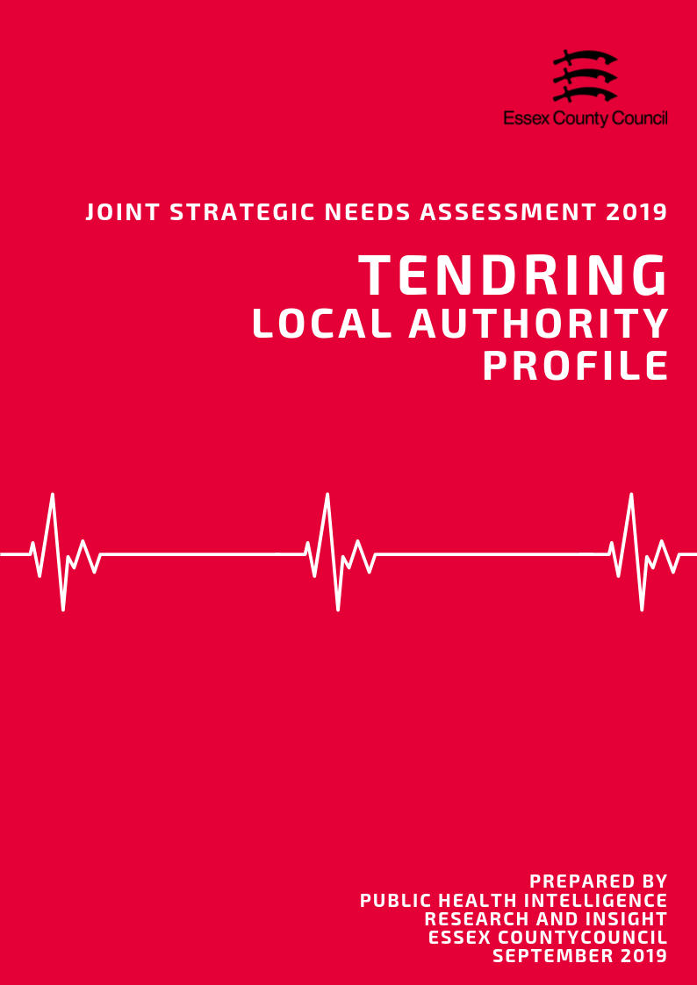

**Introduction**

What is a Joint Strategic Needs Assessment?

The JSNA is statutory process for Health & Wellbeing Boards (HWBB) to identify and improve the current and future health, wellbeing and social care needs of their area. The purpose is to inform strategic decision making, commissioning of services and reduce inequalities for all ages. There is no set format, prescribed content or specific time-period that a JSNA must cover, only that one must be produced in partnership with HWBB member organisations.

For the 2019 JSNA, the Health & Wellbeing Board is using a ‘place-based’ approach for the suite of JSNA products which will look at issues and needs at smaller local geographies. These geographies serve as building blocks to satisfy the need for intelligence at local authority and NHS geographical area and include:

• NHS/LA Locality/Neighbourhood Profiles

• District/Borough Council Profiles

• A Countywide Report

• Specialist Topic Deep Dive Reports (ESCG to develop)

This document presents data from a range of key topics which contribute to the overall the health and wellbeing of residents, in order to highlight areas of inequality and identify opportunities to improve the healthy lives for residents across the Essex County Council Local Authority area, with information also available separately for each of the 12 Districts and Boroughs where relevant.

Key findings from this and the 12 individual Local Authority Profiles will be used to identify issues that the Health and Wellbeing Board may wish to consider when refreshing the Joint Health and Wellbeing Strategy.

*Notes of Terminology:*

This document uses the term Essex to refer to the Essex County Council local authority area which does not include the Southend-on-Sea and Thurrock unitary authority areas. The term Tendring is used to refer to the whole local authority area.

**Contents**

|  |  |  |
| --- | --- | --- |
| **No.** | **Section** | **Page** |
| **1** | **Key Findings** | **3** |
| **2** | **Population & Demographics** | **7** |
| **3** | **Access to Services** | **20** |
| **4** | **Wider Determinants of Health** | **25** |
| **5** | **Lifestyle, Sexual Health & Substance Misuse** | **40** |
| **6** | **Life Expectancy & Mortality** | **50** |
| **7** | **Birth Rates and Infant Health** | **58** |
| **8** | **ILLNESS & HOSPITAL ADMISSIONS** | **63** |
| **9** | **Mental Health** | **80** |
|  |  |  |

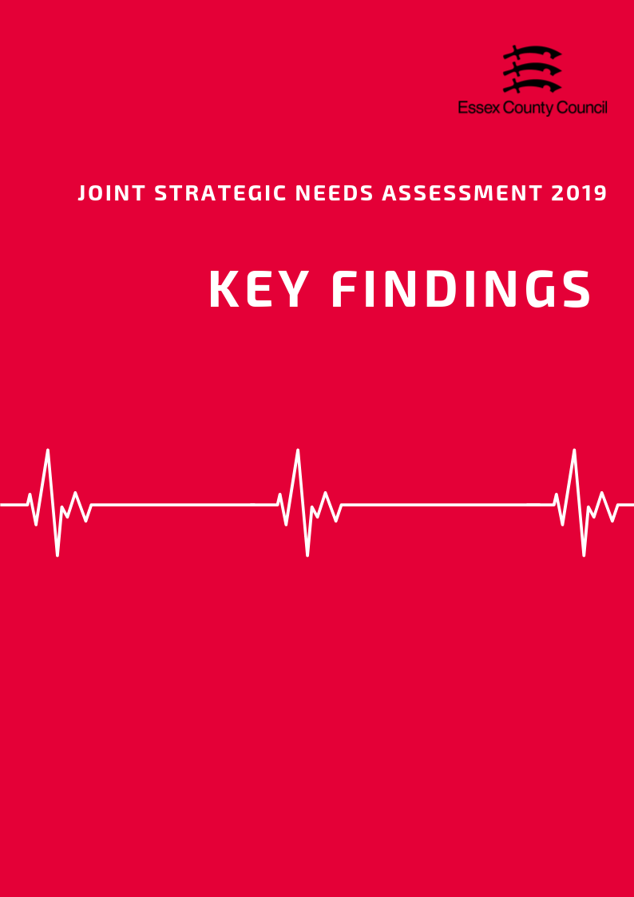

**The Top three things to know about…**

**Population and Demographics**

* According to the Office of National Statistics in 2017, the total population of the Tendring District was an estimated 145,803 people making it the fifth largest local authority area in Essex in terms of population size. This is an estimated increase of 3205 people since the 2011 census (a rise of 2.25%).
* The Tendring District has the highest percentage of residents aged 65 and over in Essex (29.5%), 9% higher than the Essex average (20.5%). The proportion of Children and Young People aged 0-15 (16.5%) and 16 to 64 years olds (53.9%) are lower than the Essex average (18.9%, and 60.6%).
* The Tendring District had an estimated Old Age Dependency Ratio of 544 people aged 65+ to every 1000 working age. This is equivalent to 1.8 working age people to every person aged 65 and over and is significantly above than the average for Essex (335.6) and England (286.8).

**Access to Services**

* Covering an area of approximately 338 square kilometres, the Tendring District is the fifth largest local authority in Essex in terms of area.
* With an estimated 428 residents per square kilometre, the Tendring District is the eighth (out of 12) most densely populated area in Essex, well roughly in line with the county average (424 people per sq. km).
* Tendring residents have the third highest travel times to local services compared to the Essex average (19.4 minutes), with an average of 21.5 minutes by walking or public transport to 8 key services. Looking at times to health services, average times to GP surgeries were estimated at 10.2 minutes just below the Essex average (11.6 minutes); whilst the average time to hospital was 64.3 minutes, 19 minutes higher than the county average.

**Wider Determinants of Health**

* The average weekly income for a Tendring resident working full time in 2018 was £543.90, £74.70 (-13.7%) below than the average for Essex and £31 (-5.7%) less than the average for England. This was the second lowest average income out of 12 Districts.
* In 2018, 47.2% of pupils achieved grade 9-4 in English and Maths (a good pass) and 26.5% achieved grade 9-5 (a strong pass) at GCSE. This is significantly lower than the averages for England (59.1%, 39.9%) and Essex (63.3%, 40.7%), and are the lowest levels in the county in 2018.
* The amount of residents claiming out of work benefits has increased to its highest level in 5 years from 2.6% in April 2015 to 4% in April 2019. This is higher than the averages for Essex (2.1%) and England (2.6%), is the highest claimant rate in Essex overall.

**Lifestyle, Sexual Health & Substance Misuse**

* In 2017/18 that 24.8% of pupils in Reception year were classed as overweight or obese, the 2nd highest rate in Essex. The sample of pupils in Year 6 showed that 36.3% of pupils in this year group were classed as overweight or obese, also the 2nd highest in the county.
* 67.54% of residents in Tendring aged over 18 years were classified as overweight or obese in 2016/17. This is higher than the prevalence of adult overweight or obesity across the whole of Essex (63.56%) and England (61.29%), and was ranked as being the 2nd highest prevalence across the Essex Districts
* According to the Office for National Statistics, the age-standardised mortality rate from drug misuse per 100,000 population in the Tendring District was 7.6 over the period of 2015 - 2017. This was the highest rate compared across that of the other Districts in Essex with data available, and higher than the rate across the whole of Essex (3.63) and England (4.33).

**Life Expectancy & Mortality**

* The average life expectancy at birth for a child born in Tendring (2015-2017) was 81.5 years for females and 77.8 years for males. This lower than the average for England for (Females =83.1 years, Males 79.6 years), and is the lowest life expectancy for both sexes in Essex.

During the same period, life expectancy at age 65 (the number of additional years a person could expect to live) was 20.6 years for females and 18.2 years for males; again this this is lower than the England average (Females =21.1 years, Males = 18.8 years), and is the (joint) lowest life expectancy at 65 in the county for females, and the lowest for males.

* Tendring had a rate of 57.43 people per 100,000 who were killed or seriously injured on roads in 2015-17. This was above the England and Essex averages and was the 4th highest level in the county.

**Birth Rates & Infant Health** 

* The rate of conceptions in women aged under 18 years per 1,000 females aged 15 to 17 years in the Tendring District was 23.5 in 2016. This was the second highest rate compared to that of the other Essex Districts, and significantly higher than that for Essex as a whole (16.7) and England (18.8).
* According to Public Health England, the rate of infant mortality aged under 1 years old was 5.52 per 1,000 live births in the Tendring District over the period 2015 - 2017. This was the highest rate compared to the other districts of Essex, and significantly higher than that for the whole of Essex (3.10) and England (3.92).
* The percentage of mothers known to be smokers at the time of delivery out of all maternities was 14.70 in the North East Essex CCG in 2017/18. This was the highest compared to the other CCGs in Essex, and significantly higher than Essex as a whole (10.60) and England (10.80).

**Illness & Hospital Admissions**

* In 2015/16, the estimated proportion of all those registered at General Practitioner surgeries in the Tendring District with a diagnosis of Hypertension was 19.58%. This was higher than the prevalence across Essex as a whole (15.11%) and England (13.94%), and was ranked as being the highest QOF prevalence compared across the Essex Districts
* In Tendring in 2017/18, the age standardised rate of emergency hospital admissions due to hip fractures among persons aged over 65 years was 660.87 per 100,000 population. This was higher than the rate across Essex as a whole (611.91) and England (577.76) and was ranked as being the second highest rate across the Districts in Essex.
* The proportion of patients of all ages registered at General Practitioner surgeries in Tendring with a diagnosis of Dementia was estimated to be 1.07%. This was ranked as being the highest prevalence compared across the other Districts in Essex and was higher than the prevalence across Essex (0.81%) and England (0.77%).

**Mental Health**

* The prevalence of reporting a long-term mental health condition among persons aged over 18 years in the NHS North East Essex CCG of Essex, according to the GPPS, was 9.63% in 2017/18. This was slightly higher than the prevalence across Essex (8.23%) and was ranked as being the highest prevalence compared across the CCGs of Essex.
* Severe mental health conditions include schizophrenia, bipolar affective disorder and other psychoses. The prevalence of these as recorded on general practise disease registers in the Tendring District in 2017/18 was 1.00. This was the highest prevalence compared across the other Districts in Essex and was also significantly higher than the prevalence across Essex as a whole (0.80) and for England (0.94).
* The age-standardised mortality rate per 100,000 population from suicide and injury of undetermined intent among persons aged over 10 years in Tendring was 15.96 in 2015/17, which was ranked as being the highest rate across the Districts in Essex. This was significantly higher than the rate across Essex as a whole (10.88) and England (9.57).
* registers in the Tendring District in 2017/18 was 1.00. This was the highest 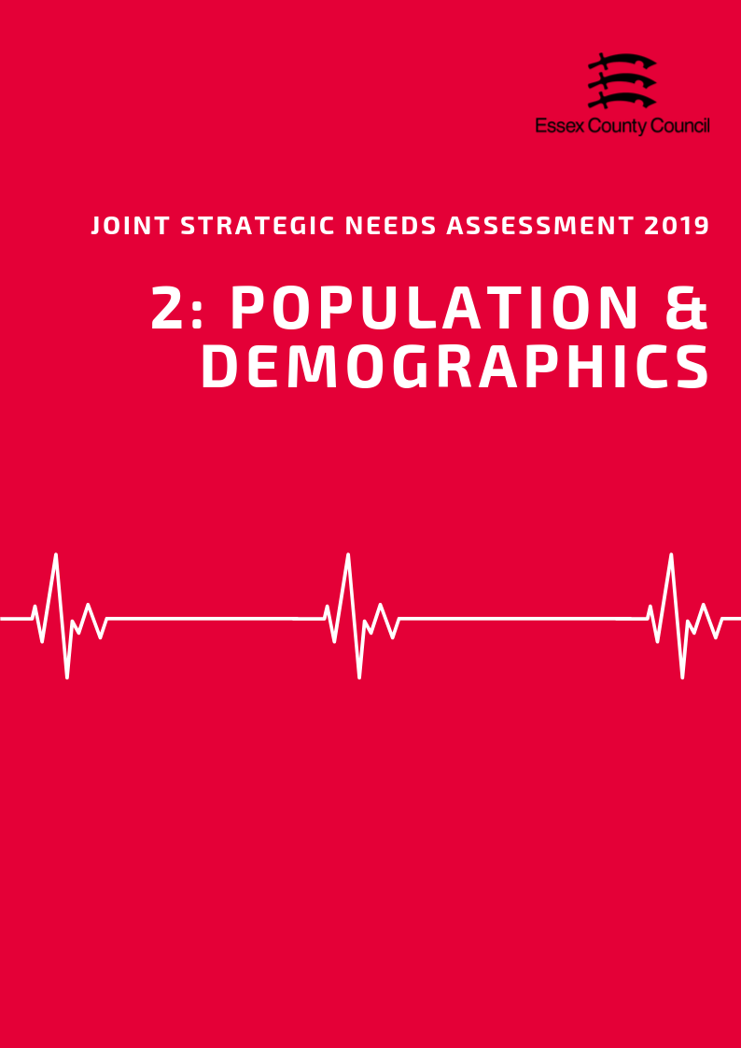

**POPULATION & DEMOGRAPHICS**

***Population Growth***

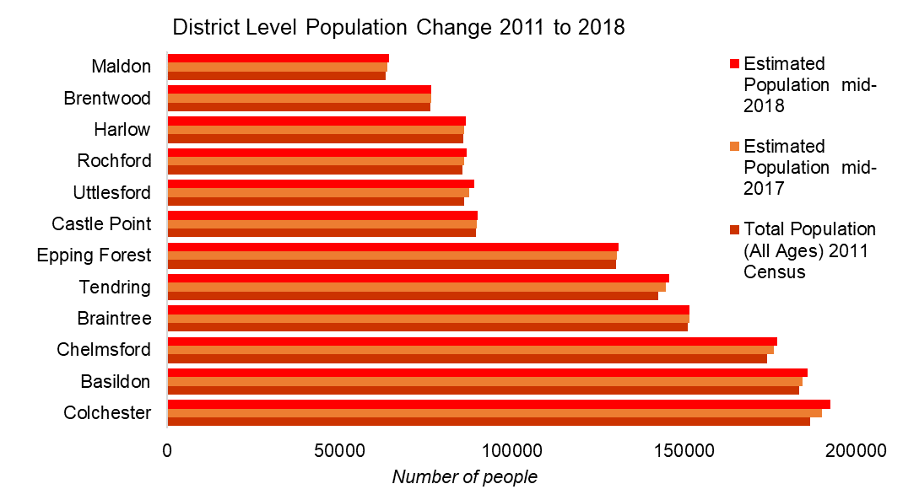According to the Office of National Statistics in 2018, the total population of the Tendring District was an estimated 145,803 people making it the fifth largest local authority area in Essex in terms of population size. This is an estimated increase of 3205 people since the 2011 census (a rise of 2.25%) which is lower than the growth rate for England (5.59%) but higher than Essex.

Looking forward, the Office of National Statistics population projections (2016 based) predict that by 2034 the total population will increase by another 21,095 people to a total of 165,800, becoming the fourth largest district in Essex by population size.

***Age Split***

The Tendring District has the highest percentage of residents aged 65 and over in Essex (29.5%), 9% higher than the Essex average (20.5%). The proportion of Children and Young People aged 0-15 (16.5%) and 16 to 64 years olds (53.9%) are lower than the Essex average (18.9%, and 60.6%). This is also the lowest percentage of 16 to 64-year olds (working age) in the county.

Over the next 15 years the percentage of older people in the Tendring District will continue to rise (to 32.3%), higher than the predicted average for Essex (22.6%) by 2034. Over the same period, the percentage of young people (15.2%) and residents aged 18 to 64 (52.5%) will continue to decrease below the county average (17.9% and 59.4%) to the lowest levels in Essex.

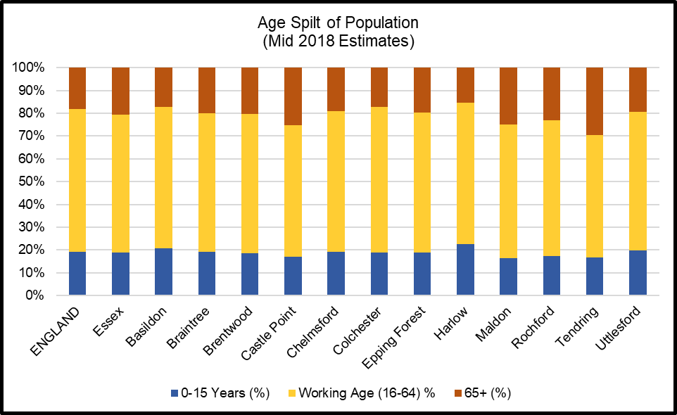

|  |  |  |  |  |  |
| --- | --- | --- | --- | --- | --- |
|  | | **Essex** | | **Tendring** | |
| **2024** | **Total Population** | 1549200 |  | 153200 |  |
| **Under 18** | 292989 | 18.9% | 25258 | 16.5% |
| **18-64** | 936049 | 60.4% | 82430 | 53.8% |
| **65+** | 320162 | 20.7% | 45512 | 29.7% |
| **2029** | **Total Population** | 1602700 |  | 159700 |  |
| **Under 18** | 295387 | 18.4% | 25227 | 15.8% |
| **18-64** | 972743 | 60.7% | 86572 | 54.2% |
| **65+** | 334570 | 20.9% | 47901 | 30.0% |
| **2034** | **Total Population** | 1650800 |  | 165700 |  |
| **Under 18** | 296076 | 17.9% | 25118 | 15.2% |
| **18-64** | 981362 | 59.4% | 87029 | 52.5% |
| **65+** | 373362 | 22.6% | 53553 | 32.3% |

***Old Age Dependency Ratio***

A useful measure to understand how the balance in the population will change, particularly when planning for the needs of the aging population is the old age dependency ratio (OADR) – the number of people over 65 years old for every 1,000 people aged between 16 and 64 years old. Compared to other areas in Essex, the Tendring District has the largest OADR than most other areas with an estimated rate of 544 in 2019. This is equivalent to 1.8 working age people to every person aged 65 and over and is significantly above than the average for Essex (335.6) and England (286.8). By 2034 this rate is predicted to rise to 615.3 per 1000, well above the rates for Essex (380.4) and England (334.2), equivalent to 1.6 working age people to every resident aged 65+.

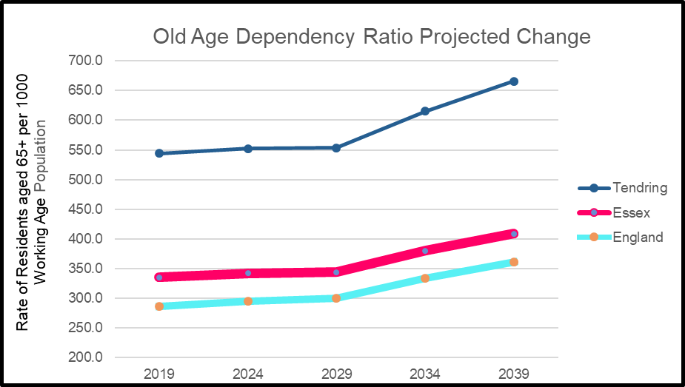

***Ethnicity***

At the time of the 2011 census the population of the Tendring District was majority White British (95.4%) with the remainder (4.6%) of residents coming from Black and Minority Ethnic (BAME) ethnic groups including white non-British residents. The percentage of BAME residents was significantly lower than the averages for both Essex (9.2%) and England (20.3%) and was the (joint) third lowest percentage in the county in 2011.

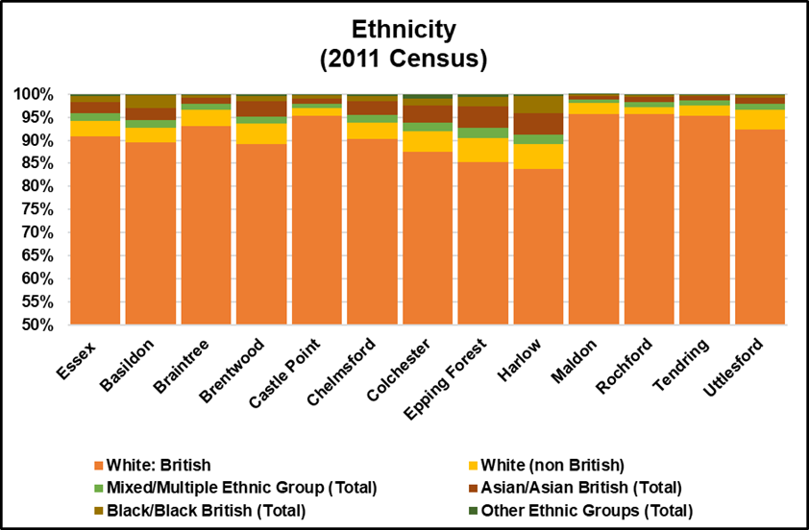

*Researchers note: The Office of National Statistics does not produce modelled estimates or projected figures by ethnic group; as such the only comprehensively available figures are taken from the 2011 Census. Given the age of this data caution is advised when generalising to the current population.*

***Household Composition***

At the time of the 2011 Census there were an estimated 62,105 households in the Tendring District of which 16.9% contained dependent children. This was below the average for Essex (22.8%) and England (21.99%) and the lowest rate in the county.

The percentage of households with married or civil partnership couples (30.7%) was below the average for Essex (36.8%) and England (33.2%) and was the lowest level in the county. By comparison the Tendring District had the highest percentage of single person households (33.1%) in Essex, higher than the Essex (28.4%) and England (30.2%) averages. The number of lone parent households (9.8%) was similar to the average for Essex (9.7%) and England (10.6%).

20,272 households (32.6%) were occupied solely by residents aged 65 and over including 11,540 households (18.6%) where a resident aged 65 and over was living alone. This was higher than the average for Essex (23.2%, 13.1%) and for England (20.7%, 12.4%) and the highest level in Essex.

***Learning Disabilities and Special Educational Needs***

Exact figures for the number of residents with Learning Disabilities are not available however modelled predictions from POPPI/PANSI suggest the level could be around 2747 people of whom 1828 people are aged 18-64 and 919 people are aged 65+. This total is equivalent to 2.3% of the age weighted population and is similar to the levels across England (2.36%) and Essex (2.34%). Of this number it is estimated that a total of 536 (*413 age 18-64; 123 age 65+)* have severe learning disabilities thus may have additional support needs.

*By predicted changes up to 2035 are included in the data tables at the end of this chapter.*

***Impaired Mobility***

Exact figures for the number of people living in an area with a physical impairment are not available, as such for the purposes of the JSNA we will look at a number of proxy measures. For adults aged 18-64 predictions from PANSI (2019) estimate that 4785 people in the area might currently have some form of impaired mobility, 4142 have difficulty in performing personal care tasks, and 273 have a health condition caused by a stroke.

For Adults aged 65+ predictions from POPPI (2019) estimate that 8078 people might be unable to manage one or more mobility task (*such as going out of doors and walking down the road; getting up and down stairs; getting around the house on the level; getting to the toilet; getting in and out of bed),* whilst 10,819 people have their day to day activities limited a lot by their physical health.

***Sensory Impairments***

POPPI / Predictions estimate that there are 4013 people with severe hearing loss of which 3510 people are aged 65+. 50 people aged 18-64 were predicted to have serious visual impairments whilst 3866 people aged 65+ had moderate or severe visual impairment.





***Table 3: Old Age Dependency Ratio***

|  |  |  |  |  |  |  |  |  |  |
| --- | --- | --- | --- | --- | --- | --- | --- | --- | --- |
| **Old Age Dependency Ratio**  **(Rate of residents aged 65 years and over per working age population)** | | | | | | | | | |
|  | **2019** | | **2024** | | **2029** | | **2034** | | **2039** |
| **England** | 286.8 | | 295.1 | | 299.7 | | 334.2 | | 361 |
| **Essex** | 335.6 | | 342.0 | | 343.9 | | 380.4 | | 408.6 |
| Basildon | 272.4 | | 273.2 | | 272.6 | | 298.8 | | 318.3 |
| Braintree | 330.0 | | 348.0 | | 358.2 | | 409.2 | | 448.1 |
| Brentwood | 325.1 | | 322.5 | | 321.6 | | 350.6 | | 368.1 |
| Castle Point | 431.1 | | 438.3 | | 432.9 | | 469.6 | | 496.8 |
| Chelmsford | 307.9 | | 316.8 | | 317.7 | | 347.1 | | 369.9 |
| Colchester | 266.4 | | 265.6 | | 263.1 | | 288.7 | | 310.1 |
| Epping Forest | 311.8 | | 310.2 | | 309.9 | | 340.9 | | 365.9 |
| Harlow | 242.8 | | 248.3 | | 250.0 | | 276.1 | | 294.9 |
| Maldon | 426.6 | | 457.5 | | 471.1 | | 533.8 | | 579.2 |
| Rochford | 385.1 | | 392.1 | | 394.9 | | 438.2 | | 473.1 |
| Tendring | 544.0 | | 552.1 | | 553.3 | | 615.3 | | 665.7 |
| Uttlesford | 327.7 | | 344.9 | | 358.6 | | 408.2 | | 448.4 |
| ***Source: Office of National Statistics Population Projections 2016*** | | | | | | | | | |
|  |  |  | |  | |  | |  | |
|  | | | | | | | | | |

**Table 4: Ethnicity**

|  |  |  |  |  |  |  |  |
| --- | --- | --- | --- | --- | --- | --- | --- |
| **Ethnicity** | | | | | | | |
|  | **White British %** | **% White non British** | **% Mixed/ Multiple Ethnic Group** | **% Asian/ Asian British** | **% Black/ Black British** | **% Other Ethnic Groups** | **Total Percentage of BAME (Inc. white non-British)** |
| **England** | 79.75% | 5.7% | 2.3% | 7.8% | 3.5% | 1.0% | 20.25% |
| **Essex** | 90.8% | 3.5% | 1.5% | 2.5% | 1.3% | 0.4% | 9.24% |
| Basildon | 89.5% | 3.1% | 1.7% | 2.7% | 2.7% | 0.3% | 10.48% |
| Braintree | 93.2% | 3.5% | 1.2% | 1.4% | 0.6% | 0.2% | 6.85% |
| Brentwood | 89.2% | 4.3% | 1.6% | 3.2% | 1.2% | 0.4% | 10.75% |
| Castle Point | 95.4% | 1.5% | 1.0% | 1.1% | 0.8% | 0.2% | 4.62% |
| Chelmsford | 90.3% | 3.6% | 1.6% | 2.9% | 1.2% | 0.4% | 9.70% |
| Colchester | 87.5% | 4.5% | 1.8% | 3.7% | 1.5% | 1.0% | 12.49% |
| Epping Forest | 85.2% | 5.3% | 2.1% | 4.8% | 1.9% | 0.7% | 14.78% |
| Harlow | 83.9% | 5.2% | 2.1% | 4.6% | 3.8% | 0.5% | 16.14% |
| Maldon | 95.8% | 2.3% | 0.8% | 0.8% | 0.2% | 0.1% | 4.25% |
| Rochford | 95.6% | 1.6% | 1.1% | 1.1% | 0.5% | 0.2% | 4.39% |
| Tendring | 95.4% | 2.2% | 1.1% | 0.9% | 0.3% | 0.1% | 4.62% |
| Uttlesford | 92.3% | 4.3% | 1.2% | 1.4% | 0.5% | 0.2% | 7.70% |
| ***Source: Office of National Statistics 2011 Census*** | | | | | | | |

**Table 5: Household Composition**

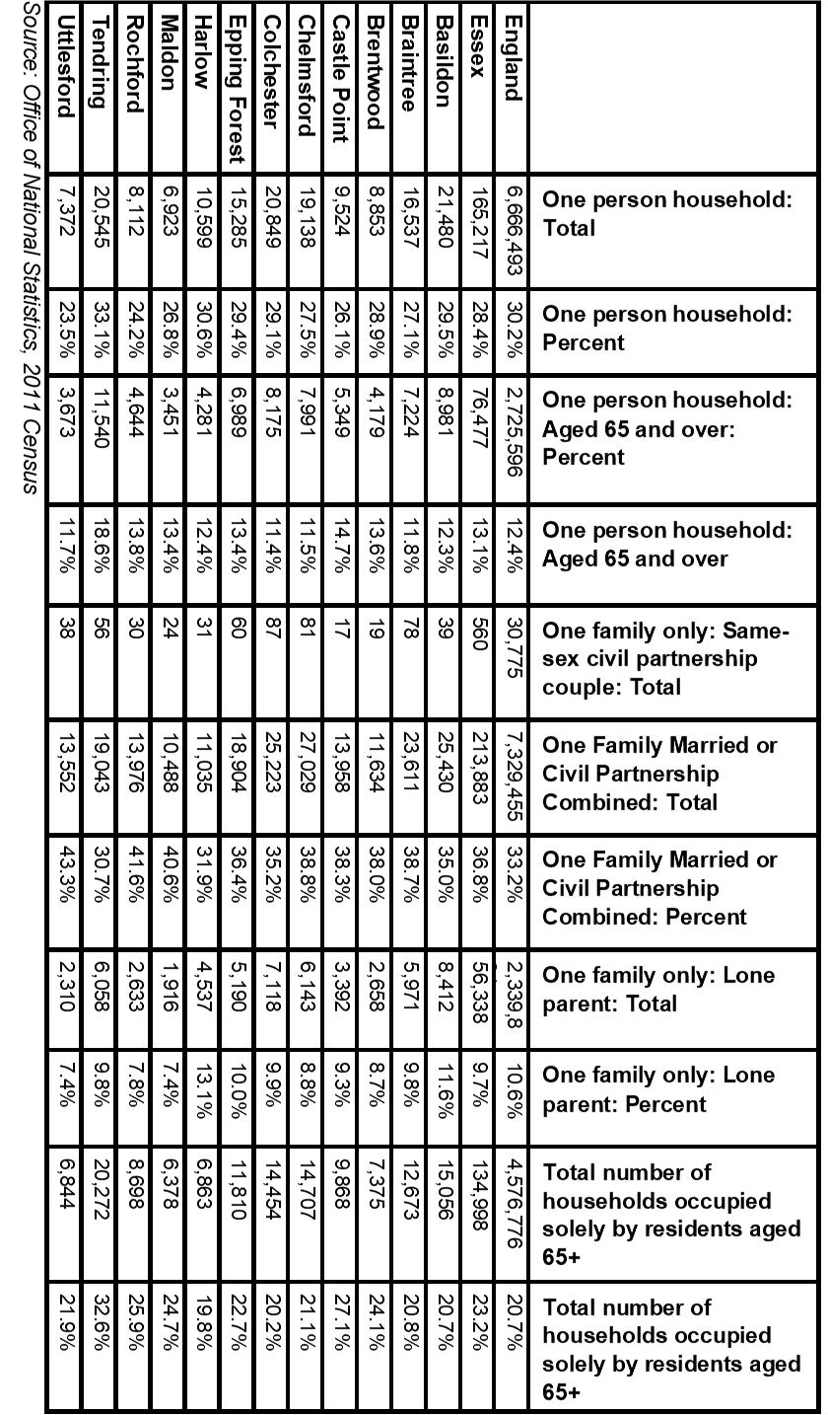

**Table 6: Learning Disability Predictions 2019**

|  |  |  |  |  |  |  |
| --- | --- | --- | --- | --- | --- | --- |
|  | **Number of people predicted to have a learning disability in 2019** | | | | | |
| **Age 18-64** | | **Age 65+** | | **Total Age 18+** | |
| **Number** | **%\*** | **Number** | **%\*** | **Number** | **%\*** |
| **England** | **826834** | **2.44%** | **216362** | **2.09%** | **1043196** | **2.36%** |
| **East of England** | **89212** | **2.43%** | **26011** | **2.09%** | **115223** | **2.34%** |
| **Essex** | **21059** | **2.43%** | **6487** | **2.09%** | **27546** | **2.34%** |
| Basildon | 2740 | 2.43% | 683 | 2.09% | 3423 | 2.36% |
| Braintree | 2164 | 2.42% | 659 | 2.09% | 2823 | 2.34% |
| Brentwood | 1110 | 2.42% | 333 | 2.08% | 1443 | 2.33% |
| Castle Point | 1219 | 2.42% | 486 | 2.09% | 1705 | 2.32% |
| Chelmsford | 2561 | 2.43% | 725 | 2.09% | 3286 | 2.35% |
| Colchester | 2947 | 2.45% | 713 | 2.10% | 3660 | 2.37% |
| Epping Forest | 1914 | 2.43% | 546 | 2.09% | 2460 | 2.34% |
| Harlow | 1276 | 2.44% | 282 | 2.07% | 1558 | 2.36% |
| Maldon | 870 | 2.41% | 344 | 2.11% | 1214 | 2.32% |
| Rochford | 1210 | 2.42% | 429 | 2.09% | 1639 | 2.32% |
| Tendring | 1828 | 2.41% | 919 | 2.09% | 2747 | 2.30% |
| Uttlesford | 1237 | 2.42% | 376 | 2.09% | 1613 | 2.33% |
|  | **Number of people predicted to have a moderate or severe learning disability in 2019** | | | | | |
| **Age 18-64** | | **Age 65+** | | **Total Age 18+** | |
| **Number** | **%\*** | **Number** | **%\*** | **Number** | **%\*** |
| **England** | 188444 | 0.56% | 29128 | 0.28% | 217572 | 0.49% |
| **East of England** | 20343 | 0.55% | 3488 | 0.28% | 23831 | 0.48% |
| **Essex** | 4797 | 0.55% | 870 | 0.28% | 5667 | 0.48% |
| Basildon | 625 | 0.56% | 92 | 0.28% | 717 | 0.49% |
| Braintree | 493 | 0.55% | 89 | 0.28% | 582 | 0.48% |
| Brentwood | 253 | 0.55% | 44 | 0.28% | 297 | 0.48% |
| Castle Point | 277 | 0.55% | 65 | 0.28% | 342 | 0.47% |
| Chelmsford | 585 | 0.56% | 97 | 0.28% | 682 | 0.49% |
| Colchester | 672 | 0.56% | 96 | 0.28% | 768 | 0.50% |
| Epping Forest | 437 | 0.55% | 73 | 0.28% | 510 | 0.49% |
| Harlow | 291 | 0.56% | 38 | 0.28% | 329 | 0.50% |
| Maldon | 197 | 0.55% | 47 | 0.29% | 244 | 0.47% |
| Rochford | 276 | 0.55% | 57 | 0.28% | 333 | 0.47% |
| Tendring | 413 | 0.55% | 123 | 0.28% | 536 | 0.45% |
| Uttlesford | 283 | 0.55% | 50 | 0.28% | 333 | 0.48% |
| *Source POPPI/PANSI 2019* | | | | | | |

***Table 7: Learning Disability Projections***

|  |  |  |  |  |  |  |  |  |
| --- | --- | --- | --- | --- | --- | --- | --- | --- |
| **Predicted Numbers of People with a Learning Disability to 2035** | | | | | | | | |
|  | **2025** | | **2030** | | **2035** | | **Predicted Change 2019-2035** | |
| **18-64** | **65+** | **18-64** | **65+** | **18-64** | **65+** | **18-64** | **65+** |
| **England** | **833689** | **240660** | **839192** | **269064** | **842807** | **296050** | **15973** | **79688** |
| **East of England** | **90564** | **28952** | **91550** | **32438** | **92307** | **35875** | **3095** | **9864** |
| **Essex** | **21467** | **7179** | **21763** | **8011** | **22030** | **8855** | **971** | **2368** |
| Basildon | 2816 | 754 | 2880 | 844 | 2953 | 932 | 213 | 249 |
| Braintree | 2167 | 744 | 2166 | 842 | 2149 | 936 | -15 | 277 |
| Brentwood | 1137 | 354 | 1155 | 397 | 1180 | 433 | 70 | 100 |
| Castle Point | 1217 | 520 | 1221 | 566 | 1230 | 614 | 11 | 128 |
| Chelmsford | 2590 | 797 | 2619 | 881 | 2650 | 958 | 89 | 233 |
| Colchester | 3078 | 784 | 3182 | 877 | 3254 | 976 | 307 | 263 |
| Epping Forest | 1961 | 594 | 1993 | 662 | 2034 | 733 | 120 | 187 |
| Harlow | 1292 | 319 | 1315 | 356 | 1341 | 391 | 65 | 109 |
| Maldon | 853 | 392 | 844 | 434 | 835 | 482 | -35 | 138 |
| Rochford | 1213 | 467 | 1219 | 521 | 1218 | 570 | 8 | 141 |
| Tendring | 1856 | 1017 | 1879 | 1139 | 1893 | 1263 | 65 | 344 |
| Uttlesford | 1268 | 437 | 1283 | 506 | 1299 | 572 | 62 | 196 |
| **Predicted Numbers of People with Moderate or Severe Learning Disabilities to 2035** | | | | | | | | |
|  | **2025** | | **2030** | | **2035** | | **Predicted Change 2019-2035** | |
| **18-64** | **65+** | **18-64** | **65+** | **18-64** | **65+** | **18-64** | **65+** |
| **England** | **190642** | **31818** | **192706** | **35452** | **193757** | **38627** | **5313** | **9499** |
| **East of England** | **20718** | **3802** | **21027** | **4244** | **21222** | **4654** | **879** | **1166** |
| **Essex** | **4906** | **942** | **4994** | **1047** | **5064** | **1150** | **267** | **280** |
| Basildon | 645 | 100 | 663 | 112 | 680 | 123 | 55 | 31 |
| Braintree | 495 | 98 | 496 | 110 | 493 | 121 | 0 | 32 |
| Brentwood | 260 | 46 | 266 | 51 | 272 | 56 | 19 | 12 |
| Castle Point | 277 | 68 | 279 | 73 | 282 | 79 | 5 | 14 |
| Chelmsford | 593 | 104 | 603 | 114 | 610 | 123 | 25 | 26 |
| Colchester | 704 | 103 | 731 | 115 | 749 | 127 | 77 | 31 |
| Epping Forest | 449 | 78 | 458 | 87 | 468 | 95 | 31 | 22 |
| Harlow | 296 | 43 | 303 | 48 | 309 | 51 | 18 | 13 |
| Maldon | 194 | 52 | 192 | 57 | 191 | 63 | -6 | 16 |
| Rochford | 277 | 61 | 279 | 68 | 280 | 74 | 4 | 17 |
| Tendring | 420 | 133 | 428 | 149 | 432 | 164 | 19 | 41 |
| Uttlesford | 290 | 57 | 295 | 66 | 299 | 74 | 16 | 24 |
| *Source POPPI/PANSI 2019* | | | | | | | | |

***Table 8: Physical Impairments***

|  |  |  |  |  |  |  |  |  |
| --- | --- | --- | --- | --- | --- | --- | --- | --- |
| **The number of people aged 18-64 predicted to have a physical impairment in 2019** | | | | | | | | |
|  | **Impaired Mobility** | | **Any moderate or severe personal care disability** | | **A longstanding health condition caused by a stroke** | | **Combined Total** | |
| **Number** | **%\*** | **Number** | **%\*** | **Number** | **%\*** | **Number** | **%\*** |
| **Essex** | **48922** | **5.23%** | **43109** | **4.61%** | **2817** | **0.30%** | **94848** | **10.13%** |
| **Basildon** | **6079** | **4.97%** | **5385** | **4.40%** | **345** | **0.28%** | **11809** | **9.66%** |
| Braintree | 5149 | 5.41% | 4540 | 4.77% | 300 | 0.32% | 9989 | 10.49% |
| Brentwood | 2618 | 5.27% | 2307 | 4.65% | 151 | 0.30% | 5076 | 10.23% |
| Castle Point | 2969 | 5.54% | 2604 | 4.86% | 172 | 0.32% | 5745 | 10.73% |
| Chelmsford | 5814 | 5.16% | 5139 | 4.56% | 334 | 0.30% | 11287 | 10.01% |
| Colchester | 5953 | 4.53% | 5328 | 4.06% | 338 | 0.26% | 11619 | 8.85% |
| Epping Forest | 4467 | 5.24% | 3937 | 4.62% | 256 | 0.30% | 8660 | 10.16% |
| Harlow | 2786 | 4.95% | 2461 | 4.38% | 155 | 0.28% | 5402 | 9.61% |
| Maldon | 2282 | 6.02% | 1991 | 5.25% | 135 | 0.36% | 4408 | 11.63% |
| Rochford | 2967 | 5.56% | 2604 | 4.88% | 172 | 0.32% | 5743 | 10.76% |
| Tendring | 4785 | 5.80% | 4142 | 5.02% | 273 | 0.33% | 9200 | 11.16% |
| Uttlesford | 3089 | 5.51% | 2710 | 4.83% | 181 | 0.32% | 5980 | 10.66% |
| *Percentage of the total population aged 18-64 based on 2019 population projections | | | | | | | | |

|  |  |  |  |  |  |  |
| --- | --- | --- | --- | --- | --- | --- |
|  | **The number of Adults aged 65 and over with long term limiting conditions or restricted mobility** | | | | | |
| **Day-to-day activities are limited a little** | | **Day-to-day activities are limited a lot** | | **Unable to manage at least one mobility** activity on their own** | |
| **Number** | **%** | **Number** | **%** | **Number** | **%** |
| Essex | 76314 | 24.6% | 66662 | 21.5% | 57212 | 18.4% |
| Basildon | 8044 | 24.6% | 8043 | 24.6% | 6058 | 18.5% |
| Braintree | 7669 | 24.3% | 6309 | 20.0% | 5676 | 18.0% |
| Brentwood | 3793 | 23.7% | 3020 | 18.9% | 3147 | 19.7% |
| Castle Point | 5593 | 24.1% | 5482 | 23.6% | 4180 | 18.0% |
| Chelmsford | 8433 | 24.3% | 6379 | 18.4% | 6387 | 18.4% |
| Colchester | 8386 | 24.7% | 7079 | 20.8% | 6142 | 18.1% |
| Epping Forest | 6265 | 24.0% | 5398 | 20.7% | 5017 | 19.2% |
| Harlow | 3465 | 25.5% | 3615 | 26.6% | 2625 | 19.3% |
| Maldon | 3909 | 24.0% | 3237 | 19.9% | 2893 | 17.7% |
| Rochford | 5259 | 25.7% | 4198 | 20.5% | 3727 | 18.2% |
| Tendring | 11449 | 26.1% | 10819 | 24.6% | 8078 | 18.4% |
| Uttlesford | 4309 | 23.9% | 3242 | 18.0% | 3358 | 18.7% |
| *\*\*Activities include: going out of doors and walking down the road; getting up and down stairs; getting around the house on the level; getting to the toilet; getting in and out of bed* | | | | | | |
| *Source POPPI/PANSI 2019* | | | | | | |

***Table 9: Sensory Impairments***

|  |  |  |  |  |  |  |
| --- | --- | --- | --- | --- | --- | --- |
|  | **Severe Hearing Loss** | | | **Visual Impairments** | | |
| **Visual Impairments Total** | **Serious Visual Impairments in people age 18-64** | **Moderate or Severe Visual Impairments in People age 65+** |
| **Total 18 and over** | **18-64** | **65+** |
| Essex | 30503 | 5272 | 25231 | 27745 | 564 | 27181 |
| Basildon | 3309 | 659 | 2651 | 2925 | 74 | 2851 |
| Braintree | 3074 | 562 | 2511 | 2775 | 59 | 2716 |
| Brentwood | 1718 | 285 | 1433 | 1475 | 29 | 1446 |
| Castle Point | 2154 | 317 | 1837 | 2059 | 32 | 2027 |
| Chelmsford | 3496 | 632 | 2864 | 3113 | 68 | 3045 |
| Colchester | 3293 | 631 | 2663 | 3022 | 78 | 2944 |
| Epping Forest | 2757 | 487 | 2269 | 2364 | 52 | 2312 |
| Harlow | 1487 | 310 | 1177 | 1238 | 34 | 1204 |
| Maldon | 1471 | 245 | 1227 | 1418 | 23 | 1395 |
| Rochford | 1956 | 310 | 1645 | 1827 | 33 | 1794 |
| Tendring | 4013 | 503 | 3510 | 3916 | 50 | 3866 |
| Uttlesford | 1775 | 331 | 1443 | 1613 | 33 | 1580 |
| *Source POPPI/PANSI 2019* | | | | | | |

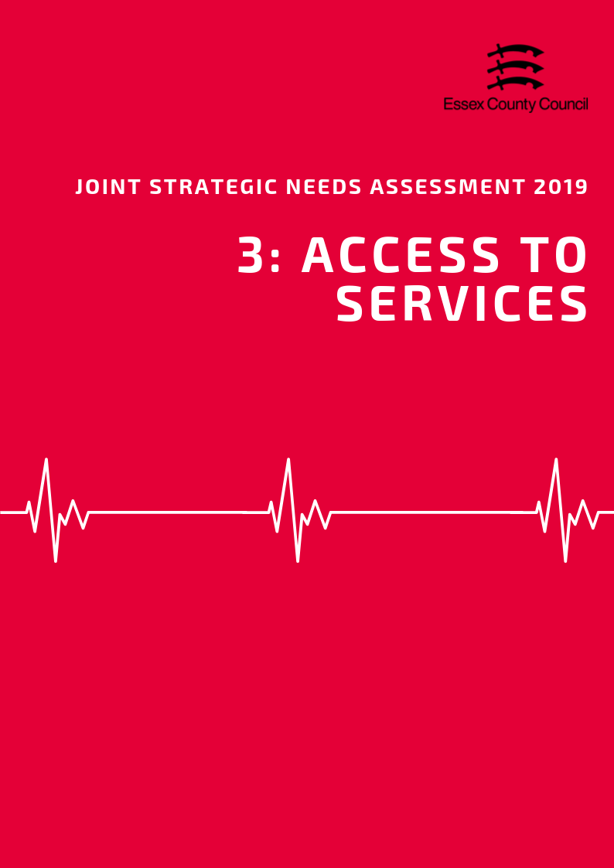

**ACCESS TO SERVICES**

**Area**

Covering an area of approximately 338 square kilometres, the Tendring District is the fifth largest local authority in Essex in terms of area. It is classed statistically as predominantly rural with residents spread across a number of locations including the towns of Clacton, Frinton & Walton, Harwich.

***Population Density***

With an estimated 428 residents per square kilometre, the Tendring District is the eighth (out of 12) most densely populated area in Essex, well roughly in line with the county average (424 people per sq. km).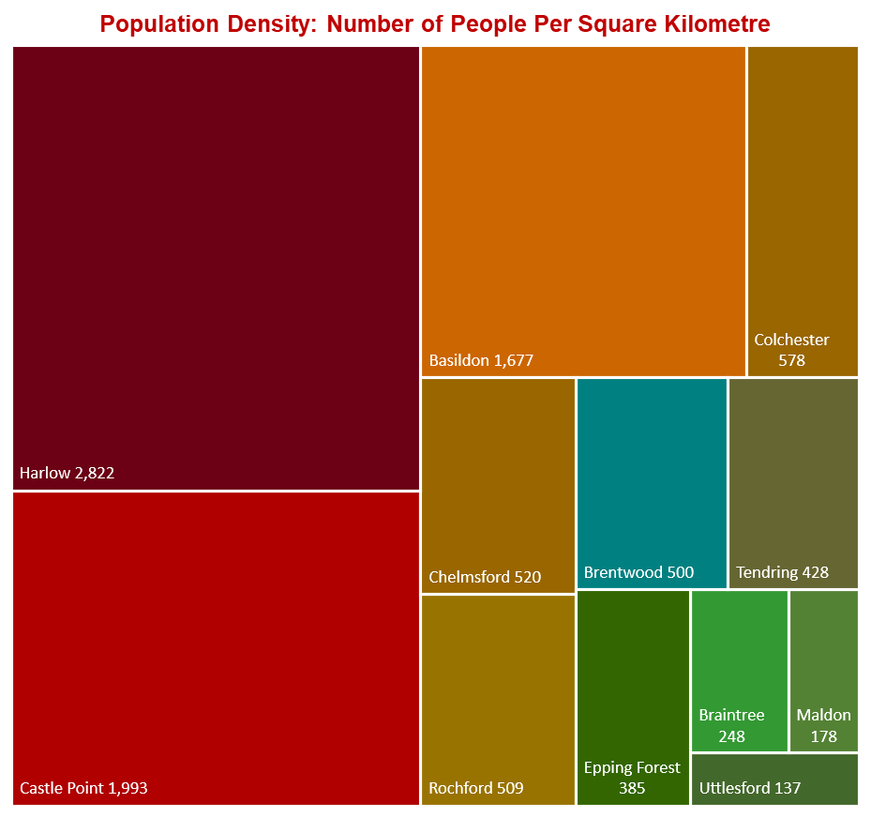

***Travel Time to Key Services***

According to the Department for Transport, Tendring residents have the third highest travel times to local services compared to the Essex average (19.4 minutes), with an average of 21.5 minutes by walking or public transport to 8 key services. Looking at times to health services, average times to GP surgeries were estimated at 10.2 minutes just below the Essex average (11.6 minutes); whilst the average time to hospital was 64.3 minutes, 19 minutes higher than the county average. Access to a car reduced these travel times significantly to 7.6 minutes for GP surgeries and 31.8 minutes to hospitals, although times to hospitals remained the second highest in the county.

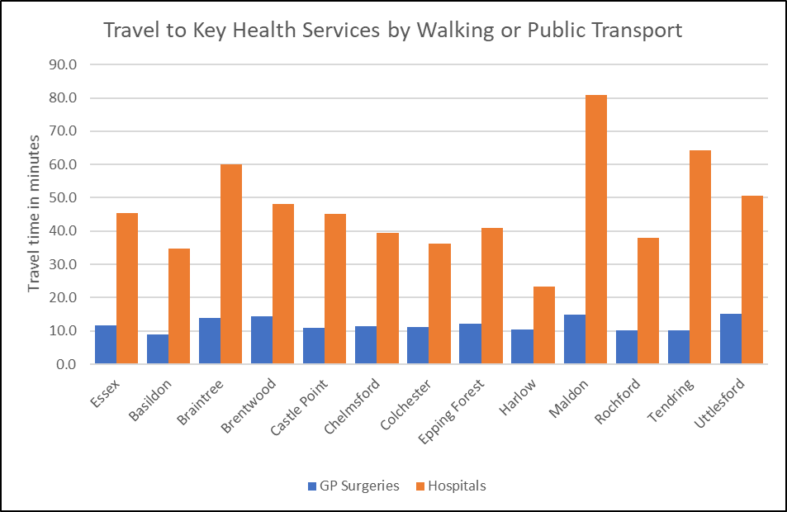

***Source: Department for Transport***

*See table at the end of this chapter for average travel times to all service types.*

***Satisfaction with GP Services***

Information about satisfaction with GP services from the GP Patient Survey are only available at CCG level so it is not possible to present views of Tendring residents in isolation. According to data from the 2018 survey, 79.1% of patients in the North East Essex CCG reported a positive experience of their GP practice. This lower than the average for both England (83.75%) and the NHS Eastern Region (83.3%) but is in line with the combined average for all CCGs in Essex (80.35%).

|  |  |  |
| --- | --- | --- |
| **The percentage of patients aged 16+ who have a positive experience of their GP practice** | **Time period** | **%** |
| **England** | **2018** | **83.8** |
| **East NHS region** | **2018** | **83.3** |
| NHS Basildon And Brentwood CCG | 2018 | 80.6 |
| NHS Castle Point and Rochford CCG | 2018 | 82.8 |
| NHS Mid Essex CCG | 2018 | 79.2 |
| NHS North East Essex CCG | 2018 | 79.1 |
| NHS Southend CCG | 2018 | 80.1 |
| NHS Thurrock CCG | 2018 | 76.0 |
| NHS West Essex CCG | 2018 | 80.2 |

*Source: GP Patient Survey 2018*

***Carers***

The exact number of residents providing informal or unpaid care to friends or family members is not known, however figures from the Department for Work and Pensions identified 2800 residents who had been in receipt of Carers Allowance benefits in November 2018.The largest numbers of claimants were in 55-64 age group. Women were more likely to be in receipt of carers allowance (2010 / 71.5%) compared to Men however this rate was lower than the levels across Essex as a whole (77.4%).

|  |  |  |  |  |  |  |  |  |  |  |  |  |  |
| --- | --- | --- | --- | --- | --- | --- | --- | --- | --- | --- | --- | --- | --- |
|  | **Number of people in receipt of carers allowance by age Group – November 2018** | | | | | | | | | | | | |
| **Total** | | **under 18** | | **18-24** | **25-34** | | **35-44** | | **45-54** | **55-64** | | **65+** |
| **Essex** | **16,620** | | **30** | | **580** | **2,940** | | **4,020** | | **4,410** | **4,410** | | **230** |
| Basildon | 2,690 | | 10 | | 120 | 530 | | 710 | | 670 | 630 | | 30 |
| Braintree | 1,750 | |  | | 40 | 350 | | 430 | | 460 | 430 | | 20 |
| Brentwood | 540 | |  | | 20 | 70 | | 120 | | 160 | 150 | | ~ |
| Castle Point | 1,110 | |  | | 40 | 160 | | 220 | | 310 | 350 | | 20 |
| Chelmsford | 1,500 | |  | | 50 | 260 | | 400 | | 400 | 360 | | 20 |
| Colchester | 1,990 | | 10 | | 80 | 390 | | 500 | | 520 | 450 | | 30 |
| Epping Forest | 1,170 | |  | | 40 | 170 | | 280 | | 320 | 340 | | 20 |
| Harlow | 1,100 | |  | | 40 | 220 | | 300 | | 260 | 260 | | 10 |
| Maldon | 720 | |  | | 10 | 130 | | 170 | | 200 | 210 | | 10 |
| Rochford | 770 | |  | | 20 | 80 | | 190 | | 230 | 250 | | 10 |
| Tendring | 2,800 | |  | | 100 | 490 | | 610 | | 720 | 830 | | 40 |
| Uttlesford | 480 | |  | | 10 | 80 | | 90 | | 140 | 130 | | 10 |
|  | | **Number of people in receipt of carers allowance by Gender –November 2018** | | | | | | | | | | | |
| **All Claimants** | | **Male** | | | | | **Female** | | | | |
|  | | **Number** | | **Number** | | | **%** | | **Number** | | | **%** | |
| **Essex** | | **16,620** | | **3,760** | | | **22.6%** | | **12,860** | | | **77.4%** | |
| Basildon | | 2,690 | | 610 | | | 22.7% | | 2,080 | | | 77.3% | |
| Braintree | | 1,750 | | 390 | | | 22.3% | | 1,360 | | | 77.7% | |
| Brentwood | | 540 | | 100 | | | 18.5% | | 440 | | | 81.5% | |
| Castle Point | | 1,110 | | 230 | | | 20.7% | | 880 | | | 79.3% | |
| Chelmsford | | 1,510 | | 310 | | | 20.5% | | 1,200 | | | 79.5% | |
| Colchester | | 1,990 | | 430 | | | 21.6% | | 1,560 | | | 78.4% | |
| Epping Forest | | 1,170 | | 260 | | | 22.2% | | 910 | | | 77.8% | |
| Harlow | | 1,100 | | 230 | | | 20.9% | | 870 | | | 79.1% | |
| Maldon | | 720 | | 140 | | | 19.4% | | 580 | | | 80.6% | |
| Rochford | | 770 | | 160 | | | 20.8% | | 610 | | | 79.2% | |
| Tendring | | 2,810 | | 800 | | | 28.5% | | 2,010 | | | 71.5% | |
| Uttlesford | | 480 | | 100 | | | 20.8% | | 380 | | | 79.2% | |
| *Source: Department of Work and Pensions 2019* | | | | | | | | | | | | | |

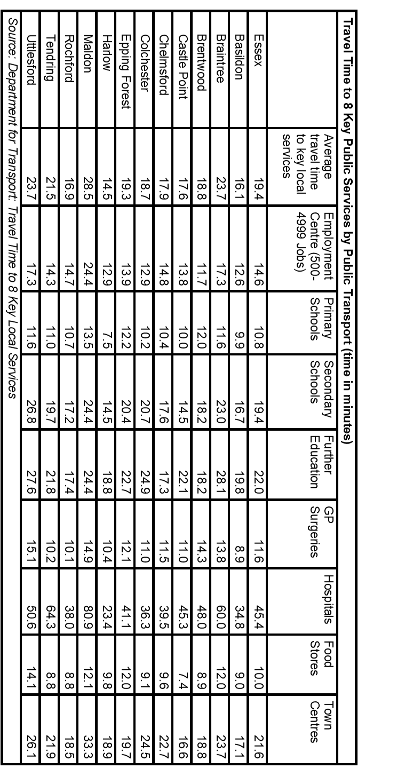

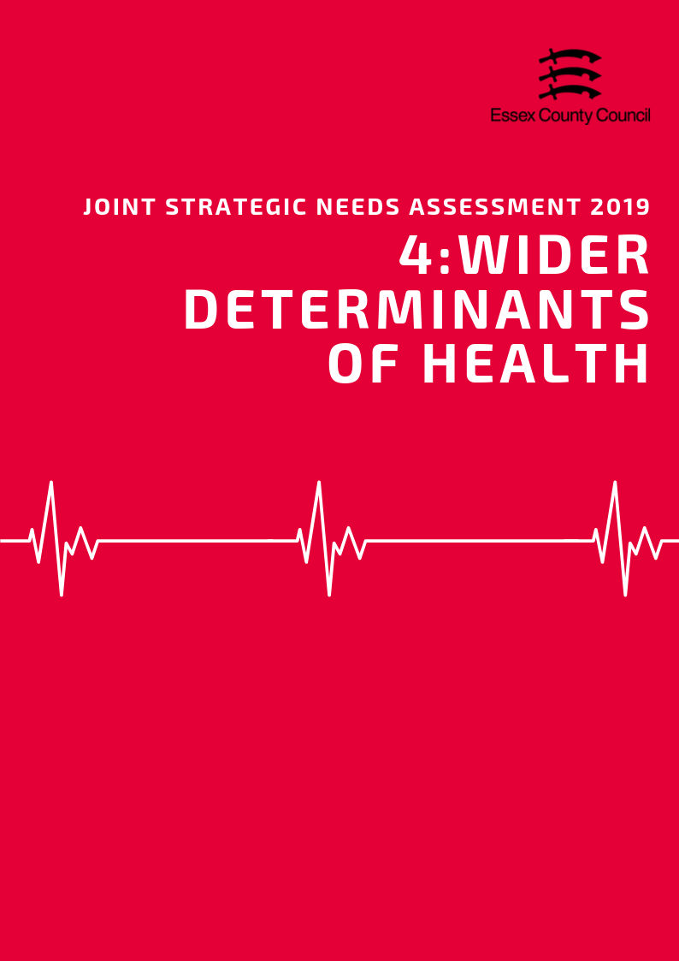

**Wider Determinants of Health**

***“Wider determinants, also known as social determinants, are a diverse range of social, economic and environmental factors which impact on people’s health. Such factors are influenced by the local, national and international distribution of power and resources which shape the conditions of daily life. They determine the extent to which different individuals have the physical, social and personal resources to identify and achieve goals, meet their needs and deal with changes to their circumstances.” Public Health England 2019***

***Income & Average Earnings***

The average weekly income for a Tendring resident working full time in 2018 was £543.90, £74.70 (-13.7%) below than the average for Essex and £31 (-5.7%) less than the average for England. This was the second lowest average income out of 12 Districts. Part time workers earned an average of £148 per week, 23% below the Essex average, 26.5% lower than the average for England, and was the lowest average income in the county.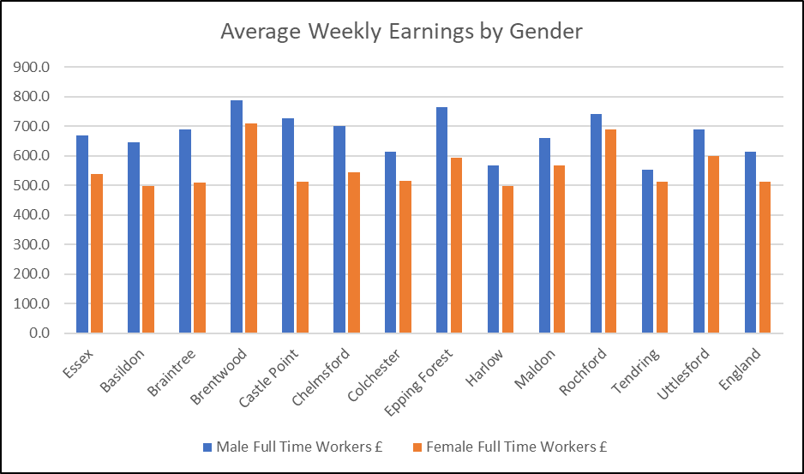

Male residents generally earned £41.10 (7.44%) more per week than females with an average weekly pay of £552.70 for male full time workers compared to £511.60 for females. This was below the average income difference for England (16.7%) and was second lowest average difference in percentage in Essex.

***Deprivation***

In the Indices of Multiple Deprivation 2019 the Tendring Local Authority area was ranked 32 out of 317 lower tier authorities in England based on the average rank of the LSOAs in this area (where 1= most deprived). This places Tendring in the bottom 10% of most deprived Lower Tier Local Authorities (LTLAs) nationally for the first time. Compared to the other local authority areas in Essex, Tendring is ranked as the most deprived area out of 12 districts in the county for overall deprivation and is the only area in Essex which fall into the 10% of most deprived areas nationally.

*See the Essex 2019 Indices of Deprivation report for a full analysis of the latest English Indices of deprivation data for each district.*

***Fuel Poverty***

Figures from 2016 estimate that 6,947 households the Tendring area were classed as fuel poor. This is equivalent to 10.6% of the total number of households in the area which was higher than the average for Essex (8.6%) but lower than England (11.1%) and was the highest level in the county.



***Child Poverty***

6255 children and young people (23% living in the area) are recorded as being in low income households either in receipt of Child Tax Credits, Income Support or Job Seeker Allowance. This is the highest rate in Essex and 6.4% higher than the rate for England (16.6%). It is also estimated that 3056 pupils (16.9%) were eligible for free-school meals at the time of the last school census, this is again the highest rate in the county and above the average for Essex (9.87%) and for England (13.4%).

|  |  |  |  |  |  |  |
| --- | --- | --- | --- | --- | --- | --- |
| **Children in families in receipt of CTC (<60% median income) or IS/JSA** | | | | | | |
|  | *Total number of children where the youngest child is aged:* | | | | *Total Number of Children in low income households* | *% of All Children* |
| *0 - 4* | *5 - 10* | *11 - 15* | *16 - 19* |
| ***Basildon*** | 4,075 | 2,240 | 985 | 370 | 7,670 | 18.2% |
| ***Braintree*** | 1,950 | 1,010 | 575 | 215 | 3,750 | 11.7% |
| ***Brentwood*** | 695 | 335 | 205 | 80 | 1,315 | 9.0% |
| ***Castle Point*** | 1,250 | 680 | 380 | 120 | 2,430 | 14.1% |
| ***Chelmsford*** | 1,900 | 1,030 | 565 | 195 | 3,690 | 10.6% |
| ***Colchester*** | 2,985 | 1,510 | 630 | 230 | 5,355 | 14.0% |
| ***Epping Forest*** | 1,595 | 940 | 475 | 205 | 3,215 | 12.0% |
| ***Harlow*** | 2,040 | 995 | 420 | 175 | 3,630 | 16.6% |
| ***Maldon*** | 645 | 380 | 230 | 80 | 1,335 | 11.1% |
| ***Rochford*** | 755 | 455 | 230 | 120 | 1,560 | 9.6% |
| ***Tendring*** | 3,250 | 1,755 | 890 | 360 | 6,255 | 23.0% |
| ***Uttlesford*** | 545 | 345 | 190 | 80 | 1,160 | 6.6% |
| ***Essex Total*** | ***21,685*** | ***11,675*** | ***5,775*** | ***2,230*** | ***41,365*** | ***13.0%*** |
| ***England*** | ***1,016,710*** | ***530,585*** | ***270,235*** | ***111,760*** | ***1,929,290*** | ***16.6%*** |

Department for Education performance tables estimate that in 2017/18 there were 3056 pupils (16.9%) who were eligible for free school meals in the area. This was higher than the average for Essex (9.9%) or England (13.9%) and was the highest level in the county.



***Education & Skills***

*Adult Qualifications*

34.3% of Tendring residents aged 16+ had no formal qualifications at the time of the 2011 Census, 10.4% higher than the average for Essex (23.9%) and 11.8% higher than the average for England (22.5%). Tendring residents also achieved lower than the national average of NVQ level four qualifications (certificate of higher education) or higher (Batchelors Degree and above) with 15.9% of residents gaining this level of qualification compared to an average of 23% for the whole of Essex and 27.4% at the England level. These are the highest and second lowest levels in Essex respectively.

*Levels for all districts in the Essex County Council area along with averages for the county, East of England and England are set out in the table below.*

|  |  |  |  |  |
| --- | --- | --- | --- | --- |
| ***Area*** | ***Number of adult residents with no qualifications*** | ***% of adult residents with no qualifications*** | ***Number of adult residents with Level 4 qualifications and above*** | ***% of adult residents with Level 4 qualifications and above*** |
| **Basildon** | 37084 | 26.64% | 25939 | 18.63% |
| **Braintree** | 26958 | 22.83% | 26212 | 22.20% |
| **Brentwood** | 11651 | 19.38% | 18441 | 30.68% |
| **Castle Point** | 21885 | 29.92% | 10693 | 14.62% |
| **Chelmsford** | 25844 | 18.86% | 39452 | 28.80% |
| **Colchester** | 27440 | 19.40% | 38412 | 27.16% |
| **Epping Forest** | 24360 | 23.95% | 25769 | 25.34% |
| **Harlow** | 16948 | 26.05% | 11468 | 17.63% |
| **Maldon** | 11749 | 23.13% | 12009 | 23.64% |
| **Rochford** | 16134 | 23.63% | 13659 | 20.01% |
| **Tendring** | 39616 | 34.30% | 18340 | 15.88% |
| **Uttlesford** | 11232 | 17.72% | 20251 | 31.94% |
| **Essex** | 270901 | 23.89% | 260645 | 22.99% |
| **England** | 9656810 | 22.46% | 11769361 | 27.38% |
| **East of England** | 1067449 | 22.53% | 1218862 | 25.72% |

*Early Years*

***Achieving at least the expected level across all early learning goals***

*Children achieving at least the expected level across all early learning goals (ELGs) are those achieving ‘expected’ or ‘exceeded’ in all 17 ELGs.*

In Tendring the percentage of children achieving a good level of development has generally improved since 2015 with 70% of children achieving a good level of development in 2018, an increase of 4% compared to 2015. The 2018 level was below the average for Essex (72.1) and England (71.5%), and was no change compared to 2017. A similar trend was seen in the percentage of children achieving at least the expected level across all early learning goals. This has also increased to 70% in 2018, up by 6% compared to 2015 and 3% on the previous year. This similar to the averages for Essex (70.7%) and England (70.2%), but had the lowest pupil attainment in Essex for both measures.

***Good level of development (GLD)***

*Children achieving a good level of development are those achieving at least the expected level within the following areas of learning: communication and language; physical development; personal, social and emotional development; literacy and mathematics.*

*Levels for all districts in the Essex County Council area along with averages for the county, East of England and England are set out in the table below.*

|  |  |  |  |  |  |  |  |  |  |  |  |
| --- | --- | --- | --- | --- | --- | --- | --- | --- | --- | --- | --- |
|  | **2015** | | **2016** | | **2017** | | **2018** | |  | **Change 2015-2018** | |
| **Area of Pupil Residence** | ***% of ELG*** | ***% of GLD*** | ***% of ELG*** | ***% of GLD*** | ***% of ELG*** | ***% of GLD*** | ***% of ELG*** | ***% of GLD*** |  | *% of ELG* | *% of GLD* |
| **Basildon** | 65 | 67 | 70 | 71 | 70 | 71 | 72.0 | 73.0 | 2.0 | 6.0 |
| **Braintree** | 63 | 65 | 71 | 72 | 72 | 74 | 72.0 | 73.0 | 9.0 | 8.0 |
| **Brentwood** | 70 | 71 | 73 | 75 | 77 | 78 | 76.0 | 77.0 | 6.0 | 6.0 |
| **Castle Point** | 61 | 65 | 70 | 72 | 70 | 73 | 73.0 | 74.0 | 12.0 | 9.0 |
| **Chelmsford** | 68 | 70 | 73 | 73 | 74 | 75 | 74.0 | 75.0 | 6.0 | 5.0 |
| **Colchester** | 64 | 66 | 68 | 70 | 71 | 72 | 73.0 | 73.0 | 9.0 | 7.0 |
| **Epping Forest** | 67 | 69 | 69 | 70 | 72 | 73 | 73.0 | 73.0 | 6.0 | 4.0 |
| **Harlow** | 65 | 66 | 69 | 71 | 69 | 72 | 71.0 | 72.0 | 6.0 | 6.0 |
| **Maldon** | 70 | 72 | 73 | 74 | 74 | 75 | 75.0 | 76.0 | 5.0 | 4.0 |
| **Rochford** | 70 | 72 | 73 | 74 | 76 | 77 | 77.0 | 79.0 | 7.0 | 7.0 |
| **Tendring** | 64 | 66 | 66 | 67 | 67 | 70 | 70.0 | 70.0 | 6.0 | 4.0 |
| **Uttlesford** | 72 | 73 | 78 | 79 | 76 | 77 | 76.0 | 77.0 | 4.0 | 4.0 |
| **Essex** | 65.8 | 67.7 | 70.5 | 71.9 | 72.1 | 73.5 | 70.7 | 72.1 | 4.9 | 4.4 |
| **England** | 64.1 | 66.3 | 67.3 | 69.3 | 69.0 | 70.7 | 70.2 | 71.5 | 6.1 | 5.2 |
| **East of England** | 64.6 | 66.6 | 67.8 | 69.7 | 69.4 | 71.3 | 73.0 | 73.8 | 8.4 | 7.2 |
| *% of ELG = % of pupils achieving at least the expected standard in all Early Learning Goals* | | | | | | | | | | | |
| *% of GLD = % of pupils achieving a Good Level of Development at the Early Years foundation Stage* | | | | | | | | | | | |

*GCSE Attainment*

***Attainment 8***

*Attainment 8 measures a student's average grade across eight subjects across the following three groups:*

***English and maths:*** *(double-weighted)*

***English Baccalaureate (Ebacc):*** *the highest scores from the sciences, computer science, geography, history and languages.*

***Open group:*** *Any remaining GCSEs and other approved academic, arts or vocational qualifications.*

Since the introduction of the new GCSE grading system, pupil performance in Tendring has fallen with 47.2% of pupils achieving grade 9-4 in English and Maths (a good pass) and 26.5% achieving grade 9-5 (a strong pass) in 2018. This is significantly lower than the averages for England (59.1%, 39.9%) and Essex (63.3%, 40.7%), and are the lowest levels in the county in 2018. Compared to scores for 2017 this is reduction attainment rates for both measures (-4.9%, -5.4%), the second largest percentage point drop in Essex. Longer term comparisons are not possible due to changes in the grading system.

Looking at the pupils' Attainment 8 score provides a slightly longer term comparison of performance and shows that overall performance has fallen 5.9% down from 45.8% in 2016 to 39.9% in 2018. These figures are signifcantly lower than the average for England (48.5, 44.5) and Essex (50.4, 46.1), and were the lowest scores in the county in 2018. The downward trend in performance for is steeper than the trend observed at across England since the introducation of the new GCSE grading system which has seen a 4% reduction in average attainment 8 scores between 2016 and 2018.

|  |  |  |  |  |  |  |  |
| --- | --- | --- | --- | --- | --- | --- | --- |
| **Area** | 2017 | | | 2018 | | | Average Attainment 8 Score 2017-2018 Change |
| % of pupils who achieved grade 9-5 in English and Maths | % of pupils who achieved grade 9-4 in English and Maths | Average Attainment 8 Score | % of pupils who achieved grade 9-5 in English and Maths | % of pupils who achieved grade 9-4 in English and Maths | Average Attainment 8 Score |
| **Basildon** | 41.4 | 63.4 | 46.4 | 40.7 | 62.6 | 45.3 | -4.0 |
| **Braintree** | 40.4 | 63.6 | 45.2 | 39 | 63 | 45.5 | -4.0 |
| **Brentwood** | 56.5 | 79.3 | 51.0 | 56.2 | 76.8 | 52.6 | -1.5 |
| **Castle Point** | 39.2 | 64.2 | 45.6 | 41.9 | 65.6 | 45 | -4.7 |
| **Chelmsford** | 49.5 | 72.2 | 50.4 | 49.5 | 72 | 50.9 | -3.1 |
| **Colchester** | 46.9 | 66.7 | 47.6 | 43.6 | 65.3 | 48 | -3.6 |
| **Epping Forest** | 43.8 | 66.8 | 47.8 | 45 | 67.8 | 46.9 | -4.3 |
| **Harlow** | 36.5 | 59.8 | 44.1 | 38.3 | 59.6 | 42.8 | -5.4 |
| **Maldon** | 42.4 | 62.4 | 47.0 | 39 | 62.8 | 47 | -5.8 |
| **Rochford** | 47.5 | 70.5 | 47.9 | 41.5 | 63.1 | 46.3 | -4.7 |
| **Tendring** | 31.9 | 52.0 | 41.6 | 26.5 | 47.2 | 39.9 | -5.9 |
| **Uttlesford** | 51.6 | 74.9 | 51.5 | 50.1 | 71.1 | 51.8 | -3.1 |
| **Essex** | 42.4 | 64.9 | 46.7 | 40.7 | 63.3 | 46.1 | -4.3 |
| **East of England** | 43.5 | 65.4 | **46.7** | 43.7 | 65.2 | 47 | -3.4 |
| **England** | 39.1 | 58.5 | 44.6 | 39.9 | 59.1 | 44.5 | -4.0 |

*Destinations of School Leavers*

In 2017 92% of pupils in Tendring were in sustained Education, Employment or Training at the end of Key stage 4 (Secondary School), below the average for England (94%) and Essex (95%). Within this group 82% were in education, again lower than with the county and England averages (86%) and the (joint) lowest level in Essex. A further 5% were in apprenticeships, whilst another 6% were in employment. At this stage 7% of young people were not in any form of sustained education, employment or training, just above to the national and county average (5%).

After Key Stage 5 (Further Education) the number of young people in sustained education employment or training reduced to 87%. Of this cohort, 51% were believed to be in Education including 41% in Higher Education, the (joint) third lowest rate in the county. The rate of young people attending university was 9% lower than the national average (50%) and 5% below the average for Essex (46%). The next largest destination was sustained employment accounting for approximately 28% of the cohort, higher than the England (22%) and Essex (26%) averages. 8% were in apprenticeships, in line with the average for Essex (8%). 9% were not in any form of sustained education, training or employment, higher than the rate for Essex (7%) and the (joint) highest Level in the county.

|  |  |  |  |  |  |  |
| --- | --- | --- | --- | --- | --- | --- |
| ***Percentage of pupils with destinations sustained for at least two terms post KS4 in 2016/17:*** | | | | | | |
| **Area** | Any sustained education or employment | Any sustained education destination | Sustained apprenticeships | Sustained employment destination | Destination not sustained | Activity not captured in the data |
| **ENGLAND\*** | **94** | **86** | **5** | **3** | **5** | **1** |
| **EAST** | **95** | **87** | **4** | **3** | **5** | **1** |
| **Essex** | **95** | **86** | **5** | **4** | **5** | **1** |
| Basildon | 93 | 82 | 5 | 5 | 7 | 1 |
| Braintree | 94 | 85 | 5 | 5 | 5 | 1 |
| Brentwood | 96 | 90 | 3 | 2 | 3 | 2 |
| Castle Point | 94 | 83 | 8 | 3 | 5 | 1 |
| Chelmsford | 96 | 89 | 4 | 3 | 4 | 0 |
| Colchester | 95 | 87 | 4 | 4 | 5 | 1 |
| Epping Forest | 95 | 88 | 5 | 2 | 4 | x |
| Harlow | 95 | 88 | 4 | 3 | 3 | 2 |
| Maldon | 96 | 85 | 6 | 5 | 3 | x |
| Rochford | 95 | 86 | 7 | 3 | 4 | 2 |
| Tendring | 92 | 82 | 5 | 6 | 7 | 1 |
| Uttlesford | 94 | 87 | 5 | 3 | 5 | 0 |
| * State-funded schools (mainstream and special)  x Data not available  *NB: England figures may not add to 100% due to rounding* | | | | | | |

|  |  |  |  |  |  |  |
| --- | --- | --- | --- | --- | --- | --- |
| ***Percentage of pupils with destinations sustained for at least two terms post KS5 in 2016/17:*** | | | | | | |
| **Area** | Any sustained education destination | Higher education (level 4 and above) | Sustained apprenticeships | Sustained employment destination | Destination not sustained | Activity not captured in the data |
| **ENGLAND\*** | **61** | **50** | **6** | **22** | **8** | **4** |
| **EAST** | **58** | **49** | **7** | **25** | **7** | **3** |
| **Essex** | **56** | **46** | **8** | **26** | **7** | **3** |
| Basildon | 50 | 40 | 11 | 28 | 9 | 3 |
| Braintree | 53 | 42 | 7 | 30 | 6 | 4 |
| Brentwood | 58 | 52 | 10 | 21 | 8 | 3 |
| Castle Point | 45 | 32 | 10 | 32 | 9 | 4 |
| Chelmsford | 60 | 54 | 7 | 25 | 5 | 2 |
| Colchester | 62 | 48 | 4 | 24 | 7 | 3 |
| Epping Forest | 59 | 47 | 8 | 22 | 8 | 4 |
| Harlow | 52 | 39 | 7 | 32 | 9 | 1 |
| Maldon | 50 | 41 | 9 | 32 | 5 | 3 |
| Rochford | 47 | 39 | 12 | 30 | 9 | 3 |
| Tendring | 51 | 41 | 8 | 28 | 9 | 4 |
| Uttlesford | 61 | 52 | 5 | 26 | 6 | 2 |
| * State-funded schools (mainstream and special)  x Data not available  *NB: England figures may not add to 100% due to rounding* | | | | | | |

***Employment and Economic Activity***

76.6% of residents (62,700 people) aged 16-64 in Tendring are economically active, 4.2% lower than the average for Essex (80.8%) and 2.1% lower than England (78.7%). This is the third lowest rate of economic activity in the county (Highest = Braintree (87.1%), Lowest = Brentwood (71.9%)). Within the same age group (including both economically active and inactive people) it is estimated that the 74% are in Employment, 4.1% lower than the Essex Average (78.1%) and 1.4% lower than England (75.4%) and is the 5th lowest rate in Essex.

The amount of residents claiming out of work benefits has increased to its highest level in 5 years from 2.6% in April 2015 to 4% in April 2019. This is higher than the averages for Essex (2.1%) and England (2.6%), is the highest claimant rate in Essex overall, and is equivalent to an increase of 1,135 claimants. It should be noted however that some of the increases in claimant rates may be affected by the introduction of universal credit and changes in the way in which certain claimants are logged as "out of work", with all districts and boroughs showings increases. As such these figures may not actually reflect real term increases.

|  |  |  |  |  |  |  |  |  |  |  |
| --- | --- | --- | --- | --- | --- | --- | --- | --- | --- | --- |
| **Residents Age 16-64 Claiming Key Out of Work Benefits** | | | | | | | | | | |
| **Area** | **April 2015** | | **April 2016** | | **April 2017** | | **April 2018** | | **April 2019** | |
| **Claimant Count** | **%** | **Claimant Count** | **%** | **Claimant Count** | **%** | **Claimant Count** | **%** | **Claimant Count** | **%** |
| Basildon | 2,155 | 1.9 | 2,110 | 1.8 | 2,140 | 1.9 | 2,605 | 2.3 | 3,330 | 2.9 |
| Braintree | 1,155 | 1.2 | 1,090 | 1.2 | 1,030 | 1.1 | 1,315 | 1.4 | 1,720 | 1.9 |
| Brentwood | 355 | 0.8 | 295 | 0.6 | 415 | 0.9 | 555 | 1.2 | 720 | 1.5 |
| Castle Point | 685 | 1.3 | 740 | 1.4 | 675 | 1.3 | 555 | 1.1 | 920 | 1.8 |
| Chelmsford | 1,430 | 1.3 | 1,250 | 1.2 | 1,255 | 1.1 | 1,225 | 1.1 | 1,590 | 1.5 |
| Colchester | 1,395 | 1.2 | 1,540 | 1.3 | 1,425 | 1.2 | 1,435 | 1.2 | 2,240 | 1.8 |
| Epping Forest | 1,050 | 1.3 | 925 | 1.1 | 980 | 1.2 | 1,010 | 1.3 | 1,230 | 1.5 |
| Harlow | 1,195 | 2.2 | 1,000 | 1.8 | 1,050 | 1.9 | 1,535 | 2.8 | 1,865 | 3.5 |
| Maldon | 400 | 1.1 | 360 | 1.0 | 385 | 1.0 | 380 | 1.0 | 405 | 1.1 |
| Rochford | 500 | 1.0 | 455 | 0.9 | 470 | 0.9 | 465 | 0.9 | 700 | 1.4 |
| Tendring | 2,015 | 2.6 | 2,200 | 2.8 | 2,225 | 2.8 | 2,170 | 2.8 | 3,150 | 4.0 |
| Uttlesford | 300 | 0.6 | 240 | 0.5 | 255 | 0.5 | 370 | 0.7 | 500 | 0.9 |
| **England** | **660,415** | **1.9** | **630,975** | **1.8** | **662,795** | **1.9** | **751,250** | **2.1** | **922,235** | **2.6** |
| **East** | **51,805** | **1.4** | **48,255** | **1.3** | **51,225** | **1.4** | **60,080** | **1.6** | **75,315** | **2.0** |
| **Essex** | **12,625** | **1.4** | **12,200** | **1.4** | **12,305** | **1.4** | **13,615** | **1.5** | **18,370** | **2.1** |

19,100 people or 23.4% of residents aged 16-64 are thought to be economically inactive (not in employment who have not been seeking work within the last 4 weeks and/or are unable to start work within the next 2 weeks). The Tendring rate is higher than the average for Essex (19.2%) and England (21.3%) and is the 3rd highest rate of economic inactivity in the county (Highest = Brentwood (28.1%), lowest = Braintree (12.9%)).

The most common reason for working age people to be economically inactive was either looking after family or their home (29.5%), Long term sickness (28%) or being retired before age 65 (16.8%). Compared to the rest of Essex, the rate of people who are long term sick is higher than the Essex average (+8.6%) and the second highest level overall, whilst the rate of students was the lowest level in Essex (12.8%) and was lower than both the Essex (20.8%) and England (27.1%) levels.

***Occupations***

Tendring residents are most likely to work as managers, directors and senior officials (16.6%) or Skilled Trades roles (16.3%) which was the second highest level in the county. The smallest occupation groups were Plant and Machine Operative Roles (1.7%), which compared to the rest of Essex, was the lowest level where data was available.

|  |  |  |  |  |  |  |  |  |  |
| --- | --- | --- | --- | --- | --- | --- | --- | --- | --- |
| **Percentage of Residents by Employment Occupation Group**  *(Annual Population Survey: 12 months to June 2019)* | | | | | | | | | |
|  | **1: managers, directors and senior officials** | **2: professional occupations** | **3: associate prof & tech occupations** | **4: administrative & secretarial occupations** | **5: skilled trades occupations** | **6: caring, leisure and other service occupations** | **7: sales and customer service occupations** | **8: process, plant and machine operatives** | **9: elementary occupations** |
| Basildon | 7.3 | 18.2 | 17.3 | 11.2 | 8.9 | 11.1 | 9.4 | 4.9 | 11.7 |
| Braintree | 14.4 | 18.7 | 15.4 | 8.8 | 12.0 | 8.6 | 5.9 | 2.9 | 12.9 |
| Brentwood | 20.0 | 24.1 | 18.0 | 5.4 | 13.5 | 8.5 | ! | ! | 6.0 |
| Castle Point | 7.8 | 14.2 | 9.7 | 13.2 | 17.6 | 10.2 | ! | 7.8 | 17.8 |
| Chelmsford | 13.1 | 22.2 | 16.5 | 9.2 | 9.1 | 10.6 | 5.9 | 3.5 | 10.0 |
| Colchester | 11.5 | 18.6 | 12.3 | 9.6 | 10.2 | 13.3 | 5.4 | 9.1 | 9.9 |
| Epping Forest | 19.2 | 22.3 | 12.0 | 11.7 | 12.4 | 6.5 | 3.3 | 5.7 | 6.9 |
| Harlow | 7.9 | 14.8 | 19.0 | 9.9 | 9.8 | 8.0 | 7.1 | 15.0 | 8.5 |
| Maldon | 19.0 | 8.2 | 12.8 | 9.3 | 12.0 | 12.5 | 8.7 | 7.3 | 10.2 |
| Rochford | 8.0 | 22.0 | 20.0 | 15.4 | 14.5 | 4.5 | 4.2 | 6.0 | 5.5 |
| Tendring | 16.6 | 14.1 | 13.0 | 10.2 | 16.3 | 9.8 | 8.9 | 1.7 | 9.3 |
| Uttlesford | 20.2 | 16.0 | 17.7 | 14.4 | 4.4 | 5.9 | 9.9 | 4.0 | 7.5 |
| **England** | **11.4** | **21.2** | **15.0** | **9.9** | **9.8** | **8.9** | **7.1** | **6.2** | **10.2** |
| **East** | **12.2** | **20.0** | **14.4** | **10.5** | **10.3** | **9.1** | **6.8** | **6.3** | **10.3** |
| **Essex** | **13.3** | **18.3** | **15.1** | **10.6** | **11.5** | **9.5** | **6.1** | **5.6** | **10.0** |

***Housing***

According to the most recent statistics there are an estimated 5,948 social housing units in the Tendring area, of which 3,134 are owned by the local authority. This is the seventh highest number of social housing units of any district or borough in the Essex County Council area (Highest: Basildon = 16,890, Lowest: Castle Point = 2,104 units).

Across both the Social and Private rented housing sector in 2018-19 in 2018-19 there were 27 properties which were inspected and found to have one or more "category 1 hazard". i.e. it poses a serious and immediate risk to a person's health and safety (Highest: Epping Forest = 614, Lowest: Brentwood = 0). All properties with these hazards were found to be the private rented sector.

|  |  |  |  |  |  |
| --- | --- | --- | --- | --- | --- |
|  | ***Local Authority Owned (including those owned by other Local Authorities)*** | ***General Needs Social Housing Stock (owned by RSLs)*** | ***Sum of Supported Accommodation Housing Stock (owned by RSLs)*** | ***Sum of Social Housing for Older People (owned by RSLs)*** | ***Total*** |
| **Essex** | **42,569** | **40102** | **2100** | **4844** | **89,928** |
| **Basildon** | 10,954 | 5293 | 220 | 351 | 16,890 |
| **Braintree** | 4 | 9499 | 305 | 713 | 10,622 |
| **Brentwood** | 2,441 | 759 | 114 | 169 | 3,483 |
| **Castle Point** | 1,517 | 460 | 54 | 73 | 2,104 |
| **Chelmsford** | 56 | 9458 | 294 | 286 | 10,140 |
| **Colchester** | 5,945 | 3988 | 524 | 355 | 10,835 |
| **Epping Forest** | 6,453 | 1403 | 58 | 228 | 8,213 |
| **Harlow** | 9,279 | 1468 | 197 | 292 | 11,236 |
| **Maldon** | 0 | 2178 | 22 | 812 | 3,012 |
| **Rochford** | 0 | 2133 | 45 | 697 | 2,875 |
| **Tendring** | 3,134 | 1935 | 198 | 681 | 5,948 |
| **Uttlesford** | 2,786 | 1528 | 69 | 187 | 4,570 |
| RSL = Register Social Landlord (including Housings Associations) | | | | | |
| Source: LA Housing Returns 2018-19; Regulator of Social Housing Statistical returns 2017/18 | | | | | |

In 2018/19 there were a total of 1,362 households on the housing waiting list in Tendring, equivalent to 2% of all households in the area. During the same period, it is estimated that 205 homes were let directly or through nominations from the local authority, equivalent to 15% of households on the waiting list. Out of the total number of households on waiting list it was recorded that:

* 1,275 households (93.6%) were classed as being in a "reasonable preference category" (Highest: Rochford=100%/638 Households. Lowest: Maldon 10.1%/95 Households)
* 19 households (1.4%) were classed as "homeless" regardless of statutory duty to be housed (Highest: Castle Point=21.2%/114 Households. Lowest: Epping Forest and Maldon= 0 Households)
* 589 households (43.3%) were classed as being overcrowded or in unsatisfactory conditions (Highest: Tendring = 43.3%/589 Households. Lowest: Epping Forest = 0 Households)
* 563 households (41.3%) need to move due to welfare, medical or disability grounds (Highest: Rochford = 60.8%/388 Households. Lowest: Chelmsford = 4.4%/173 Households)

Compared to other areas Tendring has as higher than average percentage of applicants in a reasonable preference category (Essex average = 54.5%) and the second lowest percentage of households which are overcrowded or unsanitary (Essex average 15.9%).

|  |  |  |  |  |  |  |  |  |  |
| --- | --- | --- | --- | --- | --- | --- | --- | --- | --- |
|  | ***Total households on the housing waiting list*** | ***Total households on the housing waiting list in a reasonable preference category*** | | ***Percentage People who are homeless within the meaning given in Part VII of the Act, regardless of whether there is a statutory duty to house them*** | | ***People occupying insanitary or overcrowded housing or otherwise living in unsatisfactory housing conditions*** | | ***People who need to move on medical or welfare grounds, including grounds relating to a disability*** | |
| ***Count*** | ***Count*** | ***%*** | ***Count*** | ***%*** | ***Count*** | ***%*** | ***Count*** | ***%*** |
| Essex | **21,803** | **11,885** | **54.5%** | 1560 | **7.2%** | 3473 | **15.9%** | 3262 | **15.0%** |
| Basildon | 1,169 | 576 | **49.3%** | 5 | **0.4%** | 441 | **37.7%** | 57 | **4.9%** |
| Braintree | 2,749 | 1,070 | **38.9%** | 47 | **1.7%** | 773 | **28.1%** | 276 | **10.0%** |
| Brentwood | 626 | 389 | **62.1%** | 57 | **9.1%** | 8 | **1.3%** | 267 | **42.7%** |
| Castle Point | 539 | 509 | **94.4%** | 114 | **21.2%** | 183 | **34.0%** | 197 | **36.5%** |
| Chelmsford | 3,939 | 3,269 | **83.0%** | 494 | **12.5%** | 429 | **10.9%** | 173 | **4.4%** |
| Colchester | 4,392 | 1,983 | **45.2%** | 111 | **2.5%** | 299 | **6.8%** | 533 | **12.1%** |
| Epping Forest | 1,376 | 299 | **21.7%** | 0 | **0.0%** | 0 | **0.0%** | 299 | **21.7%** |
| Harlow | 2,965 | 1,403 | **47.3%** | 537 | **18.1%** | 522 | **17.6%** | 298 | **10.1%** |
| Maldon | 936 | 95 | **10.1%** | 0 | **0.0%** | 28 | **3.0%** | 54 | **5.8%** |
| Rochford | 638 | 638 | **100.0%** | 79 | **12.4%** | 62 | **9.7%** | 388 | **60.8%** |
| Tendring | 1,362 | 1,275 | **93.6%** | 19 | **1.4%** | 589 | **43.2%** | 563 | **41.3%** |
| Uttlesford | 1,112 | 379 | **34.1%** | 97 | **8.7%** | 139 | **12.5%** | 157 | **14.1%** |
| Source: LA Housing Returns 2018-19; Regulator of Social Housing Statistical returns 2017/18 | | | | | | | | | |

*Homelessness & Rough Sleeping*

According to Public Health England homeless people experience the most significant health inequalities and that the mean life expectancy of somebody who is homeless is just 44 years for men and 42 years for women. Since 2010 the number of rough sleepers across the Tendring District has fluctuated between 0 and 7 annually, with 6 individuals recorded in 2018. These individuals were all male with five out of the six aged 26 or over and one person of unknown age.

Compared to the average rates of rough sleeping in other areas, Tendring had estimated 0.9 rough sleepers to every 10,000 households in the area. This is lower than the average for England (2.01 per 10,000) and the rest of the Essex County council area (1.09) and is the fifth highest rate compared to the other districts and boroughs (Highest: Harlow = 2.51, Lowest: Castle Point, Maldon, Uttlesford = 0).

|  |  |  |  |  |  |  |  |  |
| --- | --- | --- | --- | --- | --- | --- | --- | --- |
|  | ***Under 18*** | | ***18 - 25*** | | ***26 or over*** | | ***Age not known*** | |
| ***Count*** | ***%*** | ***Count*** | ***%*** | ***Count*** | ***%*** | ***Count*** | ***%*** |
| **England** | **1** | **0.02%** | **295** | **6.3%** | **3744** | **80.1%** | **637** | **13.6%** |
| **East of England** | **0** | **0.00%** | **28** | **5.8%** | **395** | **81.6%** | **61** | **12.6%** |
| **Essex** | **0** | **0.00%** | **1** | **1.5%** | **47** | **70.1%** | **19** | **28.4%** |
| Basildon | 0 | 0.00% | 1 | 8.3% | 11 | 91.7% | 0 | 0.0% |
| Braintree | 0 | 0.00% | 0 | 0 | 5 | 100.0% | 0 | 0.0% |
| Brentwood | 0 | 0.00% | 0 | 0 | 2 | 100.0% | 0 | 0.0% |
| Castle Point | 0 | 0.00% | 0 | 0 | 0 | 0.0% | 0 | 0.0% |
| Chelmsford | 0 | 0.00% | 0 | 0 | 6 | 42.9% | 8 | 57.1% |
| Colchester | 0 | 0.00% | 0 | 0 | 9 | 69.2% | 4 | 30.8% |
| Epping Forest | 0 | 0.00% | 0 | 0 | 0 | 0.0% | 3 | 100.0% |
| Harlow | 0 | 0.00% | 0 | 0 | 9 | 100.0% | 0 | 0.0% |
| Maldon | 0 | 0.00% | 0 | 0 | 0 | 0.0% | 0 | 0.0% |
| Rochford | 0 | 0.00% | 0 | 0 | 0 | 0.0% | 3 | 100.0% |
| Tendring | 0 | 0.00% | 0 | 0 | 5 | 83.3% | 1 | 16.7% |
| Uttlesford | 0 | 0.00% | 0 | 0 | 0 | 0.0% | 0 | 0.0% |

***Crime and Community Safety***

Nationally and locally the number of crimes recorded by the police force in England and Wales is on the increase. Over a four year period the number of crimes recorded in the Tendring area has risen by 41.3% from 9,919 incidents or 71 crimes per 1000 residents in 2015/16 to 14,013 crimes or 97 crimes per 1000 in 2018/19. The overall crime rate for Tendring is higher than the average for England (89 per 1000), and the whole Essex Police area (87 per 1000) and is the 5th (out of 14) highest local authority in Essex (including Southend and Thurrock).

The largest category of crime in the area in the last year was Violent Crime which accounted for 5,762 offences (41.1%) or a rate of 40 crimes per 1000; higher than the average rate for Essex police (32 per 1000) or for England (28 per 1000) and the second highest rate in Essex overall. Theft makes up the second largest category with 4,059 crimes (29%) or a rate of 28 per 1000; lower than the Essex Police (32 per 1000) average and in line with the rate for England (28 per 1000). The proportion of Violent Crime is just above the average for Essex Police whilst theft is slightly lower (Violent Crime = 36.2%, Theft = 35.3%).

The most significant four year change in the number of crimes recorded in the Tendring area is the increase in the levels of Violent Crime, which has seen an additional 2,641 offences in 2018/19 (an increase of 84.6%) compared to the same period in 2015/16. The increase in the rate of violent Crime locally reflects a national trend which includes an increase in the number of crimes recorded as stalking or harassment. Nationally the Crown Prosecution Service (CPS) reports that there was a 69% increase in prosecutions started for stalking offences from 2016–17 to 2017–18 because of improvements in awareness following a police and CPS inspection and the implementation of Violence Against Women Strategies. This development is reflected locally with 2,156 crimes recorded as stalking or harassment in 2018/19 up from 1,137 in 2017/18.

**Environmental Health and Licencing**

The Marmot Review (2008) identified different health outcomes could be associated with the prevalence of certain build environment factors in their area such as the rate of noise complaints, the number of alcohol licences in an area, to the density of fast food outlets in a neighbourhood.

***Noise***

Excessive noise can have a range of impacts on our health from directly affecting our auditory system and hearing, to impacting our physical and mental health and quality of life; especially through long term exposure. Modelled estimates from based on data collected by the Chartered Institute of Environmental Health (CIEH) give an estimate for the rate of complaints per 1000 people about excessive noise from neighbours, their neighbourhood or the environment.

Public Health England estimates that in 2016 there was an average of 3.1 noise complaints per 1000 residents in the Tendring area; lower than the average rates for Essex (4.8) or England (6.3). Compared to other areas this was the 5th lowest estimated rate in the Essex County Council area (Highest: Epping Forest = 9.8, Lowest: Castle Point = 1.6).

***Alcohol Licences***

Number of premises permitted to sell or supply alcohol on trade and/or off trade is another measure used to look at the impact of the physical environment on health, particularly when considering alcohol related harm and illness. Local Alcohol Profiles for England estimate that in 2016/17 there were an average of 1.5 licenced premises per square kilometre in Tendring, just above the England average of 1.4 (data is not available for an Essex countywide average). Compared to other districts in Essex this is the 5th highest rate per square kilometre in the county* (Highest: Harlow = 5.4, Lowest: Uttlesford = 0.5).

***Density of Fast Food Outlets***

The availability of fast food is an issue which is associated with a range of negative health outcomes for our communities such as obesity. This indicator calculates the number of fast food outlets per 100,000 population at an area level as a proxy for the density of these businesses within a particular local authority area. In 2014 it was estimated that Tendring had a density of 95.8 per 100,000, higher than the Essex (69.5) and England (88.2) average densities. Compared to other districts, this is the highest density in Essex Lowest: Uttlesford = 41.6).

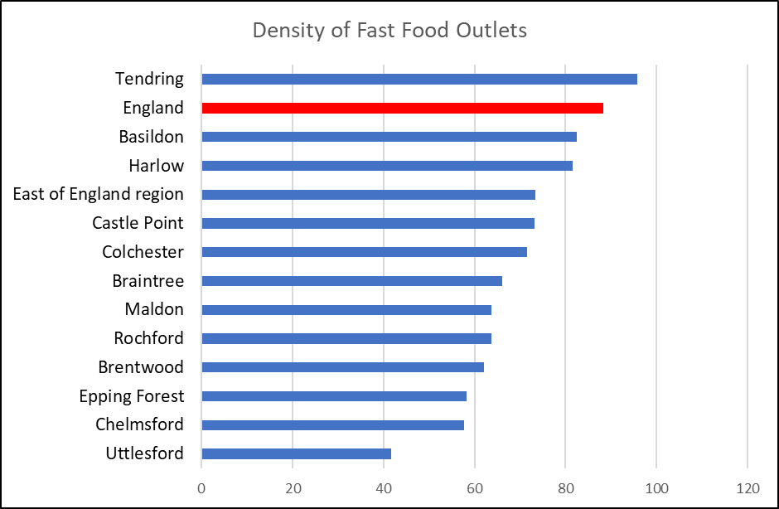

***Air Quality***

Poor air quality is a significant public health issue with clear evidence that particulate matter (human made air pollution) having a significant contributory role in a range of poor health outcomes including respiratory disorders and cardiopulmonary mortality. The Indicator for fine particulate matter looks at the average annual concentration in micrograms per cubic metre (weighted for population exposure) and showed that in 2016 the air pollution levels were 9.2 micrograms per cubic metre, lower than the average levels for England (9.3) and Essex (9.6). Compared to other areas Tendring had the joint lowest air pollution levels in the county (Highest: Epping Forest = 10.1 per cubic metre).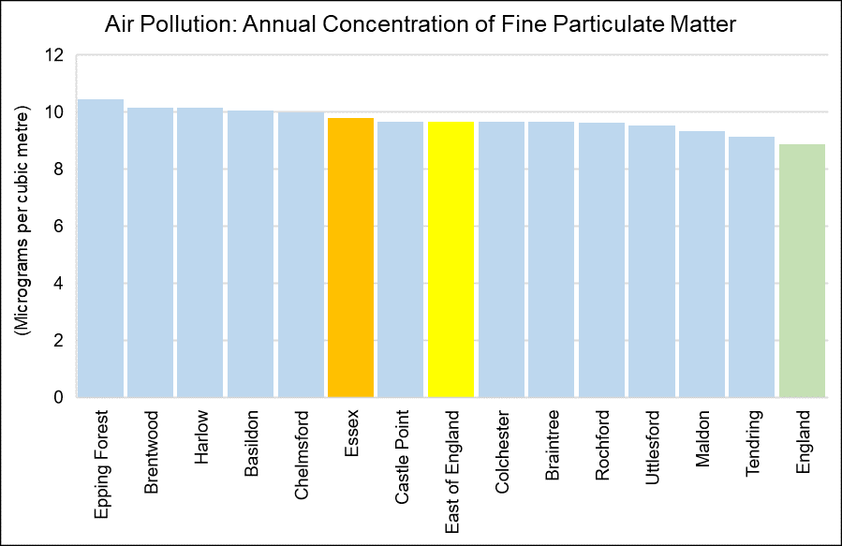

|  |  |
| --- | --- |
| Air pollution: fine particulate matter (2017) | |
| Area Name | micrograms per cubic metre |
| **England** | 8.904 |
| **East of England** | 9.6851 |
| **Essex** | 9.8132 |
| **Basildon** | 10.0819 |
| **Braintree** | 9.6742 |
| **Brentwood** | 10.1725 |
| **Castle Point** | 9.6913 |
| **Chelmsford** | 10.002 |
| **Colchester** | 9.6771 |
| **Epping Forest** | 10.4769 |
| **Harlow** | 10.1565 |
| **Maldon** | 9.3362 |
| **Rochford** | 9.6448 |
| **Tendring** | 9.1363 |
| **Uttlesford** | 9.5392 |
| *Annual concentration of human-made fine particulate matter at an area level, adjusted to account for population exposure. Fine particulate matter is also known as PM2.5 and has a metric of micrograms per cubic metre (µg/m3).* | |

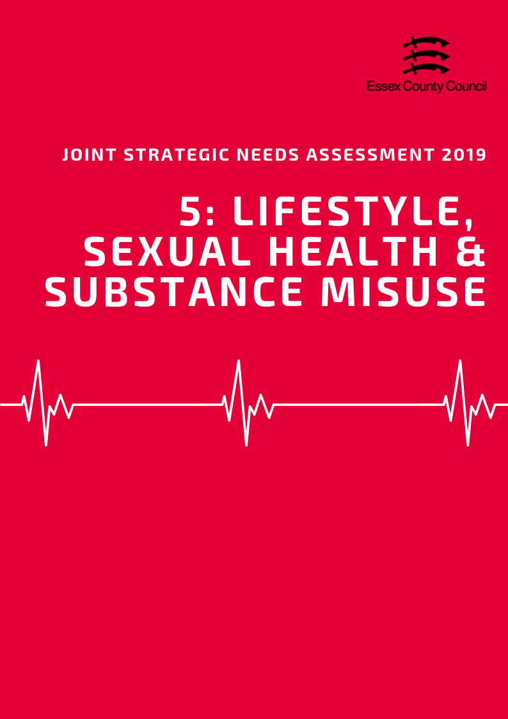

**LIFESTYLE, Sexual Health & Substance misuse**

This Section brings together datasets looking at a range of lifestyle and behavioural factors which can impact on long term health outcomes and increase or decrease the likelihood of developing a range of conditions or require more serious treatments going forward. This section includes:

* Children’s Weight
* Adult Healthy Eating, Obesity and Physical Activity
* Sexual Health
* Substance Misuse

**Children’s Weight**

***Reception Class***

In 2017/18 the National Child Measurement Programme (NCMP) estimated that 24.8% of pupils in Reception class (R in the table below) in Tendring were classed as overweight or obese. This was higher than the average for England (22.4%) and Essex (21.1%) and was the second highest rate in the county. Of this group 10.52% were classed as obese, with a further 2.90% also classed as severely obese. Compared to the rest of Essex the overall level of obesity was above the average for Essex (8.6%) and England (9.53%) and were the third highest levels in the county. The levels of severe obesity for this age group were also higher than the county and national averages and were the second highest in Essex.

|  |  |  |  |  |  |  |  |  |  |  |  |
| --- | --- | --- | --- | --- | --- | --- | --- | --- | --- | --- | --- |
| **National Child Measurement Programme**  2017/18 | Prevalence of all overweight (including overweight, obesity and severe obesity) | | | |  | Prevalence of overweight  (%) | | Prevalence of obesity including severe obesity  (%) | | Prevalence of severe obesity  (%) | |
| Reception (R) | | Year 6  (Y6) | |
| % | Rank | % | Rank | R | Y6 | R | Y6 | R | Y6 |
| Basildon | 20.2 | 7 | 33.9 | 4 | 11.38 | 14.27 | 8.82 | 19.66 | 2.31 | 4.30 |
| Braintree | 24.0 | 3 | 32.5 | 7 | 15.25 | 14.80 | 8.78 | 17.70 | 1.60 | 3.44 |
| Brentwood | 18.5 | 10 | 26.3 | 11 | 11.21 | 11.49 | 7.27 | 14.80 | 1.48 | 2.11 |
| Castle Point | 19.2 | 8 | 33.8 | 5 | 10.19 | 14.39 | 8.98 | 19.42 | 2.08 | 4.80 |
| Chelmsford | 20.6 | 6 | 29.7 | 10 | 13.24 | 14.26 | 7.40 | 15.40 | 1.46 | 2.67 |
| Colchester | 21.2 | 5 | 29.8 | 9 | 13.00 | 14.30 | 8.15 | 15.53 | 1.54 | 2.93 |
| Epping Forest | 17.3 | 12 | 33.4 | 6 | 9.96 | 14.37 | 7.33 | 19.05 | 1.39 | 3.17 |
| Harlow | 22.8 | 4 | 37.4 | 1 | 11.82 | 15.38 | 10.97 | 22.07 | 2.92 | 5.39 |
| Maldon | 28.1 | 1 | 34.6 | 3 | 17.44 | 17.47 | 10.63 | 17.12 | 1.99 | 2.57 |
| Rochford | 18.5 | 11 | 30.9 | 8 | 10.62 | 14.76 | 7.84 | 16.19 | 0.72 | 2.64 |
| Tendring | 24.8 | 2 | 36.3 | 2 | 14.27 | 13.72 | 10.52 | 22.56 | 2.90 | 4.81 |
| Uttlesford | 18.8 | 9 | 25.8 | 12 | 12.09 | 11.92 | 6.74 | 13.91 | 0.96 | 2.09 |
| Essex | 21.1 |  | 32.2 |  | **12.52** | **14.24** | **8.59** | **17.93** | **1.84** | **3.51** |
| England | 22.4 |  | 34.3 |  | **12.84** | **14.18** | **9.53** | **20.14** | **2.40** | **4.24** |

***Year 6***

The sample of pupils in Year 6 in the 2017/18 NCMP showed that 36.3% of pupils in this year group were classed as overweight or obese in Tendring, 11.5 percentage points higher than their Reception class counterparts. This was higher than the England (34.3%) and Essex (32.2%) averages and was the second highest level out of any district or borough in the county. Within this year group it estimated that 22.56% of pupils were classed as obese (12.03% higher than Reception Class), of whom 4.81% were classed as severely obese. Combined obesity levels were the highest level in the county and were higher than the county and national averages. Levels of severe obesity were also higher than England and Essex levels and were the second highest in the county.

***Change Over Time***

Over the last 10 years the prevalence levels of overweight and obese children in both Reception class and Year 6 has fluctuated around similar levels but not shown definitive upward or downward trends in most areas. In Tendring the lowest recorded prevalence in the last 10 years was in 2012/13 for Reception class (21%), and 2008/09 for Year 6 pupils (29.5%). The 10 year high was recorded in 2009/10 for Reception class (25.8 %) and 2017/18 Year 6 pupils (36.3%).

|  |  |
| --- | --- |
|  |  |

**Healthy & underweight children**

The level of Reception aged children in Tendring classed as underweight in 2017/18, was 0.56% and was lower than the average for England (0.98%) and Essex (0.8%). This was the second lowest level of underweight children in the county for this age group (where data is available). In Year 6 the recorded prevalence increased to 0.93% which was lower than the recorded levels for both England (1.39%) and Essex (1.34%).

The prevalence of healthy weight children in Reception class (74.65%) was lower than the Essex (78.08%) and England (76.64%) averages and was the lowest level in county for this age group. In Year 6 the prevalence of healthy weight had (62.79%) had dropped by 11.86 percentage points to the second lowest level in Essex, lower than both the county and England average. The majority of the can be attributed to increases in the prevalence of Overweight and Obesity between the year groups.

|  |  |  |  |  |
| --- | --- | --- | --- | --- |
| **Time Period: 2017/18** | **Prevalence of underweight (%)** | | **Prevalence of healthy weight (%)** | |
| **R** | **Y6** | **R** | **Y6** |
| Basildon | 0.70 | 1.40 | 79.10 | 64.67 |
| Braintree | 0.47 | 1.03 | 75.49 | 66.47 |
| Brentwood | 0.99 | ! | 80.54 | ! |
| Castle Point | ! | 1.17 | ! | 65.03 |
| Chelmsford | 0.76 | 1.59 | 78.61 | 68.75 |
| Colchester | 0.93 | 1.54 | 77.91 | 68.62 |
| Epping Forest | 1.32 | 1.51 | 81.39 | 65.08 |
| Harlow | 1.46 | 1.22 | 75.75 | 61.34 |
| Maldon | ! | ! | ! | ! |
| Rochford | ! | 2.42 | ! | 66.63 |
| Tendring | 0.56 | 0.93 | 74.65 | 62.79 |
| Uttlesford | 0.86 | 1.26 | 80.32 | 72.91 |
| Essex | 0.80 | 1.34 | 78.08 | 66.49 |
| England | 0.98 | 1.39 | 76.64 | 64.29 |

***Adult Obesity, Healthy Eating, and Physical Activity***

67.54% of residents in Tendring aged over 18 years were classified as overweight or obese in 2016/17. This is higher than the prevalence of adult overweight or obesity across the whole of Essex (63.56%) and England (61.29%) and was ranked as being the 2nd highest prevalence across the Essex Districts (highest: Basildon 70.47%; lowest: Uttlesford 55.32%).

The proportion of adults aged over 16 years meeting the recommended fruit and vegetable intake of 5 portions on a ‘usual day’ was 54.7% in 2016/17. This was just below the proportion meeting this recommendation across Essex (55.96%), lower than England (57.44%) and was ranked as being the 8th highest proportion across the Districts in Essex (highest: Braintree 62.92%; lowest: Harlow 46.23%).

|  |  |  |  |  |  |  |  |  |
| --- | --- | --- | --- | --- | --- | --- | --- | --- |
|  | **Percentage eating the recommended “5 a day”** | |  | **Percentage of Adults who are overweight or obese** | |  | **Percentage who take part in Organised sport** | |
| **Value** | **Rank** |  | **Value** | **Rank** |  | **Value** | **Value** |
| **Basildon** | 50.2% | 11 |  | 70.5% | 1 |  | 29.5% | 10 |
| **Braintree** | 62.9% | 1 |  | 60.8% | 8 |  | 33.7% | 9 |
| **Brentwood** | 62.1% | 3 |  | 58.5% | 10 |  | 43.0% | 2 |
| **Castle Point** | 58.2% | 5 |  | 65.1% | 4 |  | 35.1% | 6 |
| **Chelmsford** | 53.7% | 10 |  | 63.3% | 6 |  | 38.2% | 5 |
| **Colchester** | 54.6% | 9 |  | 64.4% | 5 |  | 35.1% | 7 |
| **Epping Forest** | 56.7% | 6 |  | 58.8% | 9 |  | 46.9% | 1 |
| **Harlow** | 46.2% | 12 |  | 66.9% | 3 |  | 25.8% | 11 |
| **Maldon** | 59.7% | 4 |  | 57.9% | 11 |  | 34.6% | 8 |
| **Rochford** | 55.3% | 7 |  | 61.4% | 7 |  | 41.0% | 4 |
| **Tendring** | 54.7% | 8 |  | 67.5% | 2 |  | 22.1% | 12 |
| **Uttlesford** | 62.7% | 2 |  | 55.3% | 12 |  | 42.6% | 3 |
| **Essex** | 55.9% | - |  | 63.6% | - |  | 35% | - |
| **England** | 57.4% | - |  | 61.3% | - |  | - | - |

Physical inactivity is classified as doing less than 30 minutes of moderate intensity activity per week. Of adults aged over 19 years, 25.09% were classified as being physically inactive in 2017/18. This is higher than proportion of adults physically inactive across Essex (21.78%) and similar England (22.23%) and was the third highest level in the county.

The proportion of adult residents classified as physically active (doing more than 150 minutes of moderate intensity activity per week) was 62.55% (highest: Uttlesford 70.72%; Lowest: Basildon 61.87%). This was lower than the proportion of adults physically active across Essex as a whole (66.07%) and England (66.26%) and was the second lowest level in the county.

In 2016/17 the area was also ranked as having the lowest percentage of residents involved in organised sports across the Essex Districts, at 22.1% compared to the percentage across the whole of Essex (35%).

|  |  |  |  |  |  |  |  |  |
| --- | --- | --- | --- | --- | --- | --- | --- | --- |
|  | Percentage of Adults who are physically active or inactive | | | | | | | |
| 2015/16 | | 2016/17 | | *2017/18* | | 3 year change | |
| % active | % inactive | % active | % inactive | *% active* | *% inactive* | % active | % inactive |
| England | 66.13 | 22.33 | 66.01 | 22.24 | ***66.26*** | ***22.23*** | 0.13 | -0.10 |
| Essex | 66.06 | 22.10 | 65.95 | 22.64 | ***66.07*** | ***21.78*** | 0.01 | -0.32 |
| Basildon | 65.46 | 24.00 | 60.98 | 26.28 | ***61.87*** | ***25.30*** | -3.59 | 1.31 |
| Braintree | 57.80 | 23.20 | 66.45 | 23.22 | ***67.55*** | ***19.17*** | 9.75 | -4.04 |
| Brentwood | 68.63 | 18.31 | 70.10 | 21.77 | ***65.79*** | ***22.51*** | -2.84 | 4.20 |
| Castle Point | 69.86 | 22.14 | 61.27 | 25.05 | ***68.43*** | ***21.43*** | -1.43 | -0.71 |
| Chelmsford | 67.26 | 22.16 | 67.88 | 22.09 | ***62.73*** | ***23.74*** | -4.53 | 1.58 |
| Colchester | 74.33 | 16.63 | 67.21 | 21.64 | ***67.74*** | ***18.45*** | -6.59 | 1.82 |
| Epping Forest | 68.72 | 18.05 | 67.65 | 18.97 | ***69.78*** | ***18.48*** | 1.06 | 0.44 |
| Harlow | 60.80 | 29.28 | 62.78 | 23.30 | ***63.31*** | ***25.36*** | 2.50 | -3.92 |
| Maldon | 68.56 | 19.42 | 67.44 | 19.11 | ***68.39*** | ***19.09*** | -0.17 | -0.34 |
| Rochford | 64.23 | 20.83 | 70.05 | 19.21 | ***69.75*** | ***22.37*** | 5.52 | 1.54 |
| Tendring | 58.01 | 31.44 | 62.61 | 27.30 | ***62.55*** | ***25.09*** | 4.54 | -6.35 |
| Uttlesford | 68.99 | 18.39 | 71.38 | 18.42 | ***70.72*** | ***19.21*** | 1.73 | 0.83 |

**Sexual Health**

***New STI Diagnosis***

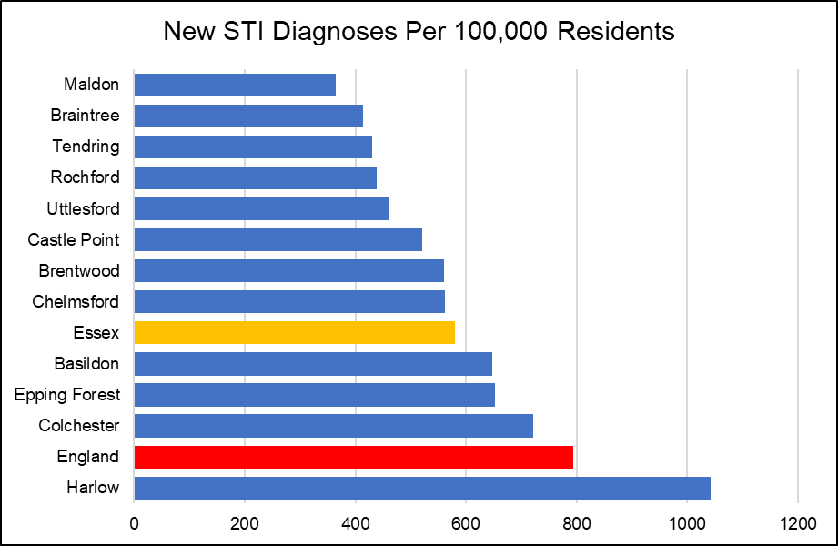According to Public Health England in 2017, the rate of new STI diagnoses among persons in the Tendring District was 430.44 per 100,000 population aged between 15 - 64 years. This was the third lowest rate compared across the other Districts in Essex, and significnalty lower than that for Essex as a whole (580.81) and England (793.85). STI diagnoses excluded chlamydia in under 25 year olds, and was among persons attending specialist (level 3) and non-specialist (level 1 and 2) sexual health services.

***Chlamydia***

The proportion of all 15 - 24 year olds in the Tendring District in 2017 screened for chlamydia with asymptomatic screens and symptomatic tests at sexual health services was 13.1. This was the third lowest proportion compared to that of the other Districts in Essex, and slightly lower than that across the whole of Essex (15.5) and for England (19.3).

|  |  |  |  |  |
| --- | --- | --- | --- | --- |
|  | **New STI diagnoses (excluding chlamydia aged <25) / 100,000** | | **Chlamydia proportion aged 15-24 screened** | |
| **Value** | **Rank** | **%** | **Rank** |
| Basildon | 647.54 | 4 | 14.5 | 5 |
| Braintree | 414.14 | 11 | 12.5 | 11 |
| Brentwood | 560.57 | 6 | 13.2 | 8 |
| Castle Point | 520.65 | 7 | 12.4 | 12 |
| Chelmsford | 561.50 | 5 | 15.3 | 4 |
| Colchester | 721.10 | 2 | 18.2 | 2 |
| Epping Forest | 653.27 | 3 | 15.5 | 3 |
| Harlow | 1042.41 | 1 | 29.5 | 1 |
| Maldon | 364.71 | 12 | 13.1 | 9 |
| Rochford | 438.23 | 9 | 13.7 | 6 |
| Tendring | 430.44 | 10 | 13.1 | 10 |
| Uttlesford | 459.94 | 8 | 13.7 | 7 |
| **Essex** | **580.81** |  | **15.5** |  |
| **England** | **793.85** |  | **19.3** |  |

The rate of all chlamydia diagnoses among 15 to 24 year olds attending sexual health services was 1320.6 per 100,000 population aged 15 to 24. This was the 4th highest detection rate compared to the other Districts in Essex.

|  |  |  |  |  |  |  |
| --- | --- | --- | --- | --- | --- | --- |
| **Chlamydia detection rate / 100,000 aged 15-24** | **Persons** | | **Male** | | **Female** | |
| **Value** | **Rank** | **Value** | **Rank** | **Value** | **Rank** |
| **Basildon** | 1484.2 | 3 | 1000.3 | 4 | 1972.9 | 3 |
| **Braintree** | 1199.6 | 8 | 750.5 | 9 | 1689.1 | 7 |
| **Brentwood** | 1016 | 11 | 820.3 | 8 | 1192.8 | 12 |
| **Castle Point** | 1081.3 | 9 | 635.3 | 11 | 1564.5 | 8 |
| **Chelmsford** | 1266.8 | 6 | 836.3 | 7 | 1720.8 | 5 |
| **Colchester** | 2094.9 | 2 | 1564.1 | 2 | 2679.4 | 1 |
| **Epping Forest** | 1295.8 | 5 | 873.7 | 6 | 1711.8 | 6 |
| **Harlow** | 2444.9 | 1 | 2266 | 1 | 2641.3 | 2 |
| **Maldon** | 933.3 | 12 | 621.1 | 12 | 1279.5 | 11 |
| **Rochford** | 1262.2 | 7 | 1088.1 | 3 | 1444.2 | 9 |
| **Tendring** | 1320.6 | 4 | 897.4 | 5 | 1777.2 | 4 |
| **Uttlesford** | 1035 | 10 | 749.5 | 10 | 1351 | 10 |
| **Essex** | 1449.1 |  | 1049.8 |  | 1872.1 |  |

***HIV***

The rate of all new HIV diagnoses among adults aged over 15 years accessing HIV care in Tendring was 1.63 per 100,000 population. This was the second lowest rate compared across the Essex Districts, and lower than the rate for the whole of Essex (5.63) and England (8.66).

According to Public Health England, HIV late diagnosis is a CD4 cell count of less than 350 cells per mm3 among all new diagnoses with a CD4 cell count available within 91 days of diagnosis. In the Tendring District, the percentage of adults aged over 15 years with a HIV late diagnosis accessing HIV care was 60.0 over the three year period of 2015 - 2017. This was the second highest percentage compared across the other Districts in Essex with data available, and higher than that for the whole of Essex (44.52) and England (41.12). Values for Castle Point and Maldon were not disclosed.

***Other Key STIs***

The rate of all diagnoses of the first episode of genital warts among people accessing sexual health services was 74.64 in the Tendring District. This was the lowest rate compared to the other Essex Districts, and lower than the rate across Essex as a whole (98.43) and England (103.86).

**Substance MisusE**

***Smoking***

In the Tendring District in 2017, the prevalence of current smokers among persons aged over 18 years was 16.72. This was ranked as the 4th highest prevalence across the Districts.

Smoking attributable mortality in Tendring over the three year period of 2012 - 14 was estimated to be 297.95. This was the third highest compared across the other Districts in Essex, and higher than that for Essex as a whole (258.24) and England (274.76). Of smoking attributable mortality, 32.15 was due to heart disease. This was also the second highest across the Districts in Essex, and slightly higher than that for Essex (26.21) and England (29.68). Overall, it was estimated that 1683.79 potential years of life were lost due to smoking in Tendring.

The Tendring District had the third lowest prevalence of never-smokers among persons aged over 18 years compared across the other Districts of Essex, with a prevalence of 51.25. This is slightly lower than the prevalence of never-smokers across the whole of Essex (56.65) and England (58.96).

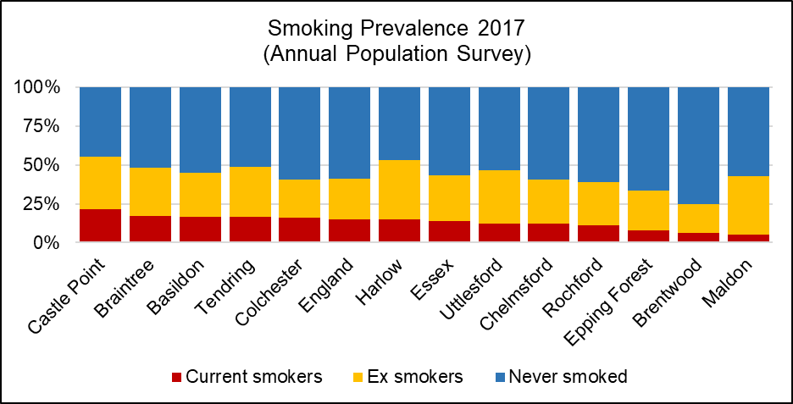

*See table below for the ranked prevalence of current and previous smoking status across the Districts in Essex in 2017/18.*

|  |  |  |  |  |  |  |
| --- | --- | --- | --- | --- | --- | --- |
|  | **Smoking prevalence in adults by current and previous status (Annual Population Survey, 2017)** | | | | | |
| **Current smoker** | | **Ex-smoker** | | **Never-smoked** | |
| **%** | **Rank** | **%** | **Rank** | **%** | **Rank** |
| **Basildon** | 16.72 | 3 | 28.18 | 8 | 55.10 | 7 |
| **Braintree** | 17.15 | 2 | 31.19 | 6 | 51.65 | 9 |
| **Brentwood** | 6.48 | 11 | 18.37 | 12 | 75.15 | 1 |
| **Castle Point** | 21.48 | 1 | 33.89 | 4 | 44.62 | 12 |
| **Chelmsford** | 12.02 | 8 | 28.75 | 7 | 59.23 | 4 |
| **Colchester** | 15.99 | 5 | 24.80 | 11 | 59.20 | 5 |
| **Epping Forest** | 7.84 | 10 | 25.72 | 10 | 66.44 | 2 |
| **Harlow** | 14.81 | 6 | 38.19 | 1 | 47.01 | 11 |
| **Maldon** | 5.33 | 12 | 37.50 | 2 | 57.17 | 6 |
| **Rochford** | 10.98 | 9 | 28.02 | 9 | 61.00 | 3 |
| **Tendring** | 16.72 | 4 | 32.03 | 5 | 51.25 | 10 |
| **Uttlesford** | 12.33 | 7 | 34.38 | 3 | 53.29 | 8 |
| **Essex** | 13.84 | - | 29.51 | - | 56.65 | - |
| **England** | 14.87 | - | 26.17 | - | 58.96 | - |

***Alcohol***

Alcohol-related hospital admissions are defined as admissions where the primary and any secondary diagnoses are an alcohol-attributable code. According to Public Health England, the directly age standardised rate of alcohol-related hospital admissions in the Tendring District in 2017/18 was 2237.58 per 100,000 population. Compared to other areas, this was the second highest rate compared across the other Districts in Essex, and higher than the rate across Essex as a whole (1935.65) and England (2223.80).

The directly age standardised rate per 100,000 population of alcohol-related mortality was estimated to be 61.49 in Tendring in 2017. This was the highest rate compared to the other Districts in Essex, and higher compared to that across the whole of Essex (41.90) and England (46.15). 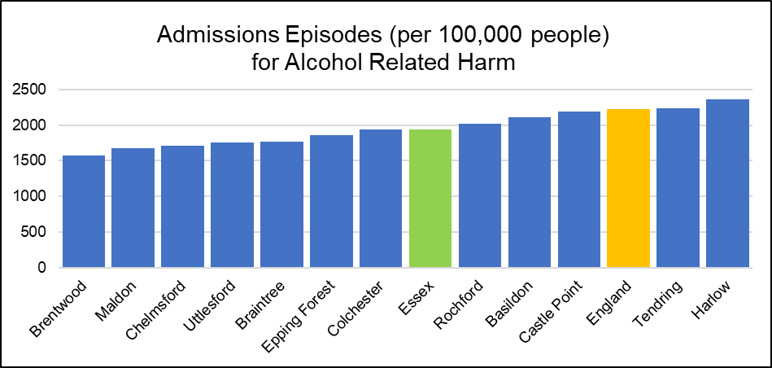

***Drug Use***

According to the Office for National Statistics, the age-standardised mortality rate from drug misuse per 100,000 population in the Tendring District was 7.6 over the period of 2015 - 2017. This was the highest rate compared across that of the other Districts in Essex with data available, and higher than the rate across the whole of Essex (3.63) and England (4.33).

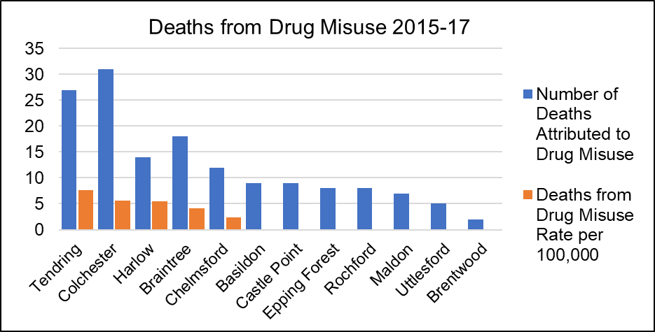

|  |  |  |  |  |  |  |
| --- | --- | --- | --- | --- | --- | --- |
|  | **Alcohol and Drugs** | | | | | |
| **Alcohol-related hospital admission rate per 100K** | | **Alcohol mortality** | | **Deaths from drug misuse** | |
| Value | Rank | Value | Rank | Count | Rate Per 100K |
| **Basildon** | 2111.07 | 4 | 46.31 | 2 | 9 | * |
| **Braintree** | 1761.831 | 8 | 41.66 | 4 | 18 | 4.19 |
| **Brentwood** | 1576.501 | 12 | 39.80 | 6 | 2 | * |
| **Castle Point** | 2194.25 | 3 | 39.46 | 7 | 9 | * |
| **Chelmsford** | 1713.9 | 10 | 38.26 | 8 | 12 | 2.33 |
| **Colchester** | 1934.702 | 6 | 40.12 | 5 | 31 | 5.59 |
| **Epping Forest** | 1856.899 | 7 | 35.50 | 10 | 8 | * |
| **Harlow** | 2360.043 | 1 | 44.38 | 3 | 14 | 5.51 |
| **Maldon** | 1675.22 | 11 | 37.67 | 9 | 7 | * |
| **Rochford** | 2022.617 | 5 | 32.49 | 12 | 8 | * |
| **Tendring** | 2237.576 | 2 | 61.49 | 1 | 27 | 7.60 |
| **Uttlesford** | 1749.756 | 9 | 33.78 | 11 | 5 | * |
| **Essex** | 1935.651 | - | 41.90 | - | 150 | 3.63 |
| **England** | 2223.806 | - | 46.15 | - | 6996 | 4.33 |

*value cannot be calculated as number of cases too small

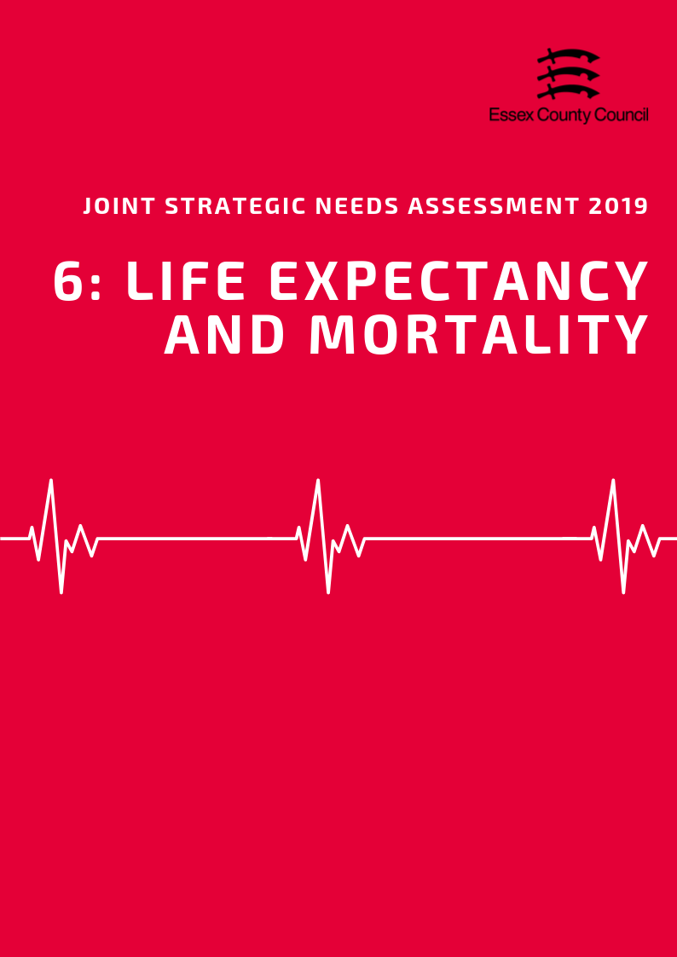

**LIFE EXPECTANCY & MORTALITY**

***Life Expectancy***

*Life Expectancy at Birth*

The average life expectancy at birth for a child born in Tendring (2015-2017) was 81.5 years for females and 77.8 years for males. This lower than the average for England for (Females =83.1 years, Males 79.6 years), and is the lowest life expectancy for both sexes in Essex. In this area, it estimated that the difference (inequality) in life expectancy at birth between most and least deprived areas is an average of 7 years for females and 11 years for males, whilst the gap in female life expectancy is slightly lower than average lower than the average (England = 7.4) the gap in male life expectancy is above average (England = 9.4) and is the largest inequality gap in the county. 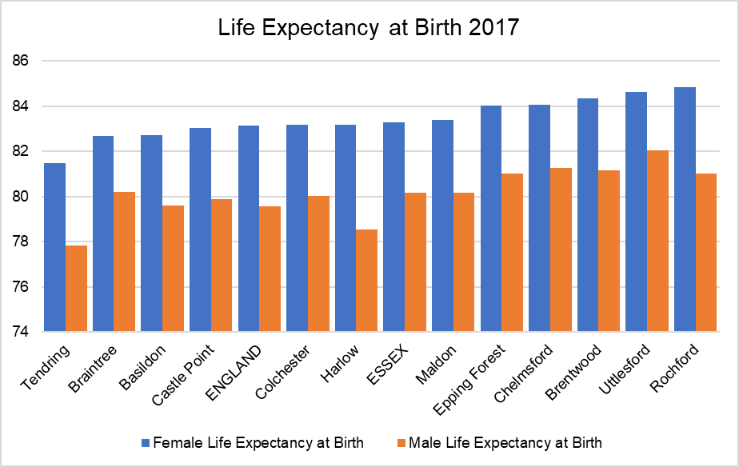

*Life Expectancy at 65*

During the same period, life expectancy at age 65 (the number of additional years a person could expect to live) was 20.6 years for females and 18.2 years for males; again this this is lower than the England average (Females =21.1 years, Males = 18.8 years), and is the (joint) lowest life expectancy at 65 in the county for females, and the single lowest for males. Like life expectancy at birth, life expectancy at age 65 varies between the most and least deprived areas with an estimated gap of 4 years for females and 4.5 years for males, just below the average for England (4.5, 4.9).

*Life Expectancy estimates for each lower tier local authority area at birth and at age 65 are set out in the table below:*

|  |  |  |  |  |  |  |  |  |  |
| --- | --- | --- | --- | --- | --- | --- | --- | --- | --- |
|  | **Female Life Expectancy** | | | |  | **Male Life Expectancy** | | | |
| **At 65** | **At birth** | **Inequality in LE** | |  | **At 65** | **At birth** | **Inequality in LE** | |
| **At 65** | **At Birth** |  | **At 65** | **At Birth** |
| **England** | **21.1** | **83.1** | **4.5** | **7.4** |  | **18.8** | **79.6** | **4.9** | **9.4** |
| **Essex** | **21.2** | **83.3** | **3.2** | **6** |  | **18.9** | **80.2** | **4.2** | **7.7** |
| Basildon | 21.1 | 82.7 | 4 | 7.5 |  | 18.6 | 79.6 | 5.1 | 9.6 |
| Braintree | 20.6 | 82.7 | 2.1 | 5 |  | 18.7 | 80.2 | 2.4 | 5.5 |
| Brentwood | 21.6 | 84.3 | 5.1 | 7 |  | 19.4 | 81.2 | 5.9 | 9.9 |
| Castle Point | 20.8 | 83.0 | 2.6 | 4.3 |  | 18.4 | 79.9 | 3.6 | 6 |
| Chelmsford | 21.6 | 84.0 | 2.7 | 4.5 |  | 19.8 | 81.3 | 3.3 | 6 |
| Colchester | 21.1 | 83.2 | 4.7 | 7.8 |  | 18.8 | 80.0 | 4.7 | 7.5 |
| Epping Forest | 21.1 | 84.0 | 3.3 | 5.6 |  | 19.1 | 81.0 | 4.1 | 6.6 |
| Harlow | 21.3 | 83.2 | 2.6 | 5.1 |  | 18.3 | 78.5 | 5.3 | 7.8 |
| Maldon | 21.7 | 83.4 | 1.9 | 2.3 |  | 19.0 | 80.2 | 1.9 | 3.9 |
| Rochford | 21.9 | 84.8 | 2.6 | 4.4 |  | 19.1 | 81.0 | 2.8 | 3.2 |
| Tendring | 20.6 | 81.5 | 4 | 7 |  | 18.2 | 77.8 | 4.5 | 10.8 |
| Uttlesford | 22.0 | 84.6 | 0.6 | -0.3 |  | 20.0 | 82.1 | 1.9 | 2.2 |

***Mortality***

In 2017 the Tendring area had an all ages mortality rate of 1068.9 deaths per 100,000 residents, based on 2243 deaths recorded during that time period. This overall mortality rate was higher than the England average of 958.7 (per 100K), was a slight increase compared the previous year (1062.8 per 100K) and was the highest all ages mortality rate in the county. Looking at mortality rates across the different age groups, 41% of all deaths during this period were from residents aged 85 years and over with an age standardised mortality rate of 16076.5 per 100K (based 920 actual deaths). This was higher than the England (40.4%, 15280.8 per 100K) and the Essex average (43.3%, 16031.7 per 100K), with all younger age groups also having mortality rates which were higher the national averages.

*Premature Mortality*

The Tendring District has the highest rate of all premature mortalities in Essex with a rate of 400 deaths per 100,000 residents under the age of 75. This is 17.1% above the average for England, 23.2% higher than the average for the county, and 36.9% higher than the best performing area (Uttlesford). This indicates a significant health inequality for residents in this area compared to less deprived areas of Essex.

There is also a significant difference in the under 75 mortality rates between females (321 per 100,000) and males (489 per 100,000); a difference of 34% however this is largely similar to the average difference across England.

*Premature Deaths from Cancer*

763 deaths from cancer under the age of 75 were recorded in the Tendring District between 2015-17, equivalent to a rate of 149.3 deaths per 100,000 residents. This is higher than the average for Essex (131) and England (135) and was the second highest rate in the county overall. Experimental statistics for early stage cancer diagnosis estimate that 47.8% of cases were diagnosed at either stage 1 or 2 in 2017. This is below the estimates for Essex (53.3%) and England (52.5%) and was the lowest level in the county.

Breast cancer is a serious cause of premature mortality for women nationally. In the Tendring District 54 deaths of women under the age of 75 were recorded between 2015 and 2017. This was equivalent to a rate of 22 deaths per 100,000 people and was higher than the average Essex (21.5) or England (20.6). The percentage of eligible women in Tendring who were screened adequately for breast cancer in (the previous three years from 31st March) 2018 was 75.7%. This was higher than the average for Essex (73.5%) and England (74.9%), but a reduction compared to 77.7 in 2017. Public Health England recommends that improvements in coverage would mean more breast cancers are detected at earlier more treatable stages.

Colorectal cancer was the other most common cause of premature deaths by cancer for both sexes with 77 deaths also recorded in 2015/17. This is equivalent to a rate of 15.2 deaths per 100,000 residents, was higher than the average rates for Essex (11.3) and England (11.9) and was the second highest rate in the county overall (lowest: Harlow = 8.3 per 100,000). Colorectal cancer was the other most common cause of premature deaths by cancer with 39 deaths also recorded in 2015/17. This is equivalent to a rate of 8.7 per 100,000 residents (the 2nd lowest mortality rate for all districts) and is significantly lower than the rate for Essex (11.3) and England (12).

***Preventable Mortality***

*According to Public Health England, "preventable mortality is that deaths are considered preventable if, in the light of the understanding of the determinants of health at the time of death, all or most deaths from the underlying cause (subject to age limits if appropriate) could potentially be avoided by public health interventions in the broadest sense".*

In the period of 2015-2017 it is estimated that 1,149 deaths for all age groups or 17.5% of all deaths that occurred in the Tendring area were preventable. This is equivalent to a rate of 218.1 per 100,000 people, higher than the rate (181.5) and percentage (18.9%) for England and this highest rate in Essex. Males were 39.6% more likely to die from a preventable cause (SMR= 274.9 per 100K) compared to females (SMR= 166 per 100K).

For the under 75 age group Cancer was the largest cause of preventable mortality with a rate of 90.1 preventable deaths per 100,000 for all persons. This was higher than the England baseline (82.8) and the rate for Essex (74.2) and was also higher than average for males (SMR = 97.4) and females (SMR=83.5) when looked at separately. Cardiovascular disease (SMR=51.4), Respiratory Disease (25.4) and Liver Disease (SMR=22.2) all also had higher than average rates for preventable mortality for all persons and for both males and females in each category separately.

|  |  |  |  |  |  |  |  |  |  |  |
| --- | --- | --- | --- | --- | --- | --- | --- | --- | --- | --- |
|  | **Mortality Rates for All Persons** | | | | | | | | | |
|  | **Under 75 mortality from colorectal cancer** | **Under 75 mortality rate from all cardiovascular diseases** | **Under 75 mortality rate from all causes** | **Under 75 Mortality rate from breast cancer** | **Under 75 mortality rate from cancer** | **Under 75 mortality rate from heart disease** | **Under 75 mortality rate from injuries** | **Under 75 mortality rate from liver disease** | **Under 75 mortality rate from respiratory disease** | **Under 75 mortality rate from stroke** |
| **England** | **11.97** | **72.50** | **331.95** | **10.60** | **134.59** | **38.72** | **12.78** | **18.51** | **34.26** | **13.08** |
| **Essex** | **11.32** | **62.56** | **307.35** | **11.22** | **131.18** | **31.57** | **10.20** | **14.68** | **30.76** | **11.73** |
| Basildon | 13.82 | 70.92 | 336.39 | 9.81 | 157.15 | 35.80 | 7.39 | 15.06 | 33.14 | 13.42 |
| Braintree | 9.61 | 65.40 | 310.64 | 14.10 | 132.10 | 34.11 | 11.18 | 13.98 | 27.49 | 13.47 |
| Brentwood | 11.37 | 48.51 | 265.73 | 8.77 | 119.54 | 24.19 | 7.54 | 13.63 | 26.70 | 7.89 |
| Castle Point | 11.75 | 66.34 | 313.33 | 14.03 | 141.84 | 32.15 | 8.67 | 14.13 | 32.70 | 13.16 |
| Chelmsford | 10.17 | 54.03 | 272.91 | 11.22 | 119.76 | 28.45 | 9.85 | 11.26 | 24.02 | 10.46 |
| Colchester | 8.66 | 56.64 | 298.36 | 8.88 | 122.23 | 29.44 | 12.54 | 15.99 | 34.37 | 10.51 |
| Epping Forest | 8.76 | 52.34 | 276.80 | 12.69 | 121.43 | 25.31 | 9.88 | 13.81 | 28.24 | 10.55 |
| Harlow | 8.36 | 91.62 | 356.97 | 10.82 | 127.68 | 48.42 | 12.35 | 13.82 | 40.82 | 17.71 |
| Maldon | 16.10 | 61.97 | 297.26 | 13.50 | 126.61 | 31.51 | 17.62 | 14.29 | 23.06 | 11.74 |
| Rochford | 10.33 | 49.03 | 263.54 | 10.20 | 120.80 | 20.34 |  | 9.21 | 21.59 | 6.15 |
| Tendring | 15.21 | 79.58 | 400.31 | 11.80 | 149.39 | 37.51 | 17.86 | 25.26 | 45.35 | 15.68 |
| Uttlesford | 10.45 | 52.83 | 252.76 | 9.45 | 113.08 | 30.85 | 5.47 | 13.50 | 23.93 | 8.65 |

|  |  |  |  |  |  |  |  |  |  |  |
| --- | --- | --- | --- | --- | --- | --- | --- | --- | --- | --- |
|  | **Mortality Rates for Female Residents** | | | | | | | | | |
| **Under 75 mortality from colorectal cancer** | **Under 75 mortality rate from all cardiovascular diseases** | **Under 75 mortality rate from all causes** | **Under 75 Mortality rate from breast cancer** | **Under 75 mortality rate from cancer** | **Under 75 mortality rate from heart disease** | **Under 75 mortality rate from injuries** | **Under 75 mortality rate from liver disease** | **Under 75 mortality rate from respiratory disease** | **Under 75 mortality rate from stroke** |
| **England** | **9.36** | **45.22** | **264.13** | **20.59** | **120.68** | **18.46** | **7.08** | **12.97** | **28.98** | **11.33** |
| **Essex** | **9.54** | **37.62** | **250.12** | **21.53** | **120.61** | **14.03** | **6.34** | **11.49** | **25.44** | **9.69** |
| Basildon | 10.31 | 44.80 | 280.68 | 18.43 | 143.66 | 17.14 |  | 15.78 | 29.86 | 11.47 |
| Braintree | 6.45 | 41.03 | 259.69 | 27.49 | 125.03 | 15.85 | 6.64 | 9.85 | 23.61 | 12.05 |
| Brentwood | 12.08 | 28.51 | 217.07 | 17.08 | 106.45 |  |  | 14.93 | 22.74 |  |
| Castle Point | 11.60 | 37.02 | 255.09 | 27.15 | 135.91 | 12.14 |  | 12.61 | 25.47 | 8.02 |
| Chelmsford | 9.30 | 32.79 | 220.20 | 21.76 | 112.36 | 12.28 | 5.47 | 5.98 | 20.98 | 7.20 |
| Colchester | 8.27 | 33.63 | 231.45 | 16.34 | 100.83 | 13.04 | 10.20 | 10.54 | 25.83 | 10.54 |
| Epping Forest | 6.03 | 31.76 | 230.83 | 24.42 | 106.93 | 11.46 | 8.94 | 9.38 | 25.44 | 8.78 |
| Harlow |  | 48.16 | 256.41 | 20.81 | 108.86 | 21.88 |  | 12.50 | 30.63 | 14.90 |
| Maldon | 14.24 | 33.27 | 254.87 | 26.60 | 133.30 | 13.33 | 13.36 |  | 19.54 |  |
| Rochford | 10.67 | 26.76 | 213.16 | 19.72 | 113.43 | 9.14 |  | 7.50 | 13.51 |  |
| Tendring | 10.64 | 50.97 | 320.64 | 22.03 | 133.00 | 17.01 | 7.67 | 20.63 | 37.80 | 15.13 |
| Uttlesford | 14.23 | 34.52 | 221.05 | 18.54 | 124.54 | 14.97 |  | 11.93 | 17.59 |  |

|  |  |  |  |  |  |  |  |  |  |  |
| --- | --- | --- | --- | --- | --- | --- | --- | --- | --- | --- |
|  | **Mortality Rates for Male Residents** | | | | | | | | | |
| **Under 75 mortality from colorectal cancer** | **Under 75 mortality rate from all cardiovascular diseases** | **Under 75 mortality rate from all causes** | **Under 75 Mortality rate from breast cancer** | **Under 75 mortality rate from cancer** | **Under 75 mortality rate from heart disease** | **Under 75 mortality rate from injuries** | **Under 75 mortality rate from liver disease** | **Under 75 mortality rate from respiratory disease** | **Under 75 mortality rate from stroke** |
| **England** | **14.74** | **101.25** | **403.22** | **0.16** | **149.57** | **60.09** | **18.56** | **24.30** | **39.90** | **14.93** |
| **Essex** | **13.24** | **89.42** | **368.93** |  | **142.83** | **50.47** | **14.20** | **18.10** | **36.54** | **13.93** |
| Basildon | 17.81 | 99.62 | 397.73 |  | 172.39 | 56.22 | 11.82 | 14.36 | 36.87 | 15.54 |
| Braintree | 13.02 | 91.43 | 364.90 |  | 139.74 | 53.66 | 15.89 | 18.39 | 31.54 | 14.99 |
| Brentwood | 10.55 | 69.95 | 317.48 |  | 133.43 | 43.71 |  | 12.22 | 30.95 |  |
| Castle Point | 12.06 | 98.06 | 377.12 |  | 149.35 | 53.77 | 13.49 | 15.71 | 40.68 | 18.99 |
| Chelmsford | 11.13 | 77.03 | 329.61 |  | 128.28 | 45.96 | 14.34 | 16.89 | 27.24 | 14.00 |
| Colchester | 9.00 | 81.61 | 371.09 |  | 145.81 | 47.24 | 15.05 | 21.98 | 43.84 | 10.44 |
| Epping Forest | 11.70 | 74.50 | 326.33 |  | 137.14 | 40.29 | 10.87 | 18.58 | 31.31 | 12.39 |
| Essex | 13.24 | 89.42 | 368.93 |  | 142.83 | 50.47 | 14.20 | 18.10 | 36.54 | 13.93 |
| Harlow | 12.24 | 139.51 | 468.88 |  | 149.33 | 78.10 | 20.15 | 15.19 | 52.91 | 20.54 |
| Maldon | 17.94 | 91.25 | 341.00 |  | 119.81 | 50.07 | 21.78 | 21.79 | 26.56 | 17.01 |
| Rochford | 10.07 | 73.13 | 317.49 |  | 128.69 | 32.39 |  | 11.08 | 30.51 | 10.28 |
| Tendring | 20.24 | 111.07 | 488.75 |  | 167.63 | 60.01 | 28.97 | 30.42 | 53.80 | 16.34 |
| Uttlesford |  | 71.35 | 284.31 |  | 101.11 | 46.90 |  | 15.01 | 30.38 | 9.84 |

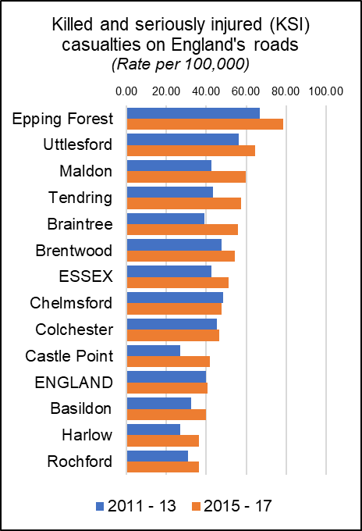***Killed and Seriously Injured in Road Traffic Accidents***

The rate of people killed or seriously injured on England’s roads has risen is recorded as a rate per 100,000 population (all ages) over a three year period. During the last recorded period (2015-17) the average rate for Essex (51.28) was higher than the average for England (40.8) with nine out of 12 Districts having rates above the national average.

Tendring had a rate of 57.43 which was above the England and Essex levels and was the fourth highest in Essex. Rates in Tendring have increased by 14.08 per 100K or 32.5% compared to 2011-13 with the largest increase occurring between the two most recent reporting periods.

*KSI rates for all areas & over time are set out in the table below.*

|  |  |  |  |  |  |  |  |  |
| --- | --- | --- | --- | --- | --- | --- | --- | --- |
|  | **Killed and seriously injured (KSI) casualties on England's roads** | | | | |  | **5 Year Change** | |
| 2011 - 13 | 2012 - 14 | 2013 - 15 | 2014 - 16 | 2015 - 17 | Rate (per 100K) | % |
| Epping Forest | 66.93 | 70.35 | 67.73 | 75.81 | 78.76 | 11.83 | 17.7% |
| Uttlesford | 56.24 | 50.80 | 48.37 | 55.16 | 64.51 | 8.27 | 14.7% |
| Maldon | 42.51 | 42.86 | 43.52 | 57.83 | 59.92 | 17.41 | 41.0% |
| Tendring | 43.35 | 39.80 | 40.60 | 45.84 | 57.43 | 14.08 | 32.5% |
| Braintree | 39.09 | 40.45 | 43.09 | 51.37 | 55.76 | 16.67 | 42.7% |
| Brentwood | 47.66 | 47.28 | 45.23 | 54.10 | 54.28 | 6.62 | 13.9% |
| **ESSEX** | **42.74** | **42.21** | **42.47** | **48.18** | **51.28** | **8.55** | **20.0%** |
| Chelmsford | 48.61 | 43.25 | 44.49 | 45.74 | 47.65 | -0.96 | -2.0% |
| Colchester | 45.41 | 42.89 | 44.02 | 46.51 | 46.54 | 1.14 | 2.5% |
| Castle Point | 26.83 | 28.97 | 32.99 | 39.24 | 41.97 | 15.14 | 56.4% |
| **ENGLAND** | **39.71** | **39.26** | **38.50** | **39.70** | **40.80** | **1.09** | **2.7%** |
| Basildon | 32.48 | 36.98 | 35.79 | 39.02 | 39.72 | 7.25 | 22.3% |
| Harlow | 26.97 | 21.97 | 24.03 | 31.25 | 36.49 | 9.52 | 35.3% |
| Rochford | 30.99 | 34.94 | 32.23 | 39.52 | 36.17 | 5.18 | 16.7% |
| Number of people reported killed or seriously injured (KSI) on the roads, all ages, per 100,000 resident population | | | | | | | | |

***Excess Winter Deaths***

Excess Winter Deaths Index (EWD Index) is the excess winter deaths measured as the ratio of extra deaths from all causes that occur in the winter months compared with the expected number of deaths, based on the average of the number of non-winter deaths. The Excess Winter Deaths Index is calculated as the number of excess winter deaths divided by the average non-winter deaths expressed as a percentage.

**According to the Office of National Statistics…**

*“Colder than average temperatures for the winter months of 2017 to 2018 may partially explain the increase in winter deaths. However, previous years demonstrate a weak relationship between temperature and EWD. Increased EWD are not always coupled with unusually cold winters and conversely winters with decreased EWD are not always coupled with milder winter temperatures, indicating factors other than temperature, such as influenza, are also relevant in explaining trends in excess winter mortality (EWM).”\**

Between August 2014 and July 2017, the three year average rate of Excess Deaths for all ages was 26.1%, which was higher than the average for England (21.9%) and Essex (23.3%). Looking at the level of Excess Winter Deaths specifically in the over 85s age group shows a level of 32.7% Excess Winter Deaths for this age group during the same period. This is higher than the England rate of 29.3% and the county average of 31.7% and is the 7th highest level in the county. (Highest: Maldon = 39.5%; Lowest: Brentwood 14.5%). A breakdown of the levels of Excess Winter Deaths for each district can be found in the table below.

|  |  |  |  |  |
| --- | --- | --- | --- | --- |
|  | ***Excess winter deaths index (3 years, age 85+) Percentage*** | ***Essex rank (lowest to Highest)*** | ***Excess winter deaths index (3 years, all ages) Percentage*** | ***Essex rank (lowest to Highest)*** |
| **England** | **29.3** |  | **21.1** |  |
| **Essex** | **31.7** |  | **23.3** |  |
| Basildon | 34.5 | 7 | 19.4 | 3 |
| Braintree | 30.9 | 3 | 26.1 | 9 |
| Brentwood | 14.5 | 1 | 9.3 | 1 |
| Castle Point | 37.7 | 10 | 27.2 | 11 |
| Chelmsford | 22.2 | 2 | 22.2 | 6 |
| Colchester | 36.8 | 9 | 25.4 | 7 |
| Epping Forest | 31.8 | 4 | 25.5 | 8 |
| Harlow | 35.2 | 8 | 22.1 | 5 |
| Maldon | 39.5 | 12 | 17.4 | 2 |
| Rochford | 32.2 | 5 | 21.5 | 4 |
| Tendring | 32.7 | 6 | 26.1 | 10 |
| Uttlesford | 38.5 | 11 | 30.1 | 12 |

*[*https://www.ons.gov.uk/peoplepopulationandcommunity/birthsdeathsandmarriages/deaths/bulletins/excesswintermortalityinenglandandwales/2017to2018provisionaland2016to2017final*](https://www.ons.gov.uk/peoplepopulationandcommunity/birthsdeathsandmarriages/deaths/bulletins/excesswintermortalityinenglandandwales/2017to2018provisionaland2016to2017final)

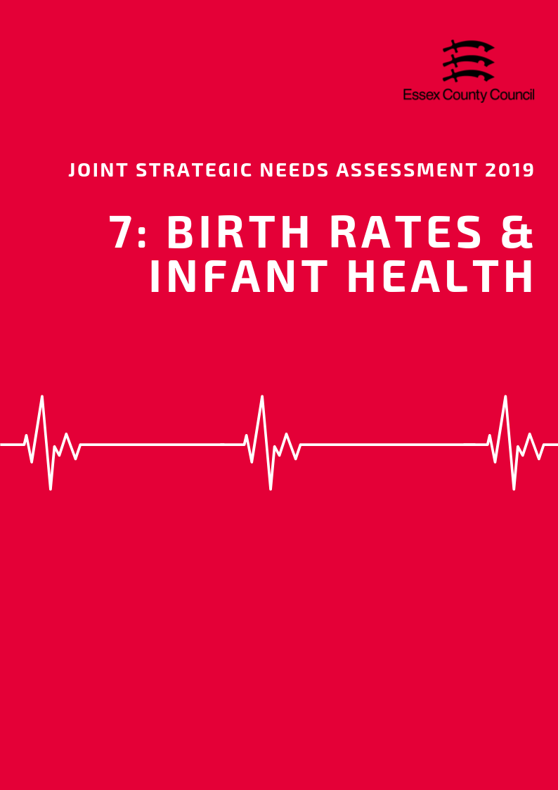

**Birth Rates & Infant Health**

***Birth Rates***

According to the Office for National Statistics the Crude Birth Rate (CBR; all births per 1,000 population) was 9.4 in the Tendring District in 2017. This was the second lowest rate compared to the other Districts in Essex, and lower than the CBR for Essex as a whole (11.4) and for England (12.0). 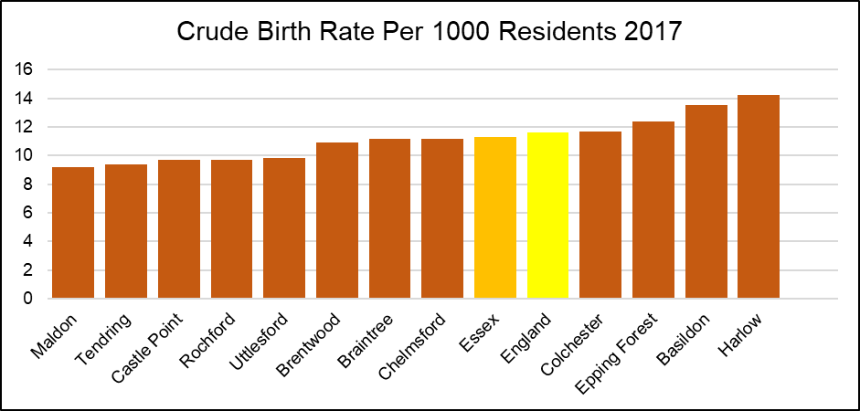 Between 2013 to 2017, there was an overall decrease in the CBR in Tendring with, for example, a CBR of 9.7 in 2013. This was also the 3rd largest rate decreases relative to that of the other Essex Districts. In contrast, the CBR remained stable across Essex (2013 and 2017: 11.3) and decreased across England by 0.7 (2013: 12.3; 2017: 11.6).

*The Table below provides the ranked CBR in each district in each year from 2013 to 2017*

|  |  |  |  |  |  |  |  |  |  |  |
| --- | --- | --- | --- | --- | --- | --- | --- | --- | --- | --- |
|  | **Year** | | | | | | | | | |
| **2013** | | **2014** | | **2015** | | **2016** | | **2017** | |
| **CBR** | **Rank** | **CBR** | **Rank** | **CBR** | **Rank** | **CBR** | **Rank** | **CBR** | **Rank** |
| **England** | **12.3** | **-** | **12.2** | **-** | **12.1** | **-** | **12.0** | **-** | **11.6** | **-** |
| **Essex** | **11.3** | **-** | **11.5** | **-** | **11.3** | **-** | **11.4** | **-** | **11.3** | **-** |
| Basildon | 13.6 | 2 | 13.4 | 2 | 13.5 | 2 | 13.6 | 2 | 13.5 | 2 |
| Braintree | 11.1 | 5 | 11.0 | 7 | 10.7 | 7 | 11.4 | 6 | 11.2 | 5 |
| Brentwood | 11.1 | 6 | 11.6 | 4 | 11.7 | 5 | 11.1 | 7 | 10.9 | 7 |
| Castle Point | 9.0 | 10 | 9.7 | 10 | 9.5 | 9 | 9.6 | 9 | 9.7 | 9 |
| Chelmsford | 10.9 | 7 | 11.4 | 6 | 10.9 | 6 | 11.7 | 5 | 11.2 | 6 |
| Colchester | 12.4 | 3 | 12.4 | 3 | 12.2 | 4 | 11.8 | 4 | 11.7 | 4 |
| Epping Forest | 12.2 | 4 | 11.5 | 5 | 12.5 | 3 | 12.2 | 3 | 12.4 | 3 |
| Harlow | 14.6 | 1 | 16.1 | 1 | 14.3 | 1 | 15.2 | 1 | 14.2 | 1 |
| Maldon | 8.8 | 11 | 8.5 | 12 | 9.2 | 11 | 8.4 | 12 | 9.2 | 12 |
| Rochford | 8.4 | 12 | 9.4 | 11 | 8.8 | 12 | 8.8 | 11 | 9.7 | 10 |
| Tendring | 9.7 | 9 | 9.8 | 9 | 9.5 | 10 | 9.0 | 10 | 9.4 | 11 |
| Uttlesford | 9.9 | 8 | 10.9 | 8 | 10.5 | 8 | 10.7 | 8 | 9.8 | 8 |

***Birth rates by age of mother***

The rate of births per 1,000 population among females aged under 20 years (18.8) was the highest in Tendring compared to the other Districts in Essex in 2016, and higher than that for Essex as a whole (11.9) and England (13.5).

The rate of births per 1,000 population among females aged 20 - 24 years (88.4) was the highest in Tendring compared to the other Districts in Essex in 2016, and higher than that for Essex as a whole (57.3) and for England (55.6).

The rate of births per 1,000 population among females aged 30 - 34 years (101.7) was the lowest in Tendring compared to the other Districts in Essex in 2016, and lower than that of Essex as a whole (123.9) and England (112.4).

The rate of births per 1,000 population among females aged 35 - 39 years (36.8) was also the lowest in Tendring compared to the other Districts in Essex in 2016, and lower than that for Essex as a whole (66.7) and England (67.5). 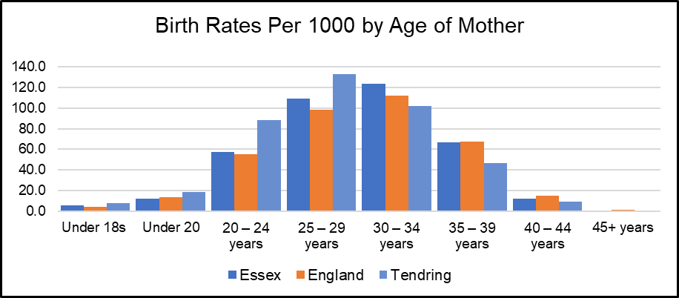

*See Table 2 for birth rates by age of mother for each Essex District*

***Under 18 Conceptions and Births***

The rate of conceptions in women aged under 18 years per 1,000 females aged 15 to 17 years in the Tendring District was 23.5 in 2016. This was the second highest rate compared to that of the other Essex Districts, and significantly higher than that for Essex as a whole (16.7) and England (18.8).

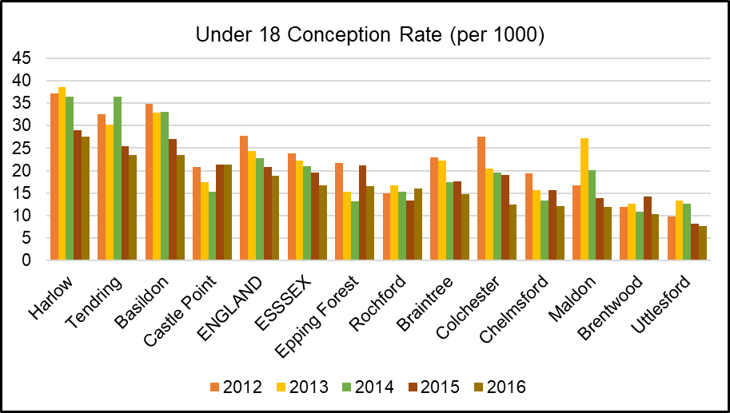

The rate of live births in women aged under 18 per 1,000 females aged 15 to 17 years was 8.14 in Tendring in 2016. This was the second highest rate compared to the other Districts in Essex, and higher than that for Essex as a whole (4.64) and England (5.55).

|  |  |  |  |  |  |  |  |  |
| --- | --- | --- | --- | --- | --- | --- | --- | --- |
|  | **Birth Rates (per 1000) by Age of Mother** | | | | | | | |
| **Under 18s** | **Under 20** | **20-24 years** | **25-29 years** | **30-34 years** | **35-39 years** | **40-44 years** | **45+ years** |
| **Essex** | **5.6** | **11.9** | **57.3** | **109.2** | **123.9** | **66.7** | **12.4** | **1** |
| **England** | **4.6** | **13.5** | **55.6** | **98.5** | **112.4** | **67.5** | **14.9** | **1.1** |
| Basildon | 4.1 | 17 | 73.9 | 117.9 | 122.5 | 66.3 | 13 | - |
| Braintree | 7.2 | 12.7 | 70.3 | 120.8 | 115.1 | 61 | 12.8 | 0.7 |
| Brentwood | 3.0 | 7.5 | 36 | 90.7 | 145.4 | 77.4 | 14 | 1 |
| Castle Point | 3.8 | 10.1 | 51.2 | 110.4 | 126.5 | 62.1 | 7.7 | 1.2 |
| Chelmsford | 3.1 | 10.4 | 43.3 | 105.1 | 124.8 | 73 | 14.6 | 1.1 |
| Colchester | 3.4 | 11.4 | 52.1 | 93 | 111.4 | 61.9 | 11.7 | 1.7 |
| Epping Forest | 4.2 | 8.6 | 45 | 98.8 | 145.5 | 77.8 | 14.5 | 1 |
| Harlow | 8.5 | 16.2 | 72.4 | 137.5 | 116.8 | 69.3 | 15.4 | 2.7 |
| Maldon | 2.8 | 8.3 | 61.9 | 100.8 | 122.4 | 60.8 | 6.3 | - |
| Rochford | 5.3 | 7.9 | 32.4 | 105.3 | 128.2 | 53.5 | 12.3 | - |
| Tendring | 8.1 | 18.8 | 88.4 | 132.6 | 101.7 | 46.8 | 9.4 | - |
| Uttlesford | 1.9 | 6.2 | 47.1 | 93.7 | 151.1 | 85.9 | 13.2 | 1.4 |

**INFANT HEALTH**

***Premature Births***

Premature births are live or still births at a gestational age of less than 37 weeks. The rate of premature births per 1,000 total live and still births in the Tendring District was 81.90 over the 3 year period of 2014 - 2016. This was the third highest rate compared to the other Districts in Essex, and higher than that for Essex as a whole (74.69) and England (79.52).

***Low Birth Weight***

Low birth weight is defined as a live birth with a recorded weight under 2500g and gestational age of at least 37 weeks. In the Tendring District in 2016, the percentage of low birth weight out of all live births with a recorded weight (and gestational age >=37 weeks) was 2.03. This was the 7th highest out of the other Districts in Essex, and similar to that for Essex as a whole (2.11) and England (2.79).

***Infant Mortality***

According to Public Health England, the rate of infant mortality aged under 1 years old was 5.52 per 1,000 live births in the Tendring District over the period 2015 - 2017. This was the highest rate compared to the other districts of Essex, and significantly higher than that for the whole of Essex (3.10) and England (3.92).

***Breastfeeding Initiation***

Breastfeeding initiation is mothers giving their babies breast milk in the first 48 hours after delivery. The percentage of breastfeeding initiation of the total number of maternities in the Tendring District in 2016/17 was 68.38 This was the second lowest compared across the Essex Districts with data available, and lower than that for the whole of Essex (75.02) and England (74.49).

***Smoking at The Time of Delivery***

The percentage of mothers known to be smokers at the time of delivery out of all maternities was 14.70 in the North East Essex CCG in 2017/18. This was the highest compared to the other CCGs in Essex, and significantly higher than Essex as a whole (10.60) and England (10.80).

*All of the infant health datasets mentioned in this section are set out in table below:*

|  |  |  |  |  |  |
| --- | --- | --- | --- | --- | --- |
|  | **Premature births (less than 37 weeks gestation) Per 1000** | **Low birth weight of term babies (%)** | **Infant mortality (per 1000)** | **Breast Feeding Initiation (%)** | **Smoking status at time of delivery (%)** |
| **England** | 79.52 | 2.79 | 3.92 | 74.49 | 10.80 |
| **Essex** | 74.69 | 2.11 | 3.10 | 75.02 | 10.6 |
| Basildon | 79.05 | 2.52 | 2.83 | 68.02 | 11.82 |
| Braintree | 73.88 | 2.32 | 3.19 | 70.82 | 7.76 |
| Brentwood | 62.79 | 2.03 | 1.56 | 76.56 | 11.82 |
| Castle Point | 91.76 | 1.92 | 1.94 | 75.70 | 6.25 |
| Chelmsford | 65.68 | 1.67 | 3.06 | 77.55 | 7.76 |
| Colchester | 77.37 | 2.50 | 4.20 | 82.02 | 14.70 |
| Epping Forest | 74.35 | 2.07 | 1.24 | ! | 9.98 |
| Harlow | 84.90 | 2.61 | 3.20 | 71.18 | 9.98 |
| Maldon | 59.39 | 1.18 | 2.95 | ! | 7.76 |
| Rochford | 62.91 | 1.13 | 3.42 | 83.35 | 6.25 |
| Tendring | 81.90 | 2.03 | 5.52 | 68.38 | 14.70 |
| Uttlesford | 67.35 | 1.82 | 2.99 | 80.28 | 9.98 |
| Time Period | 2014-16 | 2016 | 2015-17 | 2016/17 | 2017/18 |
| ! Data not available | | | | | |

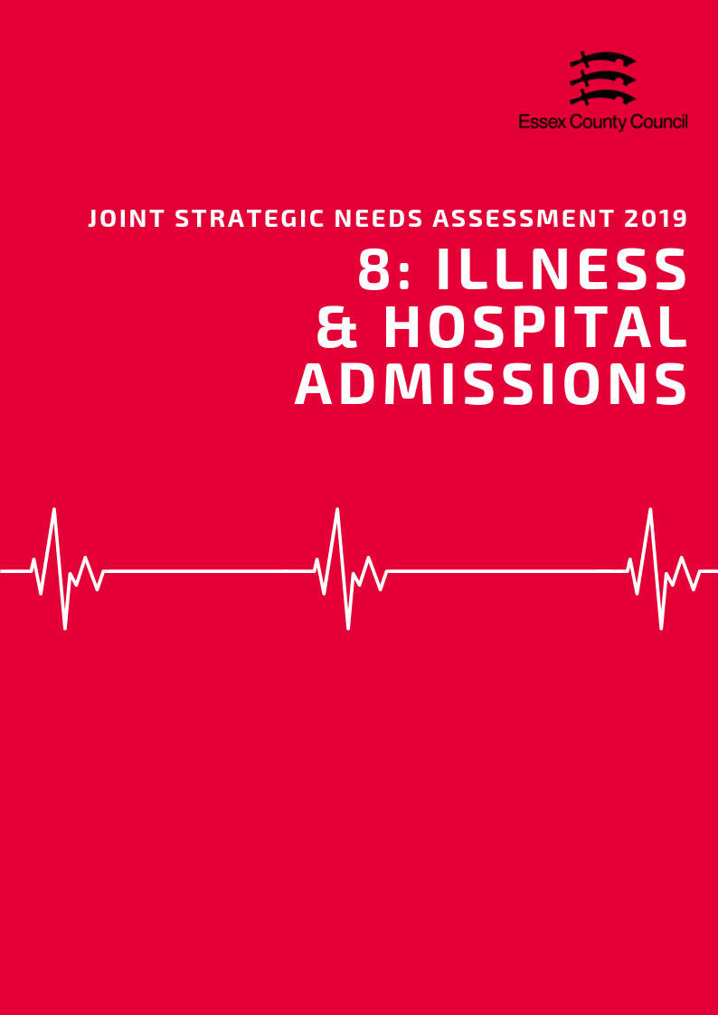

**Illness & Hospital Admissions**

***Emergency Hospital Admissions***

Emergency (unplanned) hospital admissions are both costly to the Health Service and can be a proxy indicator for wider health inequalities within local communities. In order to accurately compare admissions rates between areas of different sizes and compositions statistics are presented using Standardised Admission Ratio is defined as the ratio of the observed number of admissions in an area to the number expected if the area had the same age specific rates as England (Always set at 100).

***Emergency Admissions; all causes and all ages***

The admissions ratio for emergency admissions for all causes among persons of all ages was 100.26 in Tendring, which was ranked as being the 2nd highest admission ratio across the Essex Districts and was similar to the admission ratio for all causes across England (100).

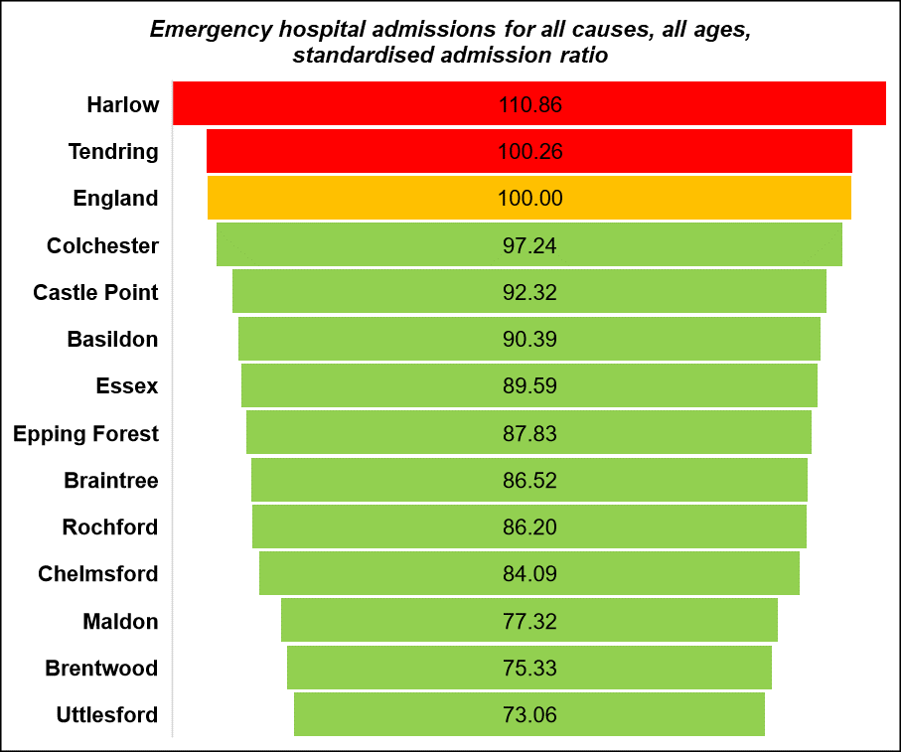

***Emergency Admissions for under 18s***

The emergency hospital admission rate per 1,000 population among those aged 18 years or younger was 8.48 in Tendring. This was ranked as being the second highest rate compared across the rates of the Essex Districts (highest: Colchester 10.09; lowest: Castle Point 3.57). Note that this data is an estimate produced by aggregating GP level data. This data is available from Public Health England Fingertips.

|  |  |  |  |  |  |  |
| --- | --- | --- | --- | --- | --- | --- |
|  | Emergency hospital admissions (standardised admission ratio) | | | | | |
|  | All causes  & All ages | Chronic Obstructive Pulmonary Disease (COPD) | Coronary Heart Disease, (CHD) | Hip fracture in persons 65 years and over | Myocardial Infarction (heart attack) | Stroke |
| Basildon | 90.4 | 116.5 | 100.4 | 103.5 | 104.0 | 113.8 |
| Braintree | 86.5 | 75.5 | 83.5 | 116.1 | 85.2 | 88.8 |
| Brentwood | 75.3 | 61.3 | 81.1 | 104.4 | 81.6 | 89.8 |
| Castle Point | 92.3 | 102.0 | 84.7 | 104.5 | 77.5 | 102.0 |
| Chelmsford | 84.1 | 61.2 | 77.2 | 107.9 | 75.4 | 89.3 |
| Colchester | 97.2 | 71.7 | 92.4 | 108.3 | 81.2 | 86.5 |
| England | 100.0 | 100.0 | 100.0 | 100.0 | 100.0 | 100.0 |
| Epping Forest | 87.8 | 78.4 | 88.3 | 99.7 | 91.9 | 89.8 |
| Essex | 89.6 | 83.2 | 90.5 | 106.2 | 87.5 | 94.3 |
| Harlow | 110.9 | 129.8 | 128.8 | 99.3 | 125.8 | 96.8 |
| Maldon | 77.3 | 52.2 | 80.8 | 105.8 | 83.9 | 80.2 |
| Rochford | 86.2 | 81.6 | 90.5 | 101.9 | 77.0 | 105.7 |
| Tendring | 100.3 | 100.3 | 105.7 | 108.4 | 93.7 | 100.1 |
| Uttlesford | 73.1 | 51.9 | 67.6 | 106.1 | 74.4 | 76.0 |

***Heart Attack***

Over the period of 2013/14 - 2017/18, the admissions ratio for emergency admissions for Myocardial Infarction (heart attack) was 93.70 in Tendring. This was ranked as being the third highest admissions ratio across the Essex Districts and higher than the admissions ratio across Essex (87.49), but better than that across England (100). Every District had a significantly better admissions ratio for Myocardial Infarction than England, with exception for Basildon and Harlow.

***Coronary Heart Disease***

The admission ratio for emergency admissions due to Coronary Heart Disease (CHD) was 105.73 in Tendring, which was ranked as the second highest admission ratio across the Essex Districts. This was also significantly worse than the admission ratio across England (100). Harlow and Tendring were the only two Districts of Essex with an admissions ratio for CHD that was significantly worse than that across England.

***Stroke***

The emergency admission ratio for Stroke in Tendring was 100.09, which was the 4th highest admission ratio compared across the Essex Districts. All Districts in Essex had an admission ratio similar to (Harlow, Rochford, Tendring) or significantly better than that of England, with exception of significantly worse in Basildon.

***Chronic Obstructive Pulmonary Disease (COPD)***

Chronic Obstructive Pulmonary Disease (COPD) refers to serious lung conditions, including chronic bronchitis and emphysema. According to data from the Hospital Episode Statistics, the age standardised rate of emergency hospital admissions for COPD in adults aged over 35 years was 428.40 per 100,000 in Tendring in 2017/18. This was ranked as the 4th highest rate across the Essex Districts (lowest: Uttlesford 215.50; highest: Basildon 490.48).

**Violence and Injuries**

***Violence Related Admissions***

In the Tendring District, the directly age standardised rate per 100,000 population of emergency hospital admissions for violence was 50.75 over the period of 2015/16 - 2017/18. This was ranked as being the highest rate compared across the Essex Districts (lowest: Uttlesford 12.80), and significantly worse than the emergency hospital admission rate for Essex as a whole (28.83) and England (43.36). Tendring was the only Essex District with this rate significantly worse relative to England.

***Injuries***

Tendring had a higher than average rate of hospital stays due to alcohol related harm with a SAR of 105.2 and was significantly worse for intentional self-harm with a rate 151.5 which was the highest rate in the county.

|  |  |  |  |  |  |
| --- | --- | --- | --- | --- | --- |
|  | **Unintentional and deliberate injuries (per 10,000)** | | **Hospital admissions for violence (Incl. sexual violence) *Directly Age Standardised Per 100K*** | **Hospital Stays (Standardised Admissions Ratios)** | |
| **Children (aged 0-14 years)** | **Young People (aged 15-24)** | **For alcohol-related harm** | **For self-harm** |
| **England** | **96.44** | **132.67** | **43.36** | **100.0** | **100.0** |
| **Essex** | **88.22** | **125.93** | **28.83** | **86.1** | **81.6** |
| Basildon | 56.04 | 188.13 | 34.50 | 85.9 | 57.5 |
| Braintree | 96.73 | 135.54 | 18.06 | 77.7 | 78.4 |
| Brentwood | 65.56 | 112.42 | 20.47 | 67.9 | 40.1 |
| Castle Point | 70.35 | 107.87 | 28.24 | 89.1 | 62.0 |
| Chelmsford | 99.08 | 136.21 | 26.99 | 75.4 | 76.9 |
| Colchester | 120.74 | 124.52 | 34.90 | 93.0 | 130.6 |
| Epping Forest | 88.23 | 89.35 | 29.05 | 87.4 | 47.7 |
| Harlow | 85.02 | 105.57 | 34.25 | 111.0 | 87.7 |
| Maldon | 95.84 | 114.00 | 23.93 | 72.6 | 61.9 |
| Rochford | 73.12 | 93.17 | 17.86 | 81.2 | 59.8 |
| Tendring | 112.74 | 114.68 | 50.75 | 105.2 | 151.5 |
| Uttlesford | 69.12 | 118.85 | 12.80 | 75.8 | 68.4 |

***Injuries to Children & Young People***

The rate of hospital admissions caused by unintentional and deliberate injuries in children aged under 15 years per 10,000 resident population aged under 15 was 112.74 in Tendring in 2017/18. This was the second highest rate compared across the Districts in Essex, and higher than the rate across Essex (88.22) and England (96.44). Colchester, Tendring and Chelmsford were the only Districts with rates higher than Essex and England. The rate of injuries for young people age 15-24 was 114.68 but was lower than the rate for Essex or England.

**Falls and Hip Fractures**

According to data from the Hospital Episode Statistics, the age standardised rate of emergency hospital admissions due to falls in persons aged over 65 years was 1955.95 per 100,000 in Tendring in 2017/18. This was lower than the rate across Essex (2059.46) and England (2170.43).

|  |  |  |  |  |  |  |
| --- | --- | --- | --- | --- | --- | --- |
|  | **Emergency hospital admissions due to falls** | | | **Hip fractures** | | |
| **All Persons Aged 65 and over** | **Age 65-79** | **Age 80+** | **All persons aged 65 and over** | **Age 65-79** | **Age 80+** |
| England | 2170.43 | 1032.87 | 5469.37 | 577.76 | 246.32 | 1539 |
| Essex | 2059.46 | 940.94 | 5303.19 | 611.9 | 259.41 | 1634 |
| Basildon | 2677.1 | 1345.86 | 6537.69 | 617.96 | 300.99 | 1537 |
| Braintree | 2122.3 | 950.99 | 5519.13 | 716.43 | 269.9 | 2011 |
| Brentwood | 2071.46 | 1067.65 | 4982.49 | 623.82 | 337.66 | 1454 |
| Castle Point | 2362.11 | 912.43 | 6566.18 | 588.79 | 207.44 | 1695 |
| Chelmsford | 1929.67 | 883.43 | 4963.76 | 565.04 | 214.47 | 1582 |
| Colchester | 1945.47 | 921.23 | 4915.78 | 626.55 | 261.02 | 1687 |
| Epping Forest | 1772.09 | 774.38 | 4665.45 | 542.61 | 239.76 | 1421 |
| Harlow | 1742.48 | 830.26 | 4387.93 | 615.28 | 291.71 | 1554 |
| Maldon | 1877.77 | 876.69 | 4780.91 | 604.99 | 264.76 | 1592 |
| Rochford | 2258.51 | 850.92 | 6340.51 | 607.61 | 219.16 | 1734 |
| Tendring | 1955.95 | 902.11 | 5012.1 | 660.87 | 292.17 | 1730 |
| Uttlesford | 1871.26 | 822.68 | 4912.14 | 532.18 | 215.53 | 1450 |

In Tendring in 2017/18, the age standardised rate of emergency hospital admissions due to hip fractures among persons aged over 65 years was 660.87 per 100,000 population. This was higher than the rate across Essex as a whole (611.91) and England (577.76) and was ranked as being the second highest rate across the Districts in Essex (highest: Braintree 716.43; lowest: Uttlesford 532.18).

**ILLNESS AND LONG TERM CONDITIONS**

As part of the Quality Outcomes Framework (QOF) each GP surgery records the percentage of registered patients who have been diagnosed with a range of different medical conditions. This rate is known as QOF prevalence which along with records from of practices can be combined to give a prevalence level at different geographies.

***Hypertension & Stroke***

In 2015/16, the estimated proportion of all those registered at General Practitioner surgeries in the Tendring District with a diagnosis of Hypertension was 19.58%. This was higher than the prevalence across Essex as a whole (15.11%) and England (13.94%) and was ranked as being the highest QOF prevalence compared across the Essex Districts (lowest: Colchester 13.32%). Rochford, Castle Point, Maldon and Tendring were the only Districts across Essex with a Hypertension QOF prevalence higher than both England (13.94) and Essex (15.11).

In the Tendring District in 2015, the prevalence of diagnosed hypertension among persons aged over 16 years was estimated to be 27.44. This was higher than the prevalence across England (20.78) and was ranked as being the highest prevalence across the Essex Districts (highest: Tendring 27.44; lowest: Colchester 19.01).

Tendring was also ranked as having the highest prevalence of undiagnosed hypertension among persons aged over 16, with an estimate of 14.04 (lowest: Colchester 11.61). This was also higher than the estimated prevalence across England (12.15).

The percentage of patients in the Tendring District with a stroke or transient ischemic attack, as registered on the disease practice register, was 2.47% in 2017/18. This was higher than that across Essex (1.76%) and England (1.77%) and ranked as being the highest across the Essex Districts.

***Coronary Heart Disease***

The QOF prevalence of Coronary Heart Disease (CHD) in the Tendring District was 5.05% in 2017/18. This was ranked as the highest estimated prevalence across the Essex Districts, and higher than the prevalence across the whole of Essex (3.16%) and England (3.13%).

Among persons aged between 55 - 79 years in Tendring, the estimated prevalence of CHD was 8.80 in 2015. This was ranked as being the highest estimated prevalence across the Essex Districts, and higher than the prevalence across England (7.94).

***Asthma***

The proportion of all those registered at General Practitioner surgeries in the Tendring District with a diagnosis of Asthma was estimated to be 6.90%. This was ranked as being the highest prevalence compared across the other Districts in Essex and was higher than that across England (5.93%). Note that this estimate is produced by aggregating from GP level data.

***Epilepsy***

In 2017/18, the estimated proportion of all those registered at General Practitioner surgeries in the Tendring District with a diagnosis of Epilepsy was 1.05%. This was ranked as being the highest QOF prevalence compared across the Essex Districts, and was higher than the prevalence across England (0.80).

***Dementia***

The proportion of patients of all ages registered at General Practitioner surgeries in Tendring with a diagnosis of Dementia was estimated to be 1.07%. This was ranked as being the highest prevalence compared across the other Districts in Essex and was higher than the prevalence across Essex (0.81%) and England (0.77%).

Among persons aged over 65 years in the Tendring District in 2018, the estimated Dementia diagnosis rate was 54.5. This was lower than the diagnosis rate across Essex as a whole (61.1) and England (67.5) and was ranked as being the second lowest rate compared across the Essex Districts (highest: Epping Forest 80.9; lowest: Maldon 52.1).

In 2019 information from Projecting Older People’s Population Information (POPPI) estimated that there were 3104 people with dementia which would rise to 4684 by 2035. Projected numbers are set out in the table below (Source: POPPI 2019)

***Table: QOF Prevalence of Long -Term Conditions***

|  |  |  |  |  |  |
| --- | --- | --- | --- | --- | --- |
|  | **QOF Prevalence (% of GP Registered Patients)** | | | | |
|  | **Asthma**  **(all ages)** | **Dementia**  **(all ages)** | **Epilepsy (18+)** | **Hypertension (all ages)** | **Stroke (all ages)** |
| **England** | **5.93** | **0.76** | **0.80** | **13.94** | **1.77** |
| Basildon | 6.09 | 0.69 | 0.78 | 14.96 | 1.82 |
| Braintree | 6.29 | 0.80 | 0.89 | 13.70 | 1.77 |
| Brentwood | 5.29 | 0.90 | 0.73 | 14.67 | 1.89 |
| Castle Point | 5.87 | 0.77 | 0.80 | 18.07 | 1.87 |
| Chelmsford | 6.08 | 0.72 | 0.75 | 13.76 | 1.55 |
| Colchester | 5.81 | 0.67 | 0.80 | 13.32 | 1.43 |
| Epping Forest | 5.10 | 1.06 | 0.59 | 13.95 | 1.61 |
| Harlow | 5.83 | 0.59 | 0.81 | 13.40 | 1.48 |
| Maldon | 6.40 | 0.78 | 0.82 | 16.19 | 1.92 |
| Rochford | 5.94 | 1.04 | 0.70 | 16.13 | 1.89 |
| Tendring | 6.90 | 1.07 | 1.05 | 19.58 | 2.47 |
| Uttlesford | 6.55 | 0.79 | 0.64 | 14.41 | 1.58 |

|  |  |  |  |  |  |
| --- | --- | --- | --- | --- | --- |
| **Projected number of people age 65+ with Dementia** | **2019** | **2020** | **2025** | **2030** | **2035** |
| **Essex** | 21,972 | 22,478 | 25,510 | 29,437 | 33,729 |
| Basildon | 2,284 | 2,316 | 2,595 | 2,926 | 3,349 |
| Braintree | 2,174 | 2,225 | 2,595 | 3,114 | 3,633 |
| Brentwood | 1,264 | 1,276 | 1,403 | 1,576 | 1,744 |
| Castle Point | 1,566 | 1,619 | 1,840 | 2,129 | 2,338 |
| Chelmsford | 2,452 | 2,503 | 2,908 | 3,330 | 3,799 |
| Colchester | 2,323 | 2,396 | 2,689 | 3,180 | 3,639 |
| Epping Forest | 1,967 | 1,994 | 2,233 | 2,541 | 2,858 |
| Harlow | 1,018 | 1,024 | 1,111 | 1,229 | 1,370 |
| Maldon | 1,053 | 1,103 | 1,319 | 1,597 | 1,835 |
| Rochford | 1,417 | 1,444 | 1,661 | 1,880 | 2,133 |
| Tendring | 3,104 | 3,183 | 3,576 | 4,112 | 4,684 |
| Uttlesford | 1,309 | 1,349 | 1,625 | 1,944 | 2,275 |

***Cancer***

The NHS estimates that more than 1 in 3 people will develop some form of cancer during their lifetime with the 4 most common types of cancer being:

* lung cancer
* breast cancer
* prostate cancer
* bowel cancer

The following incidence ratio of all cancers and the major cancer sub-types are the standardised incidence ratio, the number of observed new cases as a percentage of number expected new cases, calculated relative to England (100) during the period of 2012-2016.

|  |  |  |  |  |  |
| --- | --- | --- | --- | --- | --- |
|  | Incidence Rates of Cancers | | | | |
| Breast Cancer | Colorectal Cancer | Lung Cancer | Prostate Cancer | All Cancers |
| **England** | **100.00** | **100.00** | **100.00** | **100.00** | **100.00** |
| **Essex** | **100.97** | **97.58** | **90.53** | **104.12** | **98.49** |
| Basildon | 106.58 | 102.13 | 108.63 | 92.01 | 104.75 |
| Braintree | 98.81 | 88.86 | 84.42 | 104.95 | 95.66 |
| Brentwood | 99.53 | 88.81 | 68.29 | 101.00 | 93.95 |
| Castle Point | 92.74 | 92.87 | 101.61 | 93.50 | 96.58 |
| Chelmsford | 104.20 | 99.87 | 70.10 | 99.10 | 92.40 |
| Colchester | 98.63 | 98.14 | 84.95 | 112.32 | 97.99 |
| Epping Forest | 103.04 | 103.80 | 96.50 | 132.98 | 104.62 |
| Harlow | 100.36 | 98.95 | 123.62 | 95.24 | 105.18 |
| Maldon | 105.22 | 93.31 | 83.34 | 95.07 | 93.35 |
| Rochford | 96.24 | 98.32 | 80.73 | 97.19 | 91.62 |
| Tendring | 97.98 | 101.04 | 106.26 | 109.79 | 104.66 |
| Uttlesford | 108.04 | 96.62 | 67.11 | 102.20 | 94.02 |

The incidence ratio for all cancers over the period of 2012 - 2016 in the Tendring District was 104.66. This was significantly worse than the incidence ratio for all cancers across England (100) and was ranked as being the 3rd highest across the Essex Districts (highest: Harlow: 105.18; lowest: Rochford 91.62). Basildon, Epping Forest, Harlow and Tendring were the only Essex Districts with an incidence ratio of all cancers significantly worse than England.

In Tendring, the incidence ratio for lung cancer was 106.26. This was similar to the incidence ratio relative to England (100) and was ranked as being the 3rd highest across Essex Districts (highest: Harlow 123.62; lowest: Uttlesford 67.11).

The incidence ratio for Breast Cancer was 97.98 in Tendring, which was ranked as being the second lowest incidence ratio compared across the Districts of Essex (highest: Uttlesford 108.04; lowest: Castle Point 92.74). However, the incidence ratio of all Districts in Essex for breast cancer was not significantly different to England (100).

The incidence ratio for colorectal cancer was 101.04, which was ranked as being the 3rd highest incidence ratio across the Essex Districts (highest: Epping Forest 103.80; lowest: Braintree 88.86). However, with exception of Braintree, the incidence ratios for colorectal cancer of all Essex Districts were similar relative to England (100).

The incidence ratio of prostate cancer was 109.79, which was ranked as being the third highest incidence ratio across the Essex Districts (highest: Epping Forest 132.98; lowest Basildon 92.01). This was also significantly worse relative to the incidence of prostate cancer across England (100).

***Musculoskeletal (MSK) Conditions***

An estimated 47.7% of residents were recorded as reporting a long term musculoskeletal (MSK) problem. This was the highest level in the county and higher than the rate for Essex (34.9%) and (33.5%)

The percentage of residents reporting a long term back problem (13.1%) was also higher the average for England (9.4%) and Essex (9.3%), as was the percentage of residents reporting arthritis or a long term joint problem (17.6%). Both were also the highest levels in the county.

The QOF prevalence of patients aged 50+ recorded with a diagnosis of Osteoporosis (0.41%) was lower than the national average (0.62%) and but just above than the average for Essex (0.39%).

|  |  |  |  |  |
| --- | --- | --- | --- | --- |
|  | **% reporting a long term MSK problem** | **% reporting a long-term back problem** | **% reporting arthritis or long-term joint problem** | **Osteoporosis: QOF prevalence (50+)** |
| Basildon | 33.5 | 9.4 | 11.5 | 0.35 |
| Braintree | 33.4 | 8.7 | 12.8 | 0.45 |
| Brentwood | 35.7 | 10.5 | 13.0 | 0.42 |
| Castle Point | 39.3 | 9.4 | 15.3 | 0.26 |
| Chelmsford | 30.8 | 7.5 | 11.3 | 0.4 |
| Colchester | 32.0 | 8.2 | 10.6 | 0.56 |
| England | 33.5 | 9.4 | 12.2 | 0.62 |
| Epping Forest | 32.0 | 8.7 | 11.7 | 0.42 |
| Essex | 34.9 | 9.3 | 12.6 | 0.39 |
| Harlow | 33.4 | 10.5 | 11.9 | 0.27 |
| Maldon | 36.6 | 11.3 | 13.3 | 0.33 |
| Rochford | 36.8 | 8.0 | 13.4 | 0.29 |
| Tendring | 47.7 | 13.1 | 17.6 | 0.41 |
| Uttlesford | 29.8 | 8.2 | 9.8 | 0.36 |

***Diabetes***

Diabetes is a lifelong condition that causes a person's blood sugar level to become too high.

There are 2 main types of diabetes:

* type 1 diabetes – where the body's immune system attacks and destroys the cells that produce insulin
* type 2 diabetes – where the body does not produce enough insulin, or the body's cells do not react to insulin

Type 2 diabetes is far more common than type 1. In the UK, around 90% of all adults with diabetes have type 2.

The recorded QOF prevalence of Diabetes for people aged 17+ in the North East Essex CCG area was 6.8%. This is higher than the average for England (6.5%) and Essex (6.6%) was the second highest prevalence rate out of the 5 CCGs in Essex. It is estimated that up to 9% of residents in this CCG area may have diabetes including those who are currently undiagnosed,

Diabetes can reduce the blood supply to feet and cause a loss of feeling known as peripheral neuropathy. This can mean foot injuries don't heal well and you may not notice if your foot is sore or injured. Annual foot checks for people with diabetes are therefore an essential part of care monitoring procedures. In the North East Essex CCG area, an estimated 81.8% of people with Type 1 diabetes and 85.5% of people with type 2 diabetes have received an annual foot check. This is higher than the average for England and is the only area to have rates well below the national average.

|  |  |  |  |  |
| --- | --- | --- | --- | --- |
|  | Diabetes: QOF prevalence (17+) | Estimated prevalence of diabetes (undiagnosed and diagnosed) | People with type 1 diabetes who have received an annual foot check | People with type 2 diabetes who have received an annual foot check |
| England | 6.5% | 8.5% | 70.1% | 79.4% |
| Essex | 6.6% | 8.5% |  |  |
| NHS Basildon And Brentwood CCG | 6.4% | 8.2% | 61.8% | 65.9% |
| NHS Castle Point and Rochford CCG | 7.2% | 8.6% | 54.4% | 61.8% |
| NHS Mid Essex CCG | 6.4% | 8.1% | 58.3% | 65.7% |
| NHS North East Essex CCG | 6.8% | 9.0% | 81.8% | 85.5% |
| NHS West Essex CCG | 6.2% | 8.1% | 64.0% | 72.4% |

**Vaccinations**

Vaccinations are one of the most important interventions in place to prevent the spread of avoidable diseases amongst the population. In the UK the majority of vaccinations are given childhood, with a number of boosters and additional vaccinations also given to people of different ages who might be at higher risk from certain diseases.

Across the UK vaccination rates are declining with fewer people completing full courses of vaccinations compared to recent years leading to increased potential for outbreaks of diseases within an area. According to the NHS "If 95% of children receive the MMR vaccine, it's possible to get rid of measles. However, measles, mumps and rubella can quickly spread again if fewer than 90% of people are vaccinated."

***Vaccine Preventable Conditions***

Variation in incidence rates for certain conditions which are considered vaccine preventable may reflect differences in underlying population including the uptake of vaccination. Public Health England suggests that high prevalence of the following conditions "should prompt a review of routine immunisation uptake and vaccination of high risk groups".

|  |  |  |  |  |  |
| --- | --- | --- | --- | --- | --- |
|  | **Mumps 5-year incidence rate/100,000** | **Mumps incidence rate/100,000** | **Pertussis incidence rate/100,000** | **Measles 5-year incidence rate/100,000** | **Measles incidence rate/100,000** |
| Basildon | 1.33 | 0.55 | 0.54 | 0.00 | 0.54 |
| Braintree | 2.27 | 0.00 | 9.89 | 0.27 | 0.66 |
| Brentwood | 2.39 | 0.00 | 3.92 | 0.80 | 0.00 |
| Castle Point | 1.80 | 1.11 | 4.45 | 1.57 | 11.13 |
| Chelmsford | 3.26 | 1.15 | 0.57 | 0.12 | 0.00 |
| Colchester | 3.10 | 2.14 | 14.20 | 0.11 | 0.00 |
| England | 3.60 | 3.25 | 7.80 | 1.49 | 1.74 |
| Epping Forest | 2.49 | 0.77 | 1.53 | 1.09 | 3.83 |
| Essex | 2.07 | 1.10 | 5.45 | 0.38 | 1.50 |
| Harlow | 2.13 | 2.33 | 3.48 | 0.00 | 3.48 |
| Maldon | 0.32 | 0.00 | 1.56 | 0.00 | 0.00 |
| Rochford | 2.36 | 3.50 | 1.16 | 0.24 | 1.16 |
| Tendring | 1.43 | 0.70 | 6.22 | 0.29 | 0.69 |
| Uttlesford | 0.00 | 1.16 | 14.83 | 0.72 | 0.00 |

***Measles***

In 2018 the rate of measles per 100,000 people in Tendring was 0.69 and was lower than the England average of 1.7.

***Mumps***

The incidence rate of Mumps in 2017 was 0.7 per 100,000 and was below the rate for England (3.2) and Essex (1.1).

***Pertussis (Whooping Cough)***

The incidence rate of pertussis in 2017 was 6.22 per 100,000 people and was significantly higher than the average for Essex (5.4 per 100,000) but lower than England (7.8 per 100,000).

***Childhood Vaccination Coverage***

Data on Childhood Vaccinations is largely presented as the average for the CCG area, using data amalgamated up from individual GP practices. These averages can be positively skewed by figures higher performing practices in the area and mask coverage issues at a more local level. As such we have also analysed vaccination coverage levels within relevant age groups against two additional criteria recorded by NHS England;

* The number and percentage of GP practices meeting the minimum of 90% of patients vaccinated
* The number and percentage of GP practices meeting the target of 95% or more patients vaccinated

*Tables at the end of this chapter provide a full breakdown of current childhood vaccination coverage levels by CCG area.*

***Measles, Mumps and Rubella (MMR)***

By age 5 it is estimated that 96.5% of the GP registered children in the North East Essex CCG have received one of the two MMR vaccination injections required to achieve full vaccination coverage. This is higher than the average for England of 94.9% and similar to the Essex average of 96.5%, with 31 out of 37 GP practices (83.8%) in the area achieving at least 95% coverage or Higher.

By comparison the rate of GP registered children who have received both of MMR vaccination injections by age five drops to 86.6%, which is lower than the England (87.2%) and Essex (89.4%) averages and well below the 95% needed to eliminate measles within the population. NHS England Child Vaccination coverage statistics identified 22 out of 37 GP practices (79.5%) in the CCG area with less than 90% vaccination coverage of the eligible population, and only 2 practices (5.4%) which were achieving coverage of 95% or higher. The level practices achieving less than 90% coverage is far higher than the county average (45.5%) and is the lowest performing CCG in Essex (Lowest: Mid Essex CCG = 22.8%; Highest: West Essex CCG = 60.6%).

***Diphtheria, Tetanus, Pertussis (Whooping Cough), Polio, Haemophilus Influenzae Type B (hib): DTaP/IPV/Hib***

96.2% of GP registered children in the North East Essex CCG area had received the full course of DTaP/IPV/Hib injections by Age 5. This is just below the Essex average of 97.1%, just above the average for England (95.6%) and is the second lowest vaccination coverage level out of the 5 CCG areas in Essex (Highest: Castle Point & Rochford CCG = 98.3%; Lowest: West Essex CCG = 94.6%). At induvial practice level the NHS vaccination coverage statistics identified no practices which had coverage levels below 90% and 30 out of 37 (81.1%) which were achieving coverage levels of 95% or higher; this is similar to the averages for Essex (3%, 83.7%).

***Rotavirus***

An estimated 88.5% of GP registered children in the North East Essex CCG area had received their vaccinations against Rotavirus by 12 months; lower than the average for Essex (92.4%) and England (90.1%). Compared to the other CCG areas in Essex this is the lowest coverage level out of five areas (Highest: Mid Essex CCG = 95.1%). Looking at coverage levels across individual GP practices, NHS England statistics identified 18 practices (48.6%) which had coverage levels below 90% and 5 practices (13.5%) achieving coverage of 95% or higher. This is worse than the Essex average for both measures (22.5%, 35.4%) and is significantly lower than the highest performing area for GP surgeries achieving 95% coverage or higher (Highest: Castle Point and Rochford CCG = 62.5%).

***Pneumococcal Vaccine (PCV)***

The pneumococcal vaccine protects against serious and potentially fatal pneumococcal infections such as pneumonia, septicaemia (a kind of blood poisoning) and meningitis and is given to infants over three separate doses at 8 weeks, 16 weeks and 1 year. By 24 months 89% of the GP registered children in the North East Essex CCG area have received their PCV vaccinations; lower than the Essex (92.8%) and England (91%) average coverage levels. This is the lowest coverage level out of 5 CCG areas (Highest: Castle Point and Rochford CCG = 96.2%) with 15 out of 37 GP practices (37.8%) achieving coverage levels of less than 90% and 7 practices (18.9%) achieving coverage levels of 95% or higher. These coverage levels worse than the Essex average for both measures (77.5%, 41.6%) and has the lowest proportion achieving 95% or higher in the County (Highest: Castle Point and Rochford CCG = 70.8%).

***Meningitis***

*According to the NHS Meningitis can be caused by a number of different infections, as such a number of different vaccinations are used to offer protection against this including the MMR, DTaP/IPV/Hib, and Pneumococcal Vaccine already mentioned in this report. In addition, the NHS also includes separate vaccinations against Meningitis C (and Hib) at one year old and also Meningitis B which takes place at 8 weeks, 16 weeks and booster at 1 year.*

*Coverage levels of the Hib & Meningitis C vaccination across the North East Essex CCG area is 93.8% of eligible GP registered children by age 5, just below the Essex average of 94.8% and higher than the rate for England of 92.4%. This is the lowest coverage level out of the 5 CCGs in Essex (Highest: Castle Point and Rochford CCG = 96.5%), with 5 out of 37 GP practices (13.5%) with coverage levels below 90% and 18 practices (48.6%) achieving 95% coverage or higher. This is similar to the Essex average for practices achieving less than 90% coverage (15.2%) and lower for those achieving 95% or higher (59%).*

*Coverage levels of the new Meningitis B vaccination across the North East Essex CCG area is 92.4% of eligible GP registered children at 12 months, just below the Essex average of 94.2% and similar to the rate for England of 92.5%. This is the lowest coverage level out of the 5 CCGs in Essex (Highest: Castle Point and Rochford CCG = 95.8%) with 9 out of 37 GP practices (24.3%) with coverage levels below 90% and 14 practices (37.8%) achieving 95% coverage or higher. This is worse than the Essex average for both measures (16.9%, 46.1%) and is the second lowest CCG area for the percentage of GP practices achieving 95% coverage (Highest: Castle Point and Rochford CCG = 70.8%; Lowest: West Essex CCG = 30.3%).*

***Children in Care Immunisations***

According to figures from the Department for Education in 2018, 77.6% of children in care are up to date with the vaccinations in the NHS routine list across the whole of Essex. This is lower than the average for England (85.3%) and the East of England (85.1%) and is the 4th lowest rate out of 11 upper tier and unitary authorities in the eastern region (Highest: Norfolk = 96.3%; Lowest: Thurrock = 65.4%).

|  |  |  |  |  |  |  |  |
| --- | --- | --- | --- | --- | --- | --- | --- |
|  | ENGLAND | ESSEX | BASILDON AND BRENTWOOD CCG | CASTLE POINT AND ROCHFORD CCG | MID ESSEX CCG | NORTH EAST ESSEX CCG | WEST ESSEX CCG |
| Total no. GPs | | 178 | 39 | 24 | 45 | 37 | 33 |
| MMR 1 injection coverage at age 5 (% of eligible population) | 94.9 | 96.5 | 96.2 | 97.1 | 97.0 | 96.5 | 95.5 |
| No. GP Practices meeting the minimum 90% vaccination coverage level for MMR1at 5y |  | 173 | 38.0 | 23.0 | 44.0 | 37.0 | 31.0 |
| % GP Practices meeting the minimum 90% vaccination coverage level for MMR1 at 5y |  | 97.2% | 97.4% | 95.8% | 97.8% | 100.0% | 93.9% |
| No. GP Practices meeting the target 95% vaccination coverage level for MMR1 at 5y |  | 139 | 29.0 | 19.0 | 38.0 | 31.0 | 22.0 |
| % GP Practices meeting the target 95% vaccination coverage level for MMR1 at 5y |  | 78.1% | 74.4% | 79.2% | 84.4% | 83.8% | 66.7% |
|  |  |  |  |  |  |  |  |
| MMR 2 Injections coverage at age 5 (% of eligible population) | 87.2 | 89.4 | 90.1 | 91.5 | 91.9 | 86.6 | 87.8 |
| No. GP Practices meeting the minimum 90% vaccination coverage level for MMR2 at 5y |  | 97 | 22 | 12 | 35 | 15 | 13 |
| % GP Practices meeting the minimum 90% vaccination coverage level for MMR2 at 5y |  | 54.5% | 56.4% | 50.0% | 77.8% | 40.5% | 39.4% |
| No. GP Practices meeting the target 95% vaccination coverage level for MMR2 at 5y |  | 22 | 6 | 4 | 10 | 2 | 0 |
| % GP Practices meeting the target 95% vaccination coverage level for MMR2 at 5y |  | 12.4% | 15.4% | 16.7% | 22.2% | 5.4% | 0.0% |

|  |  |  |  |  |  |  |  |
| --- | --- | --- | --- | --- | --- | --- | --- |
|  | ENGLAND | ESSEX | BASILDON AND BRENTWOOD CCG | CASTLE POINT AND ROCHFORD CCG | MID ESSEX CCG | NORTH EAST ESSEX CCG | WEST ESSEX CCG |
| Total no. GPs | | 178 | 39 | 24 | 45 | 37 | 33 |
| PCV coverage at 24 months (% of eligible population) | 91 | 92.8 | 93.0 | 96.2 | 94.3 | 89.9 | 92.0 |
| No. GP Practices meeting the minimum 90% vaccination coverage level for PCV Booster at 24m |  | 138 | 30.0 | 21 | 41.0 | 23.0 | 23.0 |
| % GP Practices meeting the minimum 90% vaccination coverage level for PCV Booster at 24m |  | 77.5% | 76.9% | 87.5% | 91.1% | 62.2% | 69.7% |
| No. GP Practices meeting the target 95% vaccination coverage level for PCV Booster at 24m |  | 74 | 19.0 | 17 | 22.0 | 7.0 | 9.0 |
| % GP Practices meeting the target 95% vaccination coverage level for PCV Booster at 24m |  | 41.6% | 48.7% | 70.8% | 48.9% | 18.9% | 27.3% |
|  |  |  |  |  |  |  |  |
| Rotavirus vaccinations at 12 months (% of eligible population) | 90.1 | 92.4 | 92.6 | 94.9 | 95.1 | 88.5 | 90.1 |
| No. GP Practices meeting the minimum 90% vaccination coverage level for Rotavirus at 12m |  | 138 | 34 | 23 | 41 | 19 | 21 |
| % GP Practices meeting the minimum 90% vaccination coverage level for Rotavirus at 12m |  | 77.5% | 87.2% | 95.8% | 91.1% | 51.4% | 63.6% |
| No. GP Practices meeting the target 95% vaccination coverage level for Rotavirus at 12m |  | 63 | 9.0 | 15 | 27.0 | 5.0 | 7.0 |
| % GP Practices meeting the target 95% vaccination coverage level for Rotavirus at 12m |  | 35.4% | 23.1% | 62.5% | 60.0% | 13.5% | 21.2% |

|  |  |  |  |  |  |  |  |
| --- | --- | --- | --- | --- | --- | --- | --- |
|  | ENGLAND | ESSEX | BASILDON AND BRENTWOOD CCG | CASTLE POINT AND ROCHFORD CCG | MID ESSEX CCG | NORTH EAST ESSEX CCG | WEST ESSEX CCG |
| Total no. GPs | | 178 | 39 | 24 | 45 | 37 | 33 |
| Hib & MenC vaccinations at 24 months (% of eligible population) | 91.2 | 92.7 | 93.1 | 96.1 | 94.6 | 89.8 | 91.8 |
| No GP Practices meeting the minimum 90% vaccination coverage level for Hib & Men C at 5y |  | 142 | 31 | 21 | 42 | 24 | 24 |
| % GP Practices meeting the minimum 90% vaccination coverage level for Hib & Men C at 5y |  | 79.8% | 79.5% | 87.5% | 93.3% | 64.9% | 72.7% |
| No. GP Practices meeting the target 95% vaccination coverage level for Hib & Men C at 5y |  | 68 | 17 | 15 | 22 | 7 | 7 |
| % GP Practices meeting the target 95% vaccination coverage level for Hib & Men C at 5y |  | 38.2% | 43.6% | 62.5% | 48.9% | 18.9% | 21.2% |
|  |  |  |  |  |  |  |  |
| Hib & MenC vaccinations at 5 years (% of eligible population) | 92.4 | 94.8 | 95.2 | 96.5 | 95.6 | 93.8 | 93.9 |
| No GP Practices meeting the minimum 90% vaccination coverage level for Hib & Men C at 5y |  | 160 | 35 | 22 | 43 | 32 | 28 |
| % GP Practices meeting the minimum 90% vaccination coverage level for Hib & Men C at 5y |  | 89.9% | 89.7% | 91.7% | 95.6% | 86.5% | 84.8% |
| No. GP Practices meeting the target 95% vaccination coverage level for Hib & Men C at 5y |  | 105 | 25 | 17 | 30 | 18 | 15 |
| % GP Practices meeting the target 95% vaccination coverage level for Hib & Men C at 5y |  | 59.0% | 64.1% | 70.8% | 66.7% | 48.6% | 45.5% |

|  |  |  |  |  |  |  |  |
| --- | --- | --- | --- | --- | --- | --- | --- |
|  | ENGLAND | ESSEX | BASILDON AND BRENTWOOD CCG | CASTLE POINT AND ROCHFORD CCG | MID ESSEX CCG | NORTH EAST ESSEX CCG | WEST ESSEX CCG |
| Total no. GPs | | 178 | 39 | 24 | 45 | 37 | 33 |
| DTaP/IPV/Hib Vaccinations at 5 years (% of Eligible Population) | 95.6 | 97.1 | 97.0 | 98.3 | 98.0 | 96.2 | 94.6 |
| No GP Practices meeting the minimum 90% vaccination coverage level for DTaP/IPV/Hib at 5y |  | 173 | 37.0 | 24.0 | 45.0 | 37.0 | 30.0 |
| % GP Practices meeting the minimum 90% vaccination coverage level for DTaP/IPV/Hib at 5y |  | 97% | 95% | 100% | 100% | 100% | 91% |
| No. GP Practices meeting the target 95% vaccination coverage level for DTaP/IPV/Hib at 5y |  | 149 | 32.0 | 21.0 | 44.0 | 30.0 | 22.0 |
| % GP Practices meeting the target 95% vaccination coverage level for DTaP/IPV/Hib at 5y |  | 83.7% | 82.1% | 87.5% | 97.8% | 81.1% | 66.7% |
|  |  |  |  |  |  |  |  |
| MenB vaccinations at 12 months (% of eligible population) | 92.5 | 94.2 | 93.2 | 95.8 | 95.6 | 92.4 | 92.8 |
| No GP Practices meeting the minimum 90% vaccination coverage level for Men B at 12m |  | 148 | 32 | 22 | 41 | 28 | 25 |
| % GP Practices meeting the minimum 90% vaccination coverage level for Men B at 12m |  | 83.1% | 82.1% | 91.7% | 91.1% | 75.7% | 75.8% |
| No. GP Practices meeting the target 95% vaccination coverage level for Men B at 12m |  | 82 | 19 | 17 | 22 | 14 | 10 |
| % GP Practices meeting the target 95% vaccination coverage level for Men B at 12m |  | 46.1% | 48.7% | 70.8% | 48.9% | 37.8% | 30.3% |



**Mental Health**

***Common Mental Health Conditions***

According to the General Practice Patient Survey (GPPS; NHS England) in 2016/17, the prevalence of depression and anxiety among persons aged over 18 years in NHS North East Essex CCG in Essex was 14.30%. This was higher than the prevalence across Essex (12.49%) and across England (13.74%), and was ranked as being the highest prevalence compared across that of the other CCGs in Essex (lowest: NHS Mid Essex CCG 11.23%).

***Severe Mental Health Conditions***

Severe mental health conditions include schizophrenia, bipolar affective disorder and other psychoses. The prevalence of these as recorded on general practise disease registers in the Tendring District in 2017/18 was 1.00. This was the highest prevalence compared across the other Districts in Essex and was also significantly higher than the prevalence across Essex as a whole (0.80) and for England (0.94).

***Long Term Mental Health Conditions***

The prevalence of reporting a long-term mental health condition among persons aged over 18 years in the NHS North East Essex CCG of Essex, according to the GPPS, was 9.63% in 2017/18. This was slightly higher than the prevalence across Essex (8.23%) and was ranked as being the highest prevalence compared across the CCGs of Essex (lowest: NHS West Essex CCG 7.19%) but was similar to that across England (9.06%).

***Children and Young People’s Mental Health***

The Tendring District had the highest estimated prevalence of any mental health disorder among children aged between 5 to 16 years across the Districts of Essex in 2015, with a prevalence of was 9.76. This was higher than the estimated prevalence across the whole of Essex (8.71) and England (9.23). This estimate was based on the prevalence’s previously given in the Office for National Statistics survey Mental Health of Children and Young People in Great Britain (2004).

|  |  |  |  |
| --- | --- | --- | --- |
|  | **Depression and Anxiety prevalence (GP Patient Survey): % of respondents aged 18+** | **Prevalence of Severe Mental Health Conditions** | **Estimated prevalence of mental health disorders in children and young people:**  **% population aged 5-16** |
| **Essex** | **12.49** | **0.80** | **8.71** |
| **England** | **13.74** | **0.94** | **9.23** |
| Basildon | 13.28 | 0.92 | 9.29 |
| Braintree | 11.23 | 0.75 | 8.80 |
| Brentwood | 13.28 | 0.66 | 7.82 |
| Castle Point | 12.48 | 0.68 | 8.89 |
| Chelmsford | 11.23 | 0.72 | 8.24 |
| Colchester | 14.30 | 0.93 | 8.75 |
| Epping | 11.31 | 0.78 | 8.22 |
| Harlow | 11.31 | 0.81 | 9.65 |
| Maldon | 11.23 | 0.76 | 8.38 |
| Rochford | 12.48 | 0.63 | 8.24 |
| Tendring | 14.30 | 1.00 | 9.76 |
| Uttlesford | 11.31 | 0.63 | 7.67 |

***Social Isolation***

According to the Essex Residents Survey in 2018, 29.08% of residents aged 16 to 65 plus years in Tendring reported feeling isolated from others. This was the third highest percentage compared to the other Districts in Essex, and higher than that of Essex as a whole (25.50%).

***Self-Harm***

According to estimates produced by Public Health England, the Tendring District in 2017/18 had the highest rate of emergency hospital admissions for intentional self-harm among persons of all ages, with a rate of 289.20. This is significantly higher than the rate across Essex as a whole (156.98) and England (185.48). Women in Tendring had the highest admissions rate in the county (326.8) and were 1.3 more likely to be admitted to hospital for intentional self-harm than men (252.7) This is higher than the rates for women across the rest of Essex (201.7) or England (235.3).

This data is also shown by gender breakdown in the table below:

|  |  |  |  |  |  |  |
| --- | --- | --- | --- | --- | --- | --- |
| **Rate of Emergency Hospital Admissions for Intentional Self-Harm in Essex Districts, 2017/18** | | | | | | |
|  | **All Persons** | | **Male** | | **Female** | |
| **Rate** | **Rank** | **Rate** | **Rank** | **Rate** | **Rank** |
| **England** | **185.48** | **N/A** | **137.73** | **N/A** | **235.28** | **N/A** |
| **Essex** | **156.98** | **N/A** | **113.48** | **N/A** | **201.70** | **N/A** |
| Basildon | 200.48 | 3 | 153.78 | 2 | 248.32 | 3 |
| Braintree | 145.48 | 5 | 101.13 | 6 | 191.72 | 6 |
| Brentwood | 96.74 | 11 | 64.56 | 10 | 129.53 | 11 |
| Castle Point | 155.06 | 4 | 116.04 | 4 | 192.8 | 5 |
| Chelmsford | 134.88 | 7 | 75.57 | 8 | 194.97 | 4 |
| Colchester | 207.63 | 2 | 145.51 | 3 | 273.85 | 2 |
| Epping Forest | 71.73 | 12 | 52.41 | 11 | 92.48 | 12 |
| Harlow | 123.59 | 8 | 99.53 | 7 | 148.17 | 10 |
| Maldon | 112.78 | 9 | 75.47 | 9 | 149.1 | 9 |
| Rochford | 100.88 | 10 | 51.55 | 12 | 150.42 | 8 |
| Tendring | 289.2 | 1 | 252.69 | 1 | 326.81 | 1 |
| Uttlesford | 142.57 | 6 | 102.45 | 5 | 184.84 | 6 |

***Suicide***

The age-standardised mortality rate per 100,000 population from suicide and injury of undetermined intent among persons aged over 10 years in Tendring was 15.96 in 2015/17, which was ranked as being the highest rate across the Districts in Essex. This was significantly higher than the rate across Essex as a whole (10.88) and England (9.57).

Tendring was ranked as having the second highest suicide rate among males compared to that across the other Essex Districts, with a rate of 23.39. This is 59.2% higher than the rate for England (14.69) and significantly higher than Essex as a whole (16.90).

The suicide rate among females in Tendring (8.89) was also ranked as being the highest compared across the rates of that in Districts with data available, and higher than the rate across Essex as a whole (5.31) and England (4.69).

|  |  |  |  |  |  |  |
| --- | --- | --- | --- | --- | --- | --- |
|  | **Suicide Rate across Essex Districts among persons, males and females in 2015 / 17** | | | | | |
| **Persons** | | **Male** | | **Female** | |
| **Rate** | **Rank** | **Rate** | **Rank** | **Rate** | **Rank** |
| **England** | 9.57 | N/A | 14.69 | N/A | 4.69 | N/A |
| **Essex** | 10.88 | N/A | 16.90 | N/A | 5.31 | N/A |
| Basildon | 9.69 | 7 | 16.94 | 7 | - | - |
| Braintree | 11.12 | 6 | 17.61 | 6 | 5.86 | 3 |
| Brentwood | 7.78 | 10 | 12.03 | 11 | - | - |
| Castle Point | 8.34 | 8 | 13.91 | 9 | - | - |
| Chelmsford | 11.78 | 5 | 17.97 | 5 | 5.72 | 4 |
| Colchester | 13.08 | 4 | 19.6 | 4 | 6.97 | 2 |
| Epping Forest | 5.24 | 12 | 7.26 | 12 | - | - |
| Harlow | 14.9 | 2 | 23.34 | 3 | - | - |
| Maldon | 14.52 | 3 | 23.64 | 1 | - | - |
| Rochford | 8.02 | 9 | 12.36 | 10 | - | - |
| Tendring | 15.96 | 1 | 23.39 | 2 | 8.89 | 1 |
| Uttlesford | 7.74 | 11 | 13.94 | 8 | - | - |

**Data Sources and Further Information**

*There are several caveats to the estimates of prevalence of depression and anxiety, severe mental health conditions, and prevalence of reporting long-term health conditions in the Districts across Essex. The prevalence of depression and anxiety, and the reporting of long-term health conditions among residents were produced by aggregating data available from CCG level upwards to the District which the CCG is located. The prevalence of severe mental health conditions at District level was estimated through aggregating data of General Practitioner (GP) surgeries located in that District. The district level estimates were then aggregated together to provide Essex level estimates for these three indicators.

