Executive Summary
Be part of the equation
Technical report
ecda Physical Activity Analysis
Emma Farrow, Public Health Analyst; Jevon Harper, Senior Analyst

The Essex Centre for Data and Analytics (ecda) produced an interactive tool in partnership with the Essex Local Delivery Pilot in order to improve the insight available that is needed for an evidence-based approach to improving physical activity levels across Essex. This tool is the ecda Physical Activity Dashboard, located on the Essex Open Data Platform.
The data we worked on was split up into 10 different themes representing barriers and drivers to physical inactivity, such as health, economy and education and skills, and then each variable transformed into deciles. An average decile per theme was created for every LSOA, which was then weighted and combined according to a regression analysis to produce an overall score estimating the physical inactivity levels at an LSOA level. The impact of each theme on the physical inactivity scores was also ascertained from the regression analysis. Health was found to be the biggest likely driver of physical inactivity levels. On average, Essex scores 5.93 for health indicators (out of 10). Tendring has the lowest score (4.54) for health compared across all Essex Districts, lower than the Essex average along with the two other ELDP target districts, Basildon and Colchester. LSOAs with some of the lowest scores on health are located along the Tendring Coast and the Pitsea South East ward, some of the most deprived areas according to the IMD 2019 and are also of focus for the ELDP. However, other factors related to the area also have an impact on the risk of an LSOA being inactive, with economy and presence of vulnerable groups also found to be the next most important drivers.
Furthermore, a cluster analysis of all LSOAs in Essex found that there are 4 distinct groups based on similarities and differences in their drivers and barriers to physical activity. Two of these groups were found to likely have high levels of inactivity, with a range of different drivers for this within each. Cluster 1 has issues in most driver themes, especially in: Crime, Education and Skills, and Vulnerable Groups. Cluster 2 also has low scores in most driver themes, but especially in: Access and Transport, Communities and Environment, and Population. Most of the ELDP Target Areas fall within these two challenging types of clusters, with 78% of target LSOAs in Cluster 1 and 16% in Cluster 2. Most of the LSOAs in Cluster 1 are in the Basildon District, and most of the LSOAs in Cluster 2 in the Tendring District. There appears to be a socio-economic gradient according to deprivation in the clusters; the LSOAs estimated to be most the physically inactive are LSOAs with relatively high levels of deprivation and LSOAs estimated to be the least physically inactive are LSOAs with relatively lower levels of deprivation.
The tool holds a massive range of data and therefore gives great flexibility in what it can be used for. For example, you can profile your communities to identify physical activity and inactivity levels, and the extent of possible key drivers of physical activity levels down to a LSOA level. This can, in turn, provide actionable insight on specific communities in Essex and an evidence-base to inform commissioning decisions and intervention development.

Contents
Executive Summary 1
1. Introduction 4
1.1 Purpose of project 4
2. Methodology 5
2.1 Summary of literature review 5
2.2 Data collection and cleansing 6
2.3 Geography of data 8
2.4 Creation of deciles for indicators 10
2.5 Regression and weighting of variables 10
2.6 Creation of LSOA clusters 11
2.7 Dashboard and data relationships 13
3. Findings 14
3.1 Regression outputs and weighting 15
3.2 Estimated levels of physical activity in Essex 17
3.3 Findings by data theme 23
3.3.1 Health 23
3.3.2 Economy 25
3.3.3 Vulnerable groups 28
3.3.4 Active Lives measures 30
3.3.5 Crime 33
3.3.6 Access and Transport 35
3.3.7 Housing 38
3.3.8 Education and skills 40
3.3.9 Communities and Environment 43
3.3.10 Population 45
3.4 LSOA clusters 48
4. Conclusions and recommendations 52
4.1 Recommendations for further research and analysis 54
4.2 Recommendations for use of the tool 57

Introduction

The Essex Centre for Data and Analytics, also known as ecda, is a partnership venture between Essex County Council, Essex Police, the University of Essex, and the Essex Fire and Rescue to build our capacity and capability. Ecda takes a whole-system approach to bringing together data and intelligence held within the ecda partners in order to form new insight to drive evidence-based decision making. The actionable insight developed through ecda aims to improve outcomes for people, place and public services.
Ecda developed the Physical Activity Dashboard in partnership with the Essex Local Delivery Pilot (ELDP) in order to improve the insight available on physical activity levels and drivers of this at low geographical levels across Essex.
This report outlines the development of this dashboard, produced by senior and public health intelligence analysts of the ecda team within Essex County Council’s Strategy and Insight Engagement function. This includes: the scope and purpose of the project; the cleansing and structuring of data; the underlying analysis of the dataset, developing a physical inactivity score and cluster classification; and the development of the interactive PowerBI Dashboard.
A summary of key findings is also provided, such as the level of physical inactivity and potential drivers of this at a low-geographical level across Essex and resultant groupings into four clusters based on the physical inactivity drivers and barriers. Recommendations formed throughout these processes and stakeholder engagement are also provided. These form into one of three categories: suggestions for potential operational use of the dashboard and resultant processes, including commissioning decisions and intervention development; suggestions for the use of the tool as a spring-board for further research and analysis; and suggestions for further adaptation of the tool and underlying analysis.

Purpose of project

The ELDP and ecda formed a partnership to develop an interactive evidence-base to enable data-led solutions aimed towards improving and sustaining the physical activity levels within communities across Essex. According to Intelligent Health’s report, A review of physical activity data and Insight in Essex, the levels of physical inactivity are as follows within the three ELDP Target Districts:
- Basildon 28.7%
- Colchester 25.2%
- Tendring 33%
Tendring and Basildon’s physical activity rates are above the Essex inactivity rate of 26.3%, while Colchester is not far behind. Inactivity rates within these three districts are high and in need of addressing. These Districts are also amongst the most deprived districts of Essex according to Indices of Multiple Deprivation (2015 and 2019).
It was initially identified that there was a need to develop additional, improved insight at a locally granular level to what was currently available, with limitations in both data and tools. For example, there was no data on the outcome measure of physical inactivity at the level required. We also needed insight into why the ELDP Target areas have high levels of physical inactivity. This includes insight into whether there are potential barriers present within the community that, if effectively overcome, could promote and encourage residents within that community to partake in physical activity and sustain this improved health behaviour in the long-term.
Planned use of this ecda Physical Activity Dashboard by the ELDP and partners therefore includes profiling communities at granular, geographical levels, to identify such physical inactivity levels and its’ potential drivers. This, in turn, can provide the ELDP with: support for their case for need; actionable insight for specific communities; and an evidence-base for commissioning decisions and the development of interventions and pilot programmes across the Essex system and Districts. Overall, given the range of integrated data included in the ecda Physical Activity Dashboard, not only is this tool providing a unique opportunity to target determinants of physical activity in Essex, but also to identify and encourage new opportunities for cross-agency co-production to do so.

Methodology

This section of the report outlines the analytical steps taken used to create an overall ‘risk’ score summarising the challenges to increasing physical activity for each LSOA in the country. This involved:
- Reviewing existing literature to identify appropriate data sources
- Collecting data and cleansing ready for analysis
- Theming this data and the creation of decile scores for each theme
- Undertaking a regression to identify weightings to assign to each theme in order to create the physical activity risk score

Summary of literature review

A rapid systematic literature review was conducted in June 2019 of studies investigating the determinants and risk factors for physical inactivity. This, in turn, was used to inform the data to be used in the ELDP ecda Physical Inactivity Dashboard and the underlying analyses.
The literature search was conducted on a number of electronic databases, including PubMed, Open Athens and Medline, and further searches on Google Scholar. Key words used in the search included: physical inactivity, determinants, risk factors, sedentary, health behaviour and activity. Citation chasing was also used, whereby the reference sections of obtained studies were searched for further relevant studies. Upon availability, the following information was abstracted from each publication: sample size and participant demographics, the study methodology and the study findings. Approximately 50 studies were obtained and reviewed.
Many studies obtained found that wider and individual level determinants were strongly and significantly associated with physical activity levels. This included factors such as neighbourhood safety, accessibility to facilities and recreational environments, social support, education levels, employment levels, health and mental health status, and health risk behaviours such as smoking and alcohol use.

Data collection and cleansing

Early on in the project, open data sources were being located for data pertaining to the range of wider and individual factors found to associate with physical activity levels in the previously conducted literature review.
Building on the findings of our literature review, we contacted Sport England who shared the data included in their Local Insights tool. This tool contains information on wider and individual determinants of physical activity, and estimated physical activity levels. However, this tool does not provide physical activity estimates at an LSOA level and does not bring together the variables included to estimate the impact of determinants on physical activity.
This dataset geographically covered across England, and where possible this was all at LSOA level. Where LSOA level data was not available, the geographical level of data available was then used such as MSOA and Ward level (see section 2.3 for more information and definitions of geographies). The data in this dataset provided was all obtained from open data sources and consisted of the most recent time point and the time points previous to this if available.
Theming of data
Before any analysis was undertaken, each indicator was themed to align with the themes identified by Sport England within this tool. Namely, these themes are:
- Health indicates the level of health of the Essex LSOAs, with measures covering life expectancy, health outcome prevalence such as obesity and cardiovascular disease, self-reported mental health and wellbeing, hospital admissions and mortality.
- Economy indicates the state of the economy of Essex LSOAs, including information around the workforce and employment, income and debt.
- Vulnerable groups includes information around claimants of a range of benefits including for disabilities, carers, pensioners, lone-parents, and child and household poverty.
- Active Lives indicates the level of physical inactivity and activity at MSOA level, across Essex with measures including Sport England’s MSOA modelled estimates of whether an area has high participation in sport.
- Crime indicates the level of a range reported crimes across the Essex LSOAs, including rates of anti-social behaviour, drug crime and violent crime per 1,000 population.
- Access and transport indicates how well-connected the Essex LSOAs are in terms of accessibility such as through the internet, use of cars, and travel times by public transport and walking.
- Housing provides an overview of the housing sector and market, including in type of housing tenure, ownership, house prices and affordability, in the Essex LSOAs.
- Education and skills indicates the level of education and skills of the Essex LSOAs, with a range of information provided around pupil attainment and absences, and qualification levels.
- Communities and environment includes a range of information such as road safety, community cohesion and satisfaction, and the physical environment such as air quality and green space coverage.
- Population provides demographic information of the population of the Essex LSOAs, including information on age, gender, ethnic groups and marital status.
The dataset we received from Sport England contained 1,258 variables. We conducted a manual review of indicators and drew up criteria to exclude variables from the data provided to us. Variables were removed on the following basis:
- If they were more than 5 years out of date (some exceptions were made for 2011 Census variables, which were included as they are the only robust data source available for some measures)
- If the variable is a one-off measure with no planned updates
- If data is infrequently collected (again, an exception was made for census variables)
In the end we were left with 832 variables, split across the ten themes, as shown in the table below.
Theme: | Number of indicators:
Access and Transport | 13
Active Lives | 4
Communities and Environment | 31
Crime | 41
Economy | 96
Education and Skills | 29
Health | 102
Housing | 71
Population | 132
Vulnerable groups | 313

Not all of these were included in the creation of deciles by theme, more information about which can be found later in this report.
The appendix to this report contains a full list of all the variables included in this analysis, showing:
- The theme of each indicator
- Name of indicator
- The date the data was collected
- The data source
- The level of geography the data is available at
- Whether this indicator was included in the creation of theme deciles.
More information can also be found in the meta dataset published on Essex County Council’s open data platform: https://data.essex.gov.uk/dataset/emkw5/eldp-physical-activity-dashboard
Transformation of data for analysis
This dataset was originally in a wide format, whereby every England LSOA was represented in a row, with a column for every variable and time point. Meta-data for each variable was included within the column headers. Firstly, we conducted a transformation of this dataset into a long format. This involved creating a row for the value of each indicator for each LSOA and for each time point where data was available. This was conducted in R Studio, and the code can be obtained by contacting the report authors.
Once this transformation was completed, each variable was assigned a variable number. The meta-data was then removed from the transformed dataset into a separate file, and the variable number used to provide a join between the raw dataset and meta-data for the dashboard.

Geography of data

Our aim for the project was to provide insight at as low a level as possible, in order to provide insight into small areas and neighbourhoods. As such, we aimed to use LSOA data wherever possible.
These units of geography are defined as follows:
- LSOA – A Lower Layer Super Output Area (LSOA) is a small, low-level geographical area. LSOAs typically consist of a 1,000 minimum – 3,000 maximum population, and 400 minimum – 1,200 maximum households. LSOAs align to other geographical boundaries and can be aggregated up, including to MSOAs, Wards and Local Authority Districts.
- MSOA - A Middle Layer Super Output Area (MSOA) is a geographical unit constructed from groups of LSOAs. They consist of a 5,000 minimum – 15,000 maximum population, and 2,000 minimum – 6,000 maximum households. MSOAs align to other geographical boundaries, including Local Authority Districts.
Where LSOA data was not available, outputs at larger geographies (MSOA for example) were used for LSOAs where figures were not available. Below is a summary of the indicators where the outputs of larger geographies were used as LSOA figures:

Theme: | Indicator(s): | Level of geography data collected at:
Active Lives | Modelled estimates of physical inactivity | MSOA
Communities and Environment | Total income of registered Charities by Area of Benefit | Ward
Communities and Environment | Voter turnout | Ward/Electoral division
Economy | Annual household income estimates | MSOA
Health | Female & Male life expectancy | MSOA
Health | Anxiety, happiness and life satisfaction measures | County/Unitary
Health | Prevalence of various medical conditions (21 indicators) | MSOA
Health | Rate of emergency hospital admissions & A&E attendance for children under 5 | MSOA
Health | Aged 15 modelled smoking prevalence | MSOA
Health | Childhood obesity measures at reception year and year 6 | MSOA
Vulnerable groups | Households in poverty | MSOA
Vulnerable groups | Social benefits as a percentage of total household income | NUTS3

In a small amount of cases, some LSOAs had data missing for some measures. Where this was the case, these missing values were excluded from the creation of decile scores.
For more information on each indicator, please consult the appendix, which provides a full list.

Creation of deciles for indicators

All the data we had were in different formats, including rates, percentages and counts. We needed to standardise this data to allow comparison between areas, and so we converted the data into deciles. Data included in this process was restricted to the most recent time points and variables in which determining a polarity was appropriate. This therefore excluded historic data and contextual variables, such as counts of ethnic groups within populations where there is no obvious polarity. This left us with 253 variables to convert into deciles.
Initially all deciles were calculated in excel, whereby 1 represented a low score and 10 represented a high score. This was done by using the percent rank function. A low score on some variables may have indicated relatively poor performance, but on other variables a low score may have indicated a relatively good performance. Likewise, a high score could be bad on some measures and good on others. For example, a low score on an income variable represents a bad thing for that area, whilst a low score on crime would represent a good thing.
As such, we next manually reviewed all 253 variables to decide upon their polarity (e.g. whether a high score indicates poor or good performance and vice versa). All variables data was then re-coded in SPSS to reflect this assigned polarity, so that a score of 1 consistently showed relatively bad performance and a score of 10 showed relatively good performance. This was done using the re-code function in SPSS v23.
These deciles are not calculated as Essex specific. We calculated the deciles based on data for the whole of England, so that we could see in the deciles for Essex how the areas are performing nationally.
Once we had calculated the individual variable deciles, we had then grouped all of the variables into 10 driver themes. The decile for each variable within each theme was then averaged to produce an average decile by theme for every Essex LSOA. These average theme deciles were then again averaged to produce an overall average decile, termed the physical inactivity score; a score of 1 reflects the area to be likely inactive, and a score of 10 likely active. This score is therefore an abstraction based on proxy indicators as a measure of the likely presence of drivers to physical activity within each LSOA. This last process of producing the overall physical inactivity score also required outputs gained from conducting a regression analysis, as outlined below.

Regression and weighting of variables

Early on in the project, a literature review was conducted to gain understanding into the key drivers and associated factors of physical activity. Whilst this was useful in focusing efforts on sourcing data, the impact of each key driver was needed to be understood in more detail to allow the production of a more accurate overall weighted average decile by area. This was done by conducting a regression analysis with the outcomes used to produce weightings that could be applied at an LSOA level to estimate how likely that area is to be physically inactive. The data included in the analysis covered the whole of England, so that the weighting of how much impact each driver had of physical activity levels was informed by national evidence.
There was no data currently available relating to physical activity at an LSOA level. Instead, modelled figures of physical inactivity at an MSOA level, derived from Sport England’s Active Lives survey, was used as the dependent variable in the regression analysis with each LSOA within each MSOA assigned that MSOA value.
The 253 variables previously selected to transform into deciles were used as the bases for the predictor values in the regression model. This data was a mixture of counts, percentages and rates, so first the data was standardised, creating z-scores for each indicator.
A multiple linear regression model was then conducted using the modelled MSOA physical inactivity variable as the dependant variable. The 253 variables z-scores were used as the predictor variables in this model. This analysis was conducted in R Studio, and the code available from report authors.
Once analysis was completed, the overall R2 of the model was observed to see how much variance in the dependant variable, physical activity, was explained by all of the predictor variables. The individual variable coefficients were the collected to assess how much the outcome variable changes according each of the predictor variables. The resulting coefficients were grouped by the ten themes to allow us to see which themes have the biggest cumulative impact on rates of inactivity by producing an average coefficient per theme. The weightings derived from the regression analysis were then applied to each theme decile at LSOA level to then produce an overall weighted average decile score for every LSOA (aka risk of being inactive in that LSOA). The lower the average score, the more likely the population of that area is to be inactive.

Creation of LSOA clusters

Cluster analysis was next conducted to investigate whether the 872 LSOAs across all the Essex Districts ‘cluster’, or group, together based upon any similarities or differences between them on the average decile by theme in the data for each LSOA. This analysis would identify LSOAs with similar barriers in the driver themes to physical activity that may require addressing to reduce physical inactivity levels, which are then also distinct to the barriers present in another of the clusters of LSOAs. Such insights gained from these outputs can therefore show the LSOAs across Essex, even spanning across different Districts within Essex, that could benefit from similar pilot programmes and interventions. For example, the cluster analysis outputs presented may suggest that a cluster of LSOAs may require targeted interventions to specific barries whilst another of the cluster of LSOAs may require a holistic intervention approach to cover a range of potential physical activity barriers.
Firstly. the optimal number of clusters that were needed to describe the Essex LSOAs was determined using the elbow method. Based on the within and between similarity measures, N = 4 clusters were decided upon. This was the point in which the distance decrease levelled off as the number of clusters required increased - the difference in distance between N = 4 - 5 was much smaller in comparison to the difference in distance between N = 1 – 2, N = 2 – 3 and N = 3 – 4. This is shown in the graphs below.
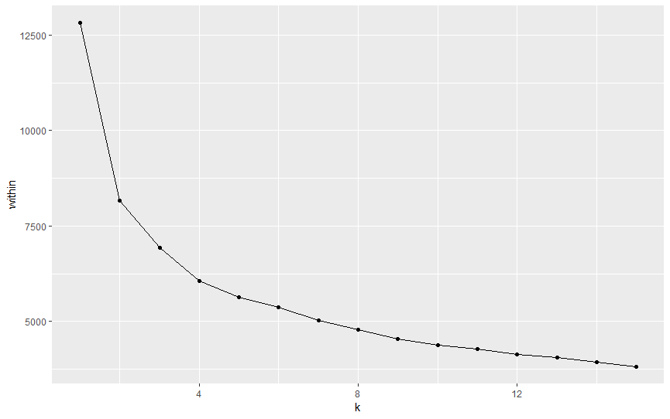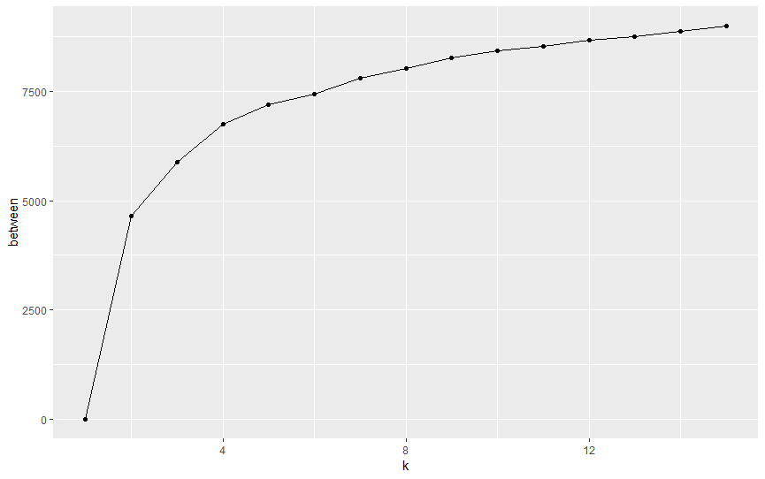
K-means clustering was then conducted to identify the 4 clusters of LSOAs based across the 10 driver theme decile data, and then subsequently categorised each of the Essex LSOAs into one of these 4 distinct clusters. All of the above Cluster Analyses processes was conducted in R Studio. The full code can be obtained via contacting the technical report authors.
The graph below shows a scatterplot of PC1 and PC2 outputs of the cluster analysis. Each LSOA is represented by a dot, and the graph visualises the variances between the LSOAs which places them in different places in the graph. This allows us to visualise which LSOAs are most similar to each other. LSOAs are colour coded by the cluster they are placed into.

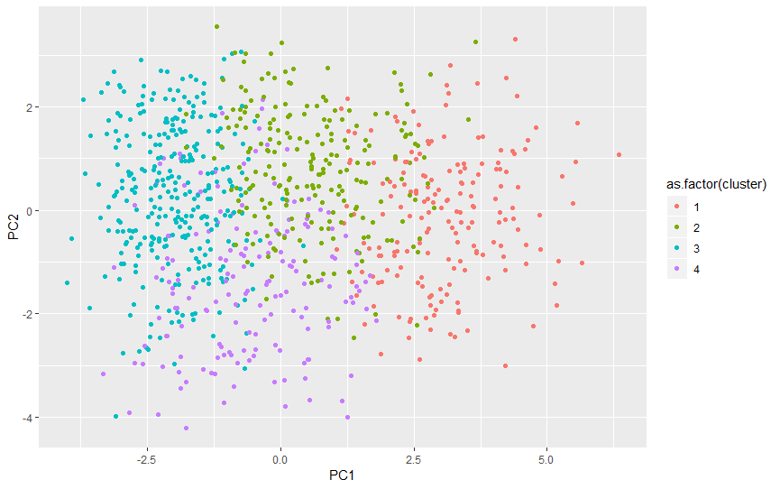
A definition to represent each cluster, including potential physical inactivity levels and its’ drivers, was then produced. This was developed by obtaining the average decile by theme for each LSOA within each of the 4 clusters, and then averaging these figures to give an average decile by theme overall for each cluster. This is provided in the table below. A lower number indicates a relatively poor performance, a potential barrier, in that theme that applies across all of the Essex LSOAs that are classified as being in that cluster.
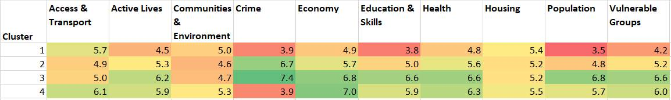

Dashboard and data relationships

In order to display and visualise the data, deciles and clusters, a dashboard was created in Microsoft Power BI. This dashboard enables the user to see a profile of each LSOA in Essex and its associated physical activity risk score and data by theme. Other tabs in the dashboard allow the user to view the spread of our LSOA clusters throughout Essex, and provides hotspot maps for each indicator used in the analysis.
In order to achieve this, the data was structured in a way so that each dataset can be separately updated. A table with geographical codes and labels was used as the central table, with all other data tables joined to this using LSOA code as the basis of the relationship, as shown in the image below.
The only exception to this are the two metadata tables, which were joined to their corresponding datasets by variable number. Two metadata tables were created, one for the full dataset, and the other only for indicators which had been included in deciles. A separate metadata table was required as there are fewer indicators within the decile dataset.
All tables can be replaced with updated datasets, as long as the previous relationships have been re-established.
All relationships were created on a many to one cardinality. This cardinality ensures the data structure remains stable, keeping the relationships in this dashboard as simple as possible.

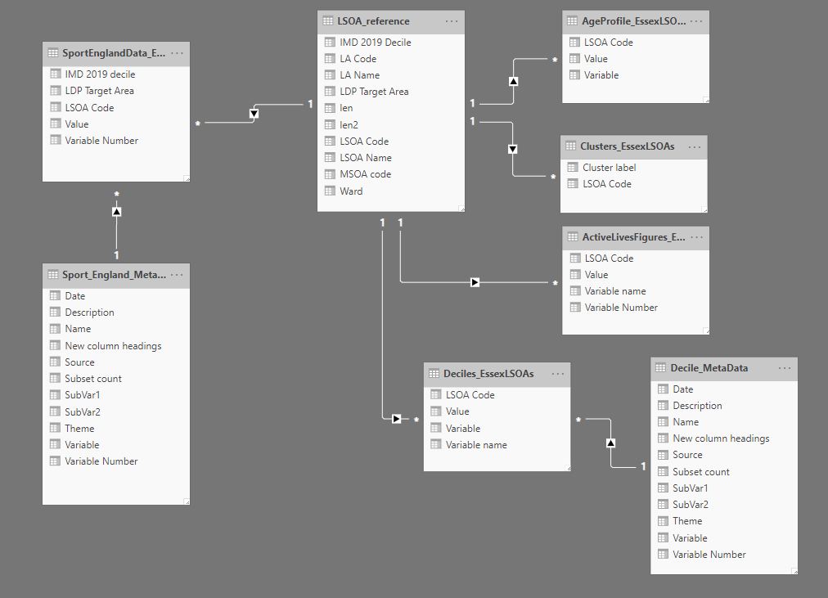

Findings

Our analysis looked at quantifying the drivers and barriers to physical inactivity at LSOA level. The dashboard, and accompanying datasets produced as part of this project, provides our findings for each of the 872 LSOAs in Essex. This section of the report outlines the headline findings of our analysis, outlining:
- The findings of our regression analysis used to weight the data to create a physical activity risk score for each LSOA
- The findings of each data theme, showing data summarised at district level, and maps which show the lowest and highest scoring areas
- The outcomes of the cluster analysis to group similar LSOAs based on shared characteristics and barriers to physical activity.

Regression outputs and weighting

The table provided below shows the average coefficients by theme, ranked from the theme found to have the highest impact to the lowest impact on the physical activity scores. It was found that the themes of Health, Economy and presence of Vulnerable Groups were the top three biggest drivers of physical inactivity at an MSOA level. The themes which were found to have the least impact on physical activity levels were Population, Community and Environment, and Education and Skills. The below ranking of the average R2 coefficients were then used as the basis of developing an amount of weighting to apply to the average decile by theme when these were averaged to produce the overall weighted average decile (e.g. the physical inactivity score) for every LSOA.
The average coefficient and weightings applied are provided in the table below:
Rank | Theme | Average coefficient | Weighting applied
1 | Health | 0.170406924 | 3
2 | Economy | 0.022662018 | 2
3 | Vulnerable groups | 0.009185299 | 1.6
4 | Active lives | 0.007342285 | 1.4
5 | Crime | 0.004904315 | 1
6 | Access | -0.011695172 | 1
7 | Housing | -0.009178436 | 0.9
8 | Education | -0.008926532 | 0.75
9 | Community | -0.004677807 | 0.5
10 | Population | -0.001078081 | 0.25
Model adjusted R-square: 0.97
The 872 LSOAs across Essex were then ranked according to the overall weighted average decile, to show the relative levels of physical inactivity present from most to least at risk of being inactive.
The table below shows the ten areas with the top 10 lowest overall weighted average scores. All of these areas are ELDP target LSOAs within the ELDP target districts, with nine of these LSOAs located in Tendring and the tenth-placed LSOA found in central Basildon.
More information on the scores by theme are provided in the next section of the report.
These 10 LSOAs with the lowest overall weighted average (e.g. likely to be most inactive) score consistently low for presence of vulnerable groups, education and skills and health. There are also some extremes in crime and population with some areas scoring as low as decile 1, while others perform relatively better.

Weighted average rank | LSOA Name | IMD 2019 decile | Weighted average | Access & transport Average | Active Lives Average | Communities & Environment Average | Crime Average | Economy Average | Education & Skills Average | Health Average | Housing Average | Population Average | Vulnerable Groups Average
1 | Tendring 018A | 1 | 4.0 | 3.2 | 4.0 | 5.3 | 1.5 | 3.6 | 2.0 | 3.2 | 5.2 | 1.1 | 2.3
2 | Tendring 018D | 1 | 4.3 | 3.3 | 4.0 | 4.2 | 2.1 | 3.8 | 3.4 | 3.2 | 4.8 | 6.2 | 2.8
3 | Tendring 015D | 1 | 4.5 | 4.4 | 4.0 | 5.0 | 2.2 | 3.6 | 2.1 | 3.6 | 5.1 | 1.1 | 3.8
4 | Tendring 015C | 1 | 4.5 | 4.1 | 4.0 | 4.7 | 5.1 | 3.2 | 2.0 | 3.5 | 5.2 | 1.4 | 3.0
5 | Tendring 018C | 1 | 4.7 | 3.8 | 4.0 | 6.0 | 4.3 | 3.8 | 2.2 | 3.2 | 5.8 | 5.6 | 2.9
6 | Tendring 015E | 1 | 4.7 | 5.1 | 4.0 | 4.9 | 4.4 | 3.6 | 2.9 | 3.4 | 5.4 | 2.6 | 2.7
7 | Tendring 018E | 3 | 4.8 | 3.1 | 4.0 | 4.2 | 4.4 | 3.8 | 4.3 | 3.3 | 5.0 | 5.1 | 3.8
8 | Tendring 013C | 3 | 4.8 | 3.9 | 4.3 | 4.2 | 4.4 | 3.6 | 3.8 | 3.8 | 4.5 | 2.9 | 3.3
9 | Tendring 015B | 4 | 4.8 | 3.9 | 4.0 | 4.0 | 7.4 | 2.7 | 3.3 | 3.6 | 4.5 | 3.2 | 3.5
10 | Basildon 013E | 1 | 4.8 | 5.6 | 3.7 | 4.7 | 3.2 | 3.4 | 2.5 | 4.3 | 5.7 | 1.7 | 3.0

The table below shows the LSOAs with the top 10 highest overall weighted average scores (e.g. most likely to be active). These LSOAs are found amongst the least deprived areas of the districts of Basildon, Brentwood and Uttlesford. Communities and environment and housing are the potential areas of concern in these areas.
Weighted average rank | LSOA Name | IMD 2019 decile | Weighted average | Access & transport Average | Active Lives Average | Communities & Environment Average | Crime Average | Economy Average | Education & Skills Average | Health Average | Housing Average | Population Average | Vulnerable Groups Average
863 | Basildon 002C | 10 | 8.5 | 5.8 | 6.7 | 5.5 | 9.4 | 6.9 | 7.3 | 6.9 | 5.0 | 8.0 | 7.3
864 | Basildon 004B | 10 | 8.6 | 6.5 | 6.7 | 5.8 | 6.5 | 7.4 | 8.1 | 7.3 | 6.1 | 4.6 | 7.0
865 | Brentwood 005D | 10 | 8.6 | 6.5 | 7.7 | 6.0 | 2.9 | 7.8 | 7.6 | 7.7 | 5.9 | 7.6 | 7.1
866 | Basildon 001E | 10 | 8.6 | 5.4 | 6.7 | 4.7 | 9.0 | 7.0 | 7.2 | 7.4 | 5.5 | 7.6 | 7.3
867 | Basildon 003B | 9 | 8.7 | 6.9 | 6.7 | 6.0 | 6.6 | 8.2 | 7.8 | 7.1 | 5.8 | 5.7 | 6.7
868 | Basildon 001D | 10 | 8.7 | 5.4 | 6.7 | 5.1 | 8.5 | 7.3 | 8.0 | 7.4 | 5.4 | 8.6 | 7.4
869 | Brentwood 005A | 10 | 8.8 | 6.5 | 7.7 | 4.8 | 7.0 | 7.8 | 8.1 | 7.7 | 5.5 | 5.1 | 6.4
870 | Brentwood 005F | 10 | 8.9 | 6.6 | 7.7 | 4.6 | 5.6 | 7.7 | 7.9 | 7.7 | 5.5 | 7.8 | 7.4
871 | Brentwood 005E | 10 | 8.9 | 6.0 | 7.7 | 5.5 | 6.4 | 7.8 | 8.0 | 7.8 | 5.6 | 4.8 | 7.5
872 | Uttlesford 001B | 10 | 9.0 | 7.3 | 7.0 | 6.7 | 7.7 | 8.1 | 7.2 | 7.0 | 6.4 | 7.3 | 7.2

The map provided below shows the locations of the LSOAs with the top 10 highest and lowest overall weighted average score.
The areas with the lowest overall average weighted scores are concentrated around Clacton and Jaywick on the Tendring coast, and with one LSOA in Pitsea in the Basildon district.
The areas with the highest overall average weighted scores are located in central Brentwood, Billericay in Basildon district, and Saffron Waldon in Uttlesford.
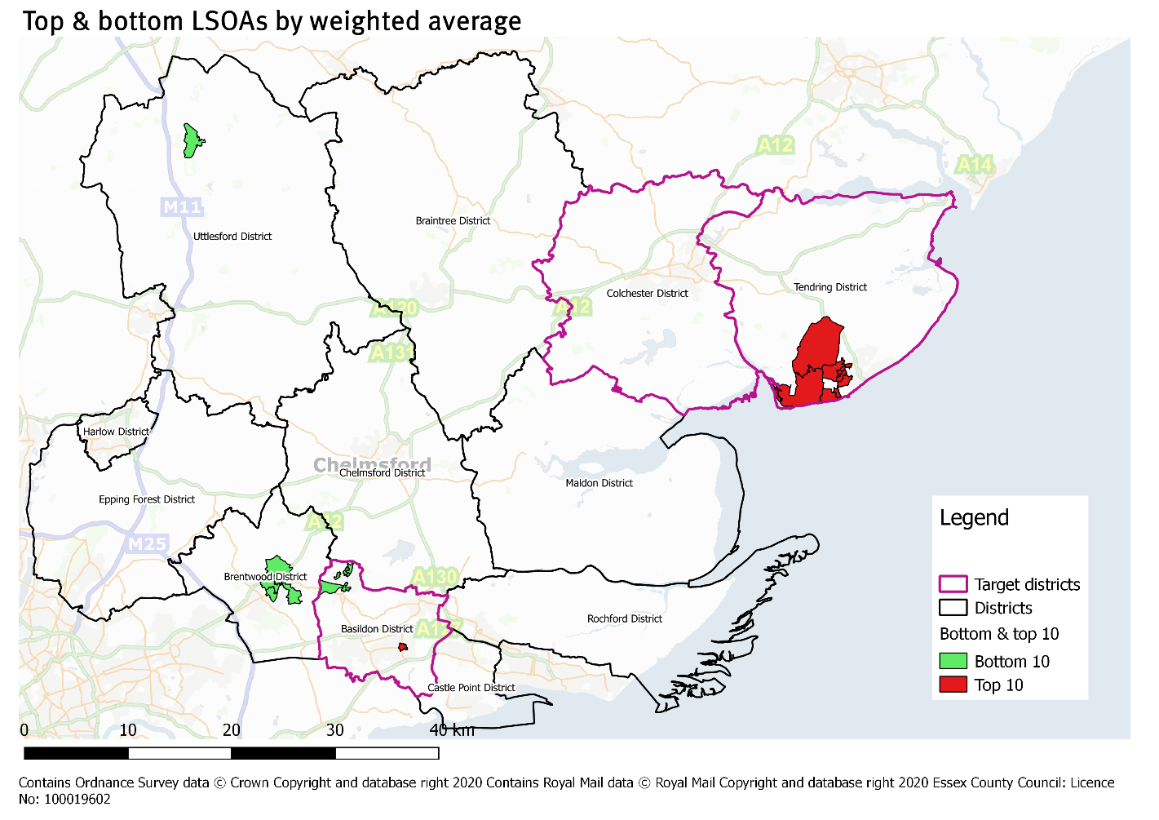

Estimated levels of physical activity in Essex

Estimated levels of physical activity in Essex
To create an estimate for physical inactivity at LSOA level, the average decile scores for each theme were weighted according to the regression findings to produce an overall score which reflects the presences of barriers and challenges across the ten themes.
Below is a summary of those weighted physical activity scores at district level.
Tendring, Harlow and Basildon have the lowest weighted scores in Essex, indicating a higher presence of barriers and challenges to physical activity (scoring 5.99, 6.47 and 6.81 out of ten respectively).
Colchester, one of the ELDP’s target districts, scores 7.06, placing it just marginally under the Essex average physical activity score.
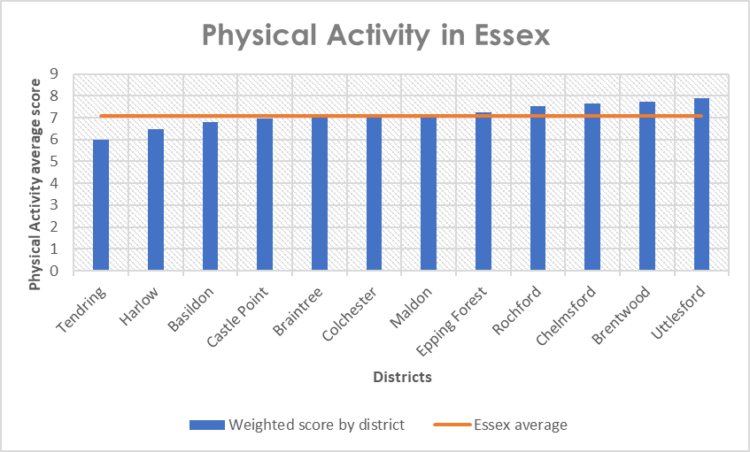
The highest scoring districts are Uttlesford, Brentwood and Chelmsford (scoring 7.88, 7.71 and 7.64 out of ten respectively).
District | Weighted score by district
Tendring* | 5.99
Harlow | 6.47
Basildon* | 6.81
Castle Point | 6.94
Braintree | 7.05
Colchester* | 7.06
Maldon | 7.15
Epping Forest | 7.23
Rochford | 7.52
Chelmsford | 7.64
Brentwood | 7.71
Uttlesford | 7.88
Essex average | 7.07
*LDP target district

Estimated levels of physical activity in LDP target areas
The ELDP’s target areas are the most deprived areas in Tendring, Basildon and Colchester. These are LSOAs which placed in deciles 1-4 of the Indices of Deprivation 2019.
Below are the average physical activity weighted scores among deprived LSOAs by Essex district. Please note, Uttlesford has no LSOAs which placed in deciles 1-4 of the Indices of Deprivation 2019, so is not included in these findings.
Tendring, Basildon and Castle Point deprived LSOAs score the lowest for physical activity score, scoring 5.55, 5.87 and 5.93 respectively.
Colchester deprived LSOAs score 6.09 on average, slightly above the average score of 5.98 for deprived LSOAs in Essex. This suggests that the barriers to physical activity in the deprived areas of Colchester are perhaps not as prevalent as they are in other districts.
Brentwood, Rochford and Chelmsford deprived LSOAs score highest (6.77, 6.51 and 6.49 respectively), however it should be noted that across all districts, the weighted scoring is a lot lower in deprived areas than the district averages. Barriers and challenges to physical activity are likely to be more prevalent in deprived areas regardless of the district.
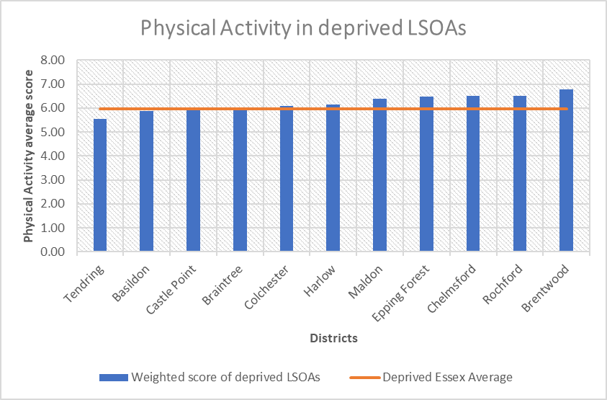
Row Labels | Weighted score of deprived LSOAs
Tendring* | 5.55
Basildon* | 5.87
Castle Point | 5.93
Braintree | 6.03
Colchester* | 6.09
Harlow | 6.14
Maldon | 6.40
Epping Forest | 6.47
Chelmsford | 6.49
Rochford | 6.51
Brentwood | 6.77
Deprived LSOA average | 5.98
*LDP target district
Physical Activity estimates mapped
The map below shows all LSOAs in Essex and a colour code according to their physical activity score (overall weighted average score). The darker red the colour, the more challenges and barriers there are to physical activity, and the brighter green the colour, the less prevalent these challenges and barriers are.
The areas of most concern are situated along the Tendring coast, central Basildon and Colchester, Harlow and Canvey Island in Castle Point.
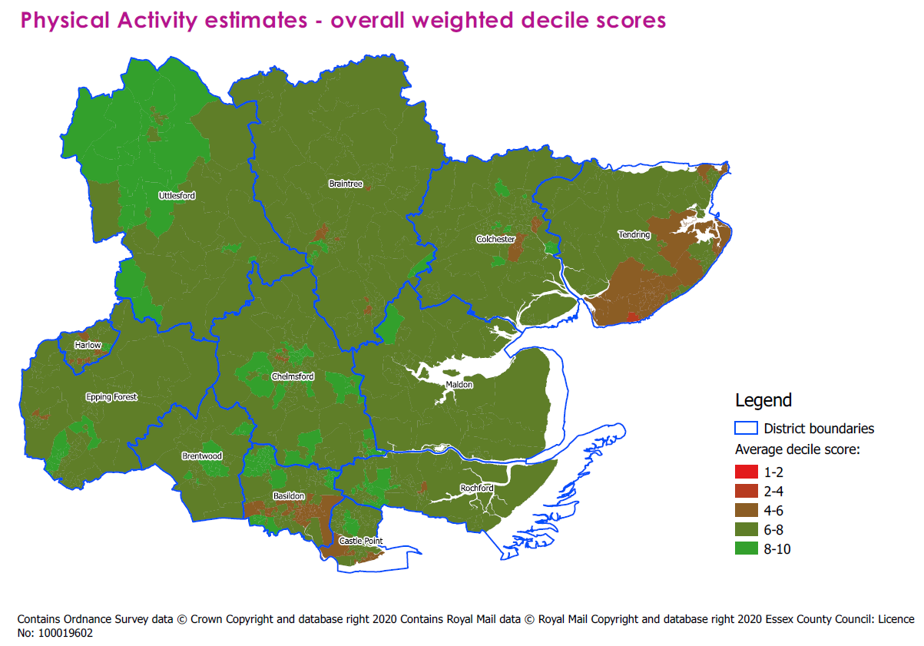
Most inactive areas of Essex
According to the weighted average decile, the top 20 areas most likely to be inactive are listed below. Of these 20, 15 are located in Tendring, and five in Basildon. All of these LSOAs are placed into deciles 1-4 of the Indices of Deprivation 2019.

Essex Weighted Average Rank | LSOA Code | LSOA Name | Ward of LSOA | LA Name | IMD 2019 decile | Weighted average
1 | E01021988 | Tendring 018A | Golf Green | Tendring | 1 | 3.97
2 | E01022045 | Tendring 018D | St Osyth and Point Clear | Tendring | 1 | 4.32
3 | E01022031 | Tendring 015D | Rush Green | Tendring | 1 | 4.52
4 | E01022030 | Tendring 015C | Rush Green | Tendring | 1 | 4.54
5 | E01021990 | Tendring 018C | Golf Green | Tendring | 1 | 4.68
6 | E01022032 | Tendring 015E | Rush Green | Tendring | 1 | 4.70
7 | E01022047 | Tendring 018E | St Osyth and Point Clear | Tendring | 3 | 4.76
8 | E01021977 | Tendring 013C | Bockings Elm | Tendring | 3 | 4.79
9 | E01022024 | Tendring 015B | Peter Bruff | Tendring | 4 | 4.79
10 | E01021306 | Basildon 013E | Pitsea North West | Basildon | 1 | 4.84
11 | E01022025 | Tendring 016B | Pier | Tendring | 1 | 4.89
12 | E01021302 | Basildon 013B | Pitsea North West | Basildon | 1 | 4.89
13 | E01021271 | Basildon 013A | Fryerns | Basildon | 1 | 4.90
14 | E01022023 | Tendring 015A | Peter Bruff | Tendring | 2 | 4.91
15 | E01021970 | Tendring 016A | Alton Park | Tendring | 1 | 4.93
16 | E01022038 | Tendring 017E | St James | Tendring | 2 | 4.94
17 | E01021304 | Basildon 013C | Pitsea North West | Basildon | 1 | 4.96
18 | E01022026 | Tendring 016C | Pier | Tendring | 1 | 4.99
19 | E01021975 | Tendring 013A | Bockings Elm | Tendring | 2 | 5.00
20 | E01021286 | Basildon 016A | Lee Chapel North | Basildon | 2 | 5.06

Most active areas of Essex
Listed below are the 20 LSOA in Essex which scored the highest weighted average scores. These areas are spread across the districts of Basildon, Brentwood, Chelmsford, Rochford and Uttlesford. All of these LSOAs are placed in deciles 9-10 of the Indices of Deprivation 2019, indicating they are a lot less deprived than the areas that score lower weighted average scores.
Interestingly, Basildon is the only district represented among the areas with the highest and lowest weighted average scores. This suggests the less deprived areas of Basildon, such as Billericay, experience fewer challenges and barriers to physical activity than the more deprived areas such as Pitsea and Fryerns.

Essex Weighted Average Rank | LSOA Code | LSOA Name | Ward of LSOA | LA Name | IMD 2019 decile | Weighted average
872 | E01022075 | Uttlesford 001B | Saffron Walden Audley | Uttlesford | 10 | 8.98
871 | E01021466 | Brentwood 005E | Shenfield | Brentwood | 10 | 8.90
870 | E01021467 | Brentwood 005F | Shenfield | Brentwood | 10 | 8.85
869 | E01021447 | Brentwood 005A | Hutton Central | Brentwood | 10 | 8.77
868 | E01021250 | Basildon 001D | Billericay West | Basildon | 10 | 8.75
867 | E01021240 | Basildon 003B | Billericay East | Basildon | 9 | 8.65
866 | E01021251 | Basildon 001E | Billericay West | Basildon | 10 | 8.61
865 | E01021465 | Brentwood 005D | Shenfield | Brentwood | 10 | 8.60
864 | E01021253 | Basildon 004B | Burstead | Basildon | 10 | 8.58
863 | E01021248 | Basildon 002C | Billericay West | Basildon | 10 | 8.53
862 | E01021239 | Basildon 003A | Billericay East | Basildon | 10 | 8.52
861 | E01021455 | Brentwood 005C | Hutton South | Brentwood | 10 | 8.52
860 | E01021247 | Basildon 003E | Billericay West | Basildon | 10 | 8.52
859 | E01021580 | Chelmsford 012D | Moulsham and Central | Chelmsford | 10 | 8.51
858 | E01021237 | Basildon 001A | Billericay East | Basildon | 10 | 8.48
857 | E01021918 | Rochford 005A | Downhall and Rawreth | Rochford | 10 | 8.48
856 | E01021453 | Brentwood 005B | Hutton North | Brentwood | 9 | 8.46
855 | E01022094 | Uttlesford 001D | Littlebury, Chesterford & Wenden Lofts | Uttlesford | 10 | 8.46
854 | E01021243 | Basildon 003D | Billericay East | Basildon | 10 | 8.46
853 | E01021584 | Chelmsford 012E | Moulsham Lodge | Chelmsford | 10 | 8.45

Overall Findings by Essex district:
The table below shows the average score by decile by Essex district. This allows you to see the difference in scores across all themes.
On a national scale, all Essex districts perform poorly on measures for Communities and environment, reflecting the fact that Essex is a largely rural based county making access to amenities more difficult for residents.
The next section of this report provides more detailed insight into each of the ten themes separately.

 | Average decile by theme:
Districts: | Health | Economy | Vulnerable Groups | Active Lives | Crime | Access & transport | Housing | Education & Skills | Communities & Environment | Population
Basildon* | 5.67 | 5.86 | 5.42 | 5.10 | 5.34 | 5.97 | 5.37 | 5.02 | 4.83 | 4.77
Braintree | 5.93 | 6.10 | 5.93 | 5.53 | 6.29 | 4.90 | 5.11 | 5.16 | 4.50 | 5.39
Brentwood | 6.73 | 6.96 | 6.15 | 6.09 | 5.88 | 5.20 | 5.35 | 6.51 | 4.73 | 6.01
Castle Point | 5.62 | 6.10 | 5.36 | 5.14 | 6.12 | 5.85 | 5.34 | 5.42 | 4.84 | 5.36
Chelmsford | 6.66 | 6.79 | 6.19 | 6.06 | 5.81 | 5.49 | 5.33 | 5.85 | 5.00 | 5.84
Colchester* | 5.89 | 6.05 | 5.64 | 5.90 | 5.58 | 5.30 | 5.29 | 5.35 | 5.12 | 5.55
Epping Forest | 6.25 | 6.49 | 5.75 | 5.69 | 5.33 | 5.47 | 5.10 | 5.79 | 4.85 | 5.19
Harlow | 5.39 | 5.16 | 5.13 | 4.71 | 4.86 | 6.07 | 5.34 | 5.24 | 4.97 | 4.86
Maldon | 6.10 | 6.32 | 5.46 | 5.98 | 6.93 | 4.30 | 5.13 | 5.19 | 4.63 | 5.77
Rochford | 6.35 | 6.56 | 6.07 | 5.43 | 6.85 | 5.62 | 5.32 | 6.08 | 4.65 | 6.25
Tendring* | 4.54 | 5.05 | 4.26 | 5.07 | 5.60 | 4.73 | 5.51 | 4.44 | 4.97 | 4.68
Uttlesford | 6.75 | 6.98 | 6.73 | 6.60 | 6.81 | 4.75 | 4.95 | 6.41 | 4.61 | 5.87
*Indicates LDP target district
Overall Findings by target areas/deprivation:
When looking at the average scores by theme by deprivation decile in Essex, there is largely a clear relationship between a lower theme score and the more deprived an area is. The exceptions to this are communities and environment, in which Essex scores poorly across the board, and housing. Interestingly, access and transport scores in deprived areas are among the highest across the deciles. This is likely because Essex’s most deprived areas are urban areas with closer proximity to local amenities than the less deprived areas which tend to be in a rural setting.
 | Average decile by theme:
IMD 2019 decile: | Health | Economy | Vulnerable Groups | Active Lives | Crime | Access & transport | Housing | Education & Skills | Communities & Environment | Population
1 (Most deprived) | 4.05 | 4.09 | 3.54 | 4.20 | 3.10 | 5.74 | 5.45 | 2.96 | 5.08 | 2.80
2 | 4.76 | 4.65 | 4.00 | 4.60 | 3.82 | 5.48 | 5.22 | 3.39 | 4.86 | 3.70
3 | 4.93 | 5.28 | 4.39 | 4.81 | 4.24 | 5.64 | 5.33 | 4.08 | 4.89 | 3.98
4 | 5.01 | 5.13 | 4.58 | 4.96 | 5.48 | 5.10 | 5.33 | 4.50 | 4.90 | 4.66
5 | 5.51 | 5.81 | 5.28 | 5.54 | 6.06 | 5.16 | 5.33 | 4.96 | 4.95 | 5.57
6 | 5.61 | 6.10 | 5.51 | 5.68 | 5.97 | 5.39 | 5.42 | 5.39 | 5.06 | 5.22
7 | 5.98 | 6.59 | 5.93 | 5.94 | 6.28 | 5.03 | 5.35 | 5.87 | 4.88 | 5.70
8 | 6.10 | 6.42 | 6.05 | 5.93 | 6.62 | 5.24 | 5.48 | 6.10 | 4.99 | 6.92
9 | 6.21 | 6.76 | 6.54 | 6.29 | 7.52 | 5.52 | 5.48 | 6.65 | 4.95 | 6.49
10 (Least deprived) | 6.92 | 7.07 | 7.05 | 6.61 | 7.31 | 5.44 | 5.56 | 7.37 | 5.25 | 6.82
Basildon, Colchester and Tendring LSOAs within deciles 1-4 chosen by the LDP as target areas

Findings by data theme

Our analysis looked at data across ten themes in order to estimate likely levels of inactivity at LSOA level.
To highlight the barriers to physical activity most prevalent in Essex, this section of the report provides a summary of our findings across these ten themes, providing the average decile scores by each Essex district, and displaying the LSOAs which score lowest across the ten themes.
The themes are presented in order of the weightings assigned to each theme in the creation of the overall physical activity score.

Health

According to our regression analysis, the health data theme was the biggest driver of physical inactivity.
On average, Essex scores 5.93 for health indicators, higher than the national average of 5.49, suggesting on the whole that Essex performs better on health measures. The highest scores are found in Uttlesford (6.75), Brentwood (6.73) and Chelmsford (6.66). The lowest scores are found in the districts of Tendring (4.54), Harlow (5.39) and Castle Point (5.62).

 | Basildon | Braintree | Brentwood | Castle Point | Chelmsford | Colchester | Epping Forest | Harlow | Maldon | Rochford | Tendring | Uttlesford | Essex average | National average
Health average decile | 5.67 | 5.93 | 6.73 | 5.62 | 6.66 | 5.89 | 6.25 | 5.39 | 6.10 | 6.35 | 4.54 | 6.75 | 5.93 | 5.49

How Essex LSOAs score nationally for health
The table below shows 20 LSOAs in Essex which score the lowest for health. The areas which experience the biggest challenges relating to health are largely concentrated on the Tendring coast, specifically in central Clacton and the surrounding areas.
Basildon also has two LSOAs in the 20 lowest scoring areas for health, both based in the Pitsea South East ward.
All of these areas are placed among the most deprived areas (deciles 1-4) according to the 2019 Indices of Deprivation.

Theme Rank | LSOA Code | LSOA Name | Ward | LA Name | IMD 2019 decile | Health Average
1 | E01021988 | Tendring 018A | Golf Green | Tendring | 1 | 3.16
2 | E01022045 | Tendring 018D | St Osyth and Point Clear | Tendring | 1 | 3.17
3 | E01022027 | Tendring 016D | Pier | Tendring | 1 | 3.18
4 | E01022026 | Tendring 016C | Pier | Tendring | 1 | 3.19
5 | E01022025 | Tendring 016B | Pier | Tendring | 1 | 3.20
6 | E01021970 | Tendring 016A | Alton Park | Tendring | 1 | 3.20
7 | E01021990 | Tendring 018C | Golf Green | Tendring | 1 | 3.21
8 | E01022047 | Tendring 018E | St Osyth and Point Clear | Tendring | 3 | 3.32
9 | E01021989 | Tendring 018B | Golf Green | Tendring | 2 | 3.34
10 | E01022032 | Tendring 015E | Rush Green | Tendring | 1 | 3.43
11 | E01022030 | Tendring 015C | Rush Green | Tendring | 1 | 3.55
12 | E01022024 | Tendring 015B | Peter Bruff | Tendring | 4 | 3.57
13 | E01022031 | Tendring 015D | Rush Green | Tendring | 1 | 3.59
14 | E01022023 | Tendring 015A | Peter Bruff | Tendring | 2 | 3.61
15 | E01022042 | Tendring 014A | St Marys | Tendring | 1 | 3.69
16 | E01022038 | Tendring 017E | St James | Tendring | 2 | 3.71
17 | E01022048 | Tendring 014C | St Pauls | Tendring | 4 | 3.71
18 | E01021315 | Basildon 018C | Pitsea South East | Basildon | 2 | 3.75
19 | E01021977 | Tendring 013C | Bockings Elm | Tendring | 3 | 3.79
20 | E01021316 | Basildon 018D | Pitsea South East | Basildon | 2 | 3.80
The map below shows where each LSOA in Essex places nationally in our health decile. As outlined in the table above, the lowest scoring areas are found around Clacton and in central Basildon. Central Colchester, Braintree, the Maldon coast, most of Harlow, Canvey Island in Castle Point and Epping Forest’s London border are placed in deciles 4-6 for health.
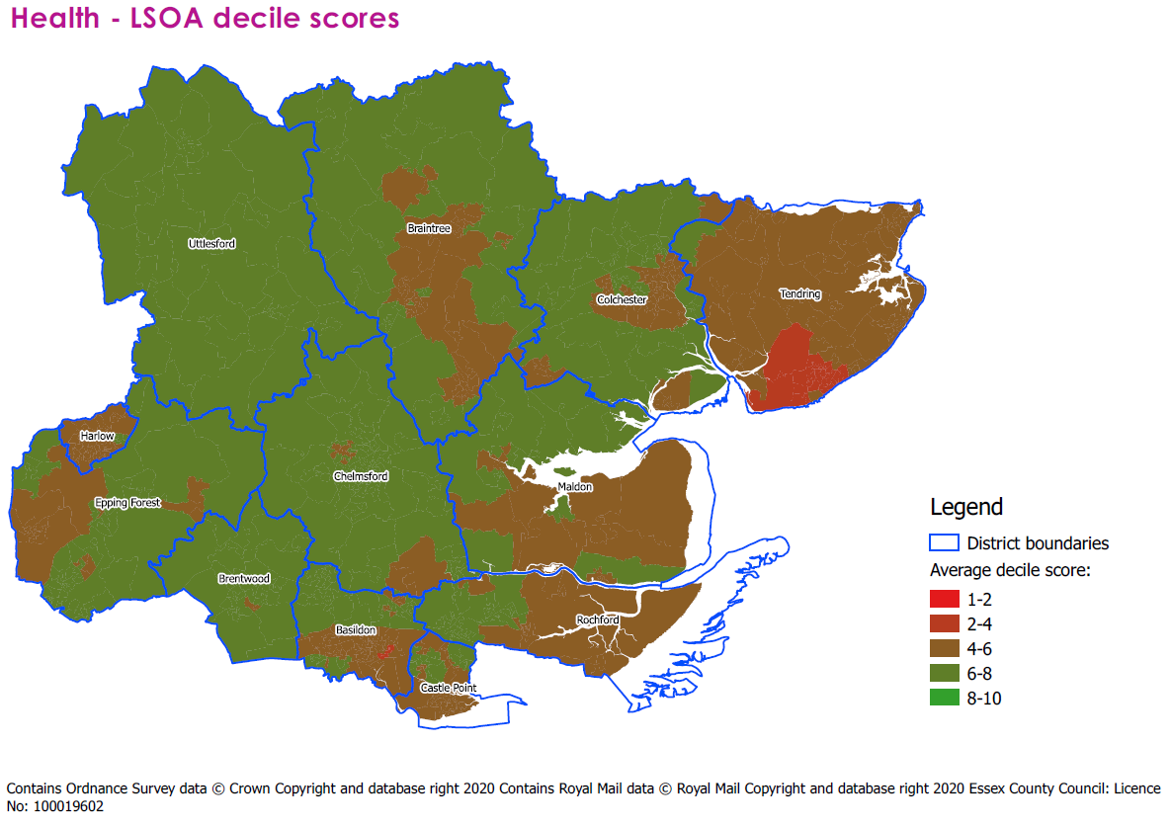
How health ranks within Essex
The map below shows each Essex LSOA ranked from 1 to 872 depending on its health decile score, with 1 being the lowest health decile score, and 872 the highest. This allows us to see the spread of health inequalities on an Essex-specific scale.
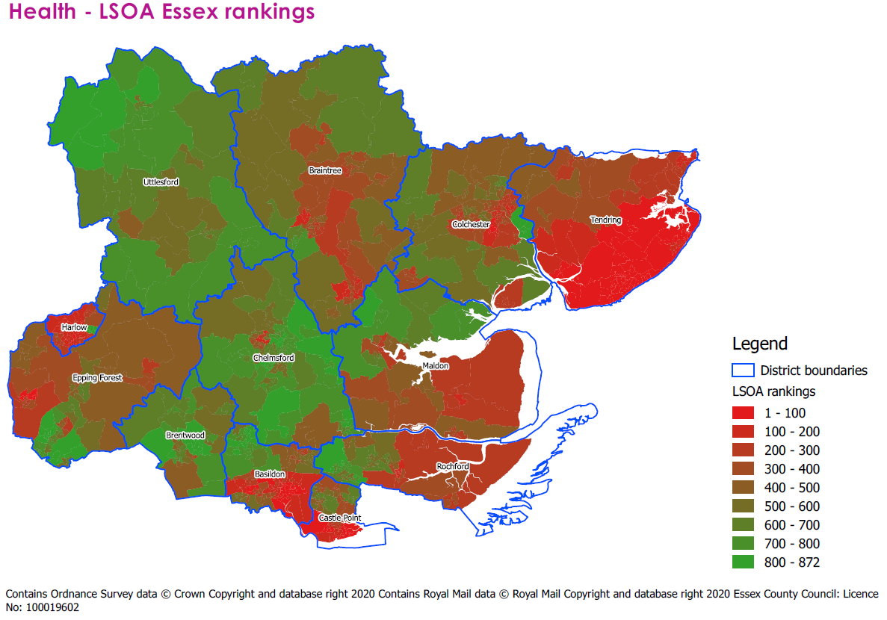

Economy

From the findings of our regression analysis, economic factors were the second biggest driver of physical inactivity.
On average, Essex scores 6.15 on economic indicators, higher than the national average of 5.44. The highest scores are found in Uttlesford (6.98), Brentwood (6.96) and Chelmsford (6.79). The lowest scores are found in the districts of Tendring (5.05), Harlow (5.16) and Basildon (5.86).

 | Basildon | Braintree | Brentwood | Castle Point | Chelmsford | Colchester | Epping Forest | Harlow | Maldon | Rochford | Tendring | Uttlesford | Essex average | National average
Economy average decile | 5.86 | 6.10 | 6.96 | 6.10 | 6.79 | 6.05 | 6.49 | 5.16 | 6.32 | 6.56 | 5.05 | 6.98 | 6.15 | 5.44

How Essex LSOAs score nationally for economy
The table below shows 20 LSOAs in Essex which score the lowest on economic indicators. The areas which experience the biggest challenges relating to the local economy are largely found in both Tendring and Basildon. Despite the Harlow district having the second lowest average economic score, no Harlow LSOAs are present in the top 20. The lowest scoring area in economic indicators is located in the Fyrerns ward in Basildon.
All these LSOAs are placed in deciles 1-4 of the 2019 Indices of Deprivation, with the exception of one LSOA in the ward of Bockings Elm in Tendring, which is in decile 5.
Theme Rank | LSOA Code | LSOA Name | Ward | LA Name | IMD 2019 decile | Economy Average
1 | E01021271 | Basildon 013A | Fryerns | Basildon | 1 | 2.08
2 | E01022024 | Tendring 015B | Peter Bruff | Tendring | 4 | 2.67
3 | E01021286 | Basildon 016A | Lee Chapel North | Basildon | 2 | 3.00
4 | E01021975 | Tendring 013A | Bockings Elm | Tendring | 2 | 3.00
5 | E01021302 | Basildon 013B | Pitsea North West | Basildon | 1 | 3.08
6 | E01021304 | Basildon 013C | Pitsea North West | Basildon | 1 | 3.17
7 | E01022030 | Tendring 015C | Rush Green | Tendring | 1 | 3.17
8 | E01022023 | Tendring 015A | Peter Bruff | Tendring | 2 | 3.33
9 | E01021486 | Castle Point 010B | Canvey Island Central | Castle Point | 2 | 3.42
10 | E01021288 | Basildon 016B | Lee Chapel North | Basildon | 2 | 3.42
11 | E01021306 | Basildon 013E | Pitsea North West | Basildon | 1 | 3.42
12 | E01021976 | Tendring 013B | Bockings Elm | Tendring | 5 | 3.42
13 | E01022036 | Tendring 017C | St James | Tendring | 4 | 3.50
14 | E01021988 | Tendring 018A | Golf Green | Tendring | 1 | 3.58
15 | E01022031 | Tendring 015D | Rush Green | Tendring | 1 | 3.58
16 | E01021977 | Tendring 013C | Bockings Elm | Tendring | 3 | 3.58
17 | E01022032 | Tendring 015E | Rush Green | Tendring | 1 | 3.58
18 | E01021969 | Tendring 017B | Alton Park | Tendring | 2 | 3.58
19 | E01021290 | Basildon 016D | Lee Chapel North | Basildon | 1 | 3.67
20 | E01021314 | Basildon 018B | Pitsea South East | Basildon | 2 | 3.67

The map below shows where each LSOA in Essex places nationally in our economy decile. As outlined in the table above, the lowest scoring areas are found on the Tendring coast, and in central Basildon. Harlow and LSOAs on the outskirts of Colchester town centre also score low, with pockets of low scoring areas also appearing in Castle Point, Braintree, Rochford, Epping Forest and Maldon.

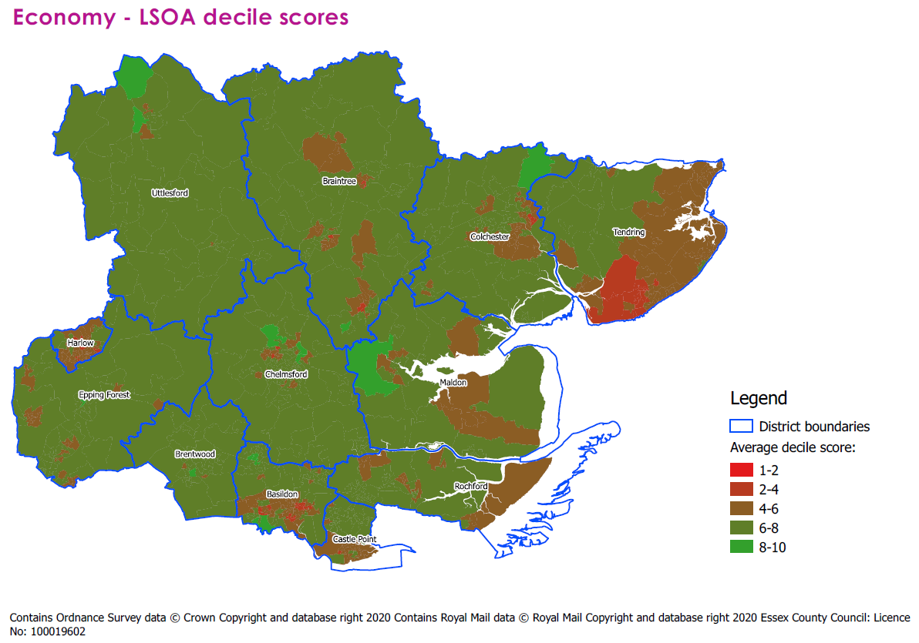
How economy ranks within Essex
The map below shows each Essex LSOA ranked from 1 to 872 depending on its economy decile score, with 1 being the lowest economy decile score, and 872 the highest. This allows us to see the spread of economic inequalities on an Essex-specific scale.
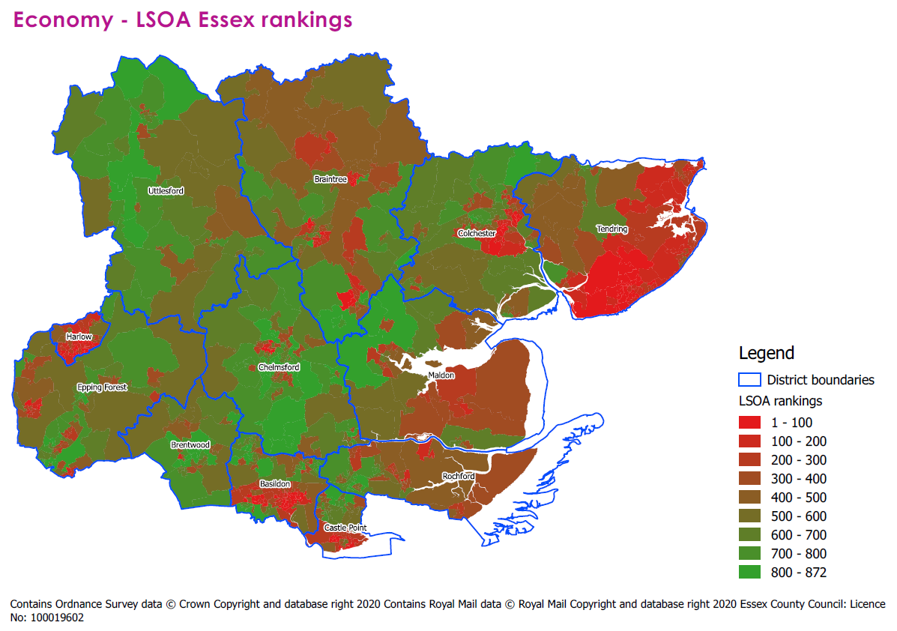

Vulnerable groups

A higher presence of vulnerable groups was identified as the third biggest driver of physical inactivity according to our regression analysis.
On average, Essex scores 5.63 for the presence of vulnerable groups, higher than the national average of 5.28. The highest scores are found in Uttlesford (6.73), Chelmsford (6.19) and Brentwood (6.15) indicating a lower presence of vulnerable groups in these areas. The lowest scores are found in the districts of Tendring (4.26), Harlow (5.13) and Castle Point (5.36).

 | Basildon | Braintree | Brentwood | Castle Point | Chelmsford | Colchester | Epping Forest | Harlow | Maldon | Rochford | Tendring | Uttlesford | Essex average | National average
Vulnerable Groups Average decile | 5.42 | 5.93 | 6.15 | 5.36 | 6.19 | 5.64 | 5.75 | 5.13 | 5.46 | 6.07 | 4.26 | 6.73 | 5.63 | 5.28

How Essex LSOAs score nationally for presence of vulnerable groups

The table below shows 20 LSOAs in Essex which score the lowest on indicators relating to vulnerable groups. The areas which experience the biggest challenges relating to the presence of vulnerable groups are largely found in Tendring, in particular in Clacton and the surrounding areas, stretching along the Tendring coastline. Basildon has two LSOAs in the table below, with one each from Castle Point, Chelmsford and Maldon.
All these LSOAs are placed in deciles 1-4 of the 2019 Indices of Deprivation.
Theme Rank | LSOA Code | LSOA Name | Ward | LA Name | IMD 2019 decile | Vulnerable Groups Average
1 | E01021988 | Tendring 018A | Golf Green | Tendring | 1 | 2.30
2 | E01022032 | Tendring 015E | Rush Green | Tendring | 1 | 2.70
3 | E01021696 | Colchester 008A | Greenstead | Colchester | 1 | 2.83
4 | E01022045 | Tendring 018D | St Osyth and Point Clear | Tendring | 1 | 2.83
5 | E01021990 | Tendring 018C | Golf Green | Tendring | 1 | 2.87
6 | E01022023 | Tendring 015A | Peter Bruff | Tendring | 2 | 2.91
7 | E01022046 | Tendring 011E | St Osyth and Point Clear | Tendring | 2 | 2.91
8 | E01021485 | Castle Point 010A | Canvey Island Central | Castle Point | 2 | 2.96
9 | E01022030 | Tendring 015C | Rush Green | Tendring | 1 | 3.00
10 | E01021970 | Tendring 016A | Alton Park | Tendring | 1 | 3.00
11 | E01021969 | Tendring 017B | Alton Park | Tendring | 2 | 3.00
12 | E01021306 | Basildon 013E | Pitsea North West | Basildon | 1 | 3.04
13 | E01022056 | Tendring 006E | Walton | Tendring | 2 | 3.04
14 | E01022027 | Tendring 016D | Pier | Tendring | 1 | 3.17
15 | E01022033 | Tendring 012B | St Bartholomews | Tendring | 4 | 3.17
16 | E01021892 | Maldon 004D | Maldon North | Maldon | 4 | 3.22
17 | E01021592 | Chelmsford 006D | Patching Hall | Chelmsford | 3 | 3.26
18 | E01021977 | Tendring 013C | Bockings Elm | Tendring | 3 | 3.26
19 | E01021305 | Basildon 013D | Pitsea North West | Basildon | 1 | 3.26
20 | E01022049 | Tendring 014D | St Pauls | Tendring | 3 | 3.30

The map below shows where each LSOA in Essex places nationally in our vulnerable groups decile. As outlined in the table above, the lowest scoring areas are found on the Tendring coast. A large number of LSOAs in Essex are placed within deciles 4-6, showing that vulnerable groups are fairly evenly spread across all Essex districts, but Tendring appears to have a higher number of LSOAs in which vulnerable groups are likely to be present.

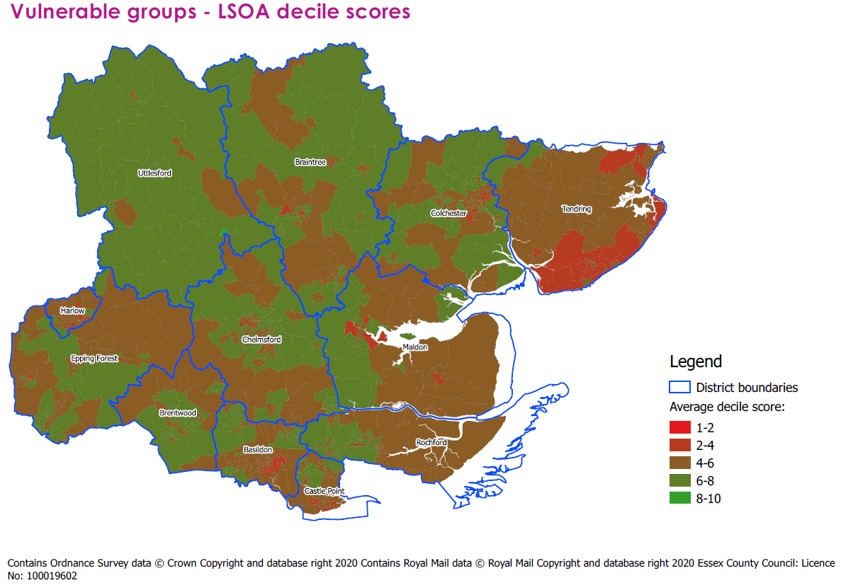
How presence of vulnerable groups ranks within Essex
The map below shows each Essex LSOA ranked from 1 to 872 depending on its vulnerable groups decile score, with 1 being the lowest vulnerable groups decile score, and 872 the highest. This allows us to see the spread of vulnerable groups on an Essex-specific scale.
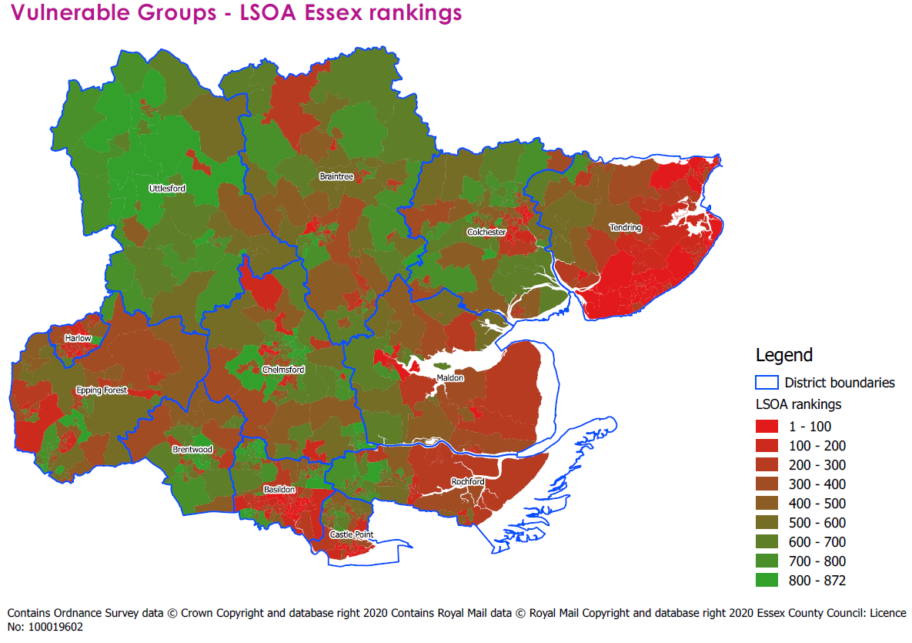

Active Lives measures

Measures from the Active Lives Survey were used to see if having an area that reported high rates of activity in the survey had a bearing on our overall weighted score. Specifically, this was included to see what sort of bearing self-reported rates of physical activity had in relation to the other barriers included in our dataset. Our regression analysis found this was the fourth most important factor that influenced our physical activity score.
On measures for physical activity, according to measures from the Active Lives Survey, Essex scored 5.58, marginally higher than the national average of 5.5. The highest scores are found in Uttlesford (6.60), Brentwood (6.09) and Chelmsford (6.06). The lowest scores are found in the districts of Harlow (4.71), Tendring (5.07) and Basildon (5.10).
 | Basildon | Braintree | Brentwood | Castle Point | Chelmsford | Colchester | Epping Forest | Harlow | Maldon | Rochford | Tendring | Uttlesford | Essex average | National average
Active Lives average decile | 5.10 | 5.53 | 6.09 | 5.14 | 6.06 | 5.90 | 5.69 | 4.71 | 5.98 | 5.43 | 5.07 | 6.60 | 5.58 | 5.50

How Essex LSOAs score nationally for Active Lives measures
The table below shows 20 LSOAs in Essex which score the lowest on Active Lives Survey measures. The modelled estimates we had from the Active Lives measure were created at MSOA level, therefore many of these scores refer to the MSOA of each area and aren’t specific to each LSOA. Nevertheless, it provides a useful indication for likely physical activity rates at a local level.
The areas which score poorest on Active Lives Survey measures are likely to be found in Witham, located in the district of Braintree, in Pitsea in Basildon, and in Clacton and the surrounding areas in Tendring.
All these LSOAs are placed in deciles 1-4 of the 2019 Indices of Deprivation, with the exception of one LSOA located in the Witham West ward of Braintree which placed in decile 5, and one LSOA located in the Greenstead ward of Colchester, which placed in decile 6.
Theme Rank | LSOA Code | LSOA Name | Ward | LA Name | IMD 2019 decile | Active Lives Average
1 | E01021425 | Braintree 016B | Witham West | Braintree | 4 | 3.67
2 | E01021427 | Braintree 016C | Witham West | Braintree | 4 | 3.67
3 | E01021306 | Basildon 013E | Pitsea North West | Basildon | 1 | 3.67
4 | E01021423 | Braintree 016A | Witham Central | Braintree | 4 | 3.67
5 | E01021304 | Basildon 013C | Pitsea North West | Basildon | 1 | 3.67
6 | E01021271 | Basildon 013A | Fryerns | Basildon | 1 | 3.67
7 | E01021429 | Braintree 016D | Witham West | Braintree | 5 | 3.67
8 | E01021305 | Basildon 013D | Pitsea North West | Basildon | 1 | 3.67
9 | E01021302 | Basildon 013B | Pitsea North West | Basildon | 1 | 3.67
10 | E01022047 | Tendring 018E | St Osyth and Point Clear | Tendring | 3 | 4.00
11 | E01033719 | Colchester 008G | Greenstead | Colchester | 6 | 4.00
12 | E01021988 | Tendring 018A | Golf Green | Tendring | 1 | 4.00
13 | E01022045 | Tendring 018D | St Osyth and Point Clear | Tendring | 1 | 4.00
14 | E01021989 | Tendring 018B | Golf Green | Tendring | 2 | 4.00
15 | E01021990 | Tendring 018C | Golf Green | Tendring | 1 | 4.00
16 | E01022024 | Tendring 015B | Peter Bruff | Tendring | 4 | 4.00
17 | E01022030 | Tendring 015C | Rush Green | Tendring | 1 | 4.00
18 | E01022031 | Tendring 015D | Rush Green | Tendring | 1 | 4.00
19 | E01021288 | Basildon 016B | Lee Chapel North | Basildon | 2 | 4.00
20 | E01022032 | Tendring 015E | Rush Green | Tendring | 1 | 4.00

The map below shows where each LSOA in Essex places nationally in our Active Lives decile. As outlined in the table above, the lowest scoring areas are found in Witham and Clacton and the surrounding areas in Tendring.
All districts appear to have a number of LSOAs in that fall within deciles 4-6 of the Active Lives decile. All LSOAs within Rochford and Castle Point fall within these deciles.

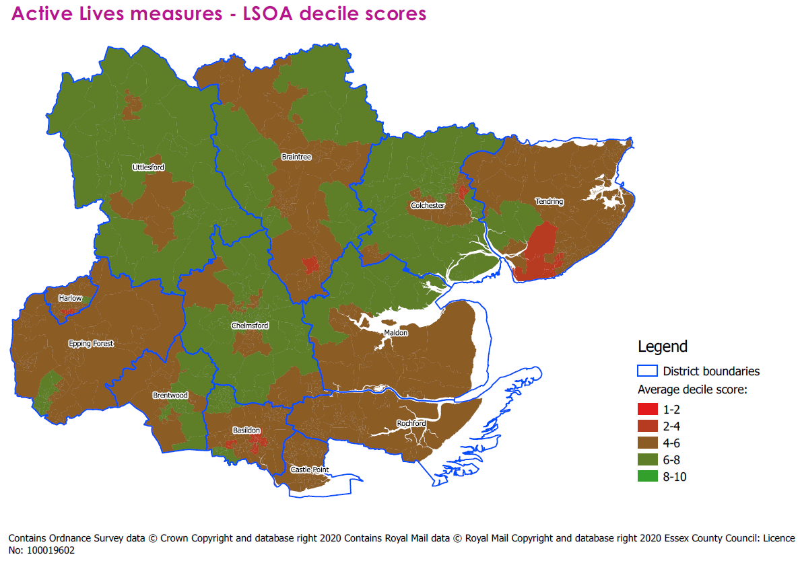
How Active Lives measures rank within Essex
The map below shows each Essex LSOA ranked from 1 to 872 depending on its Active Lives decile score, with 1 being the lowest Active Lives decile score, and 872 the highest. This allows us to see the spread of modelled data from the Active Lives Survey on an Essex-specific scale.
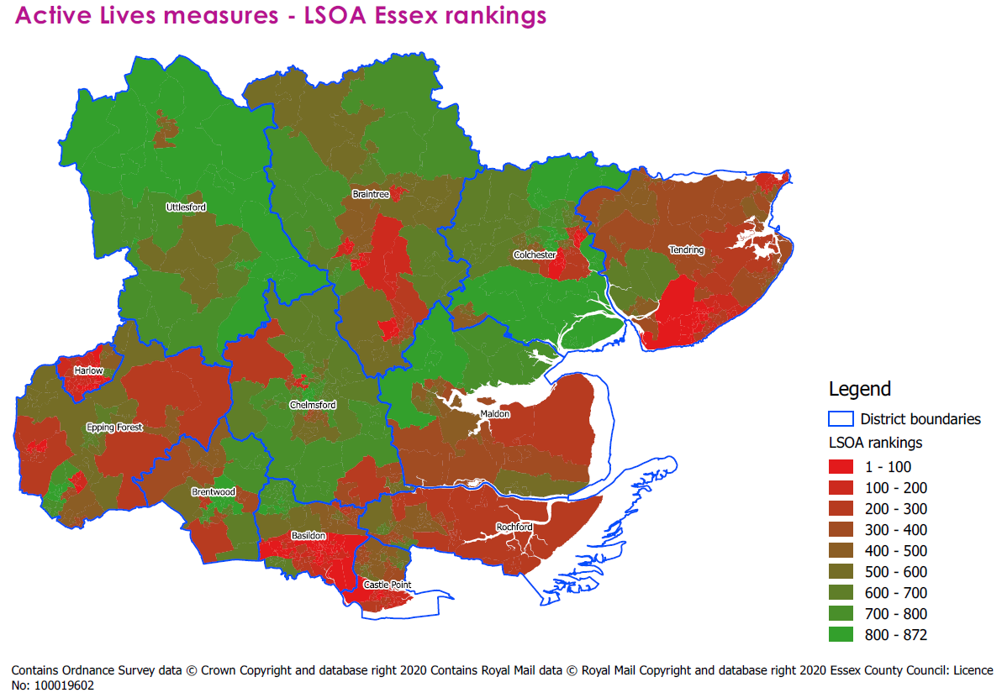

Crime

From the findings of our regression analysis, high crimes rates were the fifth biggest driver of physical inactivity.
On average, Essex scores 5.84 for Crime, scoring marginally lower than the national average of 5.86. The highest scores are found in Maldon (6.93), Rochford (6.85) and Uttlesford (6.81), meaning that crimes rates are lower in these districts. The lowest scores are found in the districts of Harlow (4.86), Epping Forest (5.33) and Basildon (5.34).

 | Basildon | Braintree | Brentwood | Castle Point | Chelmsford | Colchester | Epping Forest | Harlow | Maldon | Rochford | Tendring | Uttlesford | Essex average | National average
Crime average decile | 5.34 | 6.29 | 5.88 | 6.12 | 5.81 | 5.58 | 5.33 | 4.86 | 6.93 | 6.85 | 5.60 | 6.81 | 5.84 | 5.86

How Essex LSOAs score nationally for crime
The table below shows 20 LSOAs in Essex which score the lowest in the crime decile. Every district in Essex has LSOAs which place in deciles 1-2 for crime. The LSOA with the lowest crime decile score is found in the St Martin’s ward in Basildon. All districts are represented among the 20 lowest scoring LSOAs, except for Rochford and Uttlesford.
Most of the LSOAs in the table below are placed in deciles 1-4 of the 2019 Indices of Deprivation, with the exception of two LSOAs in the ward of Moulsham and Central in Chelmsford, an LSOA in the ward of Braintree Central and Beckers Green in Braintree and an LSOA in the Maldon North ward which are all placed in decile 5. One LSOA which scores low in the crime decile, located in the Brentwood North ward, is placed in decile 8.
Theme Rank | LSOA Code | LSOA Name | Ward | LA Name | IMD 2019 decile | Crime Average
1 | E01021318 | Basildon 015C | St Martin's | Basildon | 3 | 1.00
2 | E01033140 | Chelmsford 010F | Moulsham and Central | Chelmsford | 5 | 1.00
3 | E01033141 | Chelmsford 010G | Moulsham and Central | Chelmsford | 5 | 1.00
4 | E01021268 | Basildon 015B | Fryerns | Basildon | 2 | 1.07
5 | E01022025 | Tendring 016B | Pier | Tendring | 1 | 1.07
6 | E01021316 | Basildon 018D | Pitsea South East | Basildon | 2 | 1.07
7 | E01021872 | Harlow 007E | Toddbrook | Harlow | 2 | 1.14
8 | E01021776 | Epping Forest 011C | Loughton Broadway | Epping Forest | 4 | 1.21
9 | E01021649 | Colchester 007D | Castle | Colchester | 3 | 1.21
10 | E01021845 | Harlow 002B | Mark Hall | Harlow | 4 | 1.36
11 | E01021433 | Brentwood 007A | Brentwood North | Brentwood | 8 | 1.36
12 | E01021310 | Basildon 022B | Pitsea South East | Basildon | 4 | 1.43
13 | E01022026 | Tendring 016C | Pier | Tendring | 1 | 1.43
14 | E01021307 | Basildon 011C | Pitsea North West | Basildon | 3 | 1.50
15 | E01021988 | Tendring 018A | Golf Green | Tendring | 1 | 1.50
16 | E01033459 | Braintree 009F | Braintree Central & Beckers Green | Braintree | 5 | 1.50
17 | E01021365 | Braintree 009D | Braintree West | Braintree | 4 | 1.50
18 | E01021859 | Harlow 010C | Staple Tye | Harlow | 3 | 1.57
19 | E01021890 | Maldon 004B | Maldon North | Maldon | 5 | 1.57
20 | E01021498 | Castle Point 011B | Canvey Island South | Castle Point | 4 | 1.64

The map below shows where each LSOA in Essex places nationally in our crime decile. As outlined above, all districts experience pockets with high crime rates. However, this problem appears to be more prevalent in the districts in the south of the county (particularly Basildon, Brentwood, Epping Forest and Harlow) and in Chelmsford and Tendring.
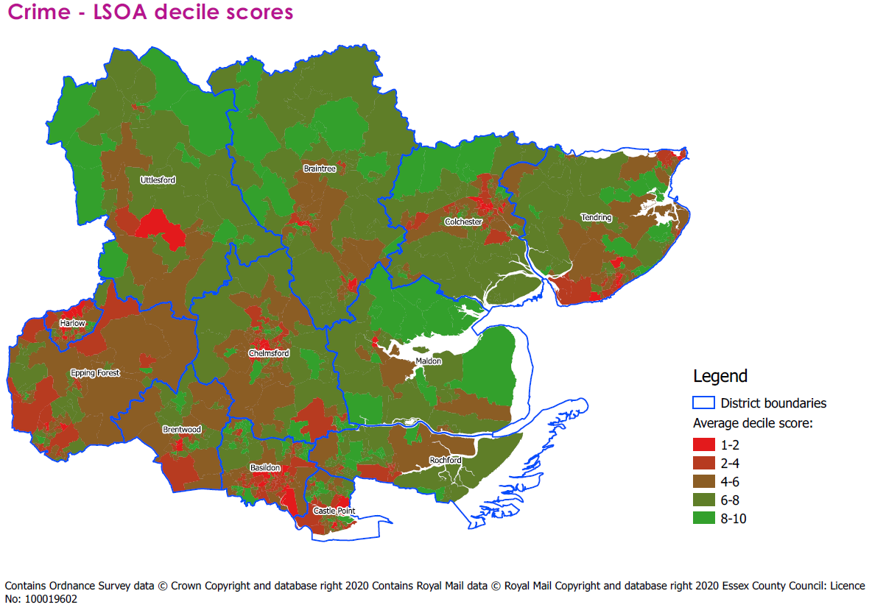
How crime ranks within Essex
The map below shows each Essex LSOA ranked from 1 to 872 depending on its crime decile score, with 1 being the lowest crime decile score, and 872 the highest. This allows us to see the spread of crime on an Essex-specific scale.
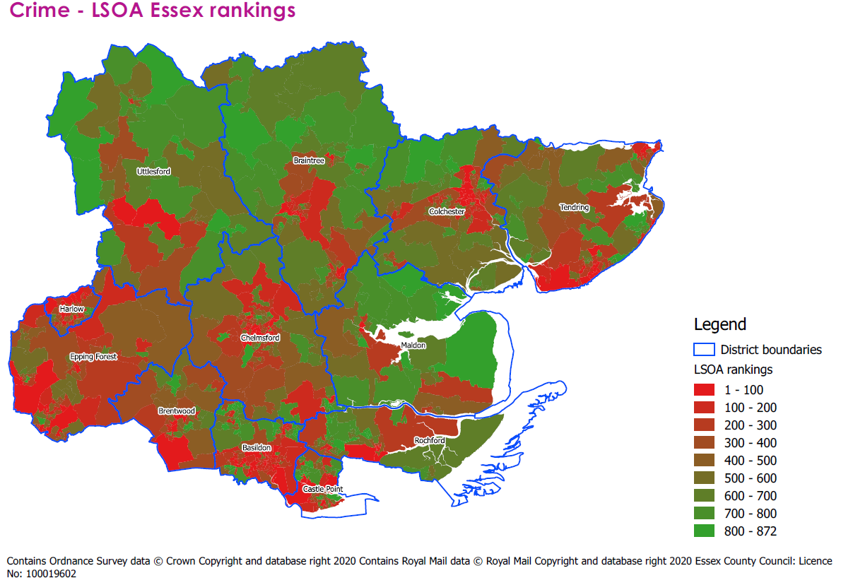

Access and Transport

From the findings of our regression analysis, data on access and transport was the sixth biggest driver of physical inactivity.
On average, Essex scores 5.35 for access and transport, lower than the national average of 5.63, suggesting that Essex as a whole experiences greater challenges to accessing local amenities and local transport. The highest scores are found in Harlow (6.07), Basildon (5.97) and Castle Point (5.85). The lowest scores are found in the districts of Maldon (4.86), Tendring (4.73) and Uttlesford (4.75).

 | Basildon | Braintree | Brentwood | Castle Point | Chelmsford | Colchester | Epping Forest | Harlow | Maldon | Rochford | Tendring | Uttlesford | Essex average | National average
Access & transport Average decile | 5.97 | 4.90 | 5.20 | 5.85 | 5.49 | 5.30 | 5.47 | 6.07 | 4.30 | 5.62 | 4.73 | 4.75 | 5.35 | 5.63

How Essex LSOAs score nationally for access and transport
The table below shows 20 LSOAs in Essex which score the lowest in the access and transport decile. The LSOA in with the lowest score is found within the ward of Stour Valley South in the district of Braintree.
The LSOAs in the table below are largely spread across rural locations in a number of districts. The LSOAs with the lowest scores are in the least deprived 2019 Indices of Deprivation deciles, (deciles 5-9 are represented in the table below). The only exception to this in one LSOA found in the ward of Manningtree, Mistley, Little Bentley and Tendring, which is placed in decile 2 for deprivation.
Theme Rank | LSOA Code | LSOA Name | Ward | LA Name | IMD 2019 decile | Access & transport Average
1 | E01021407 | Braintree 002C | Stour Valley South | Braintree | 8 | 2.31
2 | E01021663 | Colchester 010C | Rural North | Colchester | 6 | 2.38
3 | E01021406 | Braintree 002B | Stour Valley North | Braintree | 6 | 2.38
4 | E01021413 | Braintree 005D | Three Fields | Braintree | 6 | 2.38
5 | E01021901 | Maldon 006A | Mayland | Maldon | 5 | 2.46
6 | E01021348 | Braintree 018A | Hatfield Peverel & Terling | Braintree | 6 | 2.46
7 | E01021694 | Colchester 019D | Mersea and Pyefleet | Colchester | 5 | 2.54
8 | E01022098 | Uttlesford 003E | Clavering | Uttlesford | 7 | 2.54
9 | E01021875 | Maldon 007C | Althorne | Maldon | 6 | 2.62
10 | E01021404 | Braintree 005A | Rayne | Braintree | 6 | 2.62
11 | E01021414 | Braintree 001C | Stour Valley North | Braintree | 6 | 2.69
12 | E01022019 | Tendring 003E | Manningtree, Mistley, Little Bentley and Tendring | Tendring | 2 | 2.69
13 | E01022088 | Uttlesford 008E | Felsted & Stebbing | Uttlesford | 7 | 2.69
14 | E01021911 | Maldon 001D | Tolleshunt D'Arcy | Maldon | 8 | 2.69
15 | E01022058 | Uttlesford 008A | High Easter & the Rodings | Uttlesford | 7 | 2.77
16 | E01021768 | Epping Forest 001A | Hastingwood, Matching and Sheering Village | Epping Forest | 6 | 2.85
17 | E01021443 | Brentwood 001C | Brizes and Doddinghurst | Brentwood | 5 | 2.85
18 | E01021903 | Maldon 007G | Purleigh | Maldon | 6 | 2.85
19 | E01021913 | Maldon 002D | Wickham Bishops and Woodham | Maldon | 7 | 2.85
20 | E01021899 | Maldon 007D | Mayland | Maldon | 9 | 2.92

The map below shows where each LSOA in Essex places nationally in our access and transport decile. Essex is a largely rural county, meaning a lot of our LSOAs score quite low for access and transport. Typically these areas are among the least deprived LSOAs in Essex. However, rural locations experience significant challenges when accessing amenities and transport.

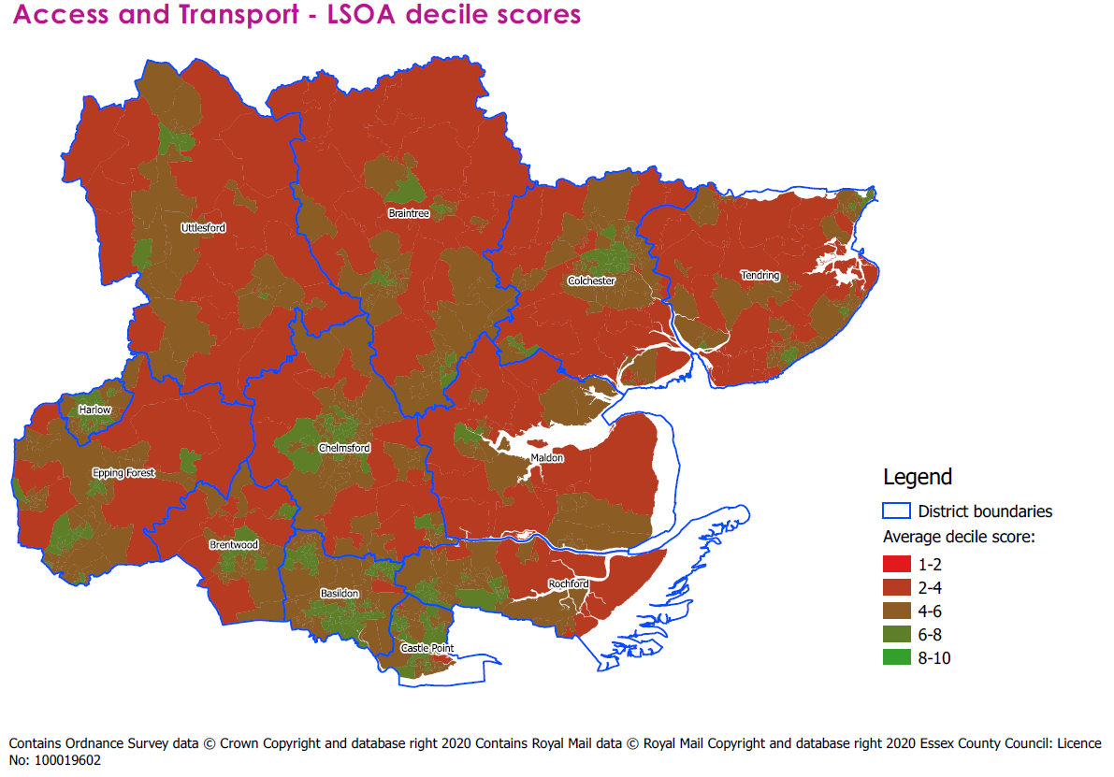
How access and transport ranks within Essex
The map below shows each Essex LSOA ranked from 1 to 872 depending on its access and transport decile score, with 1 being the lowest access and transport decile score, and 872 the highest. This allows us to see the spread of inequalities in access and transport on an Essex-specific scale.
The fact that larger, more rural LSOAs are the most affected by scoring low for access and transport is reflected in the map. Smaller, urban areas, score better for access and transport measures.
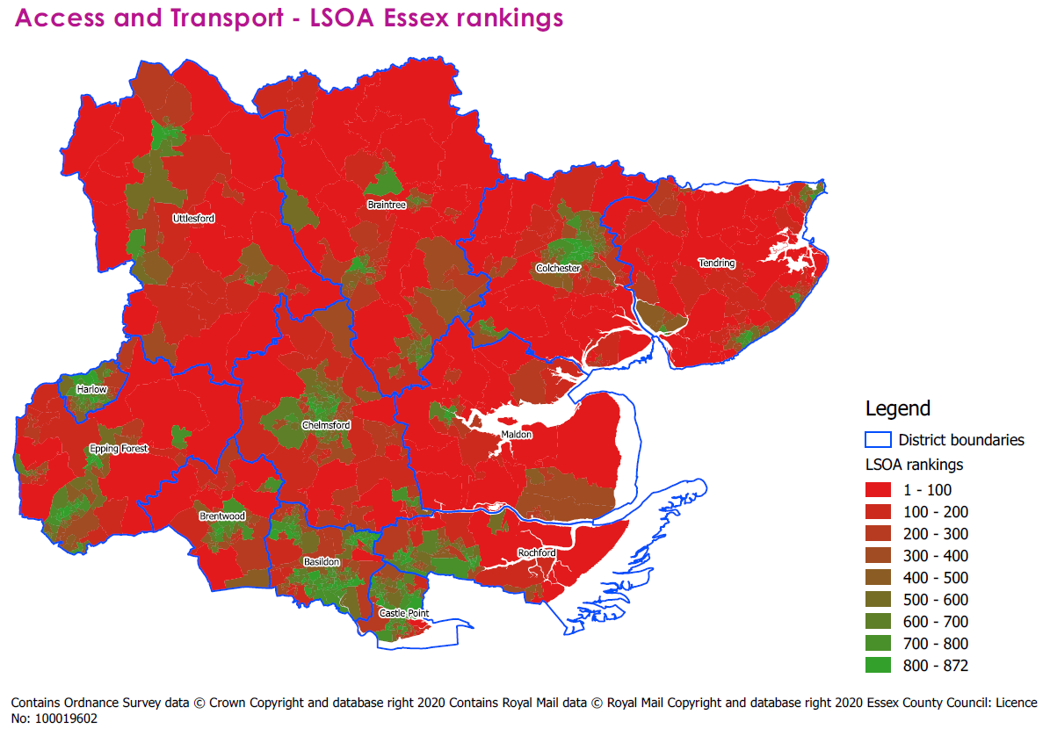

Housing

From the findings of our regression analysis, data on housing was the seventh biggest driver of physical inactivity.
On average, Essex scores 5.28 for housing measures, lower than the national average of 5.46, suggesting Essex performs worse on housing metrics when compared to the rest of the country. All Essex districts score fairly close to the Essex average. The highest scores are found in Tendring (5.51), Basildon (5.37) and Brentwood (5.35). The lowest scores are found in the districts of Uttlesford (4.95), Epping Forest (5.10) and Braintree (5.11).

 | Basildon | Braintree | Brentwood | Castle Point | Chelmsford | Colchester | Epping Forest | Harlow | Maldon | Rochford | Tendring | Uttlesford | Essex average | National average
Housing Average decile | 5.37 | 5.11 | 5.35 | 5.34 | 5.33 | 5.29 | 5.10 | 5.34 | 5.13 | 5.32 | 5.51 | 4.95 | 5.28 | 5.46

How Essex LSOAs score nationally for housing
The table below shows 20 LSOAs in Essex which score the lowest in the housing decile. The LSOA with the lowest score is found in the ward of Great Dunmow North in Uttlesford.
The LSOAs which score the lowest in the housing decile are typically in rural locations. A range of districts are represented in the lowest scoring LSOAs, but Uttlesford has the highest number of LSOAs among the lowest scorers with six.
Most of the lowest scoring LSOAs are less deprived according to the 2019 Indices of Deprivation, placing in deciles 5-10, with the exception of an LSOA in the Bocking Elms ward of Tendring which placed in decile 2, and LSOAs in the wards of Greenstead and Berechurch in Colchester, which placed in decile 4.
Theme Rank | LSOA Code | LSOA Name | Ward | LA Name | IMD 2019 decile | Housing Average
1 | E01033054 | Uttlesford 007D | Great Dunmow North | Uttlesford | 6 | 3.54
2 | E01021351 | Braintree 007B | Bocking Blackwater | Braintree | 10 | 3.96
3 | E01021349 | Braintree 007A | Bocking Blackwater | Braintree | 9 | 4.04
4 | E01022097 | Uttlesford 004C | The Sampfords | Uttlesford | 7 | 4.13
5 | E01021538 | Chelmsford 001A | Boreham and The Leighs | Chelmsford | 8 | 4.13
6 | E01021769 | Epping Forest 003A | High Ongar, Willingale and The Rodings | Epping Forest | 5 | 4.17
7 | E01021698 | Colchester 008C | Greenstead | Colchester | 4 | 4.21
8 | E01021380 | Braintree 012E | Coggeshall | Braintree | 5 | 4.21
9 | E01022089 | Uttlesford 005G | Stort Valley | Uttlesford | 8 | 4.21
10 | E01022099 | Uttlesford 004D | Debden & Wimbish | Uttlesford | 9 | 4.21
11 | E01021794 | Epping Forest 002D | Lower Nazeing | Epping Forest | 6 | 4.25
12 | E01022096 | Uttlesford 009D | High Easter & the Rodings | Uttlesford | 6 | 4.25
13 | E01021261 | Basildon 010A | Crouch | Basildon | 6 | 4.29
14 | E01033055 | Uttlesford 007E | Great Dunmow North | Uttlesford | 10 | 4.29
15 | E01021828 | Harlow 005E | Church Langley | Harlow | 9 | 4.29
16 | E01021815 | Epping Forest 007D | Waltham Abbey Paternoster | Epping Forest | 5 | 4.33
17 | E01033723 | Colchester 015G | Shrub End | Colchester | 5 | 4.33
18 | E01021874 | Maldon 007B | Althorne | Maldon | 5 | 4.33
19 | E01021975 | Tendring 013A | Bockings Elm | Tendring | 2 | 4.38
20 | E01021658 | Colchester 016B | Berechurch | Colchester | 4 | 4.38

The map below shows where each LSOA in Essex places nationally in our housing decile. As there is very little deviation from the Essex mean among LSOAs, the vast majority of LSOAs across the county place in deciles 4-6.

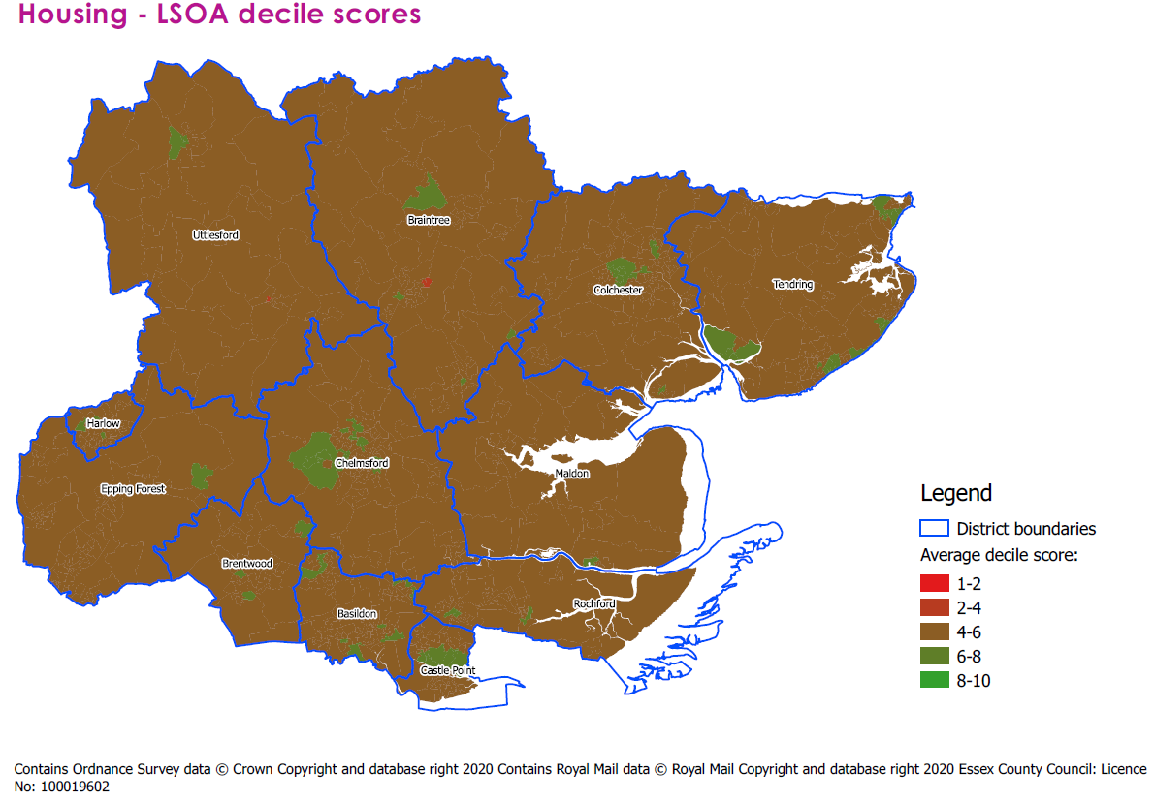

How housing ranks within Essex
The map below shows each Essex LSOA ranked from 1 to 872 depending on its housing decile score, with 1 being the lowest housing decile score, and 872 the highest. This allows us to see the spread of housing decile scores on an Essex-specific scale.
As most LSOAs are placed in deciles 4-6, this map allows us to see the differences between areas based on rank a little clearer, although it should be remembered that the range of housing decile scores in Essex is not large.
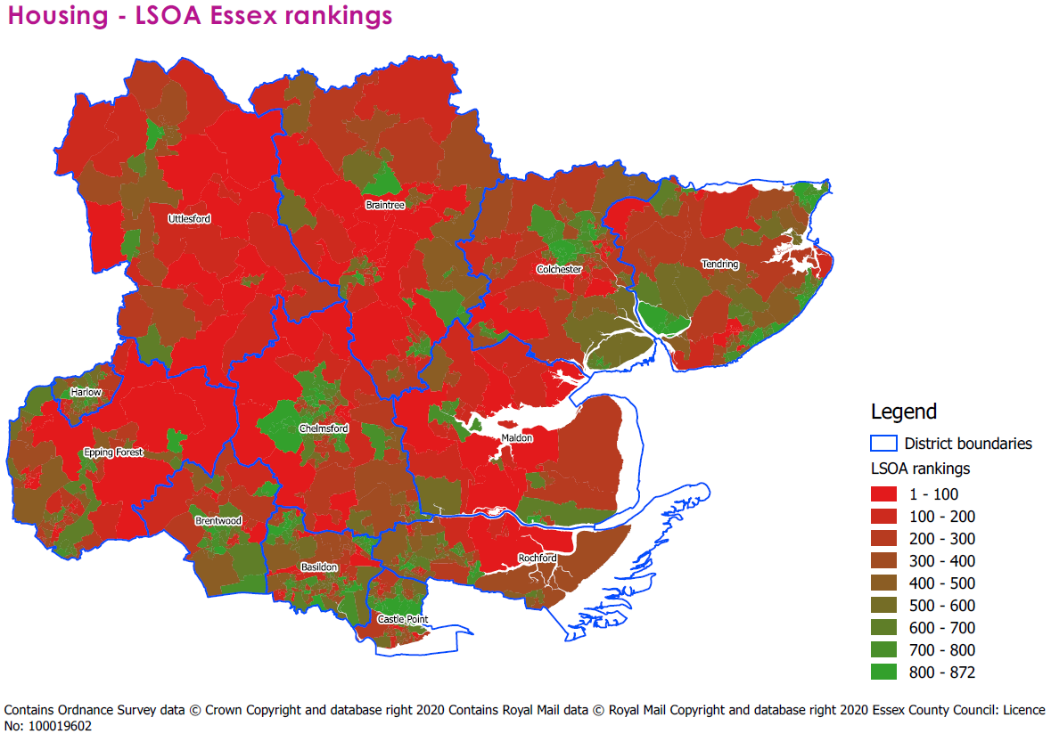

Education and skills

From the findings of our regression analysis, data relating to education and skills was the eighth biggest driver of physical inactivity.
On average, Essex scores 5.45 for education and skills, higher than the national average of 5.34. The highest scores are found in Brentwood (6.51), Uttlesford (6.41) and Rochford (6.08). The lowest scores are found in the districts of Tendring (4.44), Basildon (5.02) and Braintree (5.16).

 | Basildon | Braintree | Brentwood | Castle Point | Chelmsford | Colchester | Epping Forest | Harlow | Maldon | Rochford | Tendring | Uttlesford | Essex average | National average
Education & Skills Average decile | 5.02 | 5.16 | 6.51 | 5.42 | 5.85 | 5.35 | 5.79 | 5.24 | 5.19 | 6.08 | 4.44 | 6.41 | 5.45 | 5.34

How Essex LSOAs score nationally for education and skills
The table below shows 20 LSOAs in Essex which score the lowest in the education and skills decile. The LSOA with the lowest score for education and skills is in the area of Jaywick, in the Golf Green ward of Tendring. The other two lowest scoring areas are in Tendring, in the ward of Rush Green.
While three LSOAs in Tendring score the lowest (and with Tendring also having another three LSOAs in the lowest scoring areas), Basildon has eight LSOAs in total in the lowest 20 scoring LSOAs. These areas of Basildon are based in the wards of Fryerns, Pitsea North West and Lee Chapel North.
All of these LSOAs are placed in deciles 1-4 of the 2019 Indices of Deprivation, with the exception of one LSOA in the Greenstead ward of Colchester, which was placed in decile 6 for deprivation.
Theme Rank | LSOA Code | LSOA Name | Ward | LA Name | IMD 2019 decile | Education & Skills Average
1 | E01021988 | Tendring 018A | Golf Green | Tendring | 1 | 1.97
2 | E01022030 | Tendring 015C | Rush Green | Tendring | 1 | 2.03
3 | E01022031 | Tendring 015D | Rush Green | Tendring | 1 | 2.10
4 | E01021290 | Basildon 016D | Lee Chapel North | Basildon | 1 | 2.17
5 | E01021990 | Tendring 018C | Golf Green | Tendring | 1 | 2.21
6 | E01033719 | Colchester 008G | Greenstead | Colchester | 6 | 2.31
7 | E01022025 | Tendring 016B | Pier | Tendring | 1 | 2.31
8 | E01021271 | Basildon 013A | Fryerns | Basildon | 1 | 2.38
9 | E01021302 | Basildon 013B | Pitsea North West | Basildon | 1 | 2.38
10 | E01021596 | Chelmsford 006E | St Andrews | Chelmsford | 3 | 2.41
11 | E01021268 | Basildon 015B | Fryerns | Basildon | 2 | 2.41
12 | E01021576 | Chelmsford 006A | Marconi | Chelmsford | 2 | 2.45
13 | E01021306 | Basildon 013E | Pitsea North West | Basildon | 1 | 2.48
14 | E01021305 | Basildon 013D | Pitsea North West | Basildon | 1 | 2.48
15 | E01021592 | Chelmsford 006D | Patching Hall | Chelmsford | 3 | 2.52
16 | E01021286 | Basildon 016A | Lee Chapel North | Basildon | 2 | 2.55
17 | E01021288 | Basildon 016B | Lee Chapel North | Basildon | 2 | 2.55
18 | E01021685 | Colchester 011C | Old Heath and The Hythe | Colchester | 2 | 2.55
19 | E01021953 | Rochford 004C | Roche North and Rural | Rochford | 2 | 2.66
20 | E01022006 | Tendring 002C | Harwich West Central | Tendring | 2 | 2.66

The map below shows where each LSOA in Essex places nationally in our education and skills decile. The lowest scoring areas are found on the Tendring coast, central Basildon, Harlow and Castle Point. There are also pockets of low scoring areas in Braintree, Chelmsford, Colchester, Epping Forest, Rochford and Maldon.
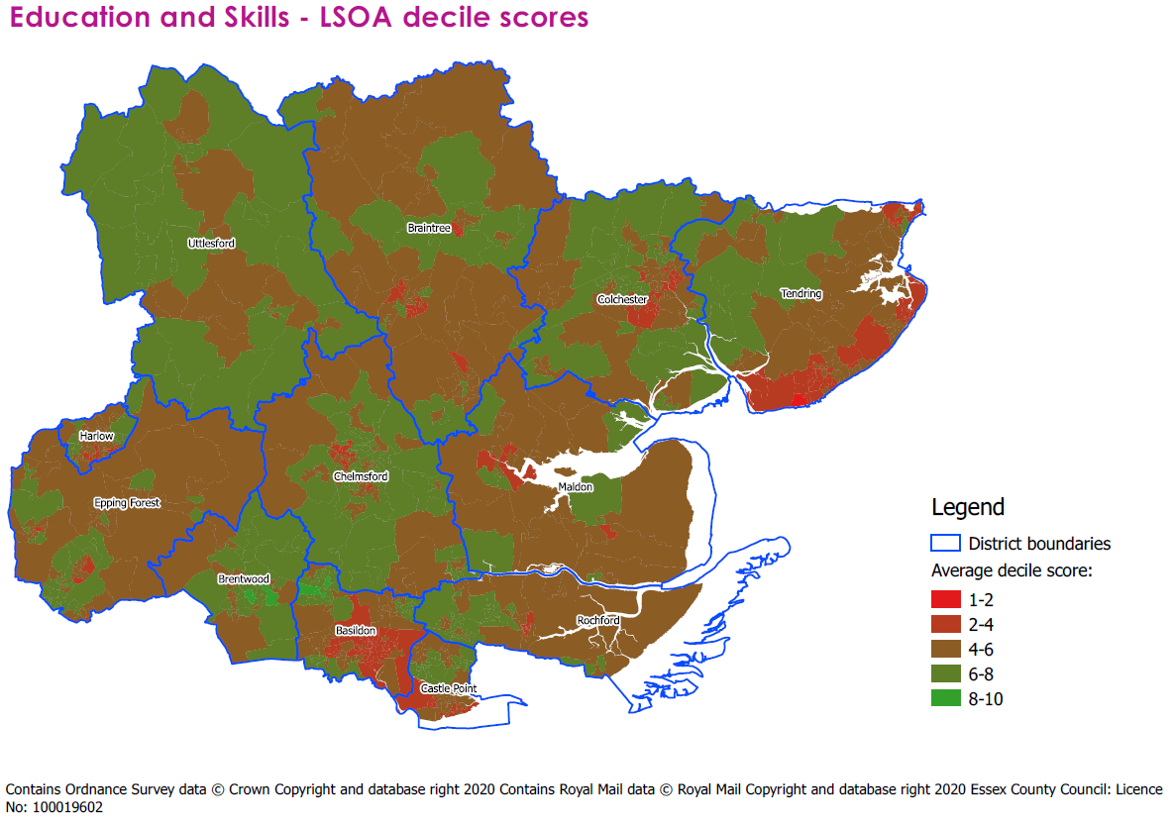
How education and skills rank within Essex
The map below shows each Essex LSOA ranked from 1 to 872 depending on its education and skills decile score, with 1 being the lowest education and skills decile score, and 872 the highest. This allows us to see the spread of education and skills on an Essex-specific scale.
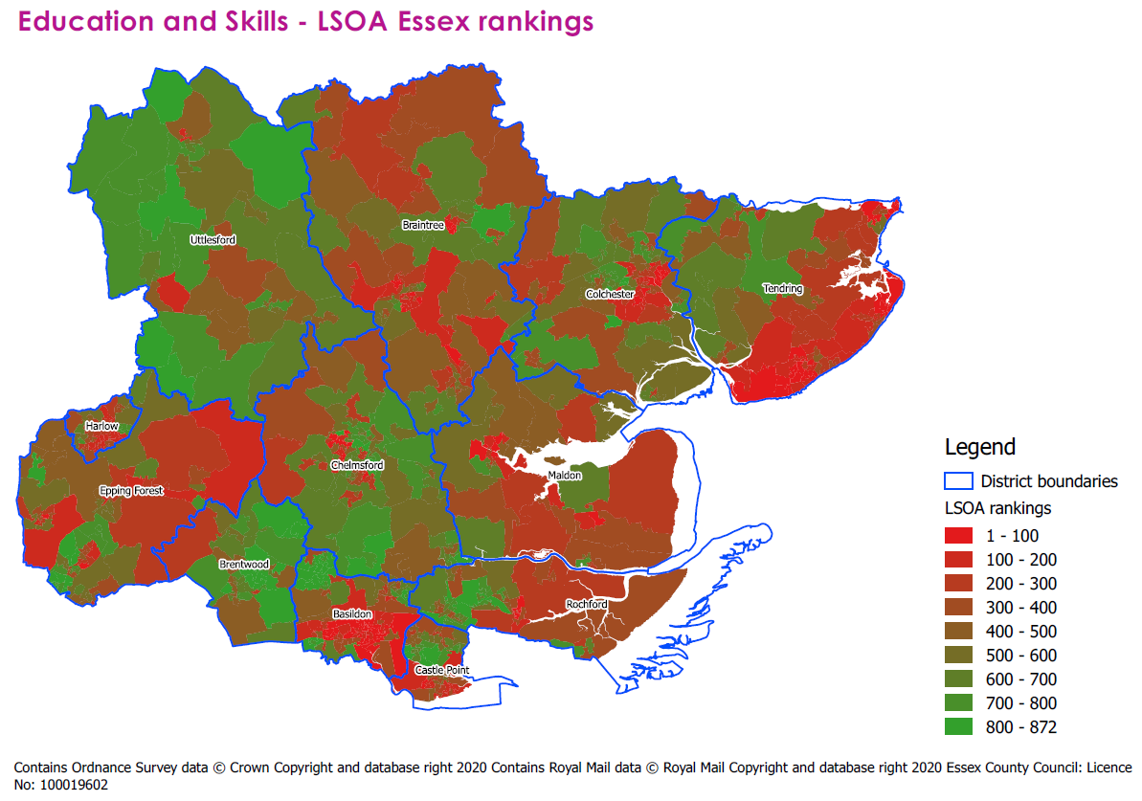

Communities and Environment

From the findings of our regression analysis, data relating to communities and environment was the ninth biggest driver of physical inactivity.
Essex scores fairly low for communities and environment as a whole. Similar to the access and transport data theme, this may be because Essex is a largely rural county with facilities spread out over a large area.
On average, Essex scores 4.84 for communities and environment, lower than the national average of 5.41, suggesting that Essex performs worse in most districts for measures relating to communities and environment than the rest of the country. The highest scores are found in Colchester (5.12), Chelmsford (5.00) and Harlow and Tendring (both scoring 4.97). The lowest scores are found in the districts of Braintree (4.50), Uttlesford (4.61) and Maldon (4.63).

 | Basildon | Braintree | Brentwood | Castle Point | Chelmsford | Colchester | Epping Forest | Harlow | Maldon | Rochford | Tendring | Uttlesford | Essex average | National average
Communities & Environment Average decile | 4.83 | 4.50 | 4.73 | 4.84 | 5.00 | 5.12 | 4.85 | 4.97 | 4.63 | 4.65 | 4.97 | 4.61 | 4.84 | 5.41

How Essex LSOAs score nationally for communities and environment
The table below shows 20 LSOAs in Essex which score the lowest in the communities and envrionment decile. Interestingly, the spread of these 20 lowest scoring areas is across multiple districts and different levels of deprivation.
The lowest scoring areas are found in Basildon, with the lowest scoring area located in the Laindon Park ward, and the second and third lowest scoring areas both found in Pitsea North West. The remaining areas are found in both residential town and rural settings across a number of districts.
Theme Rank | LSOA Code | LSOA Name | Ward | LA Name | IMD 2019 decile | Communities & Environment Average
1 | E01021277 | Basildon 014D | Laindon Park | Basildon | 4 | 3.29
2 | E01021309 | Basildon 011E | Pitsea North West | Basildon | 4 | 3.29
3 | E01021307 | Basildon 011C | Pitsea North West | Basildon | 3 | 3.32
4 | E01033460 | Braintree 017F | Witham South | Braintree | 8 | 3.32
5 | E01021361 | Braintree 012B | Coggeshall | Braintree | 7 | 3.39
6 | E01021903 | Maldon 007G | Purleigh | Maldon | 6 | 3.39
7 | E01021506 | Castle Point 008E | Canvey Island Winter Gardens | Castle Point | 4 | 3.42
8 | E01021362 | Braintree 015A | Silver End & Cressing | Braintree | 6 | 3.45
9 | E01021769 | Epping Forest 003A | High Ongar, Willingale and The Rodings | Epping Forest | 5 | 3.48
10 | E01033461 | Braintree 017G | Witham South | Braintree | 9 | 3.48
11 | E01021815 | Epping Forest 007D | Waltham Abbey Paternoster | Epping Forest | 5 | 3.52
12 | E01021418 | Braintree 015C | Witham North | Braintree | 3 | 3.52
13 | E01021800 | Epping Forest 003C | Passingford | Epping Forest | 3 | 3.52
14 | E01021828 | Harlow 005E | Church Langley | Harlow | 9 | 3.52
15 | E01021810 | Epping Forest 008D | Waltham Abbey Honey Lane | Epping Forest | 6 | 3.55
16 | E01021678 | Colchester 010E | Marks Tey and Layer | Colchester | 5 | 3.55
17 | E01021444 | Brentwood 001D | Brizes and Doddinghurst | Brentwood | 8 | 3.58
18 | E01021874 | Maldon 007B | Althorne | Maldon | 5 | 3.58
19 | E01022090 | Uttlesford 006B | Takeley | Uttlesford | 6 | 3.58
20 | E01021454 | Brentwood 009C | Hutton South | Brentwood | 9 | 3.58

The map below shows where each LSOA in Essex places nationally in our communities and environment decile. Essex is a largely rural county, meaning a lot of our LSOAs score quite low for this measure, similar to the access and transport theme. Typically, these areas are among the least deprived LSOAs in Essex.

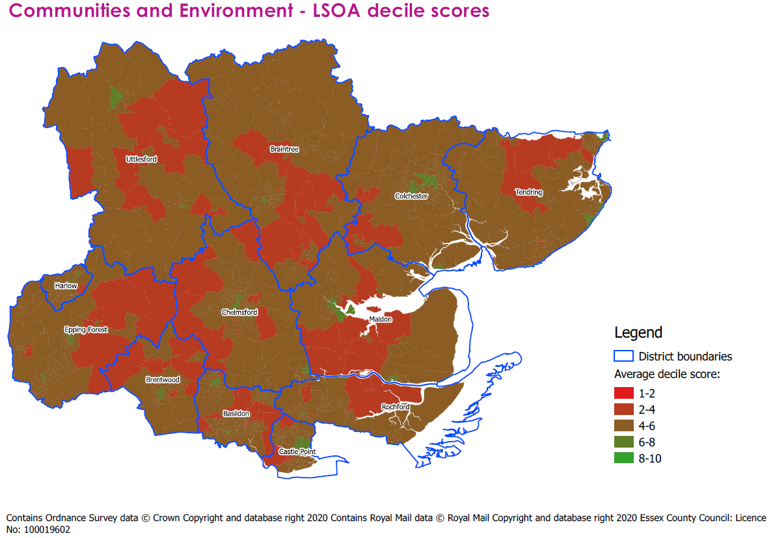
How communities and environment ranks within Essex
The map below shows each Essex LSOA ranked from 1 to 872 depending on its communities and environment decile score, with 1 being the lowest communities and environment decile score, and 872 the highest. This allows us to see the spread of communities and environment decile scores on an Essex-specific scale.
As most LSOAs are placed in deciles 2-6, this map allows us to see the differences between areas based on rank a little clearer.
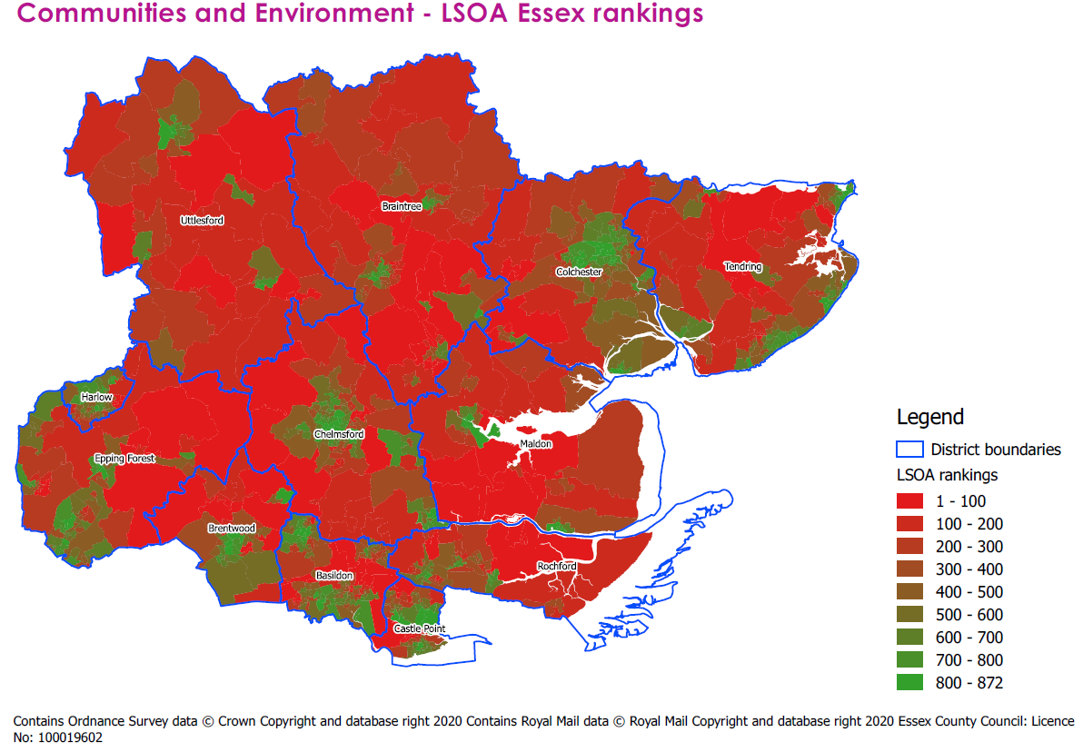

Population

A higher presence of population groups with higher challenges to being active was identified as the tenth biggest driver of physical inactivity according to our regression analysis.
On average, Essex scores 5.39 for the presence of these population groups, higher than the national average of 5.34. The highest scores are found in Rochford (6.25), Brentwood (6.01) and Uttlesford (5.87) indicating a lower presence of these groups in these areas. The lowest scores are found in the districts of Tendring (4.68), Basildon (4.77) and Harlow (4.86).

 | Basildon | Braintree | Brentwood | Castle Point | Chelmsford | Colchester | Epping Forest | Harlow | Maldon | Rochford | Tendring | Uttlesford | Essex average | National average
Population Average deciles | 4.77 | 5.39 | 6.01 | 5.36 | 5.84 | 5.55 | 5.19 | 4.86 | 5.77 | 6.25 | 4.68 | 5.87 | 5.39 | 5.34

How Essex LSOAs score nationally for population
The table below shows 20 LSOAs in Essex which score the lowest on indicators relating to populations with greater challenges to being active. Seven of these areas are found in the district of Basildon, specifically in the wards of Fryerns, Lee Chapel North, Pitsea North West and Vange. Five are found in Tendring, specifically in the wards of Frinton, Golf Green, Pier and Rush Green.
All but five these lowest scoring LSOAs are placed in deciles 1-4 of the 2019 Indices of Deprivation. The five that are placed into a less deprived decile are found in the Witham West ward of Braintree (placed in decile 5), an LSOA in the Frinton ward of Tendring, an LSOA in Maldon South and an LSOA in the Greenstead ward of Colchester (all decile 6) and an LSOA in Maldon North (decile 8).

Theme Rank | LSOA Code | LSOA Name | Ward | LA Name | IMD 2019 decile | Population Average
1 | E01022031 | Tendring 015D | Rush Green | Tendring | 1 | 1.11
2 | E01021988 | Tendring 018A | Golf Green | Tendring | 1 | 1.11
3 | E01021426 | Braintree 015E | Witham West | Braintree | 5 | 1.22
4 | E01021302 | Basildon 013B | Pitsea North West | Basildon | 1 | 1.33
5 | E01033722 | Colchester 008H | Greenstead | Colchester | 2 | 1.44
6 | E01022030 | Tendring 015C | Rush Green | Tendring | 1 | 1.44
7 | E01021267 | Basildon 012B | Fryerns | Basildon | 3 | 1.44
8 | E01021987 | Tendring 008A | Frinton | Tendring | 6 | 1.44
9 | E01021891 | Maldon 004C | Maldon North | Maldon | 8 | 1.56
10 | E01021638 | Colchester 018B | Berechurch | Colchester | 3 | 1.67
11 | E01021268 | Basildon 015B | Fryerns | Basildon | 2 | 1.67
12 | E01021665 | Colchester 016D | Old Heath and The Hythe | Colchester | 2 | 1.67
13 | E01021306 | Basildon 013E | Pitsea North West | Basildon | 1 | 1.67
14 | E01021391 | Braintree 004C | Halstead Trinity | Braintree | 2 | 1.78
15 | E01021300 | Basildon 022A | Nethermayne | Basildon | 3 | 1.78
16 | E01021894 | Maldon 005B | Maldon South | Maldon | 6 | 1.78
17 | E01022026 | Tendring 016C | Pier | Tendring | 1 | 1.78
18 | E01033719 | Colchester 008G | Greenstead | Colchester | 6 | 1.89
19 | E01021324 | Basildon 019C | Vange | Basildon | 1 | 1.89
20 | E01021290 | Basildon 016D | Lee Chapel North | Basildon | 1 | 1.89

The map below shows where each LSOA in Essex places nationally in our population decile. A number of districts have representation among the lowest scoring areas, specifically Basildon, Braintree, Colchester and Maldon. All districts have LSOAs that fall in deciles 2-4.
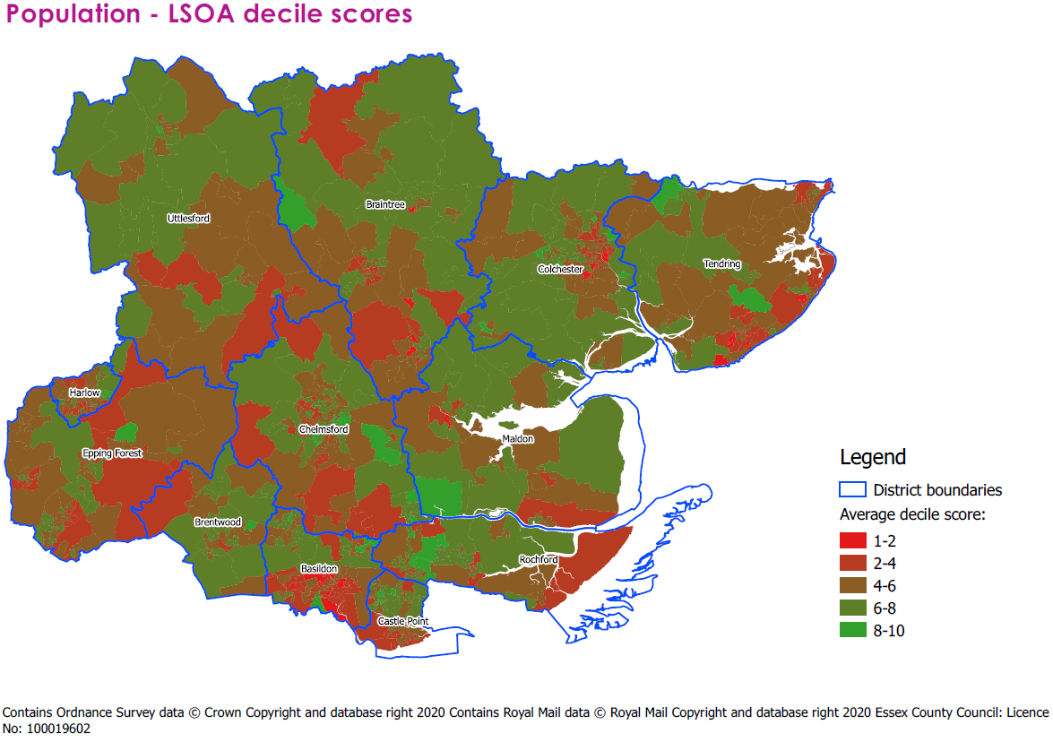
How population ranks within Essex
The map below shows each Essex LSOA ranked from 1 to 872 depending on its populations with barriers to activity decile score, with 1 being the lowest population decile score, and 872 the highest. This allows us to see the spread of populations with barriers to activity on an Essex-specific scale.
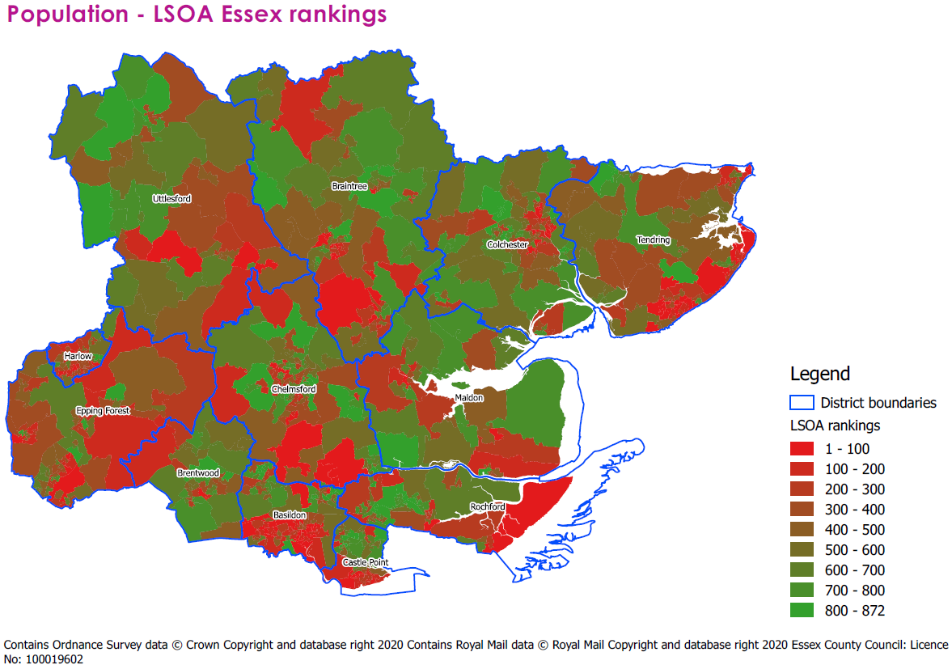

LSOA clusters

Once the cluster analysis was completed, a definition of each cluster was then produced to describe the estimated levels of physical inactivity and potential barriers driving this according to the 10 themes in the data. These definitions are as following:
Cluster 1, VERY Challenging Inactives: With an overall weighted average of 5.8, this cluster is estimated to be the most physically inactive. This cluster also scores low across most of the themes, especially on the themes of Crime, Education and Skills, Population and Vulnerable groups. This indicates that there may be a range of potential barriers to physical activity present across the constituent LSOAs of this cluster. Access and Transport seems to be of least concern within this cluster.
Cluster 2, Challenging Inactives: With an overall weighted average of 6.8, this cluster is estimated to be the second most physically inactive. This cluster also scores low across most of the themes but may need focus on specific issues such as Access and Transport, Communities and Environment, and Population. Crime seems to be of least concern within this cluster.
Cluster 3, Olympians in training: With an overall weighted average of 7.9, this was the best cluster as it is estimated to be the least physically inactive. There are no major areas for concern across the themes, other than relatively low scores in Access and Transport, and Communities and Environment.
Cluster 4, Olympians in high crime areas: With an overall weighted average of 7.4, this was the second-best cluster as it is estimated to be the second least physically inactive. The only area for concern across the themes is the relatively low score in Crime.
Descriptive analytics and geospatial mapping was next conducted to examine how many of the Essex LSOAs are within each cluster and where each of these clusters are located across Essex, including within the ELDP target areas and not.
Looking specifically at LSOAs that are located within the three LDP target districts, the largest number of LSOAs are found in cluster 1, the very challenging inactives. Most LSOAs of focus for the ELDP therefore may have issues in most themes of drivers to physical inactivity. In fact, 78% of the target LSOAs are in cluster 1 and 16% cluster 2.
However, as also shown in the table below, there is also a large number of LSOAs within cluster 1 and 2 that are outside of the LDP target districts and therefore may warrant focus in the future to address physical inactivity levels at a wider level across the whole of Essex.

Clusters |  | Non-target area | Target area | Grand Total
1 |  | 77 | 109 | 186
2 |  | 195 | 22 | 217
3 |  | 302 | 2 | 304
4 |  | 158 | 7 | 165
Grand Total |  | 732 | 140 | 872
Cluster spread by target area:
1 | 78%
2 | 16%
3 | 1%
4 | 5%

Within each of the three ELDP Target Districts, it was found that the following numbers of target LSOAs are within each of the 4 clusters.
Cluster | Basildon | Colchester | Tendring | Grand Total
1 | 49 | 17 | 43 | 109
2 | 5 | 5 | 12 | 22
3 | 0 | 0 | 2 | 2
4 | 2 | 5 | 0 | 7

Cluster | Basildon | Colchester | Tendring
1 | 88% | 63% | 75%
2 | 9% | 19% | 21%
3 | 0% | 0% | 4%
4 | 4% | 19% | 0%

The spread of each cluster within the target districts is not even. Notably, the highest proportion of LSOAs in cluster 1 was found in Tendring and Basildon Districts, and the highest proportion in cluster 2 in Colchester and Tendring.
The tables below show the number and proportion of LSOAs within each cluster by IMD 2019 Decile to examine relationships between cluster type and deprivation.
There appears to be a socio-economic gradient presented here, whereby the LSOAs deemed most at risk of physical inactivity are LSOAs with relatively high levels of deprivation and LSOAs at least risk are LSOAs with relatively lower levels of deprivation.
Notably, 16% of all LSOAs in the very challenging inactives cluster (cluster 1), the cluster deemed most likely inactive, are amongst the top 10% most deprived LSOAs nationally and 22% of LSOAs in this cluster are amongst the top 20% most deprived LSOAs nationally.
In contrast, the clusters estimated to be the most physically active (clusters 3 and 4) are mostly all found in LSOAs that are amongst the top 50% to 10% least deprived LSOAs nationally. For example, 32% of all LSOAs in cluster 3 are amongst the top 10% least deprived LSOAs nationally and 27% of LSOAs in this cluster are amongst the top 20% least deprived LSOAs nationally. Very few LSOAs in cluster 3 and 4 have relatively high levels of deprivation.
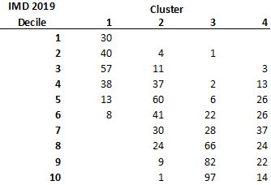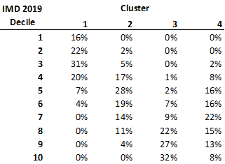

Overall, Cluster 1 and 2 LSOAs tend to be located nearby to each other, and LSOAs within these clusters are also not very spread out. This map below shows the LSOAs classified by cluster across the whole of Essex, with the ELDP target districts and LSOAs highlighted.

Essex Map of Clusters
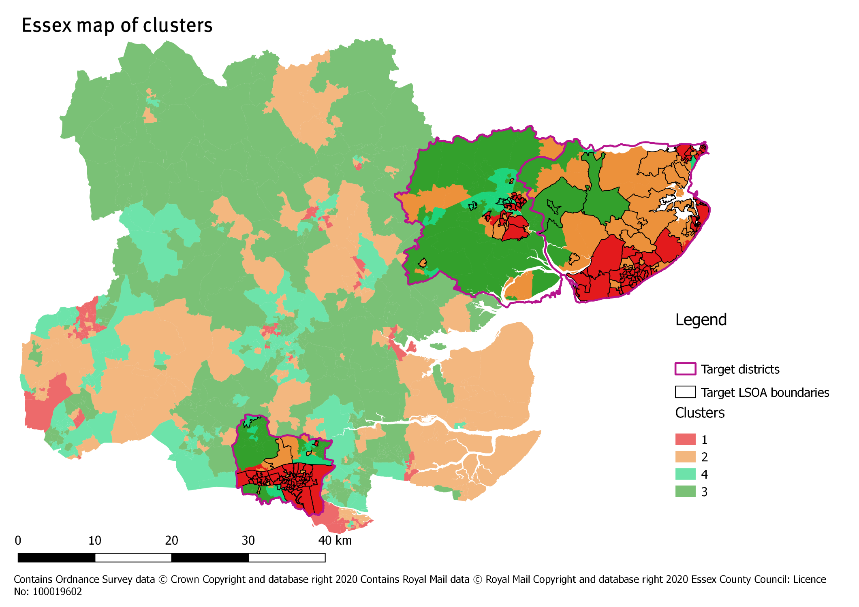

Conclusions and recommendations

This report has provided a brief description of the methodology, and resultant findings, of the work ecda has undertaken for the ELDP to estimate inactivity at a local level. While Sport England’s Active Lives Survey provides levels of physical activity at district level, little is known on a more granular level. The work we have done has been an attempt to fill this gap using data available from open data sources.
This final section of report will provide some recommendations for next steps, and for how this analysis and the accompanying dashboard should be used. First, this conclusion will serve to restate the key outcomes of this project:
The creation of a score to serve as an indicator for inactivity for each LSOA.
In order to estimate levels of inactivity at LSOA level, we used data provided to us by Sport England to create a risk score which measures the extent of the barriers to physical activity in each area.
We identified ten data themes related to barriers to physical inactivity. In order to create a risk score we needed to understand which of these themes had the biggest impact on physical activity so that this data could be weighted accordingly.
The physical activity score is ultimately is an average of all the average decile scores for each theme, with the themes which are more important for physical activity being weighted higher than those with lesser impact.
This score is an abstraction of physical activity levels, an abstraction based on proxy indicators. It should therefore be used a guide for determining the extent of the barriers to physical activity in an area, but it is not a measure of physical activity rates. Instead, it is a measure of the likely presence of drivers to physical activity within each LSOA.
Health has the biggest impact on physical activity.
Through the regression analysis undertaken to inform the weighting for the physical activity risk scores, data on health was identified as the biggest likely driver of physical inactivity. This is not necessarily surprising, it follows that LSOAs with poorer health outcomes are also more likely to be inactive.
However, there is more to physical inactivity than simply poor health. Other factors relating to the area you live in also have an impact on the risk of an LSOA being inactive. In order, these are:
- The local economy (e.g. worklessness)
- The presence of vulnerable groups (e.g. high presence of people with disabilities, carers, older people living alone)
- Active Lives measures (e.g. Sport England’s MSOA modelled estimates of whether an area has high participation in sport)
- Crime (e.g. rates of different types of crime per 1,000 population)
- Access and transport (e.g. from internet infrastructure to travel times to nearest facilities)
- Housing (e.g. housing tenure, condition and affordability)
- Education and skills (e.g. pupil attainment levels)
- Communities and environment (e.g. greenspace coverage, retail environment and sense of ‘belonging’)
- Population factors (e.g. presence of population groups at risk of having more barriers to being physically active, such as single parent households)
All these factors should be acknowledged and assessed to identify likely barriers to activity in each LSOA, with interventions designed with these barriers in mind.
On average, Essex scores better for physical activity than the national average. Despite this, there are pockets of areas at risk of physical inactivity.
We have calculated a physical activity risk score for each LSOA in England, which is available in the datasets we have created for further analysis. As such, this allows us to see how Essex scores in comparison to other areas in England.
In terms of the overall physical activity risk score, Essex, on average, scores better for physical activity than the national average, with Essex scoring 7.07, compared to the national average of 6.79. However, the districts of Tendring, Harlow, Basildon, Castle Point, Braintree and Colchester score lower than the Essex average and should therefore be the focus of the work of the ELDP.
Physical activity is likely to be lower in deprived areas. Deprived areas also pose significant challenges to physical activity across the ten data themes, although there are some exceptions.
Largely, deprived areas score worse in their physical activity risk score when compared with district average figures. On average, deprived LSOAs in Essex score 5.98 in their physical activity risk score, compared with the Essex average of 7.07.
When looking at the ten themes, deprived areas largely score worse, indicating a number of challenges to increasing physical activity in each LSOA. Each LSOA is different however, with some deprived areas performing better in some themes than others.
The only themes in which the link between deprivation and lower physical activity scores is less clear is in access and transport and communities and environment. Both of these themes pertain to accessibility to facilities, transport links, local infrastructure to the local retail offer. In these cases, isolation from central facilities and services is likely to be a bigger factor than deprivation. Housing is also a theme in which the link is less clear, but this could be driven by poorer housing affordability in less deprived areas.
The creation of clusters allows us to group areas on the basis of having shared barriers to physical activity. Interventions can be designed with groups of LSOAs in mind.
There are 872 LSOAs in the county of Essex, and while interpreting the results of each one may be necessary for some interventions, the creation of clusters allows us to group LSOAs based on their shared characteristics. As part of our analysis, we created four clusters, in which LSOAs were grouped on the basis of them having similar decile scores across the ten themes. This allows us to see which areas have similar challenges in order to design interventions intended for wider areas.
Clusters 1 and 2 were LSOAs with lower physical activity scores. Both of these clusters experience barriers to physical activity and should be the areas the ELDP focus on when designing interventions. 78% of the deprived LSOAs in the ELDP’s target districts of Basildon, Colchester and Tendring fall within cluster 1, and 16% in cluster 2.
Cluster 1 is likely to experience challenges relating to crime, education and skills, population groups at risk of inactivity and presence of vulnerable groups. Cluster 2 experiences similar challenges to a slightly lesser extent, but score quite well on crime.
The ELDP’s target areas are likely to experience lower rates in physical inactivity, but there are pockets of inactive areas that could be targeted if the scope of the pilot is expanded.
The ELDP’s initial focus was on the most deprived areas of Basildon, Colchester and Tendring. Through our analysis by theme, most of the barriers to inactivity are experienced in the more deprived areas of Essex. As such, the ELDP is correct to focus on these areas to improve physical activity.
However, the districts of Braintree, Castle Point and Harlow could be the next areas to target if pilots go well. All three of these districts score lower than the Essex average, and all have pockets of deprivation. Some interventions trialled in Basildon, Colchester and Tendring could be expanded into these areas next, with the dashboard and data produced as part of this project used to identify similar areas in Braintree, Castle Point and Harlow in which successful interventions could be replicated.

Recommendations for further research and analysis

As stated, our work provides an estimate based on the risk of physical activity by LSOA. This is a starting point for further research and analysis, and our suggested next steps are outlined below:
Analysis of the impact of the COVID-19 pandemic.
The data collected, and the subsequent analysis during this project, was all undertaken before the COVID-19 pandemic. As such, work may have to be done to analyse and understand the impact of COVID-19 on not only local physical activity levels, but also the drivers and barriers present within communities to partaking in physical activity. It is difficult to anticipate the extent of these impacts and how long this would, in turn, take to be seen in the measures, and this could also depend on the pace of lockdown easing restrictions set by the UK Government. Nonetheless, it would be interesting for further research to examine whether barriers and drivers to physical activity have changed as a result of lockdown and the changing public behaviours. This may need to be an iterative process as the impact of COVID-19 is more fully understood over the coming months and years, and as the dataflows required to examine this at a low-geographical level across such a range of measures becomes available.
This analysis, and the physical activity dashboard, should be used as the platform for further research and qualitative engagement.
By understanding the extent of different barriers to physical activity in each LSOA, targeted community engagement can be undertaken from an informed position into the likely issues in each area, meaning qualitative surveys and interviews can be focused on issues specific to the community of interest.
More data could be added to the tool to provide even greater levels of actionable insight.
The ELDP ecda Physical Activity dashboard holds a wide range of data covering every LSOA across Essex, giving insight into the area’s estimated physical inactivity levels and drivers for this spanning 10 themes. However, there are still gaps present in the dataset. For example, there are 41 variables pertaining to levels of crime in an area over time, but we do not know the extent that this could affect the residents in those areas and therefore any further barriers to physical activity, such as the levels of fear of crime. Further gaps in the dataset could be resourced through the current knowledge held by the ELDP and partners on their local communities and through any further work conducted examining determinants of physical activity. It is therefore recommended that additional data be sourced and added to the tool where possible in order to provide an even greater level of insight into factors which may need addressing by the ELDP programmes in order to tackle physical activity in Essex in an effective and sustainable way.
Our work provides insight into areas, but more can be done to understand public behaviours.
Our tool gives us an understanding of geographies and places, which provides insight to create interventions appropriate for different areas of Essex. More work could be done to align the measures within this analysis to the COM-B model. This is a model of behaviour which is used to identify what specific elements need to change in order for a behaviour change intervention to be successful. In this case, our measures could be aligned to the three factors which influence behaviour change (‘capability’, ‘opportunity’, ‘motivation’). This would provide another dimension to the analysis, offering understanding into the extent of these factors across Essex areas to ensure interventions are pitched to individuals in the most effective way possible, therefore ensuring interventions bring sustainable behaviour change among inactive people. This could be supplemented by further collection of quantitative data on resident behaviours, alongside qualitative insight.
Create a dependent variable through data sourced from a robust quantitative survey.
The regression analysis used as the basis of forming weightings to apply to the theme data, whilst creating an overall physical inactivity score, used the modelled MSOA activity figures from Sport England as the dependant variable. This is an estimate at MSOA level, however further variances in activity levels may also exist at an LSOA level. As such, a more accurate regression analysis and therefore a better understanding of barriers and drivers to activity levels could be obtained by having LSOA level physical activity estimates. This could be achieved through running a large-scale quantitative survey across Essex, targeted at LSOAs of interest. The current analysis could then be replicated with the LSOA results used as the dependent variable in regression analysis, and sense-check the current projects outputs against the findings.
Analysis to examine differences in drivers and barriers to physical activity between areas in Essex.
Information is presented on potential drivers and barriers to physical activity at an LSOA level through the themed data, giving insight into the variance in such factors between areas in Essex. This is presented alongside each LSOA’s decile score on the IMD 2019 to indicate any potential relationships to deprivation levels. However, we do not know whether the impact of drivers and barriers to physical activity differ according to level of relative deprivation, with the regression analysis used to inform weightings and production of the overall physical activity score using nation-wide data. Further work could therefore be conducted to examine this; for example, the current analysis could be replicated split by IMD 2019 decile, with each analysis using only LSOAs with the selected IMD 2019 decile. Outputs could then be examined for differences between the IMD 2019 deciles, to see whether different barriers to physical activity are present along the socio-economic gradient.
A version of this tool could be produced with individual-level data.
Although the tool does provide a range of data and insight into how likely every LSOA is to be physically active and potential factors driving these levels, this does not mean that this holds true for every resident within these LSOAs. Further work could therefore be done to replicate this project using individual level data, especially for the ELDP Target Districts. This would ensure that the ELDP work is targeting factors important to residents and not just the areas that they live within, improving chances of effectiveness in improving physical activity levels.
Analysis to predict cohorts at risk of future physical inactivity.
The data held within this tool provides insight into activity levels and drivers of this using the most current data available. Whilst time-series data is also included in the tool, how the impact of the drivers to inactivity have changed over time has not been examined. We also do not know whether the drivers of activity in an area will remain the same in the long-term, highlighting the need for updating the tool as outlined in recommendations below. Further work could also be undertaken based on the barriers to physical activity present currently to predict cohorts of residents that may be at risk of physical inactivity in the future in absence of intervention, such as through the use of individual child level longitudinal data if available. This would enable the ELDP and partners to prepare for the future and tackle physical activity in a preventative manner.
Decide on an update frequency for the measures in the dashboard.
If the ELDP are interested in updating the data in the dashboard on a regular basis, an update frequency should be decided upon. The data used in the analysis is collated from a range of different data sources, each of which is updated and released at different times of the year.
The appendix to this report, and the metadata set, shows the date of the data used in the analysis and data source for each indicator. We would recommend reviews are undertaken on a six-monthly basis, in which the datasets which are available are updated twice a year.
Allow time for any updates to the analysis.
The addition of extra data to this analysis and to the dashboard could affect the theme data scores, and as such change the outputs of the regression analysis and therefore the weightings used to calculate the physical activity scores. The clusters could also be affected.
This, combined with cleansing and structuring new data to fit in with formats necessary for the analysis and dashboard, means that plenty of time should be allowed for the addition of new data.
Additional work could be done to overlay these findings with community assets (e.g. voluntary associations and nearby amenities).
Mapping of voluntary associations, along with community spaces and facilities that could be used for interventions, could be undertaken and combined with the analysis from this project to assist in designing the shape of interventions with appropriate partners.

Recommendations for use of the tool

As well as providing a platform for additional research and analysis, in its current state the physical activity dashboard should be used to:
- Design interventions to tackle physical inactivity, based on the insight into the barriers to physical activity about the chosen locality.
- Sense-check interventions developed by partners and the community to ensure that they are addressing the right issues.
With these purposes in mind, it worth remembering the following.
The tool does not present a causal relationship between the drivers and physical activity.
The driver themes were combined to create an overall physical activity score for each LSOA, and the regression analysis informed how much weighting was applied to each theme in this process. The physical activity scores presented is therefore not a measure of physical activity levels, but instead an abstraction based on proxy indicators to give an indication of the extent of the barriers to physical activity in an area. This means that the tool does not presents a causal relationship in which the actual physical activity levels can be attributed to those factors.
Other sources of information should be used alongside the tool.
Whilst the tool provides a range of data to develop actionable insight and an evidence base to addressing physical activity across Essex, this tool should not be used on its’ own to do so. Other sources of information may be available that also provide insight into the barriers to physical activity in a local area, such as any previous work conducted by community co-ordinators. Such other sources can be used alongside the tool to sense-check the outputs and any resultant proposed next steps to ensure that the right things are being targeted in the right places.
LSOA profiles are good for gaining an understanding about a single specific area, clusters should be used for interventions spread across wider areas.
When an intervention is specific to a certain small area, the LSOA profiles in the dashboard provide a good basis for designing interventions for that area. As every LSOA is different, however, if interventions are designed on a broader scale, the clusters provide a good indication for the barriers for different groups of LSOAs. Therefore, large scale interventions spread over a broader area can be informed by the insight offered by the clusters. The cluster outputs presented also re-iterate that some Essex areas may require holistic interventions targeting several barriers to physical activity rather than focus on specific factors.

NUTS3 are an economic geography, usually consisting of two or three districts, or one large district

