Produced by:

- Research & Citizen Insight

Evaluation of the Trailblazers Homelessness Prevention Pilot

Second Deep Dive Report

June 2019

CONTENTS
- Introduction 2
About the Pilot 2
Evaluating the pilot 2
About this report 3
- Who is the pilot supporting? 5
Number of cases referred into the service 5
Demographic and household profiles 5
Referral patterns and caseloads across Districts 9
- What support is being provided? 12
Homelessness prevention support provided by mentors 12
Building capacity of local services and upskilling local district
partners 14
- How successful has the pilot been, and why? 15
Levels of homelessness prevention 15
Longer-term, holistic and flexible support is a key success of the Trailblazer mentor scheme 16
Multi-partnership working during the Trailblazer scheme 17
- Summary and recommendations 19
Summary 19
- Appendices 22
Project overview 22
Referral routes by district 23
Prevention outcome by district 24

Introduction
About the Pilot

The Trailblazers pilot funded ten specialist mentors to support people at risk of homelessness across Greater Essex, working in all its 12 districts/boroughs and two Unitary Authorities. It was managed by Essex County Council, using funding awarded by the Department for Communities and Local Government (DCLG), now the Ministry of Housing, Communities and Local Government (MHCLG).

The pilot aimed to deliver prevention activity earlier and work with a wider group of people – not just those who are owed the main homelessness duty – with a focus on complex and vulnerable groups, through:

  - Collaborating with other services to identify at-risk households and target interventions well before they are threatened with eviction;
  - Helping people 56 days or even earlier when they are threatened with the loss of their home;
  - Offering that help to a wider group of people than just those owed the main
homelessness duty; and
  - Testing new, innovative approaches to preventing homelessness

Mentors had specialist knowledge of homelessness support and prevention and sub- specialisms in supporting vulnerable groups (e.g. young people and people with significant multiple disadvantage). They coordinated a varied package of support for those at risk of homelessness, to address their holistic needs, and provide support and mentorship to those providing this support, to increase their skills and capacity. Mentors provided support for as long as is required to prevent homelessness1.

The pilot ran from May 2017 to 31st March 2019. Further details of the Trailblazer pilot and its intended outcomes are appended in Section 6.1.

Evaluating the pilot

The Trailblazer model represents a new model of delivery in homelessness prevention, and there is a need to critically review its delivery and effectiveness as it unfolds. Data provided through monitoring and evaluation will be used to report project success to MHCLG. If the project is successful, the data will also be used to

1 This is different to some other available supports, which provide only brief, intensive support when homelessness is immediately eminent or when homelessness has already occurred

influence how homelessness services are delivered locally and nationally going forward. Monitoring and evaluation was scheduled regularly throughout the pilot – including two ‘deep dive’ reports’ covering the periods to January 2018 and October 2018 – to ensure that learning could be reflected upon throughout.

The questions guiding this evaluation are shown in Figure 1 below.

Figure 1: Evaluation questions
- What types of people are supported by the mentors (directly)? How well do they reflect the intended profile of service users?

- How have mentors worked with homelessness and housing partners to build their skills and capacity around preventing homelessness? To what extent has this:
  - improved working relationships across the system?
  - built confidence and improved practice?

- What direct support have mentors provided to those at risk of homelessness?
  - How effective has this been in preventing them from becoming homeless in the short and longer-term (56 days+2)?
  - How has this altered the care and support provided to those at risk of homelessness?
  - *What costs might this have saved the system?

- What have been the barriers and enablers to the effective running of the Trailblazers approach? How could barriers be overcome?

- How effectively has the Trailblazers programme been managed and governed, and how has that affected intended outcomes?

- How well has the Trailblazers model been embedded into the current homelessness system in Essex?
  - How has Trailblazers helped prepare for the Homeless Prevention Act?

*An economic analysis looking at what costs were saved in the system is being conducted separately to this report.
About this report

This ‘deep dive’ report represents the second and final in-depth data review for the pilot3. Some of the themes discussed in the first deep-dive report are revisited and updated in this report. It draws on the following data:

- Trailblazer monitoring data. All ten mentors have recorded details of those who have been referred to them for direct support: this includes demographic,

2 56 days is the time-period captured by DCLG in their proposed data monitoring systems
3 The first ‘deep dive’ report – which reviewed the pilot to the end of January 2018 - was produced in March 2018.

referral, activity, and outcome data. This report analyses monitoring data up to and including October 2018 (n = 540).

- Discussions with key stakeholders. We have spoken to mentors, mentor managers from the 3 service providers and 5 District Council representatives throughout the programme.

- Trailblazer case studies. Mentors have regularly been sharing details of good practice with each other; these have been reviewed to identify elements of good practice to supplement other data collection.

1.3.1 Confidence in the findings

Overall, we are confident that this report provides valuable data to inform each of the evaluation questions. However, the robustness of data within this report is influenced by the following:

- Missing data. Monitoring data was not always complete, largely as a result of outcome data not being available for live cases, but also because of lost contacts or data simply being unknown. We have noted base sizes and levels of missing data throughout the report to indicate where data is less robust.

- Data not fully up to date. From a review of the data analysed at the first deep-dive report, it is apparent that mentors sometimes backfill cases (i.e. don’t record them immediately at the time of referral but enter case details at a later date), meaning that the number of referrals recorded and reported for later months is likely to be lower than the actual number of cases (being) supported by the service.

- Data errors. As an example, the first deep dive found that the number of days recorded between assessment and case closure was sometimes more than one year, when at the time, one year had not passed since the pilot went live. These issues could be resolved via standard data checks and cleaning.

- Data limitations. We spoke to five District Councils as part of the review, and so we cannot say that the project represents the views of all 14 Districts involved in the pilot.

Who is the pilot supporting?

From April 2017 to the end of October 2018, 540 cases were referred into the Trailblazer service. Thirty-one of these were repeat cases, where a person/household had previously received support from the service.

The pilot has attracted who it intended to: those referred to the service were homeless or at risk of homelessness, and half (50%) had multiple vulnerabilities within their household. Two-fifths of cases (39%) were single adults with no dependent children, with 21% of all cases referred to the service single males with no dependent children.

The level of referrals varied significantly across districts, due to a range of factors including: rates of homelessness in each district; how quickly the mentors were able to mobilise in their areas; the existing homelessness support in each district; and how well the (services offered by) Trailblazer mentors have been integrated with
district council teams.

Number of cases referred into the service

From April 2017 to the end of October 2018, 540 cases were recorded as having been referred into the Trailblazer service4. Sixty-nine of these (13%) were ‘live’ cases5 whilst the remaining cases (471) had final outcomes.

Demographic and household profiles

Demographic information was collected for the main applicant only for each case referred into the service:

  - more than two thirds of main applicants were female6 (70%)
  - more than four in five were in receipt of benefits (85%)7
  - a quarter (24%) were in employment with 10% in full-time employment8, although the number of households in employment is likely to have been higher given this information was collected for the main applicant only

4 Given it is understood that mentors sometimes backfill cases (i.e. don’t record them immediately at the time of referral but instead enter case details at a later date), the number of referrals recorded and reported may be lower than the actual number of cases (being) supported by the service.
5 This included those cases with either an ‘ongoing’ or blank prevention outcome
6 Data available for 539 cases (missing = 1)
7 Data available for 520 cases (missing = 20)
8 Data available for 523 cases (missing = 17)

  - the average age was 39.9 years (age breakdown in Figure 2) with three-fifths of main applicants (59%) aged 25-449.

Figure 2: Age-groups of those referred to Trailblazers (main applicant only)
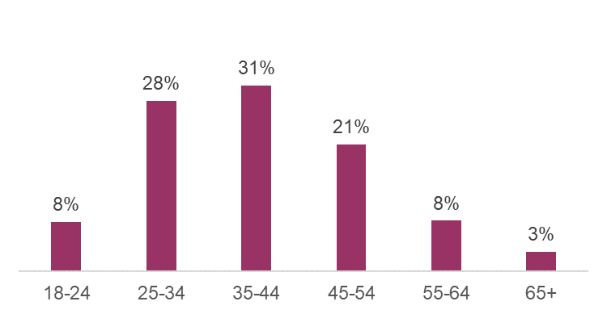
Source: Trailblazer service monitoring data, to 31st October 2018. Data available for 523 cases (missing = 17).

Four in five cases (80%) were single adults (with or without dependent children); 17% involved two adults and the remainder (3%) 3-4 adults. Just over half of households referred to the service (52%) had dependent children (Table 1).

Table 1: Household composition
 | n | %
NUMBER OF ADULTS IN HOUSEHOLD
One | 427 | 80%
Two | 91 | 17%
Three | 11 | 2%
Four | 8 | 1%
NUMBER OF DEPENDENT CHILDREN
None | 257 | 48%
One | 85 | 16%
Two | 90 | 17%
Three | 60 | 11%
Four or more | 45 | 8%
Total | 537 | 100%

Source: Trailblazer service monitoring data, to 31st October 2018. Data available for 537 cases (missing = 3).

Two-fifths of cases (39%) were single adults with no dependent children, with 21% of all cases referred to the service single males with no dependent children.

9 Other demographic information was collected: 98% of main applicants were UK nationals (Data available for 536 cases; missing = 4); 95% of main applicants described their ethnicity as White. This compares to 90.8% in the general Essex population recorded in the 2011 Census statistics.

Housing status

Nine in ten of those referred to the service (90%) were in fixed accommodation (Table 2).

Table 2: Housing status on referral to the service
 | n | %
Fixed accommodation | 472 | 90%
Social rented sector | 327 | 62%
Private rented sector | 124 | 24%
Registered Provider tenant | 17 | 3%
Owner occupier | 4 | 1%
Temporary/other accommodation | 55 | 10%
No fixed abode: Living with family | 6 | 1%
No fixed abode: living with friends | 4 | 1%
B&B | 4 | 1%
Emergency | 4 | 1%
Hostel | 3 | 1%
Other temporary accommodation | 23 | 4%
Other | 11 | 2%
Total | 527 | 100%

Source: Trailblazer service monitoring data, to 31st October 2018. From initial assessment information collected by mentors. Data available for 527 cases (missing = 13).

All those referred were assessed as being at risk of homelessness (96%), if not homeless already (4%). Whilst in one in six cases, eviction was imminent, the majority of cases were at longer-term risk of homelessness (Table 3).

Table 3: Initial assessment of homelessness risk
 | n | %
Future risk | 226 | 44%
Threatened - 29-56 days | 178 | 35%
Threatened - 28 days | 88 | 17%
Homeless | 16 | 4%
Total | 508 | 100%

Source: Trailblazer service monitoring data, to 31st October 2018. From initial assessment information collected by mentors. Data available for 508 cases (missing = 32).

Trailblazer case studies indicated that clients were most often at risk of homelessness because of rental arrears, ranging in the value of £1,500 to £3,000. In other cases, rental property in which clients were living were due to be sold, and clients did not have sufficient funds for a deposit on another property.

Previous experience of homelessness

Seventeen per cent of cases (main applicant only) reported having ever been homeless before10 and 8% reported having ever slept rough11. Sixteen per cent had been temporarily accommodated by a Local Authority in the past five years12.

It should be noted that the above figures have been rebased to exclude cases recorded as ‘Don’t know’, therefore the actual proportions may vary slightly.

Identified vulnerabilities

Half of cases (50%) had more than one type of identified vulnerability within their household13; the average number of vulnerabilities was 1.614. This aligns with data collected in the Trailblazer case studies: mentors often spoke about the clients having multiple vulnerabilities, such as both being a single parent and suffering from mental ill-health. This often led to clients feeling “overwhelmed’ when also facing housing issues, and, as more than one mentor put it ‘sticking their heads in the sand’.

In almost half of cases (45%), the presence of dependent children was the primary vulnerability identified at referral15, with mental health the primary vulnerability in nearly a third of cases (30%). Physical health problems and drug/alcohol dependency were each recorded as the primary vulnerability in around one in ten cases.

When looking at all vulnerabilities within a household, 63% of cases had a mental health problem and 21% a physical health problem (Figure 3).

10 Data available for 516 cases (missing = 24) but percentages are based on 436 cases to exclude 80 cases recorded as ‘Don’t know’.
11 Data available for 517 cases (missing = 23) but percentages are based on 441 cases to exclude 76 cases recorded as ‘Don’t know’.
12 Data available for 511 cases (missing = 29) but percentages are based on 459 cases to exclude 52 cases recorded as ‘Don’t know’.
13 Data available for 507 cases (missing = 33). It is understood that all households accessing the service should have had at least one vulnerability and therefore a blank field in the monitoring data for the Main Applicant / Household Vulnerability field indicates missing data as opposed to the household not having any vulnerabilities.
14 This relates to the number of types of vulnerability (e.g. mental health, alcohol dependency) within a
household; therefore, if multiple persons within a household had the same vulnerability, this is only counted once (i.e. at household level) within the reported figures
15 ‘Presence of dependent children’ was always recorded as the primary vulnerability where multiple vulnerabilities existed within a household. It should be noted that there were some cases with dependent children where ‘presence of dependent children’ was not recorded as an identified vulnerability.

Figure 3: Identified vulnerabilities within households referred to the Trailblazer service
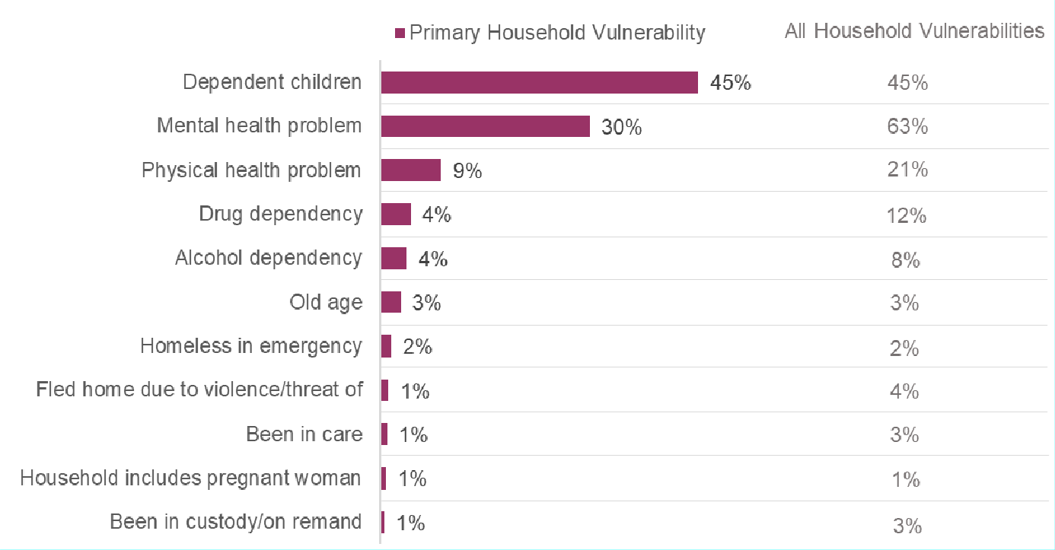

Source: Trailblazer service monitoring data, to 31st October 2018. Data available for 507 cases (missing = 33).

Referral patterns and caseloads across Districts

Half of cases were proactivity identified by the Local Authority or other partner (51%); the remaining referrals were via another service/partner (29%) or self-referral (20%)16.
The pattern of referrals was not consistent across districts, with:

- self-referrals highest in Southend-on-Sea (53%) and Brentwood (45%)
- referrals from Local Authorities (and their partners) highest in Harlow (82%) and Uttlesford (72%)
- referrals from other services/partners highest in Thurrock (76%), Chelmsford (70%), Colchester (70%) and Maldon (69%).

A full breakdown of the data is included in Section 6.2.

Mentors believed these differences were a result of the differences in how Trailblazers support was incorporated into local processes and procedures. For example, self-referrals were highest in areas with local meetings run by other

16 Data available for 527 cases (missing = 13)

homelessness support agencies, where individuals might hear about the Trailblazers project and be supported to directly contact a mentor.

2.3.1 Cases by District and over time

Referrals to the Trailblazer service were highest in Harlow (72), Braintree (64) and Tendring (62) (Figure 4), although there was significant variation across the county.

The differences in the number of referrals seen by district were due to a range of factors including: rates of homelessness in each district; how quickly the mentors were able to mobilise in their areas; the existing homelessness support in each district; and how well the (services offered by) Trailblazer mentors were integrated with district council teams. A number of these themes are discussed later in the report.

Figure 4: Number of cases by District
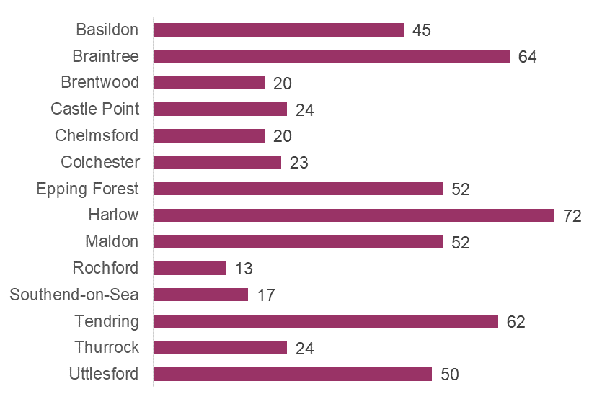
Source: Trailblazer service monitoring data, to 31st October 2018. Data available for 538 cases (missing = 2).

Figure 5 shows the pattern of referrals since May 2017. It should be noted that the figure of 23 referrals in October 2018 is unlikely to represent the final number for this month, where some cases are entered by mentors retrospectively17. The lower number of referrals in May 2017 was due to the service only launching in April 2017. It is notable that since the introduction of the Homeless Reduction Act in April 2018, the number of referrals to the service increased, as evidenced by the increase in the

17 It is possible that the figures for later months (e.g. August and September, in addition to October) may also be subject to change where cases are added retrospectively by mentors.

3 month rolling average. Indeed, the average number of cases per month increased from 29.2 prior to April 2018 (excluding April and May 2017) to 37.8 from April 2018. However, this was due to increases in referrals in two districts, as opposed to increases being seen across all districts:

- In Harlow, referrals increased from 2.2 per month prior to April 2018, to 8.3 per month from April 2018
- In Epping Forest, referrals increased from 2.3 per month prior to April 2018, to
4.7 per month from April 2018

Figure 5: Number of cases by month
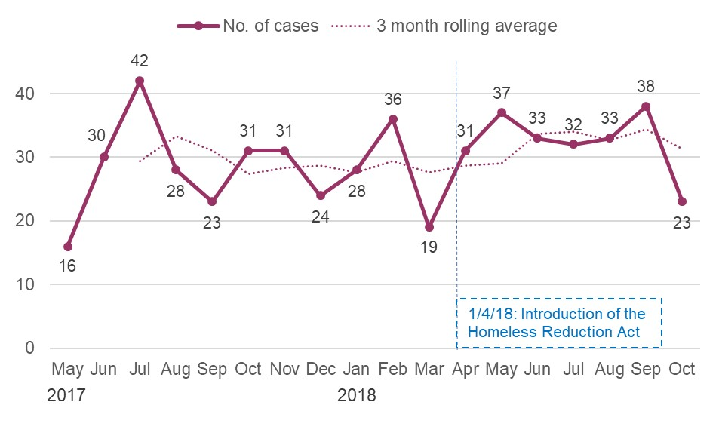
Source: Trailblazer service monitoring data, to 31st October 2018. Data available for 536 cases (missing = 4). Note that 1 case was recorded in April 2017; this has been omitted from the chart.

What support is being provided?

In line with intentions, the vast majority of activities undertaken by mentors related to preventing the risk of homelessness. As intended through trailblazers, mentors
worked with cases over an extended period of time, and the time spent with clients varied dependent on their level of need.

Homelessness prevention support provided by mentors

Amongst final cases with a ‘successful’ outcome and where prevention data was available18 (274 cases), 1,303 prevention activities were recorded by mentors, equating to a mean of 4.8 prevention activities per case. Whilst the number of prevention activities ranged from 1-28, 88% of cases received between 1-8 prevention activities, with a quarter (23%) recorded as receiving just a single activity.

However, a review of the comments entered by mentors alongside each prevention activity suggested some inconsistencies in the way mentors defined and/or entered prevention activities. For example, some mentors were using the prevention activity information to record every interaction related to a case; this included administrative entries such as:

- “Text from [INITIALS] regarding todays appointment time and confirming that she will be home for this appointment”
- “Called [NAME] – no answer”
- “Call to [INITIALS] regarding appointment next week that need to change as I have another case I have to support at the same time. No answer text sent.”

This contrasted with other entries that either described a specific activity (e.g. “Initial assessment completed and support plan agreed”) or where a single entry appeared to cover more than one action (e.g. “Discussed Debts wrote to Creditors Applied for DHP for Rent arrears and top up each week towards current cost”).

As such, caution should be taken in drawing conclusions about the specific numbers of prevention activities provided by mentors, given the inconsistencies observed in defining and recording these.

Bearing in mind the above caveat, the most common prevention activities are listed below to provide an indication of the support provided by Trailblazer mentors.

- Information/Advice (accounting for 31% of all prevention activities recorded)

18 Data available for 274 of 387 ‘successful’ cases (missing = 113). Note that there existed a number of prevention activities recorded in the monitoring data which could not be matched back to any of the 540 cases due to incompatible household reference numbers.

- Mediation (25%)
- Financial Payments (13%)
- Problem Resolution (10%)
- Partner working (10%)
- Referrals (6%)

In addition to prevention activities, mentors also recorded having provided ‘relief activities’ (activities undertaken to attempt to relieve homelessness) to 33 of 471 completed cases.

3.1.1 Duration of Trailblazer support

Amongst final cases where a valid referral and case end date had been recorded19, the mean number of days a case was supported for was 55 (57 where prevention was successful, 56 where unsuccessful and 44 where a client withdrew), equivalent to almost eight weeks.

Table 4 provides a breakdown of the duration of support for ‘prevented’ and ‘unsuccessful’ cases only.

Table 4: Duration of Trailblazer support (‘prevented’ and ‘unsuccessful’ cases only)
 | Category  % | Cumulative  %
Up to 1 week | 9% | 9%
Up to 2 weeks | 12% | 21%
Up to 3 weeks | 7% | 28%
Up to 4 weeks | 4% | 33%
Up to 5 weeks | 9% | 42%
Up to 6 weeks | 7% | 49%
Up to 7 weeks | 8% | 57%
Up to 8 weeks | 4% | 61%
Up to 9 weeks | 6% | 67%
Up to 10 weeks | 5% | 72%
Up to 11 weeks | 6% | 78%
Up to 12 weeks | 2% | 80%
Up to 16 weeks | 8% | 88%
Up to 20 weeks | 6% | 93%
Up to 24 weeks | 3% | 97%
More than 24 weeks | 3% | 100%

Source: Trailblazer service monitoring data, to 31st October 2018. Data available for 338 cases out of 413 ‘prevented’ and ‘unsuccessful’ (missing = 75).

19 Data available for 389 out of 471 final cases (missing = 82)

Mentors and providers agreed that a key part of the value of the Trailblazer scheme was in being able to provide intense, long-term support to individuals which is not possible through the standard Council Housing support teams.

‘Because of the intensive work that is being done by the mentors, they’ve got a greater prospect of success of preventing homelessness than if it stayed with the homeless team who are really pushed for time because of the amount of cases that they are dealing with at any one time.’ District Council representative

Building capacity of local services and upskilling local district partners

In the last deep dive, it was reported that building capacity of local services appeared to be less common than anticipated. For this report, this area was explored in more detail. There was some expectation amongst some of the partners, particularly those involved in the initial setting up of the Trailblazer scheme, that Trailblazer mentors could upskill local authorities in certain specialisms. In some cases, this was not necessary and may not have been appropriate for the mentor to provide training or upskilling. For example, one district was allocated a mentor who specialised in families, but as the local authority already had a dedicated officer with that speciality, it wasn’t felt there was a need for added resource in that area. In contrast, some mentors fitted the specialities required to tackle homelessness in that district. As such, it was reported that one district wanted considerably more of the mentor’s time and would have liked them to work five days a week in the office, which shows that they fully wanted to utilise the support and specialism of their mentor. Therefore, how that resource was used varied across the county.

Where discrepancies existed between local authority need and mentor specialism, it may have adversely affected the relationship between the local authority and Trailblazer mentor. This may have been due to time constraints in the bidding process which did not allow for in-depth engagement or consultation with local districts to match mentor specialities with local authority need.

‘It (Trailblazers) had been put together by commissioners without the input of operational service managers to really guide how this could work practically with boots on the ground.’ District Council representative

Mentors did provide advice and guidance to the local authority teams they worked with during the pilot, albeit informally and not in a structured manner. This enabled some form of skills sharing and upskilling. However, there were few opportunities for mentors to meet together as a group and share learning and best practice due to varying work schedules, which may have affected building capacity as part of the scheme.

‘Informally the mentors have provided knowledge of their specialisms, but again nothing formal – it’s more at sit-downs such as team meetings and talking about individual cases.’ District Council representative

How successful has the pilot been, and why?

387 successful cases were achieved to the end of October 2018.20

The model focused on supporting clients to remain in their own homes, with almost six in ten of successful cases being supported to do this. Project successes have been attributed to the long-term, comprehensive, and holistic support provided by the
mentors, and the support of local service providers and stakeholders.

Levels of homelessness prevention

Of the 471 completed cases supported by Trailblazers21, homelessness had been prevented in 387 cases (82%). Of the cases where homelessness was not prevented, 58 cases (12%) were recorded as having withdrawn from the service before completion and 26 cases (6%) were recorded as unsuccessful (Figure 6).

By district, the proportion of prevented cases ranged from 69-100%, although it should be noted that comparisons between districts are not necessarily objective due to variations in: levels of throughput (including some very low base sizes); how cases were identified for Trailblazer support; working arrangements between mentors and local authorities; and local client bases (e.g. propensity to engage with the service).
A breakdown of outcome by district is included in Section 6.3.

Figure 6: Case outcomes, trailblazers
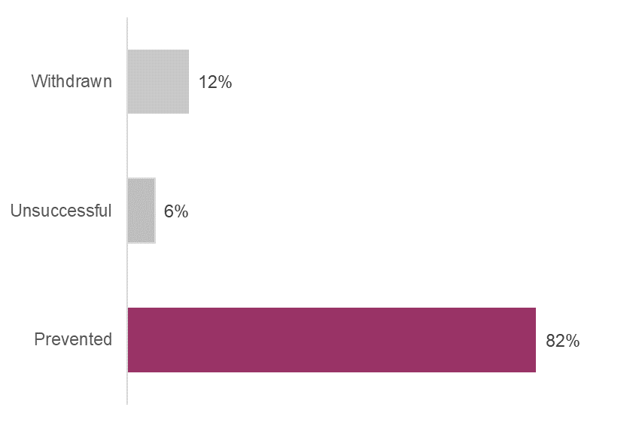
Source: Trailblazer service monitoring data, to 31st October 2018. Base = 471 completed cases.

From the monitoring data, it appeared that there was some overlap between the ‘withdrawn’ and ‘unsuccessful’ outcome codes. Case-specific comments within the

20 The programme aimed to achieve a total of 496 preventions; a total of 491 preventions were achieved by 31st March 2019.
21 Sixty-nine of the 540 cases analysed by this report were recorded as live cases

monitoring data indicated that a number of the ‘unsuccessful’ cases were due to clients withdrawing, failing to cooperate and/or losing contact, as opposed to the mentor support/prevention activities not being effective. Likewise, a number of comments attached to ‘withdrawn’ cases indicated that an eviction went ahead – akin to an unsuccessful outcome – although the general nature of the comments included by mentors and the number of cases where contact had been lost did not lend itself to reliably quantifying this.

Furthermore, in seeking to understand longer-term outcomes, the monitoring data did not always include sufficient information to ascertain what happened to clients following an ‘unsuccessful’ or ‘withdrawn’ outcome (again, often due to contact being lost with the client): for example, whether they found alternative accommodation following an eviction.

4.1.1 Proportion of cases supported to remain in their own home

Amongst cases categorised as ‘successful’ (and where this information was known22), nearly 57% had been supported to remain in their own home, whilst 20%. were in another tenancy (either private, social, Local Authority or other voluntary organisation). The remainder (23%) had a range of other outcomes23, including 15% who were recorded as ‘Other’.

Longer-term, holistic and flexible support is a key success of the Trailblazer mentor scheme

A key success of the Trailblazer scheme was that mentors could provide long-term, intense support. This was a unique part of the scheme and something most district representatives identified as a positive feature of the Trailblazer scheme. Local authorities often do not have the resource to dedicate officers to cases for long-term, dedicated support. Mentors were able to work intensively on a case as local authority officers referred complex cases to mentors which required that type of support.

‘It’s more complex clients that Trailblazers are more beneficial for as they can give more time to those cases. We have officers with 70 cases each’ District Council representative

As such, there was a significant difference in the amount of cases that Trailblazer mentors managed compared to the local authority, with mentors reportedly maintaining a caseload of around 10-12 cases at any one time. Local authorities considered that this increased the chance for more positive outcomes (e.g. more chance of a homelessness prevention) as mentors were able to dedicate more resource to a case.

22 Data available for 317 of 387 ‘successful’ cases (missing = 70), due to missing data, data being recorded as unknown, or the mentor having lost contact with the user before these details were collected.
23 2% moved in with friends/family; 2% supported housing; 1% hostel – LA; 1% shared property; 1% made own arrangements

However, there was variation across the county in how the mentor support was utilised. For example, some organisations were more tailored to the needs of the local authority they were working with and could provide them with support which is suited to a particular cohort.

‘We have [service provider] which is great for us. Have worked really well with them. We have worked with chaotic singles and this agency are very good. Some confusion over their expertise and clientele which is very much around [specialism] and less around generic homelessness. We tend to refer cases to them which require that sort of intervention. We may be less able to give the amount of attention needed for these individuals. Tends to be those sort of clients that we use the mentors for.’ District Council representative

‘What we did need was some support around single homelessness but there was some resistance around this as it had been sold to the worker as family work’ District Council representative

If mentors had a full caseload, it was reported that cases that couldn’t be dealt with by that particular mentor were referred to floating support. It was not widely reported by mentor managers or district leads that resourcing was an issue or that mentors could not manage their caseload.

There were some difficulties reported in embedding the Trailblazer model into the council setting. In some cases, mentors were not able to co-locate which may have affected their ability to form effective relationships with the local authority. Furthermore, some authorities saw the scheme as an ‘add on’ rather than something that could be embedded within the council long-term.

‘We have a [job role], so mentors can work over and above what she is able to do. So it’s nice to have the Trailblazers, but if we had the money instead we could do the same work.’ District Council representative

Multi-partnership working during the Trailblazer scheme

Partnership working during the Trailblazer scheme varied across the councils. As discussed in section 4.2, the mentors had different practical working arrangements across Essex and not everyone was able to co-locate. Some of the district leads and mentor managers highlighted that when mentors were embedded within the council some reported high levels of engagement with the local authority and were better able to attend regular meetings.

The mentor is co-located, as this is the model that the Council lead wanted to adopt. In addition, we have a six month liaison meeting to see things from a strategic point of view about how the scheme is operating, so that’s something we do above and beyond the fortnightly meeting with the mentor. [With reference to the fortnightly meetings] District Council representative

Mentor managers reported the importance of districts being proactive in referring cases to mentors and ensuring that they had enough time to support a client. The

scheme was reported to have worked better when mentors were informed and given enough time to prepare their work.

‘Because there was a point where we were getting them on a Monday and they had court on a Weds. So, had to stay up most of the night trying to put a case together and they’d never met. So, we had to put a stop to that because that was getting silly. [mentor name] had five court cases in one week the other week, on one of them [they] had three on one day, [the mentor] was just going from one room to another room in the court house all because they came in too late.’ Mentor manager

‘In terms of maximising the opportunity for trailblazers to try and assist with a particular case, we’ve tried to impress upon staff that early notification is crucial, so there’s no point in them holding onto a case for four weeks and then thinking it’s a good time to refer this case to the trailblazer because early notification is crucial if they are to be successful in achieving a prevention in homelessness… It’s not just up to the mentors, we’ve got a role to play in this and an opportunity could be lost on a very valid case if there isn’t early notification. All officers are aware that if they are dealing with a complex case where they think there is a good prospect of success through [the mentor] … then they need to make the referral.’ District Council representative

There was some inconsistency and misunderstanding in the referral process with some local authorities stating it was sometimes unclear which cases to refer to the Trailblazer mentors. This may have been because each of the areas worked slightly differently in terms of how they had been set up.

4.4 Homelessness Reduction Act

The Homelessness Reduction Act 2017 came into force on 3rd April 2018 and introduced significant changes to homelessness legislation as it brought new duties to prevent and relieve homelessness. The Homelessness Trailblazer scheme fits in with this drive towards early prevention of homelessness.

The local authority representatives interviewed as part of this deep dive were asked about how the districts had prepared for the Homelessness Reduction Act and how Trailblazer mentors had supported them during this preparation. Some authorities explained how a restructuring of staff or a transformation team had set up for supporting the implementation of the HRA, but there had not been input from mentors during this process.

Mentor Managers detailed how mentors had been supporting some of the districts with preparation for the HRA. This support and preparation varied across Essex, depending on local authority requirements

‘All three districts had to introduce personal housing plans as part of the Act. Before the Act went live, mentors were working with the districts with regards to the plans and feeding in their expertise (given mentors have to complete assessment forms and support plans as part of the support they provide).’ Mentor manager

Summary and recommendations

Summary

What types of people are supported by the mentors (directly)? How well do they reflect the intended profile of service users?

  - Four in five cases (80%) were single adults (with or without dependent children); 17% involved two adults and the remainder (3%) 3-4 adults. Just over half of households referred to the service (52%) had dependent children.
  - Two-fifths of cases (39%) were single adults with no dependent children, with 21% of all cases referred to the service single males with no dependent children.
  - More than four in five households were in receipt of benefits (85%)24
  - A quarter (24%) were in employment with 10% in full-time employment25, although the number of households in employment is likely to have been higher given this information was collected for the main applicant only
  - The average age of main applicants was 39.9 years with three-fifths of main applicants (59%) aged 25-4426.
  - It is felt that the pilot attracted who it intended to: those referred to the service were homeless (4%) or at risk of homelessness (96%), and half (50%) had multiple vulnerabilities within their household.
  - The pilot aimed to deliver prevention activity earlier, helping people 56 days or even earlier when they are threatened with the loss of their home. Whilst in one in six cases, eviction was imminent (within 28 days), the majority of cases were at longer-term risk of homelessness, with 35% at risk within 29- 56 days and 44% at ‘future risk’.

How have mentors worked with homelessness and housing partners to build their skills and capacity around preventing homelessness? To what extent has this:
- improved working relationships across the system?
- built confidence and improved practice?

  - There was some expectation amongst partners involved in the scheme that Trailblazer mentors could upskill local authorities in certain specialisms.
  - In some cases, it was not necessary for mentors to build skills and capacity of the local authority around preventing homelessness.

24 Data available for 520 cases (missing = 20)
25 Data available for 523 cases (missing = 17)
26 Other demographic information was collected: 98% of main applicants were UK nationals (Data available for 536 cases; missing = 4); 95% of main applicants described their ethnicity as White. This compares to 90.8% in the general Essex population recorded in the 2011 Census statistics.

  - It was reported that mentors provided advice and guidance during the pilot, informally and not in a structured manner.
  - Where mentors were co-located within districts, working relationships were better.

What direct support have mentors provided to those at risk of homelessness?
- How effective has this been in preventing them from becoming homeless in the short and longer-term (56 days+27)?
- How has this altered the care and support provided to those at risk of homelessness?

- In line with intentions, the vast majority of activities undertaken by mentors related to preventing the risk of homelessness. As intended through Trailblazers, mentors worked with cases over an extended period of time, and the time spent with clients varied dependent on their level of need.
- Mentors and providers agreed that a key part of the value of the Trailblazer scheme is in being able to provide intense, long-term support to individuals which is not possible through the standard Council Housing support teams.
- Of the 471 completed cases supported by Trailblazers (to the end of October 2018), homelessness had been prevented in 387 cases (82%).
- The model focused on supporting clients to remain in their own homes, with almost six in ten of successful cases being supported to do this. Project successes have been attributed to the long-term, comprehensive, and holistic support provided by the mentors, and the support of local service providers and stakeholders.

What have been the barriers and enablers to the effective running of the Trailblazers approach? How could barriers be overcome?

  - Practical arrangements in some of the districts meant that mentors were not able to co-locate. In some instances, as reported by district leads, co-location led to positive results of better engagement between the mentors and the local authority.
  - It was reported that there was a mismatch between local authority need and mentor specialism. This may have been due to time constraints in the bidding process which did not allow for in-depth engagement and consultation with local districts. This issue could be overcome in future through the bidding process and consultation between the districts and mentor agencies.
  - In relation to the point above, it should be made clear that it wasn’t the intention for mentors to be specifically matched to certain areas, as the mentor specialism was a specialism to be used within the wider Trailblazer teams and to offer support and directions to colleagues not to fit the needs of that district. The specialism was to bring a wide spectrum of specialism that might need to be used by the team.

27 56 days is the time-period captured by DCLG in their proposed data monitoring systems

How effectively has the Trailblazers programme been managed and governed, and how has that affected intended outcomes?

  - Partnership working during the Trailblazer scheme varied across the council.
  - Most districts reported regular communication between partners. Meetings were held between partners, although large multi-partnership meetings involving all districts and mentor agencies were not held frequently.

How well has the Trailblazers model been embedded into the current homelessness system in Essex?
a. How has Trailblazers helped prepare for the Homeless Prevention Act?

  - The Trailblazer scheme fitted in with the drive towards early prevention of homelessness embedded within the Homeless Reduction Act 2017.
  - The district leads spoken to as part of this deep dive did not report that there had been significant input from the mentors as they had largely undergone restructuring and transformation as part of business as usual for how they would prepare for changes brought in by the Act.

Recommendations

It is recommended that future activity seeks to build on the experiences of the Trailblazers pilot through:

- Maintaining dedicated resource in the districts to provide intense, long-term support for complex homelessness prevention cases.

- Aiming to engage and involve districts at an early stage to match resources to local needs and manage expectations about provision of resource.

- Developing good practical working arrangements between mentors and districts to enable effective co-location.

- Ensuring there are processes in place to have early handover of cases to mentors to enable better chances of prevention of homelessness.

- Working holistically with a range of partners and utilising mentor networks to access expertise across a range of sub-specialisms to support vulnerable groups.

Appendices

Project overview

6.1.1 Background

In late 2016, the Department for Communities and Local Government (DCLG) - now the Ministry of Housing, Communities and Local Government (MHCLG) – sought proposals to establish a funded network of ambitious Homelessness Prevention Trailblazer areas across England. It aimed to identify areas who wanted to go further and faster with reform and develop innovative new approaches to preventing homelessness through:

  - Collaborating with other services to identify at-risk households and target interventions well before they are threatened with eviction;
  - Helping people 56 days or even earlier when they are threatened with the loss of their home;
  - Offering that help to a wider group of people than just those owed the main homelessness duty; and
  - Testing new, innovative approaches to preventing homelessness to help build the evidence base on what works and test the effects of these approaches in different areas.

The coalition bid for the whole of Essex, submitted by Essex County Council (ECC), included all twelve district/borough councils in Essex and both unitary authorities (Southend-on-Sea and Thurrock).

As part of the programme, ten ‘Trailblazers’ positions were funded to provide specialist support for those at risk of homelessness. The programme funding was provided over two years with the programme running from April 2017 to March 2019. The Trailblazers were managed by three Essex-based services with a remit for homelessness prevention and support - Phoenix Futures, Peabody (formally Family Mosaic) and One Support.

Trailblazers were attached to or physically located within Essex District Councils but travelled across Essex as required. The trailblazers had specialist knowledge of homelessness support and prevention as well as sub-specialisms in supporting vulnerable groups (e.g. young people, people with significant multiple disadvantage and people with drug and alcohol misuse issues).

The Trailblazer programme was overseen by ECC, who were responsible for project governance, monitoring and evaluation. A steering committee - which included stakeholders from across the housing sector in Essex and was managed by ECC - oversaw project delivery.

Referral routes by district

 | TOTAL |  | Basildon |  | Braintree |  | Brentwood |  | Castle Point |  | Chelmsford |  | Colchester |  | Epping Forest |  | Harlow |  | Maldon |  | Rochford |  | Southend |  | Tendring |  | Thurrock |  | Uttlesford
Base | 527 |  | 43 |  | 64 |  | 20 |  | 24 |  | 20 |  | 23 |  | 51 |  | 71 |  | 52 |  | 13 |  | 15 |  | 62 |  | 17 |  | 50
 | n | % | n | % | n | % | n | % | n | % | n | % | n | % | n | % | n | % | n | % | n | % | n | % | n | % | n | % | n | %
Proactively identified by LA/ partner | 267 | 51% | 25 | 58% | 29 | 45% | 10 | 50% | 7 | 29% | 6 | 30% | 7 | 30% | 27 | 53% | 58 | 82% | 8 | 15% | 8 | 62% | 3 | 20% | 39 | 63% | 2 | 12% | 36 | 72%
Referred from other service/ partner | 155 | 29% | 9 | 21% | 15 | 23% | 1 | 5% | 10 | 42% | 14 | 70% | 16 | 70% | 8 | 16% | 8 | 11% | 36 | 69% | 0 | 0% | 4 | 27% | 12 | 19% | 13 | 76% | 9 | 18%
Self-referral into service | 105 | 20% | 9 | 21% | 20 | 31% | 9 | 45% | 7 | 29% | 0 | 0% | 0 | 0% | 16 | 31% | 5 | 7% | 8 | 15% | 5 | 38% | 8 | 53% | 11 | 18% | 2 | 12% | 5 | 10%

Source: Trailblazer service monitoring data, to 31st October 2018. Base: all cases - data available for 527 cases (missing = 13).

Prevention outcome by district

Note low base sizes for some districts

 | TOTAL |  | Basildon |  | Braintree |  | Brentwood |  | Castle Point |  | Chelmsford |  | Colchester |  | Epping Forest |  | Harlow |  | Maldon |  | Rochford |  | Southend |  | Tendring |  | Thurrock |  | Uttlesford
Base | 471 |  | 37 |  | 55 |  | 16 |  | 22 |  | 13 |  | 18 |  | 34 |  | 70 |  | 48 |  | 13 |  | 17 |  | 56 |  | 21 |  | 49
 | n | % | n | % | n | % | n | % | n | % | n | % | n | % | n | % | n | % | n | % | n | % | n | % | n | % | n | % | n | %
Prevented | 387 | 82% | 29 | 78% | 40 | 73% | 15 | 94% | 21 | 95% | 9 | 69% | 14 | 78% | 25 | 74% | 52 | 74% | 45 | 94% | 13 | 100  % | 15 | 88% | 48 | 86% | 19 | 90% | 40 | 82%
Unsuccessful | 26 | 6% | 3 | 8% | 0 | 0% | 0 | 0% | 1 | 5% | 1 | 8% | 3 | 17% | 0 | 0% | 10 | 14% | 0 | 0% | 0 | 0% | 2 | 12% | 0 | 0% | 0 | 0% | 6 | 12%
Withdrawn | 58 | 12% | 5 | 14% | 15 | 27% | 1 | 6% | 0 | 0% | 3 | 23% | 1 | 6% | 9 | 26% | 8 | 11% | 3 | 6% | 0 | 0% | 0 | 0% | 8 | 14% | 2 | 10% | 3 | 6%

Source: Trailblazer service monitoring data, to 31st October 2018. Base: all cases with a final outcome (387).

