Appendix B Essex HWB PNA

Essex Health and Wellbeing Board Pharmaceutical Needs Assessment (PNA) Formal Consultation 2025

Under the NHS Pharmaceutical Services Regulations 2013 regulations, all Health and Wellbeing Boards (HWB's) are required to publish a PNA by 1 October 2025.
The purpose of the PNA is to assess and set out how the provision of pharmaceutical services can meet the current and future health needs of the HWB's population for a period of up to three years.
The document is then used by NHS England as the basis for determining market entry to a pharmaceutical list including the opening of additional pharmacies, relocations and consolidations of premises and amendments to opening hours or pharmaceutical services. It is also used by local commissioning organisations to commission pharmaceutical services.
As part of the NHS Pharmaceutical Services Regulations 2013, the HWB is required to consult a specified range of relevant organisations* on a draft of the PNA at least once during the process of developing the document.
*The following organisations must be consulted:
• the local pharmaceutical committee (LPC)
• the local medical committee (LMC)
• pharmacy and dispensing appliance contractors included in the pharmaceutical list for the area of the Essex HWB,
• dispensing doctors included in the dispensing doctor list for the area of the HWB
• any pharmacy contractor that holds a local pharmaceutical services contract with premises that are in the HWB's area
• Healthwatch, and any other patient, consumer, or community group in the area which the HWB believes has an interest in the provision of pharmaceutical services
• any NHS trust or NHS foundation trust in the HWB’s area
• NHS England and NHS Improvement (NHSE)
• any neighbouring HWB, and
• Integrated Care Boards and Integrated Care Systems for the HWB area.

The consultation was open on Citizen Space, Essex County Council’s consultation portal, from 13th June 2025 to 13th August 2025.
There were 9 responses to the consultation on the portal. Not all responders answered all questions, and some questions were only directed at certain organisations. Other organisations who were consulted are Essex LPC, Essex LMC, NHSE, neighbouring HWBs and individual contractors.
Additionally, 1 email and various documents were received as part of the consultation process. The themes from these responses have been collated and analyzed and are included in this report.
A further section is provided at the end of this report as a FAQ to support understanding of the scope of the PNA.

1: Name of organisation responding (optional):
There were 5 responses to this part of the question.

2: This document sets out the draft results of the PNA for the Essex HWB – does it achieve this?
There were 9 responses to this part of the question, of which the following responded ‘yes’ or ‘no’:
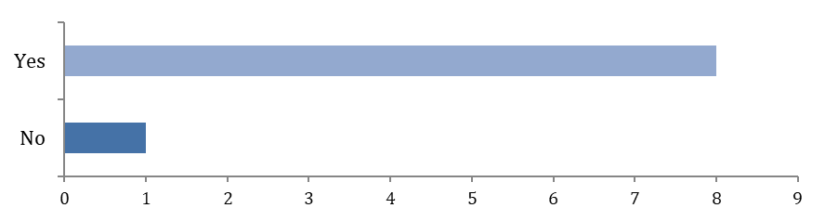
Option | Total | Percent
Yes | 8 | 88.89%
No | 1 | 11.11%
Not Answered | 0 | 0.00%
This document sets out the draft results of the PNA for the Essex HWB – does it achieve this? Comments
There was 1 response to this part of the question, comments received are presented below.
Theme | Response
Clarification and standardization of terminology, e.g., updating abbreviations and program names | Noted and clarified in the final PNA document.

3: Do you feel that the purpose of the PNA has been explained sufficiently?
There were 9 responses to this part of the question, of which the following responded ‘yes’ or ‘no’:
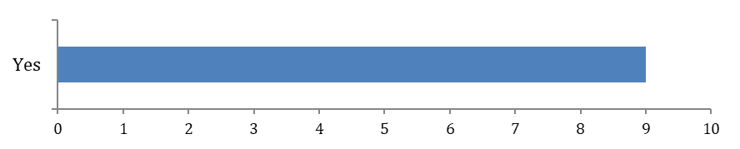
Option | Total | Percent
Yes | 9 | 100.00%
No | 0 | 0.00%
Not Answered | 0 | 0.00%
Do you feel that the purpose of the PNA has been explained sufficiently? Comments
There were 0 responses to this part of the question.

4: Do you feel the information contained within the PNA adequately reflects the current community pharmaceutical services provision within the Essex HWB?
There were 8 responses to this part of the question, (with N=1 ‘not answered), of which the following responded ‘yes’ or ‘no’:
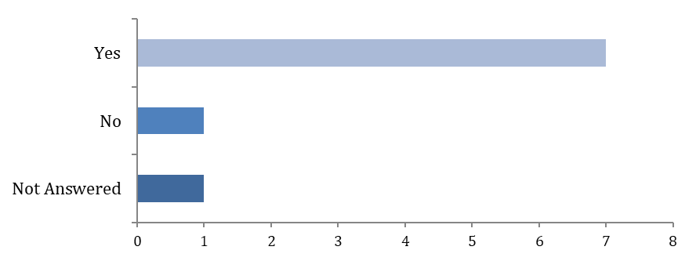
Option | Total | Percent
Yes | 7 | 77.78%
No | 1 | 11.11%
Not Answered | 1 | 11.11%
Do you feel the information contained within the PNA adequately reflects the current community pharmaceutical services provision within the Essex HWB? Comments
There was 1 response to this part of the question, comments received are presented below.
Theme | Response
Concerns about the operational and financial pressures on pharmacy capacity and staff wellbeing resulting to likely closing soon. | Supplementary statements are provided annually, and this would address such concerns, this PNA only evaluates the status quo as of 1st of January 2025.

5: Are there any pharmaceutical services currently provided that you are aware of that are not included within the PNA?
There were 9 responses to this part of the question, of which the following responded ‘yes’ or ‘no’:
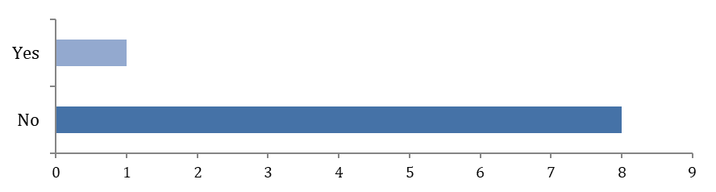
Option | Total | Percent
Yes | 1 | 11.11%
No | 8 | 88.89%
Not Answered | 0 | 0.00%
Are there any pharmaceutical services currently provided that you are aware of that are not included within the PNA? Comments
There were 2 responses to this part of the question, comments received are presented below.
Theme | Response
Awareness of additional pharmaceutical services not currently included in the PNA e.g. IP pharmacist prescribers. | Noted and amended.

6: With reference to Essential, Advanced and Locally Enhanced Services, are there any gaps or commissioning recommendations incorrectly identified?
There were 8 responses to this part of the question (with N=1 ‘not answered’), of which the following responded ‘yes’ or ‘no’:
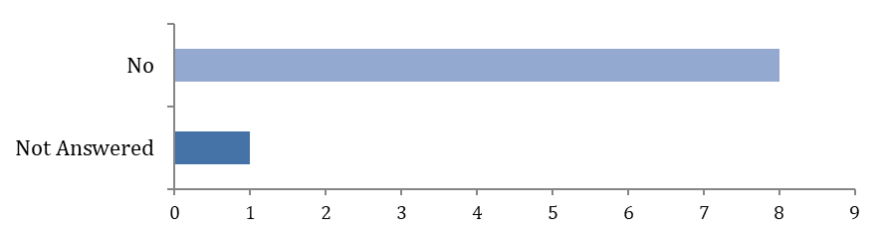
Option | Total | Percent
Yes | 0 | 0.00%
No | 8 | 88.89%
Not Answered | 1 | 11.11%

With reference to Essential, Advanced and Locally Enhanced Services, are there any gaps and commissioning recommendations incorrectly identified? Comments
There was 1 response to this part of the question, comments received have been presented below.
Theme | Response
Concerns about remuneration and resource allocation for essential and enhanced services. | Out of scope of the PNA.

7: Do you know of any relevant information not included which could affect the conclusions in the draft PNA?
There were 9 responses to this part of the question, of which the following responded ‘yes’ or ‘no’:
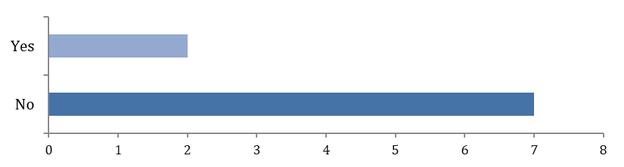
Option | Total | Percent
Yes | 2 | 22.22%
No | 7 | 77.78%
Not Answered | 0 | 0.00%
Do you know of any relevant information not included which could affect the conclusions in the document? Comments
There were 0 responses to this question.

8: Is there any additional information that you feel should be included in the PNA?
There were 9 responses to this part of the question, of which the following responded ‘yes’ or ‘no’
Option | Total | Percent
Yes | 1 | 11.11%
No | 8 | 88.89%
Not Answered | 0 | 0.00%
Please provide any comments
There were no responses to this question.

9: *ICBs only*
Has the PNA provided adequate information to inform Market entry decisions?
There were 7 responses to this part of the question, (with N=2 ‘not answered), of which the following responded ‘yes’ or ‘no’:
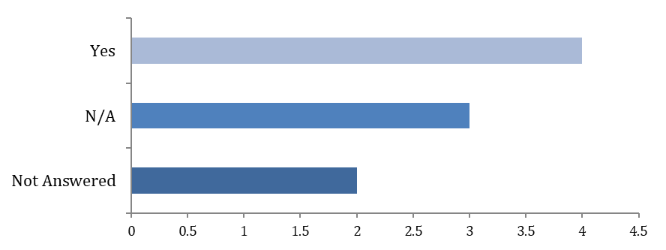
Option | Total | Percent
Yes | 4 | 44.44%
No | 0 | 0.00%
N/A | 3 | 33.33%
Not Answered | 2 | 22.22%
Has the PNA provided adequate information to inform Market entry decisions? Comments
There was 1 response to this part of the question, comments received have been presented below.
Theme | Response
Consideration of potential service gaps from pharmacy closures to support market entry decisions. | Supplementary statements are provided annually, and this would support decisions to market entry, this PNA only evaluates the status quo as of 1st of January 2025.

10: *All commissioners*
Has the PNA provided adequate information to inform how you may commission pharmaceutical services in the future?
There were 7 responses to this part of the question, (with N=2 ‘not answered), of which the following responded ‘yes’ or ‘no’:

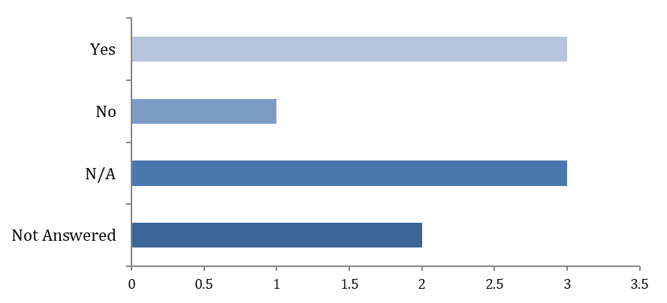
Option | Total | Percent
Yes | 3 | 33.33%
No | 1 | 11.11%
N/A | 3 | 33.33%
Not Answered | 2 | 22.22%
Has the PNA provided adequate information to inform how you may commission pharmaceutical services in the future? Comments
There were 0 responses to this part of the question.

11: *Community pharmacies, Dispensing Appliance Contractors, Distance Selling Pharmacies and Dispensing Doctors ONLY*
Has the PNA correctly reflected the following information about you?
There were 7 responses to this part of the question (with N=2 ‘not answered), of which the following responded ‘yes’ or ‘no’:
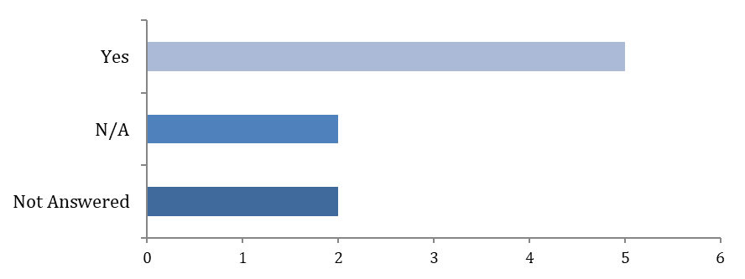
Option | Total | Percent
Yes | 5 | 55.56%
No | 0 | 0.00%
N/A | 2 | 22.22%
Not Answered | 2 | 22.22%

Has the PNA correctly reflected the following information about you? - Service provision
There were 7 responses to this part of the question (with N=2 ‘not answered), of which the following responded ‘yes’ or ‘no’:
Option | Total | Percent
Yes | 5 | 55.56%
No | 0 | 0.00%
N/A | 2 | 22.22%
Not Answered | 2 | 22.22%
Has the PNA correctly reflected the following information about you? Comments
There were 0 responses to this part of the question.

12: Do you have any other comments about the draft PNA?
Further Comments
There were 6 responses to this part of the question, comments received have been presented below.

Theme | Response
Service gaps and locality needs: Concerns about potential pharmacy gaps in specific areas (West Horndon) and whether existing services have sufficient capacity to meet local needs. | Analysis taken during the development of the PNA did not identify any gaps in provision. Supplementary statements are provided annually, and this would address any gap that arises.
Concerns about the effectiveness of pharmacies in delivering services and alleviating pressure on GPs due to limitations in managing common symptoms. | Out of scope of the PNA.
Terminology and Accuracy: precise, consistent, and sensitive terms of use, including correct labelling, abbreviations, and careful wording regarding vulnerable populations. | Noted and amended.
Distance Selling Pharmacies (DSPs) being included in the travel time analysis, as residents don`t have access to them. | DSPs are included as they are NHS contracted pharmaceutical service providers. They can serve populations within and outside of the HWB area.
Timing of public engagement could affect response rates—recommend avoiding holiday periods for future surveys. | Dates were accepted by the steering group and had to fit in with the timeline of the development of the PNA.
Lack of legislative context—suggest including relevant legal basis to strengthen clarity and credibility. | Suggestion noted.

Additional information

Background and Regulations
Section 128A of the National Health Service Act 2006 (NHS Act 2006) requires each health and wellbeing board (HWB) to assess the need for pharmaceutical services in its area and to publish a statement of its assessment.
Termed a ‘pharmaceutical needs assessment’, the NHS (Pharmaceutical Services and Local Pharmaceutical Services) Regulations 2013, as amended (the 2013 regulations) set out the minimum information that must be contained within a pharmaceutical needs assessment (PNA) and outline the process that must be followed in its development.
In summary they:
• define what is meant by pharmaceutical services (regulation 3),
• set out the minimum information requirements for a pharmaceutical needs assessment (regulation 4 and Schedule 1),
• confirm when the next pharmaceutical needs assessment is to be published, or where a new health and wellbeing board comes into being when it is required to publish its first pharmaceutical needs assessment (regulations 5 and 6),
• set out the circumstances where a health and wellbeing board may need to produce a
new pharmaceutical needs assessment sooner than the usual three yearly cycle, or
when a supplementary statement may/must be published (regulation 6),
• set out the minimum consultation process that each health and wellbeing board is
required to undertake during the development of its pharmaceutical needs assessment
(regulation 8), and
• set out specific matters that the health and wellbeing board must consider when
drafting its pharmaceutical needs assessment (regulation 9).

Wider context
The preparation and consultation on the pharmaceutical needs assessment should take account of the joint strategic needs assessments and other relevant strategies in order to prevent duplication of work and multiple consultations with health groups, patients and the public.

Local context
The PNA will be used by NHSE (or other body as identified in the regulations) when considering decisions on applications to open new pharmacies and dispensing appliance contractor premises; or applications from current pharmaceutical providers to change their existing regulatory requirements.
Decisions on whether to open new pharmacies are not made by the HWBs.
Under the Regulations, a person who wishes to provide NHS pharmaceutical services must generally apply to NHS England to be included on a relevant list by proving they are able to meet a pharmaceutical need as set out in the relevant PNA (see section on market entry below).
The PNA will also aid the HWB to work with providers to target locally commissioned services to the areas where they are needed and limit duplication of services in areas where provision is adequate.
The PNA will further inform interested parties of the pharmaceutical needs in Essex and enable work to plan, develop and deliver pharmaceutical services for the population.
It will inform commissioning decisions by local commissioning bodies including local authorities.

NHS Market entry process
If a person or corporate body wants to provide pharmaceutical services, they are required to apply to the NHS to be included in a pharmaceutical list. Pharmaceutical lists are compiled and held by NHS England. This is commonly known as the NHS “market entry” system.
Previous tests for inclusion onto the pharmaceutical list were not based on needs assessments. Existing pharmaceutical provision includes historical market entry and should not be used to assess current need.
The current regulations are the only guidance that can be referred to whilst developing the PNA, these include regulations for considering consolidations to reduce the number of pharmacies.
Petitions and requests by a community cannot bypass this Market entry process.

Scope
The services that a pharmaceutical needs assessment must include are defined within both the National Health Service Act 2006 and the NHS (Pharmaceutical and Local Pharmaceutical Services) Regulations 2013, as amended.
Pharmaceutical services is a collective term for a range of services commissioned by NHSE.
In relation to pharmaceutical needs assessments, it includes:
• Essential, advanced and enhanced services provided by pharmacies (including distance selling or online pharmacies)
• Essential and advanced services provided by dispensing appliance contractors
• The dispensing service provided by some gp practices and
• Services provided under a local pharmaceutical services contract that are the equivalent of essential, advanced and enhanced services.
Pharmaceutical services may be provided by:
• A pharmacy contractor who is included in the pharmaceutical list for the area of the HWB
• A pharmacy contractor who is included in the Local Pharmaceutical Services list for the area of the HWB
• A dispensing appliance contractor who is included in the pharmaceutical list held for the area of the HWB and
• A doctor or GP practice that is included in the dispensing doctor list held for the area of the HWB
NHSE is responsible for preparing, maintaining and publishing lists of contracted providers.
The PNA has a regulatory purpose that sets the scope of the assessment.
Pharmaceutical services are evident in other areas of work but are excluded from this assessment. These include prison pharmacy, secondary care and private pharmacy services where patients may be obtaining a type of pharmaceutical service that is not covered by this assessment.

The PNA development process
The next Essex HWB PNA is due to be published by 1st October 2025.
The process for developing the PNA is informed by the regulations and guidance provided by DHSC
There is a steering group overseeing the assessment. The steering group (as recommended in the guidance pack) has representation from:
- the Essex County Council public health team,
- the Essex County Council communications and engagement team,
- the local pharmaceutical committee (LPC),
- the local medical committee (LMC),
- Healthwatch,
- the Sub Integrated care boards (ICB) and
- the integrated care system.

The HWB area was broken down into localities for analysis using available data. The district and borough councils were agreed as the localities for the Essex HWB PNA.
The following were used to inform the assessment:
- Analysis of pharmaceutical services provided by the 230 pharmacies, 47 dispensing doctors and 5 dispensing appliance contractors in the Essex HWB area (sources- NHSE, CCGs, NHSBSA and commissioners).
- Opening hours of the pharmaceutical providers (source- NHSE).
- Mapping of locations of the pharmaceutical providers (source- SHAPE maps).
- Travel time analysis to pharmaceutical provision using a car, public transport and walking at various times of the day. 20 minutes’ drive time is a national measure being used in PNAs across the country.
- Access to neighbouring locality pharmaceutical provision and Distance Selling Pharmacies.
- Public survey (not required in the regulations but undertaken using the questions recommended in the PNA guidance pack).
- Contractor questionnaire (conducted at the same time as the public survey).
- Statutory stakeholder consultation (minimum 60 days required by the regulations).
- JSNA data on Essex population and life expectancy.
- The Index of Multiple Deprivation and deprivation ranges as well as the other wider determinants of health.
- The general lifestyle including smoking and drug and alcohol misuse.
- The disease burden.
- Predicted housing growth.
- Provision from neighbouring HWB’s.
- Analysis of dispensing locations (dispensing flows).
- Local and national strategies.

Consultation
Patient survey
A voluntary patient survey to assess levels of satisfaction with existing pharmaceutical services across the county was undertaken. Dates for the survey were from 13th December 2024 to 10th January 2025.
Questions recommended in the DHSC PNA information pack were included.
The survey was promoted by ECC communications and all partner organisations.
The public were informed by Healthwatch, all community pharmacies and GP surgeries.
The timelines of this survey were moved due to representations made by a parish council about proposed dates for the statutory consultation.
Statutory consultation
Regulation 8 requires the HWB to consult a specified range of organisations on a draft of the pharmaceutical needs assessment at least once during the process of drafting the document.
They must be given a minimum period of 60 days to submit their response.
A statutory 60-day consultation on the draft Essex HWB PNA was undertaken from 13th June 2025 to 13th August 2025.
The regulations stipulate the organisations must be consulted.
The statutory consultation was promoted by ECC communications, and all partner organisations stated in the regulations were notified.
9 responses were received via the consultation portal.
1 other email representations have also been received as part of the consultation and have been included in the analysis in this report.
This consultation report will be included in the final PNA.

Access for disabled patients
Pharmacy premises are required to make “reasonable adjustments” to make services accessible. These are not enforceable by NHSE.

Complaints about a pharmacy
Complaints about the services provided by a pharmacy should be addressed in the first place to the Pharmacy itself.
These can further be escalated to NHSE at england.contactus@nhs.net
Opening hours and workforce.
The core contract for each pharmaceutical contractor must be met, complaints can be made as stated above if these are met. The covid-19 pandemic and workforce issues are widely acknowledged and have led to pharmacies across the country having to reduce hours. This is done in conversations with NHSE as the contract holders.
Delivery services and Dossett boxes
These are not NHS pharmaceutical services.
Pharmacies are not required to provide these services as they are not commissioned.
(During the Covid-19 pandemic there was a brief period during which NHSE commissioned a delivery service. This was not an essential service and not all pharmacies chose to provide it).

Housing and neighbouring housing in other area PNAs
Housing developments across Essex have been analysed and existing pharmacies in the area and neighbouring areas are identified to be able to cope with any increase in demand over the lifetime of this PNA.
No gaps have been identified in the Essex PNA.

Cross border use
Whilst patients registered with a surgery may use Essex HWB pharmacies, they can also use pharmacies in neighbouring areas and distance selling pharmacies. There is no restriction on which pharmacy an individual chooses to use.
With a 1.6KM (1 mile) buffer zone, there are 347 pharmacies across Essex and within a 1.6KM buffer zone around Essex, as shown on the map below:
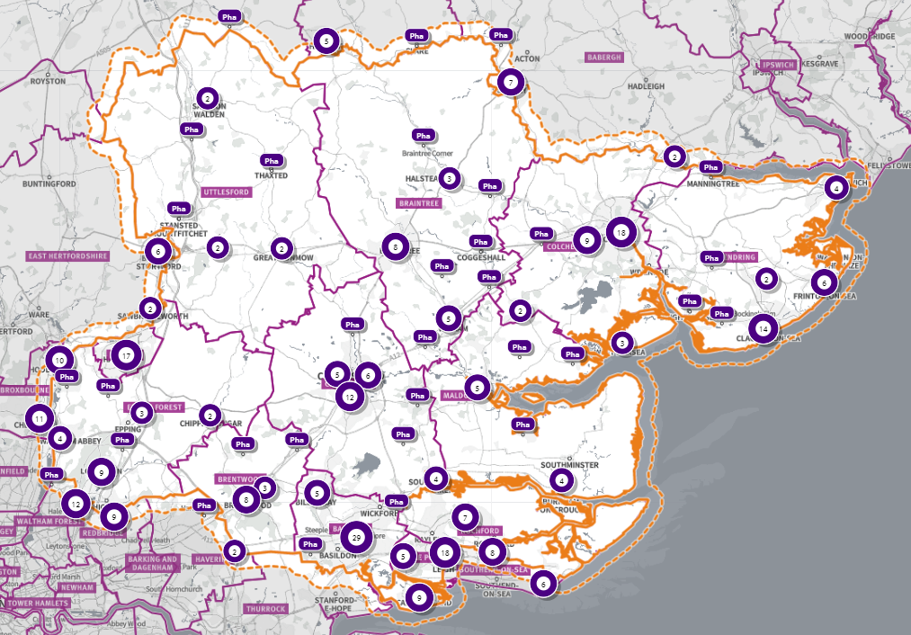
Source: Shape maps
Dispensing analysis of prescriptions issued by surgeries shows that patients use a variety of pharmacies nearer to their home, work, whilst travelling or online.
The provision of pharmaceutical services from neighbouring HWB areas is also acknowledged.

Data
Data not provided in the PNA can be sourced from other datasets available on Open Data or partner organisations. Data used in the draft PNA has been referenced.

Rurality
Parts of Essex are classed as rural areas and travel times reflect this.
The NHS (Pharmaceutical and Local Pharmaceutical Services) Regulations 2013, allow doctors to dispense to eligible patients in certain circumstances. In summary:
- Patients must live in a ‘controlled locality’ (an area which has been determined by NHSE&I or a preceding organisation as rural in character), more than 1.6km (measured in a straight line) from a pharmacy (excluding distance selling premises) and
- Their practice must have premises approval and consent to dispense to that area

Residents in rural areas have access to registering with dispensing doctor surgeries if they meet the criteria.

Choice
The PNA has determined that there is reasonable choice with regard to obtaining pharmaceutical services in the Essex HWB area and no gaps have been identified.

This report has been produced by the Essex County Council Public Health & Public Health Intelligence Team.
Contact for queries: Public.Health@essex.gov.uk

NHS (Pharmaceutical Services and Local Pharmaceutical Services) Regulations 2013, as amended (the 2013 regulations)
DHSC Pharmaceutical needs assessments Information pack for local authority health and wellbeing boards Published October 2021

