Appendix F Essex PNA 2025

Health service mapping and Pharmacy Travel Time Analysis Report
(As at 02/01/2025)
Contents
General Practioners across Essex 2
Hospitals across Greater Essex 3
Pharmacies across Essex 4
Travel Time to Pharmacies across Essex 5
Travel Time Population and step-change in Access, including by mixed journey methods, deprivation and rurality 5
Are these areas with ‘difficult access’ to a pharmacy able to get to a dispensing doctor? 12
Pharmacy Access by Walking 14
Walking Within 20-minutes 14
Walking within 30-minutes 16
Pharmacy Access by Car 19
Driving within 20-minutes 19
Pharmacy Access by Public Transport (Weekday Morning) 22
Public Transport journey within 20-minutes (weekday morning) 23
Public transport journey within 30-minutes (weekday morning) 25
Pharmacy Access by Public Transport (Weekday Afternoon) 29
Public Transport journey within 20-minutes (weekday afternoon) 29
Public transport journey within 30-minutes (weekday afternoon) 32
Pharmacy Access by Public Transport (Weekday Evening) 35
Public Transport journey within 20-minutes (weekday evening) 35
Public transport journey within 30-minutes (weekday evening) 38
Districts Pharmacies 41

General Practioners across Essex

There are 215 GP surgeries across Essex (not including Southend & Thurrock), as shown on the map below:
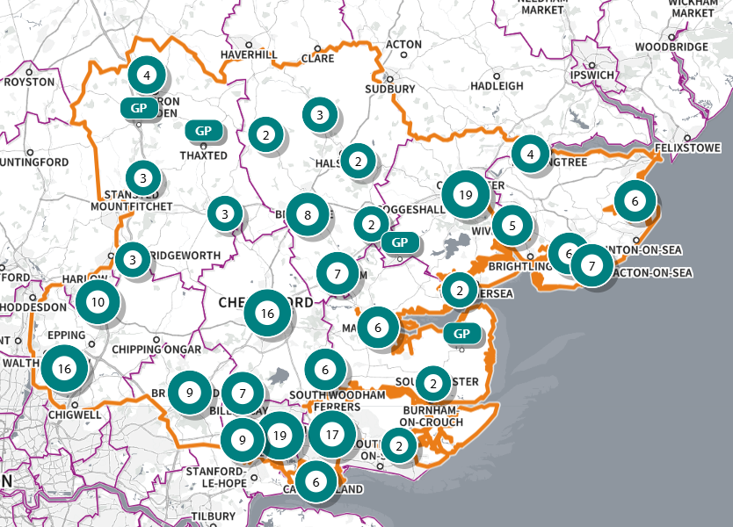
SHAPE Place • GP practice, branch practice • Added location
Figure 1 Map of GP surgeries across Essex

Hospitals across Greater Essex

There are 5 acute hospitals across Greater Essex, as shown on the map below. These are:
- Basildon Hospital
- Broomfield Hospital (also called Mid Essex Hospital)
- Southend Hospital
- Colchester General Hospital
- Princess Alexandra Hospital
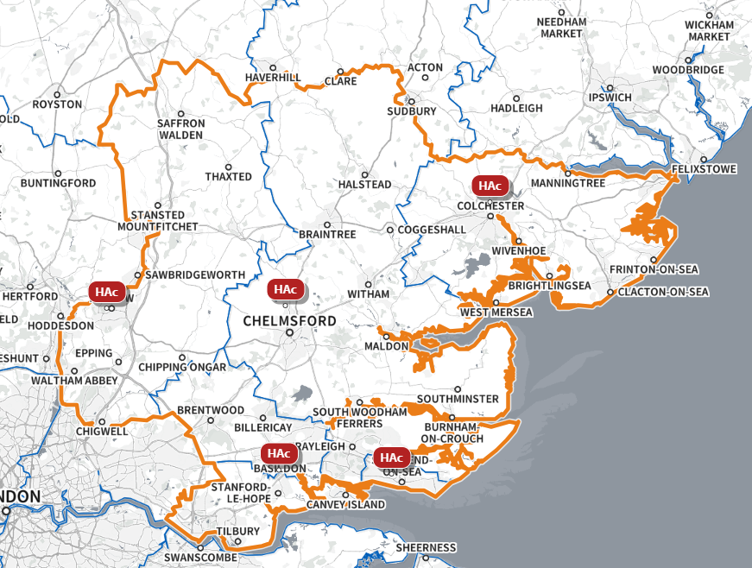
SHAPE Place • ERIC: Acute, Community, Specialist, Other
Figure 2 Map of Hospitals across Essex

Pharmacies across Essex

There are 242 pharmacies across Essex (not including Southend & Thurrock), as shown on the map below:
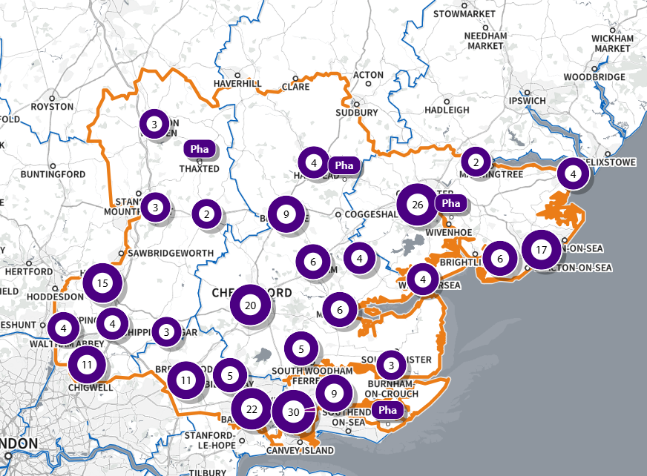
SHAPE Place • Pharmacy • Added location
Figure 3 Map of pharmacies across Essex

With a 1.6KM (1 mile) buffer zone, there are 322 pharmacies across Essex and within a 1.6KM buffer zone around Essex, as shown on the map below:
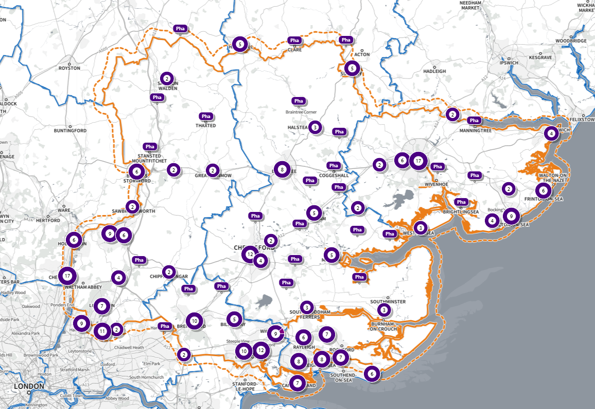
SHAPE Place • Pharmacy • Added location
Figure 4 Map of pharmacies across Essex at a buffer of 1.6km

Travel Time to Pharmacies across Essex

Travel Time Population and step-change in Access, including by mixed journey methods, deprivation and rurality

Using the base population data on the SHAPE Place Atlas platform, it is possible to calculate the Essex population (and by district) that are estimated to have a journey time either within 20 minutes, 20 - 30 minutes or over 30 minutes to a pharmacy across Essex and within a 1.6KM buffer zone around Essex by each journey method and by combination of journey methods.
Overall, across Essex, generally residents are within a relatively short travel time whichever method is chosen – 99.9% of the Essex population could get to a pharmacy in a 20-minute drive, 93% a 30-minute public transport journey (Weekday Morning) or 82% within a 20-minute walk. Residents must travel for longer if they choose to walk, with 13% over 30-minute walk away.
  - Driving – the majority of residents across all districts can drive to a pharmacy within 20 minutes.
  - Public transport – most residents can get to a pharmacy within a 20-minute journey on public transport in most districts. However, some districts see a relatively high percentage of their population having to travel for longer (Brentwood, Maldon & Uttlesford 20-30 minutes; Braintree, Epping Forest, Maldon, Uttlesford over 30 minutes)
  - Walking – most residents can get to a pharmacy within 20-minute walk in most districts. Some districts however see a relatively higher percentage of their population that’d have to walk further (Braintree, Brentwood 20-30 minutes; Braintree, Maldon, Epping Forest, Uttlesford over 30 minutes).
Access to a pharmacy may therefore be difficult for residents of some areas across some Essex Districts, such as Braintree, Maldon and Uttlesford.
The figures below show the percentage of the total population by District and Essex overall within either a 20 minute, 20-30 minutes or over 30-minute travel time for each travel method.
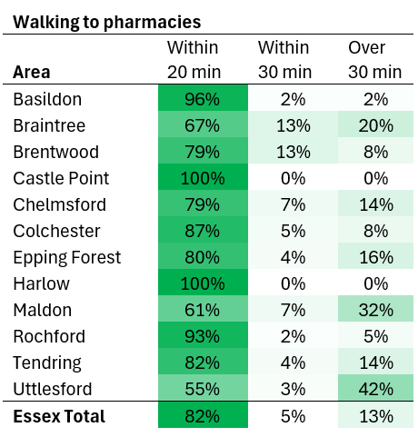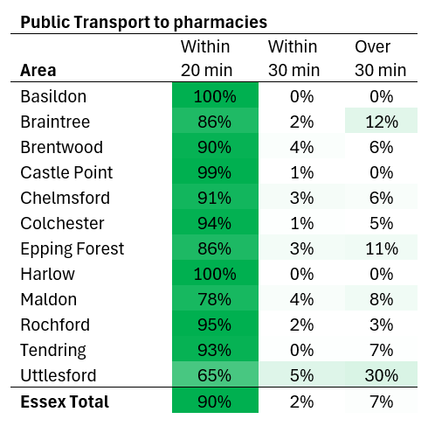
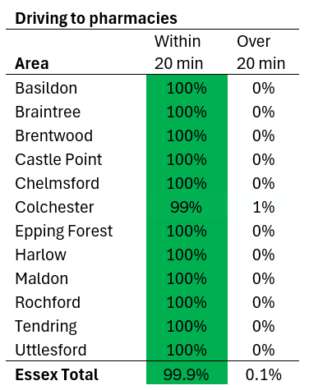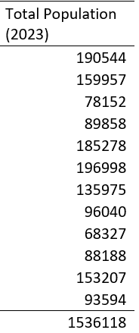
Figure 5 Percentage of population accessing a pharmacy at different travel times and methods across Essex

Deprivation and Rurality Summary
- The areas that see some of the longer travel times are relatively not that deprived.
- The longest times to travel by whatever method chosen are areas in Indices of Multiple Deprivation (IMD, 2019) Deciles 3 – 10, with the highest being 27% of the Essex population in IMD Decile 6 (among 5th least deprived areas nationally) estimated to be over a 30-minute walk to a pharmacy.
- Longer travel times are mostly seen in areas classified as ‘Rural village and dispersed’. For example, 77% of the Essex population in areas of this classification are over a 30-minute walk away and 28% are over a 30-minute public transport journey away.
  - Walking- there are rural areas in districts such as Rochford, Uttlesford, Colchester, Maldon and Tendring.

Example for walking:
Table 1 Population walking over 30 minutes to pharmacy amongst Rural village & dispersed settlements
Area | Rural village & dispersed Population over 30 min walk | Rural village and dispersed Total Population | % rural dispersed population over 30 min walk
Basildon | 0 | 0 | 0
Braintree | 18152 | 30515 | 59
Brentwood | 3033 | 6319 | 48
Castle Point | 0 | 0 | 0
Chelmsford | 6082 | 15328 | 40
Colchester | 11940 | 15426 | 77
Epping Forest | 13919 | 20384 | 68
Harlow | 0 | 0 | 0
Maldon | 14799 | 20114 | 74
Rochford | 4423 | 4423 | 100
Tendring | 14654 | 19895 | 74
Uttlesford | 30101 | 38814 | 78
Essex Total | 117103 | 171218 | 68

Relevant graphs are provided below.

Deprivation
Walking:

Figure 6 Graph of population walking time to a pharmacy and their level of deprivation

Public Transport:

Figure 7 Graph of population public transport time to a pharmacy and their level of deprivation

Driving:

Figure 8 Graph of population driving time to a pharmacy and their level of deprivation

Rurality
Walking:

Figure 9 Graph of population walking time to a pharmacy and their rurality

Public Transport:

Figure 10 Graph of population public transport time to a pharmacy and their rurality
Driving:

Figure 11 Graph of population driving time to a pharmacy and their rurality

Mixed Journey Methods
- There are some small areas with difficult access to a pharmacy.
- Most of the areas across Essex can get to a pharmacy within a 20-minute drive, even if they live over a 30-minute walk or 30-minute public transport journey away. Most of the population is within 20-minutes travel time multiple methods (995417 people).
- This isn’t the case for some areas, however, some areas as described below may have difficult access to a pharmacy depending what travel method is used. For example:
  - There are 1,466 people in 1 LSOA in Colchester (Colchester 019D) estimated to be over a 30-minute walk or 20-minute drive to a pharmacy but able to access within a 10 – 20-minute public transport journey.
  - There are 43,261 people estimated to be able to drive within 20 minutes to a pharmacy but would be over 30 minutes away if walking or on public transport. This population spans over 23 LSOAs, shown in second table below.

See table below.
Table 2 Mixed journey method within different timing
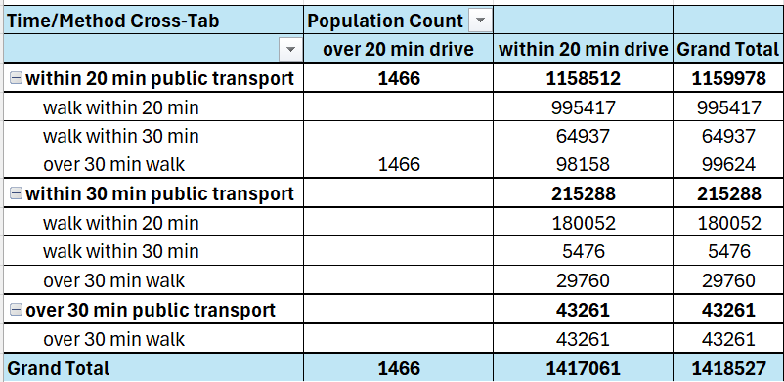
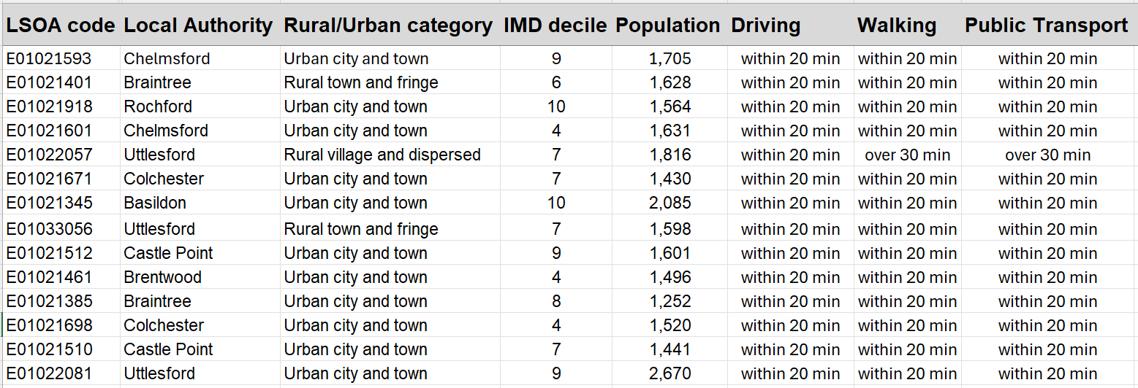

Are these areas with ‘difficult access’ to a pharmacy able to get to a dispensing doctor?

By mapping dispensing doctors across Essex and examining areas included/excluded from being able to reach them within a certain time/method of travel, we can see whether the areas identified as having ‘difficult access’ to a pharmacy are able to access a dispensing doctor.
For the LSOA’s that were found to have difficulty accessing a pharmacy in the chosen travel times, all could access a dispensing doctor within 20 minutes by car apart from 1 LSOA in Colchester (1,466 people; LSOA code: E01021694, LSOA name: Colchester 019D). This LSOA is also over a 30 -minute walk to pharmacy or dispensing doctor. It is estimated this LSOA can only reach a pharmacy via a 10-to-20-minute public transport journey, accessing a dispensing doctor via public transport would take more than 30 minutes. This LSOA is a ‘rural village and dispersed’ area that faces geographical challenges for access to multiple services due to a tidal river that runs through Mersea, cutting off road access at certain times. This is in IMD Decile 5, amongst the 50% most deprived areas nationally.

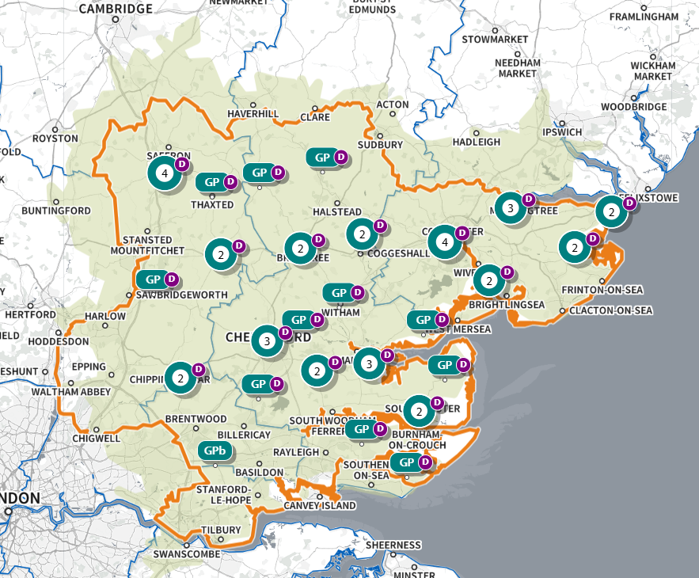
SHAPE Place • Car: by time • 0 locations • 5 to 30 minutes • 20 minutes visible
Figure 12 Map of access to Dispensing Doctors across Essex within a 20 minutes drive

Pharmacy Access by Walking

The map below shows the areas within a certain amount of time needed to walk to a pharmacy across Essex and within a 1.6KM buffer zone around Essex (5 to 30 minutes in 5 minute increments).
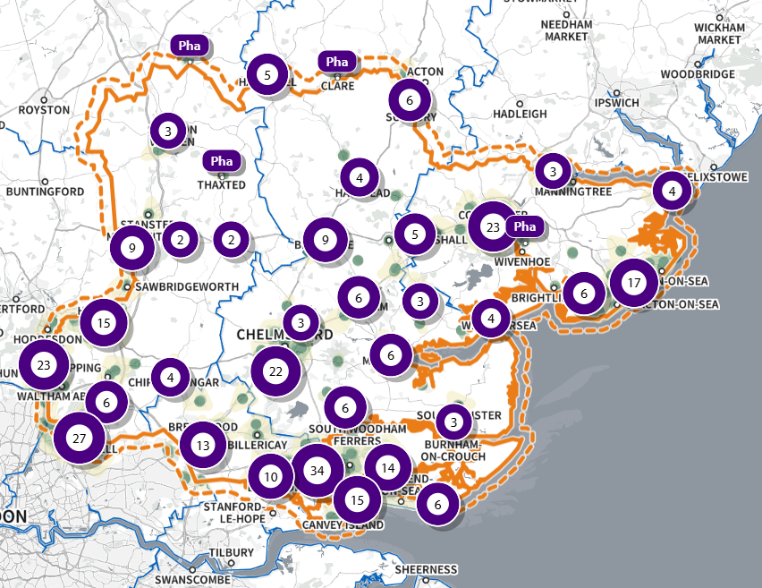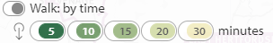
SHAPE Place • Walk: by time • 316 locations • 5 to 30 minutes
Figure 13 Map of access to a pharmacy across Essex within a 5 – 30 minutes’ walk

Walking Within 20-minutes

The map below shows the areas within a 20 minute walk to a pharmacy across Essex and within a 1.6KM buffer zone around Essex. These areas are highlighted in green, and those estimated to outside of access by this definition not highlighted.
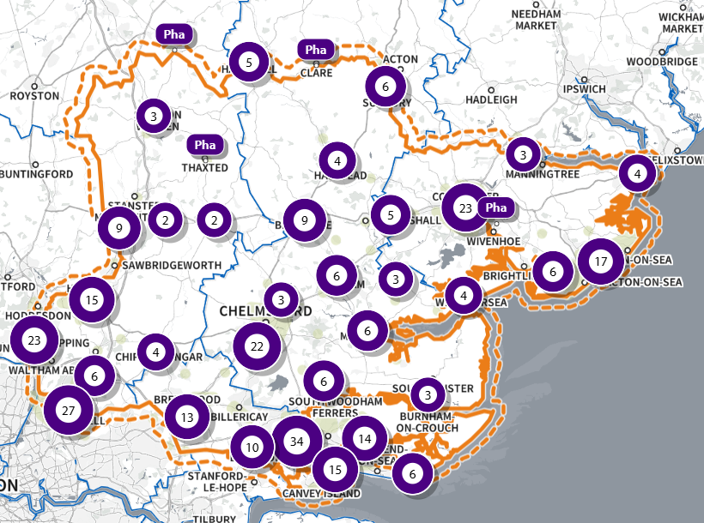
SHAPE Place • Walk: by time • 316 locations • 5 to 30 minutes • 20 minutes visible
Figure 14 Map of access to a pharmacy across Essex within a 20 minutes’ walk

20-minute walk, With Access:

It is estimated that 1,263,905 individuals across Essex have access to one of 322 pharmacies across Essex and within a 1.6KM buffer zone around Essex within a 20-minute walk. This spans 762 of the LSOAs across Essex, as shown on the map below highlighted in green.
Most of these LSOAs are classed urban city and towns (77.75% of LSOAs with access) and are mostly areas considered less deprived (13.13% of LSOAs with access in IMD Decile 10, 12.59% of LSOAs with access in IMD Decile 9, the two least deprived deciles, versus 4.07% in IMD Decile 1 and 5.41% in Decile 2, the two most deprived deciles).
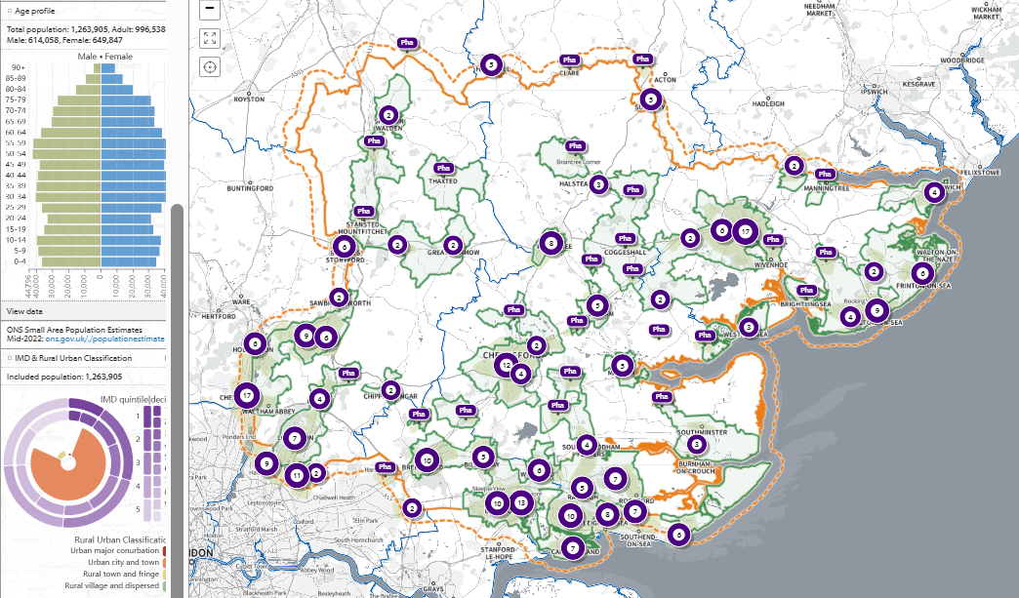
SHAPE Place • Walk: by time • 0 locations • 5 to 30 minutes • 20 minutes visible • Included population
Figure 15 Map of population with access to a pharmacy across Essex within a 20 minutes’ walk

20-minute walk, Without access:

It is estimated that 255,604 individuals across Essex do not have access to one of 322 pharmacies across Essex and within a 1.6KM buffer zone around Essex within a 20-minute walk. This spans 141 of the LSOAs across Essex, as shown on the map below highlighted in green. Most of these LSOAs are classed ‘rural village or dispersed’ areas (53.62% of LSOAs without access).
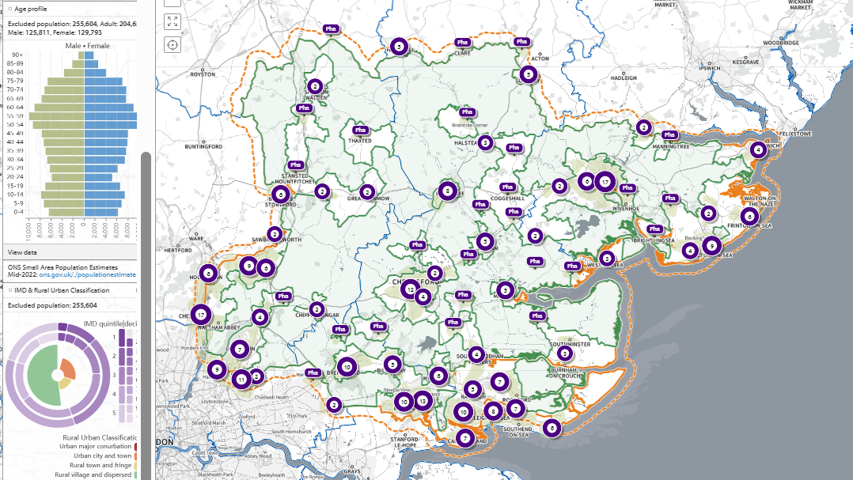
SHAPE Place • Walk: by time • 0 locations • 5 to 30 minutes • 20 minutes visible • Excluded population
Figure 16 Map of population without access to a pharmacy across Essex within a 20 minutes’ walk

Walking within 30-minutes

The map below shows the areas within a 30 minute walk to a pharmacy across Essex and within a 1.6KM buffer zone around Essex. These areas are highlighted in green, and those estimated to outside of access by this definition not highlighted.
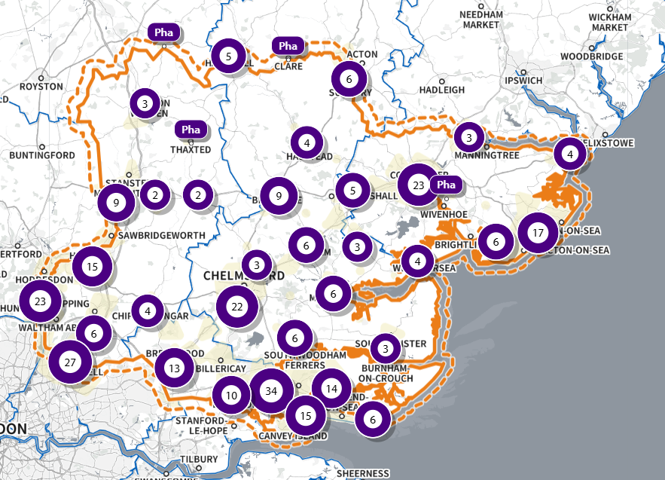
SHAPE Place • Walk: by time • 0 locations • 5 to 30 minutes • 30 minutes visible
Figure 17 Map of access to a pharmacy across Essex within a 30 minutes’ walk

30-minute walk, With Access:

It is estimated that 1,342,838 individuals across Essex have access to one of 322 pharmacies across Essex and within a 1.6KM buffer zone around Essex within a 30-minute walk. This spans 807 of the LSOAs across Essex, as shown on the map below highlighted in green.
Most of these LSOAs are classed urban city and towns (77% of LSOAs with access) and are mostly areas considered less deprived (12.76% of LSOAs with access in IMD Decile 10, 13.09% of LSOAs with access in IMD Decile 9, the two least deprived deciles, versus 3.83% in IMD Decile 1 and 5.43% in Decile 2, the two most deprived deciles).
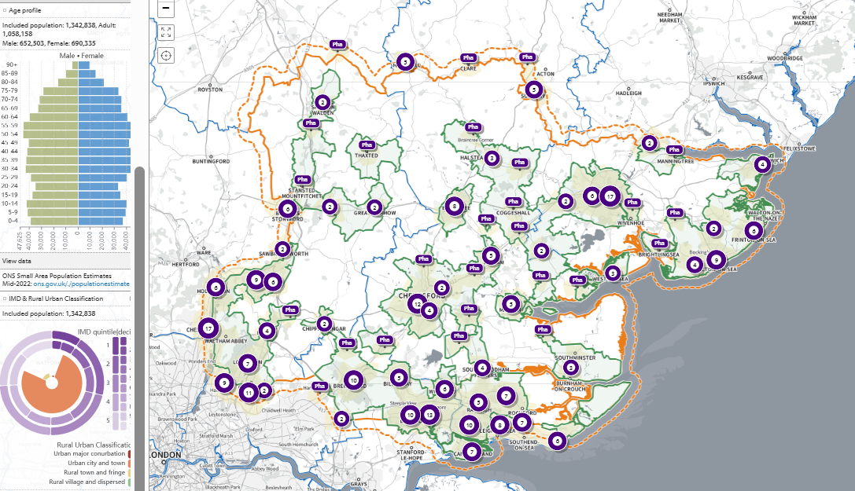
SHAPE Place • Walk: by time • 0 locations • 5 to 30 minutes • 30 minutes visible • Included population
Figure 18 Map of population with access to a pharmacy across Essex within a 30 minutes’ walk

30-minute walk, Without Access:

It is estimated that 176,671 individuals across Essex do not have access to one of 322 pharmacies across Essex and within a 1.6KM buffer zone around Essex within a 30-minute walk. This spans 96 of the LSOAs across Essex, as shown on the map below highlighted in green. Most of these LSOAs are classed ‘rural village and dispersed’ areas (68.04% of LSOAs without access).
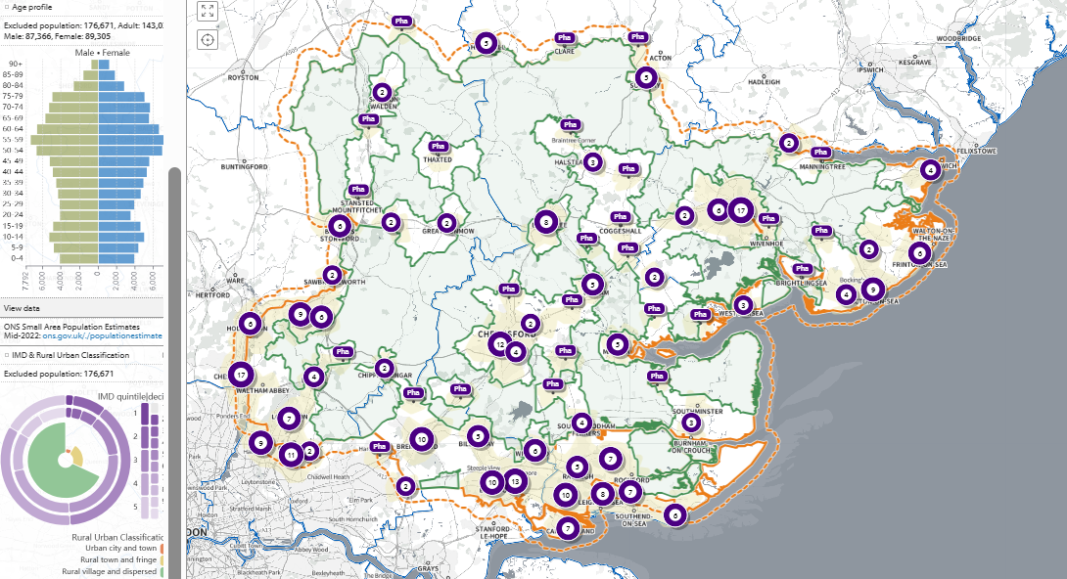
SHAPE Place • Walk: by time • 0 locations • 5 to 30 minutes • 30 minutes visible • Excluded population
Figure 19 Map of population without access to a pharmacy across Essex within a 30 minutes’ walk

Pharmacy Access by Car

The map below shows the areas within a certain amount of time needed to drive (non-rush hour) to a pharmacy across Essex and within a 1.6KM buffer zone around Essex (5 to 30 minutes in 5 minute increments).
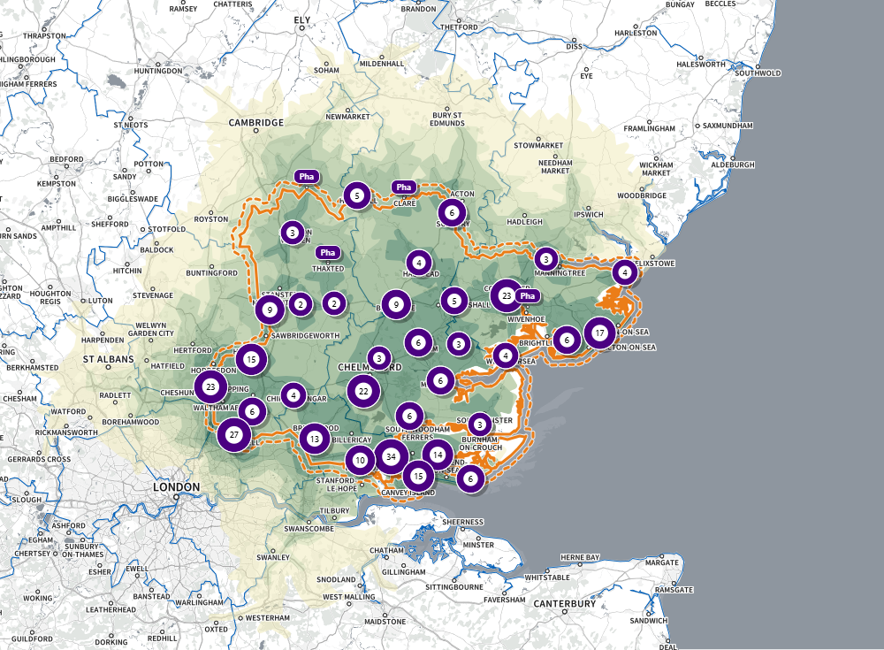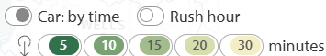
SHAPE Place • Car: by time • 0 locations • 5 to 30 minutes
Figure 20 Map of access to a pharmacy across Essex within a 5 – 30 minutes’ drive

Driving within 20-minutes

The map below shows the areas within a 20 minute drive (non-rush hour) to a pharmacy across Essex and within a 1.6KM buffer zone around Essex. These areas are highlighted in green, and those estimated to outside of access by this definition not highlighted.

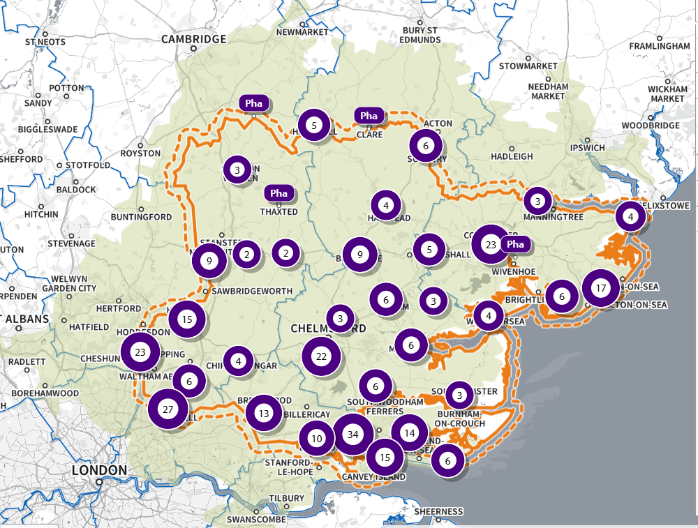
SHAPE Place • Car: by time • 0 locations • 5 to 30 minutes • 20 minutes visible
Figure 21 Map of access to a pharmacy across Essex within a 20 minutes’ drive

20-minute drive, With Access:

It is estimated that 1,518,041 individuals across Essex have access to one of 322 pharmacies across Essex and within a 1.6KM buffer zone around Essex within a 20-minute drive. This spans 902 of the LSOAs across Essex, as shown on the map below highlighted in green.
Most of these LSOAs are classed urban city and towns (69.16% of LSOAs with access) and are mostly areas considered less deprived (12.3% of LSOAs with access in IMD Decile 10, 12.49% of LSOAs with access in IMD Decile 9, and 13.69 of LSOAs with access in IMD Decile 8, the three least deprived deciles, versus 3.39% in IMD Decile 1 and 5.03% in Decile 2, the two most deprived deciles).
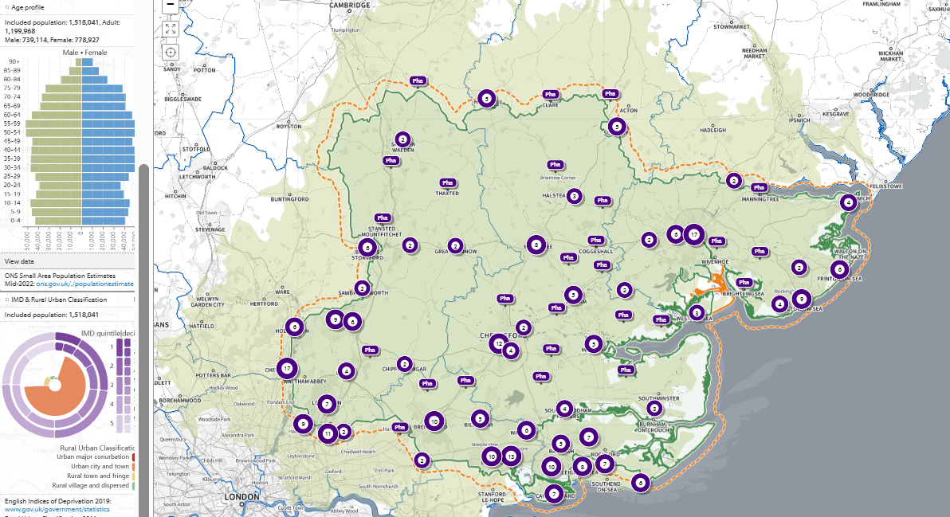
SHAPE Place • Car: by time • 0 locations • 5 to 30 minutes • 20 minutes visible • Included population
Figure 22 Map of population with access to a pharmacy across Essex within a 20 minutes’ drive

20-minute drive, Without Access:

It is estimated that 1,468 individuals across Essex do not have access to one of 322 pharmacies across Essex and within a 1.6KM buffer zone around Essex within a 20-minute drive. This is 1 of the LSOAs across Essex, as shown on the map below highlighted in green. This LSOA is a ‘rural village and dispersed’ area located in Colchester (LSOA code: E01021694, LSOA name: Colchester 019D). This is in IMD Decile 5, amongst the 50% most deprived areas nationally. This one LSOA also doesn’t have access to a pharmacy across Essex and the 1.6K buffer zone within a 30 minutes’ drive journey time.
There are no differences in access when a 30-minute drive time (non-rush) hour definition is used and is therefore not presented.
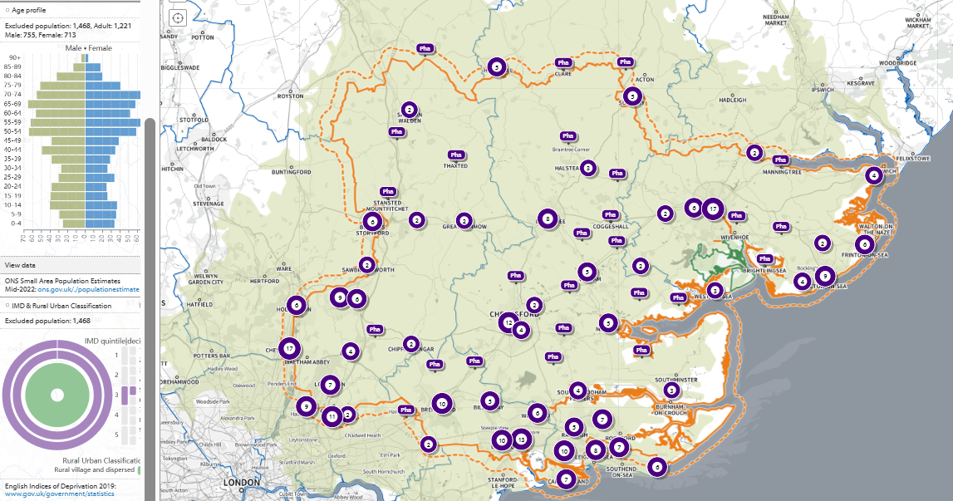
SHAPE Place • Car: by time • 0 locations • 5 to 30 minutes • 20 minutes visible • Excluded population
Figure 23 Map of population without access to a pharmacy across Essex within a 20 minutes’ drive

Pharmacy Access by Public Transport (Weekday Morning)

The map below shows the areas within a certain amount of time needed to take public transport (weekday morning) to a pharmacy across Essex and within a 1.6KM buffer zone around Essex (5 to 30 minutes in 5-minute increments).
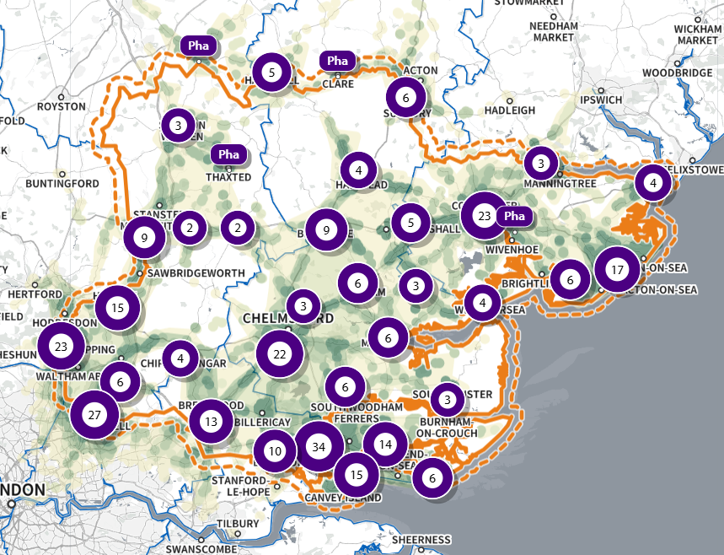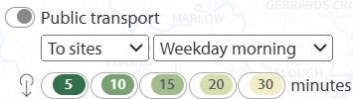
SHAPE Place • Public transport • 316 locations • 5 to 30 minutes
Figure 24 Map of access to a pharmacy across Essex within a 5 – 30 minutes’ public transport (weekday morning)

Public Transport journey within 20-minutes (weekday morning)

The map below shows the areas within a 20-minute public transport journey (weekday morning) to a pharmacy across Essex and within a 1.6KM buffer zone around Essex. These areas are highlighted in green, and those estimated to outside of access by this definition not highlighted.
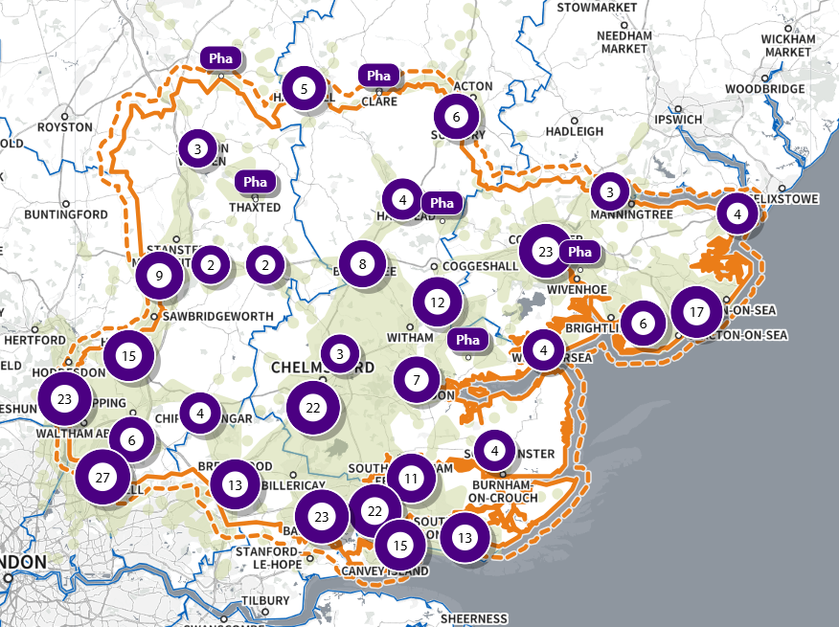
SHAPE Place • Public transport • 316 locations • 5 to 30 minutes • 20 minutes visible
Figure 25 Map of access to a pharmacy across Essex within a 20 minutes’ public transport (weekday morning)

20-minute public transport journey, With Access:

It is estimated that 1,463,471 individuals across Essex have access to one of 322 pharmacies across Essex and within a 1.6KM buffer zone around Essex within a 20-minute public transport journey (weekday morning). This spans 873 of the LSOAs across Essex, as shown on the map below highlighted in green.
Most of these LSOAs are classed urban city and towns (71.74% of LSOAs with access) and are mostly areas considered less deprived (12.58% of LSOAs with access in IMD Decile 10, 12.72% of LSOAs with access in IMD Decile 9, the two least deprived deciles, versus 3.51% in IMD Decile 1 and 5.22% in Decile 2, the two most deprived deciles).
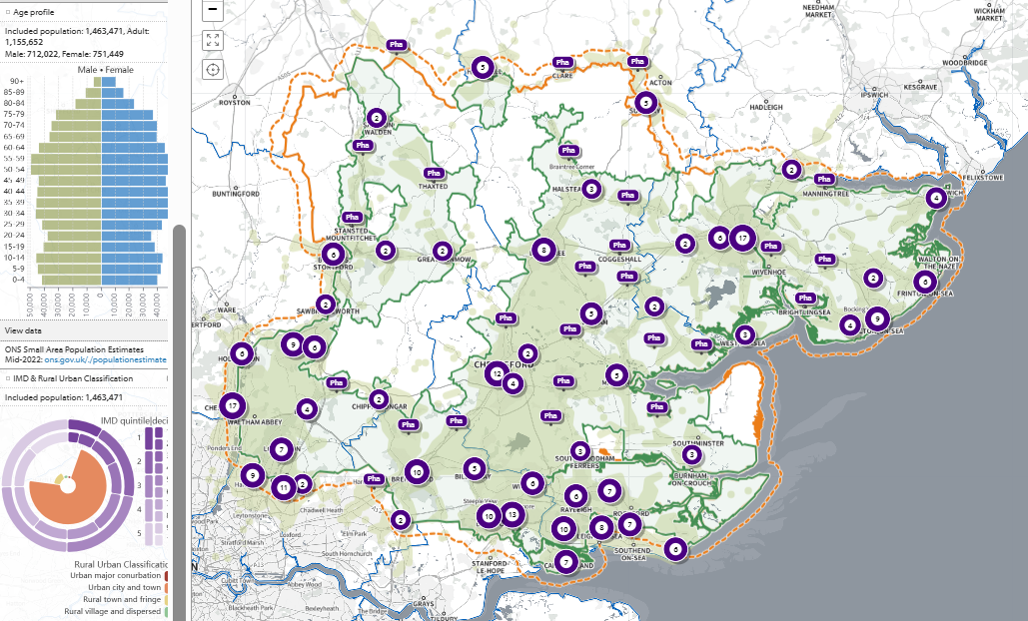
SHAPE Place • Public transport • 0 locations • 5 to 30 minutes • 20 minutes visible • Included population
Figure 26 Map of population with access to a pharmacy across Essex within a 20 minutes’ public transport (weekday morning)

20-minute public transport journey, Without Access:

It is estimated that 56,038 individuals across Essex do not have access to one of 322 pharmacies across Essex and within a 1.6KM buffer zone around Essex within a 20-minute public transport journey (weekday morning). This across 30 of the LSOAs across Essex, as shown on the map below highlighted in green. These LSOAs are all ‘rural village and dispersed’ areas (100% of LSOAs without access).
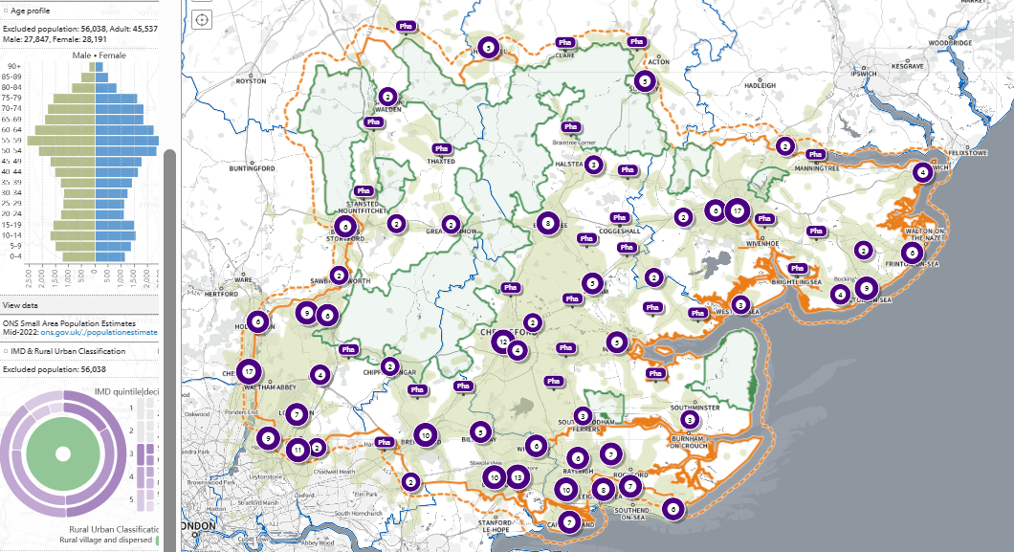
SHAPE Place • Public transport • 0 locations • 5 to 30 minutes • 20 minutes visible • Excluded population
Figure 27 Map of population without access to a pharmacy across Essex within a 20 minutes’ public transport (weekday morning)

Public transport journey within 30-minutes (weekday morning)

The map below shows the areas within a 30-minute public transport journey (weekday morning) to a pharmacy across Essex and within a 1.6KM buffer zone around Essex. These areas are highlighted in green, and those estimated to outside of access by this definition not highlighted.
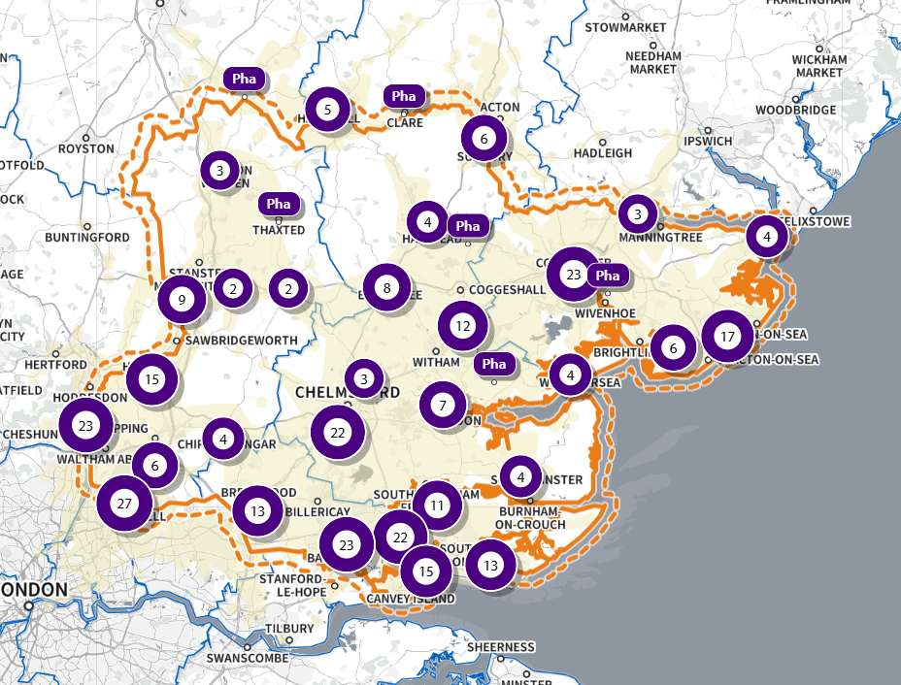
SHAPE Place • Public transport • 0 locations • 5 to 30 minutes • 30 minutes visible
Figure 28 Map of access to a pharmacy across Essex within a 30 minutes’ public transport (weekday morning)

30-minute public transport journey, With Access:

It is estimated that 1,480,132 individuals across Essex have access to one of 322 pharmacies across Essex and within a 1.6KM buffer zone around Essex within a 30-minute public transport journey (weekday morning). This spans 882 of the LSOAs across Essex, as shown on the map below highlighted in green.
Most of these LSOAs are classed urban city and towns (70.93% of LSOAs with access) and are mostly areas considered less deprived (12.61% of LSOAs with access in IMD Decile 10, 12.71% of LSOAs with access in IMD Decile 9, and 13.68% of LSOAs with access in IMD Decile 8, the three least deprived deciles, versus 3.47% in IMD Decile 1 and 5.16% in Decile 2, the two most deprived deciles).
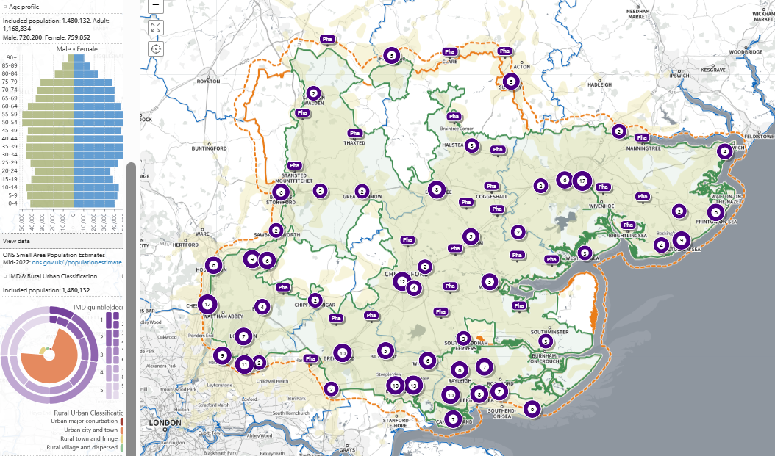
SHAPE Place • Public transport • 0 locations • 5 to 30 minutes • 30 minutes visible • Included population
Figure 29 Map of population with access to a pharmacy across Essex within a 30 minutes’ public transport (weekday morning)

30-minute public transport journey, Without Access:

It is estimated that 39,377 individuals across Essex do not have access to one of 322 pharmacies across Essex and within a 1.6KM buffer zone around Essex within a 30-minute public transport journey (weekday morning).
This is across 21 of the LSOAs across Essex, as shown on the map below highlighted in green.
These are LSOAs all classified (100%) as a ‘rural village and dispersed’ area.
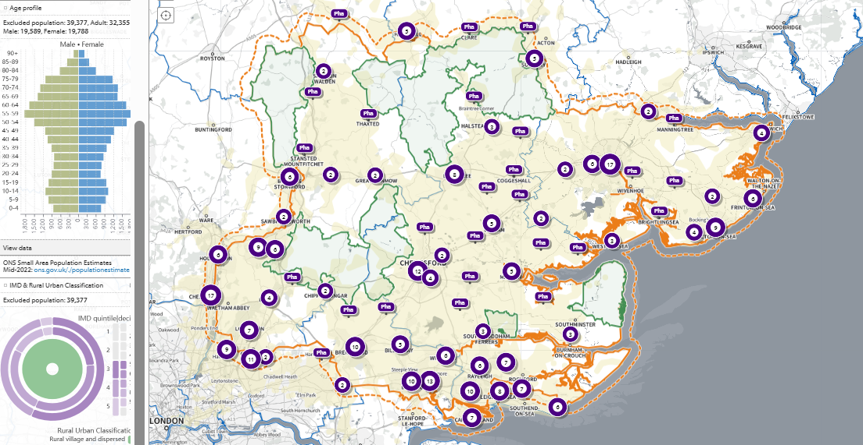
SHAPE Place • Public transport • 0 locations • 5 to 30 minutes • 30 minutes visible • Excluded population
Figure 30 Map of population without access to a pharmacy across Essex within a 30 minutes’ public transport (weekday morning)

Pharmacy Access by Public Transport (Weekday Afternoon)

The map below shows the areas within a certain amount of time needed to take public transport (weekday afternoon) to a pharmacy across Essex and within a 1.6KM buffer zone around Essex (5 to 30 minutes in 5-minute increments).
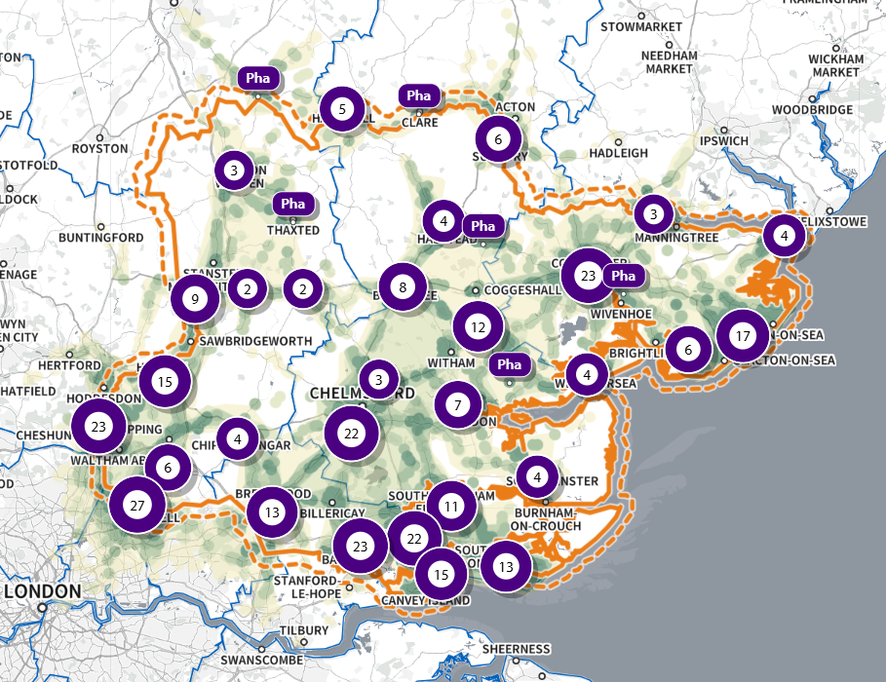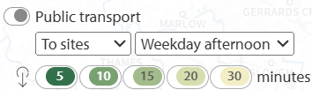
SHAPE Place • Public transport • 0 locations • 5 to 30 minutes
Figure 31 Map of access to a pharmacy across Essex within a 5 – 30 minutes’ public transport (weekday afternoon)

Public Transport journey within 20-minutes (weekday afternoon)

The map below shows the areas within a 20-minute public transport journey (weekday afternoon) to a pharmacy across Essex and within a 1.6KM buffer zone around Essex. These areas are highlighted in green, and those estimated to outside of access by this definition not highlighted.
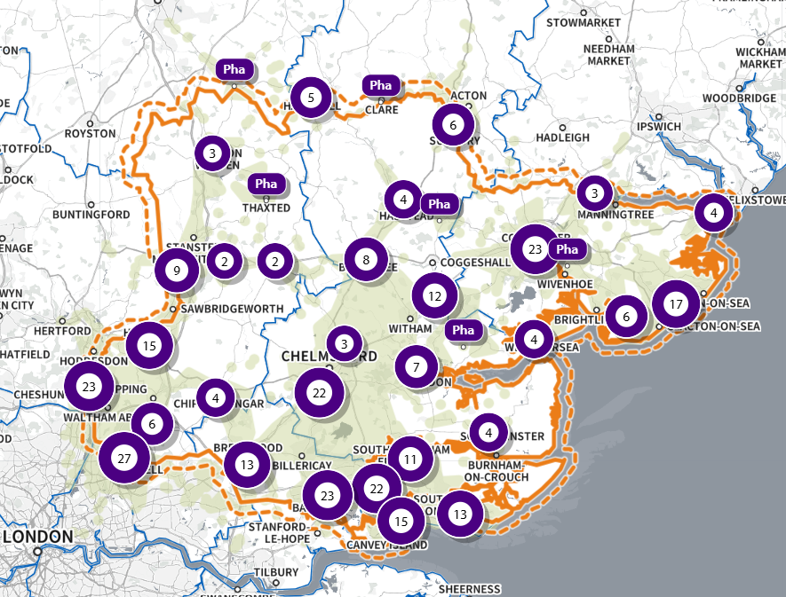
SHAPE Place • Public transport • 0 locations • 5 to 30 minutes • 20 minutes visible
Figure 32 Map of access to a pharmacy across Essex within a 20 minutes’ public transport (weekday afternoon)

20-minute public transport journey, With Access:

It is estimated that 1,458,760 individuals across Essex have access to one of 322 pharmacies across Essex and within a 1.6KM buffer zone around Essex within a 20-minute public transport journey (weekday afternoon). This spans 871 of the LSOAs across Essex, as shown on the map below highlighted in green.
Most of these LSOAs are classed “urban city and towns” (71.97% of LSOAs with access) and are mostly areas considered less deprived (12.47% of LSOAs with access in IMD Decile 10, 12.76% of LSOAs with access in IMD Decile 9, and 13.74% of LSOAs with access in IMD Decile 8, the three least deprived deciles, versus 3.52% in IMD Decile 1 and 5.24% in Decile 2, the two most deprived deciles).
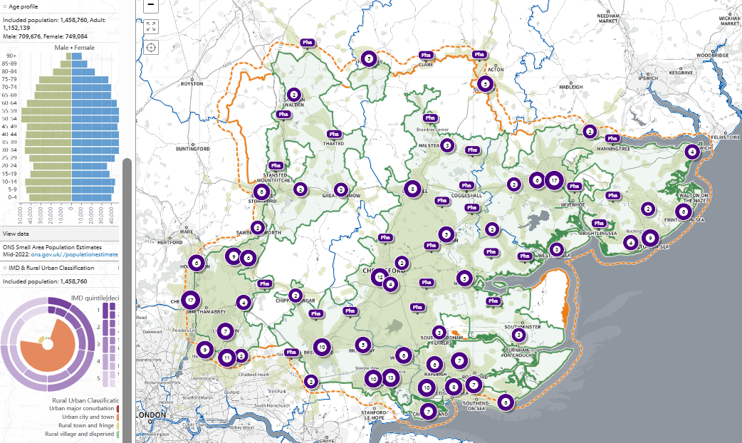
SHAPE Place • Public transport • 0 locations • 5 to 30 minutes • 20 minutes visible • Included population
Figure 33 Map of population with access to a pharmacy across Essex within a 20 minutes’ public transport (weekday afternoon)

20-minute public transport journey, Without Access:

It is estimated that 60,749 individuals across Essex do not have access to one of 322 pharmacies across Essex and within a 1.6KM buffer zone around Essex within a 20-minute public transport journey (weekday afternoon). This spans 32 of the LSOAs across Essex, as shown on the map below highlighted in green. These LSOAs are mostly ‘rural village and dispersed’ areas (96.33% of LSOAs without access).
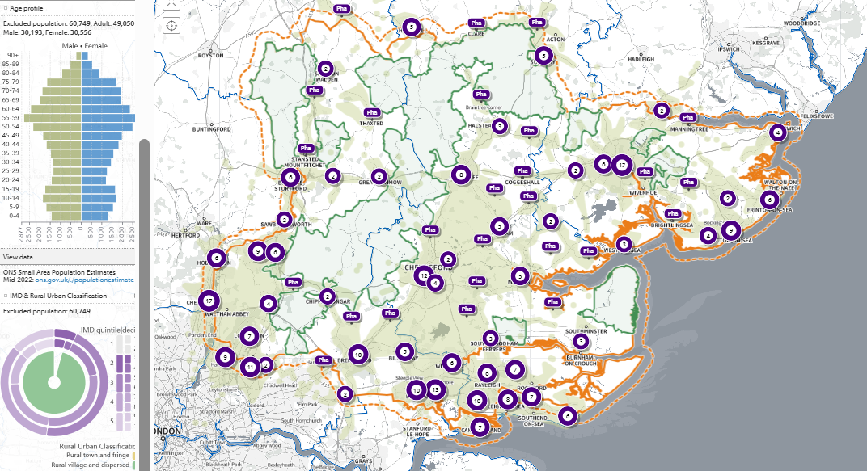
SHAPE Place • Public transport • 0 locations • 5 to 30 minutes • 20 minutes visible • Excluded population
Figure 34 Map of population without access to a pharmacy across Essex within a 20 minutes’ public transport (weekday afternoon)

Public transport journey within 30-minutes (weekday afternoon)

The map below shows the areas within a 30-minute public transport journey (weekday afternoon) to a pharmacy across Essex and within a 1.6KM buffer zone around Essex. These areas are highlighted in green, and those estimated to outside of access by this definition not highlighted.
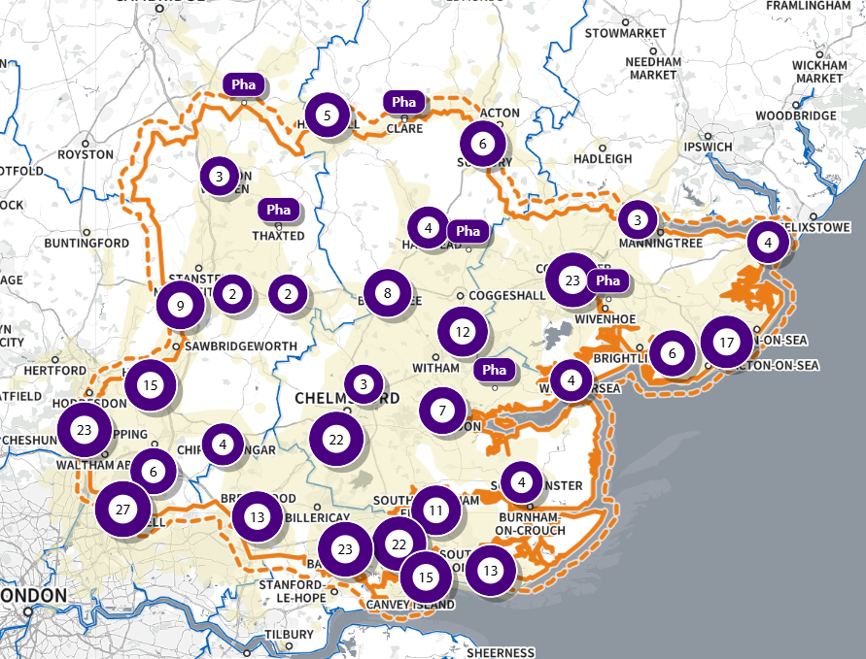
SHAPE Place • Public transport • 0 locations • 5 to 30 minutes • 30 minutes visible
Figure 35 Map of access to a pharmacy across Essex within a 30 minutes’ public transport (weekday afternoon)

30-minute public transport journey, With Access:

It is estimated that 1,475,495 individuals across Essex have access to one of 322 pharmacies across Essex and within a 1.6KM buffer zone around Essex within a 30-minute public transport journey (weekday afternoon). This spans 880 of the LSOAs across Essex, as shown on the map below highlighted in green.
Most of these LSOAs are classed urban city and towns (71.15% of LSOAs with access) and are mostly areas considered less deprived (12.65% of LSOAs with access in IMD Decile 10, 12.75% of LSOAs with access in IMD Decile 9, and 13.72% of LSOAs with access in IMD Decile 8, the three least deprived deciles, versus 3.48% in IMD Decile 1 and 5.18% in Decile 2, the two most deprived deciles).
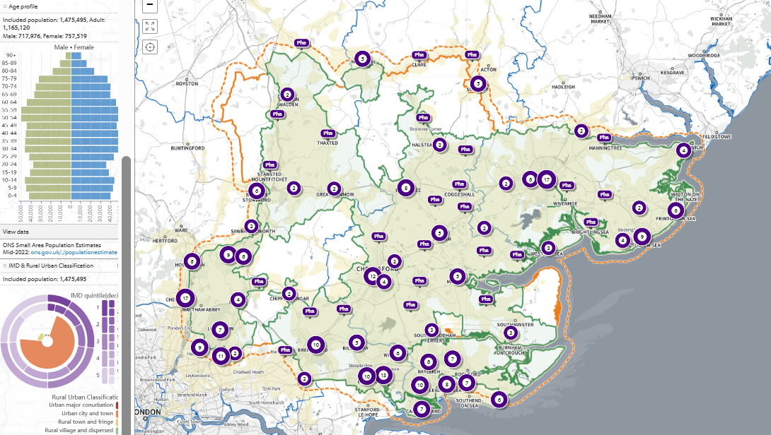
SHAPE Place • Public transport • 0 locations • 5 to 30 minutes • 30 minutes visible • Included population
Figure 36 Map of population with access to a pharmacy across Essex within a 30 minutes’ public transport (weekday afternoon)

30-minute public transport journey, Without Access:

It is estimated that 44,014 individuals across Essex do not have access to one of 322 pharmacies across Essex and within a 1.6KM buffer zone around Essex within a 30-minute public transport journey (weekday afternoon). This is across 23 of the LSOAs across Essex, as shown on the map below highlighted in green. These LSOAs are all classified (100%) as a ‘rural village and dispersed’ area.
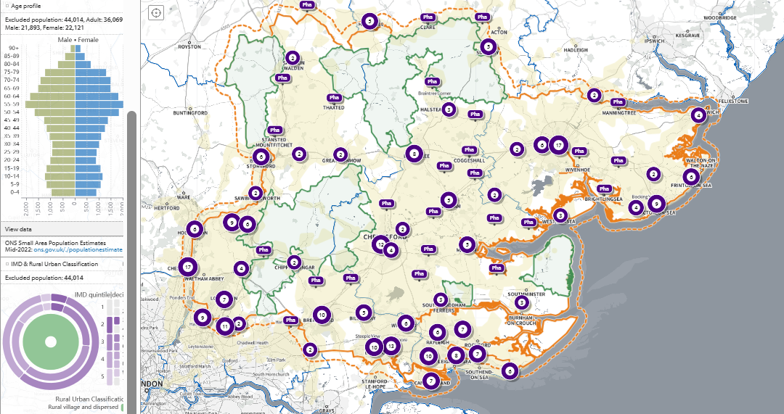
SHAPE Place • Public transport • 0 locations • 5 to 30 minutes • 30 minutes visible • Excluded population
Figure 37 Map of population without access to a pharmacy across Essex within a 30 minutes’ public transport (weekday afternoon)

Pharmacy Access by Public Transport (Weekday Evening)

The map below shows the areas within a certain amount of time needed to take public transport (weekday evening) to a pharmacy across Essex and within a 1.6KM buffer zone around Essex (5 to 30 minutes in 5-minute increments).
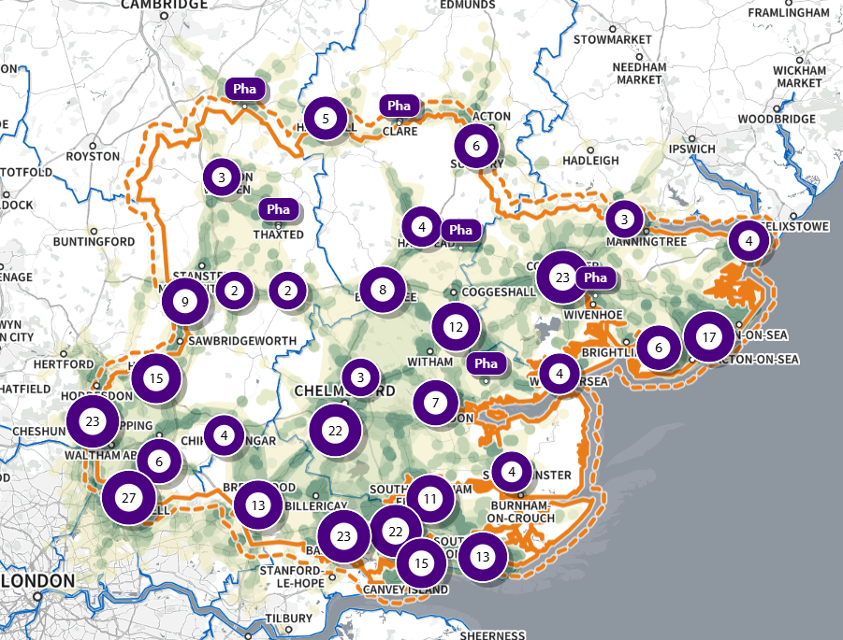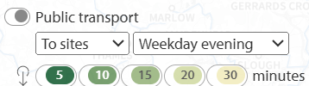
SHAPE Place • Public transport • 0 locations • 5 to 30 minutes
Figure 38 Map of access to a pharmacy across Essex within a 5 – 30 minutes’ public transport (weekday evening)

Public Transport journey within 20-minutes (weekday evening)

The map below shows the areas within a 20-minute public transport journey (weekday evening) to a pharmacy across Essex and within a 1.6KM buffer zone around Essex. These areas are highlighted in green, and those estimated to outside of access by this definition not highlighted.
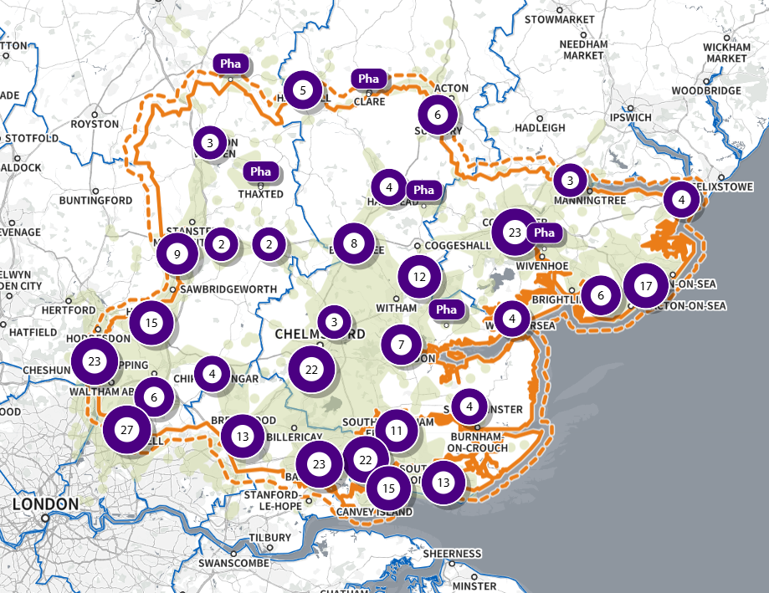
SHAPE Place • Public transport • 0 locations • 5 to 30 minutes • 20 minutes visible
Figure 39 Map of access to a pharmacy across Essex within a 20 minutes’ public transport (weekday evening)

20-minute public transport journey, With Access:

It is estimated that 1,463,471 individuals across Essex have access to one of 322 pharmacies across Essex and within a 1.6KM buffer zone around Essex within a 20-minute public transport journey (weekday evening). This spans 873 of the LSOAs across Essex, as shown on the map below highlighted in green.
Most of these LSOAs are classed “urban city and towns” (71.74% of LSOAs with access) and are mostly areas considered less deprived (12.58% of LSOAs with access in IMD Decile 10, 12.72% of LSOAs with access in IMD Decile 9, and 13.7% of LSOAs with access in IMD Decile 8, the three least deprived deciles, versus 3.51% in IMD Decile 1 and 5.22% in Decile 2, the two most deprived deciles).
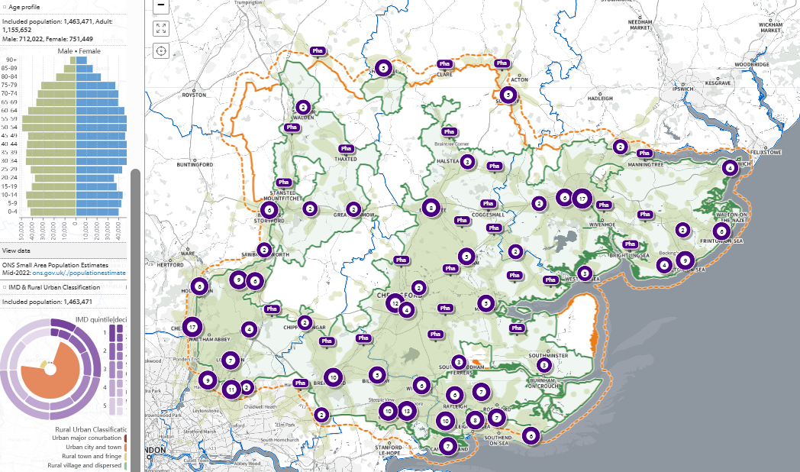
SHAPE Place • Public transport • 0 locations • 5 to 30 minutes • 20 minutes visible • Included population
Figure 40 Map of population with access to a pharmacy across Essex within a 20 minutes’ public transport (weekday evening)

20-minute public transport journey, Without Access:

It is estimated that 56,038 individuals across Essex do not have access to one of 322 pharmacies across Essex and within a 1.6KM buffer zone around Essex within a 20-minute public transport journey (weekday evening). This spans 30 of the LSOAs across Essex, as shown on the map below highlighted in green. These LSOAs are all ‘rural village and dispersed’ areas (100% of LSOAs without access).
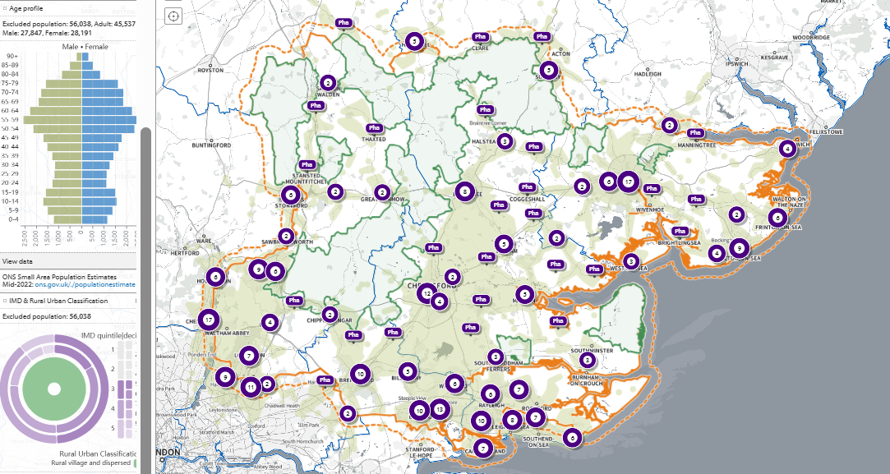
SHAPE Place • Public transport • 0 locations • 5 to 30 minutes • 20 minutes visible • Excluded population
Figure 41 Map of population without access to a pharmacy across Essex within a 20 minutes’ public transport (weekday evening)

Public transport journey within 30-minutes (weekday evening)

The map below shows the areas within a 30-minute public transport journey (weekday evening) to a pharmacy across Essex and within a 1.6KM buffer zone around Essex. These areas are highlighted in green, and those estimated to outside of access by this definition not highlighted.
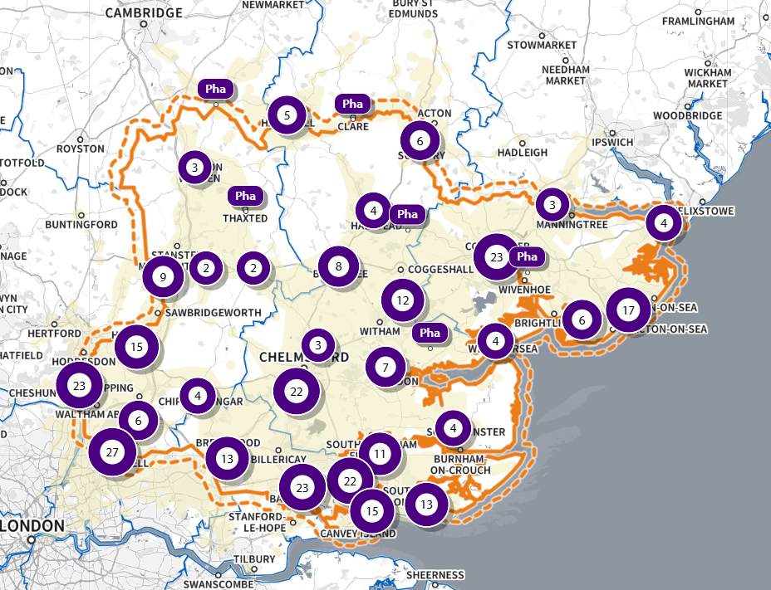
SHAPE Place • Public transport • 0 locations • 5 to 30 minutes • 30 minutes visible
Figure 42 Map of access to a pharmacy across Essex within a 30 minutes’ public transport (weekday evening)

30-minute public transport journey, With Access:

It is estimated that 1,480,132 individuals across Essex have access to one of 322 pharmacies across Essex and within a 1.6KM buffer zone around Essex within a 30-minute public transport journey (weekday evening). This spans 882 of the LSOAs across Essex, as shown on the map below highlighted in green.
Most of these LSOAs are classed ‘urban city and towns’ (70.93% of LSOAs with access) and are mostly areas considered less deprived (12.61% of LSOAs with access in IMD Decile 10, 12.71% of LSOAs with access in IMD Decile 9, and 13.68% of LSOAs with access in IMD Decile 8, the three least deprived deciles, versus 3.47% in IMD Decile 1 and 5.16% in Decile 2, the two most deprived deciles).
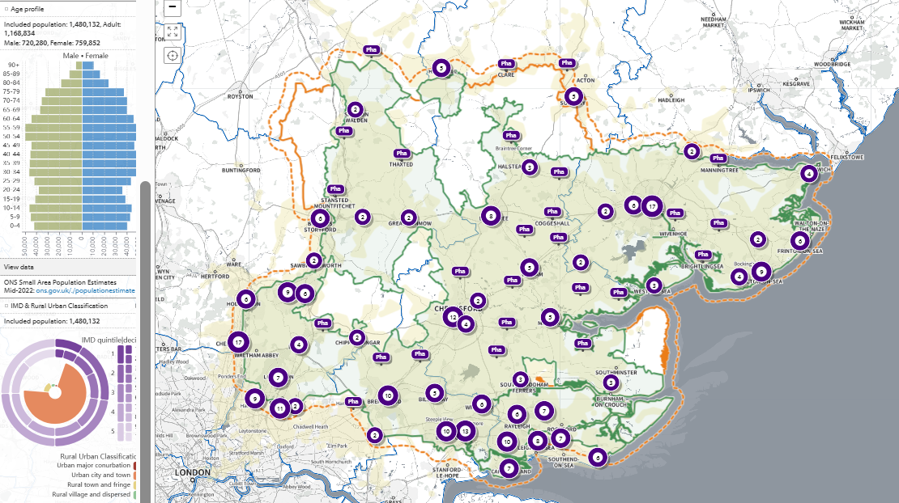
SHAPE Place • Public transport • 0 locations • 5 to 30 minutes • 30 minutes visible • Included population
Figure 43 Map of population with access to a pharmacy across Essex within a 30 minutes’ public transport (weekday evening)

30-minute public transport journey, Without Access:

It is estimated that 39,377 individuals across Essex do not have access to one of 322 pharmacies across Essex and within a 1.6KM buffer zone around Essex within a 30-minute public transport journey (weekday evening). This is across 21 of the LSOAs across Essex, as shown on the map below highlighted in green. These are LSOAs all classified (100%) as a ‘rural village and dispersed’ area.
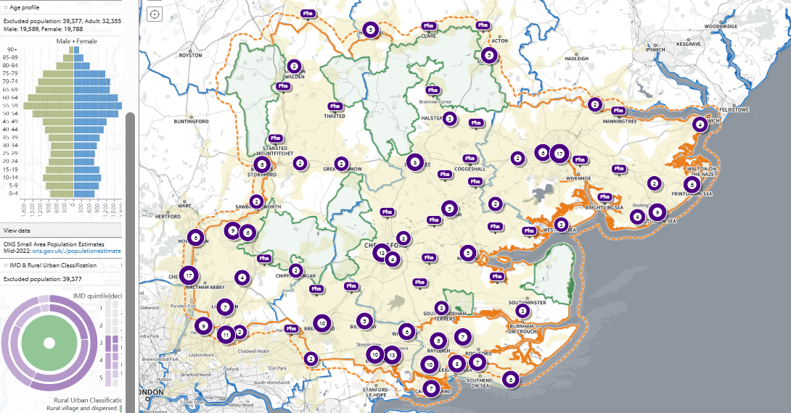
SHAPE Place • Public transport • 0 locations • 5 to 30 minutes • 30 minutes visible • Excluded population
Figure 44 Map of population without access to a pharmacy across Essex within a 30 minutes’ public transport (weekday evening)

Districts Pharmacies
Basildon

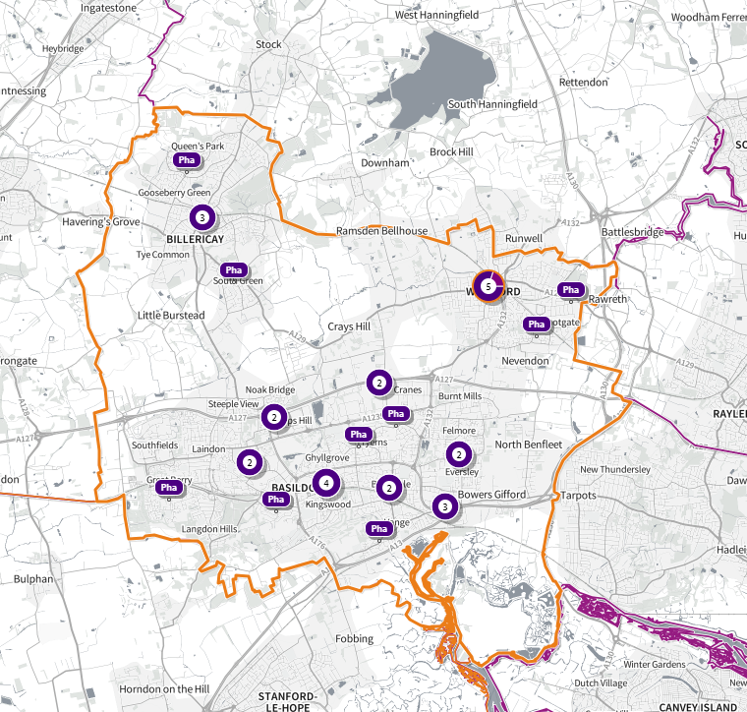

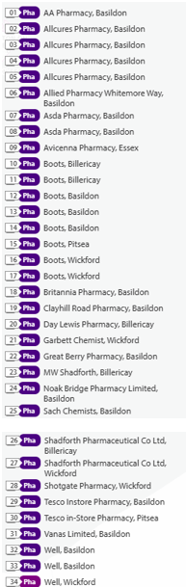
SHAPE Place • Pharmacy • Added location
Braintree
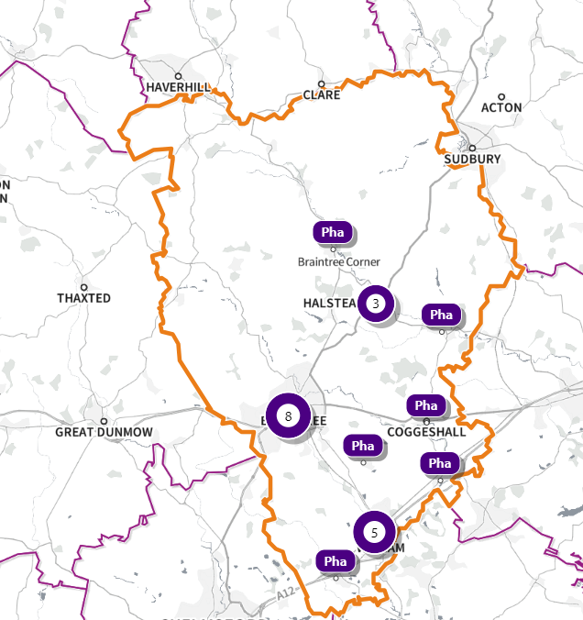
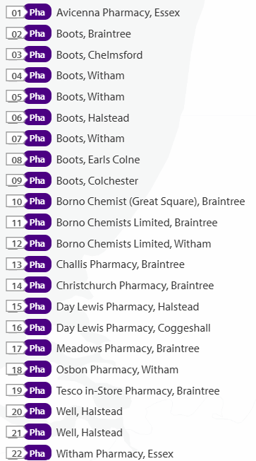
SHAPE Place • Pharmacy

Brentwood
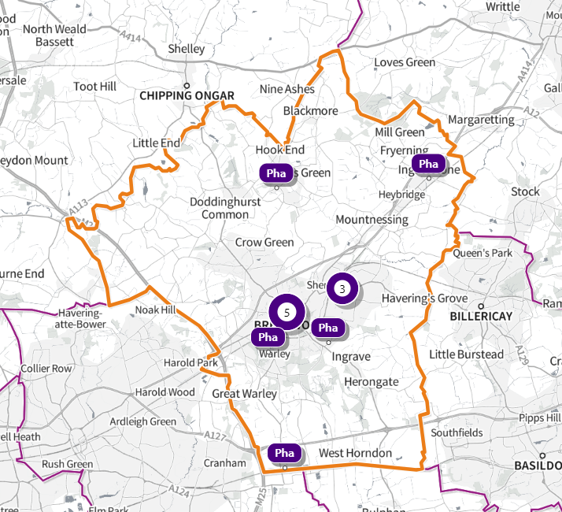
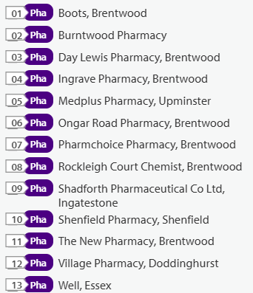
SHAPE Place • Pharmacy

Castle Point
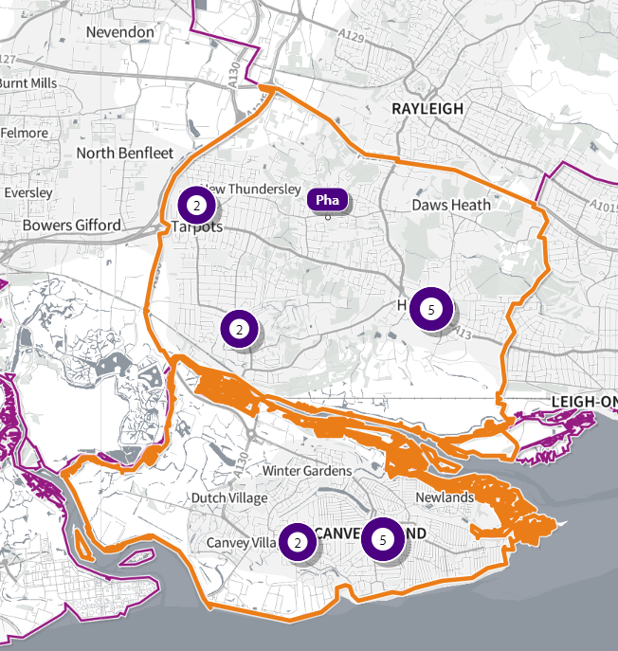
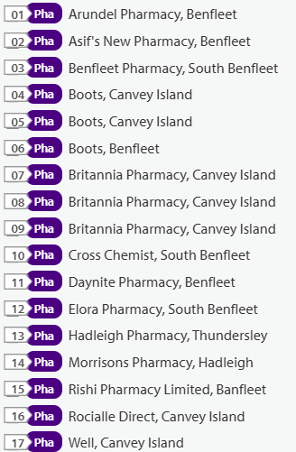
SHAPE Place • Pharmacy

Chelmsford
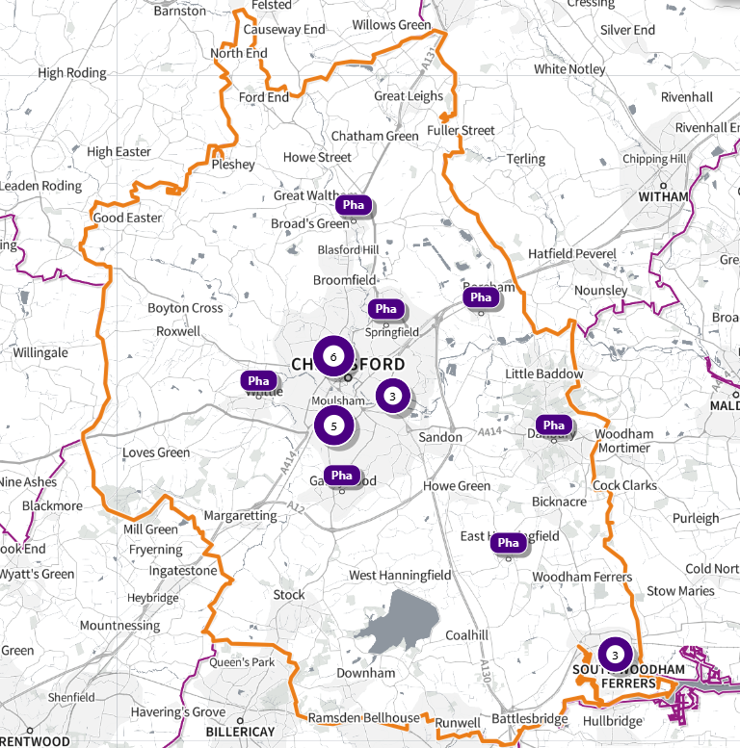
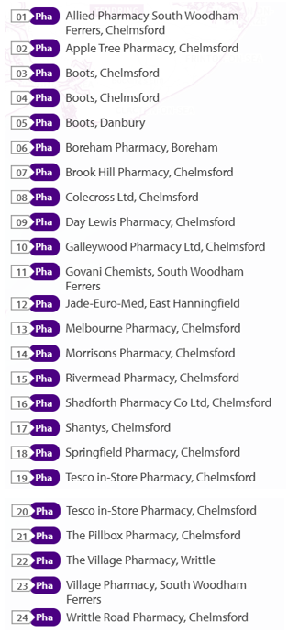
SHAPE Place • Local Authority Districts
Colchester
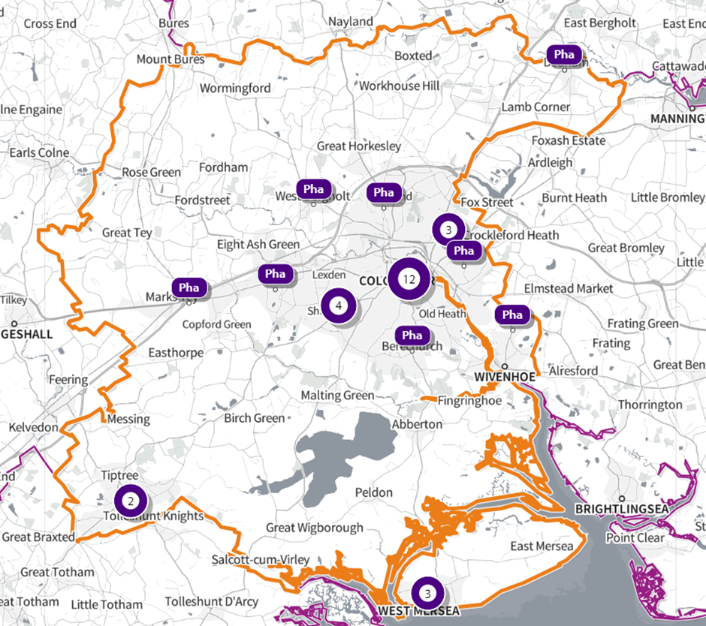
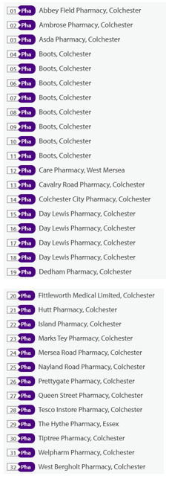
SHAPE Place • Pharmacy

Epping Forest
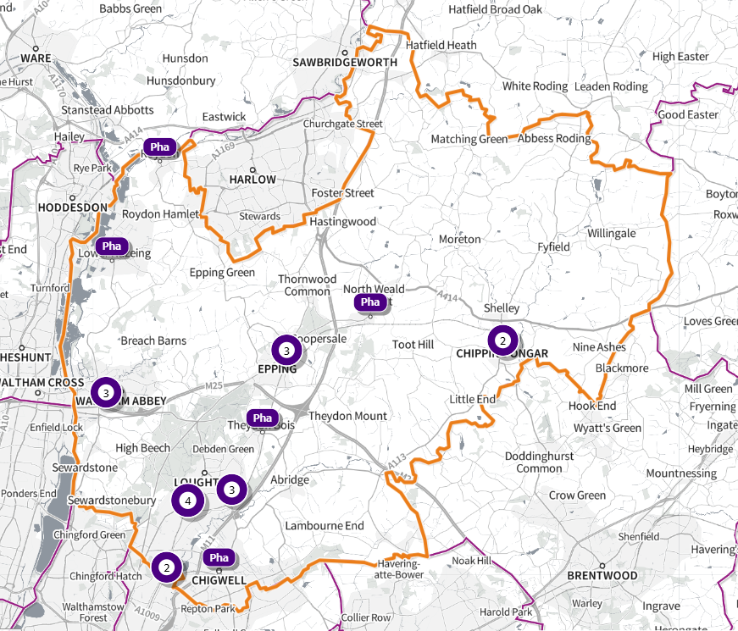
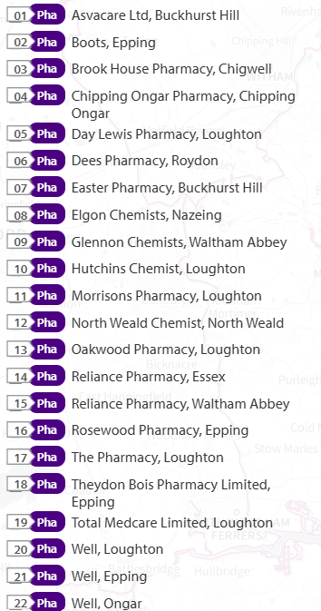
SHAPE Place • Pharmacy
Harlow
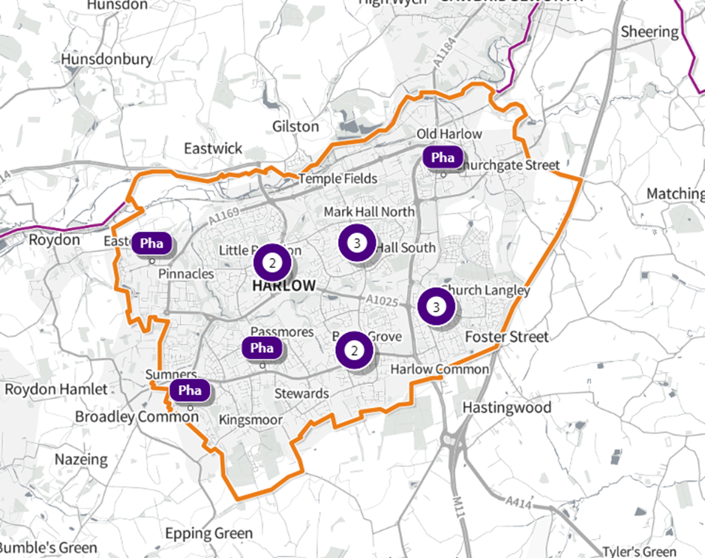
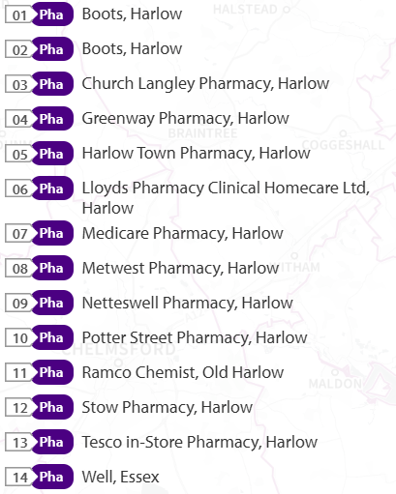
SHAPE Place • Pharmacy

Maldon
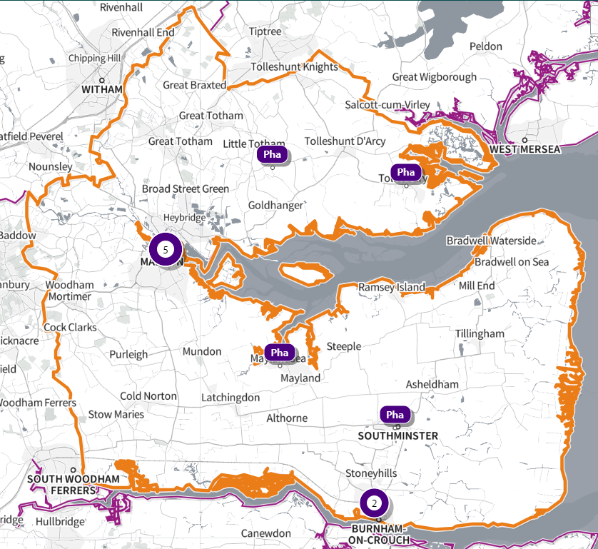
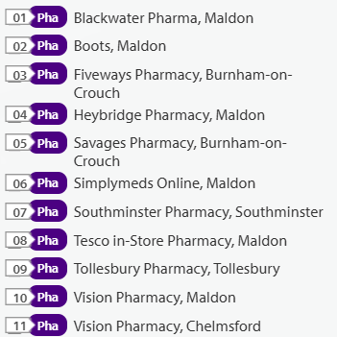
SHAPE Place • Pharmacy

Rochford
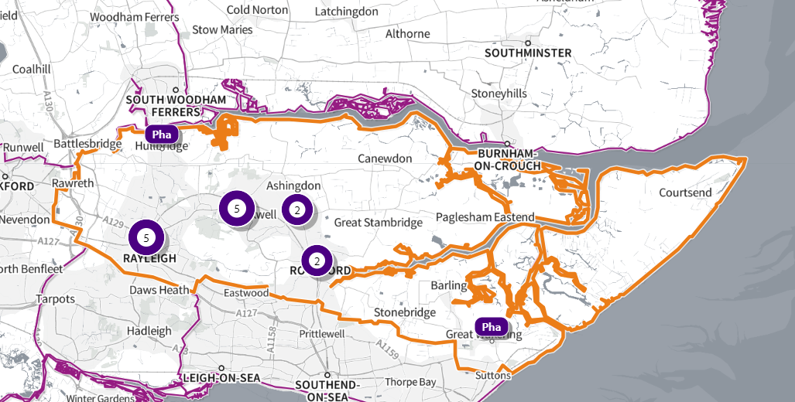

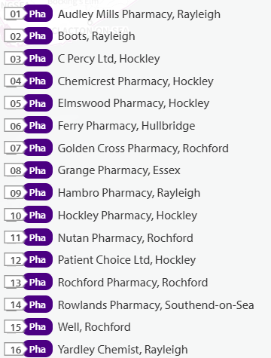
SHAPE Place • Pharmacy

Tendring
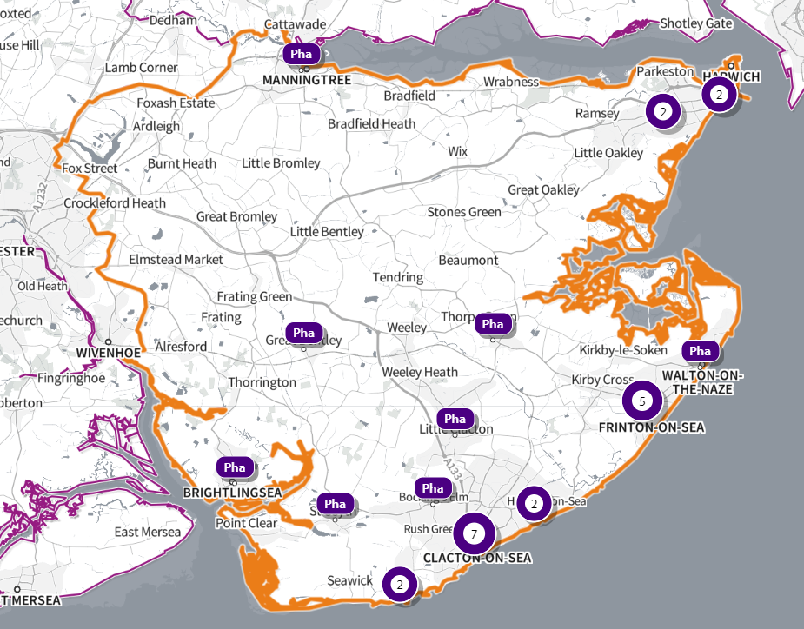

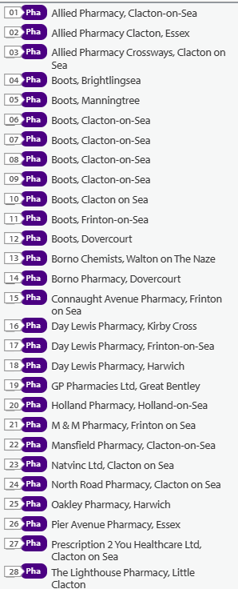
SHAPE Place • Pharmacy

Uttlesford
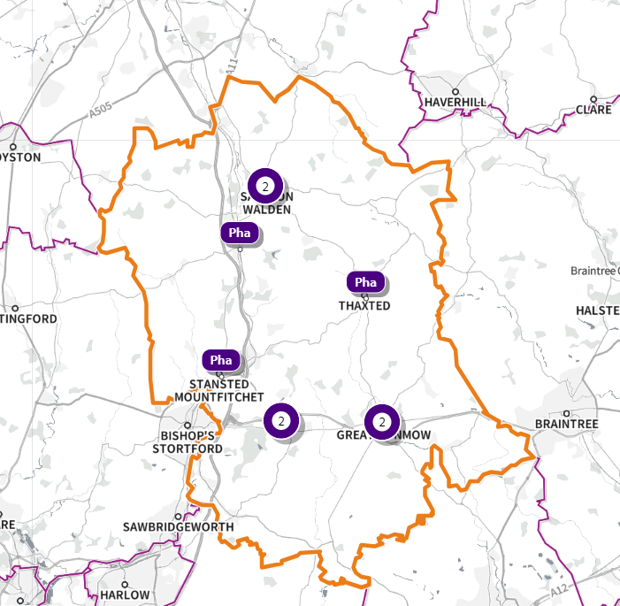
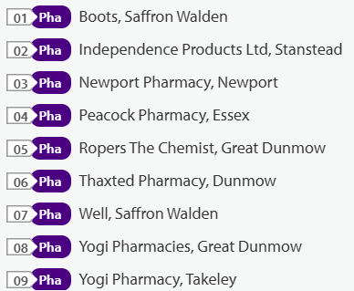
SHAPE Place • Pharmacy

