Essex HWB
Pharmaceutical Needs Assessment

September 2025

Produced for the Essex Health & Wellbeing Board by
Essex County Council Public Health & Public Health Intelligence Team

Table of Contents

Acknowledgements 7
Executive Summary 8
Chapter 1. Introduction 14
The Essex Health and Wellbeing Board Pharmaceutical Needs Assessment 14
Background and legislation 14
Local context 14
Development of the Essex PNA 15
Consultation 15
Scope of the Essex PNA 15
PNA review process 16
Localities for the purpose of the PNA 16
Chapter 2. Pharmaceutical Services 18
Pharmaceutical services provided by pharmacy contractors 18
The Community Pharmacy Contractual Framework 18
Core and supplementary hours 18
Essential services 18
Advanced Services 19
National Enhanced Services (NES) 20
Local Enhanced Services (LES) and Locally Commissioned Services (LCS) 20
Non-commissioned, value add services 20
Chapter 3. Market entry and pharmaceutical providers 24
Market Entry 24
100 hours 25
The Pharmacy Access Scheme 2022 25
Distance selling pharmacies (internet pharmacies) 26
Dispensing Appliance Contractors (DACs) 26
Dispensing doctors 26
Others 26
Chapter 4. The Essex Area 27
4.1 Demographics 27
4.1.1 Birth Rate 30
4.1.2 Ethnicity 31
4.1.3 Religion 32
4.1.4 Protected Characteristics 32
4.2 Deprivation 33
4.2.1 The Index of Multiple Deprivation (IMD) 33
4.3 Lifestyles 39
4.3.1 Physical Activity 39
4.3.2 Nutrition, Diet and Obesity 40
4.3.3 Sexual health 41
4.3.4 Substance misuse 42
4.3.5 Smoking 45
4.3.6 Lifestyles and the PNA 46
4.4 Education 48
4.4.1 GCSE attainment 48
4.5 Employment 49
4.5.1 Unemployment 49
4.6 Housing 50
4.6.1 Fuel poverty 50
4.6.2 Homelessness 52
4.7 Transport 53
4.7.1 Car ownership 53
4.7.2 Access to Services and Transport 54
4.7.3 Impact on Community Health and Wellbeing 54
4.8 Health 55
4.8.1 Life expectancy 55
4.8.2 Disability 57
4.8.3 Carers 58
4.8.4 Disease prevalence 60
Chapter 5. The Assessment 62
5.1 The assessment of pharmaceutical services 62
5.2 Pharmaceutical services in Essex 62
5.2.1 Community Pharmacies 65
5.2.2 Dispensing Appliance Contractors (DACs) registered in the Essex HWB area as of December 2024: 65
5.2.3 Distance selling Pharmacies (DSPs) registered in the Essex HWB area as of December 2024: 65
5.3 Locality of services 66
5.4 Essential services 70
5.4.1 Mandatory services 70
5.4.2 Travel times 70
5.4.3 The availability of choice 72
5.4.4 Dispensing locations 72
5.5 Advanced services 73
5.6 Enhanced services in Essex 74
5.7 Other services providers 76
5.7.1 Dispensing doctors 76
5.7.3 Dispensing Appliance Contractors (DACs) 78
5.7.4 Pharmaceutical service provision provided from outside the HWB area 78
5.7.5 Community Pharmacy Contractual Framework (CPCF) 78
5.8 Other 79
5.9 Housing growth 79
Chapter 6. Localities 2
6.1 Basildon Locality 2
6.2 Braintree Locality 15
6.3 Brentwood Locality 28
6.4 Castle Point Locality 38
6.5 Chelmsford Locality 49
6.6 Colchester Locality 63
6.7 Epping Forest Locality 78
6.8 Harlow Locality 90
6.9 Maldon Locality 101
6.10 Rochford Locality 112
6.11 Tendring Locality 123
6.12 Uttlesford Locality 139
Chapter 7: Future of pharmacy 148
Chapter 8: Conclusion 150
Appendices
Appendix A Development of PNA and Steering Group
Appendix B Full consultation report
Appendix C List of Pharmacies in the HWB area
Appendix D List of Dispensing Doctors in the HWB area
Appendix E Public survey report
Appendix F Travel times and maps
Appendix G Housing Report

Acknowledgements

We would like to acknowledge the following in supporting the development of the Essex HWB Pharmaceutical Needs Assessment:

- Pharmaceutical Needs Assessment Steering Group
- Essex Health and Wellbeing Board
- Director of Public Health and Wellbeing, Essex County Council
- Public Health Research and Citizen Insight team, Essex County Council
- Pharmacy Lead, Essex County Council
- NHS Essex ICBs
- Healthwatch Essex
- Essex Local Pharmaceutical Committee
- Essex Local Medical Committee
- Essex commissioners and providers

Executive Summary

The Essex Health and Wellbeing Board (HWB) has many responsibilities with one key responsibility being to develop and produce a Pharmaceutical Needs Assessment (PNA). PNAs looks specifically at the current provision of pharmaceutical services in Essex and determines whether these pharmaceutical services meet the needs of the population and determines if there are any potential gaps to current service delivery.

The primary purposes of the Essex Pharmaceutical Needs Assessment are summarized below:
• The PNA will be used by the NHS when making decisions on applications to open new pharmacies and dispensing appliance contractor premises; or applications from current pharmaceutical providers to change their existing regulatory requirements.
• The PNA will help the HWB member organisations to work with existing providers to target services to the area where they are needed and to limit duplication of services.
• The PNA will inform interested parties of the PNA and enable collaborative work to plan, develop and deliver pharmaceutical services for the population
• The PNA will help inform commissioning decisions by local commissioning bodies.

This PNA has been produced with the support of the Essex PNA steering group and replaces the previous Essex HWB PNA dated 2022-2025.

NHS pharmaceutical services are provided by contractors on the pharmaceutical list held by Integrated Care Boards (ICBs). Types of providers are:
• Community pharmacy contractors, including distance-selling pharmacies (DSPs)
• Dispensing appliance contractors (DACs)
• Local pharmaceutical service (LPS) providers
• Dispensing doctors

Community pharmacies operate under a contractual framework which sets levels of service:

Essential Services: Negotiated nationally, provided by all pharmacy contractors as part of the NHS Community Pharmacy Contractual Framework.

Advanced Services: Negotiated nationally, community pharmacies can choose to provide any of these services as long as they meet the requirements set out in the Secretary of State Directions.

Local Enhanced Services: Negotiated locally to address local health needs. Provided from selected pharmacies, specifically commissioned. These services are only commissioned by Nation Health Services England (NHSE).

National Enhanced Services: Negotiated nationally and implemented to address local health needs.
In addition to NHS pharmaceutical services, community pharmacies may also provide ‘locally commissioned services’ (LCS). These are not
considered ‘pharmaceutical services’ under the Pharmaceutical Regulations 2013.

Local Context
According to Office for National Statistics mid-year 2023 population estimates, Essex overall has a population size of 1,536,118, with 60% of the population aged 16-64 years.

Although Essex is relatively healthier and affluent in comparison with the rest of England there is a growing disparity in health between the most affluent and most deprived areas of Essex. Lifestyle issues such as obesity and smoking, employment and poverty issues are becoming more prevalent in the most deprived areas. This is reflected in the trends seen in life expectancy, with a growing disparity between life expectancy in those from the most affluent areas compared with those from the most deprived areas of Essex.

To meet the needs of this growing population and to help reduce inequalities in Essex it is vital that appropriate pharmaceutical services are in place and that they are accessible and improve choice to support the most deprived and vulnerable individuals in Essex.

The NHS Long Term plan for pharmacies states that:
• NHSE will work with Government to make greater use of community pharmacists’ skills and opportunities to engage patients.
• NHSE and the Government will explore further efficiencies through reform of reimbursement and wider supply arrangements.
• NHSE will work with community pharmacists and others to provide opportunities for the public to check their health, through tests for
high blood pressure and other high-risk conditions; and
• NHS 111 will start direct booking into GP practices across the country, as well as referring on to community pharmacies who can
support urgent care and promote patient self-care and self-management.
• NHSE also makes several mentions of pharmacists, noting the role that they will play in local Primary Care Networks (PCNs).

Pharmacists may be involved in helping to identify and treat people with high-risk conditions, undertaking a range of medicine reviews, including educating patients on the correct use of inhalers, and offering medicine reviews to care home residents.

As of December 2024, there are 230 pharmacies, 47 dispensing doctors, 5 dispensing appliance contractors and 6 distance selling pharmacies registered with NHSE in the Essex HWB area.

Continuing to assess and develop pharmaceutical services to meet the needs of the population is an essential component to improve the health of individuals in Essex. We have concluded that at present we have adequate choice and access to pharmaceutical services in order to meet the needs of our population, both at district locality and county level.

When assessing the provision of pharmaceutical services in the Essex HWB area the steering group considered the following:
• The number and distribution of all contractors in each PNA locality and opening hours
• The location of and choice of pharmaceutical services
• Access to community pharmacies during weekdays, evenings and the weekend
• Access to community pharmacies via various types of transport
• Provision of Essential, Advanced and Enhanced services in each locality
• Provision of necessary and relevant services
• Results of the public questionnaire
• Results of the statutory consultation (To be considered post-consultation)
• The health needs of the population from the JSNA
• Projected population growth
• Specific populations
• The Index of Multiple Deprivation and deprivation ranges as well as the other wider determinants of health
• The general lifestyle including smoking and drug and alcohol misuse
• The disease burden

This report gives the regulatory background, scope of the PNA and insight into pharmaceutical services and commissioning within the first three chapters.
Chapter 4 provides a local picture of the Essex area, its demographics, deprivation, lifestyles and other factors considered during this assessment. It is not intended as a complete population analysis as more comprehensive data is available via the Joint Strategic Needs Assessment.
Chapter 5 provides a detailed look at the pharmaceutical services provision with the Essex HWB area.
Chapter 6 looks into further detail of provision within each of the 12 localities of the HWB area.
Chapter 7 considers future needs and chapter 8 provides the conclusions as required by the regulations.
There are 8 appendices to this report which provide further data and insight.

The PNA is required to clearly state what is considered to constitute Necessary Services as required by paragraphs 1 and 3 of Schedule 1 to the Pharmaceutical Regulations 2013.

For the purposes of this PNA, Necessary Services for the HWB are defined as Essential Services plus the New Medicines Service and the Community Pharmacist Consultation Service.
Other Advanced Services are considered relevant as they contribute toward improvement in provision and access to pharmaceutical services.

For the purpose of this PNA, Enhanced Services are defined as pharmaceutical services that secure improvements or better access to, or that have contributed towards meeting the need for pharmaceutical services in the HWB area.

Locally commissioned services are those that secure improvements or better access to, or that have contributed towards meeting the need for pharmaceutical services in Essex and are commissioned by the ICB or local authority, rather than NHSE.

Access to pharmaceutical services for the residents of Essex is good and the main conclusion of this PNA is that there are currently no gaps in the provision of necessary or relevant pharmaceutical services.

Note that although a service may not be commissioned, this does not necessarily mean there is a gap in pharmaceutical service provision as services may also be delivered by other providers.

The PNA also looked at changes which are anticipated within the lifetime of the document, for example the predicted population growth.
Given the current population demographics, housing projections and the distribution of service providers across the HWB area, this document concludes that the current provision will be sufficient to meet the likely future needs of the residents during the three-year lifetime of this pharmaceutical needs assessment.

The HWB has not identified any services that would secure improvements, or better access, to the provision of pharmaceutical services either now or within the 3-year lifetime of this pharmaceutical needs assessment.

Provision of essential services during normal working hours
Based on the information available at the time of developing this PNA no gaps have been identified in any of the localities either now or in the future

Provision of essential services outside normal working hours
Based on the information available at the time of developing this PNA no gaps have been identified in any of the localities either now or in the future

Provision of the New Medicine Service and Community Pharmacist Consultation Service advanced services
Based on the information available at the time of developing this PNA no gaps have been identified in any of the localities either now or in the future

Provision of necessary services
Based on the information available at the time of developing this PNA no gaps have been identified in any of the localities either now or in the future

Provision of other relevant services
Based on the information available at the time of developing this PNA no gaps have been identified in any of the localities either now or in the future

Provision of essential services
Based on the information available at the time of developing this PNA no gaps have been identified in any of the localities either now or in the future

Provision of advanced services
Based on the information available at the time of developing this PNA no gaps have been identified in any of the localities either now or in the future

Provision of better access to the enhanced services
Based on the information available at the time of developing this PNA no gaps have been identified in any of the localities either now or in the future

Chapter 1. Introduction

The Essex Health and Wellbeing Board Pharmaceutical Needs Assessment
This Essex Health and Wellbeing Board (HWB) Pharmaceutical Needs Assessment (PNA) supersedes previous PNAs within the HWB area.

PNAs are generally updated at least every three years.

The Essex HWB PNA and its updates are published on the Essex Open Data website https://data.essex.gov.uk/datasets.

Background and legislation
Section 128A of the National Health Service Act 2006 (NHS Act 2006) requires each HWB to assess the need for pharmaceutical services in its area and to publish a statement of its assessment. Termed a ‘Pharmaceutical Needs Assessment’, the NHS (Pharmaceutical Services and Local Pharmaceutical Services) Regulations 2013, as amended (the 2013 regulations) set out the minimum information that must be contained within a PNA and outline the process that must be followed in its development.

Local context
Purpose of the Essex Pharmaceutical Needs Assessment (PNA):
The PNA will be used by NHS England (NHSE, or other body as identified in the regulations) when considering decisions on applications to open new pharmacies and dispensing appliance contractor premises; or applications from current pharmaceutical providers to change their existing regulatory requirements. Decisions on whether to open new pharmacies are not made by the HWB. If a person (a pharmacist, a dispenser of appliances or in some circumstances, and normally in rural areas, GPs) wants to provide NHS pharmaceutical services, they are required to apply to the NHS to be included on a Pharmaceutical List. At the time of writing pharmaceutical lists are compiled and held by Integrated Care Boards (ICBs). Under the NHS (Pharmaceutical Services and Local Pharmaceutical Services) Regulations, a person who wishes to provide NHS pharmaceutical services must generally apply to the relevant ICB to be included on a relevant list by proving they are able to meet a pharmaceutical need as set out in the relevant PNA. There are exceptions to this, such as applications for needs not foreseen in the PNA or to provide pharmaceutical services on a distance-selling (internet or mail order only) basis. NHS England will then review the application and decide if there is a need for a new pharmacy in the proposed location.
It will aid the HWB to work with providers to target services to the areas where they are needed, and limit duplication of services in areas where provision is adequate.
It will inform interested parties of the pharmaceutical needs in Essex and enable work to plan, develop and deliver pharmaceutical services for the population.
It will inform commissioning decisions by local commissioning bodies, including local authorities.

Development of the Essex PNA
- The process of developing the PNA has taken into account the requirement to involve and consult people about changes to health services. The specific legislative requirements in relation to development of PNAs were considered. The membership of the steering group ensured all the main stakeholders were represented. Further details are available in Appendix A.

Consultation
- A statutory consultation exercise was carried out between 13th June 2025 to 13th August 2025 to seek and consider views from a range of key stakeholders on the draft PNA.
- A full consultation report is included in the final PNA Appendix B.
- A public survey was conducted as part of the PNA development process.

Scope of the Essex PNA
- The services that a PNA must include are defined within both the National Health Service Act 2006 and the NHS (Pharmaceutical and Local Pharmaceutical Services) Regulations 2013, as amended.
• Pharmaceutical services may be provided by:
• A pharmacy contractor who is included in the pharmaceutical list for the area of the Health and Wellbeing Board (HWB).
• A pharmacy contractor who is included in the Local Pharmaceutical Services list for the area of the HWB.
• A dispensing appliance contractor who is included in the pharmaceutical list held for the area of the HWB and
• A doctor or GP practice that is included in the dispensing doctor list held for the area of the HWB.
• NHS England (NHSE) is responsible for preparing, maintaining and publishing these lists. This responsibility is delegated to the ICBs at present.
• Pharmacy contractors may operate as either a sole trader, partnership, or a body corporate and The Medicines Act 1968 governs who can be a pharmacy contractor.
• Whether a service falls within the scope of pharmaceutical services for the purposes of PNA depends on who the provider is and what is provided.
• The PNA has a regulatory purpose that sets the scope of the assessment. Pharmaceutical services are evident in other areas of work but are excluded from this assessment. These include prison pharmacy, secondary care, and private services where patients may be obtaining a type of pharmaceutical service that is not covered by this assessment.

PNA review process
- The PNA will be updated as required by legislation every three years. Supplementary statements will be published before this if deemed necessary.
- Once a pharmaceutical needs assessment is published, the 2013 regulations require the HWB to produce a new one if it identifies changes to the need for pharmaceutical services, which are of a significant extent.

Localities for the purpose of the PNA
- The PNA steering group considered how the areas in Essex could be defined for the PNA. The Essex HWB covers 12 district, borough, and city council areas and these were therefore chosen as the localities. Health and wider determinants data is also available within these locality levels.

Table 1 Localities of the Essex PNA
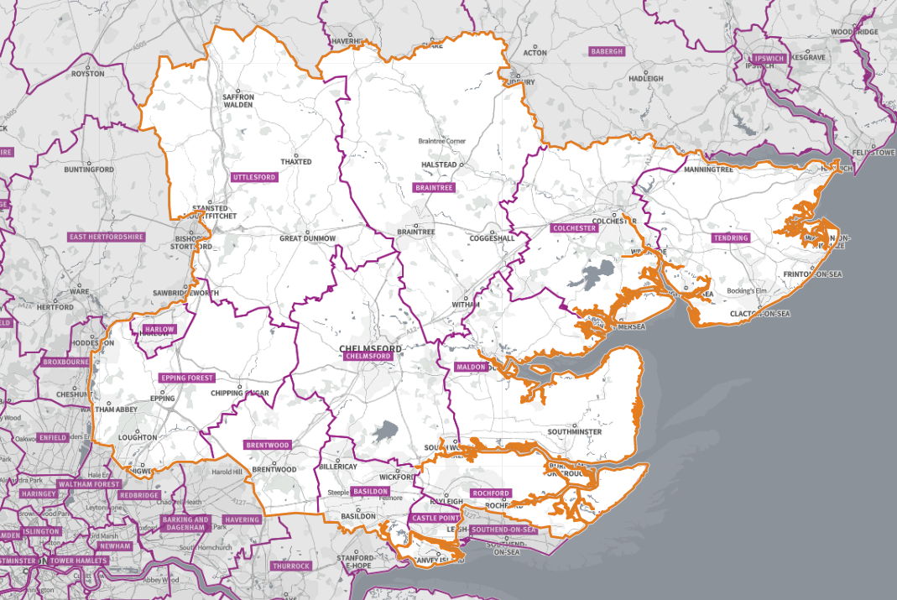
PNA Localities
Basildon
Brentwood
Braintree
Castle Point
Chelmsford
Colchester
Epping Forest
Harlow
Maldon
Rochford
Tendring
Uttlesford

Figure 1 Map of Essex showing localities

Chapter 2. Pharmaceutical Services

Pharmaceutical services provided by pharmacy contractors
Unlike for GPs, dentists and optometrists, NHSE does not hold contracts with the majority of pharmacy contractors. Instead, they provide services under a contractual framework, sometimes referred to as the Community Pharmacy Contractual Framework (CPCF), details of which (the terms of service) are set out in the NHS Pharmaceutical Services Regulations.

The Community Pharmacy Contractual Framework
The CPCF was introduced in 2005. Under the framework, there are three types of service which can be provided by community pharmacy and/or appliance contractors:
- Essential services
- Advanced services
- Enhanced services (commissioned by NHSE)

Core and supplementary hours
Pharmacy opening hours are part of pharmacies’ Terms of Service for providing NHS pharmaceutical services.
Most pharmacies must open for 40 core contractual hours (this includes Distance Selling Premises (DSP) pharmacies).
Some pharmacies must open between 72-100 core contractual hours (called 100-hour pharmacies for those that have opened under the former exemption from the control of entry test).
All pharmacies may open for additional supplementary hours.

Essential services
As part of the CPCF, Essential services are one of the three types of services which must be provided by community pharmacies, including distance selling pharmacies.

Advanced Services
Advanced services are those services that pharmacy and dispensing appliance contractors may choose to provide if they meet the required standards.

Table 2 Provision included in the contractual framework for Advanced Services
Service | Description
New Medicines Service (NMS) | The New Medicines Service (NMS) is designed to provide early support to patients to maximise the benefits of the medication they have been prescribed, and to minimise problems and side-effects, while informing the patients to self-manage their Long-Term Conditions (LTCs)
Community pharmacy seasonal influenza vaccination | The accessibility of pharmacies, their extended opening hours, and the option to walk in without an appointment have proved popular with patients seeking vaccinations.
Pharmacy First Service | The service involves pharmacists providing advice and NHS-funded treatment, where clinically appropriate, for seven common conditions (age restrictions apply).
Pharmacy Contraception Service (PCS) | Provides a model for community pharmacy teams to initiate provision of Oral Contraception (OC), and to continue the provision of OC supplies initiated in primary care or sexual health clinics.
Lateral Flow Device (LFD) Service | The Lateral flow device tests supply service for patients potentially eligible for COVID-19 treatments (LFD service) was commissioned as an Advanced service from November 2023.  In March 2024 it was announced that the service would continue to be commissioned in 2024/25 and that additional patient groups became eligible to access the service.
Hypertension case-finding service | The prevention of cardiovascular problems and identification of people with raised blood pressure. The service has two stages – the first is identifying people at risk of hypertension and offering them blood pressure measurement.  - the second stage, where clinically indicated, is offering 24 hour ambulatory blood pressure monitoring (ABPM). The blood pressure test results will then be shared with the patient’s GP to inform a potential diagnosis of hypertension.
Smoking Cessation Service (CSC) following hospital discharge | In 2020/21 a Pharmacy Integration Fund pilot on smoking cessation began to test a new model of working in which community pharmacies managed the continuing provision of smoking cessation support initiated in secondary care following patient discharge from hospital.
Appliance and Stoma services | Whilst pharmacies are required to dispense valid NHS prescriptions for all drugs, both they and dispensing appliance contractors may choose which appliances they provide. There are two appliance advanced services that pharmacies and dispensing appliance contractors may choose to provide:  •Appliance Use Reviews (AUR), and  •Stoma Appliance Customisation (SAC)

National Enhanced Services (NES)
In December 2021, provisions were made within the NHS (Pharmaceutical and Local Pharmaceutical Services) Regulations 2013 for a new type of Enhanced service, the National Enhanced Service (NES). Under this type of service, NHSE commissions an Enhanced service that is nationally specified.
This differs from a Local Enhanced Service (LES) that should be locally developed and designed to meet local health needs. A NES allows the agreement of standard conditions nationally, while still allowing the flexibility for local decisions to commission the service to meet local population needs, as part of a nationally coordinated programme.
There is currently one NES commissioned; this is the Covid-19 vaccination service.

Local Enhanced Services (LES) and Locally Commissioned Services (LCS)
This third group of services provided are locally commissioned community pharmacy Services and they can be contracted via a number of different routes and by different commissioners, including LA, ICBs and local NHSE teams.
Local services that are commissioned by the NHSE are called Local Enhanced Services (LES).

Locally commissioned services (LCS) by the LA or ICBs such as public health services are not considered to be LESs.
Services commissioned from LA and ICBs fall outside the definition of enhanced services, they have no bearing on pharmacy applications; they are only included in this assessment to secure improvements or better access to pharmaceutical services.

Non-commissioned, value add services
Community pharmacies provide some services that are not commissioned from any particular sources and have no bearing on pharmacy applications. These services add value to the local provision. They can include:
- Repeat prescription collection and delivery services
- Travel advice and vaccinations
- Screening services
- Dispensing of private prescriptions
- Sales of over-the-counter medicines

Pharmaceutical services provided by dispensing appliance contractors
As with pharmacy contractors, NHSE hold contracts with dispensing appliance contractors. Dispensing appliance contractors provide the following services for appliances (not drugs) for example catheters and colostomy bags, which fall within the definition of pharmaceutical services:

- Dispensing of prescriptions (both electronic and non-electronic), including urgent supply without a prescription
- Dispensing of repeatable prescriptions
- Home delivery service for some items
- Supply of appropriate supplementary items (e.g., disposable wipes and disposal bags)
- Provision of expert clinical advice regarding the appliances and
- Signposting

They may also choose to provide advanced services. If they do choose to provide them then they must meet certain requirements and must be fully compliant with their terms of service and the clinical governance requirements. The two advanced services that they may provide are the Stoma Appliance Customisation (SAC) and the Appliance Use Review (AUR).

As with pharmacies, dispensing appliance contractors are required to participate in a system of clinical governance.
Dispensing appliance contractors are required to open at least 30 hours per week, and these are referred to as core opening hours. They may choose to open for longer and these additional hours are referred to as supplementary opening hours.
The proposed opening hours for each dispensing appliance contractor are set out in the initial application, and if the application is granted and the dispensing appliance contractor subsequently opens then these form the dispensing appliance contractor’s contracted opening hours.

Dispensing doctor services
The NHS Pharmaceutical Services Regulations allow doctors to dispense to eligible patients in certain circumstances. In summary:
- Patients must live in a ‘controlled locality’ (an area which has been determined by NHSE or a preceding organisation as rural in character), more than 1.6km (measured in a straight line) from a pharmacy (excluding distance selling premises) and
- Their practice must have premises approval and consent to dispense to that area.

A dispensing practice can also undertake a dispensing review of use of medicines (DRUM). This is a face-to face review with a patient to find out about their experiences with prescribed medicines and aims to help identify any problems that might be occurring.

Distance Selling Pharmacies services
Distance selling pharmacies or mail order pharmacies, often known as ‘online pharmacies’, operate over the internet and send orders to customers through the mail or parcel services free of charge. The NHS Pharmaceutical Services Regulations stipulate the requirements for distance selling pharmacies. These pharmacies must provide the full range of essential services during opening hours to all persons in England presenting prescriptions but cannot provide essential services face to face, they must have a responsible pharmacist in charge of the business at the premises throughout core and supplementary opening hours and they must be registered with the General Pharmaceutical Council (GPhC).

Necessary and relevant services
Necessary services are pharmaceutical services which have been assessed as required to meet a pharmaceutical need. This should include their current provision (within the HWB area and outside of the area) and any current or likely future gaps in provision.
Any services not considered as necessary pharmaceutical services are therefore deemed to be other relevant services which can be provided as an optional service by pharmaceutical contractors and are often also delivered by other providers within the HWB area.

Other NHS services
Some NHS services reduce the need for pharmaceutical services, in particular the dispensing service, these include:

- Hospital pharmacies
- Personal administration of items by GP practices
- GP out of hours service (as it may give patients a course of treatment rather than a prescription)
- Public health services commissioned by the local authority
- Prison pharmacy services (where relevant) and
- Substance misuse services

NHS services that increase the demand for pharmaceutical services include:

- GP out of hours services (where a prescription is issued)
- Walk-in centres and minor injury units (where a prescription is issued)
- GP extended access hubs
- Community nursing prescribing
- Dental services
- End of life services, and
- Services that have been moved into the primary care setting

Chapter 3. Market entry and pharmaceutical providers

Market Entry
If a person (whether sole traders, partnerships or bodies corporate) wants to provide pharmaceutical services, they are required to apply to the NHS to be included in a pharmaceutical list. Pharmaceutical lists are compiled and are held by NHSE. This is commonly known as the NHS “market entry” system.
Under the 2013 regulations, a person who wishes to provide pharmaceutical services must apply to NHS England to be included in the relevant pharmaceutical list by proving they are able to meet a need for, or improvements or better access to, pharmaceutical services as set out in the relevant PNA.
There are exceptions to this, such as applications for benefits not foreseen in the PNA or to provide pharmaceutical services on a distance-selling (internet or mail order only) basis.
Following changes to the NHS Act 2006, NHSE may delegate the commissioning of pharmaceutical services to the ICBs; however, it retains oversight for the performance of the commissioning of pharmaceutical services.

Under the National Health Service (Pharmaceutical and Local Pharmaceutical Services) Regulations 2013, as amended (‘the Regulations’), NHSE is responsible for preparing, maintaining and publishing (for each HWB area) the lists of persons who undertake to provide pharmaceutical services from premises located in England:

Those persons who undertake to provide pharmaceutical services in particular by way of the provision of drugs, i.e. pharmacy contractors.
Those persons who undertake to provide pharmaceutical services in particular by way of the provision of appliances, i.e. dispensing appliance contractors (DACs).

The above lists are referred to as pharmaceutical lists.

NHSE is also responsible for the following lists by HWB area:
- Doctors who undertake to provide pharmaceutical services (the dispensing doctor lists).
- Local pharmaceutical services (LPS) chemists (if there are any) who provide local pharmaceutical services at or from premises situated in that area.
- Where the commissioning of pharmaceutical services has been delegated to an ICB, that organisation is responsible for preparing and maintaining the pharmaceutical lists for the areas of the HWBs within its area.
Persons wishing to provide pharmaceutical services in England must be included in the relevant pharmaceutical list or lists held by NHS England.

100 hours
Certain pharmacies opened under previous regulations undertaking to provide pharmaceutical services for 100 hours a week.
With effect from May 2023 those pharmacies subject to the 100 hours condition can apply to reduce their core opening hours in line with changes in the legislation. These pharmacies must open for between 72-100 hours as per their contract.

The Pharmacy Access Scheme 2022
The aim of the Pharmacy Access Scheme (PhAS) is to ensure that a baseline level of patient access to NHS community pharmaceutical services in England is protected.
The PhAS was designed to capture the pharmacies that are most important for patient access, specifically those pharmacies where patient and public access would be materially affected should they close. The PhAS takes isolation and need levels into account.
The objective of the 2022 PhAS is to create a scheme that is more targeted and representative of the pharmacy market as it is now, and that better targets support to pharmacies that are deemed essential for local provision of physical NHS pharmaceutical services.
Pharmacies in areas with dense provision of pharmacies remain excluded from the scheme. In areas with high numbers of pharmacies, public access to NHS pharmaceutical services is not at risk.
DSPs, DACs, Local Pharmaceutical Services (LPS) contractors, and dispensing doctors remain ineligible for the scheme.

The list of PhAS contractors in the Essex HWB area at December 2024 is shown in the table below.

Distance selling pharmacies (internet pharmacies)
Patients have the right to access pharmaceutical services from any community pharmacy including DSPs of their choice and therefore can access any of the many pharmacies available nationwide.
New conditions have been introduced in the regulations, which require all distance selling pharmacies to be able to provide essential services safely, without face-to-face contact at the premises and ensure that persons anywhere in England are able to access the essential services.

Dispensing Appliance Contractors (DACs)
Appliance contractors provide services to people who need appliances such as stoma and incontinence care aids, trusses, hosiery, surgical stockings and dressings. They do not supply drugs. However, pharmacies and dispensing doctors can also dispense appliances.

Dispensing doctors
Provision for doctors to provide pharmaceutical services in certain circumstances has been made in various NHS Acts and Regulations for many decades. Doctors in certain localities are allowed to offer a dispensing service to eligible patients living in rural areas, as defined in the pharmaceutical regulations. Dispensing Review of Use of Medicines (DRUMs) are offered by dispensing doctors but covered by-separate regulations and therefore outside the scope of this PNA. This PNA does not define rurality.

Others
Pharmaceutical services are provided by other services which this PNA makes no assessment of. These include arrangements for:
• Military personnel
• Prison population
• Hospital patients
• Services provided across the border in other HWB areas
• Private providers

Chapter 4. The Essex Area

4.1 Demographics
According to Office for National Statistics mid-year 2023 population estimates, Essex overall has a population size of 1,536,118, with 60% of the population aged 16-64 years. Table 5 below shows the population count for Essex and each Essex District, and Figure 2 below shows the Essex population pyramid for Essex in 2023. Essex has a larger older population in comparison to the nation and region, and a smaller younger population.

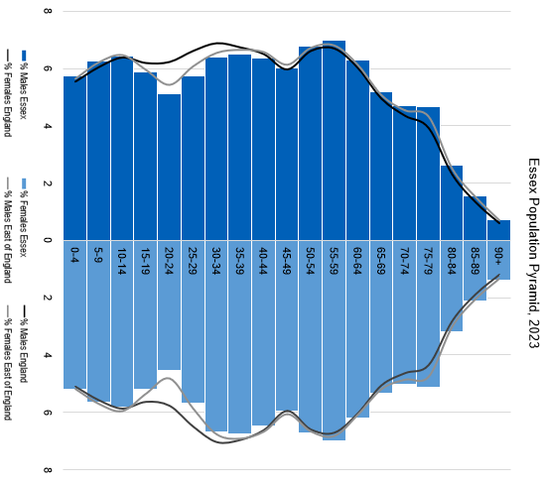
Table 2 Population count for Essex and each Essex District
Area | Under 16 years | 16 to 64 years | 65+ years | Total Population (2023)
Essex | 287450 | 928391 | 320277 | 1536118
Basildon | 39778 | 118227 | 32539 | 190544
Braintree | 29366 | 97337 | 33254 | 159957
Brentwood | 14790 | 47480 | 15882 | 78152
Castle Point | 15378 | 51407 | 23073 | 89858
Chelmsford | 35066 | 114248 | 35964 | 185278
Colchester | 37625 | 124106 | 35267 | 196998
Epping Forest | 25289 | 83536 | 27150 | 135975
Harlow | 21291 | 60777 | 13972 | 96040
Maldon | 11121 | 39659 | 17547 | 68327
Rochford | 15498 | 52180 | 20510 | 88188
Tendring | 24316 | 83518 | 45373 | 153207
Uttlesford | 17932 | 55916 | 19746 | 93594

Figure 2 Essex population pyramid, 2023

The population in Essex is projected to increase over the next 3, 5 and 10 years. Compared to 2023 mid-year estimates, ONS project that the total population size of Essex is going to increase by 2.7% to 1,550,879 people in 2026, by 3.8% to 1,566,135 in 2028, and by 6.1% to 1,601,083 in 2033.

The older age groups, especially from 80+ years, are projected to see largest increases over the next 5 and 10 years, whilst many of the largest decreases are projected in younger age groups, particularly working ages 25-39 and 50-59 years.

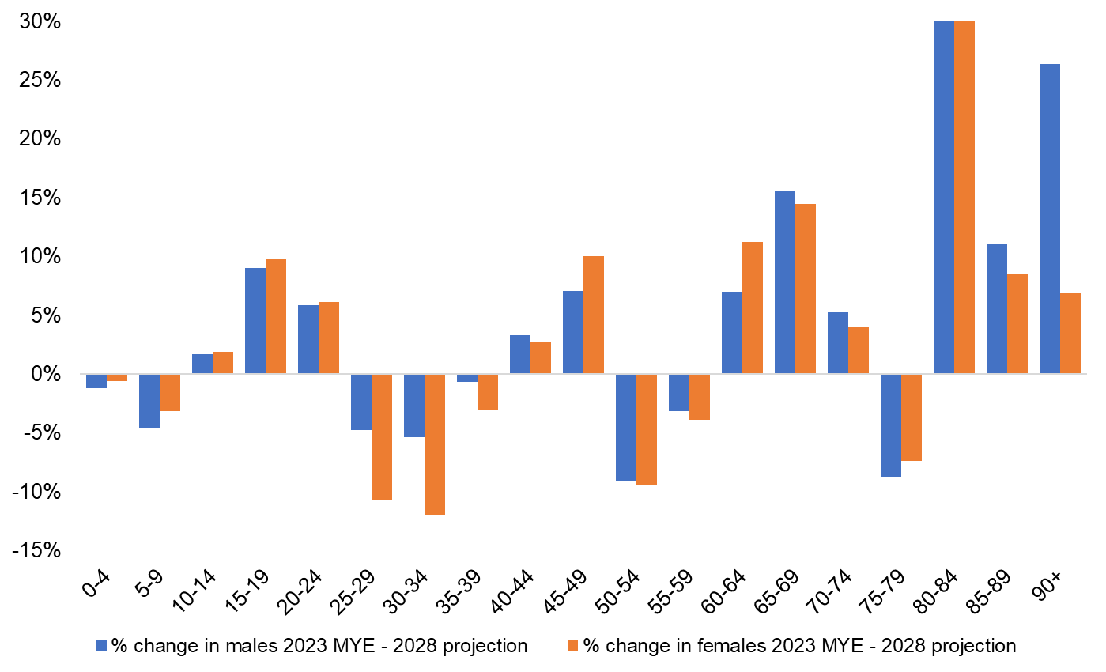
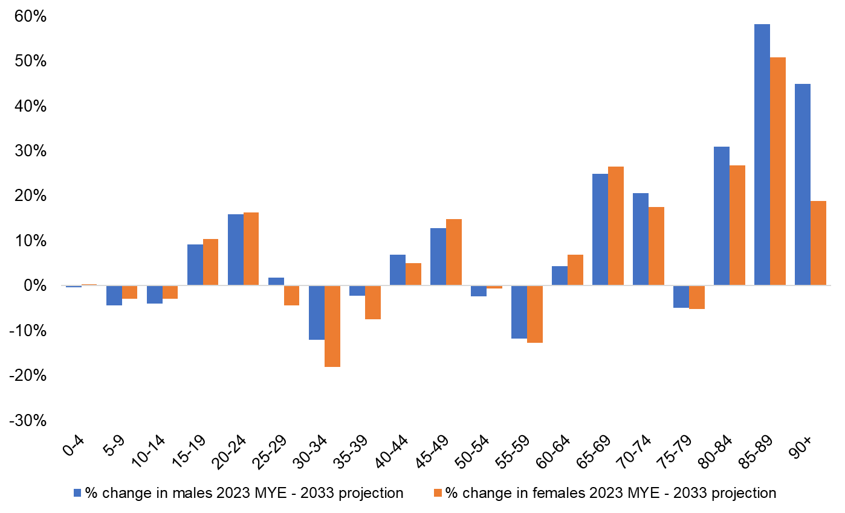

Figure 3 above shows the Essex projected population change in the next 5 and 10 years by age (%)

Table 3 below provides the Essex population current count and projections by 5-year age band
Age Group | 2023 | 2026 | 2028 | 2033
0-4 | 83715 | 82,769 | 82,933 | 83,695
5-9 | 91209 | 89,089 | 87,623 | 87,823
10-14 | 93886 | 96,572 | 95,551 | 90,614
15-19 | 85052 | 90,178 | 93,035 | 93,336
20-24 | 74063 | 74,372 | 78,480 | 85,966
25-29 | 87847 | 84,206 | 81,026 | 86,684
30-34 | 100484 | 92,337 | 91,554 | 85,185
35-39 | 101996 | 100,331 | 100,042 | 96,948
40-44 | 98677 | 98,686 | 101,641 | 104,464
45-49 | 92113 | 96,177 | 99,974 | 104,814
50-54 | 103575 | 97,292 | 93,969 | 102,063
55-59 | 107271 | 106,430 | 103,471 | 94,118
60-64 | 95953 | 102,781 | 104,722 | 101,377
65-69 | 80925 | 88,042 | 93,052 | 101,776
70-74 | 74873 | 75,729 | 78,307 | 89,094
75-79 | 75283 | 76,534 | 69,252 | 71,459
80-84 | 44751 | 52,835 | 62,213 | 57,545
85-89 | 28333 | 29,173 | 31,037 | 43,594
90+ | 16112 | 17,343 | 18,251 | 20,529
Total Population | 1536118 | 1,550,879 | 1,566,135 | 1,601,083

4.1.1 Birth Rate
Fertility Rate
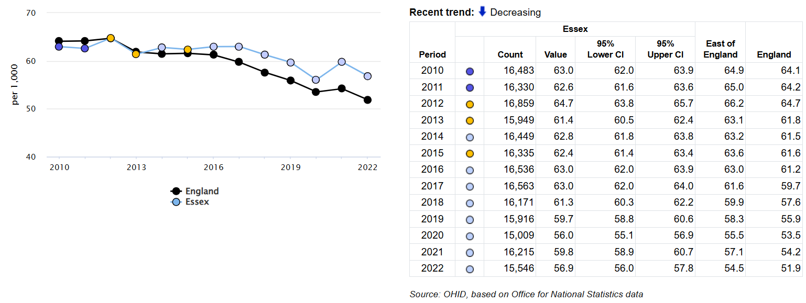
Figure 4 General Fertility rate Essex – per 1,000 female population

- The birth rate per 1,000 female population aged 15 to 44 years in Essex for 2022 was 56.9. Essex had generally trended below or similar to the average for the Region but has in recent years fallen at a slower rate than the National average, meaning Essex has been higher than the National and Regional average for general fertility rate since 2016.

4.1.2 Ethnicity
- The population of Essex is less ethnically diverse than the Eastern region and England. White British makes up 85.1% of the Essex population, compared to 73.5% Nationally. The most diverse area in Essex is Harlow, with 27.1% of the population of any other ethnicity to White British, in contrast to the least diverse area in Essex at 6% in Maldon.
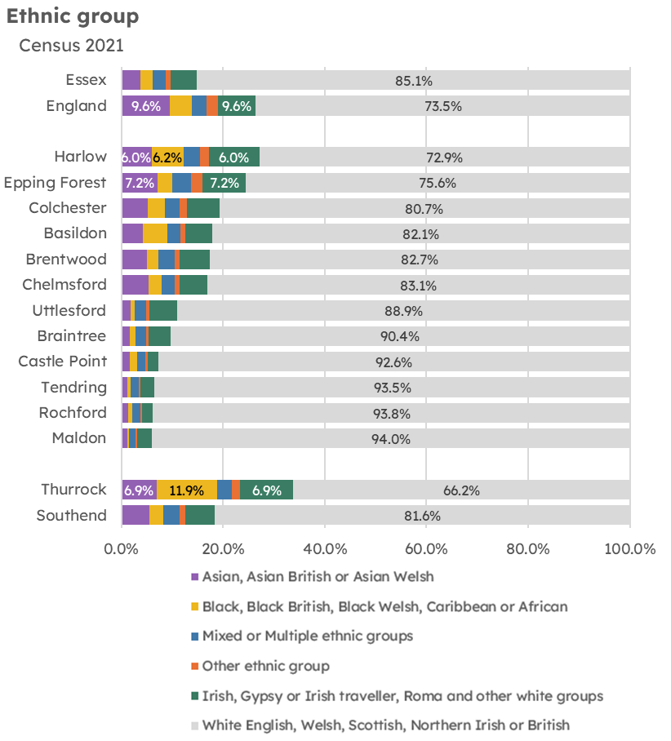
Figure 5 Essex local authority populations by ethnic group

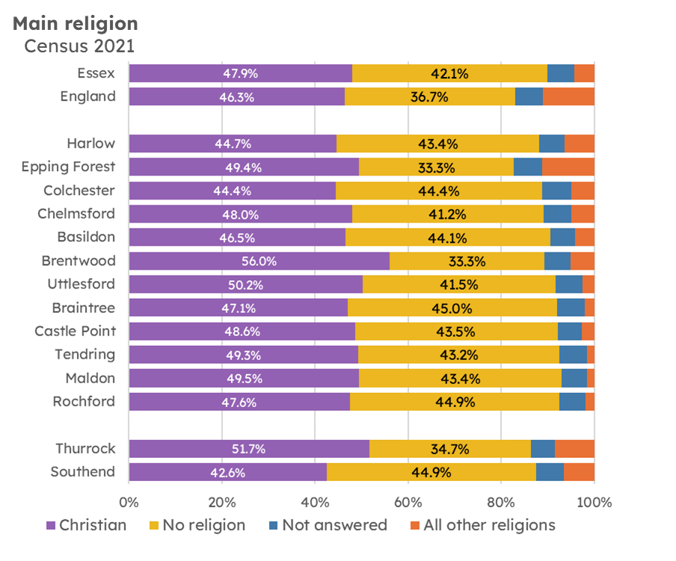
4.1.3 Religion
Figure 6 Essex local authority populations by religion

Christianity is the most common religion in Essex, 47.9% of residents listed Christianity as their main religion, with a further 42.1% of the population declaring ‘no religious belief’ and 5.7% having not declaring a religion. The remaining 4.3% of the population stating another religion is lower than that Nationally. The two largest religious groups by local authority are found in Harlow and Epping Forest.

4.1.4 Protected Characteristics
The above demographic areas (age, sex, pregnancy, ethnicity and religious belief) form part of the ‘protected characteristics’ which are safe guarded in law against discrimination. The full list includes:
- Age
- Sex
- Being pregnant or having a child
- Race including colour, nationality, ethnic or national origin
- Religion, belief or lack of religion/belief
- Being or becoming a transsexual person
- Being married or in a civil partnership
- Disability
- Sexual orientation

Certain groups within and across these characteristics have an increased risk of discrimination and social exclusion, which can lead to poor health and social care outcomes.

Whilst data on some of these protected characteristics is available and presented in this PNA, not all areas have good quality local coverage. However, for those groups not explored in detail, no specific pharmaceutical needs have been identified and all available and planned services are deemed accessible to these groups and their needs can be met by provision of necessary services.

4.2 Deprivation

4.2.1 The Index of Multiple Deprivation (IMD)
The Index of Multiple Deprivation (IMD) is the official overall measure of relative deprivation experienced by people living in an area in England. It follows an established methodological framework in broadly defining deprivation to encompass a wide range of an individual’s living conditions. It is based on 39 separate indicators, organized across seven distinct domains of deprivation, such as income, housing, employment, crime and environment, as shown in the figure below.

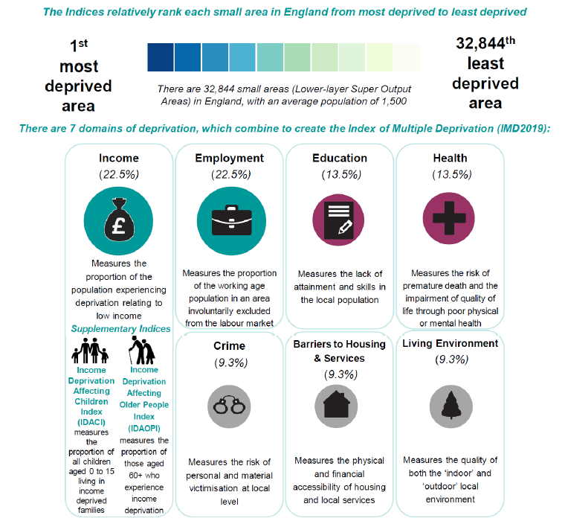
Figure 7 Index of Multiple Deprivation (IMD)

These are combined and weighted to calculate the IMD, calculated for every for every Lower-layer Super Output Area (LSOA)*, or neighbourhood, in England. This is a relative measure of deprivation rather than an absolute scale, so a neighbourhood ranked 100th is more deprived than a neighbourhood ranked 200th, but this does not mean that it is twice as deprived.

Essex has some of the least deprived and some of the most deprived areas in the country. Essex has 75 (out of 872) of its’ LSOAs that are among the top 20% most deprived areas nationally, and 225 of its’ LSOA among the top 20% least deprived areas nationally. The most deprived areas in Essex tend to be more focused in and around the larger towns, in condensed pockets and these are most common in Tendring (27 LSOAs), Basildon (26 LSOAs) and Colchester (11 LSOAs).

An area located in Tendring (in Jaywick; LSOA name: Tendring 018A) has been identified as the topmost deprived community across the whole of England. Tendring also has another LSOA (in Clacton-on-Sea; LSOA name: Tendring 016B) that has been identified as the 14th most deprived community across England.

The districts Uttlesford, Brentwood, Rochford and Chelmsford are considered less deprived, with, for example, 44 of the LSOAs in Chelmsford among 10% least deprived areas nationally.
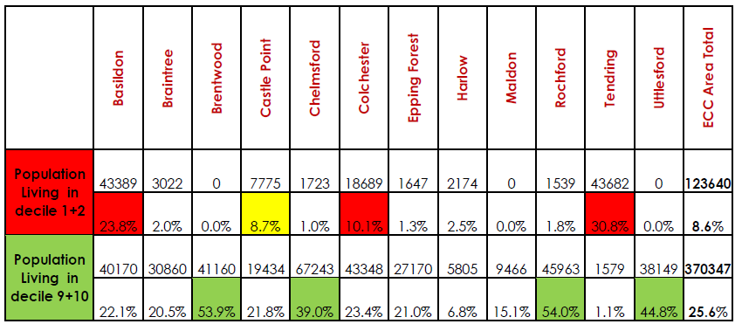
Figure 8 shows the population count and percentage living in the top 20% most deprived and top 20% least deprived areas nationally.

Many of the most deprived areas also experience the lowest levels of life expectancy, higher premature mortality rates, poor educational achievements including reaching a good level of development at reception, higher levels of teenage pregnancy, poor housing (including overcrowding and fuel poverty i.e. high proportional spending on heating their accommodation), and generally higher levels of social and health care needs, with for example higher prevalence of long term conditions than areas less deprived. More information can be explored in the Health Inequalities and Covid-19 Report and in the latest Joint Strategic Needs Assessment products available on https://data.essex.gov.uk/

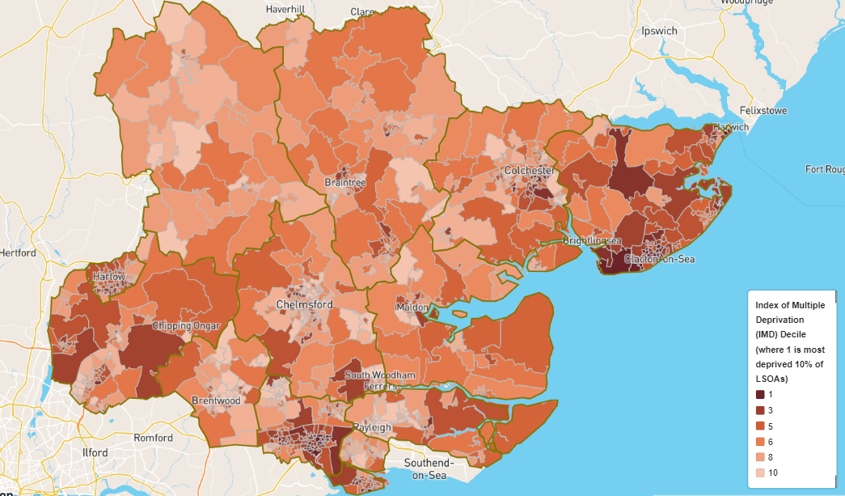
Figure 9 Indices of Multiple Deprivation (2019) across Essex
Figure 9 above shows areas of Essex by deprivation deciles from those in the most deprived areas (dark orange) to those in the least deprived areas (light orange). The places experiencing the greatest levels of deprivation include the Tendring, Basildon and Harlow districts. The least deprivation is experienced in Uttlesford, Brentwood, Chelmsford and Rochford.

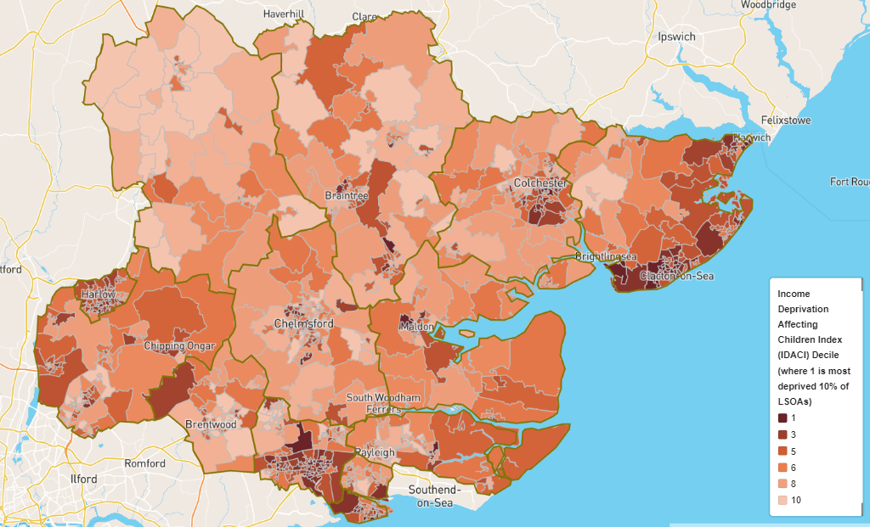
Figure 10 of Income deprivation affecting children across the Essex area (2019)
Figure 10 above displays areas in dark orange which have the greatest proportion of children aged 0-15 years old living in households which are deemed to have low incomes. The map shows that the areas with the highest concentration of children living in income deprived households are around Tendring and Basildon.

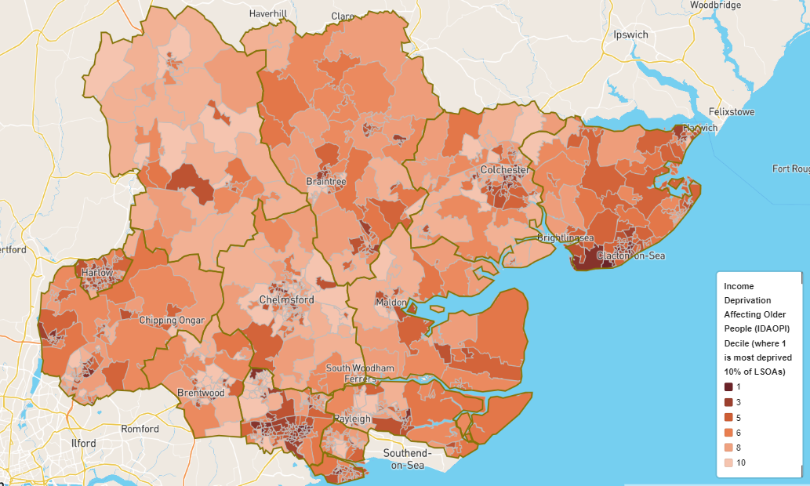
Figure 11 of Income deprivation affecting older people across the Essex area (2019)
Figure 11 above shows older people who are living in households who are experiencing income deprivation. Again, the highest concentration of low-income older people can be found in Basildon and Tendring.

There is a correlation between higher prevalence of long-term conditions and health inequalities (the unfair or avoidable differences in health status or health determinates between population groups). Access to community pharmacies within deprived communities is important to support their health needs. Commissioners can target specific disease areas particularly focusing in the areas of highest health need which generally follow the pattern of deprivation. Pharmacies in these areas should actively seek to promote health improvement and relevant services.

4.3 Lifestyles

4.3.1 Physical Activity
Physical activity can contribute significantly to people’s general physical health and wellbeing, reducing the risk of premature death from heart attacks, stroke and diabetes and improves mental health, reduces the risk of falls and protecting people from becoming overweight and obese.

The ability to keep active and independent depends greatly on mobility. Mobility can be seriously limited because of age, by the effects of falls and physical inactivity.

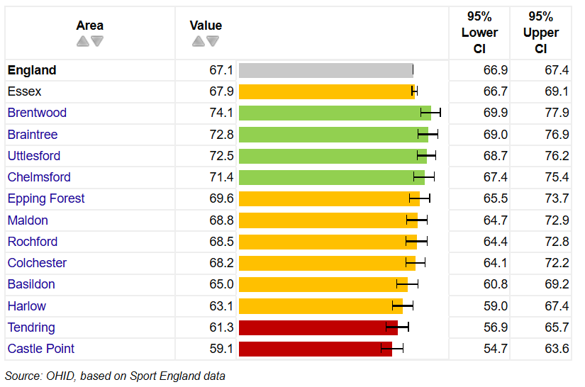
Figure 12 Percentage of adults doing 150+ minutes physical activity per week – 2022/23 in Essex local authority area

Although the percentage of adults in Essex meeting the recommended levels to benefit their health (150 minutes of moderate intensity physical activity per week) is just above the national average at 67.9%, there is some variation amongst the districts in Essex. Castle Point and Tendring districts have adult physical activity levels significantly lower than the national average (67%), with 59% and 61% respectively. Four districts had significantly higher percentage of physically active adults than the national average, highest in Brentwood (74%).

4.3.2 Nutrition, Diet and Obesity
Diet and nutrition are key contributors to the prevention of chronic ill health and to some extent social exclusion. The challenge of tackling obesity (increasing in prevalence) and associated chronic diseases means looking at this issue before the child is born right through to old age. A health, balance diet that includes fruits and vegetables, can contribute to reducing the risk of cardiovascular disease (CVD), obesity and some cancers.

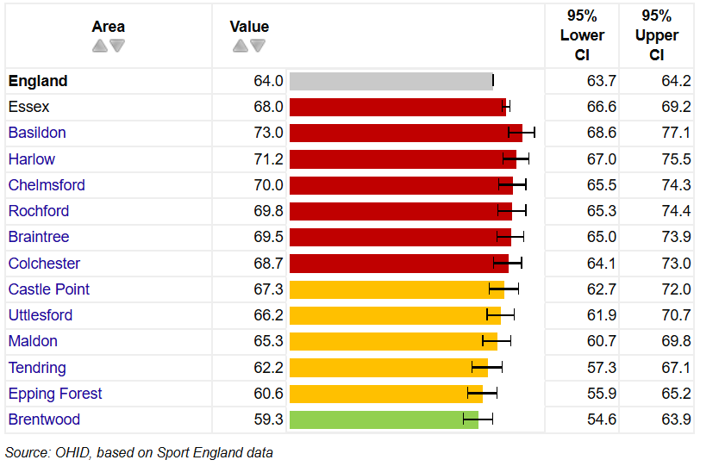
Figure 13 Percentage of adults classified as overweight or obese (18+) – 2022/23 in Essex local authority

In 2022/23, 68% of adults were classed as overweight or obese in Essex which is significantly higher than the national average of 64%. Half of the districts in Essex also have statistically greater prevalence of adults with excess weight than the national average, with only Brentwood significantly lower than national (59%).

4.3.3 Sexual health
Unprotected sex can lead to sexually transmitted diseases (STIs), unwanted pregnancy and preventable terminations. The health and social consequences associated with contracting STIs, such as human immunodeficiency virus (HIV), are enormous to the individual, their relatives and the health economy. HIV sufferers can feel excluded, and people are often so worried about stigmatisation that they avoid checking whether they may have contracted a STI following unprotected sex.

43.5% of people diagnosed with HIV in England are diagnosed late; this figure increases to 52.4% in Essex. All districts in Essex apart from Rochford, Epping Forest and Harlow have a higher level than the National average, with Uttlesford (75%), Colchester (62.5%) and Basildon (60%) the highest.

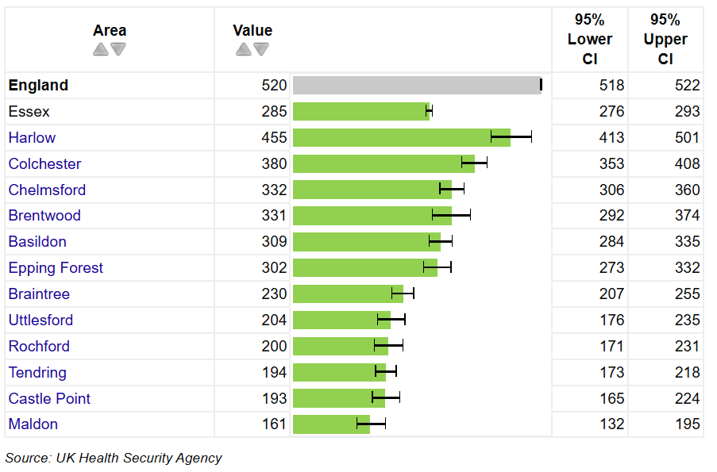
Figure 14 New STI diagnosis rate in Essex local authority area per 100,000 (aged <25) – 2023 (excluding Chlamydia)
Essex and all its districts have an STI diagnosis rate that has been trending lower than the national average. The under 18 conception rates (15–17-year-olds) are highest in Tendring (20.7), Castle Point (17.2), Harlow (16.7) and Basildon (15.1), with their rates are higher than England.

Good contraceptive services can keep the demand for terminations low and reduce the risk of teenage pregnancy.

4.3.4 Substance misuse
Substance misuse is the continued abuse of substances which has a detrimental effect on a person’s mental and physical health.

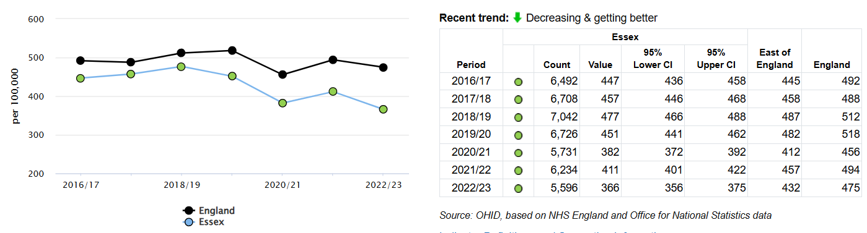
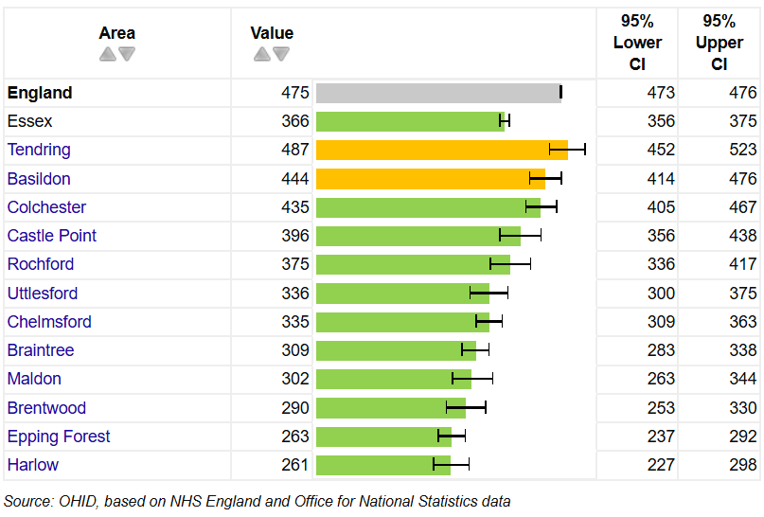

Figure 15 Admission episodes for alcohol related conditions (Narrow) – directly standardised rate per 100,000, 2022/23 and trends

Admissions to hospital where the primary diagnosis is an alcohol-attributable code, or a secondary diagnosis is an alcohol-attributable external cause code in Essex continue to be statistically significantly lower than the national average. Most (10) of the Essex districts had admission rates significantly lower than the national average in 2022/23, with highest rates across Essex in Basildon and Tendring, these are the only 2 Essex districts similar to the national average.

People who regularly binge drink (women who drink more than 6 units of alcohol a day (or more than 35 units a week) and men who regularly drink more than 8 units a day (or 50 units a week) are at the highest risk of alcohol related harm.

This behaviour increases the risk of CVD, cirrhosis, poor mental health, unemployment, accidental injury and death.

Women who drink heavily during pregnancy put their baby at risk and consequential disorders can lead to lifelong intellectual and behavioural problems for the child.

Early identification and referral of people with a drinking problem is important to slow down these gradual increases in morbidity, especially as it is estimated that only 13.2% of these people access an alcohol treatment programme annually.

Essex has introduced “DrinkCoach” which is a brief intervention tool available to all its residents. “DrinkCoach” allows you to work out what level of risk you are at as a result of your drinking, to access personalised advice online and, where appropriate, find out where you can get face-to-face support locally.

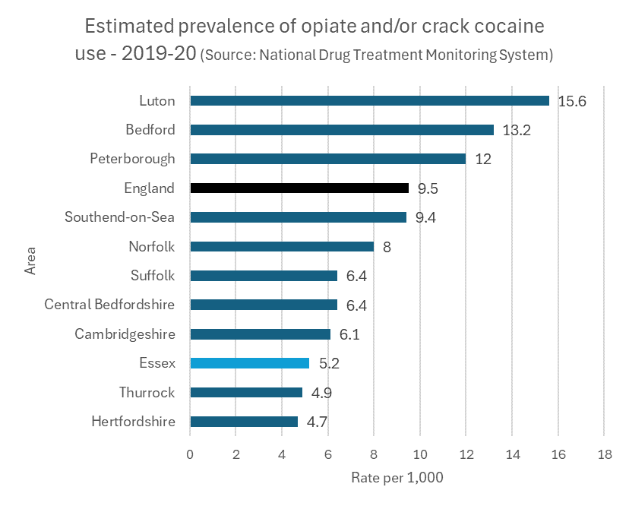
Figure 16 Estimated prevalence of opiate and/or crack cocaine use in Essex local authority area – per 1,000 – 2019-20

Use of Illicit drugs in Essex, as measured by opiate and crack cocaine, is lower than the national average, at 5.2 per 1,000 of the 15–64-year-old population it ranks as 3rd lowest in the region.

Those experiencing issues with substance misuse are more likely to be experiencing a range of health-related issues and may be linked to a number of services such as Mental Health, Primary Care and other non-medical service provision.

4.3.5 Smoking
Smoking is the UK’s single greatest cause of preventable illness and early death.
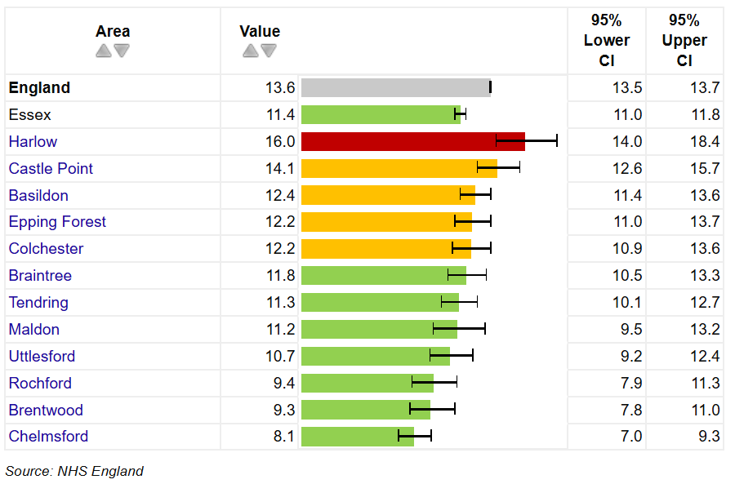
Figure 17 Smoking Prevalence in adults (18+) in Essex local authority area- current smokers (GPPS) 2022/23 – Proportion %

The GP Patient survey (2022/23) recorded 11.4% of Essex resident responders as current smokers, lower than the national average. All but 2 of the districts in Essex have rates lower than England. Harlow and Castle Point, with 16% and 14.1% respectively are the districts above the National average of 13.6%. It is important to consider these results in the context of these figures being based on survey responses e.g., the number of responses received per district.

Smoking in pregnancy is associated with poor pregnancy outcomes, and exposure of infants to second-hand smoke is associated with death in infancy. Smoking is more common in more deprived women. The variation in smoking habits in pregnancy between socioeconomic groups accounts for about one third of the difference in stillbirth rates and infant mortality rates.

The smoking cessation services from pharmacies provide one to one support and advice to people who want to give up smoking. The pharmacy service helps to increase choice and improve access to NHS Stop Smoking Services.

The pharmacy facilitates access to, and where appropriate, supply of pharmacological and non-pharmacological stop smoking aids.

4.3.6 Lifestyles and the PNA
Lifestyle factors have a recognised effect on health. Smoking, drinking at harmful levels and obesity can all lead to long term conditions. Community pharmacy is well placed to provide accessible screening services, support patients at earlier stages and provide interventions that will reduce the burden of these conditions on the person and health and social care services.

Pre-birth to five are considered key developmental years for a child’s health and wellbeing habits and foundations. Parental and in particular maternal characteristics and behaviour during pre-conception, the antenatal period and post birth play key roles in the child’s development alongside the general wider determinants of health such as family income, access to health care interventions such as immunisations and access to early education.

A number of national screening and assessment programmes are in place to support the early identification of health and social care needs. In the past 2 to 3 years a number of new schemes have been implemented across Essex which will specifically target risk factors associated with health inequalities.

Essex County Council commissions a local Health Check programme (NHS Health check), primarily through GP services and some pharmacies. This programme helps identify people at risk of conditions, such as diabetes and CVD but will also help identify those who need to be encouraged to lead a healthier lifestyle. In areas, where uptake to the checks has been low, especially with hard-to-reach groups, external providers have been commissioned including community pharmacies.

A more comprehensive alcohol pathway is developed across Essex to ensure that we can identify people who are dependent drinkers as well as consuming harmful levels of alcohol and signpost them to services to help them. The “DrinkCoach” service is available across Essex, with additional liaison nurses based in acute hospitals to provide timely assessment of people at risk of alcohol abuse.

Implementing broad lifestyle interventions aimed at supporting people to make healthier choices is important in tackling the gap in health inequalities.

Targeted social marketing is used to improve health and social wellbeing and reduce stigma (e.g., promoting the uptake of Chlamydia screening is helping to de-stigmatise perceptions about STIs).

Early interventions with medicines and their appropriate use for those patients diagnosed with long term conditions can also prevent further deterioration.

A number of well-established national public health strategies are in place for the surveillance, prevention and control of infectious diseases. Currently of particular interest in infectious disease control, vaccinations, hospital acquired infections (such as MRSA), the increase in Blood Borne diseases (such as Hepatitis B/C and HIV) and the increase of certain infections (for example, Tuberculosis and Measles).

Preventing the spread of these diseases is of paramount importance as the outcome of contracting them may shorten life.

A number of immunisation programmes are in place to ensure that the population acquire a good level of immunity from childhood into older age.

The provision of targeted specialist services, Hepatitis B/C vaccination via drug services and the Needle and Syringe Programme (NSP), is helping to prevent the spread of Blood Borne Viruses (BBV).

4.4 Education
Educational qualifications is a significant predictor of wellbeing in adult life; determining labour market position, income, housing and other material resources. Educational attainment is influenced by both the quality of education and family socio-economic circumstances.

4.4.1 GCSE attainment
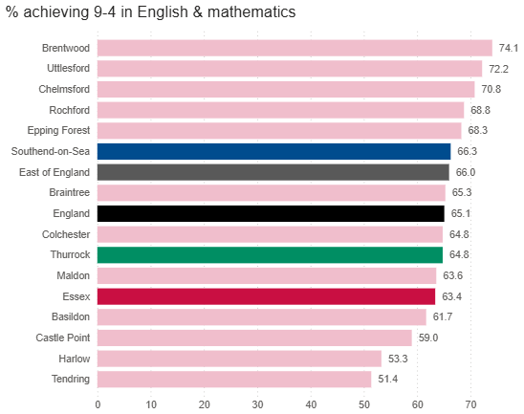
Figure 18 District level variation in the percentage of children achieving 9-4 in English and Maths at GCSE across Essex local authority area
The percentage of pupils achieving 9-4 in English and Maths at GSCE was lowest in Tendring in 2022/23 at 51.4%. The highest attainment levels were in Brentwood at 74.1%. Looking at trends, the previous 2 years has seen Essex decrease overall, from 71.5% in 2020/21 to 63.4% in 2022/23, below the Region and National averages. Attainment levels were higher than the Region and National averages in 5 Essex districts, Brentwood, Uttlesford, Chelmsford, Rochford and Epping Forest.

More information on education and skills across Essex can be explored in the latest Joint Strategic Needs Assessment products available on https://data.essex.gov.uk/

4.5 Employment
Work and income are two of the most important determinants of health and wellbeing. Evidence suggests that (good, healthy and safe) work has beneficial long-term physical and mental health effects, and correlates positively with higher healthy life expectancy rates. The quality of available work can also play a part in health outcomes both physically and mentally.

Unemployment is consistently seen to have a negative effect on a range of physical and mental health and wellbeing outcomes, including through increased stress and reduced self-esteem, and as a result of financial hardship and insecurity. Furthermore, the health consequences of unemployment have been shown to increase with duration – for mental health and life satisfaction as well as for physical health – and commonly extend beyond the individual to impact on family units.

4.5.1 Unemployment
Percentage of the economically active population aged 16+ without a job who were available to start work and were seeking employment (Q3 2024)

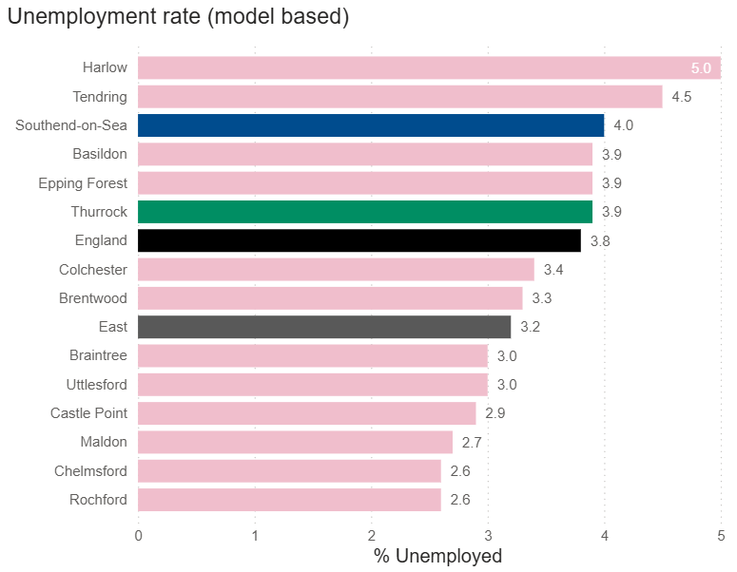
Figure 19 Number of people who are unemployed using the International Labour Organisation definition
In Q3 2024, the proportion of working-age residents in Essex who were unemployed varied through the districts, with 6 districts having a higher proportion unemployed that the Region and 4 above the National average, with Harlow (5%) ranking highest. Rochford and Chelmsford with 2.6% of the working age population unemployed represent the lowest of the districts.

Socioeconomic groups
NOMIS provides further information on employment with the ‘Standard Occupational Classification SOC 2020’. This shows that the overall majority of people in Essex (54.9%) are employed in the SOC Major Group 1-3, which are occupations classified as Managers, Directors and Senior officials, or Professional occupations or Associate Professional &Technical. This is slightly above England (53.2%). The smallest proportion of people in Essex work in SOC Major Group 8-9 (10.7%), which are Process Plant & Machine Operative or Elementary Occupations. This is lower than is seen in England (14.2%).
More information on employment across Essex can be explored in the latest Joint Strategic Needs Assessment products available on https://data.essex.gov.uk/

4.6 Housing

4.6.1 Fuel poverty
The Low-Income Low Energy Efficiency (LILEE) indicator considers a household to be fuel poor if:
- It is living in a property with an energy efficiency rating of band D, E, F or G; and
- Its disposable income (income after housing costs and energy needs) would be below the poverty line (defined as an equivalised disposable income of less than 60% of the national median).
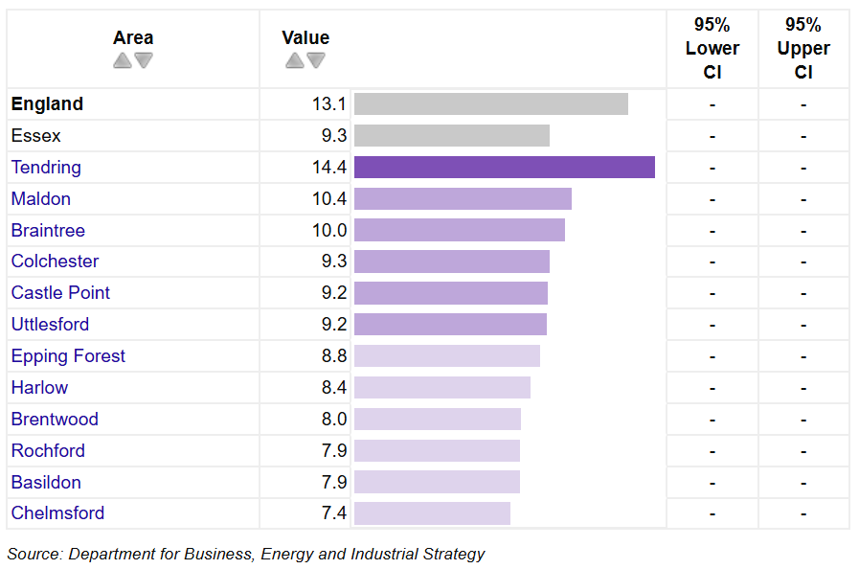
Figure 20 Proportion of fuel poor households in Essex local authority area (2022)

Although the proportion of fuel poor households in Essex (9.3%) falls below the regional and national averages of 10% and 13.1%, 59,718 households in Essex were estimated to be in fuel poverty (based on 2022 data). This figure has decreased for the last 2 years, down from 72,075 (11.4%) in 2021.

Across Essex districts the proportion of households classified as fuel poor ranges from 7.4% in Chelmsford to 14.4% in Tendring.

4.6.2 Homelessness
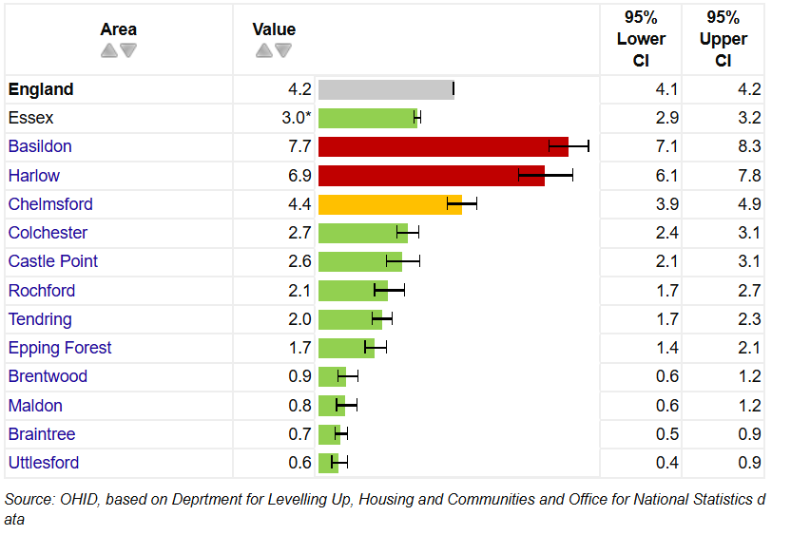
Figure 21 Homelessness: Households in temporary accommodation rate per 1,000 households 2022/23 in Essex local authority area
Essex has a rate of homelessness that is lower than the national average at 3 per 1,000 in 2022/23. However, there is variation amongst the districts in Essex. Basildon and Harlow are the only Essex districts with a statistically greater rate of homelessness the national average at 7.7 and 6.9 per 1,000, respectively. All other districts are similar to (1 district) or significantly lower (9 districts) than the national average, with the lowest rates in Braintree and Uttlesford.

More information on housing across Essex can be explored in the latest Joint Strategic Needs Assessment products available on https://data.essex.gov.uk/

4.7 Transport

4.7.1 Car ownership
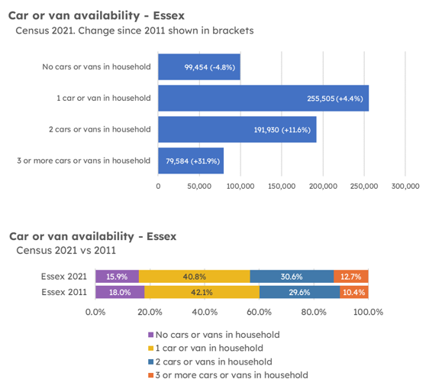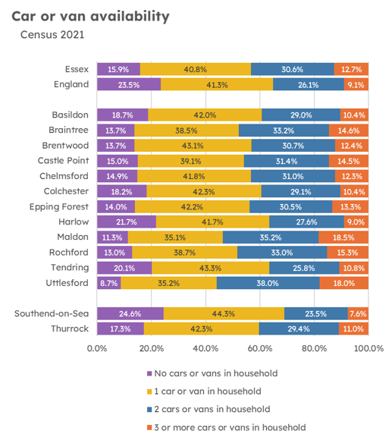
Figure 22 Households with car or van availability by Essex local authority area
Between 2011 and 2021, the number of households in Essex without a car fell by 4.8% (5,068) to just under 100,000. Since 2011 therefore, the overall proportion of households without a car has declined from 18.0% to 15.9% in 2021.

Harlow with 21.7% of households with no cars or vans in the household is the highest in the County. It is worth noting that Harlow the smallest Essex local authority in geographical terms, residents may rely more on other forms of transport to access local services.
The Tendring district has the second largest percentage of households without a car or van (20.1%), with Tendring being a largely rural district area this may cause problems with accessing services. The Essex average at 15.9% of households is lower than the national percentage of 23.5%.

4.7.2 Access to Services and Transport
Access to services, regardless of the purpose (e.g., to work, hospital, educational establishment, recreational activities), is closely linked to transportation. The chosen modes of travel (walking, cycling or motorised) can vary according to people’s means (can they afford a car or bus fare), their personal mobility (are they able to walk or cycle) and the availability of public or alternative transport. It is also important to note that lack of transport may not always be a factor in addressing inequity in access to services, as issues such as homelessness and lack of information also have an effect.

4.7.3 Impact on Community Health and Wellbeing
People have become more dependent on the use of private cars for their journeys, including short ones, instead of walking or cycling to their chosen destination, thus contributing to a reduction in physical activity.

Transport links have an effect on access to healthcare. For people that have problems with access to reliable transport, some community pharmacies provide a voluntary delivery services and distance selling pharmacies increase choice and access for patients.

It has been shown that there is access to a pharmacy or dispensing doctor within 20 minutes of a car drive across Essex. Most journeys to a pharmacy take significantly less than 20 minutes (99.9% by driving).

From the patient/resident survey, 60% of responses said they travelled to their pharmacy by car, 51% on foot, 5% by bicycle, 3% by public transport, and 1% by taxi. Most said it takes less than 20 minutes to travel to a pharmacy.

4.8 Health

4.8.1 Life expectancy
Data on years of life lost show that for males the main causes of premature death are coronary heart disease, lung cancer and stroke and for females it is breast cancer, lung cancer and coronary heart disease.

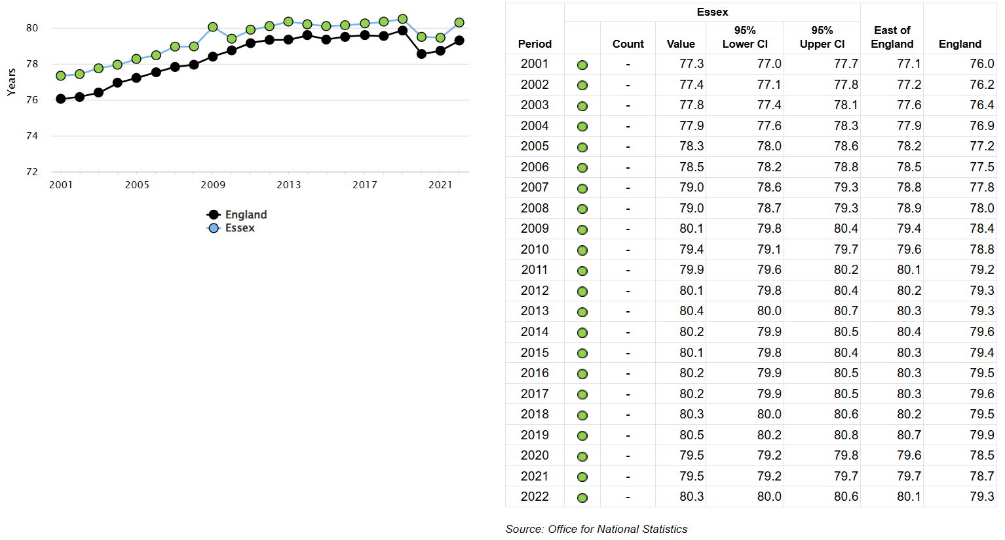
Figure 2323 Trend in life expectancy from birth, males – Essex
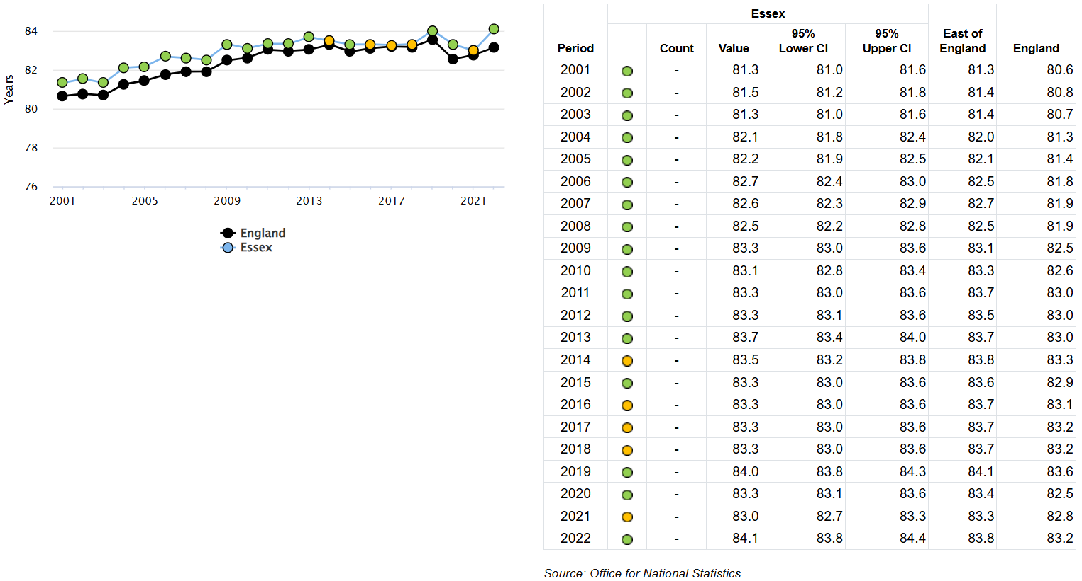
Figure 24 Trend in life expectancy from birth, females – Essex

Overall, life expectancy for males in Essex had been slightly increasing until 2020 and 2021, which saw small decreases, likely to be influenced mainly by Covid-19, returning to a more expected level in 2022, remaining above the national average. Life expectancy for females had been steady or increasing and was above the national average and slightly below the region, but followed a similar dip in 2020 and 2021, returning to the expected levels in 2022. For both males and females Tendring has the worst life expectancy in Essex at 77.4 and 82.5 years respectively. The greatest life expectancy for both males and females is seen for residents of Uttlesford at 83 years and 86.6 years respectively.

4.8.2 Disability
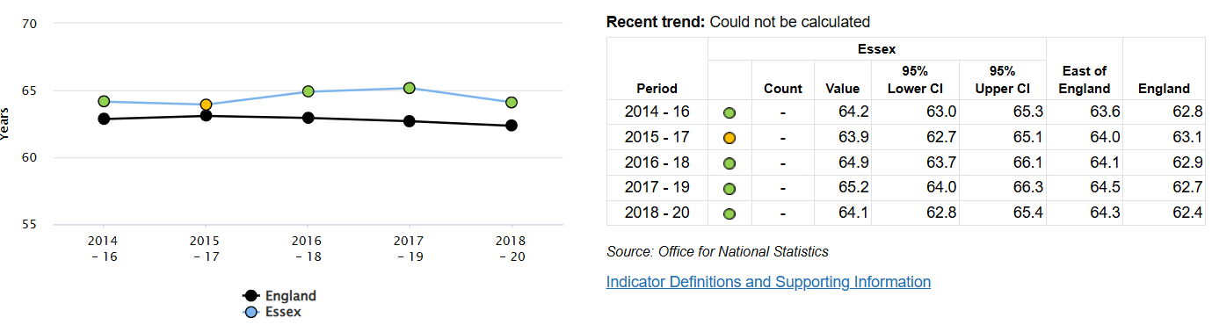

Figure 25 Disability-free life expectancy at birth, males
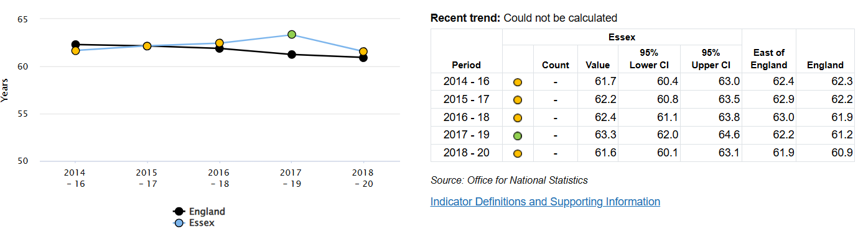
Figure 26 Disability-free life expectancy at birth, females
The average numbers of years from birth that people in Essex could expect to live without a long lasting, physical or mental health condition that limits daily activities had been steadily increasing for both males and females, however both saw decreases in the latest time-period 2018-20, whilst both remain above the national level, this is just below regional.

4.8.3 Carers
Pharmacies must comply with the Equality Act 2010. Support for patients can include, amongst other interventions, large print labels on medicines, provision of easy open containers and reminder charts to take medicines.

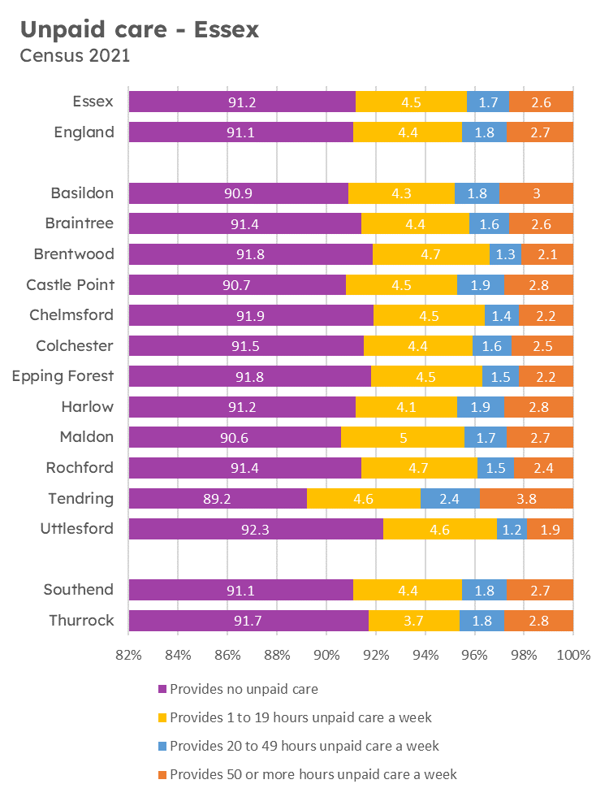
Figure 27 Provision of unpaid care across Essex and districts, 2021
Compared with England overall the proportion of Essex residents providing unpaid care (8.8%) is less than the England average (8.9%). Tendring has the highest proportion residents providing unpaid care (care provided to anyone because they have long-term physical or mental health conditions or illnesses, or problems related to old age, 11%), followed by Maldon and Castle Point (both 9%). Across the Essex area around 5% of the population provide 1 to 19 hours per week of unpaid care, ranging from 4-5% across Essex districts (highest in Maldon). For those providing 50 or more hours per week, the average across Essex is 3% with a range of 2% (Uttlesford) - 4% (Tendring).

4.8.4 Disease prevalence
It is important that pharmacists can recognise symptoms of a notifiable disease in order to appropriately refer patients who may present for advice and treatment. They should understand how an outbreak is being managed to be able to offer appropriate advice and reassurance to the public.

Community pharmacies provide services which are easy to get to and are accessible in terms of location, opening hours and waiting times, this mean that people will be more likely to attend.

Most pharmacies across Essex provide sexual health services and many are providing vaccinations contributing to health protection outcomes.

Meeting the needs of specific populations
Table 4 Supporting the needs of specific populations
Protected Characteristic | How pharmacy can support the specific population
Age | - Age has an influence on which medicine and method of delivery is prescribed.  - Older people have a higher prevalence of illness and take many medicines. The medicines management of older people is complicated by multiple disease; complex medication regimes and the aging process affecting the body’s capacity to metabolise and eliminate medicines from it.  - Community pharmacies can support people to live independently by supporting optimisation of use of medicines, support with ordering, re-ordering medicines, home delivery to the housebound and appropriate provision of multi-compartment compliance aids and other interventions such as reminder charts to help people to take their medicines.  - Supporting independence by offering:  - Reablement services following discharge from hospital  - Falls assessments  - Supply of daily living aids  - Identifying emerging problems with people’s health  - Signposting to additional support and resources  - Younger people similarly have different abilities to metabolise and eliminate medicines from their bodies.  - Advice can be given to parents on the optimal way to use the medicine and appliance and provide explanations on the variety of ways available to deliver medicines.  - Pharmacy staff provide broader advice when appropriate to the patient or carer on the medicine, for example its possible side effects and significant interactions with other substances.  - The safe use of medicines for children and older people is one where pharmacies play an essential role.
Disability | - Pharmacies deliver services in line with the Equality Act 2010.  - It is recognised that there may be a variety of reasons why people are unable to take their medicines, including both physical and mental impairment.  - Each pharmacy should have a robust system for assessment and auxiliary aid supply that adheres to clinical governance principles.  - Availability of large print labels, hearing loop, supply of original packs with braille are all examples of support that can be available where appropriate.
Sex | - It is recognised that men are often less likely to access healthcare services. Community pharmacies are ideally placed for self-care by providing advice and support for people to derive maximum benefit from caring for themselves or their families.  - When necessary, the access to advice, provision of over-the-counter medications and signposting to other services is available as a walk-in service without the need for an appointment.  - Community pharmacy is a socially inclusive healthcare service providing a convenient and less formal environment for those who do not choose to access other kinds of health service.
Race | - Language can be a barrier to delivering effective advice on medicines, health promotion and public health interventions.  - There are opportunities to access translation services that should be used when considered necessary.
Religion | - Pharmacies can provide advice to specific religious groups on medicines derived from animal sources and during periods of fasting.
Pregnancy and maternity | - Pharmacies can provide advice to pregnant mothers on medicines and self-care. They have the expertise on advising on which medicines are safe for use in pregnancy and during breast feeding.
Sexual orientation | - No specific needs are identified
Gender reassignment | - Provision of necessary medicines and advice on adherence and side effects
Marriage and civil partnership | - No specific needs are identified

Chapter 5. The Assessment

5.1 The assessment of pharmaceutical services
The assessment was undertaken with due consideration of the requirements in the NHS (Pharmaceutical and Local Pharmaceutical Services) Regulations 2013, as amended and a variety of data sources.

5.2 Pharmaceutical services in Essex
Table 5 Numbers of providers of pharmaceutical services in the Essex HWB area by locality as of December 2024
Locality |  | Type Of Pharmaceutical Contract
 |  | Total Number of Community Pharmacies:  230 across Essex | Dispensing Doctor | Dispensing Appliance Contractor | Distance Selling Pharmacy
 |  | All Pharmacies including 100 Hour | Dispensing Doctor | Dispensing Appliance Contractor | Distance Selling Pharmacy
1 | Basildon | 33 | 0 | 0 | 0
2 | Braintree | 22 | 7 | 0 | 0
3 | Brentwood | 12 | 2 | 0 | 1
4 | Castle Point | 16 | 0 | 1 | 0
5 | Chelmsford | 23 | 7 | 1 | 0
6 | Colchester | 30 | 5 | 1 | 1
7 | Epping Forest | 21 | 1 | 0 | 1
8 | Harlow | 12 | 0 | 0 | 2
9 | Maldon | 10 | 7 | 0 | 1
10 | Rochford | 15 | 2 | 1 | 0
11 | Tendring | 28 | 8 | 0 | 0
12 | Uttlesford | 8 | 8 | 1 | 0
TOTAL |  | 230 | 47 | 5 | 6

5.2.1 Community Pharmacies
A full list of community pharmacies providing services under the Regulations across the Essex HWB area is provided in Appendix C.

5.2.2 Dispensing Appliance Contractors (DACs) registered in the Essex HWB area as of December 2024:
- Fittleworth Medical Limited, D41-42 Moorside Business, Eastgates, Colchester, CO1 2ZF
- Jade-Euro-Med 14, Hanningfield Ind Est, Old Church Road, East Hanningfield, CM3 8AB
- Patient Choice Ltd, 102 Main Road, Hockley, SS5 4QS
- Rocialle Direct, 72 Furtherwick Road, Canvey Island, SS8 7AJ
- Independence Products Ltd, Suite 16, 3rd Floor, Endeavour House, Coopers End Road, Stansted, CM24 1SJ

5.2.3 Distance selling Pharmacies (DSPs) registered in the Essex HWB area as of December 2024:
- Lloyds Pharmacy Healthcare, Unit 4, Scimitar Park, Roydon Road, Harlow CM19 5GU
- Total Medcare Limited, Unit 1 Knight House, Lenthall Road, Loughton IG10 3UD
- Wel Pharm Ltd, 4 Phoenix Court, Hawkins Road, Colchester CO2 8JY
- Greenway, Promising Healthcare, Unit 78 Greenway Business Centre, Harlow CM19 5QE
- SimplyMeds Online, Unit K2, Beckingham Business Park, Tolleshunt Major, Maldon CM9 8LZ
- Medplus, Unit 5, Upminster Trading Park, Warley St, Great Warley RM14 3PJ Upminster

5.3 Locality of services
As of December 2024, there are 230 pharmacies (not including Southend & Thurrock) spread across the Essex HWB area (including 6 DSPs), as shown below. A map of pharmacy locations is also provided in each locality section.

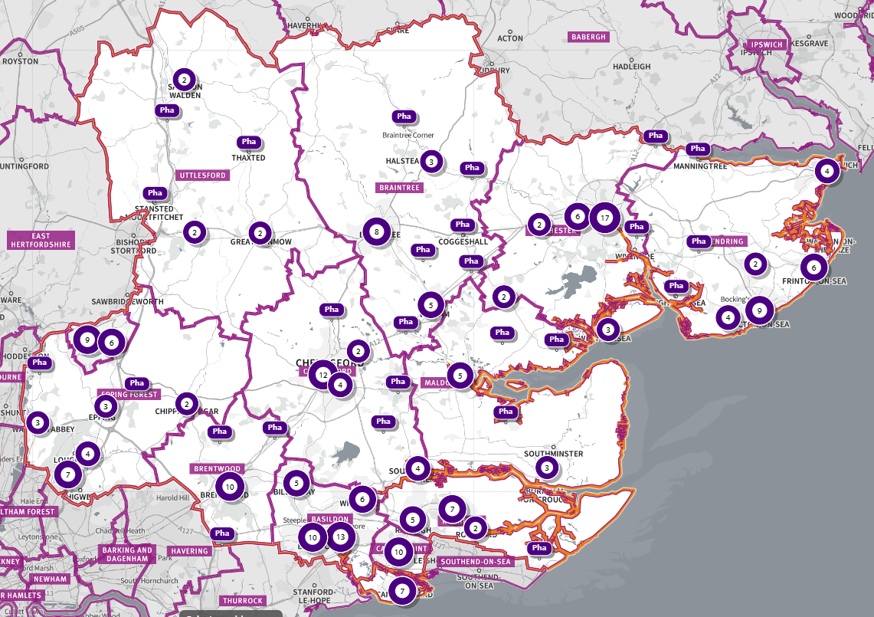
Source: Shape Place Atlas (as at 07/03/25)
Figure 28 Pharmacy locations across Essex
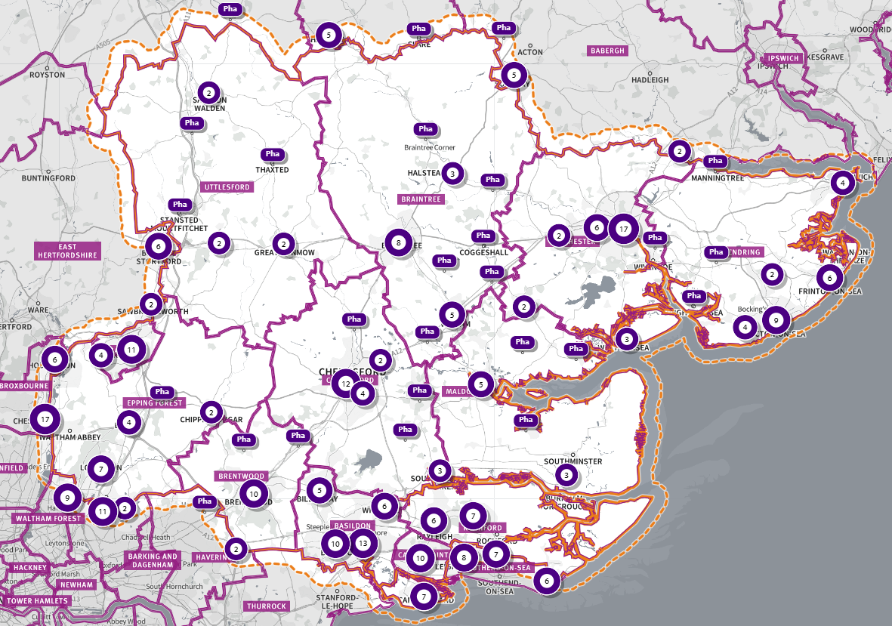
Source: SHAPE Place Atlas (as at 07/03/25)
Figure 29 Map showing pharmacies in and within a 1.6km buffer zone of the Essex HWB boundary, 322 pharmacies
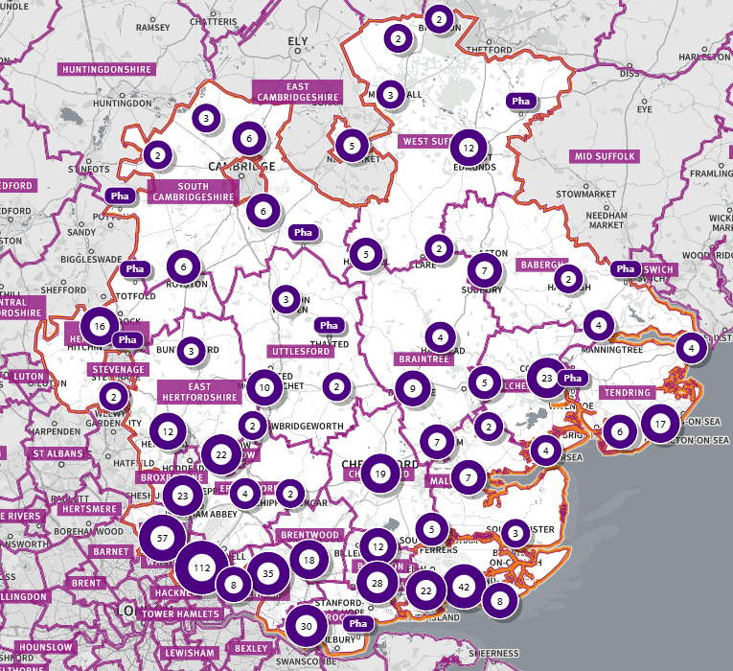
Source: SHAPE Place Atlas (07/03/2025)
Figure 30 Map showing Essex LAs & Neighbouring Local Authorities, Pharmacies only – 664 in total

Analysis from the public survey undertaken (Appendix E) shows that:
- There were 164 respondents to the public survey
- 91% of respondents report usually using a pharmacy to get medicine on prescription, 59% to buy medicine from the pharmacy, 40% to get advice from the pharmacy.
- With regards to frequency of pharmacy use, the majority of respondents usually visit pharmacies monthly (62%) and during the regular weekday business hours (between 9am and 5pm) (43%).
- Regarding the services that pharmacies might provide, most respondents are aware of buying over the counter medicine, dispensing medicines on prescription and dispensing services. On the other hand, 63% of participants were not aware of sexual health services, appliance use review (79%), immediate access to specialist drugs (87%) and stoma appliance customisation service (93%).
- Alongside dispensing medicines on prescription, participants also valued being able to receive personalised advice from their pharmacist.
- Regarding the most convenient day to use the pharmacy, respondents seem not to have a preferred day; 60% reported 'no particular day', followed by 'weekday' (Monday to Friday) (26%) and on 'Saturday' or ‘Sunday’ (14%).
- Of those replying to the survey, 82% have a reasonable distance to travel to the pharmacy equating to less than 20 minutes, 12% had travelled between 20 and 30 minutes, and 4% had travelled between 30-45 minutes. 60% made the trip by car, and 51% had travelled on foot—only 3% used public transport and 5% a bicycle.
- When asked what influenced their choice to visit a pharmacy, 91% of responders reported convenient location, 33% the opening hours, and 24% availability of medicines. Other things people said they consider included the availability of parking, quality of service, where their GP sends prescriptions, staff knowledge, helpfulness and friendliness.

5.4 Essential services
(As defined in Chapter 1 of this report)

5.4.1 Mandatory services
These are mandatory services within the pharmacy contractual framework and are monitored by the NHSE team. All NHS contracted pharmacy premises must provide these services so they can be used across the county to focus on supporting the local population to reduce health inequalities. Essential services are all considered to be necessary pharmaceutical services for our population.

5.4.2 Travel times

A travel time analysis was conducted specifically for pharmacies across Essex, full results are found in the Appendix F.

- The areas that see some of the longer travel times are relatively not that deprived.
- The longest times to travel by whatever method chosen are areas in IMD 2019 Deciles 3 – 10, with the highest being 27% of the Essex population in IMD Decile 6 (among 5th least deprived areas nationally) estimated to be over a 30-minute walk to a pharmacy.
- Longer travel times are mostly seen in areas classified as ‘Rural village and dispersed’. For example, 77% of the population in areas of this classification are over a 30-minute walk away and 28% over a 30-minute public transport journey away. Residents living in these areas would have similar travel times to access other key services.
- Overall, across Essex, generally residents are within a relatively short travel time whichever method is chosen – 99.9% of the Essex population could get to a pharmacy in a 20-minute drive, 93% a 30-minute public transport journey (Weekday Morning) or 82% within a 20-minute walk. Residents have to travel for longer if they choose to walk, 13% over 30-minute walk away.
- It is estimated that 1,518,041 individuals across Essex (99.9%) have access to one of 322 pharmacies across Essex and within a 1.6KM buffer zone around Essex within a 20-minute drive. This spans 902 of the LSOAs across Essex, as shown on the map below highlighted in green.
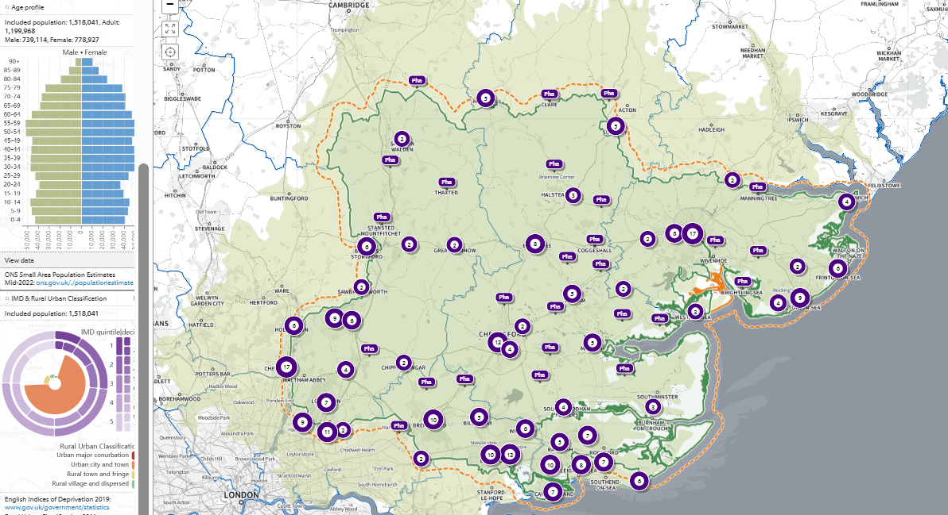
SHAPE Place • Car: by time • 0 locations • 5 to 30 minutes • 20 minutes visible • Included population
Figure 31 Access to pharmacies

All residents across all districts can drive to a pharmacy or dispensing doctor within 20 minutes, but for 1 LSOA in Colchester (1,466 people; LSOA code: E01021694, LSOA name: Colchester 019D). This LSOA is also over a 30 -minute walk to pharmacy or dispensing doctor. It is estimated this LSOA can reach a pharmacy via a 10-to-20-minute public transport journey.

This LSOA is a ‘rural village and dispersed’ area that faces geographical challenges for access to multiple services due to a tidal river that runs through Mersea, cutting off road access at certain times. This is in IMD Decile 5, amongst the 50% most deprived areas nationally.

5.4.3 The availability of choice
- Community pharmacies improve access to healthcare and increase the choice available to residents.
- Access to a greater range of services is generally available in urban areas and this applies to pharmaceutical services. All the large towns in Essex have more than one pharmacy in the town centre in addition to those in the surrounding suburbs.
- In rural areas, services and businesses are not always available in the immediate locality and public transport may be less frequent or non-existent. Residents of these areas may have to make arrangements for shopping and other services including pharmaceutical services.
- Those patients who are eligible to be on their doctor’s dispensing list can choose this option. In addition, patients can choose to access services via neighbouring HWB pharmacies and through Distance Selling Pharmacies who are required to provide Essential services to any residents in England.

5.4.4 Dispensing locations
Table 12 below shows where the prescriptions issued by prescribers in each area are dispensed (September 2024). For example, 88% of prescriptions issued by Basildon and Brentwood CCG prescribers are dispensed within the area. The rest are dispensed in other areas or by online pharmacies.

Between 87% and 91% of prescriptions generated in the area are dispensed within the same area, some are dispensed within the wider Essex network of localities and others are dispensed in neighbouring HWB areas providing improved access and choice for our residents. Further dispensing provision is available to all residents via distance selling pharmacies (online); between 3-5% of items were dispensed online for residents of the HWB area.

Table 6 Dispensing locations for prescription items issued by Essex CCGs prescribers
Prescriber Location | Dispensed in area % | Dispensed out of area including neighbouring areas %
Basildon and Brentwood CCG | 88% | 12%
Castle Point and Rochford CCG | 89% | 11%
Mid Essex CCG | 89% | 11%
North East Essex CCG | 91% | 9%
West Essex CCG | 87% | 13%
Source: NHSBSA September 2024

5.5 Advanced services
Any contractor may choose to provide Advanced Services. There are requirements which need to be met in relation to premises, training, or notification to the NHSE Area team.

The New Medicines Service (NMS) and Community Pharmacy Consultation Service (CPCS) advanced services are necessary pharmaceutical services for our population. All other services are considered relevant.

Table 7 the percentage of community pharmacies per locality signed up to provide Advanced Services (data sourced from NHSE).

Details of individual pharmacy providers can be seen in each locality report.

Advanced service Locality | Basildon | Braintree | Brentwood | Castle Point | Chelmsford | Colchester | Epping Forest | Harlow | Maldon | Rochford | Tendring | Uttlesford
New Medicines Service (NMS) | 97% | 100% | 92% | 94% | 92% | 91% | 96% | 93% | 64% | 88% | 93% | 78%
Hypertension case-finding service | 94% | 100% | 62% | 82% | 71% | 72% | 73% | 86% | 36% | 56% | 79% | 67%
Community Pharmacy Influenza service | 56% | 64% | 46% | 47% | 42% | 50% | 36% | 71% | 64% | 44% | 46% | 56%
Contraception | 56% | 68% | 46% | 53% | 67% | 63% | 50% | 57% | 18% | 50% | 50% | 44%
Lateral Flow | 29% | 32% | 31% | 18% | 38% | 22% | 32% | 21% | 18% | 25% | 18% | 44%
Pharmacy First | 94% | 100% | 92% | 82% | 83% | 84% | 86% | 86% | 91% | 81% | 93% | 89%

Data shows that Advanced Services are used, and information is skewed. Currently, there is no data recorded on the use of community pharmacy hepatitis C antibody testing service locally, Medicine Use Reviews (MUR), Stop Smoking Service & Community Pharmacy Consultation Service (CPCS). The number of providers of AUR and SAC data is also very low locally and nationally.

5.6 Enhanced services in Essex
The Pharmaceutical Services (England) Directions 2013 lists services that can be commissioned from pharmaceutical providers.

Enhanced services provided by pharmacy contractors either as enhanced services (LES) commissioned by NHSE or locally commissioned service (LCS) by local authority, ICB or another local organisation.

This is a reflection of whether a service is commissioned from a pharmacy; however, the service could also be commissioned from other providers:
- Enhanced services commissioned in the area include Needle and Syringe Provision, Palliative care drugs provision, Patient Group Direction Services (as part of sexual health services, smoking cessation and seasonal flu), Screening Service, Seasonal Influenza, Sexual Health Services, Stop Smoking Service, Supervised Administration Service.
- Enhanced services not commissioned in the area include Anticoagulant Monitoring Service, Care Home Service, Disease Specific Medicines Management Service, Gluten Free Food Supply Service, Independent Prescribing Service, Home Delivery Service, Language Access Service, Medication Review Service, Medicines Assessment and Compliance Support Service, Minor Ailment Scheme, Pharmacy Out of Hours Services, Prescriber Support Service, Schools Service, Supplementary Prescribing Service.

5.7 Other services providers

5.7.1 Dispensing doctors
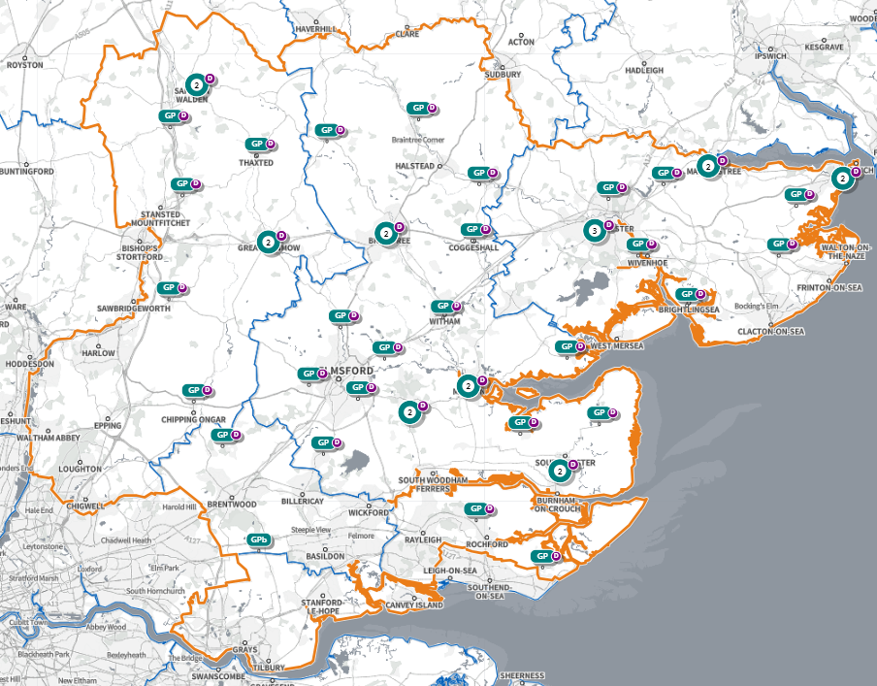
SHAPE Place • GP dispensing
Figure 32 Dispensing doctors in the Essex HWB area
As of March 2025, there are 47 dispensing doctor practices across Essex. A full list of dispensing doctor practices in Essex is provided in Appendix D.

Provision for doctors to provide pharmaceutical services in certain circumstances has been made in various NHS Acts and Regulations for many decades. Doctors in certain localities are allowed to offer a dispensing service to eligible patients. To be eligible, patients must meet the requirements which are:
- patients must live in a rural area more than 1.6 km from a community pharmacy,
- patients must have requested to be on the dispensing list,
- patients who satisfy NHSE that they would have serious difficulty in obtaining services from a pharmacy.

Dispensing services are available to these patients during surgery opening hours. Dispensing is the only pharmaceutical service available to these patients (although many other services are provided by GP practices).

In many rural areas patients are used to travelling to a neighbouring village/town for shopping and other services. and are likely to have access to a pharmacy there for over-the-counter medication and advice on the use of their medicines, in addition to the dispensing service they can use locally and via distance selling pharmacies.

5.7.2 Distance-selling pharmacies (DSP)
A DSP provides services as per the Pharmaceutical Regulations 2013. It may not provide Essential Services face-to-face, and therefore provision is by mail order and/or wholly internet. As part of the terms of service for DSPs, provision of all services offered must be offered throughout England to anyone who requested them.

It is therefore likely that patients within the HWB area will be receiving pharmaceutical services from a DSP outside of it. There are currently 6 DSPs with a registered address within the Essex HWB area.

Figures for 2024-2025 show that in England there were 409 DSPs, accounting for 3.4% of the total number of pharmacies.

5.7.3 Dispensing Appliance Contractors (DACs)
There are 5 Dispensing Appliance Contractors (DACs) with a registered address within the HWB area, DAC services are also available to the population from elsewhere in the UK. Appliances may also be dispensed from community pharmacies.

As part of the Essential Services of appliance contractors, a free delivery service is available to all patients. It is therefore likely that patients will obtain appliances delivered from DACs outside the HWB area. There were 112 active DACs registered in England in 2024.

5.7.4 Pharmaceutical service provision provided from outside the HWB area
The Essex HWB is bordered by many neighbouring HWB areas: Southend- on Sea, Thurrock, Suffolk, Hertfordshire, and some London boroughs. Good travel access provides access to further pharmaceutical provision in neighbouring HWB areas and beyond. DSPs provide further availability of pharmaceutical services.

5.7.5 Community Pharmacy Contractual Framework (CPCF)
As part of the Community Pharmacy Contractual Framework (CPCF) 5-year deal (2019 to 2024), the government committed to pursuing legislative change to enable all community pharmacies to benefit from ‘hub and spoke’ dispensing models, with the intention of supporting efficiencies for pharmacies and freeing up pharmacists and their teams for other tasks such as providing clinical services to patients.

Hub and spoke dispensing are where parts of the dispensing process are undertaken in separate pharmacy premises. Typically, there are many ‘spoke’ pharmacies to one ‘hub’ pharmacy. The concept is that the simple, routine aspects of assembling prescriptions can take place on a large scale in a ‘hub’ that usually makes use of automated processes. This means that pharmacists and other staff in the ‘spokes’ are freed up to provide more direct patient care.

5.8 Other
Across the HWB area, several healthcare providers use some pharmaceutical services. This includes (this list is not exhaustive):

- Mid and South Essex NHS Foundation Trust
- Princess Alexandra Hospital NHS Trust
- East Suffolk & North Essex NHS Foundation Trust
- Ramsay Healthcare Springfield Hospital
- Hertfordshire Partnership University NHS Foundation Trust
- Essex Partnership University NHS Foundation Trust
- North East London NHS Foundation Trust
- Cambridge University Hospital NHS Foundation Trust
- Barts Health Trust
- Whipps Cross University Hospital
- Uplands Rehabilitation Centre
- Provide Community Interest Company
- IC24 GP emergency care

5.9 Housing growth
All significant developments that are expected to be realised up to the housing plan period of 2033 are shown in Appendix G. This is the date at which data was available. Not all these developments will be realised during the lifetime of this PNA.

New ways of delivering pharmaceutical services are also being considered by the Department of Health and Social Care (DHSC), which would increase the capacity of existing providers.

Any housing delivered during the lifetime of this PNA has access to current provision and would also have access to provision from neighbouring areas and from DSPs. New technology, digital solutions and hub and spoke models would be able to provide increased access to pharmaceutical services. All significant developments that are expected to be realised during the lifetime of this PNA have access to existing pharmaceutical services either in the locality or in the neighbouring localities and no gaps are identified.

Chapter 6. Localities

6.1 Basildon Locality
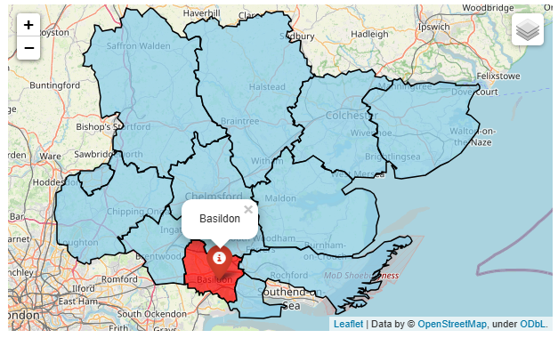

Basildon Locality

The Basildon district is situated in the southern part of Essex, 30 miles east of London. Covering some 110 square kilometers, the district includes the towns of Basildon, Billericay and Wickford.

Basildon has the largest population of the Essex districts at 190,544, giving a population density of 1,705 people per square km. 82.1% of the population are White British.

In the Indices of Multiple Deprivation 2019, Basildon was in the 40% of most deprived Lower Tier Local Authorities (LTLAs) nationally. This contains 110 LSOAs, of which 26 are ranked in the bottom two most deprived deciles nationally; equivalent to 23.6%.

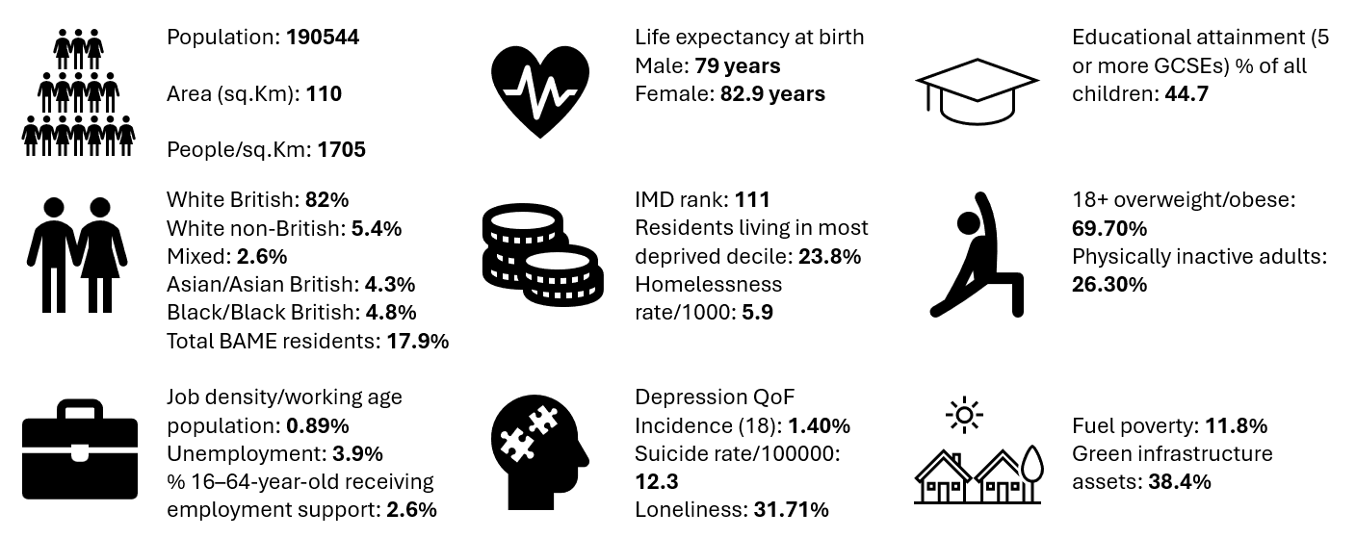

Further details can be accessed in the Essex Joint Strategic Needs Assessment https://data.essex.gov.uk/

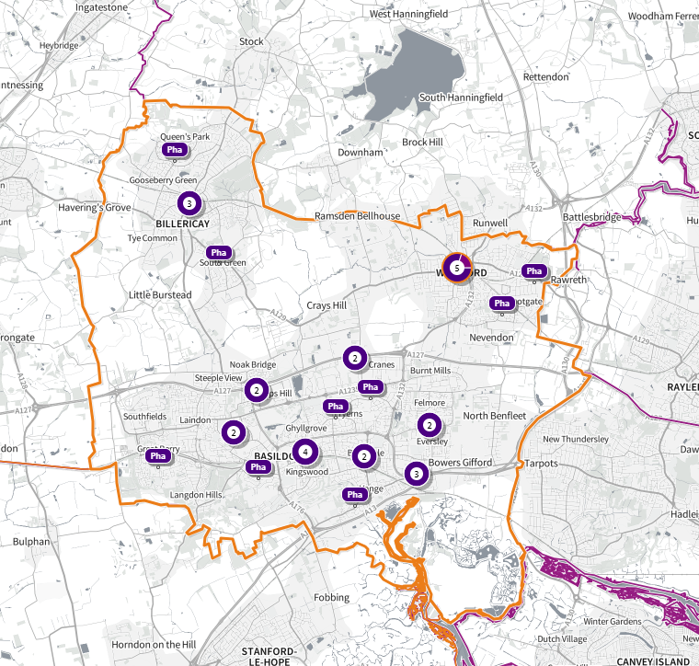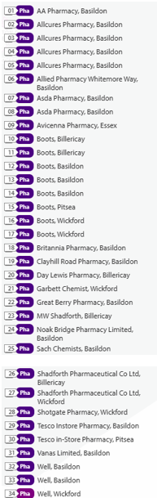
Source: SHAPE Place • Pharmacy • Added location (as at 02/01/2025)
Figure 33 Map of Basildon Pharmacies

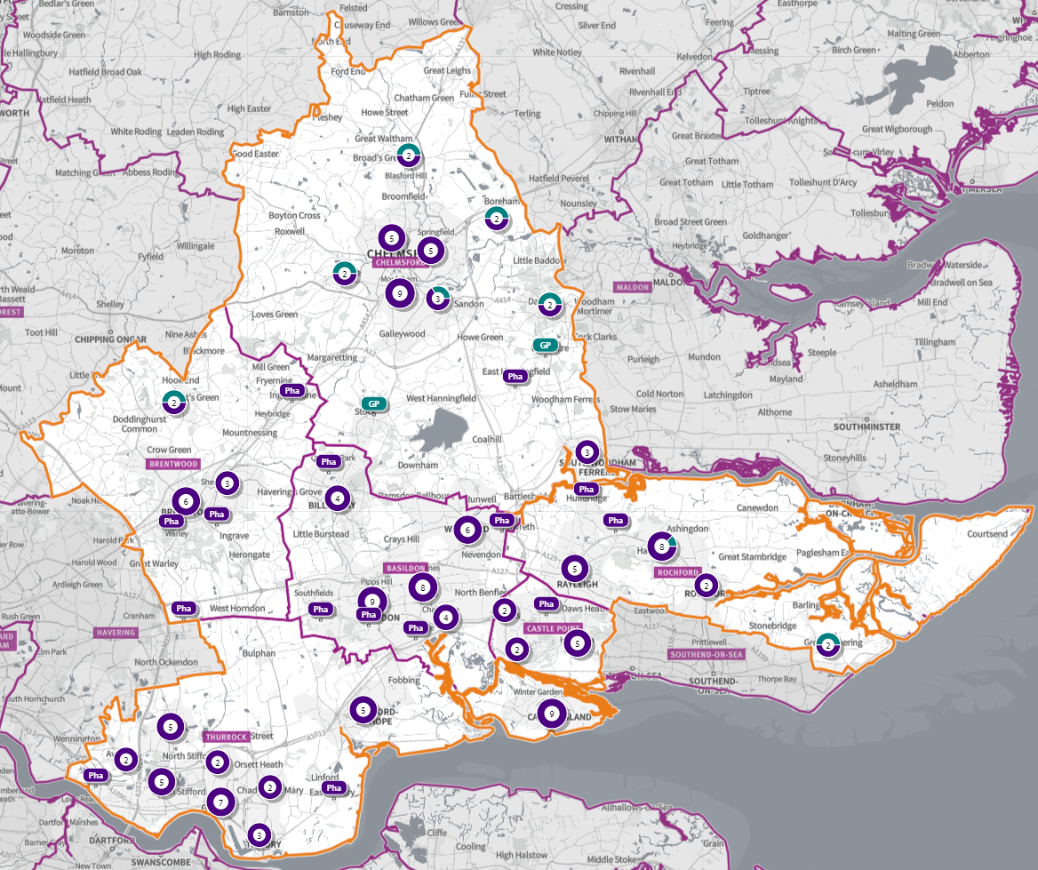
Figure 34 Map of Pharmacies and dispensing doctors within the Basildon locality, and neighbouring pharmacy provision

Pharmaceutical services provision in the locality

Provision
The information contained in this report was obtained from NHSE, local commissioners and a contractor survey.
Opening hours were obtained via the NHSE pharmacy contracts team.
Service provision for advanced services was obtained via NHSE, NHS Business Services Authority (NHSBSA) and with the support of the local LPC (Local Pharmaceutical Committee).

Access
Appendix F shows that using the base population data on the SHAPE Place Atlas platform, it is possible to calculate the Essex population (and by district) that are estimated to have a journey time either within 20 minutes, 20 - 30 minutes or over 30 minutes to a pharmacy across Essex and within a 1.6km buffer zone around Essex by each journey method.

Overall, across Essex, generally residents are within a relatively short travel time whichever method is chosen:
- 99.9% of the Essex population could get to a pharmacy in a 20-minute drive.
- 93% (Weekday Morning) within a 30-minute public transport journey.
- 83% within a 20-minute walk. Residents have to travel for longer if they walk.
- 12% over 30-minute walk away.
- Basildon residents can drive to a pharmacy within 20 minutes.
- Most residents can get to a pharmacy within a 20-minute journey on public transport in most districts. However, some districts see a relatively high % of their population having to travel for longer (Braintree, Maldon, Uttlesford 20-30 minutes; Braintree, Epping Forest, Uttlesford over 30 minutes).
- Most residents can get to a pharmacy within 20-minute walk in most districts. Some districts however see a relatively higher % of their population that’d have to walk further (Braintree, Brentwood, Uttlesford 20-30 minutes; Braintree, Maldon, Uttlesford over 30 minutes).

Travel time to access pharmaceutical services are no longer than journey times to access key services as shown in section 6 of this report.

From the results of the public survey (Appendix E) 82% of residents stated that they had a less than 20 minutes travel to the pharmacy, 12% had travelled between 20-30 minutes, and 4% had travelled between 30-45 minutes.
60% made the trip by car, and 51% had travelled on foot—only 5% travelled by bicycle, 3% by public transport and 1% by taxi.

Basildon residents also have access to pharmacies in neighbouring HWB areas and DSPs in England. Analysis of dispensing flows in the Basildon and Brentwood CCG area shows that 88% of prescriptions in the CCG are dispensed within the area and 12% out of area including the distance selling pharmacies.

Pharmaceutical services in the locality

Table 8 Number and type of providers of pharmaceutical services in the area
Type Of Contract | Basildon
Total Number of Community Pharmacies | 34
Dispensing Doctors | None
Dispensing Appliance Contractor | None
Distance Selling Pharmacies | None

Basildon pharmacies service provision
Table 9 Pharmacy contractors in the locality and provision of national NHS commissioned services
Service code |  |  |  |  |  |  |  | 1 | 2 | 3 | 4 | 5
Organisation code | Town | Postcode | Town | Postcode | Hours: M - F* OPENING SUPPLEMENTARY | Hours: Sat OPENING SUPPLEMENTARY | Hours: Sun OPENING  SUPPLEMENTARY | PHARMACY FIRST | HYPERTENSION | CONTRACEPTION | LATERAL FLOW | SMOKING CESSATION
FHW69 | AA Pharmacy | 98 Whitmore Way | Basildon | SS14 3JT | 9:00 – 18.00  13:00 - 13:30  & 17:30 - 18:00 | 9:00 - 13:00 | Closed | ✓ | ✓ | ✓ | ✓ | ✓
FDN82 | Allcures Pharmacy | 1 Marsh View Court, London Road | Basildon | SS16 4QW | 9:00 – 18.00  13:00 - 13:30 &  17:30 - 18:00 | Closed | Closed | ✓ | ✓ |  |  | ✓
FN057 | Allcures Pharmacy | 144 Clayhill Road | Basildon | SS16 5DF | 9:00 - 18: 00  17:00 - 18:00 | Closed | Closed | ✓ | ✓
FTN74 | Allcures Pharmacy | 7 Felmores End | Basildon | SS13 1PN | 9:00 - 17:30  17:00 - 17:30 | Closed | Closed | ✓ | ✓
FWL99 | Allcures Pharmacy | 562 Whitmore Way | Basildon | SS14 2ER | 9:00 - 17:30  13:00 - 13:30 | Closed | Closed | ✓ | ✓ |  | ✓ | ✓
FT704 | Allied Pharmacy Whitemore Way | 418 WHITMORE WAY | Basildon | SS14 2HB | 9:00 - 17:30  13:00 - 13:30 & 13:50 – 14:00 | 9:00 - 13:00  11:30 - 13:00 | Closed | ✓ | ✓ | ✓ | ✓
FC547 | Asda Pharmacy | Heron Retail Park, Miles Gray Road | Basildon | SS14 3AF | 9:00 - 20:00  12:30 - 14:30 &  18:00 - 20:00 | 9:00 - 20:00  12:30 - 14:30 &  16:00 - 20:00 | 10:00 – 13.00 & 13.00 - 16:00 | ✓ | ✓ | ✓ | ✓ | ✓
FH090 | Asda Pharmacy | Eastgate Shopping Centre | Basildon | SS14 1AE | 9:00 - 20:00  12.30 - 14:30 &  18:00 - 20:00 | 09:00 -20:00  12.30 - 14:30 &  16:00 - 20:00 | 10:00 - 13:00 & 13.00 – 16.00 | ✓ | ✓ | ✓ | ✓ | ✓
FAX06 | Avicenna Pharmacy | 20 London Road | Wickford | SS12 0AN | 9:00 - 18:00  17:00 - 18:00 | 9:00 - 13:00 | Closed | ✓ | ✓ | ✓ | ✓
FE004 | Boots | 10-11 The Pantiles, Queens Park Avenue | Billericay | CM12 0UA | 9:00 - 18:00  13.30 - 14:30 (Mon, Tue, Thurs, Fri) | 9:00 -17:00  13:00 - 17:00 | Closed | ✓ | ✓ | ✓ | ✓
FJ061 | Boots | 25 Town Square | Basildon | SS14 1BA | 8:30 - 17:30  8:30 – 9:00, 14:00 - 15:00 &  17:00 - 17:30 | 8:30 - 17:30  8:30 – 9:00 & 14:00 - 17:30 | 10:00 - 14:00 & 14:00 – 16:00 | ✓ | ✓ | ✓ | ✓
FJX14 | Boots | 8 Northlands Pavement | Basildon | SS13 3DU | 9:00 - 18:00  13:00 - 14:00  & 14:00 – 18:00 (Wed) | 9:00 - 16:00  13:00 - 14:00 &  14:00 - 16:00 | Closed | ✓ | ✓ | ✓ | ✓
FKP09 | Boots | 16 Willowdale Centre | Wickford | SS12 0RA | 8:30 - 18:30  8:30 - 9.30,  14:00 - 15:00 &  17:30 - 18:30 | 9:00 - 17:15  9:00 - 9:30 ,  14:00 - 15:00 &  15:30 - 17:15 | 10:00 - 16:00 | ✓ | ✓ | ✓ | ✓
FP755 | Boots | Unit 6B, Mayflower Retail Park | Basildon | SS14 3HZ | 10:00 - 18:00  14:00 - 15:00 | 9:00 - 15:00  12:00 - 13:00 | Closed | ✓ | ✓ | ✓ | ✓
FQE10 | Boots | 64-66 High Street | Billericay | CM12 9BS | 9:00 - 17:30  13:00 - 14:00 | 9:00 - 17:30  11:30 - 17:30 | 10:00 - 13:00 & 13:00 – 16:00 | ✓ | ✓ | ✓ | ✓
FTJ17 | Boots | 31 Ballards Walk | Basildon | SS15 5HL | 9:00 - 18:00  13:00 - 18:00 (Wed) | 9:00 - 17:00  14:00 - 17:00 | Closed | ✓ | ✓ | ✓ | ✓
FVK93 | Boots | 5 Silva Island Way | Wickford | SS12 9NR | 9:00 - 18:00 (9:00 – 14:00 Wed)  13:00 - 14:00 | 9:00 - 13:00 | Closed | ✓ | ✓ | ✓
FRH64 | Britannia Pharmacy | 213 Timberlog Lane | Basildon | SS14 1PB | 9:00 - 19:00 (9:00 - 18:00 Thurs)  17:00 - 19:00 (17:00 - 19:00 Thurs) | 9:00 - 13:00 & 13:00 – 16:00 | Closed | ✓ | ✓ | ✓ | ✓ | ✓
FHV32 | Clayhill Road Pharmacy | 465 Clayhill Road | Basildon | SS16 4EX | 9:00 - 18:30  13:00 - 14:00 &  18:00 - 18:30 | 9:00 - 12:00 | Closed
FA380 | Day Lewis Pharmacy | 6 Grange Road | Billericay | CM11 2RB | 9:00 - 18:00  Closed 13:00 - 14:00 | 09:00 - 13:00 | Closed | ✓ | ✓ | ✓ | ✓
FG064 | Garbett Chemist | 23 High Street | Wickford | SS12 9AE | 09:00 - 18:00  13:00 - 14:15 &  17:30 - 18:00 | 09: 00 - 17:30  13:00 - 17:30  Closed 12:45 - 13:00 | Closed | ✓ | ✓ |  | ✓ | ✓
FQC91 | Great Berry Pharmacy | Unit 4, Great Berry Centre, Nightingales | Basildon | SS16 6SA | 09:00 - 18:30  13:00 - 14:00 &  18:00 - 18:30 | 09:00 - 13:00 | Closed | ✓ | ✓ | ✓ | ✓ | ✓
FD812 | MW Shadforth | 49 High Street | Billericay | CM12 9AX | 08:45 - 18:15  8:45 - 9:00 &  13:00 - 14:15 &  17:30 - 18:15 | 9:00 – 17.00  13:00 - 17:00  Closed 12: 45 - 13:00 | Closed | ✓ | ✓ |  | ✓ | ✓
FGC13 | Noak Bridge Pharmacy Limited | 147 Coppice Lane | Basildon | SS15 4JS | 09:00 - 18:45 (09:00 - 13:00 Thurs)  18:30 - 18:45  Closed 13.00- 14.00 | 9:00 - 13:00  11:00 - 13:00 | Closed | ✓ | ✓ | ✓ | ✓
FEL23 | Sach Chemists | 10 Broadway North | Basildon | SS13 3AT | 9:00 - 18:00  13:00 - 14:00 (13:00 – 18:00 Thurs) | 9:00 - 13:00 | Closed | ✓ | ✓ | ✓ | ✓ | ✓
FJR90 | Shadforth Pharmaceutical Co Ltd | 53 High Street | Basildon | SS12 9AQ | 09:00 - 17:30  14:00 - 14:20 &  17:20 - 17:30 (13:00 - 17:30 Wed) | 9:00 - 13:00 | Closed | ✓ | ✓ |  | ✓
FNC77 | Shadforth Pharmaceutical Co Ltd | 25 Stock Road | Billericay | CM12 0AH | 9:00 - 18:30  13:00 - 14:00 &  18:00 - 18:30 | 9:00 - 13:00 | Closed | ✓ | ✓ |  | ✓ | ✓
FP449 | Shotgate Pharmacy | 312 Southend Road | Wickford | SS11 8QW | 9:00 - 18:00  17:00 - 18:00 | 9:00 - 12:00 | Closed | ✓ | ✓ | ✓ | ✓
FA473 | Tesco In-store Pharmacy | Mayflower Retail Park | Basildon | SS14 3HZ | 8:00 - 20:00  8:00 - 9:00,  13:00 - 14:00 &  16:00 – 20:00 (Mon, Tue), 17:00 - 20:00 (Wed, Thurs, Fri) | 8:00 - 20:00  8:00 - 9:00 &  13:00 - 14:00 &  17:00 - 20:00 | 10:00 - 13:00 & 13:00 – 16:00 | ✓ | ✓ | ✓ | ✓
FF009 | Tesco In-store Pharmacy | Off Station Lane | Pitsea | SS13 3JU | 8:00 - 20:00  8:00 - 9:00,  13:00 - 14:00 &  17:00 - 20:00 (16:00 – 20:00 Fri) | 8:00 - 20:00  8:00 - 9:00,  13:00 - 14:00 &  16:00 - 20:00 | 10:00 - 13:00 & 13:00 - 16:00 | ✓ | ✓ | ✓ | ✓
FW294 | Vanas Limited | 134 Rectory Road | Basildon | SS13 2AJ | 9:00 - 18:30  17:30 - 18:30  Closed 13:00 - 13:30 | Closed | Closed | ✓ | ✓ | ✓ | ✓ | ✓
FD329 | Well Basildon - Kibcaps Lee Chapel South | 1 Kibcaps, Lee Chapel South | Basildon | SS16 5SA | 9:00 - 18:00  13:00 - 14:00 | Closed | Closed | ✓ | ✓ | ✓ | ✓ | ✓
FQ898 | Well Basildon - Laindon Centre | Unit 1, Laindon Temporary Shops | Laindon | SS15 5PS | 8:30 - 18:00  8:30 - 9:00 &  13:00 - 14:00 | 9:00 - 13:00 | Closed | ✓ | ✓ | ✓ | ✓ | ✓
FQ122 | Well Wickford - The Willows | Unit 12, Willowdale Shopping Centre | Wickford | SS12 9AT | 9:00 - 18:00  13:00 - 14:00 | Closed | Closed | ✓ | ✓ | ✓ | ✓ | ✓

Basildon opening hours
- Weekday opening hours were taken from Friday as a standard.
Monday to Friday, all 34 community pharmacies are open between the hours of 9:00am to 17:00.
Earliest opening time is 8.00 and latest closing time is 20.00.
- On Saturdays 27 of the pharmacies open, 13 of these only open for the morning and the rest of the pharmacies remain open into the afternoon. Earliest opening time is 8.00 and latest closing time is 20.00.
- On Sundays seven pharmacies open and there is provision between 10:00 until 16:00.

Services (data January 2025)
There is good access to commissioned services within the locality.
The necessary services of NMS and CPCS are provided by almost all the pharmacies.
The NHSE commissioned services that are not provided by pharmacies are delivered by other organisations in the locality.
Services are also locally commissioned by Essex County Council Public Health and the ICBs.
The provision of these is not shown as it changes frequently.
Details can be obtained from the commissioners.

Housing (Appendix G)
The impact of local housing development plans on provision of pharmaceutical services has been considered but has not identified any gaps in pharmaceutical services provision in the area during the lifetime of this PNA.

No gaps in the provision of necessary pharmaceutical services have been identified in the Basildon locality

No gaps in pharmaceutical services have been identified that if provided either now or in the future would secure improvements or better access to relevant services across the Basildon locality

6.2 Braintree Locality
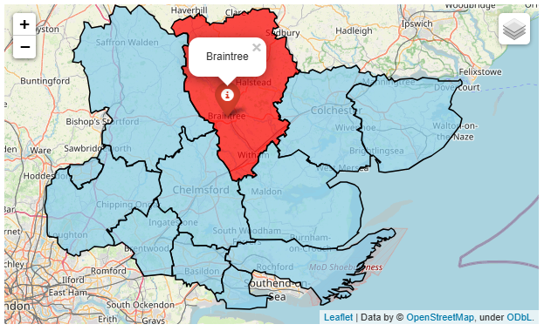

Braintree Locality

Covering approximately 612 square kilometers, the Braintree district is the second largest Essex local authority in terms of geographical area (Uttlesford is the largest).

The district consists of the two large market towns of Braintree and Halstead along with the 1970’s urban ‘expanded town’ of Witham interconnected with many smaller villages and rural areas.

Braintree has a population of 159,957 and 250 residents per square km and is the third least densely populated among the Essex districts. 90.4% of the population are of White British ethnicity.

With a rank of 303 out of 317, Braintree is placed in the in the upper 40% of least deprived Lower Tier Local Authorities (LTLAs) nationally.

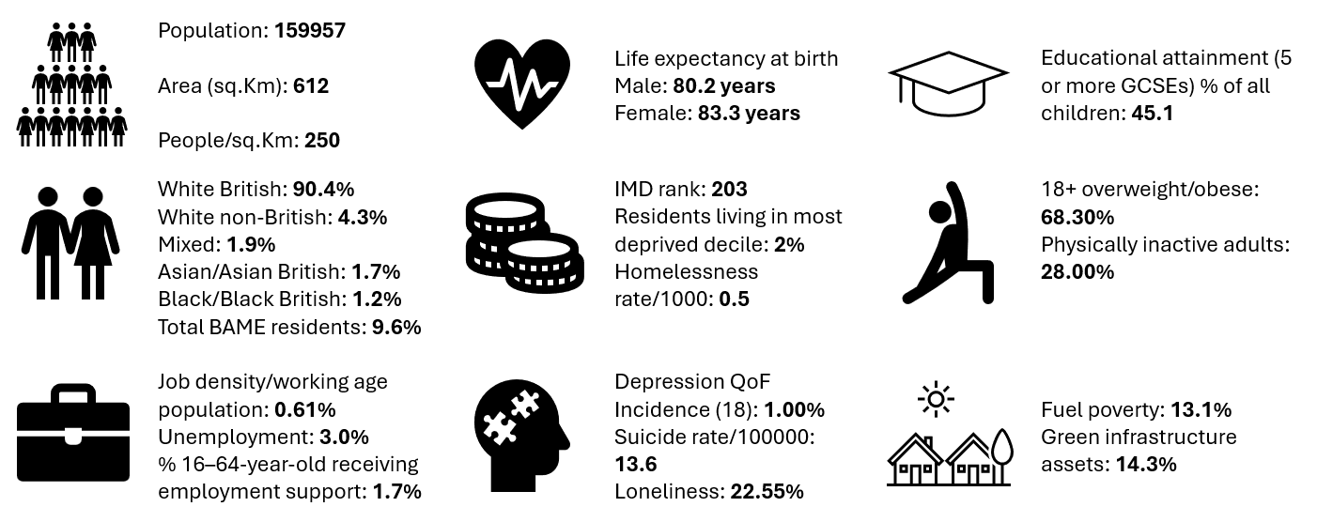

Further details can be accessed in the Essex Joint Strategic Needs Assessment https://data.essex.gov.uk/

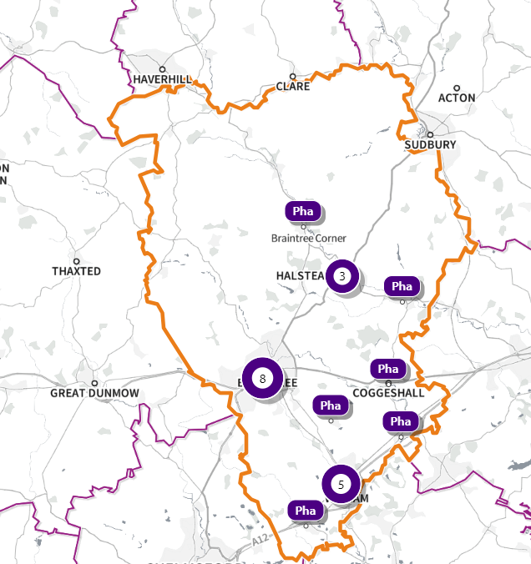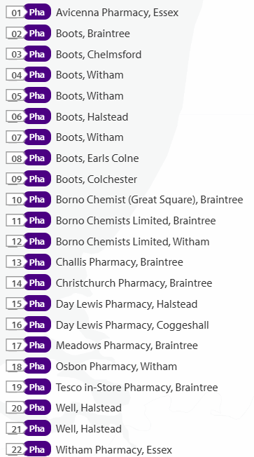

Source: SHAPE Place • Pharmacy (as at 02/01/2025)
Figure 35 Map of Braintree Pharmacies

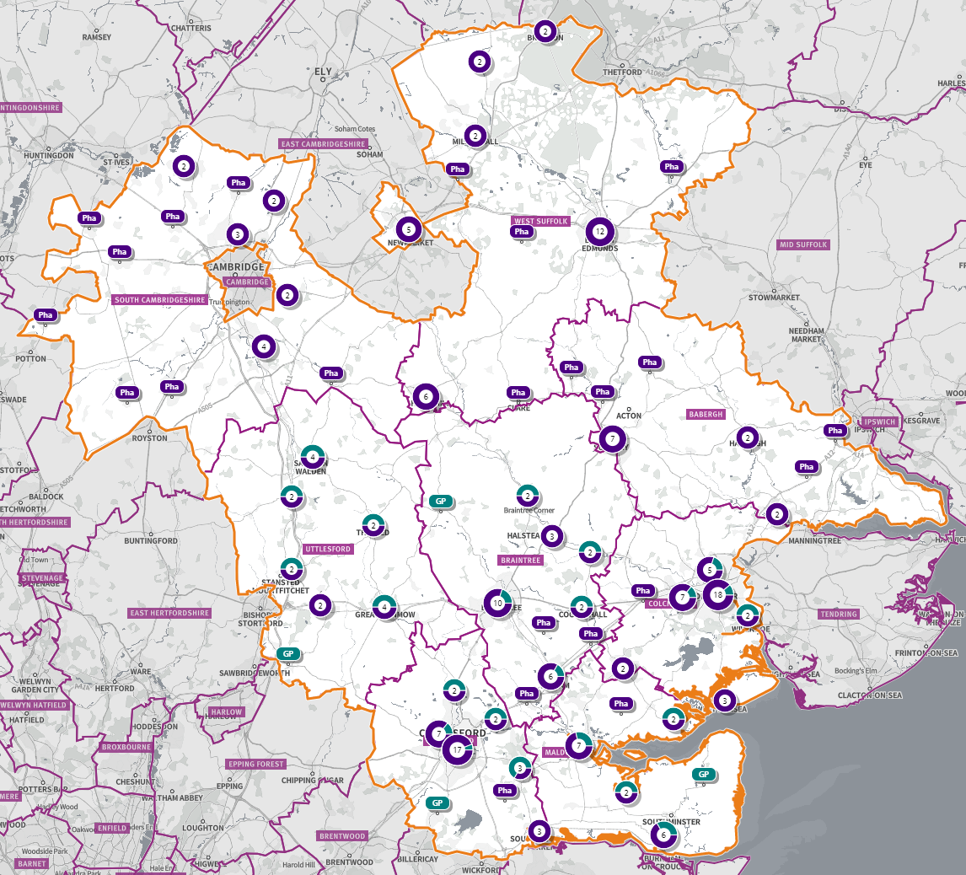
Figure 36 Map of Pharmacies and dispensing doctors within the Braintree locality, and neighbouring pharmacy provision

Pharmaceutical services provision in the locality

Provision
The information contained in this report was obtained from NHSE, local commissioners and a contractor survey.
Opening hours were obtained via the NHSE pharmacy contracts team.
Service provision for advanced services was obtained via NHSE, NHSBSA and with the support of the local LPC.

Access
Appendix F shows that using the base population data on the SHAPE Place Atlas platform, it is possible to calculate the Essex population (and by district) that are estimated to have a journey time either within 20 minutes, 20 - 30 minutes or over 30 minutes to a pharmacy across Essex and within a 1.6KM buffer zone around Essex by each journey method.

Overall, across Essex, generally residents are within a relatively short travel time whichever method is chosen:
- 99.9% of the Essex population could get to a pharmacy in a 20-minute drive.
- 93% (Weekday Morning) within a 30-minute public transport journey
- 83% within a 20-minute walk. Residents have to travel for longer if they walk.
- 12% over 30-minute walk away.
- Braintree residents can drive to a pharmacy within 20 minutes.
- Most residents can get to a pharmacy within a 20-minute journey on public transport in most districts. However, some districts see a relatively high % of their population having to travel for longer (Braintree, Maldon, Uttlesford 20-30 minutes; Braintree, Epping Forest, Uttlesford over 30 minutes)
- Most residents can get to a pharmacy within 20-minute walk in most districts. Some districts however see a relatively higher % of their population that’d have to walk further (Braintree, Brentwood, Uttlesford 20-30 minutes; Braintree, Maldon, Uttlesford over 30 minutes).

Travel time to access pharmaceutical services are no longer than journey times to access key services as shown in section 6 of this report.

From the results of the public survey (Appendix E) 82% of residents stated that they had a less than 20 minutes travel to the pharmacy, 12% had travelled between 20-30 minutes, and 4% had travelled between 30-45 minutes.
60% made the trip by car, and 51% had travelled on foot—only 5% travelled by bicycle, 3% by public transport and 1% by taxi.

Braintree residents also have access to dispensing doctors, pharmacies in neighbouring HWB areas and distance selling pharmacies in England. Analysis of dispensing flows in the Mid Essex CCG area shows that 89% of prescriptions generated in the CCG are dispensed within the area and 11% out of area including distance selling pharmacies.

Pharmaceutical services in the locality

Table 10 Number and type of providers of pharmaceutical services in the area
Type Of Contract | Braintree
Total Number of Community Pharmacies | 22
Dispensing Doctors | 7
Dispensing Appliance Contractors | 0
Distance Selling Pharmacies | 0

Table 11 Pharmacy contractors in the locality and provision of national NHS commissioned services
Service code |  |  |  |  |  |  |  | 1 | 2 | 3 | 4 | 5
Organisation code | Trading Name | Address line | Town | Postcode | Hours: M - F* OPENING HOURS SUPPLEMENTARY | Hours: Sat OPENING HOURS SUPPLEMENTARY | Hours: Sun OPENING HOURS  SUPPLEMENTARY | PHARMACY FIRST | HYPERTENSION | CONTRACEPTION | LATERAL FLOW | SMOKING CESSATION
FWF16 | Avicenna Pharmacy | 70 Coggeshall Road | Braintree | CM7 9BY | 8:00 - 18:00 |  |  | ü | ü | ü | ü
 |  |  |  |  | 8:00 - 9:00 &  17:00 - 18:00 | Closed | Closed
FCC02 | Boots | 42 Newland Street | Witham | CM8 2AR | 9:00 - 18:00 | 9:00 - 17:30 | 10:00 - 16:00 | ü | ü | ü | ü
 |  |  |  |  | 13:00 - 14:00, (14:00 – 18:00 Wed) | 13:00 - 14:00 & 14:00 - 17:30
FJA38 | Boots | 50 High Street, Earls Colne | Braintree | CO6 2PB | 9:00 - 17:30  13:00 - 14:00 | 9:00 - 13:00  11:30 - 13:00 | Closed | ü | ü | ü | ü
FJJ41 | Boots | 72A & 72B High Street, Kelvedon | Colchester | CO5 9AE | 9:00 - 19:00 |  |  | ü | ü |  | ü
 |  |  |  |  | 13:00 - 14:00 &  18:00 - 19:00 | 9:00 - 17:00 | Closed
FKK58 | Boots | 4 Spa Road | Witham | CM8 1NE | 9:00 - 18:00 | 9:00 - 18:00 |  | ü | ü | ü | ü
 |  |  |  |  | 13:00 - 13:30 (14:00 18:00 Wed) | 13:00 - 18:00 | Closed
 |  |  |  |  | Closed 13:30 - 14:00
FL500 | Boots | 69-71 High Street | Halstead | CO9 2JD | 9:00 - 17:30 | 9:00 - 17:30 |  | ü | ü | ü | ü
 |  |  |  |  | 9:00 - 9:30 &  17:15 - 17:30 | 9:00 - 9:30 &  17:00 - 17:30 | Closed
 |  |  |  |  | Closed 13:00 - 14:00 | Closed 13:00 - 14:00
FM273 | Boots | 7 George Yard | Braintree | CM7 1RB | 9:00 - 17:00 | 8:45 - 17:00 |  | ü | ü | ü | ü
 |  |  |  |  | 13:00 – 14:00 (Mon, Tues, Thurs), (16:00 - 17:00 Wed & Fri, 16:30 – 17:00 Mon, Tues, Thurs) | 8:45 - 9:00 &  13:00 - 14:00 &  16:30 - 17:30 | Closed
FWM30 | Boots | 3 Hadfelda Square | Hatfield Peverel | CM3 2HD | 9:00 -18:00 (9:00 – 18:30 Wed) | 9:00 - 16:00 |  | ü | ü | ü | ü | ü
 |  |  |  |  | 13:00 - 14:00 &  13:00 - 18:30 (Wed) | 13:30 - 16:00  Closed 13:00 – 13:30 | Closed
FXF67 | Boots | 3-4 The Broadway, Silver End | Witham | CM8 3RQ | 9:00 - 18:00 | 9:00 - 13:00 |  | ü | ü | ü | ü
 |  |  |  |  | 13:00 - 14:00 &  13:00 - 18:00 (Wed) |  | Closed
FM447 | Borno Chemist (Great Square) | 10 Great Square | Braintree | CM7 1UA | 9:00 - 19:00 | 9:00 - 17:30 |  | ü | ü | ü | ü | ü
 |  |  |  |  | 12:00 - 14:00 (12:30 – 14:00 Mon & Thurs) &  17:30 - 19:00 | 12:00 - 14:00 | Closed
FAP90 | Borno Chemists Limited | 124 Newland Street | Witham | CM8 1BA | 9:00 - 19:00 (9:00 – 18:00 Wed) |  |  | ü | ü | ü | ü | ü
 |  |  |  |  | 17:00 - 19:00 (17:00 – 18:00 Wed) | 8:30 - 12:30 | Closed
FLM31 | Borno Chemists Limited | Colne House, 96 Mount Chambers, Coggeshall Road | Braintree | CM7 9BY | 8:30 - 18:30 |  |  | ü | ü | ü | ü | ü
 |  |  |  |  | 8:30 - 9:00 &  14:00 - 15:00 &  18:00 - 18:30 | Closed | Closed
FPM74 | Challis Pharmacy | 35 Masefield Road | Braintree | CM7 1AA | 8:30 - 18:00 | 9:00 - 17:00 |  | ü | ü
 |  |  |  |  | 8:30 - 9:00,  13:00 - 14:00 (Mon, Tues, Wed, Fri) &  17:00 - 18:00 | 13:00 - 17:00 | Closed
FCM69 | Christchurch Pharmacy | Mace Avenue | Braintree | CM7 2AE | 9:00 - 18:30 |  |  | ü | ü | ü
 |  |  |  |  | 13:00 - 14:00 &  18:00 - 18:30 | Closed | Closed
FTR88 | Day Lewis Pharmacy | 1 Doubleday Corner | Coggeshall | CO6 1NJ | 9:00 - 18:30 |  |  | ü | ü | ü | ü
 |  |  |  |  | 18:00 - 18:30 | 9:00 - 13:00 | Closed
 |  |  |  |  | Closed 13:00 - 14:00
FW791 | Day Lewis Pharmacy | 132-134 Swan Street | Halstead | CO9 3PP | 9:00 - 17:30 | 9:00 - 13:00 |  | ü | ü | ü | ü
 |  |  |  |  | 17:15 - 17:30 (17:00 – 17:30 Mon) |  | Closed
 |  |  |  |  | Closed 13:00 - 14:00
FFN20 | Meadows Pharmacy | Trinovantion Way |  | CM7 3JN |  |  |  | ü | ü | ü | ü
FKE19 | Osbon Pharmacy | Unit 1, 1 Potter Court Flemming Way | Witham | CM8 2ZJ | 9:00 - 19:00 | 9:00 - 17:00 |  | ü | ü | ü | ü | ü
 |  |  |  |  | 13:00 - 14:00 &  18:00 - 19:00 (14:00 – 19:00 Wed) | 13:00 - 17:00 | Closed
FE712 | Tesco In-store Pharmacy | The Square, Great Notley | Braintree | CM77 7WW | 9:00 - 19:00 | 9:00 - 19:00 |  | ü | ü | ü | ü
 |  |  |  |  | 17:30 - 19:00 | 15:00 - 17:00, 17:30 – 19:00 | 10:00 - 16:00
 |  |  |  |  | Closed 13:00 - 14:00 | Closed 13:00 - 14:00
FEJ25 | Well Halstead - Halstead Hc | Signal House Factory Lane West | Halstead | CO9 1EX | 9:00 - 17:30 | 9:00 - 17:00 |  | ü | ü | ü | ü | ü
 |  |  |  |  | 9:00 - 9:30 &  17:15 - 17:30 (17:00 – 17:30 Wed) | 9:00 - 9:30 | Closed
FPL44 | Well Halstead - Weavers Court | 12 Weavers Court | Halstead | CO9 2JN | 9:00 - 17:30  13:00 - 13:30 | Closed | Closed | ü | ü | ü | ü | ü
FM475 | Witham Pharmacy | 5 Newland Street | Witham | CM8 2AF | 9:00 - 19:00  12:30 - 15:30 | 9:00 - 17:30  11:30 - 15:00 | Closed | ü | ü | ü |  | ü

Braintree opening hours
- Weekday opening hours were taken from Friday as a standard.
Monday to Friday, all 22 community pharmacies are open between the hours of 9:00 to 17:00.
Earliest opening time is 8.00 and latest closing time is 19.00.
- On Saturdays 17 open pharmacies, 5 are open in the morning and 12 of the pharmacies remain open in the afternoon. The latest closing time is 19.00.
- On Sundays two pharmacies are open from 10:00 until 16:00.

Services (data January 2025)
There is good access to commissioned services within the locality.
The necessary services of NMS and CPCS are provided by almost all the pharmacies.
The NHSE commissioned services that are not provided by pharmacies are delivered by other organisations in the locality.
Services are also locally commissioned by Essex County Council Public Health and the ICBs.
The provision of these is not shown as it changes frequently.
Details can be obtained from the commissioners.

Housing (Appendix G)
The impact of local housing development plans on provision of pharmaceutical services has been considered but has not identified any gaps in pharmaceutical services provision in the area during the lifetime of this PNA.

No gaps in the provision of necessary pharmaceutical services have been identified in the Braintree locality

No gaps in pharmaceutical services have been identified that if provided either now or in the future would secure improvements or better access to relevant services across the Braintree locality

6.3 Brentwood Locality

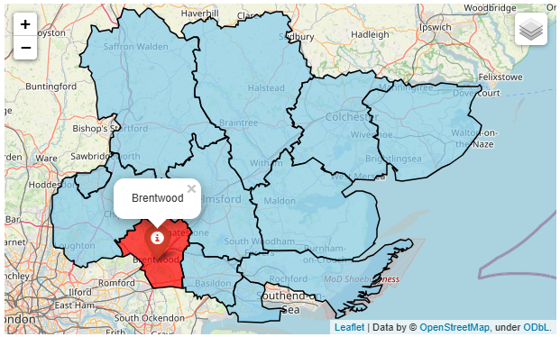

Brentwood Locality

The borough of Brentwood covers approximately 153 square kilometres and is situated in the southwest of Essex and is a town conveniently situated for London, the surrounding countryside and villages.

Brentwood has a population of 78,152 with 504 people living per square km. 82.7% of the population is White British ethnicity.

In the Indices of Multiple Deprivation 2019, Brentwood was ranked 287 out of 317 lower tier authorities in England. This places Brentwood in the 10% of least deprived Lower Tier Local Authorities (LTLAs) nationally.

As of 2019 the Brentwood area contains 46 LSOAs of which none are ranked in the bottom two most deprived deciles nationally.

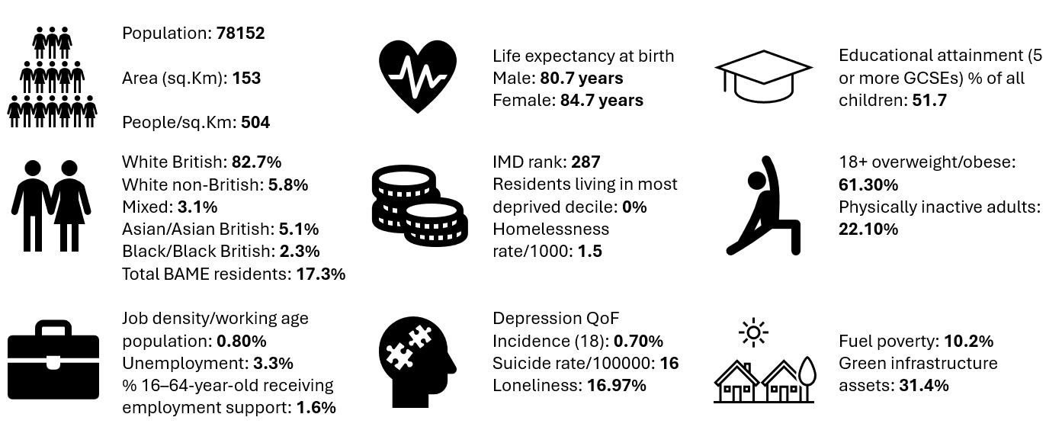

Further details can be accessed in the Essex Joint Strategic Needs Assessment https://data.essex.gov.uk/

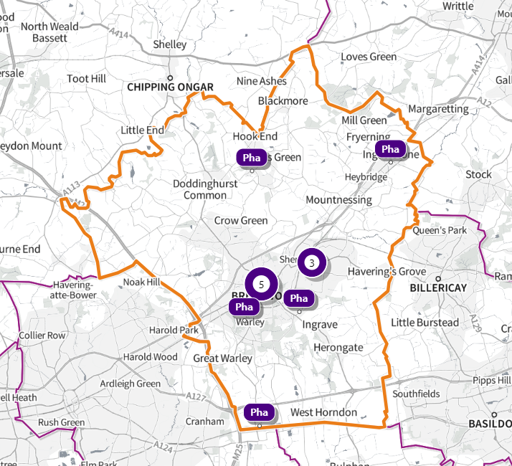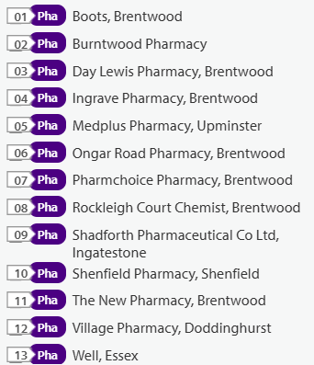
Source: SHAPE Place • Pharmacy (as at 02/01/2025)
Figure 37 Map of Brentwood Pharmacies

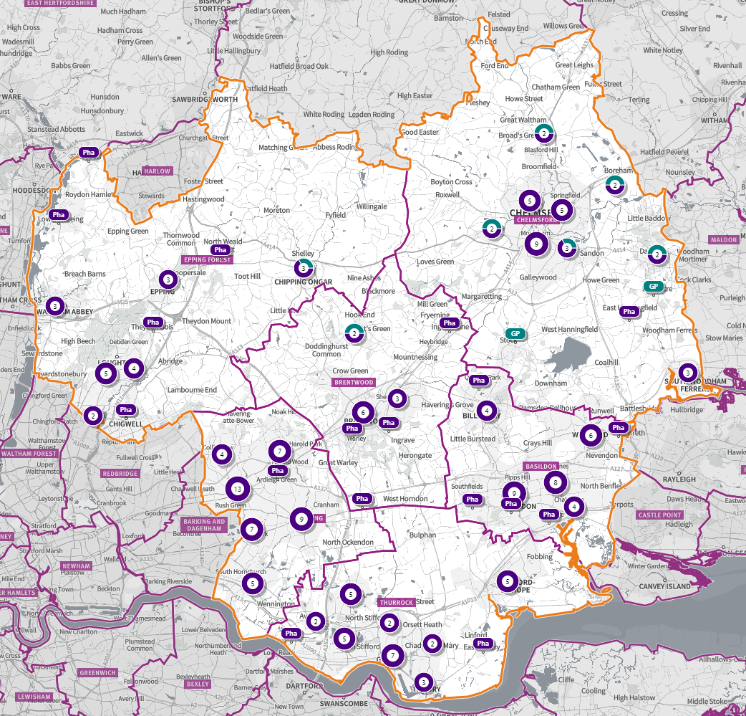
Source: Shape Place Atlas
Figure 38 Map of Pharmacies and dispensing doctors within the Brentwood locality, and neighbouring pharmacy provision
Pharmaceutical services provision in the locality

Provision
The information contained in this report was obtained from NHSE, local commissioners and a contractor survey.
Opening hours were obtained via the NHSE pharmacy contracts team.
Service provision for advanced services was obtained via NHSE, NHSBSA and with the support of the local LPC.

Access
Appendix F shows that using the base population data on the SHAPE Place Atlas platform, it is possible to calculate the Essex population (and by district) that are estimated to have a journey time either within 20 minutes, 20 - 30 minutes or over 30 minutes to a pharmacy across Essex and within a 1.6KM buffer zone around Essex by each journey method.

Overall, across Essex, generally residents are within a relatively short travel time whichever method is chosen:
- 99.9% of the Essex population could get to a pharmacy in a 20-minute drive.
- 93% (Weekday Morning) within a 30-minute public transport journey.
- 83% within a 20-minute walk. Residents have to travel for longer if they walk.
- 12% over 30-minute walk away.
- Brentwood residents can drive to a pharmacy within 20 minutes
- Most residents can get to a pharmacy within a 20-minute journey on public transport in most districts. However, some districts see a relatively high % of their population having to travel for longer (Braintree, Maldon, Uttlesford 20-30 minutes; Braintree, Epping Forest, Uttlesford over 30 minutes)
- Most residents can get to a pharmacy within 20-minute walk in most districts. Some districts however see a relatively higher % of their population that’d have to walk further (Braintree, Brentwood, Uttlesford 20-30 minutes; Braintree, Maldon, Uttlesford over 30 minutes).

Travel time to access pharmaceutical services are no longer than journey times to access key services as shown in section 6 of this report.

From the results of the public survey (Appendix E) 82% of residents stated that they had a less than 20 minutes travel to the pharmacy, 12% had travelled between 20-30 minutes, and 4% had travelled between 30-45 minutes.
60% made the trip by car, and 51% had travelled on foot—only 5% travelled by bicycle, 3% by public transport and 1% by taxi.

Brentwood residents also have access to dispensing doctors, pharmacies in neighbouring HWB areas and distance selling pharmacies in England. Analysis of dispensing flows in the Basildon and Brentwood CCG area shows that 88% of prescriptions in the CCG are dispensed within the area and 12% out of area including distance selling pharmacies.

Pharmaceutical services in the locality

Table 12 Number and type of providers of pharmaceutical services in the area
Type Of Contract | Brentwood
Total Number of Community Pharmacies | 13 (plus 1 DSP)
Dispensing Doctors | 2
Dispensing Appliance Contractors | 0
Distance Selling Pharmacies | 1

Table 13 Pharmacy contractors in the locality and provision of national NHS commissioned services
Service Code |  |  |  |  |  |  |  | 1 | 2 | 3 | 4 | 5
Organisation code | Trading Name | Address line | Town | Postcode | Hours: M - F* OPENING HOURS SUPPLEMENTARY | Hours: Sat OPENING HOURS SUPPLEMENTARY | Hours: Sun OPENING HOURS  SUPPLEMENTARY | PHARMACY FIRST | HYPERTENSION | CONTRACEPTION | LATERAL FLOW | SMOKING CESSATION
FR398 | Boots | 51 High Street | Brentwood | CM14 4RH | 9:00 - 18:00 | 9:00 - 18:00 |  | ü | ü | ü | ü
 |  |  |  |  | 14:00 - 15:00 &  17:00 - 18:00 | 14:00 - 18:00 | 10:00 - 15:00
FEM29 | Burntwood Pharmacy | 27 Shenfield Road | Brentwood | CM15 8AG | 8:30 - 18:30 |  |  | ü | ü | ü | ü | ü
 |  |  |  |  | 8:30 - 9:00 &  13:00 - 14:00 &  18:00 - 18:30 | 9:00 - 13:00 | Closed
FD285 | Day Lewis Pharmacy | Pastoral Way | Brentwood | CM14 5WF | 9:00 - 18:30  13:00 - 14:00 &  18:00 - 18:30 | 9:00 - 13:00 | Closed | ü | ü | ü | ü
FW781 | Ingrave Pharmacy | 21 East Ham Crescent | Brentwood | CM13 2BN | 9:00 - 18:00  (13:00 – 18:00 Wed) | Closed | Closed | ü | ü | ü | ü | ü
FE752 | Ongar Road Pharmacy | 249 Ongar Road | Brentwood | CM15 9DZ | 9:00 - 18:00  17:00 - 18:00 | Closed | Closed | ü | ü | ü | ü | ü
FJM44 | Pharmchoice Pharmacy (100-hour Pharmacy) | 9 Ingrave Road | Brentwood | CM15 8AP | 7:30 - 22:00 | 7:30 - 22:00 | 9:00 - 22:00 | ü | ü | ü | ü
FKX21 | Rockleigh Court Chemist | 138 Hutton Road | Brentwood | CM15 8NL | 9:00 - 18:30  13:00 - 14:00 &18:00 - 18:30 | Closed | Closed | ü |  |  | ü
FRP97 | Shadforth Pharmaceutical Co Ltd | 80 High Street | Ingatestone | CM4 9DW | 9:00 - 18:00 | 9:00 - 16:00 |  | ü | ü |  | ü
 |  |  |  |  | 13:00 - 14:00 &  17:30 - 18:00 | 11:30 - 16:00 | Closed
FWL37 | Shenfield Pharmacy | 222 Hutton Road | Shenfield | CM15 8PA | 9:00 - 18:00 |  |  | ü | ü | ü | ü | ü
 |  |  |  |  |  | 9:00 – 17:00 | Closed
 |  |  |  |  | 13:00 - 14:00
FCN73 | The New Pharmacy | 33A High Street | Brentwood | CM14 4RG | 9:30 - 17:30 | 9:30 - 17:30 |  | ü | ü |  |  | ü
 |  |  |  |  | 17:00 - 17:30 | 12:00 - 17:30 | Closed
FJ407 | Village Pharmacy | 86 Church Lane | Brentwood | CM15 0NG | 9:00 - 18:00 |  |  | ü | ü | ü | ü | ü
 |  |  |  |  | 17.00 - 18:00 | 9:00 - 17:00 | Closed
FCF02 | Well Hutton | 201 Rayleigh Road | Hutton | CM13 1LZ | 8:30 - 18:00  8:30 - 9:00 &  Closed 13:00 - 14:00 | 9:00 - 13:00 | Closed | ü | ü | ü | ü | ü
FJR27 | MedPlus Pharmacy (DSP) | Unit 5, Upminster TP, Warley Street | Upminster | RM14 3PJ | 9:00 - 18:00  Closed 13.00- 14.00 | Closed | Closed | ü | ü

Brentwood opening hours
- Weekday opening hours were taken from Friday as a standard.
Monday to Friday, all 13 community pharmacies are open between the hours of 9:00 to 17:00.
Earliest opening time is 7.30 and latest closing time is 22.00.
- On Saturdays 9 of the pharmacies are open in the morning and 6 of these pharmacies remain open in the afternoon. The latest closing time is 22.00.
- On Sundays two pharmacies are open between 10.00 – 15.00, longest opening hours are 9.00 to 22.00.

Services (data January 2025)
There is good access to commissioned services within the locality.
The necessary services of NMS and CPCS are provided by almost all the pharmacies.
The NHSE commissioned services that are not provided by pharmacies are delivered by other organisations in the locality.
Services are also locally commissioned by Essex County Council Public Health and the ICBs.
The provision of these is not shown as it changes frequently.
Details can be obtained from the commissioners.

Housing (Appendix G)
The impact of local housing development plans on provision of pharmaceutical services has been considered but has not identified any gaps in pharmaceutical services provision in the area during the lifetime of this PNA.

No gaps in the provision of necessary pharmaceutical services have been identified in the Brentwood locality

No gaps in pharmaceutical services have been identified that if provided either now or in the future would secure improvements or better access to relevant services across the Brentwood locality

6.4 Castle Point Locality
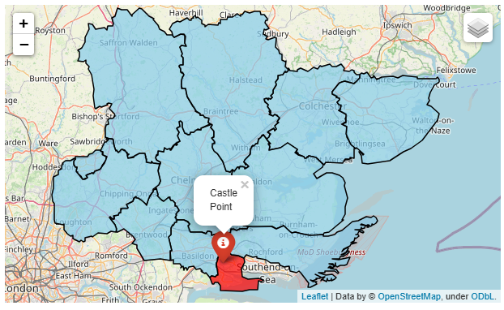
Castle Point Locality

The borough of Castle Point is situated on the coastline of Southeast Essex and has an area of approximately 45 square kilometers.

Castle Point has a population of 89,858, and the second most densely populated district with 2,026 people living per square km. 92.6% of the population is of White British ethnicity.

In the Indices of Multiple Deprivation 2019 the Castle Point Local Authority area was ranked 182 out of 317 lower tier authorities in England. This places Castle Point in the 50% of least deprived Lower Tier Local Authorities (LTLAs) nationally.

As of 2019 the Castle Point area contains 57 LSOAs of which 5 are ranked in the bottom two most deprived deciles nationally.

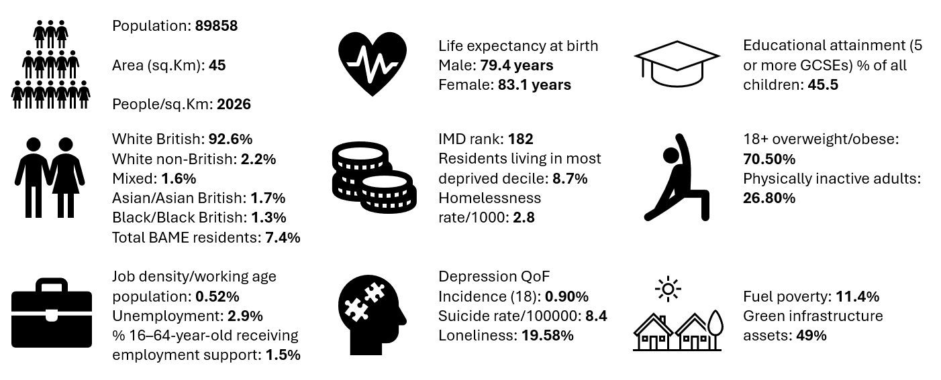

Further details can be accessed in the Essex Joint Strategic Needs Assessment https://data.essex.gov.uk/

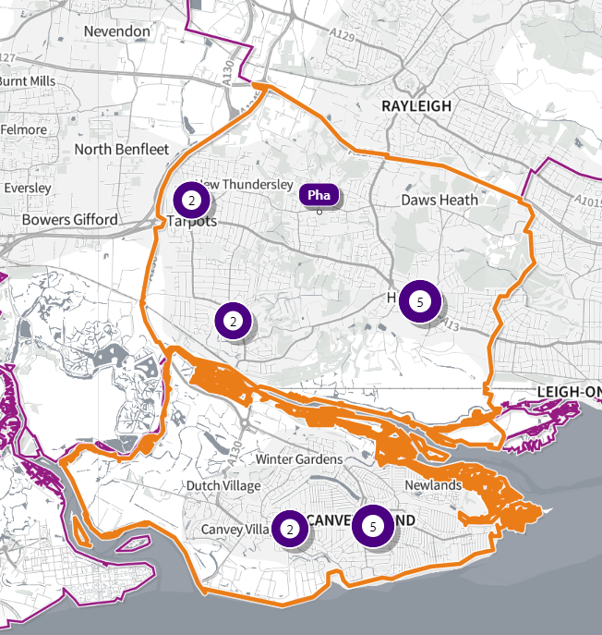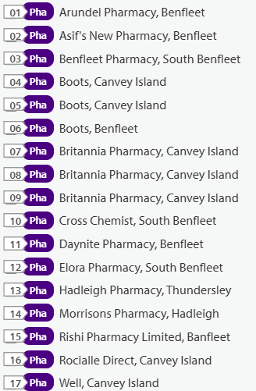

Source: SHAPE Place • Pharmacy (as at 02/01/2025)
Figure 39 Map of Castle Point Pharmacies

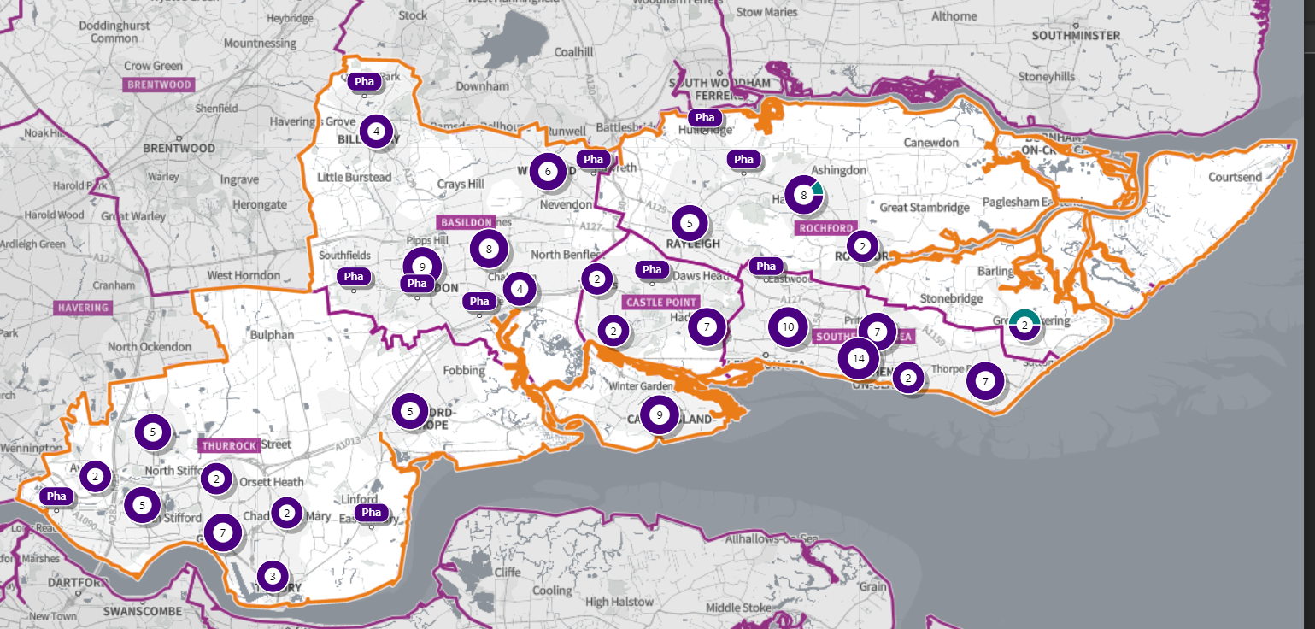
Source: Shape Place Atlas
Figure 40 Map of Pharmacies and dispensing doctors within the Castle Point locality, and neighbouring pharmacy provision
Pharmaceutical services provision in the locality

Provision
The information contained in this report was obtained from NHSE, local commissioners and a contractor survey.
Opening hours were obtained via the NHSE pharmacy contracts team.
Service provision for advanced services was obtained via NHSE, NHSBSA and with the support of the local LPC.
Access
Appendix F shows that using the base population data on the SHAPE Place Atlas platform, it is possible to calculate the Essex population (and by district) that are estimated to have a journey time either within 20 minutes, 20 - 30 minutes or over 30 minutes to a pharmacy across Essex and within a 1.6KM buffer zone around Essex by each journey method.

Overall, across Essex, generally residents are within a relatively short travel time whichever method is chosen:
- 99.9% of the Essex population could get to a pharmacy in a 20-minute drive.
- 93% (Weekday Morning) within a 30-minute public transport journey.
- 83% within a 20-minute walk. Residents have to travel for longer if they walk.
- 12% over 30-minute walk away.
- Castle Point residents can drive to a pharmacy within 20 minutes.
- Most residents can get to a pharmacy within a 20-minute journey on public transport in most districts. However, some districts see a relatively high % of their population having to travel for longer (Braintree, Maldon, Uttlesford 20-30 minutes; Braintree, Epping Forest, Uttlesford over 30 minutes)
- Most residents can get to a pharmacy within 20-minute walk in most districts. Some districts however see a relatively higher % of their population that’d have to walk further (Braintree, Brentwood, Uttlesford 20-30 minutes; Braintree, Maldon, Uttlesford over 30 minutes).

Travel time to access pharmaceutical services are no longer than journey times to access key services as shown in section 6 of this report.

From the results of the public survey (Appendix E) 82% of residents stated that they had a less than 20 minutes travel to the pharmacy, 12% had travelled between 20-30 minutes, and 4% had travelled between 30-45 minutes.
60% made the trip by car, and 51% had travelled on foot—only 5% travelled by bicycle, 3% by public transport and 1% by taxi.

Castle Point residents also have access to pharmacies in neighbouring HWB areas and distance selling pharmacies in England. Analysis of dispensing flows in the Castle Point and Rochford CCG area shows that 89% of prescriptions generated in the CCG are dispensed within the area and 11% out of area including distance selling pharmacies.

Pharmaceutical services in the locality

Table 14 Number and type of providers of pharmaceutical services in the area
Type Of Contract | Castle Point
Total Number of Community Pharmacies | 17 (plus 1 DAC)
Dispensing Doctors | 0
Dispensing Appliance Contractors | 1
Distance Selling Pharmacies | 0

Table 15 Pharmacy contractors in the locality and provision of national NHS commissioned services
Service Code |  |  |  |  |  |  |  | 1 | 2 | 3 | 4 | 5
Organisation code | Trading Name | Address line | Town | Postcode | Hours: M - F* OPENING HOURS SUPPLEMENTARY | Hours: Sat OPENING HOURS SUPPLEMENTARY | Hours: Sun  OPENING HOURS SUPPLEMENTARY | PHARMACY FIRST | HYPERTENSION | CONTRACEPTION | LATERAL FLOW | SMOKING CESSATION
FW216 | Arundel Pharmacy | 96 Arundel Road | Benfleet | SS7 4EF |  |  |  | ü | ü | ü
FE106 | Asif's New Pharmacy | 249 - 251 London Road | Benfleet | SS7 2RF | 8:30 - 19:00  8:30 - 9:00 &  18:00 - 19:00  Closed 17:00 - 18:00 | 9:00 - 18:00 | Closed | ü | ü | ü
FQN33 | Benfleet Pharmacy | 299 High Road | South Benfleet | SS7 5HA | 8.30 - 18:30  12:00 - 15:00 | 9:00 - 17:30  11:30 - 15:00 | Closed | ü | ü | ü | ü | ü
FFF58 | Boots | 171 Long Road | Canvey Island | SS8 0JD | 9:00 - 18:00  13:00 - 14:00 (13:00 – 18:00 Wed) | 9:00 - 17:00  13:00 - 17:00 | Closed | ü | ü | ü | ü
FNA55 | Boots | 33-37 Furtherwick Road | Canvey Island | SS8 7AG | 9:00 - 17:30  9:00 - 9:30 &  14:00 - 15:00 | 8:30 - 17:00  8:30 - 9:30 &  14:00 - 15:00 &  15:30 - 17:00 | 10:00 - 16:00 | ü | ü | ü | ü
FNN94 | Boots | 241/243 London Road | Benfleet | SS7 2RF | 9:00 - 18:00  13:00 - 14:00 (13:00 – 18:00 Wed) | 9:00 - 17:00  13:00 - 17:00 | Closed | ü | ü | ü | ü
FGN22 | Britannia Pharmacy | 236 Furtherwick Road | Canvey Island | SS8 7BY | 9:00 - 19:00  13:00 - 14:00 &  17:00 - 19:00 | 9:00 - 18:00  14:00 - 18:00 | Closed | ü | ü | ü | ü | ü
FJT74 | Britannia Pharmacy | 193 High Street | Canvey Island | SS8 7RN | 9:00 - 18:00  13:00 - 14:00 | Closed | Closed | ü | ü | ü | ü | ü
FWW06 | Britannia Pharmacy | 363 Long Road | Canvey Island | SS8 0JQ | 9:00 - 18:00  17:00 - 18:00 | Closed | Closed | ü | ü | ü | ü | ü
FFQ50 | Cross Chemist (Now Benfleet Pharmacy) | 133 London Road | South Benfleet | SS7 5UH | 9:00 - 18:00  13:00 - 14:00 | 9:00 - 15:00 | Closed | ü | ü | ü | ü | ü
FA235 | Daynite Pharmacy | 261 London Road | Hadleigh | SS7 2BN | 10:00 - 22:00  18:00 - 22:00 | 19:00 - 22:00 | 10:00 - 22:00 | ü | ü | ü | ü | ü
FLE07 | Elora Pharmacy | 115-117 High Road | South Benfleet | SS7 5LN | 8:30 - 18:30 (8:30 – 18:00 Thurs)  8:30 - 9:00 &  13:00 - 14:00 &  18:00 - 18:30 | 8:30 - 13:00 | Closed | ü | ü | ü | ü | ü
FL312 | Hadleigh Pharmacy | 298 Kiln Road | Thundersley | SS7 1QT | 9:00 - 18:30  18:00 - 18:30 (13:00 – 18:30 Wed) | Closed | Closed | ü | ü | ü | ü | ü
FY948 | Morrisons Pharmacy | 175 London Road | Hadleigh | SS7 2RB | 9:00 - 19:00  17:00 - 19:00  Closed 13:00 - 14:00 | 9:00 - 18:00  15:00 - 18:00  Closed 13:00 - 14:00 | 10:00 - 16:00 | ü | ü | ü | ü
FN893 | Rishi Pharmacy | 84 Hart Road | Benfleet | SS7 3PF | 8:30 - 18:30  8:30 - 9:00,  13:00 - 14:00 &  18:00 - 18:30 | 8:30 - 17:30 | Closed | ü | ü
FQ449 | Rocialle Direct | 72 Furtherwick Road | Canvey Island | SS8 7AJ | 9:00 - 16:30 | 9:00 - 15:00 | Closed
FEA83 | Well Canvey Island - Furtherwick Road | 97-99 Furtherwick Road | Canvey Island | SS8 7AY | 8:30 - 19:00  8:30 - 8:45 &  13:00 - 15:15 | Closed | Closed | ü | ü | ü | ü
FA133 | Ward Mobility Limited (DAC) | 72 Furtherwick Road | Canvey Island | SS8 7AJ |  |  |  | N/A | N/A | N/A | N/A | N/A

Castle Point opening hours
- Weekday opening hours were taken from Friday as a standard.
- Monday to Friday, all 17 community pharmacies are open between the hours of 9:00 to 17:00.
- Earliest opening time is 8.30 and latest closing time is 22.00.
- On Saturdays 12 pharmacies are open in the morning and 11 of the pharmacies remain open in the afternoon. The latest closing time is 22.00.
- On Sundays three pharmacies are open, earliest opening is 10.00 and latest closing is 22.00.

Services (data January 2025)
There is good access to commissioned services within the locality.
The necessary services of NMS and CPCS are provided by many of the pharmacies.
The NHSE commissioned services that are not provided by pharmacies are delivered by other organisations in the locality.
Services are also locally commissioned by Essex County Council Public Health and the ICBs.
The provision of these is not shown as it changes frequently.
Details can be obtained from the commissioners.

Housing (Appendix G)
The impact of local housing development plans on provision of pharmaceutical services has been considered but has not identified any gaps in pharmaceutical services provision in the area during the lifetime of this PNA.

No gaps in the provision of necessary pharmaceutical services have been identified in the
Castle Point locality

No gaps in pharmaceutical services have been identified that if provided either now or in the future would secure improvements or better access to relevant services across the Castle Point locality

6.5 Chelmsford Locality
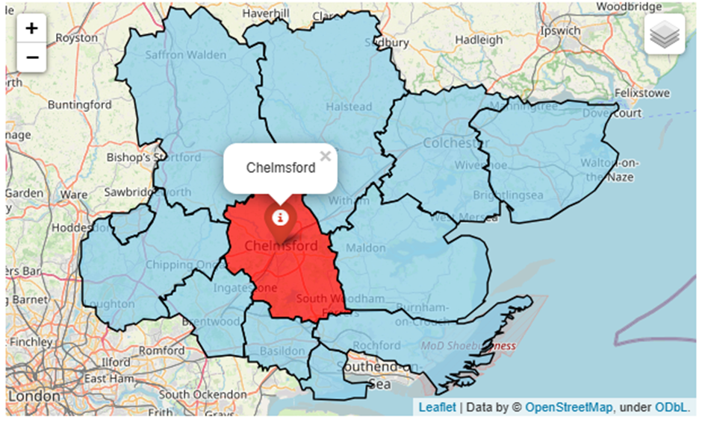

Chelmsford Locality
Covering approximately 339 square kilometers, the Chelmsford borough is situated at the heart of Essex and was granted city status in 2012.

The borough consists of two main urban areas - the county town of Chelmsford and the town of South Woodham Ferrers - along with villages and other rural areas. Chelmsford has a population of 185,278 and 530 people live per square km.

In the Indices of Multiple Deprivation 2019 the Chelmsford Local Authority area was ranked 260 out of 317 lower tier authorities in England. This places Chelmsford in the top 20% of least deprived Lower Tier Local Authorities (LTLAs) nationally.

As of 2019 the Chelmsford area contains 107 LSOAs of which 1 is ranked in the bottom two most deprived deciles nationally. This is equivalent to 0.9% of LSOAs in the area and is lower than the average for Essex.
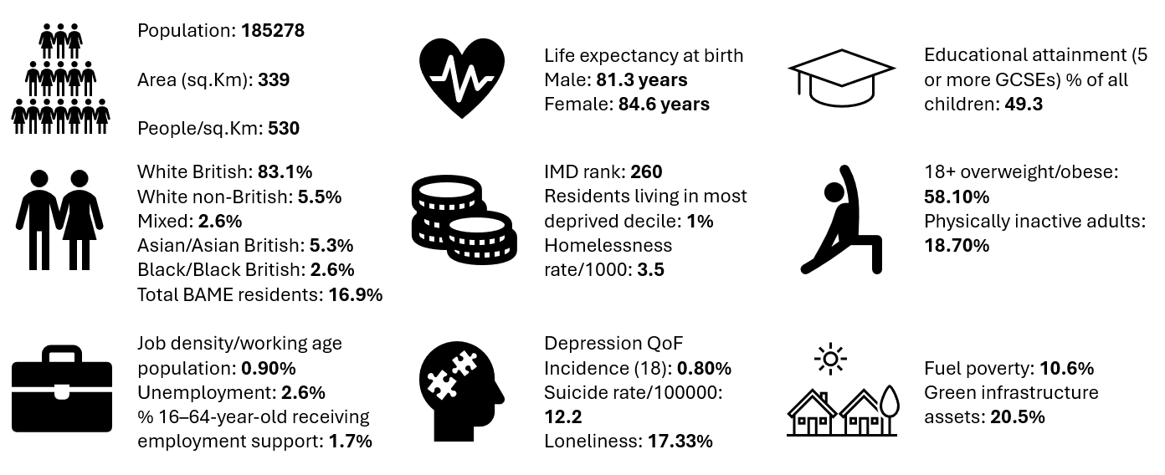

Further details can be accessed in the Essex Joint Strategic Needs Assessment https://data.esse x.gov.uk/

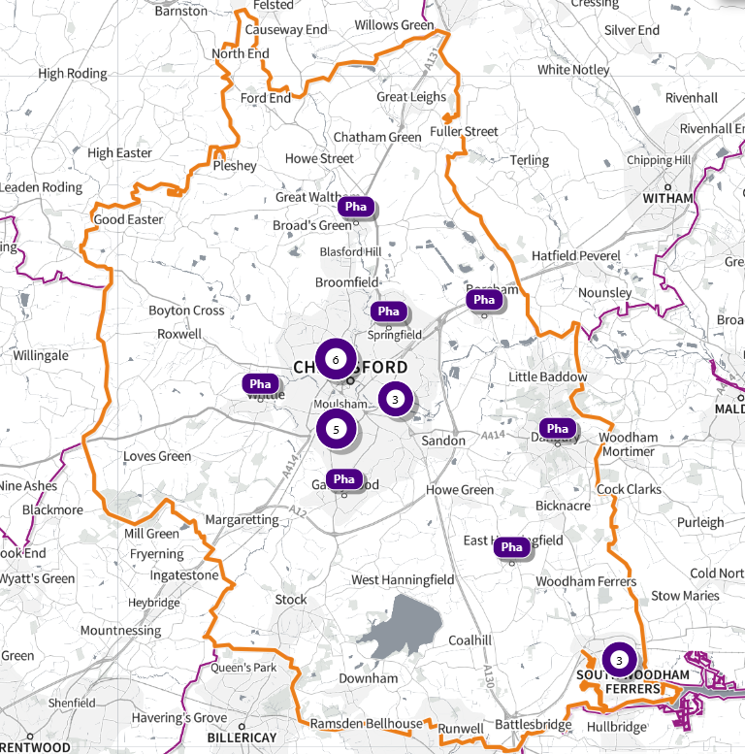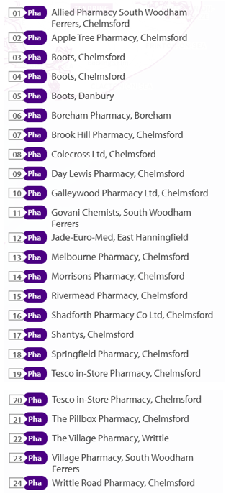
Source: SHAPE Place • Local Authority Districts (as at 02/01/2025)
Figure 41 Map of Chelmsford Pharmacies

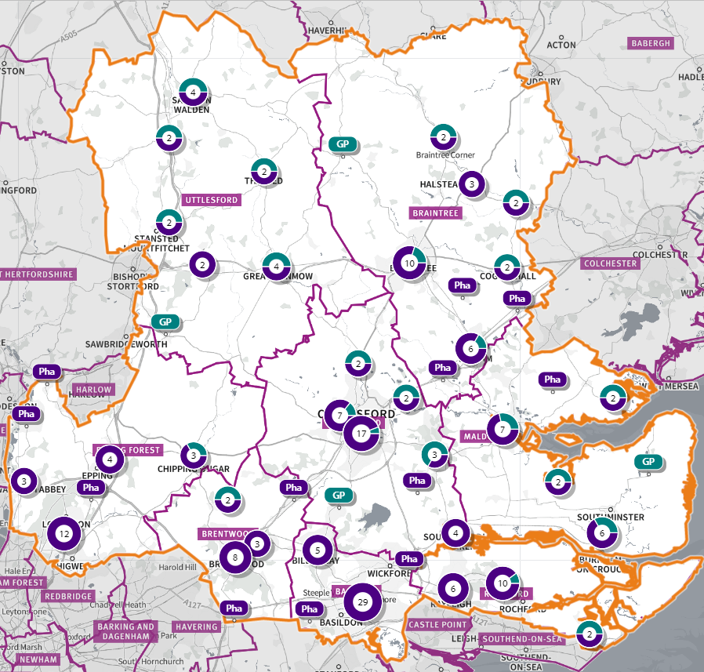
Source: Shape Place Atlas
Figure 42 Map of Pharmacies and dispensing doctors within the Chelmsford locality, and neighbouring pharmacy provision

Pharmaceutical services provision in the locality

Provision
The information contained in this report was obtained from NHSE, local commissioners and a contractor survey.
Opening hours were obtained via the NHSE pharmacy contracts team.
Service provision for advanced services was obtained via NHSE, NHSBSA and with the support of the local CPL.

Access
Appendix F shows that using the base population data on the SHAPE Place Atlas platform, it is possible to calculate the Essex population (and by district) that are estimated to have a journey time either within 20 minutes, 20 - 30 minutes or over 30 minutes to a pharmacy across Essex and within a 1.6KM buffer zone around Essex by each journey method.

Overall, across Essex, generally residents are within a relatively short travel time whichever method is chosen:
- 99.9% of the Essex population could get to a pharmacy in a 20-minute drive.
- 93% (Weekday Morning) within a 30-minute public transport journey.
- 83% within a 20-minute walk. Residents have to travel for longer if they walk.
- 12% over 30-minute walk away.
- Chelmsford residents can drive to a pharmacy within 20 minutes.
- Most residents can get to a pharmacy within a 20-minute journey on public transport in most districts. However, some districts see a relatively high % of their population having to travel for longer (Braintree, Maldon, Uttlesford 20-30 minutes; Braintree, Epping Forest, Uttlesford over 30 minutes.)
- Most residents can get to a pharmacy within 20-minute walk in most districts. Some districts however see a relatively higher % of their population that’d have to walk further (Braintree, Brentwood, Uttlesford 20-30 minutes; Braintree, Maldon, Uttlesford over 30 minutes).

Travel time to access pharmaceutical services are no longer than journey times to access key services as shown in section 6 of this report.

From the results of the public survey (Appendix E) 82% of residents stated that they had a less than 20 minutes travel to the pharmacy, 12% had travelled between 20-30 minutes, and 4% had travelled between 30-45 minutes.
60% made the trip by car, and 51% had travelled on foot—only 5% travelled by bicycle, 3% by public transport and 1% by taxi.

Chelmsford residents also have access to dispensing doctors, pharmacies in neighbouring HWB areas and distance selling pharmacies in England. Analysis of dispensing flows in the Mid Essex CCG area shows that 89% of prescriptions generated in the CCG are dispensed within the area and 11% out of area including distance selling pharmacies.

Pharmaceutical services in the locality

Table 16 Number and type of providers of pharmaceutical services in the area
Type Of Contract | Chelmsford
Total Number of Community Pharmacies | 23 (plus 1 DAC)
Dispensing Doctors | 7
Dispensing Appliance Contractors | 1
Distance Selling Pharmacies | 0

Table 17 Pharmacy contractors in the locality and provision of national NHS commissioned services
Service Key |  |  |  |  |  |  |  | 1 | 2 | 3 | 4 | 5
Organisation code | Trading Name | Address line | Town | Postcode | Hours: M - F* OPENING HOURS SUPPLEMENTARY | Hours: Sat OPENING HOURS SUPPLEMENTARY | Hours: Sun OPENING HOURS  SUPPLEMENTARY | PHARMACY FIRST | HYPERTENSION | CONTRACEPTION | LATERAL FLOW | SMOKING CESSATION
FJM80 | Allied Pharmacy South Woodham Ferrers | 6 Brickfields Road | Chelmsford | CM3 5XB | 9:00 - 18:00  13:20 - 14:00  Closed 13:00 - 13:20 | Closed | Closed | ü | ü | ü |  | ü
FL640 | Apple Tree Pharmacy | 6 Chelmer Village Square | Chelmsford | CM2 6RF | 9:00 - 18:00  13:00 - 14:00 | Closed | Closed | ü | ü | ü
FHG91 | Boots | Eves Corner, Maldon Road | Danbury | CM3 4QF | 8:30 - 18:00  8:30 - 9:00,  13:00 - 14:00 &  17:30 - 18:00 | 8:30 - 17:00  8:30 - 9:00 &  11:30 - 17:00 | Closed | ü | ü | ü | ü
FM336 | Boots | Unit B2, Chelmer Village Retail Park | Chelmsford | CM2 6XE | 9:00 - 20:00  14:00 - 15:00 &  17:00 - 20:00 | 9:00 – 20:00  14:00 - 20:00 | 10:30 - 16:00 | ü | ü | ü | ü
FPD07 | Boots | 43 High Chelmer | Chelmsford | CM1 1DD | 9:00 - 18:00 (9:00 – 19:00 Thurs)  12:00 - 13:00 &  17:00 - 18:00 (17:00 – 19:00 Thurs) | 9.00 - 18:00  12:00 - 13:00 &  15:00 - 18:00 | 10:30 - 16:00 | ü | ü | ü | ü
FNH19 | Boreham Pharmacy | The Laurels, Juniper Road | Boreham | CM3 3DX | 8:30 - 18:30  8:30 - 9:00 &  18:00 - 18:30  Closed 13:00 - 14:00 | 9:00 - 12:00 | Closed | ü | ü | ü | ü | ü
FE215 | Brook Hill Pharmacy | 30 Brook Hill | Chelmsford | CM3 3LL | 8:30 - 18:30  8:30 - 9:00 &  17:00 - 18:30 | 8:00 - 12:00 | Closed | ü
FXM66 | Colecross | 1 Hylands Parade, Wood Street | Chelmsford | CM2 8BW | 9:00 - 18:00  13:00 - 14:00 | 9:00 - 13:00 | Closed | ü | ü | ü |  | ü
FN033 | Day Lewis Pharmacy | 136 Gloucester Avenue | Chelmsford | CM2 9LG | 9:00 - 18:00  17:00 - 18:00 | 9:00 - 13:00 | Closed | ü | ü | ü | ü
FQ192 | Galleywood Pharmacy Ltd | 39 Watchhouse Road | Chelmsford | CM2 8PU | 9:00 - 17:30  13:00 - 14:00 (16:00 – 17:30 Wed) | 9:00 - 13:00 | Closed | ü | ü | ü | ü
FPE21 | Govani Chemists | 14 Queen Elizabeth Square | South Woodham Ferrers | CM3 5TD | 9:00 - 18:00  9:00 - 9:30 &  13:00 - 14:00 &  17:30 - 18:00 | 9:00 – 17:00  9: 00- 9:30 & 14:30 – 17:00 | Closed | ü | ü | ü | ü
FD477 | Melbourne Pharmacy | 18 Melbourne Parade | Chelmsford | CM1 2DW | 9:00 - 18:00  17:00 - 18:00 | 9:00 - 12:30 | Closed | ü | ü | ü | ü | ü
FNW43 | Morrisons Pharmacy | Dickens Place, Copperfield Road | Chelmsford | CM1 4UX | 9:00 - 19:00  17:00 - 19:00  Closed 13:00 - 14:00 | 9:00 - 19:00  15:00 - 19:00  Closed 13:00 - 14:00 | 10:00 - 16:00 | ü | ü | ü | ü
FPK31 | Shadforth Pharmaceutical Co Ltd | 253 Broomfield Road | Chelmsford | CM1 4DP | 8:30 - 18:30  8:30 - 9:00 &  13:00 - 13:30 &  17:30 - 18:30 | 9:00 - 13:00 | Closed | ü | ü |  | ü | ü
FP682 | Shantys | 62 Baddow Road | Chelmsford | CM2 0DL | 9:00 - 18:30  18:00 - 18:30  Closed 13:00 - 14:00 | Closed | Closed | ü | ü | ü |  | ü
FH505 | Springfield Pharmacy | 1 Clematis Tye, Crocus Way | Chelmsford | CM1 6GL | 9:00 - 18:30  18:00 - 18:30  Closed 13:00 -14:00 | 9:00 - 13:00 | Closed | ü | ü | ü | ü | ü
FQR56 | Tesco In-store Pharmacy | 47-53 Springfield Rd | Chelmsford | CM2 6QT | 8:00 - 20:00  8:00 - 9:00 &  16:30 - 20:00 (17:00 – 20:00 Mon, Tue)  Closed 13:00 - 14:00 | 8:00 - 20:00  8:00 - 9:00 &  16:30 - 20:00  Closed 13:00 - 14:00 | 11:00 - 17:00 | ü | ü | ü | ü
FW239 | Tesco In-store Pharmacy (100-hour Pharmacy) | Princes Road | Chelmsford | CM2 9XW | 9:00 – 21:00 | 9:00 - 21:00 | 10:00 - 16:00 | ü | ü | ü | ü
FR890 | The Pillbox Pharmacy | 152 Meadgate Avenue | Chelmsford | CM2 7LJ | 9:00 - 18:30  17:00 - 18:30 | 9:00 - 12:00 | Closed |  | ü
FP905 | The Village Pharmacy | 52 The Green | Writtle | CM1 3DU | 9:00 - 18:30 (9:00 – 17:30)  17:30 - 18:30 (17:00 – 17:30)  Closed 13:00 - 14:00 | 9:00 - 13:00  12:00 - 13:00 | Closed | ü | ü | ü | ü | ü
FJH49 | Rivermead Pharmacy | Unit 3&4 Rivermead Gate | Chelmsford | CM1 1TR | 8:30 - 18:30  8:30 – 9:00  13:00 – 13:30  17:30 - 18:30 | Closed | Closed | ü | ü | ü | ü | ü
FG137 | Writtle Road Pharmacy | Unit 1A, Crompton Building | Chelmsford | CM1 3RW | 8:30 - 17:30  8:30-9:00 | 9:00 - 13:00 | Closed | ü | ü | ü | ü | ü
FQH29 | Village Pharmacy | 36-38 Hullbridge Road | South Woodham Ferrers | CM3 5NG | 9:00 - 18:30  13:00 - 14:00 &  17:30 - 18:30 (16:00 – 18:30 Tue) | 9:00 - 13:00 | Closed | ü | ü | ü | ü
FMG28 | Jade-Euro-Med (DAC) | 14 Hanningfield Ind Est, Old Church Road | East Hanningfield | CM3 8AB | 9:00 - 17:00 |  |  | N/A | N/A | N/A | N/A | N/A

Chelmsford opening hours
- Weekday opening hours were taken from Friday as a standard.
- Monday to Friday, all 24 community pharmacies are open between the hours of 9:00 to 17:00.
- Earliest opening time is 8:00 and latest closing time is 21.00.
- On Saturdays 19 pharmacies are open in the morning and 7 of the pharmacies remain open in the afternoon (beyond 1pm). The latest closing time is 21.00.
- On Sundays 5 pharmacies are open, earliest opening is 10.00 and latest closing is 16.00.

Services (data January 2025)
There is good access to commissioned services within the locality.
The necessary services of NMS and CPCS are provided by many of the pharmacies.
The NHSE commissioned services that are not provided by pharmacies are delivered by other organisations in the locality.
Services are also locally commissioned by Essex County Council Public Health and the ICBs.
The provision of these is not shown as it changes frequently.
Details can be obtained from the commissioners.

Housing (Appendix G)
The impact of local housing development plans on provision of pharmaceutical services has been considered but has not identified any gaps in pharmaceutical services provision in the area during the lifetime of this PNA.

No gaps in the provision of necessary pharmaceutical services have been identified in the
Chelmsford locality

No gaps in pharmaceutical services have been identified that if provided either now or in the future would secure improvements or better access to relevant services across the Chelmsford locality

6.6 Colchester Locality
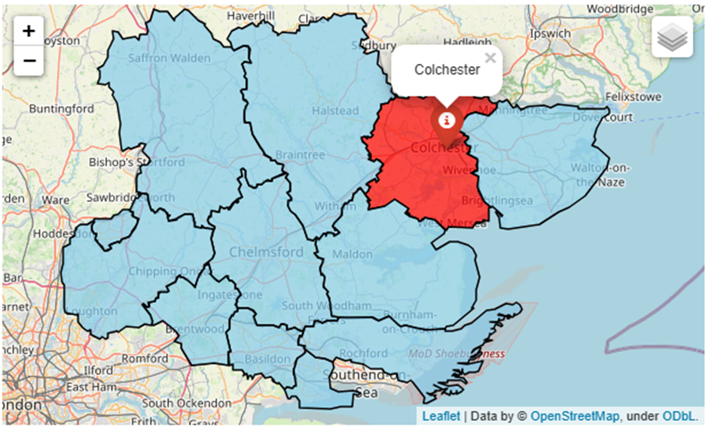

Colchester Locality
The borough of Colchester is situated in the North East of Essex and covers an area of approximately 328 square kilometers. The main settlement is Colchester, which was granted City-status to mark the Queen’s Platinum Jubilee year, but there are many surrounding small towns and villages of which the largest are Stanway, Tiptree, West Mersea and Wivenhoe.

Colchester district has a population of 196,998 with 601 people living per square km, making it the most populous district in Essex. 80.7% of the population are White British ethnicity. In the Indices of Multiple Deprivation 2019 the Colchester Local Authority area was ranked 181 out of 317 lower tier authorities in England. This places Colchester in the upper 50% of least deprived Lower Tier Local Authorities (LTLAs) nationally.

As of 2019 the Colchester area contains 105 LSOAs of which 11 are ranked in the bottom two most deprived deciles nationally. This is equivalent to 10.5% of LSOAs in the area.

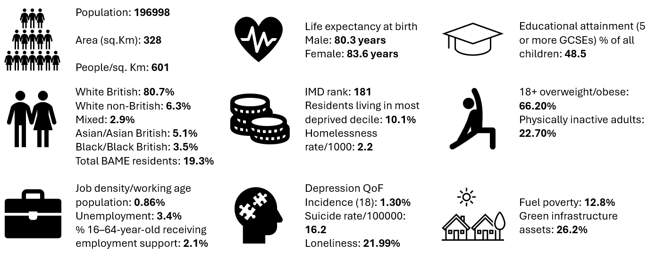
Further details can be accessed in the Essex Joint Strategic Needs Assessment https://data.essex.gov.uk/

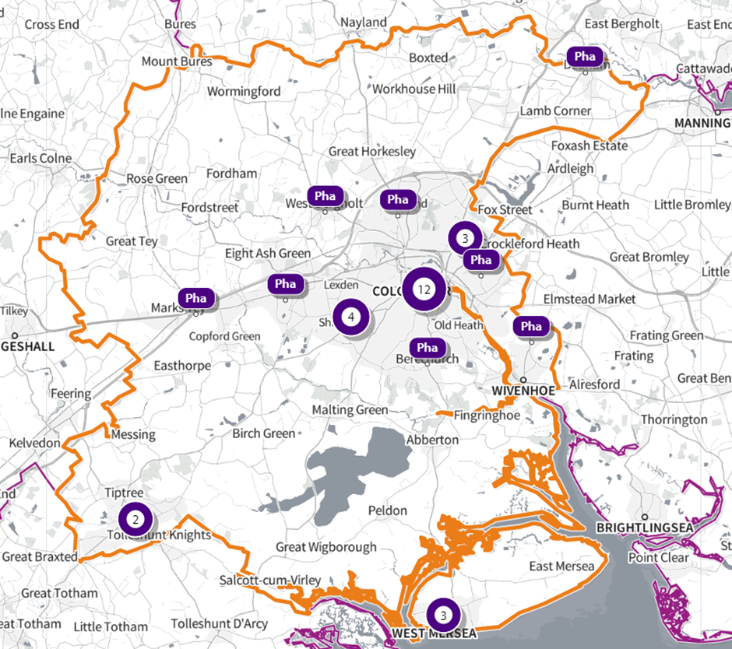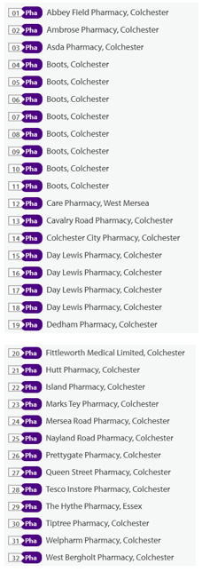
Source:SHAPE Place • Pharmacy (as at 02/01/2025)
Figure 43 Map of Colchester Pharmacies

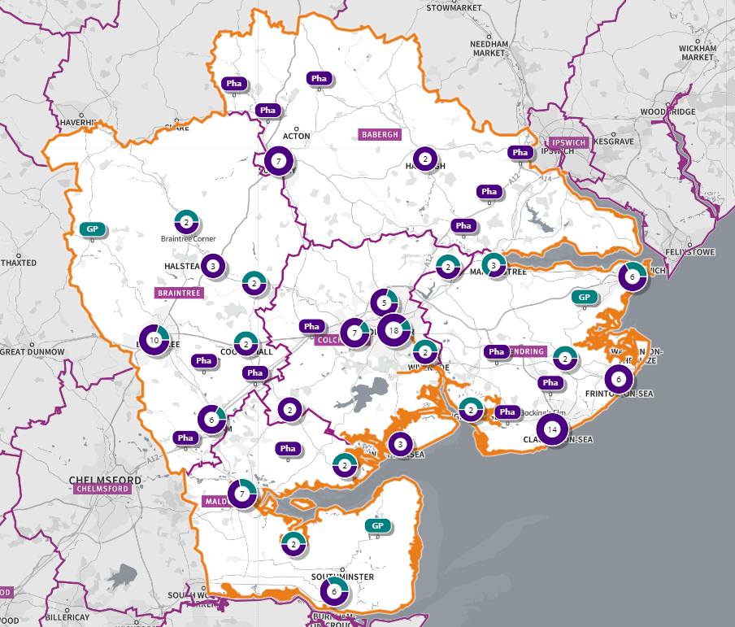
Source: Shape Place Atlas
Figure 44 Map of Pharmacies and dispensing doctors within the Colchester locality, and neighbouring pharmacy provision

Pharmaceutical services provision in the locality

Provision
The information contained in this report was obtained from NHSE, local commissioners and a contractor survey.
Opening hours were obtained via the NHSE pharmacy contracts team.
Service provision for advanced services was obtained via NHSE, NHSBSA and with the support of the local CPL.

Access
Appendix F shows that using the base population data on the SHAPE Place Atlas platform, it is possible to calculate the Essex population (and by district) that are estimated to have a journey time either within 20 minutes, 20 - 30 minutes or over 30 minutes to a pharmacy across Essex and within a 1.6KM buffer zone around Essex by each journey method.

Overall, across Essex, generally residents are within a relatively short travel time whichever method is chosen:
- 99.9% of the Essex population could get to a pharmacy in a 20-minute drive.
- 93% (Weekday Morning) within a 30-minute public transport journey.
- 83% within a 20-minute walk. Residents have to travel for longer if they walk.
- 12% over 30-minute walk away.
- Colchester residents can drive to a pharmacy within 20 minutes
- Most residents can get to a pharmacy within a 20-minute journey on public transport in most districts. However, some districts see a relatively high % of their population having to travel for longer (Braintree, Maldon, Uttlesford 20-30 minutes; Braintree, Epping Forest, Uttlesford over 30 minutes).
- Most residents can get to a pharmacy within 20-minute walk in most districts. Some districts however see a relatively higher % of their population that’d have to walk further (Braintree, Brentwood, Uttlesford 20-30 minutes; Braintree, Maldon, Uttlesford over 30 minutes).

Travel time to access pharmaceutical services are no longer than journey times to access key services as shown in section 6 of this report.

From the results of the public survey (Appendix E) 82% of residents stated that they had a less than 20 minutes travel to the pharmacy, 12% had travelled between 20-30 minutes, and 4% had travelled between 30-45 minutes.
60% made the trip by car, and 51% had travelled on foot—only 5% travelled by bicycle, 3% by public transport and 1% by taxi.

Colchester residents also have access to dispensing doctors, pharmacies in other HWB areas and distance selling pharmacies in England.

Analysis of dispensing flows in the North East Essex CCG area shows that 91% of prescriptions generated in the CCG are dispensed within the area and 9% out of area including 5% by distance selling pharmacies.

Pharmaceutical services in the locality

Table 18 Number and type of providers of pharmaceutical services in the area
Type Of Contract | Colchester
Total Number of Community Pharmacies | 30 (+ 1 DAC + 1 DSP)
Dispensing Doctors | 5
Dispensing Appliance Contractors | 1
Distance Selling Pharmacies | 1

Table 19 Pharmacy contractors in the locality and provision of national NHS commissioned services
Service Key |  |  |  |  |  |  |  | 1 | 2 | 3 | 4 | 5
Organisation code | Trading Name | Address line | Town | Postcode | Hours: M - F* OPENING HOURS SUPPLEMENTARY | Hours: Sat OPENING HOURS SUPPLEMENTARY | Hours: Sun OPENING HOURS  SUPPLEMENTARY | PHARMACY FIRST | HYPERTENSION | CONTRACEPTION | LATERAL FLOW | SMOKING CESSATION
FTA74 | Abbey Field Pharmacy | Abbey Field Medical Centre, Ypres Road | Colchester | CO2 7UW | 8:30 – 18:00 |  |  | ü | ü | ü |  | ü
 |  |  |  |  | 8:30 - 9:00 &  17:30 - 18:00 | 9:00 - 13:00 | Closed
FXG91 | Ambrose Pharmacy (100 Hour Pharmacy) | 76 Ambrose Avenue | Colchester | CO3 4LN | 10:00 - 21:00 | 10:00 - 21:00 | 8:00 - 21:00 | ü | ü | ü
 |  |  |  |  |  | Closed 13:00 - 17:00
FWM54 | Asda Pharmacy (100 Hour Pharmacy) | Unit 9 Turner Rise, Petrolea Close | Colchester | CO4 5TU | 9:00 - 21:00  Closed 12:30 - 13:00 & 16:30 – 17:00 | 9:00 - 21:00  Closed 12:30 - 13:00 & 16:30 – 17:00 | 10:00 - 16:00 | ü | ü | ü | ü
FGG82 | Boots | 11 Vine Parade, Wivenhoe | Colchester | CO7 9HA | 9:00 - 18:30 | 9:00 - 17:00 |  | ü | ü | ü
 |  |  |  |  | 18:00 - 18:30 (14:00 – 18:30 Thurs) | 14:00 - 17:00 | Closed
 |  |  |  |  | Closed 13:00 - 14:00 | Closed 13:00 - 14:00
FHH99 | Boots | 37 Barfield Road. West Mersea | Colchester | CO5 8QX | 9:00 - 18:30 | 8:30 - 17:30 |  | ü | ü | ü | ü
 |  |  |  |  |  | 8:30 - 9:00 &  11:30 - 17:30 | Closed
 |  |  |  |  | 13:00 - 14:00 & 17:30 – 18:30 | Closed 13:00 - 14:00
FMP08 | Boots (100 Hour Pharmacy) | 2/4 West Parade, Plume Avenue | Colchester | CO3 4PG | 8:00 - 21:00  13:00 – 14:00 | 8:00 - 21:00  13:00 – 14:00 | 09:00 - 19:00 | ü | ü | ü | ü | ü
FQ064 | Boots | 5-6 Lion Walk | Colchester | CO1 1LX | 8:30 - 18:00 | 9:00 - 18:00 |  | ü | ü | ü | ü
 |  |  |  |  | 8:30 - 9:00, 14:00 – 15:00 &  17:00 - 18:00 | 9:00 - 9:30, 14:00 – 15:00 &  17:00 - 18:00 | 10:30 - 16:00
FQL97 | Boots | St Edmunds Centre, Tamarisk Way. Greenstead | Colchester | CO4 3GW | 9:00 - 18:00 |  |  | ü | ü | ü | ü
 |  |  |  |  |  | 9:00 - 16:00 | Closed
 |  |  |  |  | Closed 13:00 - 14:00
FWC44 | Boots (100 Hour Pharmacy) | Unit 9 Tollgate West. Stanway | Colchester | CO3 8RG | 8:00 - 21:00 | 8:00 - 21:00 | 10:00 - 18:00 | ü | ü | ü | ü
 |  |  |  |  | 13:00 - 14:00 | 13:00 - 14:00 | 16:00 - 18:00
FWP44 | Boots | 3-5 The Centre, Church Road. Tiptee | Colchester | CO5 0HF | 9:00 - 18:00 (9:00 – 13:00 Wed) | 9:00 - 17:00 |  | ü | ü | ü | ü
 |  |  |  |  | 13:00 - 14:00 | 13:00 - 17:00 | Closed
FXK05 | Boots | 118 Military Road | Colchester | CO1 2AR | 8:30 - 18:30 |  |  | ü | ü | ü | ü
 |  |  |  |  | 8:30 - 9:00,  13:00 - 14:00 &  18:00 - 18:30 | 9:00 - 16:00 | Closed
FCX92 | Care Pharmacy (100 Hour Pharmacy) | Retail Unit 1, 37/39 Kingsland Road. West Mersea | Colchester | CO5 8RA | 11:30 - 21:00 | 11:30 - 21:00 | 6:00 - 21:00 | ü
FRH62 | Cavalry Road Pharmacy | 15 Cavalry Road | Colchester | CO2 7GH | 8:00 - 20:30 |  |  | ü | ü | ü | ü | ü
 |  |  |  |  | 8:00 - 9:00 &  13:00 - 14:00 &  18:00 - 23:00 | 8:00 - 13:00 | Closed
FDL70 | Colchester City Pharmacy | 7 Priory Walk | Colchester | CO1 1LG | 9:00 - 17:30  (9:00 - 22:00 Fri only)  Closed 13:30 – 14:00 (17:30 – 18:00 Fri only) | 9:00 - 22:00 | 9:00 - 22:00
FAX47 | Crouch End Pharmacy | 77 Crouch Street | Colchester | CO3 3EZ | 9:00 - 18:00 |  |  | ü | ü | ü | ü
 |  |  |  |  | 13:00 - 14:00 | Closed | Closed
FCF12 | Day Lewis Pharmacy | 338 Harwich Road | Colchester | CO4 3HP | 9:00 - 18:00  Closed 13:00 - 13:30 | 9:00 - 13:00 | 12:00 - 14:00 | ü | ü | ü | ü
 |  |  |  |  |  |  | 13:00 - 14:00
FPQ30 | Day Lewis Pharmacy | 38 St.Christopher Road | Colchester | CO4 0NA | 8:30 - 17:30 |  |  | ü | ü | ü | ü
 |  |  |  |  | 8:30 – 9:00 & 17:00 - 17:30 | 9:00 - 13:00 | Closed
FTG75 | Dedham Pharmacy | High Street | Dedham | CO7 6DE | 9:00 - 17:00 | 9:00 - 14:00 |  | ü | ü | ü
 |  |  |  |  |  |  | Closed
 |  |  |  |  | Closed 13:00 - 14:00
FC645 | Hutt Pharmacy | 4 The Square, Iceni Way | Colchester | CO2 9EB | 9:00 - 18:00 |  |  | ü | ü | ü
 |  |  |  |  |  | 9:00 - 13:00 | Closed
 |  |  |  |  | Closed 13:00 - 14:00
FK840 | Island Pharmacy (100 Hour Pharmacy) | 4 & 5 Kingsway, Barfield Rd. West Mersea | Colchester | CO5 8QT | 9:00 - 21:00 | 10:00 - 21:00 | 10:30 - 16:30 | ü | ü | ü | ü | ü
 |  |  |  |  | Closed 13:00 - 14:00
FEL66 | Marks Tey Pharmacy | 89 London Road | Colchester | CO6 1EB | 8:30 - 17:30 (8:30 – 14:00 Wed) | 9:00 - 14:00 |  | ü | ü | ü | ü
 |  |  |  |  | 8:30 - 9:00 &  13:00 - 14:00 |  | Closed
FN556 | Mersea Road Pharmacy | 358 Mersea Road | Colchester | CO2 8RB | 9:00 - 18:30 | 9:00 - 13:00 |  | ü | ü | ü | ü
 |  |  |  |  | 12:30 - 14:30 | 9:00 - 9:30 &  12:00 - 13:00 | Closed
FC139 | Nayland Road Pharmacy | 13 Nayland Road | Colchester | CO4 5EG | 9:00 - 18:00  Closed 13:00 – 14:00 | Closed | Closed | ü | ü | ü | ü | ü
FHK01 | Prettygate Pharmacy | 102 The Commons | Colchester | CO3 4NW | 8:45 - 18:00  12:00 - 14:00 | 9:00 - 17:30  13:00 - 17:30 | Closed | ü | ü | ü | ü | ü
FJH41 | Priory Pharmacy | 81A East Hill | Colchester | CO1 2QW | 8:30 - 18:30 |  |  | ü | ü | ü | ü
 |  |  |  |  | 8:30 - 9:00 &  18:00 - 18:30 | Closed | Closed
 |  |  |  |  | Closed 13:00 - 14:00
FV129 | Queen Street Pharmacy (100 Hour Pharmacy) | 12 Queen Street | Colchester | CO1 2PJ | 9:00 - 21:00 | 10:00 - 21:00 | 10:30 - 16:30 | ü | ü | ü | ü | ü
FTC16 | Tesco In-store Pharmacy | The In-Store Pharmacy, Highwoods | Colchester | CO4 9ED | 8:00 - 20:00 | 8:00 - 20:00 |  | ü | ü | ü | ü | ü
 |  |  |  |  | 8:00 - 9:00 &  13:00 - 14:00 &  16:30 - 20:00 (17:00 – 20:00 Mon, Tue) | 8:00 - 9:00 &  13:00 - 14:00 &  16:30 - 20:00 | 10:00 - 16:00
FGW89 | The Hythe Pharmacy | 2 Hythe Quay | Colchester | CO2 8JB | 9:00 - 18:00 |  |  | ü | ü | ü | ü | ü
 |  |  |  |  | 13:00 - 14:00 | 9:00 - 13:00 | Closed
FPP46 | Tiptree Pharmacy (100-Hour Pharmacy) | Unit 4, 80 Church Road | Colchester | CO5 0HB | 9:00 - 21:00 | 9:00 - 21:00 | 9:00 - 22:00 | ü | ü
FW890 | West Bergholt Pharmacy | 39 Chapel Road | Colchester | CO6 3JB | 9:00 - 18:00 |  |  | ü | ü | ü | ü | ü
 |  |  |  |  |  | 9:00 - 13:00 | Closed
 |  |  |  |  | Closed 13:00 - 14:00
FQV90 | Welpharm Pharmacy (DSP) | 4 Phoenix Court, Hawkins Road | Colchester | CO2 8JY | 9:00 - 17:00 |  |  | ü
 |  |  |  |  |  | Closed | Closed
FWC51 | Fittleworth Medical Ltd (DAC) | D41-D42 Moorside Business | Colchester | CO1 2ZF | 9:00 - 17:00  15:00 - 17:00 | Closed | Closed | N/A | N/A | N/A | N/A | N/A

Colchester opening hours
- Weekday opening hours were taken from Friday as a standard.
Monday to Friday, all 32 community pharmacies are open between the hours of 9:00 to 17:00.
Earliest opening time is 8.00 and latest closing time is 21.00.
- On Saturdays 27 pharmacies are open in the morning and 19 of the pharmacies remain open in the afternoon. The latest closing time is 22.00.
- On Sundays 13 pharmacies are open, earliest opening is 9.00 and latest closing is 22.00.

Services (data January 2025)
There is good access to commissioned services within the locality.
The necessary services of NMS and CPCS are provided by many of the pharmacies.
The NHSE commissioned services that are not provided by pharmacies are delivered by other organisations in the locality.
Services are also locally commissioned by Essex County Council Public Health and the ICBs.
The provision of these is not shown as it changes frequently.
Details can be obtained from the commissioners.

Housing (Appendix G)
The impact of local housing development plans on provision of pharmaceutical services has been considered but has not identified any gaps in pharmaceutical services provision in the area during the lifetime of this PNA.

No gaps in the provision of necessary pharmaceutical services have been identified in the
Colchester locality

No gaps in pharmaceutical services have been identified that if provided either now or in the future would secure improvements or better access to relevant services across the Colchester locality

6.7 Epping Forest Locality

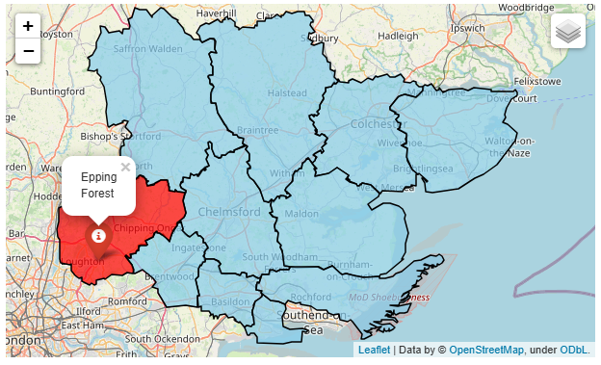
Epping Forest Locality

Epping Forest district covers an area of 339 square kilometers, the key population centers are the commuter towns of Loughton, Chigwell and Buckhurst Hill, as well as the market towns of Epping, Waltham Abbey and Ongar. Epping Forest has a population of 135,975 with 390 people living per square km.

17.2% of the population is of BAME ethnicity which makes it the second most diverse among all Essex districts. Epping forest was ranked 200 out of 317 lower tier local authorities placing it among the upper 40% of the least deprived local authorities nationally.

Only 1.3% of the total population live in the most deprived deciles.

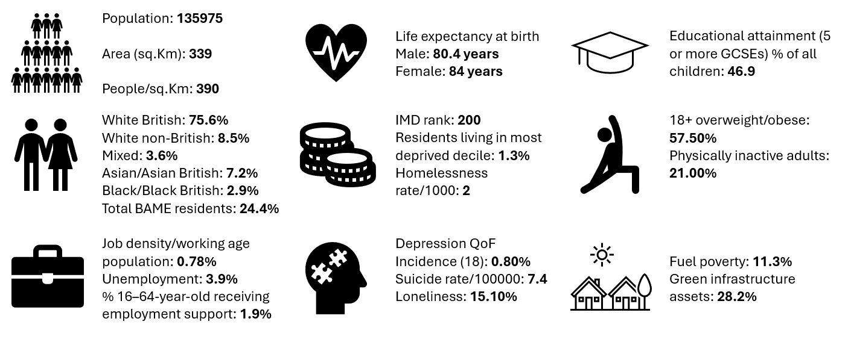
Further details can be accessed in the Essex Joint Strategic Needs Assessment https://data.essex.gov.uk/

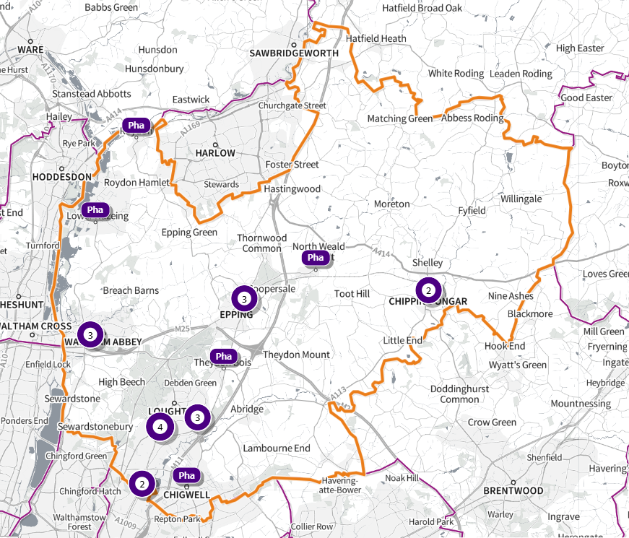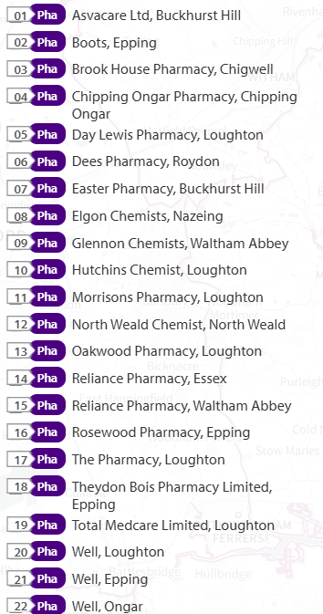
Source: SHAPE Place • Pharmacy (as at 02/01/2025)
Figure 45 Map of Epping Forest Pharmacies

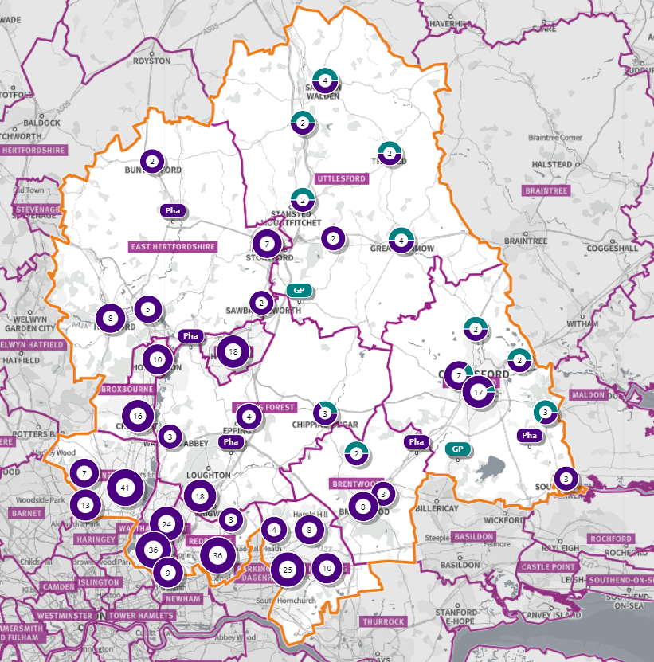
Figure 46 Map of Pharmacies and dispensing doctors within the Epping Forest locality, and neighbouring pharmacy provision

Pharmaceutical services provision in the locality

Provision
The information contained in this report was obtained from NHSE, local commissioners and a contractor survey.
Opening hours were obtained via the NHSE pharmacy contracts team.
Service provision for advanced services was obtained via NHSE, NHSBSA and with the support of the local LPC.

Access
Appendix F shows that using the base population data on the SHAPE Place Atlas platform, it is possible to calculate the Essex population (and by district) that are estimated to have a journey time either within 20 minutes, 20 - 30 minutes or over 30 minutes to a pharmacy across Essex and within a 1.6KM buffer zone around Essex by each journey method.

Overall, across Essex, generally residents are within a relatively short travel time whichever method is chosen:
- 99.9% of the Essex population could get to a pharmacy in a 20-minute drive.
- 93% (Weekday Morning) within a 30-minute public transport journey.
- 83% within a 20-minute walk. Residents have to travel for longer if they walk.
- 12% over 30-minute walk away.
- Epping Forest residents can drive to a pharmacy within 20 minutes.
- Most residents can get to a pharmacy within a 20-minute journey on public transport in most districts. However, some districts see a relatively high % of their population having to travel for longer (Braintree, Maldon, Uttlesford 20-30 minutes; Braintree, Epping Forest, Uttlesford over 30 minutes).
- Most residents can get to a pharmacy within 20-minute walk in most districts. Some districts however see a relatively higher % of their population that’d have to walk further (Braintree, Brentwood, Uttlesford 20-30 minutes; Braintree, Maldon, Uttlesford over 30 minutes).

Travel time to access pharmaceutical services are no longer than journey times to access key services as shown in section 6 of this report.

From the results of the public survey (Appendix E) 82% of residents stated that they had a less than 20 minutes travel to the pharmacy, 12% had travelled between 20-30 minutes, and 4% had travelled between 30-45 minutes.
60% made the trip by car, and 51% had travelled on foot—only 5% travelled by bicycle, 3% by public transport and 1% by taxi.

Epping Forest residents also have access to dispensing doctors, pharmacies in other HWB areas and distance selling pharmacies in England.

Analysis of dispensing flows in the West Essex CCG area shows that 87% of prescriptions generated in the CCG are dispensed within the area and 13% out of area including distance selling pharmacies.

Pharmaceutical services in the locality

Table 20 Number and type of providers of pharmaceutical services in the area
Type Of Contract | Epping Forest
Total Number of Community Pharmacies | 22 (plus 1 DSP)
Dispensing Doctors | 1
Dispensing Appliance Contractors | 0
Distance Selling Pharmacies | 1

Table 21 Pharmacy contractors in the locality and provision of national NHS commissioned services
Service Key |  |  |  |  |  |  |  | 1 | 2 | 3 | 4 | 5
Organisation code | Trading Name | Address line | Town | Postcode | Hours: M - F* OPENING HOURS SUPPLEMENTARY | Hours: Sat OPENING HOURS SUPPLEMENTARY | Hours: Sun OPENING HOURS  SUPPLEMENTARY | PHARMACY FIRST | HYPERTENSION | CONTRACEPTION | LATERAL FLOW | SMOKING CESSATION
FM777 | AsvaCare Ltd | 32 Queens Road | Buckhurst Hill | IG9 5BY | 9.00 - 18.30  17.00 - 18.30 | 9.00 -17.30 | Closed | ✓ | ✓ |  | ✓ | ✓
FVK13 | Boots | 223 High Street | Epping | CM16 4BL | 9.00- 18.00  9.00 - 10.00 & 17.00- 18.00 | 9.00 - 18.00  9.00 - 10.00 & 16.00 - 18.00 Closed 14.00 - 15.00 | 10:00 – 16:00 | ✓ | ✓ | ✓ | ✓
FG311 | Brook House Pharmacy | 20 Brook Parade, High Road | Chigwell | IG7 6PF | 9.00 - 18.00  17.00 - 18.00 | 10.00 - 16.00 | Closed | ✓ | ✓ | ✓
FA684 | Chipping Ongar Pharmacy | 205 High Street | Chipping Ongar | CM5 9JG | 8.30 - 18.30  8.30 - 9.00, 12.30 - 14.00 & 18.00 - 18.30 | 9.00 - 13.00  9.00 - 9.30 & 12.00 -13.00 | Closed | ✓ | ✓ | ✓ | ✓ | ✓
FP522 | Day Lewis Pharmacy | 48 Pyrles Lane | Loughton | IG10 2NN | 9.00 - 18.00  Closed 13:00 – 14:00 | Closed | Closed | ✓ | ✓ | ✓ | ✓
FCV41 | Dees Pharmacy | 100 High Street | Roydon | CM19 5EE | 9.00 - 18.00  Closed 13:00 – 14:00 | 9.00 - 17.30 | Closed | ✓ | ✓ | ✓ | ✓ | ✓
FTC47 | Easter Pharmacy | 54 Station Way | Buckhurst Hill | IG9 6LL | 9.00 - 18.00  13.00 - 14.15 & 17.30 - 18.00 | 9.00 - 17.30  13:00 – 17:30 | Closed | ✓ | ✓ | ✓ | ✓ | ✓
FFQ99 | Elgon Chemists | 6-8 Nazeingbury Parade | Nazeing | EN9 2JL | 9.00 - 17.30 (9:00 – 13:00 Wed)  13.00 - 13.30 | 9.00 - 13.00 | Closed | ✓ | ✓ | ✓ | ✓
FG553 | Glennon Chemists | 8 Hillhouse, Ninefields Estate | Waltham Abbey | EN9 3EL | 9.00 - 18.30 (9:00 – 17:00)  14:00 – 14:30  Closed 13.00 - 14.00 | 9.00 - 13.00  10.30 - 13.00 | Closed | ✓ | ✓ | ✓ | ✓ | ✓
FDC61 | Hutchins Chemist | 197 High Road | Loughton | IG10 4LF | 9.00 - 18.30  17.30 - 18.30 Closed 13.00 - 14.00 | 9.00 - 17.00  11.30 - 17.00 Closed 13.00 - 14.00 | Closed | ✓ | ✓ | ✓ | ✓ | ✓
FER40 | Morrisons Pharmacy | 246-250 High Road | Loughton | IG10 1RB | 9.00 - 19.00  13.00 - 14.00 & 17.00 - 19.00 | 9.00 - 19.00 13.00 - 14.00 & 15.00 - 19.00 | 11.00 - 17.00 | ✓ | ✓ | ✓ | ✓
FLR33 | North Weald Chemist | 48 High Road | North Weald | CM16 6BU | 9.00 - 18.30  13.00 - 14.00 & 17.30 - 18.30 | 9.00 - 17.30  11.30 - 17.30 | Closed | ✓
FYE61 | Oakwood Pharmacy Ltd | 118 Roding Road | Loughton | IG10 3EJ | 9.00 - 18.30  17.00 - 18.30 | 9.00 - 17.00 | Closed | ✓ | ✓
FXM06 | Reliance Pharmacy | 10 Sun Street | Essex | EN9 1EE | 9.00 - 15.30  12.30 - 13.00 & 14.00 – 15.30  Closed 13:00 - 14:00 | 9.00 - 17.00  Closed 12:30 - 13:00 | Closed
FAV44 | Reliance Pharmacy | Thrift Cottage Site | Waltham Abbey | EN9 1NP | 9.00 - 18.30  18.00 - 18.30  Closed 13:00 - 14:00 | Closed | Closed
FPH02 | Rosewood Pharmacy | 283-284 High Street | Epping | CM16 4DA | 9.00 - 18.00  12.30 - 14.30 | 9.00 - 17.30  11.30 - 15.00 | Closed | ✓ | ✓ | ✓ | ✓ | ✓
FY418 | The Pharmacy | 36 The Broadway | Loughton | IG10 3ST | 9.00 - 18.00  13.00 - 14.00 & 17.00 - 18.00 | 9.00 - 17.30  14.00 - 17.30 | Closed | ✓ |  |  | ✓ | ✓
FDE36 | Theydon Bois Pharmacy | 10 Forest Drive | Theydon Bois | CM16 7EY | 9.00 - 17.30 (9:00 – 13:00 Wed)  Closed 13.00 - 14.00 | 9.00 - 15.00 | Closed | ✓ | ✓ | ✓ | ✓ | ✓
FEE11 | Well Epping - The Limes Mc | The Limes Medical Centre, The Plain | Epping | CM16 6TL | 9.00 - 18.30  13.00 - 14.30 | Closed | Closed | ✓ | ✓ | ✓ | ✓ | ✓
FG181 | Well Loughton - Loughton Hc | Loughton Health Centre, The Drive | Loughton | IG10 1HW | 8.30 - 18.30  12.30 - 14.30 | Closed | Closed | ✓ | ✓ | ✓ | ✓ | ✓
FAM66 | Well Ongar - High Street | 198-202 High Street | Ongar | CM5 9JJ | 8.30 - 18.30  8.30 - 9.00, 13.00 - 14.00 & 18.00 - 18.30 | 9:00 – 13:00 | Closed | ✓ | ✓ | ✓ | ✓ | ✓
FGE68 | Total Medcare Limited (DSP) | Unit 1, Knight House, Lenthall Road | Loughton | IG10 3UD | 9.00 - 17.30  Closed 13.00 - 13.30 | 9.00 - 12.00 | Closed | ✓ | ✓ | ✓ | ✓ | ✓

Epping Forest opening hours
- Weekday opening hours were taken from Friday as a standard.
Monday to Friday, all 22 community pharmacies are open between the hours of 9:00 to 17:00.
Earliest opening time is 8.30 and latest closing time is 19.00.
- On Saturdays 18 pharmacies are open in the morning and 13 of the pharmacies remain open in the afternoon. The latest closing time is 19.00.
- On Sundays 2 pharmacy is open between 11.00 and 17.00 as latest closing time.

Services (data January 2025)
There is good access to commissioned services within the locality.
The necessary services of NMS and CPCS are provided by many of the pharmacies.
The NHSE commissioned services that are not provided by pharmacies are delivered by other organisations in the locality.
Services are also locally commissioned by Essex County Council Public Health and the ICBs.
The provision of these is not shown as it changes frequently.
Details can be obtained from the commissioners.

Housing (Appendix G)
The impact of local housing development plans on provision of pharmaceutical services has been considered but has not identified any gaps in pharmaceutical services provision in the area during the lifetime of this PNA.
No gaps in the provision of necessary pharmaceutical services have been identified in the
Epping Forest locality

No gaps in pharmaceutical services have been identified that if provided either now or in the future would secure improvements or better access to relevant services across the Epping Forest locality

6.8 Harlow Locality
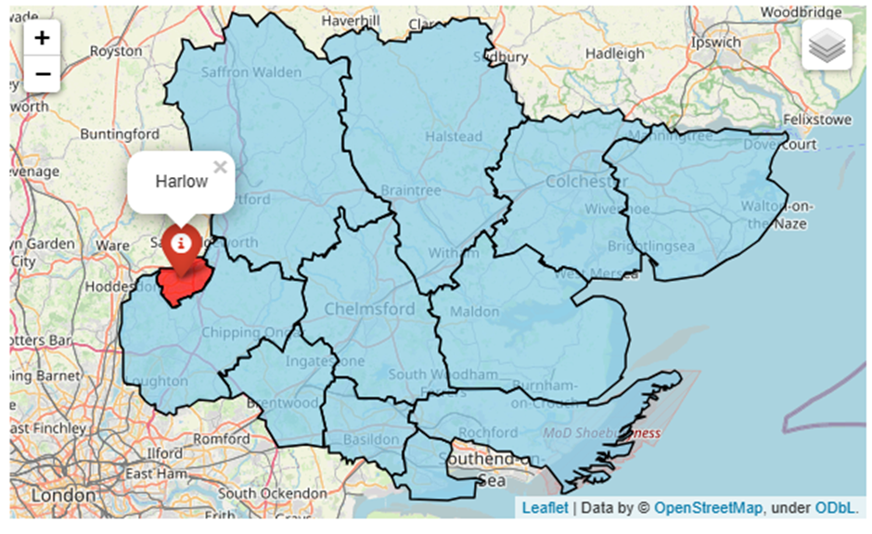
Harlow Locality
Harlow covers an area of 31 square kilometers and is one of several ‘new towns’ built in the 1950’s to provide social housing to people living in London. The town was built on a theme of neighbourhood’s around the town center. Each of the original seven neighbourhoods has necessary amenities – shops, schools, church, health center and district council neighbourhood offices. The aim across the town was to have large areas of green open spaces - most of which have been preserved.

Harlow has a population of 96,040 and is the most densely populated district in Essex with 2,858 people per square km. Harlow is also one of the more diverse districts with 21.1% of residents of Black Asian Minority Ethnicity (BAME), which is highest among all Essex districts.

In the Indices of Multiple Deprivation 2019 the Harlow Local Authority area was ranked 100 out of 317 lower tier authorities in England. This places Harlow in the lower 40% of most deprived Lower Tier Local Authorities nationally. As of 2019 the Harlow area contains 54 LSOAs of which 1 is ranked in the bottom two most deprived deciles nationally.

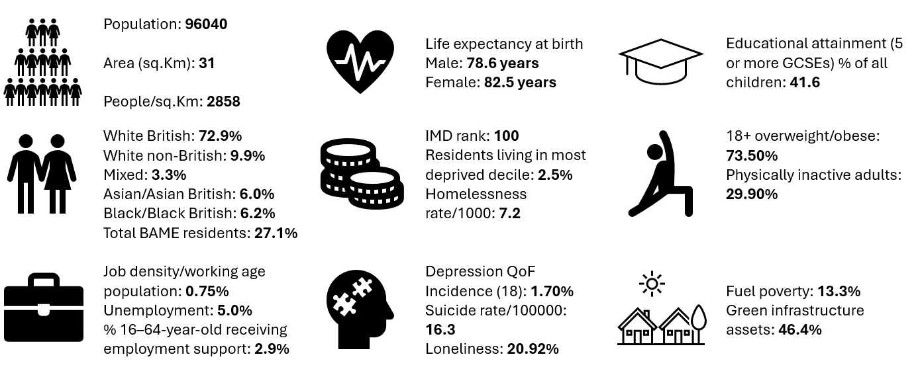
Further details can be accessed in the Essex Joint Strategic Needs Assessment https://data.essex.gov.uk/

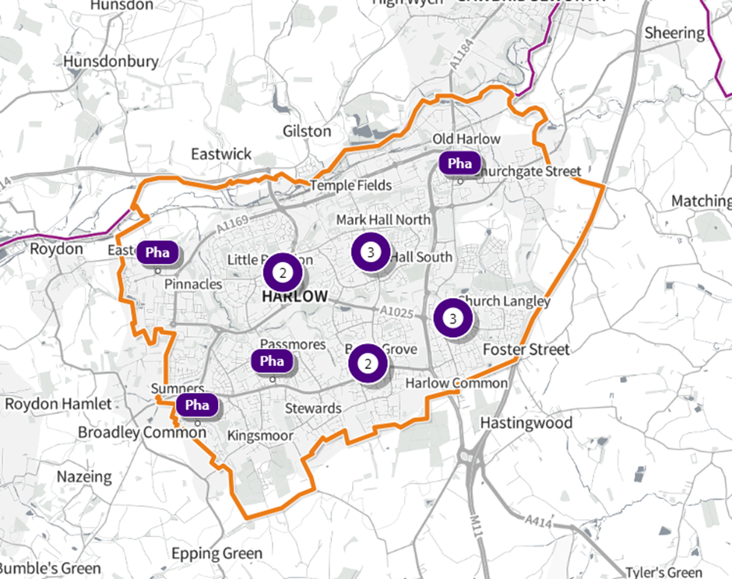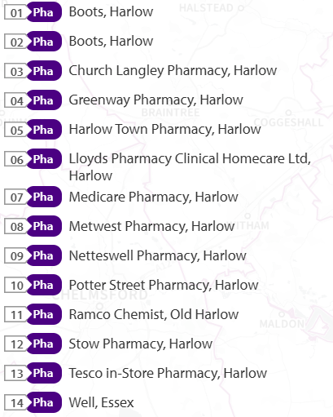
Source: SHAPE Place • Pharmacy (as at 02/01/2025)
Figure 47 Map of Harlow Pharmacies

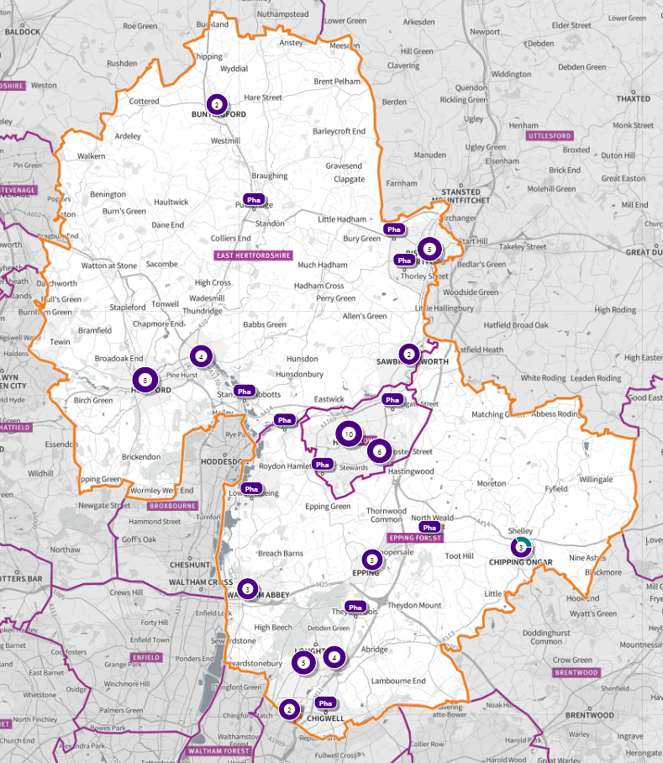
Source: Shape Place Atlas
Figure 48 Map of Pharmacies and dispensing doctors within the Harlow locality, and neighbouring pharmacy provision

Pharmaceutical services provision in the locality

Provision
The information contained in this report was obtained from NHSE, local commissioners and a contractor survey.
Opening hours were obtained via the NHSE pharmacy contracts team.
Service provision for advanced services was obtained via NHSE, NHSBSA and with the support of the local CPL.

Access
Appendix F shows that using the base population data on the SHAPE Place Atlas platform, it is possible to calculate the Essex population (and by district) that are estimated to have a journey time either within 20 minutes, 20 - 30 minutes or over 30 minutes to a pharmacy across Essex and within a 1.6KM buffer zone around Essex by each journey method.

Overall, across Essex, generally residents are within a relatively short travel time whichever method is chosen:
- 99.9% of the Essex population could get to a pharmacy in a 20-minute drive.
- 93% (Weekday Morning) within a 30-minute public transport journey.
- 83% within a 20-minute walk. Residents have to travel for longer if they walk.
- 12% over 30-minute walk away.
- Harlow residents can drive to a pharmacy within 20 minutes.
- Most residents can get to a pharmacy within a 20-minute journey on public transport in most districts. However, some districts see a relatively high % of their population having to travel for longer (Braintree, Maldon, Uttlesford 20-30 minutes; Braintree, Epping Forest, Uttlesford over 30 minutes).
- Most residents can get to a pharmacy within 20-minute walk in most districts. Some districts however see a relatively higher % of their population that’d have to walk further (Braintree, Brentwood, Uttlesford 20-30 minutes; Braintree, Maldon, Uttlesford over 30 minutes).

Travel time to access pharmaceutical services are no longer than journey times to access key services as shown in section 6 of this report.

From the results of the public survey (Appendix E) 82% of residents stated that they had a less than 20 minutes travel to the pharmacy, 12% had travelled between 20-30 minutes, and 4% had travelled between 30-45 minutes.
60% made the trip by car, and 51% had travelled on foot—only 5% travelled by bicycle, 3% by public transport and 1% by taxi.

Harlow residents also have access to pharmacies in other HWB areas and distance selling pharmacies in England. Analysis of dispensing flows in the West Essex CCG area shows that 87% of prescriptions generated in the CCG are dispensed within the area and 13% out of area including distance selling pharmacies.

Pharmaceutical services in the locality

Table 22 Number and type of providers of pharmaceutical services in the area
Type Of Contract | Harlow
Total Number of Community Pharmacies | 14
Dispensing Doctors | 0
Dispensing Appliance Contractors | 0
Distance Selling Pharmacies | 2

Table 23 Pharmacy contractors in the locality and provision of national NHS commissioned services
Service Code |  |  |  |  |  |  |  | 1 | 2 | 3 | 4 | 5
Organisation code | Trading Name | Address line | Town | Postcode | Hours: M - F* OPENING HOURS SUPPLEMENTARY | Hours: Sat OPENING HOURS SUPPLEMENTARY | Hours: Sun OPENING HOURS SUPPLEMENTARY | PHARMACY FIRST | HYPERTENSION | CONTRACEPTION | LATERAL FLOW | SMOKING CESSATION
FNQ36 | Boots | 9 North House, Bush Fair | Harlow | CM18 6PA | 9.00 - 18.30 | 9.00 - 17.00 |  | ✓ | ✓ | ✓ | ✓
 |  |  |  |  | 12.30 - 13.30 & 18.00 - 18.30 (13:00 – 18:00 Thurs) | 12.30 - 17.00 | Closed
FTV09 | Boots | 37 Broadwalk | Harlow | CM20 1JA | 9.00- 17.30 | 9.00 - 17.00 |  | ✓ | ✓ | ✓ | ✓
 |  |  |  |  | 9.00 - 10.00 & 17.00 - 17.30 | 9.00 - 10.00 & 15.00 - 17.00 | 10.00 - 16.00
FMQ91 | Church Langley Pharmacy | Florence Nightingale Health Centre, Minton lane | Harlow | CM17 9TG | 9.00 - 18.30  13.00 - 14.00 & 18.00 - 18.30 | Closed
 |  |  |  |  |  |  | Closed
FR251 | Greenway Pharmacy (DSP) | 73 Sherwood House | Harlow | CM18 6NW | 9.00- 19.00  17.00 – 19.00 | Closed | Closed | ✓ | ✓ | ✓ | ✓ | ✓
FCP20 | Harlow Town Pharmacy | 5 Market House, Stone Cross | Harlow | CM20 1BL | 9.00 - 20.00 | 9.00 – 20.00 |  | ✓ | ✓ | ✓ | ✓ | ✓
 |  |  |  |  | 13.00 - 13.30 & 17.30 – 20.00 | 9.00 – 20.00 | Closed
FKL27 | Lloyds Pharmacy Clinical Homecare Ltd (DSP) | Unit 4, Scimitar Park, Roydon Road | Harlow | CM19 5GU | 9.00- 17.30  17.00 – 17.30 | Closed | Closed
FLV19 | Medicare Pharmacy | 1 Sumners Hatch, Broadley Road | Harlow | CM19 5RD | 9.00 - 18.30 |  |  | ✓ | ✓ | ✓ | ✓ | ✓
 |  |  |  |  | 18.00 - 18.30 & Closed 12.30 - 13.30 | Closed | Closed
FFP42 | Metwest Pharmacy | Unit 2, Lister House Health Centre, Abercrombie Way | Harlow | CM18 6YJ | 9.00 - 18.30 |  | Closed | ✓ | ✓ | ✓ |  | ✓
 |  |  |  |  | 13.00 - 14.00 & 18.00 - 18.30 | 9.00 - 13.00
FWF31 | Netteswell Pharmacy | 1 Pypers Hatch, Maddox Road | Harlow | CM20 3NG | 9.00 - 19.00 (9.00 – 18.00 Thurs) |  |  | ✓ | ✓ | ✓ | ✓ | ✓
 |  |  |  |  | 13.00 - 14.00 (14.00 – 18.00 Thurs) | 9.00 - 13.00 | Closed
FX095 | Potter Street Pharmacy | 12 Prentice Place, Potter Street | Harlow | CM17 9BG | 9.00 - 18.00
 |  |  |  |  | 13.00 - 14.00 | Closed | Closed
FRC09 | Ramco Dispensing Chemist | 43/45 High Street | Old Harlow | CM17 0DN | 9.00 - 18.30 |  |  | ✓ |  |  | ✓
 |  |  |  |  | 13.00 - 13.30 & 17.00 - 18.30 | 10.00 -17.00  12.30 - 17.00 | Closed
FCP78 | Stow Pharmacy | 16 The Stow, Mark Hall | Harlow | CM20 3AH | 9.00 - 17.30 | 9.00 - 17.30 |  | ✓ | ✓ | ✓ | ✓ | ✓
 |  |  |  |  | 9.00 - 10.00 & 17.00 - 17.30 | 9.00 - 10.00, 14.00 - 15.00 & 16.00 - 17.30 | Closed
FM358 | Tesco In-store Pharmacy (100 Hour Pharmacy) | Church Langley Way | Harlow | CM17 9TE | 9.00 - 21.00 | 9.00 - 21.00 | 10.00 - 16.00 | ✓ | ✓ | ✓ | ✓
FW755 | Well Harlow - The Stow | 107 The Stow | Harlow | CM20 3AS | 8.30 - 18.30  8.30 - 9.00, 13.00 - 14.00 & 18.00 - 18.30 |  |  | ✓ | ✓ | ✓ | ✓ | ✓
 |  |  |  |  |  | 9.00 – 13.00 | Closed

Harlow opening hours
- Weekday opening hours were taken from Friday as a standard.
Monday to Friday, all 14 community pharmacies are open between the hours of 9:00 to 17:00
Earliest opening time is 8.30 and latest closing time is 21.00
- On Saturdays 9 pharmacies are open in the morning and 6 of the pharmacies remain open in the afternoon. The latest closing time is 21.00
- On Sundays 2 pharmacies open, longest opening times are 10.00 to 16.00

Services (data January 2025)
There is good access to commissioned services within the locality.
The necessary services of NMS and CPCS are provided by many of the pharmacies.
The NHSE commissioned services that are not provided by pharmacies are delivered by other organisations in the locality.
Services are also locally commissioned by Essex County Council Public Health and the ICBs.
The provision of these is not shown as it changes frequently.
Details can be obtained from the commissioners.

Housing (Appendix G)
The impact of local housing development plans on provision of pharmaceutical services has been considered but has not identified any gaps in pharmaceutical services provision in the area during the lifetime of this PNA.

No gaps in the provision of necessary pharmaceutical services have been identified in the
Harlow locality

No gaps in pharmaceutical services have been identified that if provided either now or in the future would secure improvements or better access to relevant services across the Harlow locality

6.9 Maldon Locality
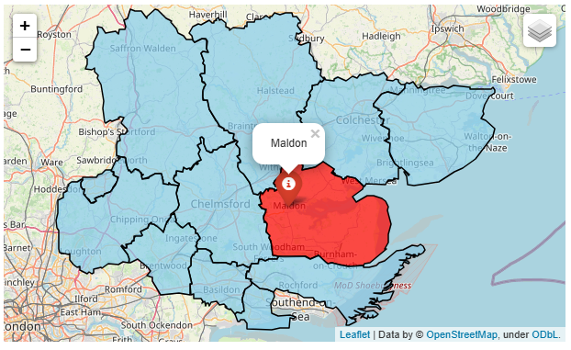
Maldon Locality
The Maldon district has a coastal border stretching from the Burnham–on-Crouch estuary, round the Dengie peninsula up to the nuclear facility at Bradwell on the River Blackwater covering an area of 358 square kilometers.

The district is home to the towns of Maldon, Burnham-on-Crouch and Heybridge along with several smaller villages: it is sparsely populated outside of the towns. With a population of 68,327 it is one of the least populous Essex districts with 183 people living per square km. 94% of the population are of White British ethnicity.

In the Indices of Multiple Deprivation 2019 the Maldon Local Authority area was ranked 211 out of 317 Lower Tier Local Authorities (LTLAs) in England. This places Maldon in the upper 40% of least deprived LTLAs nationally. Maldon is also one of the three LTLAs in Essex which has no residents in the bottom 1&2 deciles.

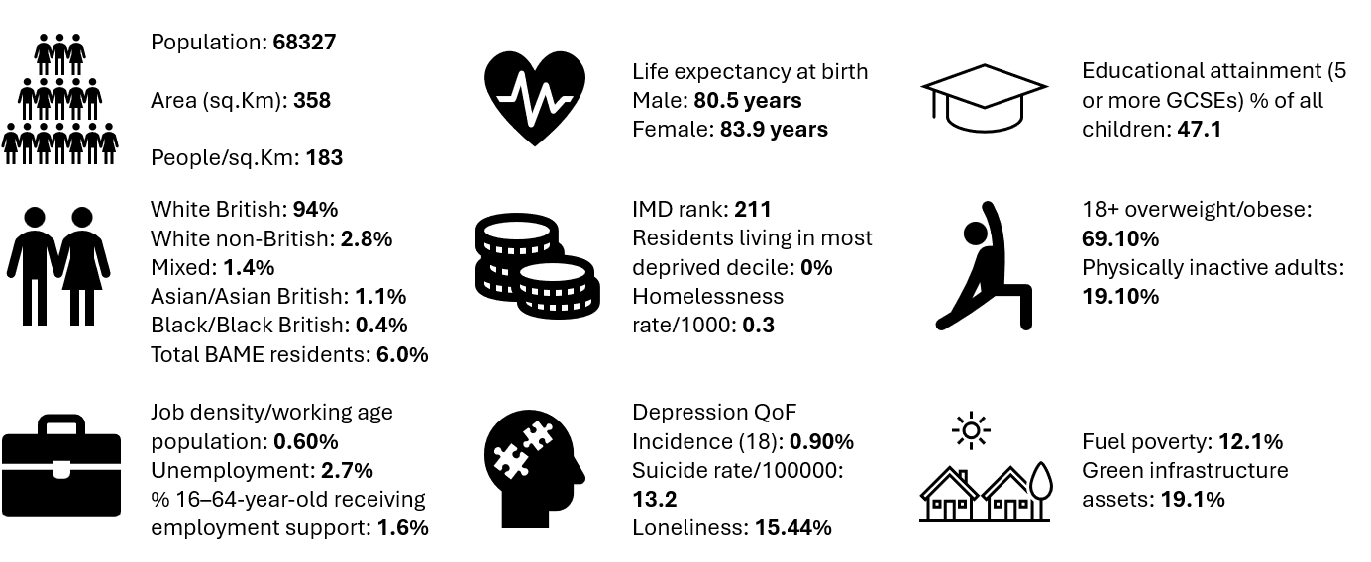
Further details can be accessed in the Essex Joint Strategic Needs Assessment https://data.essex.gov.uk/

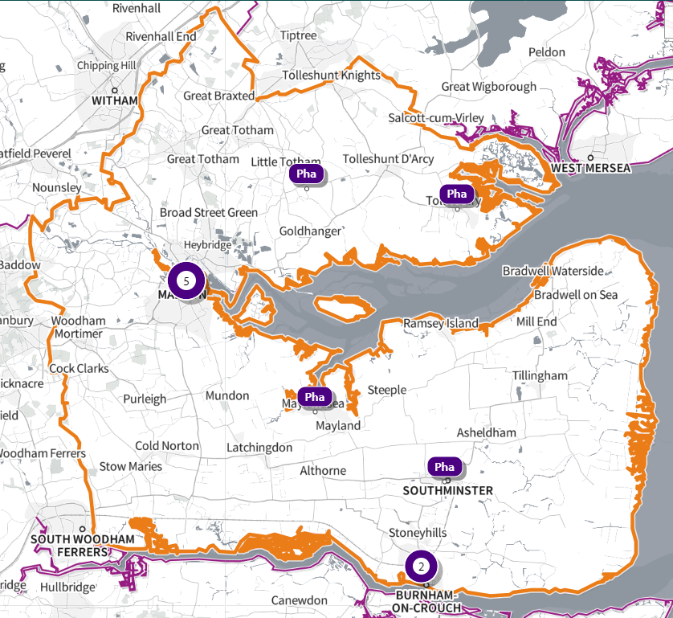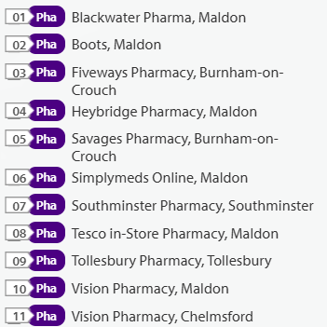
Source: SHAPE Place • Pharmacy (as at 02/01/2025)
Figure 49 Map of Maldon Pharmacies

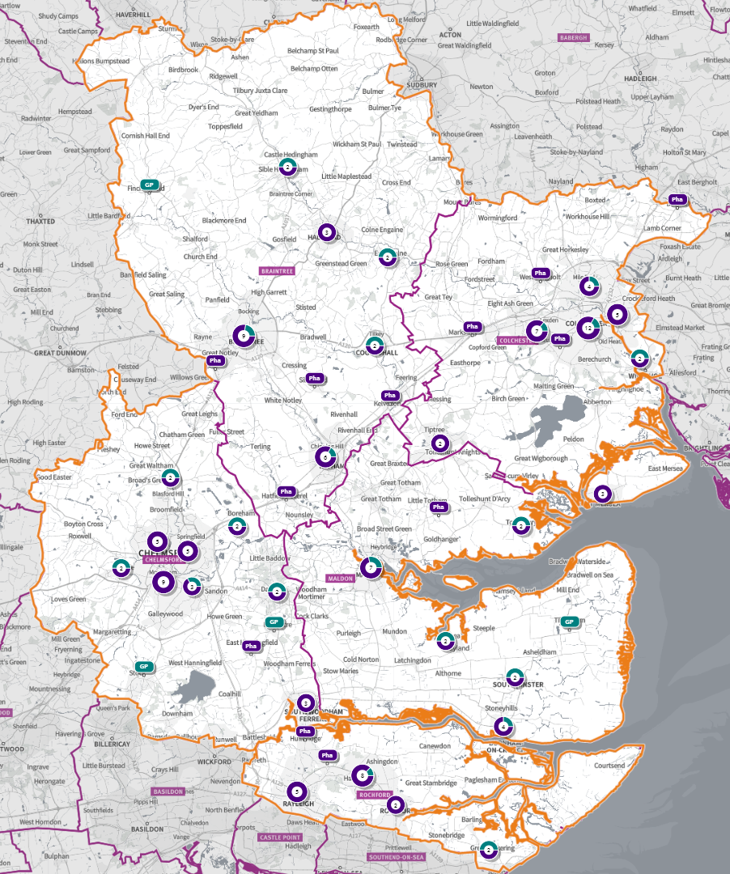
Figure 50 Map of Pharmacies and dispensing doctors within the locality, and neighbouring pharmacy provision

Pharmaceutical services provision in the locality

Provision
The information contained in this report was obtained from NHSE, local commissioners and a contractor survey.
Opening hours were obtained via the NHSE pharmacy contracts team.
Service provision for advanced services was obtained via NHSE, NHSBSA and with the support of the local LPC.

Access
Appendix F shows that using the base population data on the SHAPE Place Atlas platform, it is possible to calculate the Essex population (and by district) that are estimated to have a journey time either within 20 minutes, 20 - 30 minutes or over 30 minutes to a pharmacy across Essex and within a 1.6KM buffer zone around Essex by each journey method.

Overall, across Essex, generally residents are within a relatively short travel time whichever method is chosen:
- 99.9% of the Essex population could get to a pharmacy in a 20-minute drive.
- 93% (Weekday Morning) within a 30-minute public transport journey.
- 83% within a 20-minute walk. Residents have to travel for longer if they walk.
- 12% over 30-minute walk away.
- Maldon residents can drive to a pharmacy within 20 minutes.
- Most residents can get to a pharmacy within a 20-minute journey on public transport in most districts. However, some districts see a relatively high % of their population having to travel for longer (Braintree, Maldon, Uttlesford 20-30 minutes; Braintree, Epping Forest, Uttlesford over 30 minutes)
- Most residents can get to a pharmacy within 20-minute walk in most districts. Some districts however see a relatively higher % of their population that’d have to walk further (Braintree, Brentwood, Uttlesford 20-30 minutes; Braintree, Maldon, Uttlesford over 30 minutes).

Travel time to access pharmaceutical services are no longer than journey times to access key services as shown in section 6 of this report.

From the results of the public survey (Appendix E) 82% of residents stated that they had a less than 20 minutes travel to the pharmacy, 12% had travelled between 20-30 minutes, and 4% had travelled between 30-45 minutes.
60% made the trip by car, and 51% had travelled on foot—only 5% travelled by bicycle, 3% by public transport and 1% by taxi.

Maldon residents also have access to dispensing doctors, pharmacies in other HWB areas and distance selling pharmacies in England. Analysis of dispensing flows in the Mid Essex CCG area shows that 89% of prescriptions generated in the CCG are dispensed within the area and 11% out of area including distance selling pharmacies.

Pharmaceutical services in the locality

Table 24 Number and type of providers of pharmaceutical services in the area
Type Of Contract | Maldon
Total Number of Community Pharmacies | 11 (plus 1 DSP)
Dispensing Doctors | 7
Dispensing Appliance Contractors | 0
Distance Selling Pharmacies | 1

Table 25 Pharmacy contractors in the locality and provision of national NHS commissioned services
Service code |  |  |  |  |  |  |  | 1 | 2 | 3 | 4 | 5
Organisation code | Trading Name | Address line | Town | Postcode | Hours: M - F* OPENING HOURS SUPPLEMENTARY | Hours: Sat OPENING HOURS SUPPLEMENTARY | Hours: Sun OPENING HOURS SUPPLEMENTARY | PHARMACY FIRST | HYPERTENSION | CONTRACEPTION | LATERAL FLOW | SMOKING CESSATION
FPH83 | Blackwater Pharma | Princes Road | Maldon | CM9 5GP | 8.30 – 21.00 | 9.00 – 21.00 | 10.00 – 20.00 | ✓ | ✓
FT346 | Boots | 54 High Street | Maldon | CM9 5PN | 9.00 – 17.30 | 9.00 - 17.30 | Closed
 |  |  |  |  | 9.00 - 9.15 & 17.00 - 17.30 | 9.00 - 9.15 & 16.30 - 17.30 | Closed | ✓ | ✓ | ✓ | ✓
 |  |  |  |  | Closed  14.00- 15.00 | Closed  14.00- 15.00 | Closed
FLK60 | Fiveways Pharmacy | 3 Foundry Lane | Burnham-On-Crouch | CM0 8BL | 9.00 – 18.30 (9.00 – 16.00) | Closed | Closed
 |  |  |  |  | Closed 13.30 - 14.30 | Closed | Closed | ✓ | ✓ | ✓
FVC04 | Heybridge Pharmacy | 10a/10b Bentalls Centre | Maldon | CM9 4GD
FD637 | Savages Pharmacy | 22 Station Road | Burnham-On-Crouch | CM0 8BQ | 9.00 – 18.00
 |  |  |  |  |  | 9.00 – 13.00 | Closed | ✓ | ✓ | ✓
Closed
12.30 - 13.30
FET17 | Southminster Pharmacy | 15 High Street | Southminster | CM0 7AA | 8.45 - 17.45 |  | Closed
 |  |  |  |  |  | 9.00 – 13.00 | Closed | ✓
 |  |  |  |  | Closed 13.00 – 14.00 |  | Closed
FMY18 | Tesco In-store Pharmacy | Fullbridge Road | Maldon | CM9 4LE | 9.00 - 19.00 | 9.00 - 20.00
 |  |  |  |  | 17.30 – 19.00  Closed 14.00 -15.00 & 17.00 – 17.30 (16.30 – 17.30 Wed – Fri) | 16.30 – 17.00 & 17.30 – 20.00  Closed 14.00 -15.00 & 17.00 – 17.30 | 10.00 – 16.00 | ✓ | ✓ | ✓ | ✓
FRC59 | Tollesbury Pharmacy | 12A East Street | Maldon | CM9 8QD | 9.00 - 17.30
 |  |  |  |  | 13.00 - 13.30 | 9.00 – 13.00 | Closed | ✓ | ✓
FX083 | Vision Pharmacy | Longfield Medical Centre | Maldon | CM9 5DF
FAX23 | Vision Pharmacy | 39 Imperial Avenue | Maylandsea | CM3 6AH
FX730 | SimplyMeds Online (DSP) | Unit K2, Beckingham Business Park | Maldon | CM9 8LZ | 9.00 – 18.00
 |  |  |  |  |  | Closed | Closed | N/A | N/A | N/A | N/A | N/A
 |  |  |  |  | Closed 13.00 – 14.00

Maldon opening hours
- Weekday opening hours were taken from Friday as a standard.
Monday to Friday, all 11 community pharmacies are open between the hours of 9:00 to 17:00.
Earliest opening time is 8.30 and latest closing time is 21.00.
- On Saturdays 6 pharmacies are open in the morning and 3 of the pharmacies remain open in the afternoon. The earliest opening time is 9.00 and the latest closing time is 21.00.
- On Sundays two pharmacies open, longest opening times are 10.00 to 20.00.

Services (data January 2025)
There is good access to commissioned services within the locality.
The necessary services of NMS and CPCS are provided by many of the pharmacies.
The NHSE commissioned services that are not provided by pharmacies are delivered by other organisations in the locality.
Services are also locally commissioned by Essex County Council Public Health and the ICBs.
The provision of these is not shown as it changes frequently.
Details can be obtained from the commissioners.

Housing (Appendix G)
The impact of local housing development plans on provision of pharmaceutical services has been considered but has not identified any gaps in pharmaceutical services provision in the area during the lifetime of this PNA.

No gaps in the provision of necessary pharmaceutical services have been identified in the
Maldon locality

No gaps in pharmaceutical services have been identified that if provided either now or in the future would secure improvements or better access to relevant services across the Maldon locality

6.10 Rochford Locality
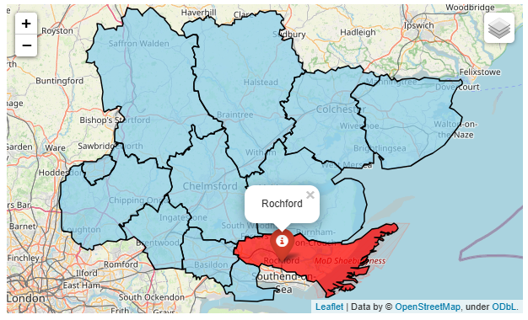
Rochford Locality
Rochford covers an area of 167 square kilometers and is predominantly rural in its character. It has miles of coastline as well as vast areas of countryside. Rochford has a population of 88,188 with 524 people living per square km. 93.8% of the population are of a White British ethnicity.

In the Indices of Multiple Deprivation 2019 the Rochford Local Authority area was ranked 286 out of 317 lower tier authorities in England. This places Rochford in the upper 10% of least deprived Lower Tier Local Authorities (LTLAs) nationally. Compared to the other local authority areas in Essex, Rochford is ranked as 10th out of 12 in the county for overall deprivation.

Rochford is also one of three areas in Essex which fall into the 10% least deprived areas nationally. As of 2019 the Rochford area contains 53 LSOAs of which 1 is ranked in the bottom two most deprived deciles nationally.

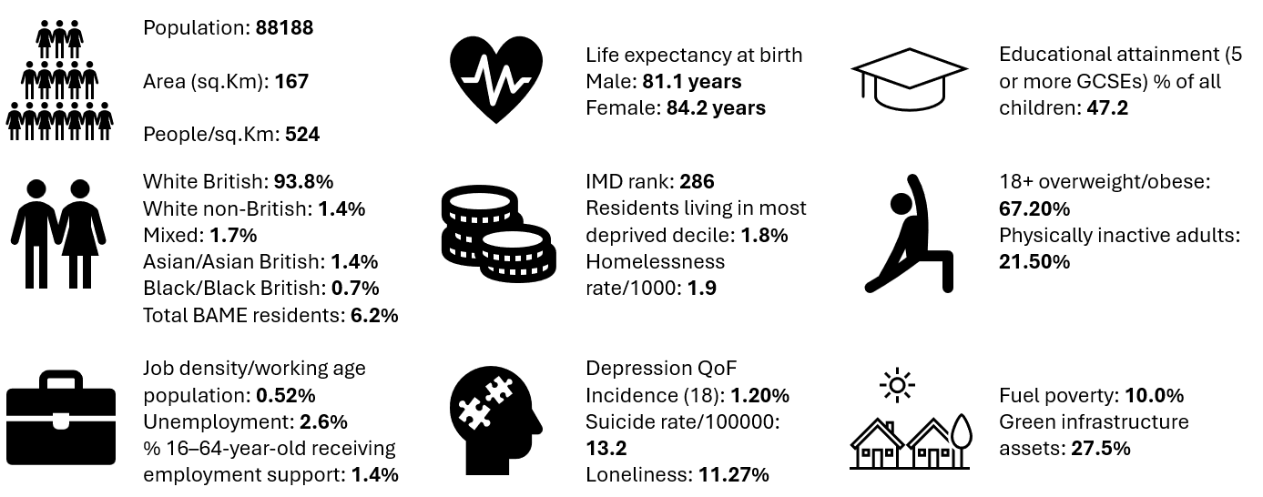
Further details can be accessed in the Essex Joint Strategic Needs Assessment https://data.essex.gov.uk/

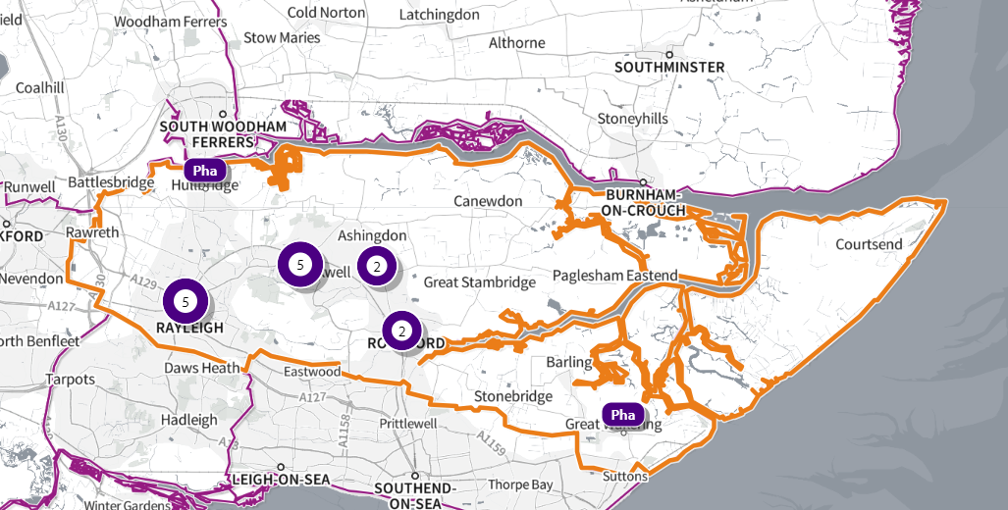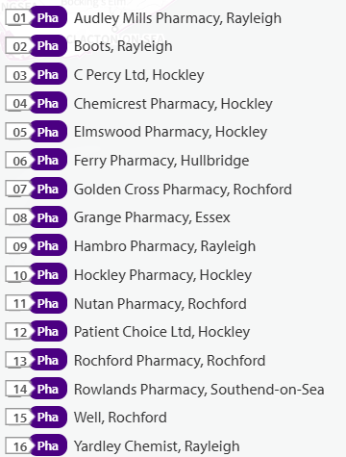

Source: SHAPE Place • Pharmacy (as at 02/01/2025)
Figure 51 Map of Rochford Pharmacies

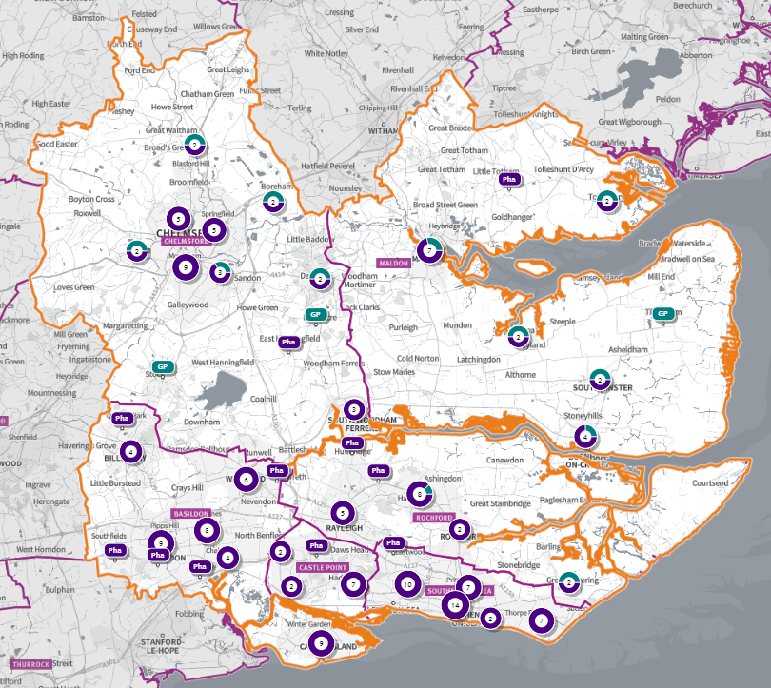
Figure 52 Map of Pharmacies and dispensing doctors within the locality, and neighbouring pharmacy provision

Pharmaceutical services provision in the locality

Provision
The information contained in this report was obtained from NHSE, local commissioners and a contractor survey.
Opening hours were obtained via the NHSE pharmacy contracts team.
Service provision for advanced services was obtained via NHSE, NHSBSA and with the support of the local LPC.

Access
Appendix F shows that using the base population data on the SHAPE Place Atlas platform, it is possible to calculate the Essex population (and by district) that are estimated to have a journey time either within 20 minutes, 20 - 30 minutes or over 30 minutes to a pharmacy across Essex and within a 1.6KM buffer zone around Essex by each journey method.

Overall, across Essex, generally residents are within a relatively short travel time whichever method is chosen:
- 99.9% of the Essex population could get to a pharmacy in a 20-minute drive.
- 93% (Weekday Morning) within a 30-minute public transport journey.
- 83% within a 20-minute walk. Residents have to travel for longer if they walk.
- 12% over 30-minute walk away.
- Rochford residents can drive to a pharmacy within 20 minutes.
- Most residents can get to a pharmacy within a 20-minute journey on public transport in most districts. However, some districts see a relatively high % of their population having to travel for longer (Braintree, Maldon, Uttlesford 20-30 minutes; Braintree, Epping Forest, Uttlesford over 30 minutes)
- Most residents can get to a pharmacy within 20-minute walk in most districts. Some districts however see a relatively higher % of their population that’d have to walk further (Braintree, Brentwood, Uttlesford 20-30 minutes; Braintree, Maldon, Uttlesford over 30 minutes).

Travel time to access pharmaceutical services are no longer than journey times to access key services as shown in section 6 of this report.

From the results of the public survey (Appendix E) 82% of residents stated that they had a less than 20 minutes travel to the pharmacy, 12% had travelled between 20-30 minutes, and 4% had travelled between 30-45 minutes.
60% made the trip by car, and 51% had travelled on foot—only 5% travelled by bicycle, 3% by public transport and 1% by taxi.

Rochford residents also have access to dispensing doctors’ pharmacies in other HWB areas and distance selling pharmacies in England. Analysis of dispensing flows in the Castle Point and Rochford CCG area shows that 89% of prescriptions generated in the CCG are dispensed within the area and 11% out of area including distance selling pharmacies.

Pharmaceutical services in the locality

Table 26 Number and type of providers of pharmaceutical services in the area
Type Of Contract | Rochford
Total Number of Community Pharmacies | 16 (plus 1 DAC)
Dispensing Doctors | 2
Dispensing Appliance Contractors | 1
Distance Selling Pharmacies | 0

Table 27 Pharmacy contractors in the locality and provision of national NHS commissioned services
Service Code |  |  |  |  |  |  |  | 1 | 2 | 3 | 4 | 5
Organisation code | Trading Name | Address line | Town | Postcode | Hours: M - F* OPENING HOURS SUPPLEMENTARY | Hours: Sat OPENING HOURS SUPPLEMENTARY | Hours: Sun OPENING HOURS SUPPLEMENTARY | PHARMACY FIRST | HYPERTENSION | CONTRACEPTION | LATERAL FLOW | SMOKING CESSATION
FDX41 | AMP Pharmacy | 55-57 Eastwood Road | Rayleigh | SS6 7JE | 8.00 - 21.00  8.00 – 8.30 & 20.00 – 21.00 | 9.00 - 17.00 | 10.00 - 17.00 | ✓ | ✓ | ✓ | ✓ | ✓
FKX68 | Boots | 77-79 High Street | Rayleigh | SS6 7EJ | 9.30 - 5.30  13.00 - 14.00 | 9.30 - 15.30  13.00 - 14.00 | Closed | ✓ | ✓ | ✓ | ✓
FG175 | C Percy Ltd | 212 Main Road | Hockley | SS5 4EG | 9.00- 18.00  13.00 - 14.00 | 9.00 - 13.00 | Closed | ✓ | ✓ | ✓ | ✓ | ✓
FJ339 | Chemicrest Pharmacy | 39-41 Spa Road | Hockley | SS5 4AZ | 9.30 - 18.00  13.00 - 14.00 & 17.30 - 18.00 | 9.30 – 16.00  13.00 - 14.00 & 15.30 - 16.00 | Closed | ✓ | ✓ | ✓
FG511 | Elmswood Pharmacy | 53 Southend Road | Hockley | SS5 4PZ | 9.00 - 18.00  13.00 - 14.00 & 17.30 - 18.00 | 9.00 - 13.00  11.30 - 13.00 | Closed | ✓ |  |  | ✓
FY681 | Ferry Pharmacy | 167 Ferry Road | Hullbridge | SS5 6JH | 9.00 - 18.30  17.00 - 18.30 | 9.00 - 13.00 | Closed | ✓ | ✓ | ✓ | ✓ | ✓
FCP70 | Golden Cross Pharmacy | 10 Golden Cross Parade, Ashingdon Road | Rochford | SS4 1UB | 9.00 - 18.45  17.00 - 18.45 | 9.00 - 16.30  13.00 – 16.30 | Closed | ✓ | ✓ |  | ✓
FWV73 | Grange Pharmacy | 113 London Road | Rayleigh | SS6 9AX | 9.00 - 18.30 (9.00 – 17.00 Wed) | 9.00 - 17.00 |  |  |  |  | ✓
 |  |  |  |  | 13.00 - 14.00 & 17.30 - 18.30 (14.00 – 17.00 Wed) | 12.00 - 13.00 & 16.00 - 17.00 | Closed | ✓ | ✓ |  | ✓ | ✓
FAC81 | Hambro Pharmacy | 53A Hullbridge Road | Rayleigh | SS6 9NL | 9.00 – 19.00  17.00 – 19.00 | 9.00 – 17.00 | 10.00 - 14.00 | ✓ | ✓ | ✓ | ✓ | ✓
FW105 | Hockley Pharmacy | 5-7 Broad Parade | Hockley | SS5 5DA | 9.00 - 18.00  13.00 - 14.00 | 9.00 - 13.00 | Closed | ✓ | ✓ | ✓
FT788 | Nutan Pharmacy | 456 Ashingdon Road | Rochford | SS4 3ET | 9.00 - 19.00  17.00 - 19.00  Closed 13.00 – 17.00 (Wed) | 9.00 - 17.00  13.00 – 17.00 | Closed | ✓ | ✓
FEM75 | Rochford Pharmacy (100 Hour Pharmacy) | 15-17 West Street | Rochford | SS4 1BE | 8.00 - 22.30 | 8.00 - 22.30 | 8.00 - 21.00 |  | ✓ |  |  | ✓
FKW03 | Rowlands Pharmacy | 62 High Steet | Great Wakering | SS3 0EQ | 9.00 - 18.00  Closed 13.00 - 14.00 | Closed | Closed | ✓ | ✓ | ✓ | ✓ | ✓
FT153 | Well Rochford - West Street | 42 West Street | Rochford | SS4 1AJ | 8.00 - 18.00  8.00 - 9.00 & 13.00 - 14.00 | 9.00 - 13.00 | Closed | ✓ | ✓ | ✓ | ✓ | ✓
FEA38 | Yardley Chemist | Burley House, 15 High Street | Rayleigh | SS6 7EW | 8.30 - 18.30  8.30 - 9.00, 13.00 - 14.00 & 18.00 - 18.30 | Closed | Closed | ✓ | ✓ | ✓ | ✓ | ✓
FWN89 | Patient Choice Ltd (DAC) | 10 – 12 Main Road | Hockley | SS5 4QS | 9.00 - 17.30 | Closed | Closed

Rochford opening hours
- Weekday opening hours were taken from Friday as a standard.
Monday to Friday, all 16 community pharmacies are open between the hours of 9:00 to 17:00.
Earliest opening time is 8.00 and latest closing time is 22.30.
- On Saturdays 13 pharmacies are open in the morning and 8 of the pharmacies remain open in the afternoon. The earliest opening time is 8.00 and the latest closing time is 22.30.
- On Sundays 3 pharmacies open, longest opening times are 8.00 to 21.00.

Services (data January 2025)
There is good access to commissioned services within the locality.
The necessary services of NMS and CPCS are provided by many of the pharmacies.
The NHSE commissioned services that are not provided by pharmacies are delivered by other organisations in the locality.
Services are also locally commissioned by Essex County Council Public Health and the ICBs.
The provision of these is not shown as it changes frequently.
Details can be obtained from the commissioners.

Housing (Appendix G)
The impact of local housing development plans on provision of pharmaceutical services has been considered but has not identified any gaps in pharmaceutical services provision in the area during the lifetime of this PNA.

No gaps in the provision of necessary pharmaceutical services have been identified in the
Rochford locality

No gaps in pharmaceutical services have been identified that if provided either now or in the future would secure improvements or better access to relevant services across the Rochford locality

6.11 Tendring Locality
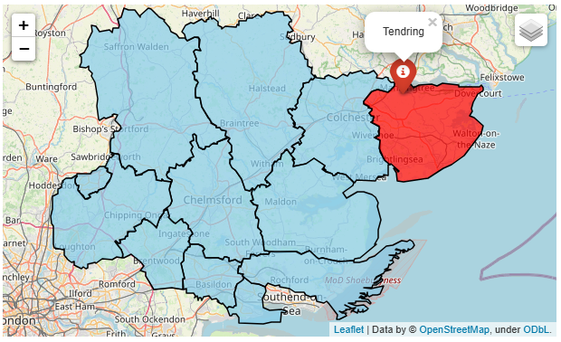
Tendring Locality
Tendring is located in the Northeastern peninsula of Essex and covers an area of approximately 336 square kilometers. The main populous areas are those on the coastline such as Frinton, Walton, Brightlingsea, Clacton and Harwich.

Tendring is the fifth most populous district in Essex with a population of 153,207, with 438 people per square km. 93.5% of the population are of White British ethnicity.

In the Indices of Multiple Deprivation 2019 the Tendring Local Authority area was ranked 32 out of 317 lower tier authorities in England. This places Tendring in the bottom 10% of most deprived Lower Tier Local Authorities (LTLAs) nationally. Tendring is ranked as the most deprived area out of 12 districts in the county for overall deprivation. Tendring is the only area in Essex which falls into the 10% of most deprived areas nationally and is 68 places below the next lowest area in the county.

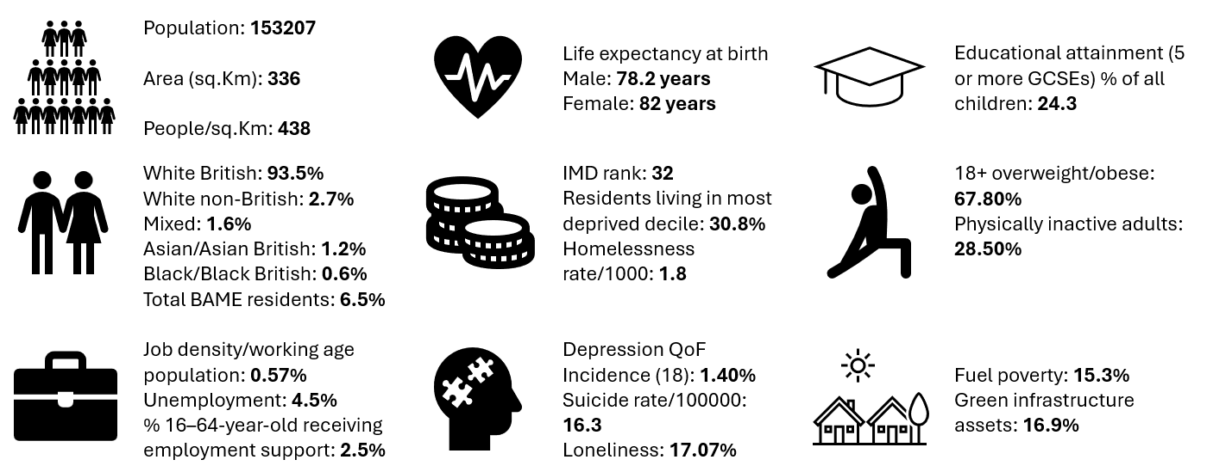
Further details can be accessed in the Essex Joint Strategic Needs Assessment https://data.essex.gov.uk/

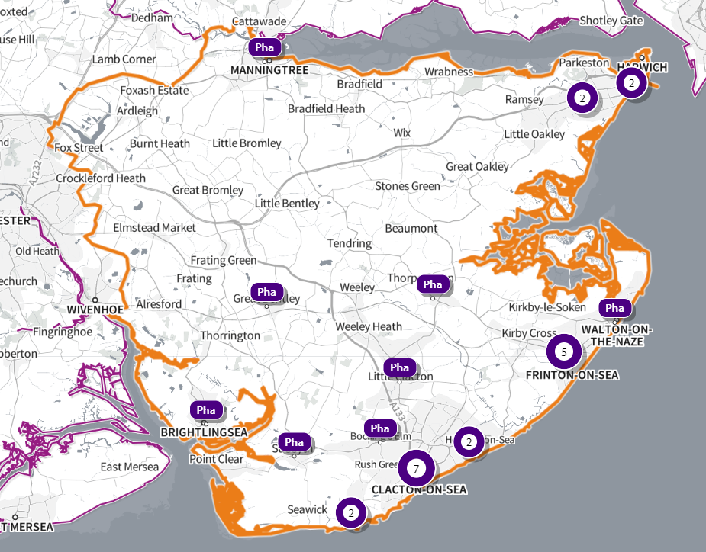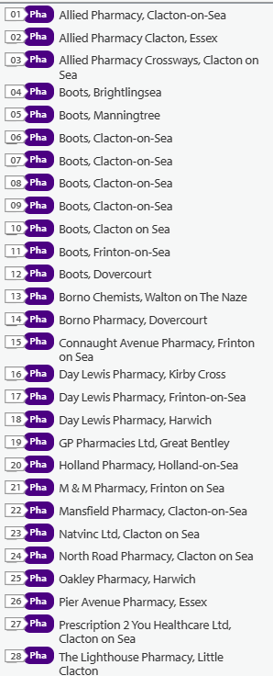
Source: SHAPE Place • Pharmacy (as at 02/01/2025)
Figure 53 Map of Tendring Pharmacies

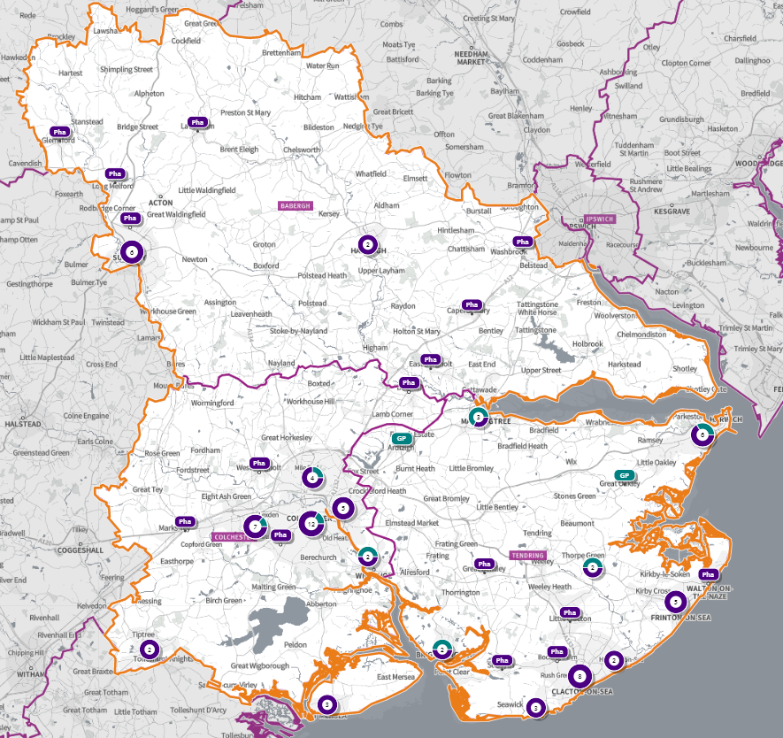
Figure 54 Map of Pharmacies and dispensing doctors within the Tendring locality, and neighbouring pharmacy provision

Pharmaceutical services provision in the locality

Provision
The information contained in this report was obtained from NHSE, local commissioners and a contractor survey.
Opening hours were obtained via the NHSE pharmacy contracts team.
Service provision for advanced services was obtained via NHSE, NHSBSA and with the support of the local LPC.

Access
Appendix F shows that using the base population data on the SHAPE Place Atlas platform, it is possible to calculate the Essex population (and by district) that are estimated to have a journey time either within 20 minutes, 20 - 30 minutes or over 30 minutes to a pharmacy across Essex and within a 1.6km buffer zone around Essex by each journey method.

Overall, across Essex, generally residents are within a relatively short travel time whichever method is chosen:
- 99.9% of the Essex population could get to a pharmacy in a 20-minute drive.
- 93% (Weekday Morning) within a 30-minute public transport journey.
- 83% within a 20-minute walk. Residents have to travel for longer if they walk.
- 12% over 30-minute walk away.
- Tendring residents can drive to a pharmacy within 20 minutes.
- Most residents can get to a pharmacy within a 20-minute journey on public transport in most districts. However, some districts see a relatively high % of their population having to travel for longer (Braintree, Maldon, Uttlesford 20-30 minutes; Braintree, Epping Forest, Uttlesford over 30 minutes).
- Most residents can get to a pharmacy within 20-minute walk in most districts. Some districts however see a relatively higher % of their population that’d have to walk further (Braintree, Brentwood, Uttlesford 20-30 minutes; Braintree, Maldon, Uttlesford over 30 minutes).

Travel time to access pharmaceutical services are no longer than journey times to access key services as shown in section 6 of this report.

From the results of the public survey (Appendix E) 82% of residents stated that they had a less than 20 minutes travel to the pharmacy, 12% had travelled between 20-30 minutes, and 4% had travelled between 30-45 minutes.
60% made the trip by car, and 51% had travelled on foot—only 5% travelled by bicycle, 3% by public transport and 1% by taxi.

Tendring residents also have access to dispensing doctors, pharmacies in other HWB areas and distance selling pharmacies in England. Analysis of dispensing flows in the North East Essex CCG area shows that 91% of prescriptions generated in the CCG are dispensed within the area and 9% out of area including distance selling pharmacies.

Pharmaceutical services in the Tendring locality

Table 28 Number and type of providers of pharmaceutical services in the area
Type Of Contract | Tendring
Total Number of Community Pharmacies | 28
Dispensing Doctors | 8
Dispensing Appliance Contractors | 0
Distance Selling Pharmacies | 0

Table 29 Pharmacy contractors in the locality and provision of national NHS commissioned services

Service Code |  |  |  |  |  |  |  |  | 1 | 2 | 3 | 4 |  | 5
Organisation code | Trading Name |  | Address line | Town | Postcode | Hours: M - F* OPENING HOURS SUPPLEMENTARY | Hours: Sat OPENING HOURS SUPPLEMENTARY | Hours: Sun OPENING HOURS SUPPLEMENTARY | PHARMACY FIRST | HYPERTENSION | CONTRACEPTION | LATERAL FLOW |  | SMOKING CESSATION
FAA57 |  | Allied Pharmacy | 354 St Johns Road | Clacton-on-Sea | CO16 8DS | 9.00 - 18.00  13.20-14.00  Closed 13.00 – 13.20 | Closed | Closed | ✓ | ✓ | ✓ |  | ✓
FJQ31 |  | Allied Pharmacy Clacton | 2 Jackson Road | Essex | CO15 1JA | 9.00 - 18.00  10.30-12.30 (Mon, Tue)  11.00 – 12.30 | 9.00-12.30 | Closed | ✓ | ✓ | ✓ |  | ✓
FRC49 |  | Allied Pharmacy Crossways | 32 Crossways | Clacton-on-Sea | CO15 2NB | 8.30 - 18.00  8.30 – 9.00 & 13.20 – 14.00  Closed 13.00 -13.20 | Closed | Closed | ✓ | ✓ | ✓ |  | ✓
FAN43 |  | Boots UK Ltd | 224-226 High Street | Dovercourt | CO12 3AJ | 8.30 - 17.30 | 8.30-17.00 | Closed |  |  | ✓
 |  |  |  |  |  | 8.30-9.30 13.30-14.30 & 17.15-17.30 | 8.30 - 9.30 & 13.30-14.30 | Closed | ✓ | ✓
FWW87 |  | Boots UK Ltd | Century House | Manningtree | CO11 1AA | 8.30 - 18.30  8.30 - 9.00, (Wed 13.0 – 18.30) 13.0 - 14.0 & 18.00 -18.30 | 8.30-17.30  8.30 - 9.00 & 13.0 – 17.30 | Closed | ✓ | ✓ | ✓ |  | ✓
FAN97 |  | Prescription 2 You Healthcare | 89/91 Pier Avenue | Clacton-On-Sea | CO15 1QE | 8.00 -18.30 | 9.00 -17.00 | 10.00- 13.00 | ✓ | ✓ |  |  | ✓ | ✓
 |  |  |  |  |  | 8.00 - 9.00, 12.00 - 14.00 & 18.00 - 18.30 (17.00 – 18.30 Fri) | 9.00- 13.00 & 16.00- 17.00 | 10.00- 13.00
FAP95 |  | GM Graham Pharmacies Ltd (100 Hour Pharmacy) | 77-79 Frinton Road | Holland-On-Sea | CO15 5UH | 9.00- 21.00 | 9.00- 21.00 | 8.00- 22.00 | ✓ | ✓ | ✓ |  | ✓ | ✓
FCX40 |  | Boots UK Ltd | 15 North Road | Clacton-On-Sea | CO15 4DA | 8.45 - 19.00 |  |  | ✓ | ✓ | ✓ |  | ✓
 |  |  |  |  |  | 8.45-9.00 & 17.00- 19.00 | 9.00 – 17.00 | Closed
FD548 |  | Natvinc Ltd | 18 Broome Way | Clacton-On-Sea | CO15 2HN | 9.00 - 18.00 |  |  | ✓
 |  |  |  |  |  | 13.00 - 14.00 | 9.00 - 13.00 | Closed
FE590 |  | Boots UK Ltd | 54-62 Pier Avenue | Clacton-On-Sea | CO15 1QN | 8.00 - 17.30 | 9.00 - 17.30 |  | ✓ | ✓ | ✓
 |  |  |  |  |  | 8.00 - 9.30, 13.00 -14.00 & 17.15 - 17.30 (17.00 – 17.30 Wed) | 9.00 - 9.30, 13.00 -14.00 & 17.00 - 17.30 | 10.00 - 16.00
FJF03 |  | GP Pharmacies Ltd | The Green Pharmacy | The Green  Colchester | CO7 8PJ | 9.00 - 18.30 |  | Closed | ✓ | ✓
 |  |  |  |  |  | 17.00 - 18.30 | Closed
FWR90 |  | GM Graham Pharmacies Ltd | 85-87 Pier Avenue | Clacton-On-Sea | CO15 1QE | 9.00 - 17.30 |  |  | ✓ | ✓ | ✓ |  | ✓ | ✓
 |  |  |  |  |  | 13.20 - 13.30  Closed 13.00 – 13.20 | Closed | Closed
FKJ91 |  | Prescriptions2You Limited (100 Hour Pharmacy) | 25 North Road | Clacton-On-Sea | CO15 4DD | 9.00 - 21.00 | 9.00 - 21.00 | 9.00 - 19.00
 |  |  |  |  |  | Closed 12.30 – 13.30 | Closed 12.30 – 13.30
FLG31 |  | Boots UK Ltd | 10 Connaught Avenue | Frinton-On-Sea | CO13 9PW | 9.00 - 17.30  9.00 - 9.30 & 13.00 - 14.15 | 9.00 - 17.00  9.00 - 9.30 & 13.00 - 14.15 |  | ✓ | ✓ | ✓ |  | ✓
 |  |  |  |  |  |  |  | 10.00 - 16.00
FLQ39 |  | Day Lewis Plc | 1-5 The Parade | Halstead Road  Kirby Cross | CO13 0LN | 8.30 - 17.30 | Closed |  | ✓ | ✓ | ✓ |  | ✓ | ✓
 |  |  |  |  |  | Closed 13.00 - 14.00 | Closed | Closed
FLY44 |  | Day Lewis Plc | 8 The Triangle Shop Ctr | Rochford Way  Frinton-On-Sea | CO13 0AU | 9.00 - 17.30 |  |  | ✓ | ✓ | ✓ |  | ✓ | ✓
 |  |  |  |  |  | 17.00 - 17.30 | 9.00 - 13.00 | Closed
FNY90 |  | Borno Chemists Ltd | Fryatt Hospital | 419 Main Road  Dovercourt | CO12 4EX | 8.30 - 18.30 |  |  | ✓ | ✓ | ✓ |  | ✓ | ✓
 |  |  |  |  |  | 8.30 - 9.00 & 17.00 - 18.30 | Closed | Closed
FPT34 |  | Borno Chemists Ltd | 3 Portobello Buildings | High Street  Walton On The Naze | CO14 8BB | 9.00 - 18.30 |  | Closed | ✓ | ✓ | ✓ |  | ✓ | ✓
 |  |  |  |  |  | 17.00 - 18.30 | 9.00 - 13.00
FLR03 |  | Connaught Avenue Pharmacy | 98 Connaught Avenue | Frinton-On-Sea | CO13 9PT
FPV12 |  | Boots UK Ltd | 19 Clacton Road | Clacton-On-Sea | CO16 8PA | 9.00 - 17.30  13.00 - 14.00 & 17.00 - 17.30 | 9.00 - 17.00  14.00 - 17.00 |  | ✓ | ✓ | ✓ |  | ✓
 |  |  |  |  |  |  |  | Closed
FQW40 |  | M & M Farmacia Ltd (100 Hour Pharmacy) | 152 Connaught Avenue | Frinton-On-Sea | CO13 9NE | 8.00 - 22.00 | 7.00 - 22.00 | 7.00 - 22.00 | ✓ | ✓ | ✓ |  | ✓
FXR02 |  | Mansfield Pharmacy | Maidshead Parade, High St | Clacton-On-Sea | CO16 0DY | 9.00 - 18.00  13.00 - 14.00 | 9.00 - 13.00 | Closed | ✓ | ✓ |  |  | ✓
FT720 |  | The Lighthouse Pharmacy Ltd | 19-21 The Street | Little Clacton | CO16 9LQ | 9.00 - 17.00 |  |  | ✓ | ✓ | ✓ |  | ✓ | ✓
 |  |  |  |  |  |  | 9.00 - 14.00 | Closed
FTA65 |  | Day Lewis PLC | 151 High Street | Harwich | CO12 3AX | 9.00 - 18.00  Closed 13.00 – 14.00 | Closed | Closed | ✓ | ✓ | ✓ |  | ✓ | ✓
FVL26 |  | L Rowland & Co (Retail) Ltd | Jaywick Community Centre | 32 Crossways  Jaywick | CO15 2NB |  |  |  | ✓ |  | ✓
FVP82 |  | Boots UK Ltd | 86 Pier Avenue | Clacton-On-Sea | CO15 1NJ | 9.00- 18.30 |  |  | ✓ | ✓ | ✓ |  | ✓
 |  |  |  |  |  | 17.00 - 18.30 | 9.00 – 17.00 | Closed
FWE04 |  | Boots UK Ltd | 52 Victoria Place | Brightlingsea | CO7 0AB | 9.00 - 18.30 | 9.00 - 17.00 |  | ✓ | ✓ | ✓ |  | ✓
 |  |  |  |  |  | 13.00 - 14.00 & 18.00 - 18.30 (13.00 – 18.30 Wed) | 13.00 - 17.00 | Closed
FWL47 |  | Boots UK Ltd | 75 Frinton Road | Clacton-On-Sea | CO15 5UH | 9.00 - 19.00  13.00 - 14.00 & 18.00 - 19.00 | 9.00 - 17.00 | Closed | ✓ | ✓ | ✓ |  | ✓
FWW87 |  | Boots UK Ltd | Century House | Station Road  Manningtree | CO11 1AA | 8.30 - 18.30  8.30 - 9.00, 13.00 - 14.00 & 18.00 - 18.30 (13.00 – 18.30 Wed) | 8.30 - 17.30  8.30 - 9.00 & 13.00 - 17.30 |  | ✓ | ✓ | ✓ |  | ✓
 |  |  |  |  |  |  |  | Closed
FXX36 |  | Oakley Prescriptions Ltd | 10 Oakley Road | Dovercourt | CO12 4QZ | 9.00 - 18.00 |  |  | ✓ | ✓ |  |  | ✓
 |  |  |  |  |  | 13.00 - 14.00 | 9.00 - 13.00 | Closed

Tendring opening hours
- Weekday opening hours were taken from Friday as a standard.
Monday to Friday, all 28 community pharmacies are open between the hours of 9:00 to 17:00.
Earliest opening time is 8.00 and latest closing time is 22.00.
- On Saturdays 21 pharmacies are open in the morning and 15 of the pharmacies remain open in the afternoon. The earliest opening time is 7.00 and the latest closing time is 22.00.
- On Sundays six pharmacies open, longest opening times are 7.00 to 22.00.

Services (data January 2025)
There is good access to commissioned services within the locality.
The necessary services of NMS and CPCS are provided by many of the pharmacies.
The NHSE commissioned services that are not provided by pharmacies are delivered by other organisations in the locality.
Services are also locally commissioned by Essex County Council Public Health and the ICBs.
The provision of these is not shown as it changes frequently.
Details can be obtained from the commissioners.

Housing (Appendix G)
The impact of local housing development plans on provision of pharmaceutical services has been considered but has not identified any gaps in pharmaceutical services provision in the area during the lifetime of this PNA.
No gaps in the provision of necessary pharmaceutical services have been identified in the
Tendring locality

No gaps in pharmaceutical services have been identified that if provided either now or in the future would secure improvements or better access to relevant services across the Tendring locality

6.12 Uttlesford Locality

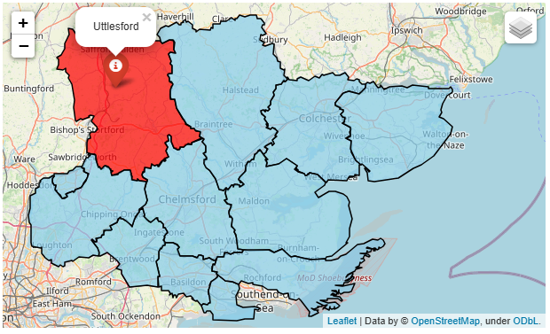
Uttlesford Locality
Uttlesford is located in the North West corner of Essex. It is the largest district in Essex covering approximately 641 square kilometers and is mainly rural in character with four market towns: Saffron Walden, Great Dunmow, Stansted Mountfitchet and Thaxted.

Uttlesford has a population of 93,594 and is the least densely populated district with 145 people living per square km. 88.9% of the population are of White British ethnicity.

In the Indices of Multiple Deprivation 2019 the Uttlesford Local Authority area was ranked 295 out of 317 lower tier authorities in England. This places Uttlesford in the upper 10% of least deprived Lower Tier Local Authorities (LTLAs) nationally.

As of 2019 the Uttlesford area contains 46 LSOAs of which none are ranked in the bottom two most deprived deciles nationally. Uttlesford is one of three LTLAs across the ECC area which do not have any LSOAs in the bottom 10% nationally.

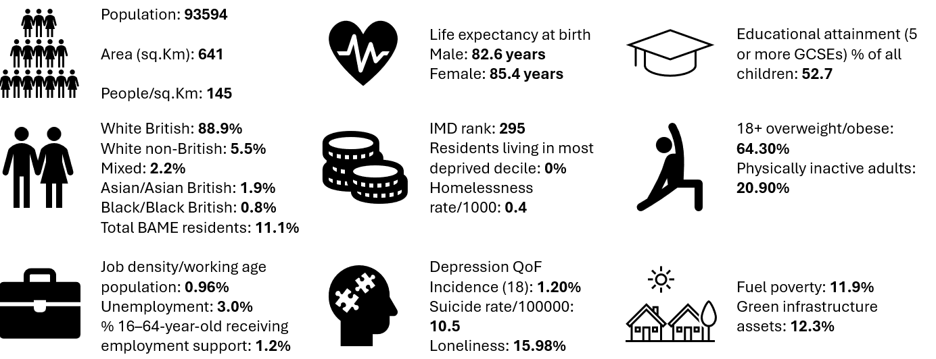
Further details can be accessed in the Essex Joint Strategic Needs Assessment https://data.essex.gov.uk/

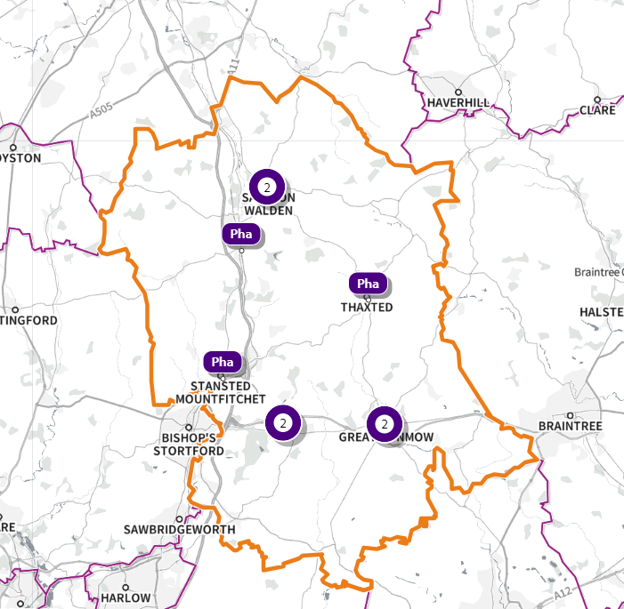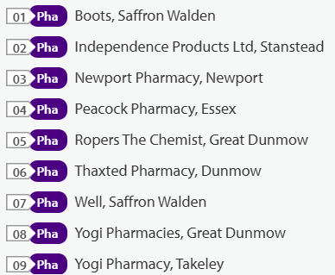 Note: Independence Products Ltd is a DAC
Source: SHAPE Place • Pharmacy (as at 02/01/2025)
Figure 55 55 Map of Uttlesford Pharmacies

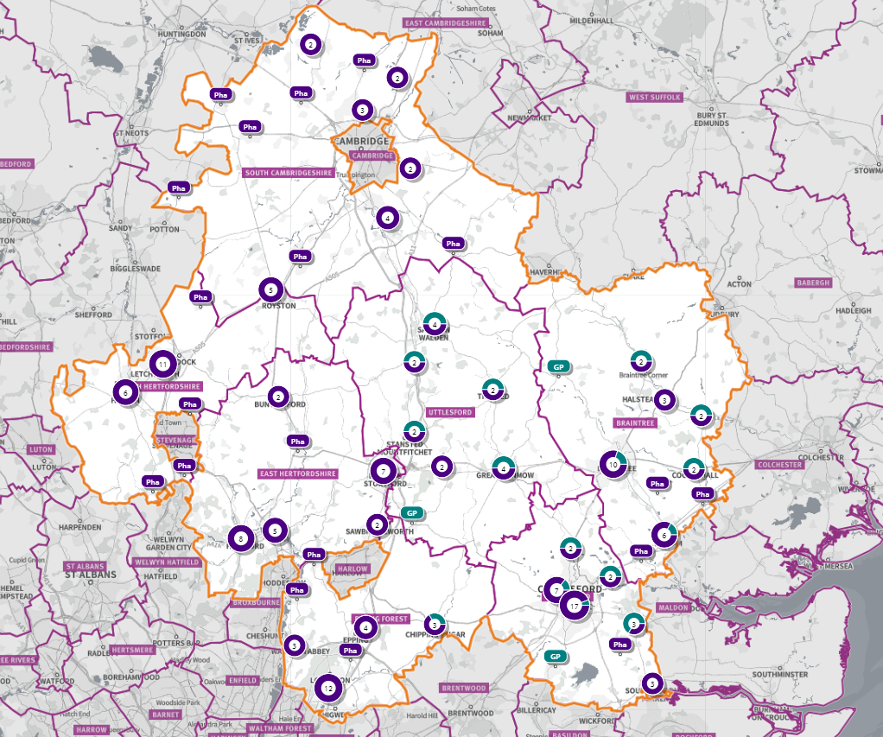
Figure 56 Map of Pharmacies and dispensing doctors within the Uttlesford locality, and neighbouring pharmacy provision

Pharmaceutical services provision in the locality

Provision
The information contained in this report was obtained from NHSE, local commissioners and a contractor survey.
Opening hours were obtained via the NHSE pharmacy contracts team.
Service provision for advanced services was obtained via NHSE, NHSBSA and with the support of the local LPC.

Access
Appendix F shows that using the base population data on the SHAPE Place Atlas platform, it is possible to calculate the Essex population (and by district) that are estimated to have a journey time either within 20 minutes, 20 - 30 minutes or over 30 minutes to a pharmacy across Essex and within a 1.6KM buffer zone around Essex by each journey method.
- 99.9% of the Essex population could get to a pharmacy in a 20-minute drive.
- 93% (Weekday Morning) within a 30-minute public transport journey.
- 83% within a 20-minute walk. Residents have to travel for longer if they walk.
- 12% over 30-minute walk away.
- Uttlesford residents across can drive to a pharmacy within 20 minutes
- Most residents can get to a pharmacy within a 20-minute journey on public transport in most districts. However, some districts see a relatively high % of their population having to travel for longer (Braintree, Maldon, Uttlesford 20-30 minutes; Braintree, Epping Forest, Uttlesford over 30 minutes)
- Most residents can get to a pharmacy within 20-minute walk in most districts. Some districts however see a relatively higher % of their population that’d have to walk further (Braintree, Brentwood, Uttlesford 20-30 minutes; Braintree, Maldon, Uttlesford over 30 minutes).

Travel time to access pharmaceutical services are no longer than journey times to access key services as shown in section 6 of this report.

From the results of the public survey (Appendix E) 82% of residents stated that they had a less than 20 minutes travel to the pharmacy, 12% had travelled between 20-30 minutes, and 4% had travelled between 30-45 minutes.
60% made the trip by car, and 51% had travelled on foot—only 5% travelled by bicycle, 3% by public transport and 1% by taxi.

Uttlesford residents also have access to dispensing doctors, pharmacies in neighbouring HWB areas and distance selling pharmacies in England. Analysis of dispensing flows in the West Essex CCG area shows that 87% of prescriptions in the CCG are dispensed within the area and 13% out of area including distance selling pharmacies.

Pharmaceutical services in the Uttlesford locality

Table 30 Number and type of providers of pharmaceutical services in the area
Type Of Contract | Uttlesford
Total Number of Community Pharmacies | 9 (plus 1 DAC)
Dispensing Doctors | 8
Dispensing Appliance Contractors | 1
Distance Selling Pharmacies | 0

Table 31 Pharmacy contractors in the locality and provision of national NHS commissioned services
Service code |  |  |  |  |  |  |  | 1 | 2 | 3 | 4 | 5
Organisation code | Trading Name | Address | Town | Postcode | Hours: M - F* OPENING HOURS SUPPLEMENTARY | Hours: Sat OPENING HOURS SUPPLEMENTARY | Hours: Sun OPENING HOURS SUPPLEMENTARY | PHARMACY FIRST | HYPERTENSION | CONTRACEPTION | LATERAL FLOW | SMOKING CESSATION
FTG55 | Boots | Market Place, Saffron Walden |  | CB10 1HR | 8.30 - 17.30  8.30- 9.00, 13.00 - 14.00 | 8.30 - 17.30  8.30 – 9.00 & 11.30 - 17.30 | 10.00 – 16.00 | ✓ | ✓ | ✓ | ✓
FAG85 | Newport Pharmacy | The Brown House, High Street, Newport | Saffron Walden | CB11 3QY | 9.00 - 18.00  17.00 – 18.00 | 9.00 – 13.00 | Closed | ✓ | ✓ | ✓ |  | ✓
FJ501 | Peacock Pharmacy | 2 Lower Street | Stansted Mountfitchet | CM24 8XG | 8.00 - 18.30 (7.00 – 18.30 Tue)  8.00 - 9.00 (7.00 – 9.00 Tue) & 17.00 – 18.30 | 8.00 - 13.00 | Closed
FTE06 | Ropers The Chemist | 3-5 High Street | Great Dunmow | CM6 1AB | 9.00 - 18.00  13.00 – 18.00 (Wed) | 9.00 - 17.00 | Closed | ✓ | ✓ |  | ✓
FF082 | Thaxted Pharmacy | 3 Town Street | Thaxted | CM6 2LD
FXV63 | Well Saffron Walden - Hill Street | 3 The Arches, Hill Street | Saffron Walden | CB10 1ED | 9.00 - 18.30  13.30 – 14.30 & 17.30 – 18.30 | 9.00 - 13.00  11.30 – 13.00 | Closed | ✓ | ✓ | ✓ | ✓ | ✓
FK965 | Yogi Pharmacies | 7 Market Place | Great Dunmow | CM6 1AX | 9.00 - 18.00  13.00 - 14.00 | 9.00 - 13.00 | Closed | ✓ | ✓ |  | ✓
FAE08 | Yogi Pharmacy | Ellesborough House, Dunmow Road | Takeley | CM22 6SH | 9.00 - 18.00  13.00 - 14.00 | 9.00 - 13.00 | Closed | ✓ | ✓ |  | ✓
FJN80 | Independence Direct Ltd (DAC) | Suite 16, 3rd Floor, Endeavour House, Coopers End Road | Stansted | CM24 1SJ | 9.00 - 17.00 | Closed | Closed | N/A | N/A | N/A | N/A | N/A

Uttlesford opening hours
- Weekday opening hours were taken from Friday as a standard.
Monday to Friday, all 9 community pharmacies are open between the hours of 9:00am to 17:30.
Earliest opening time is 8.00 and latest closing time is 18.30.
- On Saturdays 7 pharmacies are open in the morning and 2 of the pharmacies remain open in the afternoon. The latest closing time is 17.30.
- On Sundays one pharmacy is open between 10:00 until 16:00.

Services (data January 2025)
There is good access to commissioned services within the locality.
The necessary services of NMS and CPCS are provided by almost all the pharmacies.
The NHSE commissioned services that are not provided by pharmacies are delivered by other organisations in the locality.
Services are also locally commissioned by Essex County Council Public Health and the ICBs.
The provision of these is not shown as it changes frequently.
Details can be obtained from the commissioners.

Housing (Appendix G)
The impact of local housing development plans on provision of pharmaceutical services has been considered but has not identified any gaps in pharmaceutical services provision in the area during the lifetime of this PNA.

No gaps in the provision of necessary pharmaceutical services have been identified in the Uttlesford locality

No gaps in pharmaceutical services have been identified that if provided either now or in the future would secure improvements or better access to relevant services across the Uttlesford locality

Chapter 7: Future of pharmacy

Community Pharmacy England, the Department of Health and Social Care (DHSC) and NHSE have announced the 2024/25 and 2025/26 funding settlement for community pharmacy at the end of March 2025.
Substantial increases in funding were announced whilst recognising the economic pressures facing the sector.
Community pharmacies, the government and the NHS have already delivered much together, and community pharmacy continues to demonstrate all that it can do. Pharmacy First clinical pathways, which have delivered over 1.9 million consultations to date, offer just one example.
There has also been a continued increase in the number of Pharmacy Contraception Service and Hypertension Case Finding Service consultations, with over 0.25 million and 2.5 million being delivered in each respectively between January and November 2024. Alongside this the sector has continued to dispense increasing numbers of medicines, with over 1.2 billion prescriptions forecast to be dispensed in 2025 to 2026.

The government has stated that it is committed to working with the sector over the coming years to stabilise community pharmacy, build on what has achieved to date and lay the foundations for an independent prescribing service to harness its full potential in the future. Up to £8 million of funding secured for community pharmacy will be used to support digital developments in 2025 to 2026.

The national vision for community pharmacy is in line with the local vision and aspirations that community pharmacy has a critical role to play in the Essex health system.
It is essential that community pharmacy continues to be recognised and supported to support the needs of the population of Essex.
The demand on community pharmacy and on pharmacists and their staff is great and ever increasing.
The staff shortages are acute and exacerbated by the demand for pharmacists and other staff employed within PCNs and other pharmacy services.

Independent prescribing by pharmacists has been available since 2006, and in recent years there has been a drive to upskill the current pharmacist workforce, enabling a large number of pharmacists to qualify as independent prescribers.
Alongside this, newly registered pharmacists qualifying from 2026 will automatically become independent prescribers following changes made by schools of pharmacy to reflect this significant change to pharmacists' workload.
Despite there being a number of independent prescribing pharmacists working in community pharmacy in England, there are currently no clinical services commissioned nationally by NHS England that enable NHS prescriptions to be issued by independent prescribing pharmacists working in community pharmacy.
Over the next few years, there could be a significant change to the delivery of community pharmacy services, as the skills and capabilities of community pharmacists are utilised to build on clinical services already commissioned as advanced pharmaceutical services, or to add into locally commissioned services.

Whilst community pharmacies welcome the introduction of newly commissioned services it is important for commissioners to be aware of the huge demands being placed on the sector.

Community pharmacy has a key role in supporting patients in the communities they serve.

Chapter 8: Conclusion

Conclusions for the purpose of schedule 1 to The Regulations.

When assessing the provision of pharmaceutical services in the Essex HWB area the steering group considered the following:
• The number and distribution of all contractors in each PNA locality and opening hours
• The location of and choice of pharmaceutical services
• Access to community pharmacies during weekdays, evenings and the weekend
• Access to community pharmacies via various types of transport (Appendix F)
• Provision of Essential, Advanced and Enhanced services in each locality
• Provision of necessary and relevant services
• Results of the public questionnaire (Appendix E)
• Results of the contractor questionnaires (Appendix H)
• Results of the statutory consultation (Appendix B) (To be added post-consultation)
• The health needs of the population from the JSNA
• Projected population growth
• Specific populations
• The Index of Multiple Deprivation and deprivation ranges as well as the other wider determinants of health
• The general lifestyle including smoking and drug and alcohol misuse
• The disease burden

The PNA is required to clearly state what is considered to constitute Necessary Services as required by paragraphs 1 and 3 of Schedule 1 to the NHS (Pharmaceutical and Local Pharmaceutical Services) Regulations 2013.

For the purposes of this PNA, Necessary Services for the HWB are defined as Essential Services plus NMS and CPCS.
Other Advanced Services are considered relevant as they contribute toward improvement in provision and access to pharmaceutical services.

For the purposes of this PNA, Enhanced Services are defined as pharmaceutical services that secure improvements or better access to, or that have contributed towards meeting the need for pharmaceutical services in the HWB area.

Locally commissioned services are those that secure improvements or better access to, or that have contributed towards meeting the need for pharmaceutical services in Essex and are commissioned by the ICBs or local authority, rather than NHSE.

Access to pharmaceutical services for the residents of Essex is good and the main conclusion of this PNA is that there are no gaps in the provision of necessary or relevant pharmaceutical services.

The PNA also looked at changes which are anticipated within the lifetime of the document, for example the predicted population growth.
Given the current population demographics, housing projections and the distribution of service providers across the HWB area, this document concludes that the current provision will be sufficient to meet the likely future needs of the residents during the three-year lifetime of this pharmaceutical needs assessment.

The HWB has not identified any services that would secure improvements, or better access, to the provision of pharmaceutical services either now or within the 3-year lifetime of this pharmaceutical needs assessment.

Provision of essential services during normal working hours - Based on the information available at the time of developing this PNA no gaps have been identified in any of the localities either now or in the future
Provision of essential services outside normal working hours - Based on the information available at the time of developing this PNA no gaps have been identified in any of the localities either now or in the future
Provision of the New Medicine Service and Community Pharmacist Consultation Service advanced services - Based on the information available at the time of developing this PNA no gaps have been identified in any of the localities either now or in the future
Provision of necessary services - Based on the information available at the time of developing this PNA no gaps have been identified in any of the localities either now or in the future
Provision of other relevant services - Based on the information available at the time of developing this PNA no gaps have been identified in any of the localities either now or in the future
Provision of essential services - Based on the information available at the time of developing this PNA no gaps have been identified in any of the localities either now or in the future
Provision of advanced services - Based on the information available at the time of developing this PNA no gaps have been identified in any of the localities either now or in the future
Provision of better access to the enhanced services - Based on the information available at the time of developing this PNA no gaps have been identified in any of the localities either now or in the future

https://www.legislation.gov.uk/uksi/2013/349/contents
In April 2025 Funding and other arrangements for community pharmacies for 2024/25 and 2025/26 was finalised. This PNA does not show the changes, they can be accessed at https://cpe.org.uk/our-news/cpcf-arrangements-for-2024-25-and-2025-26-announced/
National Health Service Act 2006
The National Health Service (Pharmaceutical and Local Pharmaceutical Services) Regulations 2013
Pharmacy Access Scheme: guidance - GOV.UK (www.gov.uk)
www.gov.uk/discrimination-your-rights/types-of-discrimination
*A LSOA is a small geographical area for the reporting of small area statistics, developed by the Office for National Statistics. They comprise on average of 1,500 residents or 650 households.
Health Inequalities and COVID-19 – Essex Open Data
Superseded by the new agreement for 2025-2027 https://cpe.org.uk/our-news/cpcf-arrangements-for-2024-25-and-2025-26-announced/

