

Evaluation of Essex ActivAte (HAF)
  - The Impact on Children, Young People and Families
July 2024

Contents
Introduction 2
Methods 2
Key Findings 2
Findings 4
Nutritious Meals and Food Education 4
Physical Activity and Learning New Skills 7
Allowing Parents to Work 9
Benefits for Children and Young People 12
Benefits for Families 14
Holiday Experiences and Opportunities 17
Safe Spaces and Positive Role Models 18
Support for Families with Children who have SEND 20
Conclusions & Recommendations 22
Conclusions 22
Recommendations 23

Introduction
Essex ActivAte is the name for the Holiday Activity and Food (HAF) programme across Essex, run by Active Essex, Essex County Council and Thurrock Council, on behalf of the Department for Education.
This programme aims to support the physical and mental wellbeing of primary and secondary school children, through engagement in a wide variety of enrichment and physical activities, and provision of a nutritious, school standard meal. Working with a network of trusted local delivery partners, Active Essex run free clubs during the school holidays for children and young people who are eligible for benefits based free school meals, as well as those from low income working families who would benefit from this extra support.
The programme takes place during the Easter, Summer and Winter holidays. Where possible, Essex County Council and Basildon Borough Council provide additional support families during the half terms as well.
After three years of HAF delivery, the Department for Education funding is set to expire at the end of 2024 and the future of the programme is uncertain.
Essex County Council’s Research & Citizen Insight Team was asked to evaluate the Essex ActivAte programme focussing on the impact that it has on children, young people and families.

Methods
The research team collected data using a range of methods to capture the views of children, young people, parents / carers and club deliverers:
- 24 x club visits
- 18 x workshops with children and young people
- 10 x focus groups with parents and carers
- 1 x conversation with a Headteacher
- 42 x photo competition entries
- 98 x emails to HAF inbox
- Provider survey (n=95)
- Parent Survey (n=335)

Key Findings
The ‘cost of living crisis’ is not over and many families in Essex and Thurrock continue to struggle financially, particularly during school holidays when there is a need to spend additional money on food and activities as well as limited affordable childcare options making it more difficult for parents to work.
This evaluation found that Essex ActivAte is achieving far more than delivering holiday activities and food and the research team lost count of how many times it was described as ‘a godsend’. The programme is achieving multiple outcomes for children, young people and families including:
- Encouraging children and young people to try new foods both at holiday clubs and at home
- Getting children active and away from screens, increasing both their physical activity levels and physical literacy which is likely to have a longer-term impact
- Increasing parent’s ability to work and therefore pay their bills
- Giving children and young people opportunities to have fun and make friends as well as increasing their confidence, sense of achievement and mental wellbeing
- Offering a routine which makes transition back to school after the holidays easier
- Taking a ‘whole family’ approach – supporting parents as well as children and young people, and signposting to relevant support services
- Improving parent wellbeing and creating happier homes
- Providing children and young people with positive role models
- Enabling children and young people to take part in holiday experiences that their parents might not be able to afford
- Allowing parents of children with SEND to have respite

“It is very difficult to show how much Activate means to us in 1 picture, but I think this picture represents it best. This was taken on 1 of my children's Activate session. Life as a single parent is like climbing a mountain. There will be set-backs, and times when you feel yourself falling, but you just have to hold on and keep climbing. ActivAte have given us the rocks we have needed to keep on climbing. They have helped me to continue working when I cannot afford childcare, they have fed my children during the holidays, at times when I struggled to, and they have given my children many amazing adventures and very happy childhood memories which they wouldn't have otherwise. They have also given us the opportunity to meet some fantastic people and lifelong friends who have also been an amazing support harness. I will always be very grateful to ActivAte for giving me the rocks I have needed to successfully climb the great mountain of parenthood.”
(Parent, Basildon)
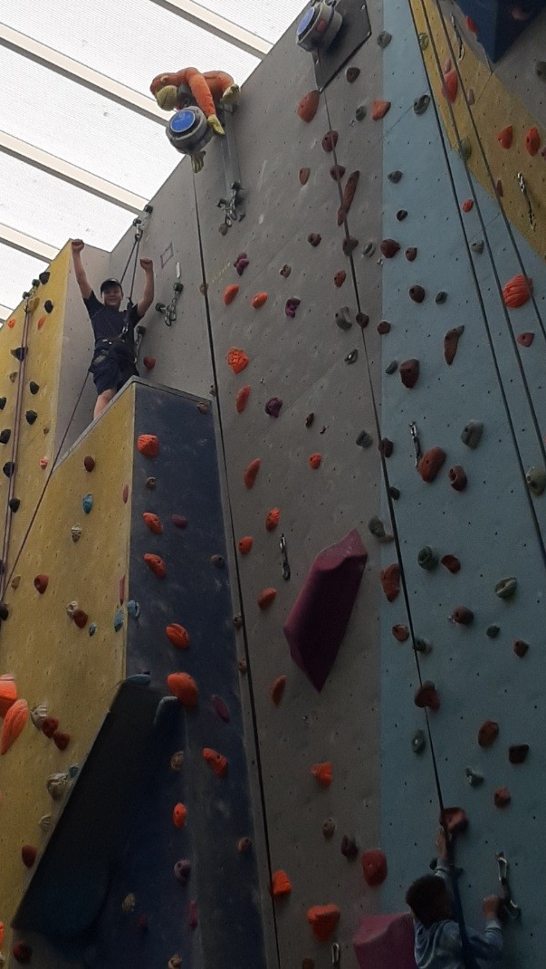

Findings
The findings of this evaluation are presented below.

Nutritious Meals and Food Education
Given the ongoing cost of living challenges and the focus of Essex ActivAte on low-income families it is not surprising that almost three quarters (72%) of those who responded to the parent survey said they were ‘just about managing’ or ‘not managing’ financially and over a quarter (27%) said that they had accessed a food bank in the last year.
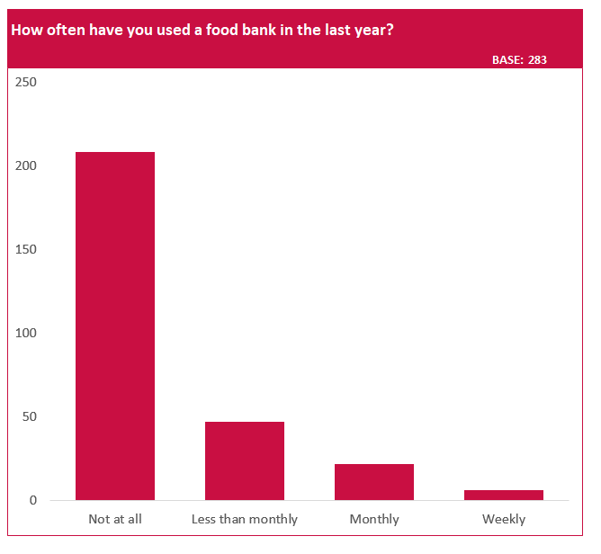
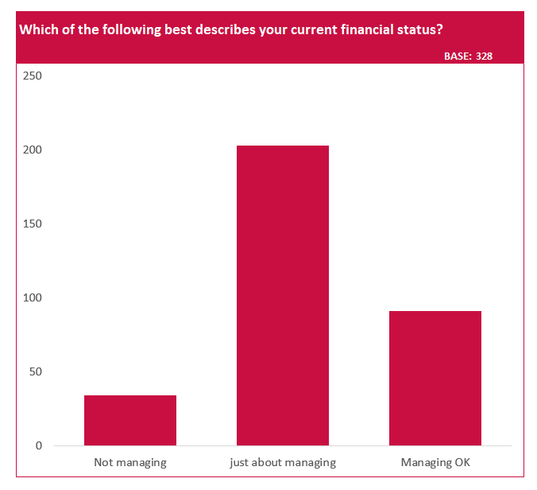

27% said they had used a food bank in the last year
When asked: Which of the following best describes your current financial status?

72% said that they are “not managing”, or “just about managing”.

This will inevitably have an impact on the amount and quality of food available to children and young people. A number of club leaders we spoke to commented that over the Easter period, many of the children are turning up hungry and some of them have asked to take more lunch home with them. Indeed, when we asked children whether they had eaten breakfast that morning, 43% of the HAF-eligible children said they had not. And when we asked the children to draw what they had eaten for dinner the previous evening, many of them drew convenience foods (pizza, pot noodle) with very few of them saying that their meal had included any fruit or vegetables.



Some of the parents that we spoke to commented on how expensive it can be to feed their children during the school holidays, particularly given that they ask for snacks more often when the are bored.
“[At holiday club] they’re not eating me out of house and home. When they’re at home, all they do is eat. And the shopping bill in the holidays goes up because all they want to do is eat. And I’m like, I can’t afford for you to eat all this stuff.” (Parent, Rochford)

Club leaders told us that they are trying to strike a balance between ensuring that children and young people are going home well fed and providing them with healthy, balanced meals. The children themselves told us about their reluctance to try new foods and how they enjoy eating the convenience foods they were drawing.
“I don’t like to try new food anywhere including at home” (Child, Maldon)

However, we observed and heard about some Essex ActivAte clubs that are managing to encourage the children and young people to try new foods through games and involvement.
At one club, we observed the children cooking fajitas for their lunch on an outdoor stove, which they were clearly really enjoying. At another club, we were told about a fruit tasting game which involved the children trying a range of different fruits (including lemon!) while blindfolded. At this club, 6 of the 11 children we spoke to said they had tried a new food at the club including pear and blackberries – “they were delicious!”.
Parents also told us that their children had tried new foods at Essex ActivAte clubs with almost a third (31%) saying that their child had tried a new food at the Holiday Club. The food that parents said their children had tried included pasta bolognese, chicken wraps, vegan burgers, sweet & sour chicken, curry, energy balls and tuna.
“[my child tried] custard (came out and told me he had mustard on his cake! It was definitely custard LOL)” (Parent, Epping Forest)

Encouragingly, almost a quarter (23%) of parents said that since attending the Holiday Club, their child had tried a new food at home suggesting that Essex ActivAte is creating longer-term behaviour change around eating habits.
“She’ll come home sometimes and say she’s had something and then she’ll want to try it… and she’ll help me with cooking. If she’s done something at holiday club, she’ll do it with me so we can do it together which is nice because we don’t get to do a lot together.” (Parent, Colchester)
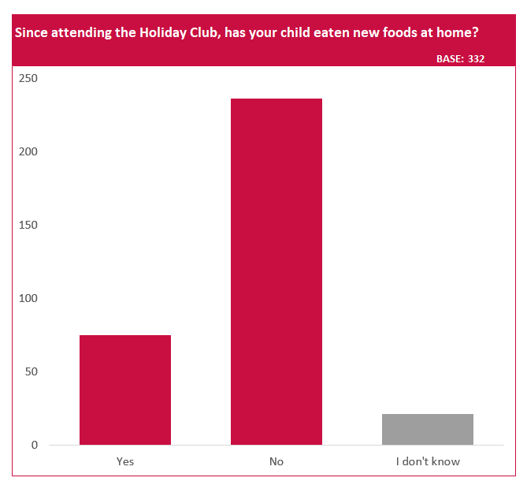
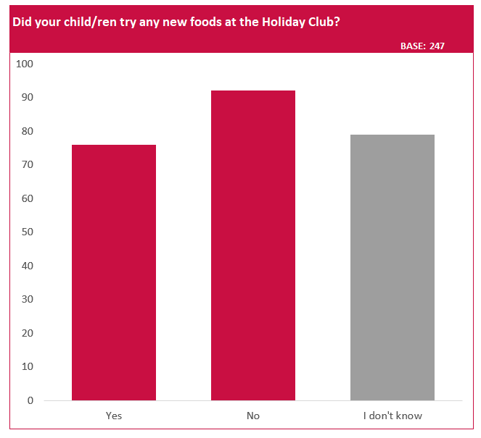
31% of parents responded that their child had tried new foods while at the holiday club, and 23% said that their child had tried new foods at home since attending the holiday club.
Trying new foods was also reported by parents of children with SEND, which is particularly positive given that some neurodiverse children have a small number of ‘safe foods’ which they can tolerate the taste / texture of.
“My child has a very limited diet and only eats 4 foods. [The club] bought in these foods to give my child in case they didn’t eat what everyone else eaten. But they served their food with each item on separate plate/bowl and my child tried everything and didn’t ask for their safe foods.” (Parent, Rochford)

Clubs also seemed to be aware of the opportunity they had to provide food outside of delivery hours and many providers reported that they reduced food waste by offering families leftovers to take home. They also seemed to be aware of the need to reduce the stigma of families accepting free food and at some clubs, this was done in creative ways, such as a ‘Supermarket Sweep’ activity.

Physical Activity and Learning New Skills
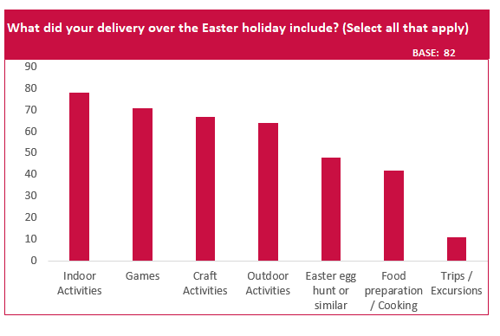
One of the requirements of Essex ActivAte clubs is that they provide children at least 60 minutes of physical activity per day. Over the Easter holiday, clubs provided a wide range of activities for the children attending; some of which were more traditional sports such as dodgeball, football and rock climbing, while others got children active ‘by stealth’ through active games. Some of these activities were developing important life skills such as swimming and learning to ride a bike as well as activities that children might not have the opportunity to try otherwise such as golf, angling and horse riding.

“Last week they taught the children to ride bikes and get more confidence. My son learnt to ride a bike after me trying teach him for years. He is 9 now.”

(Parent, Harlow)
A wide range of activity types were on offer during the Easter Holidays (see chart on left)
Indoor activities were provided by 95% of providers quite probably due to the weather, however 78% said that they provided outdoor activities.


Physical literacy is our relationship with physical activity and movement throughout our life. This is important to build during childhood as evidence shows that this relationship considerably influences our choice to be active throughout our lives.
The children we spoke to said they enjoyed the sport and physical activity opportunities provided by the holiday club and many of them linked positive emotions with taking part in these activities e.g. “I feel happy because I did well in hockey”, “I am excited because I get to try roller skating”. Parents also said that their children had enjoyed the physical activity element of their holiday club with 66% of those who responded to the parent survey rating their child’s enjoyment at 10 (out of 10) and 94% giving a score of 7 or more.
We also asked a small number of children (n=34) questions which test physical literacy and found that these children were more likely than the Active Lives average to say that they like being active, that they feel confident when they exercise or play sport and that they know how to get involved in exercise and sport, and more likely still than children from low affluence families. While this is a crude comparison, it does suggest that attending an Essex ActivAte club can play a role in increasing physical literacy and therefore chances of life-long physical activity.I
 | Essex ActivAte Attendees | Active Lives - Overall | Active Lives – Low Affluence Families
“I like being active” | 74% | 49% | 41%
“I feel confident when I exercise and play sport” | 56% | 37% | 32%
“I understand why exercise and sports are good for me” | 56% | 64% | 57%
“I know how to get involved in exercise and sport” | 47% | 36% | 30%

When the children were asked what they would be doing if they were not at the holiday club, many of them mentioned computer games, tablets and tv. While they thought that this would make them just as happy as being at the club initially, they acknowledged that these things would get boring after a while. The parents we spoke to confirmed that if their children were not at the club they would likely be on screens but would quickly get bored of this.
“Mine would probably be gaming. One’s got an Xbox, one’s got a Playstation. They’d be sat on that all day. And they’d just shout at me from upstairs “Mum I’m hungry”.” (Parent, Rochford)

“They’d be bored. The novelty of computer games would wear off – it normally wears off over the weekend before we start this! We had 4 days this time because we had the 2 bank holidays… by Saturday she was bored.” (Parent, Rochford)

Many parents commented that they would much rather their child be at the holiday club being active as this is better for both their physical and mental health.

“You know that they’re going to be running around burning energy they’re not sitting around scoffing things, they’re not sitting in front of a telly, they’re getting active and actually going out and doing things with their day. It’s good for their mental health. It’s good for releasing all the stress and built-up energy.” (Parent, Maldon)

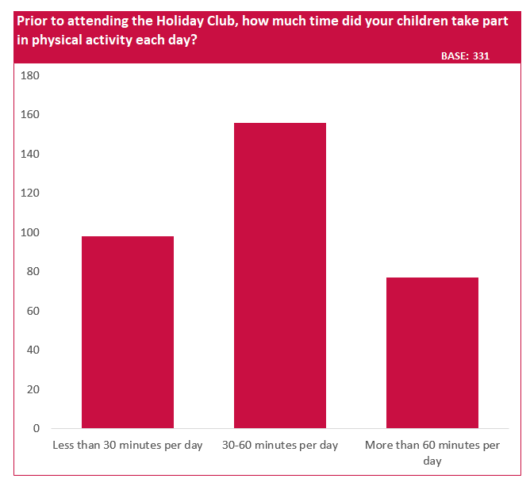
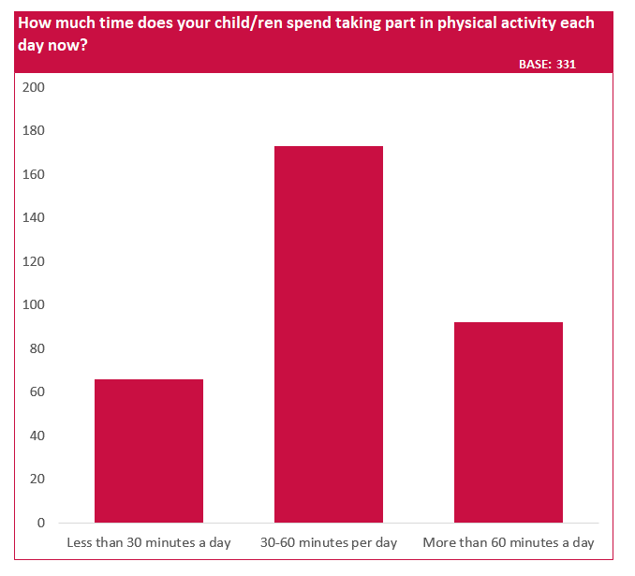
One of the aims of Essex ActivAte is to increase children’s physical activity levels not just during holidays. Encouragingly, findings from the parent survey show that prior to attending the holiday club, 30% of children were inactive (less than 30 minutes activity per day) which reduced to 20% after the holiday club. Furthermore, 37% of those who completed the parent survey said that their children were involved with the organisation running the holiday club during term-time and some of those who said they had been signposted said they had been signposted to additional physical activity opportunities such as Bikeability, ParkPlay and local sports clubs. This suggests that Essex ActivAte clubs are having an impact on physical activity during term-term as well as during the holidays.
Prior to attending the holiday clubs – 30% of the children who attended were inactive (<30 mins of physical activity per day)
After attending the holiday clubs – 20% of the children who attended were inactive (<30 mins of physical activity per day)

Over the Easter holidays, Essex ActivAte also linked in with Active Essex’s ‘Move With Us’ campaign; a behaviour change campaign which is designed for young people by young people. This is a further opportunity to promote physical activity outside of holiday clubs.

Allowing Parents to Work
While providing childcare which allows parents to work is not a priority for the Department for Education, this has been an important outcome for Essex ActivAte.
The majority of the parents who completed the Parent Survey said that they were working, with 62% saying that they were working full-time, part-time or studying. Many of the parents we spoke to said that they find school holidays difficult, saying that they either do not have enough annual leave to cover all the school holidays or are self-employed and therefore would not earn any money if they took time off work. Parents also spoke about the guilt they felt trying to balance work commitments and caring for their children, especially given the cost of other childcare options which were seen as unaffordable.
“I wouldn’t be able to work through the holidays without [the holiday club] which would mean unpaid leave.” (Parent, Tendring)

“I’m a single Mum. I can’t afford to be putting her into childcare that’s like £50 a day. So these clubs have been a godsend.” (Parent, Colchester)
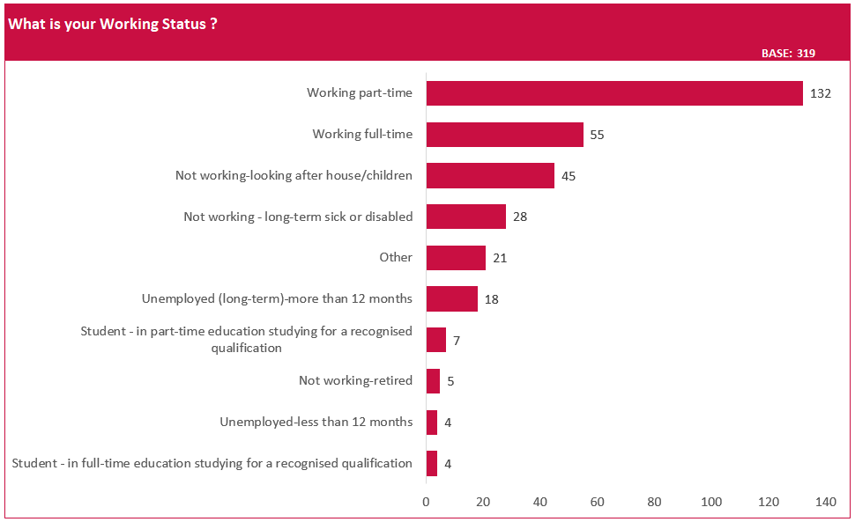
The majority of respondents were working. 62% were working (full or part-time or were students).

One parent told us that as a self-employed cleaner, she would really struggle to work, and therefore pay her bills, without the Essex ActivAte programme:
“If I didn’t have here it would be a real struggle. My friends and family don’t really look after my son so it’s just down to me… I’ve got certain people I’d have to cancel and then I wouldn’t earn any money at all. And then there’d be certain people that I’d be allowed to take him with me but for him to sit there on his own quietly while I’m trying to work, it doesn’t bode well. He wants to be entertained and he wants things to do and I’m trying to do that… but then I also need to focus on my job and working properly without having him… but then I know it’s hard for him because he doesn’t want to be sitting there on a pad – he wants to be outside he wants to be playing with his friends. So this just gives me the opportunity to be able to bring him here and I don’t feel mum guilt that he’s just sitting with me and not getting to do anything because I’m at work. It’s been a godsend. I just wish it was every day of the week.” (Parent, Maldon)
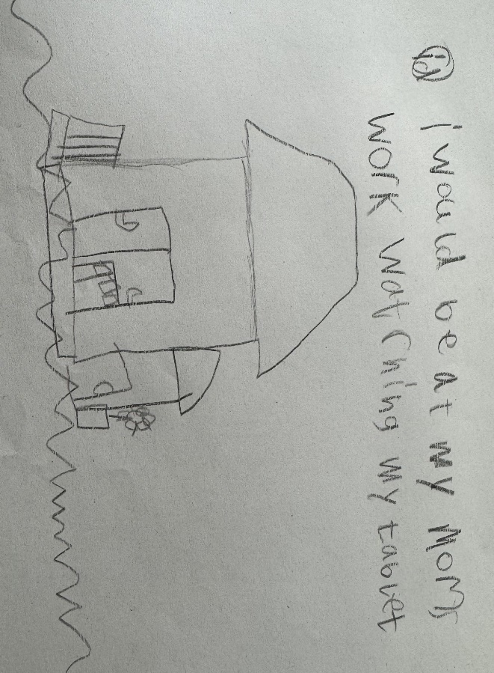
We also heard from a number of children that if they were not at the holiday club that they would have to go to work with their parent. These children said they would much rather be at the club having fun with friends than having to sit quietly and entertain themselves.

Interestingly, a number of parents we spoke to also mentioned the challenges of having their children at home while another member of the family was working or sleeping in preparation for a night shift and how this meant that they had to try and keep the children quiet – something that they did not find easy to do.
“For me, it’s about the management of the noise the boys make… You end up “be quiet” “be quiet” “grrr” constantly. And you’re nagging at them constantly… [When they’re at the holiday club] I don’t have that constant anxiety or feeling like they’re my enemy. And I don’t want my family life to feel like that. They’re not my enemy – I love them to bits. But it’s too stressful.” (Parent, Rochford)

Parents were therefore incredibly grateful that Essex ActivAte gave them the opportunity to work during the school holidays without feeling guilty and knowing that their children were safe and happy. And those who said in the Parent Survey that the holiday club had enabled them to work, were able to work an average of 5.7 hours per day that their child attended. For some parents, being able to work for part of the holidays meant that they were able to take some time and afford to do something nice with their children which they felt is a balance that they would not be able to achieve without Essex ActivAte clubs.
I actually have no idea what I would do without the activate schools out holiday club where my 3 children attend in the holidays when I am working… As a single parent and someone who suffers with a mental health disorder as well these clubs make my life and stress so much less. I don’t have to rely on family and friends to look after the kids and I don’t have to let my workplace down.” (Parent, Chelmsford)
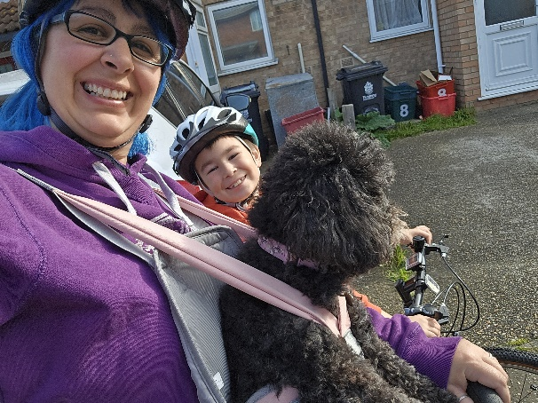
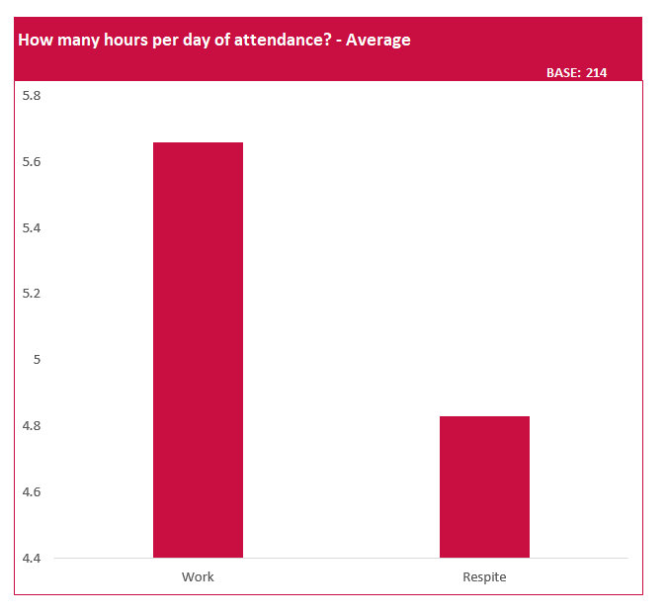
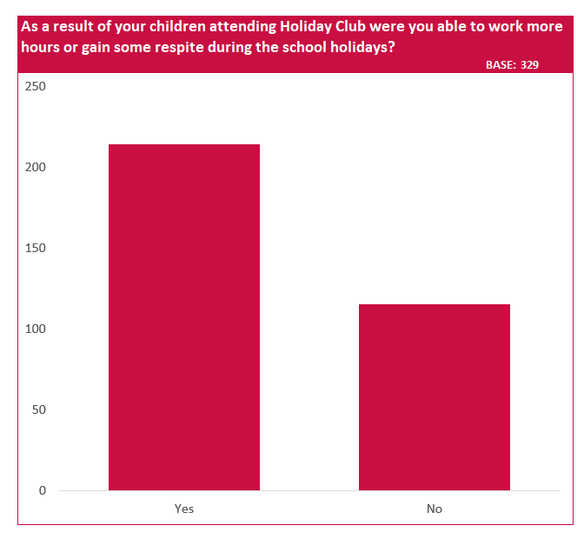
65% of respondents said that the holiday club had allowed them to either work more hours or gain some respite.

Of these, 56% had been able to work more hours (on average 5.7 hours per day of attendance), and 47% said that they had respite (an average of 4.8 hours per day of attendance)

“Having the club means that I am able to go to work so that I can provide for my family. The first week of the Easter holidays my lil man went to club everyday so that I could work. He loves it! And it alleviates the mum guilt of going to work. Second week I managed to book time off work and we were able to have quality time together going for bike rides.”
(Parent, Tendring)

Benefits for Children and Young People
The children and young people we spoke to told us that they were enjoying being at their holiday club and were also able to tell us some of the benefits of being there such as making new friends and increased confidence. Indeed, at one club we visited we did a poll; 8 out 9 children said that they were having fun and all of them said that they had made new friends.
“We get to have a lot of fun and make friends and stay off our iPads!” (Child, Thurrock)

“Because of coming from another country, I felt shy about not knowing the right words, but getting to know other people has started to make me feel more comfortable and I’ve gained confidence in speaking a second language.” (Child, Thurrock)

Parents also told us that they knew their children were having a good time at the club because they were keen to go in the morning (unlike school in many cases), spoke excitedly about what they had done afterwards and would count down until the next holiday so that they could return.
“My son won’t get up for school sometimes and he’ll say he’s got a tummy ache. But he couldn’t wait to come here. He was counting down the days. He gets so excited to come here. He gets up in the mornings. He gets himself dressed.” (Parent, Maldon)
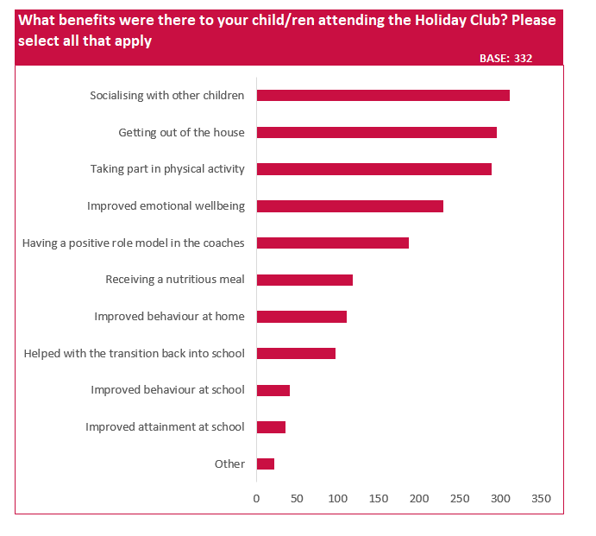
Respondents listed many benefits of the holiday clubs.
“Socialising with other children” the highest (94% listed this benefit)

87% said “taking part in physical activity”

36% said “receiving a nutritious meal”

Parents also mentioned a wide range of other benefits of their child attending the club, far beyond the obvious benefits of receiving a free meal and taking part in activities. These included having fun with other children, increased confidence, a sense of achievement when learning a new skill, making new friends and knowing that they are able to do this. Indeed, 94% of respondents to the Parent Survey said that socialising with other children was a benefit of attending the holiday club and more than three quarters (76%) said that attending the club had helped with their child’s mental health and wellbeing ‘very much’.
“Being here for some of the children is a great confidence builder. If they’re shy it really brings them out of themselves.” (Parent, Tendring)

“My child is bullied at school but luckily not here so she feels happy to be here.” (Parent, Colchester)

“It’s good for my son to be here because he doesn’t go to school round here so it gives him a more local friend base.” (Parent, Maldon)

Another benefit mentioned by several parents was how attending the club helped with the transition back to school after the holidays. They told us how their children were able to stay in a routine of getting up in the morning, getting ready and going somewhere and then going to bed at the normal time. This was particularly true for neurodiverse children who are more likely to find change in routine difficult.
“I can send my daughter here every day and she’s in a similar routine to the one she’s in at school. I haven’t got to go through that process of ‘no you’ve got school in the morning’. That first day back they don’t want to go. I don’t have to do that because she wants to go – she wants to come to [the club] and then she wants to go back to school and see her friends.” (Parent, Rochford)

“My son has ADHD and autism. At home during the holidays, it’s really difficult not having the routine there. Him coming here has been an absolute godsend.” (Parent, Tendring)

When we spoke to a headteacher, they confirmed the importance of children staying in routine over the holidays and that the children who attend Essex ActivAte clubs return to school happy.
“The HAF clubs give our children routine and engagement that may not be possible for some families to provide for a multitude of reasons. The children break up from school confident that there will be familiar adults that they feel safe with and return to school happy to share what they have been doing. For families the continuity of routines and care, which school normally provides, over the breaks is really important. Ensuring that the HAF clubs happen in our school and with some of our staff which are known to the families and know of their circumstances means that continuation of safeguarding and support happens even over extended breaks.” (Headteacher, Basildon)

Benefits for Families
As well as benefits for the children and young people who attend Essex ActivAte clubs, we also heard about a number of benefits to their families. In fact, some parents mentioned the ‘whole family’ approach that their holiday club takes, feeling that club leaders were as supportive to them as they were to their children.
“I’ve had lots of ups and downs especially with my boy’s health. And as soon as I walk to the door he’s like ‘are you alright? what’s going on?’ and I’m like ‘not really’. And he’s like ‘right, kid’s are gone – sit down’. It’s not just drop your kids and off you go.” (Parent, Maldon)

In some cases, this support to families included signposting to other support services. For example, during the Easter Holiday, children had been given oral hygiene packs which included a toothbrush, toothpaste and information about how to maintain good oral hygiene. Parents also told us that they had been signposted to term-time activities and other physical activity opportunities for their children as well as additional support for children with SEND, Food Banks and Citizens Advice Bureau.
As well as the level of support they felt from club leaders, many parents mentioned the positive impact the clubs have had on their mental wellbeing, particularly when reflecting on what their day would have looked like if their child had not been at the holiday club. Similarly, 96% of those who responded to the parent survey said that Essex ActivAte holiday clubs had helped to improve their mental health and wellbeing.
“I’d be covered in food, shaking in a corner probably.” (Parent, Rochford)

“This club is a ‘stressbuster’!” (Parent, Tendring)
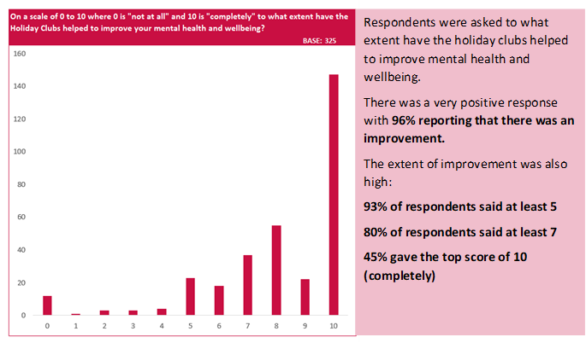
There were many contributing factors to this improvement in parent wellbeing mentioned such as reduced worry about money, reduced stress about balancing work and childcare, reduced guilt about not being able to provide memorable holiday experiences and (in some cases) respite from the challenging behaviour of their children. Something slightly more unexpected mentioned by several parents was the impact that attending a holiday club had on their child’s sleep. Parents told us that following a day at holiday club, their children would go to bed at a reasonable time and then sleep more during the night, giving them both an evening to relax and a good sleep.
“He usually sleeps 3 hours a night and last night he slept all the way through!” (Parent, Basildon)

“It makes such a difference! Yesterday, by 7 o’clock she was soundo! It was wonderful! It’s the first night off I’ve had in forever! And she slept right through til this morning. It was amazing! That never happens! Normally you get to the weekend and they’re up until 2 o’clock in the morning.” (Parent, Rochford)

It is unsurprising that the increase in parent wellbeing leads to them having additional patience with their children, more capacity for spending quality time with them and a generally happier household.
“I’ve got that much more patience. So my daughter gets home and we can play and we can do stuff together or we can cook. Whereas normally, I’d be saying “do me a favour and just go to your room”. And you feel like a terrible parent and you get some much guilt, but this is amazing because I can get her home and actually do stuff with her and feel like we’re having fun.” (Parent, Rochford)

Parents and children both also told us about the benefits that attending a holiday club can bring in terms of bonding and improving family relationships. Parents told us that their children attending the holiday club gave them something to talk about after pick-up time as the children are really keen to share what they have been doing.
We also heard about the benefits of the clubs for sibling relationships. In some instances, this was siblings being able to spend time together doing something fun. In others, it was not forcing them to spend time together and allowing them to pursue their own interests separately at the club. Two siblings we spoke to at one club told us that if they weren’t there, they would be arguing and fighting all day. Their parent agreed:
“I can’t referee between the two of them. I have to ask Mum to come and help. It is constant. All the time! If they’re not here and they’ve got other kids to play with – otherwise they spend too much time together and it’s constant… But here, when they come home, they’re sisters not enemies because they’ve not spent all that time together.” (Parent, Maldon)



“A chance for my sons to learn new skills, spend time together outdoors, bond and learn over a common interest and have fun.”
(Parent, Uttlesford)

Holiday Experiences and Opportunities
At Essex ActivAte clubs, children and young people took part in a wide range of activities which aim to give them ‘holiday experiences’ that parents might not be able to afford. Over the Easter holiday, these included trying new sports, animal experiences, craft activities and cooking/baking.
“This week [my son] got to have a go on a quadbike which he loved. This isn't something he's done before and he had a great time.” (Parent, Uttlesford)

“My children went golfing which I wouldn't be otherwise able to afford and I am extremely grateful they felt included.” (Parent, Brentwood)

Some clubs also offered trips. One club we visited were having a trip to Madison Heights in Maldon where children were able to go to a soft play centre, have a game of bowling and go roller skating. For parents to take their children for this day out, the cost would be £25 per child plus paying for food and drinks.
Many parents we spoke to mentioned how expensive it is to take their children out for the day. They told us that in order to keep their children entertained during the holidays they needed to get out of the house, but with the weather being wet over the Easter holidays, there was a need to pay to go to indoor activities such as trampoline parks and soft play, which are expensive.
“Particularly when the weather's not good, because that makes it even more difficult. You know, if it's raining, you generally have to take them inside somewhere that will cost and you can have quite an expensive day… So this has been an absolute godsend. It really has.” (Parent, Tendring)

“I’ve got 4 children – that’s a £100 day out just for a couple of hours!” (Parent, Rochford)

Some of the parents felt a sense of guilt about not being able to provide these experiences for their children and worried that they would look back and think they did not have a good childhood because of this. They were therefor grateful that their children were able to have memorable experiences through Essex ActivAte clubs.
“I would love to take the children to the zoo, but it’s too expensive”. (Parent, Chelmsford)

“Essex ActivAte have given me the opportunity to take so much guilt away from not being able afford to take my children away during school breaks. My children come home excited and happy every time. It given me the ability to carry on working during school holidays to provide for my family. It’s given me and my children a lifeline we so disproportionately need.” (Parent, Braintree)

A number of the clubs we visited had both HAF-eligible children and children who were there as part of the paid offer. However, there was no distinction between these children and when we askes staff to identify the HAF-eligible children, they needed to look at the booking system.
Parents also worried that children would not have anything to tell their friends about on return to school without attending Essex ActivAte clubs. We asked children and young people to write or draw what they would tell their friends about when they went back to school and many of them excitedly drew activities they had done at their holiday club and they had lots of stories to tell. These included going swimming, rock climbing, animal encounters and Easter egg hunts.

Safe Spaces and Positive Role Models
One of the aims of Essex ActivAte is to provide children and young people with safe spaces and positive role models. 98% of those who responded to the parent survey agreed or strongly agreed with the statement ‘I feel my child/ren are safe at the holiday club.’ Parents were also very quick to tell us in focus groups how much they trust the coaches at holiday clubs because they know their children well and understand their needs.
“I trust [coach] and the team with my whole life. I know for a 100% fact if anything goes wrong and they need to call me, they’ll call me. You just get that safe feeling with them. I’ve dropped them off at other holiday clubs and I’ve been worrying all day. But with [coach] and the team, I wholeheartedly trust them with both of my kids. It sounds silly but they almost love your kids as if they were their own. If your kid gets a bit upset or something, they know how to calm them down and make them feel better.” (Parent, Rochford)

“It’s like they take on that Mum or Dad role and they learn completely what works for that child. When I first came I told them everything and I didn’t feel like I needed to say it ever again. They straight away got it.” (Parent, Maldon)

Parents also felt that the clubs were offering their children positive role models, with 56% listing this as a benefit of their child attending the holiday club (the 5th highest rated).

The children we spoke to also saw their coaches incredibly positively. We asked them to draw a picture of their ‘ideal coach’ and in response to this, many of them chose to draw members of staff from their holiday club. The things the children liked about their coaches included being fun/funny, being kind, being supportive, being inclusive, having boundaries and being a good listener.
“I want my coach to be nice, trusting, caring, but also a bit strict. I also want my coach to be sporty and chatty and especially fun. But overall I love my coaches.” (Child, Harlow)

While we were not able to visit a club for young people at risk of involvement with the criminal justice system, Essex ActivAte staff told us about the importance of these clubs in providing a safe space for these vulnerable young people to literally ‘get them off the streets’.

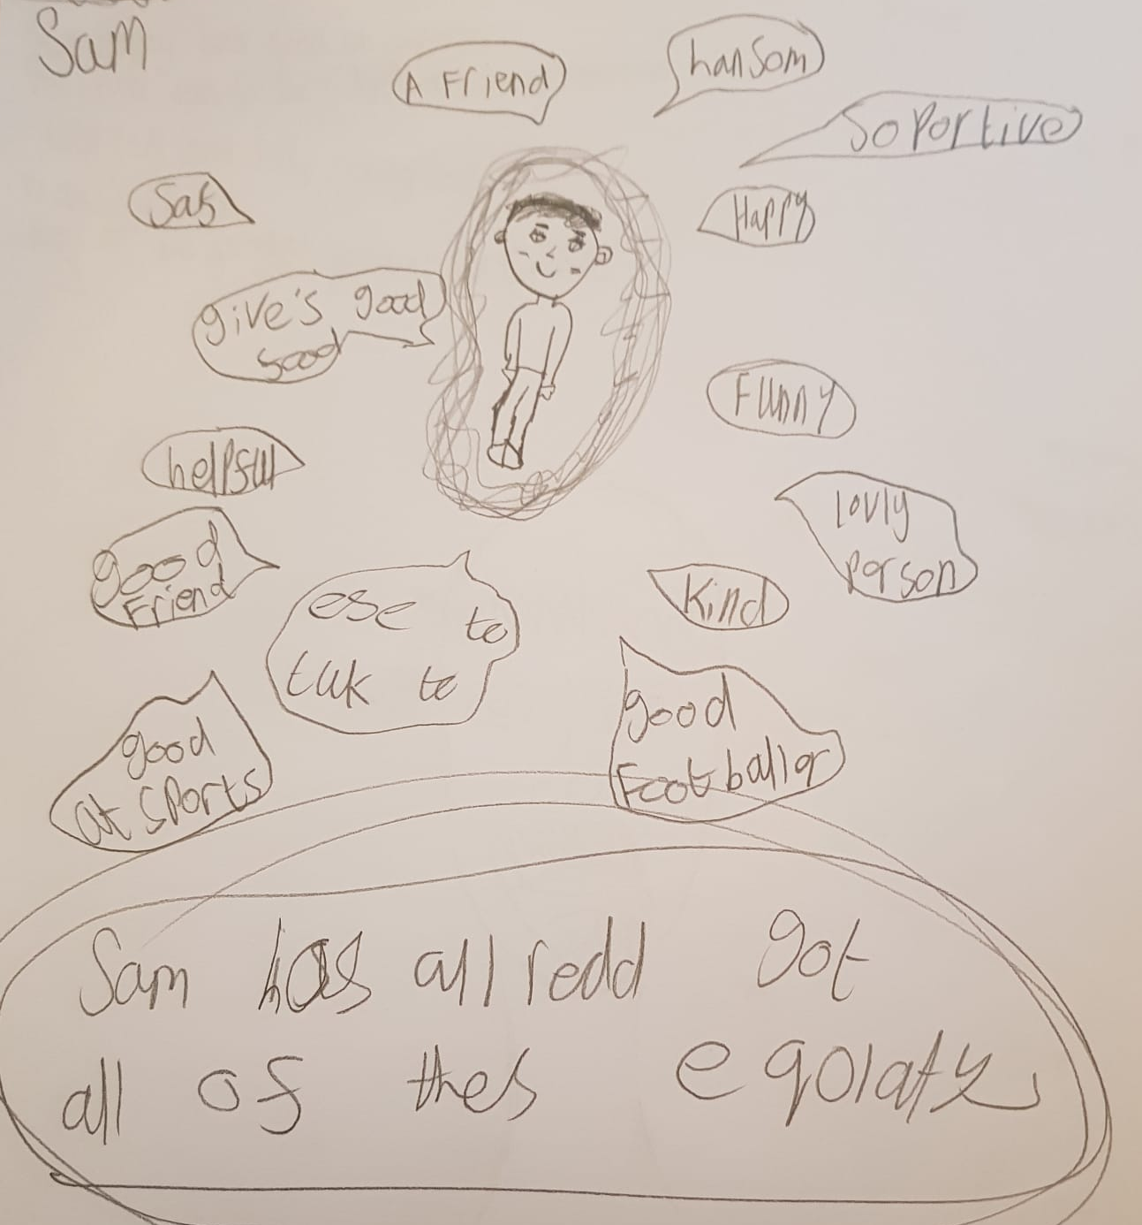

Support for Families with Children who have SEND
Essex ActivAte offers both specific provision for children who need high levels of additional support as well as an inclusive offer for children who have lower levels of additional need. Over the Easter holidays, 25% of children who attended were reported by their parents as having some level of SEND. This is considerably higher than the national average of 17% of children with SEN, suggesting that there is good uptake of Essex ActivAte clubs among this group.
Many of the benefits to children, young people and families mentioned above are relevant to families with children who have SEND, however often to a greater extent. For example, it has already been discussed the benefits of clubs providing routine, encouraging trying new foods and improving sleep are particularly helpful for children with SEND given the additional challenges they face.
In saying this, one of the biggest benefits for families with children who have SEND is respite. Some said they chose to relax, some chose to get things done around the house and some chose to spend quality time with their other children who they said are often ‘overlooked’ because of their sibling’s additional needs. Of those who said in the parent survey that the holiday club had allowed them respite, they gained an average of 4.8 hours per day of attendance.
We’re lucky that my Mum moved in with us after my daughter was diagnosed [with autism] but if she’s with me for 2 weeks… She’s just so much. All the time! And this gives me a chance to breathe.” (Parent, Rochford)

“I wouldn’t have got the grass cutting done today. Definitely not! I don’t know what my day would have looked like but I know I would not have got my grass cut. 100%.” (Parent, Maldon)


“Essex ActivAte meant that my disabled son could be himself and find his happy place. He finally found a club that he is excited to go to and wants to be there. Having people that understand his disabilities made it all so much easier! It also meant that his little sister, who's classed as a young carer could get some respite and 1:1 time with me and I could also get things done.”

(Parent, Uttlesford)

Many of the parents we spoke to in focus groups at mainstream clubs mentioned that their children had additional needs (for example sensory impairment, physical health issue, neurodiversity) but were engaging well. In fact, they were pleased that the Essex ActivAte offer is inclusive in this way. At one club visit, we saw how clubs were seeking to be inclusive to children with additional needs, as they had provided a small tent for a specific child to sit in if they became overwhelmed.
However, as much as some parents liked the inclusivity of mainstream Essex ActivAte clubs, the parents of those children attending SEND specific club, liked that this specialist provision was available. When asked how they would feel about opening up the club to non-SEND children, the did not like this idea saying that there are already lots of options for these children during the holidays but this is not the case for them.
“We do every free activity we can over the holidays normally, but a lot aren’t appropriate.” (Parent, Basildon)

“I have to get up at the crack of dawn to take him to the park so there’s no other kids there, he doesn’t do well with others.” (Parent, Basildon)

They told us that they do not have the option to use family members for childcare as their children’s needs are too great, there are very few SEND-specific clubs outside of Essex ActivAte and those that are available are very expensive and therefore unaffordable.
“I was quoted £700 for a SEND club, I can’t afford that!” (Parent, Basildon)

Conclusions & Recommendations
This evaluation found that Essex ActivAte is achieving far more than delivering holiday activities and food and the research team lost count of how many times it was described as ‘a godsend’. The programme is achieving multiple outcomes for children, young people and families.

Conclusions
Nutritious Meals and Food Education – Financial pressures mean that the amount and quality of food available to some children and young people is limited and the research team were shocked that approaching half (43%) of the HAF-eligible children we asked said that they had not had breakfast. Essex ActivAte provides food for children and young people at their holiday club, encourages them to try new foods and finds opportunities to send food home for families in non-stigmatising ways.
Physical Activity and Learning New Skills – Essex ActivAte gets children active through traditional sports as well as active games. Children and young people enjoy the physical activity elements of the holiday clubs and evidence suggests that they have led to an increase in both physical activity levels and physical literacy.
Allowing Parents to Work - Many parents told us that they find school holidays difficult and feel guilty about having to balance work and caring for their children, particularly given the cost of other childcare options. Essex ActivAte has enabled parents to work (and therefore pay their bills) when they would not have been able to if their children were at home.
Benefits for Children and Young People - Children and young people clearly enjoy attending Essex ActivAte clubs and have fun while they are there. Parents also felt that their children were benefiting in other ways such as increased confidence, improved mental wellbeing and a smoother transition back to school after the holidays.
Benefits for Families - Essex ActivAte clubs do not just benefit the children who attend, but the wider family through offering support and signposting as well as giving parents respite which improves their mental wellbeing.
Holiday Experiences and Opportunities - Many parents are unable to afford holiday experiences for their children and feel a sense of guilt about this. Essex ActivAte clubs offer a range of activities that parents may not be able to afford, giving children experiences to tell their friends about when they return to school.
Safe Spaces and Positive Role Models - Essex ActivAte provides safe spaces for children and young people with coaches who parents trust and children and young people look up to. More than half of parents said that ‘positive role models’ was a benefit of their child attending their holiday club.
Support for Families with Children who have SEND - Essex ActivAte clubs are highly valued by families with children who have SEND given the cost and availability of similar provision. Many of the benefits to children, young people and families are relevant to families with children who have SEND, however often to a greater extent. A further benefit is the respite that holiday clubs allow parents and the time this gives them for self care, getting things done and/or spending time with their other children.

Recommendations
Essex ActivAte is both effective in achieving positive outcomes for children, young people and families, and highly valued by those who make use of the programme, with many coming to rely on it to feed and care for their children during the school holidays.
“We’d have petitions outside – ‘don’t leave us!’ You’ll see it on the Walton Gazette – ‘Group of Mums Marching to Parliament!’” (Parent, Tendring)

It is therefore recommended that:
- Essex ActivAte provision should continue beyond 2024, whether Department for Education funding is available or not.


This information is issued by:
Essex County Council
Contact us:
research@essex.gov.uk
Research & Citizen Insight Team
Policy Unit
Essex County Council
County Hall, Chelmsford
Essex, CM1 1QH
Essex_CC
 facebook.com/essexcountycouncil
The information contained in this document can be translated, and/or made available in alternative formats, on request.
Published July 2024

