May 2024

Essex ActivAte

Social Impact and Valuation Report 2022 - 2024

Dr. Tim Crabbe
Luke Bullock

Report by

Contents

 | Page
Contents | 2
Executive Summary | 3
1.0 Introduction | 4
2.0 Methodology | 5
3.0 Theory of Change | 9
4.0 Health, Social and Economic Impacts | 10
5.0 Valuations | 16
Appendix 1: Methods, Assumptions and Data Sources | 19
Appendix 2: Glossary of Terms | 22

Executive Summary

In this report we present the findings of a Social Return on Investment study focused on the Essex HAF programme, Essex ActivAte.
Findings are presented in relation to three periods:
- Easter 2024
- All provision during 2023 including half term holiday provision
- Provision during the Easter, Summer and Winter holidays in 2022
Whilst it was possible to define bespoke measurements and deploy related data collection instruments to support the analysis for Easter 2024, this was not possible for the 2022 and 2023 valuations. It was possible to make use of some legacy monitoring data for these periods but the study was also reliant on a degree of modelling from the Easter 2024 data for some of the assessments relating to earlier periods. In this context the Easter 2024 results should be regarded as the most reliable and authoritative, with the valuations from 2022 and 2023 seen as supplementary.
This is also reflected in the more detailed reporting of social impact evidence for Easter 2024 than was possible for the other periods and the inclusion of additional outcome measures.
All three valuations should be regarded as conservative, based on what it has been possible to measure and relating to the benefits accrued from the period of participation rather than wider legacy effects.
The results for each period have been separated into three categories: Health and wellbeing, social impacts and economic impacts and show positive returns on investment in each case with a range from £2.57 for each £1 invested in 2022 to £4.49 returned for every £1 invested in Easter 2024 provision. The value of provision for Easter 2024 alone was assessed to be almost £4.5million, itself an increase of 33% on the same period in 2023. There is then clear evidence of an increasing rate of return, both in terms of overall value generated and the return gained on any investment.
These findings also compare well with studies focused on other food provision programmes, which were found to be at the lower end of this rate of return and a Sport England study that found for every £1 spent on community sport and physical activity, a return on investment (ROI) of £3.91 was created for individuals and society.

1.0 Introduction

Since 2021 the Department for Education have provided funding to Essex County Council to deliver the holiday activity and food (HAF) programme during each of the main school holidays (Easter, Summer, Winter). In addition to this, Essex County Council have provided funding through Levelling Up work to extend the offer to half term holidays and reach low income families as well as those who are eligible for income related free school meals. This has seen over £20m invested in the holiday activity and food programme since 2021 through to the end of 2024.
In Essex the HAF programme is called ‘Essex ActivAte’ and has been developed so that it delivers wider impacts than the Department for Education primary outcomes, (providing free holiday clubs, 60 minutes of physical activity, enrichment activities, nutritious meals and signposting support). There has been a focus on building resilience in the families benefiting from the programme, so that they can begin to support themselves, gain a local community support network and have access to opportunities for themselves and their children which mean that they have more positive life outcomes.
Funding is currently confirmed from the Department for Education until March 2025 and from Essex County Council for half term HAF delivery until February 2025. If there is no further funding allocated, then this would have significant impact on the young people and families who have already been negatively impacted the hardest through the covid pandemic and now the cost of living crisis.
The following Social Return on Investment (SROI) study has been commissioned in order to demonstrate the programmes achievement of its core aims but also to reflect the wider impact on children, families and providers, or locally trusted organisations (LTOs) and the associated value, expressed in monetary terms.

2.0 Methodology
To provide an accurate valuation of the work of the Essex ActivAte Holiday Activity and Food (HAF) programme, Substance has prepared a Social Return on Investment (SROI) calculation primarily focused on delivery of and participation in activities during the Easter, Summer and Winter holidays since 2022 with some consideration of half term holidays in 2023.
SROI is a form of cost benefit analysis and branch of social value assessment that attempts to quantify the social change created by a programme, policy, investment or entity. It is a particularly useful form of analysis for not-for-profit organisations, which seek to generate positive social changes that are difficult to measure in traditional financial terms.
Social valuing techniques have developed and been refined progressively over time and involve the following steps.
- Establishing scope and identifying key stakeholders
- Mapping outcomes
- Evidencing outcomes and giving them a value
- Establishing impact
- Calculating the SROI
- Reporting, using and embedding.
SROI studies typically begin with the determination of the changes sought or generated by the programme, policy, investment or organisation, followed by a structured approach to determining whether any identified benefits can be attributed to the work under consideration and represented in monetary terms.
SROI can be calculated for a single year or over the life of a project or programme, and it can be calculated summatively (i.e., once outcomes have been realised) or formatively (i.e. as work is underway, or prior to it getting underway).
For this study, based on data availability, the scope was separated into three discrete elements, with a series of valuations relating to the Easter 2024 programme; the Easter, Summer, Winter and half term 2023 holiday programmes; and the Easter, Summer and Winter 2022 holiday programmes.
Following a review of Department for Education and internal assessments and planning documents and a subsequent stakeholder engagement exercise, reflected in the Theory of Change diagram presented in the next section of this report, the following set of twenty outcomes were identified and separated into three domains covering: Health and Wellbeing, Social Impact and Economic Impact.

Table 1: Outcome Mapping
Health and Wellbeing | Social | Economic
Improved physical health | Improved educational attainment | Job creation
Improved mental health | Improved school attendance | Increased working hours
Improved nutrition | Access to public services | Local provider spending
Better food choices | Improved attitudes and aspirations | Local parent spending
Better food choices | Volunteering | Leveraged provider funding
Parental wellbeing | Access to training
Parental wellbeing | Reduced NEET status
Children’s wellbeing | Reduced NEET status
Access to respite care | Increased connections and belonging
NB: Monetary valuation possible for outcome cells highlighted in darker shade of green only

In order to evidence the achievement of these outcomes and to give them a value, a variety of methods were employed based on the use of three main sources of primary data and a range of secondary sources which are documented more fully in the appendices to this report. These included routine monitoring data relating to LTOs, session delivery and participants; a survey distributed to parents of participants during or following programme delivery; a survey distributed to LTOs following programme delivery.
Following assessment of available data, it was not deemed possible to provide a valuation for each of these outcomes. It was possible to represent the programme’s impact in relation to all twenty outcomes but only to represent value in monetary terms for fourteen (highlighted green in Table 1.
A specific valuation was prepared for the Easter 2024 programme for which it was possible to deploy bespoke survey instruments tailored to the needs of the study. The valuations for 2022 and 2023 were reliant on pre-existing survey instruments which did not always cover the full range of outcomes included in the study. In these scenarios proxy values were imputed from responses provided for Easter 2024 and some other periods with adjustments made to reflect the year in question as appropriate. In all cases, values were adjusted to reflect the time limited nature of any benefits associated with short term provision.

In the health domain we were able to employ a ‘risk and protective factors’ model for a range of physical health conditions, which considered the risk of participants in relevant population groups facing these conditions; the associated cost to society of negative outcomes; as well as the effect of participation in the physical activity elements of provision in reducing that risk to calculate a per capita saving which is then multiplied by the number of participants achieving the Chief Medical Officers recommended level of physical activity through their participation (revealed by responses to the parent survey) to establish an overall valuation. In terms of mental health, a similar approach was employed but adjusted to take account of measured improvements in mental health as a result of participation.
The approach to the calculation of a value for changes in wellbeing amongst both parents and participants considered the HM Treasury Green Book supplementary guidance on wellbeing which introduced a simple, but effective measure of wellbeing, the “Wellbeing-adjusted Life Year” (WELLBY). The UK Treasury defines a WELLBY as a change in life satisfaction of one point on a scale of 0-10 per person per year and recommends a value of £13,000 per WELLBY (which was adjusted to reflect current prices). We were able to assess changes in life satisfaction based on responses to the parent survey.
In the time available it was not possible to provide a full evaluative assessment of the value of increased nutrition. Whilst it was possible to measure perceptions of improved nutrition, the long-term benefits of this could not be established or valued for the population group. As such a proxy value was established based on a basket of studies relating to other food provision programmes. This was set at a conservative level based on savings to the state rather than wider personal benefits to avoid the risk of double counting benefits that might have been driven by other activities.
Finally in the health domain, the value of access to respite care (particularly for parents of SEND participants) was based on the hours of respite that parents reported gaining as a result of the programme and valued on the basis of the cost of entry level childcare provision.
In the social domain, the value of measurements of improved attainment at school are based on a ‘lifetime earnings’ approach that uses the differential between lifetime earnings potential across different levels of academic qualification to identify a monetary value for that impact. Valuation of improved school attendance, measured on the basis of the numbers reporting that the programme helped with transition back into school, employed the previously described ‘risk and protective factors’ model.

Access to public services was assessed on the basis of parent responses to questions around their access to other services through Essex ActivAte provision and what they would have been prepared to pay for those services. Volunteering was assessed on the basis of the number of volunteer hours given up across programme delivery with valuation on the basis of what a payment of minimum wage would have cost. Access to training was assessed on the basis of the number of support sessions that LTOs indicated they had accessed and the number of staff they employed and valued on the basis of entry level equivalent commercial training provision. Finally, the impact of reductions in NEET was based upon the number of young leaders that LTOs engaged and valued on the basis of the alternative cost of maintaining someone’s NEET status.
In the economic domain a value was established relating to the hours of additional employed work that parents reported being able to perform as a result of the programme, valued in terms of minimum wage payments. Participation-related expenditure is considered through use of a consumer spending approach based on the results of responses to the parent survey that identified daily expenditure in relation to a range of expenditure types. Additional value created in the supply chain is represented through the application of sector specific multipliers which identify, for example, the knock-on impact of spending on food and drink or kit and equipment in the retail, distribution and manufacturing sectors.
Two forms of provider related economic activity were also captured. The first of these was the value of direct local spending on food items at local stores reported by LTOs. The second relates to the value of additional funding that LTOs reported being able to access as a result of their participation in the programme.
For those outcomes where we were unable to identify a suitable method to establish a monetary value, we were able to capture counts of those experiencing positive effects and these have been reflected in the report.

3.0 Theory of Change
Theories of change describe the change organisations want to make and the steps involved in making that change happen in a concise way. This theory of change for Essex ActivAte was developed on the basis of a review of internal documentation and a workshop to identify and refine target goals, outcomes and processes with key staff on the 19th April 2024.
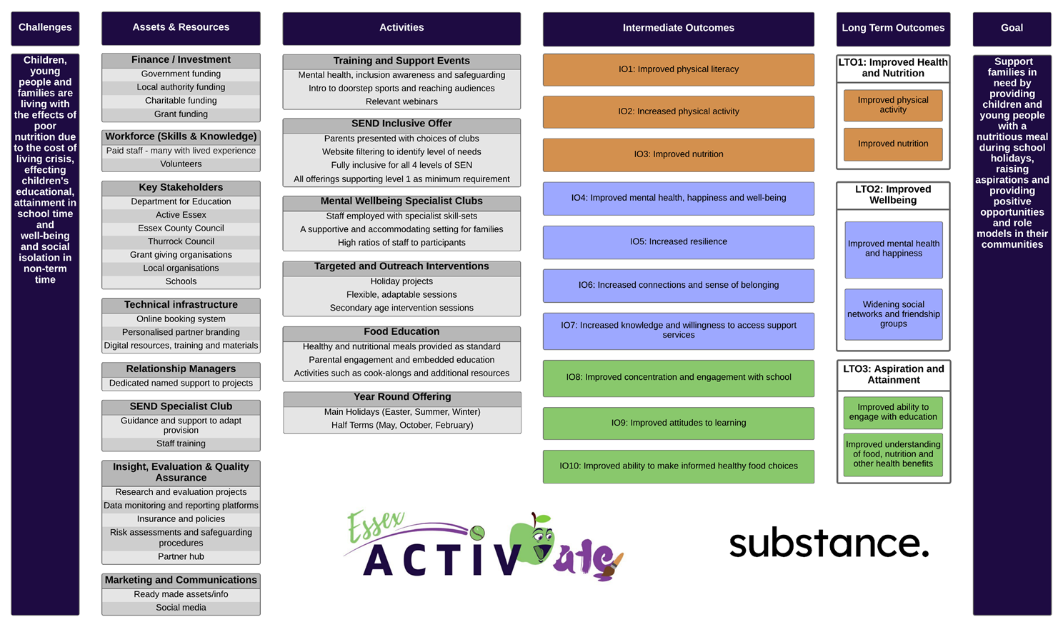

4.0 Health, Social and Economic Impacts

4.1 Previously reported impacts
Since the launch of the Essex ActivAte programme in in 2021 it has been positively impacting on the young people attending, their families and carers and the locally trusted organisations who deliver the programme in their communities. Previously reported key achievements have included:

- Worked in partnership with over 100 Locally Trusted Organisations
- Delivery of over 200 inclusive clubs each main school holidays and over 80 inclusive clubs each half term holiday
- Providing over 500,0000 free spaces at holiday clubs
- Providing support for over 40,000 young people and their families
- Providing over 750,000 meals
- Providing 72,000 activity booklets and family support booklets
- Facilitated training for over 250 individuals
- Provision of over 100 different activities
- Development of a young-leaders programme – supporting over 50 young people
- Engaging hard to reach cohorts by offering specialist clubs for those at risk of being involved in crime, to support those struggling with their mental health and children with special needs and disabilities.

Through the programme Essex County Council has positively engaged and worked in partnership with; Public Health colleagues, Children and Families, Education, Libraries, Levelling, Digital Inclusion, Social Care, Youth Service, Essex Outdoors, Country Parks, Visit Essex, Emergency Services and Community Supermarkets.

Often facilitated through these connections, wider support outcomes achieved through the programme over the past 4 years include:

For Children and young people:
- Improved concentration at school leading to better educational attainment.
- Young people having at least 1 hot nutritious meal each day.
- Improved physical literacy.
- Engagement in at least 60 minutes physical activity (CMO guidelines).
- Increased positive, healthier lifestyle choices.
- Improved mental health and wellbeing.
- SEND specific support.
- Decreasing the holiday gap experience.
- Greater social inclusion.
- Support and peer networks formed.
- Provision of safe spaces for children and young people to attend in holidays.
- Positive role models in the form of coaches, youth leaders and volunteers.
- Spaces where young people feel heard.
- Sun and water safety.
- Climate and environment awareness and action.
- Reduced risk of engaging in anti-social behaviour and youth criminality.
- Reduced risk of them being vulnerable to exploitation.
For families
- Regular support for families who have been most impacted via Covid and the cost-of-living crisis.
- Families and young people becoming embedded in local community activity.
- Families and young people becoming more aware of support available to them.
- Families and young people becoming less reliant on statutory support.
- Parents being able to work during school holidays.
- Respite support for SEND families.
- Improved wellbeing – meaning a more cohesive household.
- Up-skilling parents through multiply and food education programme.
- Giving these families and young people a voice.
- Digital access through free sim cards.
- Building resilience rather than reliance / dependence.
For local delivery partners
- Partnership work and a whole systems approach.
- Capacity and governance support for LTOs.
- Upskilling and training for staff and volunteers.
- Creating a supported network of LTOs who share learning and best practice.
- Increased reach into local communities.
- Wider support package to young people and families.
- Increased income and sustained business.
- Relationship building with local schools / wrap around care.
For local communities
- Youth crime prevention.
- Employment opportunities for local people.
- Economic benefits (local caterers, enrichment activity providers, schools, community venue hire).
- Increase in families and young people playing a positive role in local communities.
- Local community hubs developed.
- Increased community cohesion, social impact.
For Essex County Council – supporting Everyone’s Essex
- Unique access and trusted relationships with over 40,000 families who are eligible for income related free school meals or vulnerable and in need of support.
- Better supported families who are less likely to need to access more expensive support / provisions.
- Opportunity to build resilience of young people and families, as opposed to building reliance / dependence.
- Greater community cohesion.
- Partnership work with local authority areas.
- Reputation with other local authorities across the Country as Essex ActivAte is often seen as best practice in terms of HAF programmes and providing wider support for families.
- Insight into local needs.
- Relationships with locally trusted organisations.
- The development of levelling up projects via locally trusted organisations.
- General health improvements including, crucially, mental health and provision to families of the knowledge and support to live healthier, happier lives.
- Better outcomes for vulnerable families and stability in their local community, ensuring that young people and their families have independence and an active role to play as a community member.
- Neutral, and potentially beneficial, impact on ECC’s net zero ambitions.

4.2 Recently established impacts
As part of the social valuing exercise a range of data was gathered which included primary research with the parents/carers of young people accessing holiday clubs and the LTOs delivering them.
Whilst the surveys were designed to collect information relating to the full range of evaluations, many questions were specifically related to Essex ActivAte’s social impact and value during the Easter 2024 provision.
For children and young people, it is clear that, at least during this period of provision, the core aims of the programme were met.
In terms of nutrition, of the 332 parents responding to the parent survey:
- 72% reported that their children were eligible for income-based free school meals.
- 83% reported that their children had been offered a hot meal.
- 74% reported that their children took up the offer of a hot meal with 23% trying new foods at their holiday club and at home following attendance.
- 88% rated the food provided as either very satisfactory or satisfactory.
- 40% highlighted nutritional value as the reason for their satisfaction.

Chart 1: Benefits of Attendance
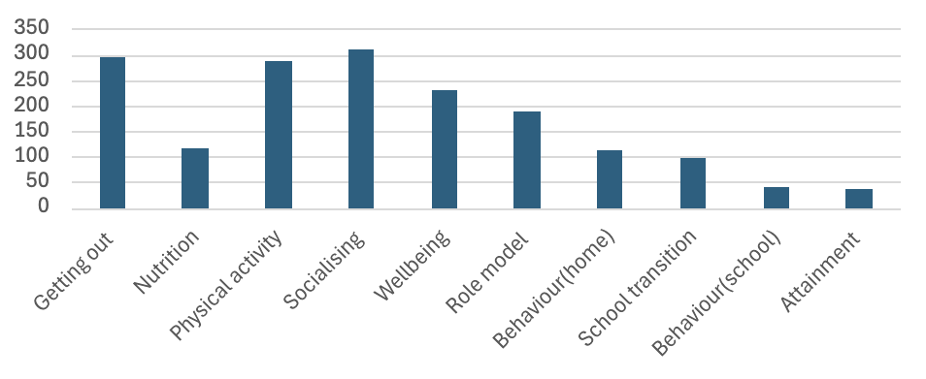

Parents reported a wide range of wider benefits of their children attending holiday clubs including:
- 94% ‘Socialising with other children’.
- 89% ‘Getting out of the house’.
- 87% ‘Taking part in physical activity’ with 10% recording an increase in levels of activity following attendance at holiday clubs and 6% more becoming physically active for more than 60 minutes a day.
- 69% ‘Improved emotional wellbeing’.
- 56% ‘Having a positive role model in the coaches’.
- 33% ‘Improved behaviour at home’.
- 29% ‘Helped with the transition back into school’.
- 12% ‘Improved behaviour at school’.
- 11% ‘Improved attainment at school’.
95% of parents also reported that the holiday clubs had helped with their children’s mental health and wellbeing, with more than 50% stating it had helped very much. They also reported on a scale of 0-10 the extent to which attendance at the holiday clubs had contributed to the development of the following skills with the results emphasising the greatest improvements in relation to teamwork (8.1), communication, creativity (7.6) and maintaining attention (7.6) but rather less development with curriculum skills such as Maths (4.9).

Chart 2: Children’s Skill Development
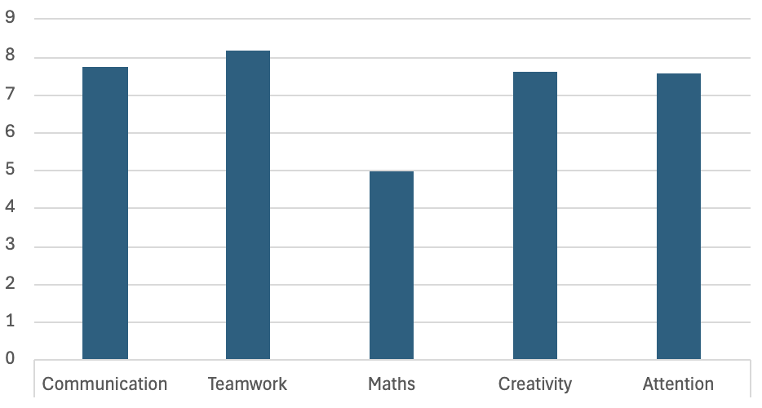

For parents there were a range of other impacts including:
- 64% who stated that they were able to work an average of more than five hours or gain an average of more than four hours of respite as a result of the holiday clubs.
- Help with parent’s own mental health and wellbeing with an average of the club’s contribution of more than 8 on a scale of 0 to 10.
- The number of parents accessing other services through their contact with holiday clubs was more modest, with just 12% indicating they had received information about or a referral to other services, although the range of services highlighted was broad and tailored to children’s needs.
The 84 respondents to the provider survey also reported benefits including those with economic value such as:
- An average of more than 10 staff employed on holiday club provision for an average of more than 250 hours.
- 34.5%being able to involve young leaders.
- 16.7% engaging parents as volunteers with an average of 20 volunteer hours being given up to each LTO
- Additional funding being secured. Whilst not every LTO benefited in this way, the average level of new funding secured amongst respondents was more than £2227.
Wider community economic benefits included the engagement of local food providers and other community organisations with the delivery of enrichment activities and other offsite onward support.
Providers also reported a range of other benefits to them as organisations as illustrated in Chart 3 below.
Chart 3: Wider Provider Benefits
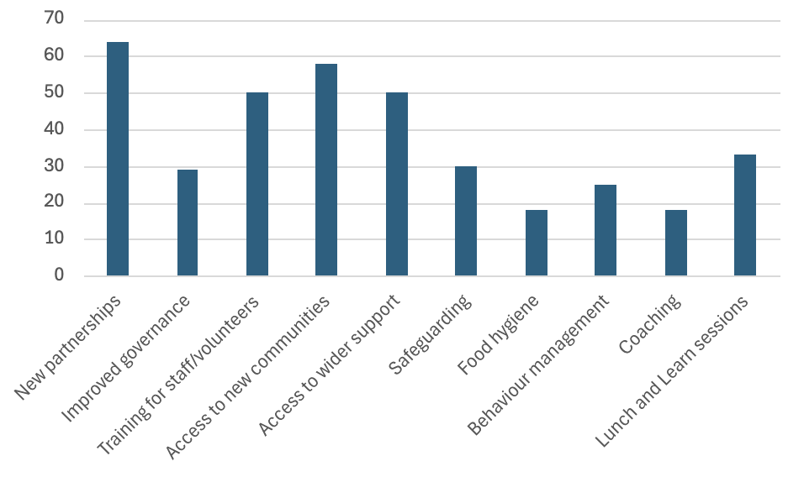

5.0 Valuations
Within Section 5, the valuations across the provisions have been provided and broken down by year and outcome.
Table 2: Easter 2024 Valuation
Health and Wellbeing
Outcome | Valuation | Beneficiaries
Physical Health | £14.24k | 1,350
Mental Health | £47.28k | 4,437
Improved nutrition | £144.01k | 3,533
Better food choices | N/A | 2,029
Parents’ wellbeing | £1.67m | N/A
Children’s wellbeing | £1.56m | N/A
Respite care | £102.90k | 3,790
Social Impact
Educational engagement | £68.60k | 2,948
Educational attainment | £8.07k | 1,089
Access to public services | £96.16k | 1,031
Improved attitudes and aspirations | N/A | 2,577
Volunteering | £24.48k | 33
Access to training | £23.10k | 660
Reduced NEET status | £38.30k | 37
Increased connections and belonging | N/A | 4,134
Economic Impact
Job creation | N/A | 1,109
Increased work hours | £179.58k | 3,790
Local provider spending | £35.15k | 67
Local parent spending:  - Food and Drink  - Transport  - Clothing and Equipment  - Childcare  - Other | £127.29k  £188.61k  £99.39k  £15.35k  £10.33k | N/A
Leveraged provider funding | £28.93k | 13
Please note values have been rounded where applicable.
Overall Social Value derived for Easter 2024 Provision = £4,479,268 (£4.48m)
Total expenditure to support delivery = £996,838
Social Return on Investment Ratio = £1: 4.49

Table 3: 2023 Valuation (including half term provision)
Health and Wellbeing
Outcome | Valuation | Beneficiaries
Physical Health | £36.96k | 4,604
Mental Health | £96.99k | 11,391
Improved nutrition | £119.66k | 9,070
Parents’ wellbeing | £4.46m | N/A
Children’s wellbeing | £6.46m | N/A
Respite care | £174.35k | 5,207
Social Impact
Educational engagement | £176.98k | 5,213
Educational attainment | £28.81k | 2,796
Access to public services | £360.02k | 2,646
Volunteering | £202.49k | 531
Access to training | £109.65k | 3,132
Reduced NEET status | £188.39k | 153
Economic Impact
Increased work hours | £322.70k | 5,207
Local provider spending | £173.11k | 76
Local parental spending (collated) | £2.71m | N/A
Leveraged provider funding | £241.07k | 15
Please note values have been rounded where applicable.
Overall Social Value derived across the 2023 Provisions = £15,860,245* (£15.86m)
*Value including Feb, May and October Half Terms equalling £3.96m
Total expenditure to support delivery = £5,182,010
Social Return on Investment Ratio = £1: 3.06

Table 4: 2022 Valuation (excluding half term provision)
Health and Wellbeing
Outcome | Valuation | Beneficiaries
Physical Health | £65.90k | 6,290
Mental Health | £158.00k | 14,450
Improved nutrition | £160.36k | 9,820
Parents’ wellbeing | £1.63m | N/A
Children’s wellbeing | £8.03m | N/A
Respite care | £11.78k | 1,436
Social Impact
Educational engagement | £199.42k | 4,738
Educational attainment | £47.81k | 3,548
Access to public services | £420.62k | 3,358
Volunteering | £137.28k | 110
Access to training | £74.34k | 2,202
Economic Impact
Increased work hours | £70.25k | 3,735
Local provider spending | £108.00k | 75
Local parent spending (collated) | £1.21m | N/A
Leveraged provider funding | £148.32k | 14
Please note values have been rounded where applicable.
Overall Social Value derived across the 2022 Provisions = £12,481,148 (£12.48m)
Total expenditure to support delivery = £4,852,670 (excluding half term delivery)
Social Return on Investment Ratio = £1: 2.57

Appendix 1: Assumptions and Data Sources
For the purposes of this report, we have made use of the following assumptions and data.

Basis Period
Valuations are based on three district periods, including the periods of ActivAte’s holiday provision during 2022 and 2023 and during the Easter 2024 provision.

Population
The population for the study included participants in the Essex ActivAte holiday provision for whom attendance records could be identified or verifiably estimated, the participants’ families/carers and the LTOs delivering the programme. It was assumed that, on average, each family had 1.5 children attending holiday clubs and so the number of participants was divided by 1.5 to estimate the total number of families benefiting from the service to support some of our calculations.

Deadweight, Discounts and Thresholds
‘Deadweight’ (what would have happened anyway) is accounted for through a discount based on the proportion of participants that would be likely to be involved in other activities if they did not engage with Essex ActivAte. Given the inclusion of a physical activity element within the provision, the assumption made is that, without this engagement, the proportion of participants meeting physical activity guidelines would match that for the relevant population group in the county at large. A value is therefore only included for the proportion of participants that would otherwise be defined as ‘inactive’.

Data
A range of data relating to participants was gathered directly through Essex County Council, including monitoring records and reports as well as via surveys administered amongst LTOs, parents and carers at different times. A more bespoke survey was prepared for the Easter 2024 programme.
Further backend data relating to social profiles, health and social condition prevalence and costs was gathered by Substance from public sources, published reports and, where not available directly, from data gathered when applying models with other entities in England as presented in Table 2 below:

Modelling
For those periods where delivery had taken place prior to the evaluation a degree of modelling was required. Where no data was available for previous periods, data gathered in relation to Easter 2024 (and other periods if available) was used as a proxy with some adjustments applied to account for inflation or other standardised variables.
Table 5: Data and Sources
Health and Wellbeing Outcomes
Risk and Protective Factors Related Measures
Outcome | Risk | Effect | Cost
Hypertension | 19.06%m/13.25%f | 50% | £4,238.56
Sources | EHN - adjusted | AOMRC | EJHE
Ischemic heart disease | 2.93%m/1.33%f | 40% | £2,140.14
Sources | EHN - adjusted | AOMRC | EHN - adjusted
Stroke | 0.93%m/0.86%f | 30% | £10,213.37
Sources | EHN - adjusted | AOMRC | EHN - adjusted
Diabetes | 12.09%m/9.93%f | 50% | £4,868.01
Sources | EHN - adjusted | AOMRC | Diabetologia
Anxiety | 10% | 56% | £1,630.08
Sources | Essex CC | Parent survey | NCBI
Depression | 10% | 56% | £4,663.40
Sources | Essex CC | Parent survey | NCBI
Dementia | 2.4% | 30% | £34,188.09
Sources | AE - adjusted | AOMRC | NCBI
Other Measures
Nutrition | £2.97:£1 invested proxy value | £3.70:£1 invested proxy value
Source | Univ. of Herts | City Harvest
Wellbeing | £13,000 Wellby value
Source | HM Treasury adjusted
Respite Care | £11.44 Adult minimum wage proxy value
Sources | HM Gov
Social Outcomes
Risk and Protective Factors Related Measures
Outcome | Risk | Effect | Cost
School attendance | 20% | Variable | £6,176.00
Sources | UK Government | Parent survey | NPC
Other Measures
Education attainment | 1% | £116,361m/91,444f
Source | SHU | OECD
Volunteering | £11.44 Adult minimum wage proxy value
Sources | HM Gov
Training | £35 proxy value per training session
Sources | Market rate
NEET | £15,992.01
Sources | Ciclavoro
Economic Outcomes
Working hours | £11.44 Adult minimum wage proxy value
Sources | HM Gov
Spending | Spend: Variable | Sector multipliers
Sources | Parent survey | EU
Other Data
Physical inactivity rates | 28.9%
 | Sport England

Appendix 2: Glossary of Terms

Absence from school: School attendance below 90% in any defined period.
Educational attainment: The highest level of education completed.
Gross Value Added (GVA): The value generated by any unit engaged in the production of good and services.
Indices of deprivation: A measure of relative deprivation in small areas in England called lower-layer super output areas.
Not in Education, Employment or Training (NEET): An acronym for Not in Education, Employment or Training which refers to a person who is unemployed and not receiving an education or vocational training.
Participation Programme: THF programmes that are primarily focused on engaging people in sport and physical activity.
Physical activity: Movement that is seen to contribute to the Chief Medical Officers guidelines for recommended levels of physical activity.
Risk and Protective Factors: Risk factors are the biological, psychological, family, community, or cultural aspects that precede and are associated with a higher likelihood of negative outcomes. Protective factors are characteristics associated with a lower likelihood of negative outcomes or that reduce a risk factor's impact.
Social capital: the networks of relationships among people who live and work in a particular society, enabling that society to function effectively.
Social Return on Investment (SROI): a method for measuring and assigning monetary values to outcomes that are not traditionally reflected in financial statements, including social, economic, and environmental benefits.
SROI Ratio: A ratio determined by dividing the identified social, economic and environmental value by the financial cost of the investment to identify the return generated for every unit of currency invested.
Subjective Wellbeing: The scientific term for levels of happiness and life satisfaction.

See https://uhra.herts.ac.uk/bitstream/handle/2299/26398/UH_Technical_Report.pdf?sequence=2&isAllowed=y and https://cityharvest.org.uk/people-value-report
https://www.sportengland.org/guidance-and-support/measuring-impact?section=social_and_economic_value_of_community_sport
https://socialvalueint.org/social-value/what-is-social-value/
Social Value UK (2012) A Guide to Social Return On Investment, http://www.socialvalueuk.org
https://sk.sagepub.com/reference/substance/n306.xml
See for example https://www.aomrc.org.uk/wp-content/uploads/2016/05/Exercise_the_Miracle_Cure_0215.pdf https://sportengland-production-files.s3.eu-west-2.amazonaws.com/s3fs-public/2020-09/Social%20return%20on%20investment.pdf?VersionId=5BgvLn09jwpTesBJ4BXhVfRhV4TYgm9E
https://www.investopedia.com/terms/c/consumer-spending.asp
Directorate-General for Education, Youth, Sport and Culture (European Commission) (2018) Study on the economic impact of sport through sport satellite accounts, Brussels: European Commission

