

**ARMED FORCES NEEDS ASSESSMENT**

November 2022 (Updated in February 2023)

Research & Citizen Insight

Essex County Council

**Contents**

Acknowledgements 4

1. Introduction 4

**1.1 Policy Context** 6

**1.2 Government Strategies for Veterans** 6

**1.3** **Scope** 8

**1.4** **Methodology** 8

2. The Armed Forces Community 9

**2.1** **Serving personnel** 9

**2.2** **Reservists** 10

**2.3 Ex-service** 12

**2.4** **Armed Forces Community** 14

3. Health 16

**3.1 Overview** 16

**3.2** **Mental Health** 17

**3.3** **Drugs and Alcohol Misuse** 22

**3.4 Healthcare among military families** 23

4. Education 24

**4.1** **Overview** 24

**4.2** **Childcare and Children’s Education** 25

**4.3** **Pupil numbers by year group (R-11 only) as at January 2022 in Essex** 26

**4.4** **Pupils Number by SEN Provision** 27

**4.5 Pupil numbers by SEN primary need type (R-11 only) as at January 2022** 28

**4.6** **Service Pupil Premium** 29

**4.7 Attainment** 32

**4.8 Free school meals** 33

**4.9 Extracurricular activities - Cadets forces** 34

5. Housing 35

**5.1** **Overview** 35

**5.2** **Service Accommodation** 36

**5.3** **Social Housing**  38

**5.4** **Population Who Previously Served in UK Armed Forces in Communal Establishments and in Households** 38

**5.5** **Homelessness** 39

6. Employment 41

**6.1** **Overview** 41

**6.2** **Spouses and Civil Partners** 42

**6.3** **Transition to Civilian Employment** 43

**6.4** **Out of Work Benefits** 45

7. Criminal Justice System 46

**7.1** **Overview** 46

8. The Needs Map 49

**8.1** **Overview** 49

9. Recommendations 59

**9.1** **Overview** 59

**9.2** **Health and Wellbeing** 59

**9.3** **Education and Children’s Care** 60

**9.4** **Housing** 60

**9.5** **Employment and Transition** 61

**9.6** **Criminal Justice System** 61

10. Appendices 61

Acknowledgements

The Research and Citizen Insight Team wishes to thank members of the Civilian Military Partnership Steering Group and colleagues for their advice and support, with a special thanks to Professor **Mike Almond**, who provided a further in-depth guidance.

**Sponsors:**

Councillor Derrick Louis & Lucy Wightman

**Civilian Military Partnership Steering Group:**

Prof. Michael Almond

Lt. Col. Ed Rankin

Maj. David Swann

Mr Malcolm Taylor

Mr Matt Welsh

Mr Philip Wilson

**Civilian Military Partnership Steering Board:**

Col. Nick Kitson

Col. Charles Thomas

**Research and Citizen Insight Team:**

Dr Paola De Pascali

Mr Saulius Ringaila

Dr Jyotsna Srinath

**Performance & Business Intelligence team** – For their input in Education section.

## **Introduction**

This Armed Forces Needs Assessment (AFNA) report forms part of a wider Joint Strategic Needs Assessment (JSNA) suite of products that provide an overview of the key issues across Essex. The aims of this report are, to:

* Provide key demographics of the armed forces community in Essex
* Examine the experiences of the armed forces community in relation to:
  + Health and wellbeing
  + Education and children's care
  + Housing
  + Employment
  + Transition
  + Criminal Justice System
* Examine the experiences of women and other minorities in the armed forces community
* Provide an evidence base to support the innovation, improvement, and commissioning of services for the armed forces community

The UK Armed Forces consists of the Royal Navy, the Royal Marines, the British Army and the Royal Air Force. The Armed Forces community includes serving personnel, both regulars and reservists, veterans, and their families and carers. Responsibility for Armed Forces healthcare is split between the Ministry of Defence (MOD) and the National Health Service (NHS), with service charities playing a vital role. The serving population is generally young, and physically and mentally fit with a lower prevalence of long-term conditions which preclude serving. However, there is a higher incidence of musculoskeletal injury due to the nature of the work[1]. The 2014 Essex armed forces needs assessment found that disorders such as depression and anxiety occur at a significantly higher rate among veterans when compared to civilians[2]. Similar needs have been identified in large cohort studies which indicate a need for investment in mental health services.

The report provides a foundation on which to scope a more comprehensive assessment of the required structures and support services for improved outcomes for the armed forces community, based on an understanding of health inequalities in this community. There is limited local data available to give an accurate picture of this population group in Essex, so national data and research has been used to build up this report. Understanding the complexity of armed forces community needs in Essex can be viewed as an iterative approach, with this report being ‘phase 1’ to a possible ‘phase 2’ which would require further resources, input, and collaboration from all partners across Greater Essex.

### **1.1 Policy Context**

The Armed Forces Covenant is a promise from the nation that those who serve or served in the armed forces, and their families, would not be disadvantaged. In 2012, Essex made its pledge to support the Armed Forces Covenant. The aims of the covenant include:

* + Raising public awareness of issues affecting the armed forces community
  + Reducing any disadvantages suffered by armed forces personnel because of their service
  + Recognising sacrifices made by the armed forces
  + Encouraging activities which help to integrate the armed forces community with the wider community

Essex County Council (ECC) works with representatives from the armed forces, veterans' charities, Essex councils, and a range of public sector bodies to deliver the Essex Armed Forces Covenant including[3]:  The Essex Civilian Military Partnership Board, The Veteran Gateway, other charities in Essex including The Soldiers’, Sailors’ & Airmen’s Families Association (SSAFA), ABF The Soldier’s Charity East Anglia and many others.

The Armed Forces Needs Assessment is part of this commitment and supports innovation, commissioning, and delivery of services to armed forces by ECC and the wider partners. This needs assessment will build on ECC’s ongoing success in this area having recently been awarded gold accreditation for supporting armed forces communities by the Ministry of Defence Employer Recognition Scheme.

### **1.2 Government Strategies for Veterans**

In 2018 the government set out **The Strategy for our Veterans** aiming to continue to support older veterans and to establish the right conditions that will support the newer generation and their wider community[4]. In this strategy, the government is aiming to achieve the following cross-cutting factors by 2028:

* **Collaboration between organisations:** Improved collaboration between organisations offers Veterans coherent support
* **Coordination of Veterans’ services:** The coordination of Veterans’ provision delivers consistent aims and principles over time and throughout the UK, ensuring Veterans, their families and the bereaved are treated fairly compared to the local population
* **Data on the Veteran community:** Enhanced collection, use and analysis of data across the public, private and charitable sectors to build an evidence base to effectively identify and address the needs of Veterans
* **Public perception and understanding:** The UK population value Veterans and understand their diverse experiences and culture
* **Recognition of Veterans:** Veterans feel that their service and experience is recognised and valued by society

In 2022, the further **Veterans’ Strategy Action Plan was introduced**[5]. The aims of this strategy were to go even further than the previous strategy and deliver five focal points for success by 2024, these five focal points are:

* Delivering a step-change in support for veterans and their families
* Maximising veteran employability as the key to positive life outcomes
* Listening, learning and addressing with compassion the historic hurt or disadvantage that sections of the veteran community have experienced
* Dealing with historic operations, recognising that these continue to impact on veterans
* Making sure veterans receive the same high standard of support, across the whole UK

In addition to the above strategies, in 2022 a policy paper was launched by the Cabinet Office, Office for Veterans’ affairs (OVA), and Veterans UK. This policy paper is a comprehensive update of what has been achieved so far and what the government will do next based on The Strategy for our Veterans (2018) and Veterans’ Strategy Action Plan: 2022 to 2024.The intention of this policy paper is to provide **6 monthly updates**[6] for the policies outlined in the above strategies.

According to the latest update, The Veterans’ Strategy Action Plan contains over 60 cross government commitments which the OVA tracks as 84 measurable tasks. As at August 2022, 21 (or 25%) of these have been completed (ibid).

### **Scope**

The scope of Armed Forces Needs Assessment will cover the following aspects of the Armed Forces community across Essex:



Health & Wellbeing

Education & Childcare

Housing





Criminal Justice System

Transition

Employment

### **Methodology**

This assessment was undertaken using:

**Literature review:**

Evidence synthesis from peer reviewed publications, grey literature, local research, analysis, and policy publications on the armed forces community in relation to:

* Health and wellbeing
* Education and children’s care
* Housing
* Employment
* Transition
* Criminal Justice System

**Secondary data analysis:**

* National and local data: Office of National Statistics (ONS); the Ministry of Defence (MOD)
* Location Statistics for UK Regular Armed Forces and Civilians
* Statistics at Veterans UK; UK Armed Forces Deaths in Service
* National and local research: Annual population survey: UK armed forces veterans residing in Great Britain; 2014 Armed Forces JSNA; Armed Forces Community Survey; UK Household Survey
* Reviews on behalf of the Government and other national studies including Forces in Mind Trust (FiMT)
* Understanding Service Leavers 50+: Challenges & Experiences in the Civilian Jobs Market (2020)

## **The Armed Forces Community**

### **Serving personnel**

According to the Annual Location Statistics (2022) for national and international UK regular forces and MOD civilian personnel, there are 208,430 MOD personnelworldwide. This number includes personnel deployed to other countries and MOD civilian personnel (excluding those who are deployed on operations and temporary assignments to North Africa, Middle East and South Atlantic). Figure 2.1 shows the change over time for number of worldwide strengths MOD personnel from 2012 to 2022.

**Figure 2.1: UK Regulars Military and MOD Civilian Personnel grand total (2012-2021)**

[7]

**Locally –** In Essex a total of 4,330 serving MOD including 3,950 Army personnel were recorded in 2022. The highest proportion of the armed forces population reside in Colchester (79%). The number for MOD and Army personnel in Essex has changed over time and this change is illustrated in the figure below (Figure 2.2). For example, the highest number of MOD personnel (4,870) was recorded in 2012 and the lowest (4,330) in 2022. The highest number of Army personnel (4,010) was recorded in 2015 and the lowest in 2018/19 (3,770).

*Royal Air Force (RAF)* – There were 40personnel members based in Colchester as at 01/04/2022.

*Royal Navy/Royal Marines (RN/RM)* – There were 10 personnel based in Colchester as at 01/04/2022.

**Figure 2.2: Number of MOD and Army personnel in Essex (2012-2022)**

[8]

### **Reservists**

There are many different reservist types, the most common being:

**Volunteer reserves** are made up of civilians who commit to training a set number of days per year and maybe called into permanent service for a set period. They are paid while training (and while deployed) and may train alongside Regular Forces.

**Regular reserves** are former members of UK Regular Forces, who are committed to serve if called up.

Currently (as at 01/07/2022) there are 77,036 UK reserve forces personnel in the UK, which includes regular reserve, volunteer reserve, sponsored reserve, and university officer cadets. The time-series figure below (Figure 2.3) shows changes in numbers of reservists in the UK between 2012 to 2022.

**Figure 2.3: Army reservists’ trends in the UK (2012-2022)**

[9]

In Essex, there are 5 army reserve units. In Colchester there are two centres - Army Reserve Centre in Merville Barracks and Army Reserve Centre in Circular Road East. There is one in Chelmsford (Colchester Road). One in Brentwood - The Army Reserves Centre (Clive Road) and one is in Southend (East Street).

A Freedom of Information (FOI) request to the MOD was made and the results show that there are 390 Future reservists in Essex (as at 08/08/2022), with the majority stationed in Colchester (Table 2.1).

**Table 2.1: Estimates of Future Reserve (FR20) strengths in the County of Essex as at 01/04/2022**

This data only includes Reserve units that are based and muster in Essex. Specialist units, including the Royal Navy Reserve and the Royal Air Force Reserve, do not muster in Essex and therefore these figures are not captured.

### **2.3 Ex-service**

*“Anyone who has served in the armed forces for at least one day is classed as a veteran*”[10].

**Nationally:** According to the Ministry of Defence (MOD), in 2017 there were approximately 2.4 million Armed Forces veterans in Great Britain (England, Wales, Scotland), an estimate of 5% of residents aged 16 and over (ibid). The latest census 2021 data showed lower percentage compared with 2017 APS survey, however the latest census data does not include Scotland. In 2021, the data showed that 3.8% (1.85m) of the population in England and Wales had previously served in the UK armed forces (residents 16 years and over), of whom 76.3% (1.4m people) previously served in the regular forces and 19.5% (361.000 people) served in reserve forces, while 4.3% (79,000 people) served in both the regular and reserve forces. Overall, the proportion of UK armed forces veterans was higher in Wales then England, 4.5% and 3.8% respectively[11].

**Regionally:** The largest proportion of veterans were recorded in South West (5.6%) and North East (5%), whilst in the East of England the percentage stood at 3.8% according to the latest census data (ibid) (See appendix, Figure 10.1).

**Locally:** In Essex, it was estimated that there are approximately 76,000 veterans, which was the 7th highest ex-service population in the UK and accounted for 5% of the total Essex population (as at 2017)[12]. However, the latest census (2021) data showed that in total there are 43,227 veterans (3% of the total Essex population), of whom 32,415 (2.2%) served in UK armed forces, 8,911 (0.6%) served in UK reserve armed forces, and 1,901 (0.1%) served in both, and Essex is among top fivecounties (out of 174 counties/unitary authorities in England and Wales) for the total number of veterans (See appendix, Figure 10.2).

**District level:** The latest census (2021) data, showed that the highest number of veterans in Essex reside in Colchester (7,172 people, 4.6% of the Colchester population) followed by Tendring (6,338 people, 5.1% of the Tendring population) (See Table 10.2 in appendix).

**Veterans’ characteristics:** Information about the characteristics of veterans is important for organisations, such as the government, local authorities, The NHS as well as voluntary sector - those that provide services for veterans. Veteran population differs from the non-veteran population and therefore their needs might be different, for example in figure 10.3 (see appendix) age distribution is displayed, which shows high proportion of older veterans. According to the latest Census 2021 report for veterans’ characteristics, the following findings have been summarised[13];

* Gender – males 86.4% (1,601,705), females 13.6% (235,430)
* Age – 31.8% (589,640) were aged 80 years and over. Over half of veterans (982,365) were 65 years and over
* Country of birth – 94.2% were born in the UK
* Ethnicity – 96.4% classed as “White”
* Religion – 64.2% “Christian”. 28.1% “No religion”
* Legal partnership status – 57.1% married or in a registered civil partnership. 13.4% widowed or surviving civil partner. 12.5% divorced or dissolved civil partnership
* Sexual orientation – 91.3% identified as straight or heterosexual. 0.9% identified as gay or lesbian. 0.5% bisexual. 0.1% other sexual orientation
* Gender identity – 93.8% identified same as registered at birth. 0.3% described as different sex from registered at birth (London and East of England highest proportion)
* Self-reported general health - 64.4% said that their health is very good or good. 24% said their health is “fair”. 8.6% said it’s very bad (see appendix figure 10.4)

**Service leavers**

Those who transition from or have ceased to be a member of Armed Forces are referred as **Service Leavers**. It is estimated that every year, approximately 15,000 people leave the army nationally.[14] Figure 2.4 shows service leavers in the UK over time.

**Figure 2.4: Tri-Service Intake and Outflow (2012-2022**)

Another way to capture those in need of further support at a local level is looking at Pension Recipients data[15]. The table below (Table 2.2) shows the number of pension recipients with a registered Essex address. For example, in 2021 there were 5,576 veterans receiving pension and 1,124 of them were receiving disablement pension, with the highest number of disabled veterans living in Colchester and Uttlesford (373 and 201 respectively). This group could have additional health and social care needs.

**Table 2.2: Location and number of pension and compensation recipients in Essex, 2022**



**Further plans for veterans:** In 2016, The Royal British Legion (RBL) launched the campaign called “Count Them In”[16] which was aimed at the government to include additional questions into Census 2021 on Armed Forces community which would help capture more precise numbers for army veterans.

The current Office for National Statistics plans are to release demographic information in 2023, as well as further detailed publications in 2024.[17]

### **Armed Forces Community**

The Armed Forces community consists of both individuals who have served in the Armed Forces and those affiliated with the Armed Forces. For example, some of the people that make up the community are veterans, and those who are currently serving in the military, reservists, and their families. According to the RBL household survey (2014)[18], there were approximately 6.2 million people within ex-Service community in the UK.

The census 2021 data showed that there are 40,018 households in Essex, having one person in the household previously served in UK Armed Forces. At a district level, Colchester (6,540) and Tendring (5,846) have the highest number of households with one member previously served in the armed forces, and Brentwood (1,686) has the lowest.

**Accessing the support:** One of the most importantprecursors for seeking support is knowing what is available and where to find it. In Essex there are local Army Veterans communities’ clubs where further information can be found, the links are provided in the appendix. However, The Veterans Gateway service[19]should be the first point of contact, the lines are open 24/7 and advice for housing, mental wellbeing, finances, and other related issues can be provided.

**According to the Strategy for our Veterans 6 monthly update, the following work will be carried out:**

* Continue reviewing the structures overseeing veterans’ issues
* Once the extension to the disregard and pardons scheme comes into force, individuals convicted or cautioned for same-sex sexual activity under any now abolished or repealed offence will be able to apply to the Home Office to have these disregarded
* Following the publication of the LGBT Veterans Independent Review, ministers will consider the recommendations in detail
* Ensure there is clear and effective decision making at all levels, as well as constructive collaboration across government with the devolved administrations and the third sector
* To publish a dedicated data and research strategy. To set out how it will help shape the work across government and the veterans’ sector
* The OVA will work across government and with external partners to dispel false narratives about veterans and champion their attributes

**Current progress Since January 2022:**

The first Veterans’ Commissioner for Wales has been appointed, adding to the commissioners already in place in Scotland and Northern Ireland.

A working group with devolved administration colleagues was established, which meets quarterly to discuss UK-wide commitments, and to share best practice.

£300,000 has been invested in research looking into the experiences and support needs of ethnic minority, non-UK, and female veterans, with further £130,000 provided to charities to assist them in overcoming barriers and improving access for female veterans.

The LGBT Veterans Independent Review has been launched, with Lord Etherton as Chair.

In collaboration with Sport England, the OVA hosted a roundtable meeting between veterans’ adaptive sport organisations and disabled people’s organisations, sharing best practice on how adaptive sport can be used to help increase activity levels and participate in communities.

The government also committed to promote veterans’ contributions to the society and the economy, by commissioning research project to better understand the public and employer perceptions of veterans, as well as partnering with media outlets to promote the benefits of employing veterans and showing their positive contribution.

## **Health**

### **3.1 Overview**

Military personnel are thought to have higher levels of fitness and a 10-25% reduction in mortality than the general population in a phenomenon termed as “healthy soldier effect”. While higher levels of fitness maybe protective later in life, there is evidence to suggest that veterans suffer from long-term health issues that affect their day-to-day functioning. [20],[21]

According to the Annual Population Survey (2017), there are no significant differences in general health between veterans and non-veterans, three out of four younger veterans (aged 16-64) and just over half (56%) of older veterans (aged 65+) reported their health as good/very good. However, 40% of veterans aged 16-64+ and 71% of veterans age 65+ reported having health problems lasting or expecting to last more than 12 months.

In terms of long-term health problems, one out of three younger veterans (aged 16-64) reported issues with their legs or feet (33%), whilst just over half older veterans (aged 65+), reported heart, blood pressure, circulation issues (52%) (Figure 3.1).[22]

**Figure 3.1 - Long term conditions reported by veterans aged 16-64 and 65+**

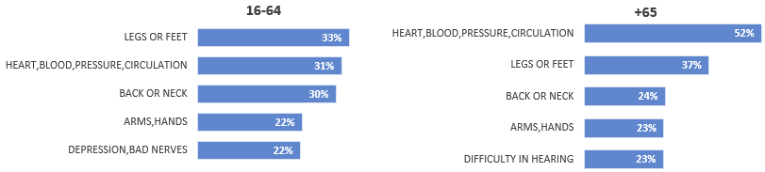

The results for East of England showed that nearly one-third of the veterans (32%) aged between 16 to 64 complained about back or neck problems, and more than half of those aged over 65 (51%) complained about heart/blood pressure problems.

Nearly one in four veterans (39%) aged 16-64 and one in three veterans aged 65+ said that their health problems did not limit their activity, which was significantly different from the non-veteran population. However, 34% of veterans aged 65+ responded that their health problems limit activity a lot, significantly higher than the non-veteran population (34% vs 28%).

East of England has the highest percentage of veterans (64%) over the age of 65 reporting at least one long term health problem, whilst the lowest percentage (31%) was recorded in Wales.

Despite several advances in veteran care in the NHS such as increase in “veteran friendly practices”, there are gaps and inconsistencies in adopting the principles of the Armed forces Covenant, and more needs to be done to improve commissioning practice for veterans. Providing training to healthcare professionals on specific areas of physical care such as chronic pain and musculoskeletal disorders, would be beneficial to veterans and their families.[23]

### **Mental Health**

The public perceive mental health disorders as being the most common problem associated with army veterans and Service leavers, 82% of respondents in the Lord Ashcroft’s “The Veterans Transition Review” (2017) thought that the biggest problem that Armed Forces leavers face is - mental health issues [24].There is a lack of Essex level data on veteran mental health however national level data and literature shows that, contrary to popular belief, there is no “tsunami” of serious mental health issues among veterans. There is only a small rise in participants experiencing Post Traumatic Stress Disorder (PTSD) from 4% to 6%, with veterans who were last deployed in combat role having the most risk for PTSD. According to the Annual Medical Discharge report for 2016/21 army leavers, musculoskeletal disorders, and injuries (MDI)is the biggest health issue facing army veterans accounting for 55% of leavers (3,473 leavers).

Research by King’s Centre for Military Health Research suggest that common mental health issues faced by UK armed forces are depression, anxiety, and alcohol misuse. The KCMHR study also indicated an increased health seeking behaviour among serving personnel and veterans. Nearly 31% of those with a recent mental health problem accessed a mental health specialist and 47% had consulted a GP or medical officer.[25]

There is an added layer of complexity when it comes to veterans from ethnically diverse backgrounds. Qualitative research on veterans from commonwealth (CW) countries suggest that participants faced institutional racism and discrimination when accessing services for mental health. Research participants reported feeling as though they were treated differently, feeling unheard, not being taken seriously when reaching for support. Systemic pressures and wider problems in the community also influenced seeking support for their mental health. [26]

**Mental Health within Forces:** The Royal Air Force (RAF) has the highest rates, and the royal marines have the lowest rates, of personnel seen in any military healthcare setting for a mental health related reason since 2012/13 (Figure 3.2), which reflects a less stigmatised and open approach to help seeking in the RAF. The latest data show that RAF had 140.6/1000 and Royal Marines have 72.9/1000 personnel seen in 2021/22. [27]

Most discharges for mental and behavioural disorders were from Royal Air Force (46%) followed by Royal Navy (30%) and Royal Marines (10%)[28]. Similar findings were reported for 2007 – 2012 by the Defence Analytical Services and Advice (DASA) (2012). [29]

**Figure 3.2 - UK armed forces personnel (per 1,000 personnel) seen in any military healthcare setting for mental healthcare setting for mental health related reason**

**Gender:** Females were twice as likely to be at risk of mental health disorders compared with males (24.2% vs 11.1% respectively) (2012-2022).

**Age:** In terms of age, personnel under the age of 20 years were at the highest risk category for mental health disorders with rate of 29.9/1,000 (2007-2022).

**Figure 3.3 – Armed forces mental health disorders (2007-2022)**

**[30],[31]**

The figure above (Figure 3.3) shows mental health disorders by type and year (2007-2022). Neurotic disorders consistently remained the most common mental health disorder among armed forces personnel since 2007. There is a rising trend in mood disorders, from 23% in 2007 to 35% in 2021.

**PTSD:** Majority of the British public think that PTSD is the greatest mental health problem affecting military personnel, however the rate of PTSD among members of the armed forces is at the rate of 2 per 1,000.[32] Findings from the KCMHR study also suggests that only a subgroup of the armed forces, who were deployed in active combat roles, have higher rates of probable PTSD. Symptoms were linked to alcohol misuse, childhood stress and violence and serving in junior ranks. Being involved in violent combat appeared to prevent recovery rather than cause the symptoms. According to qualitative findings from the KCMHR study, the military provided a set of institutional and social support structures and provided individuals with a set of ethics and cultural norms which allowed them to make sense of challenging life experiences. When participants left the military, PTSD symptoms intensified and traumatic experiences surfaced in flashbacks and nightmares, often being triggered by sights and sounds. Female veterans are at a lower risk of self-harm than male veterans, but at a higher risk of common mental health disorders. Compared to civilian women, female veterans are at a higher risk of PTSD and suicide/suicidal thoughts. [33],[34]

Qualitative research suggests that veterans face psychological and practical barriers accessing mental health services. Asking for help was often seen as a sign of weakness and there was a tendency to reject mental health diagnosis or symptoms. Simple practical information and formal support was hard to access. Post WWII veterans also reported similar issues finding the NHS uninviting and inaccessible. [35]

These findings suggest the importance of supporting veterans transition to civilian life and to help them build their support system outside the military to help manage any potential trauma.

**Suicide:** One of the causes of death that is most difficult to predict and/or prevent is suicide.According to UK Armed Forces Suicides statistics (2021)[36] which dates back to 1985, the trends changed over time significantly, for example in 1985-1987 males aged 40-44 were almost twice more likely to die by suicide than any other age group. In 1992 this trend changed and males under the age of 20 years were significantly more likely to die by suicide, which is still the case in more recent years. Figure 3.4 shows in service male suicide trends over time by age group and Figure 3.5 in service male suicide rate by service type.

**Figure 3.4- In service Male suicide rate by age per 100,000 (2010-2020)**

In 2018/20 the national average rate for male suicide in England was 15.9 per 100.000 population, whilst for males under 20 in the UK army this rate in 2020 was 20.8 per 100.000. Looking at the ratios, males are much more likely to die by suicide than females, especially those under the age of 20. The most used method for suicide is – hanging, strangulation and suffocation (60%).[37]

**Figure 3.5- In service Male suicide rate by service per 100,000 (2010-2020)**

[38]

One of the plans that was outlined in the Strategy for Veterans was to commission a research project into veterans’ suicides and to compare the results with the non-veteran population.

Rodway and colleagues (2022) conducted a large-scale study (published without peer review), where 458,058 service leavers data was linked with suicide deaths data. The findings showed that 1,086 (0.2%) veterans died by suicide between 1996-2018 [39]. The authors concluded that suicide risk was two to four times higher in males and females’ veterans aged under 25 years when compared to the general population (ibid). In addition to the above, it is important to note that the authors also suggested that the rate of contact with specialist NHS mental health services was lowest amongst the youngest age groups, and that the focus should be aimed at improving access to mental health care for young service leavers (ibid).

**Further plans for veterans**:

The government will work with the NHS England through an already established multi-agency health improvement group to ensure that female service personnel and veterans receive targeted and appropriate health care throughout their lives.

Funds from £5M budget will be allocated for the development of health and wellbeing treatments and interventions for veterans.

Further research into longer impacts of the Afghanistan withdrawal on veterans and their families will be conducted.

£1.2M funds have been allocated for a Long-term health study by the King’s Centre for Military Health Research over the next 2 years.

So far, since January 2022, over 100 NHS England trusts have been accredited as ‘veteran aware’ and 1,500 GP surgeries as ‘veteran friendly’. Under the scheme surgeries have a dedicated clinician who has specialist knowledge of military-related health conditions and veteran-specific health services.

### **Drugs and Alcohol Misuse**

There is a tradition of alcohol consumption in the Armed Forces, and it is considered a significant part of bonding and unit cohesion. However, academic research suggests a significantly higher drinking levels compared to the general population, with estimates ranging from 39% to 67%. Ministry of defence commissioned a one-off report using an alcohol screening tool (AUDIT-C) (Figure 3.6) and brief advice for all armed forces personnel from 2016-2017. The findings indicated:

**Figure 3.6 – Excerpt from the AUDIT-C screening tool**

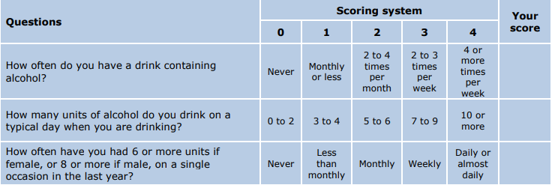

* Six out of 10 personnel had an AUDIT-C score >5 which indicated they may be at increasing risk or above of alcohol related harm
* 2% had an AUDIT-C score >10 which indicated that they may potentially be at increasing or higher risk and were advised to see their GP [40]

This pattern was also reported in veterans, with female veterans also having higher hazardous drinking patterns compared to female civilians.

Kings College London carried out a randomised control trial using a mobile app to support veterans reduce their alcohols consumption. After using the app, the veterans consumed 28 fewer units of alcohol over a week than they had previously, compared to a control group, who consumed 10.5 fewer units of alcohol [41].

### **3.4 Healthcare among military families**

Military families often only have a few weeks to uproot and move with the serving partner, impacting those with complex healthcare needs the most. Research by Anglia Ruskin University found that the participants found registering with GP time consuming, involving multiple form filling, with cases of records getting lost in transition. Records being lost, and practices requiring a physical proof of address, led to delays which may be frustrating for those in the middle of a diagnostic process or a treatment course [42]. Securing care and support for dependent children with SEND/MH needs was the most complex, with waiting times for Child and adolescent mental health services (CAMHS) up to two years, exceeding their posting[43].

Armed Forces charities providing support to the wider AF community, including family make up 14.8% of the AF charity sector as of July 2020 [44]. Common areas of support are social groups, mental health support and education support. There is evidence to suggest that involvement of family and caregivers, and supporting their needs is essential for successful patient rehabilitation. There is also a need to focus on young children in AF families, who might take on the role of a young carer, they are particularly vulnerable as they also have other aspects of military life like frequent changing to schools to contend with [45]. Healthcare professionals need more training to provide a nuanced approach when providing care to armed forces personnel and their families [46].

The NHS Long Term Plan and Healthcare for the Armed Forces Community: A Forward View sets out NHS England’s commitment to support and commission services for veterans, which include:

* Access to the Veterans Trauma Network (VTN), for veterans needing specialist treatment for physical health problems related to service
* Access to Op COURAGE, for veterans and their families needing mental health support

**Further plans for veterans:**

From April 2023, NHSE will bring together the currently 3 separate veteran mental health services into a single service, under Op COURAGE. This will improve access and reduce the need for veterans to transfer between services.

## **Education**

### **Overview**

As of January 2022, there were 202,586 pupils (year groups Reception to Year 11) in Essex Local Authority maintained schools and academies. Of these, 1,632 (0.8%) were in receipt of the Service Pupil Premium (SPP) funding.

The SPP pupils are spread across 232 different schools. In 208 of these schools there are 10 or fewer service children, 7 schools have more than 50 service children (with the highest being 159).

There is extensive evidence[47] which demonstrates that moving between schools has an adverse impact academically and pastorally, such as:

* Discontinuity of provision through delays, poor communication and transition, curriculum changes; repetition of parts of the curriculum after moving
* Emotional well-being, disrupted friendships, increased potential for bullying

On top of that, deployment has an adverse impact academically, creating:

* Increased incidence of emotional and behavioural problems
* A higher incidence of mental health issues in children and parents

Children with at least one parent in the Armed Forces may face unique challenges during their academic years, for example, attending various schools due to their parent(s) relocation. One of the main concerns of service parents is the lack of continuity and stability that this mobility means for their children. Moving house, moving schools, and even moving to a different country is an inevitable part of life for many children with parents in the Armed Forces. With jobs pulling families in numerous directions, service children can expect to change school multiple times during their educational career. The lack of continuity and stability for children with parents in the Armed Forces is the main reason of schooling disruption. On top of that, the Department of Health (DoH, 2015)[48] notes that service children have a higher rate of caring responsibilities than the general population. These young carers in military families may be caring for parents who have injuries or post-traumatic stress disorder, or they may be caring for a parent with health problems while their partner is away. Further research[49] shows that if both parents are deployed, the child may be in the care of grandparents or even foster care.

### **Childcare and Children’s Education**

**Key facts**

* According to the Tri-Service Families Continuous Attitude Survey (2022), in the UK nearly eight in 10 (79%) service families have children. Seven in 10 families with a child aged under required early years (0-4) childcare; of these families, nine in 10 can access early years childcare. Most families are satisfied with the quality, access, and opening hours of early years childcare, but less so with cost
* Just over half (54%) of all families have at least one child of school age. Of these families, half (51%) required childcare such as breakfast/after school clubs in the last 12 months. In general, families are more satisfied with most aspects of early years childcare than childcare for school age children. Over a third of families who required childcare for school age children are dissatisfied with the cost of their local childcare
* One in eight (12%) families with school age children receive Continuity of Education Allowance (CEA)[50], a decrease of two percentage points since 2015. Officer families are much more likely to receive CEA than other rank families
* MoD analysis for the year 2014/2015 shows there is little difference between the attainment of service children and non-service children at Key Stage 2, with 82.3% and 82.9% respectively achieving the expected standard of level 4 or above in reading, maths and writing. The picture is seemingly even brighter for KS4 service children, with 64.9% achieving the expected standard of five or more A*-C GCSEs including Maths and English compared to 63.0% of non-service children [51]

### **Pupil numbers by year group (R-11 only) as at January 2022 in Essex**

The following table show the numbers of service children by school age group in Essex (Table 4.1).

**Table 4.1 Service children by school age group in Essex**



\**NB. Table 4.5 which shows 1,675 pupils attracting the SPP funding. The figure is slightly higher as the funding list uses the October 2021 School Census as it’s base point whereas DfE attainment analysis will utilise the position as at the January 2022 School Census.*

### **Pupils Number by SEN Provision**

Special educational needs and disabilities (SEND) can affect a child or young person’s ability to learn. They can affect their:

* Behaviour or ability to socialise which impacts their ability to develop friendships
* Reading and writing
* Ability to understand things
* Concentration levels
* Physical ability

Table 4.2 shows pupil numbers by SEN provision among service children in Essex. In the primary phase, service children (10.6%) are slightly less likely to be in receipt of SEN Support than non-service children (11.7%). In the secondary phase, service children are slightly more likely (13.1% v 11.2%) (Table 4.2).

In respect of pupils with an EHC Plan, in the primary phase, service children (2.4%) are again slightly less likely to have one compared to non-service children (3.4%). This pattern is repeated in the secondary phase with 3.7% of service children having an EHC Plan compared to 4.4% of non-service children.

**Table 4.2: Pupil numbers by SEN provision (R-11 only) as at January 2022**



### **4.5 Pupil numbers by SEN primary need type (R-11 only) as at January 20****22**

**Primary phase**

Speech, language, and communication needs (SLCN) are most common among service children (35.9%), followed by autistic spectrum disorder (ASD) with 17.6% of service children pupils. This trend is broadly in line with the results from non-service children (Table 4.3).

### **Table 4.3: Pupil numbers (primary phase) by SEN primary need type (years R-6 only) as at January 2022**



**Secondary phase**

Social, emotional, and mental health difficulties (SEMH) is the most common primary type of need, at 30.5% of SEN pupils in the secondary phase among service children followed by autistic spectrum disorder (ASD) at 16.2% (Table 4.4).

SEMH seems to be slightly higher in-service children compared to non-service children; this may be attributed to discontinuity in education due to mobility. Literature shows that deployment has an adverse impact academically, creating incidences of emotional and behavioural problems.

### **Table 4.4: Pupil numbers (secondary phase) by SEN primary need type (years 7-11 only) as at January 2022**



### **Service Pupil Premium**

The Department of Education (DfE) introduced the Service Pupil Premium (SPP) in 2011, recognizing the specific challenges that service children face.

State schools, academies, and free schools in England, which have children of service families in school years after year 11, can receive the Service Pupil Premium (SPP) funding. The fund is designed to assist the school in providing the additional support that these children may need and is currently worth £310 per service child who meets the eligibility criteria. The aim of this funding is to provide additional pastoral support to service families.

Pupils attract SPP if they meet one of the following criteria:

* One of their parents is serving in the regular armed forces (including pupils with a parent who is on total commitment as part of the full-time reserve service)
* They have been registered as a ‘service child’ on a school census since 2016
* One of their parents died while serving in the armed forces, and the pupil receives a pension under the Armed Forces Compensation Scheme or the War Pensions Scheme

Children must be considered service children ahead of the autumn school census deadline. Service parents must inform the school of their status by talking to the head teacher or administrative staff.

Table 4.5 shows the change in the number of eligible pupils for SSP from 2014 to 2023 in Greater Essex. For example, in the 2021/2022 school year, there were 1708 pupils eligible for the Service Pupil Premium in Essex, 40 in Southend, and 17 in Thurrock. Overall, the number of eligible pupils increased over the year with some deflection for the Essex area's 2022/2023 school year.  

**Table 4.5: Number of eligible pupils for SSP and premium allocation in Greater Essex, 2014 to 2023[52]**

|  |  |  |  |  |  |  |  |  |  |
| --- | --- | --- | --- | --- | --- | --- | --- | --- | --- |
| **Year** | **2014/15** | **2015/16** | **2016/17** | **2017/18** | **2018/19** | **2019/20** | **2020/21** | **2021/22** | **2022/23** |
| **Number of pupils eligible for SSP (Essex)** | 1330 | 1499 | 1531 | 1506 | 1512 | 1591 | 1688 | 1708 | 1675 |
| **Pupil Premium Allocation £ (Essex)** | £399,000 | £449,700 | £459,175 | £451,850 | £453,600 | £477,425 | £523,280 | £529,557 | £536,000 |
| **Number of pupils eligible for SSP (Southend)** | 20 | 25 | 29 | 31 | 29 | 37 | 41 | 39 | 40 |
| **Pupil Premium Allocation £ (Southend)** | £7,000.00 | £7,500.00 | £8,700 | £9,300 | £8,700.00 | £11,100 | £12,710.00 | £12,090 | £12,800 |
| **Number of pupils eligible for SSP (Thurrock)** | 10 | 16 | 14 | 13 | 16 | 19 | 23 | 21 | 17 |
| **Pupil Premium Allocation (Thurrock)** | £2,000 | £4,800 | £4,200 | £3,775 | £4,800 | £5,700 | £7,130 | £6,510 | £5,440 |

Source: https://www.gov.uk/government/publications/pupil-premium-allocations-and-conditions-of-grant-2022-to-2023

**The Montgomery Junior School, Colchester – Case Study**

The Service Pupil Premium is used in various creative ways to support service children, for example - funding liaison officer, or supplying memory boxes for children.

Below is an example of how the funding is used in Montgomery Junior school in Colchester.

The Montgomery Junior School has just over 50% of pupils from service families and many of their dedicated team have links to the military or local community knowledge. They have invested the SPP in people, resources, initiatives, subscriptions, and activities. Through consultation with children, staff, governors, and parents they have been able to use the funding to support the differing needs of service children enrolled in the school.

One of the major successes of the school is the employment of our community engagement coordinator (CEC). Following the research of effective emotional social health and wellbeing (ESHWB) practice they identified the need for a dedicated staffing resource to deliver a comprehensive support programme for service children during periods of parental deployment, on joining and leaving the school and providing an enhanced pastoral provision. This role supports key school improvement priorities to close the learning gap as well as the social and economic gap that continue to provide challenges to service pupils and families.

The CEC works with children and families from admission enquiry stage, supporting individuals throughout school life and during exit (including at non-standard times), including the following family support:

* Transition and integration of pupils
* Building relationships with parents and the school
* Supporting families of service personnel from Commonwealth countries
* Timely transfer of pupil records and liaison with transition schools
* Supporting a wider range of family pressures including emotional and behavioural issues, bereavement, divorce, and separation
* The knowledge to offer practical solutions, reassurance, and signposting
* Establishing links to outside agencies, welfare organisation and service communities that will support the needs of all pupils and families and the school

In addition to the CEC, the Montgomery Junior School have used the SPP to fund initiatives such as enhanced curriculum provision, early morning clubs and activities, and in particular a play therapy counsellor which our in-school case studies evidence that children have achieved the following outcomes:

* Reduction in anxiety in some situations and improvement in relationships at home
* Understanding of loss and grief
* Ability to maintain self-esteem through family transition
* Improvements in friendships
* Improved concentration and participation in class
* Improved attendance
* Expression of feelings using paint and clay
* Improved self-esteem
* Building resilience

### **4.7 Attainment**

As mentioned in paragraph 4.1, moving between schools can impact students’ academic outcomes. This can occur because of delays, poor communication between schools, inadequate transition arrangements, and differences in curriculum provision. Mobility can also impact students’ emotional well-being, for example, through disrupted friendships and an increased potential for bullying. On top of that, parental deployment and separation can strain family life and impact service children’s educational and emotional well-being.

The table below illustrates service children and non-service children performance in Essex schools. It is important to consider the number of pupils when looking at the attainment outcomes at each key stage (Table 4.5).

## **Table 4.5: Pupils attracting Service Pupil Premium Funding - 2022 attainment**

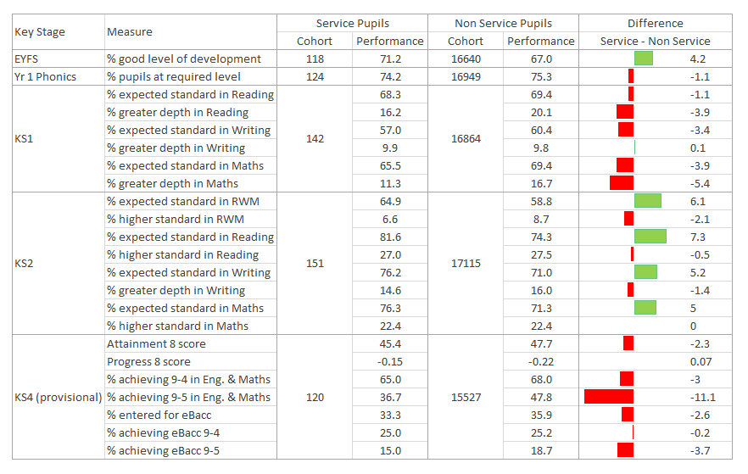Source: 2022/23 FY Pupil Premium List matched to attainment outcomes in NEXUS

There are some real strengths in the performance of service children in Essex schools. In the Early years Foundation Stage (age 5), a higher proportion of service children achieved a Good Level of Development (GLD) than non-service children. Comparing performance against service children across the Eastern Region (72.2%) and England (71.4%), Essex performance of 71.2% is broadly similar.

Age 11 is a key point in a child’s education as they progress from the primary phase to the secondary phase. KS2 results for Essex service children are higher than those for non-service children for pupils achieving the expected standard (as they have been pre-COVID too). Most notably so, in the key Reading, Writing & Maths (RWM) measure, where there is a government target for 90% of all pupils to achieve by 2030, service children outperform non-service children by 6.1% points. Again, particularly pleasing are the comparisons with Eastern Region and England averages – in the RWM measure, Essex service children outperforming their Eastern Region and national peers by 7.3% points and 5.1% points respectively.

At KS4 (age 16), the progress of all pupils in Essex schools is a concern with the Progress 8 score of -0.22 having been in decline for a number of years and now ranked in the bottom quartile of all local authorities. Whilst service children in Essex still have a negative Progress 8 score, this is noticeably higher than that of all pupils. One of the key measures at KS4 is the % pupils achieving 9-4 in the key subjects of English & Maths (this being seen as a standard pass and the main threshold). Whilst service children in Essex have lower performance than their non-service children peers, to put the difference into context, if another three service pupils have achieved, performance would be on a par with that of all pupils. The more stretching 9-5 in English & Maths measure equates to a ‘shortfall’ of 13 additional service children needing to achieve to match all pupil performance. At the time of writing, Eastern Region or England comparative KS4 performance of service children has not been made available in the education system used (NEXUS).

### **4.8 Free school meals**

Children from Service families are less likely to be eligible for free school meals (FSM)[53], which is to be expected since Service children have at least one working parent. Alternatively, there may be situations of family breakdown, where the couple have separated, and household income is low for the parent who does not serve in the Armed Forces.

The table 4.6 below shows the change from 2018 to 2023 in the number of eligible pupils for FSM in Essex. Overall, the number of eligible pupils increased from 4.3% in 2019 to 7.1% this year.

The increased number could be a consequence of a rising number of service children or attributed to the recent high cost of living crisis that has pushed families into the low-income bracket.

**Table 4.6: Service children eligible for Free School Meals in Essex, 2018 to 2023**

|  |  |  |  |  |  |  |
| --- | --- | --- | --- | --- | --- | --- |
|  | | **Pupil Premium Funding for financial year**: | | | | |
| 2018/19 | 2019/20 | 2020/21 | 2021/22 | 2022/23 |
| **SPP pupils eligible for FSM** | Number | 65 | 70 | 81 | 113 | 118 |
| % | 4.3% | 4.4% | 4.9% | 6.7% | 7.1% |

Source: 2022/23 FY Pupil Premium List matched to attainment outcomes in NEXUS

### **4.9 Extracurricular activities - Cadets forces**

The Ministry of Defence sponsors and supports five cadet forces. These voluntary youth organizations offer challenging and enjoyable activities for young people living in the UK and specific locations abroad and better prepare them for their role in the community. Cadets can learn new skills and engage in adventurous activities in disciplined and well-structured organizations, but they may also gain nationally recognized.

The cadet forces are based on their parent Service's traditions, values, and standards, but they are not part of the Armed Forces.

The cadet forces comprise the following:

* Sea Cadet Corps
* Volunteer Cadet Corps
* Combined Cadet Force
* Army Cadet Force
* Air Training Corps

In Essex there are approximately 3,901 cadets. This number includes – Sea Cadet Corps (SCC), Army Cadet Force (ACF), Royal Air Force Air Cadets (RAFAC), Combined Cadet Force (CCF) [54].

A longitudinal study of the Northampton University (2020)[55] on behalf of the Ministry of Defence (MOD) and the Cadet Vocational Qualification Organisation (CVQO)[56], shows that participation in the Cadet Forces significantly positively impacts young people, increasing their performance at school and improving their employment and career prospects.

This study pointed out how participation in the Cadet Forces develops several vital attributes. These key attributes are:

* Ability to communicate, to diverse audiences, through formal and informal presentations and in discussions and interviews
* Ability to lead a group of people to achieve an objective. This essential skill includes the ability to plan and communicate that plan, as well as being able to control, motivate and drive a team to succeed
* Resilience to keep going, even when things go wrong or the situation is challenging,
* Ability to work as a member of a team, sharing views and helping others while being able to take instructions and orders from the team leader
* Ability to use social skills, including different behaviours, to achieve positive outcomes
* Understanding that people are not the same, and the ability to accept diversity and work with the different talents that people have
* Confidence to utilize critical skills in different situations and with others

In addition to the above, because of developing these key attributes, young people and society experience positive outcomes, including:

* Increased social mobility (improved attainment is a major driver of social mobility and promotes a ‘levelling-up’ among children from disadvantaged groups)
* Improved educational outcomes (as a direct consequence of improved attendance and behaviour)
* Improved mental and physical wellbeing
* Enhanced employability
* Reduced vulnerability/increased resilience (to bullying and criminal and extremist organisations)
* Inclusive community links across ethnic, religious, and socio-economic dimensions

## **Housing**

### **Overview**

The provision of good quality homes for service personnel and their families is an important priority for the Ministry of Defence (MOD).

The Defence Infrastructure Organisation (DIO) manages around 49,000 homes in the UK on behalf of the MOD and is also responsible for planning for future requirements and targeted improvement programmes.

The Ministry of Defence established the Joint Service Housing Advice Office (JSHAO) to provide service personnel and their dependants with civilian housing information for those wishing to move to civilian accommodation at any time in their career, and for those during resettlement to assist with the transition to civilian life. Unsurprisingly, financial knowledge and access to reliable information and advice are most often identified as critical for successful housing transitions. The Royal Air Force Families Federation has produced a guide with practical advice for families in transition with links to services in England, Scotland, and Wales (Royal Air Force Families Federation, 2020).

Among the armed forces, veterans require particular attention when transitioning to civilian life. Some veterans struggle to find appropriate housing, often complicated by other difficulties associated with employment, physical and mental injuries, or problems with relationships. Finding sustainable housing is considered, along with employment, one of the most important aspects of a successful transition[57] of personnel into civilian life and for their well-being.

On top of that, plans from the Office Veterans’ affairs[58] on the Strategy for Veterans (08/2022) shows:

* Review the operation of the new duty across the UK in its Armed Forces Covenant and Veterans annual report
* Relocation of the Joint Service Housing Advice Office within Defence Transition Services. The MOD will be able to provide more tailored and timely advice to service personnel and their families
* Development of “A package of life-skills training and support”. Testing to be done for topics such as finance, housing, education and mental wellbeing, to be rolled out by the end of 2022
* To include new measures (Loneliness and social isolation) in Veterans’ Survey. It will look to understand veterans’ life experiences, as well as their view of the services available to them

### **Service Accommodation**

**Key facts**

* According to the Tri-Service Families Continuous Attitude Survey (2022), in the UK just over three-quarters (76%) of all personnel live in service accommodation during the working week, however this differs by service (Figure 5.1)

**Figure 5.1: Accommodation type (%)**

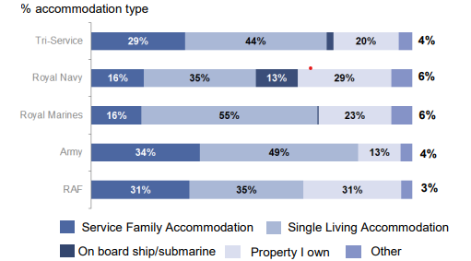

Source: Tri-Service Families Continuous Attitude Survey (2022)

* Army personnel are more likely to live in Service Family Accommodations (SFA) and less likely to live in their own property during the working week compared to the other services, whilst Royal Marines are more likely to live in Single Living Accommodations
* Just over half (51%) of personnel own their own home, unchanged since 2017. Officers are considerably more likely to own their own home (76%) than other ranks (44%). Since 2015[59] home ownership amongst other ranks has risen from 39% to 44%, largely driven by Army and Royal Marine other ranks
* 61% reported that accommodation is the most-highly reported concern presented by service personnel. The primary reason why personnel do not own their own home continues to be that they cannot afford to buy a suitable home (based on those personnel who do not own their own home 49% in 2022). However, the prevailing reason why personnel purchase their own home continues to be stability for themselves and their family, at 78% (based on those personnel who do own their own home 51% in 2022)

*In recognition of historically lower levels of home ownership than the rest of the UK population, since 2014, Defence has supported Service personnel in their aspirations for home ownership through the* ***Forces Help to Buy pilot****. The scheme enables regular Service personnel to be advanced up to 50% of their gross annual salary (to a maximum of £25,000), interest-free, to buy their first home, move to another or, in exceptional circumstances, extend an existing property. Owning a home can positively impact partner employability, provide stable education for children, and provide stability and continuity as Service personnel transitions out of active Service.*

*However, the requirement to remain mobile can mean the Service person could live in single living accommodation (SLA) in during the working week when assigned away from home. The support offered via waiving SLA charges is currently linked to marital status and, for some, age. Following the completion of the Future Accommodation Model Pilot, a new package supporting the cost of SLA will begin to be offered to all maintaining a home elsewhere, irrespective of their relationship status and age.*

*Data relating to Help to Buy Scheme is provided by MOD in quarterly report. From the start of the scheme in 2014 to the end of the third quarter of 2022/2023, the data shows:*

* *64,400 first stage applications have been received,*
* *32,746 proceed to second stage*
* *The average of payment is £15,320*
* *1,640 number of payments made in East of England*

[*https://www.gov.uk/government/statistics/forces-help-to-buy-scheme-quarterly-statistics-202223*](https://www.gov.uk/government/statistics/forces-help-to-buy-scheme-quarterly-statistics-202223)

### **Social Housing** [60]

Several studies[61] suggest that veterans in the UK seek help from numerous, diverse organisations to navigate the housing system. Evidence suggests that a form of collaborative network between local authorities and third sector has been particularly effective in delivering for veterans in housing need. Some veterans can face challenges arising from their lack of experience and knowledge of the civilian housing system, particularly for those service leavers who had joined the military at a young age. This was often attributed to a lack of transition preparation whilst serving, exacerbated by difficulties with asking for help, given the military culture of pride and self-reliance, and difficulties in navigating bureaucracy.

The Ministry of Housing, Communities and Local Government (MHCLG) has introduced various measures to improve access to social housing for the service community and veterans. The main aim is to change the law to ensure seriously injured service personnel and veterans with urgent housing needs are always given high priority for social housing by local authorities. Regulations have also been introduced, which ensure that within the first five years, those who have left the Armed Forces cannot be disqualified from social housing because of a local connection or residency requirement. In fact, UK armed forces and those recently discharged are exempt from any local connection test that a local authority may use when allocation social housing.

Data released by the Department for Levelling up, Housing and Community (2021) [62], shows that 2% of total letting in 2020/2021 was given to those who have served in the Armed Forces, as the previous year. Around 16% of these were injured or disabled due to serving in the Armed Forces.

### **Population Who Previously Served in UK Armed Forces in Communal Establishments and in Households**

### 

According to the ONS definition a person’s usual residence can be categorised as being in either a private household or a Communal Establishment. Types of communal establishments include hospitals, care homes, prisons, defence bases, boarding schools, and student halls of residence. The data provided in this paragraph shows the Essex population who have previously served in the UK Armed Forces by whether they reside in communal establishments or households (Table 5.1) (the estimates are as at Census Day, March 2021). Among all districts and in line with East of England figure, more than 95% of veterans live in a private household.

**Table 5.1: Type of accommodation of ex-service personnel in Essex and East of England, 2021**

|  |  |  |
| --- | --- | --- |
| **Local Authorities** | **Lives in a household** | **Lives in a communal establishment** |
| Basildon | 99.1% | 0.9% |
| Braintree | 98.5% | 1.5% |
| Brentwood | 98.1% | 1.9% |
| Castle Point | 98.7% | 1.3% |
| Chelmsford | 98.3% | 1.7% |
| Colchester | 98.8% | 1.2% |
| Epping Forest | 97.6% | 2.4% |
| Harlow | 98.8% | 1.2% |
| Maldon | 97.6% | 2.4% |
| Rochford | 99.2% | 0.8% |
| Southend | 97.6% | 2.4% |
| Tendring | 98.0% | 2.0% |
| Thurrock | 99.0% | 1.0% |
| Uttlesford | 97.1% | 2.9% |
| East of England | 98.0% | 2.0% |

Source: ONS 2021 – UK Armed forces veterans. [UK armed forces veterans, England and Wales - Office for National Statistics (ons.gov.uk)](https://www.ons.gov.uk/peoplepopulationandcommunity/armedforcescommunity/bulletins/ukarmedforcesveteransenglandandwales/census2021).

### **Homelessness**

Being homeless means having no home or permanent place of residence, people who are homeless are more likely to experience health issues compared to general population, for example tuberculosis (34 times), Hepatitis C (50 times), epilepsy (12 times), heart disease (6times), stroke (5 times) and asthma (2.5 times)[63]. The mortality rate amongst homeless people is four times higher than in the general population (ibid).

The Homelessness Reduction Act 2017 significantly reformed England’s homelessness legislation by placing duties for local authorities to intervene at earlier stages to prevent homelessness in their areas[64]. Local authorities now, must work with the applicants to develop personalised plans to ensure that they have somewhere to live for at least the next 6 months.

According to the statutory homelessness report, in 2021/22, 1850[65] households within the UK were assessed as having support needs resulting from having served in the Armed Forces.

**In Essex**, there were 35 such households requesting homelessness support in 2021/22. The highest number was in Chelmsford (11). Table 5.2 shows the change over time from 2019 to 2022 in Essex districts. For example, in 2016 there were 16 homeless support requests in Colchester, however in the following years this number has decreased significantly. In Chelmsford, there were consistently higher numbers of support requests in 2020/21 and 2021/22, when compared with other Essex districts.

**Table 5.2: Homelessness support requests by people who served in the armed forces, by local authority in Essex, 2019/2022[66]**

|  |  |  |  |
| --- | --- | --- | --- |
| **Served in HM Forces** | **2019/20** | **2020/21** | **2021/22** |
| Basildon | 6 | 4 | 2 |
| Braintree | 3 | 4 | 4 |
| Brentwood | 0 | 0 | 0 |
| Castle Point | 2 | 0 | 1 |
| Chelmsford | 6 | 6 | 11 |
| Colchester | 16 | 3 | 3 |
| Epping Forest | 3 | 2 | 5 |
| Harlow | 3 | 0 | 0 |
| Maldon | 0 | 3 | 1 |
| Rochford | 1 | 1 | 1 |
| Southend-on-Sea | 0 | 0 | 2 |
| Tendring | 3 | 3 | 5 |
| Thurrock | 4 | 2 | 1 |
| Uttlesford | 1 | 2 | 2 |
| **Total** | **48** | **30** | **38** |

The Government is aiming to end rough sleeping by 2024 and has substantially increased investment. The progress has been accelerated due to pandemic with the “Everyone In” initiative, which was aimed at protecting vulnerable populations, however there is a concern that after the end of this initiative the number of rough sleepers could increase again[67].

One of the most crucial steps in the process is knowing what help is available for homeless veterans and signposting them to the relevant organisations. One of such campaign is “No Homeless Veterans” which provides information and resources for Local Authorities, Housing Associations and Supported Housing Providers[68].

## **6. Employment**

### **Overview**

Working age veterans in the UK are twice as likely to be unemployed as their civilian counterparts. The differences between the working age ex-service community is greatest for those aged 16-24 and those aged 55-64. Two out of three ex-service community members aged 16-24 are economically inactive[69].

There are 700,000 members of the working age ex-service community who are not in work: 120,000 veterans and 20,000 dependents are unemployed; 130,000 veterans and 110,000 dependents are not looking for work; 160,000 veterans and 160,000 dependents are retired or in education. [70]

The Ministry of Defence established the Career Transition Partnership (CTP) in 1998 to support the transition to civilian jobs for personnel leaving the service. CTP helps with resettlement one or two years before the person is due to leave and continues one year post discharge. Of those who used CTP services, 83% found employment withing six months. Of all the demographic groups, non-UK BAME service leavers were notably more likely to be unemployed than white service leavers (18% vs 6%). Of those who used CTP services, nearly seven in 10 reported being employed in one of the following occupations: skilled trade occupations, associate professional and technical occupations, elementary occupations, and professional occupations. [71]

One in 10 people in the ex-service community have no formal qualifications. This rises to two in 10 among those aged 55-64. Groups which need support are those aged 45-64, less qualified and less confident in computer skills, those aged 16-34 and recently discharged, and female veterans[72].

In addition to the offers provided by the CTP, there are also other initiatives such as **Troops to Teachers[73]**, **Step into Health[74]**, the **Defence Employer Recognition Scheme**[75], and the **National Insurance Contributions Holiday**[76]. These initiatives recognise veterans skills and what value they add to civilian professionals.

### **Spouses and Civil Partners**

According to the Families Continuous Attitude Survey (FamCAS) 2021, 78% of the spouses are employed, which is 14.7% increase since 2014. The employment rate for male spouses is 22.3% higher compared to female spouses (76% vs 93%). Nearly a third of the spouses (32%) have been looking for employment in the last 12 months, of which 64% have been experiencing difficulty in looking for a job. Partner being unable to assist in childcare (45%), and extended family living too far away and being unable to assist with childcare (44%) are listed as the top reasons for difficulty in getting employment (Figure 6.1). [77]

**Figure 6.1 – Reasons for difficulty in getting employment (%) by spouses and civil partners**

Three in five spouses would use courses to help them find or change employment if MoD offered it to them. Access to a jobs database (55%), career consultancy (52%) CV writing course (44%) are also cited as something that would help them find/change employment.

In 2020, the Ministry of Defence launched a pilot personalised career support training scheme called the *Partner Career Support* programme. This pilot programme ran for six months and offered 750 military partners bespoke advice from career coaches and online self-assessment tests to identify their key strengths and skills. This programme was extended to March 2021, however there is no local data on service uses outcomes of the programme. [78]

### **Transition to Civilian Employment**

The Forces in Mind Trust (FiMT) projected the cost of poor transition to civilian life as £105 million in 2017, rising to £110 million in 2020. [79] Many veterans, despite having service-related qualifications, find their skills not necessarily translating in the civilian job market and not recognised outside the service. According to the AFCAS, nearly a third of respondents in the Royal Marines (36%) (Figure 6.2). reported dissatisfaction with the opportunities to gain civilian accreditation. The army had the highest satisfaction with six out of 10 respondents reported being satisfied with the opportunities to gain civilian accreditation.

**Figure 6.2 – Satisfaction in the opportunity to gain civilian accreditation in different branches**

*“There are certain things you don’t have a qualification for. For instance, being in charge of between 200 and 600 men as an HR office manager. I don’t have a qualification, so I’d go to a company and say, ‘well I’ve just been in charge of 600 men, I’ve been in charge of pay documentation, passports, deployments, bombs, bullets, you name it’…It didn’t mean a thing because I don’t have qualifications”*

*Quote from: https://www.britishlegion.org.uk/docs/default-source/campaigns-policy-and-research/deployment-to-employment.pdf*

People who join the Armed Forces at a young age have lower formal educational qualifications and vocational training that does not systematically extend relevant accreditation beyond the military. This is likely to contribute to veterans failing to find fulfilling vocations where they can utilise their knowledge and skills.

Female veterans are at more disadvantage, notably being more likely to be unemployed and economically inactive, as well as less likely to claim unemployment benefits compared to their male counterparts. There is limited research on economic inactivity in female veterans but the findings suggest difficulties in finding suitable and flexible employment, recognising, and articulating transferable skills and lack of confidence in showing them to civilian employers. Female veterans are also more likely to report challenges due to looking after family than males (20% vs 4% respectively). [80]

Another frequently quoted barrier is negative stereotypes by employers, many business owners are still hesitant to employ veterans, some asking invasive questions during interviews.[81]

The Department for Work and Pensions (DWP) have initiatives that help current and former personnel and families access Jobcentre Plus services. This includes having an Armed Forces Champion in every Jobcentre Plus district who ensures that the veterans or members of the Armed Forces community are adequately supported. The role of the Armed Forces Champion is to build staff capability, provide Armed Forces support within their Jobcentre Plus district, develop and maintain joint working arrangements, provide an understanding of the issues the forces community face that can be a barrier to employment, be the first point of contact for Jobcentre Plus staff at the Service Charities and Single Service organisations[82]. There are a network of 50 Armed Forces Champions and 11-Armed Forces Champions Group Leads within Jobcentre Plus. In Essex there are two fulltime Armed Forces champions who are part of the London & Essex Armed Forces Champion Team (made up of seven including the lead). There are Single Points of Contact’s in each Jobcentre, including Southend and Grays who link in the Armed Forces Champions who are full time resourced.

**Updates: According to the Strategy for our Veterans 6 monthly update:**

Since January 2022:

* The Civil Service developed the Great Place to Work for Veterans scheme which guarantees progression to the next stage of recruitment for veterans if they meet the minimum standard for a role. In 2022 it was rolled out across 23 departments, leading to over 800 offers made to veterans
* Advance into Justice - is a fast-track scheme to support service leavers and veterans who want to become prison officers was launched (2022)
* The NHS career booklet for service leavers and veterans was published, encouraging even more service leavers and veterans to apply for roles in the NHS

**Further plans for veterans:**

* The first meeting of the OVA Veteran Employers Group will be held in autumn (2022). This group will help identify best practice and opportunities that could inform future veterans’ employment policy
* Further rollout of the Great Place to Work initiative will take place
* The first meeting of the OVA Veteran Employers Group will be held in autumn (2022). This group will help identify best practice and opportunities that could inform future veterans’ employment policy
* Further rollout of the Great Place to Work initiative will take place
* The first meeting of the OVA Veteran Employers Group will be held in autumn (2022). This group will help identify best practice and opportunities that could inform future veterans’ employment policy
* Further rollout of the Great Place to Work initiative will take place
* The first meeting of the OVA Veteran Employers Group will be held in autumn (2022). This group will help identify best practice and opportunities that could inform future veterans’ employment policy
* Further rollout of the Great Place to Work initiative will take place
* Further rollout of the Great Place to Work initiative will take place
* The first meeting of the OVA Veteran Employers Group will be held in autumn (2022). This group will help identify best practice and opportunities that could inform future veterans’ employment policy
* Further rollout of the Great Place to Work initiative will take place
* Opportunities for veterans and service leavers to join the police will continue to be promoted, including through support to Nottinghamshire Police, which will be piloting a Military Service Leavers Pathway into Policing scheme. Codesigned with the University of Derby, this bespoke 12-week course will see the first cohort starting in September 2022

### **Out of Work Benefits**

There is limited research on veterans’ use of unemployment benefits (UB). Majority of UBs are claimed within two years of leaving service, only a small minority claim disability benefits, but they are claimed long term. Socioeconomic factors drive the use of benefits post service rather than factors related to the military. People in lower rank, those with a history of antisocial childhood behaviour, poor education, and unplanned leavers are more likely to claim benefits, whereas commissioned officers less likely to claim benefits.

Only a small proportion of veterans claim UB, therefore providing employment focussed support to service leavers and ensuring continuity of care and surveillance for mental ill health among those medically discharged would really support those transitioning to civilian life [83].

## **Criminal Justice System**

### **Overview**

Whilst many veterans in the UK lead successful life in the civilian world after leaving the army, for some veterans this transition proves to be more difficult, sometimes resulting in Criminal Justice System involvement.

It is estimated that the figure for veterans in prison range between 3% to 16.75% according to various sources, for example The Butler Trust estimated the figure to be at approximately 6.5% of the prison population[84], a findings paper published by HM Inspectorate of Prisons (2014)[85] cited 4% to 16.75% of the total prison population. Because of such inconsistencies, in 2015 an effort was made to identify veterans entering the system and became a part of the Basic Custody Screening (BCS) interview. Individuals entering custody have been asked if they served in the armed forces:

*“Have [you] been a member of the armed services?” – the wording of the question captures those who reported serving in any armed service organisation around the world, not just those serving in the UK Armed Forces. It also captures those who had served as either a regular or reserve member. As such the estimates presented here are expected to be higher than previous estimation exercises that have just focused on those having served in the UK regular Armed Forces”.* [86]

The latest report published by the Ministry of Justice (2021) suggests that of the total prisons’ population in the UK, 3% (1,411) of the prisoners are ex-Service personnel (ibid), however, it is important to note that only 63% (49,230) of the prisoners responded, so this figure could be higher, as some veterans feel ashamed and keep their service private.

**Prison region**

There is a difference in the distribution of ex-service personnel in prisons across the regions as shown in Figure 7.1, which shows the matched prison population by the percentage in each region, however the larger proportion of Ex-service personnel may reflect veterans living closer to military locations, as well as specific functions of these prisons (ibid).

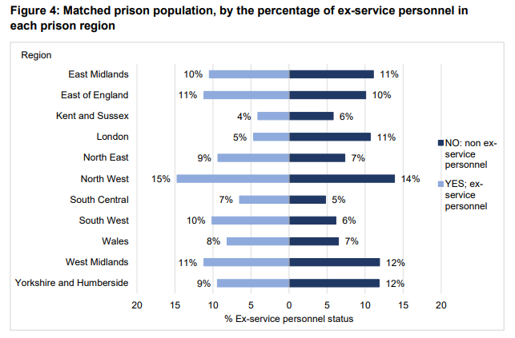**Figure 7.1: Matched prison population, by the percentage of ex-service personnel in each prison region**

**Ex-service personnel in Criminal Justice System characteristics**

According to the research paper published by MacManus and colleagues (2013), where researchers looked at 14,000 serving and ex-Service UK Armed Forces personnel, most of whom had been deployed to Iraq and Afghanistan - **younger members (under 30 years) returning from duty were more likely to commit violent offences** than the rest of the population (20% vs 6.7% respectively)[87]. In addition to that**, those who were serving in combat role** conferred an additional risk for violent offending when compared with those deployed in non-combat role (6.3% vs 2.4% respectively), as well as those, who **experienced increased exposure to traumatic events** during the deployment.

“A findings paper” published by Her Majesty Inspectorate of Prisons (2014), showed that ex-Service personnel in prisons were:

* More likely to be in the prison for the first time (54% vs 34% of the general prisoner population)
* More likely to be serving longer sentences over 10 years (39% vs 26% of the general population)
* Higher proportion of ex-Service personnel located in high security prisons

The report produced by Defence Analytical Services and Advice (DASA) (2010)[88] shows that veterans in prisons were more likely to commit crimes such as:

* Violence against the person (32.9%)
* Sexual offences (24.7%)
* Drug offences (10.7%)
* Robbery (7.2%)

Findings in the Howard League for Penal Reform[89] suggest that veterans background could be a factor for those who end up in prison, however it is the same as non-veterans who end up in prison, for example those who are drawn from poorest communities, where educational standards and attainment are low, however despite a poor start for some, military service can divert individuals from offending (ibid).

**Local Arrest Data**

The Freedom of Information request to the Essex Police (02/2023) for crime data related to ex-service personnel (Table 7.1)[90] indicated that the highest crime rate where occupation was listed as “Armed Forces” was - Violence against the Person, followed by Public Order and Sexual offences.

**Table 7.1: Service/Ex-service personnel Arrest data by crime type, Essex, 2021-2022**

|  |  |  |  |
| --- | --- | --- | --- |
| **Types of offending** |  | **2021** | **2022** |
| Violence Against the Person | Includes: Violence with and without injury | 219 | 182 |
| Public Order Offences | - | 29 | 28 |
| Sexual Offences | Includes: Rape and other sexual offences | 20 | 25 |
| Theft Act Offences | Includes: Burglary, Shoplifting, Theft | 23 | 17 |
| Criminal Damage | Includes: Criminal damage, Arson | 28 | 17 |
| Drug Offences | Includes: Possession and Trafficking of drugs | 11 | 15 |
| Misc. Crimes Against Society | - | 6 | 9 |
| Serious Crime Act | Includes: Possession of offensive weapon | 7 | 5 |
| Vehicle Offences | - | 8 | 4 |

The arrest data for Essex, shows similar findings to other counties and that Violence against the person is the highest re-occurring offence.

**The needs of ex-service personnel in prison**

When it comes to the needs of the ex-Service personnel, research by the Inspectorate of Prisons (2014) showed that the needs of ex-Service personnel are very similar to the wider prison population. For example, when arriving to a prison, ex-Service personnel are as likely as the general population to report similar problems, such as around alcohol (17%) and mental health issues (15%). However, in some areas ex-Service personnel were more likely to report some of the issues, such as:

* Feeling depressed or suicidal on arrival to prison (18% vs 14% of the general prison population)
* Higher incidence of physical health problems on arrival to prison (24% vs 13% of the general prison population)
* Stating that they have a disability (34% vs 19% of the general prison population)
* Less likely to know who to contact for help on release in regard to employment, accommodation, benefits, drugs and alcohol (ibid)

**Available support for veterans in criminal justice system**

In the UK there are approximately 1,888 armed forces registered charities, and only 31 (1.6%) offer support to those in need with the criminal justice system. The support includes various stages, from during police custody (15 charities offer support) to release from prison (25 charities offer support), although relatively few charities (13) provide direct support to those in prison [91].

One such project is Op NOVA, which is delivered by the Forces Employment Charity and is commissioned by the NHS England. This service provides support for veterans who are in contact with the justice system[92]. Op NOVA works across all needs and provide practical and emotional support. The team is made up of veterans, as well as those who worked in the police, probation, prisons, and charity sector who aims to enable veterans to live stable lives.

Certain veterans’ groups, such as women, those serving short or long sentences are disadvantaged when attempting to access Criminal Justice support [93], suggesting further work is needed to address their needs.

**Further plans for veterans:**

* From April 2023, NHS England will have a single veteran support pathway in place across the criminal justice system in England, offering pre and post custodial support according to the Strategy for our Veterans, 6 monthly report
* Research into the experiences of veterans in the criminal justice system has been commissioned, to explore what preventative interventions can be put in place

## **The Needs Map**

### **Overview**

The Northern Hub for Veterans and Families research at Northumbria University developed a map of veterans’ and their families’ welfare needs across the whole of the UK using data from public sources and Armed Forces charities [94]. The Map of Need provides an insight into where veterans are within the UK and what their current needs are. It enables the comparison of multiple data sources and research findings.

The findings suggest that financial hardship and housing issues are the most prevalent among veterans that seek help from the main charities in the sector[95]. In the sections bellow, the summaries of the hotspots for support using “The Needs Map” will be presented.

It is important to note that in April 2022, NHS England commenced a pilot across three sites (Humber and North Yorkshire; Hertfordshire and West Essex; and Kent, Medway and Sussex) to help veterans and armed forces families access and navigate services more easily by creating a single point of contact. Its impact will also be evaluated by Northumbria University.

**Military pension and compensation recipients [96]**

Figure 8.1: Military pensions & compensations hotspots in the East of England, 2017

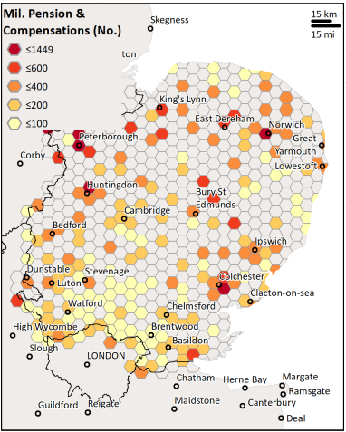

The figure above (Figure 8.1) shows the analysis of location hotspots of Armed Forces Pension and compensation recipients, conducted by Northumbria University, by post code area for 2017. In terms of Essex level data, the figure shows significantly higher concentration of pension recipients in Colchester area, followed by Basildon.

**Financial Hardship [97]**

Figure 8.2: Financial hardship recipients hotspots of Navy, Army, and RAF veterans, East of England (2015/17)

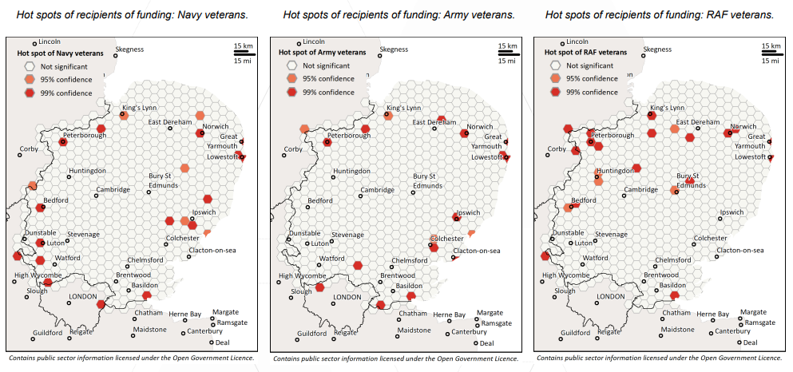

The figure above (Figure 8.2) shows the main areas where Navy, Army, and RAF veterans, recipients of financial hardship assistance were in the East of England (2015/17).

In Essex, the main hotspot for hardship support was in Basildon area for Navy, Army, and RAF veterans, whilst Colchester showed up as the financial hardship hotspot for Army veterans.

**Mental health**

Figure 8.3: Mental health referrals in England and East of England, 2017/18

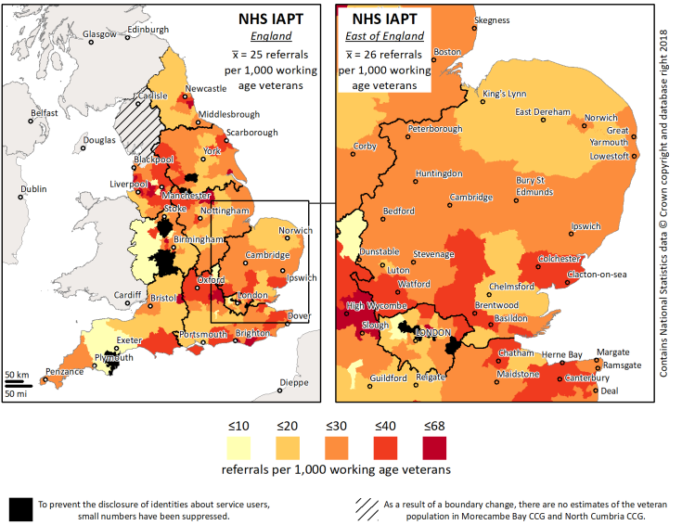

The NHS Talking Therapies (previously known as Improving Access to Psychological Therapies - IAPT) program began in 2008 and transformed the treatment of adult anxiety disorders and depression in England. The program is widely recognised for its ambition to treat people and to help them to better manage their mental health [98].

The figure above (Figure 8.3) shows the veterans’ rates of access to mental health treatment for the NHS IAPT (Psychological Therapies) service nationally and for East of England for 2017/18 [99]. When compared to England referrals average (25/1000), East of England average is very similar (26/1000). At Essex level, there is a higher referrals rate to mental health treatment services in Colchester, Brentwood and Basildon areas (≤40/1000) when compared with other areas in Essex.

**RBL’s call centre contacts [100]**

Figure 8.4: RBL’s call centre contacts hotspots in the UK and East of England, 2014/17

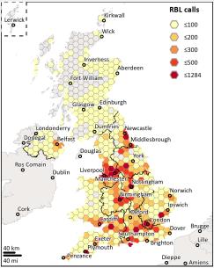 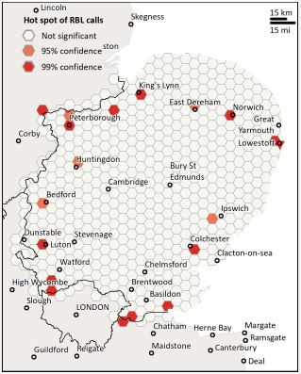

The Royal British Legion (RBL) is a charity providing financial, social and emotional support to members and veterans of the British Armed Forces, their families and dependants[101].

The total of 187,270 contacts were made between 2014 to 2017 with the RBL. The most recipients were over 85 years old, and approximately 34% of contacts requested financial support, followed by “Welfare Breaks” (17%).

The figure above (Figure 8.4) shows the hotspots for veterans who contacted RBL in the UK as well as in the East of England. At Essex level, the main hotspots were in Colchester and Basildon areas.

**ABF The soldiers’ Charity grants [102]**

Figure 8.5: ABF recipients’ hotspots in the UK and in the East of England, 2015/17

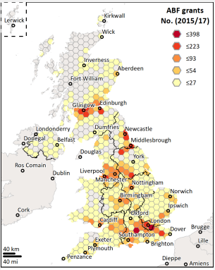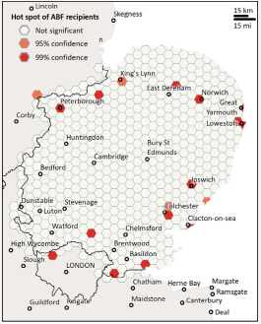

The Army Benevolent Fund (ABF) The Soldiers’ Charity is the national charity of the British Army, providing a lifetime support to soldiers, veterans and their immediate families by issuing grants. Based on 9,546 cases, the figure above (Figure 8.5) shows the hotspots of the veterans receiving these grants at national and regional level. The main hotspots for Essex were in Colchester and Basildon areas.

**Combat Stress referrals [103]**

Figure 8.6: Combat stress referrals hotspots in the UK and East of England, 2017/18

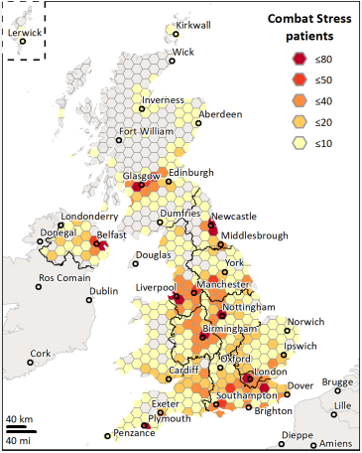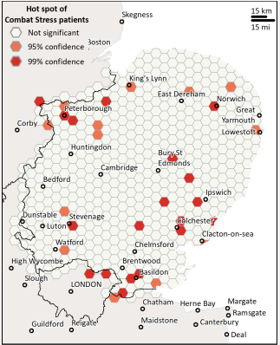

Combat Stress (CS) is the charity for veterans’ mental health and help with issues such as PTSD, anxiety and depression. The figure above (Figure 8.6) shows hotspots at the national level as well as regional. At Essex level, Colchester and Basildon showed up as two main areas in with significant prevalence of CS service users. According to the research authors, the average service user age in the UK was 47 years, and that the service users distribution is highly correlated with that of military pensions and compensations recipients, which could be useful when seeking to locate areas with veterans populations who are experiencing mental ill health (ibid).

**The RAF Benevolent Fund [104]**

Figure 8.7: Royal Air Force Benevolent fund recipients’ hotspots in the UK and East of England, 2014-17

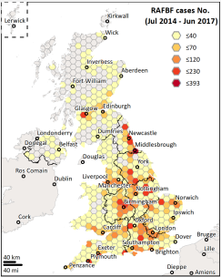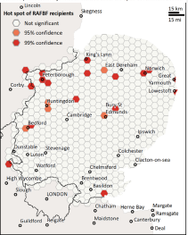

The Royal Air Force (RAF) Benevolent Fund is a charity that supports RAF veterans by providing practical, emotional and financial support.

Between 2014 to 2017, 13,743 contacts were made with 13% (1,802) veterans requiring regular financial assistance. The figure above (Figure 8.7) shows the hotspots at the national and regional level. As for Essex, the only significant hotspot area was in Basildon.

**The Royal Naval Benevolent Trust [105]**

Figure 8.8: Royal Navy Benevolent Trust Fund recipients in the UK and the East of England, 2015/17

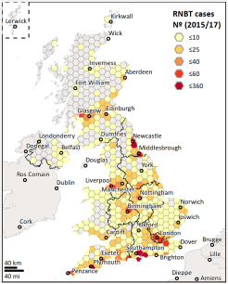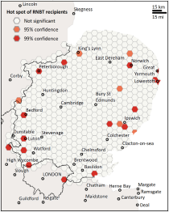

The Royal Navy Benevolent Fund provides financial assistance and support to Royal Navy and Royal Marines personnel and their families. For the 2015 to 2017 there were 4,290 assistance recipients, averaging approximately 2,100 recipients per year. The figure above (Figure 8.8) shows hotspots at the national level as well as for the East of England region. At Essex level there is a significant number of recipients in Basildon area.

**SSAFA The Armed Forces Charity [106]**

Figure 8.9: SSAFA Financial Assistance cases hotspots in the UK and east of England, 2019

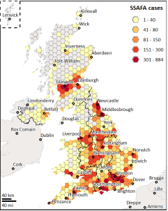 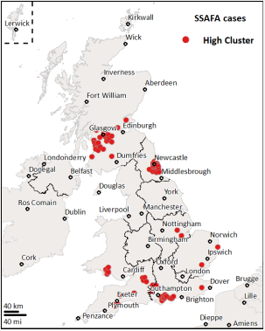

The Soldiers’, Sailors’ & Airmen’s Families Association (SSAFA) provides help in a few ways. For this analysis, the sample (32,659) was composed of financial assistance cases managed by SSAFA in 2019 (ibid). The figure above (Figure 8.9) shows SSAFA cases and High Cluster hotspots at the national level. At Essex level, the High Cluster indicator hotspot is around Basildon area.

**Table 8.1: SSAFA financial assistance cases, 2014 to 2019**

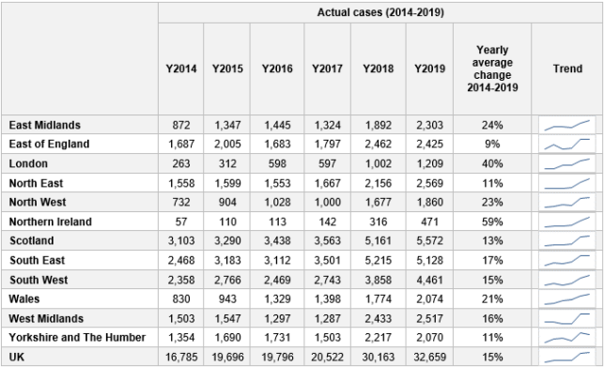

The table above (Table 8.1) shows the trends over time for financial assistance. The yearly average change between 2014 to 2019 was lowest in the East of England (9%), it ranged from 9% to 59% and the average for the UK was 15%.

## **Recommendations**

### **Overview**

Poor transition to civilian life comes at a high economic and societal cost. According to the projections by the Forces in Mind Trust, the main areas of costs are family breakdown, common mental health disorders, harmful drinking and unemployment. These are all areas which require engagement from multiple stakeholders like local authorities, local businesses, and the voluntary sector. Ensuring a data-driven approach and collecting high quality Essex level data can help us identify high risk groups and ensure that timely support is given.

### **Health and Wellbeing**

* Improve data collection to better understand age, gender breakdown, and demand for services
* Work with service members and veterans from commonwealth countries, to understand their lived experiences and barriers in accessing mental health services in Essex
* Ensure availability of practical information on accessing NHS services in one place
* Keep military families at the heart of any long-term health plans for veterans
* Provide training to healthcare professionals on key problems prevalent among veterans like chronic pain and musculoskeletal disorders
* Encourage GP practices to get a Veteran Friendly GP Practice accreditation. Accreditation is voluntary but included in NHS long term plan, which ensures all GPs in England are equipped to best serve veterans and their families
* Work with groups at high risk for PTSD
* Develop multidisciplinary and innovative approaches for alcohol services

### **Education and Children’s Care**

* It is important to increase awareness of a range of policies to minimise disruption to family life, particularly around the procedures in place to minimise educational disruption (such as avoiding moves in a GCSE year). This should include improved advice to parents about informing their children’s school when they are deployed
* To reduce the impact of education disruption due to family mobility, local schools should be supported to manage the timely transfer of children’s information through the new Common Transfer Framework or other methods. This is needed to improve the continuity of education, particularly when children move to another area or abroad
* Social, emotional, and mental health difficulties (SEMH) seem to be slightly higher in Essex in the service children group (secondary school) compared to non-service children, and this may be attributed to discontinuity in education. Additionally, support for children in local schools could be beneficial

### **Housing**

* Improve access to data related to service accommodation and social housing in Essex. To achieve this, it is necessary to work closely with the Ministry of Defence Local Authority Partnership (MODLAP) in sharing data and insights
* Data at the national level shows that accommodation is the most-highly reported concern presented by service personnel. The primary reason why personnel do not own their own home continues to be that they cannot afford to buy a suitable home. Ensure that Essex Local Plans include Service help-to-buy properties and social housing for Armed Forces personnel
* Increase and support collaborative networks between local authorities and the third sector to help veterans navigate the housing system bureaucracy and to prevent homelessness

### **Employment and Transition**

* Work with groups less confident in their skills, female veterans, and those from commonwealth countries, to upskill, and support smoother transition into civilian employment
* Engage with local business owners to raise awareness about the Armed Forces community to dispel any negative stereotypes
* Improve data collection and research on veterans seeking unemployment benefit and work with veterans deemed high risk
* Ensure every Jobcentre Plus district in Essex has an Armed Forces Champion to meet the needs of veterans and provide support to the Armed Forces community

### **Criminal Justice System**

* Ensure that all veterans in custody, prison, and probation service are asked if they served in the armed forces
* Ensure thatOp COURAGE and Op NOVA (new name [https://www.forcesemployment.org.uk/programmes/op-nova/](https://eur02.safelinks.protection.outlook.com/?url=https%3A%2F%2Fwww.forcesemployment.org.uk%2Fprogrammes%2Fop-nova%2F&data=05%7C01%7C%7C8b5e3acd8b7c4870816908db3bfe65ea%7Ca8b4324f155c4215a0f17ed8cc9a992f%7C0%7C1%7C638169736058081522%7CUnknown%7CTWFpbGZsb3d8eyJWIjoiMC4wLjAwMDAiLCJQIjoiV2luMzIiLCJBTiI6Ik1haWwiLCJXVCI6Mn0%3D%7C3000%7C%7C%7C&sdata=8%2BZOsh578tJ850Clb6NfQ7wznxGzcJJcwy5wxaufLUE%3D&reserved=0)) are sign posted to veterans
* Encourage police, local prison, and probation services to take part in the Civil and Military Partnership Board (CMPB) and share audited data on veterans in their service in Essex
* Ensure that re-offending of veterans is recorded or audited

## **Appendices**

### **Table 10.1– Districts Community support**

|  |  |
| --- | --- |
| **Local Authority** | **Link for further support/community club** |
| Basildon | [Basildon's Armed Forces Community Covenant - Basildon](https://www.basildon.gov.uk/article/7428/Basildon-s-Armed-Forces-Community-Covenant) |
| Braintree | [Braintree Armed Forces & Veterans Breakfast Club](https://www.afvbc.net/find-a-club/braintree/) |
| Brentwood | [Brentwood Borough Council](https://assets.publishing.service.gov.uk/government/uploads/system/uploads/attachment_data/file/858945/Brentwood_Borough_Council_Armed_Forces_Covenant_20191209.pdf) |
| Castle Point | [Ex-Armed Forces | Castle Point](https://www.castlepoint.gov.uk/ex-armed-forces/) |
| Chelmsford | [Chelmsford Armed Forces & Veterans Breakfast Club](https://www.afvbc.net/find-a-club/chelmsford-armed-forces-veterans-breakfast-club/) |
| Colchester | [Armed Forces · Colchester Borough Council](https://www.colchester.gov.uk/armedforces/) |
| Epping Forest | [Armed Forces community covenant - Epping Forest District Council](https://www.eppingforestdc.gov.uk/community/armed-forces-community-covenant/) |
| Harlow | [Armed forces | Harlow Council](https://www.harlow.gov.uk/community/armed-forces) |
| Maldon | [Maldon District Council](https://www.maldon.gov.uk/info/20083/community_development/9306/veterans_gateway_-_armed_forces_support) |
| Rochford | [Housing Options Service | Rochford District Council](https://www.rochford.gov.uk/housing/housing-options-service#homeless_forces) |
| Southend | [Armed Forces and Veteran's Support | Livewell Southend](https://livewellsouthend.com/kb5/southendonsea/directory/advice.page;jsessionid=2C0189CB401AA14C49D805B0398406DD?id=TlscMcC0Cw4) |
| Tendring | [Armed Forces Covenant | Tendring District Council](https://www.tendringdc.gov.uk/armed-forces-covenant) |
| Thurrock | [Online support for veterans | Armed forces | Thurrock Council](https://www.thurrock.gov.uk/armed-forces/online-support-for-veterans) |
| Uttlesford | [Resources for armed forces personnel - Uttlesford District Council](https://www.uttlesford.gov.uk/article/5541/Resources-for-armed-forces-personnel) |

### **Table 10.2 – Army veterans’ number by Local Authority**



### **Table 10.3: Service Pupil Premium allocation for Essex, Southend, Thurrock, England. 2014/22**



Source: [Pupil premium and other school premiums - GOV.UK (www.gov.uk)](https://www.gov.uk/education/pupil-premium-and-other-school-premiums)

### **Figure 10.1 – Percentage of veterans who previously served in the UK armed Forces, Census 2021**

### **Figure 10.2 – Veterans population by County, Census 2021**

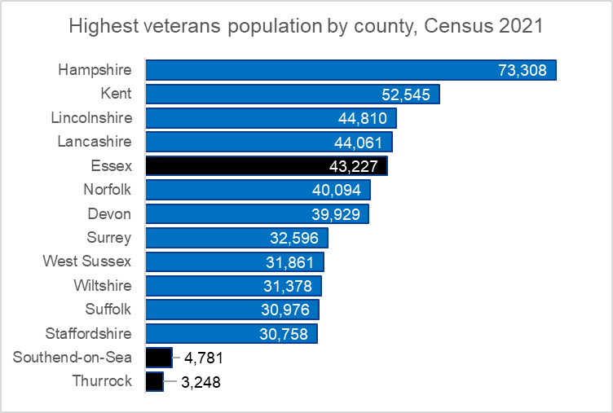

**Figure 10.3 – The structure of the UK armed forces veteran population. Percentage of the usual resident population aged 16 years and over by previous service in the UK armed forces, age groups and sex, 2021, England and Wales.**

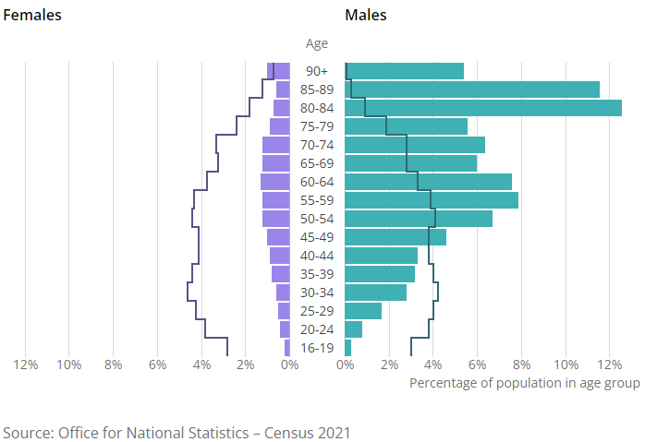

**Figure 10.4 – Veterans and non-veterans self-reported general health. Percentage of the population aged 16 years and over by previous service in the UK armed forces and general health with adjusted non-veteran estimates, 2021, England and Wales**

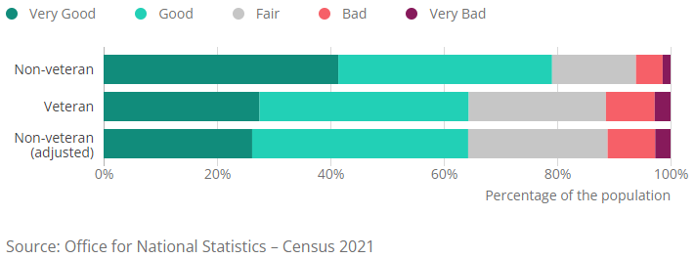

**This publication is issued by:**  
Research and Citizen Insight Team

Essex County Council

The information contained in this document can be translated, and/or made available in alternative formats, on request. If you have any queries about this publication, please contact Essex County Council’s Research and Citizens Team by email [research@essex.gov.uk](mailto:research@essex.gov.uk); or [phi@essex.gov.uk](mailto:phi@essex.gov.uk).

[www.essex.gov.uk](http://www.essex.gov.uk)

Published April 2023

1. NHS(2022) Healthcare for the Armed Forces community: a forward view [Healthcare for the Armed Forces community: a forward view to 2022 (england.nhs.uk)](https://www.england.nhs.uk/wp-content/uploads/2021/03/Healthcare-for-the-Armed-Forces-community-forward-view-March-2021.pdf)
2. Essex County Council (2014) Armed Forces Joint Strategic Needs Assessment
3. Essex Armed Forces Community Covenant (nd) Available at: <https://www.essex.gov.uk/essex-armed-forces-community-covenant>
4. <https://assets.publishing.service.gov.uk/government/uploads/system/uploads/attachment_data/file/755915/Strategy_for_our_Veterans_FINAL_08.11.18_WEB.pdf>
5. <https://www.gov.uk/government/publications/veterans-strategy-action-plan-2022-to-2024>
6. <https://www.gov.uk/government/publications/strategy-for-our-veterans-6-monthly-report>
7. ### [Location Statistics for UK Regular Armed Forces and Civilians: 2022 - GOV.UK (www.gov.uk)](https://www.gov.uk/government/statistics/location-statistics-for-uk-regular-armed-forces-and-civilians-2022). Annual location statistics: 1April 2022. Table 1.1a

  
8. <https://www.gov.uk/government/statistics/location-statistics-for-uk-regular-armed-forces-and-civilians-2022> Annual location statistics: 1 April 2022. Tables 3.6a & 3.6b
9. [1_July_2022_SPS_Accessible_Excel_Tables.xlsx (live.com)](https://view.officeapps.live.com/op/view.aspx?src=https%3A%2F%2Fassets.publishing.service.gov.uk%2Fgovernment%2Fuploads%2Fsystem%2Fuploads%2Fattachment_data%2Ffile%2F1103972%2F1_July_2022_SPS_Accessible_Excel_Tables.xlsx&wdOrigin=BROWSELINK).Table 8a
10. [Veterans Factsheet 2020 (publishing.service.gov.uk)](https://assets.publishing.service.gov.uk/government/uploads/system/uploads/attachment_data/file/874821/6.6409_CO_Armed-Forces_Veterans-Factsheet_v9_web.pdf#:~:text=Veterans%20are%20defined%20as%20anyone%20who%20has%20served,ceased%20to%20be%C2%A0a%20member%20of%20HM%20Armed%20Forces.)
11. ONS 2021 – UK Armed forces veterans. [UK armed forces veterans, England and Wales - Office for National Statistics (ons.gov.uk)](https://www.ons.gov.uk/peoplepopulationandcommunity/armedforcescommunity/bulletins/ukarmedforcesveteransenglandandwales/census2021)
12. [20190128_-_APS_2017_Annex_A.xlsx (live.com)](https://view.officeapps.live.com/op/view.aspx?src=https%3A%2F%2Fassets.publishing.service.gov.uk%2Fgovernment%2Fuploads%2Fsystem%2Fuploads%2Fattachment_data%2Ffile%2F774939%2F20190128_-_APS_2017_Annex_A.xlsx&wdOrigin=BROWSELINK)
13. Census 2021. <https://www.ons.gov.uk/peoplepopulationandcommunity/armedforcescommunity/articles/characteristicsofukarmedforcesveteransenglandandwalescensus2021/census2021>
14. [1_July_2022_SPS_Accessible_Excel_Tables.xlsx (live.com)](https://view.officeapps.live.com/op/view.aspx?src=https%3A%2F%2Fassets.publishing.service.gov.uk%2Fgovernment%2Fuploads%2Fsystem%2Fuploads%2Fattachment_data%2Ffile%2F1103972%2F1_July_2022_SPS_Accessible_Excel_Tables.xlsx&wdOrigin=BROWSELINK). Table 4
15. [20220812_-_Location_of_UK_Armed_Forces_Pension_and_Compensation_Recipients_-_Supplementary_Tables_-_OS.xlsx (live.com)](https://view.officeapps.live.com/op/view.aspx?src=https%3A%2F%2Fassets.publishing.service.gov.uk%2Fgovernment%2Fuploads%2Fsystem%2Fuploads%2Fattachment_data%2Ffile%2F1099838%2F20220812_-_Location_of_UK_Armed_Forces_Pension_and_Compensation_Recipients_-_Supplementary_Tables_-_OS.xlsx&wdOrigin=BROWSELINK). Table 3
16. [Count Them In | Policy and Campaigns | Royal British Legion](https://www.britishlegion.org.uk/get-involved/things-to-do/campaigns-policy-and-research/campaigns/count-them-in)
17. [UK armed forces veterans: Census 2021 analysis plans - Office for National Statistics (ons.gov.uk)](https://www.ons.gov.uk/census/censustransformationprogramme/census2021outputs/2021dataproducts/analysis/veteransanalysisplanscensus2021)
18. [Household Survey | Veteran Needs | Royal British Legion](https://www.britishlegion.org.uk/get-involved/things-to-do/campaigns-policy-and-research/policy-and-research/the-uk-ex-service-community-a-household-survey)
19. [Advice and support for veterans & ex-forces | Veterans' Gateway (veteransgateway.org.uk)](https://www.veteransgateway.org.uk/)
20. [Impact of military service on physical health later in life: a qualitative study of geriatric UK veterans and non-veterans | BMJ Open](https://bmjopen.bmj.com/content/9/7/e028189#ref-7)
21. [An Evaluation of the Effect of Military Service on Mortality: Quantifying the Healthy Soldier Effect - ScienceDirect](https://www.sciencedirect.com/science/article/pii/S104727970800286X?via%3Dihub)
22. Annual population survey: UK armed forces veterans residing in Great Britain 2017 - GOV.UK (www.gov.uk)
23. [2022-snapshot-physical-health.pdf (fimt-rc.org)](https://cdn.fimt-rc.org/2022-snapshot-physical-health.pdf)
24. The veterans transition review ([vtr3_followup_2017.pdf (veteranstransition.co.uk)](http://veteranstransition.co.uk/vtr3_followup_2017.pdf)
25. <https://www.kcl.ac.uk/kcmhr/publications/assetfiles/2018/kcmhr-admmh-factsheet-sept2018.pdf>, <https://www.kcl.ac.uk/kcmhr/research/kcmhr/healthstudy>
26. Mental health treatment experiences of commonwealth veterans from diverse ethnic backgrounds who have served in the UK military Pearson et al, <https://combatstress.org.uk/sites/default/files/2021Pearson_commonwealth.pdf>
27. Demographic risk groups at MOD specialist mental health services [UK-armed-forces-MH-people-2022.ods (live.com)](https://view.officeapps.live.com/op/view.aspx?src=https%3A%2F%2Fassets.publishing.service.gov.uk%2Fgovernment%2Fuploads%2Fsystem%2Fuploads%2Fattachment_data%2Ffile%2F1084009%2FUK-armed-forces-MH-people-2022.ods&wdOrigin=BROWSELINK)
28. [20210715 - MedDisBulletinFinal - O (publishing.service.gov.uk)](https://assets.publishing.service.gov.uk/government/uploads/system/uploads/attachment_data/file/1001267/UK_service_personnel_medical_discharges__financial_year_2020_21.pdf)
29. [Microsoft Word - 20120727-2011-12 Annual Mental Health report - U.doc (publishing.service.gov.uk)](https://assets.publishing.service.gov.uk/government/uploads/system/uploads/attachment_data/file/280708/2011-12.pdf#:~:text=Since%202009%2F10%20there%20have%20been%20statistically%20significant%20differences,each%20age%20group%20over%20the%20age%20of%2020)
30. [UK-armed-forces-MH-people-2022.xlsx (live.com)](https://view.officeapps.live.com/op/view.aspx?src=https%3A%2F%2Fassets.publishing.service.gov.uk%2Fgovernment%2Fuploads%2Fsystem%2Fuploads%2Fattachment_data%2Ffile%2F1084008%2FUK-armed-forces-MH-people-2022.xlsx&wdOrigin=BROWSELINK). Table 1
31. [UK-armed-forces-MH-people-2022.xlsx (live.com)](https://view.officeapps.live.com/op/view.aspx?src=https%3A%2F%2Fassets.publishing.service.gov.uk%2Fgovernment%2Fuploads%2Fsystem%2Fuploads%2Fattachment_data%2Ffile%2F1084008%2FUK-armed-forces-MH-people-2022.xlsx&wdOrigin=BROWSELINK). Figure 6 Data
32. [UK Armed Forces Mental Health annual report 2019 to 2020 (publishing.service.gov.uk)](https://assets.publishing.service.gov.uk/government/uploads/system/uploads/attachment_data/file/892426/20200618_Annual_Report_19-20_O.pdf)
33. [Research in focus: The TRIAD study - How PTSD develops in UK Armed Forces personnel (kcmhr.org)](https://www.kcmhr.org/research-in-focus-the-triad-study-how-ptsd-develops-in-uk-armed-forces-personnel/#:~:text=Findings%20from%20the%20KCMHR%20cohort%20study%20highlighted%2C%20however%2C,compared%20to%204%25%20among%20those%20still%20in%20service.)
34. Godier-McBard, Lauren R., Gillin, Nicola and Fossey, Matt (2021) We Also Served: The Health and Well-being of Female Veterans in the UK. Project Report. Anglia Ruskin University, Chelmsford, UK
35. [Frontiers | Outside the Military “Bubble”: Life After Service for UK Ex-armed Forces Personnel (frontiersin.org)](https://www.frontiersin.org/articles/10.3389/fpubh.2020.00050/full)
36. [UK_armed_forces_suicides_and_open_verdict_deaths_2021_ODS_tables.ods (live.com)](https://view.officeapps.live.com/op/view.aspx?src=https%3A%2F%2Fassets.publishing.service.gov.uk%2Fgovernment%2Fuploads%2Fsystem%2Fuploads%2Fattachment_data%2Ffile%2F1063680%2FUK_armed_forces_suicides_and_open_verdict_deaths_2021_ODS_tables.ods&wdOrigin=BROWSELINK). Figure 6 Data
37. [UK_armed_forces_suicides_and_open_verdict_deaths_2021_ODS_tables.ods (live.com)](https://view.officeapps.live.com/op/view.aspx?src=https%3A%2F%2Fassets.publishing.service.gov.uk%2Fgovernment%2Fuploads%2Fsystem%2Fuploads%2Fattachment_data%2Ffile%2F1063680%2FUK_armed_forces_suicides_and_open_verdict_deaths_2021_ODS_tables.ods&wdOrigin=BROWSELINK). Figure 7 Data
38. [UK_armed_forces_suicides_and_open_verdict_deaths_2021_ODS_tables.ods (live.com)](https://view.officeapps.live.com/op/view.aspx?src=https%3A%2F%2Fassets.publishing.service.gov.uk%2Fgovernment%2Fuploads%2Fsystem%2Fuploads%2Fattachment_data%2Ffile%2F1063680%2FUK_armed_forces_suicides_and_open_verdict_deaths_2021_ODS_tables.ods&wdOrigin=BROWSELINK). Figure 2 Data.
39. <https://www.medrxiv.org/content/10.1101/2022.12.12.22283340v1.full>
40. <https://assets.publishing.service.gov.uk/government/uploads/system/uploads/attachment_data/file/630184/20170718_Alcohol_Usage_bulletin__-_O.pdf>
41. Kings Centre for Military Health Research: [https://kcmhr.org/mobile-app-successfully-tested-with-veterans-seeking-to-reduce-their-alcohol-consumption-now-available-to-the-public /](https://kcmhr.org/mobile-app-successfully-tested-with-veterans-seeking-to-reduce-their-alcohol-consumption-now-available-to-the-public%20/)
42. <https://nff.org.uk/wp-content/uploads/2022/02/Duty_and_Care.pdf>
43. <https://nff.org.uk/wp-content/uploads/2022/02/Duty_and_Care.pdf>
44. [2022-snapshot-physical-health.pdf (fimt-rc.org)](https://cdn.fimt-rc.org/2022-snapshot-physical-health.pdf)
45. [The role of health visitors and school nurses: Supporting the health and wellbeing of military families (publishing.service.gov.uk)](https://assets.publishing.service.gov.uk/government/uploads/system/uploads/attachment_data/file/479525/2903829_PHE_Military_Families_Accessible_v0.2.pdf)
46. [2022-snapshot-physical-health.pdf (fimt-rc.org)](https://cdn.fimt-rc.org/2022-snapshot-physical-health.pdf)
47. Eodanable, M. & Lauchlan, F. (2012). Promoting Positive emotional health of children of transient armed forces families. School Psychology International, 33, 22-38 – and The Educational Attainment of Army Children report, York St John University, 2015.
48. Department of Health (2015) Supporting the health and wellbeing of military families https://www.gov.uk/government/publications/supporting-the-health-and-wellbeing-ofmilitary-families
49. Longfield, A. (2018) Kin and Country: Growing up as an Armed Forces child. Available at: <https://www.childrenscommissioner.gov.uk/wp-content/uploads/2018/06/KIN-AND-COUNTRY-Growing-up-as-an-Armed-Forces-child.pdf>
50. CEA is an allowance offered by the MOD to provide children with continuity in their education. This allowance assists Service personnel with boarding school fees to achieve the continuity of education for their children that would otherwise not be possible if their children accompanied them on frequent assignments both at home and overseas.
51. https://assets.publishing.service.gov.uk/government/uploads/system/uploads/attachment_data/file/575582/20161208-Adhoc_Statistical_Bulletin-Service_children_educational_attainment_in_England.pdf
52. For more details data, such as the number of Essex pupils and premium allocation in England and East of England, please look at paragraph 10, 'Appendices,' table 10.3: Service Pupil Premium allocation for Essex, Southend, Thurrock, England. 2014/22. 
53. Free School Meals (FSMs) are offered to children of families who are in receipt of: Income Support; Income-based Jobseeker’s Allowance; Income-related Employment and Support Allowance; Support under Part VI of the Immigration and Asylum Act 1999; The guaranteed element of Pension Credit; Child Tax Credit (provided families are not also entitled to Working Tax Credit and have an annual gross income of no more than £16,190); Working Tax Credit run-on - paid for 4 weeks after families stop qualifying for Working Tax Credit; Universal Credit.
54. Data provided by East Anglia Reserve Forces and Cadets Association (03/2023)
55. <https://www.northampton.ac.uk/wp-content/uploads/2017/10/social-impact-cadet-forces-uk-2020.pdf>
56. <https://cvqo.org/>
57. The term “transition” is used to describe the period of (re)integration into civilian life from the Armed Forces. “Resettlement” describes the formal processes and procedures by which a transition is managed, and the formal support provided to service leavers during transition
58. <https://assets.publishing.service.gov.uk/government/uploads/system/uploads/attachment_data/file/1100663/6.8080_CO_OVA_Strategy_Action_Plan_DRAFT_V6_WEB.pdf>
59. The year after the introduction of the **Forces Help to Buy (FHTB) Scheme** <https://www.gov.uk/government/publications/joint-service-housing-advice-office-leaflet-index/forces-help-to-buy-scheme>
60. In 2023, ONS will release new data from Census 2021 - This analysis will present the housing and accommodation situation of the veteran population in England and Wales. It will include analysis by housing characteristics, such as: type of accommodation; housing tenure; characteristics of household reference person; household composition, and overcrowding.
61. Rolfe, S., & Anderson, I. (2022). Meeting the housing needs of military veterans: exploring collaboration and governance. Housing Studies, 1-21.

    Fleuty, K., Cooper, A., & Almond, M. (2021). Armed forces and veteran housing policies: the United Kingdom 2021 vision. Journal of Veterans Studies, 7(1), 232-240.
62. [Social housing lettings in England, April 2020 to March 2021 (publishing.service.gov.uk)](https://assets.publishing.service.gov.uk/government/uploads/system/uploads/attachment_data/file/1094417/Social_Housing_Lettings_in_England_April_2020_to_March_2021.pdf)
63. Beijer, Ulla et al. (2012) ‘Prevalence of tuberculosis, hepatitis C virus, and HIV in homeless people: a systematic review and meta-analysis,’ The Lancet Infectious Diseases, Volume 12, Issue 11, 859 – 870
64. <https://www.gov.uk/guidance/homelessness-code-of-guidance-for-local-authorities/overview-of-the-homelessness-legislation>
65. <https://assets.publishing.service.gov.uk/government/uploads/system/uploads/attachment_data/file/1105577/Annual_Statutory_Homelessness_release_2021-22.pdf>
66. [Homelessness statistics - GOV.UK (www.gov.uk)](https://www.gov.uk/government/collections/homelessness-statistics)
67. [Coronavirus: Support for rough sleepers (England) - House of Commons Library (parliament.uk)](https://commonslibrary.parliament.uk/research-briefings/cbp-9057/#:~:text=The%20Government%E2%80%99s%20%E2%80%98Everyone%20In%E2%80%99%20initiative%20has%20been%20credited,offered%20accommodation%20as%20a%20result%20of%20%E2%80%98Everyone%20In%E2%80%99.)
68. [Resources - No Homeless Veterans - STOLL](https://www.stoll.org.uk/no-homeless-veterans/resources/)
69. UK Household survey of the ex-service community 2014: <https://storage.rblcdn.co.uk/sitefinity/docs/default-source/campaigns-policy-and-research/rbl_household_survey_report.pdf?sfvrsn=5bcbae4f_4>
70. UK Household survey of the ex-service community 2014: <https://storage.rblcdn.co.uk/sitefinity/docs/default-source/campaigns-policy-and-research/rbl_household_survey_report.pdf?sfvrsn=5bcbae4f_4>
71. [Resettlement for Ex-Service Personnel | Ex Armed Forces Recruitment from CTP](https://www.ctp.org.uk/)
72. UK Household survey of the ex-service community 2014: <https://storage.rblcdn.co.uk/sitefinity/docs/default-source/campaigns-policy-and-research/rbl_household_survey_report.pdf?sfvrsn=5bcbae4f_4>
73. <https://getintoteaching.education.gov.uk/funding-and-support/scholarships-and-bursaries>
74. <https://www.militarystepintohealth.nhs.uk/>
75. <https://www.gov.uk/government/publications/defence-employer-recognition-scheme/defence-employer-recognition-scheme>
76. <https://www.gov.uk/government/publications/national-insurance-holiday-for-the-employers-of-veterans-screening-equality-impact-assessment>
77. Tri services families continuous attitude survey 2021: [Tri-service families continuous attitude survey: 2021 - GOV.UK (www.gov.uk)](https://www.gov.uk/government/statistics/tri-service-families-continuous-attitude-survey-2021)
78. [Partner Career Support Programme - Expanded and Extended (ctp.org.uk)](https://www.ctp.org.uk/focus/news-partner-career-support/503483)
79. [Forces in Mind Trust launches the Transition Mapping Study 2017: Continue to Work Report - Forces in Mind Trust (fim-trust.org)](https://www.fim-trust.org/news-policy-item/forces-mind-trust-launches-transition-mapping-study-2017-continue-work-report/)
80. Career transition partnership Annual Statistics: https://assets.publishing.service.gov.uk/government/uploads/system/uploads/attachment_data/file/1049463/Career_Transition_Partnership_annual_statistics_UK_Regular_Service_Personnel_Employment_Outcomes__2020-21.pdf
81. https://www.britishlegion.org.uk/docs/default-source/campaigns-policy-and-research/deployment-to-employment.pdf
82. [Armed forces access to Jobcentre Plus services - GOV.UK (www.gov.uk)](https://www.gov.uk/government/publications/jobcentre-plus-services-for-the-armed-forces-and-their-families/armed-forces-enhanced-access-to-jobcentre-plus-services-and-armed-forces-champions)
83. [Unemployment and benefit claims by UK veterans in the new millennium: results from a record linkage study | Occupational & Environmental Medicine (bmj.com)](https://oem.bmj.com/content/76/10/726.long)
84. The Butler Trust. [Working with veterans in custody and the community – Butler Trust](https://www.butlertrust.org.uk/working-with-veterans-in-custody-and-the-community/#:~:text=There%20are%20almost%20five%20million%20military%20veterans%20in,obligation%20to%20those%20who%20have%20served%20their%20country.)
85. HM Inspectorate of Prisons (2014). [Microsoft Word - Ex-Service personnel findings paper - for publication.doc (justiceinspectorates.gov.uk)](https://www.justiceinspectorates.gov.uk/hmiprisons/wp-content/uploads/sites/4/2014/03/Ex-Service-personnel-findings-paper-2014.pdf#:~:text=1.8%20The%20number%20of%20ex-Service%20personnel%20in%20prison,reliability%20of%20these%20estimates%20is%20of%20variable%20quality.)
86. Ministry of Justice (2021). <https://assets.publishing.service.gov.uk/government/uploads/system/uploads/attachment_data/file/1028697/Ex-service_personnel_in_the_prison_population_2021.pdf>
87. MacManus, D., Dean, K., Jones, M., Rona, R., Greenberg, N., Hull, L. (2013) Violent offending by UK military personnel deployed to Iraq and Afghanistan: a data linkage cohort study. <https://www.thelancet.com/journals/lancet/article/PIIS0140-6736(13)60354-2/fulltext>
88. Ministry of Defence. Estimating the proportion of prisoners in England and Wales who are ex-Armed Forces – further analysis. <https://assets.publishing.service.gov.uk/government/uploads/system/uploads/attachment_data/file/280048/15-september-2010.pdf>
89. Howard League for Penal Reform. <https://howardleague.org/wp-content/uploads/2016/05/Leaving-Forces-Life.pdf>
90. Freedom of Information request to Essex Police (2023)
91. Directory of Social Change (2019) <https://www.dsc.org.uk/publication/focus-on-armed-forces-charities-in-the-criminal-justice-system/>
92. <https://www.forcesemployment.org.uk/programmes/op-nova/>
93. Forces in Mind Trust (2020) <https://cdn.fimt-rc.org/2022-snapshot-criminal-justice.pdf>
94. <https://covenantfund.org.uk/the-map-of-need/>
95. <https://covenantfund.org.uk/wp-content/uploads/2020/12/Open_Access_SSAFA.pdf>
96. <https://covenantfund.org.uk/wp-content/uploads/2020/09/Regional_Report_2019_East-of-England.pdf>
97. <https://covenantfund.org.uk/wp-content/uploads/2020/09/Regional_Report_2019_East-of-England.pdf>
98. [NHS Talking Therapies for Anxiety and Depression | Health Education England (hee.nhs.uk)](https://www.hee.nhs.uk/our-work/mental-health/improving-access-psychological-therapies)
99. Psychological Therapies (IAPT) activity by ex-British armed force status and gender 2017-18; NHS Digital 2019.
100. <https://covenantfund.org.uk/wp-content/uploads/2021/04/Open_Access_RBL.pdf>
101. <https://www.britishlegion.org.uk/>
102. <https://covenantfund.org.uk/wp-content/uploads/2020/08/Open_Access_ABF_The_Soldiers_Charity.pdf>
103. <https://covenantfund.org.uk/wp-content/uploads/2021/04/Open_Access_Combat_Stress.pdf>
104. <https://covenantfund.org.uk/wp-content/uploads/2020/09/Open_Access_RAFBF.pdf>
105. <https://covenantfund.org.uk/wp-content/uploads/2020/08/Open_Access_RNBT.pdf>
106. <https://covenantfund.org.uk/wp-content/uploads/2020/12/Open_Access_SSAFA.pdf>