Appendix e Essex HWB PNA 2022

PHARMACEUTICAL NEEDS ASSESSMENT

Public survey 2022

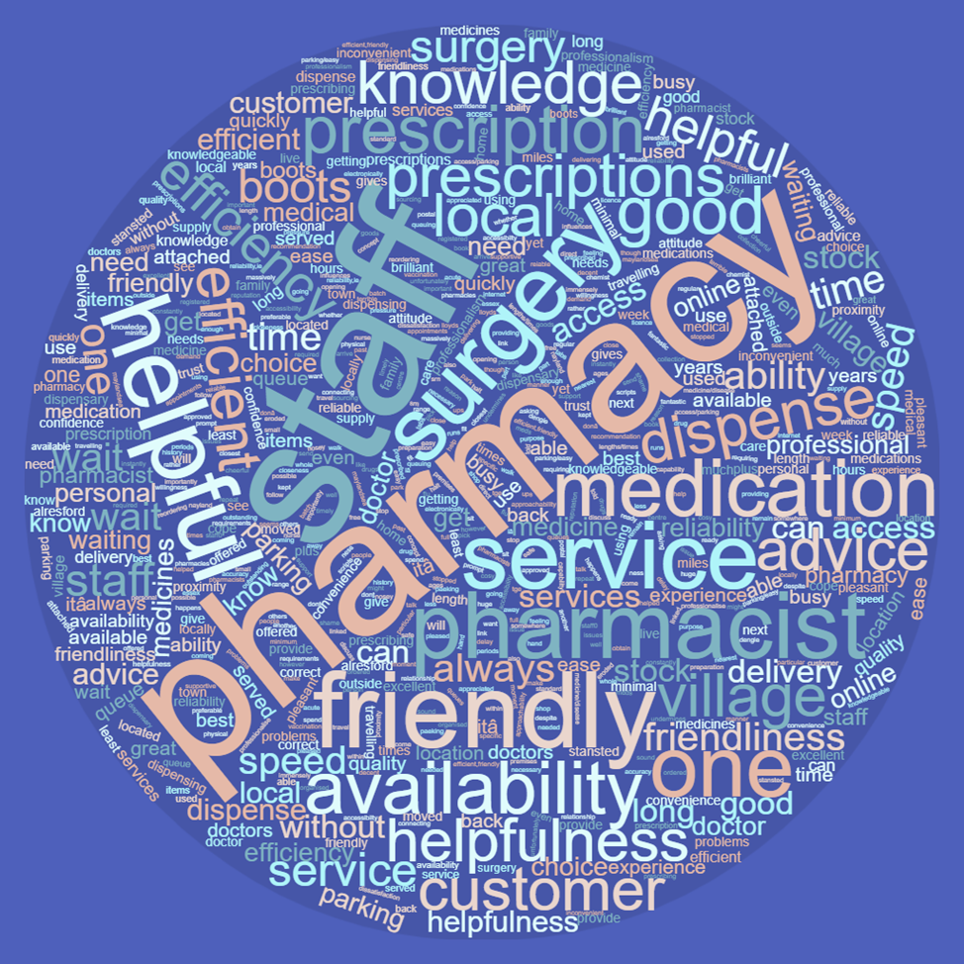

Table of contents

Table of contents 2
1. Purpose of the document 3
2. Method 3
3. Main results 3
3.1 Demographics 3
3.2 Pharmacy services 4
3.3 Use of the pharmacy 7

Purpose of the document
As part of the Pharmaceutical Needs Assessment (PNA), public engagement is recommended to enable the Health and Wellbeing Board to understand how pharmaceutical services are experienced, accessed and used by members of the public. To gather data on how people in Essex use pharmaceutical services and their satisfaction with their experience an online questionnaire was developed and administered to a self-selected sample across Essex. Data was collected from 723 residents and analysed by the Essex County Council Research and Citizen Insight Team using quantitative and qualitative approaches. This appendix provides an overview of pharmaceutical services in Essex from the perspective of residents, to assist in determining what services are required to meet the needs of the local population.
The public survey was administered between 24th December 2021 and 31st January 2022. The survey was promoted online, and an Easy Read format was made available on request.
The survey was promoted by Essex County Council (ECC) to districts and boroughs, Clinical Commissioning Groups, Community Voluntary Sector organisations, Healthwatch, GP surgeries, patient participation groups and pharmacies across Essex.
Being exploratory research, the ECC Public Health team have decided to use a self-selection sample1.

Method
To meet the research aims and objectives as outlined above, both a qualitative and quantitative approach has been used. Data was collected using an online open and close-ended questionnaire, built using the Smart Survey platform. Upon completion of the questionnaire, data was migrated and securely stored—the research adhered to the Data Protection Directive (EC 95/46) and 2018's General Data Protection Regulations.

Main results

Demographics
Seven hundred and twenty-three valid questionnaires were collected. An additional two hundred and twenty questionnaires were collected; however these were incomplete are therefore not included in analysis / this appendix.
The results showed 74% of the participants were female and 23% male; the remaining preferred not to share their gender. The sample is spread across age groups (as shown in the figure 1 below, the majority of respondents are aged 65-74 years. Most respondents (83%) identified themselves as not having a disability, and 26.68% had responsibilities as a carer.
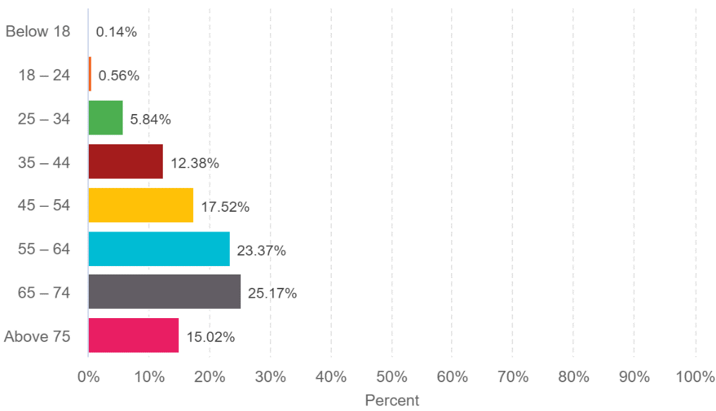

Figure 1. Age group participants

Pharmacy services
96% of respondents usually visit a pharmacy to get medicines on prescription, 65% to buy medicine and 53% to get advice (see figure n.2).

Q.1 Why do you visit a pharmacy? (Please tick all boxes that apply)
Answered: 723 Skipped:0

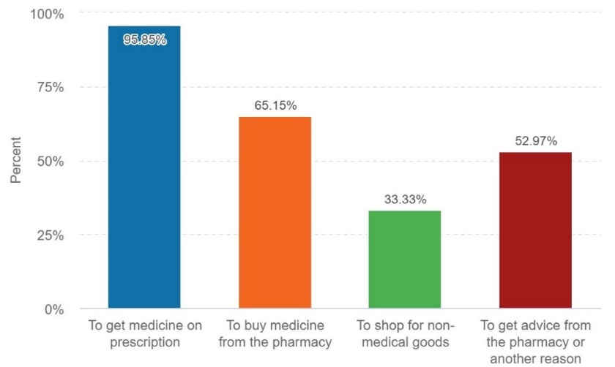

Figure 2. Reason for visiting a pharmacy
However, when we asked participants to specify, the main reasons identified was to: get medical advice on a broad range of minor illnesses (such as skin rash, allergies, flu, and eye infection); to ask pharmacist guidance on their prescriptions; and to get medical advice when GP appointments are not available.
Participants declared:
'Allergy information when unable to get a face-to-face appointment at GP surgery.'
'Advice on blood pressure. Was advised to go straight to the hospital when surgery refused the urgent appointment.'
'Nasty bite on my leg was unable to get help from my GP.'
'No choice as can't see Doctor'
'If I have doubts about the prescribed medicine, I ask the pharmacist for guidance.'
‘The frequency of use of the medicines and if before or following meals’
'How to deal with an eye infection.'
'Advice in relation to medication for Minor conditions / Ailments / Injuries et.'
'What OTC medicines I can take with my prescriptions medication.'
Regarding the services that pharmacies might provide (Q2), as shown in Table 1 below, most respondents are aware of: buying over the counter medicine; dispensing medicines on prescription and dispensing services. On the other hand, 85% of participants were not aware of hepatitis testing service, stoma appliance customisation service (87.29%), appliance use review (78%), immediate access to specialist drugs (74%), and needle exchange (68%). Please see below the complete list of services.

Q.2 Which of the following pharmacy services are you aware that a pharmacy may provide? (Please select one answer for each service - even if you do not use the service)

Answered: 723 Skipped: 0

Answer Choices | Yes | No
Buying over the counter medicines | 98.89% | 1.11%
Dispensing medicines on prescriptions | 99.59% | 0.41%
Dispensing Appliances | 58.79% | 41.21%
Repeat Dispensing Services | 95.03% | 4.97%
Discharge Medicines Service (support with medicines after a hospital stay) | 48.97% | 51.03%
Disposal of unwanted medicines | 82.48% | 17.52%
Appliance Use Review | 23.14% | 76.86%
Covid-19 lateral flow test distribution (collection) service | 88.29% | 11.71%
Flu vaccination services | 89.92% | 10.08%
Hepatitis testing service | 13.95% | 86.05%
New Medicine Service (advice about certain new medicines) | 42.40% | 57.60%
Stoma Appliance Customisation Service | 12.71% | 87.29%
Needle exchange | 31.86% | 68.14%
Stopping smoking service/ nicotine replacement therapy | 59.70% | 40.30%
Sexual health services (chlamydia testing / treating, condom distribution, emergency contraception) | 40.08% | 59.92%
Blood Pressure monitoring service | 43.72% | 56.28%
Immediate access to specialist drugs (e.g. palliative care medicines) | 26.07% | 73.93%
Supervised consumption of methadone and buprenorphine (medicines that support stopping drug use) | 35.08% | 64.92%
Emergency supply of prescription medicines | 56.41% | 43.59%
Covid -19 Vaccination services | 65.47% | 34.53%

Table 1. Awareness of pharmacy services

In addition to the awareness of pharmacy services, the questionnaire asked the participant about which services they value the most (Q3). The main themes that emerged from the content analysis were getting and collecting prescriptions, particularly repeat prescriptions, and pharmacist advice.

Q.3 Which service do you value most from your pharmacy? (Open question)

Answered: 637 Skipped: 86
Respondents declared:
'Collecting my repeat prescription, I order it digitally, then collect in person.'
'Professional advice on medication/minor medical issues'
'Prescription dispensing, chasing GP when prescription has not arrived, general advice on medications'.
'Repeat prescription service, knowledge of medications and opportunity to see Pharmacist face-to-face.'
‘All services, repeat prescriptions, advice are always provided on the medical issue when/if required.’
'Repeat prescriptions, advice on medication for minor medical conditions, general pharmacy supplies, i.e., cough medicines, cold and flu tablets, paracetamol etc. tablets'.
'I can call & get a repeat px & know it will be ready on time. Always go for advice also'.
'Repeat prescriptions which I am notified by text when ready to collect'.
'Their knowledge. Prescription services'.
'Knowledge and expertise of the pharmacist...invaluable'.
Participants also valued the personal approach established with their friendly pharmacist, particularly the possibility of seeing a specialist face to face.
'Friendly face to face service'
'They are simply the most caring, considerate and professional.'
'Personal contact and helpful advice.'
'Flu vaccination was very helpful. But just being able to speak to him is helpful as is more accessible than the GP.'
'I value the personal touch.'
'Reliability. Friendly and personal service.'
'The pharmacist has known myself & my family for over 35 years I value his opinion'.
A few participants also appreciated the presence of their pharmacist in their local community, especially when it is hard to book an appointment with GPs.
'It just being there’.
'Local pharmacy are very convenient and provide a service for the community. This is very important for older and vulnerable people
'My chemist has been amazing as my Dr has literally refused to see me as I'm exempt from the mask-wearing. The pharmacist has been my Dr in covid'.
'Free, unlimited access to knowledgeable advice and support. It's much better than seeing your doctor as they are inaccessible, and I know I can always rely on my pharmacist for help as the first port of call as opposed to my doctor who is either closed or too busy to deal with me at all'.
'[…] Pharmacist is available evening and weekends when GP is closed'.
'Advice is really good as it's so difficult to see a doctor now.'
When asked about the exclusive use of an online/internet pharmacy, less than 10% reported exclusive use. These results suggest that most respondents use a traditional pharmacy that provides face to face services and may also provide online service as shown in the figure 3.

Q 8. Do you only use an online / internet pharmacy? (An internet pharmacy is a registered pharmacy business that only provides an online service for prescriptions. A traditional pharmacy provides face to face services and may provide the facility to provide online services too).
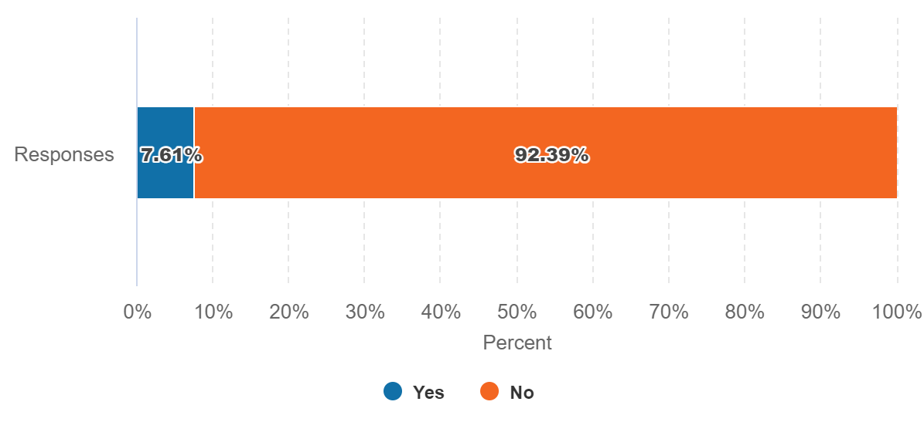
Figure 3. Use of online pharmacy

Use of the pharmacy
With regards to frequency of pharmacy use (figures 4 and 5), the majority of respondents usually visit pharmacies monthly (63%) and during the regular business hours (between 9am and 6pm) (46.5%).
Regarding the most convenient day to use the pharmacy, respondents seem not to have a preferred day; 62% reported 'no particular day', followed by 'week-day' (Monday to Friday) (27%) and on 'Saturday' 10.2%.
Only 1% have chosen 'Sunday' as the most convenient day to use a pharmacy (please see figure 6 below).

Q.4 How often do you use a pharmacy?

Answered:730 Skipped: 0
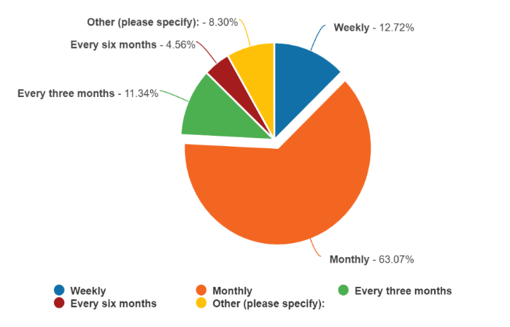
Figure 4. Frequency of use of the pharmacy

Q.5 What time is most convenient for you to use a pharmacy?

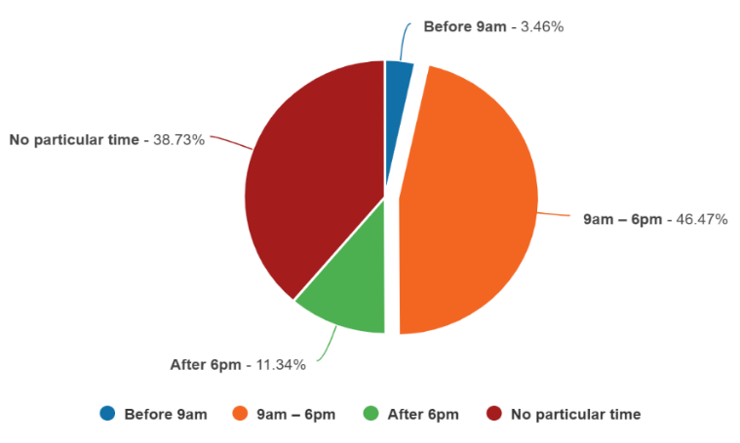
Answered: 723 Skipped: 0
Figure 5. Most convenient time to use pharmacy

Q.5 What day is the most convenient for you to use a pharmacy?

Answered: 723 Skipped: 0
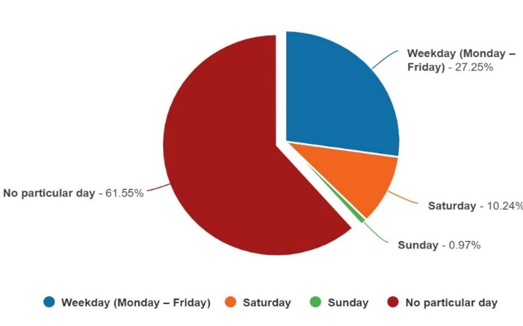
Figure 6. Most convenient day to use pharmacy
Half (50%) of respondents reported that they use the same pharmacy all the time against 47% that use different pharmacies but visit one most often. These results confirm the personal and trusted relationship between users and pharmacists highlighted in the questions described above.

Q.7 Do you use the same pharmacy or different pharmacies?

Answered: 723 Skipped: 0
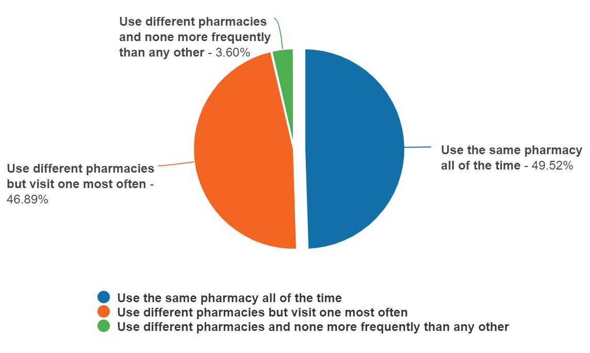
Figure 7. Preference in using the pharmacy

Of those replying to the survey, 83% have a reasonable distance to travel to the pharmacy equating to less than 20 minutes, 14% had travelled between 20 and 30 minutes, and 3% had travelled between 30-45 minutes. 61% made the trip by car, and 34% had travelled on foot—only 3% used public transport and 2% a bicycle.

When asked what influenced their choice to visit a pharmacy, 90% of responders reported convenient location, 39.42% the opening hours, and 7% medication reviews. However, when we asked participants to specify the main reasons that influence their choice, the majority reported the reliability and good service of the pharmacy, the quickness in dispensing medications, and friendly customer service.
‘Having confidence that the pharmacy will quickly dispense the medicine without problems and with minimal travelling'.
‘Efficiency and professionalism; accessibility - opening hours; not having to spend a long time queuing waiting to be served'.
'Professionalism and friendliness of staff'.
‘Reliable, meds always in stock. Not too busy, minimum wait times. Efficient, friendly, cosy, somewhere to sit if waiting'.
'The efficiency of online services to get prescriptions to me quickly without having to wait in a queue at a physical pharmacy'.
'Length of queues, ability to have ordered prescriptions ready rather than wait until you arrive then make them up, ability to give you the correct prescriptions'.
'The staff and my experience has kept me coming back to my regular, as well as the knowledge of my pharmacist who has helped me immensely and my family'.
'Good service without too much delay and where there is a reliable supply of goods'.
One participant noted the wait time outside a pharmacy (this is acknowledged in local and national services during the covid 19 pandemic)
‘The ability to be served without having to queue outside for long periods as happens at the moment’.
A few participants also choose the pharmacy because it has easy access and a car park.
'Ease of access/parking at pharmacy'.
'Availability of parking and efficient and friendly service'.
'Ease of access and parking'.
'Parking and less waiting times'.
Some participants noted an inconvenience relating to private non-NHS pharmacies.
‘Repeat dispensing services. Unfortunately our pharmacy is unable to dispense prescriptions over the counter which is most inconvenient, and this results in having to go to another pharmacy’
‘There are many people who would find it extremely convenient if the pharmacy was next to the surgery’.
To summarise, the results of this public engagement found that a relationship with a respectful, friendly, competent pharmacist represents important pharmacist-related attributes in the process of pharmacy selection.
Important pharmacy-related attributes include advice, services, location, and reduced waiting times. Availability of repeat prescription service was also a frequently reported attribute in this review.

A sample is self-selected when the inclusion or exclusion of sampling units (individuals, cases, or organisations) is determined by whether the units themselves agree or decline to participate in the research. The advantage of this sampling technique is that it can reduce the amount of time necessary to search for appropriate units; that is, those units that meet the selection criteria needed for your sample. The potential units are likely to be committed to taking part in the study, which can help in improving engagement and greater willingness to provide more insight into the subject being studied e.g., a self-selected respondent may be more willing to spend the time filling in questions in an online survey, whereas others may leave them blank).
An extending literature about survey response behaviour shows that women respond in greater proportions than men (Kwak & Radler, 2002; Sax et al, 2004; Underwood, Kim, & Mattiea, 2000).
Comments about particular pharmacies should be directed to NHS England as commissioners of pharmaceutical services

