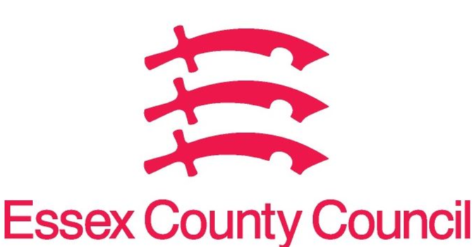
Essex Pharmaceutical Needs Assessment (PNA)
APRIL 2023- SUPPLEMENTARY STATEMENT TO PNA 2022
TENDRING LOCALITY
Notification date | Organisation code | Trading Name | Address line 1 | Town | Postcode | Change Type | Notes
February 2023 | FQK85 | Lloyds Pharmacy | 2 Jackson Road | Clacton-on-sea | CO15 1JA | 1 | G M Pharmacies Ltd
October 2023 |  | Allied Pharmacy | 2 Jackson Road | Clacton-on-sea | CO15 1JA | 1 | Sharief Healthcare 2 Ltd

CHANGE TYPE CODE KEY:
- CHANGE OF OWNERSHIP
- CHANGE OF CORE HOURS
- CHANGE OF SUPPLEMENTARY HOURS
- CONSOLIDATION
- NEW PHARMACY
- CLOSURE OF PHARMACY

No gaps in pharmaceutical services have been identified that if provided either now or in the future would secure improvements or better access to necessary pharmaceutical services across the locality

Issued on behalf of the Essex Health and Wellbeing Board
09/11/2023 | Boots, 158 Old Road, Clacton on Sea, CO15 3AY | FRL06 | Closure | 16.3.2024
North Road Pharmacy, 25 North Road, Clacton on Sea, CO15 4DD | FKJ91 | permanent change of core hours | 01/08/2023 | reduction in core hours (now 76 hours)
Holland Pharmacy, 77-79 Frinton Road, Holland on Sea, CO15 5UH | FAP95 | permanent change of core hours | 07/08/2023 | reduction in core hours (now 86 hours)

