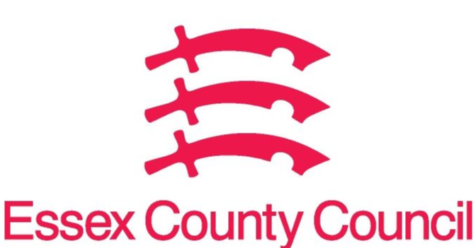
Essex Pharmaceutical Needs Assessment (PNA)
JUNE 2024 - SUPPLEMENTARY STATEMENT TO PNA 2022
BRENTWOOD LOCALITY
Notification date | Organisation code | Trading Name | Address line 1 | Town | Postcode | Change Type | Notes
January 2023 | FLQ00 | Lloyds Pharmacy | 51 William Hunter Way | Brentwood | CM14 4WQ | 6 | Closed 22nd March 2023
February 2023 | FCF02 | Well | 201 Rayleigh Road | Hutton | CM13 1LZ | 3 | Reduction to hours at lunchtimes
January 2024 | FKX21 | Rockleigh Court Chemist | 138 Hutton Road, Shenfield | Brentwood | CM15 8NL | 3 | Reduction to hours, now closed on Saturday mornings
April 2024 | FKX21 | Rockleigh Court Chemist | 138 Hutton Road, Shenfield | Brentwood | CM15 8NL | 3 | Increase to hours, open 6pm-6.30pm Monday to Fridays

CHANGE TYPE CODE KEY:
- CHANGE OF OWNERSHIP
- CHANGE OF CORE HOURS
- CHANGE OF SUPPLEMENTARY HOURS
- CONSOLIDATION
- NEW PHARMACY
- CLOSURE OF PHARMACY

No gaps in pharmaceutical services have been identified that if provided either now or in the future would secure improvements or better access to necessary pharmaceutical services across the locality

Issued on behalf of the Essex Health and Wellbeing Board

