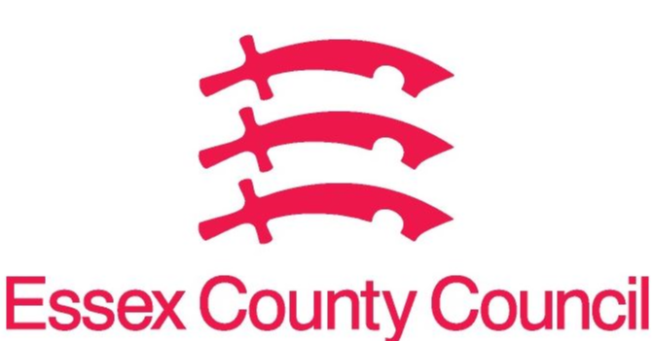
Essex Pharmaceutical Needs Assessment (PNA)
APRIL 2023- SUPPLEMENTARY STATEMENT TO PNA 2022
HARLOW LOCALITY
Notification date | Organisation code | Trading Name | Address line 1 | Town | Postcode | Change Type | Notes
March 2023 | FHF14 | Church Langley Pharmacy | Milton Lane, Church Langley | Harlow | CM17 9TG | 1 | Super Blessings Ltd
March 2023 | FKE56 | Potter Street Pharmacy | 12 Prentice Place | Harlow | CM17 9BG | 1 | Super Blessings Ltd
March 2023 | FE570 | Lloyds Pharmacy | Fifth Avenue | Harlow | CM20 2AG | 6 | Notification of closure from July 2023

CHANGE TYPE CODE KEY:
- CHANGE OF OWNERSHIP
- CHANGE OF CORE HOURS
- CHANGE OF SUPPLEMENTARY HOURS
- CONSOLIDATION
- NEW PHARMACY
- CLOSURE OF PHARMACY

No gaps in pharmaceutical services have been identified that if provided either now or in the future would secure improvements or better access to necessary pharmaceutical services across the locality

Issued on behalf of the Essex Health and Wellbeing Board

