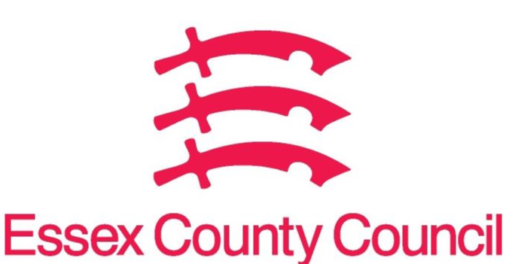
Essex Pharmaceutical Needs Assessment (PNA)
APRIL 2024- SUPPLEMENTARY STATEMENT TO PNA 2022
HARLOW LOCALITY
Notification date | Organisation code | Trading Name | Address line 1 | Town | Postcode | Change Type | Notes
March 2023 | FHF14 | Church Langley Pharmacy | Milton Lane, Church Langley | Harlow | CM17 9TG | 1 | Super Blessings One Ltd
March 2023 | FKE56 | Potter Street Pharmacy | 12 Prentice Place | Harlow | CM17 9BG | 1 | Super Blessings Ltd
March 2023 | FE570 | Lloyds Pharmacy | Fifth Avenue | Harlow | CM20 2AG | 6 | Notification of closure from July 2023
June 2023 | FLH17 | Asda | Water Gardens, Southgate | Harlow | CM20 1AN | 2 | Reduction in hours from 10 July 2023. Now open 9am-12.30pm, 1pm-4.30pm, 5pm-9pm Monday to Saturday, 11am-5pm Sunday
June 2023 | FD523 | Harlow pharmacy | Unit 2 Wych Elm, Hamstel Road | Harlow | CM20 1QR | 2 | Reduction in hours from 7th July 2023. Now open 9am-9pm Monday to Friday, 11am-9pm Saturday, 8am-10pm Sunday
August 2023 | FM358 | Tesco | Church Langley Way | Harlow | CM17 9TE | 3 | Reduction in hours from 29th August 2023. Now open 9am- 9pm Monday to Saturday, 10am-4pm Sunday
August 2023 | FD523 | Harlow pharmacy | Unit 2 Wych Elm, Hamstel Road | Harlow | CM20 1QR | 6 | Notification of closure from February 2024
November 2023 | FCX16 | Boots | 5 Bush Fair | Harlow | CM18 6NS | 6 | Notification of closure from March 2024
March 2024 | FCX16 | Boots | 5 Bush House, Bush Fair | Harlow | CM18 6NS | 6 | Closed on 16th March 2024

CHANGE TYPE CODE KEY:
- CHANGE OF OWNERSHIP
- CHANGE OF CORE HOURS
- CHANGE OF SUPPLEMENTARY HOURS
- CONSOLIDATION
- NEW PHARMACY
- CLOSURE OF PHARMACY

No gaps in pharmaceutical services have been identified that if provided either now or in the future would secure improvements or better access to necessary pharmaceutical services across the locality

Issued on behalf of the Essex Health and Wellbeing Board

