Relationships, Sex and Health Education Survey 2025 – Responses for Maldon
Background
The purpose of this survey, led by Essex Public Health and Essex Youth Service on behalf of the Teenage Pregnancy Prevention group, is to gather the views of young people on a range of topics relating to relationships and sexual health, understanding what further information and support they would like and their preferred ways in which to access it.
This survey follows on from two previous Relationships and Sex Education (RSE) surveys. The first in 2021 which gathered the views of 16–25yr olds, and the second in 2022 which gathered the views of 11–25yr olds.
This insight will be used to ensure continuous improvement to the young people’s element of the Essex Sexual Health Service including online support, clinical services, education for young people and training for educational settings and wider professionals / non-professionals working with young people.
In addition, responses relating to the online activity questions will be shared with Harm in the Community a subgroup of Essex Safeguarding Children Board and inform their wider efforts in keeping Essex children and young people safe.
It is hoped that as with the 2022 survey, Essex Educational settings will use the findings to inform their RSHE curriculum planning and staff training.
876 responses were received for Maldon
Gender:
- 47% Male
- 50% Female
- 1% Non-binary
- 1% Prefer not to say
- 1% Prefer to self-describe
Age:
- 74% School Years 7,8,9
- 20% School Year 10 or 11
- 6% Post 16 Education of Provision (16-25yrs)

[Please note some questions were ‘select all that apply’ so percentages do not always add up to 100%. This may also be the case where percentages have been rounded.]

Year 7-9 [651 responses]
Where do you currently look for information on the following topics? Please tick all that apply.
Topics | Top 3 places they’re most likely to look for information
Image sharing | - School (31%)  - Family (28%)  - Friends (22%)  - 45% haven’t looked
Healthy and respectful relationships | - Family (48%)  - School (42%)  - Friends (35%)  - 26% haven’t looked
Consent and the law | - School (46%)  - Family (32%)  - Online/social media (15%)  - 35% haven’t looked
Staying safe online | - School (68%)  - Family (50%)  - Friends (19%)  - 15% haven’t looked
Puberty | - Family (50%)  - School (49%)  - Friends (13%)  - 26% haven’t looked
Periods | - Family (41%)  - School (39%)  - Friends (14%)  - 36% haven’t looked
Gender identity | - School (33%)  - Family (23%)  - Friends (11%)  - 51% haven’t looked
Sexuality | - School (33%)  - Family (24%)  - Friends (11%)  - 50% haven’t looked

In addition to the RSHE taught at school, which topics would you like to know more about? Please tick all that apply.
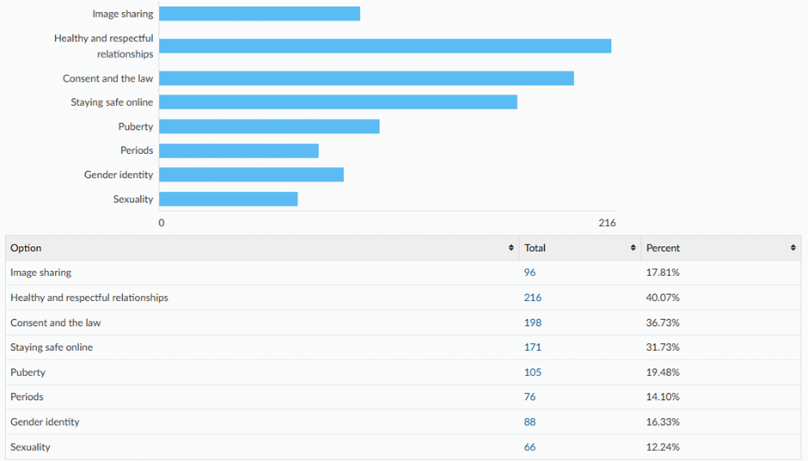
Do you feel the RSHE You have been taught at school has been inclusive of all sexualities and gender identities?
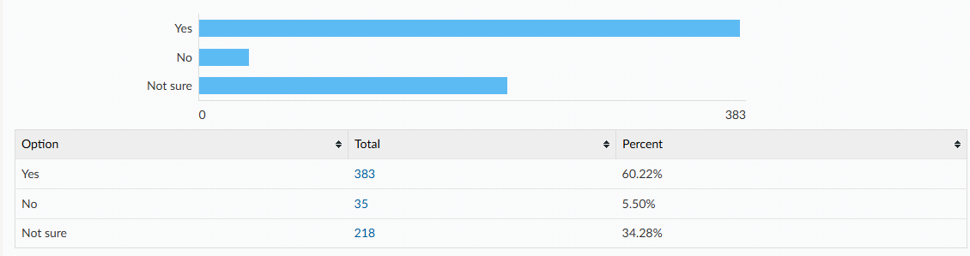
Links to following sexual health information and services can all be found on the Essex Youth Service website or the asking for a friend website. Which of the following are you already aware of? Please tick all that apply.
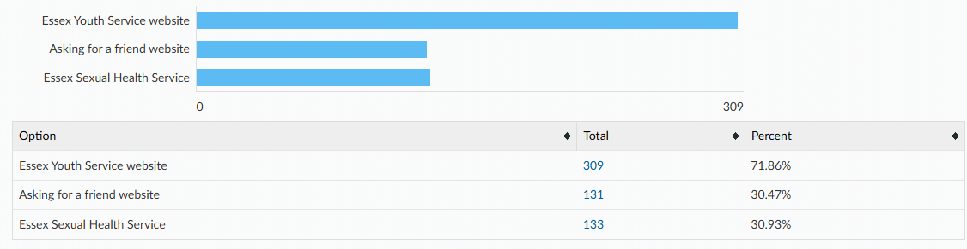

Do you experience periods?
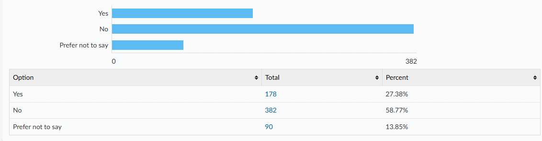

During your ‘average’ period do you experience any of the following?
- Heavy bleeding (e.g., needing to change pad or tampon every 1-2 hours)
- Bleeding which lasts more than 7 days
- Period pain which impacts your ability to participate in day-to-day activities (e.g., missing school or sports)
- An irregular cycle (e.g., period arriving early or late)

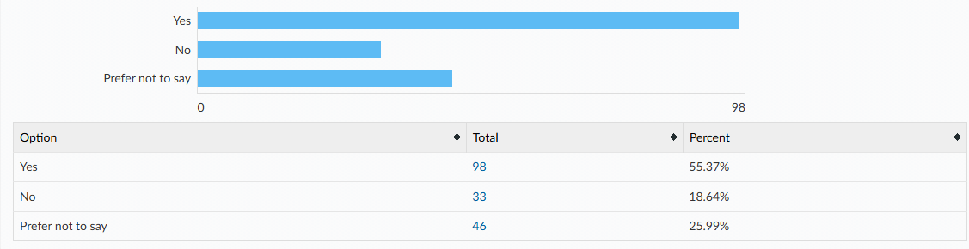

Please tick all that you experience:
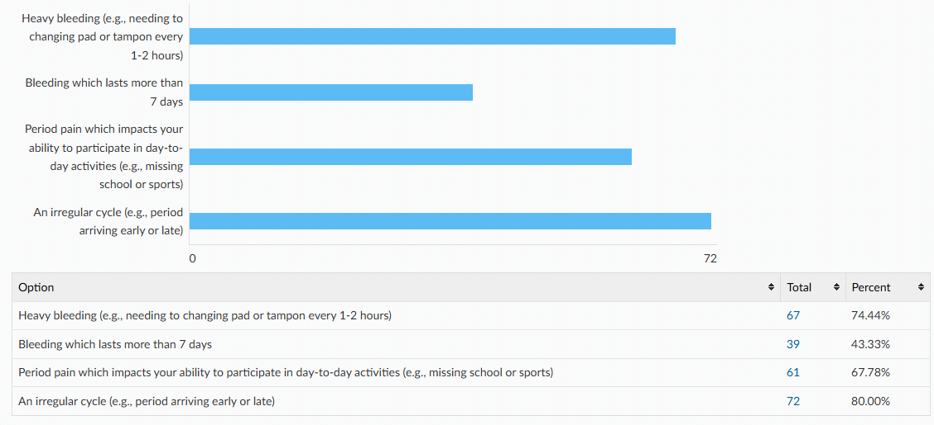
Did you seek support with these issues?
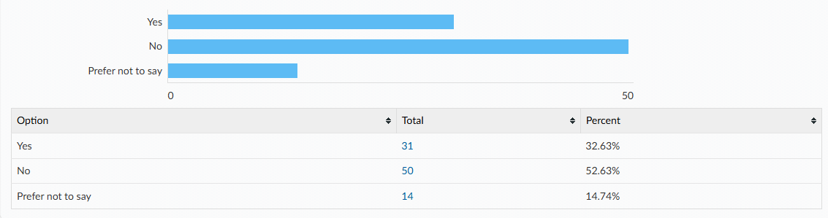
Who did you seek support from? Please tick all that apply.
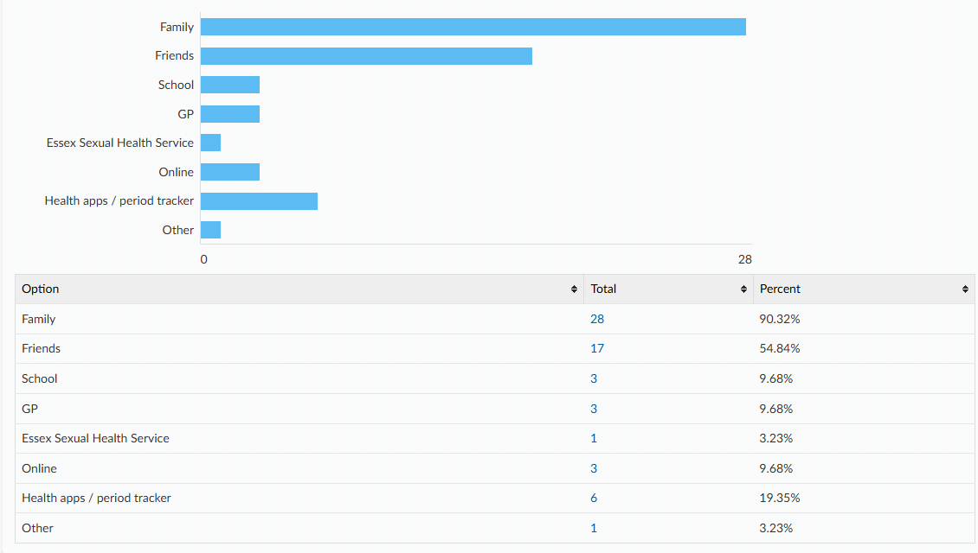
What were your reasons for not seeking support? Please tick all that apply.
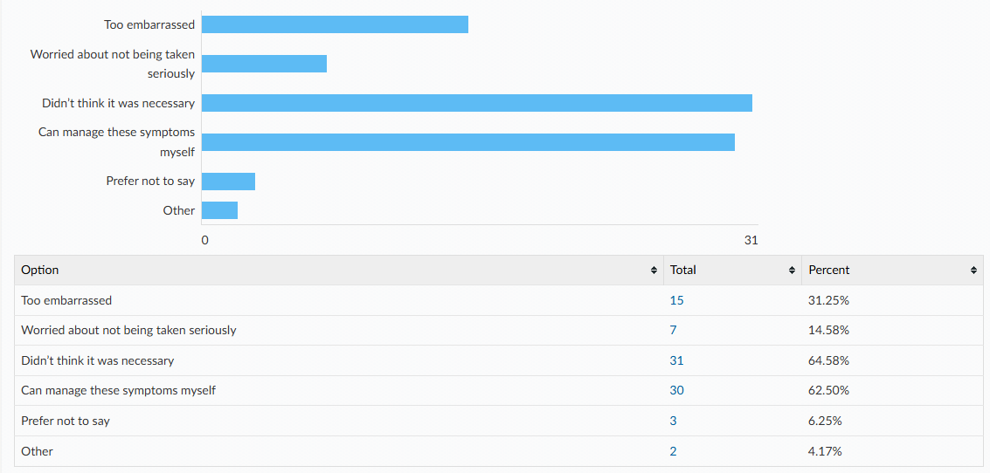
Do you use any of the following? Please tick all that apply.
 | Yes | No | Not sure
A mobile phone with access to the internet | 99% | 1% | <1%
Snapchat | 70% | 30% | <1%
Instagram | 41% | 57% | 2%
TikTok | 66% | 33% | <1%
WhatsApp | 96% | 4% | 0%
BeReal | 10% | 87% | 2%
Online gaming | 81% | 16% | 3%
Twitch | 17% | 81% | 2%
Discord | 17% | 81% | 2%
RoBlox | 71% | 27% | 2%

Have you ever been made to feel uncomfortable online? e.g. received a private image, been asked to send a private image or joined an online private chat.
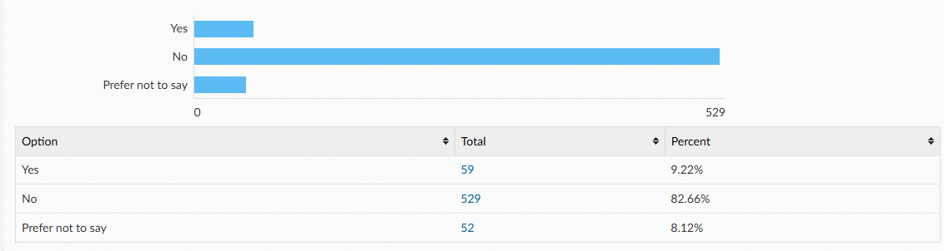

Did you tell/ seek support from anyone? Please tick all that apply.
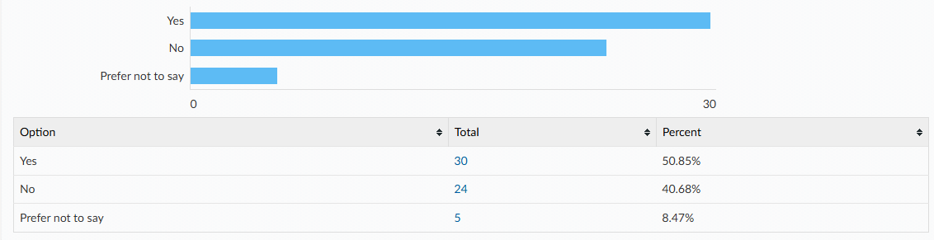

Who did you tell/ seek support from? Please tick all that apply.
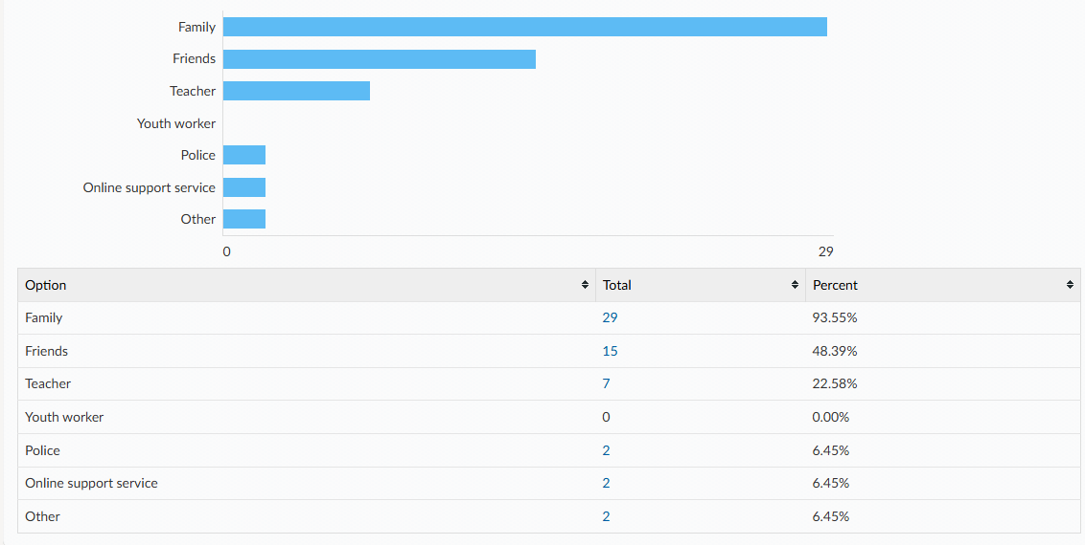

What were your reasons for not telling/ seeking support from anyone? Please tick all that apply
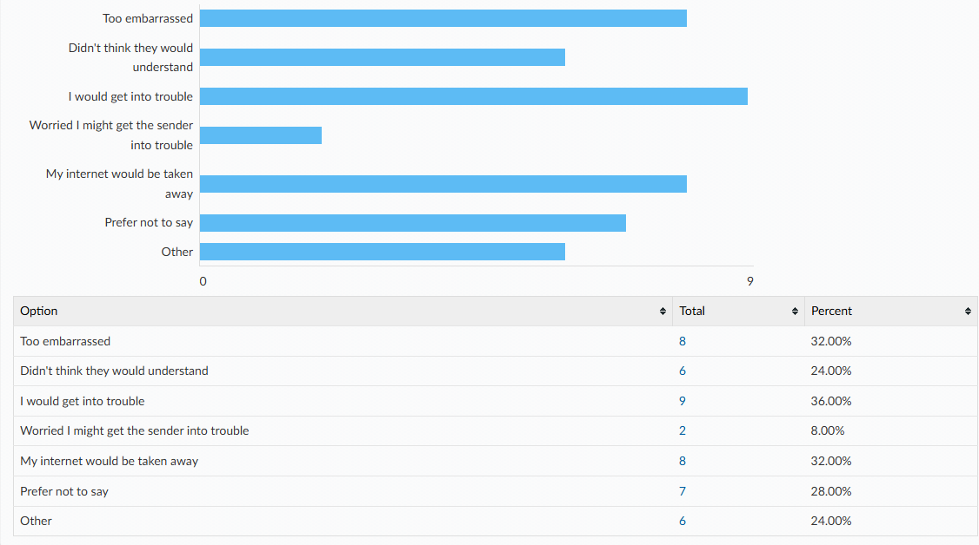

It is against the law to send, save or share nudes or sexual videos of anyone aged under 18. Were you aware of this?
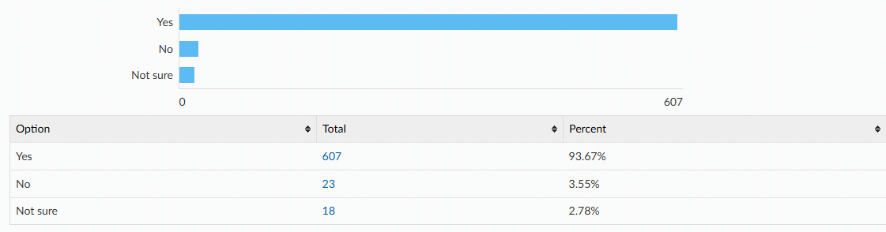

Year 10-11 [175 responses]
Where do you currently look for information on the following topics? Please tick all that apply.
Topics | Top 3 places they’re most likely to look for information
Image sharing | - Online/social media (20%)  - School (18%)  - Family (11%)  - 57% haven’t looked
Healthy and respectful relationships | - Family (36%)  - Friends (29%)  - School (20%)  - 38% haven’t looked
Sex | - School (23%)  - Family (18%)  - Friends (10%)  - 61% haven’t looked
Consent and the law | - School (32%)  - Family (19%)  - Online/social media (15%)  - 46% haven’t looked
Public sexual harassment | - School (28%)  - Online/social media (13%)  - Family (12%)  - 57% haven’t looked
Staying safe online | - School (49%)  - Family (24%)  - Online/social media (12%)  - 33% haven’t looked
Pornography | - School (15%)  - Online/social media (9%)  - Family (4%)  - 74% haven’t looked
Masturbation | - Online/social media (9%)  - School (8%)  - Family (5%)  - 77% haven’t looked
Puberty | - School (45%)  - Family (31%)  - Friends (11%)  - 35% haven’t looked
Menstruation | - School (33%)  - Family (24%)  - Friends (10%)  - 51% haven’t looked
Gender identity | - School (25%)  - Family (8%)  - Online/social media (7%)  - 67% haven’t looked
Sexuality | - School (31%)  - Family (9%)  - Friends (9%)  - 58% haven’t looked
Sexually transmitted infections (STI’s) and HIV | - School (43%)  - Family (8%)  - Online/social media (6%)  - 52% haven’t looked
HIV prevention (PEP or PrEP) | - School (40%)  - Family (8%)  - Online/social media (6%)  - 54% haven’t looked
Methods of contraception | - School (49%)  - Family (14%)  - Friends (6%)  - 44% haven’t looked
How to access contraception | - School (30%)  - Family (12%)  - Online/social media (6%)  - 61% haven’t looked
Steps to take after unprotected sex | - School (19%)  - Family (8%)  - Online/social media (6%)  - 71% haven’t looked
Choices around pregnancy | - School (23%)  - Family (14%)  - Online/social media (8%)  - 64% haven’t looked

In addition to the RSHE taught at school, which topics would you like to know more about? Please tick all that apply.
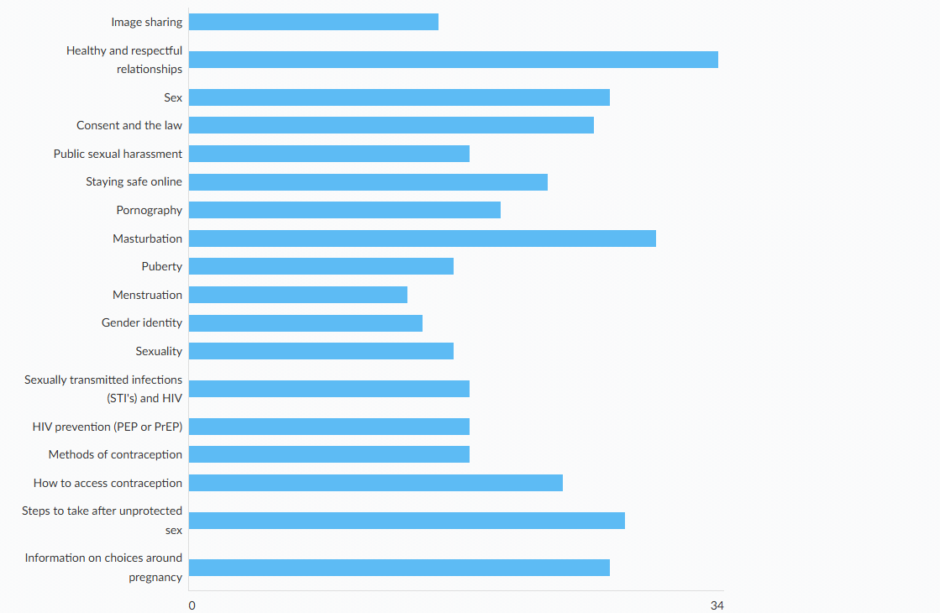
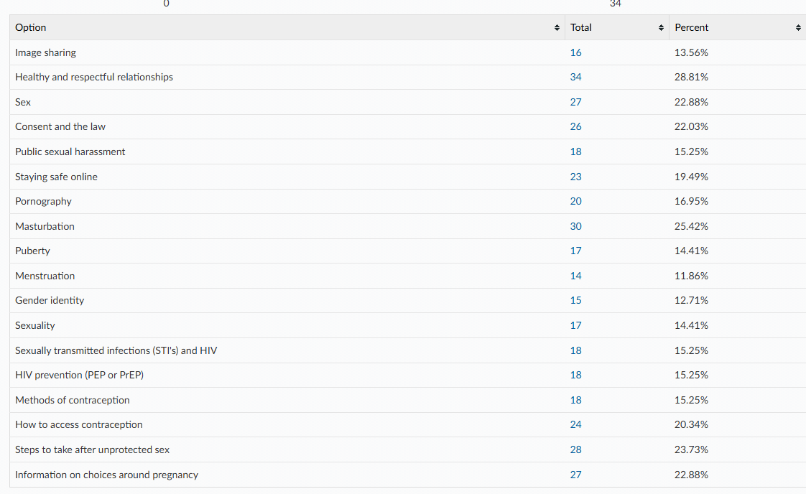

Do you feel the RSHE you have been taught at school has been inclusive of all sexualities and gender identities?
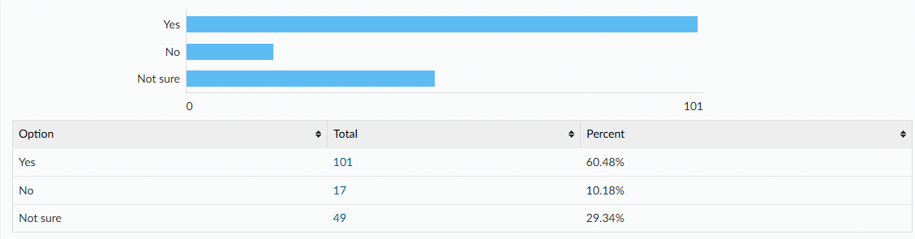

Links to the following sexual health information and services can all be found on Essex Youth Service website or the asking for a friend website. Which of the following are you already aware of? Please tick all that apply.
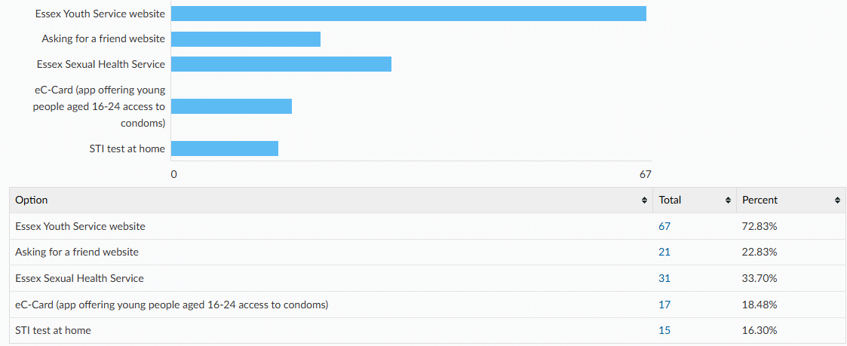

Condoms are the best way to prevent against sexually transmitted infections. There are a wide variety of other contraceptive methods designed to prevent pregnancy, some of which are listed below. All young people have the right to information and support to allow informed choices on these methods. Please tick if you know how to access the following.
[Only female and non-binary responses have been included in the table as most contraceptive methods listed are only likely to be accessed directly by those who’s biological sex is female with the exception of condoms.]
Method
Condoms | - 42% know how to access this  - 12% don’t know how to access this  - 1% have had difficulty accessing this  - Not applicable (45%)
Internal condoms | - 25% know how to access this  - 30% don’t know how to access this  - 0% have had difficulty accessing this  - Not applicable (45%)
Contraceptive pill | - 60% know how to access this  - 13% don’t know how to access this  - 1% have had difficulty accessing this  - Not applicable (26%)
Hormonal contraceptive implant | - 36% know how to access this  - 30% don’t know how to access this  - 0% have had difficulty accessing this  - Not applicable (34%)
Hormonal contraceptive injection | - 39% know how to access this  - 27% don’t know how to access this  - 0% have had difficulty accessing this  - Not applicable (34%)
Coil or intrauterine device (IUD) | - 34% know how to access this  - 30% don’t know how to access this  - 0% have had difficulty accessing this  - Not applicable (36%)
Intrauterine system (IUS) | - 25% know how to access this  - 39% don’t know how to access this  - 1% have had difficulty accessing this  - Not applicable (34%)

Please tell us where you would feel most comfortable going to access your chosen method of contraception? Please tick all that apply.
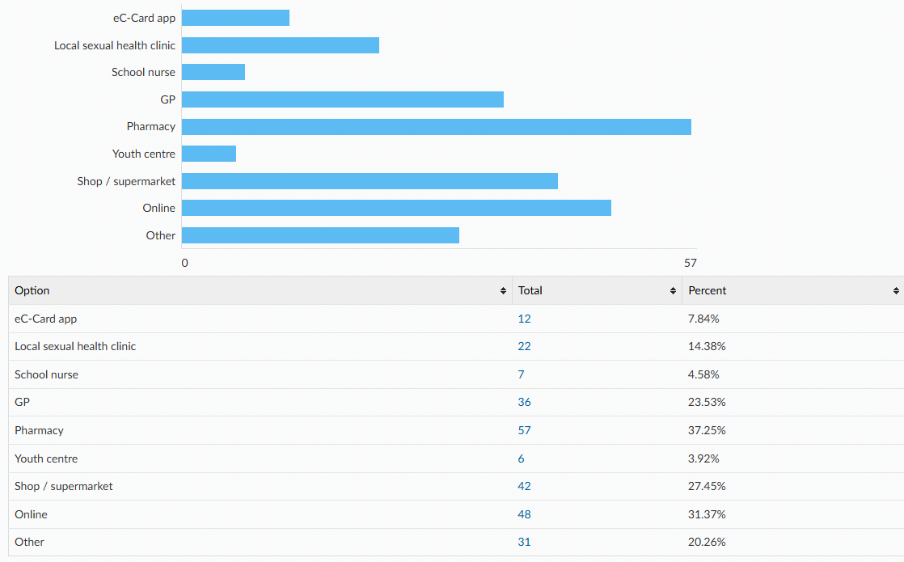

How confident do you feel that you would know how to access emergency contraception after unprotected sex (e.g. the ‘morning after pill’) for yourself or a partner?
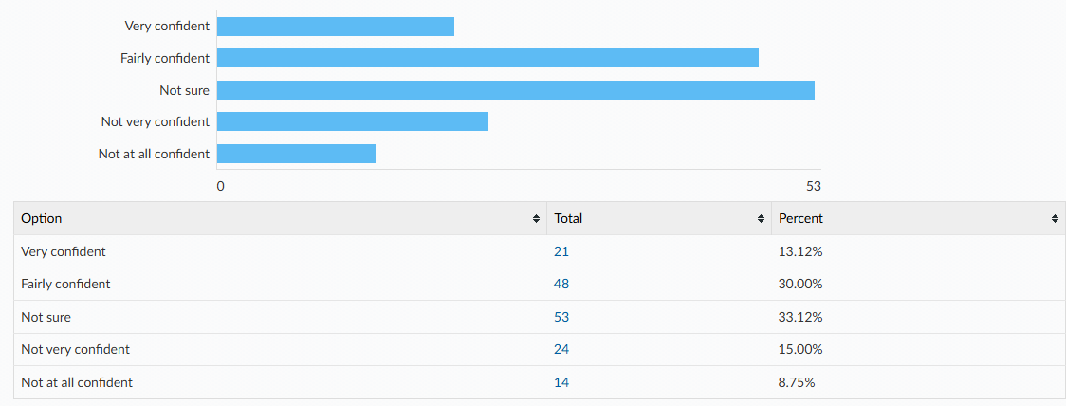

Do you experience periods?
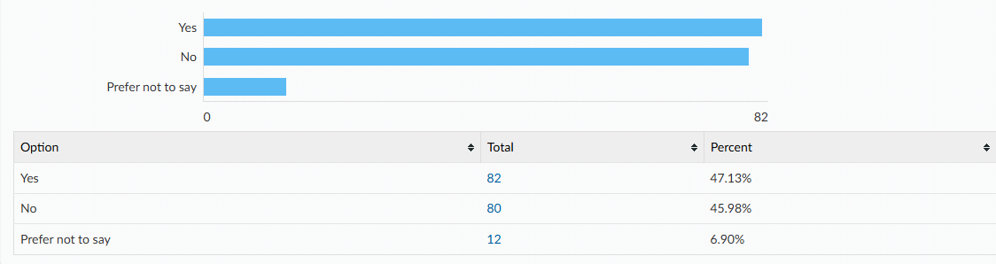

During your average period do you experience any of the following?
- Heavy bleeding (e.g., needing to change pad or tampon every 1-2 hours)
- Bleeding which lasts more than 7 days
- Period pain which impacts your ability to participate in day-to-day activities (e.g., missing school or sports)
- An irregular cycle (e.g., period arriving early or late)

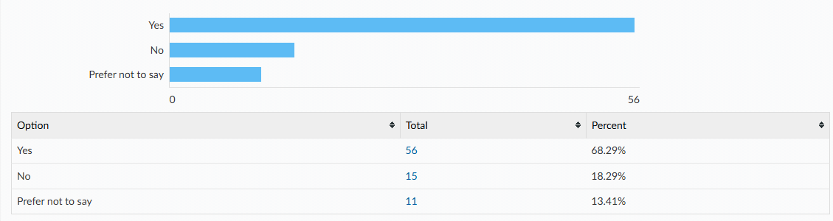

Please tick all you experience:
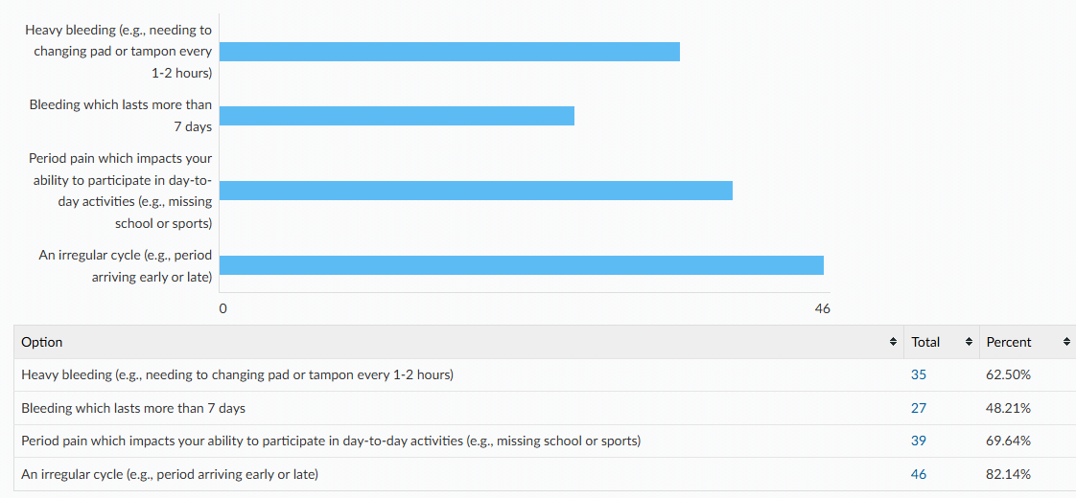
Did you seek support with these issues?
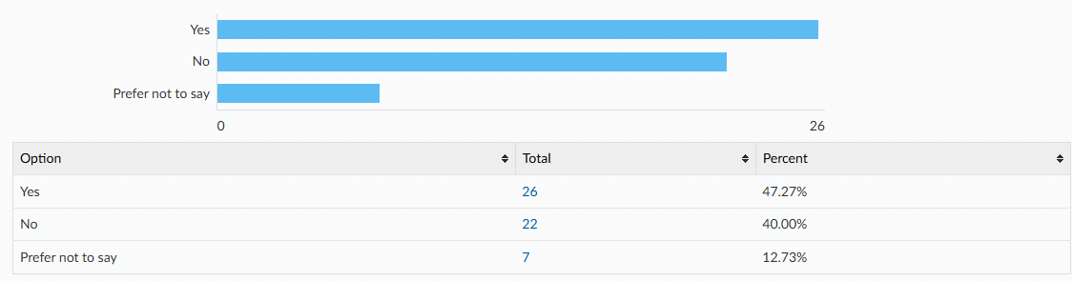
Who did you seek support from? Please tick all that apply.
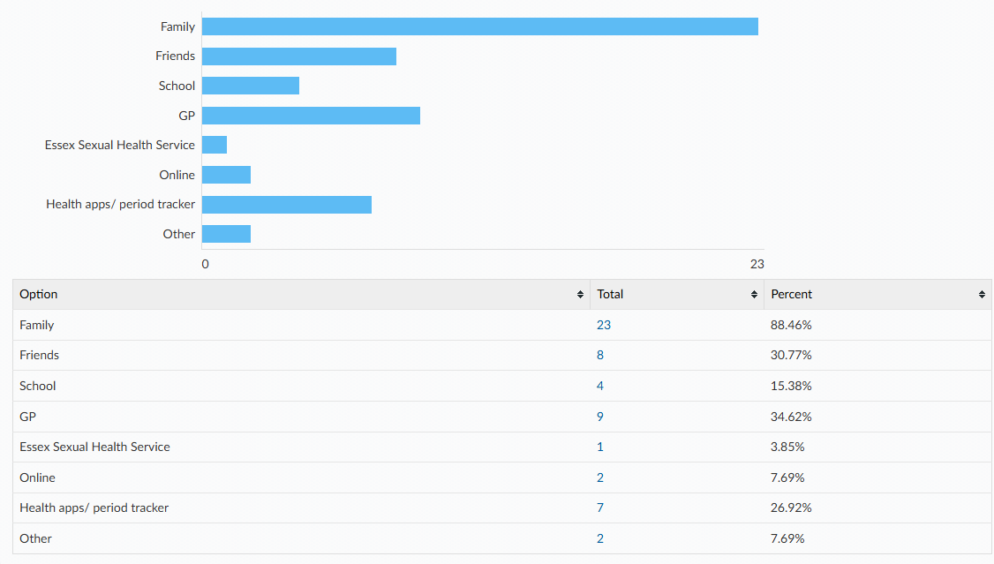
What were your reasons for not seeking support? Please tick all that apply.
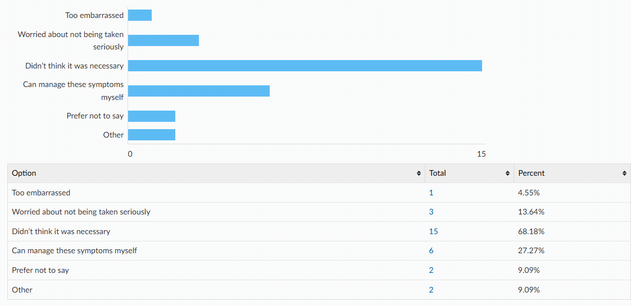
Do you use any of the following? Please tick all that apply.
 | Yes | No | Not sure
A mobile phone with access to the internet | 98% | 1% | 2%
Snapchat | 85% | 13% | 2%
Instagram | 73% | 25% | 2%
TikTok | 85% | 13% | 2%
WhatsApp | 97% | 1% | 2%
BeReal | 11% | 87% | 2%
Online gaming | 77% | 19% | 4%
Twitch | 27% | 71% | 2%
Discord | 32% | 66% | 2%
RoBlox | 63% | 35% | 3%

Have you ever been made to feel uncomfortable online? E.g. received a private image, been asked to send a private image or joined an online private chat.
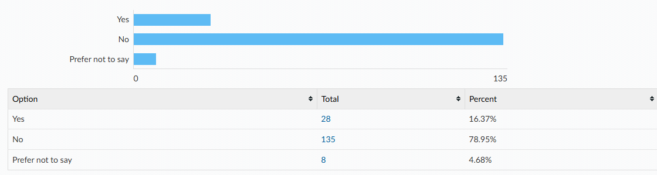

Did you tell/ seek support from anyone?
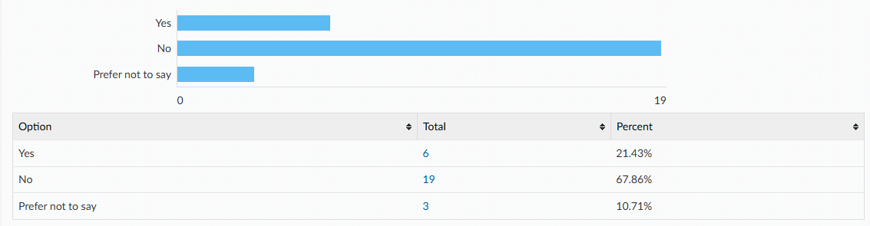

Who did you tell/ seek support from? Please tick all that apply.
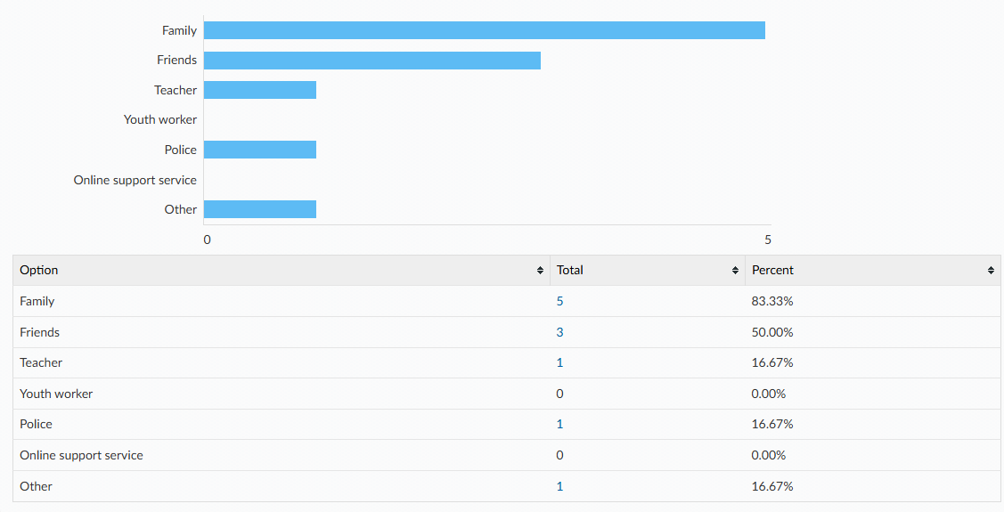

What were your reasons for not telling/ seeking support from anyone? Please tick all that apply.
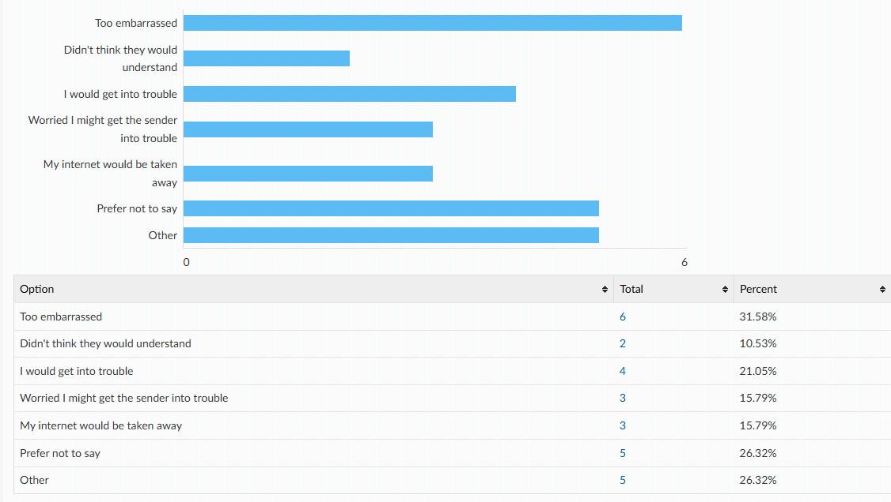

It is against the law to send, save or share nudes or sexual videos or anyone ages under 18. Were you aware of this?
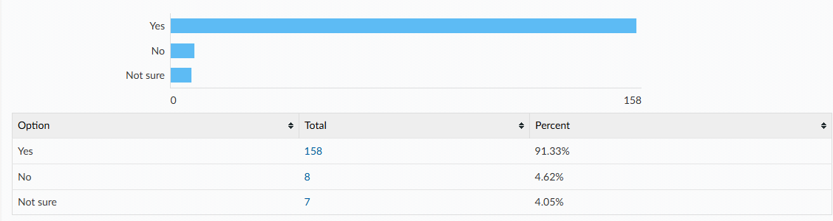

Have you or a friend ever experienced any of these behaviours in a relationship?
- Gaslighting: being made to doubt yourself and your own judgement. This may include telling you things have happened which didn’t or disagreeing with your version of events.
- Coercive Control: being manipulated into doing what another person wants. It can involve controlling who you see and where you go, telling you they will spread rumours, private information or nude photographs, getting you to lie or keep secrets and making you feel like you can't trust your family or friends.
- Love Bombing: giving you excessive affection and attention early on in the relationship in attempt to 'hook' you in and later emotionally manipulate you.
- Ghosting: suddenly ending a relationship without explanation by withdrawing all contact.
- Being told what you can and can't wear
- Being criticised, put down or humiliated
- Feeling pressured to do things you aren't comfortable with
- Having your social media accounts controlled or heavily monitored

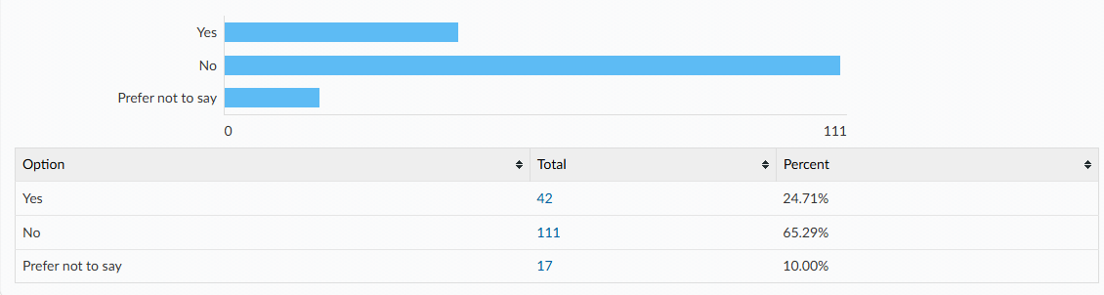

Did you or your friend tell/ seek support from anyone?
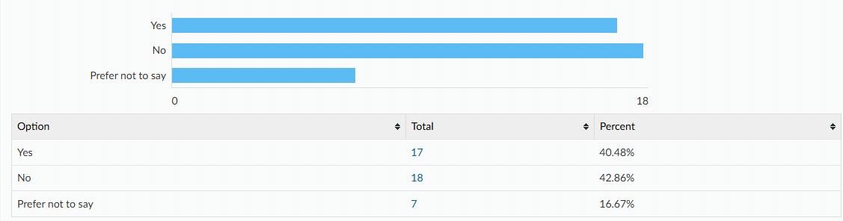
Who did you or your friend tell/ seek support from? Please tick all that apply.
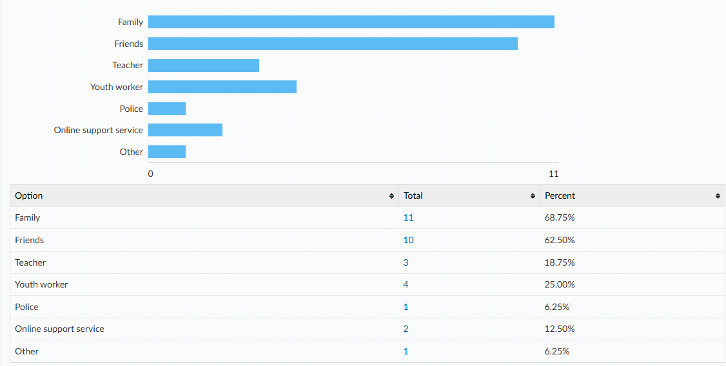

Why did you or your friend not tell/ seek support from anyone? Please tick all that apply.
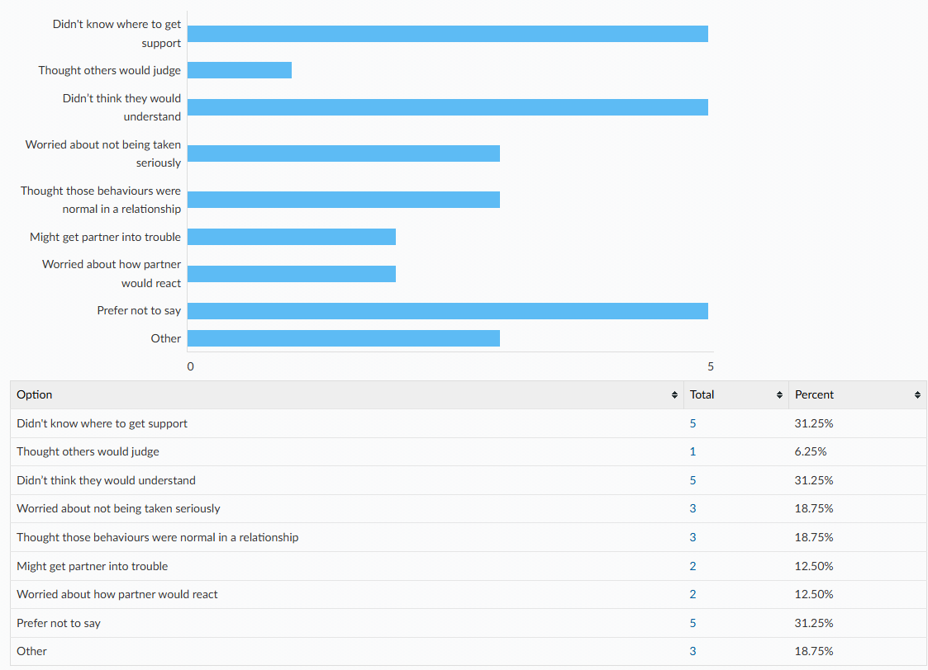

When do you think would be the most suitable age to learn about the following topics in school? (Optional Q)
Topic | Year 7 | Year 8 | Year 9 | Year 10 | Year 11 | College/ sixth form
Image sharing | 44% | 23% | 27% | 4% | 1% | 0%
Healthy and respectful relationships | 46% | 25% | 21% | 7% | 1% | 0%
Sex | 24% | 20% | 28% | 14% | 12% | 1%
Consent and the law | 47% | 21% | 18% | 10% | 5% | 0%
Public sexual harassment | 47% | 18% | 24% | 7% | 3% | 1%
Staying safe online | 93% | 3% | 3% | 1% | 0% | 0%
Pornography | 27% | 20% | 28% | 16% | 7% | 1%
Masturbation | 22% | 15% | 30% | 23% | 9% | 1%
Puberty | 74% | 15% | 7% | 3% | 1% | 0%
Menstruation | 68% | 15% | 14% | 1% | 1% | 1%
Gender identity | 58% | 21% | 13% | 1% | 1% | 6%
Sexuality | 58% | 21% | 8% | 4% | 3% | 6%
Sexually transmitted infections (STI’s) and HIV | 26% | 24% | 25% | 15% | 11% | 0%
HIV prevention (PEP or PrEP) | 30% | 20% | 24% | 14% | 9% | 3%
Methods of contraception | 26% | 21% | 29% | 16% | 7% | 1%
How to access contraception | 26% | 15% | 23% | 23% | 14% | 0%
Steps to take after unprotected sex | 20% | 9% | 30% | 28% | 12% | 0%
Information on choices around pregnancy | 20% | 7% | 28% | 28% | 15% | 1%

16-25yrs [50 responses]
Where do you currently look for information on the following topics? Please tick all that apply.
Topics | Top 3 places they’re most likely to look for information
Image sharing | - Educational setting (22%)  - Online/social media (18%)  - Friends (16%)  - 59% haven’t looked
Revenge Porn | - Educational setting (27%)  - Online/social media (4%)  - Friends (4%)  - Family (4%)  - 67% haven’t looked
Healthy and respectful relationships | - Friends (45%)  - Family (41%)  - Educational setting (37%)  - 16% haven’t looked
Sex | - Educational setting (33%)  - Friends (29%)  - Online/social media (29%)  - 35% haven’t looked
Consent and the law | - Educational setting (47%)  - Online/social media (31%)  - Family (20%)  - 24% haven’t looked
Public sexual harassment | - Educational setting (41%)  - Online/social media (22%)  - Friends (14%)  - 37% haven’t looked
Staying safe online e.g. dating | - Educational setting (47%)  - Family (24%)  - Online/social media (16%)  - 35% haven’t looked
Pornography | - Online/social media (24%)  - Educational setting (16%)  - Friends (6%)  - 63% haven’t looked
Masturbation | - Online/social media (29%)  - Educational setting (10%)  - Friends (8%)  - 59% haven’t looked
Puberty | - Educational setting (45%)  - Family (35%)  - Friends (22%)  - Online/ social media (22%)  - 29% haven’t looked
Menstruation | - Educational setting (39%)  - Family (31%)  - Friends (18%)  - 29% haven’t looked
Gender identity | - Online/ social media (31%)  - Educational setting (27%)  - Friends (14%)  - 41% haven’t looked
Sexuality | - Educational setting (35%)  - Online/social media (31%)  - Friends (22%)  - 37% haven’t looked
Sexually transmitted infections (STI’s) and HIV | - Educational setting (69%)  - Online/social media (15%)  - Family (8%)  - 17% haven’t looked
HIV prevention (PEP or PrEP) | - Educational setting (57%)  - Online/social media (16%)  - Family (8%)  - 31% haven’t looked
Methods of contraception | - Educational setting (59%)  - Online/social media (29%)  - Family (22%)  - 14% haven’t looked
How to access contraception | - Educational setting (43%)  - Family (22%)  - Online/social media (18%)  - 24% haven’t looked
Steps to take after unprotected sex | - Educational setting (31%)  - Family (12%)  - Online/social media (12%)  - 49% haven’t looked
Choices around pregnancy | - Educational setting (37%)  - Family (22%)  - Online/social media (18%)  - 47% haven’t looked

In addition to the RSHE you have received, which topics would you like to know more about? Please tick all that apply.
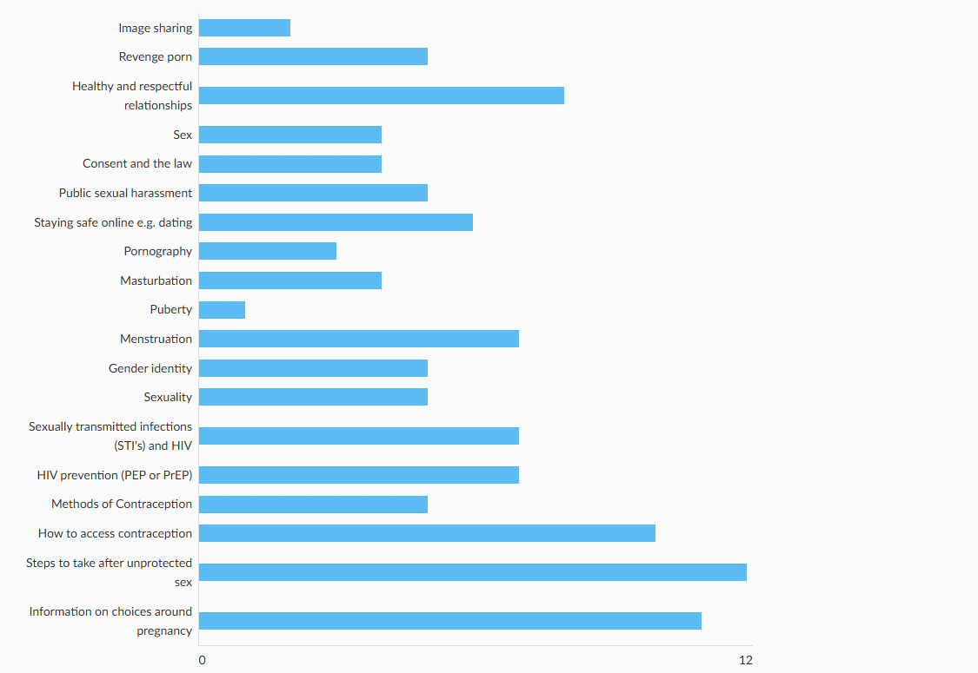
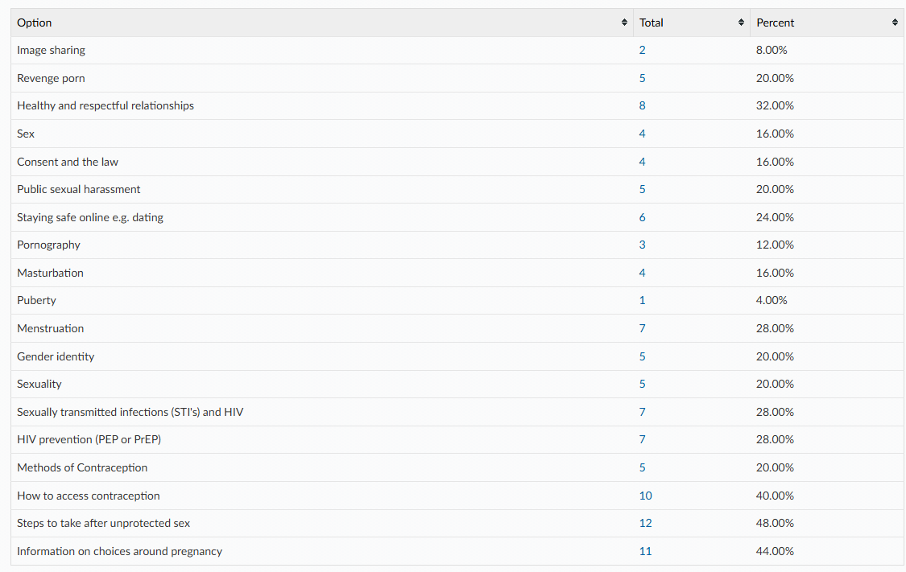

Do you feel the RSHE you have been taught at school has been inclusive of all sexualities and gender identities?
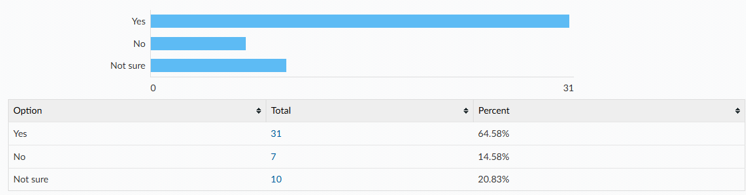

Links to the following sexual health information and services can all be found of the Essex Youth Service website or the asking for a friend website. Which of the following are you already aware of? Please tick all that apply.
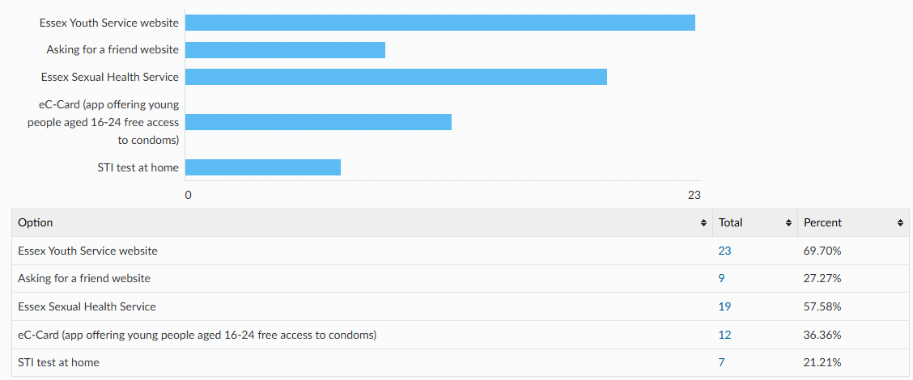

Condoms are the best way to prevent against sexually transmitted infections. There are a wide variety of other contraceptive methods designed to prevent pregnancy, some of which are listed below. All young people have the right to information and support to allow informed choices on these methods. Please tick if you know how to access the following.
[Only female and non-binary responses have been included in the table as most contraceptive methods listed are only likely to be accessed directly by those who’s biological sex is female with the exception of condoms.]
Method
Condoms | - 84% know how to access this  - 6% don’t know how to access this  - 0% have had difficulty accessing this  - Not applicable (10%)
Internal condoms | - 32% know how to access this  - 55% don’t know how to access this  - 0% have had difficulty accessing this  - Not applicable (13%)
Contraceptive pill | - 77% know how to access this  - 13% don’t know how to access this  - 0% have had difficulty accessing this  - Not applicable (10%)
Hormonal contraceptive implant | - 77% know how to access this  - 13% don’t know how to access this  - 0% have had difficulty accessing this  - Not applicable (10%)
Hormonal contraceptive injection | - 81% know how to access this  - 6% don’t know how to access this  - 0% have had difficulty accessing this  - Not applicable (13%)
Coil or intrauterine device (IUD) | - 81% know how to access this  - 10% don’t know how to access this  - 0% have had difficulty accessing this  - Not applicable (10%)
Intrauterine system (IUS) | - 52% know how to access this  - 29% don’t know how to access this  - 3% have had difficulty accessing this  - Not applicable (16%)

Please tell us where you would feel most comfortable going to access your chosen method of contraception? Please tick all that apply.
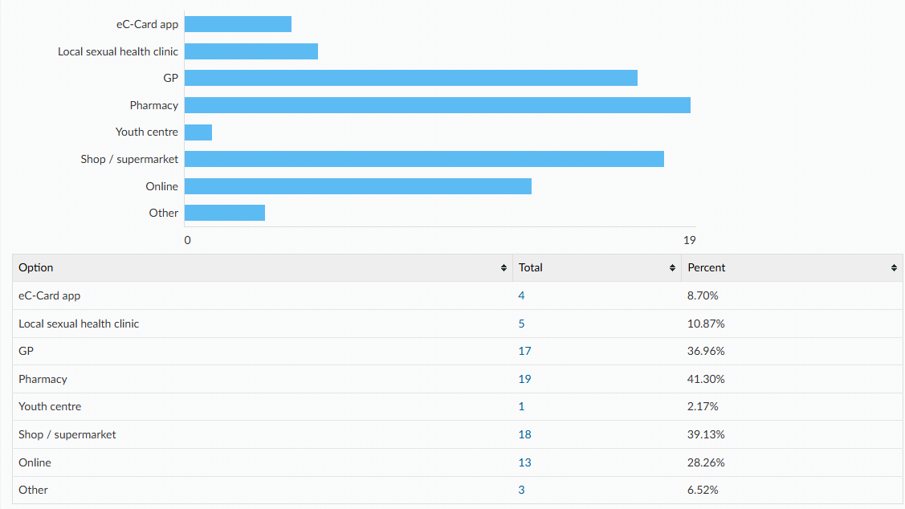

How confident do you feel that you would know how to access emergency contraception after unprotected sex (e.g. the ‘morning after pill’) for yourself or a partner?
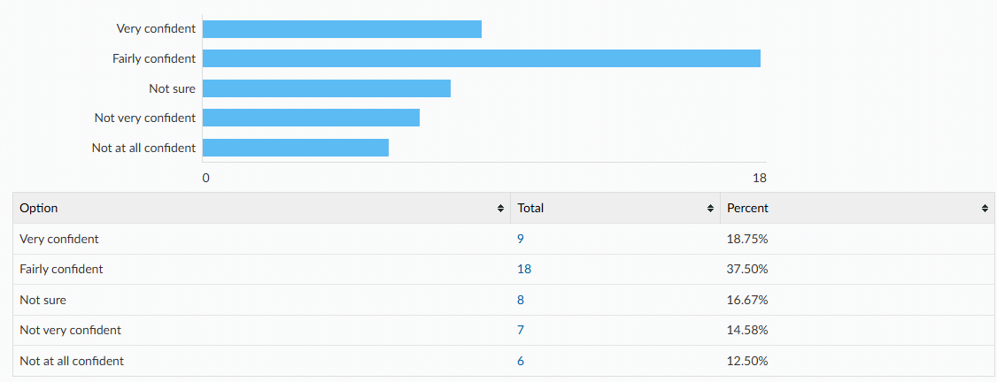

If you have previously accessed emergency contraception, how easy did you find this?
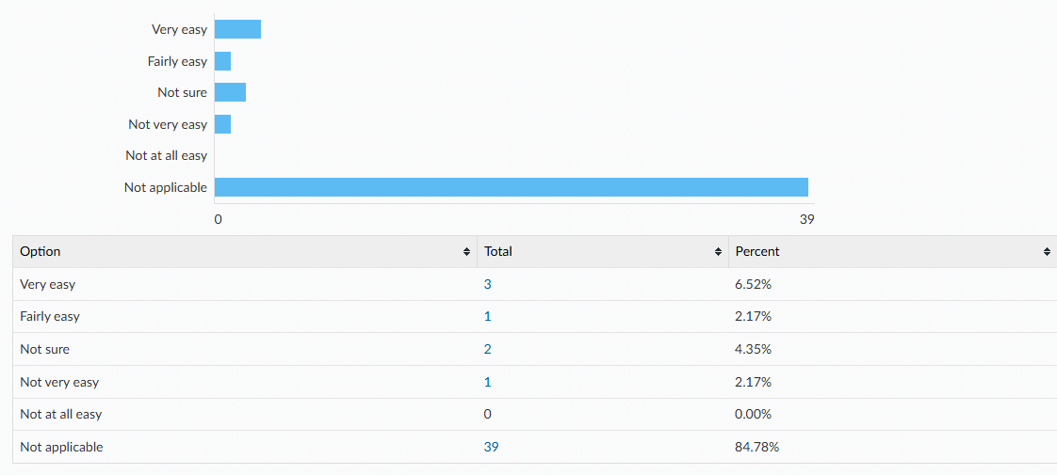

Where would you feel most comfortable accessing STI tests and advice?
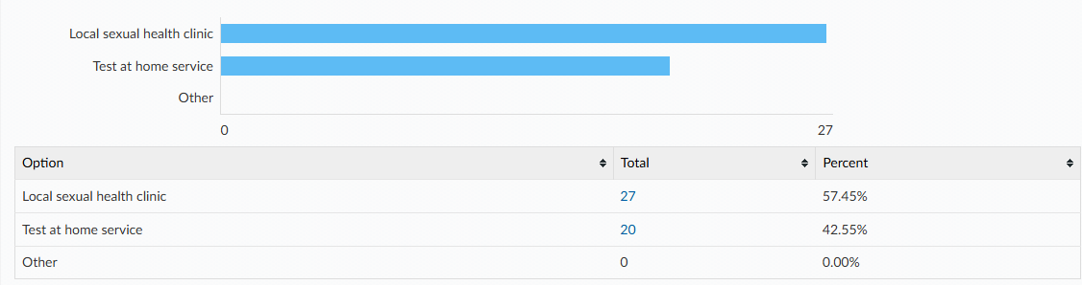

Do you experience periods?
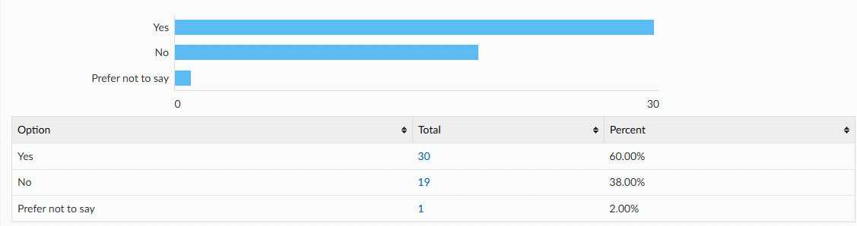

During your average period do you experience any of the following?
- Heavy bleeding (e.g., needing to change pad or tampon every 1-2 hours)
- Bleeding which lasts more than 7 days
- Period pain which impacts your ability to participate in day-to-day activities (e.g., missing school or sports)
- An irregular cycle (e.g., period arriving early or late)

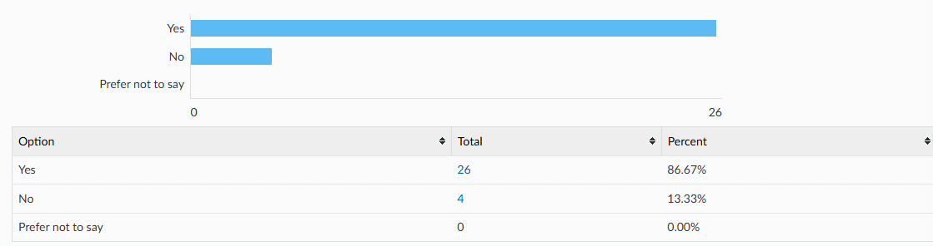

Please tick all you experience:
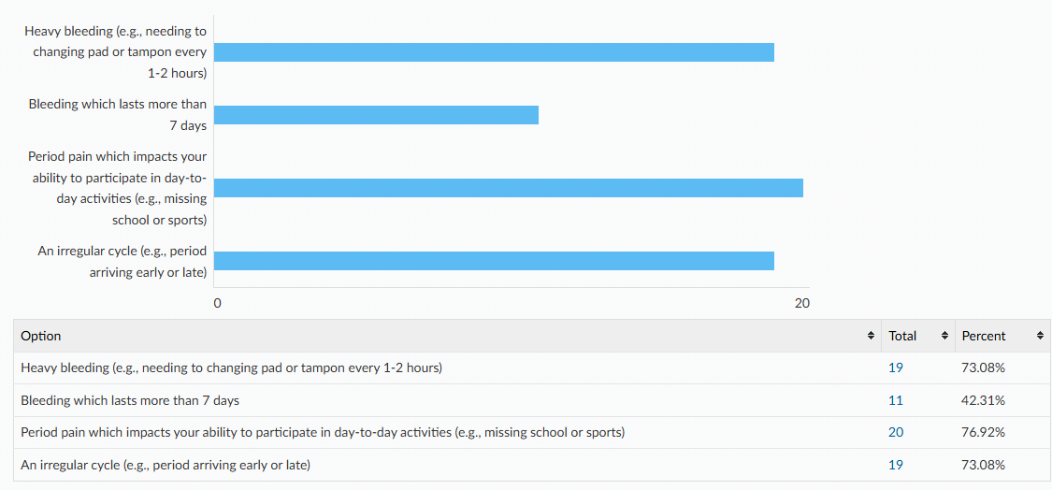

Did you seek support with these issues?
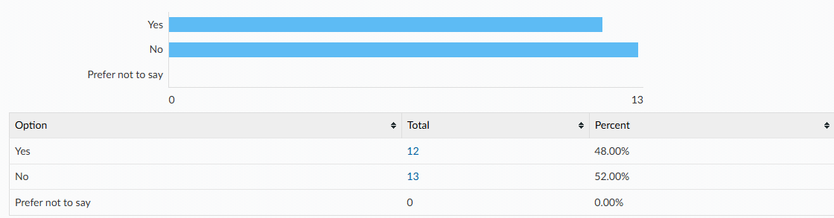
Who did you seek support from? Please tick all that apply.
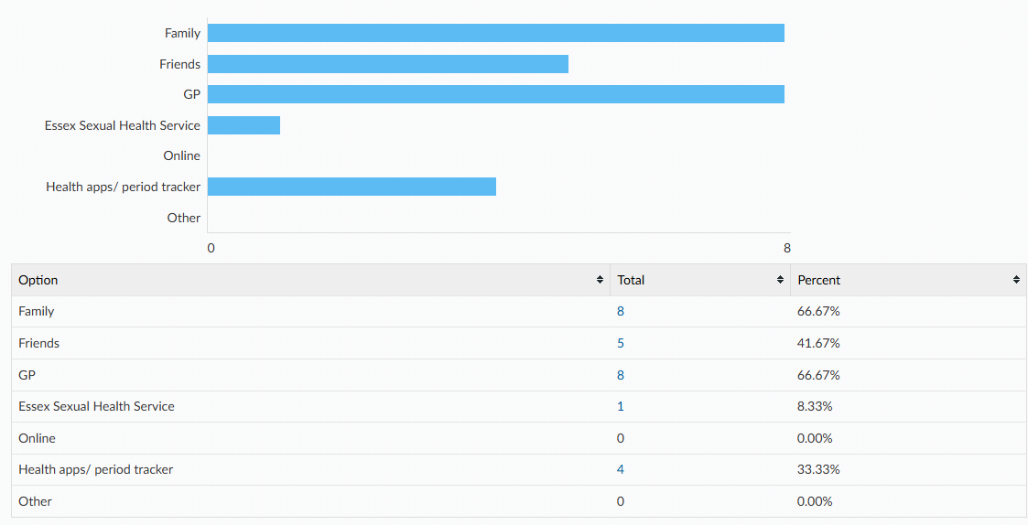

What were your reasons for not seeking support from anybody? Please tick all that apply.
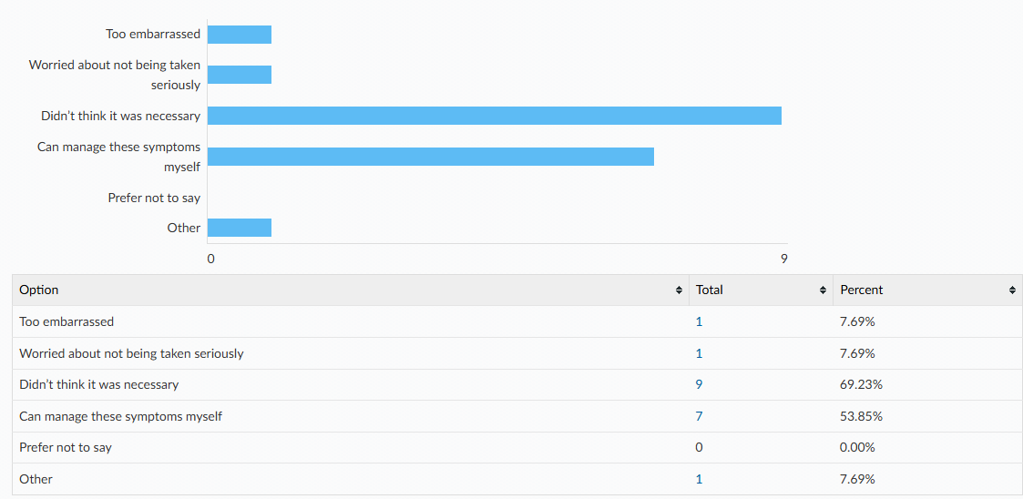

Do you use any of the following? Please tick all that apply.
 | Yes | No | Not sure
A mobile phone with access to the internet | 100% | 0% | 0%
Snapchat | 82% | 16% | 2%
Instagram | 82% | 16% | 2%
TikTok | 74% | 21% | 4%
WhatsApp | 96% | 2% | 2%
BeReal | 17% | 80% | 2%
X (Twitter) | 32% | 66% | 2%
Dating apps | 2% | 96% | 2%
Online gaming | 53% | 43% | 4%
Twitch | 15% | 83% | 2%
Discord | 28% | 67% | 4%
RoBlox | 54% | 42% | 4%

Have you ever been made to feel uncomfortable online? E.g. received a private image, been asked to send a private image or joined an online private chat.
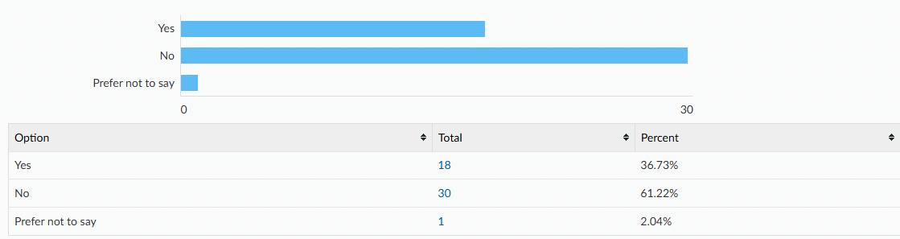

Did you tell/ seek support from anyone?
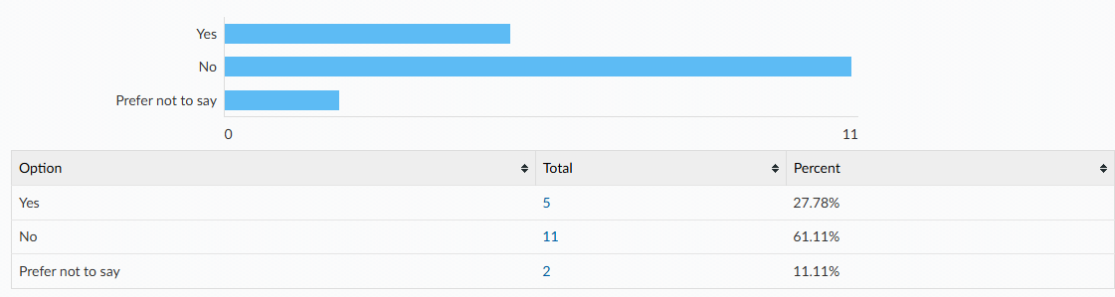

Who did you tell/seek support from? Please tick all that apply.
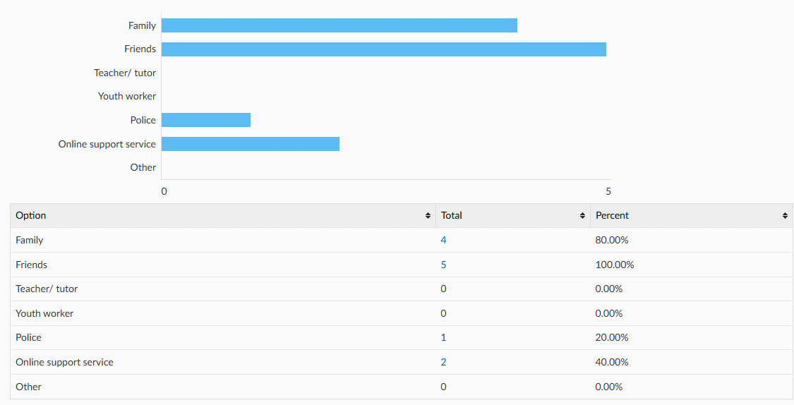

What were your reasons for not telling/ seeking support from anyone? Please tick all that apply.
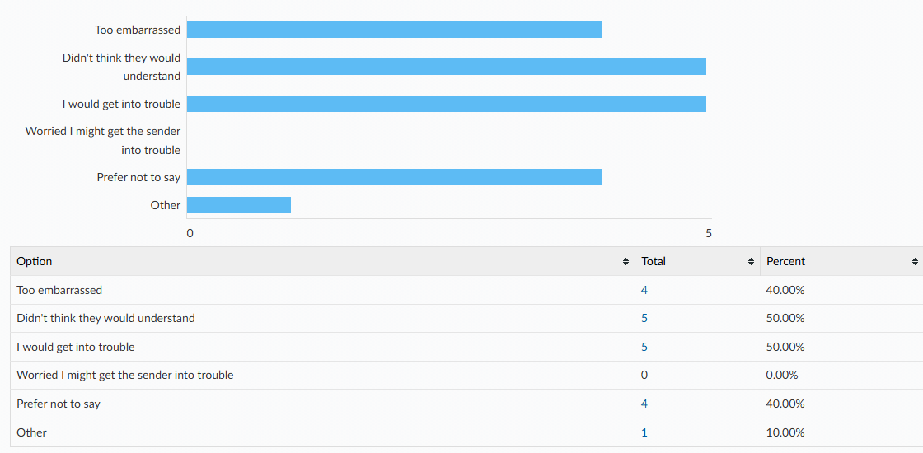

It is against the law to send, save or share nudes or sexual videos of anyone aged under 18. Were you aware of this?
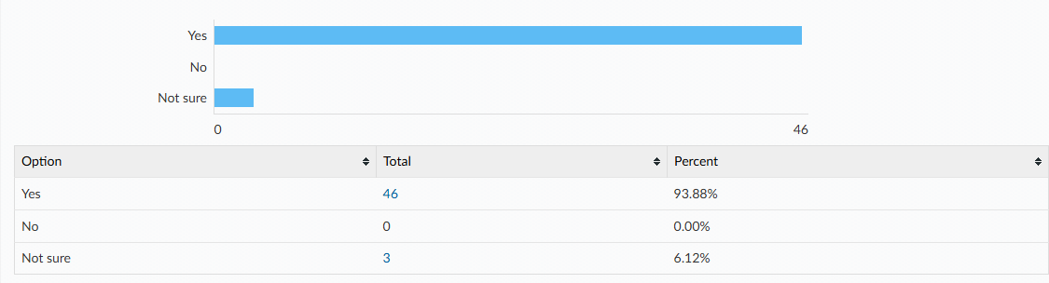

Have you or a friend ever experienced any of these behaviours in a relationship?
- Gaslighting: being made to doubt yourself and your own judgement. This may include telling you things have happened which didn’t or disagreeing with your version of events.
- Coercive Control: being manipulated into doing what another person wants. It can involve controlling who you see and where you go, telling you they will spread rumours, private information or nude photographs, getting you to lie or keep secrets and making you feel like you can't trust your family or friends.
- Love Bombing: giving you excessive affection and attention early on in the relationship in attempt to 'hook' you in and later emotionally manipulate you.
- Ghosting: suddenly ending a relationship without explanation by withdrawing all contact.
- Being told what you can and can't wear
- Being criticised, put down or humiliated
- Feeling pressured to do things you aren't comfortable with
- Having your social media accounts controlled or heavily monitored

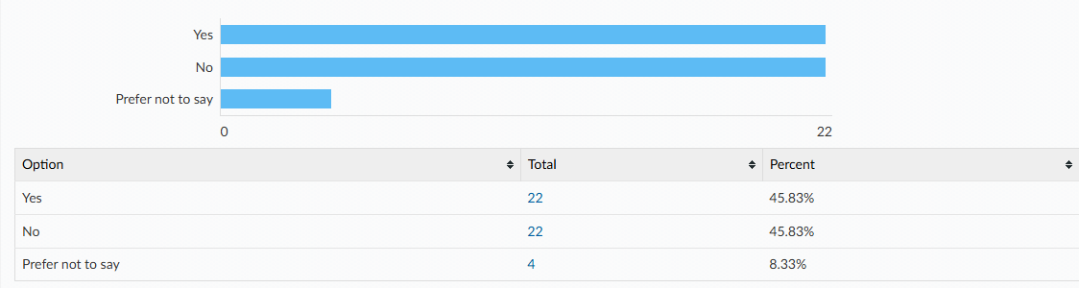

Did you or your friend tell/ seek support from anyone?
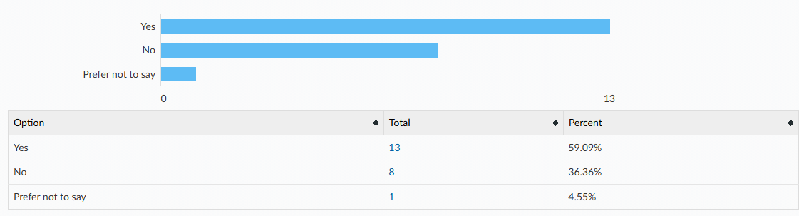

Who did you or your friend tell/ seek support from? Please tick all that apply.
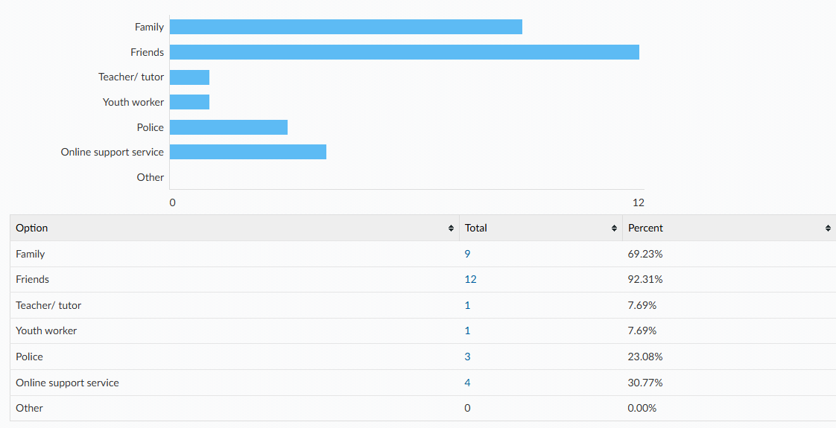

Why did you or a friend not tell/ seek support from anyone? Please tick all that apply.
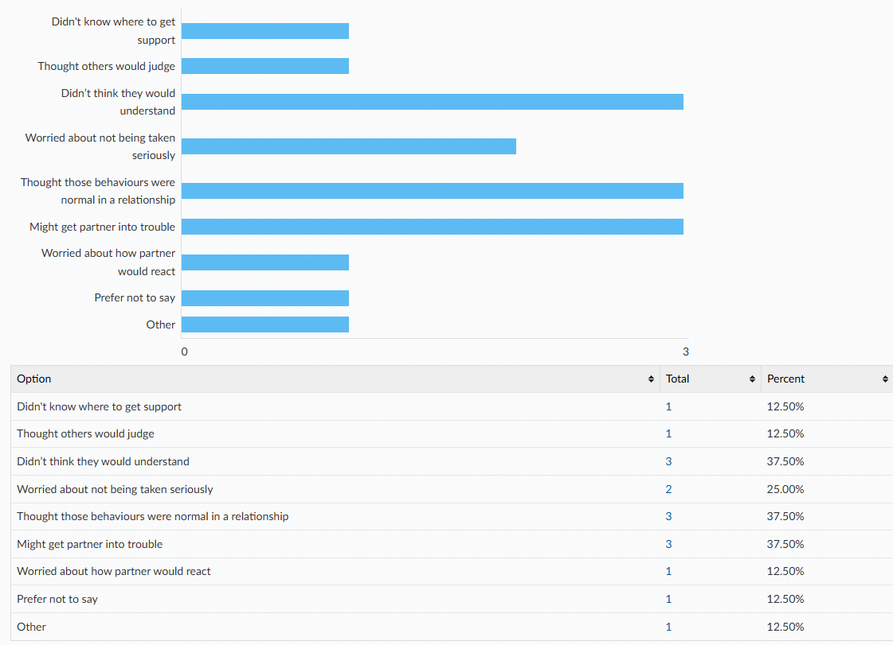

When do you think would be the most suitable age to learn about the following topics in school? (Optional Q)
Topic | Year 7 | Year 8 | Year 9 | Year 10 | Year 11 | College/ sixth form
Image sharing | 35% | 27% | 27% | 12% | 0% | 0%
Revenge porn | 15% | 12% | 19% | 35% | 12% | 8%
Healthy and respectful relationships | 69% | 12% | 12% | 8% | 0% | 0%
Sex | 19% | 38% | 23% | 8% | 8% | 4%
Consent and the law | 65% | 12% | 19% | 0% | 4% | 0%
Public sexual harassment | 42% | 23% | 31% | 4% | 0% | 0%
Staying safe online e.g. dating | 77% | 8% | 4% | 8% | 4% | 0%
Pornography | 23% | 12% | 23% | 35% | 4% | 4%
Masturbation | 20% | 16% | 36% | 12% | 4% | 12%
Puberty | 88% | 8% | 4% | 0% | 0% | 0%
Menstruation | 81% | 15% | 4% | 0% | 0% | 0%
Gender identity | 42% | 8% | 25% | 17% | 4% | 4%
Sexuality | 48% | 16% | 20% | 12% | 0% | 4%
Sexually transmitted infections (STI’s) and HIV | 19% | 23% | 19% | 23% | 8% | 8%
HIV prevention (PEP or PrEP) | 15% | 27% | 19% | 19% | 12% | 8%
Methods of contraception | 20% | 28% | 36% | 4% | 8% | 4%
How to access contraception | 16% | 28% | 36% | 0% | 16% | 4%
Steps to take after unprotected sex | 12% | 32% | 28% | 8% | 12% | 8%
Information on choices around pregnancy | 13% | 25% | 21% | 13% | 21% | 8%

