Facilitating Supportive Digital Communities: Essex Coronavirus Action Support (ECAS). A community focussed partnership response to the COVID-19 Pandemic.

Evaluation Phase 1

April 2021
Fiona Simmons-Jones, Public Health Specialty Registrar Essex County Council
Neave Beard, Lead for Strengthening Communities Essex County Council

Contents
Abbreviations 4
Executive summary 4
1. Introduction 5
2. Evaluation questions and methods 6
Table 1: Part 1 evaluation questions. 8
Table 1(continued): Part 1 evaluation questions. 9
2.1. Data collection 10
1) ECAS metrics from Facebook analytics. 10
2) Structured interviews with staff and ECAS admin. 10
3) User surveys and interviews. 11
2.2. Evaluation and write up 12
3. Outputs. 13
3.1. What makes the service that supports the community? 13
The goals. 13
The users. 13
Figure 1. ECAS demographics. 13
Development and testing of the model. 14
Figure 2. The PDSA cycle model to quality improvement (Eby, 2019). 14
Figure 3. Maslow’s hierarchy of needs (McLeod, 2020). 16
Figure 4. Theming process. 17
Figure 5. Needs analysis during first English lockdown. 17
Figure 6. the COM-B model of behaviour adapted from (West and Michie, 2020). 18
Key features. 20
3.2. What makes the team that builds a community? 21
Table 2: Application of LaFasto and Larson’s model for team effectiveness (LaFasto & Larson, 2001) to the ECAS team. 21
Figure 7. Lencioni’s five dysfunctions (Lencioni, 2002). 21
1) Skills. 22
Figure 8. Skills required for working in digital community development. 22
2) Team roles and leadership. 22
Table 3. ECAS team roles and attributes. 23
Table 3 (continued). ECAS team roles and attributes. 24
3) Team structure. 25
Figure 9. ECAS team structure. 25
4) Ways of working. 25
Setting the direction. 25
Figure 10. Process for setting strategic direction and translating it into action. 26
Managing the group. 26
Figure 11. Managing the ECAS group process diagram. 27
Problem solving. 27
Figure 12. Managing and solving problems. 28
5) Current vulnerabilities. 28
Table 4. Vulnerabilities in ECAS model. 29
3.3. What does a community cost and create? ECAS cost effectiveness analysis and methodology. 30
Figure 13. Levels of costs and benefits. 31
1) Health promotion- evaluation against national health promotion campaigns. 31
Table 5. Comparison to UK Government COVID-19 health promotion campaign. 32
Table 6. Comparison to Scottish Government COVID-19 health promotion campaign. 33
2) Comparison to a staffed service intervention. 33
3) Methodology for in depth multilevel cost/benefit analysis. 34
4) Comparison to alternative volunteer recruitment intervention. 34
3.4. Are members informed of the guidance and their rights during the COVID-19 pandemic? 35
1) Readability of ECAS content. 35
Table 7. ECAS and UK Government COVID-19 guidance readability assessment results. 37
Table 8. Difference in ECAS and UK Government COVID-19 guidance readability. 37
2) Survey results: Inform. 38
Figure 14. Survey answers to questions asking participants to identify correct guidance. 39
Figure 15. Sources of COVID-19 information that respondents reported helped them feel informed. 40
Figure 16. Sources of trusted information in the ECAS approach. 40
Figure 17: Survey respondents’ advice for new members on how to use the ECAS group. 41
3.5. Does the digital community help in improving mental and physical wellbeing outcomes? 42
Survey results: Prevent. 42
Figure 18: Survey respondents’ compliance with national COVID-19 guidance. 42
Figure 19. Self-reported compliance with specific guidance activities. 43
Figure 20. The influence of ECAS on behaviour. 44
Figure 21. Respondents’ self-reported motivations for following COVID-19 guidance. 45
Survey results: Assist. 45
Figure 22. Sources of help accessed by survey respondents during COVID-19. 45
Figure 23. Respondents’ self-reported physical activity levels. 46
3.6. Does ECAS foster a real sense of belonging and promote community assistance? 48
Figure 24. Importance of a sense of community within ECAS. 48
Figure 25. ECAS sense of community index results. 48
Reinforcement of needs. 49
Figure 26. ECAS sense of community: reinforcement of needs. 49
Membership. 49
Figure 27. ECAS sense of community: membership. 50
Influence. 50
Figure 28. ECAS sense of community: influence. 51
Shared emotional connection. 51
Figure 29. ECAS sense of community: shared emotional connection. 51
Conclusions and recommendations 53
Next steps 56
References 57
Appendix 1: Draft evaluation questions for ECAS. 61
Appendix 2: Evaluation Phase 2 protocol. 61
Appendix 4: Costs and benefits spreadsheet. 61
Appendix 5: 61
Appendix 6: slide deck 61

Abbreviations

ECAS Essex Coronavirus Action Support, a linked group and page on Facebook.
ECC Essex County Council.
EWS Essex Wellbeing Service (previously known as the Essex Welfare Service).
FAQ Frequently asked question(s).
NIHR National Institute for Health Research.
PHIRST Public Health Intervention Responsive Studies Teams.
SME Subject matter expert(s).

Executive summary

In response to the COVID-19 pandemic the Essex County Council (ECC) Public Health and Strengthening Communities teams, in partnership with local Facebook Admins, set up the Essex Coronavirus Action Support (ECAS) approach. The Facebook page and linked group were established on the 13th and 16th March 2020 respectively. ECAS provides support to Essex residents through a focus on three goals: prevent the spread of infection, inform residents on guidance and assist vulnerable residents.

The ECAS model has evolved throughout 2020/21 with an ethos of “break it live, fix it live”. The first phase of the evaluation of ECAS has demonstrated that:

- The skills and values of the ECAS team are fundamental to the successful implementation of this model.

- A partnership approach and mutual respect between organisations and individuals supports trust and creative problem solving. Combined with a developed risk appetite and willingness to try (and fail) supports rapid learning and development in uncertain circumstances.

- Flexible way of working and adaptability are essential to respond effectively to changing needs and resources. This embeds a willingness to learn from the community.

- Applying an understanding of human behaviour and of population needs can inform effective communications and services, tailored to population needs.

- Honesty, including apologising when things went wrong supports a sense of credibility and that members can relate to Admins, and fosters a sense of trust.

- The approach provides value for money as a health promotion campaign, when compared to similar national campaigns during COVID-19.

- The information shared through ECAS is more readable than corresponding national guidance, supporting members’ informed decision making around key COVID-19 issues.

Further areas for development include recruitment of expert members to support admins and developing a sense of ownership over the ECAS digital community. These recommendations will support resilience in the ECAS model and allow for future adaptation as a health promoting approach after the COVID-19 Pandemic.

Introduction

In response to the COVID-19 pandemic the Essex County Council (ECC) Public Health and Strengthening Communities teams, in partnership with local Facebook Admins, set up the Essex Coronavirus Action Support (ECAS) approach. This initiative is a part of Essex County Council’s wider digital first approach to strengthening communities which has also been applied in other projects addressing mental health needs and social isolation (Local Government Chronicle, 2020). This digital first approach builds on ECC’s partnership working with Facebook, established since 2018, and existing relationships and partnerships with local community Facebook Admins across Essex (The GovLab, 2020).
ECC mobilized existing networks and working relationships to create a more organized and inclusive response to supporting the public during the Pandemic. It created the public-facing Essex Coronavirus Action page to disseminate Essex-specific information about public health guidance, pandemic-related public services, and volunteer opportunities. An associated closed Facebook group, Essex Coronavirus Action Support, was also created to allow for interaction and discourse with citizens who wanted to privately ask questions and ask for help and connect with each other in a digital community (Essex County Council, 2020a).
The objective of the evaluation of the ECAS approach is to assess the extent to which the structure and processes of the approach have supported positive health and wellbeing outcomes for citizens of Essex and provided value for investment. The evaluation consists of two complementary parts:
Part 1: Internal evaluation: conducted by ECC Public Health and Research & Citizen Insight teams.
Part 2: Further evaluation: conducted by academic experts as part of the National Institute for Health Research (NIHR) Public Health Intervention Responsive Studies Teams (PHIRST) Local Authority interventions programme.

Evaluation questions and methods

The evaluation questions for part 1 of the evaluation were developed in discussion with members of the ECAS team. A Donabedian model of structure, process and outcome was used as a framework. Questions are aligned to the ECAS objectives: inform, prevent and assist. Questions were refined after discussion with stakeholders, including Facebook, about the feasibility of accessing required data and quantifying attributable outcomes (Appendix 1).
The evaluation used a mixture of quantitative and qualitative methods. A mixed methods approach allowed for a greater degree of triangulation where more than one data source could be used to answer a question. Table 1 shows how data sources were chosen to be able to answer the evaluation questions.
The UK Government has a set of defined criteria to quality assess and assure digital services. These criteria are collectively referred to as the Digital Service Standard (Gov.uk, 2019) and cover a range of areas to ensure digital services are accessible, user friendly, evidence based, secure and address user needs. As ECAS is a digitally enabled intervention implemented with Local Government support, and no defined quality framework for social media-based interventions could be identified, the evaluation questions have been mapped to the Digital Service Standard for quality assurance. The research questions addressed in phase one of the evaluation map to 12 out of 14 Digital Service Standard domains. The overall process of evaluation of this intervention, and sharing the learning from evaluation, addresses relevant elements of domain 13- use and contribute to open standards, common components and patterns. The sole domain not addressed in this evaluation, domain 12 (make new source code open) refers to technical aspects of digital services which are not applicable when using an existing publicly accessible digital platform (not publicly owned) to deliver a service.
Building on the learning from the phase 1 evaluation and the evolution of ECAS over 2020/21 further evaluation questions were developed in partnership with the London NIHR PHIRST team (Appendix 2). These questions will be addressed in phase 2 of the evaluation.

Evaluation question | Donabedian element | Digital Service Standard Domains | Data source
- What makes the service that supports the community?  What are the necessary elements in a digital first community service? | Structure  Process | 2) Solve a whole problem for users  3) Provide a joined-up experience across all channels  4) Make the service simple to use  7) Use agile ways of working  8) Iterate and improve frequently  9) Create a secure service which protects users’ privacy  14) Operate a reliable service | Review of Project documents.  Review of national and international evidence.  Structured interviews with staff and ECAS admin.  ECAS metrics from Facebook analytics.
- What makes the team that builds a community? | Structure  Process | 3) Provide a joined-up experience across all channels  4) Make the service simple to use  6) Have a multidisciplinary team | Structured interviews with staff and ECAS admin.  Review of Project documents.
- What does a community cost and create? Cost Benefit analysis (CBA) and cost avoidance analysis. | Outcome | 10) Define what success looks like and publish performance data  11) Choose the right tools and technology | Review of Project documents.  ECAS metrics from Facebook analytics.  Review of national and international evidence.

Table 1: Part 1 evaluation questions.

Evaluation question | Donabedian element | Digital Service Standard Domains | Data source
- Are members informed of the guidance and their rights during the COVID-19 pandemic? | Outcome | - Understand users and their needs  - Solve a whole problem for users  - Provide a joined-up experience across all channels  - Make the service simple to use  - Make sure everyone can use the service | User surveys and interviews.  Review of Project documents.  Review of national and international evidence.  Government guidance.
- Does the digital community help in improving mental and physical wellbeing outcomes? | Outcome | - Understand users and their needs  - Solve a whole problem for users  - Provide a joined-up experience across all channels | User surveys and interviews.
- Does ECAS foster a real sense of belonging and promote community assistance? | Outcome | - Understand users and their needs  - Solve a whole problem for users  - Provide a joined-up experience across all channels  14) Operate a reliable service | ECAS metrics from Facebook analytics.  User surveys and interviews.  Review of national and international evidence.

Table 1(continued): Part 1 evaluation questions.

Data collection

ECAS metrics from Facebook analytics.
Admins of Facebook groups and pages have access to basic analytics of the growth of the group and engagement with the group/page and its shared or posted content.
Growth data includes information on the number of members of the Facebook group over time since its creation on the 18th March 2020, and the number of active members accessing and interacting with the content of the page over time. In addition Admins can view the number of people who have requested membership, and those that have been declined or blocked.
Membership analytics include gender and age demographics as well as high level geographical location for users (town/ city level and country level) and the level of engagement from most active users and posters.
Engagement data for the page and group includes the number of individuals accessing content including posts, guidance shared, resources and memes. In addition it includes information about their interaction with content shared, including those who have commented or shared a reaction to the content, as well as information on the most popular posts with the highest number of users reached and highest level of engagement.
This analytical information has been used in the evaluation when assessing population coverage, information sharing reach and community development.
While the analytics available to Admins through Facebook can quantify the reach and engagement with individual posts they do not currently allow for analysis by theme of this content. Many posts, resources and questions relate to the same themes, such as financial support or access to testing, over time. It is valuable to be able to understand engagement by theme in order to ascertain the information and support needs of users, and potentially by extension the needs of the population of Essex. To address this manual analysis of themes of posts and queries was conducted by ECC researchers, primarily in Wave 1 of the pandemic. This is further explored in section 3.1 of this report.

Structured interviews with staff and ECAS admin.
Structured interviews with ECC staff and community Admins associated with the ECAS approach were carried out virtually by the ECAS project’s lead Researcher, from the ECC Research & Citizen Insight team. Participants were asked for their thoughts and reflections on the ECAS approach around four key areas of interest; set up, implementation, recruitment and management/continuation. Participation in these interviews were voluntary and all outputs were anonymised. Copies of the interview guides are available on request. Thematic analysis was used to identify areas of learning from these interviews and was conducted by the ECC Research & Citizen Insight team.
Working with the ECC staff and community Admins associated with the ECAS approach a combination of a Belbin team roles survey and framework (Belbin, 1981; BELBIN Associates, no date) and digital team roles (Gilbertson-Urtel, N. 2018) was used to developed a set of minimum team roles required for a digital community development project. Thematic analysis of interview responses and Belbin survey results were used to complete this team roles profile. Outputs are available in section 3.2 of this report.

User surveys and interviews.

Two user surveys were carried out as part of the phase 1 evaluation. Both surveys referred to user experiences of both the ECAS group and page and were recruited by self-selection after being advertised on the group and page. Survey one was available between the 23rd September 2020 and the 8th November 2020, and was a reflective, retrospective exercise. This survey probed how members used ECAS and what affect it had on behaviours, especially during the first UK lockdown. Survey two was available between the 20th November 2020 and the 2nd December 2020. This survey allowed for evaluation of how members were using the group in real-time during the second UK lockdown and how the effect of the page/group had changed over time. Both surveys gather user experiences and feedback relating to the three objectives of the ECAS approach- inform, prevent and assist, as well as assessing the impact of ECAS as a digital community development approach. A survey for wider Essex residents was conducted but did not receive sufficient responses to provide a meaningful comparator data set and is therefore not included here.

Between March and April 2020 a series of virtual one to one qualitative interviews were conducted to supplement and complement the user surveys and develop deeper understanding of the ECAS user experience. These interviews were undertaken to further explore three key areas of interest:

- How ECAS has affected behaviour during the pandemic.
- If advice & guidance given by the admins helped people understand and follow COVID-19 guidance.
- Whether the ECAS group has worked a substitute for an in-person community.
Participants for the one-to-one interviews were recruited via the online surveys where respondents were asked to indicate if they would be open to further engagement and follow up as part of this research. 208 respondents expressed an interested, of which approximately 80 were contacted individually. Seven respondents, all female, agreed to be interviewed and were offered the option of a video call or telephone interview. One phone and six video interviews, lasting no more than 60 minutes, were conducted with participants from across a number of districts across Essex; covering the four quadrant areas in Essex.
Questions addressed in the qualitative interviews included:
- Are you on the ECAS page or group or both?
- Approximately how often do you access ECAS?
- Why and how do you use ECAS?
- Do you feel ECAS has affected your behaviour during the Covid-19 pandemic?
- How connected do you feel or are you to the other members?
- Will you stay in the group post Covid-19?
- Is there something you particularly like about ECAS and/or anything you would improve?

Evaluation and write up

All analysis and write up for phase 1 of the ECAS evaluation was conducted by an internal ECC evaluation team, consisting of representation from the Public Health team and the Research & Citizen Insight team.

User survey answers are displayed as proportions of respondents choosing the different options to the evaluation questions and statements. Unless otherwise stated, survey data is based on survey one due to sample sizes. Any changes in the results from survey one to survey two have been noted.
Any quotes are used because they are particularly illustrative of the feedback or issues being described. Any quotes from users have been anonymised and quotes from staff and Admins are only used with permission.

The outputs of the phase 1 evaluation are presented with the aim of giving a descriptive overview of the range of feedback and views shared and the degree of consensus and depth of feeling on the different issues. Where relevant attempts have been made to give an idea of the proportion of respondents / staff and Admin members expressing a view, for example whether it was rare or the majority. Although the analysis and write up in this report has been explicitly structured around the initial evaluation questions, emergent themes have also been identified and added in wherever relevant in order to present a comprehensive picture of the ECAS approach. Additional questions and learning have been fed into the development of phase 2 of the ECAS evaluation, to be delivered in partnership with the London NIHR PHIRST team (Appendix 2).

Outputs.

What makes the service that supports the community?

The goals.

The ECAS approach has three goals: prevent the spread of infection, inform residents on guidance and assist vulnerable residents. These goals are communicated to members before they join the group through a pinned post on the group and are included in the information about the page. The group outlines the importance of the community members in achieving these goals:

“The success of this group and its ability to help our community will rely on the members helping each other and us to keep it a useful place of trusted information and support.”

The users.
Membership of the ECAS group is predominantly Female (81%), with fewer Male members (18%) (Figure 1). The majority of group members are between 35 and 55 years of age (55.3%), with other age ranges engaging more through the linked twitter and Instagram accounts. These demographics were reflected in the survey respondents, with Females over-represented (81% of 1,073 respondents compared to 15% Males) in comparison to the Essex population, though this is typical of online survey completion rates. Similar to the group demographics those aged under 30 years of age were underrepresented in the surveys with 90% of respondents over 30 years of age. These demographics highlight that for messaging and engagement with the whole of the Essex population ECAS should be part of a wider engagement approach. Some demographics or communities may require further tailored approaches.
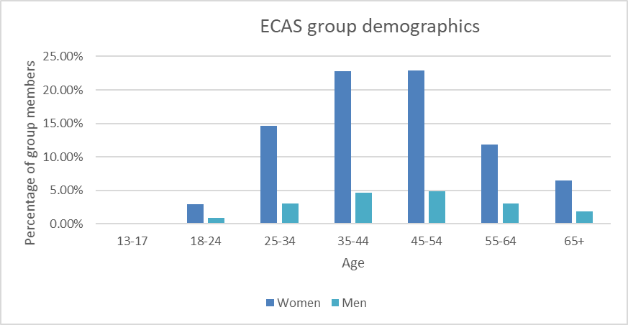

Figure 1. ECAS demographics.

Development and testing of the model.
The development of the ECAS approach since March 2020 can be described as a number of rapid sequential PDSA cycles (Eby, 2019). PDSA is an approach to continuous quality improvement where plans are implemented and the learning from their impact is analysed and used to inform further changes to the model to improve quality e.g. through addressing concerns or adapting to changing needs and circumstances (Figure 2). ECAS was initiated as a rapid response to the Pandemic with an ethos of “break it live, fix it live”. As a result the initial cycles in the early days of the Pandemic were very rapid as the group formed and the ECAS team tested ways of working as population needs started to be expressed.
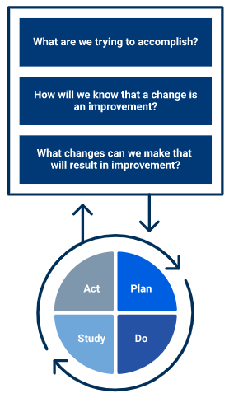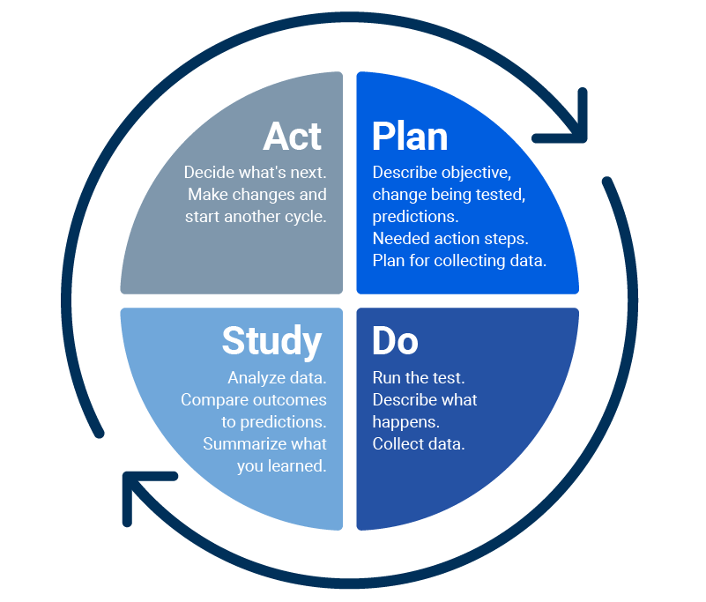

Figure 2. The PDSA cycle model to quality improvement (Eby, 2019).

PDSA cycle 1- 13th March 2020 to mid-March 2020
The challenge: The developing COVID-19 Pandemic situation, rapidly developing guidance and restrictions and impending national lockdown leading to an increased need for community support and identification of individuals requiring support.
The change: The Essex Coronavirus Action Facebook page (ECA) was established on the 13th March. Essex Coronavirus Action Support (ECAS, the online community group) launched on the 16th of March. Experienced community admins were brought in to support platform management . ECAS was able to mobilise quickly through leveraging existing work on the Community Campaign Model and projects such as United in Kind.
This built on three years of previous work, whereas the first local authority to become a Facebook Community Partner ECC worked to build a network of local community influencers to help them to become community builders to translate and cultivate digital social action into physical social action.
Through existing networks and word of mouth the group and page were populated. In the first weeks 1.5k - 2k new members were added a day. Strong branding and tone of voice was established immediately to provide a consistent and recognisable authority with the target audience. Tone was initially more directive, though still accessible and humorous, and has evolved to a gentler expressively supportive tone as needs have changed over the Pandemic.
PDSA cycle 2- Mid-March 2020- April 2020
The challenge: A significant influx of posts and requests for guidance and information as the UK headed into the first lockdown. Answering all of these individually in a timely manner was not possible due to the overwhelming number of posts, and some required expert interpretation of the rapidly changing COVID-19 situation (nationally and locally) and guidance.
Recruited Admins and community Admins required support in supporting their digital communities and in identifying and sharing accurate and official information about the Pandemic and support available. An increasing number of COVID-19 related groups appearing on Facebook which had the potential to make it challenging for users to identify sources of factual and official information and support, and an increasing risk of users falling prey to scams and misinformation.
Increasing population need for support with basic tasks including accessing shopping and prescriptions, due to shielding.
The change: Recruitment of subject matter experts (SMEs) from specialist ECC teams and Public Health to interpret and simplify guidance and answer queries from members and Admins. This opened key information pathways with ECC teams and Public Health. Public Health representatives were made available to the admin team to answer questions in real time through an admin chat messenger.
To provide additional support, ECC mobilised new and existing local community group Facebook Admin teams, inviting them to a dedicated COVID-19 local admin group. Within this group, Admins can ask questions, receive support for people in their community where needed. Members of this group are also helping to distribute official information across the county, stemming the flow of harmful misinformation.

The Essex Coronavirus Action page was verified by Facebook to provide an extra layer of trust and confidence that it was a credible source of information for the local population. Using branding that is accessible to visually impaired and screen reader users, and providing advice with clear, recognisable imagery, the Page ensured that crucial information reached the local population. Population reach was supported by Facebook throughout this process who provided Ad Credit to allow us to reach more people with key Public Health messages.

ECAS was used as the front door for recruitment for local volunteers to support communities across Essex through EWS. A recruitment campaign was launched and ECAS team members supported onboarding of volunteers. Over 7,000 volunteers were recruited across the recruitment efforts and subsequent recruitment campaigns to support COVID-19 vaccination roll out. As of April 2021 these volunteers had completed over 27,000 jobs for EWS.

PDSA cycle 3- April 2020-Summer 2020
The challenge: The number of posts and requests for guidance continue to be overwhelming, even with SME support. Public Health SME trials introducing a theming process to identify common areas of need that could be addressed by stock responses but does not have capacity to theme and produce accessible content and the stock responses needed by Admins. Without a more streamlined process there is a risk that responses will not be timely in the rapidly changing environment of the Pandemic, and that most pressing needs will be missed.
A desire to apply understanding of behaviour change theory to further support a move from exclusively reactive to increasingly proactive guidance and support.
The change: Researchers from the ECC internal Research and Citizen Insight team were recruited to support theming of incoming posts. Researchers initiated a rota that covered the ECAS group 24/7 and themed posts, identifying areas of high need and common queries. The theming process applied Maslow’s hierarchy of needs (Maslow, 1954) (Figure 3).
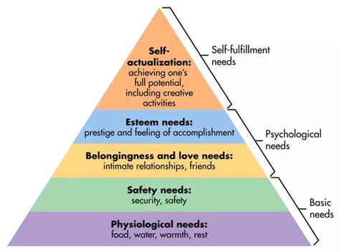

Figure 3. Maslow’s hierarchy of needs (McLeod, 2020).
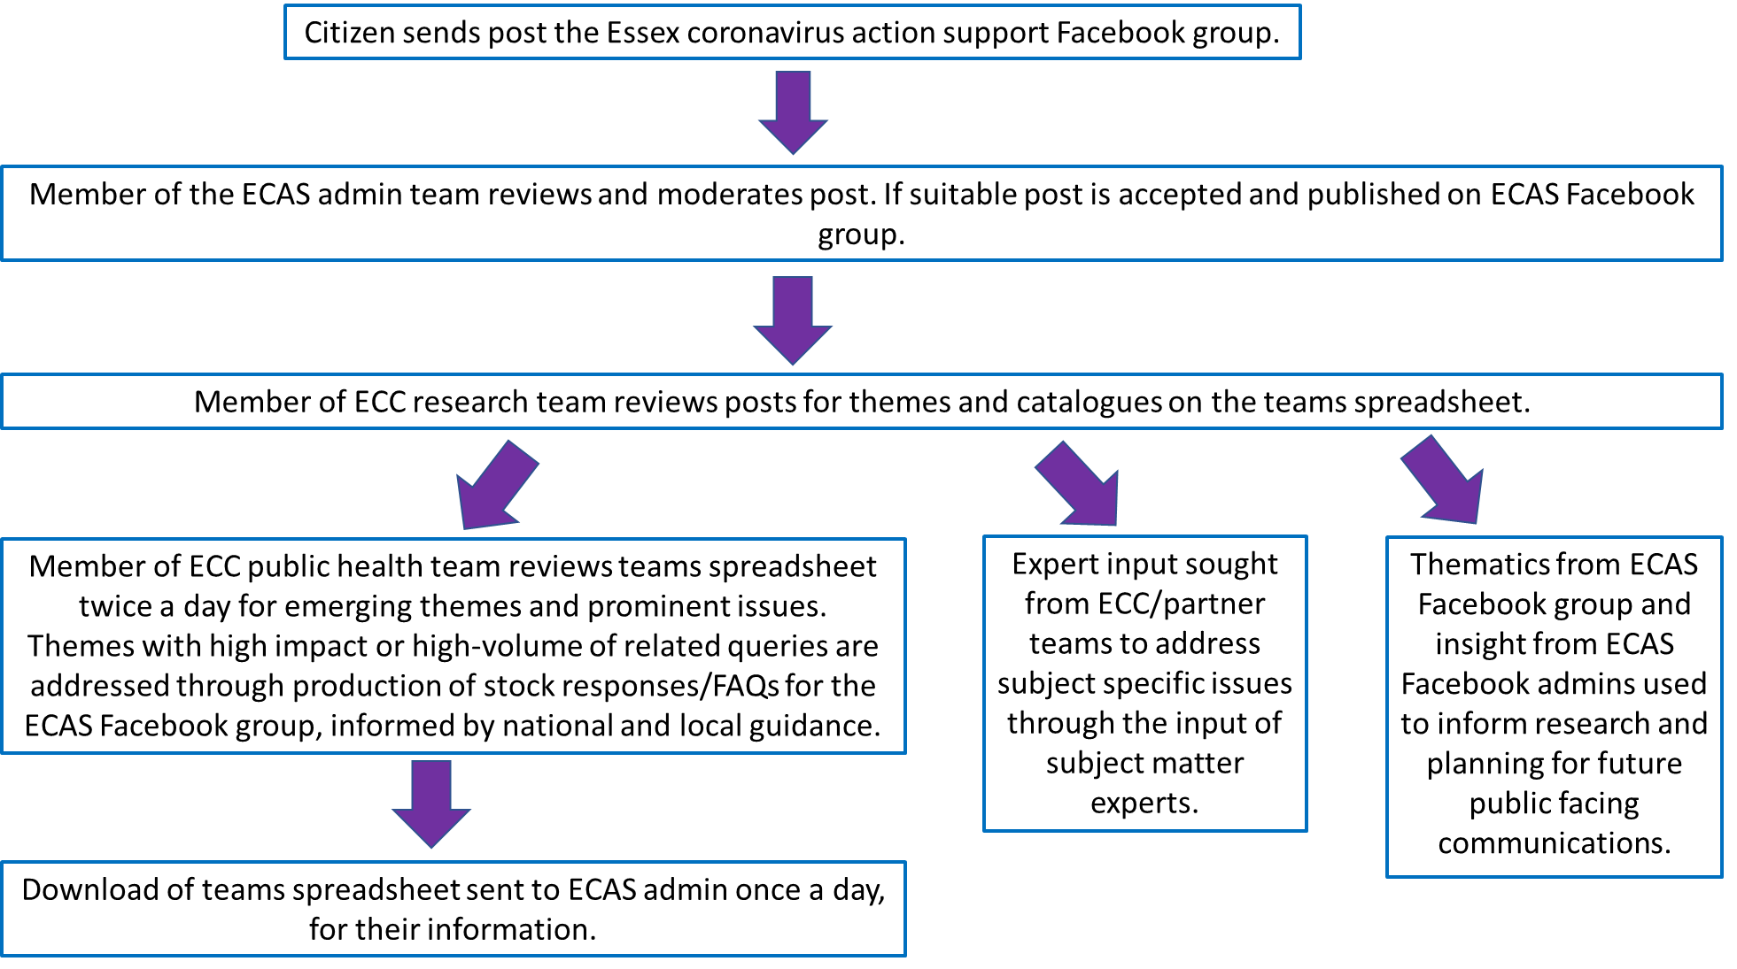
Where emergent themes, pressing queries and issues were identified these were then highlighted and addressed by Public Health SMEs or passed to other SMEs (Figure 4). These SMEs then produced themed content and stock responses that could address multiple questions and be used by the Admins as stock responses or pinned posts for signposting for members. Patterns of queries and needs were identified which broadly followed changes in national guidance (Figure 5). Identification of these themes and patterns led to proactive recruitment of further SMEs from diverse service areas including Children’s and Families, Safeguarding, and Family Law to address emerging needs as the Pandemic developed.

Figure 4. Theming process.
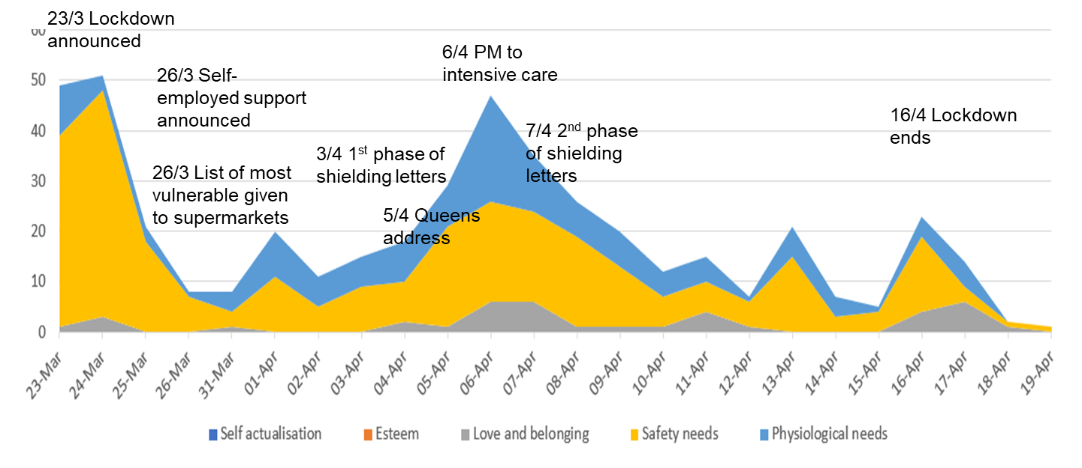

Figure 5. Needs analysis during first English lockdown.
Application of behaviour change theory allowed the team to leverage content to support health promoting behaviours, such as adherence to national guidance. The multifactorial nature of human behaviour can be described by models such as COM-B or the behaviour change wheel (Michie, van Stralen and West, 2011). In these models motivation (M) must also be accompanied by opportunity (O) and capability (C) in order to result in a desired behaviour (B) (Figure 6). Deficits in any of these will result in a suboptimal behaviour, such as non-adherence to COVID-19 measures.
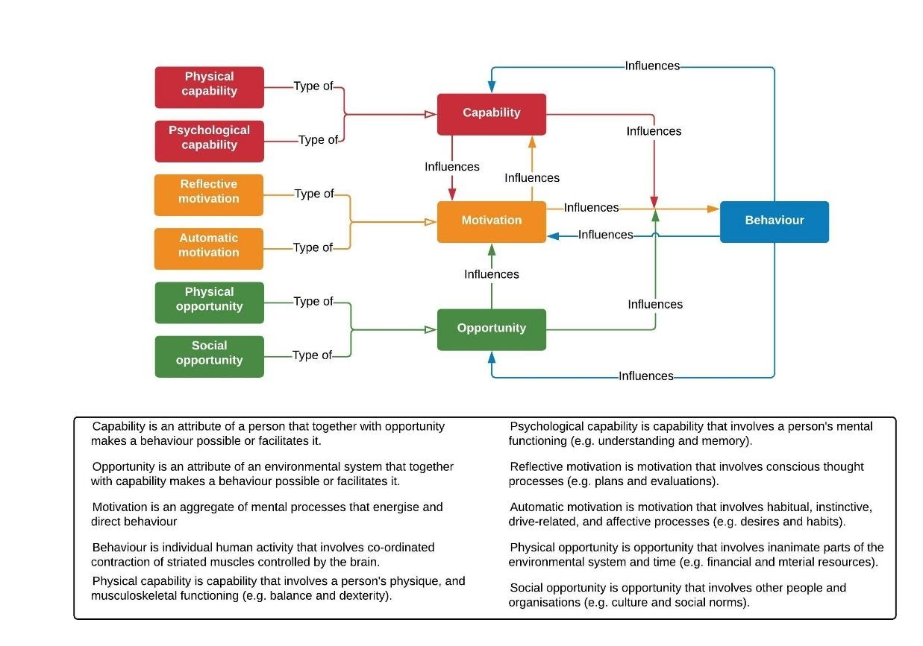

Figure 6. the COM-B model of behaviour adapted from (West and Michie, 2020).
The combination of the theming process and an application of behaviour change theory supported a move to proactively producing more FAQs and resources for admins that tapped into members expressed motivations, in order to support adherence to COVID-19 preventative measures. The identification of the pattern to queries and members expressed needs for support allowed the ECAS model to develop from a purely reactive approach to increasingly proactive as emerging needs could be identified increasingly early. Learning from ECAS and the community was used to inform ECC planning and the COVID-19 response through the ECC ECAS team members (see section 3.2).
PDSA cycle 4- Summer- Autumn 2020
The challenge: A need to ensure that all resources within the ECAS team and support functions were being used as effectively as possible as ECC increasingly returned to also delivering previously paused areas of work and other Pandemic related areas of work. Levels of expressed need in the ECAS group and linked page fluctuates and there was a recognition that the researchers’ time may be beneficial in other areas of work, including other areas of the COVID-19 response (opportunity cost).
The change: The theming process was scaled back to a less intensive process of researchers as the pattern of needs re-emerging each time national guidance and restrictions changed (e.g. furlough extended, changes to international travel restrictions or further lockdowns) was well established and accounted for in ways of working. Researchers moved to reading through posts and identifying key themes to highlight to SMEs for their input, rather than documenting all themes of posts with Public Health SME also reviewing posts. Admins could also highlight areas were support was needed or specific queries for SME input through the Admin messenger group.
PDSA cycle 5- Late Autumn 2020- current
As an increasing need for delivery of ECC business as usual developed the theming approach was further scaled back. Currently Admins and the community manager can highlight when they need themed content, and the theming can be scaled up again if needed in the future. SMEs also suggest when content may be needed by horizon scanning for developments such as the Government roadmap. This model also recognises that during the Pandemic the Admins have increasing developed their own expertise and understanding of the national guidance and require less direct SME support as their confidence and knowledge has developed.
The frequently changing nature of the Pandemic, and support and guidance from the Government means that to an extent the group must retain this reactive approach to developing content and making changes, as needs are constantly evolving and frequently driven by national policy (section 3.1). However increasing familiarity with this pattern, publication of Government roadmaps and links with SMEs and Public Health analysis/ forecasting has allowed for the increase in proactive identification of likely areas of future information and support needs. Learning from ECAS and the community continues to be fed into ECC planning and the COVID-19 response through ECC ECAS team members (see section 3.2).
Currently the ECAS approach is at a point in its development where large-scale changes are less needed and small refinements and developments occur organically as the Pandemic develops and the public adapts to life during COVID-19. However this does not mean that further large changes won’t be necessary, but that they will occur as and when they are needed to flex to the needs of the population.
See section 3.2 and Appendix 3 for a detailed explanation of current structures, processes and ways of working.

Key features.
Throughout the development of ECAS the following key features consistently contributed to the structure and processes of the approach.
- The team (see section 3.2).
- The partnership approach and mutual respect between organisations and individuals- no “pulling rank” or dictating to other members of the team.
- A flexible way of working and adaptability to changing needs and resources.
- A developed risk appetite and willingness to try (and fail) and learn while doing.
- An understanding of human behaviour and of population needs.
- Simple accessible language and communication, avoiding corporate speak.
- A willingness to learn from the community.
- Honesty with participants, including apologising when things went wrong.

What makes the team that builds a community?

This report aims to provide clarification of the minimum requirements needed for any future projects developed in the digital community development space based on the ECAS approach.

This evaluation assesses five key areas reflecting LaFasto and Larson’s model for team effectiveness (2001) which features five layers or components that increase the likelihood of team effectiveness: (Table 2):
LaFasto and Larson model layer | Evaluation element
Team member: What are his or her skills and behaviours? Picking the right person is the first step. | The skills required by individuals working in this space
Team relationships: The right behaviour in a team builds healthy working relationships between its members. | The minimum team member roles needed to execute a project
Team leadership: The right leadership enhances a team's success. | The type of team leaders needed
Team problem solving: Good team relationships make it possible to work together to solve problems. | How the project team is structured and interacts
Organization environment: The right processes and company culture in an organization promote commitment from teams. | How the project works in the organisational environment including inception, delivery, problem solving and risk management.

Table 2: Application of LaFasto and Larson’s model for team effectiveness (LaFasto & Larson, 2001) to the ECAS team.
In addition the Lencioni model for team dysfunction (2002) was used to identify current gaps and weaknesses. This model maps a team effectiveness model based on the causes of dysfunctions, conflicts, and political manoeuvrings in a workgroup. Lencioni identified five qualities effective teams do not want (Figure 7).
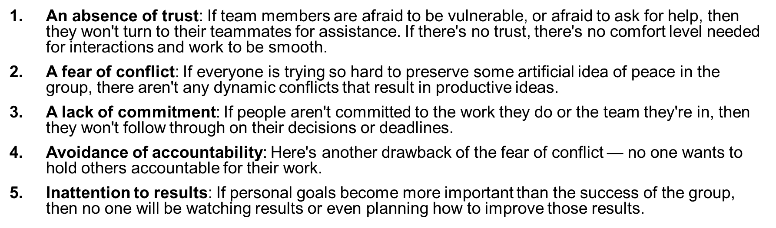

Figure 7. Lencioni’s five dysfunctions (Lencioni, 2002).
Combining these two models ensures evaluation of both areas of strength and areas of potential development for the current team and ways of working in the ECAS approach.

Skills.
Ten necessary core skills were identified by staff and Admin members of the ECAS digital community team (Figure 8). It was noted that several of the skill identified are highly values based, demonstrating alignment with public sector approaches which emphasise values-based recruitment. There are additional role-based skills that need to be represented within the team as a whole, but these ten skills and values represent the core attributes needed by all team members in order to work cohesively.
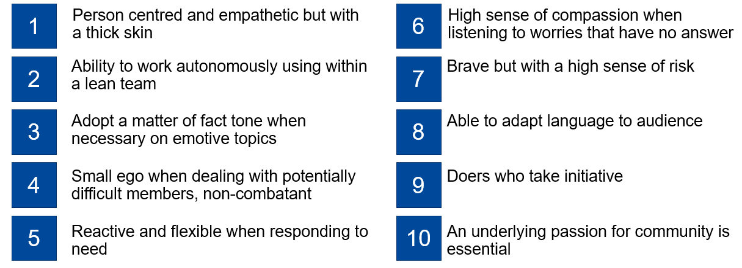

Figure 8. Skills required for working in digital community development.
It was observed that there is likely a skills deficit within Local Authorities and public sector organisations in running community management on a digital platform. This is predominantly that of adopting an informal, conversational tone and responding quickly. This may be as a result of common entrenched perceptions of professionalism and risk averse attitudes in traditional teams and services.

Team roles and leadership.
Fostering community development on a purely digital platform is a relatively new endeavour, there is not yet a theory that encompasses the minimum team roles needed. Solely applying traditional well-known models for characterising team roles, such as Belbin’s team roles (Belbin, 1981; BELBIN Associates, no date) fails to take into account where delivery through a digital platform requires highly specific or technical roles. Conversely solely applying a Digital team roles framework would fail to capture transferrable roles and attributes that are relevant to community development interventions in digital or non-digital environments. Applying these frameworks together allowed development of a set of minimum team roles required for a project in this space (Table 3). It is noted that it is likely that every project will have additional roles that are specific to its audience, context and purpose.

ECAS team role | Belbin role | Digital team role | Attributes
All (collaborative) | Resource Investigator  Plant | N/A | - Inquisitive nature  - Bring ideas and concepts to the team.  - Creativity  - Problem solving, particularly in unconventional ways.
Internal Sponsor | Monitor Evaluator  Shaper | N/A | - Acts as Barometer of what is acceptable, approves content  - Sets strategic direction and vision with dynamic leadership  - Internal risk management  - Unblocks internal blockers  - Flak jacket for external colleagues, leveraging emotional intelligence  - Bridge/point person between internal and external colleagues  - Model advocate
Community Manager/Lead Admin | Monitor Evaluator  Implementer  Completer finisher  Co-ordinator | Project manager | - Community architect/manages community culture/sets tone & values  - Manages admins and resolves disputes  - Supports & implements strategic direction  - SME point person, supports in content creation before posting  - Drives/starts conversations to engage residents and support internal objectives  - Escalates issues to internal colleagues
Content Designer | Completer finisher | Graphic Designer | - Creates engaging/quirky content rapidly  - Understands needs of community from community manager  - Gets aims of internal colleagues from internal sponsor  - Manages messaging strategy

Table 3. ECAS team roles and attributes.
ECAS team role | Belbin role | Digital team role | Attributes
Admins | Team Worker | N/A | - Reviews, approves and answers posts  - Information finder/sign poster (not necessarily an information source)  - Connects members to information  - Lean model  - Learn what is acceptable over time  - Sounding board to strategists and other admins  - Utilise day job skills to assign/answer posts
Subject matter experts | Specialist | Content writer | - Provide specialised knowledge to technical subjects  - Translate specialist information into accessible content  - Internal colleagues, partnership organisations  - Admins act as face but can be shielded from backlash if answer given by an objective 3rd party  - Offer degree of separation which aids in trust  - Light touch/removed  - Receive briefing from one point person (the community manager)
Researchers | Specialist | N/A | - Support SMEs  - Themed questions to streamline traffic and enable SMEs to respond to need in bulk  - Use themed posts to engage SMEs sooner and predict user needs
Expert member | N/A | N/A | - Equipped to seek out valid information and sources  - Disseminates correct information un-provoked  - Signposts members to valid information and sources  - Informally moderates other members

Table 3 (continued). ECAS team roles and attributes.

Team structure.
Following a period of rapid development and learning (section 3.1 of this report) the structure of the ECAS team has settled into a model that has a degree of flexibility but is currently limited by capacity and short-term period of high demands on team members (Figure 9). The team sits across internal (to ECC) and external members with key points of interaction with the wider ECC corporate structure and services, and an interface with members of the general public and Essex citizens.
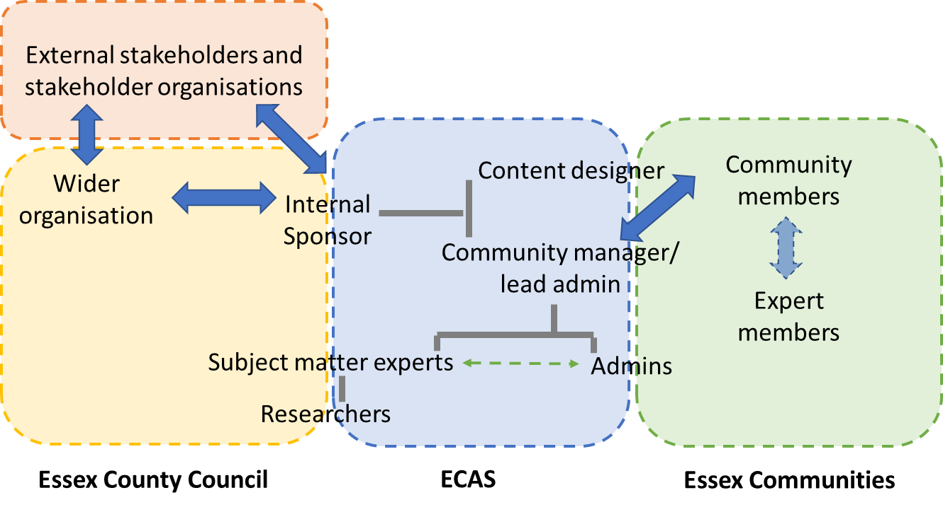

Figure 9. ECAS team structure.

Ways of working.
A project in this space is necessarily responsive and flexible based on need and context. This requires acceptance of risk and adaptability as the needs of the community change and develop during the COVID-19 Pandemic. Ways of working within the ECAS team can be characterised by four key functions:
- Identification of community needs (captured in section 3.1).
- Setting direction of travel and priorities.
- Managing the day to day functions of the group and page.
- Solving problems responsively and responsibly.

Setting the direction.
Figure 10 illustrates how strategic direction is set in the ECAS team. There is a high degree of trust between the team, which combined with the needs led approach supports innovative solutions. It is important to note that no one individual sets the strategic direction, and that while the internal sponsor and ECC staff will bring ideas and highlight needs there is no prescriptive control over direction from ECC. This is by design and supports the partnership working model embedded in the ECAS approach.
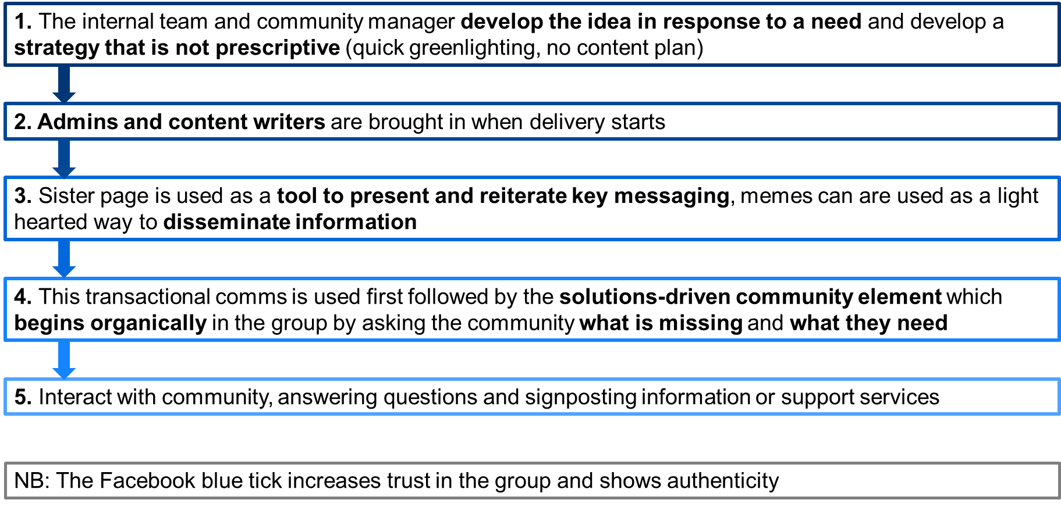

Figure 10. Process for setting strategic direction and translating it into action.

Managing the group.
Both the ECAS group and associated page are publicly searchable on Facebook. However while anyone can view the content of the page the group requires membership in order to view content and posts, and to post. Membership of the group is generally restricted to Essex residents, though Admins can exercise their discretion in approving membership, for example approving individuals seeking support for shielding family members living in Essex. Generally membership requests are approved if the Facebook account has been active for more than six months prior to their request, in order to reduce the risk of predatory account and bots being admitted to the group. However Admins can again exercise their discretion and approve any account they feel is legitimate, as it is recognised that some people may have joined Facebook specifically for finding support during COVID-19. Admins are trusted to use their judgement when admitting members who do not meet the above parameters and are able to message each other for support in making decisions through an admin only Facebook messaging group.
It is recognised that at times gaps in information and guidance, concern over the unknown and different viewpoints can lead to potential conflict in the group. Members are encouraged to be kind and supportive to each other, and Admins will often post a reminder of this rule on discussion threads that are becoming heated. In addition Admins have the ability to temporarily remove a member’s ability to comment on posts, or to post by muting them if they are demonstrating a pattern of antagonistic or rude behaviour or are spreading misinformation. Persistent negative behaviours, including targeting Admins with private messages, rude or aggressive comments or harassing other members results in Admins discussing whether to remove and block an individual from the group. This decision is made on a case by case basis and is taken seriously, with the goal to maintain a supportive environment for the users of the group.
In addition as the group has grown and its potential for impact on communities has been identified an increasing number of requests for sharing ECC corporate messages (such as information about events or opportunities to share views on services) have been received. To maintain the trusting relationship between Admins and members and support the sense of community and informal tone it is important that ECAS not be used as, or viewed as , a corporate messaging channel. These requests are therefore handled on a case by case basis with content shared if it meets the purpose and objectives of the group. It is important to highlight that sharing corporate messaging (including for outside stakeholder organisations) must be requested before being submitted for posting and cannot be demanded or forced. As with all content produced for ECAS by SMEs and ECC Public Health staff the content is for the Admins to use at their discretion to support the group and Essex communities, as ECC does not own the group and it is a partnership approach.
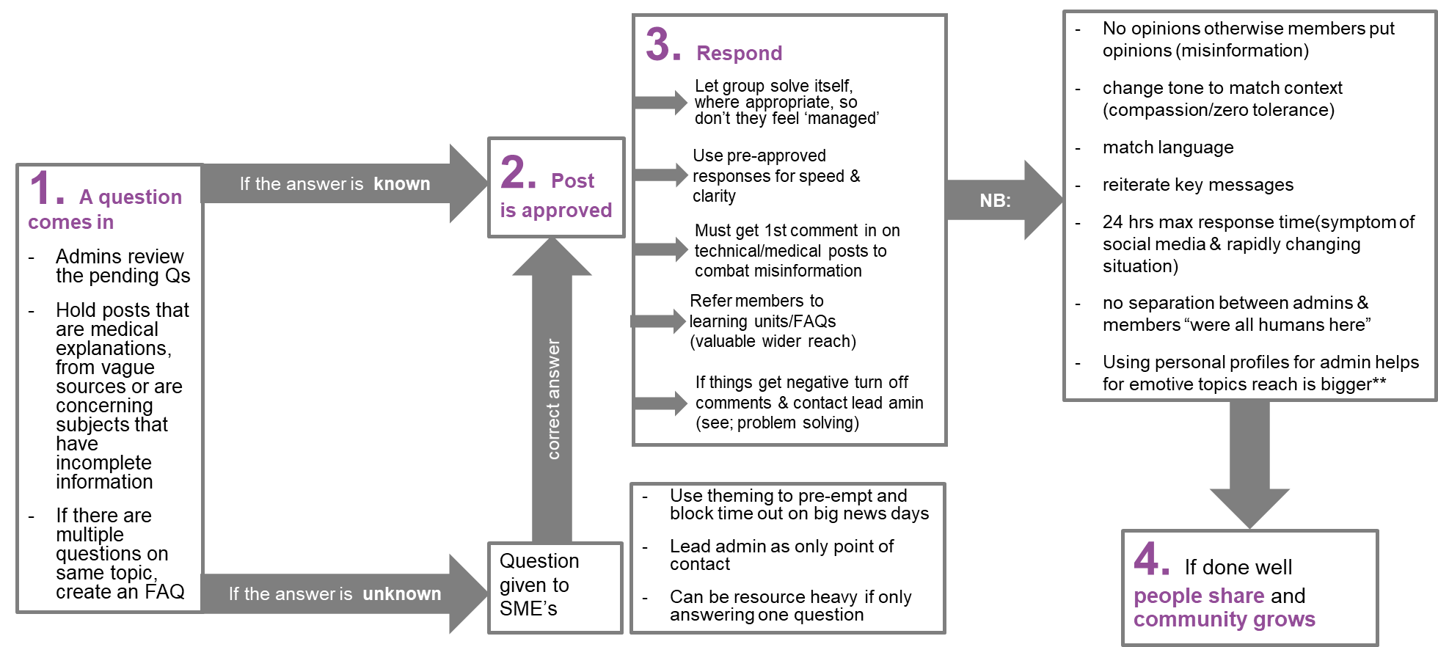
Figure 11 illustrates how the day to day activities of the group are generally managed. As previous mentioned the frequently changing nature of the Pandemic means that to an extent the group must retain a reactive approach, with forecasting and identification of likely areas of need influencing the strategic direction of the group (section 3.1).

Figure 11. Managing the ECAS group process diagram.

Problem solving.
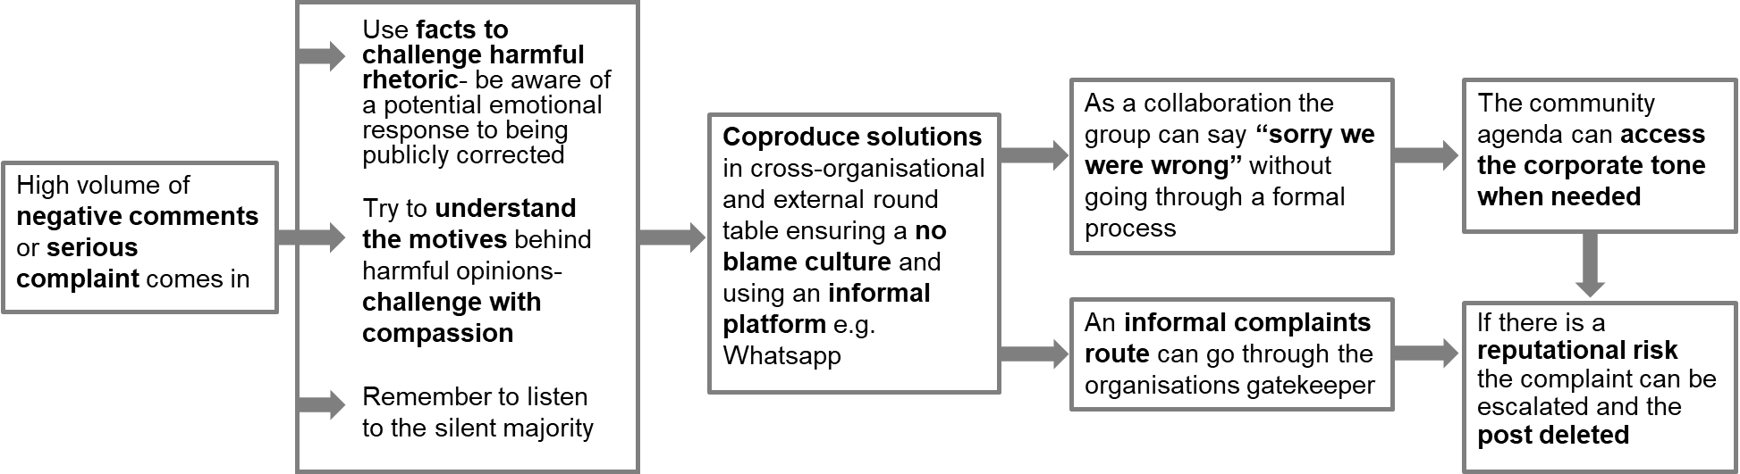
Problems and conflict are always possible whenever groups of people are involved in discussions. In addition the informal style of communications through the group, as well as the sharing of corporate messaging and service information has the potential to have unforeseen impacts. Figure 12 outlines how these issues are managed in the ECAS group. Lessons from problems and issues are reflected upon and can influence the way the group is managed. For example to mitigate corporate risk and support working relationships the ECAS Admins will share information at ECC’s corporate request but shares this content verbatim from the source and attributes the content to ECC.

Figure 12. Managing and solving problems.

Current vulnerabilities.
Risk, leading to vulnerabilities, operates at four levels in a project in this space: In the group itself, in the immediate project team, in the organisational environment and in interactions with external organisations. Table 4 captures key vulnerabilities associated with this project, their importance and how easy it would be to address them.

Vulnerability | Location | Importance | Ease of addressing
Capacity- roles are often filled by single individuals with finite capacity and competing pulls on their time. This presents a challenge for scaling the model and potential single points of failure if any team member were to be come unavailable. | Immediate ECAS project team | Intermediate | Requires commitment to resourcing and potential recruitment and training.
Protecting admins emotionally. An issue with direct messages raising safeguarding concerns or are abusive potentially leading to guilt and fear and may lead to burn out. | Immediate ECAS project team | Intermediate | Requires resources and commitment from Facebook to develop a suitable strategy.
Managing those in the organisation who are reluctant to adopt a risky, reactive approach to engaging with residents. | ECC organisational environment | High | Highly challenging- Culture change is required, continue to socialise successes and learning with wider organisation.
Relationship management with other stakeholder organisations, who may wish to use ECAS as a messaging platform for their services/messaging. | Other external organisations | Intermediate | Need consistent support and backing from ECC to channel requests appropriately to admins, and to support clarity that ECAS is not a corporate Comms channel or for broadcast comms, but for community focussed support.
Safeguarding members/ citizens when concerns are raised | ECAS community | High | Allocate appropriate resource and commitment from organisation to help address issues beyond project team remit.

Table 4. Vulnerabilities in ECAS model.

What does a community cost and create? ECAS cost effectiveness analysis and methodology.
Background.
Previous evidence has indicated that online delivery of health promotion campaigns and messages is more cost effective than television or online video-based campaigns (Allom et al., 2018). However the approach taken with ECAS does not clearly fit the definition of any particular type of public health approach. Instead it incorporates elements of a health promotion intervention, including elements of a health promotion campaign, population level health promotion and infection prevention intervention, and a digitally enabled community development project. This presents a challenge when attempting to carry out a cost/benefit or cost effectiveness analysis, as a defined evidence-based approach that could address the full scope of the intervention could not be identified from existing literature. To evaluate the costs and benefits of the ECAS model based on only one of these elements would likely result in underestimating the costs/benefits associated with each element, as well as those from the interconnectedness of the model. For these reasons it is proposed that existing evidence be drawn on and provide a layered evaluation of costs and benefits to provide a more comprehensive assessment of the ECAS model.
Financial and non-financial costs and benefits.
Within this evaluation both financial and non-financial elements may be considered as both costs and benefits. Often non-financial elements can be challenging to quantify, though some may be allocated an indicative financial value to aid comparison of costs and benefits identified. It is proposed that in this evaluation, where possible non-monetary benefits of the ECAS model may be identified using the Manchester New Economy Model (Greater Manchester Combined Authority, 2011) and the National TOMs Framework 2019 (Social Value Portal, 2017) for social value measurement.
Breadth of impact.
Costs and benefits of ECAS exist on several levels- from the individual members of the Facebook group and citizens of Essex, to the communities and organisational level. Quantifying the costs and benefits at each of these levels, including ascertaining a financial equivalent, is challenging. Though some of the elements identified may not be quantifiable or attributable to ECAS alone efforts have been made to outline the breadth of both costs and benefits anticipated to illustrate the likely breadth of impact.

Figure 13. Levels of costs and benefits.

Health promotion- evaluation against national health promotion campaigns.
One approach to evaluating the value for money of the ECAS model is to consider it as a digitally enabled health promotion campaign. This includes the broadcast communication elements of the ECAS model, where health promoting messages were shared with the members of the Facebook group and through the Facebook page, often supported by bespoke ECAS branded memes.
Attribution of impact to health promotion campaigns is often challenging, due to potential confounding influences of other campaigns and influences such as services, friends and family and other information sources. Evaluations of health promotion campaigns often attribute all quantifiable changes in the desired health outcome solely to the promotion campaign, likely over estimating impacts (Peterson et al., 2008). In addition evaluations often calculate a cost per QALY for the desired health behaviour attributed to the campaign, which may also over state benefits and discount potential other influences on the target populations behaviour, which can be both cumulative and multifactorial (MacMonegle et al., 2018). For these reasons a cost per QALY and COVID case avoidance approach has not been taken in this evaluation.
Instead the health promotion impacts may be evaluated on the following:
- Financial cost per head of target population
- Financial cost per person reached

Comparison to national media campaigns
To assess value the ECAS model has been compared to national health promotion media campaigns for COVID-19.
In June and July 2020 the Cabinet office spent in excess of £66 million on advertising, 92% of which was on COVID, a total of £60.72 million. As spend on COVID campaigns nationally were not consistent across the pandemic the two-month time period available (June and July 2020) has been compared directly with the ECAS model in order to avoid over estimation of spend. Financial costs of the ECAS model were reported as £70,000 over the first 6 months of the COVID-19 pandemic (The GovLab, 2020).
Model | Target population | Cost per head of target population | Reach | Cost per head of population reach
Cabinet office spend on COVID-19 promotion campaigns. | Whole UK population: c. 66,193,000 (Office for National Statistics, 2021)  ‬ | £1.09 for 2 months | Not reported. Estimated here at 90%, 80% and 60% of population
 |  |  | 59,573,700 | £1.02
 |  |  | 52, 954,400 | £1.15
 |  |  | 39,715,800‬ | £1.53
ECAS | Essex Residents: c.1,481,000‬ | £0.02 for 2 months | c.3, 000,000 | <£0.01

Table 5. Comparison to UK Government COVID-19 health promotion campaign.
The equivalent Scottish COVID-19 health promotion media campaign, the Scottish Government FACTS Campaign, was reported to have cost £1.61 million to create and communicate across the six months from mid July 2020 to January 2021. Comparison to the ECAS model for the same time period is documented in Table 6.

Model | Target population | Cost per head of target population | Reach | Cost per head of population reach
Scottish Government COVID-19 FACTS campaign | Whole population of Scotland: c. 5,395,000 | £0.30 for six months | 8,661,000 | £0.19 for six months
 |  | £0.05 per month |  | £0.03 per month
ECAS | Essex Residents: c.1,481,000‬ | £0.05 for six months | c.3, 000,000 | £0.02 for six months
 |  | £0.01 per month |  | <£0.01 per month

Table 6. Comparison to Scottish Government COVID-19 health promotion campaign.
In conclusion, when assessed as a health promotion campaign the ECAS model presents good value for money compared to contemporaneous national campaign models.

Comparison to a staffed service intervention.
An alternative evaluation approach, known as assessing value by comparison against a competing alternative, allows assessment of value when compared to another way of delivering the same service or outcome. The ECAS model includes both funded and volunteer admin roles/work as part of the operating model, with specific expertise in community management, social media and asset creation and community development being funded through c. £70,000 of direct payments to lead admins. The other members of the admin and support team are volunteers or subject matter experts and support staff providing support as part of their contracted service to ECC.
The ECAS admins undertake a wide range of tasks and functions including content creation, community management, query management, development scoping and engagement with members. To provide an indicative financial value of the admin time in the ECAS model admins were asked to provide an estimate of the number of hours per week spent on different task associated with the management of the group and page. Sensitivity analyses were used to provide higher and lower margins and to take into account the variation in time committed to ECAS by different Admin members (Appendix 4). This also takes into consideration the flexible nature of the role, and how demand can vary depending on national announcements and restrictions.
Indicative financial costs of paid admin time have been estimated using the national living wage for 2020/21 (Gov.uk, 2021). However it is recognised that this likely significantly underestimates the cost of resourcing a paid for model with equivalent skills and experience to those provided by current admin. Therefore estimates have also been calculated using the UK average reported salary for a social media manager (Glassdoor, 2021). It should still be recognised that the role of a social media manager does not fully encompass the roles delivered by the ECAS admin (section 3.2), though this may be considered a reasonable mainstream delivery model proxy.

Methodology for in depth multilevel cost/benefit analysis.
Methods for capturing the non-monetary benefits of the model can be applied to provide an overarching analysis of the benefits of ECAS (Manchester New Economy Model and the National TOMs Framework 2019 for social value measurement). However, information gaps can present a challenge when identifying costs and benefits and assigning a financial value.
Areas for consideration for an in-depth multi-level analysis have been captured on the attached spreadsheet, to demonstrate the breadth of factors that may be taken into consideration.

Comparison to alternative volunteer recruitment intervention.
Since its inception ECAS has been utilised by Essex County Council and its partners to recruit and support volunteers across Essex, to support vital community initiatives during the Pandemic. This has included rapid recruitment of volunteers to support the Essex Welfare Service (now Essex Wellbeing Service) in the early days of the pandemic when vulnerable residents required rapidly mobilised support to access food and medications. A large number of EWS volunteers recruited through ECAS have continued to support other residents through volunteering throughout the pandemic, completing in excess of 27,000 volunteering jobs as of April 2021. In addition more than 3,200 volunteers were recruited to support vaccination efforts across Essex, with more than 1,000 businesses and individuals being recruited within a 48-hour period.
The value of ECAS as a volunteer recruitment intervention can be assessed using the Volunteer Investment and Value Audit (Gaskin, 2011) and comparing to traditional recruitment models (Appendix 4). There are however non-financial benefits that should also be considered, including the scale and pace of recruitment and the ability to react quickly to changes in demand and needs.

Are members informed of the guidance and their rights during the COVID-19 pandemic?

Readability of ECAS content.
Background
Health information can be used to inform choice; however, it is important that information is communicated in a way that is accessible to the target audience if it is to inform capability or motivation to undertake a desired behaviour. Health information is only useful if the audience can read, understand and apply it to their own circumstances. Studies have shown that that low literacy levels are common (Department for Business Innovation & Skills, 2012, Rowlands et al., 2015). In the UK the literacy rate is 99%, meaning one person in every hundred struggles to read and write (UNA-UK, no date). Even individuals considered literate may struggle to understand written information, with one survey finding that 14.9% (or 1 in 7) of adults in England have literacy levels at or below Entry Level 3, equivalent to the literacy skills expected of a nine to 11-year-old (Department for Business Innovation & Skills, 2012).Another survey in 2015 found that 16.4% (or 1 in 6) of adults in England, have literacy levels at or below Level 1, which is considered to be 'very poor literacy skills (Organisation for Economic Co-operation and Development, 2016). Low literacy has been shown to be associated with several adverse health outcomes including knowledge, intermediate disease markers, measures of morbidity, general health status, and use of health resources (Dewalt et al., 2004, 2005). For optimum readability for the adult general population materials should aim for a reading age of 9-14 and language should be simplified as far as possible.

During the COVID-19 pandemic the general public has been asked to comprehend a vast amount of rapidly changing guidance, often including technical and scientific concepts, directing their actions as part of the national Pandemic response. Early in the Pandemic the ECAS community admins recognised that members were finding it challenging to locate and comprehend guidance, and as a result were requesting help from ECAS. It was hypothesised that the national guidance was too complex, and that a simplified version with a lower reading age would be more accessible to the general public, supporting them to undertake health protective behaviours. Previous research during the pandemic has shown that much of the general public have accessed guidance and information about COVID-19 online (Worral et al., 2020) however this information is often complex, difficult to read and understand (Lim et al., 2021; Szmuda et al., 2020; Worral et al., 2020).

As part of the Health Promotion element of the ECAS approach national and local guidance was frequently simplified into FAQs and short statements that admins could use when answering members questions or signposting. The readability of this content has been assessed against the corresponding guidance.
Methodology

Readability assessments of ECAS guidance and the related Government guidance were conducted using an online readability checker tool. This tool calculates the number of sentences, words, syllables, and characters from a sample of text submitted online, using the sample to assess readability using seven validated readability formulae. These readability formulae provide an assessment of the reading age/ level of the sample text.

The text for each piece of communication material/guidance was submitted to the readability checker tool. Each piece was assessed individually. Any foreign language words were excluded prior to conducting the readability assessment, to ensure comparability. ECAS materials have been compared to the corresponding Government guidance that was available when the ECAS materials were produced. This therefore does not take into account subsequent amendments that may have impacted readability.

Readability results
Table 7 shows a summary of the readability of ECAS guidance and the related Government guidance. See Appendix 5 for full results.
The results of the readability assessments demonstrate that the readability of both ECAS guidance and UK Government guidance is variable. When producing guidance a balance must be struck between readability and preserving accurate scientific information, some of which involves more complex scientific terms which may impact readability. However, the ECAS guidance was universally more readable than the corresponding government guidance, with a reader age range from 12-15 compared to the Government reader age range of 15-college graduate aged. Overall ECAS content had an average reading age of at least two years and up to in excess of 10 years lower than the corresponding Government guidance (Table 8).

Material | Readability score
 | Reading level | Readers age
ECAS Bereavement and funerals (28th April 2020) | fairly difficult to read | 14-15
COVID-19: guidance for managing a funeral during the coronavirus pandemic (19th April 2020) (Gov.uk, 2020a) | very difficult to read | College graduate (>22)
ECAS Domestic violence FAQs and resources (24th April 2020) | fairly difficult to read | 13-15
Guidance Domestic abuse: how to get help (11th April 2020) (Gov.uk, 2020b) | fairly difficult to read | 15-17
ECAS Coronavirus testing FAQs and resources (29th April 2020) | standard / average | 12-14
Guidance Coronavirus (COVID-19): getting tested (28th April 2020) (Gov.uk, 2020c) | very difficult to read | College graduate (>22)
ECAS Coronavirus testing FAQs and resources (19th June 2020) | standard / average | 14-15
Guidance Coronavirus (COVID-19): antibody tests (22nd May 2020) Gov.uk, 2020d) | difficult to read | 18-19
ECAS Support Bubble Guidance (11th June 2020) | fairly difficult to read | 14-15
Guidance Meeting people from outside your household (10th June 2020) (Gov.uk, 2020e) | fairly difficult to read | 18-19

Table 7. ECAS and UK Government COVID-19 guidance readability assessment results.

Topic | Readability score
 | ECAS | UK Government | Difference
Bereavement and funerals | 14-15 | College graduate (>22) | >8 years
Domestic violence | 13-15 | 15-17 | 2 years
Coronavirus testing (April 2020) | 12-14 | College graduate (>22) | >10 years
Coronavirus testing and antibody testing | 14-15 | 18-19 | 4 years
Support bubbles and meeting people from outside your household | 14-15 | 18-19 | 4 years

Table 8. Difference in ECAS and UK Government COVID-19 guidance readability.

In addition to providing COVID-19 guidance in a more readable way the ECAS approach has the additional benefit of being an interactive format for sharing health promoting messages. Unlike the Government guidance and traditional broadcast health promotion campaign approaches ECAS allows users to ask for clarification on the guidance, and an opportunity for services to incorporate local and national guidance in one accessible place. This additional element supports users in their comprehension of the information shared and increases the targeting of messages. Combined with the ability to bring together and share relevant local links and resources, the ECAS model targets multiple elements of the COM-B model for behaviour change, supporting users to engage with, understand and apply the guidance shared.

In conclusion, the use of social media provides an opportunity to provide health promoting information in an accessible way that can be targeted to address the audience’s needs. However, content must be written in a style that is suitable for the audience and a social media format. The following specific actions are recommended when producing public facing content in order to increase readability:

- Assess the readability of draft content using validated tools in order to identify areas for improvement.
- Test materials with members of the general public and ask for feedback.
- Reduce the number of multisyllable (>2 syllables) words where possible.
- Reduce the length of sentences where possible.
- Use shorter words where possible.

Survey results: Inform.
Results of the ECAS surveys conducted indicate that ECAS is successfully seen as a source of correct, up to date, trusted information (see Appendix 6 for full results). 91% of members feel ‘informed about the national coronavirus guidance” with the majority of participants demonstrated a good level of understanding when asked questions about medical and guidance aspects of COVID-19 (Figure 14). understanding remained fairly constant across both surveys .Survey questions were selected based on the topic’s significance and an anecdotal assumption of level of associated misinformation. The greatest confusion appears to be around the use of face masks/coverings which appears to stem from a misunderstanding of exemption rules rather than an issue of non-compliance.
Misunderstanding over when to wear face masks/coverings is anchored in the belief that everyone should wear masks/coverings, indicating a lack of clarity over exemption rules rather than an issue over non-compliance. Broader studies into this area (Mills et al., 2020) suggest that the UK public accept that masks/coverings reduce transmission of COVID-19, but uptake on mask/covering wearing is dependent on:
- Understanding of the virus and perceived personal risk
- Trust in experts and government
Confusion over when to wear masks/coverings are likely to stem from unclear policies and changing information throughout the pandemic.
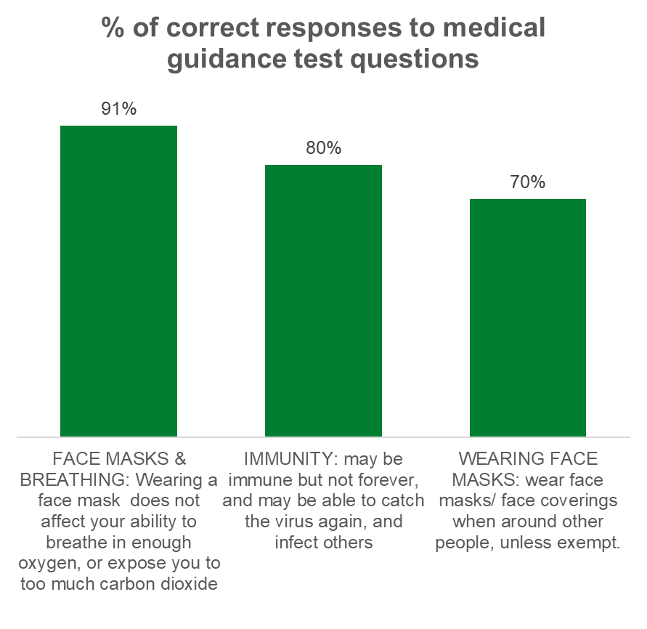

Figure 14. Survey answers to questions asking participants to identify correct guidance.
Responses indicated that ECAS is a trusted source of information which cuts through changing and confusing messages. Feedback from users included:

“Good way to get reliable information, as not many people knew what was going on in the world. Legit and trustworthy”

"consistent branding of the ECC logo is important in highlighting that his is a reliable source of information".

“Helped to understand the guidance better. Govt. guidelines can be a bit ambiguous and not user friendly”

The majority of respondents said ECAS helped them to understand the introduction of new rules and/or government easing. ECAS seen as an informative source (Figure 15) due to the following factors:

- Accessible and user-friendly information.
- Helps to clarify local restrictions and government guidance.
- Uses ‘laymans’ language which helped cut through confusing messages.
- Trusted information from a reliable source.
- Uses scientific evidence to support advice and guidance.
- Branding with ECC logo is important in highlighting that information is reliable.
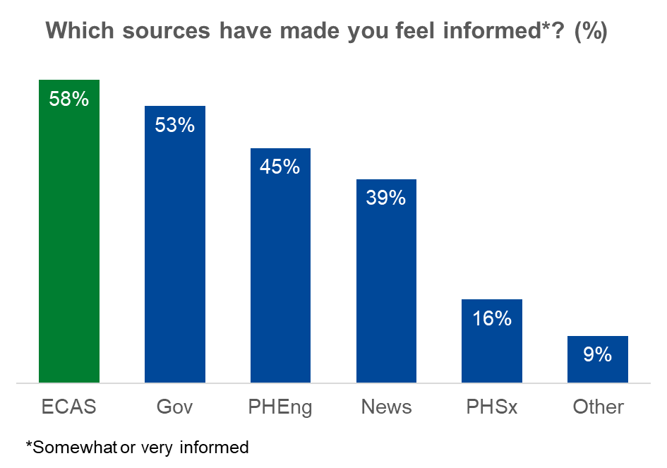

Figure 15. Sources of COVID-19 information that respondents reported helped them feel informed.
The ECAS Admins are integral to embedding this trust (Figure 16). Respondents viewed Admins as a trusted source of information, providing messaging in a clear and concise manner. They are viewed as “positive” and “create a friendly online atmosphere”, handling negative and unreliable comments professionally. It is theorised that Admins are likely to benefit from the ‘authority effect’ through affiliation with ECC, as the public generally have more trust in the local authority over national government, even during the pandemic (Essex County Council, 2021).

“There has been a lot of distrust of the government during the pandemic, people think local authority has your best interest at heart so may trust it more”

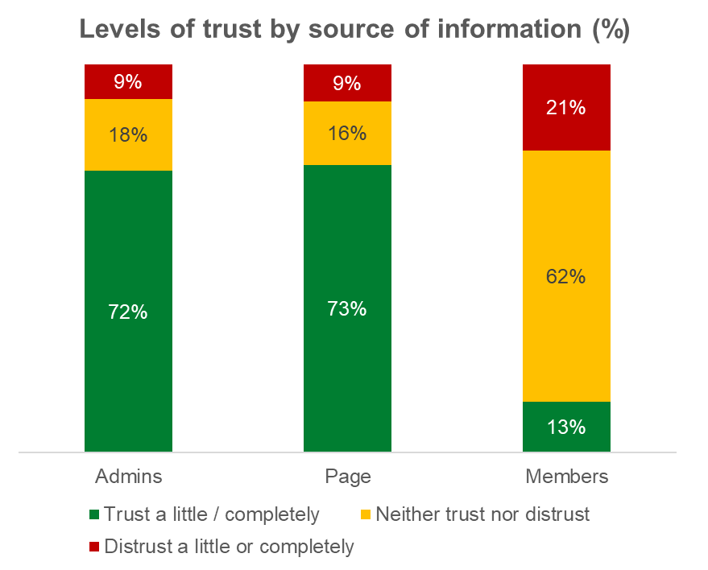

Figure 16. Sources of trusted information in the ECAS approach.
Responses to the surveys highlighted that members need to be carefully managed to maintain the credibility of ECAS while fostering engagement. This was also reflected in the advice respondents reported they would give to new members, focusing on distrust of comments not posted by admins (Figure 17).

Some respondents mentioned that incidences of ‘negativity’ from other members can be off-putting, and there is a risk that over time the negative comments that have been posted may alter the site, with the group becoming negative and judgemental. This could have a detrimental impact and lead to the misinterpretation of important key messages. To negate this many felt that the comments section needs stringent monitoring, in addition to the current Admin reminders of the supportive and kind ethos of the group.

Survey respondents felt that information on the group/page also needs to have a clearer focus towards COVID-19 related issues and not digress into other non-related subject matter. This can cause a lack of trust as some members input is evidently not based on scientific fact. Concerns relating to the negative or incorrect comments, particularly in relation to scientific or government guidance, have prompted some people to leave the group. Admins are cited to do well at ‘shutting this down’, but as ECAS evolves and member engagement is encouraged, an ‘admin system’ to monitor activity needs to be considered to maintain credibility of information and guidance posted. The small minority of negative advice was rooted in a distrust of local authorities and central government or those who did not like the humorous messaging.

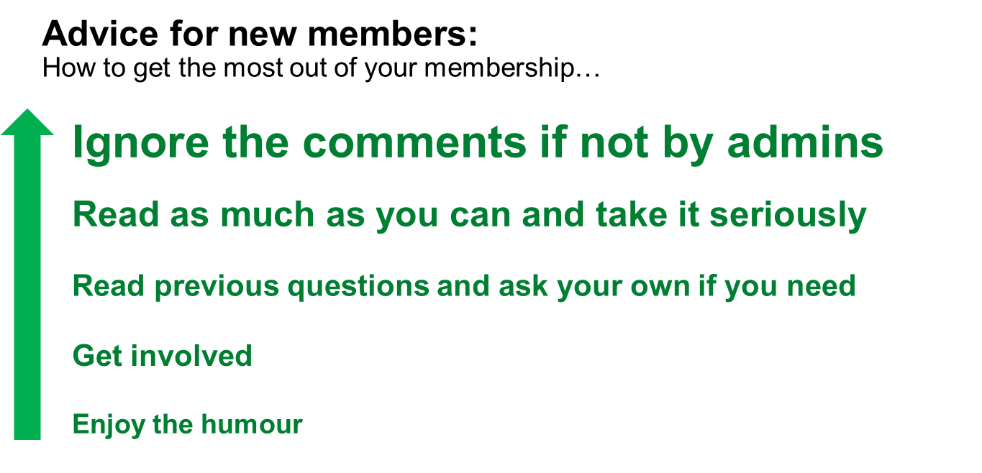

Figure 17: Survey respondents’ advice for new members on how to use the ECAS group.

Does the digital community help in improving mental and physical wellbeing outcomes?

Phase 1 of the evaluation sought to identify areas where ECAS users reported impacts on their health and wellbeing. This evaluation question will also be further explored, using mixed methods, as part of the second phase of the evaluation, along with exploring the evolution and development of ECAS as a digital community.

Survey results: Prevent.
Respondents reported being largely compliant with COVID-19 guidance, but ‘strictness’ of their resolve appears to wane over time. Though not directly comparable, self-reported compliance from ECAS members appears higher compared to the UK with 73% of respondents reporting following the rules completely / nearly all the time (Ipsos MORI, 2021). As the level of compliance is self-reported this may be subject to self-reporting biases.
The ECAS community focus on clarity of information and scientific evidence naturally tackles some broader well-reported issues of COVID-19 compliance, including:
- Lack of trust in Government.
- Lack of clarity in communication.
- Uncertainty of prolonged situation.
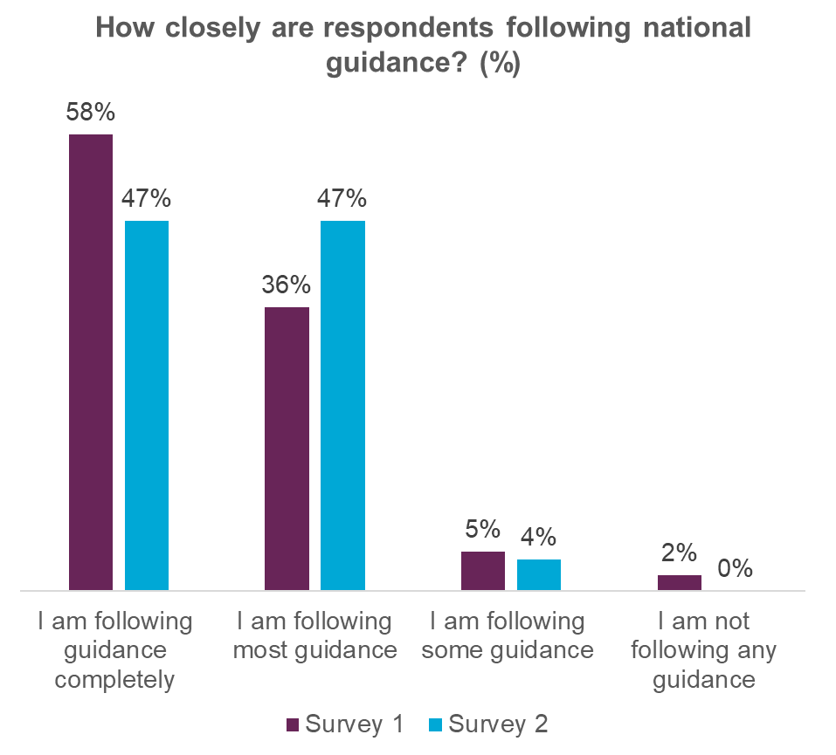

Figure 18: Survey respondents’ compliance with national COVID-19 guidance.

There was an indication that members may ‘pick and choose’ which guidance is followed, with few being fully compliant to all rules and only 30% reported taking all precautions listed. This dropped to 7% in the second survey, though this may not be representative due to the small sample size of the second survey. Activity options in the survey reflected guidance during the 1st national lockdown and were updated for the second survey.
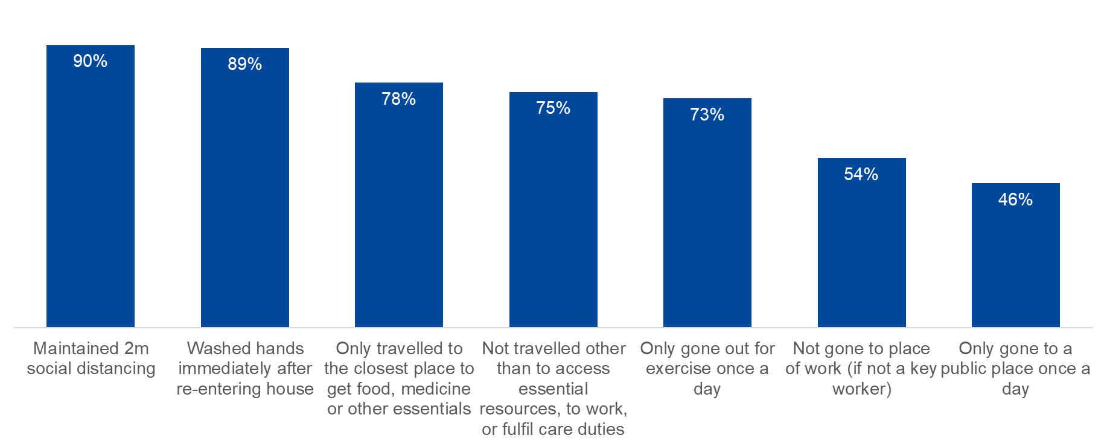

Figure 19. Self-reported compliance with specific guidance activities.
From the survey results membership or use of ECAS is perceived to have an impact on behaviour, with self-reported claimed behaviour change. ECAS has proved to be a useful source of information for members, and in developing member/user capability to undertake health protective behaviours. However, as explored in section 3.1 this is only one element driving behaviour change, along with motivation and opportunity (Michie, van Stralen and West, 2011; West and Michie, 2020).
The level of engagement with ECAS is not static, appearing to fluctuate in line with government announcements and changes. It is likely that patterns of use will further evolve with time as the Pandemic progresses and the UK experiences any further waves or lockdowns.
The observed drop in perceived influence in the 2nd survey could be attributed to external factors, such as less of a need to change behaviour, as by survey 2 as members grow ‘used’ to lockdown conditions and some of the ‘unknowns’ have already been answered. Alternatively it may be due to a growing apathy and fatigue toward the topic of COVID-19 in general.
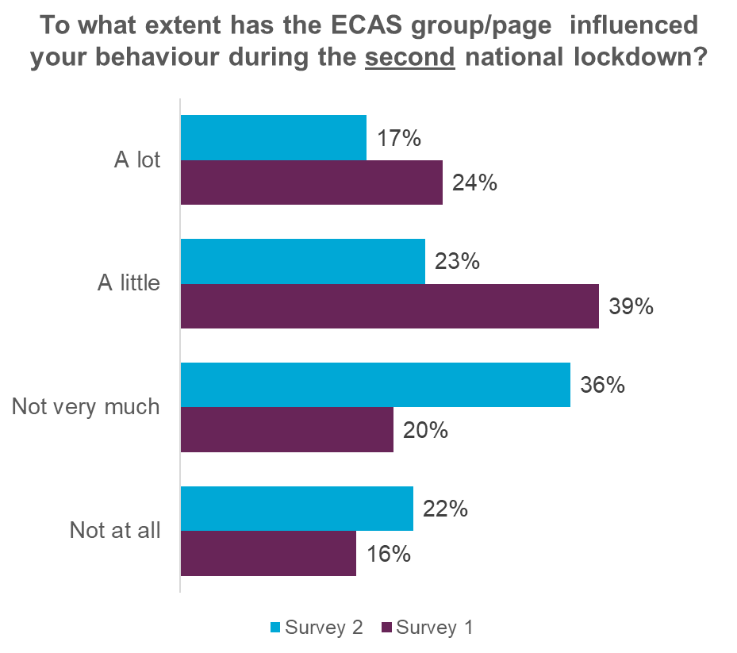

Figure 20. The influence of ECAS on behaviour.
ECAS was viewed by respondents as a source of clear, concise, trusted information cited to prevent confusion, thus encouraging compliance. It was noted that the goals of ‘Inform’ and ‘prevent’ can be intertwined, demonstrating the impact of information on capability and behaviour. Interviews highlighting that users were able to follow new rules/government guidance due to both clear and concise information, which avoids confusion and up to date information that is easy to follow effectively.
"The infographics have been really useful, rather than chunky links. Especially compared to government guidance. Local pages simplified it better than government guidance."
Additionally, the successful relaying of information could have had wider benefits beyond members. Some participants cited being able to advise family members and friends on correct guidance as a benefit.
"Shares information with family members and close friends and in doing so, made it easier to follow the guidance."

The strongest reported motivator of respondents’ compliance with guidance was health, both personal and for respondents’ families. Tapping into this motivation in messaging and content may increase user engagement.
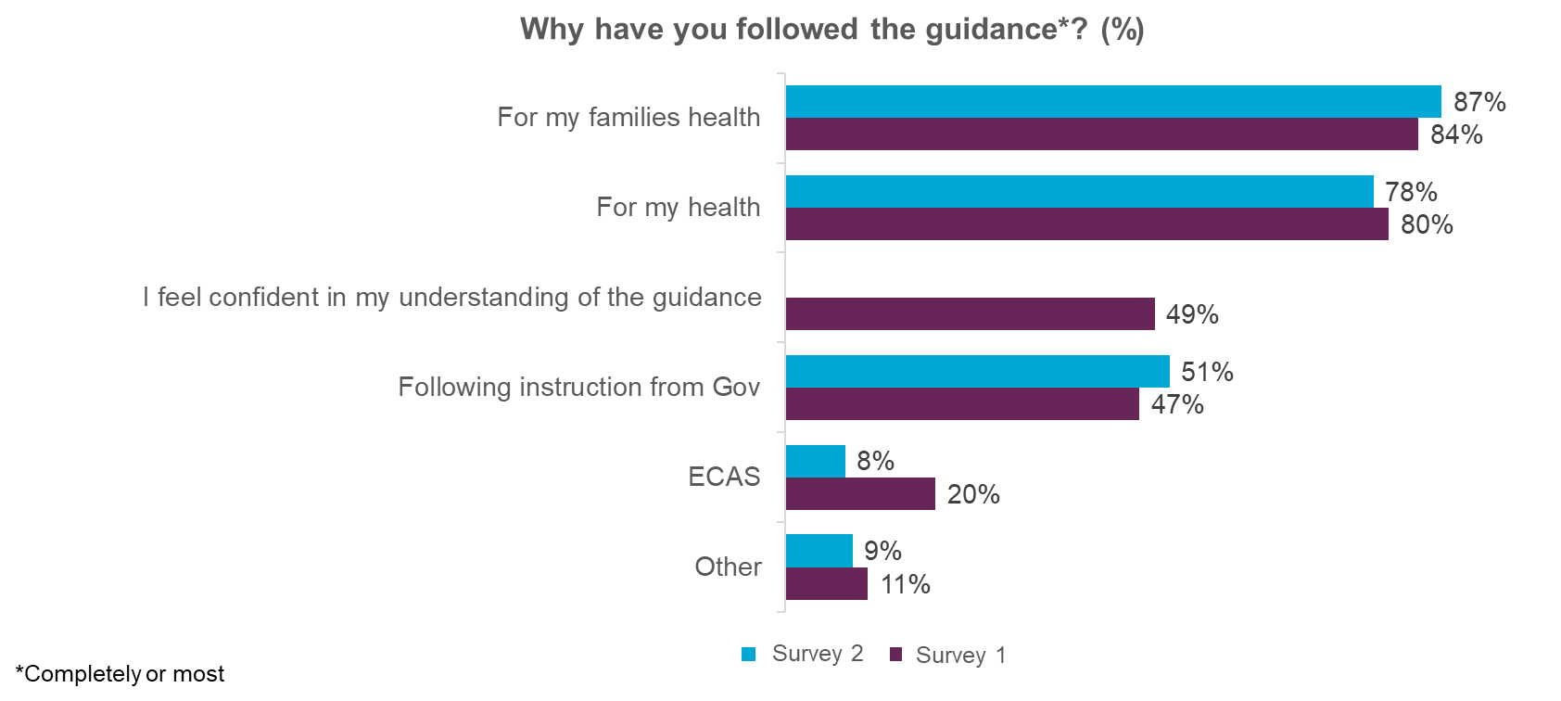

Figure 21. Respondents’ self-reported motivations for following COVID-19 guidance.

Survey results: Assist.
As may be expected personal relationships and gov.uk are the most commonly reported sources of help during the COVID-19 pandemic. Positively, 43% of respondents would feel comfortable contacting the ECAS group/page for help should they need it, demonstrating the perceived value of ECAS as an additional source of support and help. This rose to 63% in the second survey.
43% of respondents in both surveys would feel comfortable contacting EWS for help, though 20% of respondents in the second survey had not heard of EWS (this may not be representative due to small sample size of the second survey).
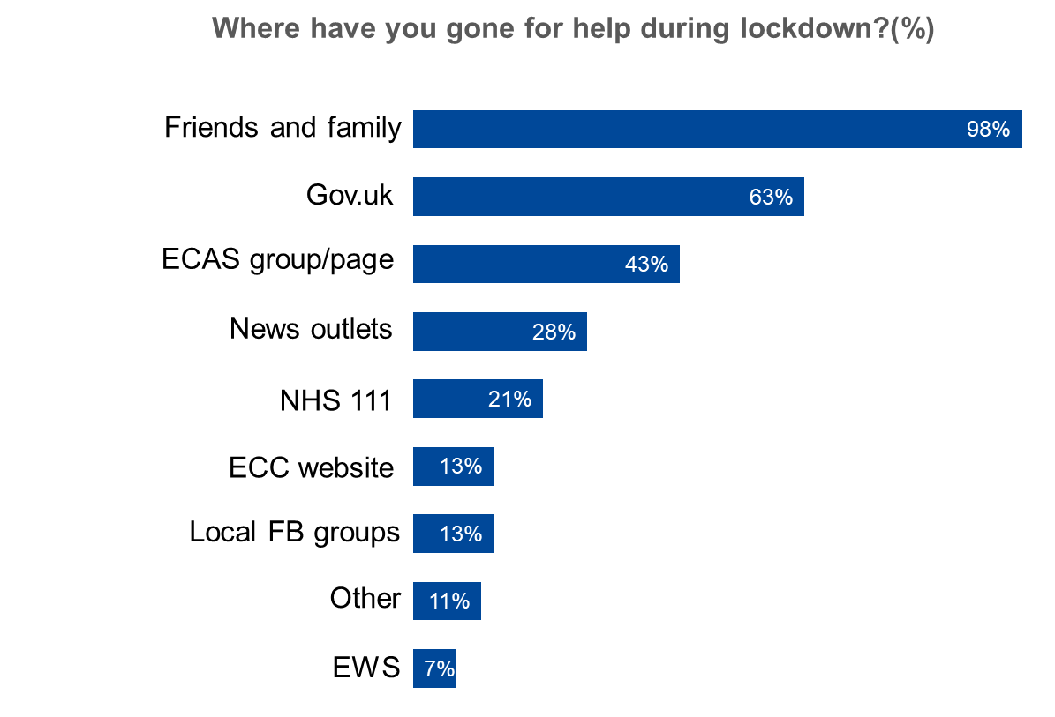

Figure 22. Sources of help accessed by survey respondents during COVID-19.
When asked about health-related activities the surveys showed that there has been shift toward respondents doing less exercise after lockdown. Only a small minority have used the ECAS group/page for suggestions about physical exercise (4%). Of those who had, the majority received them from the page itself and found them to be somewhat or very helpful. The State of Life survey (Essex County Council, 2021) demonstrates that self-reported ‘inactivity’ began to increase around the time of the ECAS surveys, reaching a peak in Feb 2021 where 55% of Essex residents report to be inactive vs. 34% active. This suggests that physical activity became less of a priority as lockdown continued.
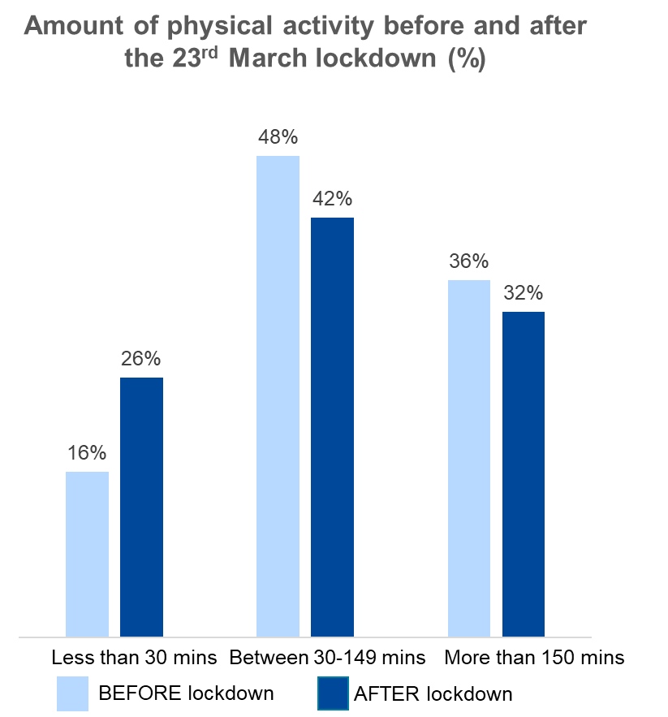

Figure 23. Respondents’ self-reported physical activity levels.
The majority of survey respondents did not report using ECAS for mental health or emotional wellbeing support, despite Essex residents on the whole worrying about mental health (Essex County Council, 2020b). Only a small minority had used the ECAS group/page for mental health or emotional wellbeing support (4%). However this does not take into account benefits to mental health and emotional wellbeing that of which members may not be consciously aware. Due to limitations of this evaluation it was not possible to test this hypothesis with a comparator group of residents not using ECAS.
Of the respondents that had used ECAS for mental health or emotional wellbeing support the majority received them from the page itself and found them to be somewhat or very helpful. The majority of survey respondents (77%) do not receive any official support for their mental health or emotional wellbeing.

Qualitative interviews outlined some examples of how ECAS has been used as a mode of support. Families have been able to source help in local communities for residents requiring support during the Pandemic.
“I used the group to ask other members about transport to and from the hospital and a carer who was on ECAS offered to help drive her father to the hospital."
An interviewee who lived 80 miles away from her older Father.
Use/ membership of ECAS may also help to give citizens confidence to go outside and interact with the community in a safe way.
"Gave her confidence because she has an autistic son who is medically viable to not wear a mask. Page gave her guidance on where to get a pass to say he is medically exempt."
An interviewee with friend who has an autistic son.
To assist users in the future, it is recommended that every member is encouraged to be able to voice an opinion/concern, as some respondents shared that they were cautious not to cause negativity.
"Cautious not to always post/comment as she doesn't want to be controversial. Sometimes negativity can come from it".
Respondents also felt that that repetition of questions was frustrating and discouraged engagement, but they did praise the Admins for keeping this to a minimum.

Does ECAS foster a real sense of belonging and promote community assistance?

The results of the surveys indicate that ECAS serving to ‘inform’ members/users, but more is required to be an effective digital community. To create a sense of community members need to feel more connected and engaged. 41% of respondents felt that a sense of community was important or very important to them (Figure 24). This dropped to 35% in the second survey (may not be representative due to small sample size of second survey).

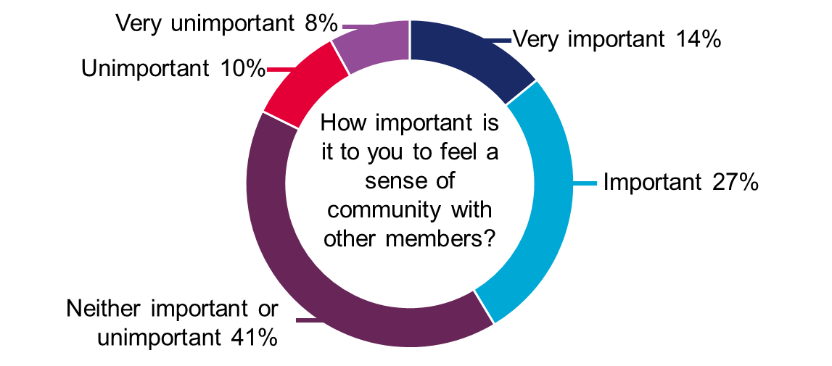

Figure 24. Importance of a sense of community within ECAS.
The Sense of Community Index (Community Science, 2007) is the most frequently used quantitative measure of sense of community. It is considered a strong predicator of behaviours and is a valid measurement instrument. Sense of community is measured over 4 domains: reinforcement of needs, membership, influence and shared emotional connection. Each of these domains is split into 6 questions and scored out of five. The higher the score the stronger the sense of community.
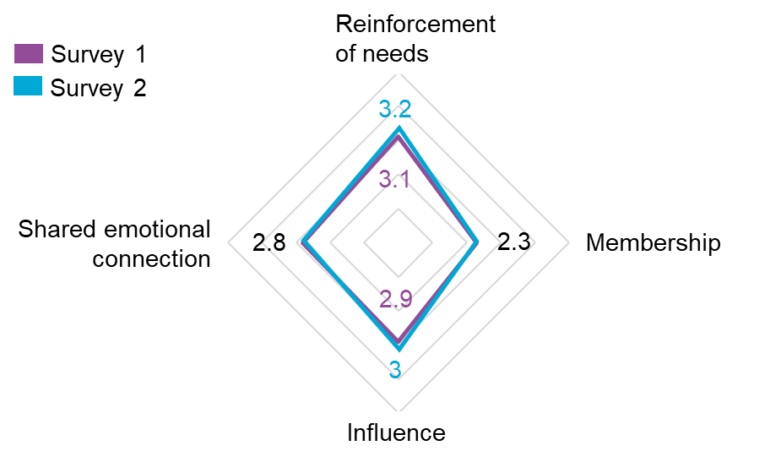

Figure 25. ECAS sense of community index results.

Reinforcement of needs.
There was little change in this indicator over the two surveys.
ECAS works well at meeting needs but is not seen as an ‘open forum’. As a next step continuing to work on facilitating peer-to-peer support within the community may address this. Members are an asset that can help relieve the pressure on the Admin role, e.g. by creating expert members.
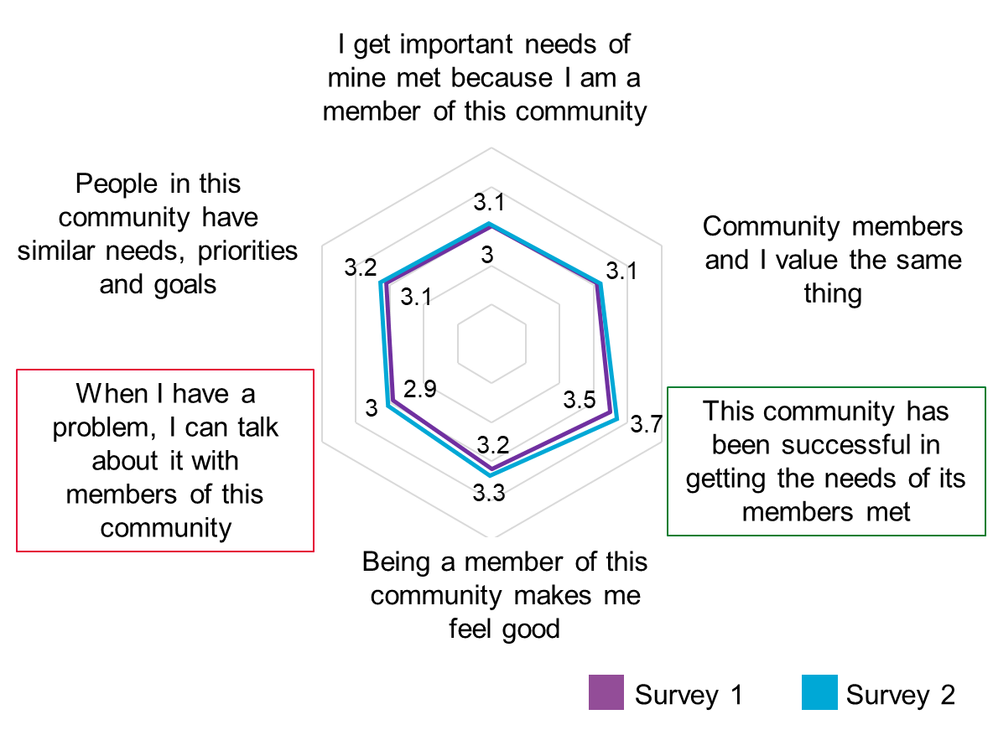

Figure 26. ECAS sense of community: reinforcement of needs.

Membership.
There was little change in this indicator over the two surveys.
Membership showed the most room for improvement as a domain. This suggests that greater engagement as ECAS evolves should be a priority, with a focus on fostering a shared sense of responsibility for members. It will be important to strike the right balance between member and admin led content and responsibilities in order to maintain trust and quality.
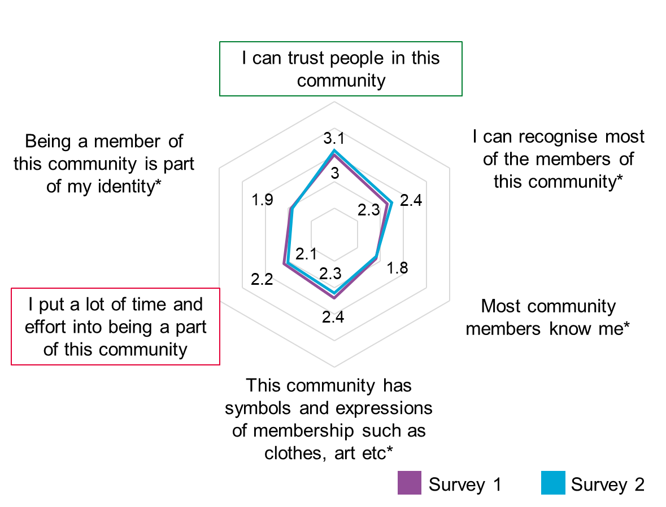
*The low scores in this section may be because of the subject of ECAS, the restrictions of the coronavirus pandemic and that some elements of a community do not translate well onto a solely digital platform.

Figure 27. ECAS sense of community: membership.

Influence.
There was little change in this indicator over the two surveys, although ‘this community has good leaders’ did see an increase.
Trust in admins was apparent from responses, but there is scope for more member involvement. Developing a way to allow members more control and influence without compromising the validity of the information on ECAS would be a valuable next step. A sense of shared influence is an important difference between an information portal and a community.

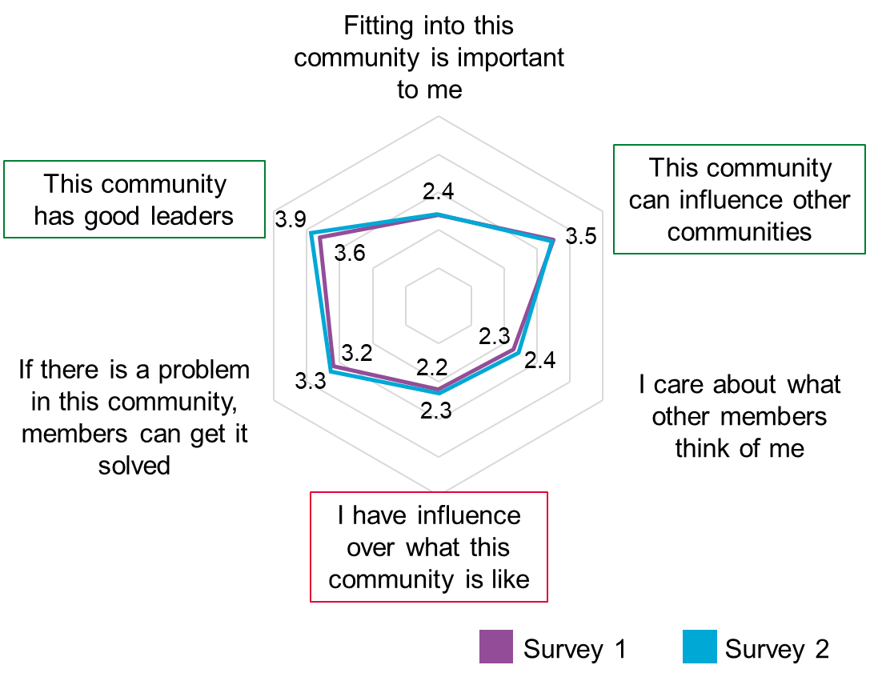

Figure 28. ECAS sense of community: influence.

Shared emotional connection.
There was little change in this indicator over the two surveys.
Respondents expressed a desire for ECAS to ‘have a future’ but the members appear to lack real connection that will drive this. To address this it will be essential to find out what is important to members and to use this to encourage and build a sense of purpose for them. Fostering members care for each other and the community will help to increase its strength and ECAS’s development as a digital community.
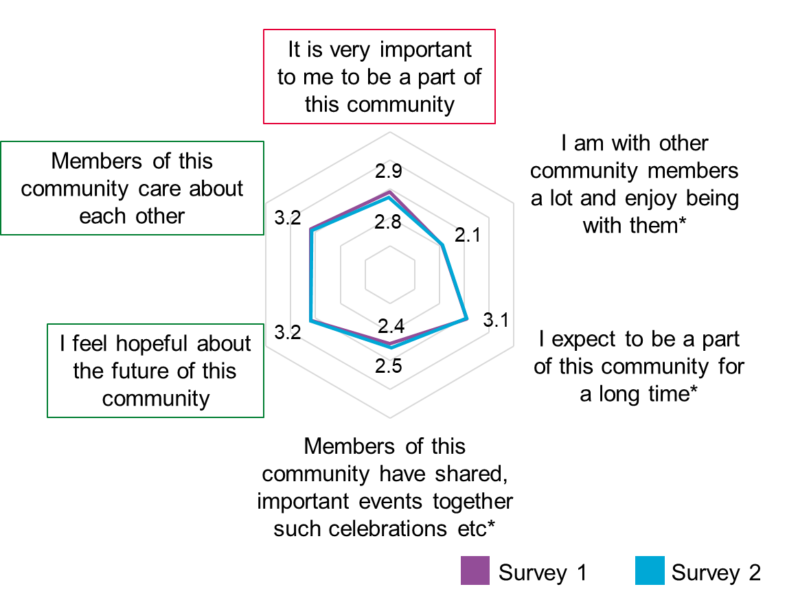

Figure 29. ECAS sense of community: shared emotional connection.
ECAS members have shown that there is an appetite for an ECAS community, but uncertainty exists over which direction it should take. COVID-19 will likely be around for the foreseeable future and continue to impact on Citizens’ lives and some members expressed a desire for ECAS to remain a source of information with an evolving focus.
Respondents identified the following topics as potential areas of focus in the future:
- Heath, and future vaccinations and long COVID-19
- Impacts on mental health
- Emotional, mental and financial support as a result of COVID-19, including as a potential link with EWS
- Localised information
Suggestions for improving ECAS included improving the filtering of duplicated content and processes to ensure the same question is not repeated in a short time period.
“Will definitely stay as a member, would be nice to still be part of this virtual community.”
The different prevalence of issues and impacts of COVID-19 across Essex creates an opportunity, and apparent appetite for further localism within the ECAS approach. This can be characterised as scope to create ‘a community within a community’, with volunteers in the local area to help, and engage with the community. Local communities need to have an aim, drive togetherness, engagement and community cohesion, and can build on the sense of community from the first lockdown.
“Depends on the directions it takes.. If changed into a community based page then would stay”

Conclusions and recommendations

The creation and implementation of the ECAS approach has entailed a large amount of work from ECC staff, community Admins and members of our communities. Over the course of 2020/21 a huge amount of development and growth occurred, using learning from previous digital communities’ work in the area to create a flexible user focussed approach to supporting communities in Essex during COVID-19. To date ECAS has successfully demonstrated value for money as a health promotion campaign approach and supported members in informed decision making during COVID-19. While further development is needed to move towards creating a robust and self-supporting and self-sustaining digital community learning from work to date can be used to support needs in other areas. The team, their skills and the ways of working are the heart of the ECAS approach. The following recommendations can be considered in order to build on and strengthen work to date:

R1: Maintain flexibility in the ways of working in order and an appetite to risk innovative working in order to respond to changing circumstances and community needs.
R2: Increase Admin capacity to increase flexibility, cover and resilience. This requires commitment to resourcing and potential recruitment and training.
R3: Use learning about the team characteristics and skills identified to inform skills and values-based recruitment for similar projects and increasing Admin capacity for ECAS.
R4: Identify gaps in the knowledge of the admin team to allow for more effective delegation of posts e.g. housing. This could come in the form of a call to action to the community with the secondary benefit of encouraging a sense of community and shared responsibility between admins and members.
R5: Ensure robust relationship management with other stakeholder organisations, who may wish to use ECAS as a messaging platform for their services/messaging. This requires consistent support and backing from ECC to channel requests appropriately to admins, and to support clarity that ECAS is not a corporate Comms channel or for broadcast comms, but for community focussed support.
R6: Safeguarding members/ citizens when concerns are raised Allocate appropriate resource and commitment from organisation to help address issues beyond project team remit ensure all Admins have basic safeguarding training and can escalate potential safeguarding concerns.

General learning and recommendations from survey responses:

R7: Take a harder line on ‘conspiracy’ theorists by revoking their membership.
R8: Promote local groups that can cement the ‘community’ feel.
R9: Extend the blanket of support to include ‘secondary’ help such as transport times for those whose only access to amenities is public .
R10: Make the invaluable training units available to those not members of the group.
R11: Add a private message capability to allow those not confident enough to post on the main feed to receive help and guidance. This would require resourcing and appropriate safeguarding for Admins. An alternative is to make it known to members, such as through the membership rules and guidance, that they can submit a post with a request for a private response, as all posts are reviewed by Admins ahead of approving for the page.
R12: Continue work to promote the visibility of the page/group.
R13: Increase reach for those who live on the London/Essex border.
R14: Identify the admins more clearly so readers know where the ‘official’ line is in the comment sections. This could be achieved with Admin profiles and pictures pinned on the group, or as an accessible module.
In addition four potential areas for development were noted in member responses to the evaluation surveys. As ECAS continues to develop and we plan for a world after the COVID-19 Pandemic it may be useful to consider the following learning and recommendations (R) from the first evaluation phase:

- Tone.

Feedback on tone was mixed. Some respondents felt that the messaging strategy over time became too unprofessional, patronising and clouded the message. Some felt it appeared opinion based and promoted judgement between members.
R15: While the tone has changed over 2020/21, reflecting changing needs, this should be carefully balanced between humour and more serious or supportive posts.
R16: Posts requiring specific expertise or directive communications, such as urgent Public Health messages, can be attributed to public facing SMEs to maintain a more serious tone to specific messages.
- Comments sections.
Many respondents felt that the comment sections needed to be monitored more closely, and that at times the dynamic in the comments sections of posts had become negative, judgemental and potentially damaging to the core messages.
R17: Recruit and train validated expert members. Create a formal pathway for expert members to become pseudo-admins relieving resource pressures and utilising an effective way to influence members e.g. one-to-one training with admins, training modules.
R18: Release a statement based on community standards explaining when and why members will be muted or membership revoked. Ensure members know that persistently rude or antagonist members, including those who maliciously target admins, will be addressed.
R19: Foster peer-to-peer connection to try and make the group less admin dependent. Begin with posts focusing on getting to know members e.g. share something you’re proud of, something that has kept you busy, guest posts.
- Clear Focus.
The sharing of information not relevant to core coronavirus messaging and support was felt, by some, to be ‘capitalising’ on the audience size and self-promotion.
R20: Use COVID-19 focused reasoning when presenting information from other sources in order to tap into member motivations. For example:
- Essex is Smoke free: better health means a better chance of recovery from COVID-19.
- Active Essex: it’s hard to exercise during lockdown, use this timetable to fit around your other responsibilities (e.g. work/childcare), better health means a better chance of recovery.
- Essex is Green: Looking forward to recovering after the pandemic, we can build back better.
R21: Give Public Health colleagues space to share content on a broad range of health and wellbeing outcomes. This will require dedicated Public Health resource with a long-term commitment which could be managed by a rota of guest posts. This can support a gradual and legitimate shift from COVID-19 content for continuation after the Pandemic.
- Layman’s terms.
Some asked admins to continue to recycle the guidance into layman's terms alongside providing the official documents. The readability assessments carried out in the evaluation demonstrate that simplified content for ECAS is more likely to be readable than national guidance for a larger proportion of the general population.
R22: Formalise a consistent internal support for this offer, it is resource intensive and needs to be factored into work planning to allow admins to continue with their original objectives.
R23: Delegate straight information sources and communication messages to the appropriate platforms. Foster the relationship between corporate comms and the communities team to be able to differentiate between broadcast communications and engagement, this will allow the communities team to dedicate the majority of resource to recycling guidance and fostering engagement.

Next steps

The learning from this evaluation has been fed into the second evaluation phase. This mixed methods evaluation will be conducted from March 2021 to January 2022 by the London NIHR PHIRST team (Appendix 2). The research questions for the second phase of the evaluation have been developed through three collaborative sandpit development sessions with the ECAS team and the London NIHR PHIRST team. The project will aim to evaluate ECAS via the following questions:
- How effective is a digital community development approach during a pandemic?
- Was the ECAS digital community development approach successful in achieving improved health literacy, protective health actions and community connectedness and mutual aid?
- Was the ECAS digital community development approach successful in achieving whole system change for the public health function?
- What factors were important in contributing to the outcomes?
Outputs from this phase of the evaluation will be disseminated by the London NIHR PHIRST team.

References
Allom, V., Jongenelis, M., Slevin, T., Keightley, S., Phillips, F., Beasley, S., Pettigrew, S. 2018. Comparing the Cost-Effectiveness of Campaigns Delivered via Various Combinations of Television and Online Media. Front Public Health. 2018 Mar 23;6:83. doi: 10.3389/fpubh.2018.00083. PMID: 29629366; PMCID: PMC5876296.
Belbin, M. 1981. Management Teams. London; Heinemann. ISBN 978-0-470-27172-8.
BELBIN Associates, no date. The Nine Belbin Team Roles. Available at https://www.belbin.com/about/belbin-team-roles
Community Science. 2007. The Sense of Community Index. Available at: https://www.senseofcommunity.com/soc-index/
Department for Business Innovation & Skills. 2012. The 2011 Skills for Life Survey: A Survey of Literacy, Numeracy and ICT Levels in England. Available at https://assets.publishing.service.gov.uk/government/uploads/system/uploads/attachment_data/file/36000/12-p168-2011-skills-for-life-survey.pdf
Dewalt, D.A., Berkman, N.D., Sheridan, S., Lohr, K.N., Pignone, M.P. 2004. Literacy and health outcomes: a systematic review of the literature. J Gen Intern Med. Dec;19(12):1228-39. doi: 10.1111/j.1525-1497.2004.40153.x. PMID: 15610334; PMCID: PMC1492599.
DeWalt, D.A., Pignone, M.P. 2005. Reading Is Fundamental: The Relationship Between Literacy and Health. Arch Intern Med. 165(17):1943–1944. doi:10.1001/archinte.165.17.1943
Eby, K. 2019. The Essential Guide to PDSA: Models, Worksheets, and Templates. Available at: https://www.smartsheet.com/content/plan-do-study-act-guide
Essex County Council. 2020a. Harnessing the power of communities during COVID-19 in Local Government. Available at https://www.linkedin.com/posts/essex-county-council_harnessing-the-power-of-communities-during-activity-6648569524255891457-VKQQ/
Essex County Council. 2020b. Residents survey 2020. Available at: https://data.essex.gov.uk/dataset/e7djq/residents-experiences-through-covid19-2020
Essex County Council. 2021. State of life survey. Available at: https://data.essex.gov.uk/dataset/ep5lg/state-of-life-survey-dashboard
Gaskin, K. 2011. VIVA: the volunteer investment and value audit. Available at https://www.bl.uk/collection-items/viva-the-volunteer-investment-and-value-audit
Gilbertson-Urtel, N. 2018. 9 Essential Roles for a Successful Digital Marketing Team. Available at https://www.outbrain.com/blog/successful-digital-marketing-team/
Glassdoor. 2021. Social media advisor salaries. Available at: https://www.glassdoor.co.uk/Salaries/social-media-advisor-salary-SRCH_KO0,20.htm
Gov.uk. 2019. Digital Service Standard. Available at https://www.gov.uk/service-manual/service-standard
Gov.uk. 2020a. COVID-19: guidance for managing a funeral during the coronavirus pandemic. Available at https://web.archive.org/web/20200422013711/https:/www.gov.uk/government/publications/covid-19-guidance-for-managing-a-funeral-during-the-coronavirus-pandemic/covid-19-guidance-for-managing-a-funeral-during-the-coronavirus-pandemic
Gov.uk. 2020b. Domestic abuse: how to get help. Available at https://web.archive.org/web/20200421221605/https:/www.gov.uk/guidance/domestic-abuse-how-to-get-help#full-history
Gov.uk. 2020c. Coronavirus (COVID-19): getting tested. Available at https://web.archive.org/web/20200428223814/https:/www.gov.uk/guidance/coronavirus-covid-19-getting-tested
Gov.uk. 2020d. Coronavirus (COVID-19): antibody tests. Available at https://web.archive.org/web/20200612205743/https:/www.gov.uk/government/publications/coronavirus-covid-19-antibody-tests/coronavirus-covid-19-antibody-tests
Gov.uk. 2020e. Meeting people from outside your household. Available at https://web.archive.org/web/20200610225211/https:/www.gov.uk/guidance/meeting-people-from-outside-your-household
Gov.uk. 2021. National Minimum Wage and National Living Wage rates. Available at: https://www.gov.uk/national-minimum-wage-rates
Greater Manchester Combined Authority. 2011. Greater Manchester CBA model. Available at https://greatermanchester-ca.gov.uk/what-we-do/research/research-cost-benefit-analysis/
Ipsos MORI. 2021. Most Britons continue to say they are following coronavirus rules; almost half believe lockdown measures are not strict enough. Available at: https://www.ipsos.com/ipsos-mori/en-uk/most-britons-continue-say-they-are-following-coronavirus-rules-almost-half-believe-lockdown
LaFasto, F., & Larson, C. 2001. When teams work best: 6000 team members and leaders tell what it takes to succeed. Thousand Oaks, CA: Sage.
Lencioni, P. 2002. The five dysfunctions of a team: A leadership fable. San Francisco: Jossey-Bass.
Lim, S-T., Kelly, M., Johnston, S. 2021. Readability of online patient education material for the novel coronavirus disease (COVID-19): a cross-sectional health literacy study. Public Health, Volume 190, 2021,mPages 145-146,ISSN 0033-3506, https://doi.org/10.1016/j.puhe.2020.09.001.
Local Government Chronicle, 2020. Friends and influencers-using Facebook to cut isolation. Available at https://www.lgcplus.com/politics/service-reform/friends-and-influencers-19-03-2020/
MacMonegle, A.J., Nonnemaker, J., Duke, J.C., Farrelly, M.C., Zhao, X., Delahanty, J.C., Smith, A.A., Rao, P., Allen, J.A. 2018. Cost-Effectiveness Analysis of The Real Cost Campaign's Effect on Smoking Prevention. Am J Prev Med. Sep;55(3):319-325. doi: 10.1016/j.amepre.2018.05.006. PMID: 30122214.
Maslow, A. H. 1954. Motivation and personality. New York: Harper & Row.
McLeod, S. A. (2020) Maslow's hierarchy of needs. Simply Psychology. Available at: https://www.simplypsychology.org/maslow.html
Michie, S., van Stralen, M. M. and West, R. 2011. The behaviour change wheel: A new method for characterising and designing behaviour change interventions, Implementation Science, 6(1), pp. 1-12.
Mills, M., Rahal, C. and Akimova, E. 2020. Face masks and coverings for the general public: Behavioural knowledge, effectiveness of cloth coverings and public messaging. The Royal Society. Available at: https://royalsociety.org/-/media/policy/projects/set-c/set-c-facemasks.pdf?la=en-GB&hash=A22A87CB28F7D6AD9BD93BBCBFC2BB24
Office for National Statistics. 2021. Population of the UK by country of birth and nationality: year ending June 2020. Available at https://www.ons.gov.uk/peoplepopulationandcommunity/populationandmigration/internationalmigration/bulletins/ukpopulationbycountryofbirthandnationality/yearendingjune2020
Organisation for Economic Co-operation and Development. 2016. Programme for the International Assessment of Adult Competencies Survey of Adult Skills. Available at Survey of Adult Skills (PIAAC) - PIAAC, the OECD's programme of assessment and analysis of adult skills
Peterson, M., Chandlee, M., Abraham, A. 2008. Cost-Effectiveness Analysis of a Statewide Media Campaign to Promote Adolescent Physical Activity. Health Promotion Practice. 2008;9(4):426-433. doi:10.1177/1524839907313722
Rowlands, G., Protheroe, J., Winkley, J., Richardson, M., Seed, P.T., Rudd, R. 2015. A mismatch between population health literacy and the complexity of health information: an observational study. British Journal of General Practice 65 (635): e379-e386. DOI: https://doi.org/10.3399/bjgp15X685285
Social Value Portal, 2017. The National Social Value Measurement Framework. Available at https://socialvalueportal.com/national-toms/
The Gov Lab, 2020. Essex Coronavirus Action: Mobilizing Essex residents and Facebook group leaders for coronavirus response. Available at https://virtual-communities.thegovlab.org/case/essex-coronavirus-action
Szmuda, T., Özdemir, C., Ali, S., Singh, A., Syed, M.T., Słoniewski, P. 2020. Readability of online patient education material for the novel coronavirus disease (COVID-19): a cross-sectional health literacy study. Public Health, Volume 185, Pages 21-25, ISSN 0033-3506, https://doi.org/10.1016/j.puhe.2020.05.041.
UNA-UK, no date. International literacy day Factsheet. Available at https://una.org.uk/international-literacy-day-factsheet#:~:text=In%20the%20UK%20the%20literacy,struggle%20to%20read%20and%20write.
Worrall, A.P., Connolly, M.J., O’Neill, A., O’Doherty, M., Thornton, K.P., McNally, C., McConkey, S.J., de Barra, E. 2020. Readability of online COVID-19 health information: a comparison between four English speaking countries. BMC Public Health 20, 1635 https://doi.org/10.1186/s12889-020-09710-5
West, R. and Michie, S. 2020. A brief introduction to the COM-B Model of behaviour and the PRIME Theory of motivation, Qeios.

Appendix 1: Draft evaluation questions for ECAS.

Appendix 2: Evaluation Phase 2 protocol.

Appendix 3: What makes the team that builds a community? Slide deck.

Appendix 4: Costs and benefits spreadsheet.

Appendix 5:
see next page

Appendix 6: slide deck

Appendix 5: Readability results.

Material | Readability assessment results
ECAS Bereavement and funerals (28th April 2020)
COVID-19: guidance for managing a funeral during the coronavirus pandemic (19th April 2020)
ECAS Domestic violence FAQs and resources (24th April 2020)
Guidance Domestic abuse: how to get help (11th April 2020)
ECAS Coronavirus testing FAQs and resources (29th April 2020)
Guidance Coronavirus (COVID-19): getting tested (28th April 2020)
ECAS Coronavirus testing FAQs and resources (19th June 2020)
Guidance Coronavirus (COVID-19): antibody tests (22nd May 2020)
ECAS Support Bubble Guidance (11th June 2020)
Guidance Meeting people from outside your household (10th June 2020)

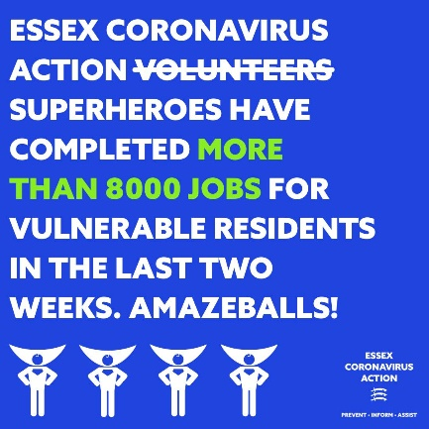
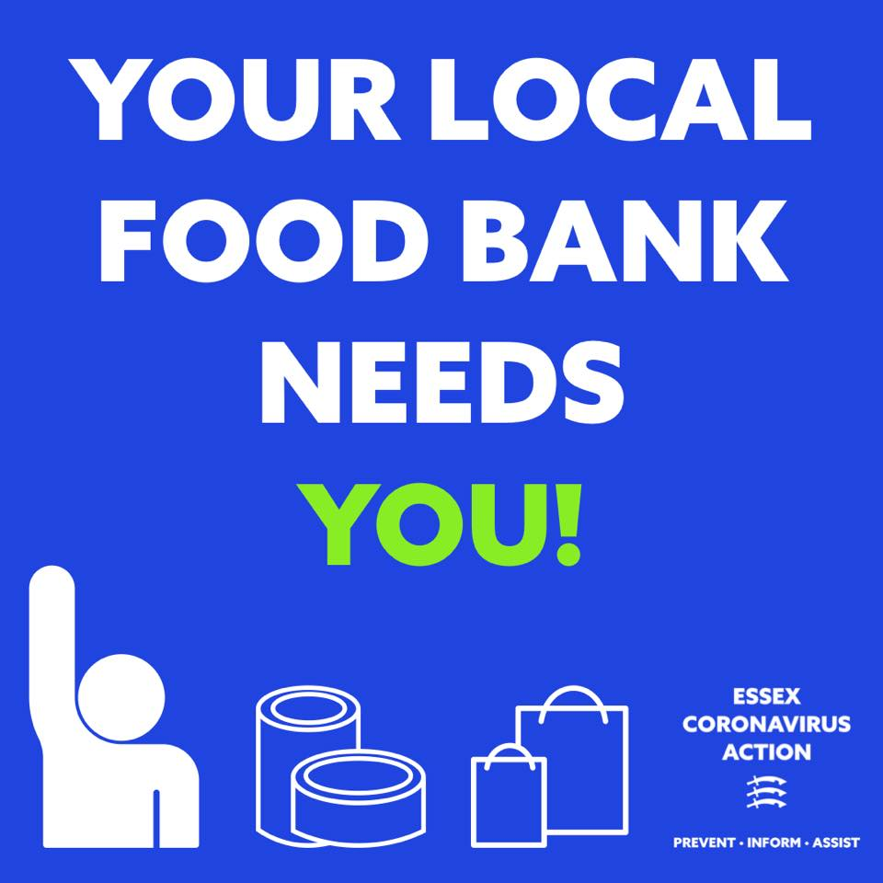
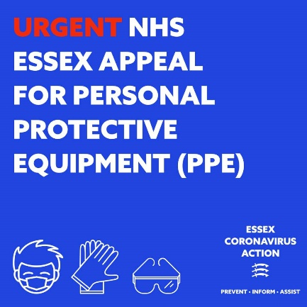
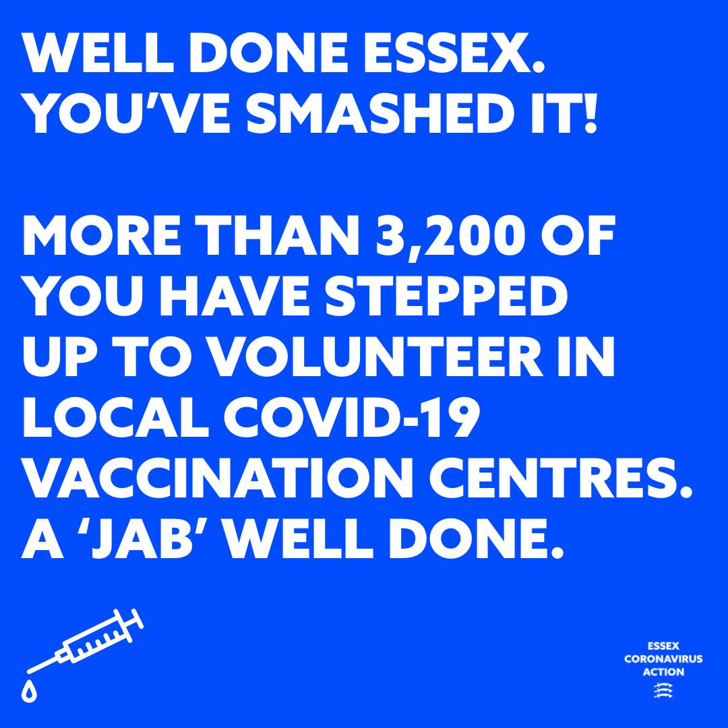
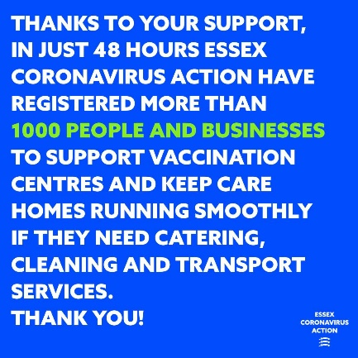
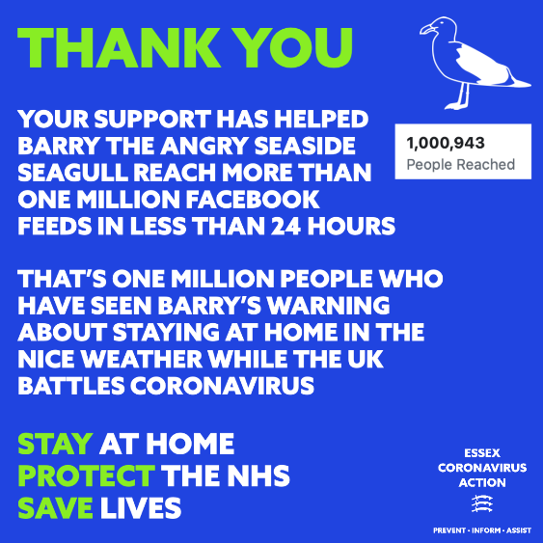

Note: this proportion of reach is significantly higher than would be anticipated for a standard health promotion campaign. However due to the public engagement with COVID-19 and the estimated reach of the similar Scottish campaign these figures have been assumed.
Based on ECAS page reach July 2020. This exceeds the population of Essex as the page is not limited to Essex residents only.
Campaign reach exceeded Scottish population as seen more than once by many people. Unique reach not reported.

