

Essential Living Fund Annual Report
  - April 2024 – March 2025
May 2025

Contents
Executive Summary 2
Methodology 3
Limitations to the data 3
Overview Essex ELF 4
Applying to the ELF 4
Essex ELF Overall Applications: Annual Trends 5
Applications by Month 6
Applications by District 7
Geographical Areas – Heatmap 9
Application Composition 10
Application Reasons 10
Application Outcomes 11
Successful Applications 12
Geographical Areas – District Hotspots 13
Successful Applications Profile 19
Summary 19
Successful Applications by Reason 20
Successful Applications by District and Reason 21
Successful Applications by Cohort, District and Reason 22
Lone Parents 23
Single Households 24
Family Households 25
Pensioners 27
Couples 28
Items Awarded to Applicants 32
Totals 32
Cohorts 34
Districts 35
Total Amount Granted Successful Applicants 35
Spend per Cohort 37
Spend per Item Category 37
Unsuccessful Applicants 38
Unsuccessful Applications by District and Cohort 38
Unsuccessful Applications by Reason 39
Summary and Key Findings 41

Executive Summary
The Essential Living Fund (ELF) is available to individuals and families who are in crisis and have exhausted all other options available, providing essential items such as clothing, bedding, furniture, white goods, and general living items. It is not designed to resolve wider poverty issues but provides immediate relief for households in crisis.
The total spent for ELF for this financial year 2024/25 is £9,259,523 at time of reporting. 2023/2024 spend was £8,647,322. This is a 25% increase in spend. Not as significant an increase as seen last year where there was 75% more spend.
The need for the fund has increased hugely over the last five years. In response to the COVID pandemic in 2020, additional central government funding of £827,934 was allocated to ELF to support the crisis. Furthermore, in November 2021 utility payment allowances were increased and the criteria for who could access the scheme was broadened in response to the emerging cost of living crisis. The continued financial instability for the UK has led to increased need.
For example, during 2023/2024 food and fuel vouchers for the fund in Essex were increased to allowing four vouchers weekly for those in need between 1st November and 11th December 2023. There were then three vouchers available weekly until the end of the financial year. Access and awareness of the ELF has heightened; there was promotion on pharmacy bags launched on 3rd October 2023, aimed at reaching those with disabilities, pensioners, and carers. There were also 20,000 leaflets to publicise the fund distributed to partners across Essex on 1st December 2023.
Between April 2023 and March 2024, there have been a total of 35,198 applications made to ELF; an 8% increase compared to the previous year when there were 32,622 total. Comparing to applications in 2018/19 (1,744), there has been 20 times more this year.
Numbers of applications were stable at the start of this year, after which they began to increase, the higher numbers seen from October onwards, peaking in October and November, though this will have been affected by there being a pause in September of applications to reduce backlog. However, there were further increases in January and February. This shows a continued seasonal trend of there being heightened needs of residents of Essex in the winter months and at Christmas/New Year.
77% of applications have been successful (total of 26,977), a continued yearly increase from 70% last year. Of which 48% were Lone Parents, 29% were Single applicants, 12% were Families, 8% from Pensioners and 3% from Couples. 74.5% of successful applications cited Cost of living as the reason for applying and 22.6% had the reason of Exceptional pressure.
The first use of detailed demographic data this year, sees no discrepancy of groups being successful when considering ethnicity, sexual orientation, disability/long term illness (where known).

Methodology
This report is a retrospective analysis of ELF and examines the period of April 2024 to March 2025, comparing to previous years. It uses the fund’s dataset supplied by Southend Borough Council who administer the scheme on behalf of Essex County Council.
Power-Bi has been utilised for the first time for 2024/25 data. This has resulted in more efficient and accurate data analysis, considering the complexity of the raw data.
This report is split into four main sections comprising of:
- Overview of the Fund
- Applications across Essex
- Successful Applications
- Unsuccessful Applications

Limitations to the data
The data is captured through two processes, the online applications where the applicant records information, and secondly the application officers who collate further information.
The data does have limitations in that the way in which individual items per application are recorded causes it to be difficult and complex to analyse items. For the purposes of this analysis the items have been broken down using the five main item categories that can be applied for, unless otherwise stated, as in previous analysis. Number of items, spend per item, and refusal codes are reliant on the raw data received.
There are small gaps in data, such as 223 applications currently not having a postcode attached. This has improved year on year though, and being such a small proportion (lower than 0.1%) does not have an impact on analysis, as they do have a Local Authority recorded.
There are also 1,663 applications that do not have a reason for application. This is again very low proportionately; 0.5% of all applications and all but one for unsuccessful applications.
Please note that the analysis in this report has been conducted using the raw data supplied to the Performance and Business Intelligence Team, which has then been uploaded to Power-Bi. This to understand the data as far as possible to contribute to robust analysis.
This year’s data for the first time contains more demographic data around applicants to the scheme, including ethnicity and health information. This will be presented within this report, though comparisons to previous years will not be possible.

Overview Essex ELF
Essex County Council (ECC) launched the Essential Living Fund in 2013, with the aim of supporting individuals and families who had become vulnerable due to temporary crisis.

Applying to the ELF
Southend Borough Council are Commissioned by ECC to manage the fund; process assessments, decision making, signposting and provide information, advice, and guidance where applications are unsuccessful. ECC also commission Community 360 to provide administration and co-ordinate across networks of Voluntary and Community Sector (VCS) organisations, to source furniture, household items and white goods for eligible applicants.

ELF does not provide loans or cash payments but does make provision for restricted prepaid cards for general living, such as fuel and food where needed.

ELF is primarily intended to help vulnerable people live as independently in the community as possible and was designed to provide support where all other options have been exhausted. Applicants must be aged 16 or over and a resident in one of the 12 districts within Essex. Applicants must also be on a low income or with little or no resources. Where applications are successful, second-hand items are sourced, and where they are not available, basic new items are purchased.

The fund aims to help:
- Vulnerable persons established in the community following a stay in a specialist care setting (mental health unit, rehabilitation centre etc.), care home, hostel or similar.
- Those discharged from prison and youth offending institutions.
- Young people leaving local authority care.
- People remaining in the community rather than enter a specialist setting or care home in which they will receive care.
- Ease exceptional pressures on individuals or families.
- People setting up home in the community, as part of a planned resettlement programme, following an unsettled way of life.
- People to care for a prisoner or young offender on release on temporary license.
- People who are unable to meet their immediate short-term needs due to emergency, either in relation to expenses, or because of disaster. Post 2019 this included the pandemic and from November 2021 those impacted adversely by the cost-of-living crisis.

Essex ELF Overall Applications
Between 2013/14 and 2018/19, the annual number of ELF Applications were seen to decrease year on year. This was due to two factors: an up-turn in the economy and no proactive advertising of ELF. However, many households did benefit from ELF, evidencing there was a need to maintain the fund.
There was a substantial rise in applications in 2020/2021 and 2021/2022 due to the COVID pandemic, resulting in an increase in applications citing exceptional pressure as the reason. During 2021/22 there was significant effort put into promoting ELF via all partners, including foodbanks, and ECC social media campaigns and this would have added to the increase.
The increase accelerated particularly in 2022/2023 and 2023/2024. Even though the year-to-year increase has not been as significant this year, numbers have still risen into 2024/2025 with a total of 35,198 applications compared to last year’s total of 32,622. Continuing to reflect the huge additional pressure on households and the economy due to the cost of living and inflation rises. This is likely to continue due to further economic and political unrest nationally and worldwide.
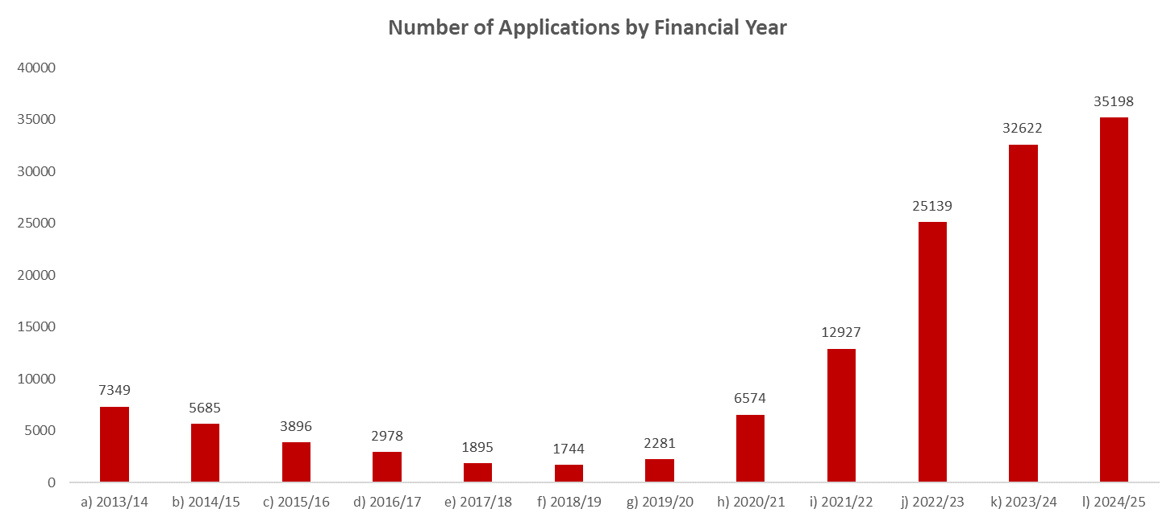
Comparing back to 2018/2019, there has been 20 times more total applications:
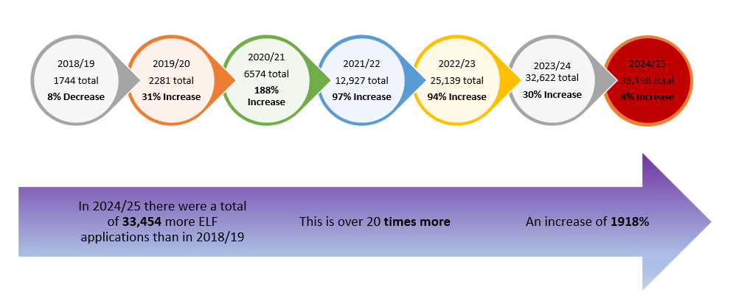

Applications by Month
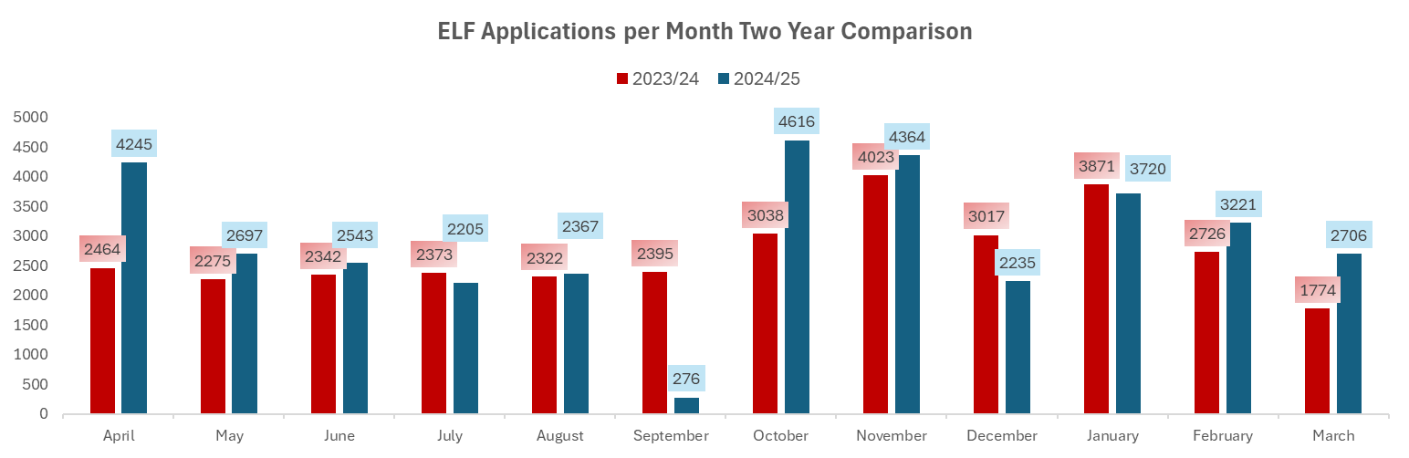
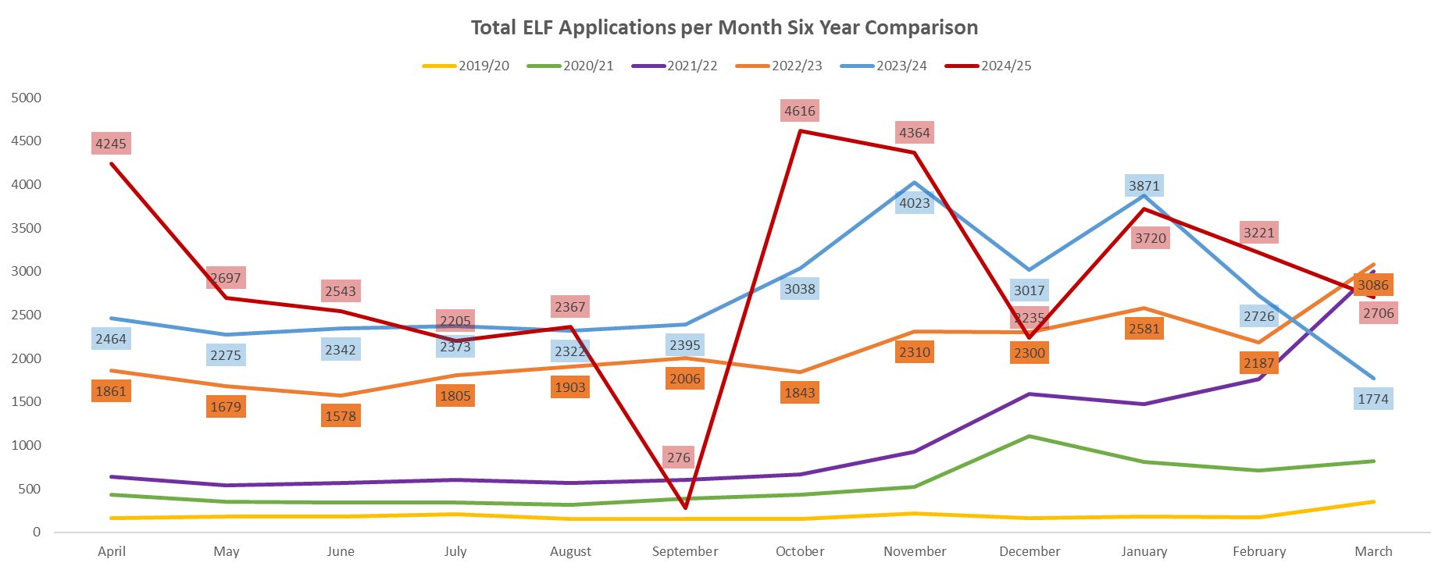
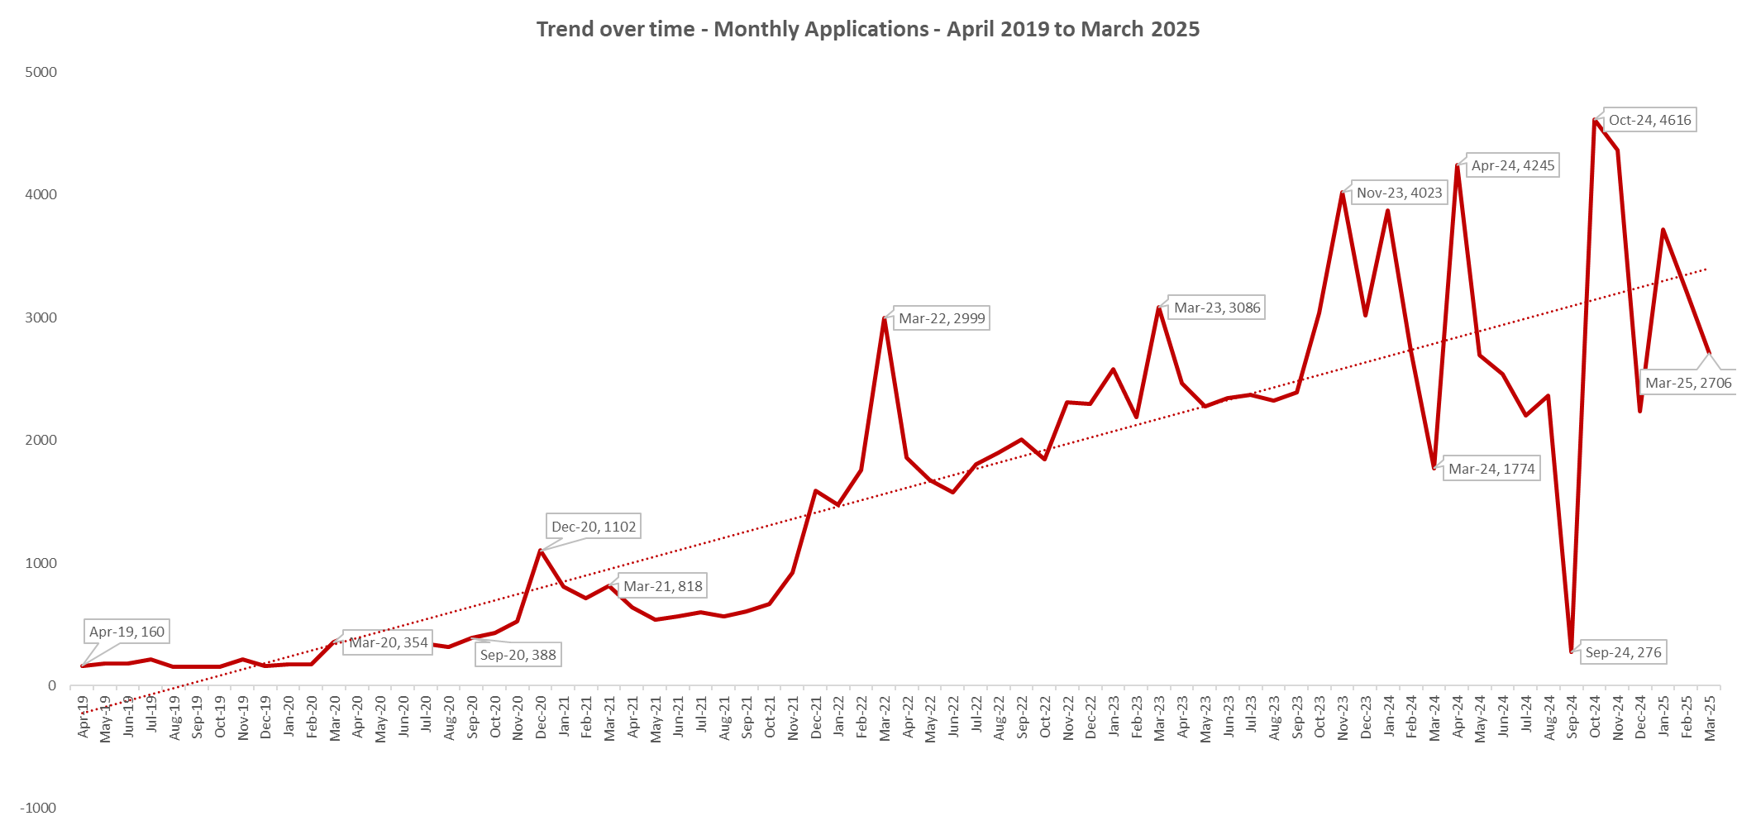
The graphs above reflect the huge increase in ELF applications over the last six years broken down per month. There were low monthly numbers in 2019/20, generally below 150 and 200 each month, until the start of the COVID pandemic in March 2020 when there was a jump to 354 applications.

During 2024/25 there was a peak of 4,616 in October 2024; the highest monthly number seen.
- However, it is important to note that this peak may have been impacted upon by there being a pause in applications in September 2024, to reduce backlog.
- March has seen a reduction in the last two years due to there being a cut-off for the financial year of applications mid-way through March.

The rising trend overall is particularly seen from November 2021 onwards, coinciding with the cost-of-living crisis, adding to the impact of COVID, and the fact that the uplifts in Universal Credit benefit during the pandemic ceased in October 2021.
The increase continued significantly into 2023/2024 and 2024/2025, with there being a clear seasonal rise in both years in the Winter period, with financial needs increasing due to Christmas/New Year and rising energy and utility costs being even more of an impact during the colder weather. This pattern is likely to continue each year.
However, the increases in the last two years are also an indication that information around the fund is reaching more individuals and being publicised successfully. During 2023/2024, applications for food and fuel vouchers in Essex were increased to four vouchers weekly for those in need between 1st November and 11th December 2023, and then three vouchers weekly until the end of the financial year. There were ELF promotions on pharmacy bags launched on 3rd October 2023, aimed at reaching those with disabilities, pensioners, and carers. There were also 20,000 leaflets to publicise the fund distributed to partners across Essex on 1st December 2023.
As well as being publicised on local government websites, it is also on charity sites and other internet news and social media sites.
https://brightlingsea.info/brightlingsea-news/1m-help-announced-for-essex-pensioners-as-part-of-9-4m-fund/
https://www.essexlive.news/news/cost-of-living/dwp-urging-brits-contact-local-9605839?int_source=mantis_rec_top&int_medium=web&int_campaign=more_like_this_top
https://www.billhelp.uk/southend-on-sea-borough-living-fund-grants/

Applications by District
ELF aims to primarily help vulnerable people on low income or with little or no resources, and although there were increases in applications across all 12 districts and boroughs, the correlation of high application numbers in areas of high deprivation, for example Basildon and Tendring, continued to be reflected for 2024/2025.
All districts have remained generally the same proportionately. As can be seen in the following graphs, Basildon continues to account for the highest proportion of applications with 19.6% this year, with Tendring still second highest with 16.7%, a slight fall from 17.9% last year. This differs from last year, in that Tendring had been seeing a proportional increase year on year.

However, they are still almost 5% higher than the next district; Colchester which remains at just over 12%.
The lower areas remain the same; Rochford, Maldon, Brentwood and Uttlesford, with Brentwood and Maldon swapping in ranking this year; Brentwood now second lowest and Maldon third highest. Of note, when considering the numerical difference compared to last year; all districts have seen increases, but smaller areas that have seen a higher numerical change proportionately in contrast to the total in 2023/24 (see second graph below). Maldon and Rochford have seen 35% and 34% increase in number for example.
Braintree has seen 19% numerical increase on their total last year, so may be an area to monitor for the coming year.
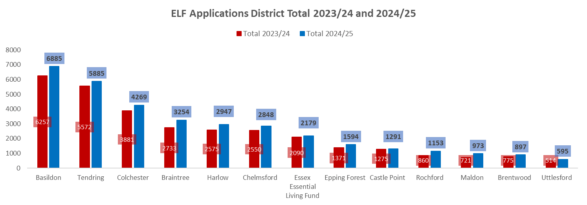
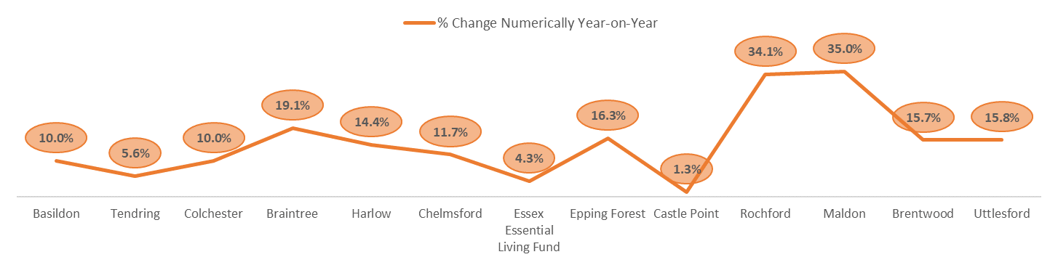
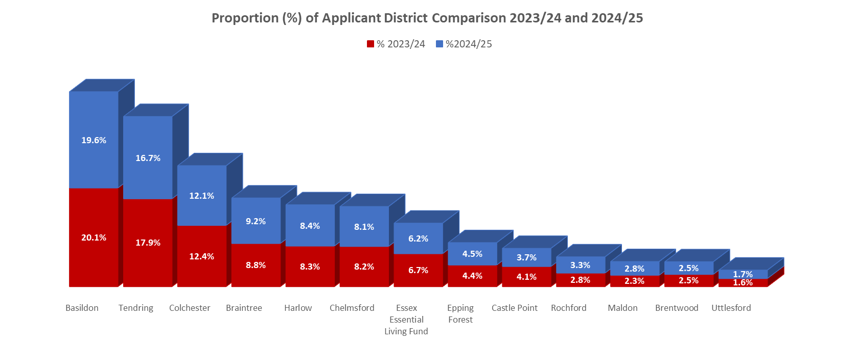

Geographical Areas – Heatmap
The following maps show all applications across Essex (using district, LSOA code and wards), confirming that the darker areas of Basildon and Tendring are the main application hotspots for Essex.
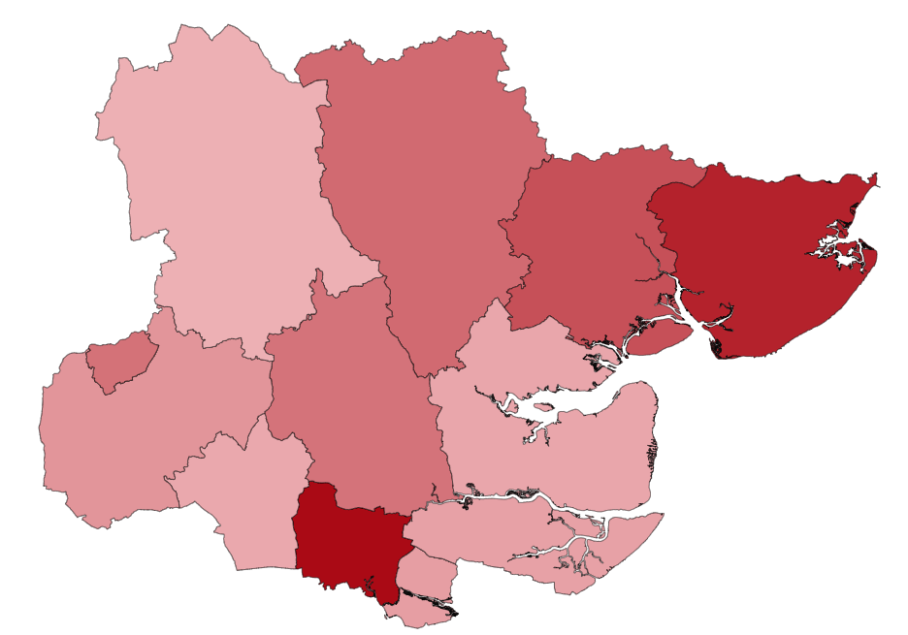
Castle Point
Harlow
Maldon

Rochford
Colchester Tendring
Basildon
Brentwood
Epping Forest
Chelmsford
Braintree
Uttlesford
Initial observations are the ward/LSOA areas below in Basildon, Colchester, Tendring and Harlow are seeing the highest concentration of applications. Maldon and Rochford have noticeable hotspot areas this year. Additional district breakdowns for successful applications are included further in the report.
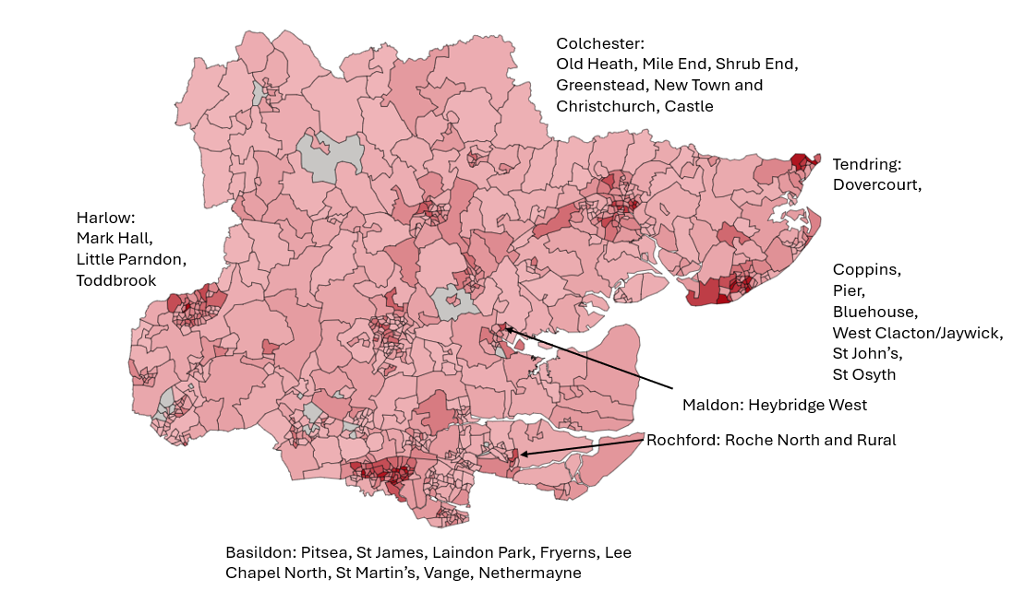

Application Composition
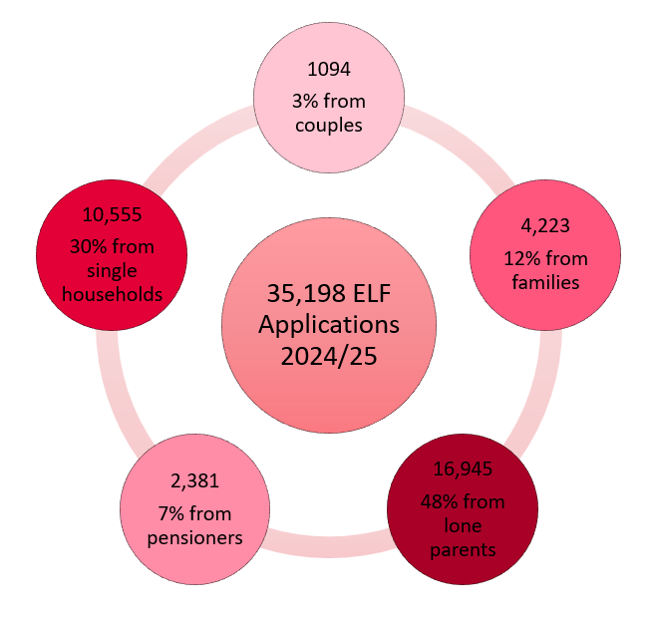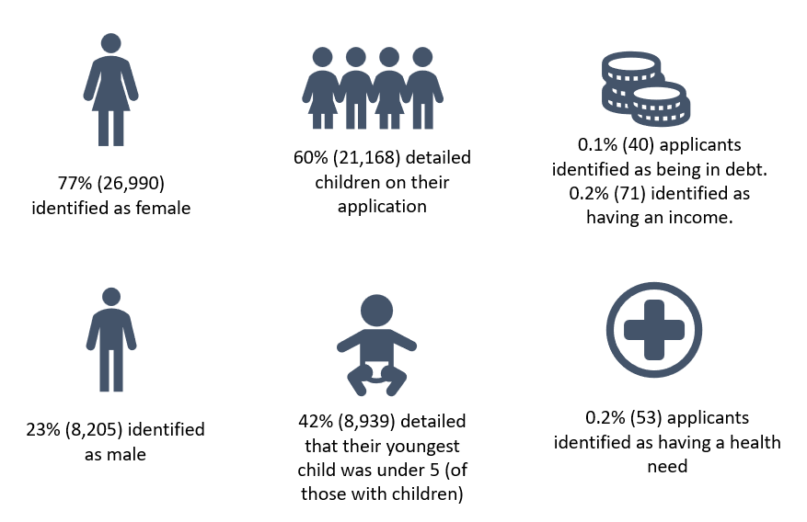
The cohorts of households are overall consistent with last year proportionately, the majority being lone parents; 48% (slight decrease from 50% last year) and single households; 30% (same as last year), and the fewest from couples with 3% (same as last year).
All cohorts have seen numerical increases this year and have the same peaks in October, November and January. However, as discussed in previous reporting, applications from Pensioners; although still low in number compared to other cohorts, have increased proportionately from 6% to 7% (2,381 applications). They have had a one percentage increase proportionately year on year since 2020/21 when this was 3% (192) of the total.
Of all applications, 60% (21,168) came from households that have children, which is a proportional decrease from 62% last year, likely accounted for by the increase in pensioner applications. The majority of those with children are lone parents; 80% (16,945), 20% being families (proportionately almost the same as last year when this was 81% and 19%).
Overall, there has been a year-on-year increase in the proportion of applications from households with children; in 2013/14, this was 35%, incrementally rising each year to 52% in 2019/20, 58% in 2020/21, and consistently being between 60% and 63% in the last four years.

Application Reasons
The primary reason for all applications is now that of ‘Cost of Living’. This now accounts for 70% of all applications (whether successful or not). Last year this sat at 31% of applications, so has more than doubled.
‘Exceptional Pressure’ was the main reason last year, decreasing this year to 22.5% from 38%. The ‘Just about managing’ reason has decreased hugely from 23% to 1%. However, this is likely due to the preferred use of the ‘Cost of Living’ reason, which only came into use for ELF applications during the 2023/24 year.
Please note that those showing as blank are majority those that are Withdrawn.

Application Outcomes
Successful applications to ELF are not solely reliant upon meeting eligibility criteria. The applicants are required to provide evidence that they have tried other avenues of support, and that ELF is the only option available to them.
In 2024/2025, of all the applications processed through ELF, 77% have been successful (26,977), with 23% unsuccessful (8,221).
Those being successful have continued to increase year on year; from 70% last year, 56% in 2022/23 year, 52% in 2021/22, and 47% in 2020/21.
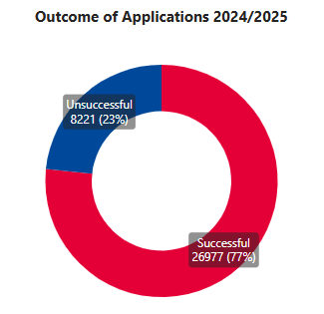

Successful Applications
As stated, for the year 2024/2025, 77% of applications were successful. Numbers have been steady for most of the year, at around 1800 to 2400 in six of the twelve months, the average per month being 2,248.
Monthly activity is sporadic with October seeing a rise following the halt in applications in September, then applications level out nearer to the average of 2248 per month, until the reduction in March due to applications being closed.
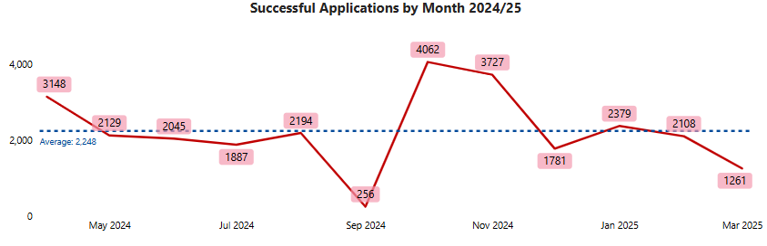
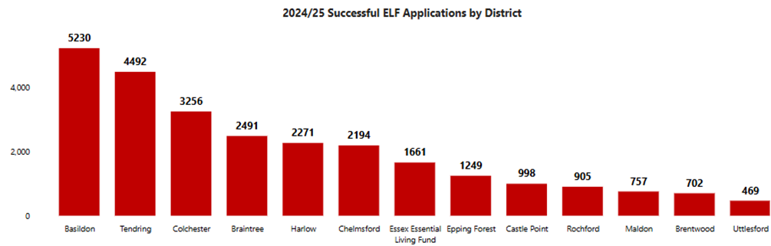
Basildon and Tendring continue to hold the highest numbers and proportions of those successful; with 19% from Basildon and 17% from Tendring, both dropping slightly by 1% proportionately compared to last year. The increase that had previously been seen in Tendring has therefore slowed down, though they are still second highest.
Smaller areas and those with lower numbers of successful applications have had the bigger proportional increase when comparing last year’s numbers. For instance, Rochford, though only holding 3% of the successful applications this year, have had a 45% rise numerically (626 last year, 905 this year). Brentwood and Maldon similarly have had a 29% and 42% rise respectively in total number, and both have had a 1% increase proportionately of the total for 2024/25.
It is also interesting to note that the smaller districts and those with the lower numbers of applications, have higher success rates, such as Uttlesford which sees 79% of their applications being successful, compared to Basildon and Tendring that have 76% successful:
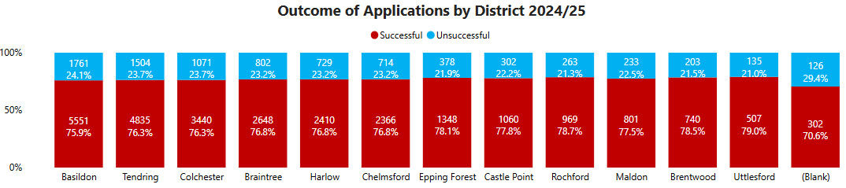
The maps and tables on the following pages highlight the hotspot areas within each Essex district where applications were successful, with tables showing the top wards. Please note any discrepancies in numbers may be where there are multiple LSOAs within a ward.

Geographical Areas – District Hotspots

Basildon
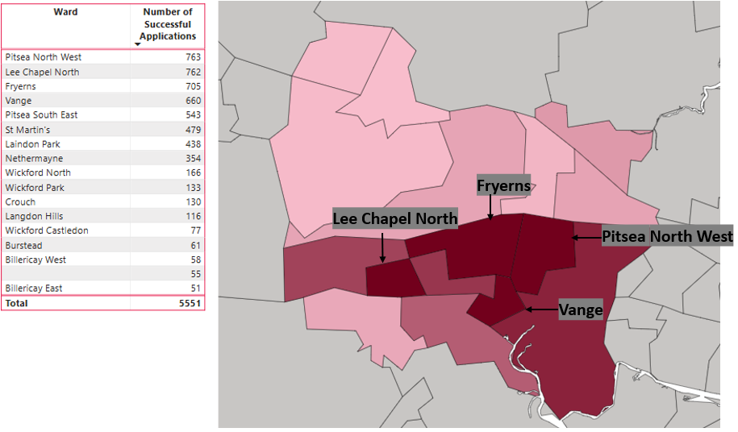

Braintree
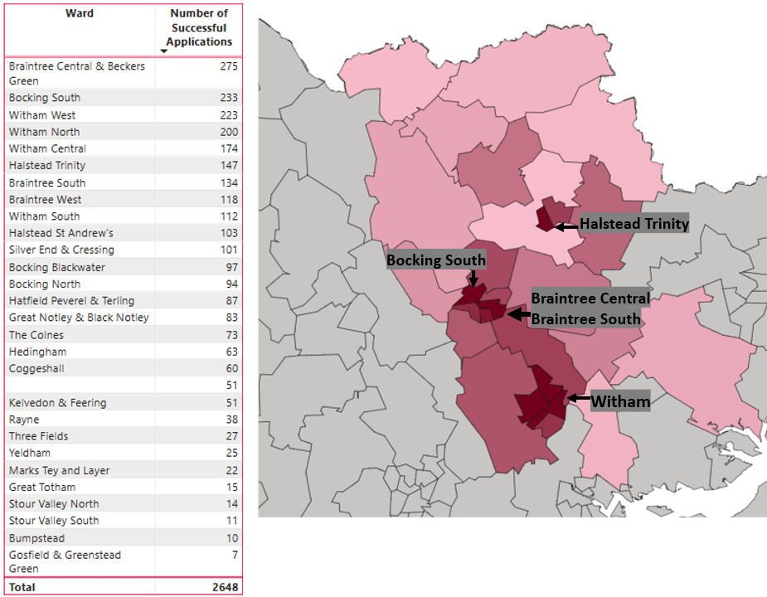

Brentwood
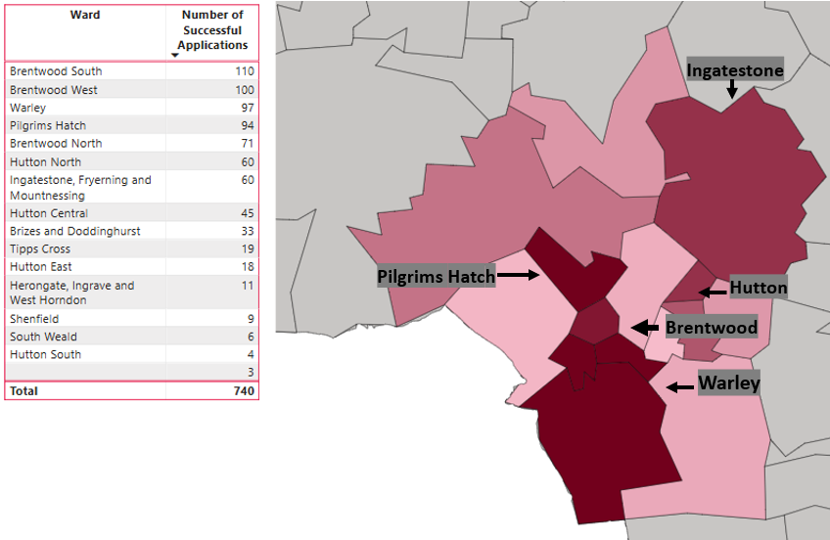

Castle Point
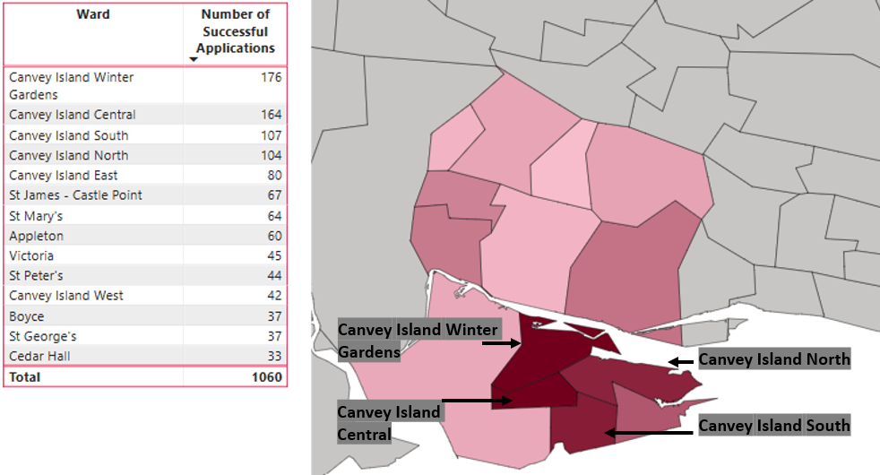

Chelmsford
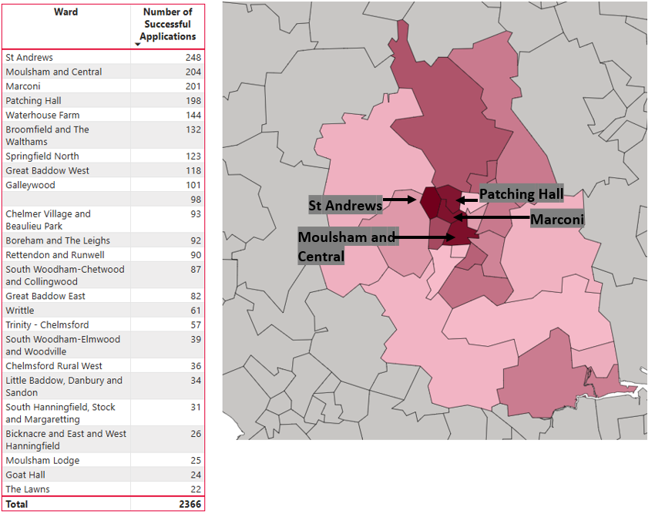

Colchester
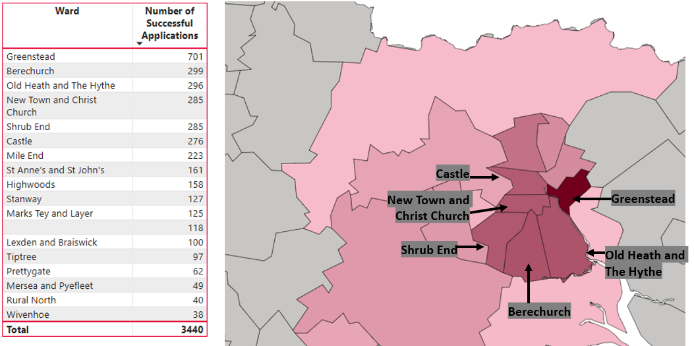

Epping Forest
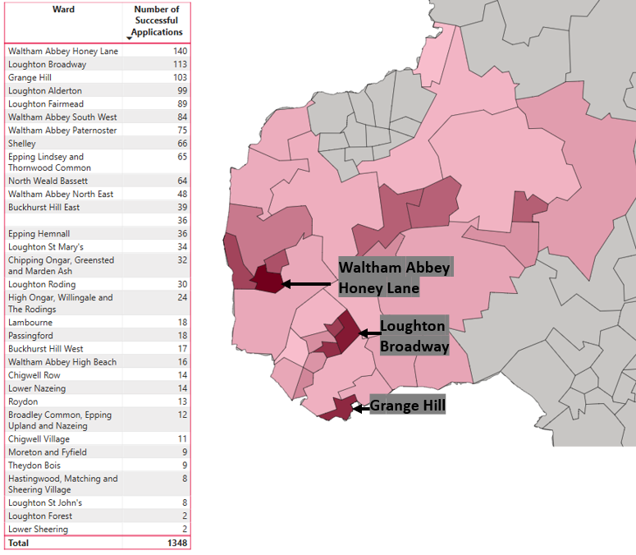

Harlow
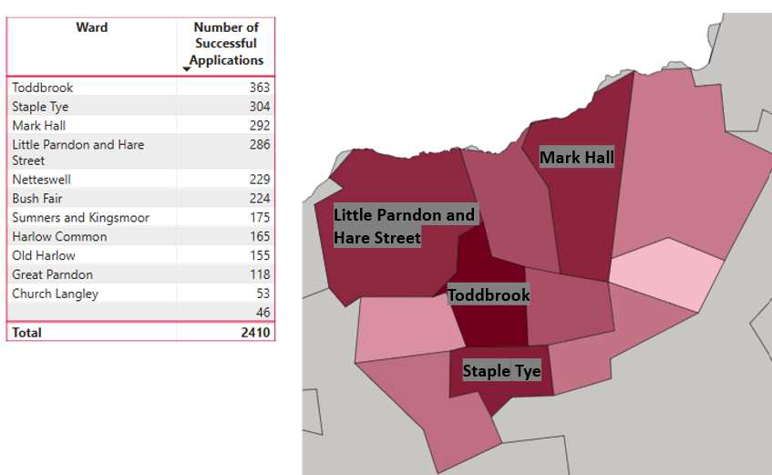

Maldon
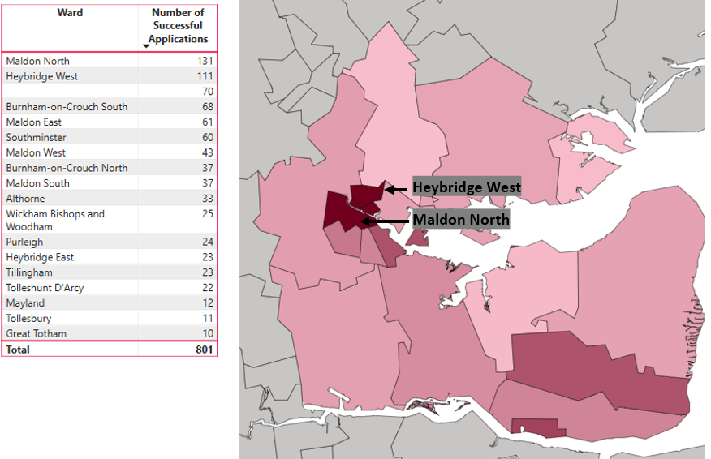

Rochford
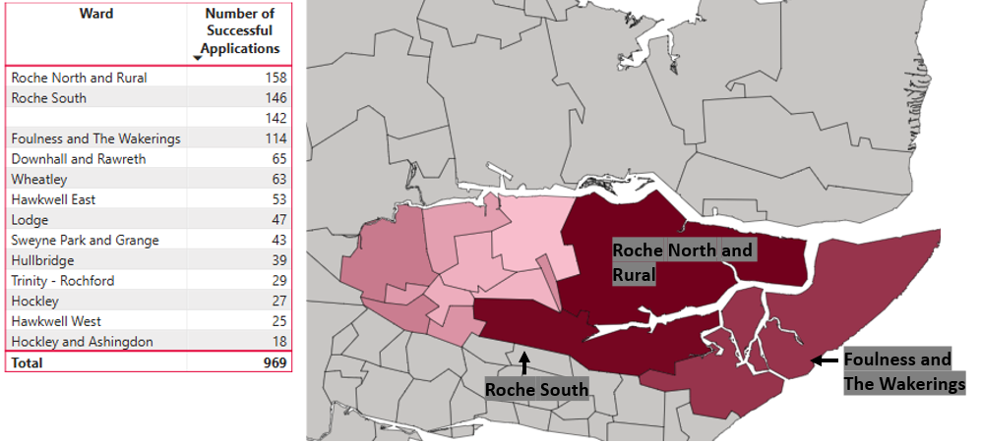

Tendring
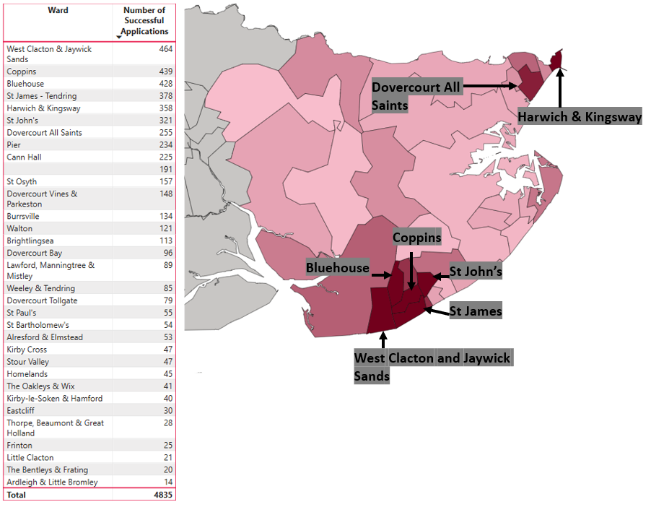

Uttlesford

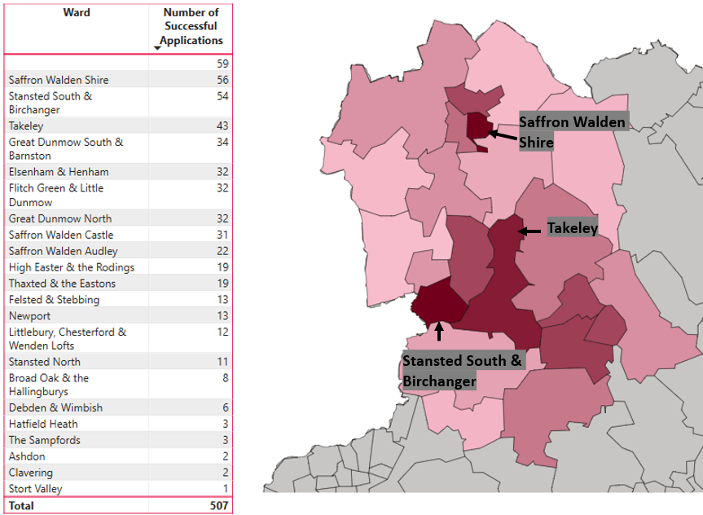

Successful Applications Profile

Summary
Of the 26,977 successful applications, the majority are from lone parents: 48% (13,067), slightly lower proportionately than last year when this was 50. Nearly a third; 29% (7,893), are from single households, the same proportion as last year.
The lowest proportion of successful applications were from couples (787) and pensioners (2,044) at 3% and 8% respectively. Couples proportionately are the same as last year. However, as mentioned previously, the proportion of pensioners for all applications and successful ones, has gradually increased year on year; having been 6% last year, 5% in the previous two years, and 3% in 2020/21.
60% (16,253) of the households had children, slightly lower proportionately than the 62% last year. The majority; 80%, were lone parents, the other 20% from families.
There are more individuals specifically identifying as being in debt (35 applicants, 26 last year), identifying as having an income (60 this year, 38 last year), and identifying as having a health need (45 this year, 31 last year). This may be indicative of the financial hardship that all residents of Essex are finding themselves in.
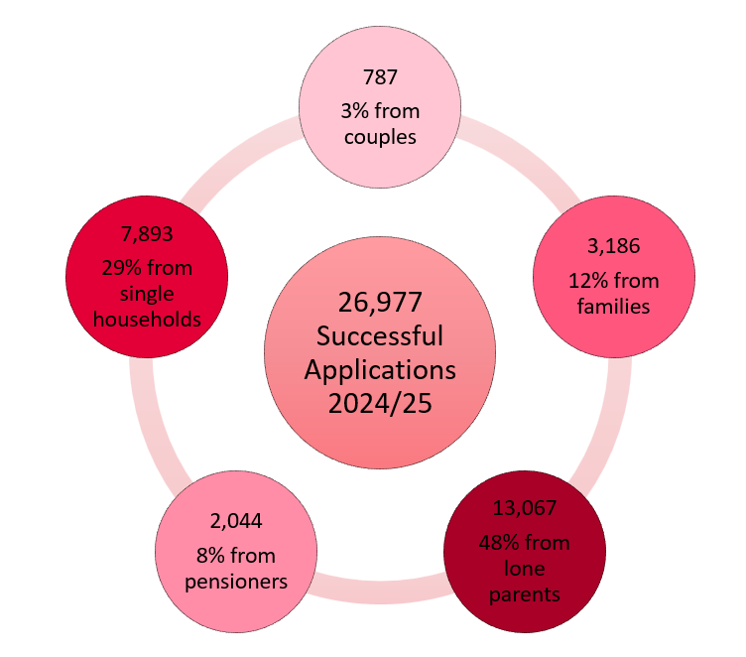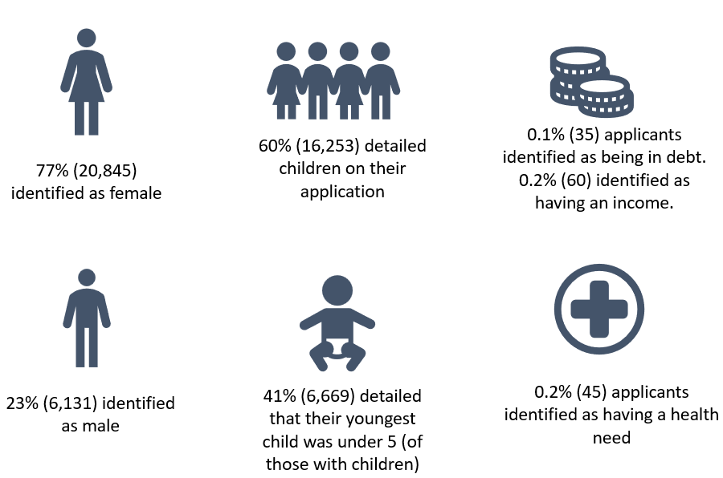
As seen in the next chart, whilst pensioners submitted the second lowest number of applications overall, they have had the highest successful conversion rate, with nearly 86% being successful. This is a continued increasing trend from last year when this was 79%, and the previous year was 62%. Couples’ conversion rate has also increased to 72% from 67% last year.
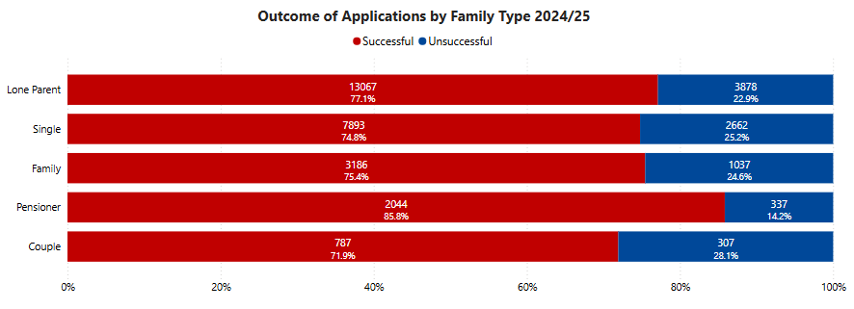

Successful Applications by Reason
As discussed earlier in the report, the ‘Cost of Living’ reason is now the primary reason for all applications, and for successful applications where it has been used by 74.5% of individuals. This is an increase from last year when this accounted for 36% of those successful. However, the reason was only introduced part way through 2023/24 financial year.
Therefore, all other reasons have decreased compared to last year due to the additional and more specific use of ‘Cost of Living’:
- ‘Exceptional pressure’ now accounts for 22.6% compared to last year’s 36.9%.
- ‘Just about managing exceptional award’ (JAM) has been used for only 1% of this year’s successful applications. Thins was 24% last year.
- Other reasons are very minimal; all fewer than 1% this year.

The reasons being used are reflective of the current financial crisis that residents of Essex are finding themselves in. The following graph shows that the ‘Cost of Living’ reason has been consistently highest throughout the 2024/25 year.
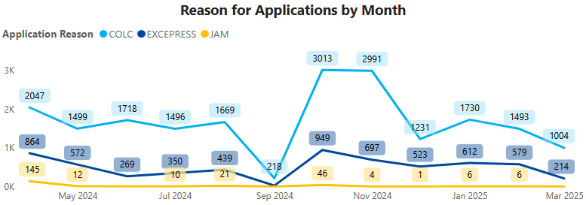
Please note: Categorisation of applicants does not reflect individual circumstances, and each applicant will have their own personal story. For example, someone leaving an abusive relationship could opt to select ‘resettlement in the community,’ ‘leaving hostel’ or ‘emergency.’

Successful Applications by District and Reason
Basildon and Tendring districts have continued to hold the highest proportions of all applications and of the successful ones, 20% of those successful are from Basildon and 17% from Tendring.
Across all districts the primary reason is Cost of Living, all seeing between 72% to 76% in this category. All then have around a quarter under the Exceptional Pressure reason.
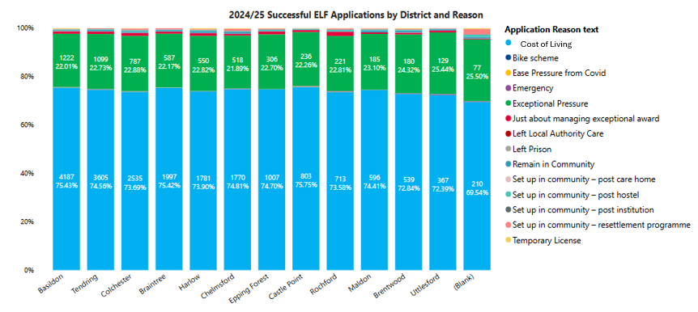

Successful Applications by Cohort, District and Reason
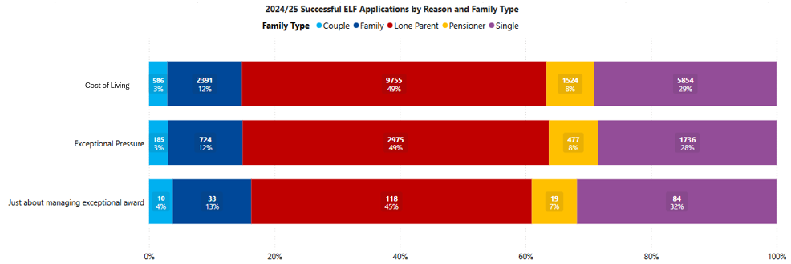
Across all cohorts, as expected, ‘Cost of Living’ has been the primary reason in successful applications. Lone parents account for around 50% of each of the three most used reasons. This section of the report contains breakdowns for each cohort, and the primary areas of geographic need.
The following chart shows that the highest proportion of lone parent applicants, as well as single and family applicants are in Basildon. Tendring has the highest proportion of pensioner and couples’ applications. This is the similar to the trend seen last year.
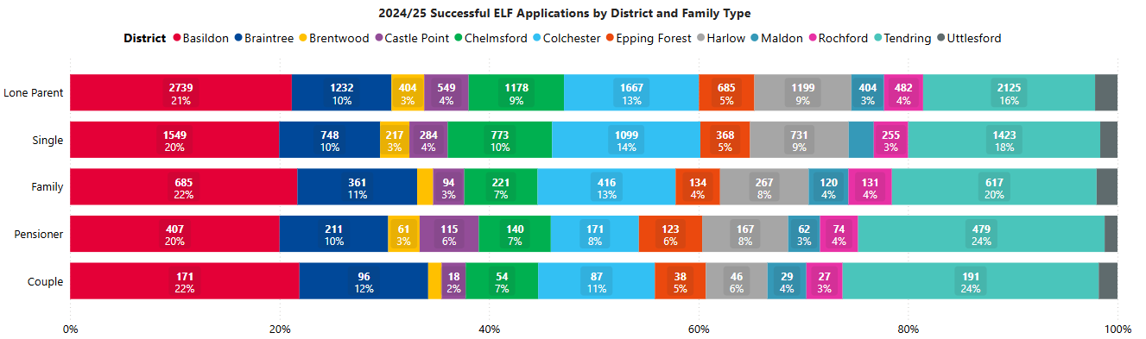

Lone Parents
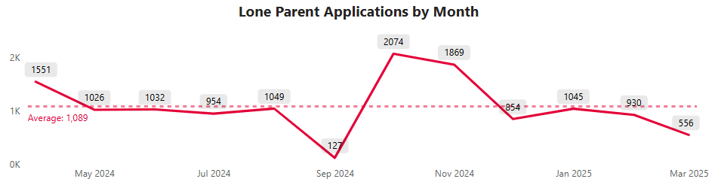
21% (2,739) of all lone parent applicants are in Basildon, 16% (2,125) in Tendring. Numbers of successful applications for lone parents were stable for most of the year, with peaks in October and November (partly due to pausing of process in September). On average, there have been 1,089 per month over the year.
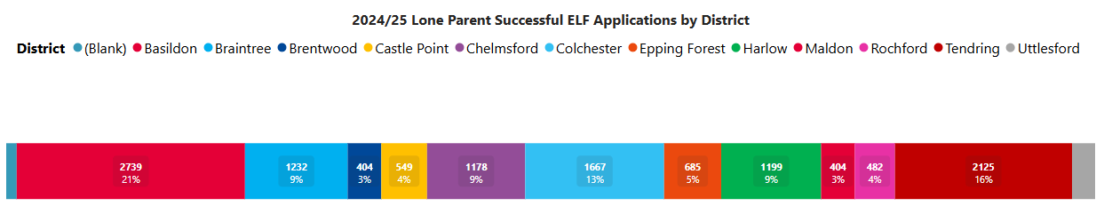
The top ten wards remain the same as last year for Lone Parents. Seven are in Basildon areas; the highest number in Lee Chapel North and Fryerns areas. Colchester Greenstead ward is third highest (same as last year). There are two Tendring wards; Bluehouse and Coppins. In all the ten wards, Cost of living is the highest reason.
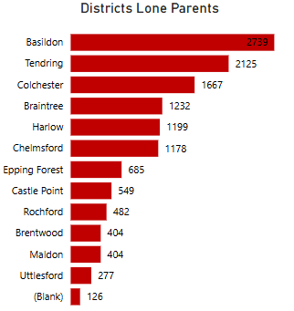
Demographics: 94% (12,325) of the lone parent successful applicants are female. Almost half of all lone parents are aged in their thirties; 46% (5,985). There are 25% (3,222) in their twenties, and 23% in their forties (2,981). Proportionately almost identical to last year.
- In unsuccessful lone parent applications, the same proportions are seen for gender, and very similar for age groups.
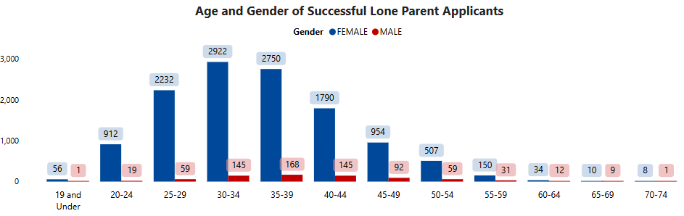

Single Households
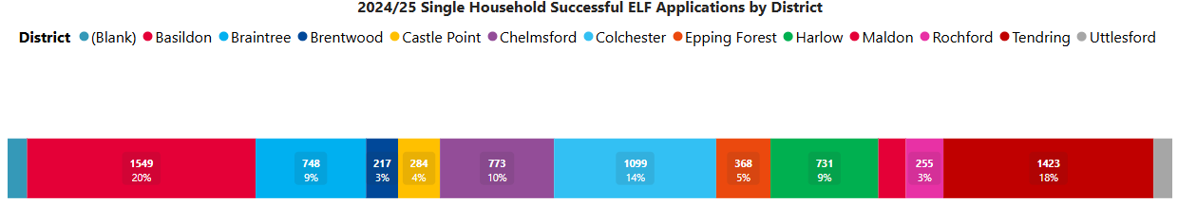
Successful applications for single households are seen slightly more in Basildon; 20%, with 18% in Tendring. They have followed the same pattern as other cohorts, having peaks in applications in October and November. They had on average 658 per month, compared to 1,089 for lone parents.
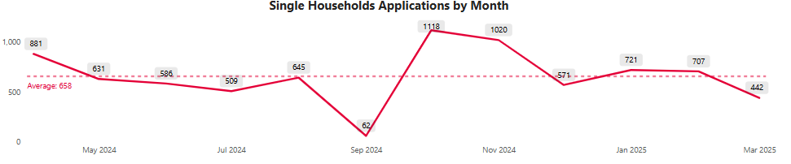
Six of the top ten wards for single person successful applications are in Basildon; the highest number is in Pitsea North West. Greenstead in Colchester is second highest. Two are Tendring wards; West Clacton & Jaywick, and St James. The wards are very similar to last year, though Colchester has now two wards with Castle being the tenth highest area. Tendring areas of Coppins and Harwich & Kingsway were in the top 10 last year for single households, but not this year.
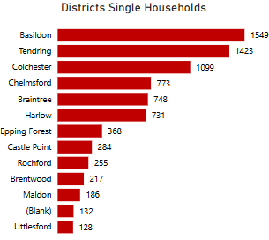
Demographics: Unlike other cohorts, there is a more even split of female and male successful applicants for single households, with 54% female (4,254), 46% male (3,639), the same proportions as last year. Ages are more varied than other cohorts; the largest group continuing to be those in their fifties with 27.5% (2,169) of all those successful. People in the 40-, 30- and 20-year age ranges as seen last year, account for between 20-23% each.
- For unsuccessful single applicants 49% are male, 51% female. Slightly more are of a younger age; those in their twenties account for 25.5% (679), and 25% (667) in their thirties.

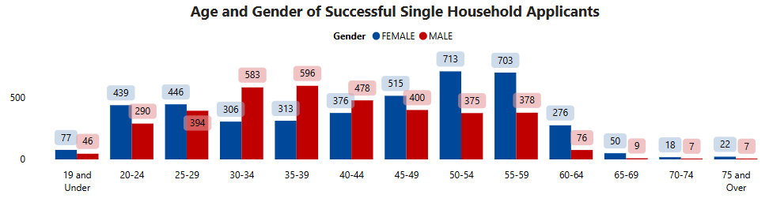

Family Households
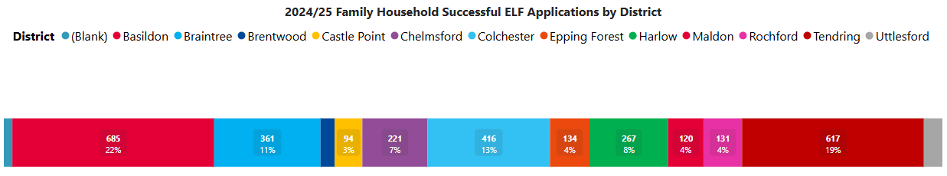
Successful applications for families are seen highest in Basildon with 22% (685) and Tendring with 19% (617). They had the same trend over time as other cohorts, and the main reason being Cost of Living in 75% of applications.
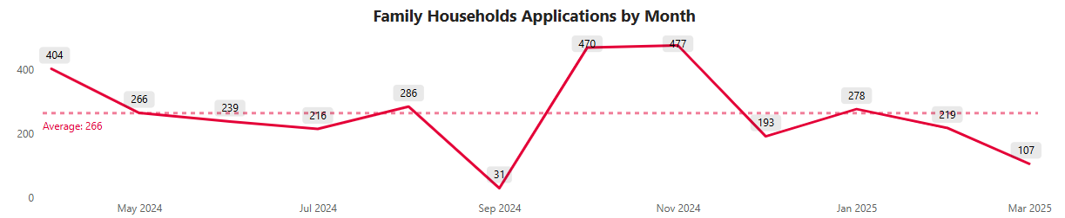
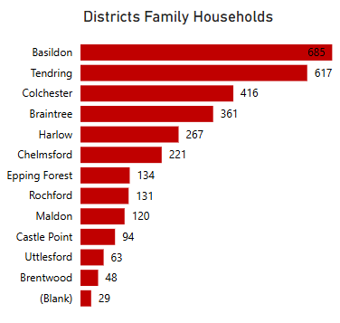
Five of the top ten wards for family household successful applications are in Basildon areas. There were six Basildon areas last year (Laindon Park is not in this year’s top 10): the highest number is in Lee Chapel North. There are three Tendring wards (St John’s this year instead of Dovercourt), and the two Colchester wards of Greenstead and the additional Berechurch area for this year.
Demographics: Most successful family applicants are female; 76% (2,417), with 24% (769) being male. Majority are in their thirties; 45% (1,433). There are then 27% (872) aged 40 to 49, and 20% (621) in their twenties.
- Almost identical proportions are seen for ages of unsuccessful family applicants; though slightly more males are unsuccessful; 26% (265).
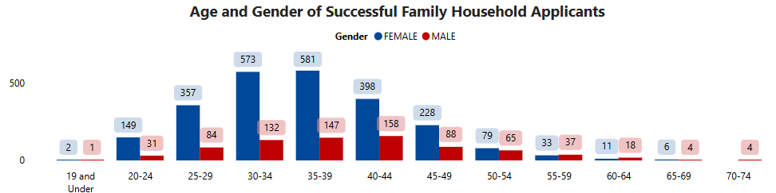

Pensioners
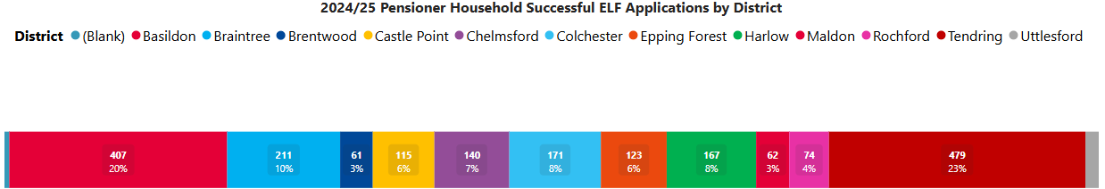
Successful applications for pensioners continue to be seen highest in Tendring with 23% (479 total), though proportionately 2% lower than last year. Next highest is Basildon with 20% (407), the same proportion as last year. Other districts see generally low levels of successful pensioner applications, although Braintree, Castle Point and Epping Forest have proportionately increased by 1%. Colchester has dropped by 1%, as has Harlow. The trend over time is the same as other cohorts, and main reason is Cost of Living (75%).
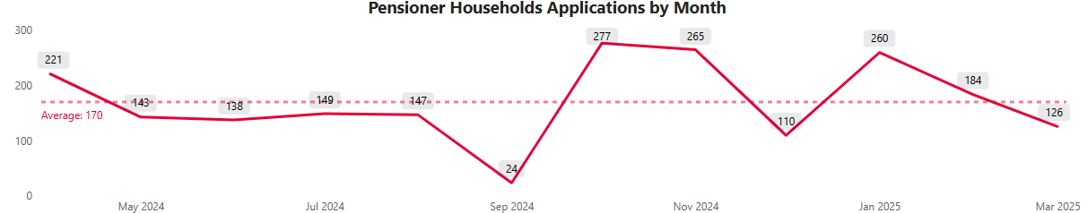
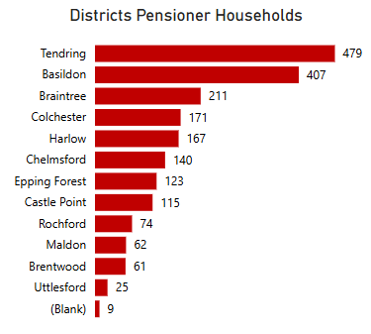
Of the top 10 areas, three are in Tendring, the top area remaining as West Clacton & Jaywick Sands, with a very similar proportion as last year. Six wards continue to be in Basildon areas; the highest being Lee Chapel North, which features highly for all family types. There is also Greenstead in Colchester as with the previous three cohorts. An area that is in the top 10 and did not feature as a high area last year, is Cann Hall in Tendring (also seen for Couples). Last year saw Harlow area of Mark Hall in the top areas for Pensioners, but not this year.
Demographics: The age of pensioners with successful applications are mostly in their sixties; 40% being between 60 and 64 (813 total), 27% between 65 and 69 (554). 29% are 70 or over (583). Nearly two thirds are female (65%, 1,327 total), and a third are male (35%, 717), which is the same proportionately as last year. Please note that some of the applicants are in lower age groups, likely due to incorrect recording on the system.
- The gender split is more even for those unsuccessful; 56% female, 44% male. Age group proportions are like those successful.
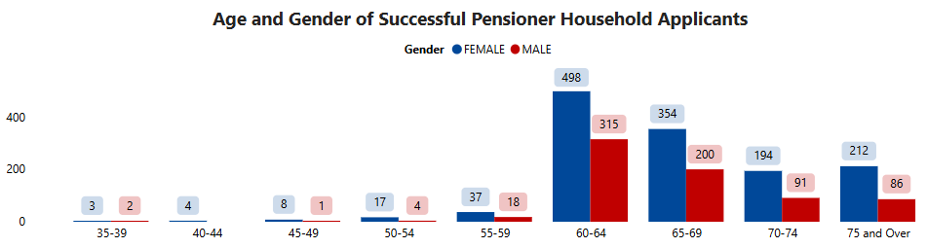

Couples
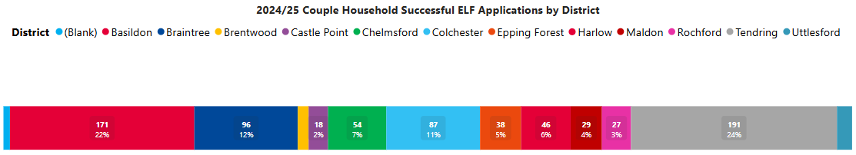
As with Pensioners, successful applications for couples are seen highest in Tendring with 24%, next highest is Basildon with 22%. Braintree and Colchester have 12% and 11% respectively, both having increased by 1% proportionately from last year. Other districts see comparatively low proportions. This indicates that along with the pensioner applications, the couples applying for ELF are of older age groups.

Demographics: It is seen that females in their fifties are the main applicants; this group accounting for 27% (214) of all the successful applications from couples (23% last year). Overall, almost 40% of all the couple applications are aged 50-59. Compared to last year’s analysis, the majority age of the Couple households has become slightly older, with there being 33% in their fifties last year. Although, the information given is for the person making the application so is not reflective of both persons in the household that have a need. 66% of all the successful couple applicants are female, only 1% less than last year.
- Comparing Unsuccessful applicants for couples, the age groups are similar, most being in their forties or fifties. The gender split is similar.

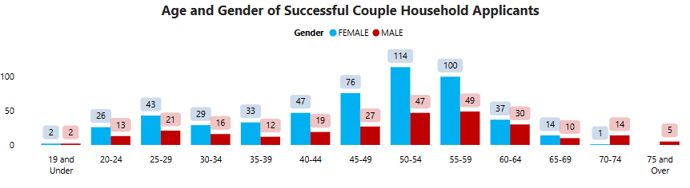
The trend over time is like that of the other cohorts, the average per month being the lowest at 66, compared to Pensioners with 170 per month. 75% give the reason of ‘Cost of Living’.
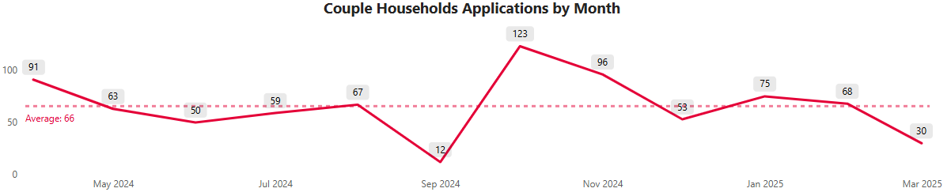
Of the top 10 areas for Couples, there are more this year in Basildon, with six of the ten, compared to last year there were three in Basildon. The highest area remaining as Vange. Though Tendring has fewer ward areas in the top 10 areas, as a district it remains the highest for couples with 191 total, with West Clacton & Jaywick remaining as the highest Tendring area. Cann Hall appears in the top areas as it does for Pensioners. There are no areas from Harlow or Colchester in the top 10 areas for Couples as there were last year.
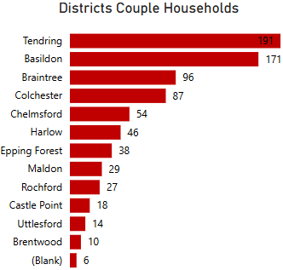

Diversity Factors
Ethnicity: The following table shows that the proportions of those being successful versus unsuccessful are even for ethnic groups. However, due to the high proportions; over a third in both categories; being unrecorded/not provided by the applicant, this skews the data and makes robust analysis difficult to determine.
There are no notable differences for Global majority groups being unsuccessful compared to successful.
Sexual Orientation: Similarly, there is no disparity seen for sexual orientation and whether successful or unsuccessful. Again, there are over a third for each category that are not provided.
Disability/Long Term Health: In 39% of all applications, the person applying has declared a disability/long term health conditions:
- 21.6% have declared a mental health condition (7,589 applicants)
- 6.9% have a Long-term illness (2429 applicants)
- 6.6% have stated they have a physical disability (2329 applicants)
- 1.7% have ‘Other’ disability (610 applicants)
- 1.7% have a learning disability (594 applicants)
- 0.3% have a sensory condition/disability (101 applicants).
The following table shows that again there appears to be no disparity between successful and unsuccessful applications for those recording a disability or health condition, the proportions being similar across all groups. For those with a long term illness or a physical disability, the proportion of those successful is slightly higher than those unsuccessful.
The following chart shows that Single applicants have the largest proportion of learning disabilities, long term illness, and physical disability. Lone parent applicants have highest proportion of mental health condition with 47% of all declaring this. They also have the majority of ‘Other’ disability category, and Sensory disability.
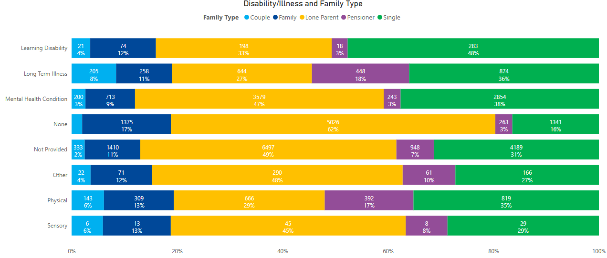
From a geographic perspective, Basildon see the majority of those declaring conditions, as do Tendring, as expected as they have the majority of applications overall. Though numbers are low for sensory conditions, the areas of Essex where applicants have this is more evenly spread, with Epping and Maldon having larger proportions under this category than the other disability types.
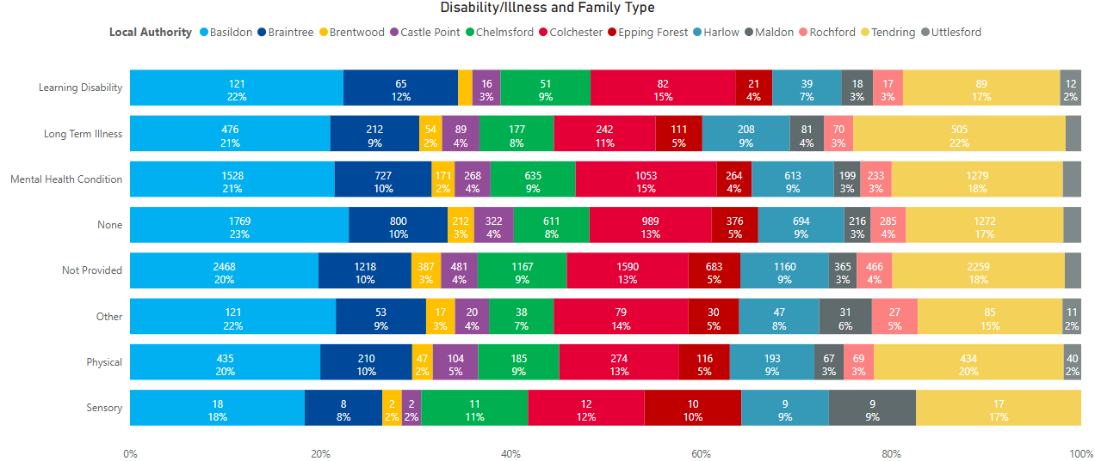
The following shows that where there is a disability or illness recorded by an applicant, there is no huge conflict between those successful or unsuccessful for each of the family types. Notably, there is proportionately double the number of pensioners being successful than unsuccessful when reporting a disability. Single applicants see slightly more unsuccessful applications proportionately than successful when reporting a disability.
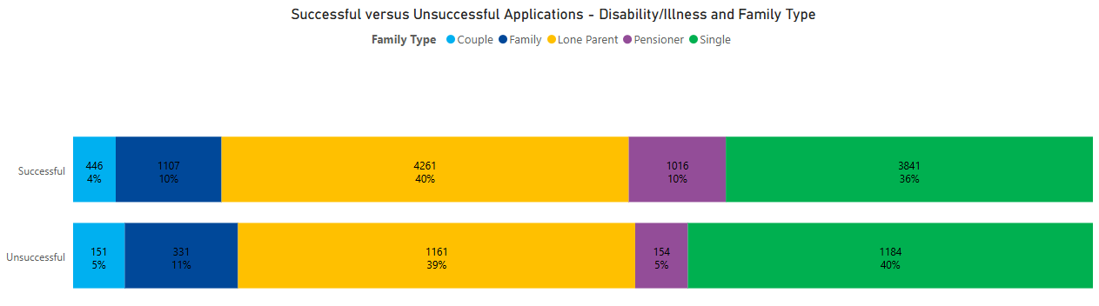

Items Awarded to Applicants

Totals
Applicants can apply for multiple items and across different categories of items within one application, dependent on their circumstances and needs.
Almost 15% of all items were awarded in October, although the monthly levels are skewed this by the drop in September due to the halt in applications to process a backlog. However there had been a slight upturn in August so it is likely that the increase would have continued. There has been a seasonal trend seen in previous years from September onwards through to January, due to the added needs of heating and utility costs in the winter months, as well as the financial pressure form the Christmas and New Year period.
March numbers are lower due to the application process for the year halting in mid-March.
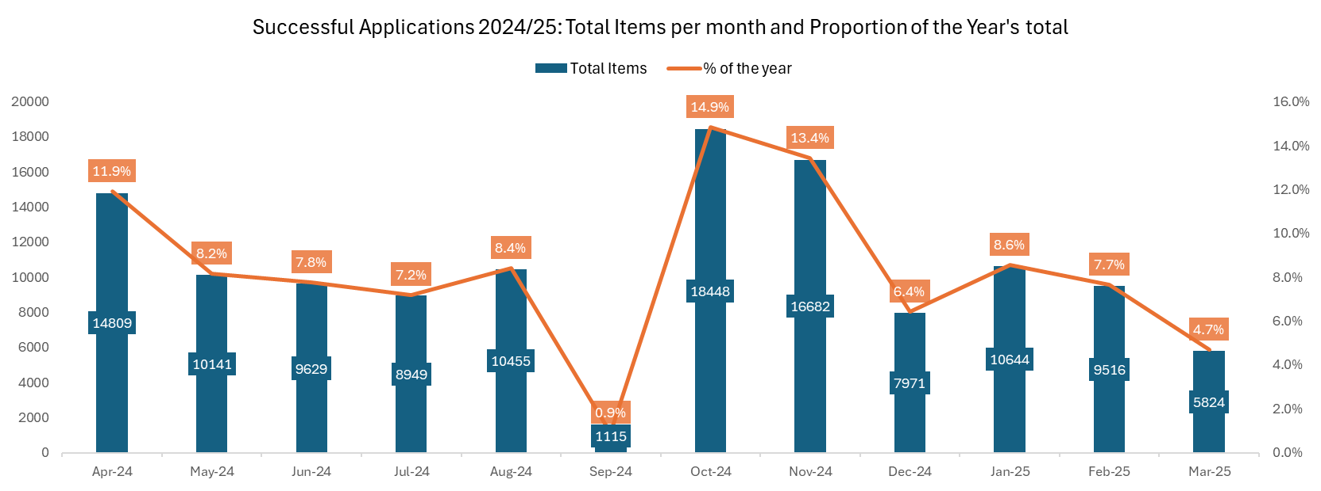
The average total number of items per application being issued each month, has remained steady over the 12 months, although with a slight decrease due to the dip in September. However, the decline in applications at the end of the year did not result in lower average items, indicating more items being requested per application.
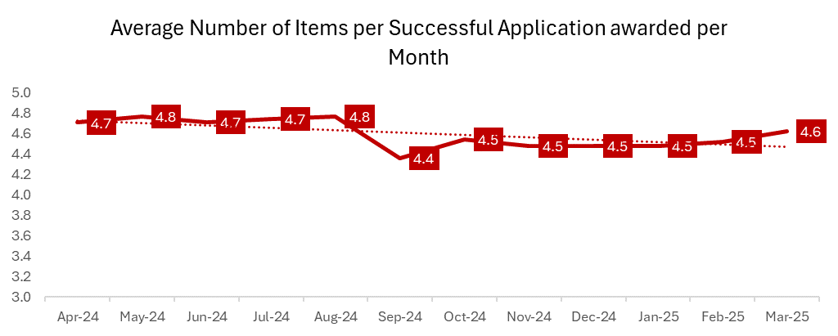

Items requested this year fall within five main categories of Bedding, Clothing, Furniture, General Living and White goods.
- The Household category has only been used in four applications (was not used at all the previous year), and together with the Admin category, is not included for this analysis.

In total, across the 26,977 successful applications, there were 124,183 items requested under the five categories. This is 21,291 more items than last year, 20% increase.
The following information relates to the 124,183 individual items, unless otherwise stated.
The majority item awarded continues to be under the category of General living; 60% of items (74,464 actual items), slightly higher than last year; 57%.
- General living items are treated as a priority and will include day to day living items such as groceries, nappies, toiletries, cleaning/hygiene products and fuel costs.
- There will be many applications where there are items being requested per family member, particularly in the case of food items under general living.

The second highest category remains as Clothing with 15% of items awarded (18,370 items), a slight decrease from 19% last year.

Third highest continues to be White Goods, accounting for 13% of all items awarded (15,523 items). This is the same proportionately as last year.
Bedding accounts for 7% (8,515 items), slight increase from 6% last year.
Furniture is slightly lower with 6% (7,307 items), same proportionately as last year.

Cohorts
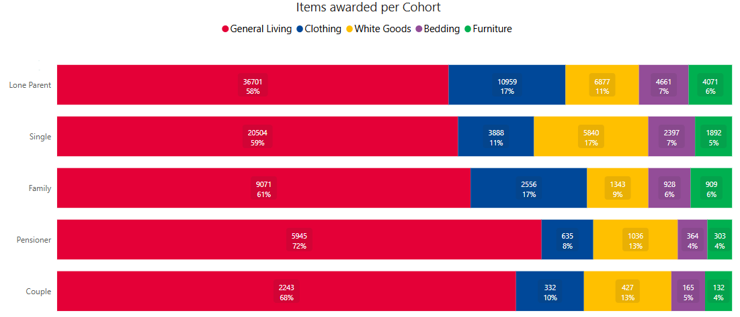
For all cohorts, most items that have been awarded are as expected under the General living category. The cohort with the biggest majority of this is that of Pensioners, 72% of all their items awarded being General living (70% last year). Couples similarly have 68% under this category (66% last year).
Lone parents, though have most successful applications, have the lowest proportion of 58% of their items being General living items, with 17% of their items being clothing. Families also have 17% under clothing, decrease from 24% last year. Single households continue to have the highest proportion of the cohorts under the white goods category, with 17% of their items.

Districts
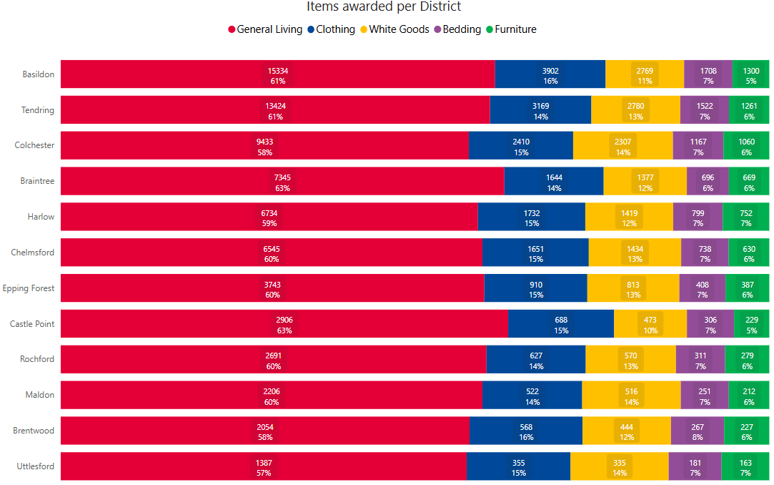
It can be seen in the chart that as expected, due to the high amount of General living items, all districts see the highest proportion of items awarded under this category, approximately all between 57% and 63% of the successful items. Braintree and Castle Point districts see the highest proportion under this category for their area.
Basildon and Brentwood see slightly higher proportions of Clothing which is a continuing trend from last year for these two areas. Colchester, Uttlesford and Maldon are highest for White goods (the former two areas being highest last year also). The same three areas, plus Harlow, see slightly higher proportions of bedding and furniture items.

Total Amount Granted Successful Applicants
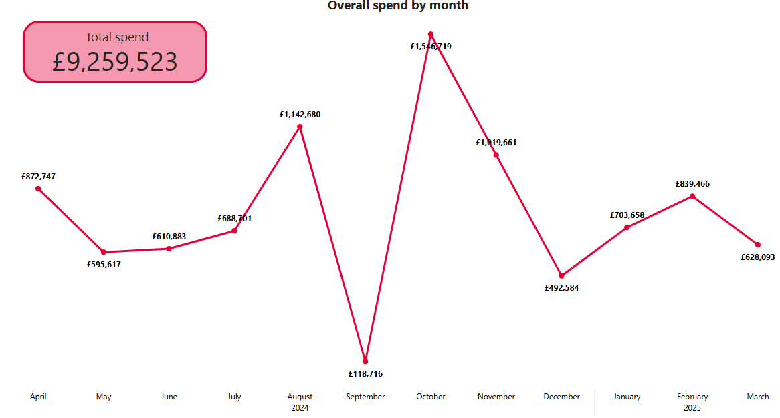
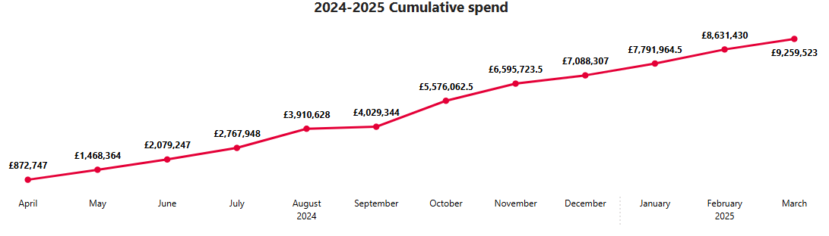
The total amount spent in 2024/25 is £9,259,523. This is £1,857,406 more than the total for 2023/24, which was £7,402,117 total (at time of last year’s reporting). This is a 25% increase.
The graphs above show the actual monthly spend and the cumulative monthly spend for the year. This shows that even though there was the huge dip in September followed by a huge peak in October/November, cumulatively there was not as much of an impact.
Basildon, with the highest number of successful applications, had the highest total spend for the year, accounting for 20% of the total amount (19% last year). Uttlesford accounted for the lowest proportion with 2%. As was seen last year, when considering average spend per application per district, the picture differs; Uttlesford has the highest average spend of £293 per application, with Basildon having the lowest with £250.
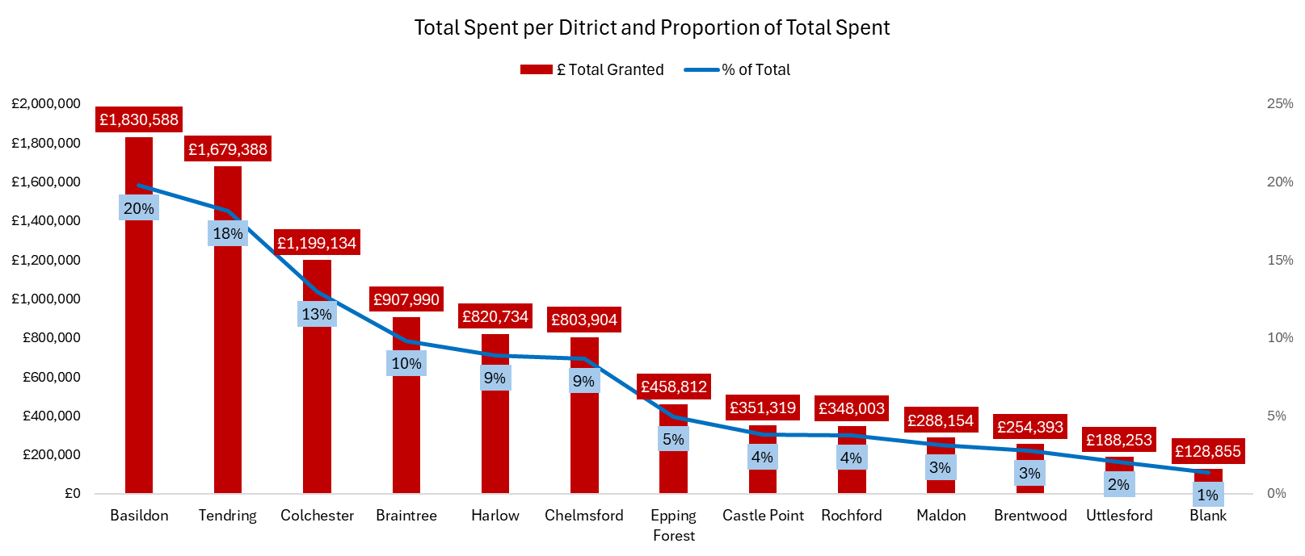

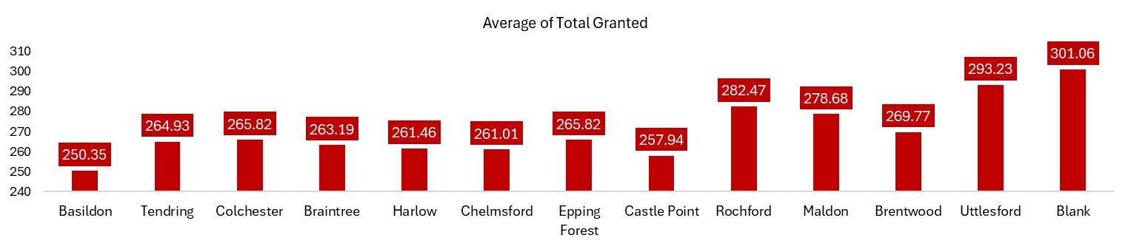

Spend per Cohort
As with the trend in applications, all cohorts had a peak in October after the drop in September, and decreasing after this in terms of spend per month. The increase in spend is particularly seen for lone parents, with the other cohorts still having similar peaks but steadier over time.
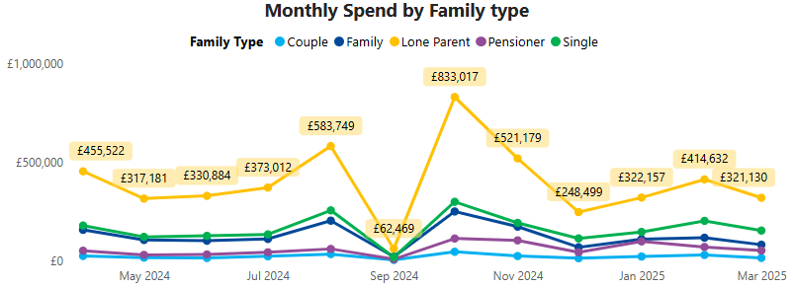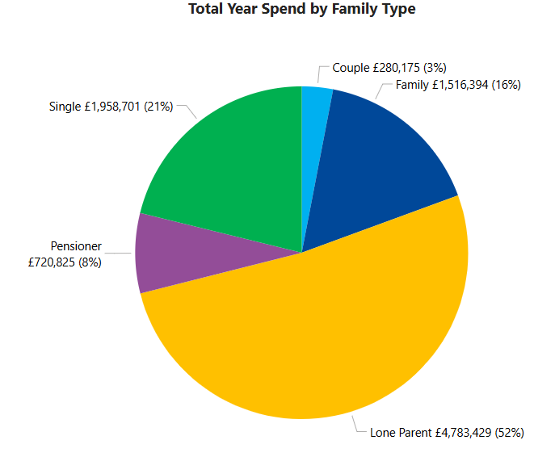
52% of the annual spend on successful applications is for lone parent families. This is followed by single households (21% of annual spend), family applicants (16%), pensioners (8%) and couples (3%). The proportions are almost identical to last year, with Pensioner spend increasing 3% proportionately.
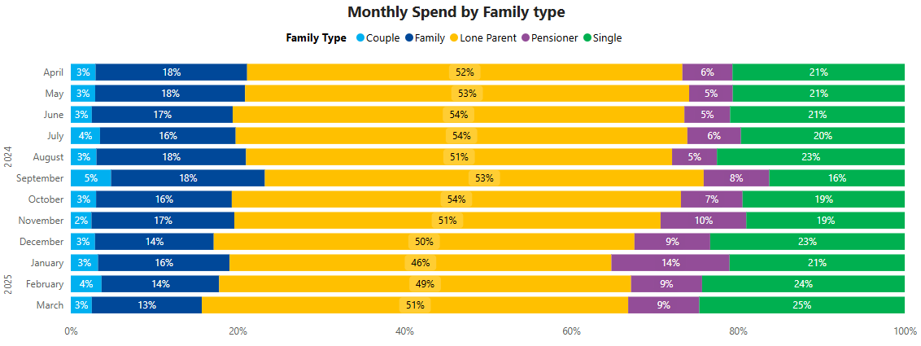
The proportion of the spend each month is seen to fluctuate for some cohorts. Whilst Couples stay at the 3-5% amount approximately, pensioners fluctuate between 5-8% for most of the year but rising to 10% in November, and further up to 14% of the month’s spend in January, indicating increased need for this group over the colder winter months. Similarly, single applicants also account for more of the spend in the last few months up the year, up to 25% by March.

Spend per Item Category
Split by item category, 87% of the total amount granted for the year for successful applicants, has been on General Living items. Almost the same as last year’s 88%. White Goods account for 10% (9% last year). Bedding, Clothing and Furniture all account for less than 1%.

Unsuccessful Applicants
A successful application to the Essential Living Fund does not just rely on meeting the eligibility criteria; applicants also need to evidence that they have tried other avenues of support and that ELF is the only option available to them.

Where applications are unsuccessful, ELF advisors offer a variety of information and advice and where appropriate will signpost on to services that may be able to support an applicant’s needs. This includes advice on benefits, finances and where to access resources/items that have been requested.

In 2024/2025, 23% of applications were unsuccessful (8,221), a 7% lower proportion than last year when there were 30% unsuccessful (9,678 total). The trend of more being successful has continued since 2021/22.

The proportion of cohorts being unsuccessful is similar to all applications and those that are successful: the highest majority being lone parents; 47%.

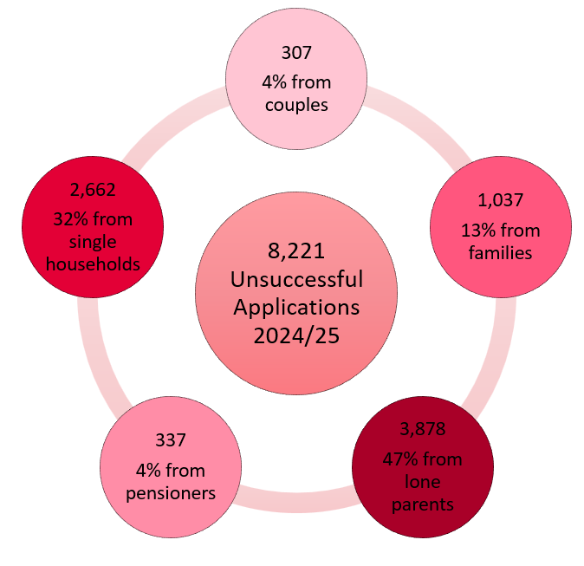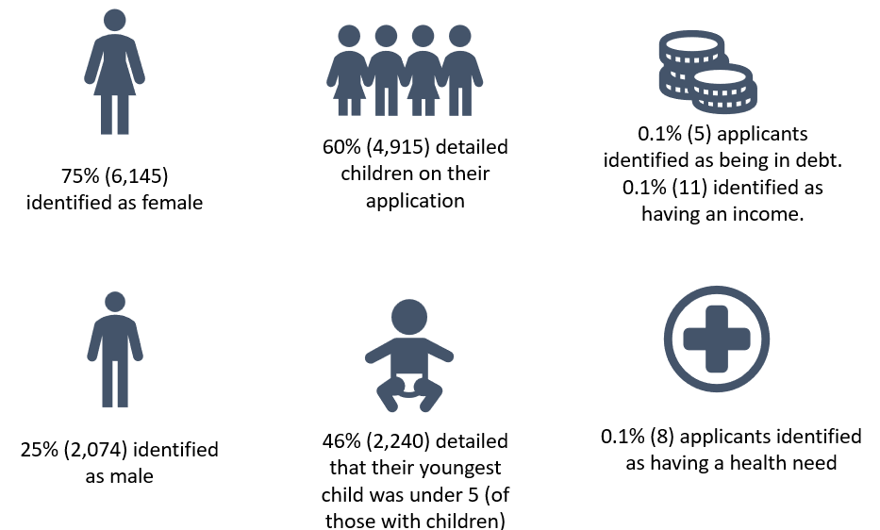

Unsuccessful Applications by District and Cohort
Having had the highest proportion of total applications and successful ones, Basildon accounts for the highest percentage of unsuccessful applications across Essex, with 21% (1,761), the same proportion as last year. Uttlesford continues to have the lowest accounting for 1.6% (135). The districts are proportionally similar overall as successful and all applications.
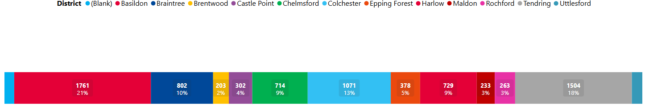
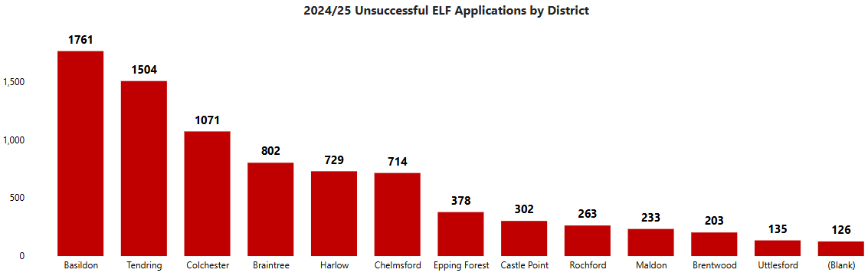
The following graphs show the ratio per district and cohort of those Successful and Unsuccessful.
All districts sit between 75 and 80% success rate, although it is the smaller areas of Brentwood, Uttlesford and Rochford that have the slightly higher success rate, whilst Basildon has the lowest rate.
Pensioners having the highest success rate of nearly 86%, all other cohorts being under 80%, with Couples being the lowest with 72%.
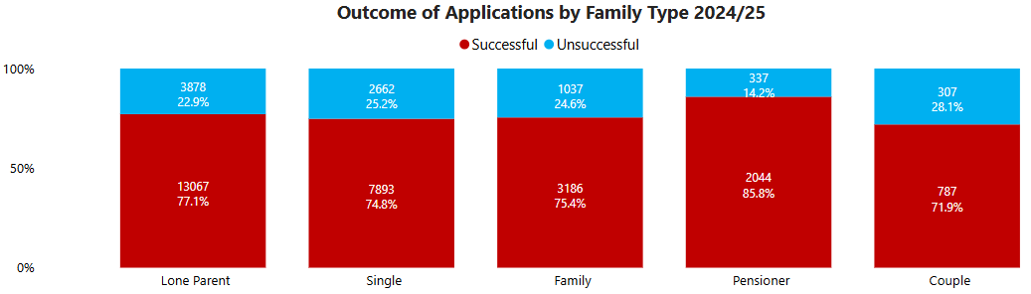

Unsuccessful Applications by Reason
Of those that were unsuccessful, the majority were refused; 80% (6,559). 20% were withdrawn (1,661), and less than 1% were not eligible or cancelled (one application).
There are 30 refusal reasons applied in 2024/2025. When examining the full dataset supplied, each item within the application is given a separate refusal code; a total of 24,930 individual items within the unsuccessful applications.
Across all these items, the most used refusal reason is ‘Second Award in period’ which is a new reason being used this year, accounting for 26% of all item refusals (6,537 total). Second highest is ‘Not an unexpected emergency’, 21% of all the items (5,138 total).
The next highest is ‘Misuse: Previously purchased items not covered’ with 15% (3,818).
When considering the different five item categories; the picture is different for the main reasons for being refused:
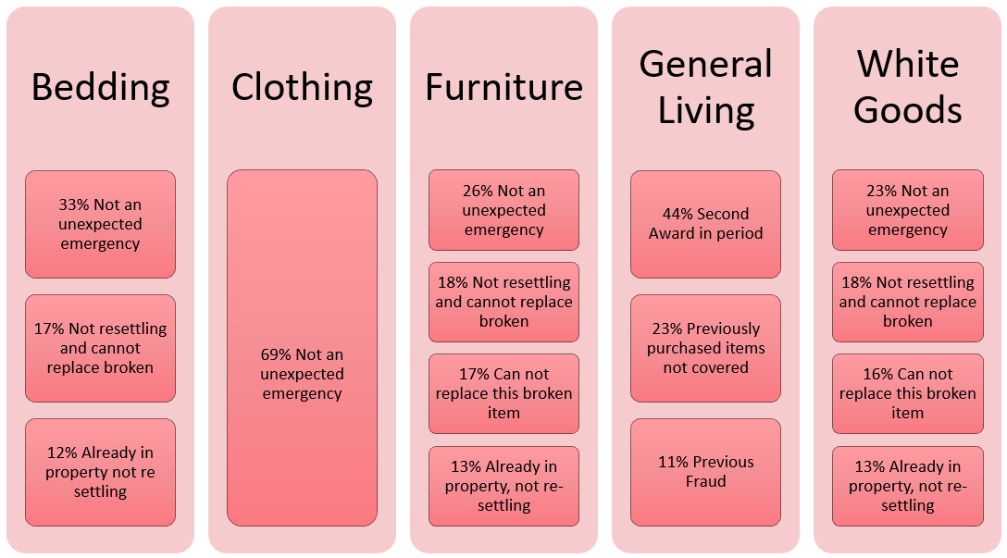
Please note, the figures reflected here are reliant on the quality and understanding of the raw data supplied.

Summary and Key Findings
The demand on ELF during the last four years has risen hugely, with increases since 2021 due to the impact of the COVID-19 pandemic, and the cost-of-living crisis which has continued to place financial pressure on households.
In 2022/2023, applications for the year doubled. Last year they have rose by nearly a third (30%). This year there has been a continued increase of 8% more applications to the fund. The total that has been spent on successful applications this year is unprecedented; approximately £9.2 million, which is £0.6 million more than last year, and a 25% increase.
The majority: 48% of all applications continue to be from Lone parent households. 30% are from single households, 12% from families, 7% from pensioners and 3% from couples.
70% of reasons for all applications is ‘Cost of Living, which was a reason introduced in the 2023/24 financial year. It is now being used more than ‘Exceptional Pressure’, which is now second highest and accounts for 22.5%.
Basildon remains the district with the highest number of applications; 19.6%, and subsequently the most successful applications, items awarded, and money spent. Tendring is next highest with 16.7%, followed by Colchester with 12%, Braintree 9%, Harlow 8%, and Chelmsford 8% of all applications.
77% of applications in 2024/2025 have been successful, 23% unsuccessful. A continuing trend of more being successful each year; 70% last year.
A higher proportion of pensioners were successful with their applications than any other cohort; 86%. This is a continued trend from last year, and alongside the proportion of applications rising slightly year-on-year for this group; indicating that the need for pensioners will continue to increase.
- 94% of Lone parent successful applicants are female, nearly half are aged 30-39 (46%). Hotspot areas for Lone parents are Lee Chapel North and Fryerns in Basildon, and Greenstead in Colchester.
- Pitsea North West in Basildon is a hotspot area for Single person successful applications, as is Greenstead. Ages are more varied, with a majority between 50 and 59, and more of an equal split of male and female single applicants.
- For Family applications, Lee Chapel North sees most successful applications, closely followed by Pitsea North West. A high proportion are female; 76%, and nearly half are aged in their thirties; 45%.
- Almost a quarter of all Pensioner successful applicants are in Tendring; 23%, with West Clacton & Jaywick Sands being the top ward area. Pitsea South East being the second highest area. Two thirds are female applicants, with nearly 40% aged 60-64.
- Successful applications for Couples are also more in Tendring, again noticeably in West Clacton & Jaywick Sands, although the top three ward areas for Couples are in Basildon in Vange, Pitsea North West and Laindon Park. Two thirds are female, and the main age group is between 50 and 59.

87% of this year’s spend was on items under the General living category. With 60% of all items being awarded under this category. The average total number of items issued per application has been consistent over the 12 months, with the average staying high even when totals have decreased towards the end of the year.
Basildon has the highest total spend for the year, accounting for 20% of the total amount. The highest average spend is seen in Uttlesford district with £293 approximately per application, even though they have the lowest overall spend; 2% of the total. This is a continuing trend.
47% of unsuccessful applications were from lone parent families. The most common reason for items being unsuccessful is ‘Second award in period’ (26% of items with unsuccessful applications), second highest is ‘Not an unexpected emergency’ (21%). This is followed by ‘Misuse: Previously purchased items not covered’ (15%).
The Essential Living Fund scheme has been one of the key vehicles to ensuring those who became vulnerable during the pandemic and then the emerging cost of living crisis had access to support either directly from ELF or, if ineligible, signposted to appropriate support.
Awareness has improved due to promotions taking place, for example on pharmacy bags for in October 2023; and 20,000 ELF leaflets distributed to partners across the county in December 2023.
The ELF will continue to be delivered. The fund will likely remain as being one of the key pathways to support individuals across Essex due to the continuing financial crisis and will be needed the most by those most vulnerable when entering the winter months.

This information is issued by:
Essex County Council
Contact us:
candfcommissioning@essex.gov.uk
Essex County Council
County Hall, Chelmsford
Essex, CM1 1QH
Essex_CC
 facebook.com/essexcountycouncil
The information contained in this document can be translated, and/or made available in alternative formats, on request.
Published 15th July 2025

https://www.southend.gov.uk/extra-financial-help/essential-living-fund

