Healthy Weight Essex Resident Survey
  - Promotional Material - Partner Toolkit
Contents
What you can do 1
Key Messaging: To Adults (18 years old +) 1
Assets – Flyer 2
Assets – Social Media 3

Background
Essex County Council wants to support all Essex residents to be a healthy weight, and to create a more supportive environment where healthy lifestyle choices are the easiest choices. As part of this ambition, ECC Public Health are developing the first Essex Healthy Weight Strategy. To help inform this, ECC Research & Citizen Insight are working to understand residents’ needs, experiences, challenges and suggestions for achieving and/or maintaining a healthy lifestyle and weight. We would like to hear from as many adults (18+) years living across Essex as possible in this short survey, to hear what matters to them: https://www.smartsurvey.co.uk/s/HealthyWeightEssex/
Survey close – Midnight, 22/03/2024

What you can do
Partner support is really important as you know your local residents and can help reach them. Please promote this survey to the adults (18+ year olds) through your channels and networks.
Please note: This must not be promoted directly to anyone in the context of, or in association with, their past or present National Health Service (NHS) or Adult Social Care Service (ASCS) use.
The following toolkit provides material for partners to use and share.
You can also support by sharing our Facebook posts and retweeting our posts on X (formerly Twitter). Please tag/signpost the accounts below on the relevant platform:
- Facebook: @essexcountycouncil
- X (formerly Twitter): @Essex_CC

Key Messaging: To Adults (18 years old +)
This is the foundation for all our key communications.
“Have YOUR say!
We want to support all Essex residents to be a healthy weight, and to create a more supportive environment where healthy lifestyle choices are the easiest choices. So, share your views, experiences, priorities and suggestions around maintaining a healthy weight and lifestyle, to help shape plans for a future strategy
Complete the Healthy Weight Survey by midnight Friday 22nd March 2024.”

Assets – Flyer
We’ve created the below flyer which you can use in any physical promotion. If you are unable to print this, please contact healthy.weight@essex.gov.uk to make arrangements. A downloadable pdf version is available on https://we.tl/t-rc5iWwJbu3.
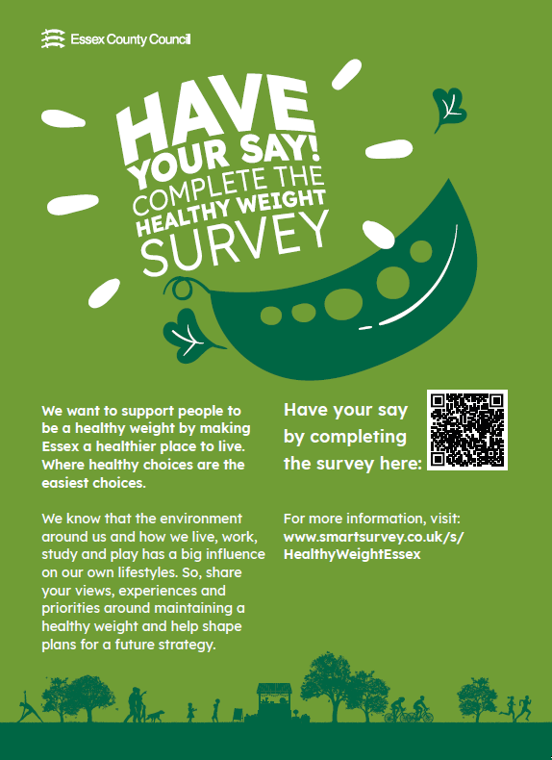

Assets – Social Media
We’ve created more ready to use assets to make it easier for partners to promote the survey on Facebook, X (Twitter) or Instagram.These can be downloaded directly from https://we.tl/t-rc5iWwJbu3 too.
Facebook:
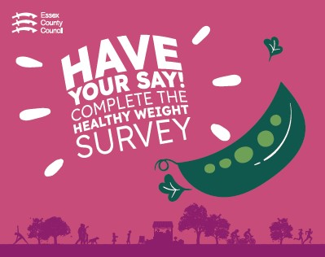
Instagram:
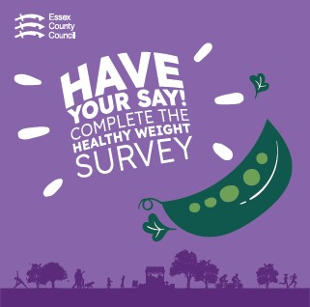

X (Twitter)
