Key Findings from the 2020 Childcare Survey

Introduction

In November 2020, the Research & Citizen Insight team in collaboration with the Corporate Strategy team and colleagues in Children and Families, we conducted a survey entitled ‘Childcare in Essex – parents’ views’. This was aimed at parents of children aged 0 – 19 (25 if SEND) living in Essex using any form of childcare (formal or informal), including those not using any. It was promoted through various online channels, existing services and professional newsletters.
This survey was conducted to inform the development of the Early Years and Childcare Strategy and the Childcare Sufficiency Audit.
The survey received 1,262 responses.

What matters most to parents
- Supporting working parents through the provision of suitable and affordable childcare
- Support for parents, especially new parents
- Need for more wrap around care
- FEEE being available from the age of 2 for all
- The high cost of childcare negatively impacting family finances

Majority of respondents were working parents (71%)
Two thirds of couples have both parents working, followed by 21% where one parent works. Over a quarter of lone parents are not working, but the majority (71%) are.

Most households were earning £45k-£59k p.a.
Household income varied among respondents, with more than 60% earning at least £35,000 p.a. The £45k-£59k bracket was the largest, with 222 households (18%).

Majority did not receive any financial support
8% received Universal Credit and 6% Child Tax Credit. An Education, Health Care Plan (EHCP) was in place in 39 households (3%).

Summary
Parents’ satisfaction with their children’s transition to school is high as is their confidence to support their children’s learning while at home however, there are clear concerns around the affordability and flexibility of available and suitable childcare for working parents.

Who we reached?
Majority of respondents were:
- Female (96%)
- White British (89%)
- Living as a couple (88%)
- Working (71%)
- Not receiving any income support (78%)

Location of respondents
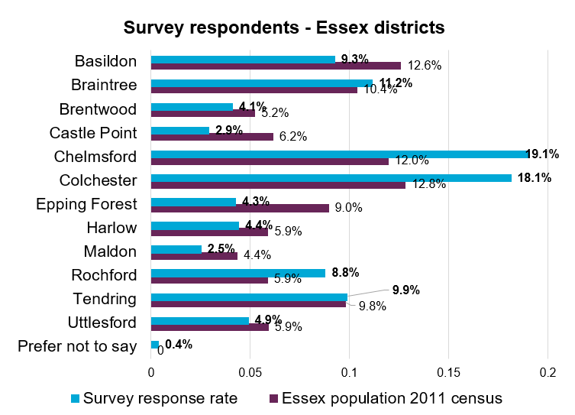

Age of children
Age group | Total number of children per age group | % of total number of children
1 year and below  (0 - 12 months) | 231 | 10.1
1 – 2 years  (13 - 24 months) | 203 | 8.9
2 – 3 years  (25 - 36 months) | 326 | 14.3
3 – 4 years  (37 - 48 months) | 326 | 14.3
4 – 5 years  (49 - 60 months) | 150 | 6.6
4 – 5 years  (i.e. Reception class) | 208 | 9.1
5 – 7 years | 293 | 12.9
7 – 11 years | 336 | 14.8
11 – 14 years | 110 | 4.8
14 years and older | 93 | 4.1
Total | 2276 | 100

Most parents feel confident about their child’s transition to school and they feel confident supporting their children’s learning while at home

Excellent or good experience of transition to school
- Majority of parents of recent ‘school starters’ have felt confident about their child’s transition to school. This applies for two-thirds of those starting next year (Sept 2021), too.
- Majority had an excellent or good experience of transition – good communication received from the school before starting school was key to an overall positive experience.

Parents draw on a wide range of sources of information
- Most parents feel confident at supporting their children’s learning while at home, drawing on a wide range of sources of information, albeit not ‘official’ as such, with general Google search, family, school and friends being the key sources, however awareness and thus usage of ECC’s existing resources (Talk, Listen, Cuddle (TLC) ‘Going to school’ resources, Family Information Service (FIS), Essex Child and Family Welling Service (ECFWS) is low. Those who have used it generally rated it as ‘helpful’ and ‘clear’.

Supporting working parents through the provision of suitable and affordable childcare

- AVAILABILITY OF CHILDCARE -

Need for more wraparound care and holiday clubs

On top of the lack of availability, affordability and flexibility of childcare pre-coronavirus, parents told us that provision had stopped due to Covid with some provisions not being reintroduced. Parents stated specific issues regarding:
- The lack of wrap-around care in rural areas
- A need for greater variety of these [wrap-around] clubs, to aid greater stimulation for the children
- Lack of wrap-around care being picked up by childminders (still scarce or oversubscribed in certain areas)

“Please cater more for parents who work longer hours such as 8am to 6.30pm and who need school holiday provision too. Most people get 5 weeks holiday a year only. I am not sure how parents are supposed to manage with term time only care.”
(Parent Quote)
“We need more options for children of working parents when those children go to school - it is very difficult to understand what options are out there and suitable for your child. I work 9am- 5pm minimum and I have no idea what we are going to do when our son finishes school at 3:30pm come Sept 2021.”
(Parent Quote)

- FLEXIBILITY OF CHILDCARE -

Parents are struggling to balance their work and childcare needs

A negative consequence of these struggles is resulting in:
- Need to change/shorten working hours
- Some being ‘forced out of work’
- Reliance on family arrangements
- Increased stress

“The cost of childcare is extortionate especially if you have multiple children.”
(Parent Quote)

Types of childcare used
For pre-school children, most respondents used formal childcare. For school-aged children, more than half didn’t use any childcare. Under a third of parents used informal childcare – overwhelmingly provided by grandparent. Not using any childcare appears to be driven more by personal choice than actual cost.

Barriers to suitable and affordable childcare

Lack of wrap-around and partial day options

The hours offered by childcare settings are not suitable for those working full-time – many need cover at least 8am-6pm, both for pre-schoolers and school-aged children (wrap-around care). Partial days are challenging to cover.

Availability has become even more limited

Actual availability of childcare - especially the lack of before and after school childcare, which has generally been limited, and even more so as a result of the coronavirus pandemic

Cost of childcare is ‘penalising’ working parents
This is putting families’ incomes under considerable strain, especially when having multiple children; many feel ‘penalised’ for working when their income just about covers their childcare costs

- AFFORDABILITY OF CHILDCARE -

Free Early Years Entitlement Funding (FEEE)

Respondents are generally grateful for the existence of FEEE/EE. However, those not eligible for FEEE until their child turns 3 call for it to be accessible universally from the age of 2.

Some still not able to afford formal childcare
While some view the current criteria as helping those ‘who are at home already’, others point out that they may be working but be on a lower/average income, or be reliant on a single income, thus being in the same situation of not being able to afford formal childcare at all.

Dissatisfaction with funding ‘conditions’
Parents were also dissatisfied about the ‘conditions’ that some settings place on the use of FEEE/EE, e.g. limiting the number of hours parents can use, being charged additional costs for food/resources and eligibility starting the term after the child’s birthday, resulting in some children having a shorter period of time to benefit from EY education.

Considerable discrepancies in experience and understanding
Greater clarity is needed around FEEE/EE offered to all those involved, this would assist with greater understanding of the underlying issues, as the comments point to a considerable discrepancy between parents’ perspectives on cost of childcare and its impact on families’ financial situations, and the experience of the EY settings.

Use of FEEE and Tax-free childcare
Awareness of FEEE (2, 3 and 4) and the Extended entitlement is high (91%). Main benefits are around getting children ‘ready for school’ and improving family finances.
Two thirds of respondents are aware of Tax-free childcare, but less than a third use it.

- SUITABILITY OF CHILDCARE -

Parents view SEND support as slow and difficult to find

This includes pathway to diagnosis, as well as trying to find suitable childcare for SEND children. EY providers are not always able to provide the support needed due to lack of resources or training on specific conditions (e.g. autism, dyslexia and speech, language, and communication needs).

What is needed
- Better/earlier SEND support/intervention for children
- Better SEND IAG/training for childcare staff
- Better SEND IAG for parents

For more detailed thematic analysis of respondents’ comments, please refer to the detailed report.

“More awareness, identification and support to receive early intervention and start diagnosis processes. SEN kids are left till they are drowning emotionally within mainstream awaiting diagnosis and support.”
(Parent Quote)
“Essex have taken away all forms of support and as a result my child has had nothing other than what we have privately paid for. This is unacceptable. His nursery is clueless and do not know how to support him. The IP has been useless too! Essex have actively neglected children with SEN by pulling all services disallowing them access to trained professionals.”
(Parent Quote)

This information is issued by:
Essex County Council
Contact us:
Le.Ho-Everiste@essex.gov.uk
www.essex.gov.uk
07740 180 566

The information contained in this document can be translated, and/or made available in alternative formats, on request.
Published March 2021.

