Essex County Councils
Essex Economic Scenarios – Technical Summary

Final Report
alb@camecon.com
www.camecon.com
Cambridge Econometrics
Cambridge, UK
June
2021

Cambridge Econometrics’ mission is to provide clear and useful insights, based on rigorous and independent economic analysis, to address the complex challenges facing society.
www.camecon.com

Cambridge Econometrics Limited is owned by a charitable body,
the Cambridge Trust for New Thinking in Economics.
www.neweconomicthinking.org

Contents
Page

1 Introduction 4
1.1 Background 4
1.2 This report 4
2 Baseline economic forecasts 5
2.1 Introduction 5
2.2 Approach and methodology 5
2.3 Data sources and definitions 6
2.4 Summary of results 7
3 Green recovery forecasts 11
3.1 Introduction 11
3.2 Background 11
3.3 Approach and methodology 11
3.4 Summary of results 14
4 Remote working forecasts 16
4.1 Introduction 16
4.2 Approach and methodology 16
4.3 Data sources and definitions 18
4.4 Overview and definition of urban areas in Essex 18
4.5 Summary of results 19
5 Appendix A: Sector definitions 40

Introduction

Background
Over the past decade the Essex economy has experienced robust growth, creating some 72,800 jobs and driving economic growth valued at £7bn, as the area has positioned itself as one of the region’s leading economic drivers with nationally significant assets. This strong rate of growth was expected to be maintained in future, as outlined in the array of ambitious strategies and plans developed by local stakeholders.
Due to the Covid-19 pandemic and the latest Brexit developments, previous expectations of the trajectory of the Essex economy are now uncertain, and there is a need to articulate the scale and pattern of the shock on the Essex economy and what impact this might have on its future growth trajectory. This will help to inform and ensure the effectiveness of any potential interventions, strategies and plans moving forward.
Cambridge Econometrics (henceforth CE) has a proven track record of assessing and modelling the short and long run impact of both micro and macro-level shocks on subnational economies, and have employed this technical expertise to produce a set of empirically sound, scenario-led projections for the Essex economy, capturing the expected scale and shape of the shock and resultant recovery from the Covid-19 pandemic across a range of variables, sectors and geographies.

This report
This report is structured as follows:
- The first section provides an overview of CE’s baseline economic forecasts for Essex, which articulate the impact and recovery trajectory from the Covid-19 pandemic, amongst other macroeconomic trends (such as Brexit). Supporting methodology and assumptions are also provided.
- The second section outlines CE’s approach to modelling a ‘green recovery’ scenario for the Essex economy, and highlights the potential scale and pattern of the economic benefits.
- The final section presents CE’s novel work on a remote working scenario for the East of England, which seeks to identify the potential ‘winners’ and ‘losers’ of a large-scale shift in remote working at a detailed spatial level.
This report is designed as a technical summary to aid understanding of the aforementioned forecasts and scenarios. Workbooks containing the detailed forecasts underlying this report have been provided to the client, and are available to access on the Essex Open Data Platform.

Baseline economic forecasts

Introduction
To help Essex County Council and colleagues better understand the likely longer-term impact of the Covid-19 pandemic on the Essex economy, Cambridge Econometrics (CE) has developed a series of credible econometric forecasts for the county and its constituent authority areas. The following analysis outlines the supporting methodology and definitions, before briefly considering the results.

Approach and methodology
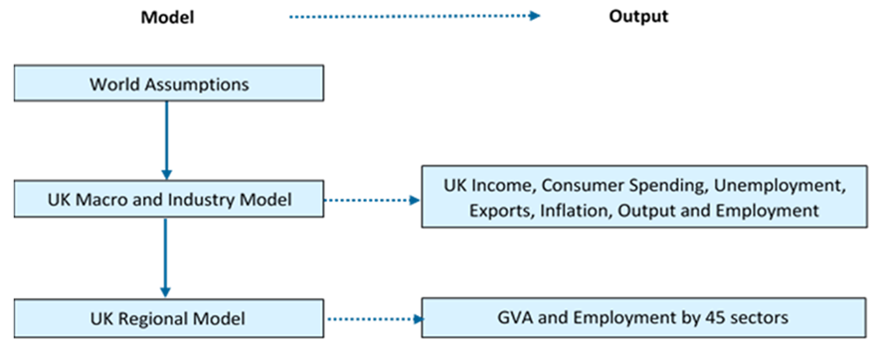
To produce these local area forecasts, CE has utilised the bespoke Local Economy Forecasting Model (LEFM) component of its macroeconomic Multi-Sectoral Dynamic Model (MDM-E3) of the UK economy. Resultantly, the local area forecasts for Essex are consistent with CE’s macroeconomic forecasts for the UK economy as a whole.
Figure 2.2.1: Links between Cambridge Econometrics' suite of models
Source: Cambridge Econometrics.
An important feature of this modelling approach is the link to CE’s wider modelling suite, ensuring any local area forecasts are consistent with CE’s world, UK national and UK regional forecasts and assumptions, as Figure 2.2.1 demonstrates.
CE’s headline UK forecasts have been developed within the context of its position within global trade networks, the worldwide impact of Covid-19, and the changing nature of the UK’s trading relationship with the EU. These national level impacts are then systematically distributed to regions and local areas, based on historic sectoral relationships.
The regional and local impact depends, therefore, on the historic precedent of how local sectors have historically performed relative to their national or regional equivalents, thereby capturing the differing intrinsic resilience of local sectors to national economic shocks.
For example, if the Professional Services sector in Essex has historically been impacted less hard, and/or recovered more rapidly from past shocks, than the UK Professional Services sector as a whole, then this will be reflected in the local forecasts.
CE’s latest local area forecasts were produced in March 2021, and draw on up to 12 months data encompassing the Covid-19 pandemic and the end of the EU transition period, for a range national and regional indicators such as:
- Output (GDP, GVA) and productivity
- Income and earnings
- Employment and unemployment
- Trade and exports
- Inflation and consumer spending
- Government-support schemes (furlough, self-employment support etc.)
It should be emphasised that even with this extensive evidence base, any efforts to determine the quantitative implications of Covid-19 on national and local economies are still highly uncertain and indicative at this early stage of the pandemic.
And even when accounting for this, as with all kinds of forecasting, there are margins of error associated with the results which tend to widen over time. Furthermore, it should also be noted that the quality and reliability of data decreases at more detailed levels of geography.

Data sources and definitions
As part of the LEFM, CE have developed and maintained a highly disaggregated database of historical and projected employment, GVA and population data from 1981 to 2050. The data are available by sector (12 broad sectors or more detailed 45 sectors, based on SIC classifications) for all unitary authorities and local authority districts in Great Britain.
Employment definition
Employment is defined as workplace-based jobs and includes full-time employees, part-time employees and the self-employed. Full- and part-time employment data by industry are based on the Business Register and Employment Survey (BRES) for time periods after 2009 and the earlier Annual Business Inquiry (ABI) for the time period 1998-2008. Estimates of self-employment are taken from the Annual Population Survey (APS) from 2004 onwards.
For earlier years estimates are generated under the assumption that the ratios of self-employed to employees at local level by industry are the same as those at the corresponding regional level. Self-employment estimates are then added to the BRES employment data. The figures are made consistent with more recently published estimates of jobs at a regional level (quarterly workforce jobs, June figures) published by ONS, which include people in the armed forces but do not include people on government training schemes.
Gross Value Added (GVA) definition
CE GVA data are consistent with sector data (balanced approach) at the local authority level from the ONS’ Regional Accounts. GVA is defined by the ONS as “...a measure of the increase in the value of the economy due to the production of goods and services”. The measure of GVA used in this report was based on the balanced approach (GVA(B)), which provides “a single measure of economic activity within a region”. This is a relatively new approach, calculated using estimates from the income (GVA(I)) and production (GVA(P)) measures. Chained Volume Measure (CVM) estimates of GVA were used in order to remove the effects of price inflation and thus allow intertemporal comparisons.
Productivity definition
The measure of productivity used in this report was labour productivity defined as output per unit of labour, with output measured by Gross Value Added (GVA) and employment by workplace-based jobs. Labour productivity, a critical indicator of workforce efficiency, is “a key dimension of economic performance and an essential driver of changes in living standards” (OECD, 2019, p. 48). Apart from its importance as an economic indicator, this definition of labour productivity offers the advantage of relatively low data and computational requirements, as the relevant data are (for the most part) readily available at the local area level.

Summary of results
CE’s forecast, incorporating the impact of the Covid-19 pandemic and the latest Brexit developments indicate a comparatively short, but unprecedented, impact to economic activity in Essex, but with a favourable outlook relative to regional and national comparators, as Figure 2.4.1 shows.
Boosted by the furlough scheme and related labour market support (e.g. self-employment support), alongside the desires of firms to retain staff in spite of falls in output, employment is expected to prove much more resilient than output, contracting by only 1% across the UK.
In fact, within Essex, net job losses could be negligible compared to the national average, as a result of high furlough uptake and a resilient labour market. However, with the unwinding of support, labour market uncertainty will persist into 2021, before momentum picks up 2022-onwards, with Essex’s jobs recovery outpacing the UK average.
Output (i.e. GVA) is expected to undergo a very sharp bottoming-out in 2020, given the substantial interruption to - and for some sectors complete cessation of - economic activity. Given the higher furlough uptake, and stricter tier restrictions during the autumn and winter in Essex, output could decline by 9.2% (in real terms) over 2020, a sharper fall than the UK average of 8.4%.
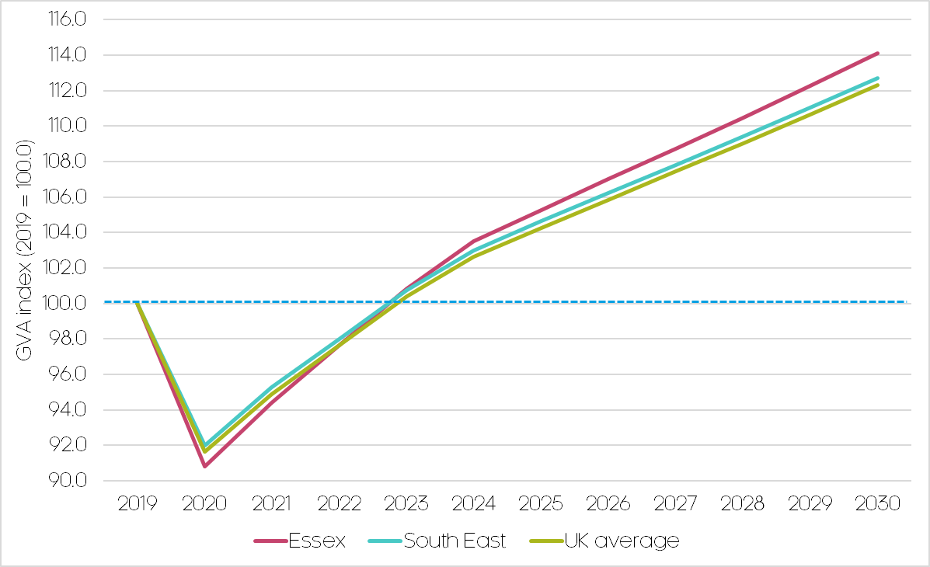
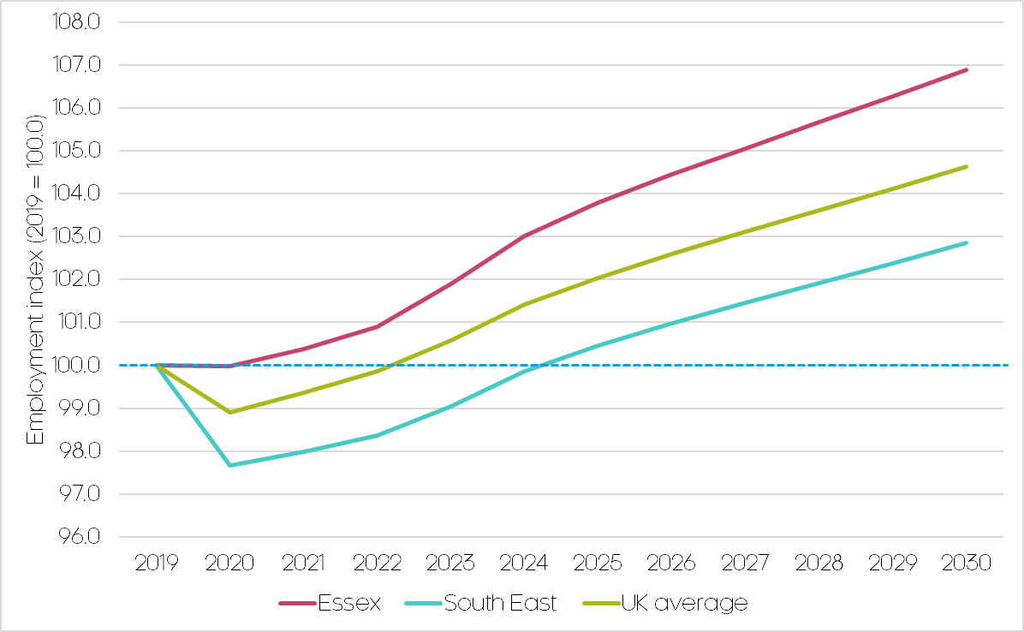
And this contraction will be unprecedented compared to previous economic crises; after the ‘Great Recession’ of 2008, output fell by ‘only’ 5.7% in Essex. There were however 11,900 net job losses in Essex during this time, multiples of those expected as a result of the pandemic.
Source: Cambridge Econometrics.
Figure 2.4.1: Forecast employment (top) and GVA (bottom) impact and recovery from the Covid-19 pandemic, 2019-30
Despite this sharper contraction, Essex is expected to undergo a much larger post-Covid ‘bounce’, with GVA forecast to grow in real terms by 2.3% per annum by 2030 in Essex, faster than the UK average of 2.1%. By 2030, the Essex economy could be £5.3bn larger than in 2019.
Given the contrasting response of output and employment during 2020, productivity consequently undergoes a sharp drop, further exacerbating Essex’s ‘productivity puzzle’, although the post-Covid recovery could be productivity-led, driven by increased digitisation and automation triggered by the pandemic.
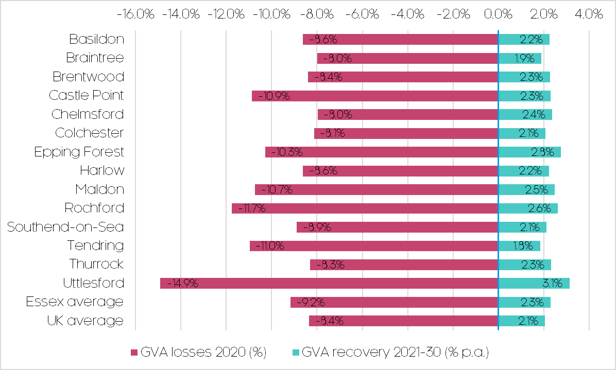
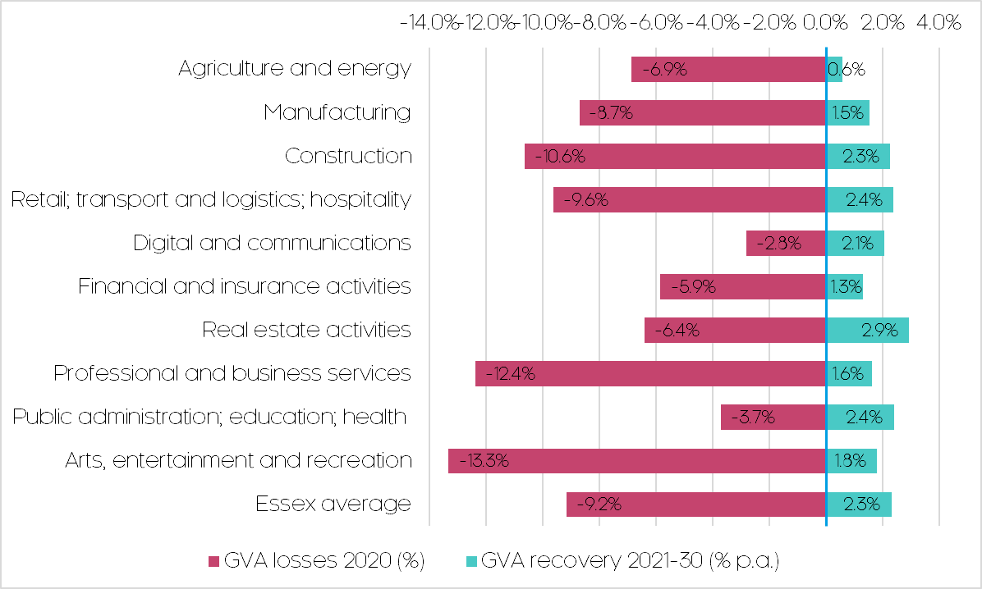
As Figure 2.4.3 shows, sectors such as retail, accommodation and food, and arts and recreation are expected to be the hardest hit in Essex, particularly short-term, and it may be 5+ years until pre-Covid levels of activity are recovered in some of these sectors. Public administration and health, digital, transport and logistics and real estate could prove resilient and emerge strongly post-Covid, whilst construction, retail and hospitality have the potential to bounce back following a difficult 2020.
Figure 2.4.2: GVA impact and recovery from the Covid-19 pandemic by unitary and local authority area in Essex, 2019-30
Source: Cambridge Econometrics.
Figure 2.4.3: GVA impact and recovery from the Covid-19 pandemic by sector in Essex, 2019-30
Source: Cambridge Econometrics. Note: sectors are aggregation of the 45 available.
Figure 2.4.2 considers the impact within Essex. Uttlesford – with its higher incidence of Covid-vulnerable industries, such as aviation, retail, and tourism – could be the hardest hit. Tendring, Rochford, Maldon, Epping Forest and Castle Point are also expected to be impacted notably worse than the UK average, whilst urban areas such as Chelmsford, Braintree, Colchester and Thurrock will be the most resilient.
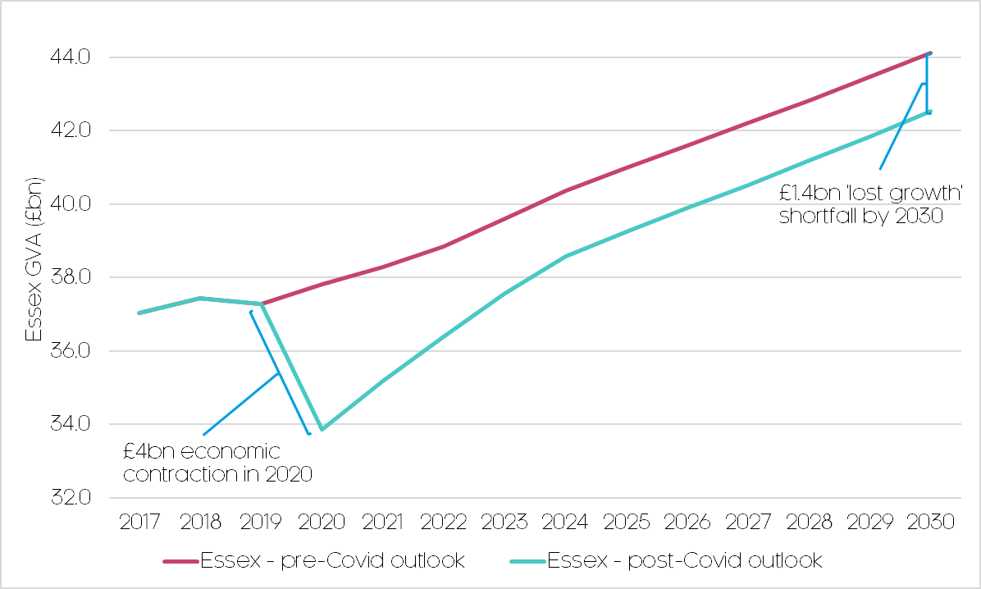
The majority of areas in Essex are expected to have fully recovered to pre-Covid levels of economic activity by 2023, and all but two (Tendring and Braintree) could experience a post-Covid ‘bounce’ and outperform the UK recovery. Despite being the most impacted, Uttlesford could lead the recovery in Essex, with Epping Forest, Rochford and Maldon also having the potential to grow notably faster than the UK average.
Figure 2.4.4: Pre- and post-Covid outlook in Essex, 2019-30
Source: Cambridge Econometrics. Note: pre-Covid outlook relates to January 2020 forecasts, re-based to March 2021 historic data.
.
The long-term costs and implications of the pandemic for Essex could be significant. As Figure 2.4.4 shows; relative to a pre-Covid trajectory, CE’s preliminary forecasts indicate that by 2030, as a legacy of the pandemic, the Essex economy is expected to be £1.6bn smaller.
However, it is important to set these trends within the wider national context; as Table 2.4.1 shows, though the short-run impact will be slightly more pronounced in Essex (see column 1), its recovery is expected to exceed the UK average (column 2), resulting in a smaller relative ‘lost growth’ shortfall over the longer timeframe (column 3).
Table 2.4.1: Covid-19 impact and recovery prospects
 | GVA impact, 2020 (relative to 2019) | GVA recovery per annum, 2021-30 | GVA shortfall relative to pre-Covid, 2030
Essex | -9.2% | 2.3% | -3.6%
UK average | -8.4% | 2.1% | -4.0%
Source: Cambridge Econometrics.

Green recovery forecasts

Introduction
In addition to providing baseline econometric forecasts incorporating the Covid-19 pandemic, CE has also modelled the impact of a potential post-Covid green recovery for the Essex economy. The following analysis outlines the supporting methodology and assumptions for a green recovery in Essex, before briefly considering the results.

Background
The green recovery is a popular term for a potential package of environmental, regulatory and fiscal reforms to be utilised in the recovery from the economic shock of the Covid-19 pandemic.
It emphasises investment that lifts an economy out of recession by reducing global warming from the use of fossil fuels (coal, oil and gas), and increasing the uptake and efficiency of clean transport, energy, buildings, and corporate or financial practices.
CE’s analysis of the government response to the 2008/09 financial crisis found that environmental spending accounted for only a small share of the economic stimulus packages.
The recession caused by the Covid-19 pandemic and subsequent lockdown offer an opportunity for public policy intervention to be ‘reset’, providing a stimulus package which could not only help people get back to work but also set the UK on a low-carbon trajectory more aligned with ambitions to become a net-zero economy by 2050.

Approach and methodology
To estimate the economic impact of a green recovery in Essex, CE has utilised the Input-Output (I-O) component of its LEFM model. I-O analysis helps to estimate the wider impacts of alternative policy strategies on a range of socio-economic variables.
This is achieved by using a series of complex and interrelated equations within the model to estimate direct, indirect and induced economic effects resulting from a public or commercial investment:
- Direct effects: represent the economic activity generated by activities that directly deal with the investment e.g. jobs created by the operation of a nuclear power plant.
- Indirect effects: are impacts which accrue indirectly due to the activities undertaken during the investment e.g. jobs created to help supply materials and technology to design and construct the nuclear power plant.
- Induced effects: represent the wider contributions of an investment through the expenditures of those jobs directly or indirectly created e.g. jobs created to oversee the demand of construction workers building the nuclear power plant on local hotels, restaurants, pubs/bars etc.
The foundation for modelling and assumptions has been the UK Governments’ Ten Point Plan for a Green Industrial Revolution, which outlines its approach to a green recovery. The Plan was published in Autumn 2020, during the pandemic, and specifically references potential benefits of delivery, including employment, investment and emissions effects, as summarised in Table 3.3.1.
Table 3.3.1: The UK Governments Ten Point Plan for a Green Industrial Revolution
Points 1-10 | Government description | Potential UK-wide employment (by 2030)
1. Advancing Offshore Wind | 1. Offshore wind: Producing enough offshore wind to power every home, quadrupling how much we produce to 40GW by 2030, supporting up to 60,000 jobs. | 60,000
2. Driving the Growth of Low Carbon Hydrogen | 2. Hydrogen: Working with industry aiming to generate 5GW of low carbon hydrogen production capacity by 2030 for industry, transport, power and homes, and aiming to develop the first town heated entirely by hydrogen by the end of the decade. | 8,000
3. Delivering New and Advanced Nuclear Power | 3. Nuclear: Advancing nuclear as a clean energy source, across large scale nuclear and developing the next generation of small and advanced reactors, which could support 10,000 jobs. | 10,000 (at peak)
4. Accelerating the Shift to Zero Emission Vehicles | 4. Electric vehicles: Backing our world-leading car manufacturing bases including in the West Midlands, North East and North Wales to accelerate the transition to electric vehicles, and transforming our national infrastructure to better support electric vehicles. | 40,000
5. Green Public Transport, Cycling and Walking | 5. Public transport, cycling and walking: Making cycling and walking more attractive ways to travel and investing in zero-emission public transport of the future. | 3,000 (by 2025)
6. Jet Zero and Green Ships | 6. Jet Zero and greener maritime: Supporting difficult-to-decarbonise industries to become greener through research projects for zero-emission planes and ships. | 5,200
7. Greener Buildings | 7. Homes and public buildings: Making our homes, schools and hospitals greener, warmer and more energy efficient, whilst creating 50,000 jobs by 2030, and a target to install 600,000 heat pumps every year by 2028. | 50,000
8. Investing in Carbon Capture, Usage and Storage | 8. Carbon capture: Becoming a world-leader in technology to capture and store harmful emissions away from the atmosphere, with a target to remove 10MT of carbon dioxide by 2030, equivalent to all emissions of the industrial Humber today. | 50,000
9. Protecting Our Natural Environment | 9. Nature: Protecting and restoring our natural environment, planting 30,000 hectares of trees every year, whilst creating and retaining thousands of jobs. | 20,000 (to 2027)
10. Green Finance and Innovation | 10. Innovation and finance: Developing the cutting-edge technologies needed to reach these new energy ambitions and make the City of London the global centre of green finance. | "hundreds of thousands" (300,000 in exports and domestic industry)
In order to estimate the extent of the impact of the national plan in Essex, a series of proxy calculations have been used to estimate the proportion of activity from each of the ten points that could be reasonably expected to take place within the area. This ensures alignment with the Governments framework and policy ambitions for a green recovery.
Source: UK Government, Cambridge Econometrics.
These effects have been estimated by distributing the UK-wide direct employment benefits (from Table 3.3.1) to constituent regions and local areas depending on their current and expected expertise in such areas, proxied by associated indicators (e.g. to allocate green public transport employment benefits, public travel commuting patterns in local areas have been utilised).
The Energy Innovation Needs Assessments (EINA’s) supporting the Plan were used to sectorally and temporally disaggregate (on an annualized basis) these direct employment effects. Table 3.3.2 outlines what proxy calculations have been utilised to convert national green recovery employment ambitions to local areas, and accompanying calculations for Essex.
Table 3.3.2: Approach to scaling Ten Point Plan employment impacts to local areas
Source: UK Government, Cambridge Econometrics. Note: assumes Bradwell B constructed and operational by 2030. UK-wide employment ending before 2030 simply extrapolated by annual average.

Points 1-10 | Potential UK-wide employment (by 2030) | Local area proxy (and source) | Direct proxy value for Essex
1. Advancing Offshore Wind | 60,000 | Installed offshore wind capacity; BEIS (Regional Renewable Statistics) | 1,100
2. Driving the Growth of Low Carbon Hydrogen | 8,000 | Energy generation jobs; ONS (BRES) | 200
3. Delivering New and Advanced Nuclear Power | 10,000 (at peak) | Bradwell B policy documents; EDF | 900 (+9,000 temporary construction/ engineering)
4. Accelerating the Shift to Zero Emission Vehicles | 40,000 | Automotive jobs; ONS (BRES) | 1,000
5. Green Public Transport, Cycling and Walking | 3,000 (by 2025) | Public travel commuters; ONS (Census) | 200
6. Jet Zero and Green Ships | 5,200 | Aerospace and marine jobs; ONS (BRES) | 200
7. Greener Buildings | 50,000 | Dwelling stock; MHCLG (Live Tables on Dwelling Stock) | 1,300
8. Investing in Carbon Capture, Usage and Storage | 50,000 | Industry and commercial carbon emissions; BEIS (Local Authority CO2 Emissions) | 600
9. Protecting Our Natural Environment | 20,000 (to 2027) | Green (non-agri) landmass; MHCLG (Live Tables on Land Use) | 700
10. Green Finance and Innovation | "hundreds of thousands" (300,000 in exports and domestic industry) | R&D workforce; ONS (BRES) | 2,500
These proxied employment effects have been supplemented and sense-checked by a substantial local evidence base, particularly that relating to the construction and operation of Bradwell B, as well as other local strategies and plans such as the South East LEP (SELEP) local industrial strategy, the Essex Climate Action Commission, The Essex Economic Plan, and Transport for the South East (TfSE) Transport Strategy.
Having estimated the direct employment effects of a Ten Point Plan-aligned green recovery, these employment totals were then input into the LEFM’s I-O modelling, to gauge the wider direct, indirect and induced effects of a green recovery in Essex. This captures the wider supply chain impacts of a green recovery (e.g. the need for sustainable building supplies for greener buildings), alongside the direct impacts laid out in the Plan.

Summary of results
The initial results of CE’s modelling suggests that a green recovery aligned to the UK Governments Ten Point Plan for a Green Industrial Revolution could support the creation of 84,700 jobs and drive £6.2bn of economic growth in Essex by 2030.
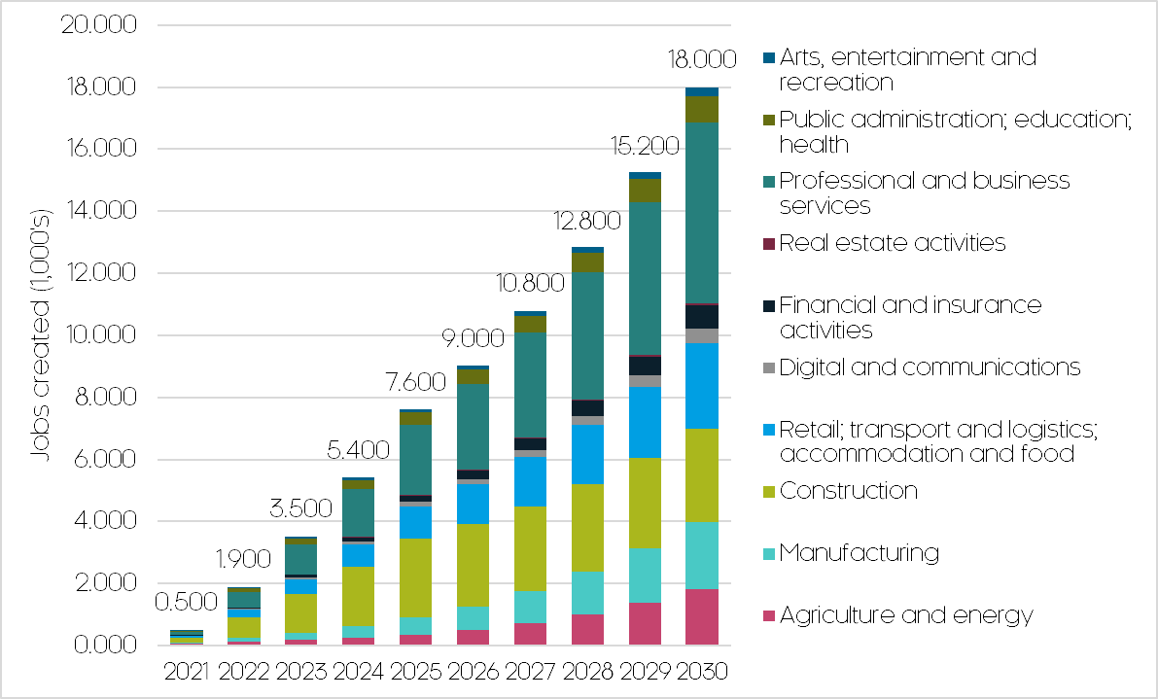
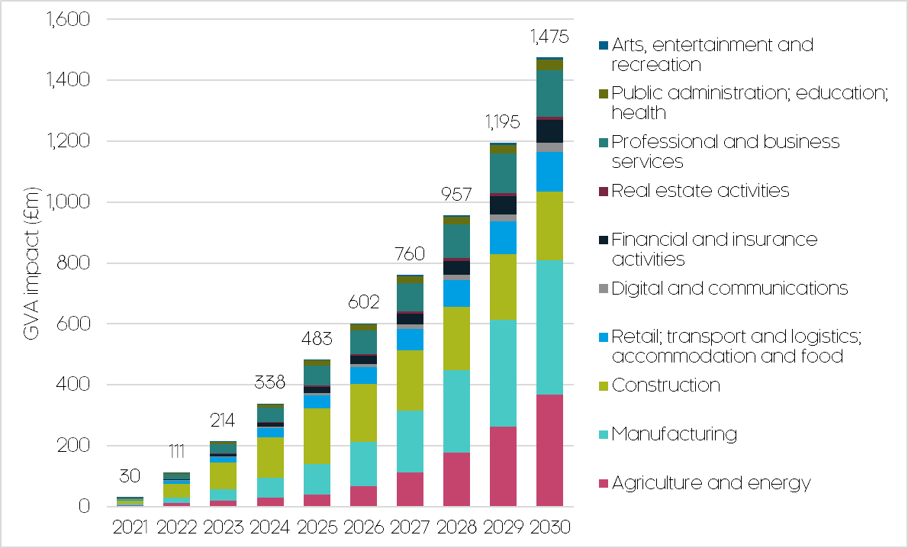
Such delivery would not only accelerate Essex’s recovery from the Covid-19 pandemic, but also set the county on a low-carbon trajectory more aligned with the UK’s ambition to become a net-zero economy by 2050.
Figure 3.4.1: Forecast employment (top) and GVA (bottom) impact from a green recovery scenario by sector in Essex, 2021-30
Source: Cambridge Econometrics.

An estimated two-fifths of the potential jobs in Essex will be in activities highly dependent on and related to the design, construction and operation of Bradwell B nuclear power station in Bradwell, Maldon. Figure 3.4.1 considers the sectoral composition of the wider green recovery impacts in more detail.
On the jobs-side, professional and business services – ranging from architecture and scientific consultancy, to cleaning services and security provision – could be the main beneficiary in Essex. This is followed by the construction sector, which is expected to reach peak rates of job creation in 2025, during the construction phase of Bradwell B.
Agriculture and energy, and manufacturing are expected to be the main generators of economic value, despite relatively modest jobs growth, accounting for over half of green recovery growth in Essex by 2030. This reflects the higher productivity in these sectors; for instance, jobs in the energy sector are expected to generate 3 times as much GVA as the Essex average.
Across both jobs and GVA, impacts are expected to incrementally increase over the decade before peaking in 2030, reflecting the timeframes outlined in the EINA’s. However, since the EINA’s predate the Covid-19 pandemic, some of the more ‘shovel-ready’ projects could be accelerated, as will their impacts.
Figure 3.4.2 considers the impact within Essex. Maldon, unsurprisingly, has the potential to be the main beneficiary of a green recovery - given the expected activity related to Bradwell B - which could support £1.2bn of growth. Basildon could also experience close to a £1bn boost. Chelmsford, Brentwood and Epping Forest could also benefit from more than £½bn of green recovery growth.
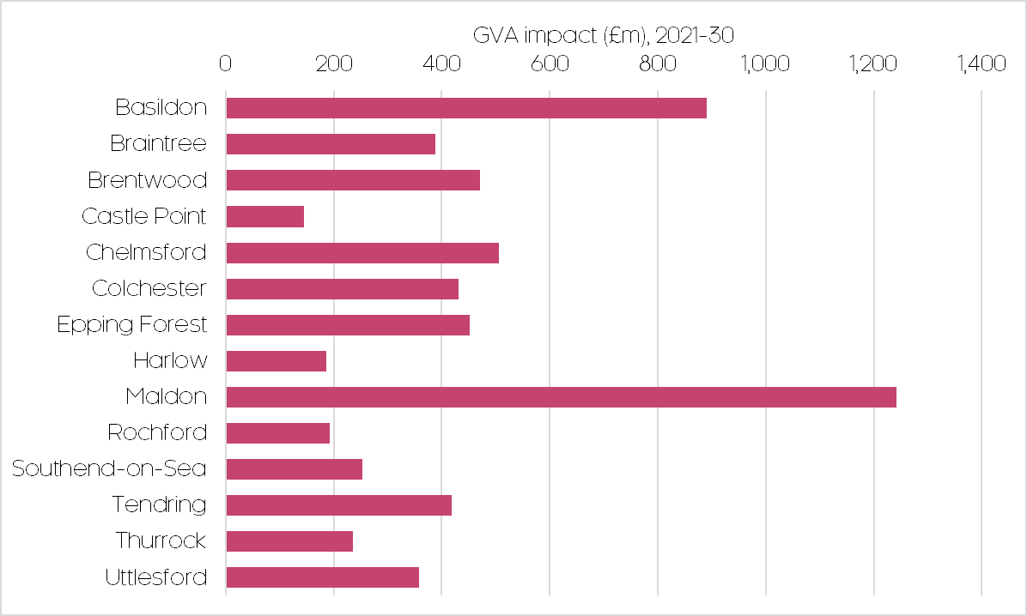
Figure 3.4.2: Forecast GVA impact from a green recovery scenario by unitary and local authority area in Essex in Essex, 2021-30
Source: Cambridge Econometrics.

Remote working forecasts

Introduction
This following analysis summarises the methodology and results of the remote working scenario developed by CE as part of the evidence base to inform the overall Transport Strategy for Transport East (which covers the East of England region, and includes the constituent Essex local authorities). The scenario considers the extent to which future workers continue to work remotely, and the implications this has for commuting and urban activity.
The purpose of the scenario development is to identify a set of possible futures for Essex and the wider Eastern region, to quantify these in a rigorous manner, and then to explore their implications for the ability of the ultimate Transport Strategy to deliver both the transport and non-transport outcomes. The set of possible futures were developed in conjunction with the Transport East Senior Officers Group (TESOG).

Approach and methodology
Disaggregation at the LSOA level
To produce the scenario, CE’s central economic forecasts (as outlined in Chapter 2 Baseline economic forecasts) have been disaggregated to Lower Output Super Area (LSOA) level. LSOA’s are broadly analogous to neighbourhoods and allow for a finer grained understanding and definition of functional economic areas. The following assumptions were adopted in order to disaggregate CE’s forecasts to the LSOA level:
- Employment: each LSOA within a Local/Unitary Authority District (LAD) grows at the same rate as the LAD
- Productivity: each LSOA within a LAD has the same productivity as the LAD
- GVA: Calculated as $Employment×Productivity$
- Workplace occupations: Application of a SIC-SOC converter (‘industry’-‘occupations’ converter) to LSOA employment projections
- Resident occupations: workplace occupation growth rates by LSOA were used to project the data forward to 2050
Commuting and place of work assumptions
Beyond CE’s standard economic indicators (employment, GVA, productivity etc.), an additional dimension of the Transport East modelling was to explore the extent that future workers within the region may continue to work remotely for more than 50% of their working week, or return to daily commuting to their place of work.
Clearly, this assumption has profound impacts for demands on the regional transport system and its ability to support different levels and distributions of economic growth. It is also worth noting that a future vision of remote work is likely to be very different, and likely more positive and flexible, than the experience of remote work under pandemic conditions.
The remote working shares were calculated on an occupational level, hence changes to projected occupational composition also directly impacts upon the overall proportion of remote workers. These assumptions were based on a combination of workforce remote working data taken before and during the Covid pandemic (derived from ONS surveys, particularly its BICS series), and research by Adams-Prassl et. al into remote working potential by occupation (which itself correlated strongly with Covid remote working trends. This provides a robust and empirical foundation for estimating future remote working trends.
The nine SOC-derived occupations, outlined in the table below, were placed into three groups with low, medium and high probabilities of future remote working potential, as described in Table 4.2.1. A split is shown for workplace-based workers – those who will continue to the travel to their workplace the majority of the time – and remote-based workers – those who will work remotely, from home, the majority of the time.
Table 4.2.1: Occupational remote working assumptions by 2035. High (green), medium (amber), low (red)
 | Workplace-based workers |  | Remote-based workers
 | Share of workers working remotely half the time | Share of workers working on any given day | Share of workers working remotely half the time | Share of workers working on any given day
Managers, directors and senior officials | 30% | 19% | 70% | 44%
Professional occupations | 30% | 19% | 70% | 44%
Associate professional and technical occupations | 30% | 19% | 70% | 44%
Administrative and secretarial occupations | 30% | 19% | 70% | 44%
Skilled trades occupations | 10% | 6% | 15% | 9%
Caring, leisure and other service occupations | 10% | 6% | 15% | 9%
Sales and customer service occupations | 10% | 6% | 15% | 9%
Process, plant and machine operatives | 5% | 3% | 5% | 3%
Elementary occupations | 5% | 3% | 5% | 3%
Source: ONS, Cambridge Econometrics, Adams-Prassl et al. (2020).
To estimate the implications for commuting flows, an LSOA-level origin-destination matrix from the 2011 Census was projected forward using the Iterative Proportional Fitting Method RAS. Origin data by LSOA for 2050 were computed as the difference between resident occupations and residential remote workers, while destination data were defined as the difference between workplace occupations and workplace remote workers.
The RAS process is an algorithm whereby the values of the matrix are continuously scaled until they converge to the given row totals (i.e. 2050 origin data) and column totals (i.e. 2050 destination data). Apart from movements between the Transport East LSOAs, commutes to six adjacent counties were modelled as well: Cambridgeshire and Peterborough; Hertfordshire; Kent; Lincolnshire; Inner and Outer London.

Data sources and definitions
LAD level data
GVA, employment, productivity and population data were obtained from the CE local database, as described previously in Chapter 2 Baseline economic forecasts.
Occupation data
Resident SOC classification occupation data by LAD for the period 2011-18 were obtained from the Annual Population Survey (APS) through Nomis. Workplace employment by occupation for the Transport East LADs was calculated by applying a SIC-SOC converter for the East of England, developed by the Institute for Employment Research at the University of Warwick. It is assumed that the distribution of occupations by sector is the same for all LADs within the East of England.
LSOA-level data
Historical LSOA data were primarily sourced from Nomis.
Employment and population
Employment data were obtained from the Business Register and Employment Survey (BRES), while population data were obtained from the ONS population estimates/projections. The data were scaled to CE LAD data to ensure consistency.
Resident occupations
Residential occupations by LSOA for 2011 were obtained through the Census. These were projected forward to 2018 using the 2011-18 growth rates from APS LAD data.
Workplace occupations
Workplace occupations by LSOA were obtained by applying the SIC-SOC converter to LSOA employment data. Similarly to the LAD-level data, this is based on the assumption that the distribution of occupations by sector is the same for all LSOAs within the East of England.

Overview and definition of urban areas in Greater Essex
A key focus of the remote working scenario is to understand the likely response and possible implications for urban areas across the Eastern region.
For Greater Essex, the seven largest urban economies have been identified, based on CE’s medium-density cores (MDC) definition. Some areas actually form part of the wider London employment core – in which case, these were split apart based on underlying employment patterns in order to provide separate analysis of each.
In geographies that spill across regional boundaries, for example Harlow, only the component of the area that lies within the Eastern region was considered.
The 7 largest urban areas in Essex are listed in Table 4.4.1 and mapped in Figure 4.4.1 below. Approximately two-thirds of all economic activity in Essex is located within these urban areas.
Table 4.4.1: Largest urban economies in Greater Essex
Urban area | Employment in 2020 (thousand jobs) | Employment density in 2020 (thousand jobs/km²)
Southend (part of London MDC) | 138.4 | 1.01
Basildon (part of London MDC) | 94.8 | 1.03
Colchester | 80.1 | 0.93
Chelmsford | 77.7 | 1.48
Grays (part of London MDC) | 64.2 | 1.08
Harlow (part of London MDC) | 59.1 | 1.10
Braintree | 20.7 | 0.96
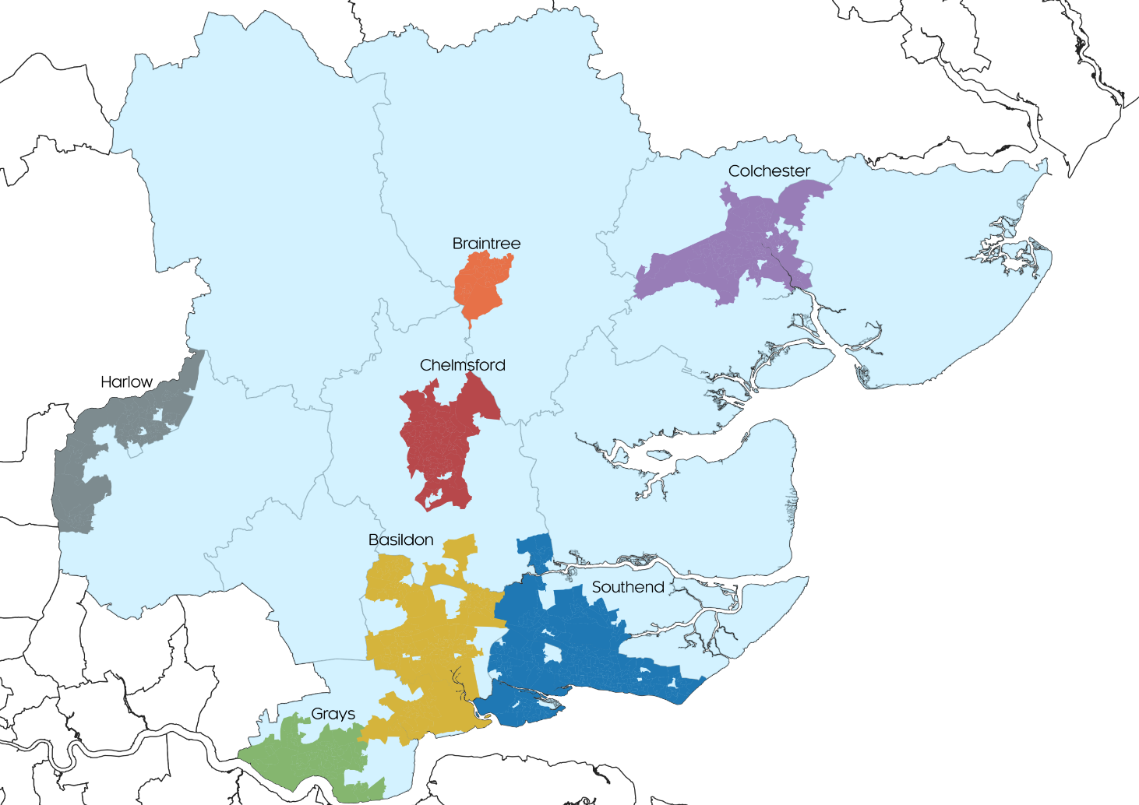
Source: ONS, Cambridge Econometrics.
Figure 4.4.1: 7 largest urban economies in Greater Essex
Source: ONS, Cambridge Econometrics

Summary of results
A key determinant of the scale and distribution of potential remote working trends across local areas in Essex will be their projected change in occupational structure. Figure 4.5.1 shows how Essex’s occupational structure is expected to change by 2035, and how these changes contrast across remote workers and commuters.
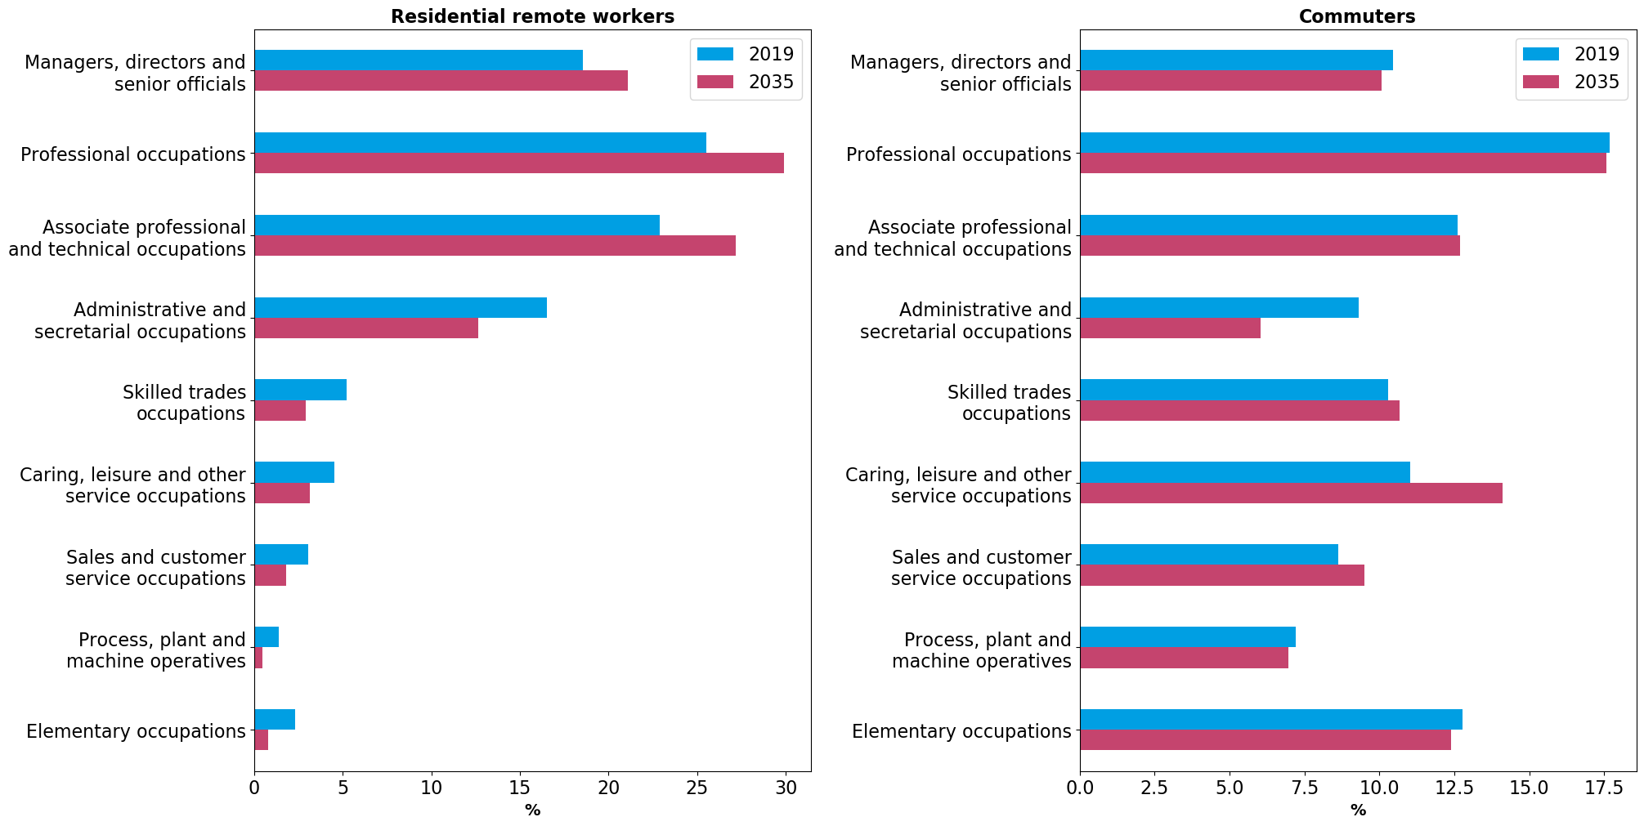
As observed in Table 4.2.1, the occupational structure and expected growth of remote workers in Essex overwhelmingly leans towards higher-level, managerial/technical occupations. This contrasts with commuters, where the occupational structure and expected growth in commuters leans more towards lower-level, service-oriented occupations (particularly care and leisure), where remote working amenability is low.
Figure 4.5.1: Occupational composition in 2019 and 2035, Essex
Source: ONS, Cambridge Econometrics

With these observations in mind, Table 4.5.1 and Figure 4.5.2, Figure 4.5.3, and Figure 4.5.4 explore the spatial implications of a shift in remote working in Essex and its largest urban areas across three key variables:
- Workplace Workers: aka commuters, those travelling to their workplace in Essex more than 50% of the week (note: commuters can reside outside of Essex)
- Remote workers: those working remotely (i.e. from home) in Essex more than 50% of the week (note: remote workers’ workplace can be outside Essex)
- Workday population: the number of people who live in an area, including those commuters and remote workers who are present during the daytime to consume local services
By looking at change across these variables, potential ‘winners’ and ‘losers’ of a large-scale shift in remote working in Essex can be identified, which can help to inform future aspirations and interventions across a range of policy areas, such as transport, leisure, the high street, and housing.
Table 4.5.1: Summary of key variables from remote working scenario, 2019 and 2035
 | Workplace Workers |  |  |  | Remote workers |  |  |  | Workday population
 | 2019 | 2035 | Change, 2019-35 | % change, 2019-35 | 2019 | 2035 | Change, 2019-35 | % change, 2019-35 | 2019 | 2035 | Change, 2019-35 | % change, 2019-35
Basildon | 83.9 | 73.4 | -10.6 | -12.6% | 10.9 | 27.1 | 16.2 | 149.4% | 188.7 | 204.4 | 15.8 | 8.4%
Braintree | 18.6 | 15.8 | -2.8 | -15.1% | 3.2 | 7.7 | 4.5 | 141.7% | 44.8 | 49.2 | 4.4 | 9.8%
Chelmsford | 68.8 | 59.4 | -9.3 | -13.6% | 8.0 | 20.2 | 12.2 | 152.0% | 132.3 | 140.5 | 8.1 | 6.1%
Colchester | 71.7 | 61.6 | -10.1 | -14.1% | 9.1 | 22.1 | 13.0 | 142.5% | 155.3 | 168.8 | 13.5 | 8.7%
Grays | 57.8 | 51.6 | -6.2 | -10.7% | 7.1 | 17.6 | 10.5 | 146.8% | 130.8 | 142.4 | 11.5 | 8.8%
Harlow | 51.9 | 45.7 | -6.2 | -11.9% | 6.6 | 16.7 | 10.1 | 152.6% | 111.4 | 121.2 | 9.8 | 8.8%
Southend | 122.7 | 105.9 | -16.8 | -13.7% | 24.2 | 59.5 | 35.3 | 145.9% | 313.3 | 350.7 | 37.5 | 12.0%
Essex (excluding large urban) | 280.9 | 245.0 | -35.9 | -12.8% | 49.1 | 122.9 | 73.8 | 150.5% | 736.8 | 815.8 | 79.0 | 10.7%
Essex (total) | 756.3 | 658.4 | -97.9 | -12.9% | 118.1 | 293.7 | 175.6 | 148.6% | 1813.4 | 1993.0 | 179.6 | 9.9%
Source: ONS, Cambridge Econometrics.

The results show that, across Essex and its large urban areas, relative to pre-Covid levels there is expected to be a notable decrease in the number of workers commuting to their workplace more than 50% of the working week. This drop is led by Braintree, with Colchester, Southend and Chelmsford also seeing falls larger than the Essex average.
This reflects the favourable sectoral and occupational structure of the jobs in these areas, which have high remote working amenability (therefore commuters, who travel to work in these roles, are no longer required to travel as frequently). In contrast, Basildon, Grays and Harlow see smaller, albeit still large, falls in workers commuting to their workplace.
In addition, there is expected to be a significant and sustained increase in the number of residents working remotely for more than 50% of the working week, with the total more than a doubling relative to pre-Covid levels.
The spatial pattern within Essex is subtly different to that of commuting though; Harlow leads the increase in remote workers, whilst Chelmsford and Basildon are the only other urban areas to see an increase above the Essex average.
These increases are attributable to the higher proportion of residents (particularly commuting residents, not least London commuters) in these areas who work in sectors and occupations with high remote working amenability and are therefore able to commute less and spend more time working from home.
This trend is less pronounced, albeit still considerable, in areas such as Colchester and Braintree. Only two large urban areas (Harlow and Chelmsford) are expected to see an increase in remote workers above the non-large-urban average, reflecting the attraction of Essex’s non-urban areas to workers in managerial and technical occupations (which have high remote working potential).
Finally, bringing the two trends together, the workday population considers the ‘live’ population of an area during the working day, comprising remote working residents, commuting workers, and other permanent residents (notably the economically inactive; retirees, students, unemployed etc.). Positively, across all large urban areas in Essex, relative to pre-Covid levels there is expected to be an increase in the workday population.
However, Southend is the only large urban area to see an increase in its workday population above the Essex average. Likewise, it is the only urban area to benefit more than the non-large-urban area average. Chelmsford for instance is expected to see only two-thirds of the increase in the workday population relative to non-large-urban areas.
Naturally, the size of the workday population in an area is highly correlated with the scale and pattern of consumption of local services. The results of this exercise indicate that as a result of a Covid-induced shift in remote working, some consumption could shift away from Essex’s large urban centres to more semi-urban and rural locations.
A more spatially granular overview of the modelling results are provided across Figure 4.5.2, Figure 4.5.3, and Figure 4.5.4, highlighting detailed urban-rural patterns and dynamics.
A detailed two-pager overview of the modelling for each of the seven largest urban areas in Essex – summarising key economic, demographic and labour market data, segmented by industry and occupation - is provided from Page 26 onwards.

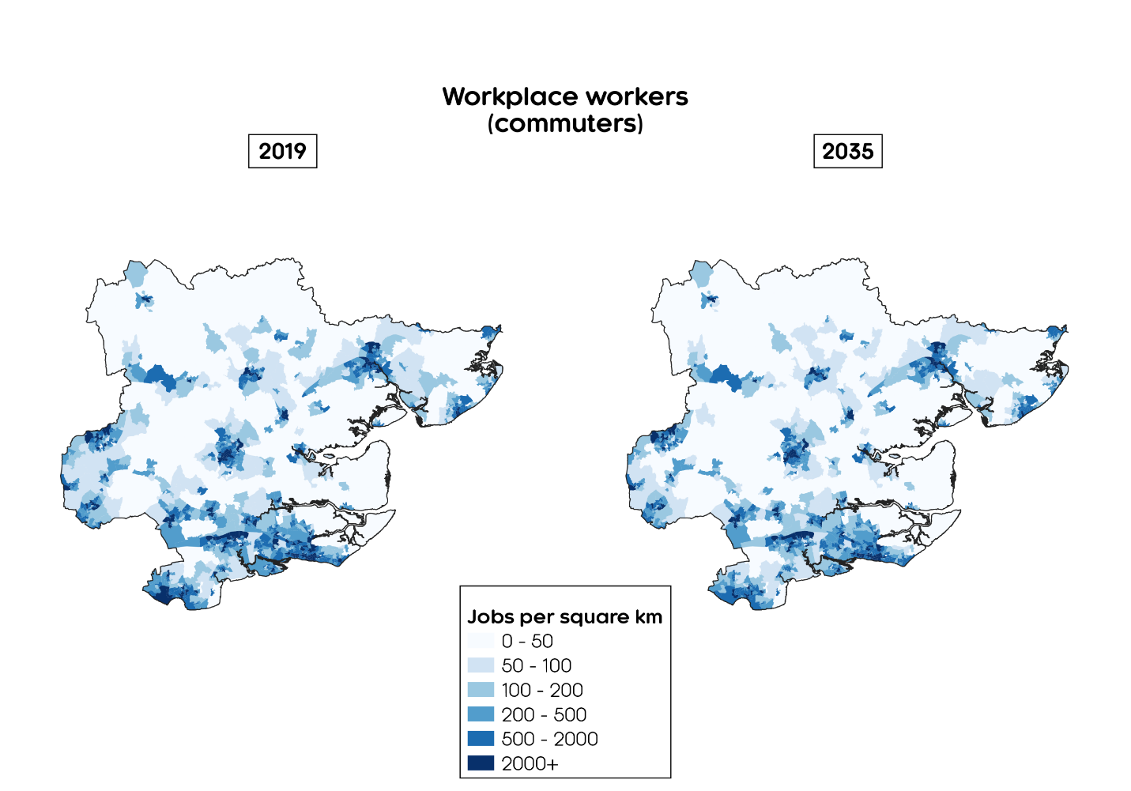
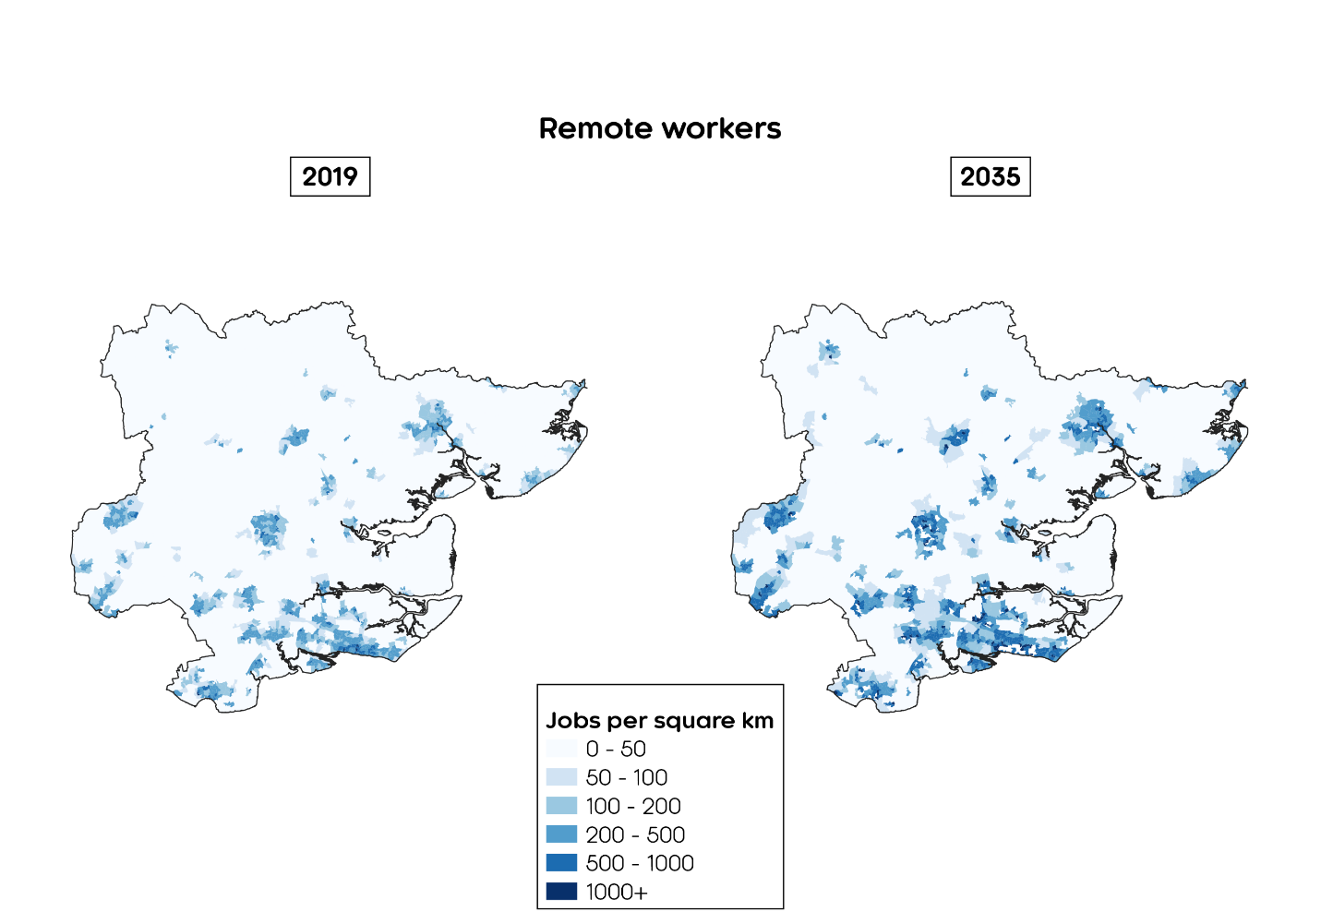
Figure 4.5.3: Workplace Workers (by workplace) in Essex, 2019 and 2035
Source: ONS, Cambridge Econometrics
Figure 4.5.2: Remote workers (by residence) in Essex, 2019 and 2035
Source: ONS, Cambridge Econometrics
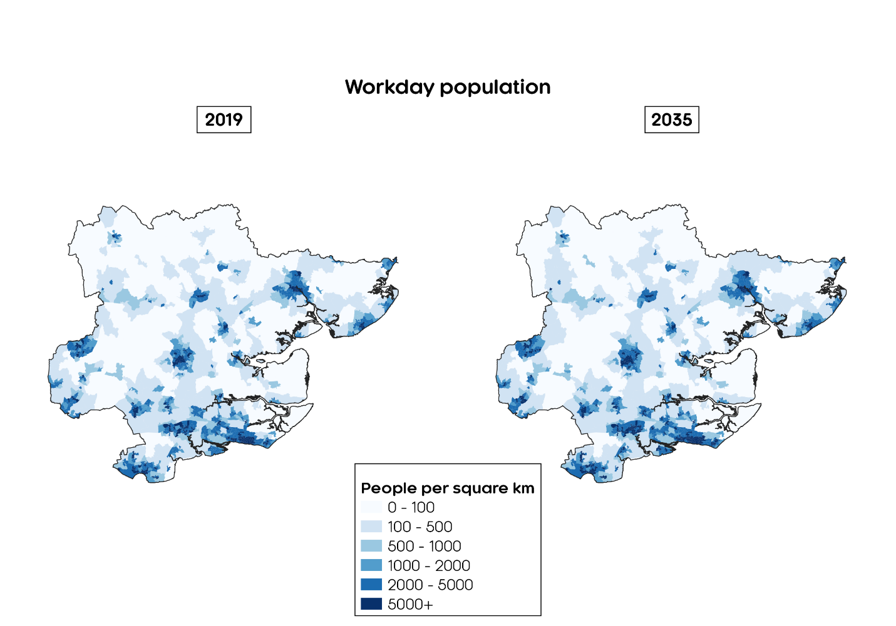
Figure 4.5.4: Workday population (commuters and remote workers) in Essex, 2019 and 2035
Source: ONS, Cambridge Econometrics
This aligns to the work that Rob Willis’ team is doing around WHERE we might need the office space in future

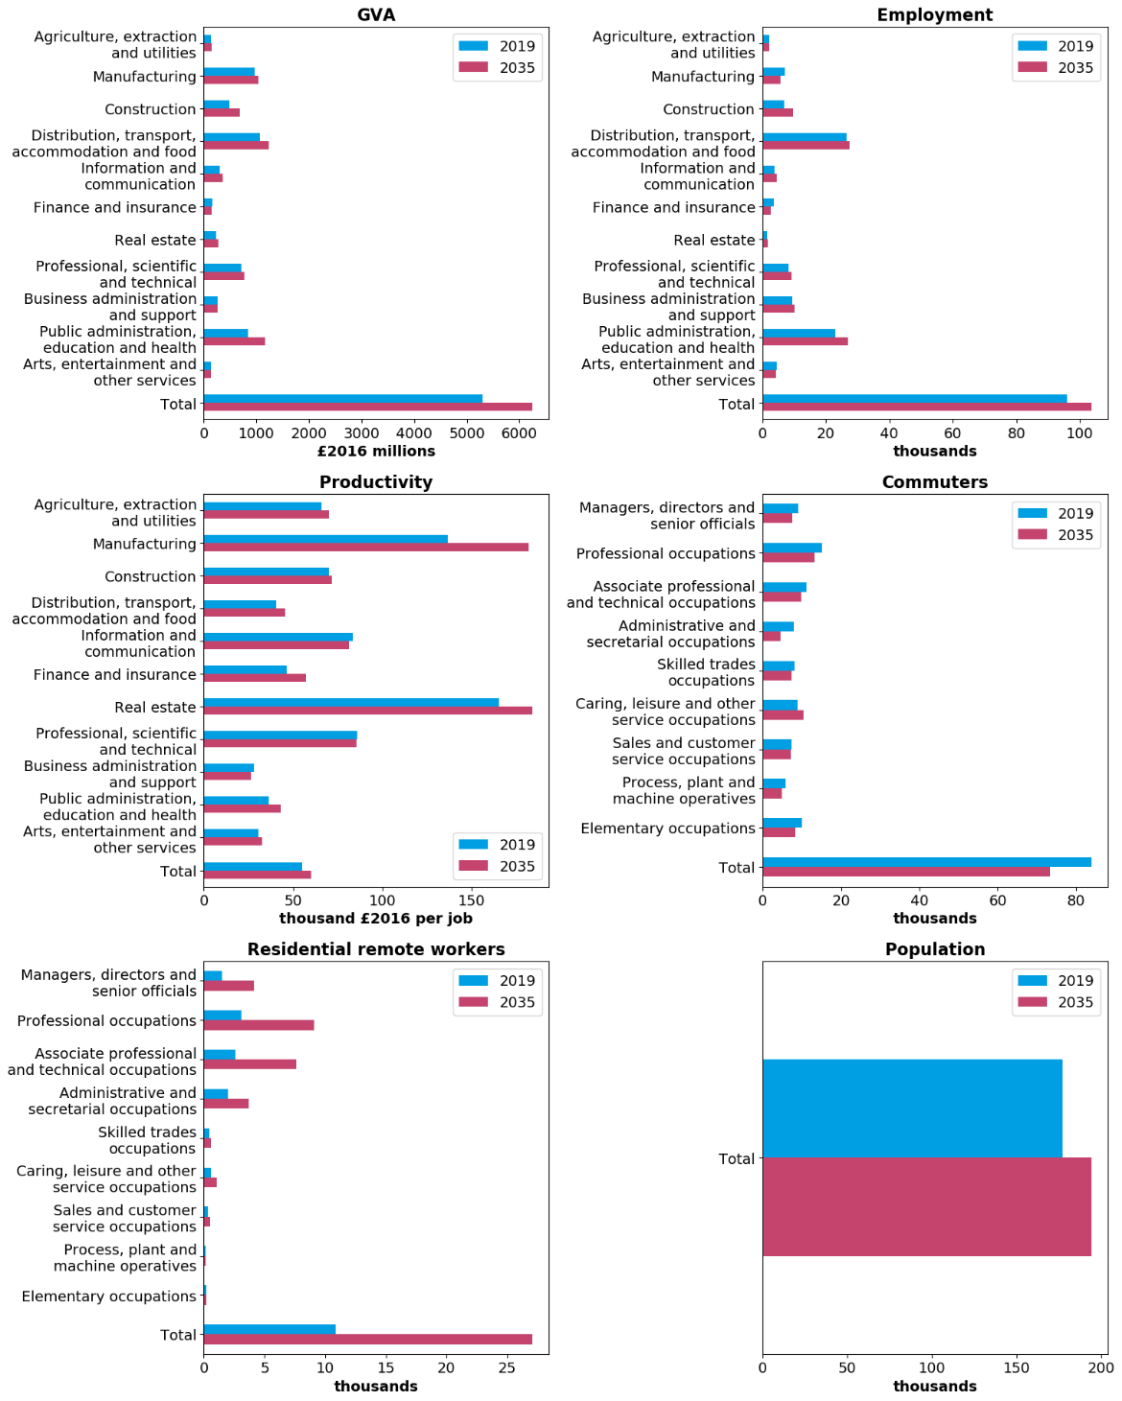
Basildon
Figure 4.5.5: 2019 and 2035 values for key variables, Basildon
Source: ONS, Cambridge Econometrics

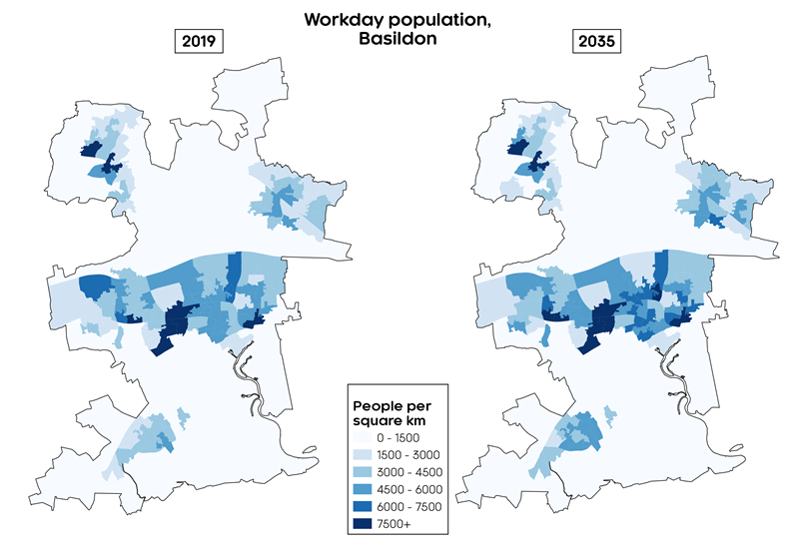
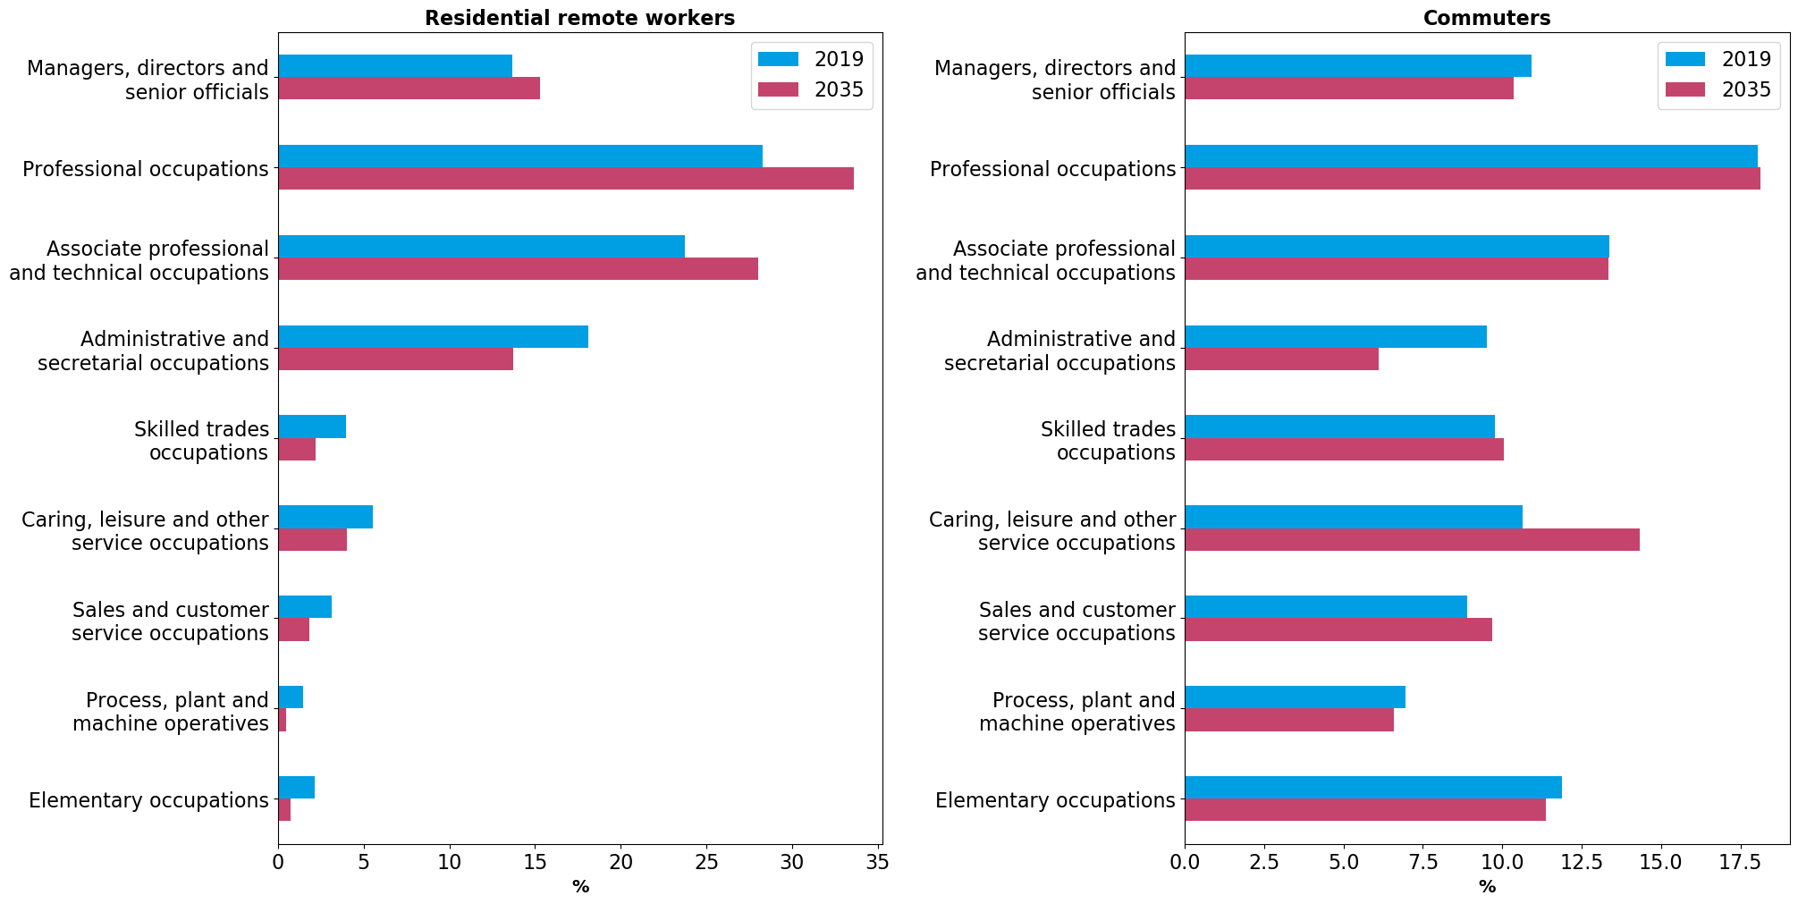
Figure 4.5.6: Change in workday population density, Basildon this doesn’t look like Basildon????
Source: ONS, Cambridge Econometrics
Figure 4.5.7: Occupational composition in 2019 and 2035, Basildon
Source: ONS, Cambridge Econometrics

Braintree
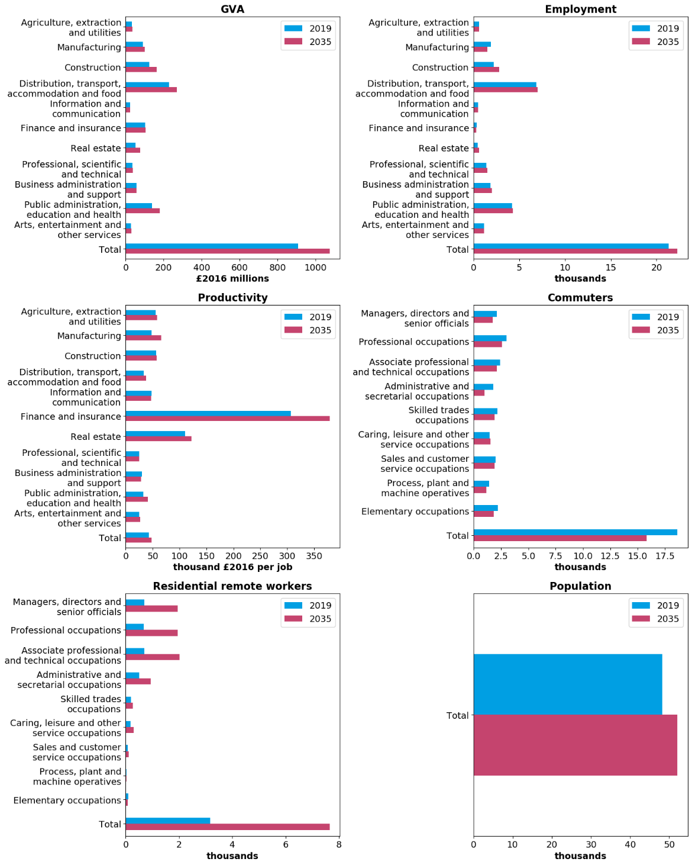
Figure 4.5.8: 2019 and 2035 values for key variables, Braintree
Source: ONS, Cambridge Econometrics

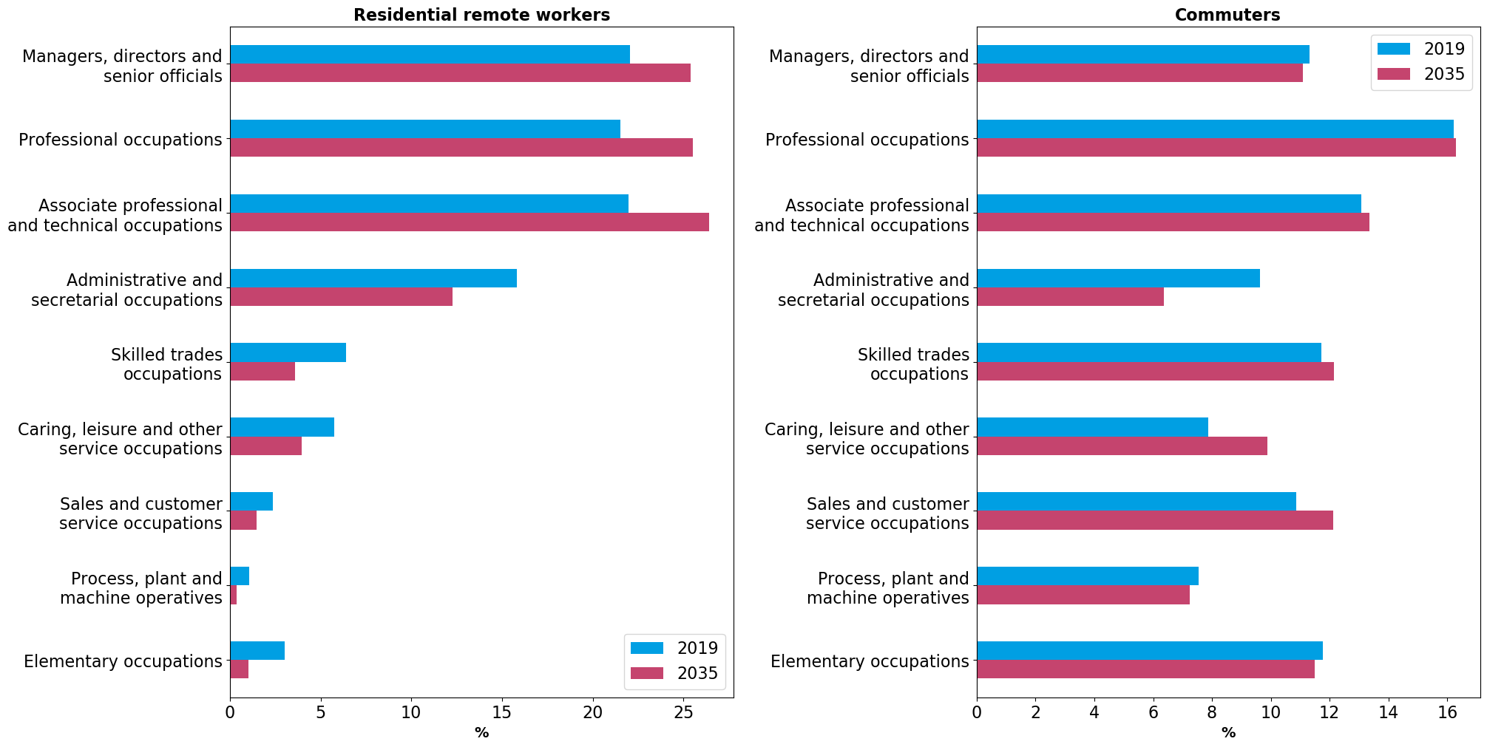
Figure 4.5.10: Occupational composition in 2019 and 2035, Braintree

Source: ONS, Cambridge Econometrics
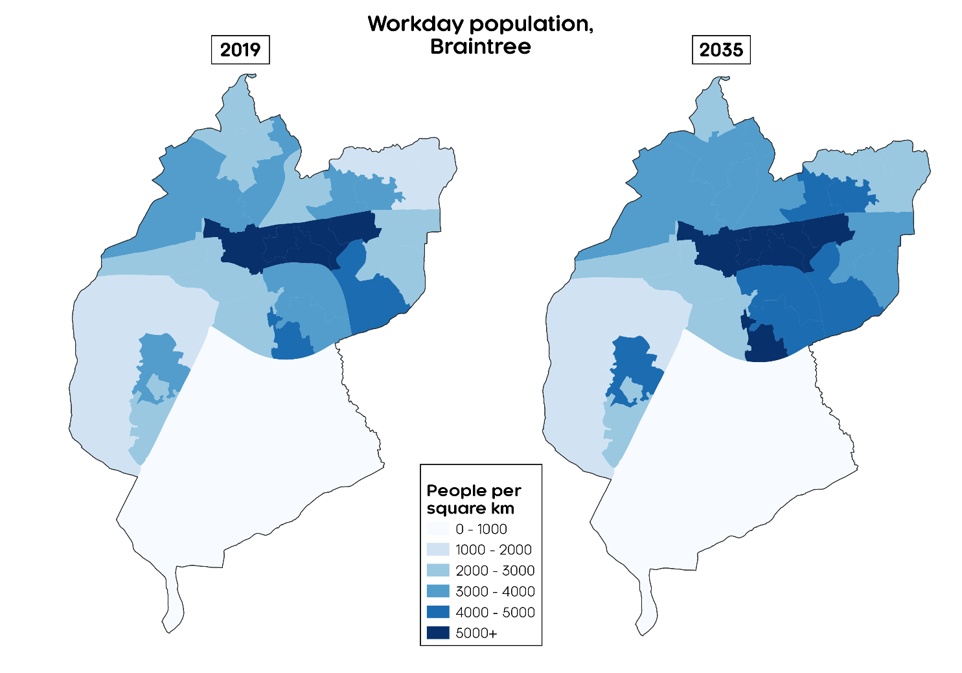
Figure 4.5.9: Change in workday population density, Braintree
Source: ONS, Cambridge Econometrics

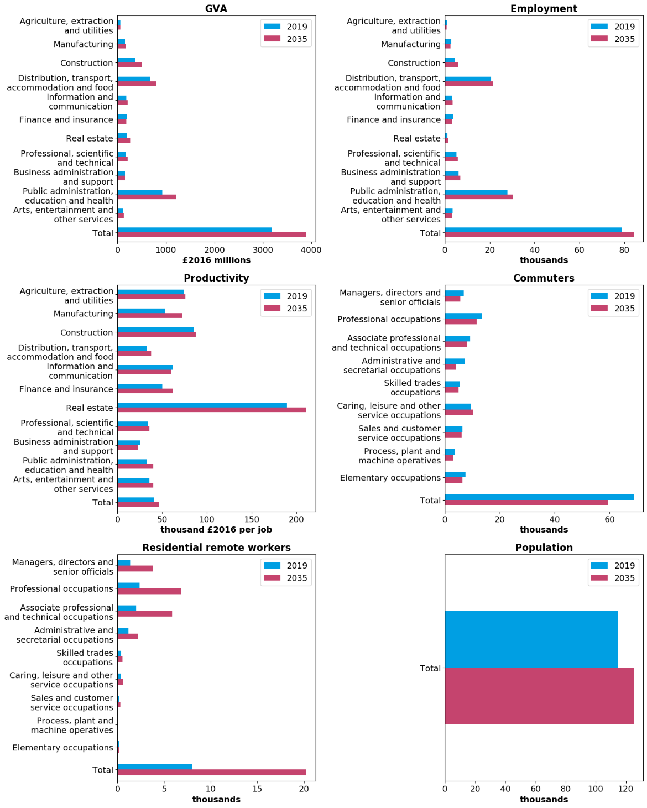
Chelmsford
Figure 4.5.11: 2019 and 2035 values for key variables, Chelmsford
Source: ONS, Cambridge Econometrics

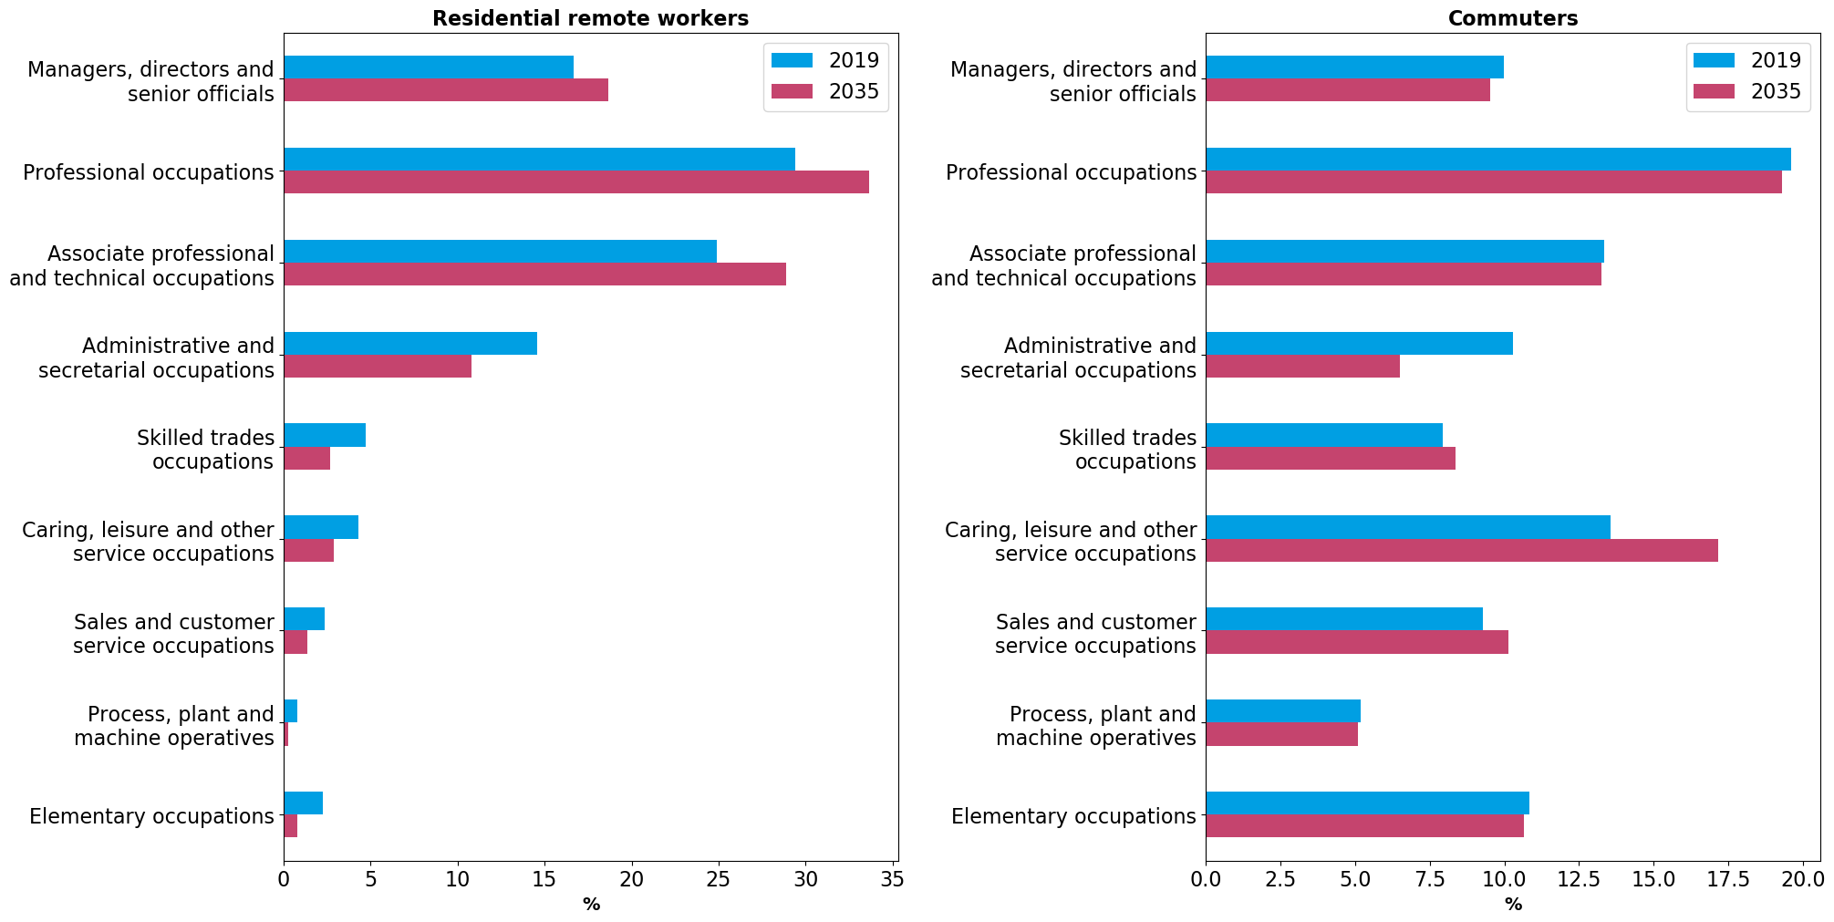
Figure 4.5.13: Occupational composition in 2019 and 2035, Chelmsford
Source: ONS, Cambridge Econometrics
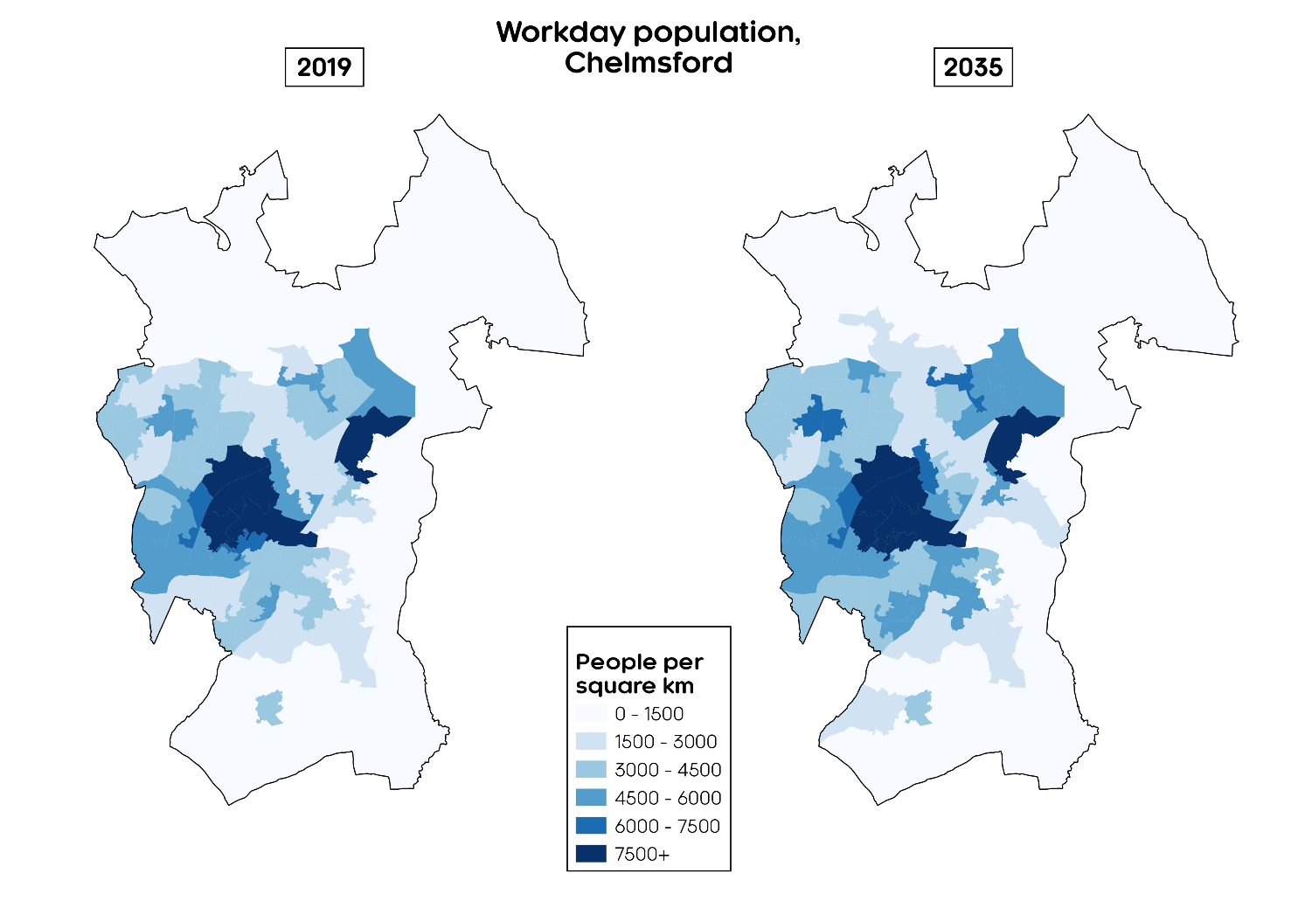
Figure 4.5.12: Change in workday population density, Chelmsford
Source: ONS, Cambridge Econometrics
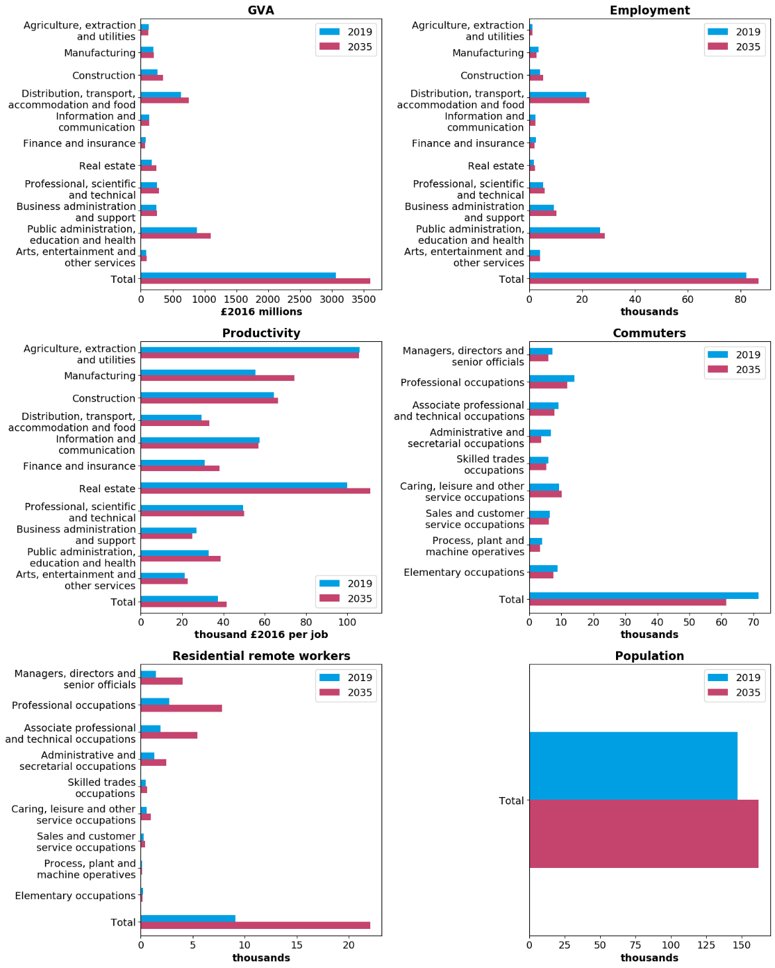
Colchester
Figure 4.5.14: 2019 and 2035 values for key variables, Colchester
Source: ONS, Cambridge Econometrics

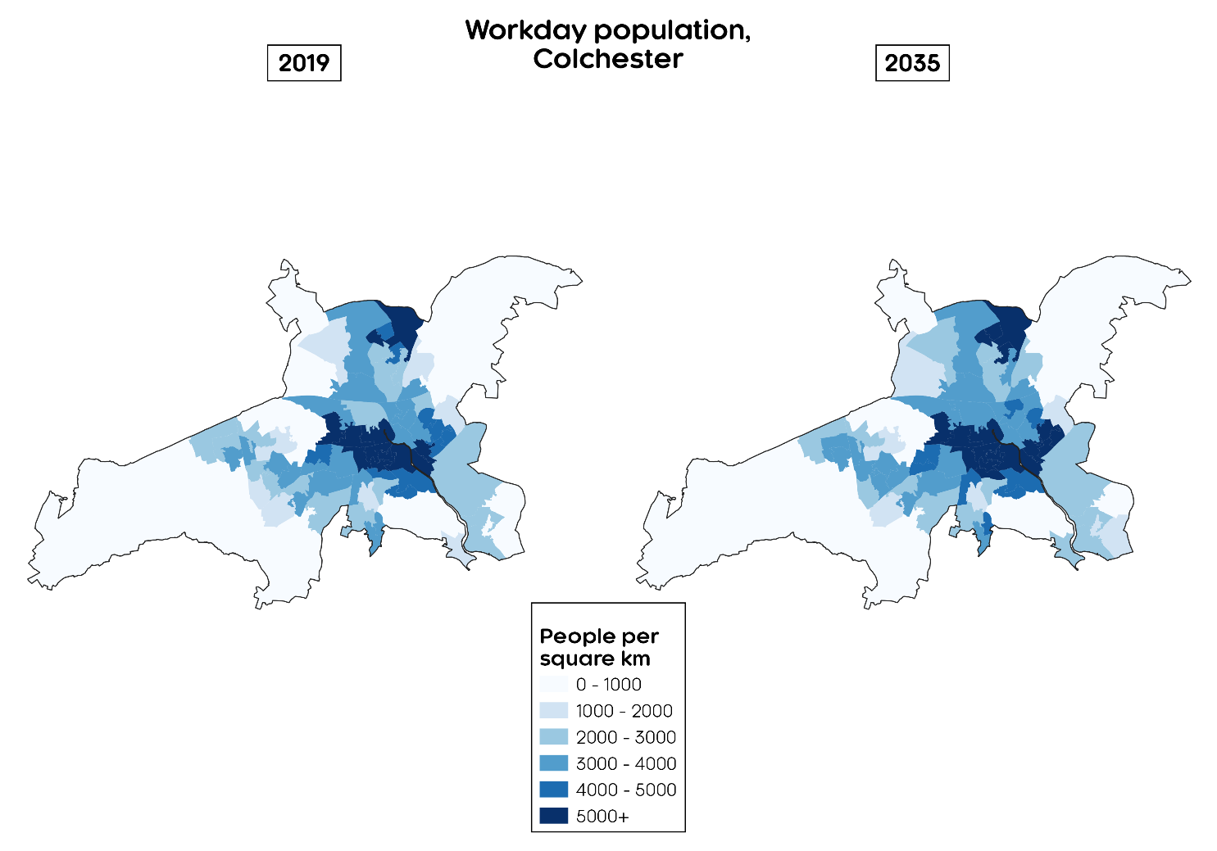
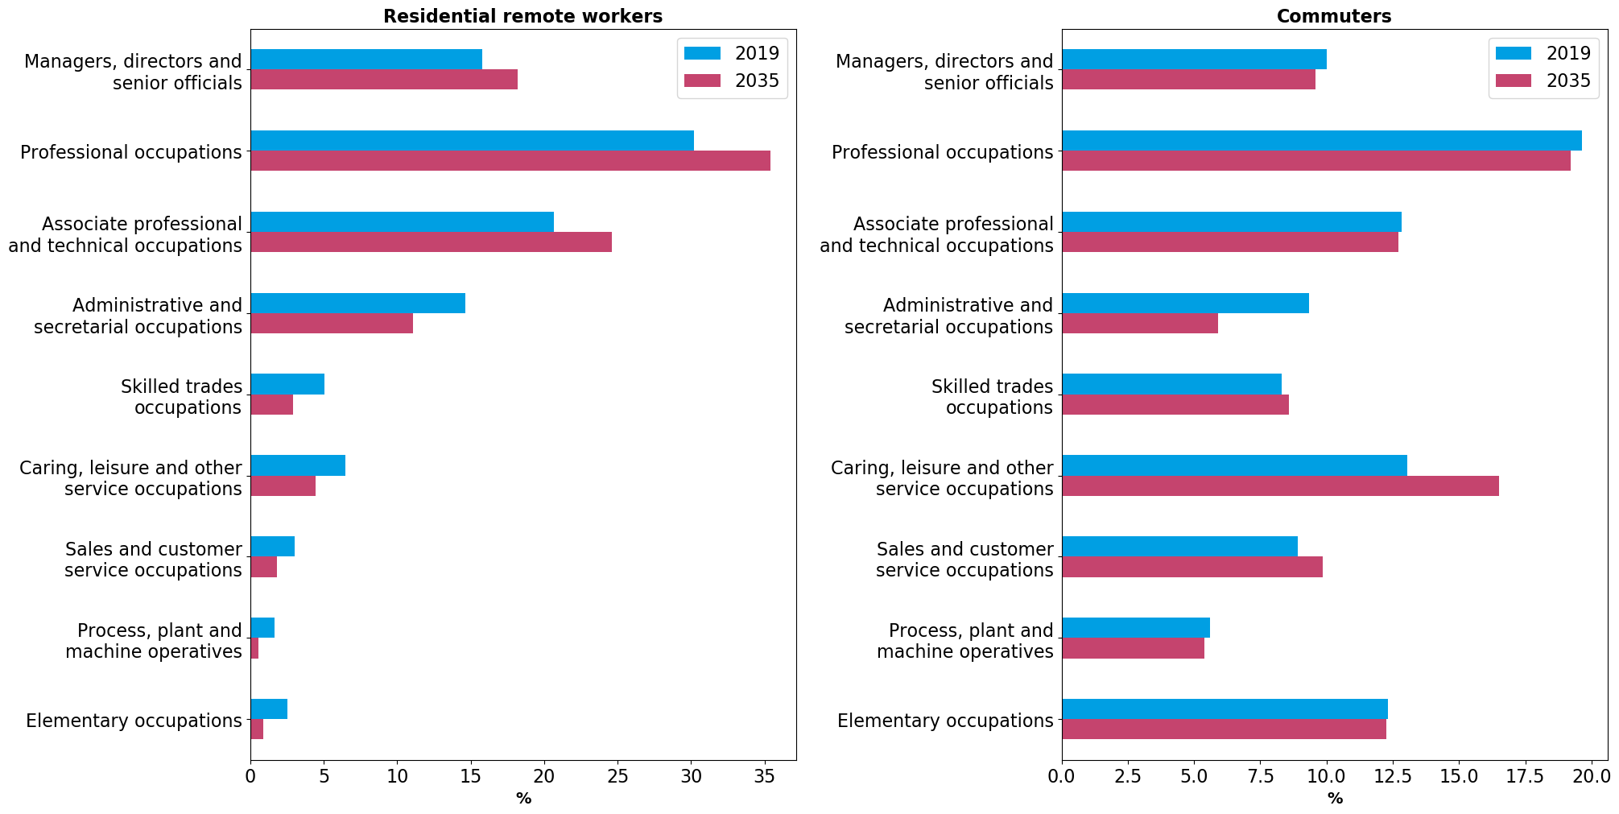
Figure 4.5.15: Change in workday population density, Colchester
Source: ONS, Cambridge Econometrics
Figure 4.5.16: Occupational composition in 2019 and 2035, Colchester
Source: ONS, Cambridge Econometrics

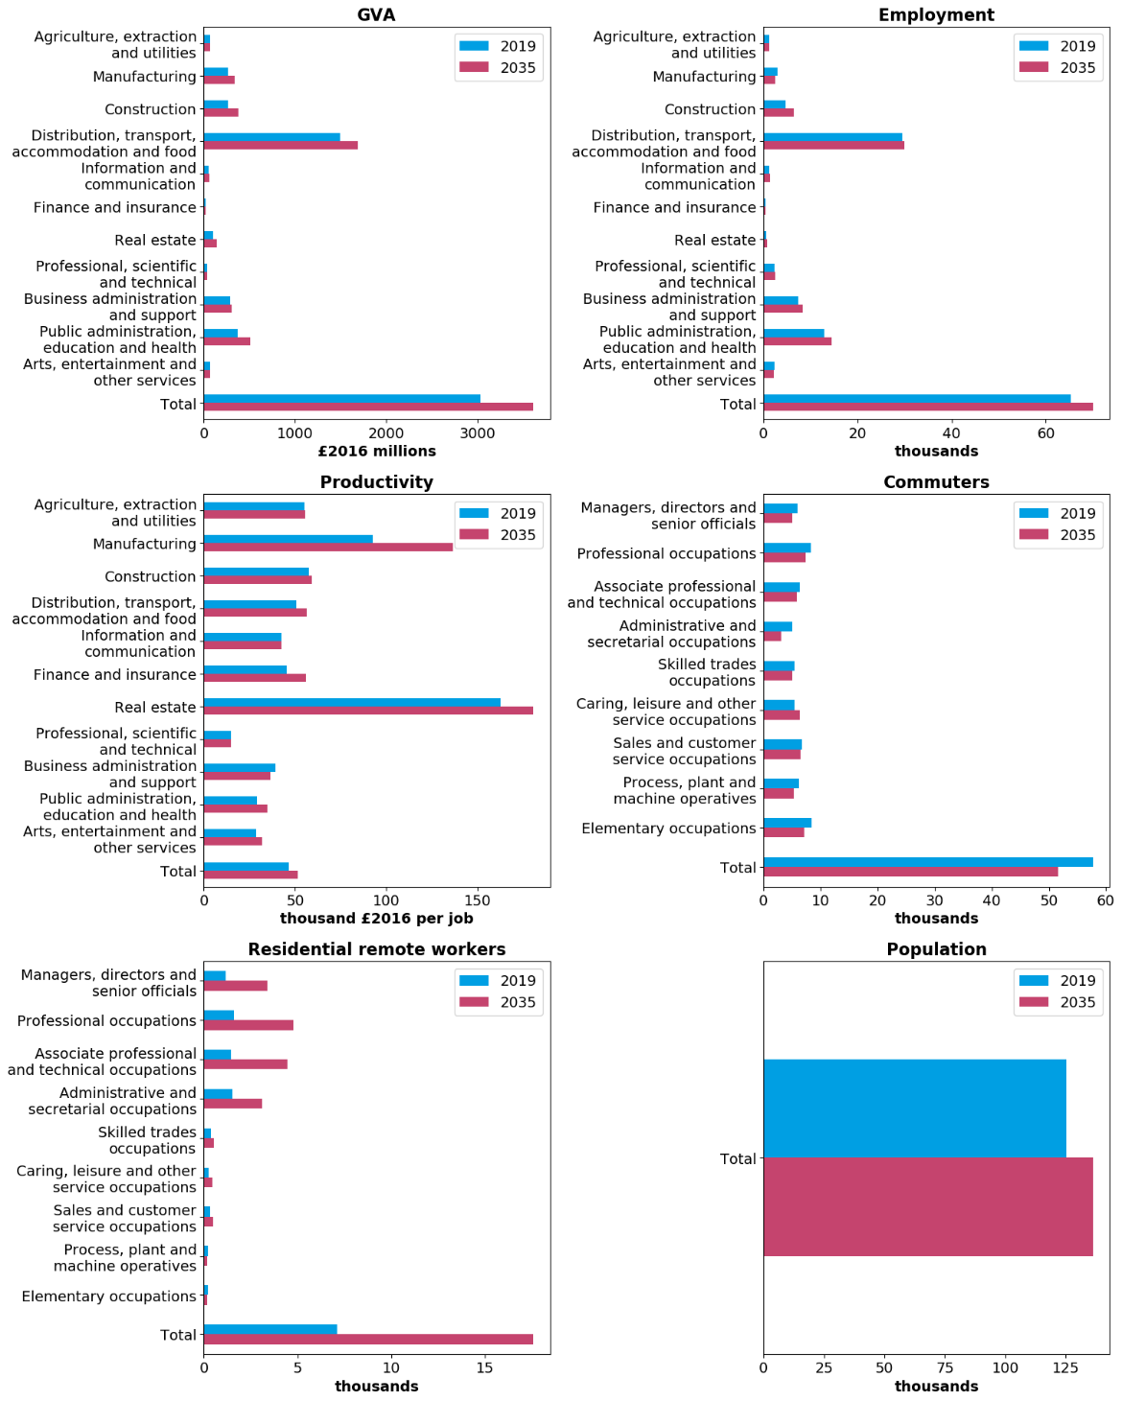
Grays
Figure 4.5.17: 2019 and 2035 values for key variables, Grays
Source: ONS, Cambridge Econometrics

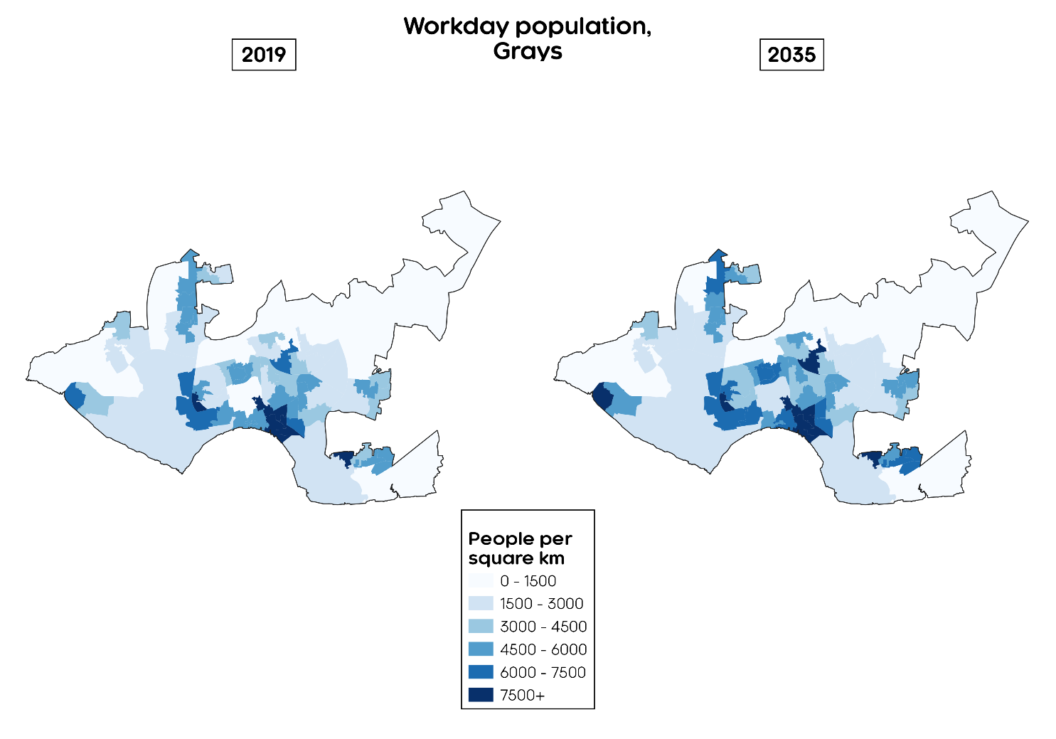
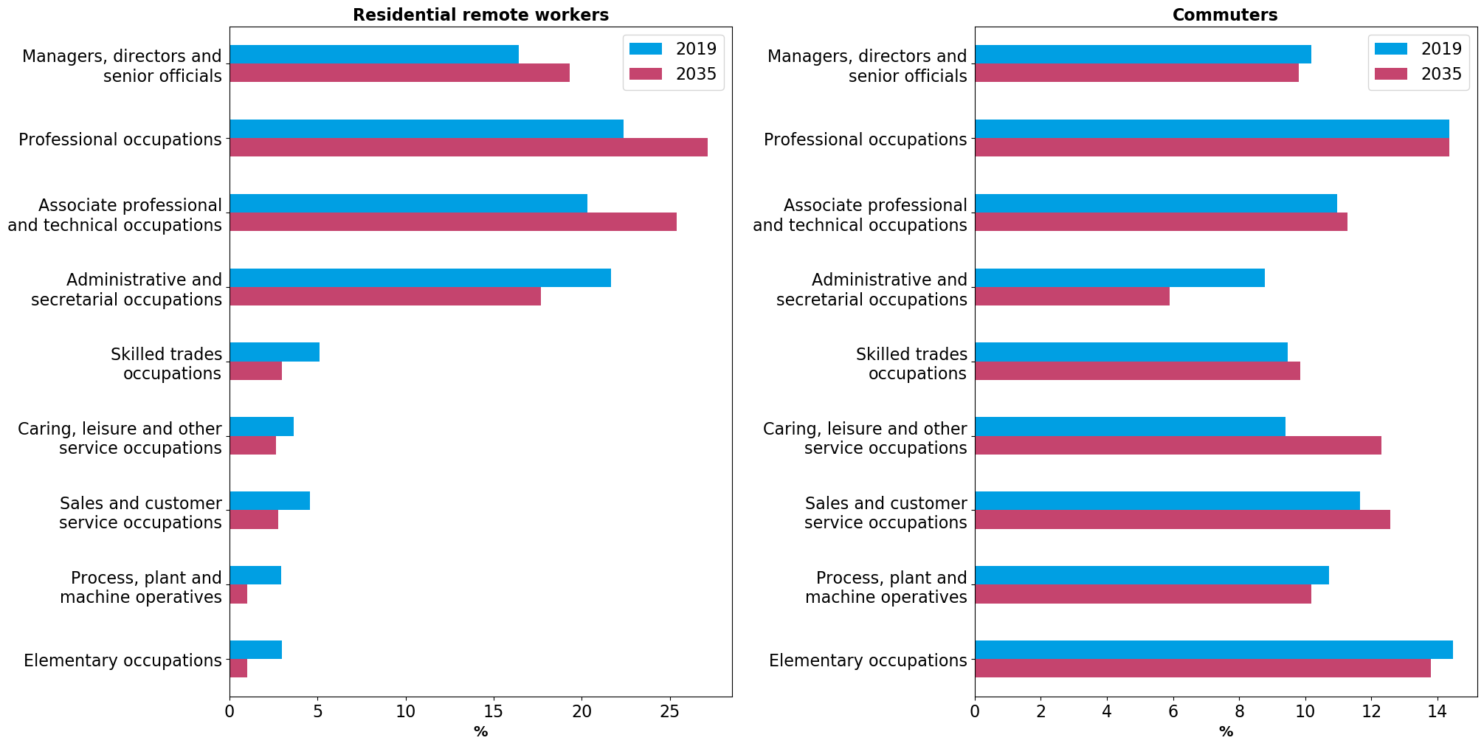
Figure 4.5.18: Change in workday population density, Grays
Source: ONS, Cambridge Econometrics
Figure 4.5.19: Occupational composition in 2019 and 2035, Grays
Source: ONS, Cambridge Econometrics

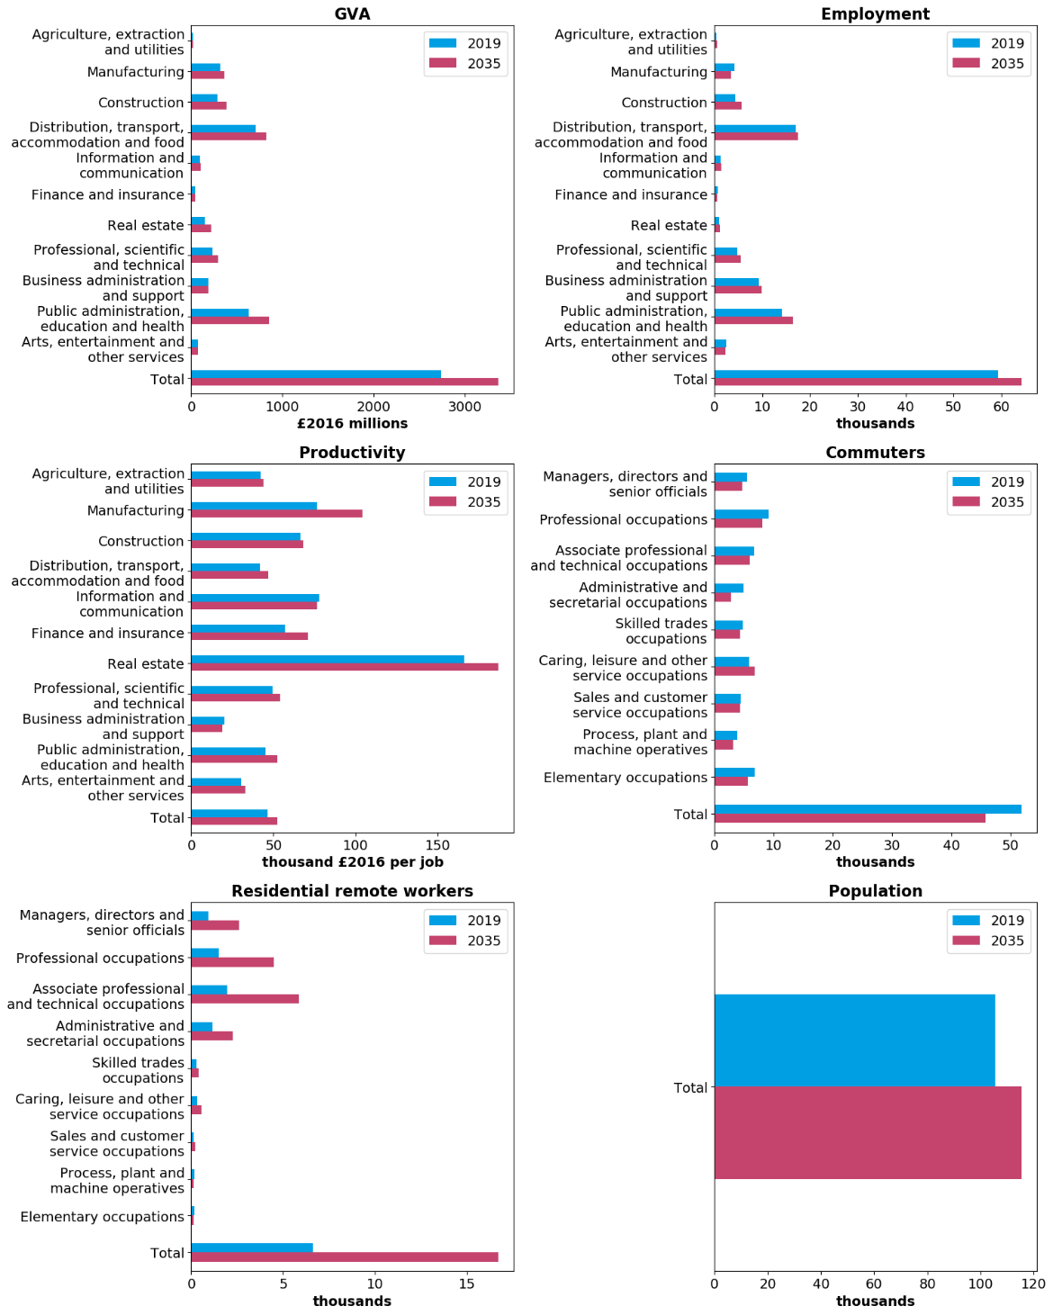
Harlow
Figure 4.5.20: 2019 and 2035 values for key variables, Harlow
Source: ONS, Cambridge Econometrics

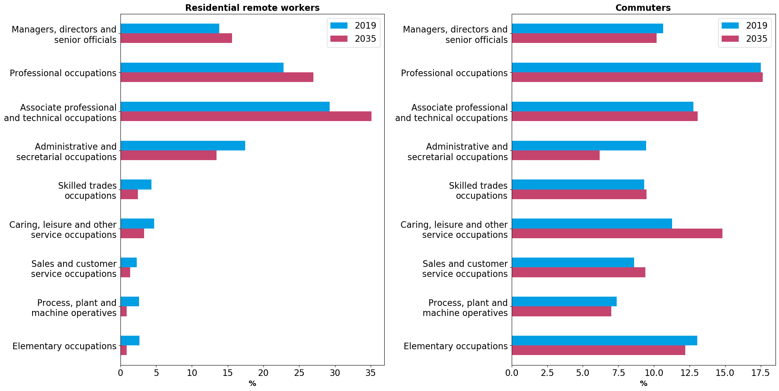
Figure 4.5.22: Occupational composition in 2019 and 2035, Harlow
Source: ONS, Cambridge Econometrics
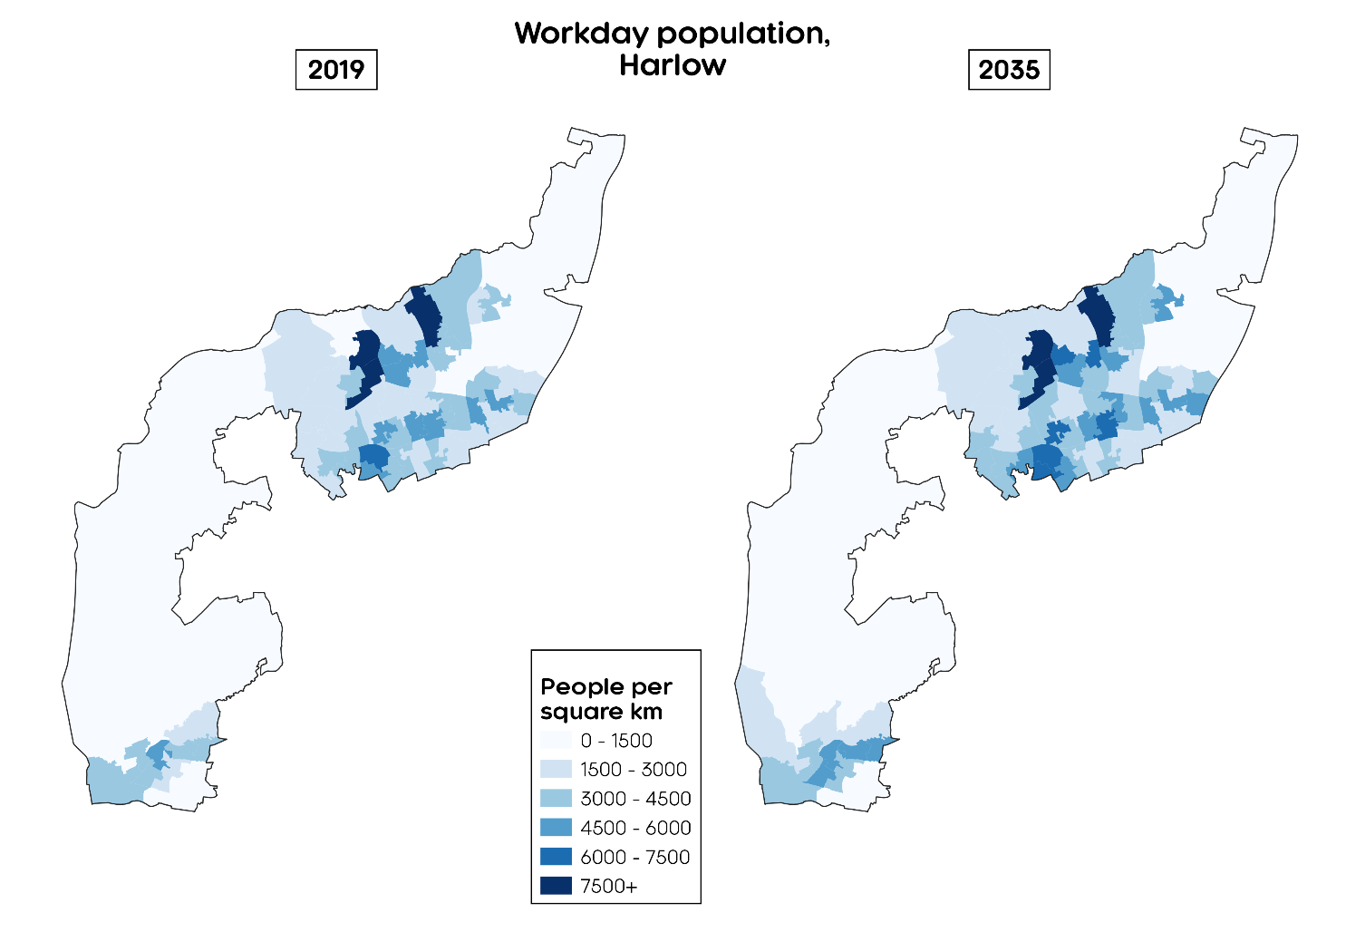
Figure 4.5.21: Change in workday population density, Harlow This looks like Southend?
Source: ONS, Cambridge Econometrics
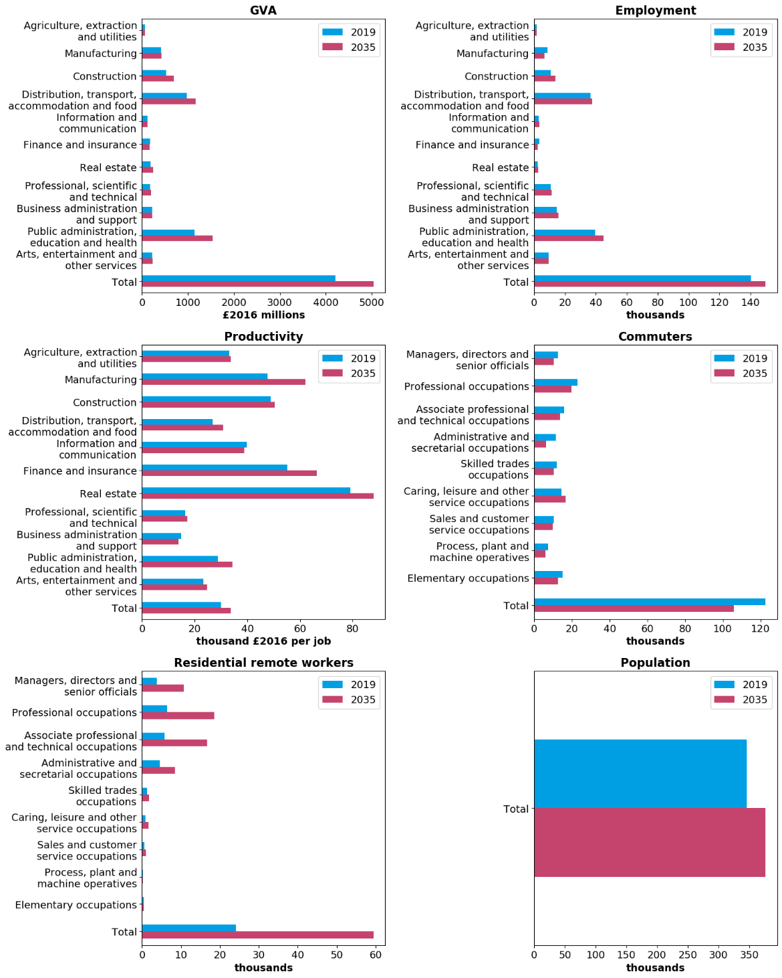
Southend
Figure 4.5.23: 2019 and 2035 values for key variables, Southend
Source: ONS, Cambridge Econometrics

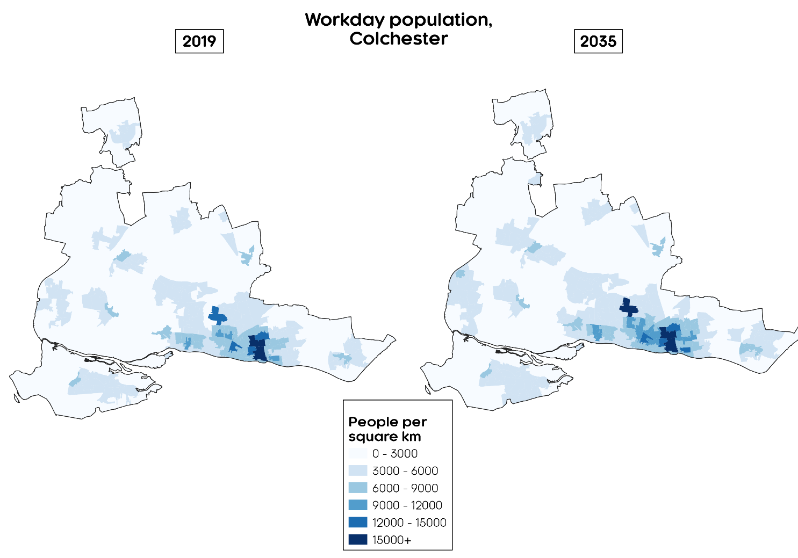
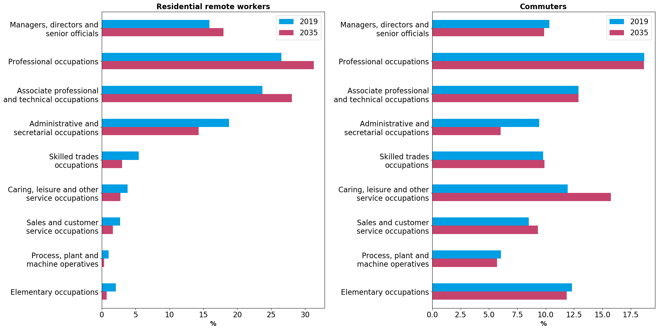
Figure 4.5.25: Change in workday population density, Colchester
Source: ONS, Cambridge Econometrics
Figure 4.5.24: Occupational composition in 2019 and 2035, Southend
Source: ONS, Cambridge Econometrics

Appendix A: Sector definitions
A look-up between CE’s 45 sectors (as provided by the LEFM) and official SIC classifications.
CE code | Sector | SIC2007
1 | Agriculture, forestry & fishing | 01-03
2 | Mining & quarrying | 05-09
3 | Food, drink & tobacco | 10-12
4 | Textiles etc | 13-15
5 | Wood & paper | 16-17
6 | Printing & recording | 18
7 | Coke & petroleum | 19
8 | Chemicals | 20
9 | Pharmaceuticals | 21
10 | Non-metallic mineral products | 22-23
11 | Metals & metal products | 24-25
12 | Electronics | 26
13 | Electrical equipment | 27
14 | Machinery | 28
15 | Motor vehicles | 29
16 | Other transport equipment | 30
17 | Other manufacturing & repair | 31-33
18 | Electricity & gas | 35
19 | Water, sewerage & waste | 36-39
20 | Construction | 41-43
21 | Motor vehicles trade | 45
22 | Wholesale trade | 46
23 | Retail trade | 47
24 | Land transport | 49
25 | Water transport | 50
26 | Air transport | 51
27 | Warehousing & postal | 52-53
28 | Accommodation | 55
29 | Food & beverage services | 56
30 | Media | 58-60
31 | IT services | 61-63
32 | Financial & insurance | 64-66
33 | Real estate | 68
34 | Legal & accounting | 69
35 | Head offices & management consultancies | 70
36 | Architectural & engineering services | 71
37 | Other professional services | 72-75
38 | Business support services | 77-82
39 | Public Administration & Defence | 84
40 | Education | 85
41 | Health | 86
42 | Residential & social | 87-88
43 | Arts | 90-91
44 | Recreational services | 92-93
45 | Other services | 94-96

Source: see Baseline economic forecasts
See Appendix A: Sector definitions for the definitions of CE’s detailed and broad sectors in terms of the 2007 Standard Industrial Classification.
An alternative would be to use number of people employed. This however would not account for people holding multiple jobs.
See this ONS statistical bulletin for more information.
Ibid.
Given National Statistics status in November 2018.
See this ONS statistical bulletin for more information.
See this ONS statistical bulletin for more information.
See this ONS technical paper for more information.
For a review of other measures of productivity see OECD (2001).
This is not the case for the main alternative of GVA per hour worked.
https://ec.europa.eu/environment/enveco/growth_jobs_social/pdf/studies/green_recovery_plans.pdf
See: https://productivityinsightsnetwork.co.uk/app/uploads/2020/12/BrownNellesNyanzuVorley2020_RethinkingPlace_PIN_Chicago.pdf for more information on how these have been defined

